Chapter 3- methodology draft
Introduction
The previous chapter achieved the first objective, to conduct an extensive literature review on the implementation of CSR practices and consumer buying behaviour.
Is there a lack of research? Explain briefly what you found in the literature review.
This chapter will help to achieve the second objective:
“To carry out questionnaires of general consumers of Coca-Cola to further understand whether CSR practices affect consumer buying behaviour.” -reword this
To achieve this objective, Saunders et al. (2016) research onion will be used to help the considerations of reliability, validity, limitations and ethical issues when dealing with public views.
Research Onion
There is no one definition of research, however DePoy and Gitlin (2015) define research to be the professional responsibility which aims to develop and advance the understanding of a subject, using already existing knowledge. Whereas, Collis and Hussey (2013) state that research establishes a deeper understanding of problems in need of an explanation. According to Stewart et al. (1993) research van be classified into primary and secondary research. Secondary research is the starting point for additional research using hypotheses and research methods, whereas primary research is the tool used for the further understanding of individuals or a groups opinions and rhetorical actions, done through interviews, questionnaires, focus groups (Gaillet and Eble, 2015).
The research onion was developed by Saunders et al. (2009) which aimed to summarise research using the several layers which will effectively help the researcher to explain why or how a phenomenon is happening. In order for this model to be effective, each layer of the model must be chosen.
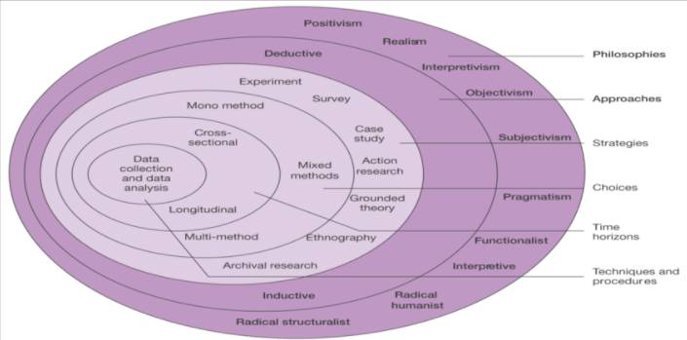

Figure 3.1 The Research Onion (Saunders et al., 2009).
Philosophy
As described by Partington (2002), philosophy is concerned with establishing, regulating and improving the methods of knowledge by the fields of intellectual endeavour, which according to Scotland (2012) philosophy can take on different fields of beliefs. This research will take on a positivism view, which has come to be associated with the idea of social science (Bryant, 1985), which Saunders et al. (2009) describe the role of positivism to be the data collection and interpretation which leads to the analysis of data and statistical collection.
This research will be using surveys for the nature of the project, therefore positivist researchers use this to help clearly understand the analysis of data from sampling, questionnaires, focus groups, etc (Pham, 2018).
Research Approaches
The second layer of the lion is the different research approaches which according to Collis and Hussey (2014), there are two types of research approaches, deductive and inductive.
This research will be using a deductive approach; this is due to the research being based on consumer buying behaviour in relation to Coca-colas CSR approach.
FIND REFERENCE DEDUCTIVE APPROACH
Strategy
There is little no consensus on what a method can be defined as, however; Chu and Ke (2017) defines it as different kind of techniques used to gather and analyse data. This research uses surveys/questionnaires in order to collect social views to provide a consensus on consumer buying behaviour in relation to a business’s CSR practices. Kotler (2012) defines surveys to be best suited for descriptive research as well as being the appropriate choice for standardised results to be compared (Saunders et al., 2009). This often because, surveys obtain faster response rates as well as increased accuracy because participants are able to enter their own information (Mol, 2017). Therefore, this allows for the researcher to further understand how and why individuals think and act in general or for example; how they react to CSR (Nardi, 2018).
The questionnaires, were created on Google Docs...The link was provided to participants, through social media platforms (e.g Facebook, Linkedin) as well as voluntary participants. Go into detail on confidentiality- find references on the importance of confidentiality.
Choice
Saunders et al. (2009) research onion displays the different choices a researcher can choose from, for the sake of this project the mono-method will be used with is the use of one method either being quantitative or qualitative (Molina-Azorin and Font, 2016).
Time management
Data collection
Questionnaire Design and (Lit review matrix ????)
Pilot Study
Sample
Reliability and Validity
Limitations
Ethical considerations
Chapter conclusion

Reference list

DePoy, E. and Gitlin, L., 2015. Introduction To Research: Understanding And Applying Multiple Strategies. 5th ed. Elsevier Health Sciences.
Saunders, M., Lewis, P., and Thornhill, A. (2016) Research methods for business students. 7th ed. Nueva York: Pearson Education.
Collis, J., and Hussey, R. (2013) Business research: A practical guide for undergraduate and postgraduate students. England: Palgrave Macmillan Higher Education.
Gaillet, L., and Eble, M. (2015) Primary Research and Writing: People, Places and Spaces. Routledge.
IBM 2020, Why SPSS Statistics. Available at :<https://www.ibm.com/uk-en/products/spss-statistics
Stewart, D. KAmins, M., and Kamins, M. (1993) ‘Secondary Research: Information Sources and Methods. 4th ed. SAGE.
Bryant, C. G. A. (1985) Positivism in Social Theory and Research: Contemporary Social Theory. Macmillan International Higher Education.
Partington, D. (2002) Essential Skills for Management Research . Business and economics: SAGE.
Pham, L. T. M. (2018) Qualitative approach to research: A review of advantages and disadvantages of three paradigms: positivism, interpretive and critical inquiry. The University of Adelaide. Available at: https://www.researchgate.net/profile/Lan-Pham-3/publication/324486854_A_Review_of_key_paradigms_positivism_interpretivism_and_critical_inquiry/links/5acffa880f7e9b18965cd52f/A-Review-of-key-paradigms-positivism-interpretivism-and-critical-inquiry.pdf
Chu, H., and Ke, Q. (2017) Research methods: What’s in the name? Library and Information Science Research, 39(4).
Saunders, M., Lewis, P., an Thornhill, A. (2009) Research methods for business students. England: Pearson Education Limited.
Nardi, P. M. (2018) Doing Survey Research: A Guide to Quantitative Methods. 4th ed. Routledge.
Mol, C. V. (2017) Improving web survey efficiency: the impact of an extra reminder and reminder content on web survey response. International Jounral of Social Research Methodology, 20(4).
Kotler, P. (2012) Kotler on marketing. Simon and Schuster.
Scotland, J. (2012) Exploring the philosophical underpinnings of research: Relating ontology and epistemology to the methodology and methods of the scientific, interpretive, and critical research paradigms. English language teaching, 5(9).
Molina- Azorin. J. F., and Font, X. (2016) Mixed methods in sustainable tourism research: an analysis of prevalence, designs and application in JOST. Journal of Sustainable Tourism, 24(4).

