

Task 1 – Reading Task Template
Upload your photo of your A3 in-class notes here:
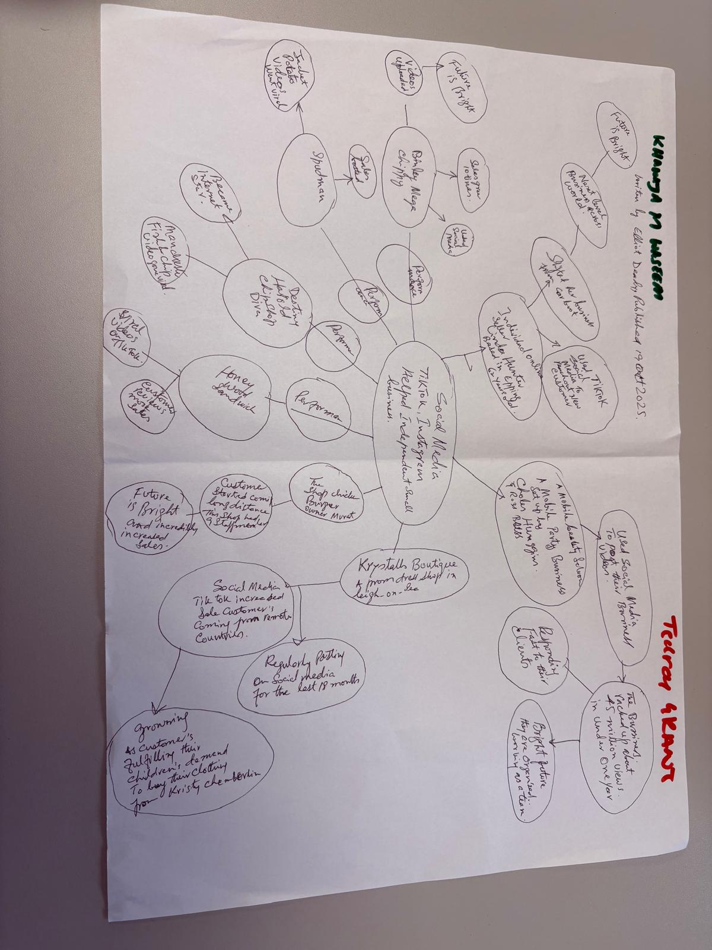

1. Answer these questions using the sentence starters below
a. What is the main idea of the text?
The main idea in the article, is that social media platforms like TikTok and Instagram are making easier for small businesses to get brand awareness, bringing in new customers, even if they never intended to go viral. The article mentions that around 1.5 million UK businesses are already on platforms like TikTok, which gives a scale to how widespread businesses using social media has become.
b. What are two key points?
One key point made in the article, is that it is not always the business posting, that makes them go viral. Murat Honywood Sandwich Shop in Basildon, saw customers travel hours to visit saying "it was a big surprise to me to hear they had travelled for our chicken burger for three hours.” It all started because one of his regulars posted about the shop first, and not Murat himself.
Another key point made in the article, is that businesses who regularly post their own content on social media, like Krystalls Boutique, are able to build up a global social media presence, bringing in customers from around the world. For Krystalls Boutique, this was fans in Cyprus.
c. What part of the text did you find most important? Why?
The most important part of the the article, is the example customers were driving three hours to get a chicken burger from Honywood Sandwich Shop. This highlights how social media can bring in much more business for local businesses, bringing in more customers and money, that would have otherwise been unattainable.
d. Was anything unclear or difficult to understand?
I was not sure about the Jet2 Holiday example at the start of the article, as I did not understand initially, how it connected to the smaller businesses being talked about further on. Once I asked my group to help me understand, it made more sense to see how content can spread to an international audience, without a company expecting it to.
e. How did your group help you understand the text better?
My group helped me by going through the different businesses in the article together, specifically the Jet2 Holiday example, where i overlooked key details. Their help made it easier to understand
3. One sentence reflection
Question: What did you find challenging about this task?
The hardest part for me writing my answers, was narrowing the text down to two key points because the article was filled with so many different businesses and examples. It was difficult to decide which examples were actually the most important to focus on.

