

A critical analysis into the relationship between Adverse Childhood Experiences (ACEs) and the Criminal Justice System.

Olivia Morgan (2124830)
Degree: Policing and Criminology
Word Count: 8333

Declaration
This work has not previously been accepted in substance for any degree and is not being concurrently submitted in candidature for any degree.
Signed: Olivia Morgan
Date: 7th October 2024

STATEMENT 1
This dissertation is being submitted in partial fulfilment of the requirements for the degree of BA.
Signed: Olivia Morgan
Date: 7th October 2024

STATEMENT 2
This dissertation is the result of my own independent work/investigation, except where otherwise stated.
Other sources are acknowledged by footnotes giving explicit references. A bibliography is appended.
Signed: Olivia Morgan
Date: 7th October 2024

STATEMENT 3
I hereby give consent for my dissertation, if accepted, to be available for photocopying and for interlibrary loan, and for the title and summary to be made available to outside organisations.
Signed: Olivia Morgan
Date: 7th October 2024

STATEMENT 4
I hereby give consent for my dissertation, if accepted, to be available on the university’s IT system to those who have consent to use the system.
Signed: Olivia Morgan
Date: 7th October 2024

Acknowledgements
I would firstly like to thank my module tutor, Jane Davies for her patience and support throughout the process of this dissertation. I would also like to thank my Sergeant and my colleagues for their time and patience in supporting me throughout completing this dissertation, both in and out of work.
Finally, I would like to thank my family, my friends, and my partner for the endless amount of kindness and encouragement they have shown me, not just throughout completing this dissertation, but over the last three years of completing my degree. I feel incredibly lucky to have such a supportive network of people around me, and I could not have completed the last three years without them.

Abstract
This study aimed to explore the correlation between adverse childhood experiences (ACEs) and criminal behaviour in individuals. It analysed academic literacy and explored the prevention of ACEs through early intervention and prevention strategies. The research also explored the role of parents and police officers' training in dealing with ACEs, all of which were key themes in the dissertation. The study aimed to understand the impact of ACEs on criminal behaviour and victimisation.
A questionnaire was sent to frontline police officers to understand their views and opinions on ACEs, their knowledge on the topic, and their perception of a direct link between ACEs and the criminal justice system. The research also aimed to assess if officers felt they had sufficient training on the topic and if there was enough help available. The findings supported many of the points analysed in the literature review, as police officers often serve as the first point of contact for criminals.
The completion of each chapter of the dissertation achieved the main aim by answering the research question “A critical analysis into the relationship between Adverse Childhood Experiences (ACEs) and the Criminal Justice System” which has been supported by the existing academic literature, and police officers taking part in the survey.

Table of Contents
Chapter One – Introduction………………………………………………………… 9
1.1 Introduction……………………………………………………………………...9
1.2 Background and Rationale…………………………………………………… 9
1.3 Aims and Objectives………………………………………………………… 12
1.4 Structure……………………………………………………………………… 12
1.5 Conclusion…………………………………………………………………… 13
Chapter Two - Literature Review………………………………………………… 14
2.1 Introduction……………………………………………………………………. 14
2.2 Understanding Adverse Childhood Experiences ………………………… 15
2.3 The Link Between ACEs and Criminal Behavior………………………… 16
2.4 Are ACEs a Generational Issue?.............................................................. 17
2.5 Early Intervention and Prevention ………………………………………… 19
2.6 ACEs and Policing ……………………………………………………………. 21
2.7 Conclusion……………………………………………………………………... 23
Chapter Three – Methodology………………………………………………………24
3.1 Introduction ……………………………………………………………………. 24
3.2 The Research Onion………………………………………………………… 24
3.2.1 Research Philosophy…………………………………………………… 25
3.2.2 Research Approach………………………………………………………26
3.2.3 Research Strategy and Choice………………………………………… 27
3.2.4 Time Horizon…………………………………………………………….. 27
3.2.5 Techniques: Data Collection and Analysis…………………………… 28
3.2.5.1 Data Collection…………………………………………………….. 28
3.2.5.2 Sampling…………………………………………………………… 28
3.2.5.3 Data Analysis……………………………………………………… 28
3.3 Reliability and Validity ……………………………………………………… 28
3.4 Limitations……………………………………………………………………. 29
3.5 Ethical Considerations……………………………………………………… 29
3.6 Conclusion…………………………………………………………………… 30
Chapter Four - Analysis of Results……………………………………………... .31
4.1 Introduction…………………………………………………………………… 31
4.2 Data Analysis…………………………………………………………………. 32
4.3 Demographics and Descriptive Statistics………………………………… 32
4.4 ACE Training………………………………………………………………… 32
4.5 ACEs and the Criminal Justice System……………………………………. 33
4.6 Early Intervention and Prevention………………………………………….. 34
4.7 ACEs in the Working Environment………………………………………… 34
4.8 Personal dealings with ACEs……………………………………………… 35
4.9 Conclusion…………………………………………………………………… .36

Chapter Five - Conclusion and Recommendations…………………………....37
5.1 Introduction………………………………………………………………….…37
5.2 Completion and Achievement of Objectives……………………………… 37
5.3 Main Findings……………………………………………………………….…38
5.4 Recommendations……………………………………………………………38
5.5 Limitations……………………………………………………………………..40
5.6 Future Research …………………………………………………………...…40
5.7 Conclusion …………………………………………………………………..…41
Bibliography……………………………………………………………………...…...43
Appendices………………………………………………………………………..…..50
Appendix A – Research Onion by Saunders…………………………………….50
Appendix B – Copy of Questionnaire………………………………………….....51
Appendix C – Questionnaire Answer………………………………………….…59
Appendix D – Responses to Questions 4, 5, 6, 14, 27 and 29……………..…67
Appendix E – Ethics Form…………………………………………………………76

Chapter 1 - Introduction
1.1 Introduction
The purpose of this dissertation it to conduct research into adverse childhood experiences, and if they have an increased influence of an individual becoming a perpetrator, witness or victim of crime. The dissertation will aim to provide an answer to the research question “A critical analysis into the relationship between Adverse Childhood Experiences (ACEs) and the Criminal Justice System”. This chapter of the dissertation will aim to provide the background and rationale of the research project, along with the aims and objectives for the research will be outlined and explained, with the description and structure.
  - Background and Rationale
Adversity is characterised by negative circumstances, events, or fate. It can also be defined as a state of unhappiness, tragedy, or suffering (Majiba and Majiba, 2020). ACEs are described as being events or circumstances that are extremely stressful and traumatic that take place during childhood and young adulthood. They are a single incident or persistent threats to or violations of the child’s security, safety, trust, or physical integrity. These events have a direct impact on children and their surroundings, necessitating major behavioural, psychological, social, emotional, or neurological adjustments, therefore ACEs have an impact on how children and act, feel, and perceive the outside world (Young Minds, 2018). A person's health, happiness, and prospects in life are all negatively impacted by ACEs over time. The amount to which childhood experiences and events, such as abuse, neglect, and chaotic home environments, are linked to the emergence of a variety of detrimental behaviours, such as drug and alcohol abuse, smoking, sexual behaviour, criminal activity, is becoming increasingly clear from an increase in research. Additionally, they are connected to conditions like mental conditions, cancer, diabetes, cardiovascular disease, and eventually early mortality (Wilkes, 2018).
Research into ACES by Bellis et al (2014) found that nearly half (47%) of English participants taking part in their survey reported have experienced at least one ACE, which shows that ACEs are extremely common in the general population. According to a 2015 survey, 24.9% of Welsh people had a chronic illness, and half of the country's population had at least one ACE. Individuals who had four or more ACEs had four times higher odds of becoming high-risk drinkers, sixteen times higher odds of using heroin or crack cocaine, and fifteen times higher odds of abusing someone else in the previous year. Furthermore, compared to individuals without ACEs, they had a twenty-fold increased chance of going to jail (Welsh Government, 2021). In addition to this, the likelihood of being a victim of violence as an adult is higher for those with numerous ACEs than for those without ACEs (Scottish Government, 2018).
Children who have experienced ACEs are more likely to contact with the criminal justice system as adults, and ACEs are becoming recognised as a significant component in adult health risk behaviours, mental and physical well-being, and social aspects of health (Hodgkinson, 2023). The Crown Prosecution Service (CPS), the police, and the national prison system are all part of the criminal justice system (CJS) in the United Kingdom. It is the group responsible for overseeing the nation's prison system (Clark, 2023). A common goal for the CJS that explains what they are striving for and how each component fits into the bigger picture. These include lowering crime and reoffending rates, punishing offenders, safeguarding the public, compensating victims, fostering public confidence among victims and witnesses, and making sure the legal system is equitable and fair (Ministry of Justice, 2013). Most identified adversities, including ACEs, have an impact on the criminal justice system. Adolescents and children who have had ACEs may become witnesses, perpetrators, or victims when they interact with the criminal justice system. They may also deal with the family court system. Consequently, the justice system is essential to ACE prevention and, in particularly, impact mitigation (The Scottish Government, 2018).
The rationale of the research into this particular research project is due to the researcher being a front-line Police officer, who on a daily basis, has interactions with victims, witnesses, and/or perpetrators of crime, from all different kinds of backgrounds. It is apparent to the researcher, from their own personal dealings with these individuals, that a large proportion have experienced childhood trauma to some extent. It is apparent that existing academic research conducted nationally and internationally, relates to the correlation between adverse childhood experiences (ACES) and the negative effects they have as a result on an individual’s health and education. However, it does not appear as though there is a vast amount of research into the relationship between adverse childhood experiences and those individuals entering the Criminal Justice System, whether as perpetrator of crime, and/or as victims and witnesses. Therefore, the research is worthy of consideration for an undergraduate dissertation as it would be valuable for all front-line Police officers across the UK and key partners/stakeholders to help have a better understanding of what ACES’s is and how they can impact an individual.

  - Aims and Objectives
The aim of this research project is to investigate and critically analyse if there is a relationship between persons who have experienced ACEs and the likelihood of them entering the criminal justice system, wither a perpetrators, witnesses or victims.
- To critically analyse and evaluate existing academic literature and statistics surrounding ACES and criminal justice system, early intervention and prevention, and policing.
- To identify an appropriate primary research method, which is designed to obtain police officers understanding and views of ACES and the persons they have encountered in their role.
- To conduct primary research and analyse the data collected to better understand the views and opinions of police officers towards ACES.
- To provide recommendations for better awareness and understanding on the relationship between ACES and individuals involved in the criminal justice system.
1.4 Structure
To ensure that the above objectives are met, the dissertation will consist of 5 chapters.
The current chapter presents a background of ACEs, which includes the research rationale, the main aim of the research project, and sets out 4 objectives to ensure the aim is achieved. The secondary research will be referenced in the literature review, and the primary research will be in the form on a questionnaire.
The second chapter of the dissertation will analyse previous and current academic literature in a literature review, to understand if there is a relationship between individuals who have experienced adverse childhood experiences, and if they are more likely to enter the criminal justice system. This chapter will also analyse if parents own experiences of ACEs play a role, the early intervention and prevention strategies that are available, and explores the training police officers have had on ACEs.
The third chapter of the dissertation will identify the most appropriate primary research method, detailing a breakdown of the methodology behind the chose primary research method.
The fourth chapter will analyse the results of the data collected as part of the primary research method identified in chapter three, where the findings will be presented, and common themes identified.
Finally, the fifth and final chapter of the dissertation will conclude the research project, achieving the final objective and answering the research question, by presenting the main findings, providing recommendations and exploring the limitations of the research.
  - Conclusion
The first chapter of the dissertation has presented the background of ACEs and the criminal justice system, provided the rational of the research project, identified the main aim and objectives, and has outlined the need for further research to better understand the relationship between the two. The next chapter of the dissertation will analyse the existing academic literature in the form of a literature review.
Chapter 2 – Literature Review
2.1 Introduction
This chapter will seek to review current academic literature, which will assist in understanding the link between individuals who have ACEs, and how individuals are more likely to enter the criminal justice system, as victims, witnesses and/or perpetrators of crime, in comparison to individuals who have not experienced ACEs.
It is apparent that current academic literature is widely based on the health and educational impacts, and not so much the link to the criminal justice system, therefore the research will identify a need for further research into the criminal justice side of ACEs and the links between them. The literature will also consider the role of parents, along with the importance and effectiveness of early intervention and prevention and the need for ACE training amongst police officers.
This chapter will aim to complete the first objective of the dissertation:
To critically analyse and evaluate existing academic literature and statistics surrounding ACES and criminal justice system, early intervention and prevention, and policing.
The sources that will be used will range from general research into the topic of ACEs, using information available in the public domain, using Google Scholar, which will allow the researcher to access to academic journals, textbooks, publications surrounding ACEs. Additionally, the researcher will be utilising the University of Wales Trinity library, which can be accessed online.
The terms that are used to obtain this information on this topic will be ‘adverse childhood experiences’, ‘ACEs’, ‘ACEs link to criminality’ and ‘criminal justice system’.
2.2 Understanding Adverse Childhood Experiences
In the late 1990s, the CDC-Kaiser Permanente ACEs Study discovered the initial set of ACEs. The study found that early exposure to these ACEs is linked to a higher likelihood of lifelong negative health consequences and an unhealthy response to stress in children. ACEs can have a negative influence on long term health and possibilities (Felitti et al, 1998). The consequences of ACEs can accumulate over time and are fairly common. A study into ACES in adults revealed that 16% had four or more forms of ACEs, while 61% had a minimum of one ACE. Higher risk of four or more ACEs was associated with females and numerous racial/ethnic minority groups. The fact that ACE exposure raises one's lifetime chance of developing health issues is something that many individuals are unaware of (CDC, 2019).
There are five direct ACEs among the 10 adverse childhood events, which include emotional, physical, sexual abuse, and physical and emotional neglect, which the parents or caregiver and responsible for. There are also five indirect ACEs, which include parent/caregiver with an alcohol or drug addiction, witnessing domestic abuse, a family member serving a prison sentence, mentally unwell family member and divorced parents or caregivers, or abandonment (Wilkes, 2018). A child endures trauma every time they encounter any adverse event, there an individual's likelihood of ACEs, such as addiction to drugs and mental disorders, increases with the amount of trauma they endured before the age of 18 (Pugle, 2022).
In the UK healthcare system, ACE history is not usually demanded. Opportunities are therefore neglected to stop and reverse the harmful impacts of ACEs (Scott, 2020). ACEs are not the fault of the individual or the child; rather, they are frequently influenced by a combination of relational, community, and social variables. The chance of having an ACE increase with risk factors and decreases with preventive variables. These factors can be either indirect or direct, and no single factor is to blame (CDC, 2024).
2.3 The Link Between ACEs and Criminal Behaviour
Research conducted by the University of Edinburgh concluded that childhood trauma increases the likelihood of criminality in adulthood. Adults who faced significant challenges as children were more likely to commit crimes as adults. Factors such as poverty, mistreatment, exclusion from school, and contact with the police were found to be significant during childhood. The study analysed over 4300 individuals aged 12 to 35, finding that 25% had been convicted of a crime by age 35. Although most people stopped committing crimes in their teens, some continued to commit crimes into their early middle years due to factors such as drug use, recurrent crime, and impulsive disposition. Since 1998, researchers have been monitoring young people's criminal behaviour, revealing that interactions with the criminal court system may not always prevent crime, and some individuals may continue to commit crimes into adulthood (University of Edinburgh, 2022).
However, a report published by The Scottish Government (2018) argues that not everyone who had a difficult or distressing upbringing goes on to commit crimes or become victims of them. It is important to understand why some children succeed despite having had negative childhood events. In order to help more children achieve their full potential and lessen crime and victimisation, policy and practice can be informed by identifying which buffers, or "protective factors," may mitigate the impacts caused by childhood adversity and trauma.
The research conducted by the University of Edinburgh is supported by a separate research project, conducted by Public Health Wales in 2015. The survey revealed that 46.5% of respondents had been exposed to at least one ACE before becoming 18 years old, with 13.6% having been exposed to four or more ACEs. Confounding factors such as age, ethnicity, sex, and deprivation contributed to higher violence rates. If no ACEs were present, the prevalence of victimisation could be 56.9% lower, resulting in approximately 97,000 fewer victims. The prevalence of violence perpetration was significantly higher in adults exposed to ACEs, with 33% having 14.6 times higher odds of perpetrating violence. If no ACEs were present, the prevalence of violence could be 59.5% lower, resulting in approximately 90,253 fewer individuals committing violence in Wales. Additionally, convicted offender rates were significantly different among Welsh adults, with those exposed to four or more ACEs having a higher risk of incarceration (Public Health Wales, 2016).
2.4 Are ACEs a Generational Issue?
Attachment refers to the early emotional connections formed with parents or caretakers, which significantly impact growth and future relationships. Healthy attachments lead to good emotions, while negative ones can negatively impact self-esteem, emotional control, and future relationships. Attachment disorders, resulting from poor early relationships, can lead to relationship problems and mental health issues (NHS, 2021). Individuals which have been exposed ACEs in childhood frequently find themselves raising their own children in an environment where ACEs are more prevalent. Aversity in childhood can trap families into a cycle of ill health and antisocial behaviour that can last for generations. However, ACEs may assist future generations in Wales if they are prevented in a single generation and their effects are minimised (Public Health Wales, 2015). These children who have been brought up in abusive, violent, and assaultive households, where this pattern of behaviour is accepted as normal, are more likely to adopt similar features themselves. As adults, they carry a greater risk of engaging in violent activity themselves, as well and being victims of it (Public Heath Wales, 2015).
A study in the UK found that detrimental effects of ACEs on an individual can be mitigated if a trusted adult was present during childhood. It was found that those without a trusted adult present in their lives were more likely to engage in unhealthy habits like smoking and eating poorly, even when there was a history of no ACEs, which emphasis how the importance of having a trusted adult to help mitigate adversities like economic hardship and other ACEs (Webster, 2022). A separate study into parents who have their own experiences of ACEs and their children behavioural health problems concluded that in comparison to children of parents without any ACEs, children with parents of four or more ACEs, had, on average had higher odds of hyperactivity and emotional disturbance diagnosis. Compared to paternal ACEs, maternal ACES displayed a larger correlation with behavioural issues in children (Schickedanz et all, 2018).
However, it is not always the case that every child who has a parent with ACEs, go on to have children that lead a troubled life. Research and policy literature on ACEs primarily focus on the risks and impacts, with little attention given to protective factors and interventions. The ACEs pathway is intuitive, but narratives often portray those children with multiple ACEs, leading to maltreatment and poor health, then neglect their own children, leading to deficit-based view of ACEs (Bullok, 2019).
2.5 Early Intervention and Prevention
ACE prevention can promote healthy development in both children and adults, as well as potentially reduce adult risk of depression, cancer, diabetes and asthma. ACE prevention can also help boost prospects for employment and education, help people cut back on dangerous habits like smoking and binge drinking and can potentially prevent the transmission of ACEs from one generation of people to the next (CDC, 2021). Early intervention is a strategy that helps children and young people at risk of negative consequences by building their strengths and skills. It aims to prevent problems from arising or address them head-on, preparing them for adulthood. Strategies can include mentoring programs, school-based initiatives, and home visitation programs. Research shows that successful interventions can enhance children's prospects at any stage of their early life, despite some claims that it may have the greatest benefit in the first few years (Early Intervention Foundation, 2023).

ACEs can be prevented through primary strategies like mental health awareness, parenting courses, substance abuse assistance, safeguarding measures, and contextual safeguarding. Secondary strategies boost emotional wellness and resilience in high-risk households, while tertiary prevention focuses on treating trauma's effects on adult mental health, ending the cycle, stopping new symptoms, and enhancing adult parenting skills to prevent transmission through generations and behaviours (Bullok, 2019).
The National Centre for Injury Prevention and Control has developed an Adverse Childhood Experiences Prevention Strategy, focusing on preventing, detecting, and treating ACEs, overdose, suicide, and other violent crime. The strategy aims to reduce the long-term risk of suicide and overdose and prevent the intergenerational transfer of ACEs. The report emphasises the need to address structural and societal injustices that increase children's vulnerability to ACEs and worsen their effects. The Centre's four strategic goals include encouraging ACE monitoring, data innovation, creative research, education on public health approaches, and developing capacity for ACE prevention and response (National Center for Injury Prevention and Control, 2020). The CDC has created Prevention Resources for Action to prevent and lessen the negative effects of adversity and abuse (ACEs) on children. These resources are divided into strategy, approach, and evidence sections, each focusing on achieving significant decreases in risk variables and outcomes. Strategies include enhancing family financial support, encouraging social norms, helping children start their lives, teaching coping mechanisms, emotional regulation, and handling challenges, introducing young people to activities and compassionate adults, and intervening to reduce short and long-term damages (National Center for Injury Prevention and Control, 2019).
Lorenc et al (2020) conducted a systematic review of 25 reviews found that cognitive behavioural treatment is the most effective in treating abuse-related mental health issues, with a focus on psychological therapies. Inconclusive results were found for other interventions like parent education and psychiatric counselling. There are significant research gaps in ACE therapies, as they focus on psychological disorders rather than social pathways mediating negative outcomes. Children and young people who have had ACEs or attachment problems can receive support from CAMHS. They carry out evaluations to comprehend the effects of ACEs and set up suitable assistance. In order to give healthier care and therapy, such as Cognitive Behavioural Therapy (CBT) or Eye Movement Desensitisation and Reprocessing Therapy (EMDR), CAMHS may collaborate with parents or carers. Furthermore, the young person may require further help to deal with challenges or develop a rapport with the CAMHS specialist. It is the obligation of parents and other caretakers to protect
However, even though ACEs occur together, most of the treatments appear to target particular adversities, such as neglect, abuse, violence in the home, and alcohol and drug abuse. Interventions designed to avoid and tackle divorce between parents and imprisonment were found to have insufficient evidence (Di Lemma, 2019). The Welsh Government was urged to prevent ACEs by Cymru Well Wales (CWW) and other organisations.They called for a decrease in the frequency of ACEs in Wales, the provision of ACE-informed public services, and the development of ACE-resilience among the populace. An ACE Support Hub for Wales was also requested. Though early evidence suggests it can make a significant difference, increasing awareness of ACEs is only the first step (Welsh Government, 2021).
2.6 ACEs and Policing
UK policing demand has increased due to welfare, public safety, and vulnerability issues. South Wales Police conducted a study to support vulnerable people in crisis situations. The ACE-Informed Approach to Policing Vulnerability Training (AIAPVT) was created to improve police expertise and confidence in responding to vulnerability. The training was mandatory in a pilot region in 2017, and staff reported higher understanding of ACEs and improved confidence (Ford et al, 2019). Following on from the research conducted by Public Health Wales in 2015, the ‘Adverse Childhood Experiences: Breaking the Cycle of Crime’ project has been launched as part of the Police Innovation Fund (PIF). The PIF projects seeks to identify and mitigate vulnerabilities in Wales’s public services through a common agenda. Three main goals were established as part of the project, and many police forces are eager to put this strategy into practice (McManus et al, 2018)
The project primary objective was aimed to understand current procedures for handling ACE-related problems, identify potential for systemic change, and enhance police-partner cooperation. It also defined susceptibility and increased knowledge of ACE prevalence in the offender community. The second objective was to intervene earlier, design and evaluate ACE-informed systems, and create a decision support tool for police. The third objective was to work with other agencies, particularly in the housing and education sectors, to address the root cause of ACEs, creating a school training model, finding practice opportunities, and exchanging expertise (McManus et al, 2018). The ACE TIME training in Wales has improved police officers' understanding of ACEs, their impact on behaviour and life outcomes, and the intergenerational cycle. However, challenges remain, such as policing culture and public participation. Improvements include thorough reactions to vulnerability, referral forms, and assistance provider suggestions. Further research is needed to determine the training's future effectiveness, but it can lead to lasting improvements in police practice (Janssen, 2020).
Persons involved in the criminal justice system, including children, youths and adults, frequently experience greater levels of childhood hardship. Enhancing cooperation and trust, making support more accessible, and helping professionals comprehend how ACEs and trauma affect behaviour, communication, and decision-making are all made possible by a trauma-informed system (Bullok, 2019).
2.7 Conclusion
This chapter has now achieved the first objective: To critically analyse and evaluate existing academic literature and statistics surrounding ACES and criminal justice system, early intervention and prevention, and policing.
To conclude this chapter of the dissertation, the literature review has evidenced that research indicates that having experiences ACEs in childhood, the likelihood of becoming a victim, witness and/or perpetrator of crime, and therefore entering the criminal justice system, is higher. However, research also indicates that this is not always the case, and that early intervention and prevention play a crucial part in rehabilitating a young person with experience of ACEs, to give them a chance at living a normal life. The literature review also evidenced how ACES play a part in everyday policing, and how ACE training can be effective in helping police officers and staff understand the needs of the people they deal with daily in their role.
The literature review highlighted a requirement for further research into each individual ACES, and how effective early intervention and prevention is, along with the importance of continued ACE training amongst police officers and relevant organisations.
The next chapter of the dissertation will identify the methodology, and an appropriate primary research method to address the issues raised in the literature review.

Chapter 3 - Methodology
3.1 Introduction
In the previous chapter of my dissertation, I analysed the existing literature regarding adverse childhood experiences and police contact, which achieved the first objective. I will now look to answer the second objective of my dissertation: To identify an appropriate primary research method, which is designed to obtain police officers understanding and views of ACES when encountering members of the public in their role.
According to Collis and Hussey (2021), research is defined as an organised, intentional process with an object of developing knowledge into a particular subject. Gratton & Jones (2010) further explains how there are two different forms of research primary and secondary, with primary research using methods such as interviews and questionnaires to gather information relating to a particular project. However secondary research makes use of existing sources and does not gather original material. The second chapter of the dissertation used secondary research as part of the literature review, which establishes and assess data gathered from earlier studies (Gratton & Jones, 2010). This chapter will primarily focus on how the primary research will be conducted.
3.2 The Research Onion
The method of primary research will be conducted using Saunders et al (2019) research technique ‘The Research Onion’, see Figure 3.2 below. The diagram illustrates the choices that underpin the selection of data gathering methods and analysis processes; the research onion places the data collection process at the core of the model (Saunders et al, 2019).
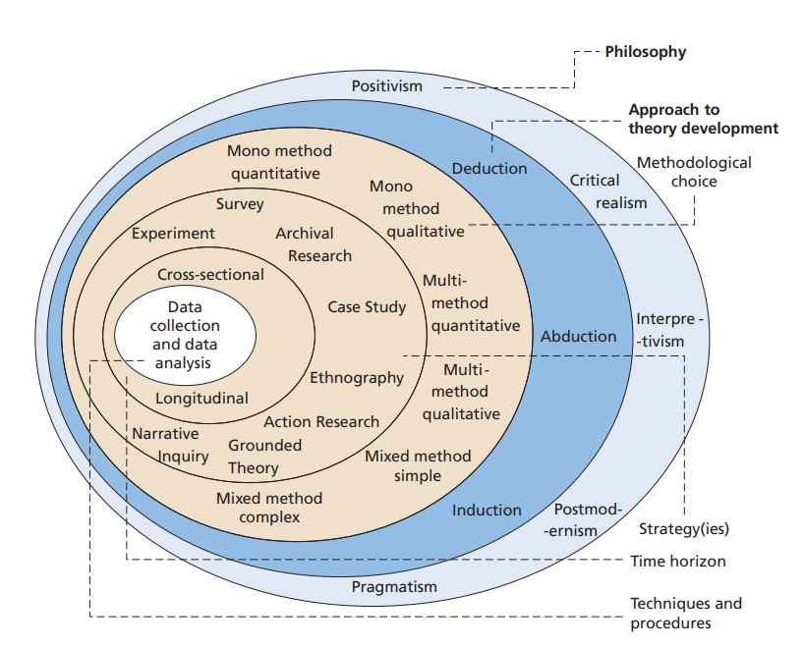
Figure 3.2 - The Research Onion (Saunders et al, 2019), which highlights the research process for the dissertation.
3.2.1 Research Philosophy
The outer layer of the ‘Research Onion’ by Saunders et al (2019) refers to research philosophy, which is a system of beliefs and assumptions about the development of knowledge (Saunders et al, 2019).
Interpretivism is a paradigm that emerged in response to criticisms of positivism. It rests on the assumption that social reality is in our minds and is multiple and subjective. Therefore, social reality is affected by the act of investigating it. The research involves an inductive process with a view to providing interpretive understanding of social phenomena within a particular context (Collis and Hussey, 2021).
Positivism is a paradigm that originated in the natural sciences. It rests on the assumption that social reality is singular and objective and is not affected by the act of investigating it. The research involves a deductive process with a view to providing explanatory theories to understand social phenomena (Collis and Hussey, 2021).
3.2.2 Research Approach
The next layer of the ‘Research Onion’ by Saunders et al (2019) refers to the research approach. There are two approaches to conducting research, deductive and inductive. The deductive approach is applied in research, when a hypothesis is generated from reading existing literature, as the basis of the study and a research plan is developed to evaluate the idea. On the other hand, an inductive method is taken when a hypothesis is developed or formed after data has been collected to investigate an event (Saunders et al, 2019).
An inductive research approach will be adapted for the research project, the differences explained by Saunders et al (2019) are show in Figure 3.1.2 by Bryman (2016), as the researcher has an observation from existing research, and a theory has been developed.

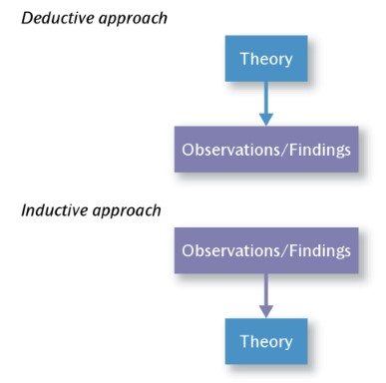
Figure 3.1.2 - Deductive and Inductive Approaches to the Relationship Between Theory and Research (Bryman, 2016)
3.2.3 Research Strategy and Choice
The strategy for the research project is the next layer of the ‘Research Onion’ by Saunders et al (2019), and I will be using a mixed method approach, which is a term used when quantitative and qualitive research methods are merged (Bryman, 2016).
A questionnaire will be created through office forms and will be distributed via a works email to police officers of all ranks in the organisation, to collect a range of anonymous answers from front line police officers, with the identity of officers being anonymous. Analysing responses from police officers who will all have received the same training in relation to ACEs will help gauge understanding and the need for further training, if required.
A questionnaire is a type of research study, that collects data from people or individuals using standardised questions. It allows for the collection of quantitative or qualitative answers regarding a particular topic (Hassan, 2024). Qualitative answers will be included by having opportunities for open questions, for respondents to add their own thoughts.
3.2.4 Time Horizon
The final layer of the ‘Research Onion’ relates to ‘Time Horizon’, which Saunders et al (2019) explains is the analysis of a certain subject over a period of time.
The time horizon most appropriate for the research project is “Cross-sectional”, which relates to observing data from previous research, where the assessor simultaneously assesses the exposures and outcome of the individuals taking part in the study (Setia, 2016).

3.2.5 Techniques: Data Collection and Analysis
3.2.5.1 Data Collection
The time to complete this project is limited, and due to also working full time in my role as a police officer, the collection of data will take place in the form of questionnaires, which will be emailed to participants who are colleagues via a works email account. A blank copy of the questionnaire can be found in Appendix B.
3.2.5.2 Sampling
The sample target will be relatively small due to the time constraints, and will consist of response and neighbourhood policing officers, as they are frontline and are most likely to be the first point of contact. I believe they will be the most suitable participants as they will be able to provide an insight into dealing with a range of individuals who have experienced ACEs, from all different backgrounds. I will aim to receive around 50 – 70 responses.
3.2.5.3 Data Analysis
The use of questionnaires will be a form of primary research, and the responses from participants will be analysed, and converted into percentages. The findings will then be presented in the form of a graph for the result of the research project. The results can be found in Appendix C.
3.3 Reliability and Validity
The reliability of data collected in a research project is defined as the measurements accuracy and preciseness, alongside the inadequacy of variation in the results of a repeat study. As such, it is one component of the finding’s credibility. The second component is validity, which refers to the degree to which a test captures the core of the study and yields findings that the researcher is hoping to obtain (Collis and Hussey, 2022).
The reliability and validity of the research project will be maintained as the participants will be police officers, who have all been front line and have dealt with similar individuals, and therefore had similar training and experiences of dealing with ACE’s.
3.4 Limitations
There is a limited time to complete the research project, therefore the primary research in the form of a questionnaires will only be assessable for several weeks, and time will also be needed to analyse the data collected, therefore achieving the desired number of responses will be difficult.
Another limitation is that the vast majority of front-line police officers are young in service, therefore I anticipate the views and opinions of more experienced officers will be a minority.
The findings are also from one police force only, with a select number of officers participating, therefore the findings may to reflect other police forces.
3.5 Ethical Considerations
Ethical considerations are important and must be taken into consideration with this research study, as the topic could be deemed as sensitive, and potentially triggering for participants who have had their own personal experiences with the subject. Participants will therefore be briefed with the purpose of the study, prior to participating, and prior to any primary data has been collected. Participation in the study will be voluntary, and participants will have the right to withdraw at any point. The identity of the participants will also be kept anonymous, so that their identity is protected. There will also be guidance to access support services at the end of the questionnaire for participants who have been affected by any of the questions.
3.6 Conclusion
This chapter has successfully achieved the second objective, as set out in the introduction of this chapter. This chapter has recognised the most suitable research methodology and has explained the key components of the research project.
The next chapter of the research project will aim to answer the third objective, where the findings of the data collected will be analysed and presented.

Chapter 4 - Data Analysis
4.1 Introduction
The previous chapter of the dissertation achieved objective two, by identifying the methodology of the research project. In this chapter, the third objective “To conduct primary research and analyse the data collected to better understand the views and opinions of police officers towards ACES” will be achieved, by analysing the findings of the primary research, which was in the form of an online questionnaire. A total of 50 responses were received, collecting the views of front-line police officers and their understanding of adverse childhood experiences, both in the working environment, and personally, and the responses to certain questions will be highlighted throughout the chapter.
4.2 Data Analysis
Data analysis refers to the use of statistical methods to convert unprocessed data into interpretable information that affects the reliability and validity of conclusions. It involves gathering, organising, analysing, and interpreting data using both quantitative and qualitative techniques (Gardiner, 2024). The collection and analyses of the primary data was completed using Microsoft forms, which allowed for a quicker response, which was most suitable due to time constraints for the research project. The questionnaire was spilt into five sub sections, which were “demographic information”, “ACE training”, “ACES and the Criminal Justice System”, “ACES in the working environment” and “personal dealings with ACES”. The key findings of these sections will be detailed below.

4.3 Demographics and Descriptive Statistics
The demographic information of the 50 participants included their gender, age and length of service, and was sent to participants work email addresses, to ensure responses from front line police officers only. The data collected included responses from 35 males, and 25 females. Previous research has shown that females are more likely to participate in questionnaire over males (Smith, 2008). However, on this occasion, there were more male respondents (28), in comparison to females (22), which the researcher expected due to the current imbalance of female officers, in comparison to males. The vast majority of respondents (88%) selected the 1-5 years length of service category, which the research thought was interesting, highlighting that response officers don’t have a large amount of service. All 50 participants answered “yes” to consenting to their answers being used in the research project.
4.4 ACE Training
For this section, officers were asked about their knowledge of ACES, and if they felt like they had sufficient training on the topic. All 50 respondents agreed that police officers should be trained on ACES, however, out of this 50, only 8% said selected that they thought they were satisfied they had received adequate training, with and overwhelming 92% of respondents selecting “no”. This would argue the earlier point made in chapter 2, by Ford et al (2019), regarding AIAVP and police officers reporting improved understanding and confidence on ACEs. The findings in this section also found that 58% of respondents selected that they last had ACE training 2 – 3 years ago, with 2 5 selecting that they had never had training. This would suggest that although officers have had ACE training, the training might not be frequent enough.
4.5 ACES and the Criminal Justice System
This section asked respondents if they thought there was a direct link between ACEs and the criminal justice system, which is what the research project aims to find out. Most respondents, 92% selected yes, while 8 % selected maybe. No one participant selected that they didn’t believe there was a link. This would coincide with research conducted by University of Edinburgh, as highlighted in chapter 2 of the research project, when stating that childhood trauma increases the likely hood of criminality in adulthood. One participant stated that they believed this was due to “Social isolation, repeating learned behaviour from their parents or others, lack of opportunity, trauma leading to mental health issues which make them more vulnerable to exploitation”. When asked what the most common ACEs were, 39 participants selected substance abuse, and 37 participants selected “physical abuse”. Participants could select multiple answers for this question; however, these were the most popular answers, with the least popular being having divorced parents, with 5 participants selecting this answer, and a family member is prison, with 6 participants selecting this answer.
When analysing the data, 76% of respondents believed that the most likely person with ACEs would enter the criminal justice system were all the above, which included perpetrators, victims and witnesses. 20% of participants selected that a victim was most likely, and 22% selected perpetrator. Not one participant selected “witness” as a stand-alone answer. The results of the survey correspond research highlighted in chapter 2 of the research project and support the consensus that persons with ACEs are more likely to become a victims or perpetrator of crime, as stated by Public Health Wales (2015).

4.6 Early Intervention and Prevention
When analysing the 50 responses, 92% of participants concluded that they thought early intervention and prevention on was effective, with 8% selected that they thought it may be effective. Not one participant though that early intervention and prevention was no effective when dealing with ACEs. The results of the survey support and coincide with the research conducted in the literature review, as highlighted by the CDC (2021) that it can have both physical and mental benefits. When asked if participants though that that there was enough support available, 60% concluded that they though there wasn’t enough support, and 34% concluded there might be enough support. Only 6% concluded that there were enough support available, which questions if the early intervention and prevention strategies which have been discussed in the literature review, are accessible enough. Participants were also asked when they thought these strategies were most beneficial, with 82% of participants concluding that they thought they were most beneficial in the early stages of life, 18% concluding teenage years, and not one participant selecting in adulthood. However, as highlighted in the literature review by the Early Intervention Foundation (2023), these interventions are beneficial in any stage of life, not just in the early years. 82% of participants also concluded that these strategies were targeted towards more popular ACES, with 18% concluded that maybe this was the case. Not one participant concluded that they thought they weren’t. These findings correspond with the research conducted in the literature review.
4.7 ACES in the Working Environment
When analysing the data, 100% of respondents said that they had dealt with persons with ACEs, in their role as a police officer, either as victims, witnesses, or perpetrators of crime, and not one participant concluded that they haven’t. 58% of respondents concluded that they dealt with persons with ACEs in their role as a police officer on a weekly basis, 40% said on a daily basis, and 2% concluded a monthly basis. Similarly to the previous question, not one respondent said that had never dealt with persons with ACEs. This supports the research conducted during the literature review by The Scottish Government (2018) and Public Health Wales (2016) and corresponds that individuals with ACEs are likely to enter the criminal justice system, whether as a victim, witness or perpetrator, which increases police contact. 54% of the 50 respondents concluded that they believed males with ACEs were more likely to enter the criminal justice system, in comparison to 6% of respondents who selected females, and 20% selecting neither. These findings coincide with research by Almuneef et al (2017) which states “Men were significantly more likely than women to have experienced four or more ACEs”.
4.8 Personal dealings with ACES
When analysing the data, 22% of respondents selected that they themselves had personal dealing with ACEs. This question was included in the survey as the researcher was interested to see how many respondents have overcome their struggles in childhood, to then become professional individuals, for example, a police officer. The result of this question is not accurate however, as 14% selected that they would prefer not to say, therefore their answer is unknown, and the vast majority, 64% selected that they did not have no personally experienced ACEs. Respondents who selected yes also had the opportunity to share how ACEs affected their day-to-day life. 1 respondent filled in this open question, stating that they “relive trauma of abuse regularly, cognitive development impaired due to disruption and unbalance as a result of parent’s divorce”. 72% of respondents concluded that they had family and friends who have experiences with ACES, with 10% selecting they did not have any family or friends with ACES, and 18% selected that they would prefer not to say. This support research highlighted in the literature review by Public Health Wales (2015), stating that 46.5% of people had been exposed to at least one ACE.
4.9 Conclusion
This chapter has achieved the third objective “to analyse the data collected from my primary research, to understand the views of police officers who have encountered individuals with ACEs, and to gauge their general understanding of ACEs”.
To conclude this chapter, the primary research, which was completed in the form of a questionnaire, identified that police officers strongly believe that there is a correlation between ACEs, and persons entering the criminal justice system, which has been ascertained by their own personal dealings with these individuals in the working environment. This chapter has analysed the data and has gathered the perspective of police officers regarding the research question. The final chapter will conclude the dissertation and will achieve the last research objective of providing recommendations for better awareness and understanding on the relationship between ACES and individuals involved in the criminal justice system.

Chapter 5 – Conclusions and Recommendations
5.1 Introduction
In the previous chapters of this dissertation, the research study has been guided through several phases, including the introduction to the project, existing literature research, panning and the analysis of the results. In the previous chapter, the findings from the data collected from the primary research, in the form of a questionnaire, was analysed. The previous chapters have achieved the objectives set out in the introduction chapter of this dissertation, and this chapter will aim to achieve the final objective:
This chapter will also give a conclusion to the research title “A critical analysis into the relationship between Adverse Childhood Experiences (ACEs) and the Criminal Justice System”, along with addressing any limitations that have been highlighted, but also recommendations for future research into the research topic, which completes the final objective.
5.2 Completion and Achievement of Objectives
- To critically analyse and evaluate existing academic literature and statistics surrounding ACES and criminal justice system, early intervention and prevention, and policing.
- To identify an appropriate primary research method, which is designed to obtain police officers understanding and views of ACES and the persons they have encountered in their role.
- To conduct primary research and analyse the data collected to better understand the views and opinions of police officers towards ACES.
- To provide recommendations for better awareness and understanding on the relationship between ACES and individuals involved in the criminal justice system.
5.3 Main Findings
In each section of the dissertation, key findings have been identified, and mostly support the research analysed in the literature review section of the dissertation. The main finding is that children who have experienced some form of abuse, neglect or household dysfunction in their childhood, are often without a trusting adult in their life, and therefore lack the necessary support system, which as a result they turn to a life of committing crime or being a victim of crime due to their vulnerabilities. However, the primary research has shown that this is not always the case, with several police officers participating in the research project also stating that they have experienced ACEs, which shows that persons with ACEs can go on to live a normal life. Another finding is that early intervention and prevention strategies are crucial and can help mitigate the long terms effects of ACEs on an induvial, however the primary researched highlighted a need for more support. Lastly, there is a requirement for police officers to have further training on ACEs, which challenges the research conducted in the literature review regarding ACE training.
5.4 Recommendations
The first recommendation that the research project has highlighted is that although there are a range of early intervention and prevention strategies, it is evident that there is not enough accessible help available, as statistics have shown that the number of people with ACEs entering the criminal justice system is considerably more than persons who don’t have any. The primary research conducted during this research project also found that police officers believe that there is not enough support available, which they have likely concluded as being a contributing reason as to why they encounter a large volume of persons who have experiences of ACEs. Further to this, research also needs to be conducted into how effectiveness and usefulness these early intervention and prevention strategies are at rehabilitating young persons, and if they are successful in preventing persons from entering the criminal justice system, as there is a lack of supporting evidence from academics and experts in this field.
The second recommendation would be to increase police officers’ awareness of ACEs, as the primary research found that although police officer understand what ACEs are, a significant number of participants felt like they needed more training on ACEs. This has the potential to further raise awareness on ACEs, helping officers identify when an individual has ACEs, allowing them to provide them with the appropriate level of care and support. In addition to this, more frequence training would also help officers better understand ACEs and would help officers understand the reasons why a person may become involved in crime, or why a person can be more vulnerable, making them more likely to become a victim of crime.
The final recommendation is for further research to be conducted into each individual ACE. The research conducted by academic and experts in the literature review suggest that the more well know, popular ACEs have the most support available to them, while the lesser known, less popular ACEs are forgotten about, and don’t have strategies in place to help these individuals. The research conducted during the primary research also found that participants believed that that the early intervention and prevention strategies were targeted more towards the more popular ACEs, therefore there is a risk that persons who have experienced the less popular ACEs, are slipping through the cracks, and are not getting the support they need to have the best chance and being rehabilitated before they enter a life of criminality and vulnerability. By adapting new strategies to deal with every type of ACE, the overall number of persons entering the criminal justice system, whether as perpetrators, witnesses or victims of crime, will likely reduce.
5.5 Limitations
There are several limitations which have been identified during the research project. The main limitations which presented as part of the research project was time constraints to complete the primary research, therefore the date source is limited due to the sample size being relatively small and lacking diversity, with the sample consisting of police officers from a standalone force only. There were several potential avenues the research project could have undertaken, which would have gained a wider range of results, however the time constraints prevented this.
Another limitation of the research project was he sensitivity of the topic itself. It is clear from the results that many participants did not feel comfortable disclosing if they had their own personal experiences with ACEs, even with the guaranteed anonymity of the participation. Therefore, the results of the primary research lacks accuracy regrading this section of the questionnaire. The research would have benefited from a true reflection on the number of police officers who have their own experiences of ACEs, and how they affect their day-to-day life, if at all, to compare against the findings from the literature review.
5.6 Future Research
As highlighted in the limitations part of his chapter, the time constrains to complete this dissertation resulted in a relatively small sample size that focused solely on the views and opinions of police officers. The findings of a larger study, with participants varying across partnerships who deal with individuals who have experienced ACEs such as social services, early intervention workers and the criminal justice system workers, would potentially provide a more accurate insight into the topic.
It would also be interesting to conduct research into if ACEs are more common in males or females, with the results of the primary research suggesting males are more common. This however could be stereotyping, and research into this topic which could include interviewing the general public, on a larger scale, would help provide a more accurate answer this question.
5.7 Conclusion
To conclude the research project, the aims and objective set out in the introduction chapter have been achieved, and the research question “A critical analysis into the relationship between Adverse Childhood Experiences (ACEs) and the Criminal Justice System” has been answered.
The dissertation has discussed key findings throughout, which have included the general topic of ACEs and the criminal justice system, early intervention and prevention, generational issues and dealing with ACEs in policing.
The main purpose of the research project has been to identify if there is a relationship between ACEs and the criminal justice system, and why this might be the case. This question has been addressed throughout the dissertation, including the introduction, literature review, methodology, and the findings of the primary research, with gaps for further research being identified, and a number of recommendations being presented as a result.
To conclude, this research project has highlighted how ACEs can have a detrimental impact on young persons, and how it can easily influence those persons to be involved in criminality, whether that is being the perpetrator, or the victim due to their vulnerabilities. There is opportunity for further research to be conducted regarding the topic of ACEs, to raise more awareness and better understand the issue.

Bibliography
- Almuneef, M., ElChoueiry, N., Saleheen, H.N. and Al-Eissa, M. (2017). Gender-based disparities in the impact of adverse childhood experiences on adult health: findings from a national study in the Kingdom of Saudi Arabia. International Journal for Equity in Health, [online] 16(1). doi:https://doi.org/10.1186/s12939-017-0588-9.
- Bellis, M.A., Hughes, K., Leckenby, N., Perkins, C. and Lowey, H. (2014). National Household Survey of Adverse Childhood Experiences and Their Relationship with Resilience to health-harming Behaviors in England. BMC Medicine, [online] 12(1). doi:https://doi.org/10.1186/1741-7015-12-72.
- Bryman, A. (2016) Social Research Methods. Oxford: Oxford University Press. Available at: https://books.google.co.uk/books?hl=en&lr=&id=N2zQCgAAQBAJ&oi=fnd&pg=PP1&dq=%E2%80%A2%09Bryman,+A.+(2016).+Social+Research+Methods.+5th+ed.+Oxford:+Oxford+University+Press.&ots=dqJzFWP8ve&sig=sM6dVOrTMkhKsS7AD2ckOxN7v_Q#v=onepage&q&f=false (Accessed: 15 June 2024).
- Bullok, M. (2019). Adverse Childhood Experiences in London Investigating ways that Adverse Childhood Experiences and related concepts of vulnerability can help us to understand and improve Londoners’ health. [online] Available at: https://www.london.gov.uk/sites/default/files/adverse_childhood_experiences_in_london._final_report_october_2019_with_author._mb.pdf#:~:text=Investigating%20ways%20that%20Adverse%20Childhood%20Experiences [Accessed 16 Jun. 2024].

- CDC (2019). Adverse Childhood Experiences (ACEs). [online] Available at: https://www.cdc.gov/vitalsigns/aces/pdf/vs-1105-aces-H.pdf [Accessed 4 Oct. 2024].
- CDC (2024). Risk and Protective Factors. [online] Adverse Childhood Experiences (ACEs). Available at: https://www.cdc.gov/aces/risk-factors/?CDC_AAref_Val=https://www.cdc.gov/violenceprevention/aces/riskprotectivefactors.html [Accessed 4 Oct. 2024].
- Centers for Disease Control and Prevention (2021). Adverse childhood experiences (ACEs). [online] Centers for Disease Control and Prevention. Available at: https://www.cdc.gov/vitalsigns/aces/index.html [Accessed 4 Oct. 2024].
- Clark, D. (2023). Topic: Criminal justice system in the UK. [online] Statista. Available at: https://www.statista.com/topics/6150/criminal-justice-system-in-the-uk/#topicOverview [Accessed Mar. 2024].
- Collis, J. and Hussey, R. (2022) Business research: A practical guide for students. London: Bloomsbury Academic. Available at: https://books.google.co.uk/books?hl=en&lr=&id=NnhkEAAAQBAJ&oi=fnd&pg=PT13&dq=%E2%80%A2+Collis,+J.+%26+Hussey,+R.+(2014).&ots=Qc34-D0fNv&sig=--LBfYJHMzPcas6c7UdKhTRWzpA#v=onepage&q=philo&f=false (Accessed: 15 June 2024).
- Di Lemma, L., Davies, A., Ford, K., Hughes, K., Homolova, L., Gray, B. and Richardson, G. (2019). An evidence review of interventions to prevent and address adversity across the life course Responding to Adverse Childhood Experiences. [online] Available at: https://phw.nhs.wales/news/responding-to-adverse-childhood-experiences-an-evidence-review/responding-to-adverse-childhood-experiences/#:~:text=ACEs%20are%20strongly%20associated%20with%20mental [Accessed 22 Sep. 2024].
- Early Intervention Foundation (2023). What is early intervention? [online] Early Intervention Foundation. Available at: https://www.eif.org.uk/why-it-matters/what-is-early-intervention [Accessed 16 Jun. 2024].
- Felitti, V.J., Anda, R.F., Nordenberg, D., Williamson, D.F., Spitz, A.M., Edwards, V., Koss, M.P. and Marks, J.S. (1998). Relationship of Childhood Abuse and Household Dysfunction to Many of the Leading Causes of Death in Adults. American Journal of Preventive Medicine, [online] 14(4), pp.245–258. doi:https://doi.org/10.1016/S0749-3797(98)00017-8.
- Ford, K., Newbury, A., Meredith, Z., Evans, J. and Roderick, J. (2019). An evaluation of the Adverse Childhood Experience (ACE) Informed Approach to Policing Vulnerability training (AIAPVT) pilot. [online] Cardiff: Public Health Wales. Available at: https://phwwhocc.co.uk/wp-content/uploads/2020/07/3-ACEs-Training-Evaluation-Report.pdf [Accessed 16 Jun. 2024].
- Gardiner, F. (2024). Analysing and Interpreting Data in Your Dissertation: Making Sense of Your Findings. [online] University Librarian. Available at: https://www.universitylibrarian.com/blog/analysing-and-interpreting-data-in-your-dissertation-making-sense-of-your-findings [Accessed 22 Sep. 2024].
- Gratton, C. and Jones, I. (2010) Research methods for sports studies. London: Routledge. Available at: file:///C:/Users/swp8150/Downloads/SPORTChris_Gratton_Ian_Jones_Research_Methods_for_SportStudies.pdf (Accessed: 15 June 2024).
- Hassan, M. (2023) Questionnaire - definition, types, and examples, Research Method. Available at: https://researchmethod.net/questionnaire/ (Accessed: 15 June 2024).
- Hodgkinson, J. (2023). Systematic review of Adverse Childhood Experiences (ACEs) and their association with later life substance use in prisoner populations in high-income countries. Public Health Institute Journal, [online] pp.18–18. Available at: https://openjournals.ljmu.ac.uk/PHIJ/article/view/956 [Accessed 3 Oct. 2024].
- Janssen, H., Harker, S., Barton, E., Newbury, A., Jones, B. and Ramos Rodriguez, G. (2020). Police perspectives on the impact of the Adverse Childhood Experience Trauma Informed Multi-Agency Early Action Together (ACE TIME) training across Wales Early Action Together: Police & Partners ACEs Programme Police perspectives on the impact of the Adverse Childhood Experience Trauma Informed Multi-Agency Early Action Together (ACE TIME) training across Wales. [online] Available at: https://www.rsph.org.uk/static/f9b809fe-8938-4480-af323542dcdefa1d/PHW-EAT-Police-Perspectives-report.pdf [Accessed 16 Jun. 2024].
- Lorenc, T., Lester, S., Sutcliffe, K., Stansfield, C. and Thomas, J. (2020). Interventions to Support People Exposed to Adverse Childhood experiences: Systematic Review of Systematic Reviews. BMC Public Health, [online] 20(1). doi:https://doi.org/10.1186/s12889-020-08789-0. [Accessed 3 Oct. 2024].
- Majiba, N. and Majiba, N.H. (2020). How Adversity Shapes Character. [online] www.intechopen.com. IntechOpen. Available at: https://www.intechopen.com/chapters/71385 [Accessed 16 Jun. 2024].

- McManus, M., Barton, E., Newbury, A. and Roderick, J. (2018). Adverse Childhood Experiences: Breaking the Generational Cycle of Crime An Overview. [online] Public Health Wales . Available at: https://phwwhocc.co.uk/wp-content/uploads/2020/08/ACEs-Policing-Overview-Report-E-Final.pdf [Accessed 16 Jun. 2024].
- Ministry of Justice (2013). Transforming the CJS A Strategy and Action Plan to Reform the Criminal Justice System. [online] Available at: https://assets.publishing.service.gov.uk/media/5a7b9a45ed915d1311060519/transforming-cjs-2013.pdf [Accessed 3 Oct. 2024].
- National Center for Injury Prevention and Control (2019). Adverse Childhood Experiences Prevention Resource for Action A Compilation of the Best Available Evidence. [online] Available at: https://www.cdc.gov/violence-prevention/media/pdf/resources-for-action/ACEs-Prevention-Resource_508.pdf [Accessed 16 Jun. 2024].
- National Center for Injury Prevention and Control (2020). Adverse Childhood Experiences Prevention Strategy. [online] Available at: https://www.cdc.gov/aces/media/pdfs/ACEs-Strategic-Plan_Final_508.pdf [Accessed 16 Jun. 2024].
- NHS (2021). Adverse Childhood Experiences (ACEs) and Attachment. [online] NHS. Available at: https://mft.nhs.uk/rmch/services/camhs/young-people/adverse-childhood-experiences-aces-and-attachment/ [Accessed 4 Oct. 2024].
- Public Health Wales (2016). Adverse Childhood Experiences and their impact on health-harming behaviours in the Welsh adult population. [online] Available at: https://phw.nhs.wales/files/aces/aces-and-their-impact-on-health-harming-behaviours-in-the-welsh-adult-population-pdf/ [Accessed 16 Jun. 2024].
- Pugle, M. (2022). What Are Adverse Childhood Experiences? [online] Verywell Health. Available at: https://www.verywellhealth.com/adverse-childhood-experiences-5222347#citation-1 [Accessed 21 Sep. 2024].
- Saunders, M., Lewis, P. and Thornhill, A. (2009) Research methods for business students. Paris: Pearson Education. Available at: file:///C:/Users/swp8150/Downloads/Research_methods_for_business_students_f.pdf (Accessed: 15 June 2024).
- Schickedanz, A., Halfon, N., Sastry, N. and Chung, P.J. (2018). Parents’ Adverse Childhood Experiences and Their Children’s Behavioral Health Problems. Pediatrics, [online] 142(2), p.e20180023. doi:https://doi.org/10.1542/peds.2018-0023. (Accessed: 15 June 2024).
- Scott, K. (2020). Adverse Childhood Experiences. InnovAiT: Education and inspiration for general practice, [online] 14(1), pp.6–11. doi:https://doi.org/10.1177/1755738020964498. (Accessed: 15 June 2024).
- Setia, M.S. (2016) ‘Methodology series module 3: Cross-sectional studies’, Indian Journal of Dermatology, 61(3), pp. 261–261. doi:10.4103/0019-5154.182410. (Accessed: 15 June 2024).
- Smith, W.G. (2008). Does Gender Influence Online Survey Participation? [online] Available at: https://files.eric.ed.gov/fulltext/ED501717.pdf [Accessed 6 Oct. 2024].
- The Scottish Government (2018). UNDERSTANDING CHILDHOOD ADVERSITY, RESILIENCE AND CRIME. [online] Available at: https://www.gov.scot/binaries/content/documents/govscot/publications/research-and-analysis/2018/05/understanding-childhood-adversity-resilience-crime/documents/00535550-pdf/00535550-pdf/govscot%3Adocument/00535550.pdf [Accessed 16 Jun. 2024].
- University of Edinburgh (2022). Childhood trauma linked to risk of adult crime. [online] The University of Edinburgh. Available at: https://www.ed.ac.uk/news/2022/vulnerable-children-more-likely-to-offend-as-adult#:~:text=Childhood%20experiences%20such%20as%20poverty [Accessed 16 Jun. 2024].
- Webster, E.M. (2022). The Impact of Adverse Childhood Experiences on Health and Development in Young Children. Global Pediatric Health, [online] 9(9). doi:https://doi.org/10.1177/2333794x221078708. [Accessed 22 Sep. 2024].
- Welsh Government (2021). Review of Adverse Childhood Experiences (ACE) policy: report [HTML]. [online] GOV.WALES. Available at: https://www.gov.wales/review-adverse-childhood-experiences-ace-policy-report-html#64135 [Accessed 22 Sep. 2024].
- Wilkes, D. (2018). Birmingham City Council Adverse experiences in childhood. [online] p.2. Available at: https://www.local.gov.uk/sites/default/files/documents/Reducing%20family%20violence%20case%20study%20Birmingham%20final.pdf [Accessed 16 Jun. 2024].
- Young Minds (2018). Understanding trauma and adversity. [online] YoungMinds. Available at: https://www.youngminds.org.uk/professional/resources/understanding-trauma-and-adversity/ [Accessed 16 Jun. 2024].
- Appendices
Appendix A – Research Onion by Saunders

Figure 3.2 - The Research Onion (Saunders et al, 2019), which highlights the research process for the dissertation.

Appendix B – Copy of Questionnaire
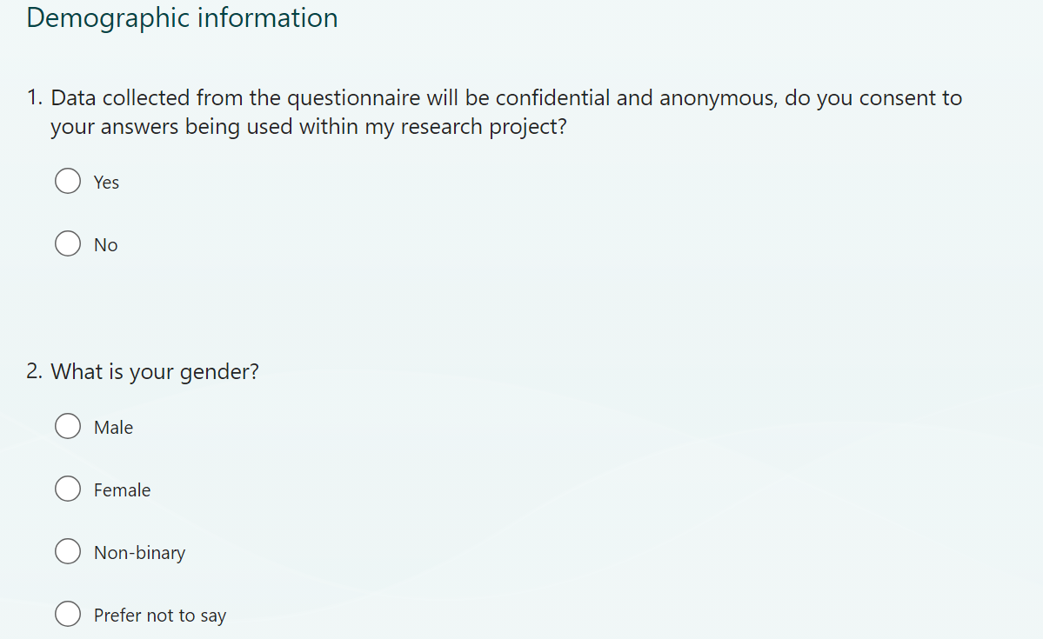

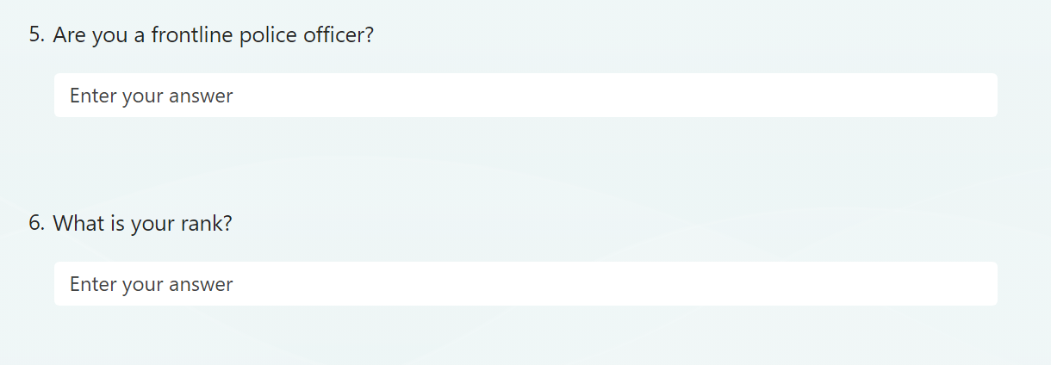

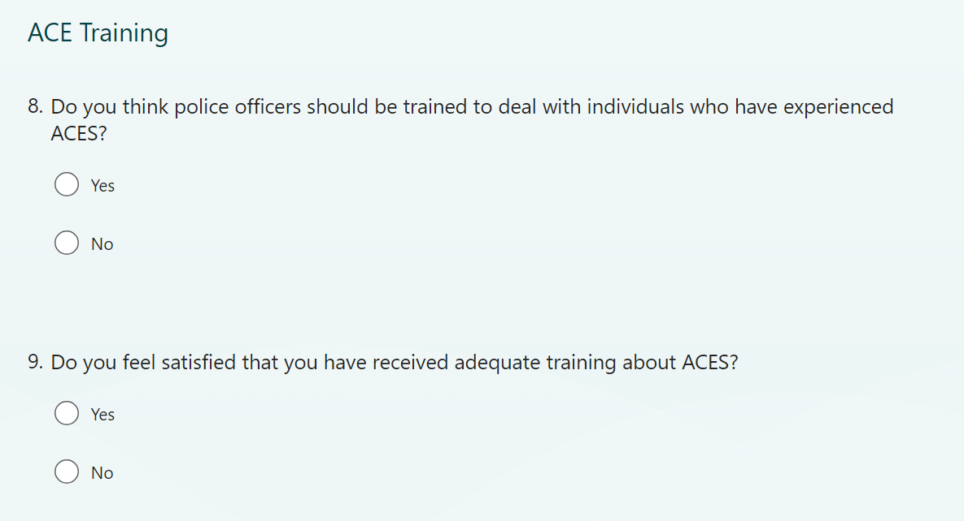
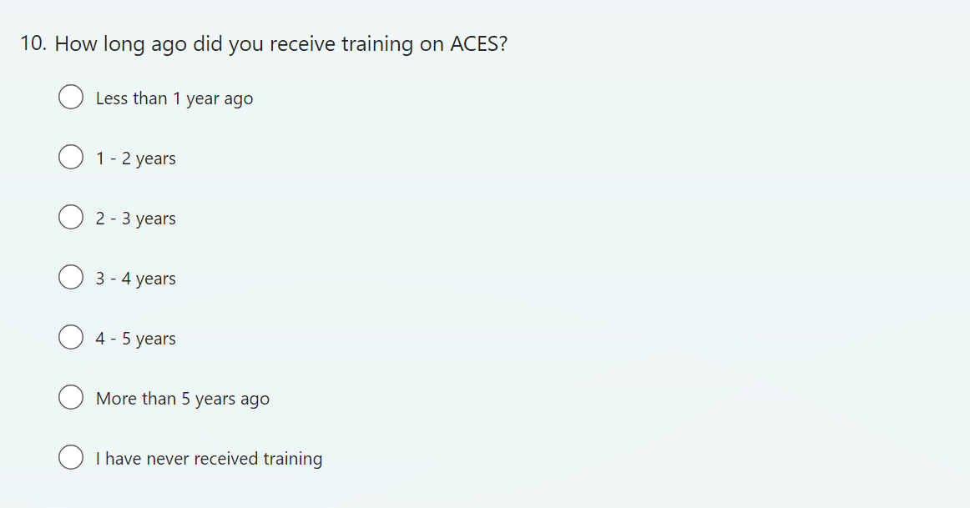

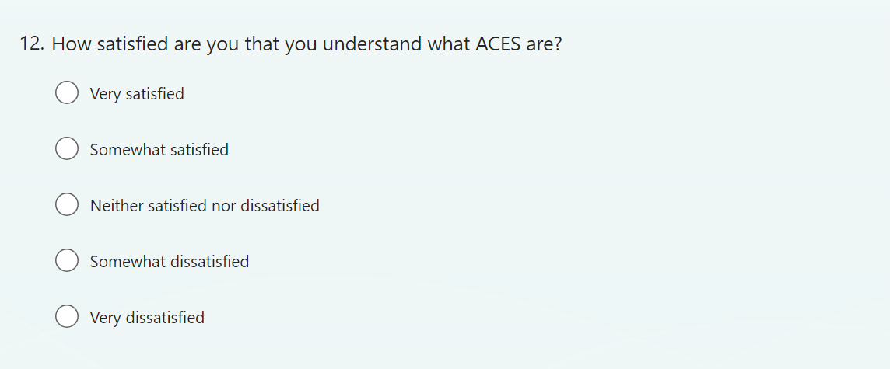
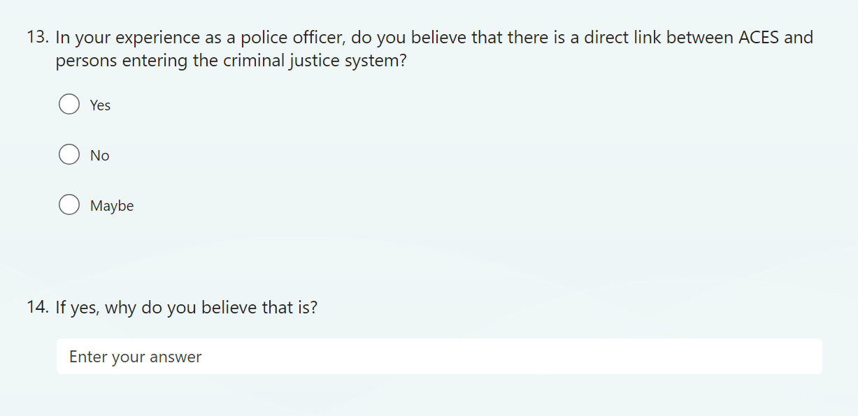
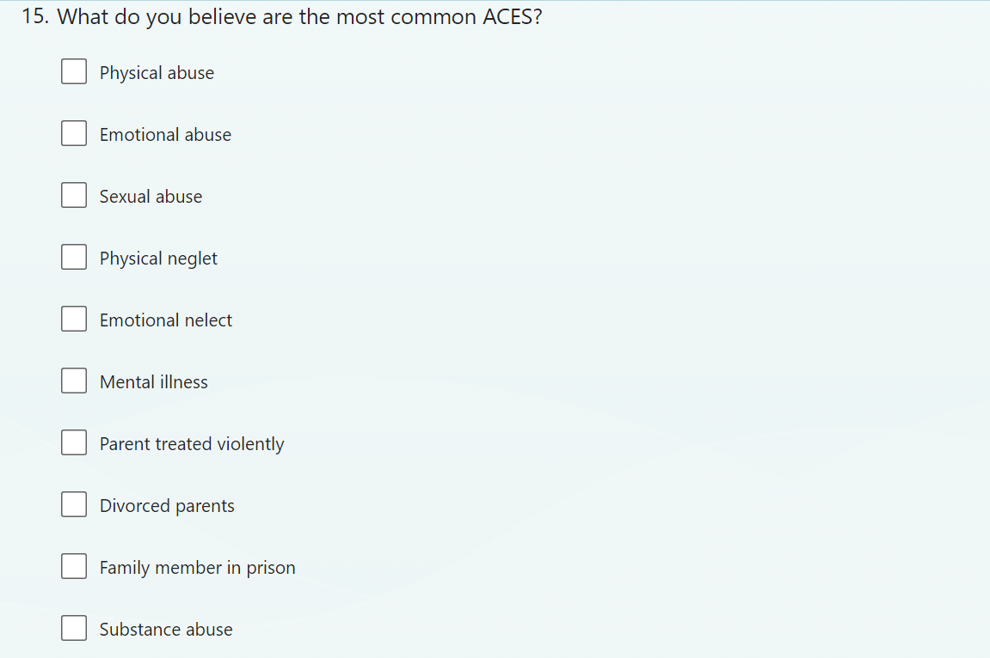
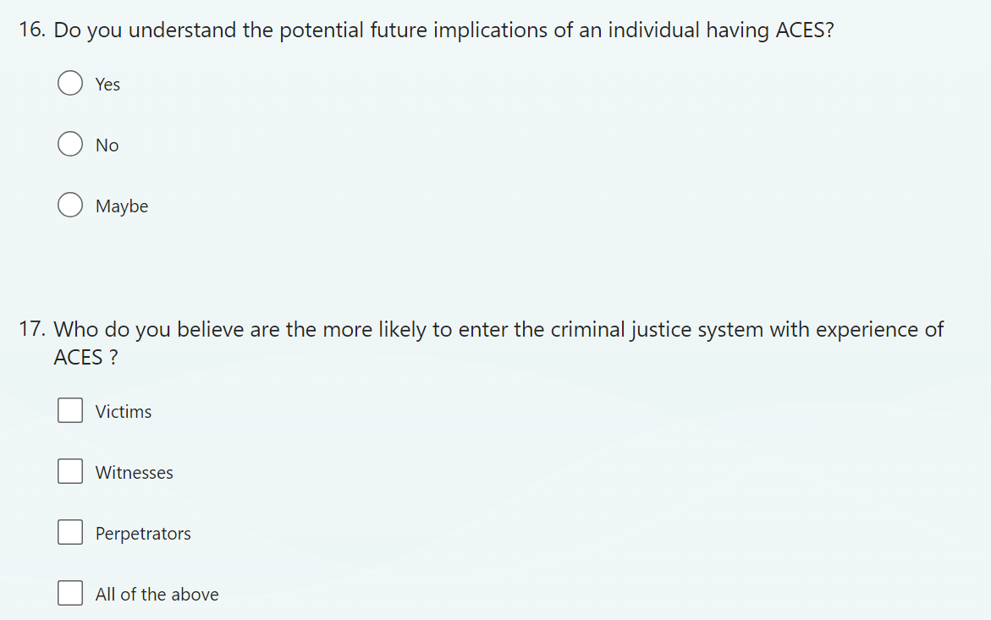
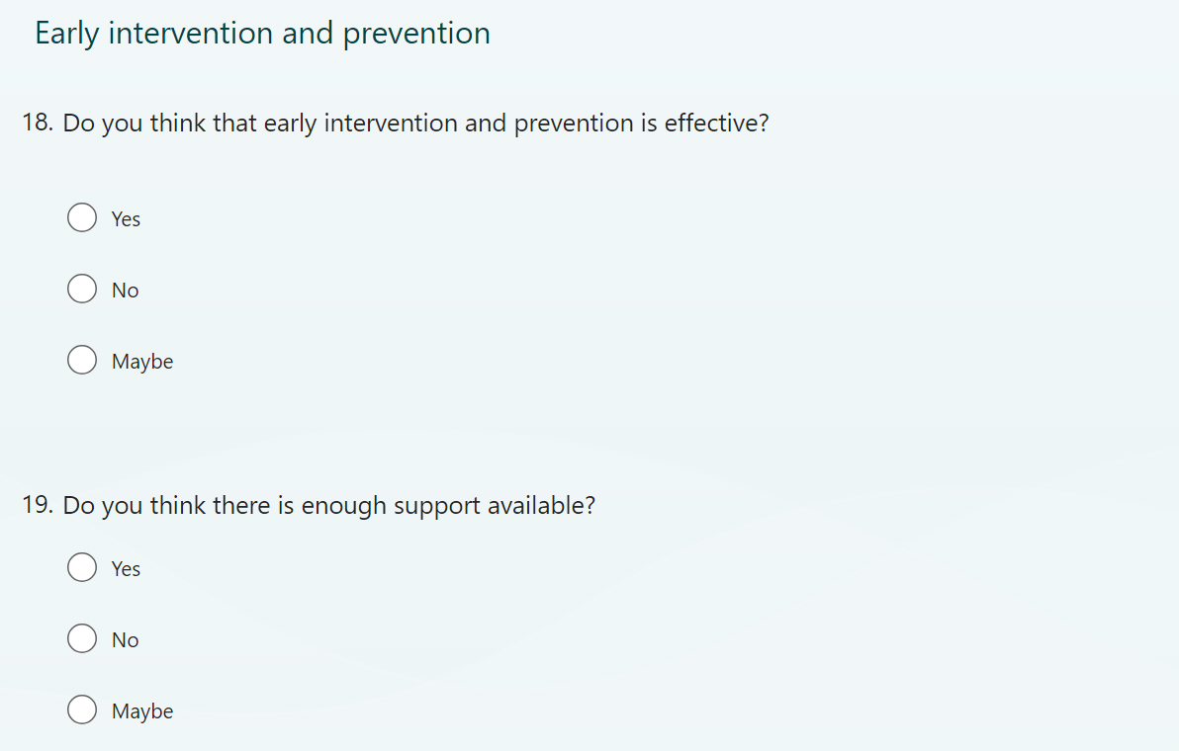
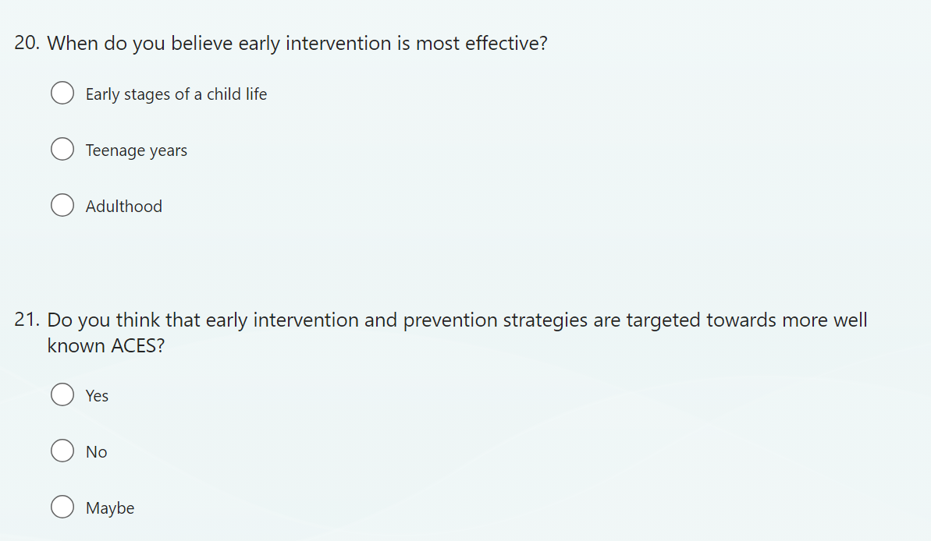
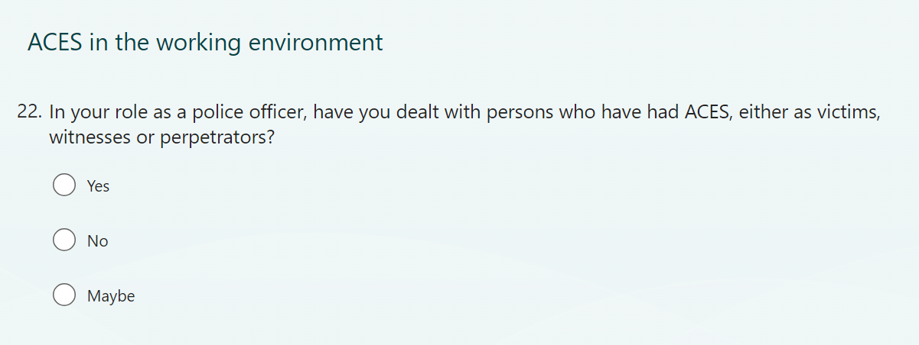
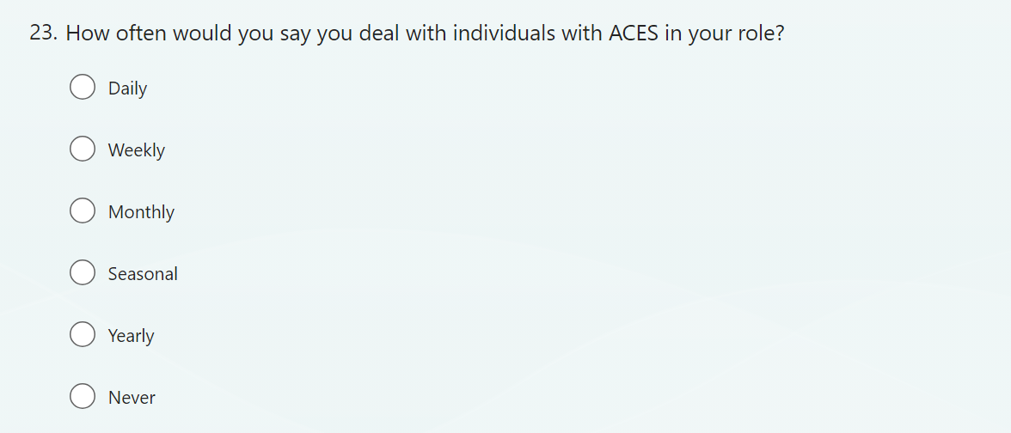
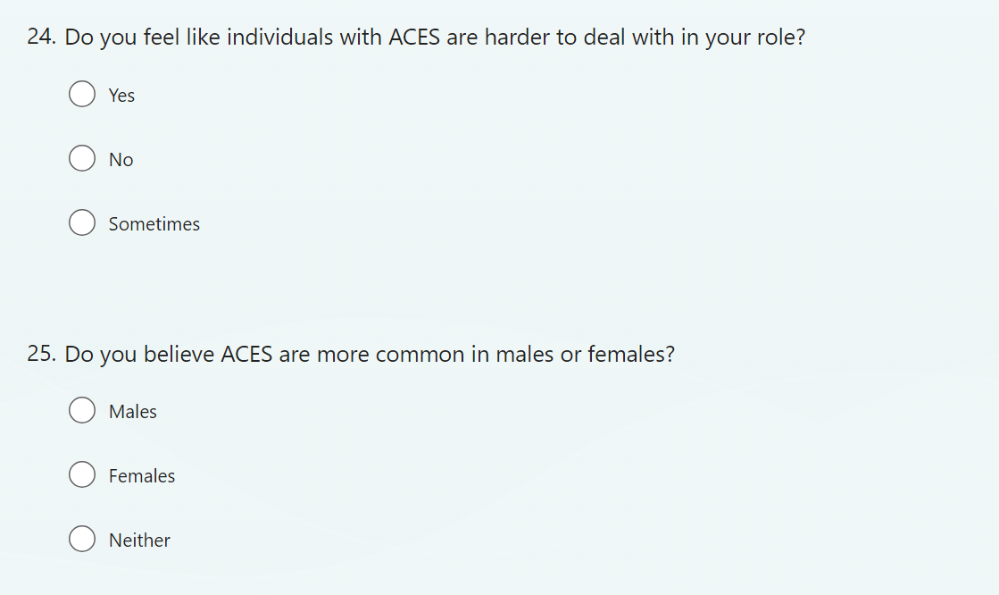
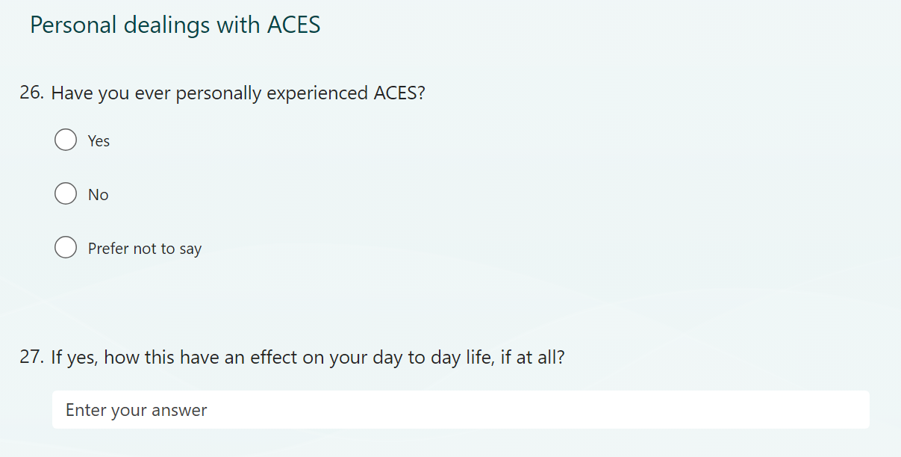

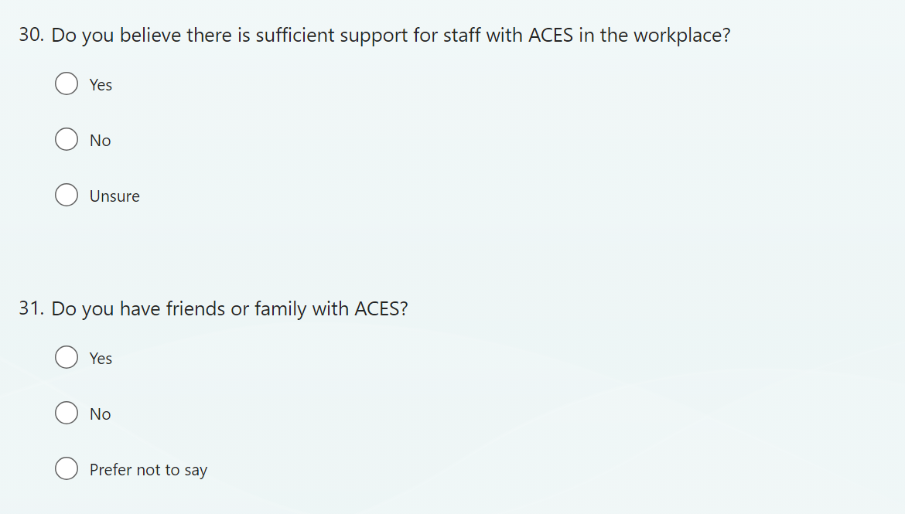

Appendix C – Questionnaire Answers
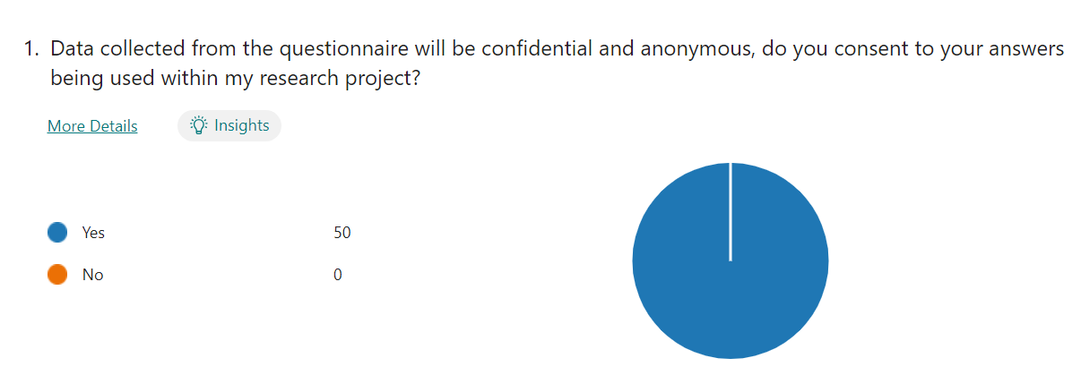

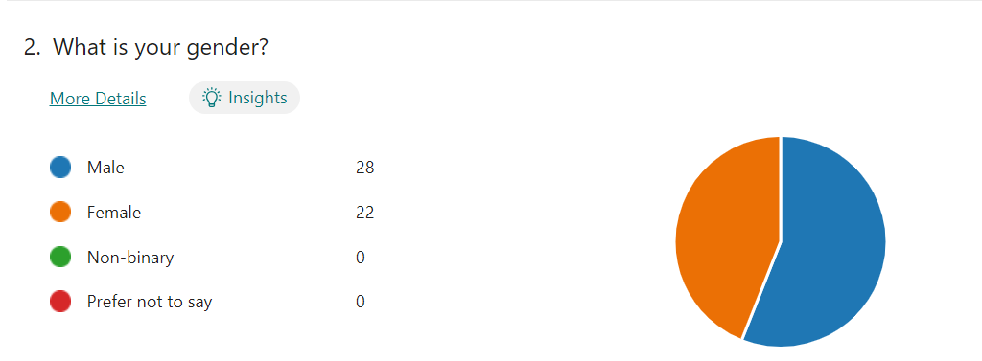

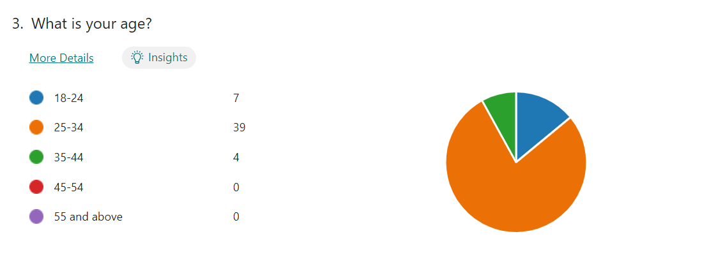
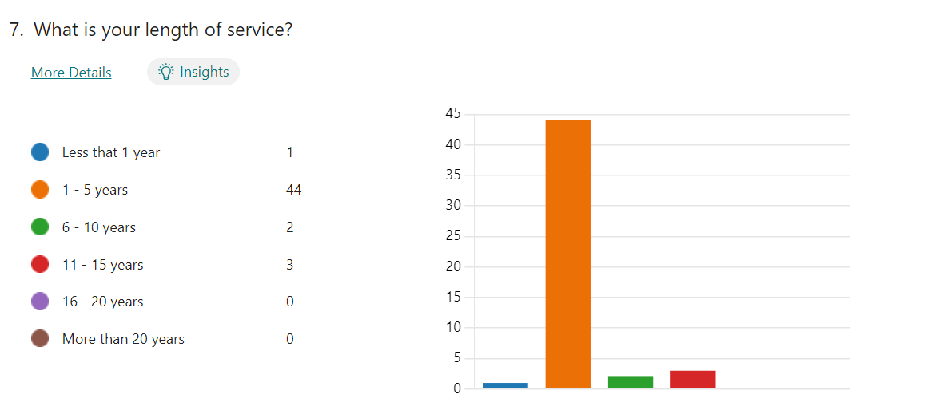

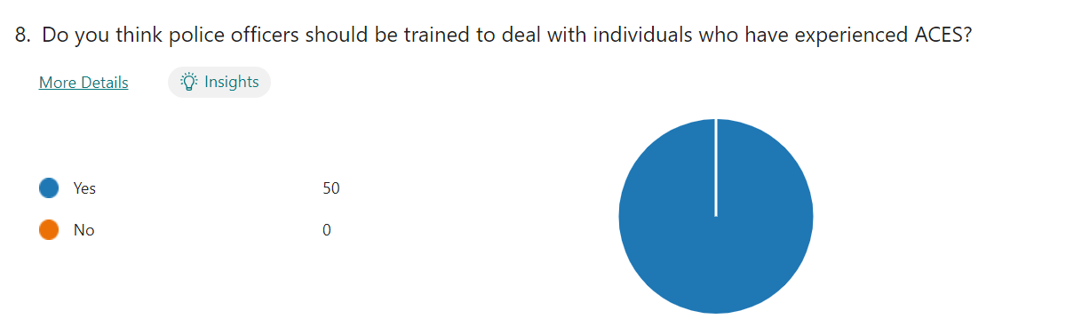

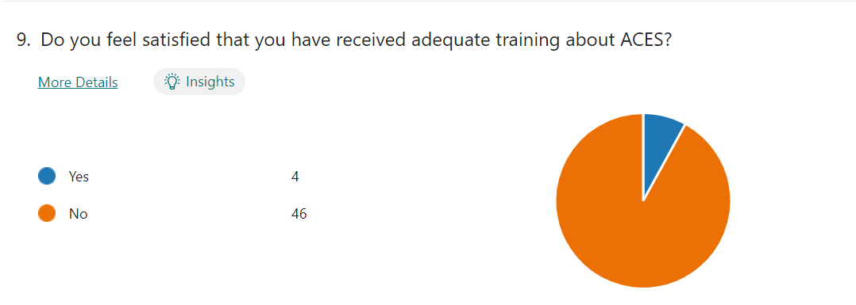

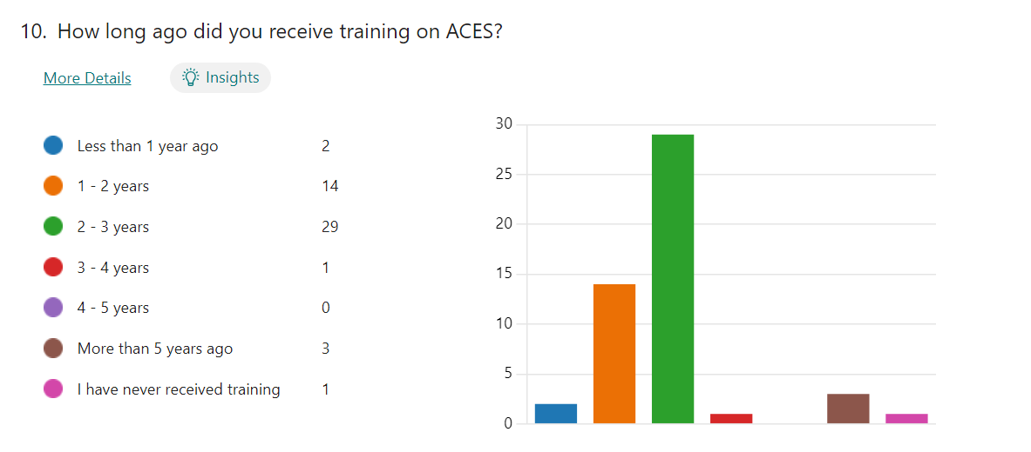

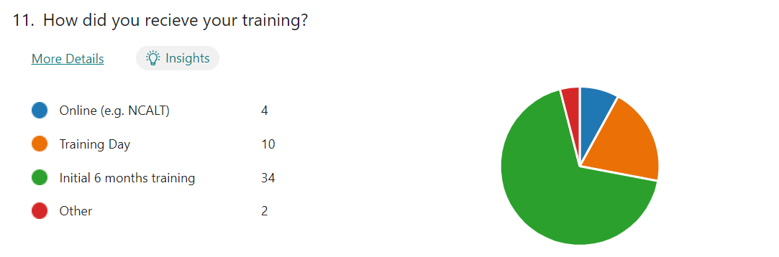

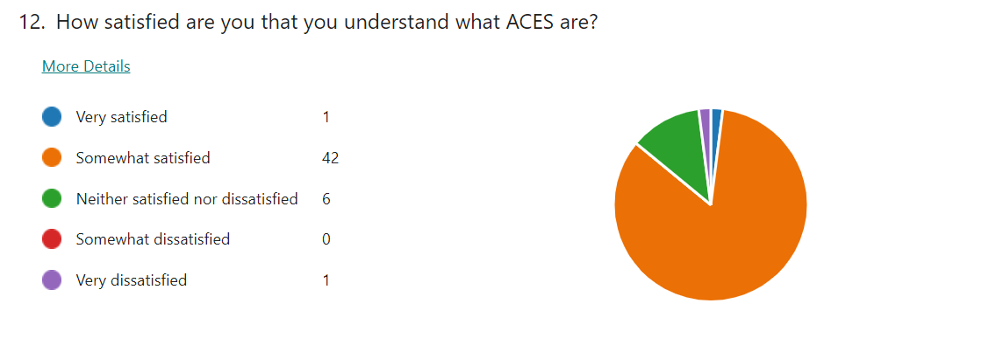

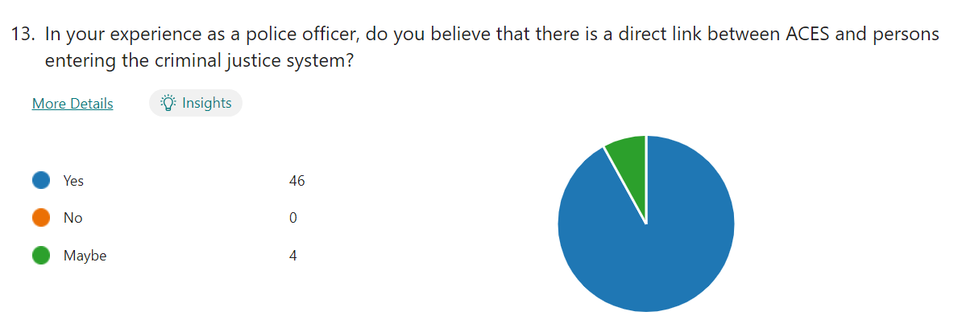

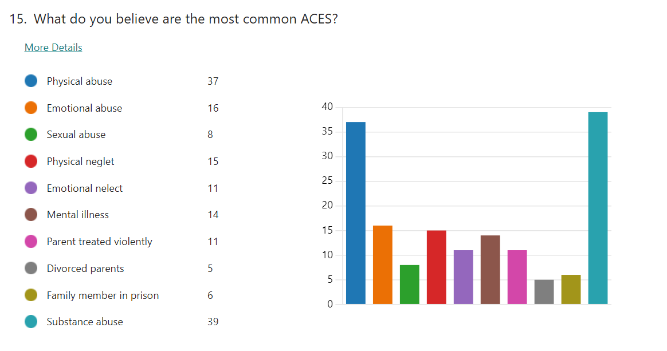

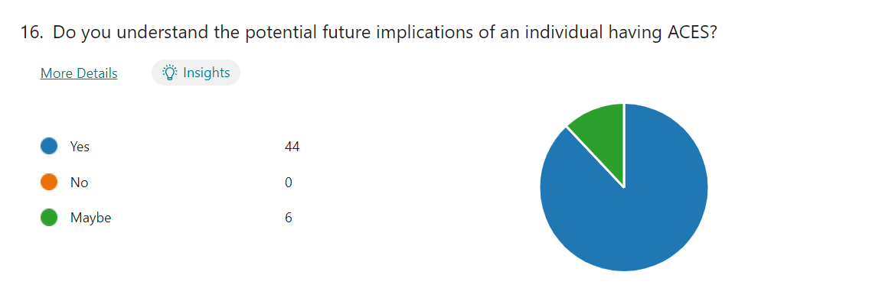

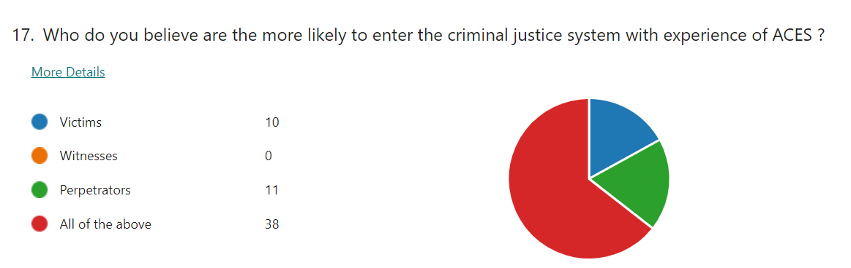

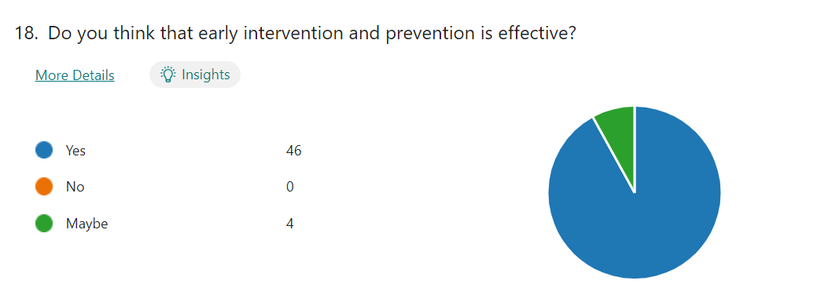

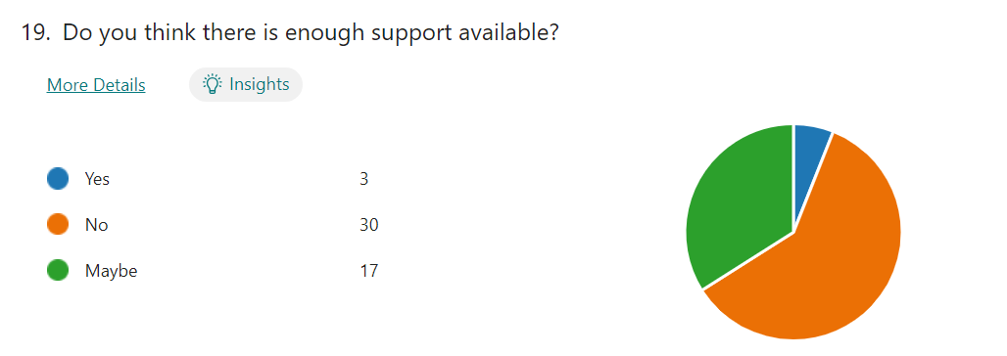
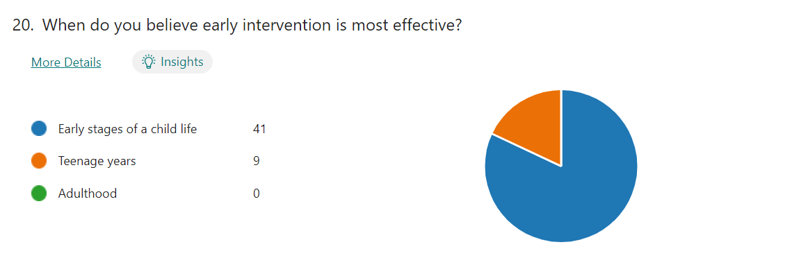

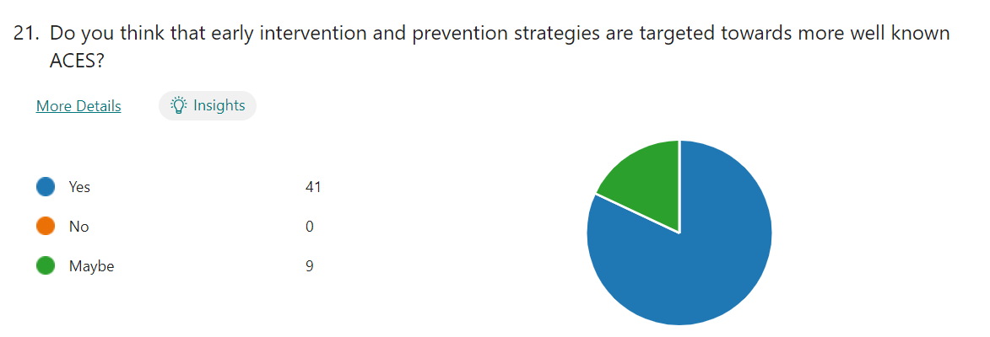

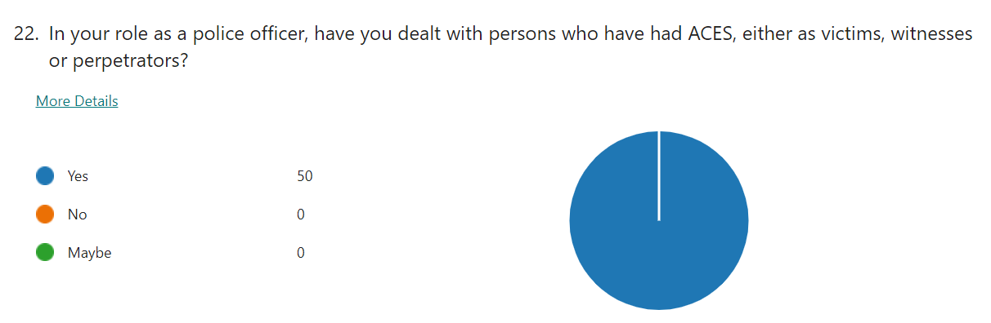

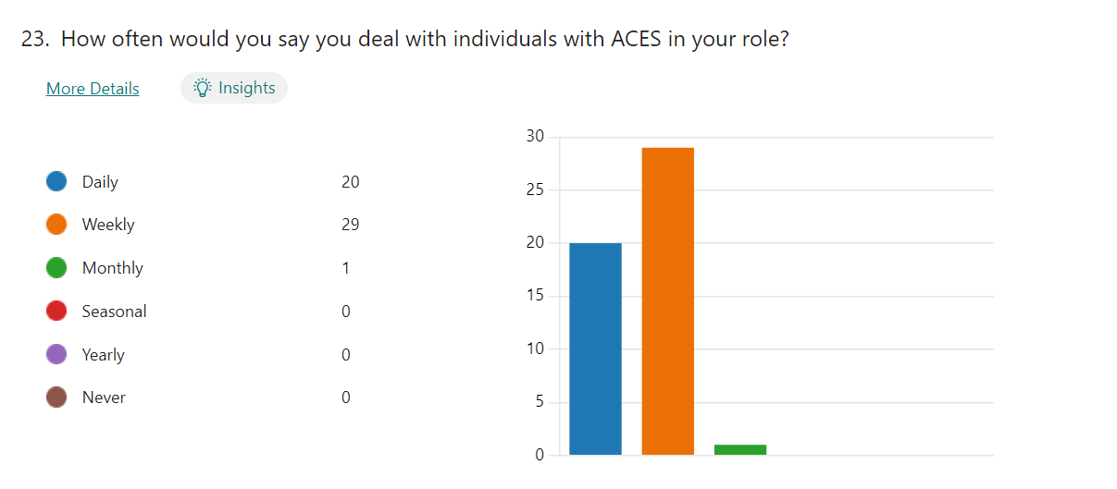

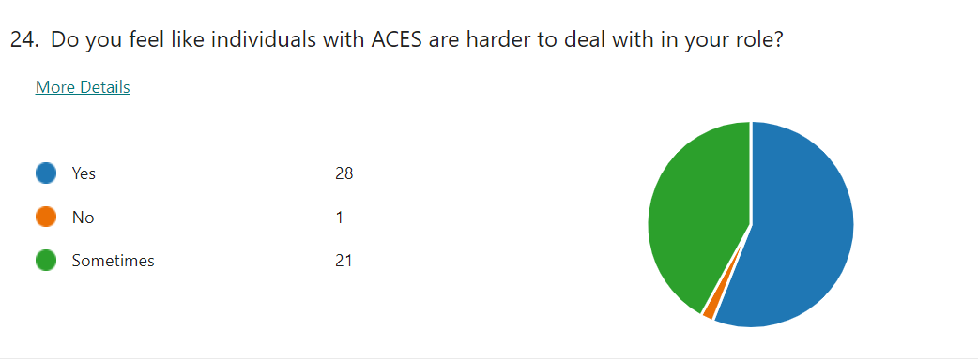
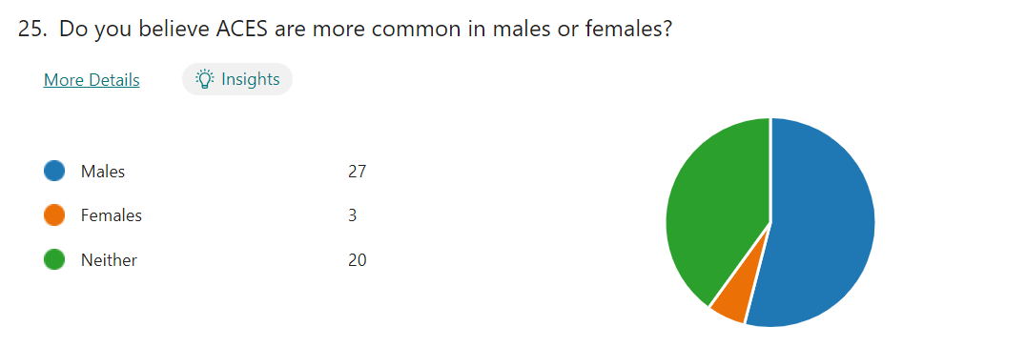
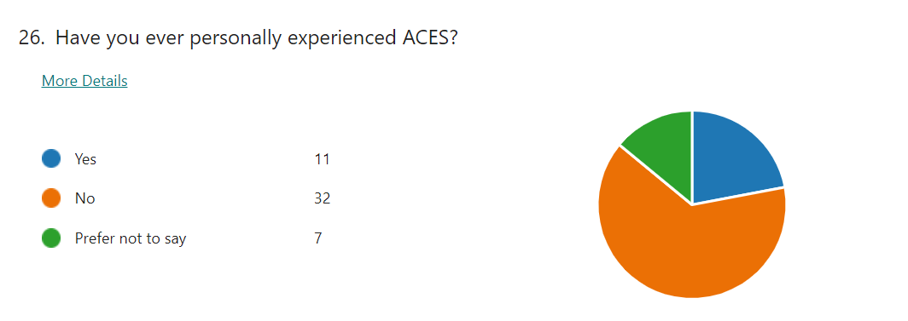
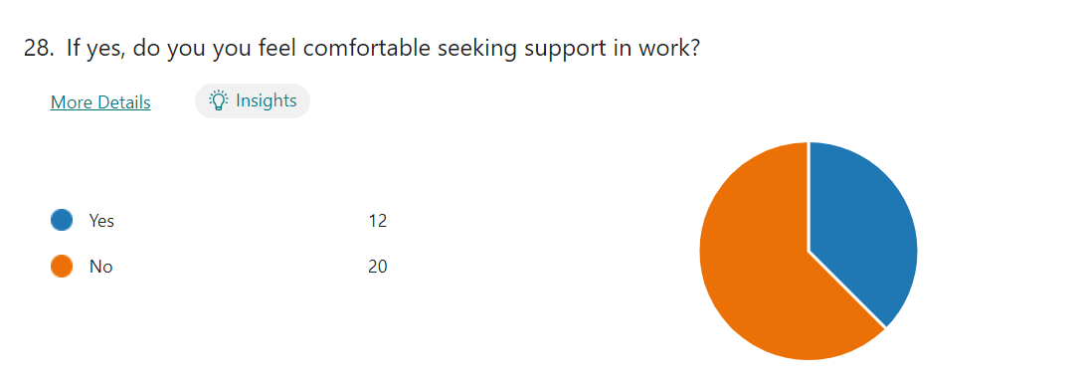
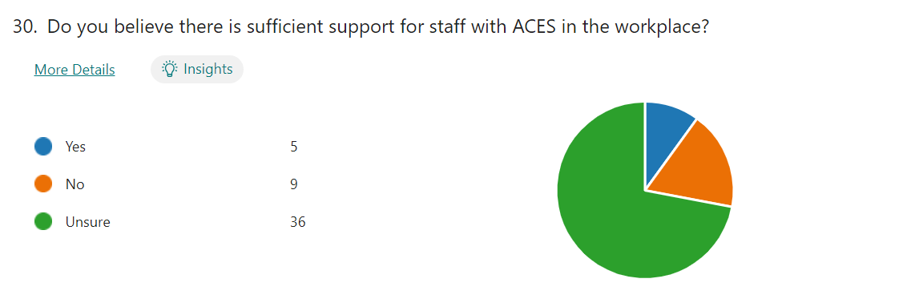
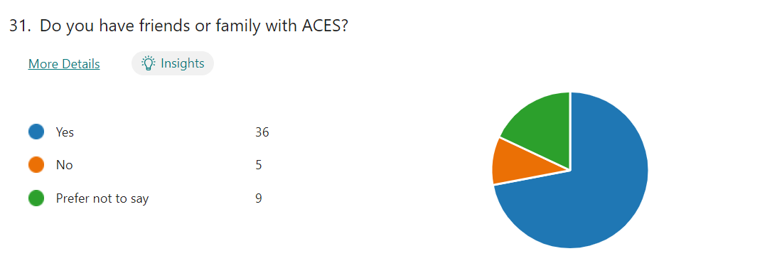
Appendix D – Responses to Questions 4, 5, 6, 14, 27 and 29
Question 4 - What is your ethnicity?
ID Name Responses
1 anonymous White
2 anonymous White
3 anonymous White British
4 anonymous White
5 anonymous White/British
6 anonymous White
7 anonymous White British
8 anonymous British
9 anonymous White
10 anonymous White British
11 anonymous White
12 anonymous White
13 anonymous White British
14 anonymous W1
15 anonymous White
16 anonymous White
17 anonymous White
18 anonymous White
19 anonymous White
20 anonymous White
21 anonymous White
22 anonymous White
23 anonymous White
24 anonymous White
25 anonymous White
26 anonymous White
27 anonymous White
28 anonymous White
29 anonymous White
30 anonymous White
31 anonymous Whire
32 anonymous White
33 anonymous White
34 anonymous White
35 anonymous White
36 anonymous White
37 anonymous White
38 anonymous White
39 anonymous Whire
40 anonymous White
41 anonymous WHITE
42 anonymous White
43 anonymous White
44 anonymous White
45 anonymous White
46 anonymous White
47 anonymous White
48 anonymous White
49 anonymous White
50 anonymous White

Question 5 - Are you a frontline police officer?
ID Name Responses
1 anonymous Yes
2 anonymous Yes
3 anonymous No
4 anonymous Yes
5 anonymous Yes
6 anonymous Yes
7 anonymous Yes
8 anonymous Yes
9 anonymous Yes NPT
10 anonymous Yes
11 anonymous Yes
12 anonymous Yes
13 anonymous Yes
14 anonymous Yes
15 anonymous Yea
16 anonymous Yes
17 anonymous Yes
18 anonymous Yes
19 anonymous Yes
20 anonymous Yes
21 anonymous Yes
22 anonymous Yes
23 anonymous Yes
24 anonymous Yes
25 anonymous Yes
26 anonymous Yes
27 anonymous Yes
28 anonymous Yes
29 anonymous Yes
30 anonymous Yes
31 anonymous Yes
32 anonymous Yes
33 anonymous Yes
34 anonymous Yes
35 anonymous Yes
36 anonymous Yes
37 anonymous Yes
38 anonymous Yes
39 anonymous Yes
40 anonymous Yes
41 anonymous Yes
42 anonymous Yes
43 anonymous Yes
44 anonymous Yes
45 anonymous YES
46 anonymous Yes
47 anonymous Yes
48 anonymous Yes
49 anonymous Yes
50 anonymous Yes

Question 6 - What is your rank?
ID Name Responses
1 anonymous PC
2 anonymous Pc
3 anonymous Pc
4 anonymous Pc
5 anonymous Sergeant
6 anonymous Pc
7 anonymous Sergeant
8 anonymous Pc
9 anonymous PC
10 anonymous PC
11 anonymous Constable
12 anonymous PC
13 anonymous PC
14 anonymous PC
15 anonymous Pc
16 anonymous Pc
17 anonymous Pc
18 anonymous Pc
19 anonymous Pc
20 anonymous Pc
21 anonymous Pc
22 anonymous Pc
23 anonymous Pc
24 anonymous Pc
25 anonymous Pc
26 anonymous Pc
27 anonymous Pc
28 anonymous Pc
29 anonymous Pc
30 anonymous Pc
31 anonymous Pc
32 anonymous Pc
33 anonymous Pc
34 anonymous Pc
35 anonymous Pc
36 anonymous Pc
37 anonymous Pc
38 anonymous Pc
39 anonymous Pc
40 anonymous PC
41 anonymous PC
42 anonymous PC
43 anonymous PC
44 anonymous PC
45 anonymous Pc
46 anonymous PC
47 anonymous PC
48 anonymous PC
49 anonymous PC
50 anonymous PC

Question 14 - If yes, why do you believe that is?
ID Name Responses
1 anonymous Trauma coping mechanism
2 anonymous From personal experience
3 anonymous Often those we deal with on a daily basis have a number of ACES
4 anonymous Learnt behaviour
5 anonymous Social isolation, repeating learned behaviour from their parents or others, lack of opportunity, trauma leading to mental health issues which make them more vulnerable to exploitation

Question 27 - If yes, how this have an effect on your day to day life, if at all?
ID Name Responses
1 anonymous Relive trauma of abuse regularly, cognitive development impaired due to disruption and unbalance as a result of parent’s divorce

Question 29 - If no, please explain why
ID Name Responses
1 anonymous Mental health still stigmatised

Appendix E – Ethics Form
APPLICATION FOR ETHICAL APPROVAL

RESEARCH STUDENTS
This form is to be completed by the student within SIX months for full-time students and TWELVE months for part time students, after the commencement of the research degree or following progression to Part Two of your course.

Once complete, submit this form via the MyTSD Doctoral College Portal at (https://mytsd.uwtsd.ac.uk).

This document is also available in Welsh.

RESEARCH STAFF ONLY
All communications relating to this application during its processing must be in writing and emailed to pgresearch@uwtsd.ac.uk , with the title ‘Ethical Approval’ followed by your name.

STUDENTS ON UNDERGRADUATE OR TAUGHT MASTERS PROGRAMMES should submit this form (and receive the outcome) via systems explained to you by the supervisor/module leader.

In order for research to result in benefit and minimise risk of harm, it must be conducted ethically. A researcher may not be covered by the University’s insurance if ethical approval has not been obtained prior to commencement.

The University follows the OECD Frascati manual definition of research activity: “creative work undertaken on a systematic basis in order to increase the stock of knowledge, including knowledge of man, culture and society, and the use of this stock of knowledge to devise new applications”. As such this covers activities undertaken by members of staff, postgraduate research students, and both taught postgraduate and undergraduate students working on dissertations/projects.

The individual undertaking the research activity is known as the “principal researcher”.

Ethical approval is not required for routine audits, performance reviews, quality assurance studies, testing within normal educational requirements, and literary or artistic criticism.

Please read the notes for guidance before completing ALL sections of the form.

This form must be completed and approved prior to undertaking any research activity. Please see Checklist for details of process for different categories of application.

SECTION A: About You (Principal Researcher)
1 | Full Name: |  | Olivia Leigh Morgan
2 | Tick all boxes that apply: |  | Member of staff: | ☐ | Honorary research fellow: | ☐
 | Undergraduate Student | ☒ | Taught Postgraduate Student | ☐ | Postgraduate Research Student | ☐

3 | Institute/Academic Discipline/Centre: | IMH
4 | Campus: | Swansea
5 | E-mail address: | 2124830@student.uwtsd.ac.uk
6 | Contact Telephone Number:
 | For students:
7 | Student Number: | 2124830
8 | Programme of Study: | BSc (Hons) Professional Policing Practice
9 | Director of Studies/Supervisor: | Jane Davies

SECTION B: Approval for Research Activity
1 | Has the research activity received approval in principle?  (please check the Guidance Notes as to the appropriate approval process for different levels of research by different categories of individual) |  | YES | ☒ | NO | ☐
 |  |  |  |  | Date
2 | If Yes, please indicate source of approval (and date where known): Approval in principle must be obtained from the relevant source prior to seeking ethical approval | Research Degrees Committee |  | ☐
2 |  | Institute Research Committee |  | ☐
2 |  | Other (write in) |  | ☒ | Jane Davies

SECTION C: Internal and External Ethical Guidance Materials
 | Please list the core ethical guidance documents that have been referred to during the completion of this form (including any discipline-specific codes of research ethics, location-specific codes of research ethics, and also any specific ethical guidance relating to the proposed methodology). Please tick to confirm that your research proposal adheres to these codes and guidelines. You may add rows to this table if needed.
1 | UWTSD Research Ethics & Integrity Code of Practice | ☒
2 | UWTSD Research Data Management Policy | ☒
3 | [List any other relevant documents here] | ☐

SECTION D: External Collaborative Research Activity
If there are external collaborators then you should gain consent from the contact persons to share their personal data with the university. If there are no external collaborators then leave this section blank and continue to section E.
1 | Institution
2 | Contact person name
3 | Contact person e-mail address
4 | Is your research externally funded? |  | YES | ☐ | NO |  | ☐
5 | Are you in receipt of a KESS scholarship? |  | YES | ☐ | NO |  | ☐
6 | Are you specifically employed to undertake this research in either a paid or voluntary capacity? | Voluntary | YES | ☐ | NO | ☐
7 |  | Employed | YES | ☐ | NO | ☐
8 | Is the research being undertaken within an existing UWTSD Athrofa Professional Learning Partnership (APLP)? | If YES then the permission question below does not need to be answered. | YES | ☐ | NO |  | ☐
9 | Has permission to undertake the research has been provided by the partner organisation? | (If YES attach copy)  If NO the application cannot continue | YES | ☐ | NO |  | ☐

Where research activity is carried out in collaboration with an external organisation
10 | Does this organisation have its own ethics approval system? | YES | ☐ | NO | ☐
 | If Yes, please attach a copy of any final approval (or interim approval) from the organisation (this may be a copy of an email if appropriate).

SECTION E: Details of Research Activity
1 | Indicative title: | A critical analysis into the relationship between Adverse Childhood Experiences (ACEs) and victims, witnesses and offenders entering the Criminal Justice System.
2 | Proposed start date: | 26/02/2024 | Proposed end date: | 07/10/2024
Introduction to the Research (maximum 300 words per section)
Ensure that you write for a Non-Specialist Audience when outlining your response to the points below:
- Purpose of Research Activity
- Proposed Research Question
- Aims of Research Activity
- Objectives of Research Activity
Demonstrate, briefly, how Existing Research has informed the proposed activity and explain
- What the research activity will add to the body of knowledge
- How it addresses an area of importance.
3 | Purpose of Research Activity  This research will address the subject of adverse childhood experiences (ACEs), and how they can have an impact on an individual, resulting in them having contact with the Criminal Justice System, wither as a victim, witness or perpetrator. It will also gather front line officer’s general understanding of ACEs, and their opinions on if they are adequality trained to deal with these individuals.  (this box should expand as you type)
4 | Research Question  A critical analysis into the relationship between Adverse Childhood Experiences (ACEs) and victims, witnesses and offenders entering the Criminal Justice System.  (this box should expand as you type)
5 | Aims of Research Activity  The aim of the research activity for this dissertation is to critically evaluate the relationship between individuals who have experienced adverse childhood experiences (ACEs), and the Criminal Justice System.  (this box should expand as you type)
6 | Objectives of Research Activity  Objective 1 - To critically analyse and evaluate existing academic literature and statistics surrounding ACES and criminal justice system, early intervention and prevention, and policing.  Objective 2 - To identify an appropriate primary research method, which is designed to obtain police officers understanding and views of ACES and the persons they have encountered in their role.  Objective 3 - To conduct primary research and analyse the data collected to better understand the views and opinions of police officers towards ACES.  Objective 4 - To provide recommendations for better awareness and understanding on the relationship between ACES and individuals involved in the criminal justice system.  (this box should expand as you type)
Proposed methods (maximum 600 words)
Provide a brief summary of all the methods that may be used in the research activity, making it clear what specific techniques may be used. If methods other than those listed in this section are deemed appropriate later, additional ethical approval for those methods will be needed. You do not need to justify the methods here, but should instead describe how you intend to collect the data necessary for you to complete your project.
7 | In the form of questionnaire which will be emailed to colleagues.  (this box should expand as you type)
Location of research activity
Identify all locations where research activity will take place.
8 | Wales  (this box should expand as you type)
Research activity outside of the UK
If research activity will take place overseas, you are responsible for ensuring that local ethical considerations are complied with and that the relevant permissions are sought. Specify any local guidelines (e.g. from local professional associations/learned societies/universities) that exist and whether these involve any ethical stipulations beyond those usual in the UK (provide details of any licenses or permissions required). Also specify whether there are any specific ethical issues raised by the local context in which the research activity is taking place, for example, particular cultural and/or legal sensitivities or vulnerabilities of participants. If you live in the country where you will do the research then please state this.
9 | N/A.  (this box should expand as you type)

10 | Use of documentation not in the public domain: Are any documents NOT publicly available? | NO | ☒
10 |  | YES | ☐
11 | If Yes, please provide details here of how you will gain access to specific documentation that is not in the public domain and that this is in accordance with the current data protection law of the country in question and that of England and Wales.  (this box should expand as you type)

 | Does your research relate to one or more of the seven aims of the Well-being of Future Generations (Wales) Act 2015? | YES | NO
12 | A prosperous Wales | ☐ | ☒
13 | A resilient Wales | ☐ | ☒
14 | A healthier Wales | ☐ | ☒
15 | A more equal Wales | ☐ | ☒
16 | A Wales of cohesive communities | ☐ | ☒
17 | A Wales of vibrant culture and thriving Welsh language | ☐ | ☒
18 | A globally responsible Wales | ☐ | ☒
19 | If YES to any of the above, please give details:
 | (this box should expand as you type)

SECTION F: Scope of Research Activity
 | Will the research activity include: | YES | NO
1 | Use of a questionnaire or similar research instrument? | ☒ | ☐
2 | Use of interviews? | ☐ | ☒
3 | Use of focus groups? | ☐ | ☒
4 | Use of participant diaries? | ☐ | ☒
5 | Use of video or audio recording? | ☐ | ☒
6 | Use of computer-generated log files? | ☐ | ☒
7 | Participant observation with their knowledge? | ☐ | ☒
8 | Participant observation without their knowledge? | ☐ | ☒
9 | Access to personal or confidential information without the participants’ specific consent? | ☐ | ☒
10 | Administration of any questions, test stimuli, presentation that may be experienced as physically, mentally or emotionally harmful / offensive? | ☐ | ☒
11 | Performance of any acts which may cause embarrassment or affect self-esteem? | ☐ | ☒
12 | Investigation of participants involved in illegal activities? | ☐ | ☒
13 | Use of procedures that involve deception? | ☐ | ☒
14 | Administration of any substance, agent or placebo? | ☐ | ☒
15 | Working with live vertebrate animals? | ☐ | ☒
16 | Procedures that may have a negative impact on the environment? | ☐ | ☒
17 | Other primary data collection methods. Please indicate the type of data collection method(s) below. | ☐ | ☒
 | Details of any other primary data collection method:  (this box should expand as you type) | ☐ | ☒
If NO to every question, then the research activity is (ethically) low risk and may be exempt from some of the following sections (please refer to Guidance Notes).

If YES to any question, then no research activity should be undertaken until full ethical approval has been obtained.

SECTION G: Intended Participants
If there are no participants then do not complete this section, but go directly to section H.

 | Who are the intended participants: | YES | NO
1 | Students or staff at the University? | ☐ | ☒
2 | Adults (over the age of 18 and competent to give consent)? | ☒ | ☐
3 | Vulnerable adults? | ☐ | ☒
4 | Children and Young People under the age of 18? (Consent from Parent, Carer or Guardian will be required) | ☐ | ☒
5 | Prisoners? | ☐ | ☒
6 | Young offenders? | ☐ | ☒
7 | Those who could be considered to have a particularly dependent relationship with the investigator or a gatekeeper? | ☐ | ☒
8 | People engaged in illegal activities? | ☐ | ☒
9 | Others. Please indicate the participants below, and specifically any group who may be unable to give consent. | ☐ | ☒
 | Details of any other participant groups:  (this box should expand as you type) | ☐ | ☒

Participant numbers and source
Provide an estimate of the expected number of participants. How will you identify participants and how will they be recruited?
10 | How many participants are expected? | Approximately 50 respondents to a questionnaire.  (this box should expand as you type)
11 | Who will the participants be? | The participants of the questionnaire will be front line police officers; however the identity of the officers will be anonymous.  (this box should expand as you type)
12 | How will you identify the participants? | The questionnaire will be sent via email to South Wales police officers.  (this box should expand as you type)

 | Information for participants: | YES | NO | N/A
13 | Will you describe the main research procedures to participants in advance, so that they are informed about what to expect? | ☒ | ☐ | ☐
14 | Will you tell participants that their participation is voluntary? | ☒ | ☐ | ☐
15 | Will you obtain written consent for participation? | ☒ | ☐ | ☐
16 | Will you explain to participants that refusal to participate in the research will not affect their treatment or education (if relevant)? | ☐ | ☐ | ☒
17 | If the research is observational, will you ask participants for their consent to being observed? | ☐ | ☐ | ☒
18 | Will you tell participants that they may withdraw from the research at any time and for any reason? | ☒ | ☐ | ☐
19 | With questionnaires, will you give participants the option of omitting questions they do not want to answer? | ☐ | ☒ | ☐
20 | Will you tell participants that their data will be treated with full confidentiality and that, if published, it will not be identifiable as theirs? | ☒ | ☐ | ☐
21 | Will you debrief participants at the end of their participation, in a way appropriate to the type of research undertaken? | ☒ | ☐ | ☐
22 | If NO to any of above questions, please give an explanation
Each response to my questionnaire will be a crucial part of my research project into this subject, and each question will lead onto the next question. Due to the questionnaire having no ethical issues, there will not be a need for an option to omitting any questions.

(this box should expand as you type)

 | Information for participants: | YES | NO | N/A
24 | Will participants be paid? | ☐ | ☒ | ☐
25 | Is specialist electrical or other equipment to be used with participants? | ☐ | ☒ | ☐
26 | Are there any financial or other interests to the investigator or University arising from this study? | ☐ | ☒ | ☐
27 | Will the research activity involve deliberately misleading participants in any way, or the partial or full concealment of the specific study aims? | ☐ | ☒ | ☐
28 | If YES to any question, please provide full details
 | (this box should expand as you type)

SECTION H: Anticipated Risks

Outline any anticipated risks that may adversely affect any of the participants, the researchers and/or the University, and the steps that will be taken to address them.

If you have completed a full risk assessment (for example as required by a laboratory, or external research collaborator) you may append that to this form.
1 | Full risk assessment completed and appended? |  | Yes | ☐
1 |  |  | No | ☒
2 | Risks to participants  For example: sector-specific health & safety, emotional distress, financial disclosure, physical harm, transfer of personal data, sensitive organisational information
 | Risk to participants:  - The participant could have concerns regarding their personal data, and the anonymity of the questionnaire.  (this box should expand as you type) | How you will mitigate the risk to participants:  - Ensure that the confidentiality of the research data is protected.  (this box should expand as you type)
3 | If research activity may include sensitive, embarrassing or upsetting topics (e.g. sexual activity, drug use) or issues likely to disclose information requiring further action (e.g. criminal activity), give details of the procedures to deal with these issues, including any support/advice (e.g. helpline numbers) to be offered to participants. Note that where applicable, consent procedures should make it clear that if something potentially or actually illegal is discovered in the course of a project, it may need to be disclosed to the proper authorities
 | (this box should expand as you type)
4 | Risks to the investigator  For example: personal health & safety, physical harm, emotional distress, risk of accusation of harm/impropriety, conflict of interest
 | Risk to the investigator:  - Contingencies out of the investigators control, participants might find the questionnaire difficult or time consuming and therefore not complete fully, or there might not be enough participants.  (this box should expand as you type) | How you will mitigate the risk to the investigator:  - Be prepared for any potential issues and have a backup plan.  (this box should expand as you type)
University/institutional risks
For example: adverse publicity, financial loss, data protection
 | Risk to the University:  - An adverse effect on the university.  (this box should expand as you type) | How you will mitigate the risk to the University:  - Ensure that any research will be in line with the ethics while maintaining the universities reputation.  (this box should expand as you type)
6 | Environmental risks  For example: accidental spillage of pollutants, damage to local ecosystems
 | Risk to the environment:  There does not appear to be any environmental risks.  (this box should expand as you type) | How you will mitigate the risk to environment:  (this box should expand as you type)

 | Disclosure and Barring Service
 | If the research activity involves children or vulnerable adults, a Disclosure and Barring Service (DBS) certificate must be obtained before any contact with such participants. | YES | NO | N/A
7 | Does your research require you to hold a current DBS Certificate? | ☐ | ☒ | ☐
8 | If YES, please give the certificate number. If the certificate number is not available please write “Pending”; in this case any ethical approval will be subject to providing the appropriate certificate number.

SECTION I: Feedback, Consent and Confidentiality

1 | Feedback  What de-briefing and feedback will be provided to participants, how will this be done and when?
Participants will be able to access the dissertation once it has been completed, so that they are able to see the results of the research project.

(this box should expand as you type)
2 | Informed consent  Describe the arrangements to inform potential participants, before providing consent, of what is involved in participating. Describe the arrangements for participants to provide full consent before data collection begins. If gaining consent in this way is inappropriate, explain how consent will be obtained and recorded in accordance with prevailing data protection legislation.
There will be a box at the start of the questionnaire, which will require the participant to tick if they consent. They will be given information on the research project prior to this, to ensure they have had sufficient information before making a decision about participating. The decision will be made of their own free will.

(this box should expand as you type)
3 | Confidentiality / Anonymity  Set out how anonymity of participants and confidentiality will be ensured in any outputs. If anonymity is not being offered, explain why this is the case.
The confidentiality and anonymity of the participant will be ensured; therefore no participant will be named in the dissertation.

(this box should expand as you type)

SECTION J: Data Protection and Storage

 | Does the research activity involve personal data (as defined by the General Data Protection Regulation 2016 “GDPR” and the Data Protection Act 2018 “DPA”)? | YES | NO
1 | “Personal data” means any information relating to an identified or identifiable natural person (‘data subject’). An identifiable natural person is one who can be identified, directly or indirectly, in particular by reference to an identifier such as a name, an identification number, location data, an online identifier or to one or more factors specific to the physical, physiological, genetic, mental, economic, cultural or social identity of that natural person. Any video or audio recordings of participants is considered to be personal data. | ☐ | ☒
 | If YES, provide a description of the data and explain why this data needs to be collected:
2 | (this box should expand as you type)
 | Does it involve special category data (as defined by the GDPR)? | YES | NO
3 | “Special category data” means sensitive personal data consisting of information as to the data subjects’ –  (a) racial or ethnic origin,  (b) political opinions,  (c ) religious beliefs or other beliefs of a similar nature,  (d) membership of a trade union (within the meaning of the Trade Union and Labour Relations (Consolidation) Act 1992),  (e) physical or mental health or condition,  (f) sexual life,  (g) genetics,  (h) biometric data (as used for ID purposes), | ☐ | ☒
 | If YES, provide a description of the special category data and explain why this data needs to be collected:
4 | (this box should expand as you type)

 | Will data from the research activity (collected data, drafts of the thesis, or materials for publication) be stored in any of the following ways? | YES | NO
5 | Manual files (i.e. in paper form)? | ☐ | ☒
6 | University computers? | ☐ | ☒
7 | Private company computers? | ☐ | ☒
8 | Home or other personal computers? | ☐ | ☒
9 | Laptop computers/ CDs/ Portable disk-drives/ memory sticks? | ☒ | ☐
10 | “Cloud” storage or websites? | ☐ | ☒
11 | Other – specify: | ☐ | ☒
12 | For all stored data, explain the measures in place to ensure the security of the data collected, data confidentiality, including details of backup procedures, password protection, encryption, anonymisation and pseudonymisation:
Laptops are encrypted and password protected.

(this box should expand as you type)

 | Data Protection
 | Will the research activity involve any of the following activities: | YES | NO
13 | Electronic transfer of data in any form? | ☐ | ☒
14 | Sharing of data with others at the University outside of the immediate research team? | ☐ | ☒
15 | Sharing of data with other organisations? | ☐ | ☒
16 | Export of data outside the UK or importing of data from outside the UK? | ☐ | ☒
17 | Use of personal addresses, postcodes, faxes, emails or telephone numbers? | ☐ | ☒
18 | Publication of data that might allow identification of individuals? | ☐ | ☒
19 | Use of data management system? | ☐ | ☒
20 | Data archiving? | ☐ | ☒
21 | If YES to any question, please provide full details, explaining how this will be conducted in accordance with the GDPR and Data Protection Act (2018) (and any international equivalents, where appropriate):
 | (this box should expand as you type)
22 | List all who will have access to the data generated by the research activity:
Only myself.

(this box should expand as you type)
23 | List who will have control of, and act as custodian(s) for, data generated by the research activity:
Only myself.

(this box should expand as you type)
24 | Give details of data storage arrangements, including security measures in place to protect the data, where data will be stored, how long for, and in what form. Will data be archived – if so how and if not why not.
Research data must be stored in a secure environment so that unauthorised personnels are unable to access it, or make any modifications, and to prevent loss or damage. It will be made secure by encryption and password protection. The data will be stored no longer than necessary, or until the dissertation is completed. It will then be destroyed.

(this box should expand as you type)
25 | Please indicate if your data will be stored in the UWTSD Research Data Repository (see https://researchdata.uwtsd.ac.uk/ ). If so please explain. (Most relevant to academic staff)
N/A

(this box should expand as you type)
26 | Confirm that you have read the UWTSD guidance on data management (see https://www.uwtsd.ac.uk/library/research-data-management/) | YES | ☒
27 | Confirm that you are aware that you need to keep all data until after your research has completed or the end of your funding | YES | ☒

SECTION K: Declaration
The information which I have provided is correct and complete to the best of my knowledge. I have attempted to identify any risks and issues related to the research activity and acknowledge my obligations and the rights of the participants.

In submitting this application I hereby confirm that I undertake to ensure that the above named research activity will meet the University’s Research Ethics and Integrity Code of Practice which is published on the website: https://www.uwtsd.ac.uk/research/research-ethics/
1 | Signature of applicant: | O L MORGAN | Date: 26/02/2024

For STUDENT Submissions:
2 | Director of Studies/Supervisor: |  | Date:
3 | Signature: |  | Date:

For STAFF Submissions:
4 | Academic Director/ Assistant Dean: |  | Date:
5 | Signature: |  | Date:

Checklist: Please complete the checklist below to ensure that you have completed the form according to the guidelines and attached any required documentation:
☒ | I have read the guidance notes supplied before completing the form.
☒ | I have completed ALL RELEVANT sections of the form in full.
☒ | I confirm that the research activity has received approval in principle
☒ | I have attached a copy of final/interim approval from external organisation (where appropriate)
☐ | I have attached a full risk assessment (where appropriate) ONLY TICK IF YOU HAVE ATTACHED A FULL RISK ASSESSMENT
☒ | I understand that it is my responsibility to ensure that the above named research activity will meet the University’s Research Ethics and Integrity Code of Practice.
☒ | I understand that before commencing data collection all documents aimed at respondents (including information sheets, consent forms, questionnaires, interview schedules etc.) must be confirmed by the DoS/Supervisor, module tutor or Academic Director.

RESEARCH STUDENTS ONLY
Once complete, submit this form via the MyTSD Doctoral College Portal at (https://mytsd.uwtsd.ac.uk).

RESEARCH STAFF ONLY
All communications relating to this application during its processing must be in writing and emailed to pgresearch@uwtsd.ac.uk , with the title ‘Ethical Approval’ followed by your name.

STUDENTS ON UNDERGRADUATE OR TAUGHT MASTERS PROGRAMMES should submit this form (and receive the outcome) via systems explained to you by the supervisor/module leader.

