
Heat exchanger laboratory analysis
Thermo Fluid Mechanics M5X00406

April 7, 2019
Kacper oskar kaczmarczyk
1701199

Contents
Table of Figures 2
Introduction 3
Experiment 1: Varying Water Flow Rate 4
Objective 4
Procedure 4
Analysis 4
Chart 1 4
Chart 2 5
Chart 3 6
Experiment 2: Varying Air Flow Rate 7
Objective 7
Procedure 7
Analysis 7
Chart 1 7
Chart 2 8
Chart 3 9
Experiment 3: Varying Water Temperature (600) 10
Objective 10
Procedure 10
Analysis 10
Chart 1 10
Chart 2 11
Chart 3 12
Conclusion (400) 13
References 14
Appendices 15
Appendix A 15

Table of Figures
Figure 1: Picture of the used heat exchanger 3
Figure 2: Experiment 1 – Heat Emitted & Absorbed Graph 4
Figure 3: Experiment 1 - Temperature Efficiencies Graph 5
Figure 4: Experiment 1 – Heat Transfer Coefficient Graph 6
Figure 5: Experiment 2 - Heat Emitted & Absorbed Graph 7
Figure 6: Experiment 2 – Temperature Efficiencies Graph 8
Figure 7: Experiment 2 - Heat Transfer Coefficient Graph 9
Figure 8: Experiment 3- Heat Emitted & Absorbed Graph 10
Figure 9: Experiment 3 - Temperature Efficiencies Graph 11
Figure 10: Experiment 3 - Heat Transfer Coefficient Graph 12

Introduction
This laboratory report focuses on three heat exchanger experiments that have been carried out to collect relevant data, which have been critically analysed, to allow the performance to be compared against theoretical approach and so that solutions can be found to improve the experiments.
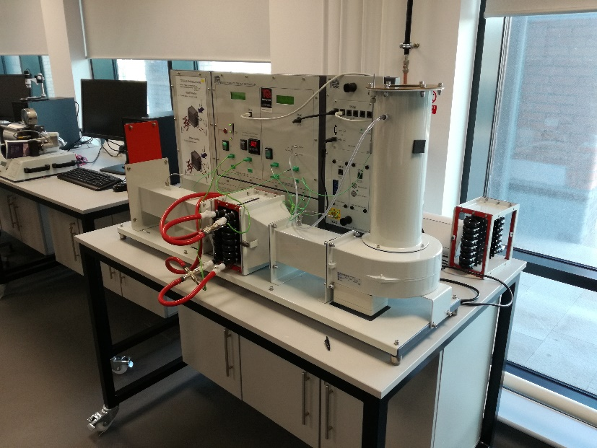
All three experiments have been carried out on 26th of February 2019, in University of Trinity Saint David. The cross-flow heat exchanger used in all experiments was the “TD1007” manufactured by “TecQuipment” as seen in Figure 1. It was set up with the 32 tubes parallel heat exchanger core, where the water inlet was at the bottom and the outlet was at the top of the core. It had an equivalent mean heat transfer area of 0.1558m². The inspected orifice diameter was 100.11mm and the C_{d} was 0.6 (TecQuipment Ltd, 2014). The pressure measurement tolerance was +/-5Pa and the water flow rate tolerance was +/-0.01Lmin⁻¹.
Figure 1: Picture of the used heat exchanger
The recorded measurements were:
- Water temperature at the inlet of the heat exchanger core – Tw1
- Water temperature at the outlet of the heat exchanger core – Tw2
- Air temperature at the inlet of the heat exchanger core – Ta1
- Air temperature at the outlet of the heat exchanger core – Ta2
- Ambient air temperature, which probe was located at the inlet of the duct connected inlet of the fan – Ta3
Spreadsheets were created to calculate all of the required values used in this report. The spreadsheets can be looked at in Appendix A. All of the equations used came from the “Water to Air Heat Exchangers: User Guide” (TecQuipment Ltd, 2014). The C_{p} of water, air and water densities were estimated by using equations 7, 8 and 9, from the same book, as it was believed to have higher accuracy than a graph reading.

Experiment 1: Varying Water Flow Rate

Objective
To observe the effects on the heat exchanger performance, by varying water flow rate, when air flow and water temperature are held constant.

Procedure
- The ambient pressure was measured.
- The heater tank was set to 60°C.
- The fan was turned on.
- The slide valve at the outlet of the air track is manipulated to set a pressure drop of 250Pa.
- The water pump was turned on.
- The water valve was manipulated to set the water flow rate to 2.25Lmin⁻¹.
- The heat exchanger was timed to 5min before taking a reading.
  - The water and air flow rates have been closely monitored at all times and adjusted accordingly.
- The procedure was repeated for water flow rates of 1.75 Lmin⁻¹, 1.25 Lmin⁻¹, 0.75 Lmin⁻¹ and 0.25 Lmin⁻¹.

Analysis

Chart 1

Figure 2: Experiment 1 – Heat Emitted & Absorbed Graph
Figure 2 shows that the power transfer increases as the water flow rate increases. This is because, more molecules are introduced per second to the heat exchanger, which increases the total heat input into the core.
The high ∆Q̇ at high flowrates suggests an alternate heat source such as, the duct walls which could have been conducting heat from the core or friction between the air and the duct which converted kinetic into thermal energy. However, as the error bars show that the tolerance of the conducted experiment wasn’t accurate enough, causing both error ranges of Q̇a and Q̇w to be inside of each other. This is believed to be the reason behind the ∆Q̇ fluctuations. Nonetheless, the relatively small ∆Q̇ results in the energy balance coefficient being relatively low, the calculated average was 104.2%. It is believed that an average value is the best representation due to the previously mentioned fluctuations and the probable cause.
The average of Q̇a and Q̇w flattens out at higher water mass flow rates, this suggests that the heat transfer is at or is close to being optimal.

Chart 2

Figure 3: Experiment 1 - Temperature Efficiencies Graph
Figure 3 shows that water efficiency decreases and the air efficiency increases with flow rate, but at a much lower rate compared to water. Since the water efficiency is much greater than the air efficiency, the mean efficiency follows the same trend as the water efficiency, but at a much lower level as well as rate.
The efficiency of the water circuit is much greater at lower water mass flow rates, this is due to much higher temperature drops. Which is caused by the fact that water molecules spend more time in the heat exchanger core at lower flow rates, giving the air molecules more time to conduct the heat away from the water molecules. Additionally, as the Figure 2 shows, the total thermal power input into the core is lower at lower flow rates, resulting in less heat rate (Power) required to decrease the temperature of the water. However, bigger temperature drop in the water circuit also means that there is less available heat which could be transferred to the air circuit, causing the increase of the air temperature to be smaller and as such, causing the efficiency to be also lower, than at higher flow rates.

Chart 3

Figure 4: Experiment 1 – Heat Transfer Coefficient Graph
Figure 4 shows that the overall correlation between the heat transfer coefficient and water mass flow rate is positive when the error bars are considered. Unexpectedly, Figure 4 shows little correlation with Figure 2 as the rate of U (heat transfer coefficient) at low water mass flow rates is minuscule compared to the rate of change of thermal power shown in Figure 2. Furthermore, at high water flow rates, the rate of U is negative whereas the mean of thermal power at the same flowrates is still positive. This has happened as the LMTD or the “heat driving force” has increased with water flow rate, causing a decreased in U, as the equation 18 in the “Water to Air Heat Exchangers: User Guide” (TecQuipment Ltd, 2014) shows.

Experiment 2: Varying Air Flow Rate

Objective
To observe the effects on the heat exchanger performance, by varying the air flow rate, when water flow and water temperature are held constant.

Procedure
- The heater tank was set to 60°C.
- The fan was turned on.
- The slide valve at the outlet of the air track is manipulated to set a pressure drop of 250Pa.
- The water pump was turned on.
- The water valve was manipulated to set the water flow rate to 0.25Lmin⁻¹.
- The heat exchanger was timed to 5min before taking a reading.
  - The water and air flow rates have been closely monitored at all times and adjusted accordingly.
- The procedure was repeated for pressure drops of 200Pa, 150Pa, 100Pa, 50Pa.

Analysis

Chart 1

Figure 5: Experiment 2 - Heat Emitted & Absorbed Graph
Figure 5 shows a positive correlation between the air mass flow rate and the power transfer, which is relatively linear. It also shows that ∆Q̇ is high at low flow rates. This is most likely caused by environmental factors such as steel boundary wall which conducted some of the heat away from the core as well as the air and it transferred it to the surrounding ambient air, effectively acting as a heatsink.
It is clear that the power emitted by water and power absorbed by the air converge as the flow rate increases. This caused the ∆Q̇ to have a negative correlation with the flow rate. It is believed to be caused by more air molecules being able to conduct more heat, which naturally caused the air temperature to increase and as a result, it decreased the available heat which could have been conducted by the steel boundary wall. Both phenomena caused the energy balance coefficient to increase with flow rate, from 71.4% to 103.7%.
At high flow rates, the air is absorbing 13.8W more than the water is emitting. This has most likely been caused by air collecting heat from the heat-soaked boundary wall as well as other smaller processes such as friction between the air and the boundary wall. These kinds of small processes sum up to a bigger effect, causing the ∆Q̇ to be even more negative in Figure 5.
Figure 5 also shows that the rate of air power increases relatively high after 0.0897kgs⁻¹. This cannot be caused by the rate of mass flow rate since at the two instances which this occurs, the average rate of mass flow rate is 0.013kgs⁻¹ as opposed to an average of 0.0189kgs⁻¹ at earlier points. It can also be observed that at instances of the high rate of air power, the error bars of air & water powers are in the range of each other. Making it possible for those points to have achieved 100% ‘real’ energy balance coefficient.
Lastly, both curves show a relatively high gradient throughout the tested range, as opposed to Experiment 1 results. This suggests that the peak heat transfer rate hasn’t been achieved as it would require higher flow rates.

Chart 2

Figure 6: Experiment 2 – Temperature Efficiencies Graph
Figure 6 shows the water efficiency to increase with air mass flow rate, as opposed to air efficiency which decreases as air flow rate increases. The rate of water efficiency increase is greater than the rate of air efficiency decreases, which has caused the mean efficiency to have a positive correlation with the flow rate at the relatively low gradient.

Chart 3

Figure 7: Experiment 2 - Heat Transfer Coefficient Graph
Figure 7 shows a positive and relatively linear correlation between U and air mass flow rate. This makes it clear that the heat exchanger performance increases with the air flow rate.
Since the gradient stays relatively large, when compared to Figure 4, it is believed that the peak heat exchanger performance hasn’t been achieved as it would require higher flow rates, as Figure 5 previously suggested.
Unlike in Experiment 1: Varying Water Flow Rate, Figure 7 shows a correlation with Figure 5, as both resemble similar curve trends. This has happened in this experiment as the LMTD stayed relatively constant: range of 2K as oppose to 10.8K in experiment 1. Making the power emitted by water have a much greater effect on U.

Experiment 3: Varying Water Temperature

Objective
To observe the effects on the heat exchanger performance, by changing the water supply temperature when water flow is held constant.

Procedure
- The heater tank was set to 45°C.
- The procedure from Experiment 2 was repeated.

Analysis

Chart 1

Figure 8: Experiment 3- Heat Emitted & Absorbed Graph
Figure 8 shows that both driving forces of 60°C & 45°C produce very similar curve trends: both have positive as well as linear correlation with the air mass flow rate. In addition, the gradient of each line at different driving forces is so similar, that when the error bars are taken into consideration, it can be concluded that they are the same. Due to the similarity of the results from Experiment 2, the same conclusion can be made. Which is that more flow rate was required to achieve the peak heat transfer rate.
It can also be observed that the difference between the Q̇w @60°C & Q̇w @45°C is increasing with the flow rate. However, this happens at such low rate that it shouldn’t be definitely concluded, as the error bars show, the difference isn’t great enough to move outside of the accuracy of both curves. On the other hand, it is clear that the difference between Q̇a @60°C & Q̇a @45°C increases with flow rate, the rate at which this occurs increases substantially past 0.0897kgs⁻¹. This suggests that the Q̇a @60°C is either a statistical or environmental anomaly.
Lastly, Figure 8 shows that ∆Q̇ @60°C & ∆Q̇ @45°C follow similar trends, but at different levels. Suggesting that the extra driving force helps the water to emit more heat, like expected. However, at 0.0897kgs⁻¹ ∆Q̇ @60°C clearly decreases at a fast rate. This suggests that the extra temperature causes the boundary wall to heat soak, whereas @45°C this doesn’t happen, as the ∆Q̇ @45°C follows much more linear trend throughout the measured flow range.

Chart 2

Figure 9: Experiment 3 - Temperature Efficiencies Graph
Figure 9 shows that the temperature efficiencies are the same, despite changing the driving force, when the accuracy range is considered. This suggests that: Firstly, the heat transfer rate will linearly scale with the driving force. Secondly, the increase in air flow rate increases the overall efficiency of the heat exchanger.
However, as Figure 9 shows, the nw @60°C falls short of the nw @45°C. This also suggests that the higher the driving force the lower the air flow rate at which peak efficiency occurs.

Chart 3

Figure 10: Experiment 3 - Heat Transfer Coefficient Graph
Figure 10 shows that U (heat transfer coefficient) is not affected by the driving force, as U @45°C & U @60°C have the same result considering the accuracy range. This suggests that U will improve as the air flow rate is increased at any driving force. However, it is acknowledged that a difference of 15°C is not great enough to support this conclusion at much different driving force levels.

Conclusion (400)
To conclude, the results of the laboratory experiment made the following clear:
- The increase of air and water mass flow rate increases the heat transfer rate at a relatively predictable rate.
- The increase in water flow rate causes the heat exchanger efficiency to increase. However, it doesn’t affect U.
- The increase of air flow rate causes U to increase at a linear rate. However, it has a minuscule effect on the heat exchanger efficiency.
- Driving force has a strong effect on the heat transfer rate. However, it doesn’t affect efficiency or U.
The author believes that all of the mentioned points have proven the established expectations prior to the laboratory experiment. However, the author was surprised by the ‘selectiveness’ of the effects that the flow rates had on U & heat exchanger efficiency.
Overall, experimental results have been deemed ‘successful’ since they followed expected trends.
To improve the experiment, it is believed that the following should be considered:
- Most importantly, the experiment should be conducted at least 4 more times to eliminate the statistical error.
- The ambient pressure should be recorded each time the other measurements are being recorded.
- The steel boundary wall temperature should be monitored and recorded. This is to allow the ‘heat sink’ effect to be accounted for.
  - The system could also be insulated.
- To calculate the heat exchanger efficiency the enthalpy should be considered instead of just temperature. As the specific heat at constant pressure changes based on the pressure and temperature at a different rate for each different fluid.
- The tolerance of the results should be improved to preferably: +/-1Pa for the ambient pressure reading, +/-0.001Lmin⁻¹ for water flow rate and +/-0.005K for the fluid temperature reading. This improvement would greatly decrease the inaccuracy of all results, especially the power emitted and absorbed, by 90.0%.
To improve the heat exchanger performance the following was recommended by the author:
- Make a ‘multi-pass’ modification which will allow the water to circulate the heat exchanger core for longer.
- Convert from cross-flow to counter-flow since that design is more efficient.
- Increase the area by making the tubes longer and/or by adding an extra row of tubes.
- Increase U by changing the material and/or increasing the air flow rate.
- Increase water flow rate to increase the heat transfer rate directly.
- Increase the driving force to increase the heat transfer rate directly.

References
TecQuipment Ltd, 2014. Water to Air Heat Exchangers: User Guide. s.l.:s.n.

Appendices

Appendix A
This is the file which contains the spreadsheets with all calculations that have been carried out for this report.

