
Programme | MSc Public Health and Social Care in Practice
Module: | Practice-Based Research
Module code | LCHS7008
Lecturer | Dr Diola Bijlhout
Assignment Title | Component 2 Written Research Proposal
Student ID | 2435003
Student Name | MEETKUMAR SANGANI
Word count | 2623

Table of Contents
1. The prevalence of the problem(s) identified in the area of health and/or social care 3
Problem Statement 3
2. Introduction, including a literature based background of the study 4
3. Rationale & Research Question/Aims/Objectives 5
3.1 Rationale 5
3.2 Question 7
3.3 Aim 7
3.4 Objectives 7
4. Research methodology section 8
4.1 Conceptual Framework 8
4.2 Research Design 9
4.3. Materials/Data Collection Method(s)/procedure 9
4.4. Proposed data analysis technique 11
5. Ethical considerations 11
6. Implication of research 12
7. Plan of Work and Time Schedule 12
8. Reference list 14

Title of the proposed research: Self-management of Type 2 diabetes among older adults attending primary care in UK: challenges and adherence

1. The prevalence of the problem identified in the area of health and/or social care

Problem Statement
Type 2 Diabetes (T2D) is a significant challenge facing the UK older adults due to inequitable primary and social care. The prevalence rate of this issue is approximately 8.2% in the UK, where mainly older adults are facing this issue due to the overconsumption of sugar, ageing, lack of healthcare access and lack of exercise (Stewart, 2026).
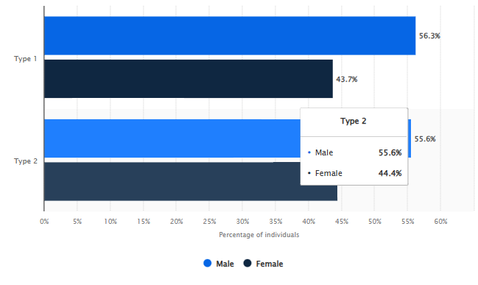
Figure 1: Prevalence rate of diabetes in England by gender
(Source: Stewart, 2026a)
It has been found that 55.6% male and 44.4% of females are suffering from the health burden (Stewart, 2026a). Therefore, social education and care are essential in decreasing the prevalence rate of T2D among UK older adults. Moreover, it has been seen that 9 in 10 older adults are suffering from these long-term conditions (T2D) due to many different causes, including overweight, high blood pressure, and genetic issues (Age UK, 2026). Overall, diabetes affects 3.3 million people in the UK as of now, and it creates a significant economic and health burden (Seidu et al., 2025). Furthermore, it is expected to increase and reach 4.2 million people by 2030 (NHS. England, 2026), which highlights a gap in primary care support in the UK. Therefore, providing an equitable and easy access to prevent this disease is essential in the UK to reduce the prevalence rate and the risk of developing T2D through self-management.

2. Introduction, including a literature based background of the study
Type 2 diabetes (T2D) is a form of diabetes which happens due to the inability of the body to produce enough insulin, leading to higher sugar levels in the blood. The disease can be fatal for old aged individuals as it can damage the heart, nerves, kidneys and eyes (MayoClinic, 2026). In the older adults of the UK, type 2 diabetes has greatly increased in previous years, as it is found that between 2023-24, 44.1% of type 2 diabetes registered patients in the UK were aged between 40-64 years (Stewart, 2026).

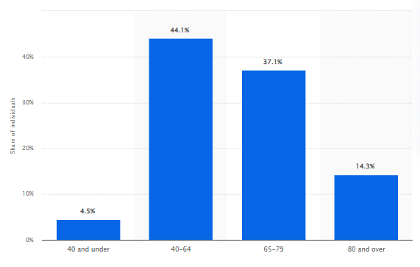
Figure 2: Individuals affected with diabetes in England between 2023-24
(Source: Stewart, 2026b)
Additionally, it is identified that the care process is crucially important for type 2 diabetes aged patients, as the lack of primary care can cause long-term complications in their health (Nikpour et al., 2022). In this context, it is found that the care of type 2 diabetes patients in the UK has increased from 48.9% to 54.3%, indicating the sincerity of the UK government in handling diabetes patients (GOV.UK, 2025). Moreover, the improvement in the care processes of the disease also indicates the need for self-management in handling type 2 diabetes, as it can be helpful to reduce the severity of the disease. In this context, Maina et al. (2023), found that self-management is crucial for T2DM patients to improve their quality of life through glycaemic control. The author found four practices for effective self-management of the disease, such as acquisition of diabetes-related knowledge, essential skills to manage T2DM, such as self-monitoring of blood glucose, lifestyle modification and availability of psychological support and follow-up. These factors are crucial, as they help to reduce complications in the disease. Additionally, from this perspective, Alliston et al. (2024), cited that the self-management of diabetes is helpful for improving the patient’s knowledge and behaviour. Simultaneously, it is beneficial for improving the health outcomes such as reduced weight, BMI and glycemic control.
However, Hanlon et al. (2021), opined that the self-management of type 2 diabetes varies from person to person, as the capacity of the patient in managing their condition is heavily influenced by the mental or physical morbidity, financial issues, and others. The self-management of T2D is significantly associated with diminished socio-economic status. People with major psychological illnesses are more likely to develop T2D, compared to psychologically healthy people, due to a lack of knowledge of self-management (Hanlon et al., 2021). Furthermore, in the UK, 42.5% of individuals have faced difficulties in maintaining their glucose control due to the lack of self-management capabilities (Sauchelli et al., 2021).
From the lens of the biopsychosocial model, the daily monitoring of blood glucose may lead to fatigue as a biological factor (Fritschi et al., 2020). Additionally, the distress about managing their condition leads to depression and anxiety, leading to reduced motivation and psychological burden (Owens-Gary et al., 2019). Lastly, the lower socioeconomic status is found to be challenging as changing the diet from cheap food to healthy ones is complex due to the lack of financial support as a social factor (Woodward et al., 2024).
Moreover, prior studies like Maina et al. (2023) and Hanlon et al. (2021) are excellent at describing the importance and burdens of the self-management of T2D. However, they lack in describing what barriers are faced by UK older adults while attending primary care to self-manage T2DM. Also, there is limited evidence on how to overcome these barriers to effectively self-manage to mitigate disease severity. These aspects will be covered in the future research, which will be helpful for the UK older adults in the primary care settings.

3. Rationale & Research Question/Aims/Objectives

3.1 Rationale
Type 2 Diabetes (T2D) is a non-communicable disease, which damages the kidneys, heart, nerves and eyes over time and increases economic and health burden in low-middle income populations (Zhang et al., 2025). The prevalence rate of T2D is significantly rising in the UK, which disproportionately affects low-income urban populations due to poor education regarding dietary habits, limited access to blood glucose monitoring, and limited access to preventive healthcare. Manchester is mainly an urban area of London, and the diabetes prevalence rate is higher in urban areas, such as 7.80% in England, as compared to rural areas, 7.24% (Mason et al., 2022).
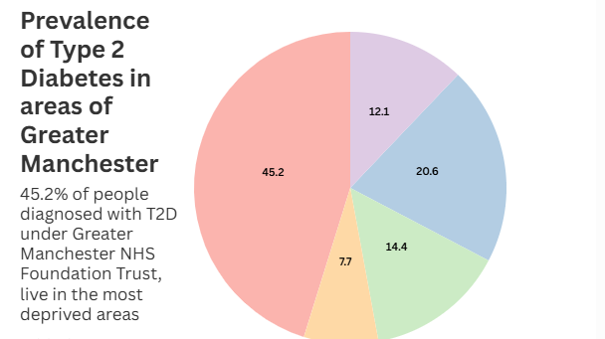
Figure 3: Prevalence of Type 2 diabetes of Greater Manchester
(Source: Macunian Matters, 2025)
45.2% people in Greater Manchester are facing this T2D issue (Macunianmatters, 2025), which needs to be addressed through social care and preventive primary healthcare support. Existing research showcases that UK governance spends around £10 billion a year on diabetes to prevent its prevalence rate (NHS England, 2022), and NHS provides Diabetes Prevention Program (NHS DPP) (NHS, 2026), which aims to empower people with high risk of developing type 2 diabetes to bring lifestyle changes including improved diet, weight loss and increasing physical activity, however it is a long-term intervention approximately requires nine-month, which requires long-term engagement. Hence, only 20% of people complete 60% of sessions (Hawkes et al., 2020), which is not sufficient to tackle the increasing prevalence rate of diabetes. It has been found that 1 million UK older adults are living with type 2 diabetes and remain undiagnosed due to unequal access to primary care in the UK (Diabetes. UK. 2023). Overall, 1.9 million people in England are unable to receive primary care, which they need to prevent their diabetes and reduce this prevalence rate, which highlights gaps in the equitable primary care system in the UK and increased urgency to provide equitable care support for all people to enhance quality of life. Thus, the research will add value to the existing research by highlighting alternative options to self-manage this disease and identifying gaps in the existing medication for type 2 diabetes. Additionally, increasing the prevalence rate of T2D is also a rationale for introducing a proactive strategy through research to help in addressing this disease in an early stage through education. The research will be timely to the increasing prevalence rate of the primary care burden due to unequal access to preventive healthcare support.

3.2 Question
What barriers and facilitators do older adults with Type 2 diabetes attending primary care in the UK encounter in carrying out recommended self-management behaviors (diet, physical activity, medication adherence and blood glucose monitoring?

3.3 Aim
To explore older adults (aged 45+) perceptions of factors that hinder or support effective self-management of Type 2 diabetes in a primary care setting in the UK.

3.4 Objectives
- To identify how adults with Type 2 diabetes adopt self-management practices (diet, physical activity, medication use, blood glucose monitoring) and explore challenges
- To explore personal, social and health-system barriers that make self-management difficult.
- To explore facilitators and sources of support (e.g. family, education, technology, health professionals) that help patients manage their condition.

4. Research methodology section

4.1 Conceptual Framework
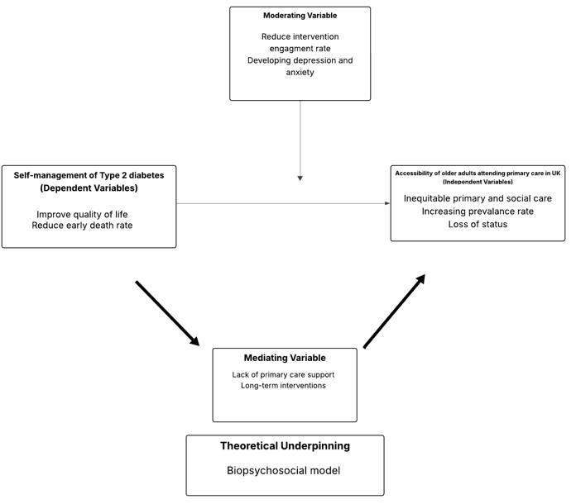
Figure 4: Conceptual Framework
(Source: Self-developed)
The conceptual framework is a valuable framework to identify independent and dependent variables of the research and mediating and moderating variables (Martirosyan et al., 2025). Throughout the study, it has been identified that the biopsychosocial model is effective in supporting regular glucose monitoring of patients with a high chance of developing diabetes in future (Hsiung et al., 2025), which has also been highlighted through this conceptual framework. Various challenges, like lack of primary care access and long-term intervention, are the main root causes of the increasing prevalence rate of this disease, which is leading to anxiety and depression and affects the quality of life of a patient.

4.2 Research Design
This study will use Systematic Literature Review (SLR) for secondary qualitative research, which will help to identify root cause of increasing prevalence rate of T2D and highlight possible solutions to reduce this increasing social and health burden among older adults in the UK (Cabrera and Cabrera, 2023) asserted that SLR is transparent, rigorous and reproducible research method, which helps to identify, synthesize and collect high-quality existing studies to answer main research questions of a specific topic, hence its select to answer what barriers and facilitators do older adults with Type 2 diabetes attending primary care in the UK. Additionally, PEO is a core component of SLR, which is a structured approach to define search terms for specific studies, focusing on Population, Exposure and Outcome; this will focus on how self-management behaviors influence adherence and barriers within the older adults with diabetes in the UK, ensuring all reviewed studies directly address these components.
P (Population): Older adults with Type 2 Diabetes in UK primary care.
E (Exposure): Self-management practices (diet, medication adherence, glucose monitoring, lifestyle changes)
O (Outcomes): Challenges faced and levels of adherence to self-management.
“What challenges influence the level of adherence to self-management practices among older adults with Type 2 Diabetes attending primary care in the UK?”

4.3. Materials/Data Collection Method(s)/procedure
Data collection: The study will use a systematic literature review and meta-analysis data collection procedure to find information regarding how many older adults in the UK are suffering from T2D and how they self-manage their conditions. According to Naghib et al. (2025), systematic data collection methods will be selected for finding various reliable and high-quality papers regarding the increasing prevalence of T2D and highlighting its suitable medication. These findings will be structured and aligned with the PRISMA framework to evaluate the final outcomes of the research. This study will adopt a systematic search strategy across databases, including Google Scholar and PubMed. Using the Boolean technique (AND/OR), keywords will include self-management, challenges, adherence, Type 2 diabetes rate, etc. This strategy will help to find existing sources from the study, then screen these collected papers to identify irrelevant papers such as outdated information, papers with only abstracts and incomplete methods and remove them later. In this secondary research method, it is most important for this proposed research to highlight challenges and facilitators that persist within the primary care for older adults in the UK who are suffering from T2D. After screening through the lens of PRISMA, only full-text articles will be selected for the study, which will enhance reliability.
Data sources
To extract data regarding T2D prevalence rate and its impact on the older adults in the UK, the study will use various secondary databases, including Google Scholar, PubMed and ScienceDirect.
Selection Criteria
Search terms
This is a key step to find specific information through specific words, phrases, acronyms and plurals through Boolean Operators to find accurate and relevant pre-established papers (Benjafield et al., 2025) regarding the prevalence rate of T2D in the UK and older adults self-managing their chronic conditions and getting support from the primary care system.
Boolean Operators | AND | “Prevalence rate of T2D” AND “Older adults in UK”, and “UK primary care” AND “self-management”
Boolean Operators | OR | “Anxiety” OR “Depression”, “self-management” OR “self-care” OR “disease management”
Boolean Operators | NOT | “Type 2 Diabetes” AND “older adults” NOT “Type 1 Diabetes”
Table 1: Boolean Operators
(Source: Self-developed)
Time Frame
These articles will be published within the last 10 years, which focus on Type 2 Diabetes patients in the UK and how it occurred due to primary care negligence. These papers will include peer-reviewed journals, only English language papers and explore how T2D is increasing day by day due to a lack of primary care support.
Inclusion and Exclusion Criteria
Criteria | Inclusion | Exclusion
Publication Type | Peer-reviewed journal articles | Non peer-reviewed sources (unpublished manuscripts, blogs)
Text Availability | Full-text article | Only with abstract
Methodology | Qualitative and Quantitative (Empirical research)  Systematic Literature Review paper | Thesis paper, and Doctoral dissertations,
Language | English | Non-English
Timeframe | 2016-2026 | Before 2016
Table 2: Inclusion and Exclusion Criteria
(Source: Self-developed)

4.4. Proposed data analysis technique
This research method will use thematic analysis within the secondary qualitative data regarding the T2D prevalence rate in the UK older adults. According to Demers et al. (2025), secondary qualitative analysis helps in deriving in-depth information from the various established sources; however, it is unable to collect and put practical experiences from the participants. Through this qualitative research, the root cause of T2D and its prevalence rate, its symptoms, and primary care support in the UK will be derived and meaningful outcomes will be made within the research. Thus, thematic analysis will be beneficial for the study to derive the interrelationship between self-management of T2D and older adults attending primary care in the UK.

5. Ethical considerations
In this systematic literature review, this research will collect data from the secondary sources, where acknowledging real authors is a must to avoid ethical misconduct. Ethical considerations in the secondary research ensure responsible use of existing data with proper citation while respecting the original context of the data (Ali et al., 2025), which will also be maintained in this research when incorporating data regarding the prevalence rate of T2D among UK older adults. Additionally, this research will avoid misinterpretation or selective bias in theme extraction, which will enhance the reliability and authenticity of the research and produce a meaningful research outcome in an ethical manner.

6. Implication of research
The study aims to demonstrate the impact of primary and social care treatment on the UK older adults with Type 2 Diabetes. This research will add value by highlighting possible solutions to reduce the prevalence rate of Diabetes in the UK within the older adult population. Apart from that, future research findings will highlight gaps in primary care and facilitators for older adults with type 2 diabetes in the UK. Additionally, this research will highlight ideas to improve poor practices within the type 2 diabetes care system within the UK primary care and identify which practices are essential for enhancing the quality of care.

7. Plan of Work and Time Schedule
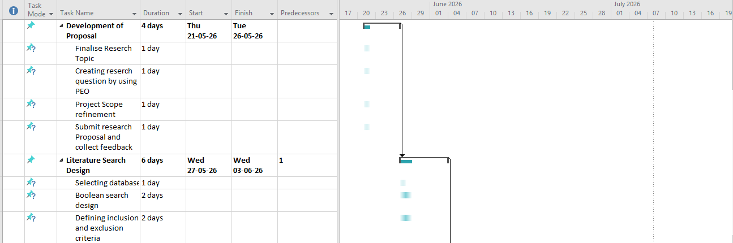
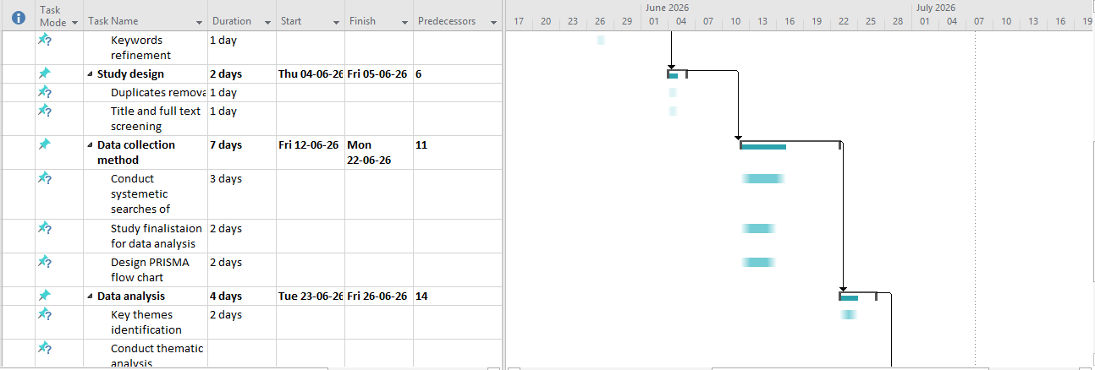

Figure 5: Gantt Chart
(Source: Self-Developed)
This research timeline helps in showcasing a roadmap to frame this project and accomplish this within the deadline. This research gantt chart highlights step-by-step project proposal development, including project proposal development, literature search design, data collection, analysis and final dissertation submission, which helps to meet the expected deadline of the project. According to Sekuloska (2025), this Gantt chart is used as a project management tool to define the duration of the project based on the research and set an expected timeline to meet a strict deadline.

8. Reference list
Age UK. (2026) Diabetes types, symptoms & treatment. Available at: https://www.ageuk.org.uk/information-advice/health-wellbeing/conditions-illnesses/diabetes/ [Accessed: 19 April 2026]
Ali, E.P.S.E., Ndubuisi, O.G., Obiorah, C.A.R., Aku, U.T., Nesiama, O., Agbakhamen, C.O. and Okoro, O.P. (2025) Ethical standards in research: A professional imperative. International Journal of Innovative Scientific & Engineering Technologies Research, 13(1), pp.94-104. Available at: doi:10.5281/zenodo.14875237
Alliston, P., Jovkovic, M., Khalid, S., Fitzpatrick-Lewis, D., Ali, M.U. and Sherifali, D. (2024) The effects of diabetes self-management programs on clinical and patient reported outcomes in older adults: a systematic review and meta-analysis. Frontiers in Clinical Diabetes and Healthcare, 5, p.1348104. Available at: https://doi.org/10.3389/fcdhc.2024.1348104
Benjafield, A.V., Kuniyoshi, F.H.S., Malhotra, A., Martin, J.L., Morin, C.M., Maurer, L.F., Cistulli, P.A., Pépin, J.L. and Wickwire, E.M. (2025) Estimation of the global prevalence and burden of insomnia: a systematic literature review-based analysis. Sleep medicine reviews, 82, p.102121. Available at: https://doi.org/10.1016/j.smrv.2025.102121
Cabrera, D. and Cabrera, L.L. (2023) The steps to doing a systems literature review (SLR). Journal of Systems Thinking Preprints.
Demers, M., Charalambous, M., Kwah, L.K., Thilarajah, S., Bazadona, D., Chapman, S., Nasreldein, A., Yperzeele, L., Amoah, D., Winstein, C. and Bernhardt, J. (2025) Unique needs and challenges experienced by young people with stroke: an international qualitative analysis. Neurology: Clinical Practice, 15(1), p.e200406. Available at: https://doi.org/10.1212/CPJ.0000000000200406 [Accessed: 19 April 2026]
Diabetes. UK. (2023) Too many people with diabetes still not receiving vital care, our new report shows. Available at: https://www.diabetes.org.uk/about-us/news-and-views/too-many-people-diabetes-still-not-receiving-vital-care-our-new-report [Accessed: 19 April 2026]
Fritschi, C., Park, C., Quinn, L. and Collins, E.G. (2020) Real-time associations between glucose levels and fatigue in type 2 diabetes: sex and time effects. Biological research for nursing, 22(2), pp.197-204. Available at: 10.1177/1099800419898002
GOV.UK (2025) Diabetes profile: statistical commentary, March 2025. Available at: https://www.gov.uk/government/statistics/diabetes-profile-update-march-2025/diabetes-profile-statistical-commentary-march-2025 [Accessed: 15 April 2026].
Hanlon, P., Bryson, I., Morrison, H., Rafiq, Q., Boehmer, K., Gionfriddo, M.R., Gallacher, K., May, C., Montori, V., Lewsey, J. and McAllister, D.A. (2021) Self-management interventions for Type 2 Diabetes: systematic review protocol focusing on patient workload and capacity support. Wellcome open research, 6, p.257. Available at: 10.12688/wellcomeopenres.17238.1
Hawkes, R.E., Cameron, E., Cotterill, S., Bower, P. and French, D.P. (2020) The NHS Diabetes Prevention Programme: an observational study of service delivery and patient experience. BMC health services research, 20(1), p.1098. Available at: https://link.springer.com/article/10.1186/s12913-020-05951-7 / [Accessed: 19 April 2026]
Hsiung, K.S., Datye, K.A. and Schlundt, D.G. (2025) Barriers and facilitators to continuous glucose monitor use in type 1 diabetes: A biopsychosocial model of the adolescent experience. Health Psychology Open, 12, p.20551029251408544. Available at: https://doi.org/10.1177/20551029251408544
Maina, P.M., Pienaar, M. and Reid, M. (2023) Self-management practices for preventing complications of type II diabetes mellitus in low and middle-income countries: A scoping review. International Journal of Nursing Studies Advances, 5, p.100136. Available at: https://doi.org/10.1016/j.ijnsa.2023.100136
Mancunian Matters (2025) Most people with Type 2 Diabetes in Greater Manchester live in the most deprived areas, data reveals. Available at: https://www.mancunianmatters.co.uk/lifestyle/29052025-most-people-with-type-2-diabetes-in-greater-manchester-live-in-the-most-deprived-areas-data-reveals/ [Accessed: 19 April 2026]
Martirosyan, A., Ilyushin, Y., Afanaseva, O., Kukharova, T., Asadulagi, M. and Khloponina, V. (2025) Development of an oil field’s conceptual model. Available at: https://www.researchgate.net/profile/Yury-Valeryevich-Ilyushin/publication/386373143_Development_of_an_Oil_Field's_Conceptual_Model_Graphical_Abstract/links/674f05493d17281c7df6c9c7/Development-of-an-Oil-Fields-Conceptual-Model-Graphical-Abstract.pdf
Mason, T., Whittaker, W., Dumville, J.C. and Bower, P. (2022) Variation in appropriate diabetes care and treatment targets in urban and rural areas in England: an observational study of the ‘rule of halves’. BMJ open, 12(2), p.e057244. Available at: https://doi.org/10.1136/bmjopen-2021-057244
MayoClinic (2026) Type 2 diabetes. Available at: https://www.mayoclinic.org/diseases-conditions/type-2-diabetes/symptoms-causes/syc-20351193 [Accessed: 15 April 2026].
Naghib, A., Gharehchopogh, F.S. and Zamanifar, A. (2025) A comprehensive and systematic literature review on intrusion detection systems in the internet of medical things: current status, challenges, and opportunities. Artificial Intelligence Review, 58(4), p.114. Available at: https://doi.org/10.1007/s10462-024-11101-w
NHS (2026) Treatment for type 2 diabetes. Available at: https://www.nhs.uk/conditions/type-2-diabetes/treatment/ [Accessed: 19 April 2026]
NHS England. (2022) NHS Prevention Programme cuts chances of Type 2 diabetes for thousands. Available at: https://www.england.nhs.uk/2022/03/nhs-prevention-programme-cuts-chances-of-type-2-diabetes-for-thousands/ [Accessed: 19 April 2026]
NHS England. (2026) Diabetes treatment and care programme. Available at: https://www.england.nhs.uk/diabetes/treatment-care/ [Accessed: 19 April 2026]
Nikpour, S., Mehrdad, N., Sanjari, M., Aalaa, M., Heshmat, R., Mafinejad, M.K., Larijani, B., Nomali, M. and Ghezeljeh, T.N. (2022) Challenges of type 2 diabetes mellitus management from the perspective of patients: conventional content analysis. Interactive journal of medical research, 11(2), p.e41933. Available at: 10.2196/41933 [Accessed: 15 April 2026].
Owens-Gary, M.D., Zhang, X., Jawanda, S., Bullard, K.M., Allweiss, P. and Smith, B.D. (2019) The importance of addressing depression and diabetes distress in adults with type 2 diabetes. Journal of general internal medicine, 34(2), pp.320-324. Available at: 10.1007/s11606-018-4705-2
Sauchelli, S., Bradley, J., England, C., Searle, A. and Whitmarsh, A. (2021) Exploring support needs of people living with diabetes during the coronavirus COVID-19 pandemic: insights from a UK survey. BMJ Open Diabetes Research & Care, 9(1).
Seidu, S., Tetteh, J., Kunutsor, S., Choudhary, P., Khunti, K. and Ajjan, R.A. (2025) Prescription distribution and inequities in diabetes care: A comparative analysis of continuous glucose monitoring access by diabetes status, ethnicity and socio‐economic factors in England. Diabetic Medicine, 42(11), p.e70130. Available at: https://doi.org/10.1111/dme.70130
Sekuloska, F.M.J.D. (2025) Increasing Project Efficiency by Utilizing Project Management Software & Gantt Charts. Preface to Volume 5 Issue 2 of the Journal of University of Information Science and Technology “St. Paul the Apostle”–Ohrid, 5(2), p.5. Available at: https://journal.uist.edu.mk/wp-content/uploads/2025/11/Journal-of-UIST-Vol-5_2_2025.pdf#page=5
Stewart, C. (2026) Individuals with diabetes in England and Wales 2023/24, by type. Available at: https://www.statista.com/statistics/386742/individuals-with-diabetes-by-type-in-england-and-wales/?srsltid=AfmBOop5JvoVe2b-Vy6yhZ9ocYDtJOA2F5Vd0bEI1T7H-BbWft2nevbj [Accessed: 19 April 2026]
Stewart, C. (2026a) England: distribution of people with diabetes 2023/24, by gender. Available at: https://www.statista.com/statistics/387302/individuals-with-diabetes-by-gender-in-england/?srsltid=AfmBOop29xA84tzBwjEB8NS-0QPzNrhLBDa8R9ub-Gagm6W_1X54JclP [Accessed: 19 April 2026]
Stewart, C. (2026b) England: distribution of individuals with type 2 diabetes 2023/24, by age. Available at: https://www.statista.com/statistics/387343/individuals-with-type-2-diabetes-by-age-in-england/?srsltid=AfmBOorETU9LrEYF5GC5xw-mB0YiIkHKZS3_9m3cBROX7RlrylPI2tOf [Accessed: 15 April 2026].
Woodward, A., Walters, K., Davies, N., Nimmons, D., Protheroe, J., Chew‐Graham, C.A., Stevenson, F. and Armstrong, M., 2024. Barriers and facilitators of self‐management of diabetes amongst people experiencing socioeconomic deprivation: a systematic review and qualitative synthesis. Health Expectations, 27(3), p.e14070. Available at: 10.1111/hex.14070
Zhang, M., Coppell, K., Lo, J. and Whitehead, L. (2025) Cultural influences, experiences and interventions targeting self‐management behaviours for prediabetes or type 2 diabetes in first‐generation immigrants: A scoping review. Journal of advanced nursing, 81(6), pp.2929-2945. Available at: https://doi.org/10.1111/jan.16621

