N/A

Student Name: Nazreen Akhtar
Student Number: 2128933
Module Code: LCHS7009
Module Title: Population Health and Digital Health Promotion
Lecturer Name: Besty Jose

Impact of Assistive Technology Apps on People with Autism
Assignment Title: Component 1 (2 Blogs)
Nazreen Akhtar

Different Not Less

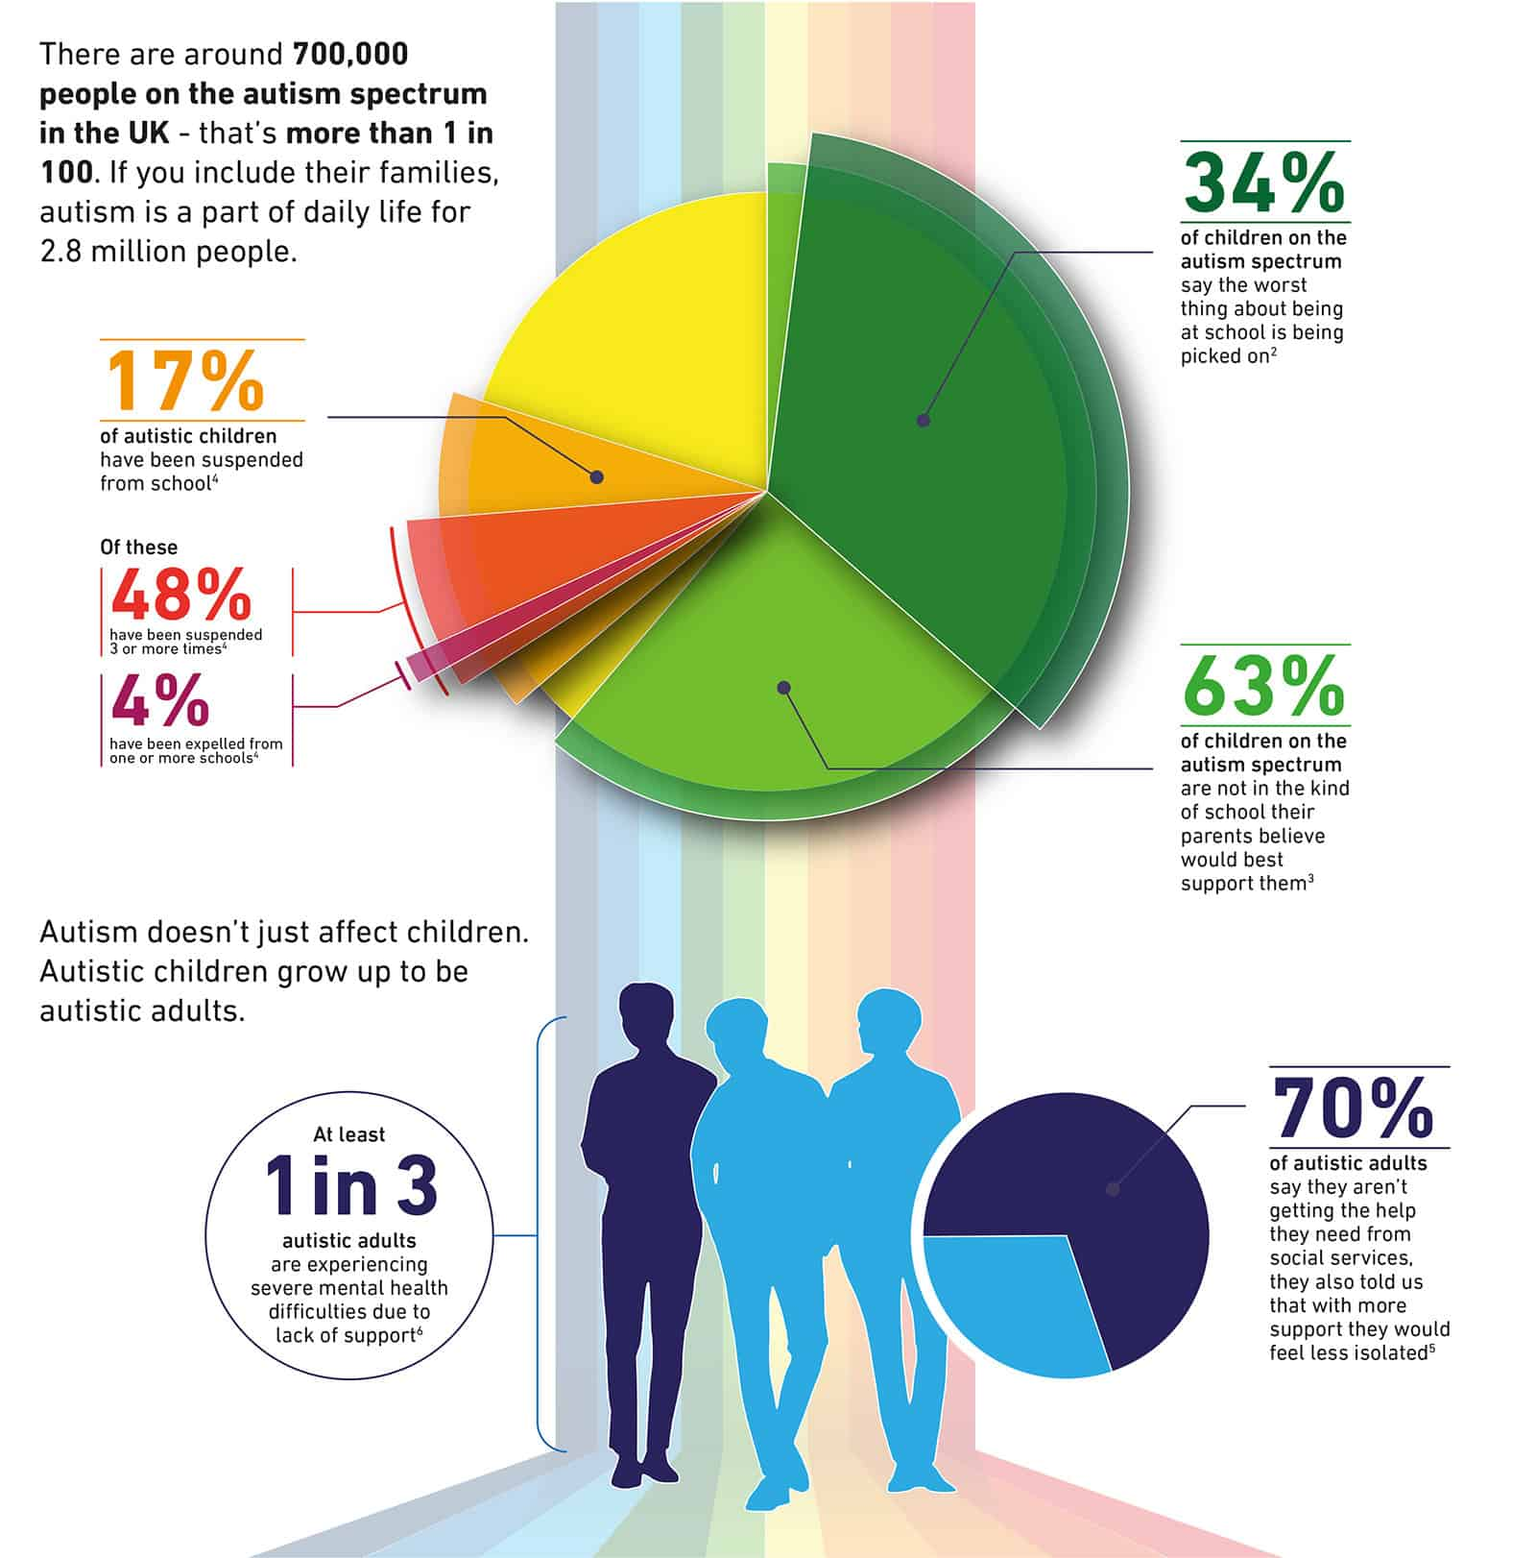
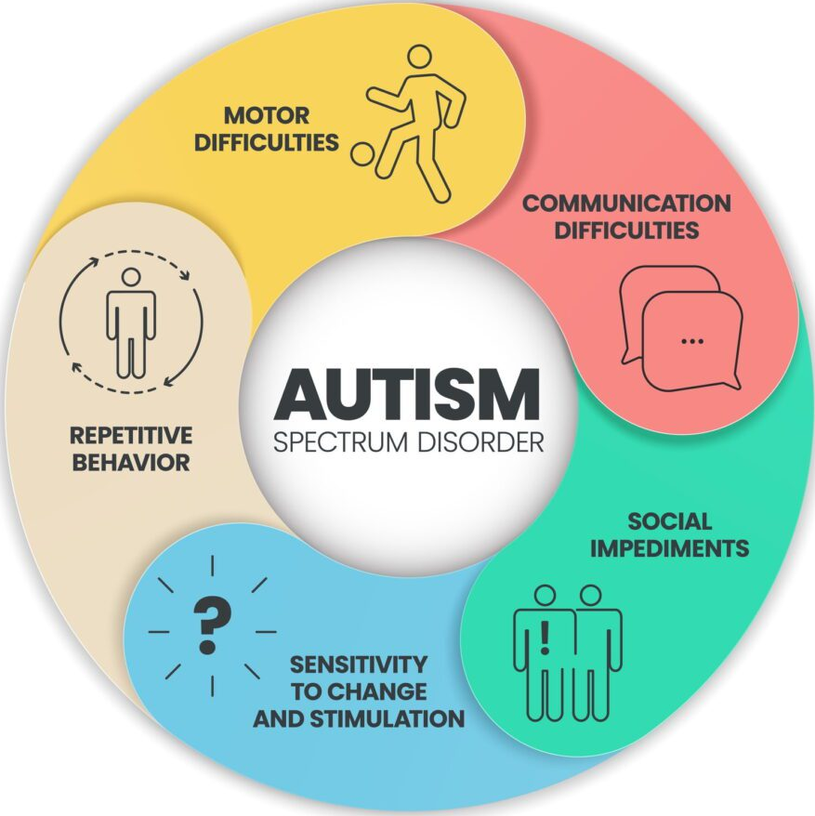
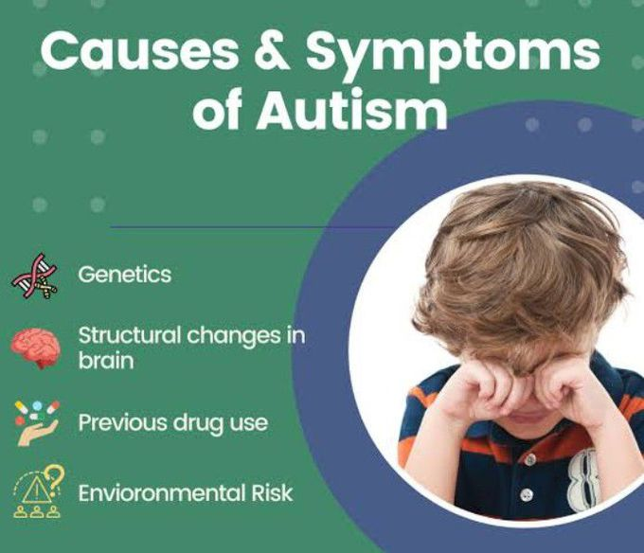
Autism, often known as Autism Spectrum Disorder, is a broad category of disorders affecting how the brain develops. About 1 in 127 people had autism in 2021 (WHO, 2023). Being autistic indicates that your brain functions differently from other people (NHS, 2022). Approximately 80% of individuals with autism will have a mental health issue (Joseph, 2024). Anxiety is one of the pertinent issues and mostly caused by social and environmental factors that autistic people experience and sensory overloading environments (Hull et al., 2017).
(Autism UK ,2018)

(Medizzy,2023)

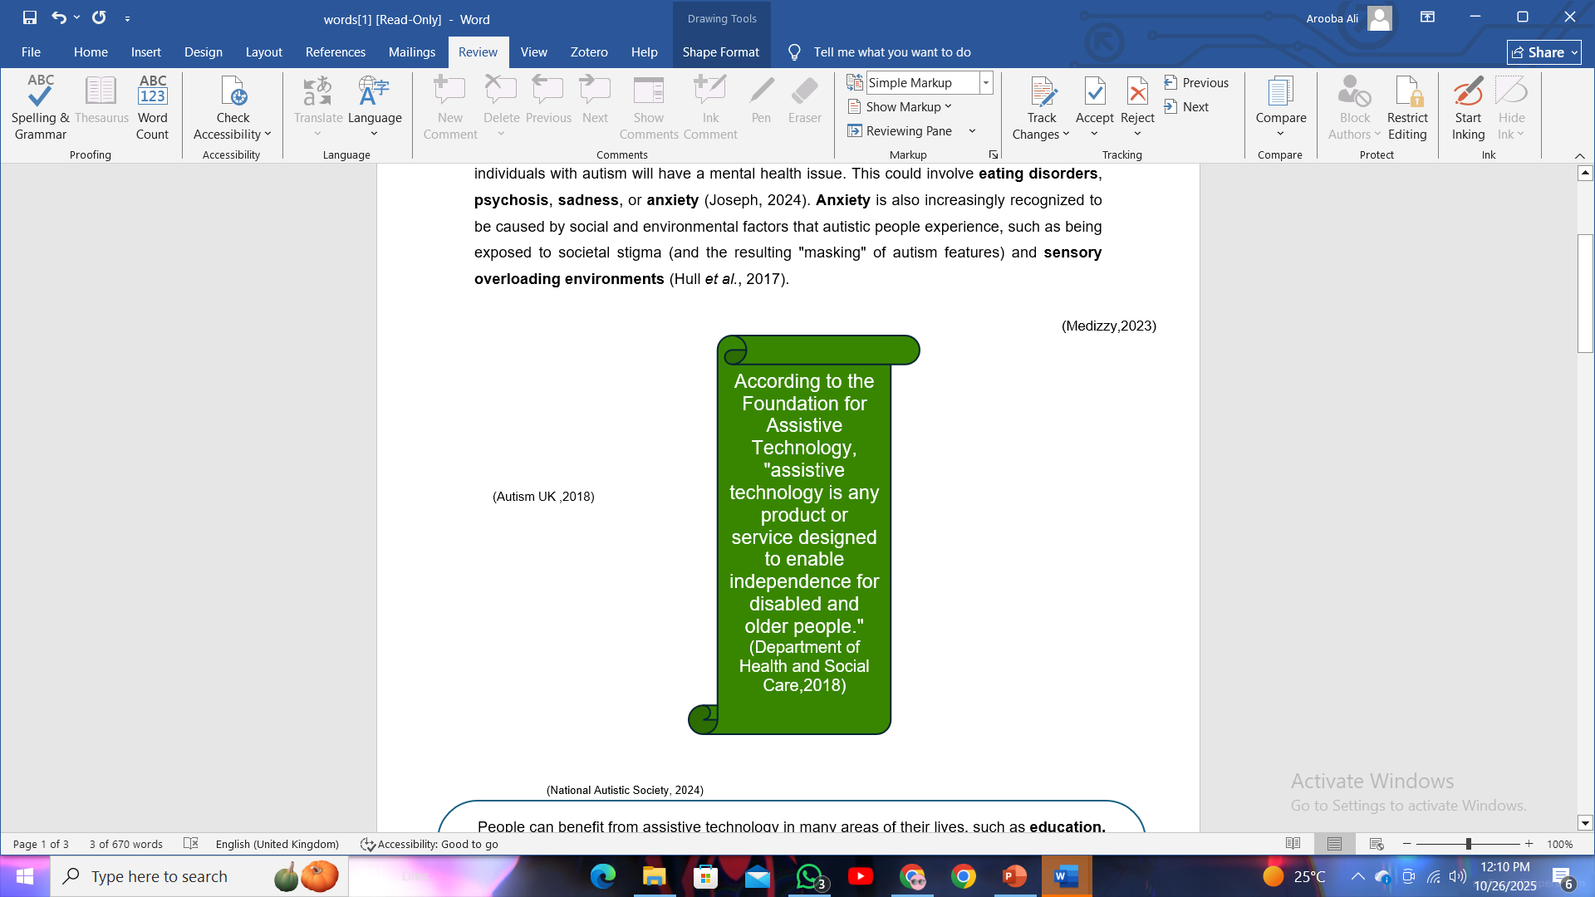
(National Autistic Society, 2024)

Blog 1:

Molehill Mountain – An App to Help Autistic People with Anxiety
People can benefit from assistive technology in many areas of their lives, such as education, work, exercise, leisure, and other daily tasks. In order to fulfil the Convention on the Rights of Persons with Disabilities, and achieve the Sustainable Development Goals, it is imperative that the unmet need for assistive devices be addressed. "Leaving no one behind" refers to making sure that everyone who requires assistive technology, including those with disabilities, the elderly, and those afflicted by chronic illnesses, can enjoy a healthy and respectable life (World Health Organization, 2024).

Molehill Mountain – An App to Help Autistic People with Anxiety

Anxiety disorders are diagnosed in 2 out of 5 autistic individuals that interfere with their daily lives (Autistica, 2024). Autistica and King's College London collaborated to create the "Molehill Mountain" app. Using a participatory study design and NICE-recommended modified cognitive behavioural therapy techniques, the app-based anxiety intervention was created especially for individuals with autism (Oakley et al., 2023).
(Integrate! Network, 2024)

How it works:
Molehill Mountain allows users to quickly check in every day to track their worries and emotional state. Molehill Mountain, an activity intended to detect and record any concerns, is played when the user opens the app. After finishing the task, the user will receive a daily advice regarding autism and anxiety. After answering three easy questions about their day, the user is offered the opportunity to supplement their daily journal with more context. Through a dashboard, the user examines their statistics, advice, and journal entries while tracking their progress in Molehill Mountain at each check-in (Bisson, 2016).
Advantages:
People with autism can benefit greatly from assistive technologies. They help people enhance social connections, cope with anxiety issues, facilitate learning, and foster independence (Iannone and Giansanti, 2023).
- The App allows to monitor mood and see how it changes over time using calendars and graphs.
- Support is available if having trouble identifying emotions.
- To avoid feeling overpowered, "unlock" each of the app's features and advice one at a time.
- Try a breathing technique, add a specific emergency contact, and "lock" stress in "worry mountain." are some of the features the App offers (NHS,2023).
Disadvantages:
- One of the main sensory problems with mobile assistive devices is touchscreen sensitivity (Deng and Rattadilok, 2022).
- Another issue is fine motor skill deficits, since people with ASD may find it challenging to use touchscreens and other mobile device input methods efficiently (Noureddine, 2024).
- Issues like security and ethics must be taken into account before developing any complex program to assist those with ASD (Rehman et al., 2021).

Recommendations To Address Shortfalls:
The innovation of assistive technologies for autism opens up revolutionary potential. Researchers are now focusing more on development than focusing on problems like acceptability and regulation (Iannone and Giansanti, 2023). Data management, privacy, access and usability, risks and rewards, and ethical considerations must all be taken into account when choosing and deploying technologies in the digital health ecosystem. Although new technologies have the potential to be very beneficial, they could also make health inequities among the most disadvantaged worse if they are not carefully vetted (Nebeker, Torous and Bartlett Ellis, 2019).

Blog 2
NutriNeuro A Supporting Assistive Tool for Eating Difficulties in Children with Autism
The Problem:
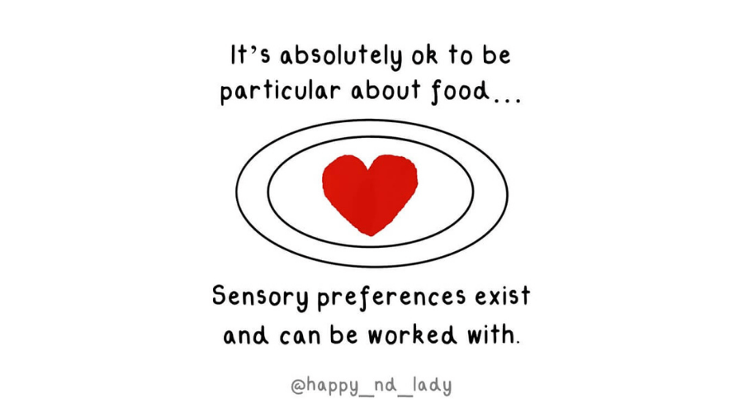
Eating and feeding difficulties are common and impact people with autism (Baraskewich et al., 2021). Certain individuals with autism may have highly specific dietary needs. Some autistic individuals follow ritualistic eating habits or have strong dietary preferences (Autistica, 2024).
Our body uses interoception, an internal sense, to notify when we are hungry, thirsty, in pain, or need to use the restroom. These messages may be difficult for autistic persons to understand. As a result, persons with autism may eat less or even too much (NHS, 2025). Problems with feeding not only affect a child’s health but can also negatively affect other prospects as well. Finding suitable solutions to their child's feeding issues that address not only feeding issues but also issues with mealtime participation, socialization, and communication facilitation is a challenge for many families and healthcare professionals (Adams, 2022).
(Ambitions About Autism, 2017)

Approximately 70% of children with autism exhibit "atypical" eating behaviours (Autistica, 2024).

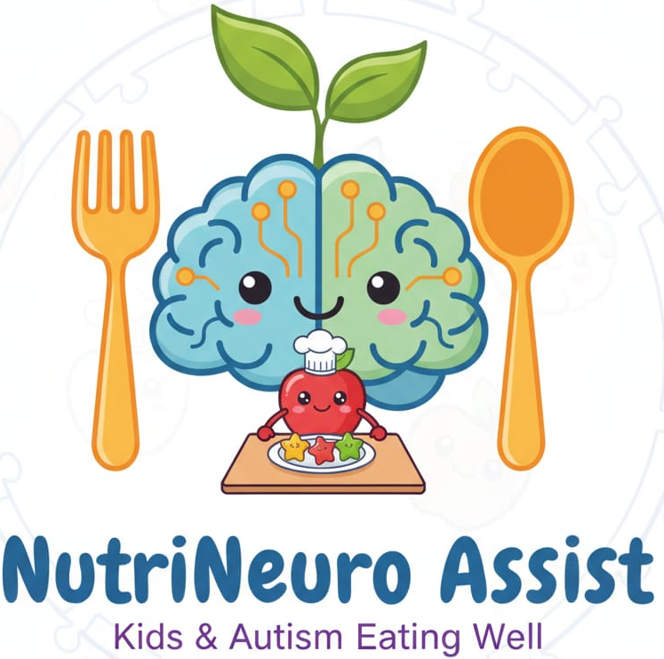
Solution:
NutriNeuro is a mealtime assistive technology helping child living with Autism and have eating difficulties. The App is designed by taking research-based studies on dietary patterns of autistic kids. Food preferences in children with ASD are frequently dependent on factors like temperature, colour, texture, or taste (Nadon et al., 2010). Children with ASD may have very selective food choices due to multiple factors (Sharp et al., 2013), and there should be an assistive tool to target this aspect. In order to teach parents of children with autism spectrum disorder and food selectivity how to implement a home-based treatment package that included taste exposure, escape extinction, and fading, the app focuses on behavioural skills training (Seiverling et al., 2012).
Source: AI Generated (Google, 2025)
The App offers following core features:
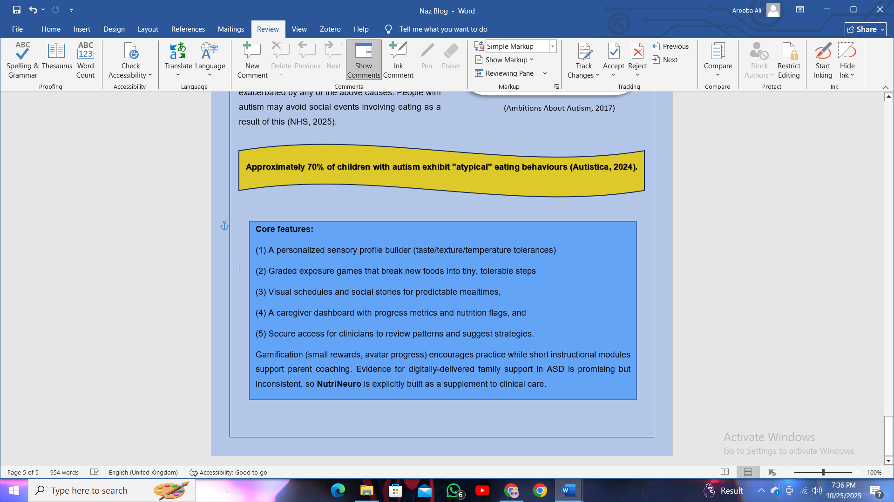

Impact:
- According to Ledford, Whiteside, and Severini (2018), there is strong evidence that medical and behavioural interventions can help children with ASD who exhibit severe food selectivity. NutriNeuro targets individualized reinforcement for trying new foods, hierarchical exposure to non-preferred foods.
- The App helps in gradual and increased food acceptance, and spontaneous requests for new foods by focusing on the behavioural and sensory issues of children with ASD. By taking into account sensory issues (Park et al., 2020), positive reinforcement and making meal time less stressful through gamification and rewards.
- According to (Koegel et al., 2011), the assistive tools which targets the behaviour aspect and sensory sensitivity holistically improve eating patterns in autistic kids. NutriNeuro aims the same impact.

Challenges in Implication and Recommendations:
In a study by Iannone and Giansanti (2023), parents explicitly mention the requirement for a very basic interface in terms of usability. Since the majority of children with ASD lack focus when it comes to completing tasks, every encounter should be interactive in terms of audio, video, images and other prospects. Another prospect of utilizing the full potential of assistive tools like NutriNeuro is integration of behaviour change theories for designing strategies, because food behaviour change is a complicated activity influenced by numerous factors. One popular intrapersonal theory for predicting behavioural intention and conduct is the theory of planned behaviour (TPB) (Hackman and Knowlden, 2014). NutriNeuro and other assistive apps that need a good outcome must focus on behaviour change theories for wider implication.

- Blog 1 Reference list
- Autism UK (2018) Autism Statistics - The Autism Page Autism and SEN in numbers, The Autism Page. Available at: https://www.theautismpage.com/autism-statistics/.
- Autistica (2024) Anxiety and Autism | What Is autism? | Autistica, Autistica. Available at: https://www.autistica.org.uk/what-is-autism/anxiety-and-autism.
- Bisson, R. (2016) Molehill Mountain – an app to help autistic people with anxiety | Website archive | King’s College London, Kcl.ac.uk. Available at: https://www.kcl.ac.uk/archive/news/ioppn/records/2018/july/molehill-mountain-%e2%80%93-an-app-to-help-autistic-people-with-anxiety.
- Deng, L. and Rattadilok, P. (2022) ‘A Sensor and Machine Learning-Based Sensory Management Recommendation System for Children with Autism Spectrum Disorders’, Sensors, 22(15), p. 5803. Available at: https://doi.org/10.3390/s22155803.
- Department of Health and Social Care (2018) Research and development work relating to assistive technology 2017–18, https://assets.publishing.service.gov.uk/government/uploads/system/uploads/attachment_data/file/775870/Research_and_development_work_relating_to_assistive_technology_2017_to_2018.pdf.
- Hull, L. et al. (2017) ‘“Putting on My Best Normal”: Social Camouflaging in Adults with Autism Spectrum Conditions’, Journal of Autism and Developmental Disorders, 47(8), pp. 2519–2534. Available at: https://doi.org/10.1007/s10803-017-3166-5.
- Iannone, A. and Giansanti, D. (2023) ‘Breaking Barriers—The Intersection of AI and Assistive Technology in Autism Care: A Narrative Review’, Journal of Personalized Medicine, 14(1), pp. 41–41. Available at: https://doi.org/10.3390/jpm14010041.
- Integrate! Network (2024) Exploring Molehill Mountain: Autism-Friendly Mental Health App Review, Substack.com. You Belong Here. Available at: https://letsintegrate.substack.com/p/exploring-molehill-autism-friendly.
- Joseph, W. (2024) Challenges autistic people face, Autistica. Available at: https://www.autistica.org.uk/what-is-autism/challenges-autistic-people-face.
- Medizzy (2023) Cause of Autism - MEDizzy, Medizzy.com. Available at: https://medizzy.com/feed/38477728 (Accessed: 24 October 2025).
- National Autistic Society (2024) Autism support - leading UK charity - National Autistic Society, Autism.org.uk. Available at: https://www.autism.org.uk/.
- Nebeker, C., Torous, J. and Bartlett Ellis, R.J. (2019) ‘Building the case for actionable ethics in digital health research supported by artificial intelligence’, BMC Medicine, 17(1). Available at: https://doi.org/10.1186/s12916-019-1377-7.
- NHS (2022) What Is autism?, NHS. NHS. Available at: https://www.nhs.uk/conditions/autism/what-is-autism/.
- NHS (2023) Molehill Mountain (app of the month July 2023) - Best For You, Best For You. Available at: https://bestforyou.org.uk/molehill-mountain-app-of-the-month-july-2023/ (Accessed: 24 October 2025).
- Noureddine, N. (2024) Addressing Accessibility Challenges in Mobile Technology for Children with Autism Spectrum Disorder: Issues and Potential Solutions, Pressbooks.pub. Power Learning Solutions. Available at: https://pressbooks.pub/thealttext/chapter/addressing-accessibility-challenges-in-mobile-technology-for-children-with-autism-spectrum-disorder-issues-and-potential-solutions/.
- O’Brolcháin, F. and Gordijn, B. (2018) ‘Risks of Stigmatisation Resulting from Assistive Technologies for Persons with Autism Spectrum Disorder’, Technologies, 6(1), p. 27. Available at: https://doi.org/10.3390/technologies6010027.
- Oakley, B. et al. (2023) ‘Molehill Mountain feasibility study: Protocol for a non-randomised pilot trial of a novel app-based anxiety intervention for autistic people’, PLOS ONE, 18(7), pp. e0286792–e0286792. Available at: https://doi.org/10.1371/journal.pone.0286792.
- Rehman, I.U. et al. (2021) ‘Features of Mobile Apps for People with Autism in a Post COVID-19 Scenario: Current Status and Recommendations for Apps Using AI’, Diagnostics, 11(10), p. 1923. Available at: https://doi.org/10.3390/diagnostics11101923.
- WHO (2023) Autism Spectrum Disorders, World Health Organization. World Health Organization. Available at: https://www.who.int/news-room/fact-sheets/detail/autism-spectrum-disorders.
- World Health Organization (2024) Assistive Technology, Who.int. World Health Organization: WHO. Available at: https://www.who.int/news-room/fact-sheets/detail/assistive-technology.

Blog 2 Reference list
- Adams, S.N. (2022) ‘Feeding and Swallowing Issues in Autism Spectrum Disorders’, Neuropsychiatric Disease and Treatment, Volume 18, pp. 2311–2321. Available at: https://doi.org/10.2147/ndt.s332523.
- Ambitions About Autism (2017) Eating Disorder Awareness Week, Ambitious about Autism. Available at: https://www.ambitiousaboutautism.org.uk/about-us/media-centre/blog/eating-disorder-awareness-week (Accessed: 24 October 2025).
- Autistica (2024) Eating, eating disorders and autism | What is autism? | Autistica, Autistica. Available at: https://www.autistica.org.uk/what-is-autism/eating-eating-disorders-and-autism.
- Baraskewich, J. et al. (2021) ‘Feeding and eating problems in children and adolescents with autism: A scoping review’, Autism, 25(6), p. 136236132199563. Available at: https://doi.org/10.1177/1362361321995631.
- Google (2025) ‎Gemini, gemini.google.com. Google. Available at: https://gemini.google.com/.
- Hackman, C. and Knowlden, A. (2014) ‘Theory of reasoned action and theory of planned behavior-based dietary interventions in adolescents and young adults: A systematic review’, Adolescent Health, Medicine and Therapeutics, 5(5), p. 101. Available at: https://doi.org/10.2147/ahmt.s56207.
- Iannone, A. and Giansanti, D. (2023) ‘Breaking Barriers—The Intersection of AI and Assistive Technology in Autism Care: A Narrative Review’, Journal of Personalized Medicine, 14(1), pp. 41–41. Available at: https://doi.org/10.3390/jpm14010041.
- Koegel, R.L. et al. (2011) ‘Using Individualized Reinforcers and Hierarchical Exposure to Increase Food Flexibility in Children with Autism Spectrum Disorders’, Journal of Autism and Developmental Disorders, 42(8), pp. 1574–1581. Available at: https://doi.org/10.1007/s10803-011-1392-9.
- Ledford, J.R., Whiteside, E. and Severini, K.E. (2018) ‘A systematic review of interventions for feeding-related behaviors for individuals with autism spectrum disorders’, Research in Autism Spectrum Disorders, 52, pp. 69–80. Available at: https://doi.org/10.1016/j.rasd.2018.04.008.
- Nadon, G. et al. (2010) ‘Mealtime problems in children with Autism Spectrum Disorder and their typically developing siblings: A comparison study’, Autism, 15(1), pp. 98–113. Available at: https://doi.org/10.1177/1362361309348943.
- NHS (2025) Eating and drinking information for autistic people | Autism Space | Leicestershire Partnership NHS Trust, Leicestershire Partnership NHS Trust. Available at: https://www.leicspart.nhs.uk/autism-space/health/eating-and-drinking-difficulties-for-autistic-people/.
- Park, H.J. et al. (2020) ‘Mealtime Behaviors and Food Preferences of Students with Autism Spectrum Disorder’, Foods, 10(1), p. 49. Available at: https://doi.org/10.3390/foods10010049.
- Seiverling, L. et al. (2012) ‘EFFECTS OF BEHAVIORAL SKILLS TRAINING ON PARENTAL TREATMENT OF CHILDREN’S FOOD SELECTIVITY’, Journal of Applied Behavior Analysis, 45(1), pp. 197–203. Available at: https://doi.org/10.1901/jaba.2012.45-197.
- Sharp, W.G. et al. (2013) ‘Feeding Problems and Nutrient Intake in Children with Autism Spectrum Disorders: A Meta-analysis and Comprehensive Review of the Literature’, Journal of Autism and Developmental Disorders, 43(9), pp. 2159–2173. Available at: https://doi.org/10.1007/s10803-013-1771-5.

