
Technology Advances, e-Commerce and e-Business:

Have Traditional Organisational Structures and Management Roles Become Obsolete?

A Critical Evaluation of the Online Retail Marketplace Sector

Module: LCDB7008 – Vision for the Future: Theoretical Perspectives on Management

Assessment: 7,500-word report
Sector cases: Amazon and eBay
Author: Nikolay Kostov, 2530998
Date: 03.08.2026

Abstract
This study uses a comparative literature review to examine whether new developments in e-commerce and e-business have made traditional organisational structures and management roles outdated. Amazon and eBay are two selected examples from the digital industry. This study applies the CATWOE framework to evaluate how digital technologies contribute to organisational structures, managerial authority, and governance. CATWOE was selected because it provides a structured framework for analysing organisational transformation from numerous stakeholder perspectives. However, it was originally developed as a soft systems methodology for analysing purposeful activity systems, not only to test management theories, but also to evaluate claims of organisational obsolescence alongside comparative organisational analysis. Amazon and eBay are presented as contrasting examples of platform-based organisations, each exemplifying distinct models of digital commerce and organisational governance. This comparative review examines how digital platforms transform organisational design, managerial responsibilities, and decision-making, and argues that organisational revolution is better explained by adapting and recombining classical management principles than by wholesale replacement.
This investigation adopts a socio-technical and contingency perspective, arguing that organisational change emerges from interactions among technology, managerial decisions, institutional contexts, and stakeholder connections. Data, software interfaces and recommender systems perform coordination, monitoring and allocation functions that were previously concentrated within managerial hierarchies. However, digital technologies have significantly changed how these principles are applied.
A CATWOE analysis shows that the transformation converts fragmented transactions into continuously monitored, data-mediated interactions. The worldview legitimating this transformation privileges convenience, prediction and customer-centricity. Its limitations are surveillance, market power, and systemic cyber risk. The investigation concludes that organisational structures become obsolete only when they remain rigid, closed and resistant to digital adaptation, whereas hierarchy and classical management continue to provide value when redesigned to support accountable, adaptive and digitally enabled governance.
Keywords: e-Commerce, e-Business, Digital transformation, CATWOE, Amazon, and eBay.
Table of Contents
Abstract 2
List of Tables 6
List of Figures 6
List of Abbreviations 7
1. Introduction 8
1.1 Background 10
1.2 Purpose, Scope and Method 11
1.2.1 Purpose 11
1.2.2 Scope 11
1.2.3 Method 12
1.2.4 CATWOE 12
2. Literature Review 13
2.1 The evolution of business technology 13
2.2 The Rise of e-Commerce 14
2.3 The Emergence of e-Business 14
2.4 Definition and Explanation of Organisational Structure 15
2.5 Theories of Management Roles 16
2.6 Implications for Traditional Models 17
3. Changing Nature of 21st-Century Corporations 17
3.1 Increased Connectivity and Globalisation 17
3.2 Shift towards Digital Transformation: Networks, Data, Platforms and Algorithms 18
3.3 Importance of Adaptability and Agility 19
4. Obsolescence of Traditional Organisational Structures 20
4.1 Hierarchical Structures versus Flat Organisations 20
4.2 Matrix Organisation and Cross-Functional Teams 21
4.3 Decentralisation, Empowerment and Platform Power 21
4.4 CATWOE Analysis of the Marketplace Transformation 22
5. Redefining Management Roles 22
5.1 Transformation and Distributed Leadership 22
5.2 Technological Literacy and Algorithmic Management 23
5.3 Trust, Customers, Stakeholders and Ethical Governance 25
5.4 AI Lifecycle, Success Conditions and Limitations 25
6. Challenges and Opportunities 26
6.1 Overcoming Resistance to Change 26
6.3 Leveraging Technology for Competitive Advantage 27
6.4 Competing Explanations and Scholarly Judgement 28
6.5 Comparative Case Evidence: Amazon and eBay 28
6.6 Philosophical Synthesis: What Has Actually Become Obsolete? 31
Assumption 1: Information Monopoly 31
Assumption 2: Closed Organisational Boundary 32
Assumption 3: Direct Supervision 32
Assumption 4: Technology as a Neutral Instrument 32
Philosophical synthesis 32
Positivism 33
Interpretivism 33
Critical theory 33
Realism 33
Emergence 34
Classical Management Still Matters 34
Empirical evidence from Amazon and eBay 35
Scholarly Judgement 35
Overall Synthesis 35
Future of management 35
7. Conclusion 36
7.1 Summary of the Findings 36
7.2 Implications for Future Research 36
References and Bibliography 38
Appendix A 46
Table A1: Comparative Evaluation of Amazon and eBay 46
Table A2: Classical Management Principles and Digital Adaptation in Amazon and eBay 47
Table A3: Comparative Analysis of Amazon and eBay 48
Table A4: Implications for Obsolescence: Amazon and eBay 51
Appendix B 54
Table B1: Key Assumptions Underpinning the Investigation 54
Appendix C 58
Table C1: Organisational Opportunities and Governance Risks Associated with Digital Technologies 58
Figure C2: Evolution of digital technology and management 59
Figure C3: Evolution of organisational structures 60
Figure C4: Value, data and governance flow in an online marketplace ecosystem 61
Figure C5: Stages of digital platform development 62
Figure C6: Empirically derived dimensions of organisational restructuring during digital transformation 63
Figure C7: Digital Transformation 64
Appendix D 65
Table D1: CATWOE Operationalisation and Analytical Framework 65
Table D2: CATWOE Analysis of the Marketplace Transformation 66
Table D3: CATWOE Operationalisation Framework 67
Table D4: Evidence Coding Framework 69
Table D5: Amazon CATWOE Analysis 70
Table D6: eBay CATWOE Analysis 71
Table D7: Cross-Case CATWOE Comparison 72
Table D8: Evidence Trail 73
Figure D1: Research Framework 74
Figure D2: CATWOE interpretation 75
Figure D3: Research Methodology Flow for Comparative CATWOE Analysis 76

List of Tables
Table A1: Comparative Evaluation of Amazon and eBay 46
Table A2: Classical Management Principles and Digital Adaptation in Amazon and eBay 47
Table A3: Comparative Analysis of Amazon and eBay 48
Table A4: Implications for Obsolescence: Amazon and eBay 51
Table B1: Key Assumptions Underpinning the Investigation 54
Table C1: Organisational Opportunities and Governance Risks Associated with Digital Technologies 58
Table D1: CATWOE Operationalisation and Analytical Framework 65
Table D2: CATWOE Analysis of the Marketplace Transformation 66
Table D3: CATWOE Operationalisation Framework 67
Table D4: Evidence Coding Framework 69
Table D5: Amazon CATWOE Analysis 70
Table D6: eBay CATWOE Analysis 71
Table D7: Cross-Case CATWOE Comparison 72
Table D8: Evidence Trail 73

List of Figures
Figure 4.1: The centralisation-decentralisation paradox in platform organisations 21
Figure 5.1: Algorithmic-management functions 24
Figure C2: Evolution of digital technology and management 59
Figure C3: Evolution of organisational structures 60
Figure C.4: Value, data and governance flow in an online marketplace ecosystem 61
Figure C5: Stages of digital platform development 62
Figure C6: Empirically derived dimensions of organisational restructuring during digital transformation 63
Figure C7: Digital Transformation 64
Figure D1: Research Framework 74
Figure D2: CATWOE interpretation 75
Figure D3: Research Methodology Flow for Comparative CATWOE Analysis 76

List of Abbreviations

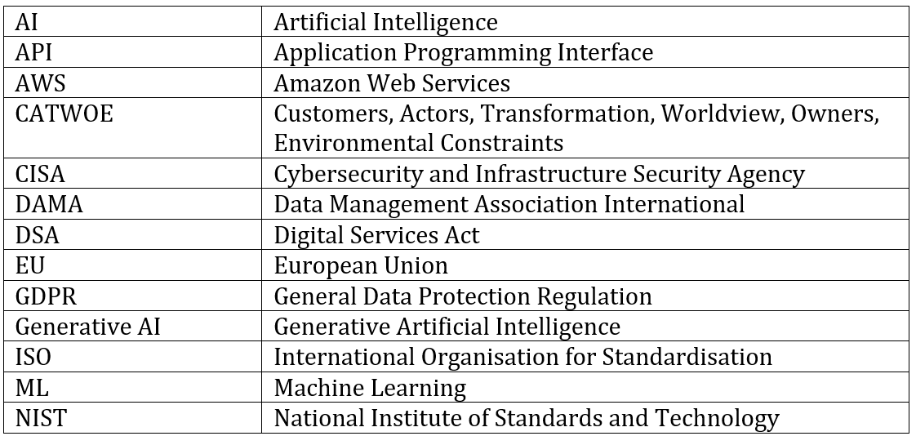

Introduction

Modern organisations differ from traditional organisations in their increased reliance on digital technologies, flexible structures, and data-based decision-making processes (OECD, 2024; UNCTAD, 2024; Verhoef et al., 2021). E-business extends beyond e-commerce by integrating digital technologies across all business processes, including procurement, supply chain, customer relationships, analytics and internal coordination (OECD, 2024; UNCTAD, 2024).
This report critically evaluates whether advances in e-commerce and e-business have rendered traditional organisational structures and management roles obsolete. It argues that digitalisation has not eliminated hierarchy or management but has redistributed coordination and control across managers, teams, algorithms and platform infrastructures (UNCTAD, 2024; Verhoef et al., 2021).
Amazon and eBay provide contrasting cases through which this proposition is examined. Amazon combines a digitally mediated marketplace with extensive physical fulfilment, logistics and cloud infrastructure, whereas eBay operates a more asset-light marketplace centred on matching, trust and marketplace governance (Amazon, 2025; eBay, 2025).
This report distinguishes between the obsolescence of management theories and the obsolescence of assumptions embedded in their application. It argues that four assumptions are untenable in digital marketplace organisations: an information monopoly at the managerial apex, closed organisational boundaries, direct supervision as a dominant control mechanism, and technological neutrality (UNCTAD, 2024; Verhoef et al., 2021).
The expansion of e-commerce creates both organisational opportunities and governance challenges, including intensified competition, cybersecurity exposure and increased reliance on digital infrastructure (OECD, 2024; UNCTAD, 2024). In this environment, AI, automation, and predictive analytics support activities such as personalisation, forecasting, fraud detection, and operational decision-making. However, their organisational significance lies not simply in efficiency gains but in how they redistribute information, coordination, and managerial control.
Amazon has enhanced customer satisfaction through new technologies such as AI, automation, predictive analytics, and logistics innovations (Wang, 2024). AI is a primary driver of efficiency, innovation, and management strategies in contemporary organisations. The report analyses Amazon’s applications of AI in personalised recommendations, demand forecasting, fraud detection, and intelligent customer service (Davidson, 2025; Verhoef et al., 2021). The academic studies show that generative AI improves operational efficiency, customer personalisation, and predictive decision-making, while posing ongoing governance and ethical challenges (Dwivedi et al., 2023; Li et al., 2025).
AI generates new high-skill employment opportunities but reduces demand for certain routine jobs. Consequently, effective measures are essential to safeguard e-businesses from data breaches and online fraud (Yuan and Fang, 2024). The value of customer data must be balanced with the imperative to protect confidential information, including privacy, informed consent, transparency, and responsible data usage (Deng et al, 2024; Li et al., 2025).
This academic study does not assume that AI advancements necessarily lead to organisational transformation. It critically evaluates theoretical perspectives on the relationship between digital technologies and management (Busalim and Asadi, 2025). A central focus is the comparative analysis of Amazon and eBay in relation to advances in e-commerce and diminishing significance of hierarchy, managerial authority, and formal organisational structures. Digital platforms, algorithmic governance, and ecosystem coordination redistribute these functions. The discussion synthesises classical management theory with contemporary digital organisation literature to develop an evidence-based evaluation of organisational change, while de-emphasising the assumption that technological progress is inherently transformative (Shabankareh et al., 2025; Davidson, 2025; Busalim and Asadi, 2025).
This investigation addresses whether the digitalisation of commerce has made the inherited architecture of hierarchy, functional specialisation, and manager-centred control unsuitable for contemporary corporations. Classical management theory, including Taylor’s scientific management, Fayol’s administrative principles and Weber’s bureaucracy, provides the theoretical baseline. These classical perspectives are critically contrasted with contemporary theories of digital networks, socio-technical systems, contingency theory and algorithmic management to determine whether technological change represents organisational replacement or organisational adaptation (Costabile, 2024; Davidson, 2025; Burke and Morley, 2023; Meijerink and Bondarouk, 2023; Huzooree et al., 2025).
This study evaluates evidence from Amazon and eBay to determine whether traditional management has become obsolete or evolved into a hybrid organisational form, but analysis is limited by restricted access to proprietary organisational charts, algorithms and internal performance data, and by the difficulty of separating technological effects from strategy, regulation, market maturity and institutional culture (Saunders et al., 2023; Shabankareh et al., 2025; Verhoef et al., 2021).

Background
E-commerce mainly refers to digitally enabled buying and selling, whereas e-business is broader. It encompasses the digital integration of procurement, supply chain, and customer relationship management, payments, marketing, internal communication, analytics and organisational knowledge (UNCTAD, 2024; OECD, 2024). A marketplace such as eBay coordinates transactions among independent buyers and sellers. Amazon combines a first-party retailer, a third-party marketplace, fulfilment infrastructure, advertising, subscriptions, cloud computing and a growing portfolio of AI services (Amazon, 2025; Costabile, 2024; eBay, 2025). Both organisations impose familiar boundaries among the firm, the market, and the ecosystem (Davidson, 2025; Haraca et al., 2023; Costabile, 2024).
Generally, scale was managed through hierarchy. Taylor sought predictable output through task decomposition and measurement. Fayol described planning, organising, commanding, coordinating and controlling. Weber conceptualised legitimate authority through offices, rules, expertise and an impersonal chain of command. Digital technologies evolve rapidly (Burke and Morley, 2023; Verhoef et al., 2021). Classical hierarchical structures addressed coordination problems, production technologies were comparatively stable, and managerial supervision was a principal mechanism for integrating work (Davidson, 2025; Verhoef et al., 2021).
The philosophical issue is whether these changes constitute a new ontology of organisation, even as new instruments align with an old managerial logic (Davidson, 2025). Technological determinism treats technology as an independent force that compels flatter, faster and more decentralised firms. This deterministic interpretation is contested by perspectives that emphasise managerial agency, institutional context and power relations. Critical management theory argues that claims of neutrality can conceal surveillance, labour discipline, and asymmetrical value capture. Systems thinking rejects single-cause explanations and examines feedback, interdependence and emergence (Burke and Morley, 2023; Davidson, 2025; Verhoef et al., 2021).
A social-constructionist perspective provides an alternative to technological determinism: digital affordances both constrain and enable action, while organisational outcomes depend on ownership, governance, culture, regulation and strategic interpretation. This perspective provides the basis for evaluating whether traditional organisational structures can be replaced by digital transformation or whether leaders need to reconfigure their functions within contemporary platform organisations (Costabile, 2024; Davidson, 2025; Busalim and Asadi, 2025; Verhoef et al., 2021).

Purpose, Scope and Method

1.2.1 Purpose
This investigation critically evaluates whether advances in e-commerce and e-business have made traditional organisational structures and management roles obsolete. It examines how digital technologies change managerial authority, coordination, and control, rather than merely assuming obsolescence. The analysis distinguishes between the disappearance of management and its adaptation to digitally mediated organisations (Burke and Morley, 2023; Verhoef et al., 2021).

Scope
The analysis focuses on Amazon and eBay because they represent contrasting organisational responses within the online marketplace sector. Amazon combines a digital platform with extensive fulfilment and logistics infrastructure, while eBay operates a more asset-light marketplace centred on matching, trust and transactional governance (Amazon, 2025; eBay, 2025; OECD, 2024). This contrast provides a useful test of technological determinism, such as whether technology independently determines the organisational structure and whether firms operating in comparable digital environments would be expected to converge towards similar organisational forms. Their differences allow technology, strategy, infrastructure and governance to be considered together. See Appendix A for a detailed comparison.

Method
The study uses a critical comparative literature review drawing on peer-reviewed research, foundational management literature, Amazon and eBay corporate disclosures, and relevant regulatory and institutional evidence (Booth et al., 2016; Yin, 2018; Petticrew and Roberts, 2006; Saunders et al., 2023). Sources were selected for their relevance to organisational structure, managerial roles, digital transformation, platform governance and algorithmic management, and assessed for credibility, methodological rigour, recency and consistency with other evidence. Evidence was coded thematically around organisational structure, decision rights, managerial authority, algorithmic control, platform governance, and stakeholder relationships, with triangulation used to reduce dependence on any single source (Yin, 2018; Petticrew and Roberts, 2006). See Appendix D for a detailed coding framework.

CATWOE
CATWOE is used as a supplementary interpretive framework to examine customers, actors, transformation, worldview, owners and environmental constraints. It helps structure the comparison of Amazon and eBay as complex socio-technical systems, but it does not test whether management theories have become obsolete. The judgement of obsolescence combines CATWOE with comparative evidence and classical, contingency, socio-technical and platform-governance theory. Because the study relies on two cases and publicly available evidence, its conclusions provide analytical, not statistical, generalisation (Yin, 2018; Saunders et al., 2023). See Appendix D for the CATWOE operationalisation and Appendix B for the assumptions and limitations underpinning the analysis.
Traditional management has not disappeared, but certain assumptions have become obsolete, while planning, coordination, accountability, and strategic control have been reconfigured through platforms, algorithms, and distributed expertise.

2. Literature Review

2.1 The evolution of business technology
This can be interpreted in three overlapping phases. The first phase automated discrete tasks through mainframes, enterprise resource planning and transaction-processing systems. The second connects organisations through the internet, mobile devices, and cloud computing. This enables distributed work and global supply chains. The third embeds AI into processes through ML, generative AI, robotics, and continuous experimentation. Each phase changes the economics of information (Verhoef et al., 2021; Wang, 2024; Li et al., 2025). This includes cheaper collection, faster transmission, and more scalable analysis, but lower information costs do not eliminate the need for organisation. They alter where coordination occurs and who controls it (Burke and Morley, 2023; Davidson, 2025).
Drucker’s knowledge-worker thesis anticipates that expertise is likely to become mobile. This means that no single ideal organisational form would fit every task, time and culture (Verhoef et al., 2021; Wang, 2024; Li et al., 2025). Systems theory likewise conceptualises the organisation as an open system exchanging information, resources, and legitimacy with its environment.
Contingency theory provides a stronger explanation than the universal claims of obsolescence. It proposes an effective structure that depends on environmental uncertainty, task interdependence, technology, size, and strategy. Digital businesses face high uncertainty and reciprocal interdependence, favouring lateral coordination and flexible teams, but their infrastructure and regulatory duties require formalisation (Kuhlmann et al., 2023; Burke and Morley, 2023).
Morgan’s organisational metaphors demonstrate why no single organisational model properly describes the digital platform. Amazon’s fulfilment operations exhibit machine-like standardisation, its product-development activities depend on distributed knowledge, and its marketplace resembles a political ecosystem of independent actors. It would be analytically misleading to describe the organisation as ‘flat’ or ‘hierarchical’ (Morgan, 2006; Amazon, 2025; Burke and Morley, 2023).

2.2 The Rise of e-Commerce
E-commerce reduces search, transaction and territorial barriers. However, its tactical value lies in the data generated by every exchange. Moreover, search queries, clicks, dwell time, prices, reviews, returns, and fulfilment events operate as inputs for prediction and optimisation (UNCTAD, 2024; OECD, 2024). E-commerce platforms create value for several stakeholder groups: customers gain convenience, assortment, and personalisation; sellers gain market access; and platform owners receive fees and gain greater capacity to shape discovery. This creates positive network effects. It brings in more sellers, increasing variety, and more buyers. Collectively, it increases sellers’ opportunities and interactions, improving data quality. However, network effects generate concentration. This improves both usefulness and the platform’s capacity to subsidise growth (Davidson, 2025; Costabile, 2024; OECD, 2024).
Digital platforms create value that enables interactions among numerous user groups, even within traditional value chains, leading to interconnected business ecosystems (Parker and Van Alstyne, 2024; Costabile, 2024). Their analysis shows that network effects reinforce platform growth but also increase the importance of ecosystem coordination and platform governance. Amazon and eBay differ in operations and logistics. eBay’s original model depended heavily on trust (Amazon, 2025; eBay, 2025). It relies on reputation scores and rule enforcement by largely independent parties. Amazon’s model unites and supports all marketplace participants through fulfilment, advisory, subscription, and cloud infrastructure. In both cases, the modern platforms constitute the market through eligibility rules, search rankings, fee structures, dispute procedures, and data access. Therefore, organisational authority goes beyond employees to external complementors. This calls into question the firm's legal borders but not the need for governance (Davidson, 2025; Costabile, 2024; Rahman et al., 2024).

2.3 The Emergence of e-Business
Internal and inter-organisational processes drive this emergence (Verhoef et al., 2021; Busalim and Asadi, 2025). Digital procurement links suppliers to demand forecasts. Warehouse systems coordinate inventory and labour, and customer-service platforms integrate communication and analytics to support pricing and fraud detection. Cloud infrastructure enables rapid deployment, and dashboards keep performance continuously visible. Consequently, the organisation is modular. This includes teams coordinating through common data standards and interfaces rather than repeatedly escalating through a vertical chain (Costabile, 2024; Burke and Morley, 2023; Davidson, 2025).
Digital integration can increase central control by standardising software processes, narrowing local discretion, and weakening formal management layers. Digital systems can determine permissible actions and define performance through dashboards and embedded metrics (Meijerink and Bondarouk, 2023; Costabile, 2024; Davidson, 2025).
Digital platforms create a form of centralised decentralisation, in which operational decisions are distributed to teams, sellers, and automated systems, while strategic authority over architecture, data, access rights, metrics, and platform rules remains concentrated. This distinction matters because decentralised activity does not necessarily imply decentralised power (Leon, 2026; Fehr et al., 2023; Davidson, 2025).
E-business resilience is a major managerial concern. It enables systemic interdependence among cloud services, payment systems, identity verification, logistics networks, and third-party sellers, but efficiency reduces slack and amplifies disruption (Caputo et al., 2023; Verhoef et al., 2021; NIST, 2024; CISA, 2023).

2.4 Definition and Explanation of Organisational Structure
Organisational structure allocates tasks, authority, information and accountability. Traditional forms include functional structures organised around specialist departments, divisional structures organised around products, geographies, or customers, and hierarchical bureaucracies with clear reporting lines (Burke and Morley, 2023; Thi et al., 2025). Matrix structures overlay multiple dimensions, while network structures coordinate semi-autonomous units and external partners, but platform organisations add another layer. This includes the owner defining the technological architecture and participation rules. As a result, users and complementors generate much of the content, inventory, and innovation (Haraca et al., 2023; Costabile, 2024; Davidson, 2025).
Structural flatness should not be equated with decentralisation. A firm may remove management layers while retaining highly centralised control over capital allocation, data, technological architecture and strategic priorities (Tarzijan and Snihur, 2024; Verhoef et al., 2021).
Four critical dimensions emerge: vertical differentiation, horizontal differentiation, formalisation, and centralisation. Digital technologies reduce vertical differentiation. This includes direct communication, increased horizontal differentiation through specialist roles, increased formalisation through code, and decentralised routine decisions while centralising strategic control (Burke and Morley, 2023; Davidson, 2025; Verhoef et al., 2021).
Amazon has a complex hybrid model that illustrates structural plurality and integration of many dimensions. This includes retail categories, geographic regions, AWS, advertising, devices, and operations, and requires divisional accountability (Amazon, 2025). Moreover, it includes finance, HR, legal functions, security, and engineering expertise. Product teams also coordinate across functions, and platform governance connects millions of external sellers and customers. eBay combines product and engineering teams with risk, trust, payments, policy and market functions (eBay, 2025; Islam et al., 2023; Costabile, 2024).

2.5 Theories of Management Roles
Classical management theories provide a significant foundation for understanding how contemporary digital organisations are managed, despite rapid technological evolution. They do not replace traditional management functions; digital transformation has altered how planning, organising and controlling are carried out in a technological environment (Fayol, 1949; Drucker, 1954). Process optimisation is associated with scientific management, but AI, automation, and experimentation now support it to improve efficiency (Fayol, 1949; Weber, 1947). Administrative principles remain evident, but managerial control has shifted from direct supervision towards strategic coordination and employee empowerment (Mintzberg, 1973). These developments suggest that digital transformation has not rendered classical management obsolete but has reconfigured traditional principles for operating in technological contexts (Doshi and Schmidt, 2024; Davidson, 2025; Burke and Morley, 2023).
Behavioural and human-relations theories provide valuable insights for digital transformation, which depends on motivation, identity, psychological safety, and perceived fairness (Crammond et al., 2024; Sanlioz and Yildiz, 2026). Transformational leadership explains how leaders articulate a digital vision and mobilise change, however, it over-personalises outcomes and understates systems, routines and distributed expertise. Shared and distributed leadership better suit knowledge-intensive teams. They obscure accountability when outcomes fail. Socio-technical systems theory supplies a stronger synthesis by insisting that technical and social arrangements must be jointly optimised (Sanlioz and Yildiz, 2026; Crammond et al., 2024; Burke and Morley, 2023).
Critical management scholarship highlights the politics of managerial roles, but management is more than coordination. It is also about metrics, legitimate knowledge, and category definitions (Davidson, 2025; Doshi and Schmidt, 2024). In platform firms, managers and engineers decide which sellers are visible, which risks are acceptable and which behaviours are rewarded. Algorithms can exercise quasi-managerial authority by shaping visibility, performance assessment and resource allocation. Calling an algorithm the manager risks erasing the human decisions embedded in its objectives and data (Costabile, 2024; Ji and Hong, 2025).

2.6 Implications for Traditional Models
Recent literature converges on the view that digital transformation challenges only those organisational forms that are rigid, closed, and unable to adapt to rapidly changing environments (Burke and Morley, 2023; Verhoef et al., 2021). Bureaucratic rules are embedded within digital systems, but strategic authority continues to support governance, accountability and organisational resilience (Rahman et al., 2024; Davidson, 2025). This synthesis provides the theoretical foundation for the comparative analysis of Amazon and eBay in the following chapters.

3. Changing Nature of 21st-Century Corporations

3.1 Increased Connectivity and Globalisation
Connectivity enables marketplace firms to coordinate customers, sellers, payment providers, and logistics partners across borders, shifting competition from isolated firms towards interconnected ecosystems (Tiwana, 2014). The relevant unit of competition becomes the ecosystem rather than a standalone firm. Amazon competes not only through its retail assortment but through fulfilment density, Prime membership, advertising data, cloud infrastructure and developer capabilities. eBay competes through specialised communities, cross-border reach, search, trust mechanisms and seller tools. Strategy involves coordinating interdependent actors whose interests overlap but do not always coincide (Rahman et al., 2024; Davidson, 2025).
Global connectivity increases institutional complexity and organisational flexibility. Marketplace companies must comply with different requirements for competition, consumer protection, product safety, and data privacy. This demands local knowledge and decentralised responsiveness alongside central standards and enterprise risk oversight. Globalisation strengthens network coordination without eliminating bureaucratic capability (Burke and Morley, 2023; Verhoef et al., 2021).
Culture shapes how organisations implement digital practices. Shared values can support coordination and experimentation, but strong organisational narratives may suppress dissent or normalise excessive risk (Butt et al., 2024; Ghafoori et al., 2024).

3.2 Shift towards Digital Transformation: Networks, Data, Platforms and Algorithms
Digital transformation reshapes organisational coordination through complex networks of platforms and data, not just a technological capability. Networks enable collaboration among consumers, partners, and investors, while the data generated through these interactions supports personalisation, decision-making, and operational activities. Platform architecture integrates these activities through participation rules and governance, while algorithms coordinate visibility, resource allocation and performance at scale (Doshi and Schmidt, 2024; Wang, 2024).
As customers and stakeholders become both data producers and users, managerial responsibility shifts from supervising individual tasks to governing the technological and institutional conditions that shape participation and value creation (Doshi and Schmidt, 2024; Costabile, 2024; Wang, 2024).
Digital platforms need to be understood not merely as technological structures but as socio-technical systems that coordinate innovation and governance within complex business ecosystems (Gawer, 2014; Tiwana, 2014). Their competitive advantage depends on orchestrating stakeholder interactions through governance, digital boundaries, and shared resources (Parker et al., 2016; Davidson, 2025).
Trust is a central coordination mechanism in digital marketplaces. eBay’s reputation systems reduced uncertainty among unfamiliar parties. Amazon’s fulfilment and guarantee mechanisms shift trust from individual sellers to the platform brand (Parker et al., 2016; eBay, 2025). Fraud, counterfeit goods, opaque decisions, and data breaches can undermine trust, making procedural fairness, reliability, and redress key governance responsibilities (Rahman et al., 2024; OECD, 2024).

3.3 Importance of Adaptability and Agility
Agility refers to the capacity to detect change, make informed decisions, and rapidly reconfigure operations (Farooq, 2023; Verhoef et al., 2021). Cross-functional product teams, cloud infrastructure and experimentation can accelerate feedback cycles (Kuhlmann et al., 2023; Amazon, 2025). Amazon’s “two-pizzas team” ideal and eBay’s product-led development exemplify efforts to position decision-making near relevant expertise (Amazon, 2025; eBay, 2025). However, agility can become rhetorical when frequent change increases coordination costs, employee fatigue, and managerial fragmentation (Burke and Morley, 2023; Crammond et al., 2024).
Dynamic capabilities theory delivers a more disciplined account (Farooq, 2023). Organisations must identify opportunities and threats, capitalise on them through targeted investments and business model adaptations, and transform assets and routines accordingly. These capabilities depend on effective leadership, governance, organisational learning, and resource flexibility (Farooq, 2023; Verhoef et al., 2021). The capacity to discontinue unsuccessful initiatives is as important as launching new ones. Amazon’s record of both successful services and discontinued projects illustrates that experimentation generates value when robust selection mechanisms are in place (Amazon, 2025; Li et al., 2025).
Agility must be balanced with clearly defined boundaries. Functions such as cybersecurity, financial reporting, and safety should not be subject to unrestricted experimentation. High-reliability functions require escalation protocols, redundancy, and disciplined procedures. As a result, effective digital organisations are ambidextrous, integrating exploratory innovation with disciplined operational execution (Farooq, 2023; CISA, 2023; ISO, 2022; Verhoef et al., 2021).
These developments show that digitalisation changes how organisations coordinate and exercise authority, providing the basis for evaluating structural obsolescence in the next chapter (Verhoef et al., 2021; Davidson, 2025; Gawer, 2014).

4. Obsolescence of Traditional Organisational Structures

4.1 Hierarchical Structures versus Flat Organisations
The strongest argument for structural obsolescence concerns information flow (Chowdhury, Pawan, and Wood, 2024). Historically, hierarchies aggregated information upward and disseminated decisions downward. Digital teamwork platforms let specialists collaborate directly, reducing the need for middle managers as information intermediaries. Flatter structures can accelerate decision-making and place authority closer to relevant expertise (Baumann and Wu, 2023; Bohr, 2026; Burke and Morley, 2023).
However, hierarchy performs functions beyond information transmission, including facilitating conflict resolution, asset allocation, accountability, and legal representation for the organisation (Burke and Morley, 2023). Platform firms face complex trade-offs among growth, safety, sellers' interests, customer experience, privacy, and profitability. Such trade-offs cannot be entirely delegated to autonomous teams, as they require centralised prioritisation and cross-system adjudication (Burke and Morley, 2023; Shahzad et al., 2025).
Structural flatness can conceal power concentration. When formal layers are eliminated, but executives maintain control over strategy, capital, and system architecture, the span of control increases, and informal influence becomes more significant. Digital dashboards enable closer executive oversight, which may lead to increased micromanagement. The critical issue is not the existence of hierarchy, but whether authority is transparent, contestable, and appropriately aligned with expertise (Burke and Morley, 2023; Shahzad et al., 2025). See Fig. 4.1 below.
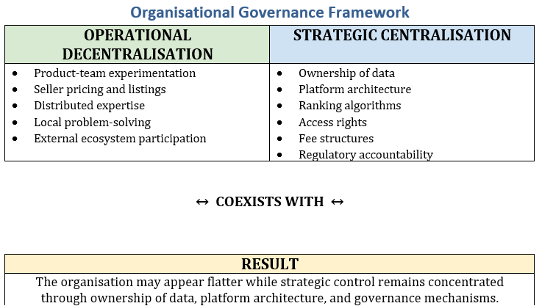
Figure 4.1: The centralisation-decentralisation paradox in platform organisations.
Source: (Plekhanov et al., 2023; Tarzijan and Snihur, 2024)

4.2 Matrix Organisation and Cross-Functional Teams
Cross-functional teams and matrix structures suit digital products because customer outcomes span engineering, design, operations, legal, and data science. A digital market search feature affects buyer relevance, seller visibility, advertising revenue, fraud exposure and regulatory conformity. No single function has all the necessary knowledge (Zhu and Rozan, 2026; Crammond et al., 2024).
Matrix structures and product teams can improve integration and problem-solving, but may create unclear authority, duplicated meetings and tensions between functional quality and product speed. They are not inherently superior because they require clear decision rights, shared metrics and escalation mechanisms. Amazon’s use of written reports and accountable “single-threaded leaders” can be seen as an attempt to reduce ambiguity in matrixed structures by assigning a clear owner while retaining cross-functional input. eBay’s focused-category strategy requires coordination between platform capabilities and vertical category expertise (Kuhlmann, Bening, and Hoffmann, 2023; eBay, 2025).
Cross-department teams do not eliminate management (Junge et al., 2023). Instead, they shift the locus of managerial responsibility. Team leaders integrate and manage interdependencies, functional leaders maintain professional capabilities, and executives address portfolio-level trade-offs (Degen and Gleiss, 2025; Kausche and Weiss, 2025).

4.3 Decentralisation, Empowerment and Platform Power
Firms may decentralise operational decisions to improve responsiveness and motivation, while platform owners retain authority over data access, ranking, and participation (Haxhiu and Marc, 2026; Cosa and Torelli, 2024). Platform owners determine participation rules, data access, exposed APIs, ranking mechanisms, fees, and dispute processes, thereby creating a distinction between operational decentralisation and strategic decentralisation. Direct command declines at the task level while strategic control remains concentrated through ownership of digital infrastructure (Degen and Gleiss, 2025; Kausche and Weiss, 2025).
Power is exercised through performance metrics that shape organisational priorities and behaviour. Indicators such as conversion rates, delivery times, defect rates, and customer contacts are useful, but overreliance on metrics can marginalise less measurable concerns such as dignity, long-term seller capability, and environmental impact. Effective governance requires safeguarding against metric gaming (Ji and Hong, 2025; Lachmann et al., 2024).

4.4 CATWOE Analysis of the Marketplace Transformation
The CATWOE analysis shows that marketplace transformation is both normative and technical. Transactions are monitored and data-intermediated, and prediction, customer focus, and convenience are treated as evidence of progress; however, only platform owners retain the authority to define system boundaries and participation rules. CATWOE is particularly powerful when combined with platform-governance theory, as it makes power asymmetries more explicit. This transformation benefits shareholders and buyers but imposes costs on sellers and other workers (Gilbert et al., 2024; Rahman et al., 2024). Appendix D provides detailed CATWOE analysis.
Although CATWOE clarifies stakeholders, organisational transformations, and environmental constraints, it cannot by itself establish whether traditional management theories have become obsolete (Russell et al., 2025). Its principal contribution is to reveal differing stakeholder perspectives, governance relationships and organisational assumptions (Gilbert, Schrage, and Behnam, 2024). Assessing organisational obsolescence requires combining CATWOE with evidence from the comparative analysis of Amazon and eBay and broader organisational theories discussed throughout this investigation (Saunders, Lewis and Thornhill, 2023; Yin, 2018).

5. Redefining Management Roles

5.1 Transformation and Distributed Leadership
Transformational leadership is an integrative process that unites digital change, a credible purpose, the capacity to challenge routines, and an investment in new capabilities. Leaders need to connect digital change to stakeholder value and model continuous learning. In Amazon, leadership principles function as cultural decision heuristics. By contrast, eBay's purpose centres on economic opportunity and supports its marketplace identity. These cultural devices can coordinate decentralised action when formal rules are insufficient (Crammond et al., 2024; Farooq, 2023).
However, transformational leadership has limitations. It can overattribute outcomes to charismatic executives while underplaying collective expertise, institutional constraints and contextual factors. Strong leadership can suppress challenge when disagreement is interpreted as resistance. Distributed leadership offers a corrective by recognising that expertise and influence are distributed across all department teams. Effective digital leadership combines clear ownership with structural challenge (Crammond et al., 2024; Farooq, 2023).
Managers design the conditions for effective decision-making by framing problems, allocating decision rights, building teams, managing interdependencies and establishing ethical boundaries. Their legitimacy rests less on possessing all answers than on creating a process through which answers can emerge (Farooq, 2023; Batool et al., 2025).

5.2 Technological Literacy and Algorithmic Management
Technological literacy is not the same as coding expertise. Managers need a sufficient understanding of data provenance, model objectives, uncertainty, cybersecurity, and system architecture, including what models optimise, which populations the data represent, which errors are costly, and how performance is monitored. Without this literacy, managers risk either uncritical adoption or defensive rejection (Leon, 2026; Batool et al., 2025).
Algorithmic management delegates functions such as task allocation, monitoring, evaluation and nudging to software (Noponen et al., 2024). This can improve consistency and responsiveness. In the marketplace, it identifies fraud, personalises search and matches supply with demand. However, algorithms intensify control by operating continuously and at scale. Information asymmetry becomes pronounced when workers or sellers cannot understand or contest decisions (Meijerink and Bondarouk, 2023; Fehr et al., 2023). See Fig. 5.1 below.
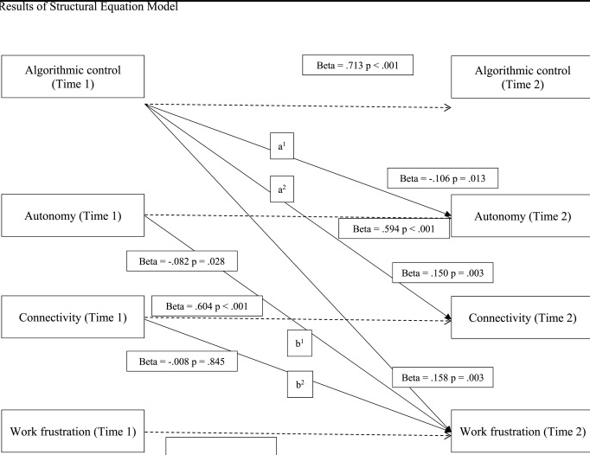
Figure 5.1: Algorithmic-management functions
Source: Adapted from Rottgen et al. (2024, p. 25)
Fig. 5.1 illustrates how algorithmic-management functions can affect demands, resources, and employee well-being.
Algorithmic management remains a governance responsibility. Humans choose objectives, thresholds, data, escalation rules and remedies. A responsible organisation documents these choices, tests disparate impacts, provides human review and preserves the ability to override automated outcomes. “The algorithm decided” is not an acceptable theory of accountability (Batool et al., 2025; Leon, 2026).

5.3 Trust, Customers, Stakeholders and Ethical Governance
Trust reduces transaction costs and enables exchanges between unfamiliar parties. Trust is inherently relational since stakeholders evaluate the fairness of procedures and the proportionality of the platform's use of power. Even technically accurate systems may be distrusted if their decisions lack transparency or if appeals processes are ineffective (Rahman et al., 2024; Zhu and Rozan, 2026).
Stakeholder theory expands managerial responsibility beyond the traditional objective of maximising shareholder and investor value. Organisational success in digital markets is based on balancing relationships with regulators, sellers, and local communities (Gawer, 2014; Rahman et al., 2024). Decisions that excessively prioritise financial gains can discourage investment and reduce market quality (Rahman et al., 2024).
Ethical governance should be embedded in routine organisational practices, not treated solely as a compliance requirement. Boards need sufficient expertise in AI and digital technologies to oversee strategic decisions effectively, and the product teams need to consider privacy, fairness and security throughout the development process (Batool et al., 2025; Leon, 2026). Risk management requires reliable technical evidence, while stakeholders need accessible channels to question or appeal platform decisions. These mechanisms strengthen accountability, transparency and organisational resilience (Batool et al., 2025; Bohr, 2026).

5.4 AI Lifecycle, Success Conditions and Limitations
AI is best managed as a lifecycle rather than a procurement event. The stages include problem definition, data acquisition and preparation, model development, validation, deployment, monitoring, change control and retirement. However, failure at any stage can undermine the system (Murikah et al., 2024; Batool et al., 2025). A well-performing model can still address the wrong business problem. High-quality historical data may encode past discrimination, deployment conditions may differ from those used in testing, and model drift can reduce accuracy.
Successful AI adoption requires long-term effective oversight throughout the AI lifecycle. It requires a defined use case, baseline comparison, representative and lawful data, cross-functional ownership, measurable benefits, human supervision and monitoring. Therefore, outputs must be evaluated against accuracy and safety, rather than novelty (Leon, 2026; Zhu and Rozan, 2026).
Limitations are substantive. Models may hallucinate, reproduce bias, expose confidential data, be manipulated, consume significant computing resources and create automated bias in human decision-makers. Their opacity can weaken procedural justice. AI shifts power to those who control models, market visibility, and work allocation. Therefore, management must establish risk tiers, audit trails, incident response, independent challenge, and retirement criteria. The most successful AI system is not necessarily the most autonomous. It is the one that creates durable stakeholder value while avoiding the biggest risks (Murikah et al., 2024; Olatokun and Oladokun, 2026).

6. Challenges and Opportunities

6.1 Overcoming Resistance to Change
Organisational change entails careful planning, stakeholder engagement and capability development. Leaders should implement it only after thoroughly assessing and investigating all challenges. This includes identifying skill gaps, conflicting incentives, and genuine threats or ethical concerns. Frontline staff have valuable, detailed operational knowledge and should be consulted for input. These piloting initiatives provide viable alternatives that help organisations mitigate risks, including by communicating outcomes transparently. Regular staff training, with adjustments to workloads and job responsibilities, is effective. This organisational support is essential for digital upskilling (Zacher and Rudolph, 2024; Wahl and Herbrechter, 2023; Kyratsis, 2026).
Institutional activities expose obsolete practices and deliver new professional development. This potential can be realised only with experimental outcomes that contribute to collective knowledge. Consequently, systematic review of outcomes, transparent data sharing, and the development of communities of practice facilitate the transformation of localised organisational capabilities (Mohammad and Sayari, 2025; Lefebvre and Legner, 2026).

6.2 Ensuring Data Security and Privacy
Internet platforms store organisational and personally sensitive data at scale (NIST, 2024; ISO, 2022). A security failure can seize operations, expose customers, make errors, and destroy trust. Private risk can result from breaches, unlawful excessive collection, and secondary use. Collectively, data governance must define ownership, access, quality, retention, sharing and deletion (DAMA International, 2017; EU, 2016; Zuboff, 2019).
Centralisation offers consistent standards that create attractive targets (NIST, 2024; ISO, 2022). Consequently, decentralisation supports local innovation but produces fragmented control. A federated model is preferable (Dolhopolov et al., 2024). Enterprise policies and security architecture remain central (Verhoef et al., 2021). However, domain teams retain accountable stewardship of significant datasets (DAMA International, 2017; Gartner, 2023). Zero-trust access, encryption, logging, testing and incident response are necessary but insufficient without a culture that reports weaknesses (NIST, 2024; CISA, 2023).
Regulation shapes management roles by making platform accountability externally enforceable. The EU Digital Services Act (DSA), GDPR and emerging AI rules require risk assessment, transparent processes and stronger control over data (EU, 2016; EU, 2022). Recent regulatory developments demonstrate that cybersecurity and privacy are strategic governance responsibilities that require board oversight (Kraus et al., 2024; Wirtz et al., 2022).

6.3 Leveraging Technology for Competitive Advantage
Technology creates an advantage when it complements distinctive assets and routines. Advantage can also come from data quality, logistics density, trusted communities, learning speed, brand, ecosystem relationships, and execution. Amazon’s integrated modern technologies deliver retail demand, fulfilment, advertising and cloud investment to reinforce one another. eBay’s differentiation lies more in asset-light marketplace orchestration, specialised categories and long-established buyer-seller trust (Verhoef et al., 2021; Parker and Van Alstyne, 2024).
Data produces feedback loops, but not all data are equally valuable. More observations improve prediction when the data are representative and unbiased, but poor-quality data amplify existing errors (Qin et al., 2024). Competitive advantage depends on the ability to act on insight. This requires decision rights, operational capacity and willingness to cannibalise existing practices. Technology investment without organisational change often digitises inefficiency (Dwivedi et al., 2023; Busalim and Asadi, 2025).

6.4 Competing Explanations and Scholarly Judgement
The technological-determinist perspective attributes flatter organisational structures and new roles to technological change. This view accounts for reduced communication costs but does not explain the contrast between Amazon’s infrastructure–heavy hierarchy and eBay’s asset-light platform (Busalim and Asadi, 2025; Davidson, 2025).
The strategic-choice perspective emphasises managerial agency to capture varying degrees of organisational technological deployment. The institutional perspective demonstrates the roles of regulation, culture, and legitimacy, thereby explaining differences in governance across jurisdictions. This political-economy perspective focuses on ownership and control, showing how decentralised participation can persist alongside concentrated platform power (Shabankareh et al., 2025; Shahzad et al., 2025).
Taken together, the competing explanations in these paragraphs indicate that technology influences organisational design without determining it. Strategic choices, institutional pressures and governance arrangements remain equally significant. Consequently, organisational outcomes are better explained by the interaction of technology, managerial decision-making and institutional context than by technological determinism alone (Shabankareh et al., 2025; Davidson, 2025).
Significant biases include cognitive bias, which shapes scholarly evaluation, and availability bias, which emphasises digital successes. Moreover, survivorship bias treats Amazon and eBay as representative cases and neglects unsuccessful marketplaces. Confirmation bias leads observers to celebrate disruption and defend hierarchy. Consequently, scholarly judgement requires triangulation, reasoning and explicit acknowledgement of uncertainty. The available evidence supports a qualified conclusion (Fasolo et al., 2024; Pilgrim et al., 2024; Pinto, 2023).

6.5 Comparative Case Evidence: Amazon and eBay
Amazon demonstrates that digital technologies coexist with an extensive organisational hierarchy, rather than replacing it. Its marketplace is digitally mediated, supported by fulfilment operations, logistics, and cloud infrastructure. (Sinha et al., 2026; Shahzad et al., 2025; Allgor et al., 2023). The organisation’s digital surface is supported by an operational core where classical management principles remain highly visible. Measurement is more granular and real-time. It is expressed in access permissions, audit records and compliance systems. The company’s scale heightens the need for coordination, even as digital tools enable distributed execution. Amazon illustrates that digital transformation redistributes managerial responsibilities without eliminating hierarchical authority (Haxhiu and Marc, 2026; Buckley and Strange, 2015; Amazon, 2025).
Amazon illustrates genuine structural changes. Developing customer-facing products involves multiple departments that combine engineering, product management, design, finance, operations, and legal expertise. Written narratives, measurable inputs, and accountable owners coordinate complex choices without relying on committee consensus. Cloud infrastructure allows external sellers to contribute to assortment and commercial investment (Degen and Gleiss, 2025; Kausche and Weiss, 2025).
Managers must orchestrate not only employees but relationships among sellers, logistics providers, developers, advertisers and regulators. Their authority concerns interfaces and rules rather than detailed supervision of every transaction (Gozman et al., 2026; Islam et al., 2023; Costabile, 2024).
Amazon reveals a paradox inherent in platform decentralisation. Sellers set many prices and make assortment decisions. Moreover, teams conduct experiments and customers generate reviews. Furthermore, the platform retains control over search architecture, eligibility, fee schedules, data access, and account enforcement. Algorithmic ranking converts ownership into distributive power because visibility affects economic opportunity. Consequently, reducing conventional middle-management layers does not mean reducing managerial control. Control may become less visible (Degen and Gleiss, 2025; Kausche and Weiss, 2025; Farooq, 2023).
By contrast, eBay demonstrates that digital platforms operate with lighter physical infrastructure. However, reduced asset ownership does not eliminate managerial authority, as governance, reputation systems, marketplace rules, and platform architecture remain under central control. Rather than supervising operational logistics, management concentrates on designing and governing the institutional framework that enables marketplace transactions (Gozman et al., 2026; Islam et al., 2023; Costabile, 2024; Davidson, 2025; eBay, 2025).
eBay demonstrates the importance of management in a network. Markets between strangers require institutional design. Listing rules, identity control, reputation system, payment protection, product authentication and sanctions create the conditions under which exchange becomes credible. These are managerial and governance functions even when automated. Search, feedback, and recommendations must balance relevance, diversity, seller opportunity, advertising, and fraud risk (Gozman et al., 2026; Islam et al., 2023; Costabile, 2024; Rahman et al., 2024).
The comparison weakens technological determinism. Amazon and eBay both rely on advanced digital technologies and highlight e-commerce's advantages. Amazon’s focus on fulfilment speed and service integration creates an operational hierarchy and capital intensity. eBay’s emphasis on marketplace intermediation allows a lighter asset base but relies more heavily on governance and reputation (Islam et al., 2023; Rahman et al., 2024; Gilbert et al., 2024; Costabile, 2024).
Success cannot be inferred from adoption, scale or a short-term increase in transactions. For Amazon, success requires the joint performance of digital discovery, physical fulfilment, seller economics, employee capabilities, relevant search and viable seller communities. In both giants, local optimisation can damage the whole. A ranking change that increases conversion may concentrate visibility and discourage long-tail sellers. Moreover, faster fulfilment may increase costs or workload intensity, and stricter fraud controls may exclude legitimate users. Consequently, managers must interpret system-wide recommendations to maximise a single metric (Costabile, 2024; Iannuzzi and Campolongo, 2023; Haxhiu and Marc, 2026).
Evidence from these cases supports a contingent hybrid model and holds that predictable, safety-sensitive, high-volume work, formalisation, and process discipline are beneficial. This knowledge is dispersed, but not all teams across departments and decentralised experimentation have more effective experiences. Wherever external actors co-create value, platform governance and relational capabilities become central. Someplace algorithms mediate consequential outcomes and independent oversight. The managerial challenge is to combine these modes coherently rather than declare one universally modern (Burke and Morley, 2023; Haraca et al., 2023; Siguencia, 2025).
The obsolescence claim depends on stakeholders’ readings and requires further qualification. They value scale and margin; customers value convenience and price; sellers value access and predictable rules; employees value autonomy, fair treatment, and regulatory rules; and stakeholders value data safeguarding. Moreover, neither a traditional hierarchy nor a self-organising network automatically resolves the conflict. Networks may also privilege actors with superior data or bargaining power. Collectively, responsible management must create forums, metrics and escalation routes through which competing claims are surfaced and adjudicated (Gilbert et al., 2024; Dzreke, 2025; Martela, 2023; Sen et al., 2023).
Organisational structure depends on the interaction between technological capabilities, strategic priorities, infrastructure requirements and governance choices. Amazon and eBay adopt different organisational configurations while retaining central strategic authority. The evidence supports a contingent hybrid model in which digital technologies reshape managerial roles and coordination mechanisms without rendering hierarchy or classical management obsolete (Rahman, Karunakaran, and Cameron, 2024; Costabile, 2024).

6.6 Philosophical Synthesis: What Has Actually Become Obsolete?
The evidence suggests that digital transformation has rendered several traditional managerial assumptions obsolete, rather than making entire management theories obsolete. Consequently, the discussion below examines four assumptions that no longer adequately explain how contemporary digital platforms are organised and managed (Burke and Morley, 2023; Davidson, 2025; Verhoef et al., 2021).

Assumption 1: Information Monopoly
Classical management assumed that senior managers possessed superior organisational information because communication was slow and information travelled vertically through the hierarchy. Digital platforms redistribute information through data systems, dashboards, and real-time analytics, enabling expertise to span multiple organisational levels. Consequently, managerial authority depends on interpreting information, not only possessing it (Burke and Morley, 2023; Davidson, 2025).

Assumption 2: Closed Organisational Boundary
Traditional organisations were generally understood as operating within clearly defined organisational boundaries. Amazon and eBay demonstrate that value creation depends on external sellers, logistics providers, developers, regulators and customers. Organisational boundaries become more permeable, requiring managers to govern ecosystems rather than only internal operations (Haraca et al., 2023; Costabile, 2024; Davidson, 2025).

Assumption 3: Direct Supervision
Classical management associated organisational control primarily with direct managerial supervision. Digital platforms coordinate behaviour through algorithms, standardised processes, dashboards, performance metrics and organisational culture. Human management remains essential, but control is exercised through socio-technical systems rather than direct observation (Meijerink and Bondarouk, 2023; Rottgen et al., 2024; Burke and Morley, 2023).

Assumption 4: Technology as a Neutral Instrument
The evidence challenges the assumption that technology is an objective or neutral organisational tool. Platform architecture, algorithms and data governance reflect managerial priorities, institutional values and organisational power. Technology should be understood as part of a socio-technical governance system, not only as an autonomous driver of organisational change (Zalmanson and Mohlmann, 2024; Duan and Li, 2023; Davidson, 2025).

Philosophical synthesis
This is required because the language of obsolescence carries assumptions about progress (Eriksson, Jeandri, & Anna, 2025). It implies that newer forms are inherently superior and management evolves through linear replacement. This includes better information, faster operations, and expectations for removing uncertainty from organisational life. Taylorism shared this drive by seeking a science of work, and contemporary data-driven management seeks to produce it at greater scale. The difference is that observation is now continuous, categories are generated through ML, and interventions can be personalised (Rahman et al., 2024; Haxhiu and Marc, 2026; Eriksson et al., 2025).

Positivism
A positivist perspective assesses organisational performance through appropriate measurement using monitoring data and empirical evidence (Davidson, 2025). This approach highlights applications within digital platforms, including fulfilment optimisation, fraud detection, and predictive analytics, but evaluates performance using high-quality operational data. However, recent literature converges on the view that performance metrics are not neutral, as they reflect assumptions embedded in model design, organisational interests, and data collection (Huang & Li, 2026). Consequently, data should be treated as evidence that informs progress toward firm objectives, organisational context, and methodological choices, rather than as a representation of reality (Saunders et al., 2023; Mahadevan, 2024; Alharahsheh and Pius, 2020).

Interpretivism
Examining meanings is a corrective from the interpretivist perspective. This includes customers who assess platform reliability through experience, sellers who interpret rule changes as reflecting perceived fairness, and workers who interpret automation in terms of identification and security. The same technology can be understood as empowerment, surveillance or professional support depending on context. Therefore, organisational transformation requires sensemaking, not only interpretation. Culture becomes constitutive and shapes what is reported, what risks are normalised, and which voices are credible (Burke and Morley, 2023; Rottgen et al., 2024; Zalmanson and Mohlmann, 2024).

Critical theory
It questions the assumption that digital platforms are neutral. Rather than facilitating marketplace transactions, platform owners set rules for data access and search results and change ranking algorithms. These choices affect opportunities, risks, and gains in the market, but they expose the closest link between organisational power and technology (Zalmanson and Mohlmann, 2024; Duan and Li, 2023; Davidson, 2025).

Realism
A realistic perspective offers a more balanced understanding of how to integrate classical management principles with contemporary digital realities, rather than opposing them (Burke and Morley, 2023; Zheng et al., 2023; OECD, 2024). Organisational structures should be evaluated for how they support decision-making in their specific context, not merely described as flat, agile, or traditional. Hierarchy supports strategic coordination and accountability and informs decisions, but it limits adaptability, learning, and knowledge sharing (Anderson et al., 2023; Huang and Li, 2026; Nerbel and Kreutzer, 2023).
Seller dependence increases investments in new technologies. This improves assortment but raises switching costs and the consequences of suspension. Efficiency initiatives may remove slack until the system becomes fragile (Duan & Li, 2023). Consequently, managers need scenario analysis and leading indicators to recognise these dynamics (Engert et al., 2023; Nerbel and Kreutzer, 2023). Additionally, linear cause-and-effect reasoning is inadequate when interventions alter the environment that generated the initial valuable data (Zheng, He, & Li, 2023).

Emergence
Emergence is significant because digital platforms increase interactions among millions of users, staff members, sellers, buyers, and automated processes (Haugen et al., 2023; Hanish et al., 2023). Consequently, platform owners cannot predict every outcome or interaction (Huang & Li, 2026). This does not absolve owners of responsibility. The form of responsibility changes the capacity for learning. Independent challenges, established tolerances, and escalation mechanisms must be outlined by executives (Caputo et al., 2023; Haugen et al., 2023). Product teams across different departments should observe distributional effects (Teichmann, 2026). The board needs to prepare the organisation to detect weak signals before they become systematic failures (Ofe & Sandberg, 2023).

Classical Management Still Matters
Classical management principles continue to support organisational direction (Davidson, 2025; Santoro, 2023). Digital systems increase concentration and specialisation. This requires division of labour. Teams share a strategic objective that supports unity of direction. Modular teams create interdependencies through vital coordination (Santoro, 2023). Additionally, control over controllers is an essential managerial tool. This includes algorithm testing, constant review of all measurements, and scrutiny of assumptions. Bureaucratic impartiality matters because it ensures consistent treatment across departments. Effective executives must balance exploration and administrative discipline while exercising judgement within transparent governance and accountability structures. They are creating institutions based on their own judgement and with unquestioned authority. Intellectual humility is also an organisational design principle, not just a personal virtue (Davidson, 2025; Santoro, 2023).

Empirical evidence from Amazon and eBay
Amazon and eBay demonstrate this hybrid requirement. Amazon’s scale rewards formal operations and central investment, while its innovation model requires distributed expertise. eBay’s network form depends on central trust, risk and marketplace governance (Amazon, 2025; eBay, 2025; Davidson, 2025). However, neither case supports the disappearance of management. Furthermore, both support a transformation in the object of management. Consequently, this includes everything from supervising bounded employees to governing socio-technical ecosystems (Burke and Morley, 2023; Davidson, 2025). Leaders manage relationships among humans, data, models, platforms, and institutions (Rottgen et al., 2024; Shabankareh et al., 2025).

Scholarly Judgement
Finally, the claim is justified only when “traditional” refers to a rigid worldview in which the organisation is a closed machine directed by superior knowledge from the apex. It is not justified to understand traditional theory and coordination principles as being critically adaptable (Huzooree, 2025). The scholarly conclusion is not that the old theory should be discarded. Therefore, it should be interpreted through systems, platforms, stakeholders, and critical perspectives (Burke and Morley, 2023; OECD, 2024).

Overall Synthesis
These four obsolete assumptions explain organisational transformation more effectively than the claim that classical management has become obsolete. The evidence from Amazon and eBay shows that hierarchy, coordination, and managerial authority still exist, but they are reconfigured through digital technologies, platform governance, and socio-technical systems (Burke and Morley, 2023; OECD, 2024).

Future of management
The future of management lies in synthesis, through disciplined execution without dehumanisation, decentralised knowledge without abdicated accountability, and technological innovation without surrendering judgement (Wang, 2024; Baumann and Wu, 2023).

7. Conclusion

7.1 Summary of the Findings
The assertion that e-commerce and e-business have rendered traditional organisational structures and management roles obsolete is partially justified. The marketplace sector has undergone a profound change. Organisational boundaries extend into systems and networks where data and algorithms coordinate activities. Additionally, teams across product departments accelerate learning, and managers need technological, ethical, and stakeholder capabilities. Rigid hierarchies that rely on slow, vertical information flows are progressively incompatible with the demands of a dynamic digital marketplace. This transformation is better explained by the obsolescence of specific managerial assumptions, not only by the disappearance of classical management.
The term ‘obsolescence’ overstates the case. Organisations such as Amazon and eBay still rely on hierarchy, specialisation, planning, coordination, and control. Classical management principles persist in digital form through process engineering, platform rules, dashboards, management regulations, and compliance systems. The prevailing pattern is hybridisation, combining decentralised operational decision-making with centralised authority over architecture, data, and governance. As a result, constitutional authority over architecture and data, along with a comprehensive focus on all participants, becomes essential. Managers shift from direct supervision toward system design, ecosystem orchestration, sensemaking, trust stewardship and accountable governance.
This investigation identified four managerial assumptions that have become untenable in digital organisations: managerial information monopoly, closed organisational boundaries, direct supervision as the dominant form of control, and technological neutrality. Technology operates within socio-technical systems shaped by strategy, culture, regulation and power. Appropriate criteria for evaluating organisational change include effectiveness, legitimacy, and resilience, not structural novelty alone.

7.2 Implications for Future Research
Future research should examine how decision rights are allocated among executives, teams and AI, employing longitudinal and comparative methodologies. More attention is needed on the organisational effects of generative and agentic AI. Furthermore, these systems initiate activities and provide recommendations. Research is needed to compare stakeholder experiences across jurisdictions as digital regulation develops.
Future research should move beyond quantifying organisational layers and rely less on self-reported agility. Instead, it should systematically examine actual escalation patterns, data access, employee autonomy and seller redress. Network analysis can reveal concentration of influence, while ethnographic research clarifies how actors interpret automated decisions.

References and Bibliography
Alharahsheh, H., and Pius, A. (2020). 'A review of key paradigms: Positivism vs. interpretivism'. Global Academic Journal of Humanities and Social Sciences, 2(3), pp. 39–43. DOI: 10.36348/gajhss.2020.v02i03.001.
Allgor, R., Cezik, T. and Chen, D. (2023). ‘Algorithm for Robotic Picking in Amazon Fulfillment Centers Enables Humans and Robots to Work Together Effectively’, INFORMS Journal on Applied Analytics, 53(4), pp. 266–282. DOI: 10.1287/inte.2022.1143.
Amazon (2025). Annual Report 2025. Available at: https://ir.aboutamazon.com/annual-reports-proxies-and-shareholder-letters/default.aspx?c=97664andp=irol-reportsannualand (Accessed: 27 July 2026).
Anderson, E., Parker, G. and Tan, B. (2023). ‘Strategic Investments for Platform Launch and Ecosystem Growth: A Dynamic Analysis’, Journal of Management Information Systems, 40(3), pp. 807–839. DOI: 10.1080/07421222.2023.2229125.
Batool, A., Zowghi, D. and Bano, M. (2025). ‘AI governance: a systematic literature review’, AI and Ethics, 5(3), pp. 3265-3279. DOI: 10.1007/s43681-024-00653-w.
Baumann, O. and Wu, B. (2023). ‘Managerial hierarchy in AI-driven organisations’, Journal of Organisation Design, 12(1-2), pp. 1–5. DOI: 10.1007/s41469-023-00147-9.
Bohr, J. (2026). ‘Coordination transparency: governing distributed agency in AI systems’, AI and SOCIETY, 41(5), pp. 4767–4777. DOI: 10.1007/s00146-026-02853-w.
Booth, A., Sutton, A., and Papaioannou, D. (2016). Systematic Approaches to a Successful Literature Review. 2nd edn. London: Sage.
Burke, C. and Morley, M. (2023). ‘Toward a non‐organizational theory of human resource management? A complex adaptive systems perspective on the human resource management ecosystem in (con)temporary organizing’, Human Resource Management, 62(1), pp. 31–53. DOI: 10.1002/hrm.22132.
Buckley, P. and Strange, R. (2015). 'Governance in the global factory ’. Journal of World Business, 29(2), p. 101497. DOI: 10.5465/amp.2013.0113.
Busalim, A. and Asadi, S. (2025). ‘What drives customers to engage with social commerce: a systematic review and factor derivation approach’, Information Systems and e-Business Management, 23(3), pp. 717–743. DOI: 10.1007/s10257-025-00700-x.
Butt, A., Imran, F., Helo, P., and Kantola, J. (2024). ‘Strategic design of culture for digital transformation’, Long Range Planning, 57(2), p. 102415. DOI: 10.1016/j.lrp.2024.102415.
Caputo, F., Sala, A., Landoro, F., Mohiya, M., and Farronato, N. (2023). 'Unfolding resilience in digital platforms from a microfoundations perspective'. IEEE Transactions on Engineering Management, 71, pp. 12807–12814. DOI: 10.1109/tem.2023.3282367.
Chowdhury, S., Pawan, B., and Wood, G. (2024). ‘Generative artificial intelligence in business: towards a strategic human resource management framework’. British Journal of Management, 35(4), pp. 1680–1691. DOI: 10.1111/1467-8551.12824
CISA. (2023). Cybersecurity and Infrastructure Security Agency (2023). Available at: Cross-Sector Cybersecurity Performance Goals. Washington, DC: CISA: https://www.cisa.gov/cross-sector-cybersecurity-performance-goals
Cosa, M. and Torelli, R. (2024). ‘Digital Transformation and Flexible Performance Management: A Systematic Literature Review of the Evolution of Performance Measurement Systems’, Global Journal of Flexible Systems Management, 25(3), pp. 445–466. DOI: 10.1007/s40171-024-00409-9.
Costabile, C. (2024). ‘Digital platform ecosystem governance of private companies: Building blocks and a research agenda based on a multidisciplinary, systematic literature review’, Data and Information Management, 8(1), p. 100053. DOI: 10.1016/j.dim.2023.100053.
Crammond, R. (2024). ‘Developing intellectual property management skills and the entrepreneurial university element: an educator perspective’. Int. J. Intellectual Property Management. Vol. 14, No. 4, pp. 389–409. DOI: 10.1504/IJIPM.2024.139664.
DAMA International. (2017). DAMA International (2017). The DAMA Guide to the Data Management Body of Knowledge (DAMA-DMBOK2). 2nd edn. Basking Ridge, NJ: Technics Publications.
Davidson, S. (2025). ‘The nature of the decentralised autonomous organisation’, Journal of Institutional Economics, 21, p. e5. DOI: 10.1017/S1744137424000341.
Degen, K. and Gleiss, A. (2025). ‘Time to break up? The case for tailor-made digital platform regulation based on platform-governance standard types’, Electronic Markets, 35(1), p. 5. DOI: 10.1007/s12525-024-00747-7.
Deng, G., Zhang, J. and Xu, Y., 2024. How e-commerce platforms build channel power: the role of AI resources and market-based assets. Journal of Business & Industrial Marketing, 39(2), pp.173-188. DOI: 10.1108/JBIM-11-2022-0497.
Dolhopolov, A., Castelltort, A. and Laurent, A. (2024). Implementing federated governance in data mesh architecture. Future Internet, 16(4), p.115. DOI: 10.3390/fi16040115.
Doshi, A., and Schmidt, W. (2024). 'Soft Governance Across Digital Platforms Using Transparency'. Strategy Science, 9(2). DOI: 10.1287/stsc.2023.0006.
Drucker, P. (1954). The Practice of Management. New York: Harper and Row.
Dzreke, S. (2025). Adapt or perish: ‘How dynamic capabilities fuel digital transformation in traditional industries’. Advanced Research Journal, 9(1), pp. 67–90. DOI: 10.71350/3062192584.
Duan, W., and Li, C. (2023). 'Be alert to dangers: Collapse and avoidance strategies of platform ecosystems'. Journal of Business Research, 1(1), p. 113869. DOI: 10.1016/j.jbusres.2023.113869.
Dwivedi, Y., Kshetri, N., Hughes, L., Slade, E., Jeyaraj, A., Kar, A., Baabdullah, A.M., Koohang, A., Raghavan, V., Ahuja, M. et al. (2023). ‘“So what if ChatGPT wrote it?” Multidisciplinary perspectives on opportunities, challenges and implications of generative conversational AI for research, practice and policy’, International Journal of Information Management, 71, 102642. DOI: 10.1016/j.ijinfomgt.2023.102642
eBay (2025). Annual Report 2025. Retrieved from Financial Information: https://investors.ebayinc.com/financial-information/sec-filings/sec-filings-details/default.aspx?FilingId=19165811.
Engert, M., Evert, J., Hein, A., and Krcmar, H. (2023). 'Sustaining complementor engagement in digital platform ecosystems: Antecedents, behaviours and engagement trajectories'. Information Systems Journal, 33(5), pp. 1151–1185. DOI: 10.1111/isj.12438.
Eriksson, T., Jeandri, R., and Anna, T. (2025). ‘Functional top management teams and marketing organisation: exploring strategic decision-making’. Journal of Strategic Marketing, 33(1), pp. 1–18. DOI: 10.1080/0965254X.2020.1765410
Farooq, R. (2023). Employee exit and its relationship. Journal of Information and Knowledge Management Systems, 53(6), 1207–1230. DOI: 10.1108/VJIKMS-06-2021-0093
Fasolo, B., Heard, C., and Scopeliti, I. (2024). 'Mitigating Cognitive Bias to Improve Organisational Decisions: An Integrative Review, Framework, and Research Agenda'. Journal of Management, 51(6), p. 1177. DOI: 10.1177/01492063241287188.
Fayol. (1949). General and Industrial Management. London: Pitman.
Fehr, R., Cremer, D., and Li, M. (2023). 'Fairness perceptions of artificial intelligence: A review and path forward'. International Journal of Human–Computer Interaction, pp. 4–23. DOI: 10.1080/10447318.2023.2210890
EU. (2016). Regulation (EU) 2016/679 (General Data Protection Regulation). Official Journal of the European Union.
EU. (2022). Regulation (EU) 2022/2065 on a Single Market for Digital Services (Digital Services Act). Official Journal of the European Union.
Gartner (2023). Enhance Your Roadmap for Data and Analytics Governance. Gartner Research G00774548. Stamford, CT: Gartner, Inc.
Gawer, A. (2014). 'Bridging differing perspectives on technological platforms: Toward an integrative framework'. Research Policy, 43(7), pp. 1239–1249. DOI: 10.1016/j.respol.2014.03.006.
Ghafoori, A., Gupta, M., Merhi, M., and Shore, A. (2024). ‘Toward the role of organisational culture in data-driven digital transformation’. International Journal of Production Economics, 271(1), p. 109205. DOI: 10.1016/j.ijpe.2024.109205.
Gilbert, D., Schrage, S., and Behnam, M. (2024). 'Advancing the moral legitimacy of digital platforms as gatekeepers: A critical analysis from a political corporate social responsibility perspective'. Journal of Business Economics, 94(1), pp. 1115–1145. DOI: 10.1007/s11573-024-01200-z
Gozman, D., Tan, B., Dhvamani, P., and Muthukannan, P. (2026). From Open Banking Regulation to Platform Orchestration: The Evolution of Digital Platform Governance. Information Systems Journal, 23(5), p. 70030. DOI: 10.1111/isj.70030.
Haraca, M., Castello, I., and Gawer, A. (2023). 'How digital platforms organise immaturity: A sociosymbolic framework of platform power'. Business Ethics Quarterly, 38(2), pp. 185–206. DOI: 10.1017/beq.2022.40.
Hanish, M., Goldsby, C., Fabian, N., and Oehmichen, J. (2023). 'Digital governance: A conceptual framework and research agenda'. Journal of Business Research, 162(1), p. 113777. DOI: 10.1016/j.jbusres.2023.113777.
Haugen, R., Skeie, N., Muller, G., and Syverud, E. (2023). 'Detecting emergence in engineered systems: A literature review and synthesis approach'. Systems Engineering, 26(4), pp. 463–481. DOI: 10.1002/sys.21660.
Haxhiu, E., and Marc, M. (2026). Unintended consequences of management control systems: A systematic review and conceptual framework. Journal of Management Control, 12(4), pp. 45–67. DOI: 10.1007/s00187-026-00422-2.
Huang, L., and Li, G. (2026). 'Anticipatory governance of digital platforms: An analysis based on the UK's Online Safety Act'. Telecommunications Policy, 13(1), 50–62. DOI: 10.1016/j.telpol.2026.103194.
Huzooree, G., Subramanian, J., Dewasiri, N., and Narayanage, D. (2025). Reskilling for the AI age: project management approaches and organisational strategies for workforce readiness. In Global work arrangements and outsourcing in the age of AI, 61(15), pp. 471–494. DOI: 10.4018/979-8-3373-1270-5.ch025.
Iannuzzi, F., and Campolongo, F. (2023). Transformed or transferred? How workers perceive managerial control over home telework. Some insights from an Italian case. Relations industrielles/Industrial Relations, 78(1), pp. 1–11. DOI: 10.7202/1101313ar.
Islam, H., Farrell, M., Nair, A., and Zhang, J. (2023). 'Understanding transaction platform governance and conflicts: A configuration approach'. Science Direct, 189(2), p. 122382. DOI: 10.1016/j.techfore.2023.122382.
ISO. (2022). International Organisation for Standardisation (2022) ISO/IEC 27001:2022 Information Security, Cybersecurity and Privacy Protection — Information Security Management Systems — Requirements. Geneva: ISO.
Ji, S., and Lachmann, M. (2025). ‘Hidden costs of performance management: When performance feedback encourages gaming and dysfunctional behaviors'. Public Performance and Management. DOI: 10.1080/15309576.2025.2486061.
Junge, S., Luger, J., and Mammen, J. (2023). ‘The Role of Organisational Structure in Senior Managers' Selective Information Processing '. Journal of Management Studies, pp. 1178–1204. DOI: 10.1111/joms.12918.
Kausche, K., and Weiss, M. (2025). 'Platform power and regulatory capture in digital governance'. Business and Politics, 27(2), pp. 284–308. DOI: 10.1017/bap.2024.33.
Kraus, S., Durst, S., Ferreira, J., Veiga, P., Kailer, N., and Weinmann, A. (2024). 'Digital transformation and cybersecurity management: A systematic literature review and research agenda'. Technological Forecasting and Social Change, 199(3), p. 123089. DOI: 10.1016/j.ijinfomgt.2021.102466.
Kuhlmann, M., Bening, C., and Hoffmann, V. (2023). ‘How incumbents realise disruptive circular innovation- Overcoming the innovator's dilemma for a circular economy’. Business Strategy and the Environment, pp. 1106–1121. DOI: 10.1002/bse.3109.
Kyratsis, Y. (2026). ‘From bedside to bytes: the digital transformation of the healthcare workforce’, Frontiers in Digital Health, 8, Article 1777607. DOI: 10.3389/fdgth.2026.1777607.
Lachmann, M., Trapp, R., and Wenger, F. (2024). ‘Transparency in performance measurement systems: An exploration of rationales and diverging perceptions in the hospital setting’. Journal of Management Control, pp. 467–507. DOI: 10.1007/s00187-024-00384-3.
Lefebvre, H., and Legner, C. (2026). 'Unpacking data democratisation: How communities of practice help organisations develop and scale their data practices'. European Journal of Information Systems, 35(4), pp. 601–627. DOI: 10.1080/0960085X.2025.2607450.
Leon, M. (2026). ‘Lifecycle-Based Governance to Build Reliable Ethical AI Systems’, Systems Research and Behavioural Science, 43(3), pp. 1116–1132. DOI: 10.1002/sres.70014.
Li, J., Chen, Z., Kwon, O. and Wang, J. (2025). ‘Modes of control in international digital commerce: evidence from Amazon.com’, Journal of International Business Studies, 56(3), pp. 440–450. DOI: 10.1057/s41267-024-00731-5.
Mahadevan, J. (2024). 'What connects positivism and interpretivism in cross-cultural management studies: Genealogy as a method for re-ordering disciplinary knowledge'. Cross Cultural and Strategic Management, 58(2), p. 101419. DOI: 10.1177/1470595823122387.
Martela, F. (2023). 'Managers matter less than we think: how can organisations function without any middle management'? Journal of Organisation Design, 12(1), pp. 19–25.DOI: 10.1007/s41469-022-00133-7,
Meijerink, J., and Bondarouk, T. (2023). 'The duality of algorithmic management: Toward a research agenda on HRM algorithms, autonomy and control'. The International Journal of Human Resources. DOI: 10.1016/j.hrmr.2021.100876.
Mintzberg. (1973). The Nature of Managerial Work. New York: Harper and Row.
Mohammad, E., and Sayari. S. (2025). 'From knowledge silos to collaborative learning: Redefining communication in the hybrid workplace'. International Journal of Strategy and Organisational Learning, 2(2), p. 56830. DOI: 10.56830/IJSOL12202503.
Morgan, G. (2006). Images of Organization. Updated edn. Thousand Oaks, CA: Sage Publications.
Murikah, W., Nthenge, J., and Musyoka, F. (2024). 'Bias and ethics of AI systems applied in auditing: A systematic review'. Scientific African, 25(4), p. 2281. DOI: 10.1016/j.sciaf.2024.e02281.
Nerbel, J., and Kreutzer, M. (2023). ‘Digital platform ecosystems in flux: From proprietary digital platforms to wide-spanning ecosystems’. Electronic Markets, 33(6), pp.123–145. DOI: 10.1007/s12525-023-00625-8.
NIST. (2024). National Institute of Standards and Technology (2024). The NIST Cybersecurity Framework (CSF 2.0). Gaithersburg, MD: U.S. Department of Commerce. DOI: 10.6028/NIST.CSWP.29.
Noponen, N., Feshchenko, P., Auvinen, T., Luoma-aho, V. (2024). ‘Taylorism on steroids or enabling autonomy? A systematic review of algorithmic management’, Management Review Quarterly, 74, pp. 1695–1721. DOI: 10.1007/s11301-023-00345-5.
OECD. (2024). OECD Digital Economy Outlook 2024: Volume 1 – Embracing the Technology Frontier. Paris: OECD Publishing. DOI: 10.1787/a1689dc5-en.
Ofe, H., and Sandberg, J. (2023). 'The emergence of digital ecosystem governance: An investigation of responses to disrupted resource control'. Information Systems Journal, 33(2), pp. 350–384.DOI: 10.1111/isj.12404.
Olatokun, W, and Oladokun, B. (2026). 'Hallucination in Generative AI: Challenges to data integrity, ethical concerns and implications for knowledge management'. Journal of Information Science. Advance online publication, 17(4), p. 1177. DOI: 10.1177/1875878926146309.
Parker, G., Alstyne, M., and Choudary, S. (2016). Platform Revolution: How Networked Markets Are Transforming the Economy—and How to Make Them Work for You. New York: W.W. Norton.
Parker, G. and Van Alstyne, M. (2024). ‘Platforms: Their Structure, Benefits, and Challenges’, in Werthner, H. et al. (eds.) Introduction to Digital Humanism. Cham: Springer. DOI: 10.1007/978-3-031-45304-5_33.
Petticrew, M., and Roberts, H. (2006). Systematic Reviews in the Social Sciences: A Practical Guide. Oxford: Blackwell Publishing.
Pilgrim, C., Sanborn, A., Malthouse, E., & Hills, T. T. (2024). Confirmation bias emerges from an approximation to Bayesian reasoning. Cognition, 245, 1–15. DOI: 10.1016/j.cognition.2023.105693
Pinto, M. (2023). 'Methodological and Cognitive Biases in Science: Issues for Current Research and Ways to Counteract Them'. Perspectives on Science, pp. 535–554. DOI: 10.1162/posc_a_00589.
Plekhanov, D., Franke, H., and Netland, T. (2023). 'Digital transformation: A review and research agenda'. European Management Journal, 41(6), pp. 821–844. DOI: 10.1016/j.emj.2022.09.007.
Qin, V., Pauwels, K., and Zhou, B. (2024). 'Data-driven budget allocation of retail media by ad product, funnel metric, and brand size'. Journal of Marketing Analytics, 12(3), pp. 235–249. DOI: 10.1057/s41270-024-00294-2
Rahman, H., Karunakaran, A. and Cameron, L. (2024). ‘Taming platform power: Taking accountability into account in the management of platforms’, Academy of Management Annals, 18(1), pp. 251–294. DOI: 10.5465/annals.2022.0090.
Rottgen, C., Herbig, B., Weinmann, T. and Muller, A. (2024). ‘Algorithmic management and human-centered task design: A conceptual synthesis from the perspective of action regulation and sociomaterial systems theory’, Frontiers in Artificial Intelligence, 7, Article 1441497. DOI: 10.3389/frai.2024.1441497.
Russell, W., Crammond, R. J., Chinnasamy, J., and Sobhan, N. (2025). 'Supporting businesses through adaptive intervention: reviewing national policy and university engagement towards a principles-led entrepreneurial development framework'. Journal of Perspectives in Applied Academic Practice. Vol. 13, No. 4, pp. 94–118. DOI: 10.56433/x9qcqd71
Shabankareh, M., Kalantari Daronkola, H., Sarhadi, A., Thaichon, P., & Nazarian, A. (2025). The influence of artificial intelligence quality on business-to-business relationships on E-commerce platforms: unveiling the nexus. International Journal of Advertising, 44(8), 1483–1522. DOI: 10.1080/02650487.2025.2557053
Shahzad, K., Imran, F., and Butt, A. (2025). 'Digital transformation and changes in organisational structure: Empirical evidence from industrial organisations'. Research-Technology Management, 68(3), 25–40. DOI: 10.1080/08956308.2025.2465706.
Sanlioz, E., and Yildiz, B. (2026). ‘How and when transformational leadership sparks innovative workplace behaviours: Cumulative evidence from a meta-analytic review’. Current Psychology, 45(999), p. 1417-1422. DOI: 10.1007/s12144-026-09567-8.
Santoro, G. (2023). 'Thriving in turbulent environments through adaptive forms of organizing'. Management Decision, 63(6), pp. 2038-2060. DOI: 10.1108/MD-05-2022-0655.
Saunders, M., Lewis, P., and Thornhill, A. (2023). Research Methods for Business Students. Harlow: Pearson.
Sen, A., Kumar, A., Dubey, V., and Gupta, A. (2023). 'Managing two-sided B2B electronic markets: Governance mechanisms, performance implications, and boundary conditions'. Journal of Business Research, 38(2), pp. 185–206.DOI: 10.1016/j.jbusres.2023.114257.
Siguencia, L. (2025). 'Building resilience: the role of senior talent management in adaptive organisational structures'. Open Global Trusted, 2(21), 11–25. DOI: 10.59476/mtt2025.v2i21.728.
Sinha, A., Agta, J., Allgor, R., Lara, C., Agiwal, A., and Atakan, S. (2026). 'Regionalise and Scale: Amazon’s Fulfilment Network Design for Faster and Cheaper Delivery'. Informs Journal on Applied Analytics, 56(1), p. 1287.DOI: 10.1287/inte.2025.0295.
Tarzijan, J., and Snihur, Y. (2024). 'Centralisation Decisions in Multisided Platform Portfolios'. Academy of Management Perspectives, 42(12), pp. 845-855.DOI: 10.5465/amp.2023.0075.
Teichmann, F. (2026). 'Platform governance under NIS2 and the Cyber Resilience Act: Cybersecurity by design as social practice'. Information, Communication and Society, 12(3), 234–243.DOI: 10.1080/1369118X.2025.2609780
Thi, P., Dung, T., and Duong, N. (2025). 'Impacts of Competitive Pressure and Organisational Context on Organisational Structure: A Role of Knowledge Management'. Sage Open, 15(2), 15–25. DOI: 10.1177/21582440251339859.
Tiwana, A. (2014). Platform Ecosystems: Aligning Architecture, Governance, and Strategy. Waltham, MA: Morgan Kaufmann.
UNCTAD. (2024). Digital Economy Report 2024: Shaping an Environmentally Sustainable and Inclusive Digital Future. Geneva: United Nations Conference on Trade and Development.
Verhoef, P., Broekhuizen, T., Bart, Y., Bhattacharya, A., Dong, J., Fabian, N. and Haenlein, M. (2021). ‘Digital transformation: A multidisciplinary reflection and research agenda’, Journal of Business Research, 122, pp. 889–901. DOI: 10.1016/j.jbusres.2019.09.022.
Wahl, J., and Herbrechter, D. (2023). 'How do leading staff members foster digital change inside the organisation? A qualitative case study'. Zeitschrift für Weiterbildungsforschung, 46(1), pp. 43–66. DOI: 10.1007/s40955-023-00243-z.
Wang, J. (2024). 'Using artificial intelligence to analyse SME e-commerce utilisation and growth strategies. Journal of Computational Methods in Sciences and Engineering', 24(1), pp. 611–621. DOI: 10.3233/JCM-22693.
Weber, M. (1947). The Theory of Social and Economic Organisation. New York: Oxford University Press.
Wirtz, B., Weyerer, J., and Kehl, I. (2022). 'Governance of artificial intelligence: A risk and guideline-based integrative framework'. Government Information Quarterly, 39(4), p. 101685. DOI: 10.1016/j.giq.2022.101685.
Yin, R. (2018). Case Study Research and Applications: Design and Methods. 6th edn. Thousand Oaks, CA: Sage.
Yuan, L., and Fang, D. (2024). 'Machines vs. humans: The evolving role of artificial intelligence in livestreaming e-commerce'. Journal of Business Research, 188(1), 115077. DOI: 10.1016/j.jbusres.2024.115077.
Zacher, H., and Rudolph, C. (2024). 'Workplace digitalisation and workload: Changes and reciprocal relations across three years'. Scientific Reports, 14(1), p. 5924. DOI: 10.1038/s41598-024-56537-w
Zheng, J., He, W., and Li, M. (2023). 'Switching cost, network externality and platform competition'. International Review of Economics and Finance, 84(1), pp. 428–443. DOI: 10.1016/j.iref.2022.11.037.
Zhu, T. and Abd Rozan, M.Z. (2026). ‘AI adoption in e-commerce enterprises: Insights into current practices and future directions from an interview study’, PLOS ONE, 21(3), Article e0336416. DOI: 10.1371/journal.pone.0336416.
Zuboff, S. (2019). 'The Age of Surveillance Capitalism: The Fight for a Human Future at the New Frontier of Power'. London: Profile Books.

Appendix A

Table A1: Comparative Evaluation of Amazon and eBay

Characteristic | Amazon | eBay
Operational Hierarchy | 5 | 2
Platform Governance | 5 | 5
Physical Infrastructure | 5 | 1
Cross-functional Teams | 5 | 4
Algorithmic Management | 5 | 4
Ecosystem Dependence | 4 | 5
Customer Trust Mechanisms | 5 | 5
Decentralised Decision- Making | 4 | 5
Regulatory Exposure | 5 | 4
Need for Traditional Management | 5 | 4
Scale: 1-Very low organisational emphasis; 2-Low; 3-Moderate; 4-High; 5-Very high;
Table A1: Comparative evaluation of Amazon and eBay
Source: Amazon, (2025); eBay, (2025); Wang, (2024); OECD, (2024); UNCTAD, (2024);

Table A2: Classical Management Principles and Digital Adaptation in Amazon and eBay

Classical management principle | Digital adaptation | Amazon | eBay
Hierarchy | Hybrid organisational hierarchy combining central governance with decentralised teams | Strong  (Amazon, 2025). | Moderate  (eBay, 2025).
Planning | AI-supported forecasting and data-driven planning | Extensive | Extensive
Coordination | Cross-functional teams and platform ecosystem coordination | High operational integration  (Amazon, 2025). | High ecosystem integration
Control | Algorithmic monitoring supported by managerial oversight | Extensive | Moderate  (eBay, 2025).
Authority | Shared between managers, digital platforms and algorithms | Centralised strategic authority | Platform governance with distributed operational authority
Source: Synthesised from Amazon (2025) and eBay (2025).

Table A3: Comparative Analysis of Amazon and eBay
Dimension | Amazon | eBay | Management Implication
Business Model | Hybrid model combining first-party retail, third-party marketplace, AWS, advertising, Prime and logistics | Primarily a third-party online marketplace connecting buyers and sellers (eBay, 2025) | Amazon requires greater operational coordination, while eBay focuses on platform governance
Core Value Proposition | Fast delivery, customer convenience, integrated ecosystem | Marketplace access, product variety, and specialist categories and auctions | Different strategic priorities require different organisational structures (Amazon, 2025; eBay, 2025; Wang, 2024; OECD, 2024; UNCTAD, 2024).
Inventory Ownership | Own inventory and extra third-party sellers (Amazon, 2025). | Sellers own inventory (eBay, 2025) | Amazon requires inventory management. eBay focuses on transaction facilitation.
Logistics Infrastructure | Extensive global fulfilment centres, transportation and last-mile delivery | Minimal physical infrastructure, logistics managed by sellers | Amazon retains a stronger hierarchical operational management.
Revenue Sources | Retail sales, marketplace commissions, AWS, advertising, subscriptions, logistics services | Transaction fees, advertising, payment services (eBay, 2025) | Amazon operates a diversified business portfolio. eBay focuses on platforms.
Organisational Structure | Divisional structure supported by functional expertise and cross-functional product teams | Flatter product-led structure with marketplace governance functions | Both organisations combine hierarchy with network coordination
Decision Making | Decentralised product teams within centrally controlled strategic architecture (Amazon, 2025). | Product teams supported by central governance and trust functions (eBay, 2025). | Decision rights are distributed operationally but centralised strategically
Management Style | Data-driven, performance-oriented, experimental culture (“Two Pizzas Teams”). | Collaborative marketplace management with emphasis on trust and community | Leadership shifts towards ecosystem orchestration rather than direct supervision
Technology Usage | AI, ML, robotics, cloud computing, recommendation systems, predictive analytics (Amazon, 2025). | AI-assisted search, fraud detection, recommendation algorithms and authentication services. | Technology augments managerial decision-making rather than replacing it.
Algorithmic Management | Extensive algorithmic monitoring of fulfilment, logistics, pricing and seller performance. | Algorithmic ranking, fraud detection and reputation management (eBay, 2025). | Algorithms become a form of managerial control and governance (Amazon, 2025; eBay, 2025; Wang, 2024; OECD, 2024; UNCTAD, 2024).
Platform Governance | Control seller eligibility, fulfilment standards, ranking algorithms and pricing policies | Control listings, reputation systems, dispute resolution and marketplace rules (eBay, 2025) | Platform owners exercise constitutional power through digital rules
Customer Relationship | Direct relationship reinforced through Prime membership and fulfilment services | Buyers primarily interact with independent sellers under eBay governance | Trust mechanisms differ but remain central to competitive advantage
Primary Competitive Advantage | Integrated ecosystem. Logistics capability, cloud infrastructure and customer experience (Amazon, 2025) | Trusted marketplace, specialised communities and asset-light scalability | Competitive advantage extends beyond technology to organisational capabilities
Main Management Challenges | Balancing innovation efficiency, regulation, employee wellbeing and AI governance | Maintaining trust, seller satisfaction, fraud prevention and regulatory compliance | Digital managers require governance, ethical oversight and stakeholder management
Classical Management Theory | Taylorism visible in fulfilment optimisation. Fayol in planning. Weber in compliance and operational control | Weberian governance through marketplace rules. Fayol through coordination. Taylor in process optimisation. | Classical management theories evolve rather than become obsolete (Amazon, 2025; eBay, 2025; Wang, 2024; OECD, 2024; UNCTAD, 2024).
Overall Evaluation | Hybrid hierarchical-platform organisation with decentralised innovation and centralised governance | Network-based platform supported by central governance and digital trust mechanisms (eBay, 2025). | Both organisations demonstrate selective adaptation of traditional management rather than complete structural replacement

Source: Author’s synthesis based on Amazon (2025); eBay (2025); OECD (2024); UNCTAD (2024); Wang (2024); Davidson (2025);

Table A4: Implications for Obsolescence: Amazon and eBay
Criterion | Implication for Obsolescence | Amazon |  | eBay
Organisational Structure | Both organisations retain hierarchy but adapt it to digital platforms, demonstrating hybrid rather than obsolete structures | Strong operational hierarchy that supports international fulfilment with a hybrid organisation unifying logistics, AWS, market activities, and cross-functional teams. |  | Asset-light platform with flatter-led structure supported by marketplace governance, trust and risk functions
Decision rights | Digital firms decentralise operations decisions but retain central strategic authority | Product teams exercise operational autonomy, but not only strategic decisions such as platform architecture, data governance, and investments remain controlled by central operations. |  | Operational decisions are distributed among cross-functional teams while retaining central strategic authority (eBay, 2025).
Managerial roles | Management system shifts from direct supervision towards orchestration, governance and ecosystem, not only disappearing | Managers coordinate cross-functional teams, allocate resources, govern AI, oversee fulfilment, manage ecosystem relationships and ensure regulatory compliance |  | Managers coordinate marketplace development, trust systems, fraud prevention, seller relationships and platform governance, not only physical operations
Algorithmic control | Algorithms augment managerial control, but do not replace managerial accountability. | Algorithms support search ranking, reputation systems, fraud detection, authentic and personalised recommendations, with managers responsible for oversight. |  | Algorithms augment managerial control but do not replace managerial accountability (eBay, 2025).
Physical operations | Amazon demonstrates continuing need for traditional operational management, whereas eBay reduces but does not eliminate managerial requirements. | Extensive fulfilment centres, transportation networks, inventory management, and warehouse automation require a formal hierarchy, operational control, and standardisation (Amazon, 2025). |  | Limited physical structure, but logistics are largely managed by independent sellers. Operational emphasis is on the marketplace, not only fulfilment
Platform governance | Governance occurs through digital platforms not only as direct supervision but at the same time remains centralised | Controls seller eligibility, fulfilment standards, ranking algorithms, pricing policies, account enforcement and access to marketplace data. |  | Governs listing, seller reputation, dispute resolution, authentication, search visibility and marketplace participation rules (eBay, 2025).
CATWOE | CATWOE analysis demonstrates that both companies require governance of complex socio-technical systems rather than elimination of management | Customers include buyers, sellers and Prime members. Actors include employees, engineers, sellers and algorithms. Transformation integrates digital commerce with physical fulfilment. Worldview emphasises customer obsession and operational excellence. Owners retain control over infrastructure and data. Environmental constraints include regulation, labour, cybersecurity and competition (Amazon, 2025). |  | Customers include buyers and independent sellers. Actors include platform employees, sellers, payment providers and algorithms. Transformation creates trusted digital marketplace exchanges. Worldview emphasises trust, accessibility and marketplace efficiency. Owners govern marketplace architecture. Environmental constraints include fraud, regulation, competition and market trust.
Evidence for obsolescence | Some traditional supervisory functions become digitally mediated | Cross-functional teams, decentralised innovation. AI-supported decision-making, algorithmic coordination and digital platforms reduce reliance on traditional middle management |  | Asset-light operations, distributed seller ecosystem, platform governance and algorithmic coordination reduce reliance on traditional hierarchy.
Evidence against obsolescence | Traditional management evolves into hybrid governance rather than becoming obsolete | Hierarchy remains essential for fulfilment, investment decisions, risk management, governance, compliance and strategic coordination. |  | Traditional management evolves into hybrid digital governance rather than becoming obsolete (eBay, 2025).

Source: Author’s synthesis based on Amazon (2025); eBay (2025); OECD (2024); UNCTAD (2024); Wang (2024); Rottgen et al. (2024)

Appendix B

Table B1: Key Assumptions Underpinning the Investigation
Assumption | Basis for the assumption | Limitation or risk | How the report addresses it
Amazon and eBay are appropriate examples of modern e-commerce organisations (Amazon, 2025; eBay, 2025; Wang, 2024; OECD, 2024; UNCTAD, 2024). | Both operate large digital marketplaces and use platforms, data analytics, algorithms and AI to coordinate commercial activity. | Their scale and market position may make them unrepresentative of smaller e-commerce businesses. | Findings are treated as analytically informative rather than universally applicable (Amazon, 2025; eBay Inc., 2025; Wang, 2024; OECD, 2024; UNCTAD, 2024).
Amazon and eBay provide a meaningful comparison despite having different business models. | Amazon combines retail, marketplace, logistics, and cloud services. eBay facilitates transactions between independent buyers and sellers. | Differences may result from strategy and asset ownership rather than technology (Amazon, 2025; eBay, 2025; Wang, 2024; OECD, 2024; UNCTAD, 2024). | The comparison considers technology, strategic choice, organisational resources and institutional conditions together.
Publicly available information provides a sufficiently reliable basis for evaluating the organisations. | Academic literature, company reports, regulatory material and established management theories provide relevant evidence. | Public documents may be selective, promotional, incomplete or outdated. | Evidence should be triangulated across independent academic, corporate and regulatory sources.
Traditional organisations can be characterised by hierarchical structures, functional specialisation, formal rules, and manager-centred control. | These characteristics reflect the classical approaches associated with Taylor, Fayol and Weber. | Traditional organisations are diverse and may use flexible teams and digital systems (Amazon, 2025; eBay, 2025; Wang, 2024; OECD, 2024; UNCTAD, 2024). | The report treats “traditional” as an analytical category rather than a description of every non-digital organisation.
Modern organisations generally rely more heavily on digital technologies, data and flexible coordination. | Platform businesses use real-time information, cross-functional teams, cloud systems and digital networks. | Digital adoption does not automatically make an organisation flexible, decentralised or innovative. | The report distinguished formal flatness from actual control over strategy, capital, data and architecture.
Organisational structure is influenced by technology but is not determined by technology. | Similar technologies support different organisational structures and management practices. | The influence of technology may be difficult to separate from strategy, culture, regulation and organisational size. | This paper uses a socio-technical and contingency-based interpretation rather than technological determinism.
E-business has broader organisational consequences than e-commerce (Amazon, 2025; eBay, 2025; Wang, 2024; OECD, 2024; UNCTAD, 2024). | E-business includes procurement, logistics, customer relationship management, payment, internal communication and analytics, while e-commerce primarily concerns online transactions | The concepts overlap in practice and are sometimes used interchangeably (Amazon, 2025; eBay, 2025; Wang, 2024; OECD, 2024; UNCTAD, 2024). | The report maintains a clear conceptual distinction throughout the analysis (Amazon, 2025; eBay, 2025; Wang, 2024; OECD, 2024; UNCTAD, 2024).
AI and algorithms perform functions that were previously undertaken in part by managers. | AI supports forecasting, recommendations, fraud detection, monitoring, task allocation and customer service. | Describing algorithms as managers could conceal the human decisions embedded in their design and objectives. | Human managers, executives, and governing bodies retain final accountability.
Greater use of AI improves efficiency and customer experiences. | AI enables faster analysis, personalisation, automation and predictive decision-making. | Benefits may be undermined by bias, inaccurate outputs, model drift, cybersecurity problems or poor-quality data. | AI is evaluated throughout its lifecycle, including validation, monitoring, human review, and retirement.
Customer data is a strategic resource for e-commerce organisations (Amazon, 2025; eBay, 2025; Wang, 2024; OECD, 2024; UNCTAD, 2024). | Transactional and behavioural data support personalisation, forecasting, pricing, marketing and fraud detection. | Data collection can create privacy, consent, surveillance, discrimination and security concerns. | The analysis incorporates data minimisation, transparency, access control, lawful processing and ethical governance.
E-commerce generates benefits for customers, sellers and platform owners | Customers receive convenience and variety, sellers obtain market access, and platforms earn fees and gain data | Benefits are not distributed equally, and one stakeholder’s advantage may create costs for another | Stakeholders are examined separately rather than being treated as a single group with identical interests
Organisational success cannot be measured through sales, scale or technological adoption. | Long-term success depends on trust, resilience, employee capability, seller viability, compliance and customer satisfaction. | Some non-financial outcomes are difficult to quantify using publicly available evidence. | The report applies multiple evaluative criteria rather than relying on a single performance indicator
Digital technologies can reduce some management layers without eliminating management | Real-time information and automated coordination reduce the need for managers acting as information intermediaries. | Formal delayering may coexist with stronger centralised or algorithmic control (Amazon, 2025; eBay, 2025; Wang, 2024; OECD, 2024; UNCTAD, 2024). | The analysis examines decision rights, data ownership, platform rules and accountability, not only organisational charts.
AI will transform employment rather than simply eliminate it (Amazon, 2025; eBay, 2025; Wang, 2024; OECD, 2024; UNCTAD, 2024). | Automation can replace routine tasks while creating roles in data science, cybersecurity, AI governance and system oversight. | The balance between displacement and job creation is uncertain and differs across occupations and regions. | Both positive and negative employment effects are considered, including reskilling and job-quality implications
Cybersecurity and privacy are central management responsibilities in e-business | Digital businesses depend on interconnected platforms, payment systems, cloud services and large data repositories. | Cyber threats evolve rapidly, meaning controls may become outdated | The report emphasises adaptable governance, zero-trust access, encryption, monitoring, testing and incident response.
Findings from Amazon and eBay are relevant to the wider online marketplace (Amazon, 2025; eBay, 2025; Wang, 2024; OECD, 2024; UNCTAD, 2024). | Both cases demonstrate platform governance, network effects, digital trust and algorithmic coordination | Two cases cannot establish universal causal relationships or represent every marketplace | Conclusions are qualified and presented as sector-relevant analytical insights rather than general laws.
Future development in AI and e-commerce cannot be predicted with certainty | Technological adoption is shaped by regulation, investment, customer behaviour, infrastructure and social acceptance | Ten-year forecasts may be affected by unforeseen technological, economic or political developments | Future claims should be presented as reasoned scenarios rather than definite predictions.

Source: Author’s synthesis based on Amazon (2025); eBay (2025); OECD (2024); UNCTAD (2024); Wang (2024); Burke and Morley (2023); Foroudi and Dennis (2025)

Appendix C

Table C1: Organisational Opportunities and Governance Risks Associated with Digital Technologies
Technology | Organisational application | Potential benefit | Management role created or changed | Critical risk
Machine Learning | Demand forecasting and recommendations | Improved prediction and personalisation | Validate models and align outputs with strategy | Bias, opacity and model drift
Generative AI | Customer service, content and decision support | Faster knowledge production and service delivery | Establish human oversight and acceptable-use controls | Confidentiality and accountability
Robotics and automation | Warehousing, sorting and fulfilment | Speed, consistency and scalability | Redesign work and manage human-machine interaction | Labour intensification, displacement and safety
Predictive analytics | Pricing, inventory and risk management | Faster and more informed decisions | Interpret outputs and manage uncertainty | Over-reliance on historical data
Fraud-detection systems | Transaction and identity monitoring | Reduced fraud and improved trust | Balance protection against accessibility and fairness | False positives and exclusions
APIs and cloud infrastructure | Ecosystem integration and scalable operations | Modular coordination and external participation | Govern access, standards and dependencies | Cybersecurity and concentration risks

Source: Author’s synthesis based on Wang (2024); OECD (2024); UNCTAD (2024); Dwivedi et al. (2023); Rottgen et al. (2024);

Figure C2: Evolution of digital technology and management

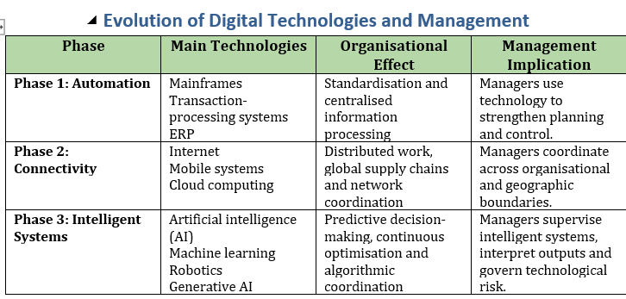
Source: Adapted table from Verhoef et al. (2021);

Figure C3: Evolution of organisational structures

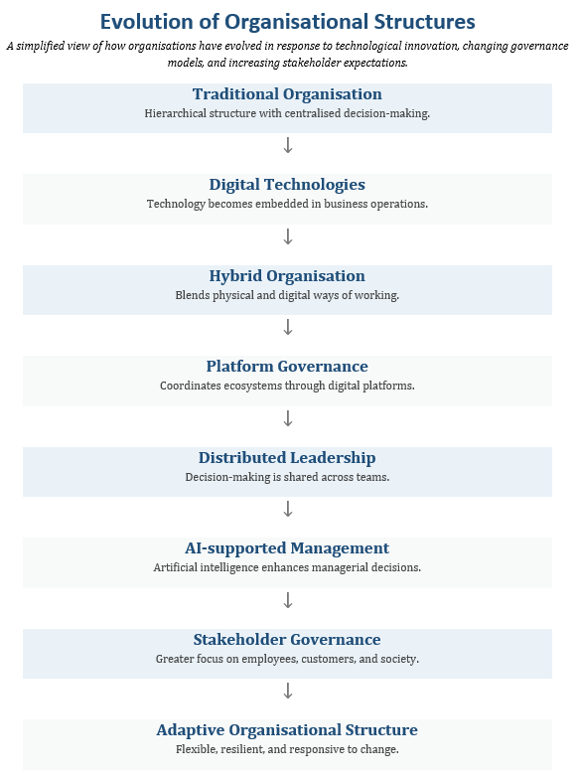
Source: Adapted from Henry Mintzberg's model (1979)

Figure C4: Value, data and governance flow in an online marketplace ecosystem

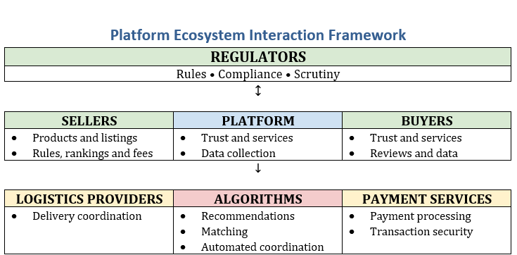
Source: Adapted model from Tiwana (2014) and Gawer (2014).

Figure C5: Stages of digital platform development

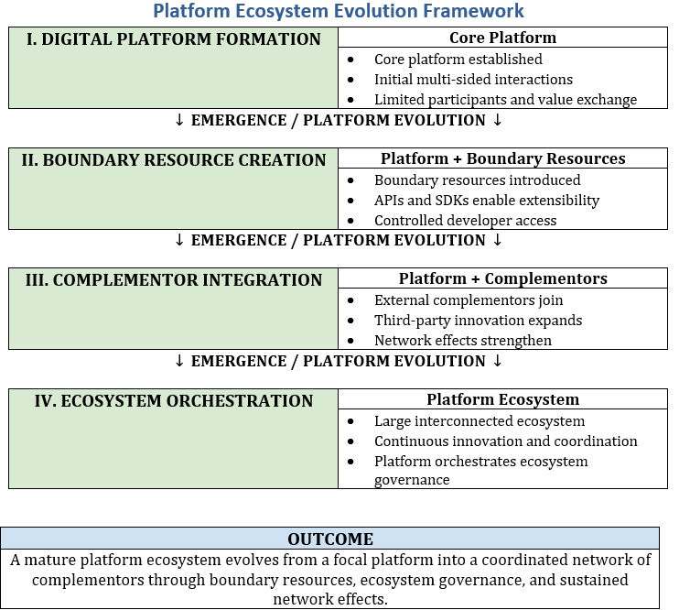
Source: Adapted figure from Nerbel and Kreuzer model (2023, Figure 1)

Figure C6: Empirically derived dimensions of organisational restructuring during digital transformation

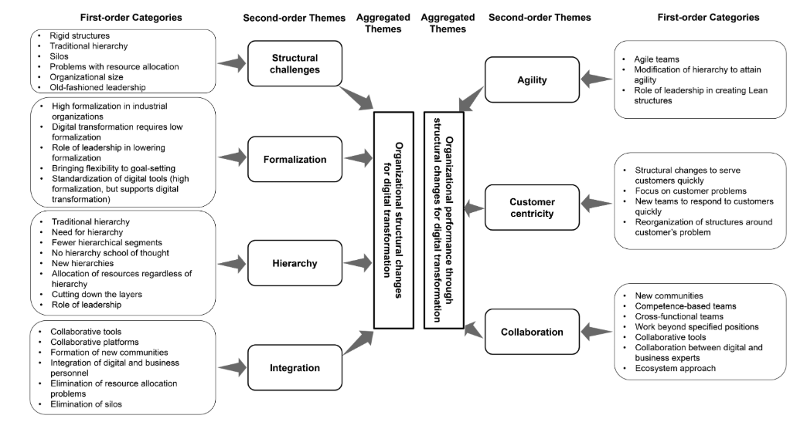
Source: Adapted from Shahzad, Imran and Butt (2025, Figure 1)

Figure C7: Digital Transformation

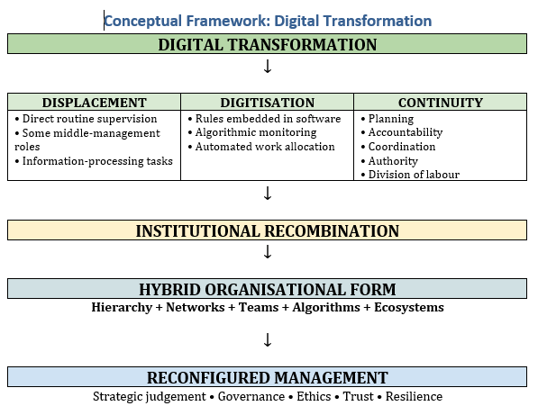
Source: Adapted model from Fayol (1949), Mintzberg (1979), Tiwana (2014), and Verhoef et al. (2021).

Appendix D

Table D1: CATWOE Operationalisation and Analytical Framework
CATWOE element | Operational definition | Evidence sources | Analytical focus | Amazon–eBay comparison
Customers (C) | Stakeholders receiving value or affected by platform decisions | Annual reports; academic literature; regulatory reports | Who benefits, bears costs, and how interests are aligned | Customer value, dependency and stakeholder relationships
Actors (A) | Human and organisational participants executing or governing activities | Corporate reports; academic studies | Who performs the transformation and who is accountable? | Internal workforce versus external ecosystem participants
Transformation (T) | Change from traditional retail/market coordination to digitally mediated platform activity | Academic literature; company documentation | How digitalisation, AI and automation transform coordination | Degree and form of organisational transformation
Worldview (W) | Assumptions and values legitimising organisational design and decisions | Strategy reports; CEO letters; academic literature | Why is the transformation considered desirable? | Strategic philosophy and organisational assumptions
Owners (O) | Individuals or bodies possessing authority over organisational direction | Corporate governance reports | Who retains strategic decision-making authority? | Centralisation, decentralisation and governance authority
Environmental constraints (E) | External institutional, regulatory and technological factors limiting organisational discretion | Legislation; regulatory reports; academic research | How do regulation and institutional pressures constrain governance? | Differences in regulatory and institutional pressures
Framework limitation | CATWOE is used as an interpretive framework, not a standalone test of management obsolescence | CATWOE literature; comparative evidence | Findings triangulated with management theory and Amazon–eBay evidence | Identifies differences in governance and transformation rather than proving causality
Source: Author's operationalisation based on Russel et al. (2025), Tiwana (2014), Gawer (2014), Amazon (2025), eBay (2025), OECD (2024)

Table D2: CATWOE Analysis of the Marketplace Transformation

Element | Critical interpretation | Management implication
Customers | Buyers receive convenience, variety and speed. Sellers receive market access. Both experience dependence, opacity and asymmetric redress (Rahman, Karunakaran, & Cameron, 2024). | Segment stakeholders rather than treating “the customer” as a single interest. Furthermore, design fair complaints and appeal processes.
Actors | Employees, managers, engineers, sellers, logistics partners, payment providers, regulators and algorithms enact the system (Russel et al., 2025). | Clarify human accountability where automated systems recommend or execute decisions.
Transformation | Fragmented, episodic transactions become continuous, globally accessible and data-mediated interactions. | Manage data quality, interoperability, process redesign and unintended feedback effects.
Worldview | Scale, prediction, convenience and customer-centricity are treated as legitimate sources of progress (Russel et al., 2025). | Challenge technological solutions and test whether efficiency claims externalise social costs.
Owners | Shareholders and senior executives hold formal ownership. Platform owners control the architecture, data, and participation rules. | Separate operational delegation from constitutional power and establish board-level digital accountability.
Environmental constraints | Competition law, DSA/GDPR, production safety, cybersecurity, labour norms, infrastructure, climate and cultural expectations. | Build compliance and resilience into design rather than adding them after deployment
Source: Adapted model from Russel et al. (2025) and synthesised with Rahman et al. (2024).

Table D3: CATWOE Operationalisation Framework
CATWOE Element | Operational Definition | Data Sources | Evidence Extracted | Analytical Questions | Comparison Criteria
Customers (C) | Individuals or organisations receiving value or affected by platform decisions | Annual reports, sustainability reports, academic literature, regulatory reports | Customer experience, seller satisfaction, complaints, market access | Who benefits? Who bears costs? Are stakeholder interests aligned? | Amazon vs eBay customer dependency and value creation
Actors (A) | Human participants responsible for executing or governing organisational activities (employees, managers, sellers, logistics, partners, regulators). | Organisational reports, academic studies | Management roles, employee responsibilities, ecosystem participants | Who performs transformation? Who is accountable? | Internal workers vs external ecosystem participants
Transformation (T) | Process converting traditional retail transactions into digital mechanisms, not only independent actors | Literature, company documentation | Digitalisation, automation, AI, logistics, platform governance | What organisational change occurs? | Degree of organisational transformation
Worldview (W) | Assumptions legitimising organisational design and managerial decisions | Strategy reports, CEO, letters, academic literature | Customer obsession, innovation, efficiency, growth | Why is the transformation considered desirable? | Strategic philosophy of each organisation
Owners (O) | Individuals or bodies possessing authority to determine organisational direction | Corporate governance reports | Board authority, shareholders, executive leadership | Who ultimately controls organisational decisions? | Governance structure and ownership concentration
Environmental Constraints (E) | External factors limiting organisational decisions | Regulatory reports, legislation, academic research | GDPR, DSA, competition law, cybersecurity, labour legislation | What limits organisational discretion? | Regulatory complexity and institutional pressure

Source: Adapted from Tiwana (2014); Amazon (2025); eBay (2025); OECD (2024); Rahman et al., (2024);

Table D4: Evidence Coding Framework
CATWOE Element | Evidence Source | Evidence Type | Coding Theme | Interpretation
Customers | Amazon Annual Report | Primary | Customer obsession | Customer value drives strategic priorities
Customers | OECD (2024) | Secondary | Consumer protection | Regulatory expectations shape governance
Actors | eBay Annual Report | Primary | Marketplace governance | Human managers supervise ecosystem relationships
Actors | Davidson (2025) | Secondary | Algorithmic management | Algorithms support rather than replace managerial authority
Transformation | Verhoef et al. (2021). | Secondary | Digital transformation | Technology reconfigures organisational coordination
Worldview | Amazon CEO Letter | Primary | Innovation | Continuous experimentation legitimises organisational change
Owners | Corporate Governance Report | Primary | Executive authority | Strategic control remains centralised
Environmental Constraints | EU Digital Services Act | Primary | Platform regulation | External institutions constrain platform governance

Source: Adapted from Amazon (2025); eBay (2025); Davidson (2025); Verhoef et al. (2021); EU (2022).

Table D5: Amazon CATWOE Analysis
CATWOE | Evidence | Interpretation
Customers | Consumers, Prime members, third-party sellers | Value created through convenience, fulfilment and ecosystem participation
Actors | Managers, software engineers, warehouse employees, logistics, partners, sellers | Human actors execute operations, and AI supports decision-making processes
Transformation | Retail – integrated digital platform | Physical retail becomes AI-supported platform governance
Worldview | Customer obsession, operational excellence, innovation | Efficiency and customer value justify digital transformation
Owners | Board of Directors, executive leadership, shareholders | Strategic authority remains centralised
Environmental Constraints | Competition law, GDPR, D-commerce regulation, labour regulation | Regulation shapes managerial discretion

Adapted from Amazon (2025); Tiwana (2014); Gawer (2014); Verhoef et al. (2021); Davidson (2025); OECD (2024); EU (2016; 2022).

Table D6: eBay CATWOE Analysis
CATWOE | Evidence | Interpretation
Customers | Buyers and independent sellers | Value created through trusted marketplace interactions
Actors | Managers, software engineers, sellers, payment providers, regulators | Platform coordinates independent market participants
Transformation | Auctions – digital market ecosystem | Digital governance replaces traditional market coordination
Worldview | Trust, transparency, community participation | Reputation systems underpin organisation legitimacy
Owners | Board, executive management, shareholders | Platform governance remains centrally controlled
Environmental Constraints | Consumer law, GSPR, Digital Services Act | Platform governance constrained by regulation

Adapted from eBay (2025); Tiwana (2014); Gawer (2014); Verhoef et al. (2021); Davidson (2025); OECD (2024); EU (2016; 2022).

Table D7: Cross-Case CATWOE Comparison
CATWOE | Amazon | eBay | Analytical Finding
Customers | Buyers, Prime users, sellers | Buyers and sellers | Amazon creates integrated service ecosystem; eBay facilitates market exchange
Actors | Large internal workforce plus ecosystem | Smaller workforce with external ecosystem | Amazon relies more on hierarchical coordination
Transformation | Retail and logistics and AI platform | Market coordination platform | Different organisational architectures achieve digital coordination
Worldview | Customer obsession | Centralised platform governance | Both retain executive authority despite operational decentralisation
Owners | Highly centralised strategic control | Centralised platform governance | Both retain executive authority despite operational decentralisation
Environmental Constraints | Labour, logistics, competition, privacy | Competition, marketplace regulation, consumer protection | Institutional pressures differ but remain significant

Adapted from Amazon (2025); eBay (2025); Tiwana (2014); Gawer (2014); Verhoef et al. (2021); Davidson (2025); OECD (2024); EU (2016; 2022).

Table D8: Evidence Trail
Finding | Evidence | CATWOE Element | Interpretation
Digital technology reduces information asymmetry | Amazon Annual Report; Verhoef et al. (2021). | Transformation | AI improves coordination
Hierarchy remains necessary | Davidson (2025); Amazon Governance Report | Owners | Strategic authority remains centralised
Platform governance replaces some supervisory functions | Tiwana (2014); Gawer (2014); | Actors | Governance shifts from managers to digital infrastructure
Customer experience drives organisational design | Amazon CEO Letter | Worldview | Customer-centricity legitimises organisational change
Regulation constrains digital platforms | OECD (2024); DSA | Environment | Digital transformation remains institutionally bounded

Adapted from Amazon (2025); eBay (2025); Tiwana (2014); Gawer (2014); Verhoef et al. (2021); Davidson (2025); OECD (2024); EU (2016; 2022).

Figure D1: Research Framework

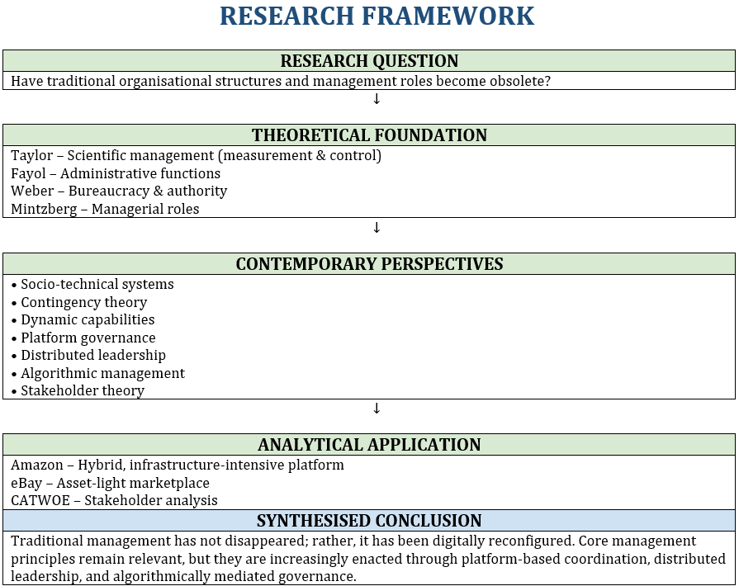
Source: (Tiwana, 2024; Verhoef et al., 2021; Davidson, 2025).

Figure D2: CATWOE interpretation

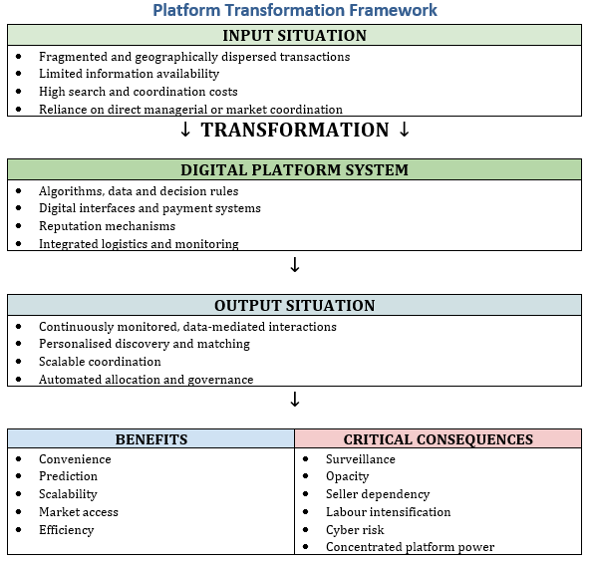
Source: Gilbert, Schrage, and Behnam (2024); Rahman, Karunakaran, and Cameron (2024).

Figure D3: Research Methodology Flow for Comparative CATWOE Analysis
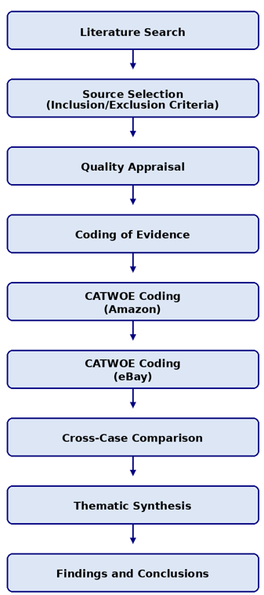
Adapted from Booth et al. (2016); Petticrew and Roberts (2006); Yin (2018);

