
LDE Assignment 2
Learning in the Digital Era


STUDENT NAME: SADAF YUSUFZAI
STUDENT ID: 2513631
ACCA4025_LON
GROUP 4
LECTURER’S NAME: DIPO DUNSIN

December 19, 2025
uNiversity of wales trinity saint david LONDON CAMPUS

Table of Contents
Introduction 2
Main Body 2
Conclusion 9
References 9

Introduction
This report supports a 3–4-minute video presentation that provides a detailed overview of my self-evaluation and professional development planning.

Main Body
The main body of the presentation will cover three key areas: first, a self-evaluation where I review on my strengths, weaknesses, and personal traits using insights from self-assessment tools; second, the production of a Professional Development Plan (PDP) with SMART goals, underpinned by research and appropriate references to inform my growth; and third, a summary topic 3 from Moodle Unit 4, ‘Becoming a Lifelong Learner’, emphasising key concepts and their significance to my development. The presentation summarises a reflection on skill gaps, strategies to address them, and a compilation of reference supporting the content discussed.

Video Link: my.sharepoint.com/:p:/g/personal/2513631_student_uwtsd_ac_uk/IQB685LYru9HQJ_R-P3h_mlsAYteEV8v_Ei7nl0vkcyW2bc?email=d.dunsin%40uwtsd.ac.uk&e=U0BMz6

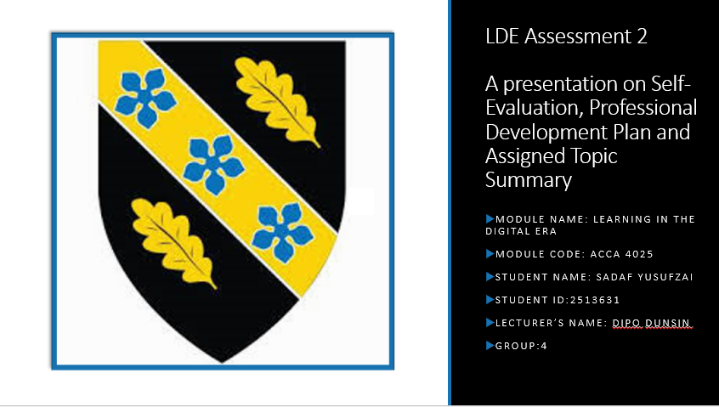
Slide 1 COVER PAGE

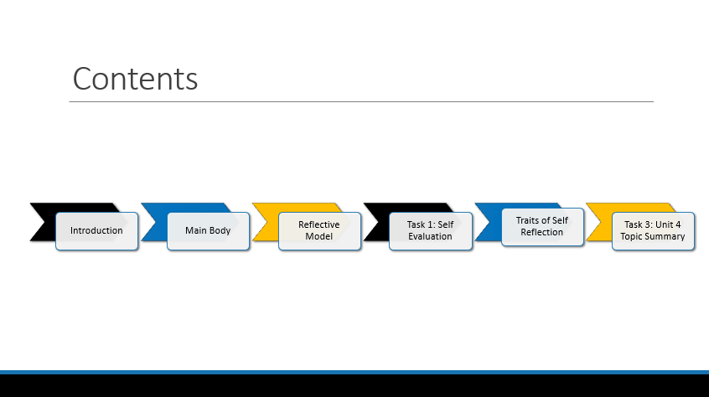
Slide 2 CONTENTS

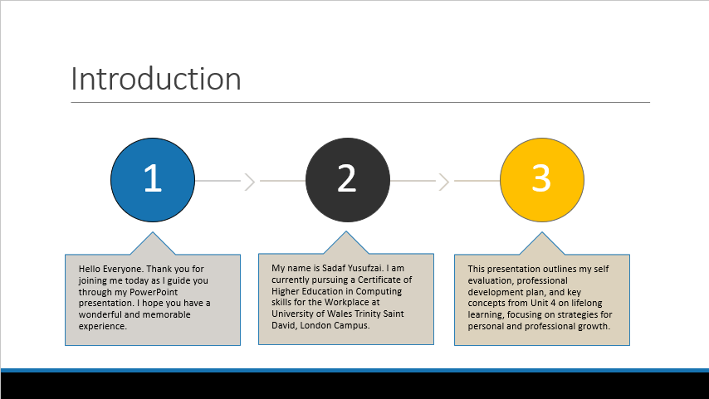
Slide 3 INTRODUCTION

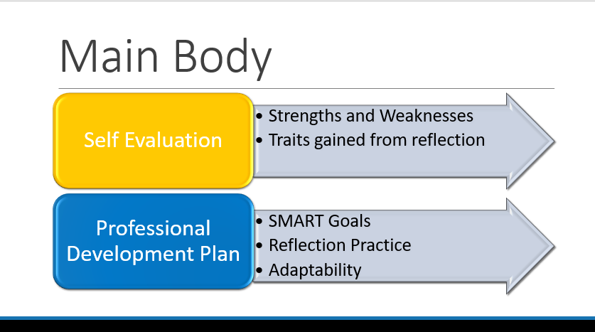
Slide 4 MAIN BODY

Slide 5 GIBB’s REFLECTIVE MODEL

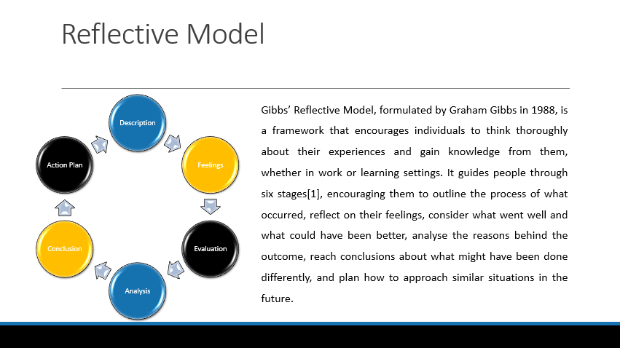
Gibbs’ Reflective Model, formulated by Graham Gibbs in 1988, is a framework that encourages individuals to think thoroughly about their experiences and gain knowledge from them, whether in work or learning settings. It guides people through six stages [1], encouraging them to outline the process of what occurred, reflect on their feelings, consider what went well and what could have been better, analyse the reasons behind the outcome, reach conclusions about what might have been done differently, and plan how to approach similar situations in the future.
Through my self-evaluation, I have shown several key traits that enhance my personal and professional development. These include empathy, which allows me to respect and understand my teammates; critical thinking, which helps me solve tasks effectively; and a willingness to learn, shown through by being open to feedback and continuously improving my skills.
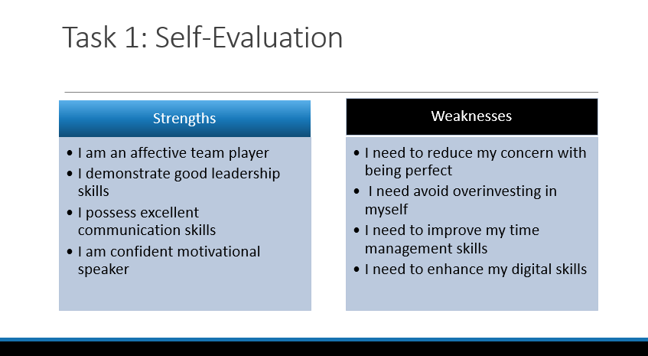
Slide 6 TASK 1: SELF EVALUATION

Based on my SWOT analysis, one of my key strengths [2] is my leadership skills. This allows me to lead and inspire team members, assign tasks effectively, and ensure that activities are completed successfully.
An ability I am looking to enhance further is time management. I sometimes find it challenging to balance multiple tasks and prioritise successfully, which can affect my productivity. To strengthen, I am organising to use scheduling tools, set clear deadlines, and asses my workload regularly to manage my time more efficiently.
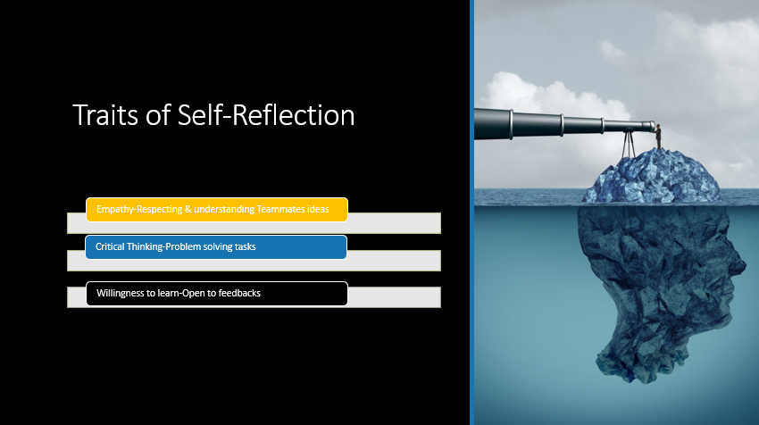
Slide 7 TRAITS GAINED FROM THE SELF EVALUATION

Through my self-evaluation, I have shown several key traits that enhance my personal and professional development. These include empathy, which allows me to respect and understand my teammates; critical thinking, which helps me solve tasks effectively; and a willingness to learn, shown through by being open to feedback and continuously improving my skills.

Slide 8 PROFESSIONAL DEVELOPMENT PLAN
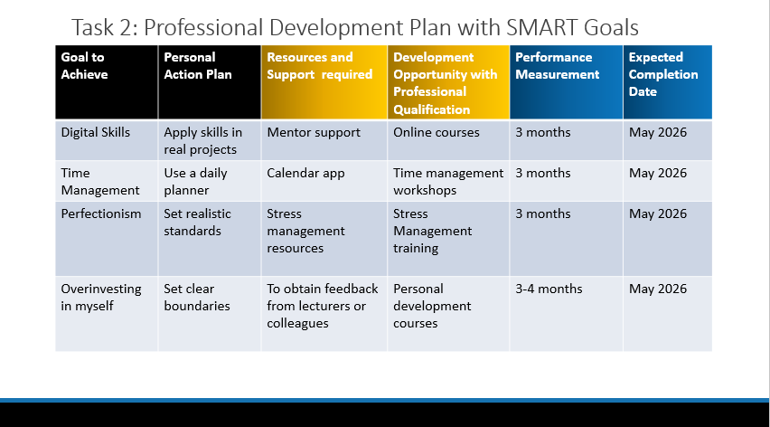

A Personal Development Plan (PDP) is an organised framework that helps individuals set goals, recognise areas for growth, and plan practical steps to enhance their skills and knowledge. I am using it to guide my personal and professional growth, ensure I address skill gaps, and track my progress effectively. It encourages self-reflection, setting priorities for my goals, and the use of strategies such as SMART goals to achieve significant development. [3]

Slide 9 UNIT 4 TOPIC SUMMARY
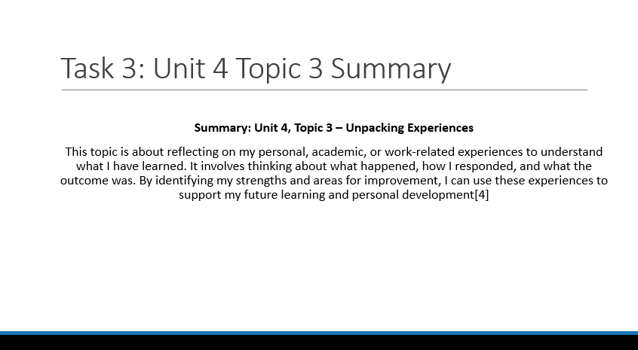

Summary: Unit 4, Topic 3 – Unpacking Experiences
This topic is about reflecting on my personal, academic, or work-related experiences to understand what I have learned. It involves thinking about what happened, how I responded, and what the outcome was. By identifying my strengths and areas for improvement, I can use these experiences to support my future learning and personal development [4]. Engaging in this reflection helps me to make informed decisions, apply lessons learned to new situations, and pursue lifelong learning to enhance my skills and behaviours. It also promotes self-awareness and adaptability, which are essential for becoming a lifelong learner and reaching both personal and career goals.

Slide 10 CONCLUSION
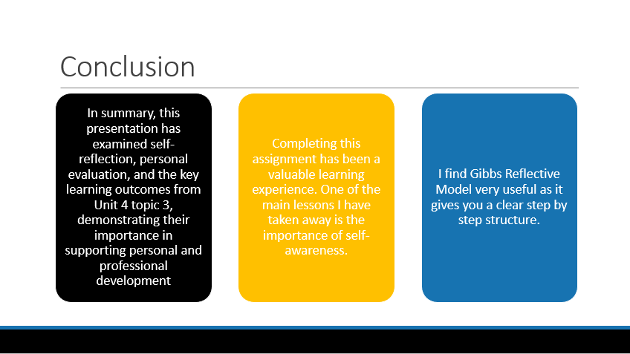

In summary, this presentation has explored self-reflection, personal evaluation, and key learning from Unit 4, Topic 3, highlighting their role in supporting personal and professional development. Completing this assignment has emphasised the importance of self-awareness, and I have found Gibbs’ Reflective Model particularly useful for providing a clear, step-by-step structure for reflection.

Conclusion
This presentation has shown the value of self-reflection and personal evaluation in enhancing both personal and professional development. By applying Gibbs’ Reflective Model, I was able to identify strengths, recognise areas for development, and plan actionable steps to improve my skills. The insights gained from Unit 4, Topic 3, and this reflective process will guide my ongoing learning and support my growth as a lifelong learner.

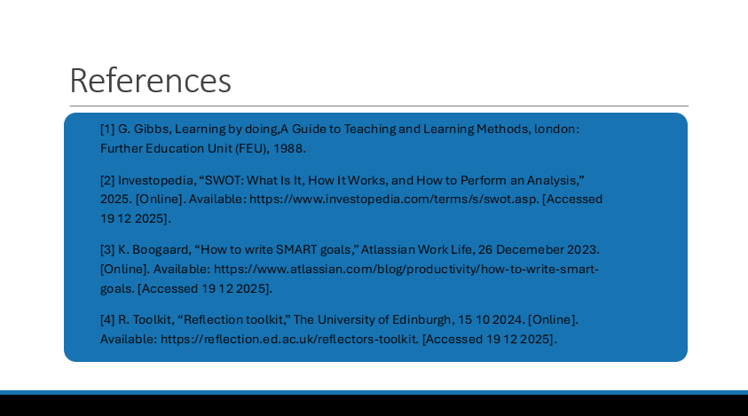

References

