
OpenGL based 3D Game


By Andrew Ridgeway
P148551
Computer Games Development
Game Programming and Graphics
Gordon Dickers
Table of Contents
Introduction 2
Screenshots 2
• The Command Prompt 2
• The Programme is Running 3
• The Move 3
• The Up and Down 4
• The Rotate 4
Script 5
• The Library and Global Variable 5
• The Main 6
• The Init 7
• The Texture Loader 8
• The Reshape 9
• The Rectangle Shapes 10
• The Display 11
• The Mouse Inputs 13
• The Keyboard Inputs 14
• The Arrow Inputs 15
• The Help of the Controls 15
Testing Table 16
References 16

Introduction
In this document will have screenshots of the program, such as what the controls are with the command window is up and screenshots of the game how it looks and runs.
There'll be a section with a script showing what type of scripts was used to create this program for OpenGL.
There will be a test in table to see everything is working properly with the program.
There will be a references section that was used to help to create the program.
The textures that was used in this program was created in Microsoft paint.

Screenshots

The Command Prompt
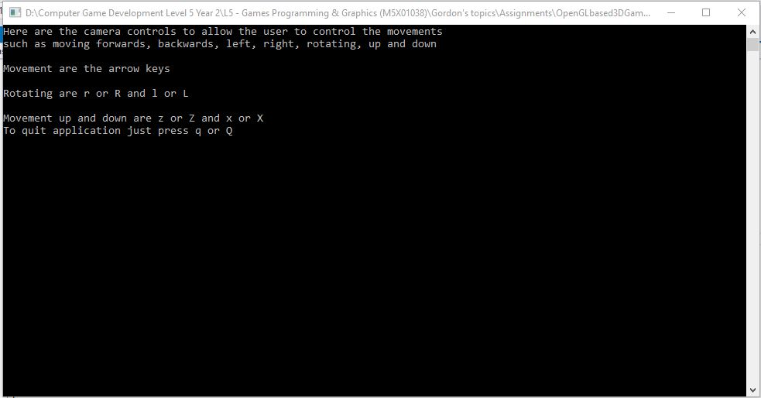
Here is an image of the command prompt to display the text to help the end-user with the control.

The Programme is Running
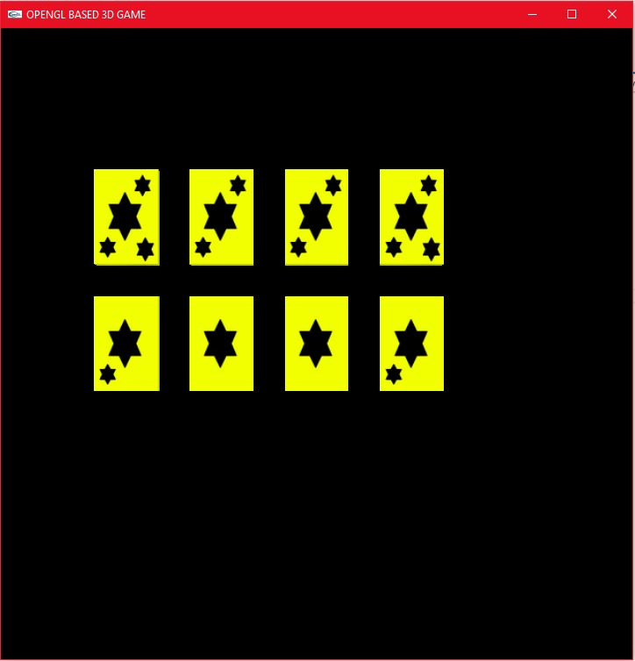
Here is an image of the running window application of the object.

The Move
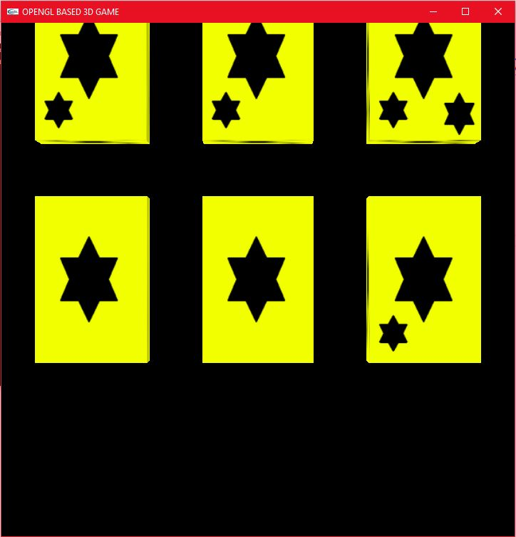
Here is an image of the moving around.

The Up and Down
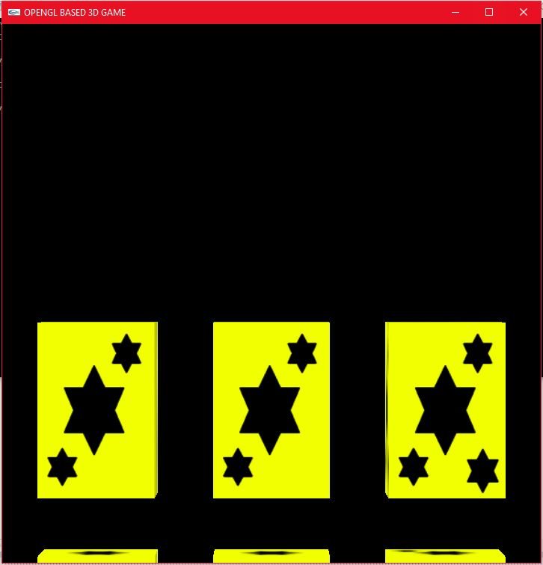
Here is an image of the moving up and down.

The Rotate
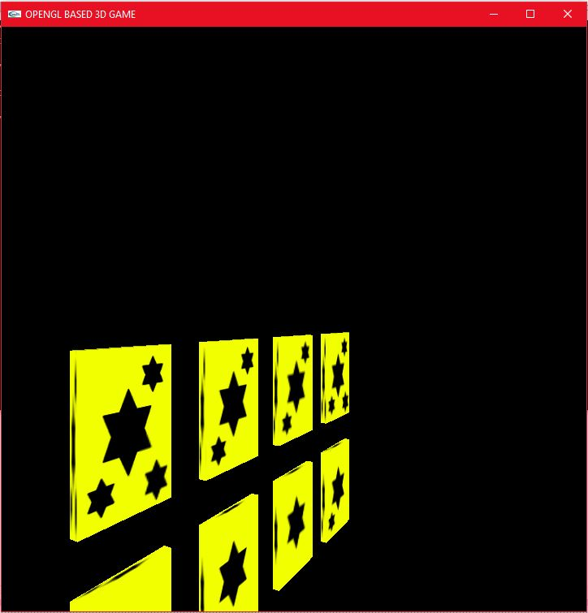
Here is an image of the rotate.

Script

The Library and Global Variable
#define BITMAP_ID 0x4D42
#include <iostream>
#include <stdio.h>
#include <stdlib.h>
#include <math.h>
#include <windows.h>
#include "glut.h"
#include "Vector.h"
using namespace std;

// allow global variable to be called first

// use for the controls while running
static int xC = 0, zC = 0, yUD = 0, angle = 0;
static GLuint texture[3];
// this is used to make sure numbers to not go to negative
unsigned char* bitData;
// this is use for the type size and layout of files
BITMAPINFOHEADER bitInfo;

float BVposX, BVposY, BVposZ;
float BoundSphereRadius = 1.0f;
bool intere;

double WorldT[16];
double objectNear[4];
double objectFar[4];

// this line of code is use for the collision hit and miss
// attempted
bool isBoundSphereIntersect(Ray v) {
intere = false;

//calc collision
float BVpositionX = 0.0f, BVpositionY = 0.0f, BVpositionZ = 0.0f;
float positionX = 0.0f, positionY = 0.0f, positionZ = 0.0f;
BVposX = (BVpositionX = positionX) + 0.0;
BVposY = (BVpositionY = positionY) - 0.0;
BVposZ = (BVpositionZ = positionZ) - 0.0;

cout << "line point distance squared is: " << BVposX << "\n";
cout << "line point distance squared is: " << BVposY << "\n";
cout << "line point distance squared is: " << BVposZ << "\n";

if (BVposX>(BoundSphereRadius*BoundSphereRadius))
return false; //no intersection detected
else true;//intersection detected
if (BVposY>(BoundSphereRadius*BoundSphereRadius))
return false; //no intersection detected
else true;//intersection detected
if (BVposZ>(BoundSphereRadius*BoundSphereRadius))
return false; //no intersection detected
else true;//intersection detected
}
// attempted

void init(void);
unsigned char* loadTex(const char* readFile, BITMAPINFOHEADER* bitInfo);
void reshape(int w, int h);
void display(void);
void drawRectangle(void);
void mouse(int button, int state, int x, int y);
void keyboard(unsigned char key, int x, int y);
void arrowInput(int key, int x, int y);
void controlHelp();
Here is the library and the global variable[1][2], this code (#define BITMAP_ID 0x4D42/isBoundSphereIntersect(Ray v)) would provide by Gordon Dickers.

The Main
// call the whole thing to work
int main(int argc, char** argv) {
controlHelp(); // make sure the command prompt screen show the user how to use the controls
glutInit(&argc, argv);
glutInitDisplayMode(GLUT_DOUBLE | GLUT_RGB);

glutInitWindowPosition(100, 100);
glutInitWindowSize(720, 720);
glutCreateWindow("OPENGL BASED 3D GAME");
init();

glutDisplayFunc(display);
glutIdleFunc(display);
glutReshapeFunc(reshape);
glutKeyboardFunc(keyboard);
glutSpecialFunc(arrowInput);
glutMouseFunc(mouse);
glutMainLoop();

return 0;
}
Here is the main that running the programming for the end-user.

The Init
// this is used to allow materials such as lighting and textures to be used within the code
void init(void) {
WorldT[0] = 1; WorldT[4] = 0; WorldT[8] = 0; WorldT[12] = 0;
WorldT[1] = 0; WorldT[5] = 1; WorldT[9] = 0; WorldT[13] = 0;
WorldT[2] = 0; WorldT[6] = 0; WorldT[10] = 1; WorldT[14] = 0;
WorldT[3] = 0; WorldT[7] = 0; WorldT[11] = 0; WorldT[15] = 1;

glClearColor(0.5, 1.0, 0.5, 0.0); // empties the background colour
glShadeModel(GL_SMOOTH);

glLightModeli(GL_LIGHT_MODEL_LOCAL_VIEWER, GL_TRUE);
glEnable(GL_LIGHTING); // this allows fighting to be enabled
glEnable(GL_LIGHT0);

glutInitDisplayMode(GLUT_DEPTH);
glEnable(GL_DEPTH_TEST); // this will allow objects to look good and don't look horrible
glEnable(GL_TEXTURE_2D); // to allow 2D textures to be used

// this is used to set up the positions of the lighting and the colour of the lights
GLfloat light_ambient[] = { 0.2, 0.2, 0.2, 1.0 }; // ambien light
glLightfv(GL_LIGHT0, GL_AMBIENT, light_ambient);

GLfloat light_diffuse[] = { 0.8, 0.8, 0.8, 1.0 }; // diffuse light
glLightfv(GL_LIGHT0, GL_DIFFUSE, light_diffuse);

GLfloat light_specular[] = { 1.0, 1.0, 1.0, 1.0 }; // specular light
glLightfv(GL_LIGHT0, GL_SPECULAR, light_specular);

GLfloat light_position[] = { 1.0, 10.0, 7.0, 1.0 }; // the position of the light
glLightfv(GL_LIGHT0, GL_POSITION, light_position);

// this is use for the number of textures that is used for the objects
glGenTextures(3, texture);

// this is used to call texture 1
bitData = loadTex("Star.bmp", &bitInfo);
glBindTexture(GL_TEXTURE_2D, texture[0]);
glTexEnvf(GL_TEXTURE_ENV, GL_TEXTURE_ENV_MODE, GL_MODULATE);
glTexParameterf(GL_TEXTURE_2D, GL_TEXTURE_MIN_FILTER, GL_LINEAR_MIPMAP_NEAREST);
glTexParameterf(GL_TEXTURE_2D, GL_TEXTURE_MAG_FILTER, GL_LINEAR);
gluBuild2DMipmaps(GL_TEXTURE_2D, 3, bitInfo.biWidth, bitInfo.biHeight, GL_RGB, GL_UNSIGNED_BYTE, bitData);

// this is used to call texture 2
bitData = loadTex("Star1.bmp", &bitInfo);
glBindTexture(GL_TEXTURE_2D, texture[1]);
glTexEnvf(GL_TEXTURE_ENV, GL_TEXTURE_ENV_MODE, GL_MODULATE);
glTexParameterf(GL_TEXTURE_2D, GL_TEXTURE_MIN_FILTER, GL_LINEAR_MIPMAP_NEAREST);
glTexParameterf(GL_TEXTURE_2D, GL_TEXTURE_MAG_FILTER, GL_LINEAR);
gluBuild2DMipmaps(GL_TEXTURE_2D, 3, bitInfo.biWidth, bitInfo.biHeight, GL_RGB, GL_UNSIGNED_BYTE, bitData);

// this is used to call texture 3
bitData = loadTex("Star2.bmp", &bitInfo);
glBindTexture(GL_TEXTURE_2D, texture[2]);
glTexEnvf(GL_TEXTURE_ENV, GL_TEXTURE_ENV_MODE, GL_MODULATE);
glTexParameterf(GL_TEXTURE_2D, GL_TEXTURE_MIN_FILTER, GL_LINEAR_MIPMAP_NEAREST);
glTexParameterf(GL_TEXTURE_2D, GL_TEXTURE_MAG_FILTER, GL_LINEAR);
gluBuild2DMipmaps(GL_TEXTURE_2D, 3, bitInfo.biWidth, bitInfo.biHeight, GL_RGB, GL_UNSIGNED_BYTE, bitData);

// this is used to call texture 4
bitData = loadTex("Star3.bmp", &bitInfo);
glBindTexture(GL_TEXTURE_2D, texture[3]);
glTexEnvf(GL_TEXTURE_ENV, GL_TEXTURE_ENV_MODE, GL_MODULATE);
glTexParameterf(GL_TEXTURE_2D, GL_TEXTURE_MIN_FILTER, GL_LINEAR_MIPMAP_NEAREST);
glTexParameterf(GL_TEXTURE_2D, GL_TEXTURE_MAG_FILTER, GL_LINEAR);
gluBuild2DMipmaps(GL_TEXTURE_2D, 3, bitInfo.biWidth, bitInfo.biHeight, GL_RGB, GL_UNSIGNED_BYTE, bitData);
}
Here is the init to give the lighting and the texture[3][4].

The Texture Loader
// load the texture
unsigned char* loadTex(const char* readFile, BITMAPINFOHEADER* bitInfo)
{
// this is used to read the image files
FILE* theFile;
BITMAPFILEHEADER bitFile;
unsigned char* data;
unsigned char colour;

theFile = fopen(readFile, "rb");
if (theFile == NULL)
return NULL;

// this is used to read blocks of data
fread(&bitFile, sizeof(BITMAPFILEHEADER), 1, theFile);
fread(bitInfo, sizeof(BITMAPINFOHEADER), 1, theFile);

// this is used to allocate memory for the object
data = (unsigned char*)malloc(bitInfo->biSizeImage);
if (!data)
{
free(data);
fclose(theFile);
return NULL;
}

fread(data, 1, bitInfo->biSizeImage, theFile);
for (int i = 0; i < bitInfo->biSizeImage; i++)
{
// this is used to make sure the colours is the same as the image
colour = data[i];
data[i] = data[i + 4];
data[i + 4] = colour;
}

fclose(theFile);
return data;
}
Here is the file loader to read the file for the texture, this code would provide on Moodle by Gordon Dickers[5].

The Reshape
// this is used to resize the view points for the window
void reshape(int w, int h)
{
glViewport(0.0, 0.0, w, h);
glMatrixMode(GL_PROJECTION);
glLoadIdentity();
glFrustum(-1.0, 1.0, -1.0, 1.0, 1.5, 20.0);

glMatrixMode(GL_MODELVIEW);
}
Here is the reshape to give the view points to show the shapes and resize the view points for the window[3, pp 460].

The Rectangle Shapes
// draw rectangle is used to create the shape of the rectangle
void drawRectangle(void) {
glPushMatrix();

// puts circulation around the object
glTranslatef(0.0, 0.0, 0.0);
glutWireSphere(BoundSphereRadius, 18, 18);
glPopMatrix();

glPushMatrix();

// create the shape in quads
glBegin(GL_QUADS);

// used to create the top face for the rectangle
glTexCoord2f(0.0, 0.0);
glVertex3f(1.0, 1.5, 0.1);
glTexCoord2f(1.0, 0.0);
glVertex3f(1.0, 1.5, -0.1);
glTexCoord2f(1.0, 1.0);
glVertex3f(-1.0, 1.5, -0.1);
glTexCoord2f(0.0, 1.0);
glVertex3f(-1.0, 1.5, 0.1);

// used to create the front face for the rectangle
glTexCoord2f(0.0, 0.0);
glVertex3f(1.0, 1.5, 0.1);
glTexCoord2f(1.0, 0.0);
glVertex3f(-1.0, 1.5, 0.1);
glTexCoord2f(1.0, 1.0);
glVertex3f(-1.0, -1.5, 0.1);
glTexCoord2f(0.0, 1.0);
glVertex3f(1, -1.5, 0.1);

// used to create the right face for the rectangle
glTexCoord2f(0.0, 0.0);
glVertex3f(1.0, 1.5, 0.1);
glTexCoord2f(1.0, 0.0);
glVertex3f(1.0, -1.5, 0.1);
glTexCoord2f(1.0, 1.0);
glVertex3f(1.0, -1.5, -0.1);
glTexCoord2f(0.0, 1.0);
glVertex3f(1.0, 1.5, -0.1);

// used to create the left face for the rectangle
glTexCoord2f(0.0, 0.0);
glVertex3f(-1.0, 1.5, 0.1);
glTexCoord2f(1.0, 0.0);
glVertex3f(-1.0, 1.5, -0.1);
glTexCoord2f(1.0, 1.0);
glVertex3f(-1.0, -1.5, -0.1);
glTexCoord2f(0.0, 1.0);
glVertex3f(-1.0, -1.5, 0.1);

// used to create the bottom face for the rectangle
glTexCoord2f(0.0, 0.0);
glVertex3f(-1.0, -1.5, 0.1);
glTexCoord2f(1.0, 0.0);
glVertex3f(-1.0, -1.5, -0.1);
glTexCoord2f(1.0, 1.0);
glVertex3f(1.0, -1.5, -0.1);
glTexCoord2f(0.0, 1.0);
glVertex3f(1.0, -1.5, 0.1);

// used to create the back face for the rectangle
glTexCoord2f(0.0, 0.0);
glVertex3f(1.0, -1.5, -0.1);
glTexCoord2f(1.0, 0.0);
glVertex3f(-1.0, -1.5, -0.1);
glTexCoord2f(1.0, 1.0);
glVertex3f(-1.0, 1.5, -0.1);
glTexCoord2f(0.0, 1.0);
glVertex3f(1.0, 1.5, -0.1);

glEnd();
glPopMatrix();
}
Here the draw rectangle so it can create the shapes[3, pp 79, 399].

The Display
// display the shape to be shown while it's running
void display(void) {
glClear(GL_COLOR_BUFFER_BIT | GL_DEPTH_BUFFER_BIT);
glLoadIdentity(); // reset transformation (of modelview matrix)
glTranslatef(0.0, 0.0, -10.0); // move the position of the camera

// allows the user to move the camera up, down, forward, back, left and right
glTranslatef(xC, yUD, zC);

// allows the end user to rotate the camera
gluLookAt(5 * sin(float(angle)*0.0175), 0.0, 5 * cos(float(angle)*0.0175), 0.0, 0.0, 0.0, 0.0, 1.0, 0.0);

// use for mouse controls to give the end user the god solution
glGetDoublev(GL_MODELVIEW_MATRIX, WorldT);//get for use with gluUnproject
glBegin(GL_TRIANGLES); //fire ray
glColor3f(1.0, 0.0, 0.0);
glNormal3f(0.0, -1.0, 0.0);
glVertex3d(objectNear[0], objectNear[1], objectNear[2]);
glVertex3d(objectFar[0], objectFar[1], objectFar[2]);
glVertex3d(objectNear[0] + 0.1, objectNear[1], objectNear[2]);
glEnd();

// this is used to put lights on the material and position the lighting effect
GLfloat mat_amb_diff[] = { 2.0, 2.0, 2.0, 1.0 };
glMaterialfv(GL_FRONT_AND_BACK, GL_AMBIENT_AND_DIFFUSE, mat_amb_diff);
glMaterialf(GL_FRONT, GL_SHININESS, 100.0);

glBindTexture(GL_TEXTURE_2D, texture[0]); // apply the texture to the rectangle
drawRectangle(); // this call the rectangle
glPushMatrix();

glTranslatef(3.0, 0.0, 0.0); // move the rectangles position
glBindTexture(GL_TEXTURE_2D, texture[1]);
drawRectangle();
glPopMatrix();

glTranslatef(0.0, 4.0, 0.0);
glBindTexture(GL_TEXTURE_2D, texture[2]);
drawRectangle();
glPushMatrix();
glPopMatrix();

glTranslatef(3.0, 0.0, 0.0);
glBindTexture(GL_TEXTURE_2D, texture[3]);
drawRectangle();
glPushMatrix();
glPopMatrix();

glTranslatef(-6.0, -4.0, 0.0);
glBindTexture(GL_TEXTURE_2D, texture[0]);
drawRectangle();
glPopMatrix();

glTranslatef(-3.0, 0.0, 0.0);
glBindTexture(GL_TEXTURE_2D, texture[1]);
drawRectangle();
glPopMatrix();

glTranslatef(0.0, 4.0, 0.0);
glBindTexture(GL_TEXTURE_2D, texture[3]);
drawRectangle();
glPushMatrix();
glPopMatrix();

glTranslatef(3.0, 0.0, 0.0);
glBindTexture(GL_TEXTURE_2D, texture[2]);
drawRectangle();
glPushMatrix();
glPopMatrix();

glFlush();
glutSwapBuffers();
}
Here is the display to the shapes, texture and lighting on the material.

The Mouse Inputs
// here are the inputs to allow the user to be able to use a mouse
void mouse(int button, int state, int x, int y)
{
int view[4];
// double modelview[16];
double proj[16];
glGetIntegerv(GL_VIEWPORT, view);
glGetDoublev(GL_PROJECTION_MATRIX, proj);
int realy = view[3] - (GLint)y - 1;
int check = gluUnProject(x, realy, -1, WorldT, proj, view, objectNear, objectNear + 1, objectNear + 2);
cout << "unprojected near co-ords are ";
for (int i = 0; i<4; i++) {
cout << objectNear[i] << " ";
} cout << "\n";
check = gluUnProject(x, realy, 1, WorldT, proj, view, objectFar, objectFar + 1, objectFar + 2);
cout << "unprojected far co-ords are ";
for (int i = 0; i<4; i++) {
cout << objectFar[i] << " ";
} cout << "\n";
//prepare for collision test by making a ray
Vector d(objectFar[0], objectFar[1], objectFar[2]);
Vector p(objectNear[0], objectNear[1], objectNear[2]);
Ray ray1; //this is the ray cast
ray1.SetOrigin(p); //initialise ray with origin and direction vector
ray1.SetDirection(d - p);
if (isBoundSphereIntersect(ray1))
cout << "hit" << endl;
else
cout << "miss" << endl;

glutPostRedisplay();
}
Here is the mouse controls to allow the end user to click on objects[2].

The Keyboard Inputs
// here are the inputs to allow the user to rotate, move up and down and quit application
void keyboard(unsigned char key, int x, int y) {
switch (key)
{
case 'z' | 'Z': // used for moving up
yUD--;
break;
case 'x' | 'X': // used for moving down
yUD++;
break;
case 'q' | 'Q': // used for closing the application
exit(0);
break;
case 'l' | 'L': // used for rotating left
angle = (angle - 10) % 360;
break;
case 'r' | 'R': // used for rotating right
angle = (angle + 10) % 360;
break;
default:
break;
}
glLoadIdentity();
glutPostRedisplay();
}
Here are the controls to rotate, move up and down and quit for the end-user.

The Arrow Inputs
// special import is use for arrow key controls to move the camera
void arrowInput(int key, int x, int y) {
switch (key)
{
case GLUT_KEY_UP: // used for moving forward
zC++;
break;
case GLUT_KEY_DOWN: // used for moving back
zC--;
break;
case GLUT_KEY_LEFT: // used for moving left
xC++;
break;
case GLUT_KEY_RIGHT: // used for moving right
xC--;
break;
default:
break;
}
}
Here are the controls to move the cameras for the end-user[6].

The Help of the Controls
// here are the controls to help the end user while application is running
void controlHelp() {
cout << "Here are the camera controls to allow the user to control the movements" <<
endl << "such as moving forwards, backwards, left, right, rotating, up and down" << endl << endl;
cout << "Movement are the arrow keys" << endl << endl;
cout << "Rotating are r or R and l or L" << endl << endl;
cout << "Movement up and down are z or Z and x or X" << endl;
cout << "To quit application just press q or Q" << endl;
}
Here is the prompt to help the end-user.

Testing Table
Here is the testing table to see if the code is working.
Test No | Test | Expected Result | Actual Result | Pass/Fail
1 | The texture shows on the object. | To see if the texture is showing on the object. | The texture show on the object. | pass
2 | Controls the moving forward, back, left and right. | To see if the Controls is working by moving around, press arrow inputs. | The Controls is working. | Pass
3 | Controls the rotating to left and right. | To see if the Controls is working by rotating, press r or R and l or L. | The Controls is working. | Pass
4 | Controls the objects moving up and down. | To see if the Controls is working by moving up and down, press z or Z and x or X. | The Controls is working. | Pass
5 | Closing the application. | To see if the windows application closing, press q or Q. | The windows application closing is working. | Pass
6 | The light. | To see if the light is working by changing value. | The light is working. | Pass

References
[1] msdn.microsoft, “BITMAPFILEHEADER structure,” Microsoft, 2018. [Online]. Available: https://msdn.microsoft.com/en-us/library/windows/desktop/dd183374(v=vs.85).aspx. [Accessed: 14-Mar-2018].
[2] G. Dickers, “L5 - Games Programming & Graphics (M5X01038)/Section 12,” Moodle UWTSD, 2018. [Online]. Available: https://moodle.uwtsd.ac.uk/course/view.php?id=2276. [Accessed: 21-Mar-2018].
[3] OpenGL, “How lighting works - OpenGL Wiki,” khronos, 2018. [Online]. Available: https://www.khronos.org/opengl/wiki/How_lighting_works. [Accessed: 14-Mar-2018].
[4] D. Shreiner, OpenGL ® Programming Guide Seventh Edition, Seventh. Addison Wesley, 2009.
[5] G. Dickers, “scene dev egs,” Moodle UWTSD, 2018. [Online]. Available: https://moodle.uwtsd.ac.uk/mod/resource/view.php?id=18427. [Accessed: 14-Mar-2018].
[6] OpenGL, “7.9 glutSpecialFunc,” opengl.org, 1996. [Online]. Available: https://www.opengl.org/resources/libraries/glut/spec3/node54.html. [Accessed: 10-Mar-2018].

