

Banking and Financial Economics (LCMB7032)

Assessment Title

Student name: Sakshi Soni
Student Number: 2320592
Lecturer: Isaiah Oino
Word count: 5000
Submission Date: 27th August 2024

Table of Contents
Company Overview 3
Deliveroo’s Business Model 3
Target Market 3
Unique Selling Proposition 4
Key Reasons for Going Public 5
Funding Expansion 5
Increasing Brand Visibility 5
Offer liquidity to the early investors 5
Key Risks Analysis 5
Risk 1: Some of the regulatory concerns within the context of Gig economy 5
Risk 2: Intense Competition in Food Delivery Market 6
Risk 3: Dependency on Restaurant Partners 6
Valuation in context of Risks 7
Impact of Identified Risks on Valuation 7
Critical Analysis of Valuation Considering Risks 7
Deliveroo Share price performance 8
Descriptive Statistics 8
Deliveroo CAGR Calculation and Comparison Analysis 13
Sharpe and Treynor Ratios 14
Options Analysis for Uber Technologies Inc (NYSE: UBER) 16
At-the-Money Call Option Payoff 16
At-the-Money Put Option Payoff 17
Construction of a Straddle for Uber Technologies Inc. (UBER) 19
Period January 2023 to December 2023 21
Performance of the 10Y Note 21
Impact on Consumer Debt 21
References 23

List of Figures
Figure 1: Price Trend Over time 10
Figure 2: Distribution of Share Prices 11
Figure 3: Outliers in Price Data 12
Figure 4: Change Comparison 12
Figure 5: Graphical Representation of the Call-Option Payoff 17
Figure 6: Graphical Representation of the Call-Option Payoff 18
Figure 7: UK 10-Year Glit from 2014 till 2024 21

List of Tables
Table 1: Descriptive Statistics of Price for Deliveroo 8
Table 2: Calculated CAGRs 14
Table 3: Variable to calculate ratios 14

Company Overview

Deliveroo’s Business Model
Launched in 2013 by Will Shu and Greg Orlowski, Deliveroo is a UK based online food delivery platform that functions as a platform between consumers, restaurants and riders. The primary value proposition of the company is the usage of a mobile application and a website to order foods and delivering the latter (Deliveroo, 2023).
Deliveroo generates revenue primarily through three streams:
- Commission fees from restaurant partners for new business, reviving old business, increased business or any other incentive-related business.
- Delivery fees from customers
Deliveroo latest statistics to 2020 show that the firm had reached 7.1 million customers, 183,000 partner restaurants and grocers, 180,000 riders in 800 locations across 12 countries (Deliveroo, 2023a).

Target Market
Deliveroo's target market is broad and diverse, encompassing:
- Urban and suburban consumers: Mainly the working population and individuals who can’t spend time preparing own food and young families.
- Restaurants and food outlets: From independent restaurants in a certain town to massive corporations in the restaurant business who need to expand their delivery service.
- Grocery stores: Subsequently, Deliveroo has ventured into grocery delivery service since it started partnering with some of the supermarkets and convenience stores.
Deliveroo has always been concentrating on densely populated areas, relatively high income per capita, and the density of smartphone usage. The United Kingdom and Ireland appealing markets as they contributed almost 54% to Deliveroo’s gross transaction value (Deliveroo, 2023a). This strategy is evident in the increase in the company’s GTV or Gross Trading Volume in the last few years. Thus, in 2020, the GTV of Deliveroo was equal to 2,091.3 million GBP and thus entered a new market of food delivery. GTV hence grew to 3,570 million GBP in the subsequent years up to 2021, 3,888 million GBP in 2022, and 4,180.9 million GBP in 2023 (Statista, 2023).
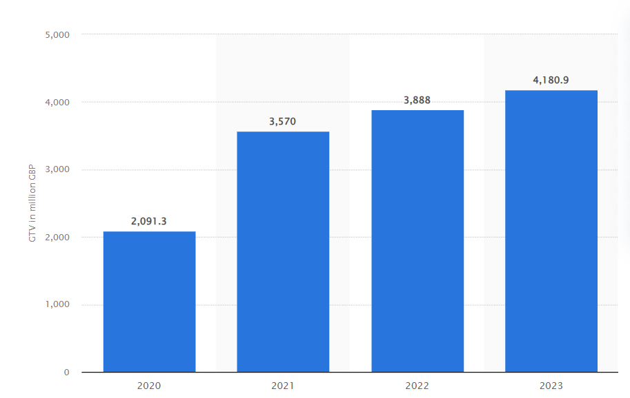
Figure 1: Gross Transaction Value of Deliveroo in UK and Ireland from 2021 to 2023 (Statista, 2023)

Unique Selling Proposition
Deliveroo's USP centres around three key elements:
- Technology-driven efficiency: Deliveroo has exclusive technology such as Frank algorithm that put into consideration the most efficient time to deliver food as well as the routes, this increases the efficiency in service delivery (Deliveroo, 2023a).
- Premium restaurant partnerships: Contrary to many of its counterparts, Deliveroo maintains exclusive relationships usually with excellent restaurants, often those restaurants that have not offered delivery options before.
- Rapid delivery: Deliveroo declares the average delivery time is thirty minutes and describes it as a quicker service than regular takeaway (Deliveroo, 2023a).
- Innovative offerings: There are such novelties as “Editions” or dark kitchens, and delivery of groceries and other products besides meals from restaurants (Deliveroo, 2023a).

Key Reasons for Going Public

Funding Expansion
The main reason behind IPO at Deliveroo was to get the funds for executing the growth strategy on a large scale. The firm planned to employ the funds to acquire new technologies, open new delivery-only kitchen centres, and enter new markets (Deliveroo, 2021). This proves to be supporting Deliveroo’s strategic vision of being the ‘‘world’s ultimate online food business’’ as averred by the CEO, Will Shu (Financial Times, 2021). The IPO raised £1.5 billion, which would offer a lot of capital for such growth program (Financial Times, 2021a).

Increasing Brand Visibility
The going public amplified the brand’s awareness and legitimacy with the target clientele in the space. The acquisition of a public offering strategy for Deliveroo let to more exposure to the media and analysts, which, in turn, helped to increase awareness of the brand among consumers and possible partners (BCG, 2021).

Offer liquidity to the early investors
The IPO allowed early investors and employees to exit their stakes, out of which many made good profits. This is a usual factor for many technology ventures that seek listing IPOs so that early fund raisers can diversify and source for other means of getting their value back (Deloitte, 2021). In the case of Deliveroo, that had raised considerable venture capital funding during its growth phase, the IPO provided the investors with an easy exit (CNBC, 2021). Also, the public listing provides, for example, a constantly tradable security for Deliveroo that can be utilized for future acquisitions to strengthen its position in the market or as rewards for attracting and retaining talent in the highly competitive tech industry (PWC, 2021).

Key Risks Analysis

Risk 1: Some of the regulatory concerns within the context of Gig economy
Description: The identified regulatory risks associated with the gig economy model; particularly concerning the riders’ employment status. Several of the riders receive the treatment of independent contractors but the model remains a contentious one to this date and is still subject to examination by various judicial authorities across the world (Prassl, 2018). Recent case in the UK Supreme court where the business civil was defeated by the company Uber in 2021 means that a similar lawsuit against Deliveroo is not far-fetched (The Guardian, 2021).
Probability of Occurrence: Its possibility is more than the other five such characteristics mentioned above. And bearing in mind that more legal cases are still being heard in court and as regulators’ anxiety increases, it means that Deliveroo will be forced to adapt consistently to the new position and reassess the employment status of riders, he added costs that change the business model of the company (Deliveroo, 2021).

Risk 2: Intense Competition in Food Delivery Market
Description: To be even more specific, this is a rather competitive market which already includes such strong players as the Just Eat Takeaway, UberEATS and others, as well as newcomers to the market. Highly competitive pressure of this type is detrimental to the companies’ margin and requires ongoing marketing and the enhancement of technology (Mckinsey & Company, 2024).
Probability of Occurrence: This means that the probability can therefore be concluded as being very high. The market that is already being occupied by food delivery service is somehow expected to remain pretty much affiliated with competition, although entry through mergers and acquisitions or emergence of new entrants in the market (Statista, 2024).

Risk 3: Dependency on Restaurant Partners
Description: Therefore, given that Deliveroo has such a good business model and depends solely on relations with the partners – restaurants. Such changes in dynamics for example where restaurants themselves have offered own-delivery services or where some of the restaurants have withdrawn from using the services of Deliveroo due to high commission charges would be dramatic to the business (Deliveroo, 2023a).
Probability of Occurrence: Which is moderate to high to experience such an event or to have such a probability, it goes without saying that most restaurants rely on delivery applications; nevertheless, nowadays restaurateurs begin searching for the ways how to sever the ties with third-party delivery applications (CNBC, 2021).

Valuation in context of Risks
Proposed Valuation Overview: Deliveroo, an online food delivery firm, went public in March 2021 and it has a £7.6 billion, or 390 pence per share. This valuation was based on the company's strong growth trajectory and market position, despite the company not yet achieving profitability (CNBC, 2021).

Impact of Identified Risks on Valuation
The identified risks significantly impact Deliveroo's valuation
- The legal factor may result into cost escalation influencing the overall quantity of revenues and likely rates of expansion (Prassl, 2018).
- The great competition will catalyse marketing and technology expenses thus applying pressure on the margins, and the cash (McKinsey & Company, 2024).
- Restaurant partners cause oscillation of the amount of the expected operational revenues and share in the market (Deliveroo, 2023a).

Critical Analysis of Valuation Considering Risks
The initial valuation for it was £7.6 billion when compared to the huge threats that exist in Deliveroo’s environment, could be seen as rather optimistic. Analysing the market reaction to the Deliveroo IPO, it was discovered that, on its first day of trading or floating, the share price of the company declined by 26% admitting that the market did not initially approve of the procedures used to fix its price (Financial Times, 2021a).
The two major risks that Deliveroo had is the regulatory risk which may well prove to be too dangerous a proposition for the company’s current business model, and the risk which can quickly ramp up the cost.
Furthermore, the massive competition in the food delivery industry insinuates that Deliveroo may not be able to attain the high growth rate and market share as mandated by the company’s valuation. Geographic concentration risk is another consideration occasioned by the company’s concentration on a selective number of markets, especially UK and Ireland (Deliveroo, 2021).
Against these factors a conservative evaluation could be justified which considers the risk that changes in the legal environment may occur in the future, that competition may intensify and that due to the currently still modest market share the high investments in technology and market penetration appear to be necessary. The subsequent performance of the market in response to the IPO also confirms that investors are factoring these risks into their determination of a company’s worth, and thus assigning it a lower value than was envisioned earlier (Financial Times, 2021).

Deliveroo Share price performance

Descriptive Statistics
The following statistical data presents the details of Deliveroo’s stock price, which will provide the understanding of the business dynamics and market response since its listing.
Table 1: Descriptive Statistics of Price for Deliveroo
Specifically, it was identified that the mean price equals 156.67 which is above the median of 116. 55, it can be inferred that although there are times in which Investors value Deliveroo highly, this has been accompanied by long moments of low Valuation. This is further evidenced by the positive skewness that stood at 1.106, which would suggest minor fluctuation in the position of stocks every now and then maybe due to positive sentiment news or increases in the stock value. This active indicated a massive standard deviation of 84.741 and roughly equal to 54 percent of the mean price, though characterize by the highly unpredictable conditions that surround the operations of Deliveroo. This volatility likely stems from various factors including: This volatility likely stems from various factors including:
- Legal issues of the sharing economy
- There is cutthroat competition in the food delivery market.
- Different lockdown polices that impacted demand in the period of COVID-19 pandemic
- These include matters of profitability and firm’s path towards achieving sustainable growth.
Pricing started from 76 to 395 which shows how the market has drastically changed how they value Deliveroo. The lower bound might be associated with cyclicality and pessimism regarding the firm’s business model or its profitability, while the upper bound would correspond to periods of optimistic outlook on growth opportunities or market development.
The coefficient of kurtosis is also negative, (K=-0.196) which means that the prices data are less likely to be clustered around the mean than a normal distribution and more likely to be spread out with some extreme values; overall, investors has not had a clear and unambiguous idea about Deliveroo’ s value. This could be attributed to the market doubt and doubtless in Deliveroo’s business model concerning its sustainably profitable business model. With 691 data points which means that we have sufficient data from the day of its IPO up to date. A fairly accurate estimate of the population total is given by the 95% confidence interval of ± 6. 329, which is the range of conventional mean price, adequately captures the variability of Deliveroo’s typical market capitalization.
This means that the mode of 124 provides further insights into the most frequently occurring, which may be considered as a ‘baseline’ estimate in the investors’ working assumptions. On the same note, the sample variance was high at 7181.103 due to changes in the market sentiment probably evoked by the evaluation of quarterly results by Deliveroo as well as changes in the market and competitive environment.
By summarizing the statistics mentioned above, this information indicates the situation of a company operating in a complex and constantly evolving environment.
Figure 1 displaying the company’s stock price from the start of the company’s IPO in 2021 up to December, 2023 is a rather volatile one. For the first period of the analysis, the level of stock fluctuation was rather high, which could be attributed to several factors including a high level of uncertainty and speculative traders’ activity right after the IPO. There is an initial spike, nearly 400 in mid-2021, and which rapidly trends downwards, indicating either that the coin was overpriced initially or that there was a drastic change in the buyers’ market perception. This steep decline persisted up to the start of this year 2022, and the prices fell to as low as 80, revealing the investor’s loss of confidence.
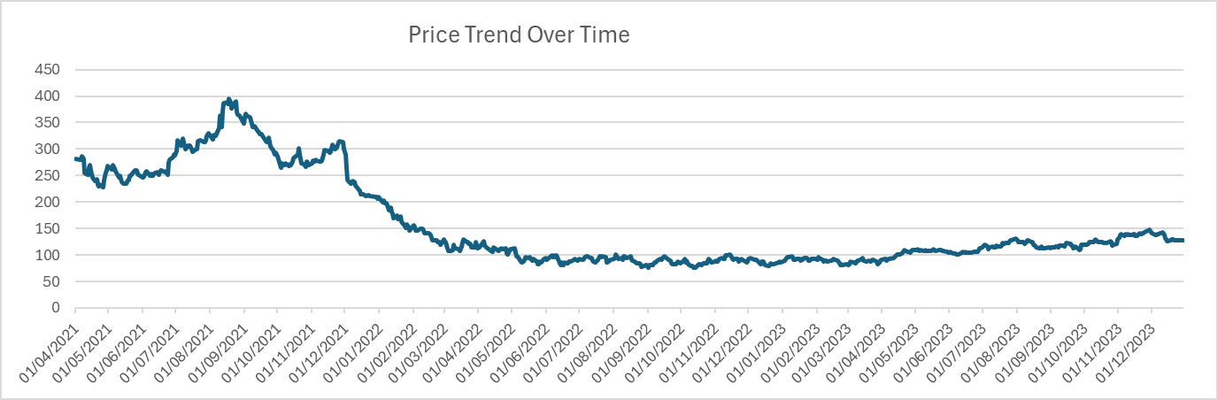
Figure 1: Price Trend Over time
But, starting from the middle of the year 2022, the price ceased increasing dramatically and started to be relatively stable, and gradually rise. This may be due to better performance of the firms or altering situation in the market. Finally, the price rose once again with the currency average coming to 150 at the end of 2023 which although still can be considered as significantly lower than the initial price is now displaying a pattern of gradual increment with neither rapid growth nor decline.
Figure 2 the histogram of the frequency distribution of shares of Deliveroo showing the prices has the following features. Most notably, the distribution is bimodal, showing two distinct peaks: two are randomly selected from the categories of [76; 110] and [110; 144] respectively. From this, it is inferred that there two most basic trading zones for the stock. Most of the price changes recorded are clustered in low ends that are aligned to the general falling trend of the Sofitel share price after the company’s IPO.
Some bars are shifted towards the right, which creates an extended right tail, which should mean that High Price has more values during the first days after IPO. It reveals that most of the price falls have been in the lower scale, meaning that for most of the time Deliveroo has been a public company, it has basically operated at low prices. The skinny line in the higher bracket implies that the above values were most probably attained in rather brief times.
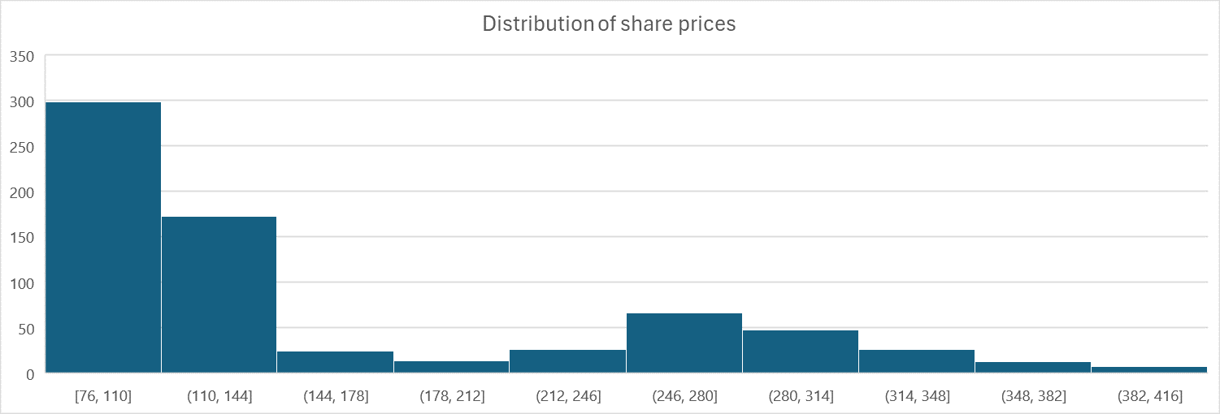
Figure 2: Distribution of Share Prices
Figure 3 Using the box plot, depicting the distribution of Deliveroo’s stock prices, it becomes possible to deduce the level of volatility, appearance of the outlier values. The plot reveals the relative fluctuation between the minimum price of 76 and the maximum price of 395, this portraying a series of large fluctuations in prices over the years. The median of 117 is also located lower in position more towards the bottom of the box agreeing with the observation made earlier that price distribution is skewed more to the left for Deliveroo’s stock which indicates that lower prices are more frequent.
Some observations are quite evidently located above the upper whiskers as thick lines, which stand for the participation rates of certain stocks with epically high prices, probably during the initial times after an IPO. The IQR based on the box and extending from about 93 to 233 is larger, adding to the stock’s variability. Also, it can be pointed out that the upper whisker is longer than the lower one which suggests that there is greater spread in the upper prices. Using the plot of this type, it is possible to show how Deliveroo’s stock price vary around the middle, the presence of outliers, which is relevant because of the high volatility of the stock after its floatation.
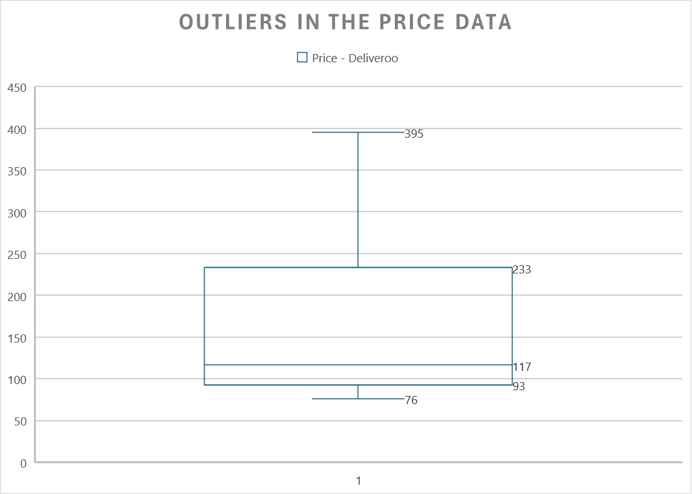
Figure 3: Outliers in Price Data
Figure 4 represents the graph representing the percentage change in Deliveroo’s stock price with the reference to the UK 1 Year Bond and FTSE 250 analysis is highly insightful in terms of the relative position of the stock and the level of its risk. The figure of Deliveroo’s daily 30 trading days rolling percent change also reveals that its stock is highly volatile compared to both the benchmark: the UK 1 Year Bond, and FTSE 250, with several large spikes in percentage change, many of which are observed in the early periods. These are used to show the days of high volatility in the price of the stock, thus supporting the Conclusion that the stock is very volatile.
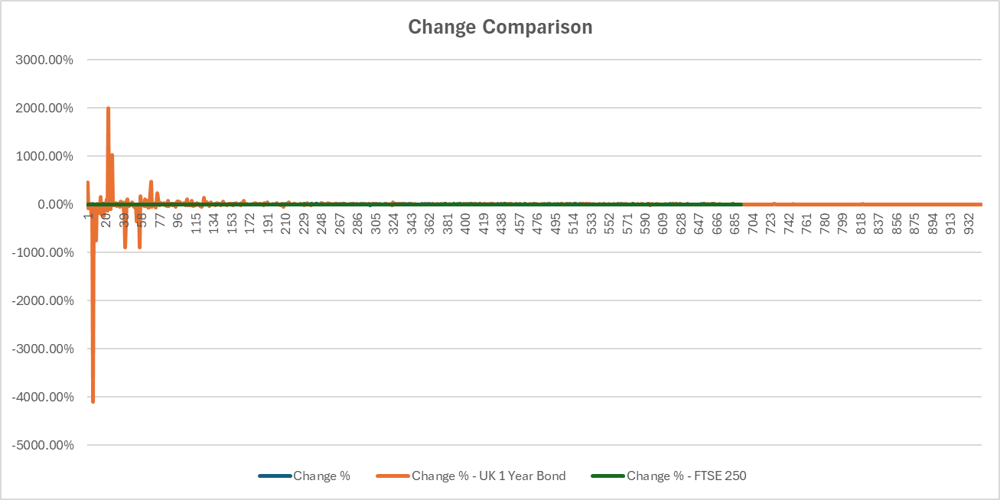
Figure 4: Change Comparison
On the other hand, the trend of both, the UK 1 Year Bond and FTSE 250 looks a lot smoother, which underlines the high risk associated with investing in Deliveroo. Nevertheless, available data points to a certain correlation between Deliveroo’s position and the FTSE 250 index, even though the company’s Stock has been relatively more unpredictable. The considerable nature of the Deliveroo fluctuation compared to the steadiness of the bond means that Deliveroo is considered a high-risk against safer fixed-income bonds. From this comparison, Deliveroo ranks more as a growth stock with high volatility in its prices relatively to the main market indices.

Deliveroo CAGR Calculation and Comparison Analysis
CAGR has been calculated on yearly basis for Deliveroo (ROO) starting from the date of IPO, that is March 31, 2021, to December 31, 2023. The calculation uses the formula:
CAGR = (Ending Value / Beginning Value)^(1-year / number of days) –1
This formula has been applied to three time periods:
- From 31-03-2021 to 31-12-2021 Which is 276 days.
- Specifically, from Mach 31, 2021 to December 31, 2022 which is equivalent to 641 days.
- Since last one year from March 31, 2021 to December 31, 2023 that is 1006 days.
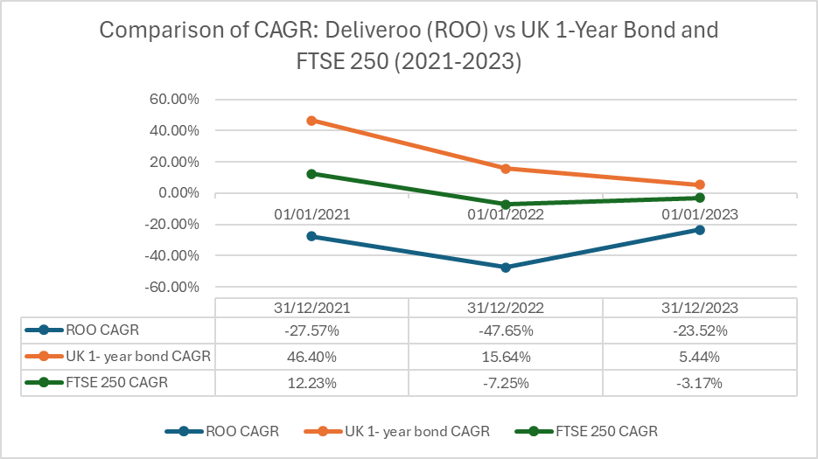
Comparison to Appropriate Indices
The CAGRs for Deliveroo have been compared to two appropriate indices:
- UK 1-year bond: Representing a low-risk, fixed-income investment
- FTSE 250: Representing the broader mid-cap UK stock market
Date | ROO CAGR | UK 1- year bond CAGR | FTSE 250 CAGR
31/12/2021 | -27.57% | 46.40% | 12.23%
31/12/2022 | -47.65% | 15.64% | -7.25%
31/12/2023 | -23.52% | 5.44% | -3.17%
Table 2: Calculated CAGRs
Using a CAGR analysis on the Deliveroo data from 2021 to 2023, the company’s performance stands out as an issue of concern because year on year, Deliveroo underperforms even low-risk investment options and other mid-cap stocks. The CAGR has been negative right through this period and touched a low of -47.65% in 2022 it differs from the positive values of the 1-year UK bond and the comparatively less negative figure of the FTSE 250 index. On the same note, although Deliveroo also had a potential growth improvement in 2023 with a CAGR of -23.52% this recovery is still weak when put into consideration of some key figures in the market. It is evident that the period negative growth generates pertinent questions on the firm’s business model, market offering and layout, as well as its potential to deliver strong investor value in a competitive environment. Deliveroo’s performance and risk are clearly high by demonstrating high flow volatility than the benchmark index and disappointing returns compared to the stable UK 1-year bond.

Sharpe and Treynor Ratios
Table 3: Variable to calculate ratios
Sharpe Ratio = (R_{d} - R_{f}) / σ_{d}
Where:
- R_{d} = Average daily return of the portfolio
- R_{f} = Average daily risk-free return
- σ_{d} = Standard deviation of daily returns
Sharpe Ratio = (R_{p} - R_{f}) / β_{p}
Where:
- R_{p} = Average daily return of the portfolio
- R_{f} = Average daily risk-free return
- β_{p} = Beta of the portfolio
2021 Calculations
Sharpe Ratio = (-0.002776279 - 0.002810345) / 0.039746864 = -0.140309
Treynor Ratio = (-0.002776279 - 0.002810345) / 0.117192052 = -0.047667
2022 Calculations
Sharpe Ratio = (0.001830184 - 0.008727321) / 0.022089728 = -0.312534
Treynor Ratio = (0.001830184 - 0.008727321) / -0.158081401 = 0.043633
The Sharpe and Treynor ratios applied on Deliveroo reveal that it experienced a lot of trouble in providing the investors with risk-adjusted profits in 2021 and 2022. The negative Sharpe ratios in both years (-0.140309 in 2021 and -0.312534 in 2022) depict how the firm of underperformed and the situation worsened in 2022 notwithstanding a reduction in the volatility coefficient. This means that investors would have been better off with safer securities This means then that the market portfolio did not offer investors a higher level of risk-adjusted returns since they would have been better off investing in risk-free securities.
The Treynor ratios provide a rather diverse picture in this case. The value of the Sharpe ratio is also negative, -0.047667, which corresponds to the poor risk-adjusted performance described earlier in 2021. However, the Treynor ratio of 0.043633 in 2022 is comical due to negative beta meaning it is not really an advancement. Transition from a positive to a negative beta (0.117192052 to -0.158081401) implies a relative transformation in Deliveroo’s connection and association with the market and its risk diversification factor while at the same time illustrates the disconnection with the broader market. Deliveroo while evidencing some operational improvement with lower risk and mean excess returns becoming positive in 2022, has a poor risk-adjusted return and justifies value in the rising risk-free rates environment.

Options Analysis for Uber Technologies Inc (NYSE: UBER)

At-the-Money Call Option Payoff
The closest at-the-money call option for Uber Technologies Inc. (UBER) has the following specifications:
Strike Price: $69. 00
Expiration Date: The program is to end on 16th august 2024.
Last Price: $1.56
Bid: $1.53
Ask: $1.59
Volume: 631
Open Interest: 388
UBER, as of August 9, 2024 had its stock closing at $68.54, which has a premarket price of $68.87 on August 12, 2024 (Yahoo Finance, 2024). This option is near the current stock price, making it near at the money; it has lower risks for investors who believe in Uber’s short-term growth.
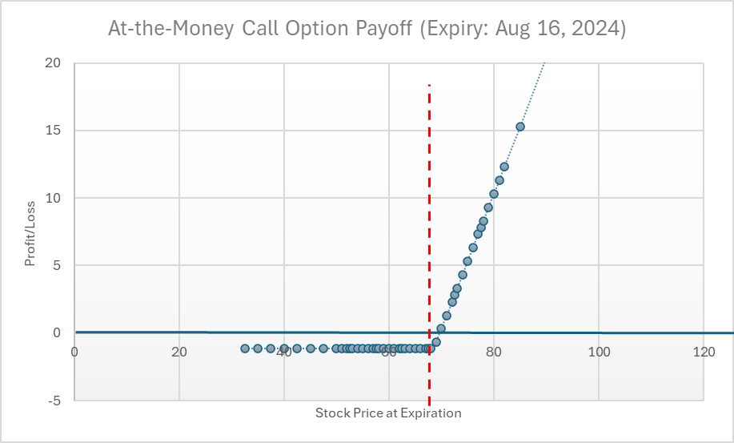
Figure 5: Graphical Representation of the Call-Option Payoff
The $69 call option's payoff structure is as follows:
Maximum Loss: If the price of UBER’s shares is less than $69 at expiration then the option is allowed to terminate without any value. The case also has the advantage of the maximum possible loss is limited to the premium paid ($1.56 per share or $156 per contract).
Breakeven Point: The breakeven point of the option holder is the stock price below which the holder gives and is above which the holder receives, $70.56 ($69 strike + $1. 56 per share premium). This represents a 2.95% increase from its closing price of $68.54.
Profit Zone: For each dollar going higher than $70.56, the option holder makes $100 per contract if one contract controls 100 shares, the standard.
Leverage: This option gives leveraged position in the upside of UBER. For instance, a stock price of $72 at expiration will earn the investor $144 for each contract representing 92.3% return on the $156 initial capital which was invested.
However, it is important to bear into consideration some of the risks like time decay, change in the level of implied volatility and Uber’s company position as a ride-sharing company that faces some regulatory issues and intense competition within the market (Uber Annual Report, 2023).

At-the-Money Put Option Payoff
The closest at-the-money put option for Uber Technologies Inc. (UBER) has the following specifications:
- Strike Price: $69.00
- Expiration Date: August 16, 2024
- Last Price (Premium): $0.77
- Bid: $0.72
- Ask: $0.75
- Volume: 3,201
- Open Interest: 21,902
As for UBER, its stock was $68.54 On August 9, 2024, making the $69 strike put option slightly out of the money but the closest to being at the money as it can get (Hull, 2018).
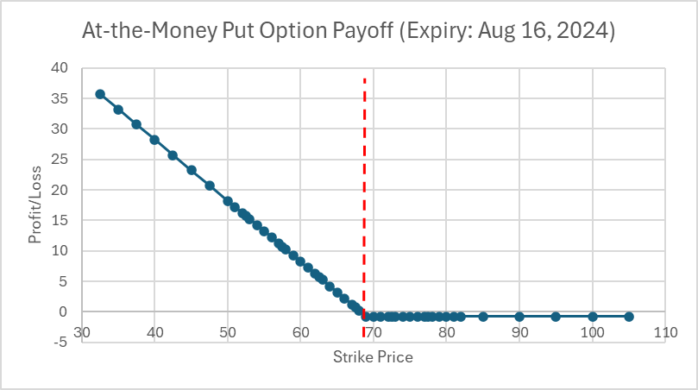
Figure 6: Graphical Representation of the Call-Option Payoff
Maximum Loss: The maximum loss which is possible in reinsurance is restricted to the premium that has been paid here it is $0.77 per share or $77 per contract (entitling the holder to 100 shares). This is the case if the price of the stock at expiration is greater or equal to $69 (Natenberg, 2014).
Break-even Point: The break-even point is calculated as:
Break-even = Strike price – Premium
= $69.00 - $0.77 = $68. 23
Certainly, at this stock price, the option holder does not gain or lose anything (other than fees to acquire the option).
Maximum Profit: The theoretical maximum of such profit is equal to the stock price that is equal to zero, and it is defined as:
Max Profit = Strike Price - Premium
= $69.00 - $0.77 = $68.23 per share
This represents a return of 8,861% on the initial investment (premium paid).
Profit Zone: Put option is favourable at expiration in as much as the value of the stock is less than the put option break-even point of $68.23.
Critical Analysis
Implied Volatility: The implied volatility is low because a near-the-money option with seven days to expiry costs only $0. 77 in premium. This may suggest market performance forecast low fluctuations of the stock prices within the next period (Sinclair, 2013).
Time Value: Because the option is just a bit out of the money and very close to its expiration time, it means that most of the premium is therefore going to be the time value, this is since there is always some level of volatility prior to the expiration time (McDonald, 2013).
Leverage: This put option comes with such high leverage. For instance, a cut by 5% to stock price of $65.11 would make $3.12 per share, though it was 405% of the amount paid before the premium was instituted.
Risk Management: This put option could be used as a hedge against a long stock position in UBER, protecting against downside risk below $68.23

Market Sentiment: The high open interest (21,902) compared to volume (3,201) suggests this strike is popular among traders, possibly indicating a key technical or psychological price level for UBER stock (Cohen, 2005).
Liquidity: The tight bid-ask spread ($0.72 - $0.75) indicates good liquidity, which is crucial for ease of entry and exit from the position (Bodie et al., 2018).

Construction of a Straddle for Uber Technologies Inc. (UBER)
A straddle is the application of two options where both are put and call option with same strike price and same time expiration (Hull 2018). In the case of UBER, using the data to determine whether to build an at-the-money straddle.
Components of the UBER Straddle:
Call Option: Strike Price: $69.00, Premium: $1. 56, Expiration: August 16, 2024
Put Option: Strike Price: $69. 00, Premium: $0. 77, Expiration: August 16, 2024
Total Cost (Premium Paid): To make money, people are ready to risk: $1. 56 + $0. 77 = $2. 33 per share or $233 per contract
A construction of a straddle for Uber Technologies Inc. (UBER) is an exemplary management of the expected market fluctuations. This strategy, which entails the use of at-the-money call and put options, with the same strike prices and expiration dates, appropriately applies to UBER given the previous POS of regulatory issues, competition, and financial reports (Jiang et al., 2020). Hull, 2018 puts it clearly, the range that has been offered for the call and the put options ($1.56 for call and $0. 77 for Put) indicates that there is more probability of the market going up but the overall strategy does not have direction bias.
The straddle’s earnings depend on its underlying asset, which in this case is UBER stock and it requires that movement past the break-even points of $71.33 (upside) or $66. 67 on the downside, which implies that there is a look for a 4% fluctuation, in either direction. This large movement threshold highlights that the strategy relies on large volatility and this is commensurate with the UBER that has fluctuating market prices most of the time (Natenberg, 2014). In this case the maximum possible loss is equal to the premium paid, $2.33 per share, while the profit is unlimited in either direction, which makes it very appealing to those willing to bet on some significant market event (Cohen, 2005).
However, this sensible strategy has its weakness – the important effect of time decay or theta. It is thus prudent to make the adjustment when expiration is near in hopes that it will lower in value if the stock price does not fluctuate significantly Also, as with all options, the straddle loses value as the expiration date approaches, so timing is crucial according to Sinclair (2013). Another factor decisive for the strategy’s efficiency is also connected with changes in implied volatility: if an increase of the latter after forming positions occurs, it will be possible to receive profits even if the prices of stocks do not change profoundly (Gatheral, 2006). The selected expiration date (16/08/2024) was chosen because it falls during Q2 at which UBER releases its earnings causing a possible earnings-related volatility (Billings & Jennings, 2011).
Based on the analysis of the regulatory and competitive environment of UBER, this position is a complex insurance policy against major fluctuations in the price of the security that could be the result of some significant shift in the business dynamics (Cramer & Krueger, 2016).

Period January 2023 to December 2023

Performance of the 10Y Note
The graph enables an understanding of the behaviour of the commodity, particularly the UK 10-year Gilt yield from the year 2014 to the year 2024, with a focus on the year 2023. The yield in 2023 was highly volatile and on balance, was up which points to a difficult operating climate.

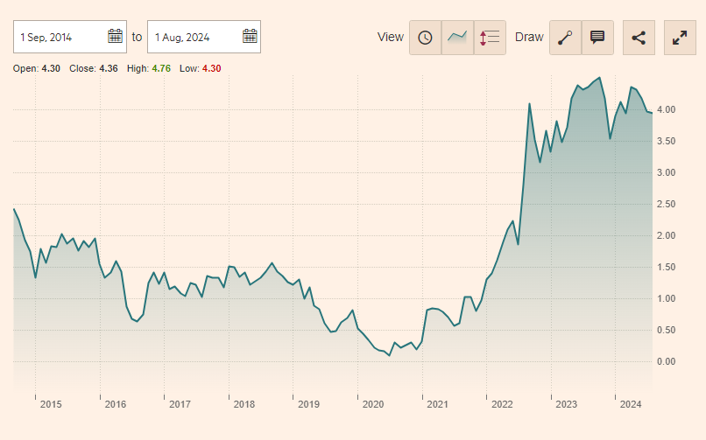
Figure 7: UK 10-Year Glit from 2014 till 2024 (Financial Times, 2024)
Key observations:
- Starting Point: The yield started the year 2023 at about 3.5%.
- Peak: It was most popular at around 4.5% mid-year.
- Year-End: This reduced further to about 4% by December 2023, although with a tendency downwards.
This performance may be attributed to monetary policy contraction by the Bank of England due unrelenting inflation (Bank of England, 2023). To support this analysis, reference will be made to the specific incidents when the Monetary Policy Committee (MPC) raised interest rates in course of 2023, which directly affected gilt yields, as Joyce et al., (2011) indicate in their work.

Impact on Consumer Debt
The fluctuations in the 10-year Gilt yield during 2023 had significant implications for consumer debt across several key areas:
Mortgages and Housing: The increase in yields on gilts translated directly on interest rates on home loans, especially on variable rate mortgage and even on most of the newly floated fixed rate mortgage. With this, the monthly payment on a home was raised, thereby exerting pressure on people’s income and expenditure.
Consumer Credit and Borrowing attitudes: Its rise was associated with high gilt yields and announced cost pressures relating to unsecured operations like the personal loans and credit cards (Goodhart & Hofmann, 2008). Such a change in the structure of lending may have made consumers avoid new credit or made it more costly to service existing credit balances. Thus, general trends in borrowing money by consumers probably changed, there could have been less spending on consumer goods and services and more attention to credit obligations.
Savings and Consumer Spending: Returns translate to yields and the often-higher yields that came with these assets may have provided the supply side the incentive to save rather than borrow hence slowing the growth in consumers’ consumption expenditure (Attanasio and Weber, 2010). Such a shift in consumer expenditure may have had other similar effects on other sectors of the economy as spending by consumers is a critical aspect of business and economic growth since businesses are funded by consumer expenditure which is either through borrowing or out-rightly saving.
Refinancing and Debt Management: Residents seeking funds by refinancing existing mortgages saw the terms worsen, which might put some in a more expensive debt trap (Campbell and Cocco, 2003). It probably made it difficult for household to manage their debt burden and possibly led to more difficulties especially to those that could not get better rates of borrowing.
Consequently, gilt yields affected consumer debt in 2023 in many ways: the behaviour of household borrowing, the financial position of individuals, the attitude towards borrowing of both lenders and borrowers, economic performance. These effects may have led to that is making the financial situation of many consumers somewhat more difficult to bear and unalterably altering several trends connected to its tentative spending and saving across the general economy in the United Kingdom.

References
Attanasio, O.P. and Weber, G., 2010. Consumption and saving: Models of intertemporal allocation and their implications for public policy. Journal of Economic Literature, 48(3), pp.693-751.
Bank of England, 2024. Monetary Policy Reports. [Online]
Available at: https://www.bankofengland.co.uk/monetary-policy-report/monetary-policy-report
[Accessed 02 August 2024].
BCG, 2021. The 2021 M&A Report: Mastering the Art of Breaking Up. Boston: Boston Consulting Group.. [Online]
Available at: https://www.bcg.com/publications/2021/m-and-a-report-mastering-the-art-of-breaking-up
[Accessed 02 August 2024].
Billings, B.K. and Jennings, R., 2011. The option market's anticipation of information content in earnings announcements. Review of Accounting Studies, 16(3), pp.587-619.
Bodie, Z., Kane, A. and Marcus, A.J., 2018. Investments. 11th ed. New York: McGraw-Hill Education.
Campbell, J.Y. and Cocco, J.F., 2003. Household risk management and optimal mortgage choice. The Quarterly Journal of Economics, 118(4), pp.1449-1494.
CNBC, 2021. Deliveroo shares push higher as retail investors start trading the stock. [Online]
Available at: https://www.cnbc.com/2021/04/07/deliveroo-shares-push-higher-as-retail-investors-start-trading.html
[Accessed 03 August 2024].
Cohen, G., 2005. The Bible of Options Strategies. Upper Saddle River, NJ: FT Press.
Cramer, J. and Krueger, A.B., 2016. Disruptive change in the taxi business: The case of Uber. American Economic Review, 106(5), pp.177-182.

Deliveroo, 2021. Registration Document. [Online]
Available at: https://dpd-12774-s3.s3.eu-west-2.amazonaws.com/assets/6216/1521/6447/Deliveroo_-_Registration_Document.pdf
[Accessed 04 August 2024].
Deliveroo, 2023a. Annual Report 2023. [Online]
Available at: https://corporate.deliveroo.co.uk/investors/annual-report-summary/
[Accessed 06 August 2024].
Deliveroo, 2023. About Us. [Online]
Available at: https://deliveroo.co.uk/about-us
[Accessed 06 August 2024].
Deloitte, 2021. Strategies for going public. [Online]
Available at: https://www2.deloitte.com/content/dam/Deloitte/ch/Documents/audit/deloitte-ch-en-audit-strategies-for-going-public-5th-edition-update.pdf
[Accessed 09 August 2024].
Financial Times, 2021a. Disaster strikes as Deliveroo becomes ‘worst IPO in London’s history. [Online]
Available at: https://www.ft.com/content/bdf6ac6b-46b5-4f7a-90db-291d7fd2898d
[Accessed 09 August 2024].
Financial Times, 2021. Deliveroo’s challenge to serve up growth after IPO. [Online]
Available at: https://www.ft.com/content/5ce64d6e-8ee5-46f6-9580-f59d0708b547
[Accessed 10 August 2024].
Financial Times, 2024. UK 10 year Gilt. [Online]
Available at: https://markets.ft.com/data/bonds/tearsheet/charts?s=UK10YG
[Accessed 11 August 2024].
Gatheral, J., 2006. The volatility surface: a practitioner's guide. Hoboken, NJ: John Wiley & Sons.
Goodhart, C. and Hofmann, B., 2008. House prices, money, credit, and the macroeconomy. Oxford Review of Economic Policy, 24(1), pp.180-205.
Hull, J.C., 2018. Options, futures, and other derivatives. 10th ed. Hoboken, NJ: Pearson Education.
Jiang, G.J., Tian, Y.S. and Wu, R., 2020. Predictability of stock returns: New evidence from option-implied variance. Journal of Financial and Quantitative Analysis, 55(1), pp.285-316.
Joyce, M., Tong, M. and Woods, R., 2011. The United Kingdom's quantitative easing policy: design, operation and impact. Bank of England Quarterly Bulletin, Q3.
McDonald, R.L., 2013. Derivatives markets. 3rd ed. Boston: Pearson Education.
Mckinsey & Company, 2024. The future of online grocery in Europe. [Online]
Available at: https://www.mckinsey.com/industries/retail/our-insights/state-of-grocery-europe
[Accessed 12 August 2024].
Miles, D., 2004. The UK mortgage market: Taking a longer-term view. HM Treasury.
Natenberg, S., 2014. Option volatility and pricing: advanced trading strategies and techniques. 2nd ed. New York: McGraw-Hill Education.
Prassl, J., 2018. Humans as a service: The promise and perils of work in the gig economy, s.l.: Oxford University press.
PWC, 2021. Considering an IPO? First, understand the costs. [Online]
Available at: https://www.pwc.com/us/en/services/consulting/deals/library/cost-of-an-ipo.html
[Accessed 12 August 2024].
Sinclair, E., 2013. Volatility trading. 2nd ed. Hoboken, NJ: John Wiley & Sons.
Statista, 2023. Gross Transaction Value (GTV) of Deliveroo in the United Kingdom and Ireland from 2020 to 2023. [Online]
Available at: https://www.statista.com/statistics/1337079/deliveroo-s-gross-transaction-value-uk-and-ireland/
[Accessed 13 August 2024].
Statista, 2024. Online Food Delivery - Worldwide. [Online]
Available at: https://www.statista.com/outlook/dmo/online-food-delivery/worldwide?currency=usd
[Accessed 13 August 2024].
The Guardian, 2021. Uber drivers entitled to workers' rights, UK supreme court rules. [Online]
Available at: https://www.theguardian.com/technology/2021/feb/19/uber-drivers-workers-uk-supreme-court-rules-rights
[Accessed 13 August 2024].
Uber Technologies, 2023. Annual Report. [Online]
Available at: https://investor.uber.com/financials/default.aspx
[Accessed 14 August 2024].
Yahoo Finance, 2024. Uber Technologies Inc. (UBER) Stock Price, News, Quote & History. [Online]
Available at: https://uk.finance.yahoo.com/quote/UBER/options/
[Accessed 14 August 2024].

