Assessment 2

Marketing Fundamentals
MODULE CODE: LCBB4004

Analysis and Evaluation
Waitrose & Partners

University of Wales Trinity Saint David

Name of Student: Maria Hagiu
Student’s ID: 2024157
January 2022

Executive Summary
Marketing activities are very important and vital factors for every organization to gain profits and survive in competition. Waitrose company is a very popular supermarket company in England. Due to covid-19, the company has faced some operating inefficiency. This report is shown by some analysis, models and marketing mix as a way of development in the company's overall growth. An organisation will grow faster when the organisation will able to do its all marketing activities perfectly (Cowley et al., 2007). Waitrose company has to analyse swot and Peter's five force analysis as internal analysis of marketing. The company has to do pestle analysis external analysis. By doing these analyses, the organisation will be able to find out its strong factors and also its weak factors. By finding out those the company has to take decisions to make the weak factors strong and hold the strong factors' strong sides.

Table of Contents
Executive Summary 2
Table of Contents 3
Introduction 4
Analysis and Discussion 5
Task-1 5
Process of Marketing 5
Stages of Marketing 7
Task-2 9
Role of Marketing Environment in the context of Waitrose Company 9
Some situational analysis of Waitrose company 10
Task-3 15
STP analysis of Waitrose Company 15
Marketing Mix of Waitrose Company 15
Recommendations and Conclusion 17
References 18

Introduction
Marketing is a core activity from all other activities of an organisation. A Company will be able to gain much more profit margin if the company can do its marketing activities properly. There are lots of internal and external analyses and models by which an organisation can no its strong and weak points (Hao, 2020). By finding out these points, the marketing manager and other managers should work to develop those points and hold the strongest factors of the organization. To analyse some internal and external factors, models, the role of marketing and marketing mix the Waitrose company of supermarket industry is chosen.
Waitrose and Partners which is known as Waitrose company is a British supermarket brand. The company was founded in 1940 as Waite, Rose & Taylor and after that, it's named Waitrose. The company's headquarters is situated in the United Kingdom and it services products from all over the UK and Channel Islands. The organisations' revenue had dampened in 2020 due to covid-19 by 3% it the previous year. In 2021 it can be seen that in mid-year the company can gain 4.3% revenue growth the previous year which is £7,043.9 million.

Analysis and Discussion

Task-1

Process of Marketing
Marketing includes all of the processes by which an organisation promotes the buying and selling activities of its products (Di, 2019). There are lots of processes included under marketing activities. The processes generally started from value creation for customers and end with the markers that capture those values from customers in return. Those processes are described below:
- Understanding customer: Understanding customer and their demands are the core objectives of marketing. To produce any goods to satisfy customer, first of all, an organization need to know if these products will be demanded by its customers or not (Lostakova and Stejskalova, 2015). If an organization produce any products in a huge quantity that has less demand in the market, the organization will face a huge loss on that particular product line. Waitrose company also needs to produce products according to customers need. The company's marketing manager and research and development department search analyse about market force and analyse the customer's demands to provide supply force according to customers' demand.
- Designing marketing strategy: Designing a customer strategy is mainly divided into two categories, first one is Defining the target market and the Second one is Choosing the value proportion. Under 1st one an organization choose the customers or their area to serve. It enables the company to find out the specific needs of their customers and their special wants. Under the second one, an organization selects or choose the method by which it can provide the best services to its customer. Waitrose company generally select highly sophisticated and moderate populated area to establish its grocery outlet. The company also adopts all new technology and types of machinery to provide the best services with minimum labour for its customers.
- Constructing marketing plan: After setting the strategy an organisation has to set a marketing plan to achieve the strategic goals and objectives. The marketing plan consists of a marketing mix (4P), the set of marketing tools, the marketing broadening tools, additional promotional activities etc. And this process and organisation take lots of marketing programs by which the company can build customer relationships by transferring the marketing strategy into action. Waitrose company generally use accumulates all of these tools in a comprehensive and integrated way to provide expected value to its customer.
- Building profitable relationships: Building a profitable relationship suggests that an organization should maintain or strengthen the relationship with those customers who are very profitable for the company. Customer relationship management has to work in the best way to provide the best customers to the organization (Timiyo, 2014). If an organization can acquire its profitable customer's loyalty, the organization will be able to enlarge its business. Waitrose's relationship managers try hard and soul to hold the profitable customer's loyalty by providing better services to them. The company sets a margin of selling above which customers are generally considered as a profitable customer for the company.
- Capturing value from customers: Under this process, an organisation get back the customer value's price which was generated by the company. The difference between the value generation cost and the aqua below is known as profit or loss of the for serving the specific customer. Waitrose generally closes the customer relationship or product line which is proved unprofitable. The company wants to hold the profitable customer to drive the high value.

Stages of Marketing
An organization can use Boston Consulting Group's matrix to manage its products portfolio. It is also known as the BCG matrix. This matrix helps an organization to decide which products should the organization develop more and which products should the organization reduce or stop producing. Under this matrix, there are four stages are Stars, Question marks, Cash cow and Dogs. The matrix is described below in the context of Waitrose company.

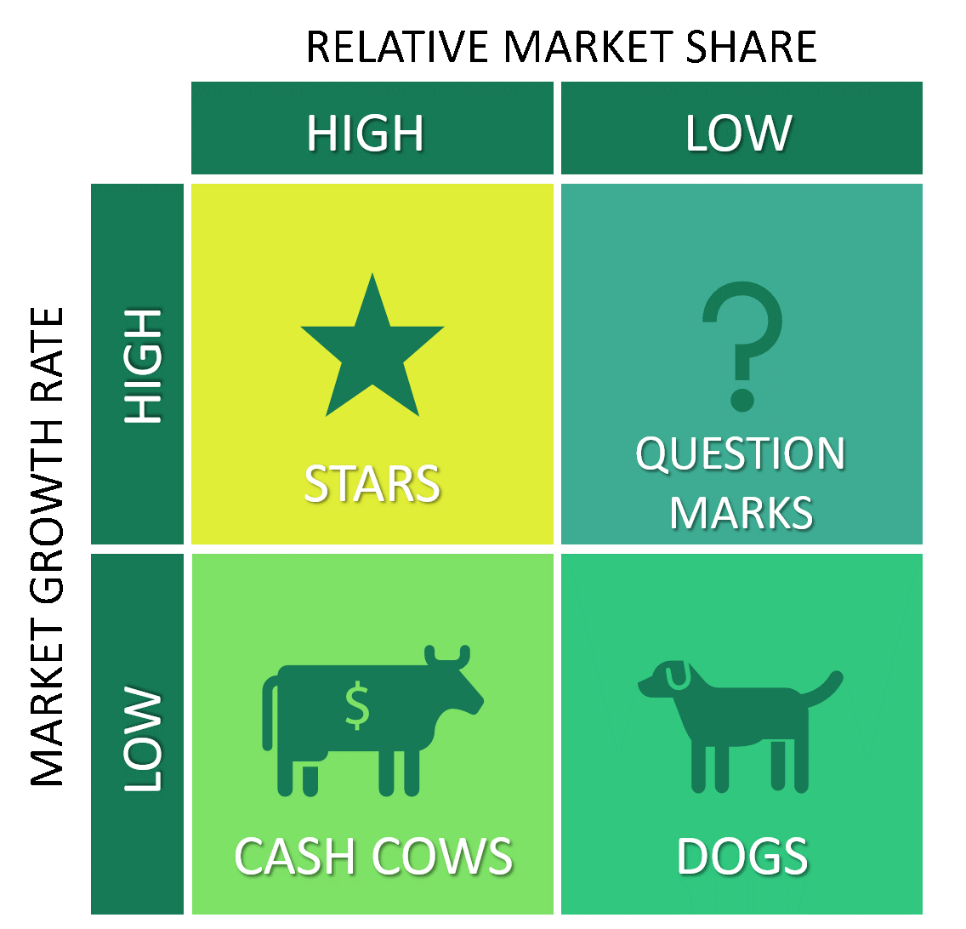

Figure 01: Boston Consulting Group's matrix (BCG matrix) (ThemeGrill, 2019)
- Stars: In the BCG matrix we can see that the products which fall in stars, those products have high market growth and relatively high market share. So for these products and an organisation needs to invest more to retain market share, boost production to avail competitive advantage.
The fruits, vegetables, Bakery and drinks are considered as Stars Products of Waitrose. This product will consume a large fund of the company but in return, the products will also generate a large cash flow. Wait for market maturity, the products will grow their market position more and become a cash cow.
- Question marks: In the BCG matrix we can see that the products which fall in the Question mark, those products have high market growth and relatively low market share. These products are considered managerially intensive products. These products need a high level of investment to grow their market shares. An organization uses the cash caws fund in question marks products to improve its market shares.
Waitrose company’s question marked products are toiletries and deodorants. The company needs to invest a high level of funds in these products to grow its market shares.
- Cash cows: In the matrix, it can be shown that a cash cows product has a market share with a low growth rate. It means the company has already invested highly in this product, so no further investment is required for this product.
Waitrose companies baby care and lighting. According to Waitrose company, those products have investment no need for further investment, and products for holding high market growth rate. So this products funding can be used in other products development.
- Dogs: The product which falls in the Dogs quadrant have a low market share and low growth rate. Products that fall in this quadrant generally generate a loss for the company. So an organisation doesn’t invest more in this quadrant product and sometimes an organisation stops producing this quadrant product. For Waitrose company, the Dogs quadrant's products are kitchenware and furniture. The company is thinking about stopping these products supply.

Task-2

Role of Marketing Environment in the context of Waitrose Company
Marketing environment refers to the combination of some internal and external forces and factors those effects and organisation's all activities (Duong, 2016). A company's internal environment includes the internal factor and forces such as owners, workers, types of machinery and materials. The external government includes some microeconomic macroeconomic factors. Microeconomic factors are suppliers, market intermediaries, Partners, customers, competitors etc. The roles of the marketing environment in the contacts of Waitrose company are described below.
- Essential for planning: Marketing managers who are involved in planning, need to access internal and external environment factors to take any e decision or any strategic planning. For any planning, if a manager does not consider those factors he will not able to construct an effective plan. Waitrose’s marketing manager will need the internal and external environment factors to take any plan or decision. Waitrose's managers mostly consider the external factors to take any decisions. They put little weight on internal factors of marketing.
- Understanding customers: By analysing the internal and external marketing managers can find out the actual needs and wants of customers. An in-depth analysis of these factors can reduce the communication gap between marketers and customers. Sometimes Waitrose managers send marketing agents to face customer dissatisfaction due to not analysing the internal and external forces effectively. The managers should analyse these factors to make a perfect plan.
- Tapping trends: Every organisation should be very careful about the recent trends going on. The organization should adopt those trends to gain competitive advantage competition. If an organization can't update its strategy according to the most recent trend, the organization will lose lots of customers. The recent marketing trends are artificial intelligence, social media marketing, SEO marketing, interactivity etc. Waitrose company's managers should be careful about all of these marketing trends take decisions accordingly. The Company is now promoting its products online due to these recent trends.
- SWOT factors: Every Organisation has some internal strengths and weaknesses and some external opportunities and threats. All organisation has to go through these internal external factors of swot to survive in competition. Waitrose company's manager has to analyse all of these internal and external factors of swot to take any effective decision. SWOT use can help the organisation's managers to know about its company and its external factors very completely.
- Understanding the competitors: Competitors attempts and competitor’s strategy some extensible influencing factors for every organization. Every time every organisation has to face competition from its competitors. So understanding competitors is a must for every organisation. Waitrose has developed some strategies to understand its competitors. Strategy Planning and activities of competitors. Sometimes computers main copy the invention of Waitrose company. So Waitrose should strong patent and trademarks on its invention.

Some situational analysis of Waitrose company
SWOT analysis
SWOT analysis is a strategic framework to evaluate an organization’s competitive position and develop strategic planning for the organization. Under this analysis, organization managers or analysis analyse the internal and external factors of the organization as well as the future and current potential of the organization (Bhatnagar, 2006). Recently due to Covid-19, all organizations are facing much more competitive forces and hindrances in every industry. The SWOT analysis of the Waitrose organization is given below.
- Strength: Strength includes those factors for which an organization can achieve some competitive advantage in comparison to its competitors. Waitrose company's strengths are the company has a royal warrant to supply groceries to Queen Elizabeth and Prince Charles places, it has so many stores over almost 300+ stores are available in the UK. The company's promotional activities are very strong. By sponsoring the England cricket team, the company is building its brand value worldwide. These are some strengths of Waitrose which helps the organization to improve.
- Weakness: Weakness includes those factors which hinder the organisation to achieve its strategies goals and objectives. There is a very low amount of weakness available for Waitrose company. The main weakness of the company is intense competition in price, the company has to cut its price as well as the margin for its competitor's pricing. A magazine was published about Kitchen of Waitrose company which is considered as social media backlash of the company. The weakness is increasing recently due to the bad impacts of the Covid-19 pandemic on the grocery industry.
- Opportunities: Opportunities are some favourable external factors of an organization for which an organization gets a competitive advantage. For example, tax cut by any government is identified as an opportunity for every organization of that country. The opportunities for Waitrose company is success in white-based packaging of essential goods, gaining more market shares in various geographic areas, being able to build a brand value, expanding more favourable markets.
- Threats: Threats are those factors for which an organization may face any kind of loss. These factors are external factors for any organization. For producing rice, drought is considered a threat. There are some threats for Waitrose company. The threats are recent lagging in competition, increasing e-commerce business and adoption of this business. The poor economic situation for COVID-19.
Peter’s Five Force Analysis
Peters five force analysis helps an organisation to understand that was factors affecting the portability of the organisation. By analysing these factors, the organization will be able to know whether it should enter a specific industry or not, whether the organization needs to increase its capacity or not and whether the company needs to develop its completive strategies or not (Kolesnik, 2016). During and after COVID-19, every organisation should make a Peter five force analysis to find out the competitive advantage available for the organisation. The forces are described below in the context of Waitrose Company.
- Threats of new entries: Threats of new entry means the accessibility of new organisation in an industry. The threats depend on the barriers to entry in a certain industry. If the barriers to entry in an organization are higher, the threats for an existing organization is lower regarding the new entries. Waitrose company is a supermarket industry's company. The supermarket industry has a medium level of threats of new entries. The entry of a new organization is not so hard and also not so easy in this industry.
- Bargain power of buyers: Customers enjoy more bargaining power when there are more similar kinds of organizations available or products and everyone is supplying products at different prices. For the supermarket industry, it is not always possible for customers to have more bargaining power because though there are lots of supermarkets available but all markets have to provide products at an almost similar price. So Waitrose company has less risk of Bargaining power of buyers.
- Bargaining power of suppliers: This force analysis how much an organization's suppliers of raw materials of other necessary items has for a specific industry. When suppliers have unlimited bargaining power or there are limited numbers of suppliers they have a high power of bargaining. For supermarket companies, there are very moderate threats to the bargaining power of suppliers because there are a lot of suppliers available for the supermarket industry. Waitrose company can collect its products or raw materials from any organization its wants. If the organisation can achieve the products at a low cost, they will be able to gain more profit.
- Threats of substitute products: There are so many similar products available nowadays for every organization's products. The higher the substitute products, the lower an organization has strength in the competition. The supermarket has lots of substitution. It is also a threat for Waitrose company. For this threat, the company has provided its products at a very low cost. As there are lots of substitute products available for the supermarket industry, the company has to be very careful about these threats.
- Rivalry among existing competitors: The last force or threat for an organization is to have threats of existing competitors. Sometimes competitors produce products at very low cost and innovate newer forms of products that capture so many customers. So Waitrose needs to be very careful about existing competitors and their attempts.
These are some threats factors or Peter’s Five forces factor for Waitrose company and the supermarket industry. All the threats except threats of new entry have increased due to COVID-19.

PESTEL Analysis
PESTEL analysis is an external environment analysis. In which an organization analyses the factors of the macro-environment on the organization’s performance (Majid, 2021). Due to COVID-19, the external factors or macro-environment factors are providing very bad impacts on Waitrose company’s activity. The factors of PESTEL for Waitrose company is described below.
- Political factors: These are those factors by which governments intervene in an economy or a certain industry. Governments can create an impact by generally changing the tax system and by reducing or expanding the cost system which is considered as fiscal policy. This environment can also include government policy, political stability, foreign trade policy etc. Waitrose company face a great political impact to provide its products in different geographic areas.
- Economic factors: Economic factors are those factors that affect a country's economic performance directly. These factors affect has increased to a great extent during COVID-19. WAITROSE Company faces most of the factors are inflation rate, exchange rate, interest rate, unemployment rate etc factors. All of these factors have some positive and negative factors on the company. During COVID-19 the negative effect of those factors has been increased to a great extent.
- Social factors: The social factors of an economy represent the demographic characteristics, norms, customs and values of the population through which an organisation operates its business (MOSTOVA, 2014). The factors faced by Waitrose company are population growth rate, age distribution, income distribution, health consciousness, lifestyle attitudes and cultural barriers. These factors impact greatly on the activity of Waitrose company
- Technological factors: Technological factors are those factors by which innovations in technology main affect an organisation's activity favourably or unfavourably. Waitrose company adopts all the latest technology available in the market to provide are produce products for customers. The factors include technological innovations, automation, the amount of technological awareness etc. Waitrose company may have been positively or negatively affected by these factors.
- Environmental factors: Environment factors those factors which are known as the ecological effect on any organization by the environment (Analysis of Factors Affecting Water Environment Quality and Protection of Water Ecological Environment, 2021). These factors relatively have become more important in recent years during and after COVID-19. Waitrose company has to analyse these factors well to save the environment and get positive impacts on the environment. The environmental factors which are faced by Waitrose company are weather, climate, environmental offsets etc.
- Legal factors: These factors are almost similar factors to political factors but these factors indicate the specific law for specific operations. Waitrose company has to follow all laws and regulations available in the UK. If they do not follow any, the company will be penalized. The legal factors of the company include discrimination law, employment law, consumer protection law, copyright and patent law etc.

Task-3

STP analysis of Waitrose Company
STP analysis consists of three steps that help an organisation to find out the most profitable customers and product lines (Muravska, 2020). This model shares an organisation to offer and communicates its benefits and value to a specific group. The model is described below in the context of Waitrose company.
- Segmenting: An organisation cannot produce all products for all people so the organisation has to do market segmentation. In market segmentation, an organization divide its customer into groups for people with common characteristics. Waitrose company do market segmentation according to demographic, geography, physiographic and behavioural characteristics.
- Targeting: After segmenting the customers and product line the organisation has to decide which segment is most profitable for the organisation. Waitrose company the criteria of choosing the best segment by looking at the profitability segment, analysing the size and potential growth of the segment by using BCG matrix, At Last, the company thinks about the company will be effective to providing services in that segment. To find out these criteria, the company generally do PESTEL Analysis.
- Positioning: An organisation cannot produce all products for all people so the organisation has to do market segmentation. In market segmentation, an organization divide its customer into groups for people with common characteristics. Waitrose company do market segmentation according to demographic, geography, physiographic and behavioural characteristics.

Marketing Mix of Waitrose Company
Marketing mix refers to the combinations of different factors generally 4P of marketing which is controlled by a company to influence customers to purchase the company’s products. The Marketing Mix of Waitrose Company is given below.
- Product: A company's product refers to those things which are manufactured by the company in response to meet the demand of the customers (Mäntyneva, 2020). Waitrose company's products include fruits, vegetables, bakery, drinks, meat, baby care products etc.
- Place: A company has to choose the perfect way of placing its products to gain a competitive advantage. With perfectly distribution or delivery of products, customers will not be satisfied with the company. Waitrose company generally place its products in their outlet and shops. Recently the company is placing its products online.
- People: Price is an important factor in the marketing mix for any organisation. An organisation has to choose the best pricing strategy for the company by which it may set an affordable price for its customers. Waitrose generally follows cost-based pricing for its products. But sometimes it follows competitive pricing when competition is too high.
- Promotion: Promotional activities will increase the knowledge of customers about an organisation's products. Waitrose company previously followed the promotional activities offline but recently the organisation is adopting online promotional activities. Through the company is not so good at online promotion but the company trying to achieve to provide an effective marketing promotional online.

Recommendations and Conclusion
By analysing all of these internal and external factors it can be said as a conclusion that the company SWOT and PESTEL factors are strong enough. The company needs to improve its promotional element in the marketing mix. The company is not in a very appreciate able position on promotional activities. The company Should try to promote all its products online (Lazonick, Mazzucato and Tulum, 2013). Nowadays online promotional activities and selling activities provide an organisation much more benefits in gaining profit. To compensate for the loss that happened due to COVID-19 the company needs to take some extensive marketing activities. Waitrose company will be able to gain expected profit in the following years by providing its marketing mix virtually.

References
Analysis of Factors Affecting Water Environment Quality and Protection of Water Ecological Environment. (2021). Foreign Language Science and Technology Journal Database Natural Science.
Bhatnagar, J. (2006). Measuring organizational learning capability in Indian managers and establishing firm performance linkage. The Learning Organization, 13(5), pp.416–433.
Cowley, S., Caan, W., Dowling, S. and Weir, H. (2007). What do health visitors do? A national survey of activities and service organisation. Public Health, 121(11), pp.869–879.
Di, Y. (2019). Architects and Global Marketing – Buying and Selling in China. KnE Social Sciences.
Duong, M.-Q. (2016). The Effects of Demographic, Internal and External University Environment Factors on Faculty Job Satisfaction in Vietnam. Journal of Educational Issues, 2(2), p.113.
Hao, L. (2020). Internal Change Points and External Transmissions. SSRN Electronic Journal.
Kolesnik, A.P. (2016). WHETHER PENSION SYSTEM SHOULD BE USED AS INSTRUMENT OF FINANCIAL SYSTEM. Business Strategies, (10), p.1.
Lazonick, W., Mazzucato, M. and Tulum, O. (2013). Apple’s Changing Business Model: What Should the World’s Richest Company Do with All Those Profits? SSRN Electronic Journal.
Lostakova, H. and Stejskalova, I. (2015). Importance of Company Reputation and its Customer-Oriented Culture for Strengthening of Relationships with Customers on Industrial Market with Chemical Products. Economics and Business, 26, p.69.
Majid, H.A. (2021). ANALYSIS OF THE EXTERNAL ENVIRONMENT AND INTERNAL CONTROL OF COMPANY PERFORMANCE. Inovbiz: Jurnal Inovasi Bisnis, 9(1), p.70.
Mäntyneva, M. (2020). Company Offers to Meet the Needs of Business-to-Business Customers: Customer Strategy and Orientation. Technology Innovation Management Review, 10(3), pp.79–87.
MOSTOVA, I.O. (2014). Demographic Situation and its Impact on the Population Settlement. Demography and social economy, (1), pp.222–232.
Muravska, J. (2020). How can the European Commission help Europe’s defence industry? By making the most out of what it is already doing. Defense & Security Analysis, 36(4), pp.450–452.
ThemeGrill (2019). BCG Matrix EXPLAINED with EXAMPLES | B2U | Business-to-you.com. [online] B2U - Business-to-you.com. Available at: https://www.business-to-you.com/bcg-matrix/.
Timiyo, A.J. (2014). High Performance Work Practices: One best-way or no best-way. IOSR Journal of Business and Management, 16(6), pp.08-14.

