Business Research Project BMBM5001
A Critical Evaluation of the Impacts Online Shopping has had on Swansea city centre Retailers.
Benjamin John (1707698)

Contents
List of Tables ii
List of Figures iii
COVID-19 iii
Abstract iv
Chapter 1- Introduction 1
1.1 Introduction 1
1.2 Rationale 1
1.3 Background 2
1.4 Aim and Objectives 2
1.5 Structure 3
1.6 Chapter Summary 3
Chapter 2- Literature Review 5
2.1 Chapter Introduction 5
2.2 Consumer Convenience and Online Shopping 6
2.3 Consumer Behaviour 7
2.4 Out of Town Retail Parks and Parking 8
2.5 Rising Business Rates 10
2.6 Chapter Summary 11
Chapter 3 – Research Design & Methodology 12
3.1 Chapter Introduction 12
3.2 Research Definitions 12
3.3 Research Onion 13
3.3.1 Research Philosophy 13
3.3.2 Research Approaches 14
3.3.3 Research Strategies 14
3.3.4 Research Choices 15
3.3.5 Time Horizons 15
3.3.6 Techniques and Procedures 15
3.3.6.1 Questionnaire 15
3.3.6.2 Data Analysis 16
3.4 Sample 16
3.5 Reliability and Validity 17
3.5.1 Validity 17
3.5.2 Reliability 17
3.5.3 Pilot Study 17
3.6 Ethical Considerations 18
3.7 Chapter Summary 18
Chapter 4 – Analysis 19
4.1 Chapter Introduction 19
4.2 Demographics 19
4.2.1 Gender 19
4.2.2 Participant Age 20
4.2.3 Participants Shopping Behaviours 21
4.3 Demographics and Convenience 22
4.4 Associated Costs 24
4.5 Consumers Time 25
4.6 Pricing and Brands 26
4.7 Impact of Out of Town Retail Parks 26
4.8 Chapter Summary 27
Chapter 5 – Discussion 28
5.1 Chapter Introduction 28
5.2 Achievement of Objectives 28
5.3 Main Findings 29
5.4 Limitations 30
5.5 Conclusion 30
5.6 Recommendations 31
Bibliography 33
Appendix 37

List of Tables
Table 4.2 Crosstabulation analysis comparing how often participants shop online against visiting Swansea to shop.
Table 4.3 Crosstabulation of Age and Convenience.
Table 4.4 Chi-Square of Age and Convenience.
Table 4.5 Crosstabulation of costs associated with city centre shopping and convenience of online shopping.
Table 4.6 Chi-Square of costs associated with city centre shopping and convenience of online shopping.
Table 4.7 Crosstabulation analysis shopping online due to lack of time and online retailers allow purchase of goods when most convenient.
Table 4.8 Chi-Square test shopping online due to lack of time and online retailers allow purchase of goods when most convenient.
Table 4.9 Crosstabulation analysis browsing online before visiting city centre against shopping online to purchase certain brands.
Table 4.10 Chi-Square test browsing online before visiting city centre against shopping online to purchase certain brands.
Table 4.11 Crosstabulation of the lack of suitable parking in Swansea and the free parking provided by retail parks.

List of Figures
Figure 3.1 The Research Onion (Saunders et.al, 2019).
Figure 4.1 Gender of Participants.
Figure 4.2 Age of Participants.
Figure 4.3 Word Cloud why is online shopping more convenient.

COVID-19
After the UK implemented a 24-Hour curfew in March 2020, UWTSD took steps to support the research student and research during the curfew and University building closures. Formal supervision meetings continued as much as possible and were arranged via suitable meeting software with documents being shared electronically.
Some research was at a greater risk of delays due to the nature of the data collection methods. As a result of this supervisors and research students urgently reviewed their research plans. UWTSD understands that some students’ projects were planned to include in-person research and data collection that is currently not possible during this period of remote learning. Digital research activities that advance the studies, were prioritised. If it was no longer possible to continue with the existing plan then consideration to changes to the project plan should be considered to offset, wherever possible, undue future delays to the project submission. All fieldwork conducted by the researcher has occurred remotely using electronic means wherever possible to do so and any issues presented to the researcher, as a result, have been documented throughout the project.

Abstract
This business research project will evaluate how a wide range of factors including the rise of online retailers as well as changing consumer behaviours, the increase in out of town retail parks and the rising business rates have all played a role in the decline of retailers in Swansea City Centre. The project will analyse all of these different factors to understand whether or not the rise of online retailers and the convenience they possess for the consumer is the main factor behind the subsequent decline in the number of city centre retailers located in Swansea.
The researcher conducted a significant amount of research into the available literature that discussed the topics that were significant to the research. The findings found from the literature were used to generate a series of questions that were asked to participants via an online questionnaire.
The online questionnaire was created online and sent to participants via the social media channels of the researcher. There was a total of 100 participants who took part in the questionnaire and the results generated from the questionnaires were analysed to understand how certain factors have impacted retailers located in Swansea city centre. The findings from the analysis corresponded with much of the literature that had been previously discussed and indicated that the convenience possessed by online retailers is the main factor causing the greatest impact to the retailers located in Swansea city centre.

Chapter 1- Introduction

1.1 Introduction
This business research project seeks to understand the decline of city centre retailers, using Swansea city centre as the focus of the project. Butler (2019) highlighted how Wales was the hardest hit region with a loss of 2.3% of its high street retailers in the first half of 2019. This study seeks to identify and evaluate the key factors such as the rise of online retailers, out of town retail parks and the increase of business rates with the aim of learning about each factor to see which is causing the greatest impact on the retailers located in Swansea City Centre as well as understanding if the online retail environment is the main factor causing the decline in the number of retailers located in the city centre.

1.2 Rationale
Soaring business rates, online retailers and the weakening consumer demand for brick and mortar retail stores are beginning to present challenging conditions for city centre retailers (Hope, 2019). In 2019 alone, twelve chain retailers were forced to close their doors in Swansea City Centre due to the rise in costs and the lack of consumer interest (BBC, 2019).
The widespread availability of the internet has contributed to the change in consumer behaviours regarding the way that consumers now choose to shop. According to the Office for National Statistics, in 2017, online sales in the UK had risen by 15.9% compared to the previous year (ONS, 2018). By the year 2028, it has been predicted that at least half of retail sales within the UK will be from online retailers (Butler, 2019), this is a growing problem for retailers which are located in Swansea city Centre as they face readjustment if they are to stay open amid the inevitable growth of online retailers.

1.3 Background
Online retailers are becoming ever more popular while retailers located in city centres are impacted by their rapid growth. The online shopping market in the UK is calculated to be worth around £190 Billion (Skeldon, 2020). Major retailers have now been found to have integrated many online offerings into their current business plans, therefore eliminating the need for many of their flagship city centre stores (Jones and Livingstone, 2017). The internet has provided alternative ways for consumers to satisfy their shopping needs by allowing them to conveniently be able to shop from the comfort of their own homes (Kanjer and Bhatia, 2018), often allowing consumers to save money by offering them significant savings on the goods that they are purchasing (Montaldo, 2019).

1.4 Aim and Objectives
Due to the current situation regarding COVID-19, the research aim and objectives have been slightly modified from those originally proposed.
Research Aim
This project aims to critically evaluate the factors that have impacted retailers in Swansea City Centre to try and establish the impact that online retailers have had on city centre retailers in Swansea.
Research Objectives
The research objectives are as follows
- To conduct an extensive literature review discussing literature produced by key authors covering the potential factors that could be causing the decline in city centre retailers as well as analysing literature produced by Swansea City Council to aid in the understanding.

- To conduct primary research through the use of a survey in order to gain a better understanding of how consumers view the factors impacting the city centre.

- To make recommendations to city centre retailers based on the findings of this project that will allow them to ensure that they can adapt to the ever-changing circumstances and the changes in consumer buying behaviours.

1.5 Structure
To ensure that the project achieves the aim and objectives set out, chapter two will analyse a range of available literature produced by key authors who discuss a range of potential factors that could be responsible for the decline in the number of city centre retailers as well as analysing literature that has been produced by Swansea City Council to aid in the understanding of the issue in Swansea.
Chapter three will outline the research design and methodology used to conduct the primary research for the project to answer any questions that were raised from chapter two. As well as this the chapter will discuss limitations and ethical considerations of the project.
Chapter four will analyse the primary data that was collected via the online questionnaires and will be analysed using the SPSS software.
Chapter five will discuss the achievement of the research objectives followed by a discussion on the main findings that were found as part of the analysis in chapter four.

1.6 Chapter Summary
This chapter has successfully outlined the need for the project through the rationale and background discussed. As well as this the aim and objectives of the project have been set out to ensure that the research can be successful in its aim.
Chapter two will analyse a range of available literature produced by key authors as well as literature produced by Swansea City Council to gain a better understanding of the issues causing the decline in city centre retailers.

Chapter 2- Literature Review

2.1 Chapter Introduction
The previous chapter introduced the project, giving reasoning for the need of the project as well as setting out the aim and objective that the project hopes to achieve.
This chapter seeks to explore a range of key factors that have impacted city centre retailers by discussing the available literature that has been reviewed to gain deeper knowledge into these factors.
The literature review aims to explore the vast amount of literature that is available by using a wide range of sources including, Textbooks, Articles, Journals and Documents which have been produced by Swansea City Council to gain knowledge of the main factors impacting the retailers in Swansea City Centre. As well as this a selection of theoretical concepts and frameworks will be analysed and discussed to allow for a better understanding of some of the factors which have been discussed.
Finally, the literature review will aim to identify any gaps that are available within the literature, this makes it possible to understand what areas need more research to allow for a better knowledge of the factors that are impacting Swansea City Centre retailers.
This chapter will achieve the first research objective of the project:
- To conduct an extensive literature review discussing literature produced by key authors covering the potential factors that could be causing the decline in city centre retailers as well as analysing literature produced by Swansea City Council to aid in the understanding.

2.2 Consumer Convenience and Online Shopping
The rapid expansion of online retailing has caused great concern for many city centre retailers (Rao, 2019). More people now choose to shop online before visiting their local city centre. In 2019, a study conducted by the Office for National Statistics (2019) found that 82% of people living in the UK now choose to visit online retailers before visiting their local city centre retailers, a significant rise from just 53% in 2008. Similarly, in an earlier study conducted by Swansea City Council, it was found that in 2013 just 43% of people living in the Swansea catchment area used Swansea City Centre for their shopping needs (Swansea City Council, 2013).
Online retailers make it easier for consumers to compare prices and specifications (East et al. 2017), the internet can allow consumers to find the best prices as well as providing a wide range of choice of brands and products that may not be available in the city centre. An article by Ross (2016) which details twelve of the main reasons why online shopping is better than in-store shopping states that consumers use online retailers as they are able to search for the best prices when making a purchase decision. A similar study mentions that online shopping provides the consumer with a wider selection of products to purchase (Hamza and Saidalavi, 2014).
The convenience that online shopping provides for the consumer has been one of the principle factors that have paved the way for how consumers now choose to shop (Jiang, Yang and Jun, 2013). Consumers are most engaged by retailers that provide the greatest amount of convenience (Roy et al. 2020) as consumers are now looking for the easiest and most convenient ways to fulfil their shopping needs. Reimers and Chao (2014) stated that convenience is regarded as essential in order for consumers to regard their shopping trip as satisfying. Similarly, the study by Jiang, Yang and Jun (2013) argued that convenience is a key contributor in why consumers now choose to shop online as appose to visiting their local city centre. As consumers now allocate less time to shopping and more time to engaging in other endeavours, their desire for convenience has risen and therefore their wish to shop online has also increased (Kumar and Kashyap, 2018). In a similar statement by Beauchamp and Ponder (2010) it was argued by them that consumers choose to shop online over visiting the city centre in order to reduce the time and effort that would be required in order to visit the physical stores. This was again backed up by Jiang, Yang and Jun (2013) who also argue that the time, effort and costs that are associated with visiting the physical stores all play a role in the way that the consumer measures convenience.
In a study conducted by Clulow and Reimers (2009) it was stated that the consumers time and effort are infinite resources, so in order to ensure convenience for the consumer, the retail environment must be designed accordingly. Retailers located within Swansea City Centre currently operate between the hours of 9-5 (Swansea City Council, 2015), whereas the online environment allows for consumers to shop from any location, 24 hours a day, 7 days a week (Beauchamp and Ponder, 2010) therefore allowing for consumers to have full control over where and when they choose to satisfy their shopping needs, thus providing a great deal of convenience for the consumer.

2.3 Consumer Behaviour
Consumer Behaviour has been defined as the way that consumers buy and use goods and services as well as how they react to certain factors such as the pricing and advertisement of a product (East et.al, 2017). Similarly, Perner (2018) has defined consumer behaviour as the psychology behind the way that consumers think, feel, reason and select between the different options that are available to them when purchasing a product or a service. There have been many theoretical frameworks produced in order to aid in the understanding of the consumer behaviour concept. One of the models is the Engel-Kollat-Blackwell model.
The Engel-Kollat-Blackwell model is a theoretical model that was designed to enable the understanding of the consumer behaviour concept. The model helps the user to see different components of decision making and the relationship and interaction between them. The model describes consumer behaviour as a decision-making process which has five key stages. The five stages are problem recognition, need recognition, information search, evaluation of alternatives and finally choice (Engel, Kollat and Blackwell, 1978).
The way consumers now choose to shop has changed, in an article by Nageswari (2019) it was mentioned that consumers now make their buying decisions in a very digital environment with the intervention of technology impacting almost every stage of the consumer decision-making process. The results of a study conducted by Arora, Singha and Sahney (2017), indicate that consumers are motivated to visit traditional brick and mortar stores in order to be able to touch and feel products as well as getting assistance from staff, however, it was found that consumers then purchase the goods online, often as the price for the product is lower.
The use of the Engel-Kollat-Blackwell model as seen in Appendix A, can be used by traditional brick and mortar stores in order to be able to adapt to the changing environment and consumer behaviours. Puccinelli et.al, (2009), found that in order to continue to operate it is vital that the brick and mortar stores can adapt and fully understand the changes to that are happening with the behaviours of the consumers.

2.4 Out of Town Retail Parks and Parking
As well as the rise of online retailers, out of town retail parks are also another factor that has been understood to have contributed to the decline in the number of retailers in Swansea City Centre as argued by Jones and Livingstone (2017). In a study by Wise (2012) that discusses the fundamental shifts that are impacting city centre retailers, it is mentioned that out of town retailers are gaining custom at the expense of the city centre retailers and that the competitiveness and convivence that is provided by these out of town retail parks are very difficult for city centre retailers to match. Similarly, a study by Musso and Druica (2019), found that retail parks are considered to be an influence behind the decline in the number of retailers in city centres.
The city centre in Swansea has been a vital shopping channel for centuries, however, retailers are now opting to open their stores in more strategic locations (Swansea City Council, 2015). To try and counter the growth of online retailing and out of town retail parks, city centre retailers are adapting and using different strategies to try and compete (Nicholson, Clarke and Blakemore, 2011). A study by the Department of Business, Innovation and Skills found that the amount of out-of-town shopping centres has increased by 25% in recent years (BIS, 2011). While out-of-town retail parks are on the rise, city centre retailers across Britain are facing an inevitable battle to stay open. Between the years of 2000 and 2009, there was a colossal reduction in the amount of city centre retailers in the UK with 15,000 retailers moving from the city centre and into more profitable out-of-town locations (BIS, 2011).
Out-of-town shopping centres have a wide range of benefits for the consumers and the retailers. Anderson (2015) states that benefits such as free parking and a range of well-known high-street retailers located within the same space make retail parks a more desirable option for consumers who still wish to shop in-store. This was also previously argued by Guy (1994) when he stated that the free car parking provided by retail parks and the abundance of shops and other outlets make out of town retail parks a more attractive option for the consumers.
It has been argued that out of town retail parks demonstrate a retail environment that is increasingly demanded by consumers who still wish to shop in traditional brick and mortar stores (Jones, 1990). Similarly, it was argued by Turner and Corstorphine (2020) that out of town shopping centres better facilitate the needs and wants of the consumer. This was again backed in the same study by Musso and Drucia (2019) who also stated that out of town retail parks better facilitate the consumers’ needs.
A study by Jones and Vignali (1993) states that the development of out of town shopping centres ensures that a more tailored set of outlets can be provided in order to meet the needs of the consumers and therefore eliminate the need for shopping at the local city centre. This was found to be the case in a 2013 report by Swansea City Council, when it was discovered that the average spend per customer in Swansea City Centre retailers was less than the average spend per customer in the local out of town retail parks (Swansea City Council, 2013). Out of town retail parks such as ‘Parc Fforestfach’ and ‘Morfa Retail Park’ with their wide range of shops coupled with free parking for shoppers, has led to a large increase in the number of shoppers visiting out of town retail parks before choosing to visit Swansea Centre retailers. The report by Swansea Council also found that nearly half the people living in the Swansea area completely avoid shopping in the city centre due to the hassle and expense of parking in the city centre (Swansea City Council, 2013).

2.5 Rising Business Rates
The final factor that is going to be discussed in this literature review that could be responsible for the decline in the number of retailers in Swansea City Centre is the increasing business rates. An article by Butler (2019) states that high street retailers account for 5% of the British economy but pay around 10% of all business taxes and around 25% of all business rates. It has been argued by Greenhalgh, Johnson and Huntly (2019), that the rising business rates are one of the main factors that have caused the demise in city centre retailers as retailers are failing to make a substantial enough profit to cover their costs and therefore remaining open becomes a difficult challenge. Similarly, the same article by Butler (2019) states that high streets are undergoing a fundamental change in response to the changing consumer shopping habits and it is vital that there is an overhaul of property taxes to ensure that brick and mortar businesses in city centres are able to stay open. As well as this as the online retail sector continues to grow and consumers shift towards out of town options, the rising business rates and other costs such as staff associated with running a physical store in the city centre has put a great deal of additional pressure on retailers (Makortoff, 2019), thus potentially leading to the increase in the number of city centre retailers closing.

2.6 Chapter Summary
This Chapter has achieved the first research objective of the Project:
- To conduct an extensive literature review discussing literature produced by key authors covering the potential factors that could be causing the decline in city centre retailers as well as analysing literature produced by Swansea City Council to aid in the research.
In summary, this chapter has examined the range of literature that is available to understand the leading factors that have potentially caused the decline in retailers in city centres. The literature review has used a range of sources including literature in the form of reports that have been produced by Swansea City Council to understand how the some of the leading factors have effected retailers located in Swansea City Centre. The literature that has been reviewed has supported the need for further research into the factors that have impacted city centre retailers especially those located in Swansea City Centre.
Chapter three will outline the research design and methodology used to conduct the primary research for the project as well as discussing any limitations and ethical considerations taken into account.

Chapter 3 – Research Design & Methodology

3.1 Chapter Introduction
The previous chapter discussed the available literature that covered a range of factors that could be responsible for the decline in retailers in Swansea City Centre. This chapter of the report is going to be analysing and discussing the research design and methodology that was used for the project. The chapter begins by defining research followed by discussing how the project was structured following the steps of the ‘Research Onion’ that was developed by Saunders et. al, (2019). The chapter then discusses each of the layers of the research onion and explains each step that has been used to perform the research for the project with a range of academic resources that will explain the reasoning behind the steps that have been taken. Finally, the chapter discusses the limitations and ethical issues that were faced by the researcher as part of the research.

3.2 Research Definitions
The definition of research in literature can be very different depending on who has written it, this is because research can be interpreted differently to each person (Wilson, 2014).
The concept of research as defined by Kumar (2008) is “an intensive and purposeful search for knowledge and understanding of social and physical phenomena”, as a result of performing intensive and purposeful research, a deeper knowledge and understanding of the subject in question is made available to the researcher. However, Wilson (2014) defines research as a “step by step process that involves the collecting, recording, analysing and interpreting of information”. This definition best describes the research process undertaken by the researcher.

3.3 Research Onion
In order to conduct successful research, Saunders et.al (2019) developed a model that outlines the steps required when conducting any research. The model that they developed is called the ‘Research Onion’. The model consists of six different layers that allow the researcher to use a range of techniques and tools that can be used in order to complete successful research (Sahay, 2016). The Research Onion helps the researcher to organise their research by allowing them to implement each layer step by step (Melnikovas, 2018).
The six layers of the Research Onion represent Philosophies, Approaches, Strategies, Choices, Time Horizons and Techniques Saunders et al (2019).

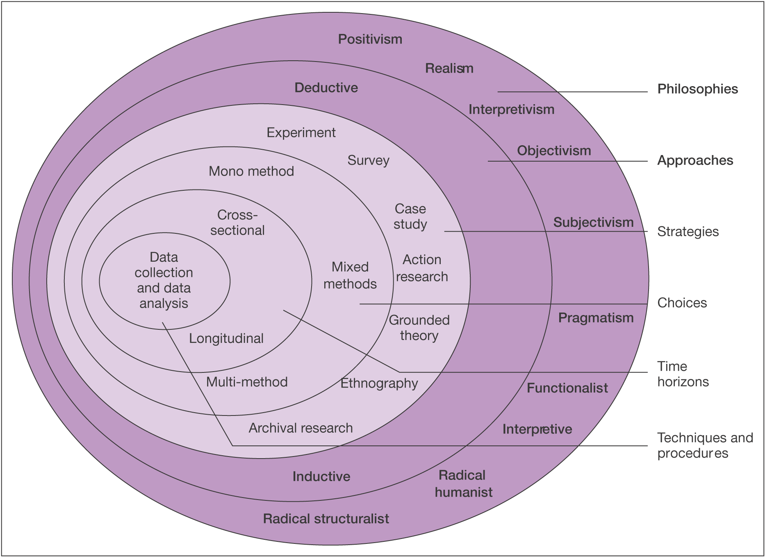

Figure 3.1 The Research Onion (Saunders et.al, 2019).

3.3.1 Research Philosophy
As shown in figure 3.1, research philosophy is the outermost layer of the Research Onion. According to Saunders et.al (2009) the philosophy that is adopted by the researcher will underpin the research strategy and methods of the research.
Again, as you can see in figure 3.1 the Philosophy layer of the Research Onion consists of ten possible options for the researcher to pick when conducting research. The philosophical approach that was used for this particular project was the positivism approach. Grey (2019), states that positivism is the natural and human sciences which share common methodological and logical principles when dealing with facts and not with values. As the aim of the research is to test what is causing the greatest impact to retailers located in Swansea City Centre by using surveys to collect data for the research, this philosophical approach was necessary.

3.3.2 Research Approaches
The research approach that was utilised for the research was the deductive approach. The deductive approach is seen as a more scientific approach to research, this is because a theory is rigorously tested against propositions (Saunders et.al, 2019). Therefore, using the deductive approach along with the positivism philosophy is the most suitable approach for the project as it will allow for a hypothesis to be tested against existing theory (Wilson, 2010), thus allowing for the data collected by the researcher to be tested against the existing theory.

3.3.3 Research Strategies
The primary data collection method that the researcher selected to collect a data sample for the research was surveys in the form of questionnaires. Questionnaires are a popular method for data collection (Sue and Ritter, 2012). It was stated by Dillman (2000) that a questionnaire begins by defying objectives and ends with data analysis which reports the results of the research. For this reason, a questionnaire was the appropriate research strategy for the project.

3.3.4 Research Choices
As the researcher decided to use only one method of analysing the data collected from the survey the research choice for the project was the Mono Method. As the researcher was using quantitative research, the data collected was put into numerical form and then tested by using quantitative data analysis techniques (Azorin and Cameron, 2010).

3.3.5 Time Horizons
Cross-sectional studies allow all the data to be collected at a single point in time (Sedgwick, 2014). The research was conducted over a three-week period during April and May 2020, as it was collected over a short period of time, the most appropriate time horizon for the research was cross-sectional. To ensure the research was completed on time and in a timely manner, the use of a Gantt chart was required. Gantt charts are a powerful and effective visual tool that can be used to strategically plan and schedule the entire project (Kumar, 2005). The Gantt chart as seen in Appendix B, clearly shows the time scale that the project followed.

3.3.6 Techniques and Procedures
This project utilised a mono method approach to collect the quantitative data produced by the questionnaire. Quantitative research seeks to generate knowledge and create an understanding based on the information that has been gathered to observe different occurrences that affect individuals (Allen, 2017). The questionnaire responses provide the researcher with quantitative data which when analysed allowed the researcher to understand the responses in a way that was helpful to the overall research (Nardi, 2016).

3.3.6.1 Questionnaire
Questionnaires are a primary method of quantitative data collection (Harland, 2020). According to (Kotler, Armstrong and Harris, 2020) the use of questionnaires is the favoured research method among researchers as they are a very flexible method for asking a range of open and closed-ended questions. This allows the researcher to limit the possible responses for some questions while letting the participant express their own opinions on other questions. The questionnaire can be seen in appendix c and their link to literature can be seen in appendix D.
The questionnaire produced using Google Forms and posted on Social Media can help gather a substantial data set that can be statistically tested in order to assist with the research. The benefit of using online platforms to produce and distribute the questionnaire to participants means that all participants are able to keep their anonymity at all times during the process of the research. As 100 participants are needed in order to create a substantial data set and for the research to be successful, using social media allows for a wider audience to be accessed more efficiently (Wright, 2017).

3.3.6.2 Data Analysis
Once the data was collected it was vital that appropriate statistical tests were conducted in order to look for similarities and trends that have been found from the data set. SPSS is a powerful statistical software that allows for key information to be analysed from the data set provided (IBM, 2020) and therefore was the software used to analyse the quantitative data.

3.4 Sample
The sample of the research collected was a convenience sample. A convenience sample is a type of non-probability sample that allows for participants to be chosen simply because they are the most convenient sources for the data collection (Lavrakas, 2008). A convenience sample allows for factors such as accessibility and geographic proximity to be considered when choosing the research participants (Etikan, 2016). As the research was focusing on Swansea City Centre, the questionnaire was aimed at those who currently live or have lived in the Swansea area.

3.5 Reliability and Validity

3.5.1 Validity
According to Heale and Twycross (2015), validity in research is the extent to which a concept is accurately measured in a study. To ensure the research is valid, the questionnaire needed to be designed accordingly, as the aim of the study was to understand the factors impacting Swansea city centre retailers and whether or not online shopping is the main reason for the decline in retailers then the questionnaire needs to ensure that these topics can be explored from the data provided by the participants.

3.5.2 Reliability
Again, Heale and Twycross (2015) State that the reliability of research relates to the consistency of the results. The data is perceived as reliable if the measurements of the data would have very similar results if the study was to be completed again in the future.

3.5.3 Pilot Study
Before the research was conducted a pilot study of the questionnaire was conducted. Pilot studies are crucial to ensure an adequate study design of the research questionnaire to ensure it is suitable for its intended purpose (Teijlingen and Hundley, 2001). The advantage of conducting a pilot study is that it can give advanced warning to the researcher about where there may be an issue within their research strategy (Teijlingen and Hundley, 2002). This allows the researcher to change some of the questions and the way they had been written to ensure that the questions not only provided the information necessary for the success of the research but also to ensure that all participants were able to fully understand each of the questions that were being asked. Upon completion of a pilot study, the researcher slightly changed the way some of the questions were worded to ensure the participants could fully understand what they were being asked.

3.6 Ethical Considerations
During the data collection process of the research, it is vital that the researcher ensures that ethical considerations are taken into account. Ethical considerations are set out by guidelines which are intended to ensure that the participants who have taken part in the research are protected against any potential risks which may arise as a result of their participation in the research (Krishnaswamy, Sivakumar and Mathirajan, 2009). A completed copy of the UWTSD ethics form can be seen as Appendix E.

3.7 Chapter Summary
In summary, this chapter has successfully outlined the research design and methodology for the project and has laid out the pathway followed using the research onion to ensure successful research. The chapter has discussed the limitations encountered by the researcher as well as the ethical considerations taken into account during the research process.
Chapter four will analyse the primary data collected from the online questionnaire using the SPSS software.

Chapter 4 – Analysis

4.1 Chapter Introduction
This chapter is going to analyse the data that was collected from participants who participated in the online questionnaire. The data collected will be analysed using the SPSS software which will allow for a range of statistical tests to be conducted on the data set.
This chapter will achieve the second research objective of the project:
- To conduct primary research through the use of a survey in order to gain a better understanding of how consumers view the factors impacting the city centre.

4.2 Demographics
The questionnaire began with a range of demographic questions for the participants. This was to allow the researcher to gain a deeper understanding of each individual participant as well as being able to understand whether or not demographics such as age and gender would have a significant impact on the way participants choose to shop. However, as the participants were gathered using the social media accounts of the researcher, the participants are likely to be those who have a friendship with the researcher and therefore could influence the age and gender of the participants.

4.2.1 Gender
The first question of the questionnaire asked the participants to specify the gender category to which they associated themselves. Figure 4.1 below displays the Genders of each of the participants. The participants were given a wide range of gender options to choose from as well as being able to self identify, however, all of the participants identified as either Male or Female.
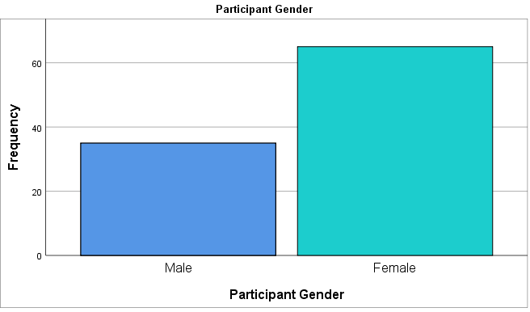
Figure 4.1 Gender of Participants.
Figure 4.1 represents the gender of the 100 participants, the figure could indicate that the topic of shopping is that of which is more interesting to females and therefore would lead to an increased number of females who decided to take part in the survey. However, as mentioned earlier the higher percentage of females could be the results of the researcher's friendships.

4.2.2 Participant Age
The second question of the questionnaire asked participants to specify which age range they belonged to. Figure 4.2 below displays the ages of each participant. This was an important demographic question as it allows for the use of a crosstabulation analysis to better understand how online shopping has impacted the way that people of all ages choose to shop. Again, these results are likely to be linked to the social media friendships of the participant.
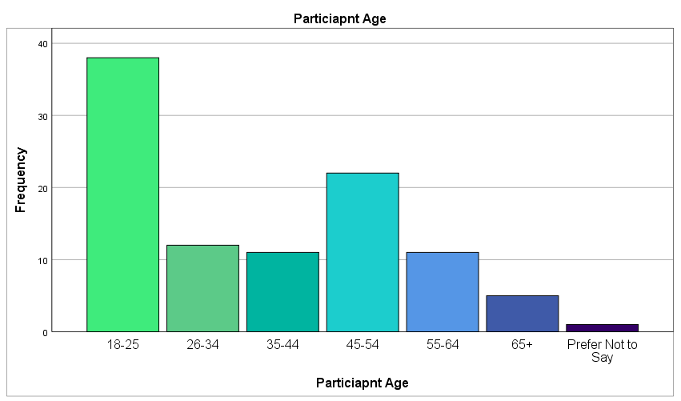
Figure 4.2 Age of Participants.

4.2.3 Participants Shopping Behaviours
Questions 5 and 6 of the questionnaire asked the participants how often they shop in Swansea and how often they shop online. As the project is aiming to understand how online shopping has impacted retailers located in Swansea, this was a useful question that once analysed would allow the researcher to see the difference between how often the participants shop in Swansea compared to online.
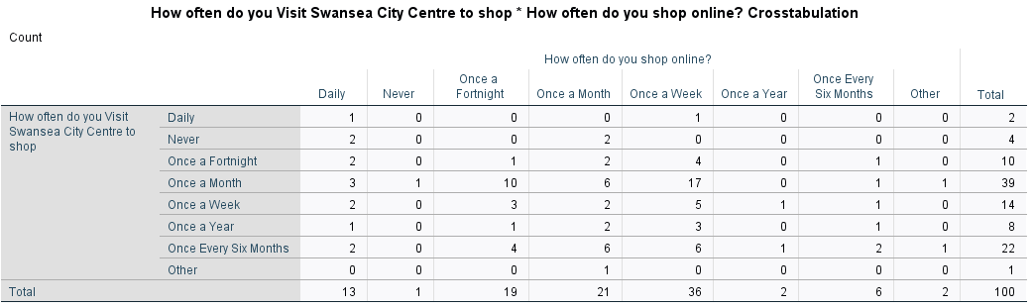
Table 4.2 Crosstabulation analysis comparing how often participants shop online against visiting Swansea to shop.

A crosstabulation analysis was conducted using questions 5 and 6 as seen above in Table 4.2. The analysis revealed that 17 of the 100 participants shop online once a week but only visit Swansea to shop once a month. It was also revealed that 22 of the participants shop in Swansea just once every six months compared to just 6 who shop online as often. These results clearly show that the participants use online retailers to shop more than visiting Swansea City centre retailers.
This finding corresponds with the findings by the Office for National Statistics (2019) when they found that 82% of people living in the UK now choose to shop online before visiting their local city centre retailers. Similarly, a 2013 report conducted by Swansea City Council found that just 43% of people living in the Swansea catchment area use Swansea city centre for their shopping needs.

4.3 Demographics and Convenience
Using the demographic data collected a crosstabulation analysis was conducted to see whether or not the age of the participants impacted the way they perceive the convenience of online shopping against visiting Swansea city centre. The analysis as shown in Table 4.3 below reveals that each of the age categories either agree or strongly agree that online shopping is more convenient than visiting the city centre in Swansea for their shopping needs. This was a significant question to aid in the research as convenience had been previously discussed in chapter 2 of the project. However, the Chi-Square conducted as shown in table 4.4 indicates that there is no statistically significant link between the participant's age and whether or not they find online shopping more convenient than visiting Swansea city centre.
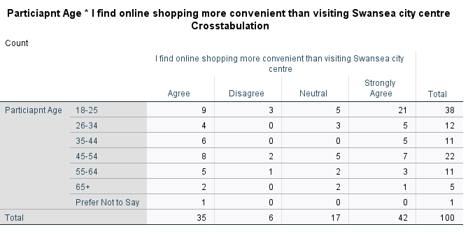
Table 4.3 Crosstabulation of Age and Convenience.
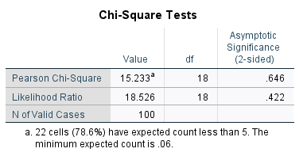
Table 4.4 Chi-Square of Age and Convenience.

Table 4.3 shows that 77 of the 100 participants either agree or strongly agree that online shopping is more convenient than visiting the city centre to shop. To gain a better understanding of why this was, question 19.1 asked the participants to describe why they believe online shopping is more convenient than visiting the retailers located in Swansea city centre. After analysing the feedback using a word cloud as seen in figure 4.3 below, the most commonly used word was ‘Time’. This finding corresponds with that of Kumar and Kashyap (2018) when they discussed that consumers now allocate less of their time to shopping and more time to other endeavours.

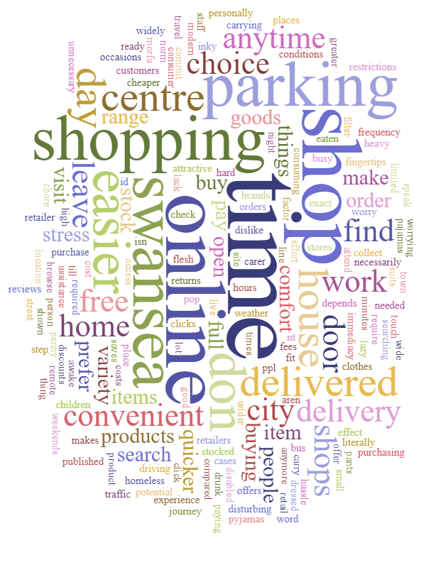
Figure 4.3 Word Cloud why is online shopping more convenient.

4.4 Associated Costs
Further tests were conducted to better understand how the costs, time and effort associated with visiting the city centre have changed the way that consumers shop and the way they perceive the convenience of online shopping.

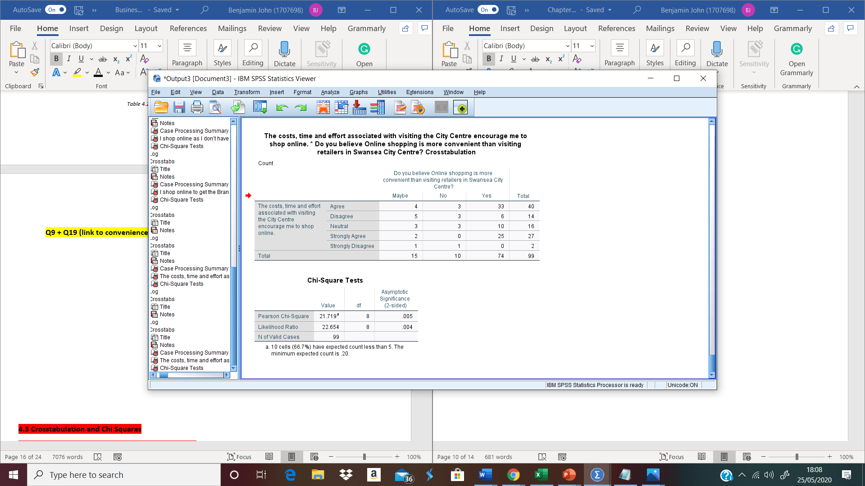
Table 4.5 Crosstabulation of costs associated with city centre shopping and convenience of online shopping.
Table 4.6 Chi-Square of costs associated with city centre shopping and convenience of online shopping.

The results from the Chi-Square shown in Table 4.6 reveal that the P-value is 0.005, this is less than 0.05 meaning there is a statistically significant difference between the two variables tested. The results indicate a clear link between the costs and efforts associated with visiting the high street and the way that the consumer perceives the convenience of online shopping. These findings correspond with the findings by Beauchamp and Ponder (2010) and Jiang, Yang and Jun (2013) When they mentioned that online shopping allows the consumer to reduce the time and effort that would be required to visit the brick and mortar stores, therefore allowing for greater convenience for the consumer.

4.5 Consumers Time
As discussed earlier, time is an important resource to the consumer and one that is limited as discussed previously by Clulow and Reimers (2009). As seen in Table 4.8 a significant statistical link was found between the participants having a lack of spare time and online retailers allowing them to shop when is most convenient for them to do so.

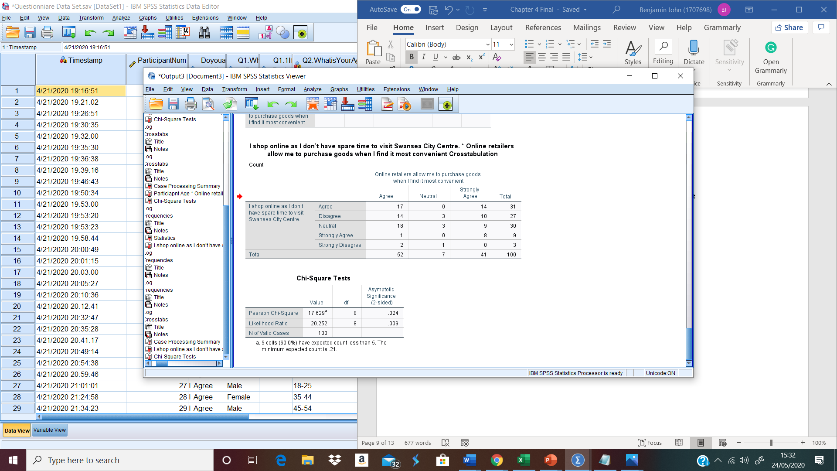
Table 4.7 Crosstabulation analysis shopping online due to lack of time and online retailers allow purchase of goods when most convenient
Table 4.8 Chi-Square test shopping online due to lack of time and online retailers allow purchase of goods when most convenient

These findings could be due to the fact that Swansea city centre operates between the hours of 9-5 (Swansea City Council, 2015), whereas the online retail environment allows consumers to shop from any location 24 hours a day, 7 days a week as mentioned by Beauchamp and Ponder (2010).

4.6 Pricing and Brands
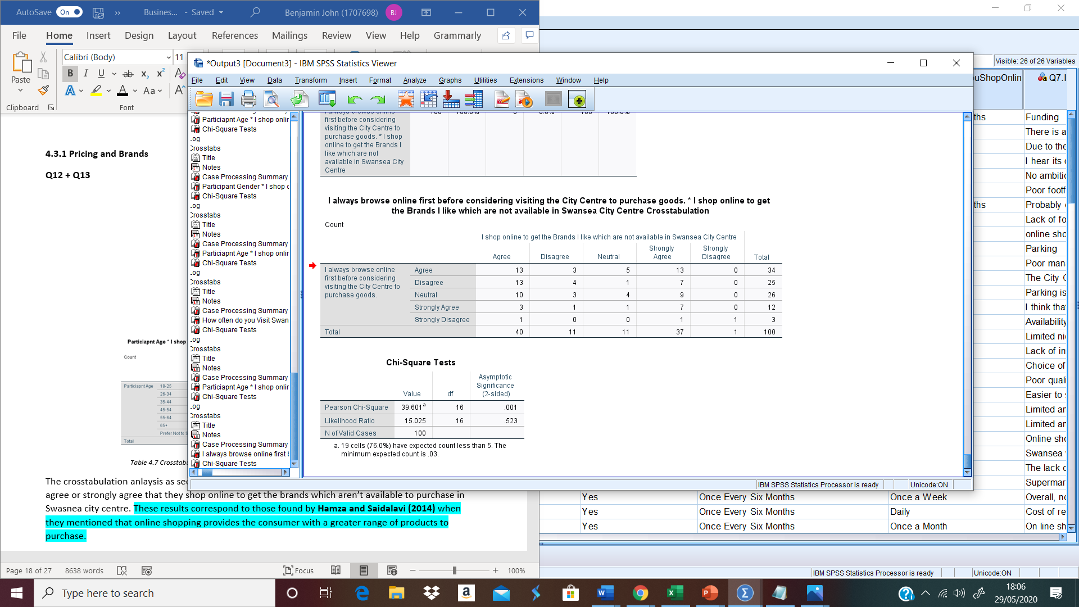
Table 4.9 Crosstabulation analysis browsing online before visiting city centre against shopping online to purchase certain brands.
Table 4.10 Chi-Square test browsing online before visiting city centre against shopping online to purchase certain brands.

The Chi-Square test as seen in Table 4.10 shows a P value of .001, this means there is a statistically significant link between participants browsing online before they visit the city centre to shop and that they shop online to get brands which are not available to purchase in Swansea city centre. The results could indicate that the participants browse online retailers first to ensure the best prices for the products they are wishing to purchase as previously discussed by East et.al, (2017) and Ross (2016). The results also correspond to those found by Hamza and Saidalavi (2014) when they mentioned that online retailers provide the consumer with a greater range of products to choose from when purchasing goods.

4.7 Impact of Out of Town Retail Parks
As well as examining the convenience of online shopping and the impact this has on retailers located in Swansea, the researcher analysed the convenience of out-of-town retail parks and the convenience these posses for the consumer to try and establish if they are a factor which has impacted retailers in Swansea city centre.
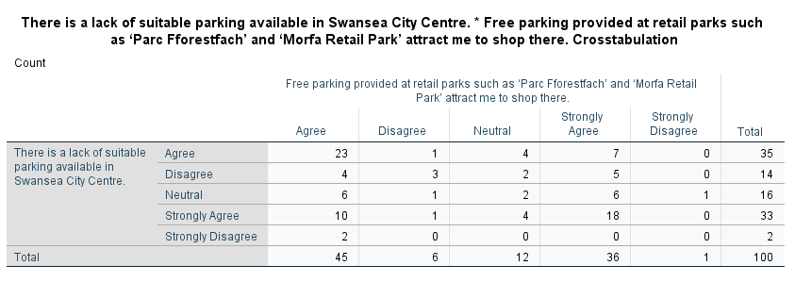
Table 4.11 Crosstabulation of the lack of suitable parking in Swansea and the free parking provided by retail parks.

The crosstabulation analysis as seen in Table 4.11 indicates that 81 of the participants either agree or strongly agree that the free parking provided by retail parks attract them to shop there, these findings correspond with the studies conducted by Guy (1994) and Anderson (2015) which were previously mentioned in chapter 2 when they mentioned that the free parking provided at retail parks make them a more desirable option for consumers who still wish to shop in-store.

4.8 Chapter Summary
This chapter has achieved the second research objective of the project:
- To conduct primary research through the use of a survey in order to gain a better understanding of how consumers view the factors impacting the city centre.
In summary, this chapter has successfully analysed the primary data that was collected from the questionnaire as well as presenting the findings. Chapter five will discuss the main findings that have emerged from the analysis of the data collected and will satisfy the third and final research objective of the project.

Chapter 5 – Discussion

5.1 Chapter Introduction
The data collected via online questionnaires was analysed in chapter four. The analysis concluded that the main theme found was convenience.
This chapter will achieve the third and final objective of the project:
- To make recommendations to city centre retailers based on the findings of this project that will allow them to ensure that they can adapt to the ever-changing circumstances and the changes in consumer buying behaviours.

5.2 Achievement of Objectives

- To conduct an extensive literature review discussing literature produced by key authors covering the potential factors that could be causing the decline in city centre retailers as well as analysing literature produced by Swansea City Council to aid in the understanding.
This was achieved in chapter 2 of the project where the researcher conducted an extensive literature review analysing a range of academic sources as well as previously produced document by Swansea City Council.

- To conduct primary research through the use of a survey in order to gain a better understanding of how consumers view the factors impacting the city centre.
This was achieved in chapter 4 of the project when the primary data that had been collected from the participants was used to conduct statistical tests in order to better understand the factors impacting the city centre in Swansea.

- To make recommendations to city centre retailers based on the findings of this project that will allow them to ensure that they can adapt to the ever-changing circumstances and the changes in consumer buying behaviours.
This was achieved in chapter five of the project when the researcher discussed the recommendations to retailers located in Swansea city centre.

5.3 Main Findings
The main findings from the data that was analysed corresponded with much of the literature that had been previously discussed in chapter two of the project. Firstly the data set that was collected and analysed in chapter four indicates that convenience is a very important factor to the consumer when they are deciding on where to shop. The findings indicate that online retailers provide the consumer with the greatest amount of convenience, these findings correspond with those of Jiang, Yang and Jun (2013) when they mentioned that the convenience provided by online retailers is one of the principle factors that have paved the way for how consumers now choose to shop.
The convenience possessed by online retailers make them a more popular choice for consumers and therefore have had an impact on the way consumers now choose to shop, in turn having an impact on the city centre retailers located in Swansea. The findings indicate that online shopping provides consumers with a wider choice of products to purchase from, cheaper products as well as allowing the consumer to save time by not having to leave the comfort of their own homes. These findings correspond with the findings by Hamza and Saidalavi (2014) when they discussed that online shopping provides the consumer with a wider selection of products to purchase.
As well online shopping and the convenience it possesses for the consumer, the findings also indicate that the lack of free parking available in Swansea city centre has discouraged consumers to shop there, often being encouraged to shop at out-of-town retail parks due to the vast amount of free parking they have available. Again these findings correspond with those mentioned previously by Anderson (2015) and Guy (1994) when they both mentioned that out-of-town retail parks are a more desirable option for consumers due to the free parking and abundance of shops available in the same place.

5.4 Limitations
One of the limitations that were faced by the researcher was that as the data was collected via online questionnaires which were posted on the social media channels of the researcher, this limited the potential participants who could participate in the research therefore possibly impacting the overall results of the research.
Another limitation was that due to the impact of COVID-19, participants were unlikely to be visiting the City Centre during the period of the research. Therefore, some of the responses to some of the questions received from the participants may be slightly inaccurate which could mean the reliability of the study is affected. If the study was to be done again at a later date when participants were not impacted by COVID-19, it is possible that the overall findings of the study could be different.

5.5 Conclusion
This study has successfully achieved the main aim of the project which was to evaluate the factors that have impacted retailers in Swansea city centre to try and establish the impact that online retailers have had on city centre retailers. The study has also provided the researcher with greater knowledge into the factors that are causing city centre retailers to decline.
The study has successfully achieved all of the research objectives that were set out at the beginning of the study. The objectives were achieved throughout various chapters of the project. Chapter two achieved the first objective by discussing a wide range of literature that was available to the author to get an understanding of the factors impacting city centre retailers. Chapter four achieved the second research objective by conducting and analysing the primary research that had been collected via the online questionnaire and finally chapter five achieved the final research objective which was to make recommendations to city centre retailers based on the main findings of the project that would allow them to ensure they can adapt to the changing consumer buying behaviours.
In conclusion, this study has found that although the city centre in Swansea has been a vital shopping channel for centuries, there is a range of factors impacting the city centre retailers. The study has found that the convenience possessed by online retailers make them a more desirable option for consumers who are now choosing to shop online as appose to visiting the city centre for their shopping needs. The findings of the study indicate that the convenience of online shopping has caused the greatest impact to the city centre retailers located in Swansea city centre.

5.6 Recommendations
The researcher recommends that in order to gain deeper knowledge into the individual factors that are causing the decline of retailers in Swansea city centre, further research needs to be conducted at a later date. It is recommended that further research is conducted over a longer period of time, with a greater range of participants to truly understand the impacts different factors including online retailers have had on city centre retailers.
The researcher also recommends that the retailers located in Swansea city centre try to increase the convenience they offer to the consumers in order to attract business to the city centre. As previously discussed, the free parking that is provided by out-of-town retail parks attracts consumers to shop there due to the increased convenience, because of this, it is recommended that retailers located in Swansea city centre offer reduced parking or free parking for the consumers who shop in their store. This would help to encourage consumers to shop in city centre retailers as appose to shopping online or visiting the out-of-town retail parks.

Bibliography
Allen, M., (2017). Quantitative Research. The Sage Encyclopedia of Communication Research Methods. Sage.
Anderson, E., (2015). High Street Suffers as More People Favour Out-Of-Town Locations. [online] The Telegraph. Available at: https://www.telegraph.co.uk/finance/newsbysector/retailandconsumer/11409692/High-Street-suffers-as-more-people-favour-out-of-town-locations.html [Accessed 9 April 2020].
Arora, S., Singha, K. and Sahney, S., (2017). Understanding Consumers Showrooming Behaviour. Asia Pacific Journal of Marketing and Logistics, 29(2), pp.409-431.
Azorin, J. and Cameron, R., (2010). The Application of Mixed Methods in Organisational: Research A Literature Review. The Electronic Journal of Business Research Methods. 8(2), pp.95-105.
BBC, (2019). Retail: Chain Shop Closures Outweigh New Stores Opening. [online] Available at: https://www.bbc.co.uk/news/uk-wales-49648242 [Accessed 4 February 2020].
Beauchamp, M and Ponder, N. (2010), “Perceptions of Retail Convenience for in-store and Online Shoppers”, The Marketing Management Journal, Vol.20(1), pp.49-65.
BIS, (2011). Understanding High Street Performance. [online] Available at: https://assets.publishing.service.gov.uk/government/uploads/system/uploads/attachment_data/file/31823/11-1402-understanding-high-street-performance.pdf [Accessed 9 April 2020].
Butler, S., (2019). Half of UK Retail Sales Will be Online Within 10 Years, Report Predicts. [online] The Guardian, Available at: https://www.theguardian.com/business/2019/jul/09/half-of-uk-retail-sales-will-be-online-within-10-years-report-predicts [Accessed 6 May 2020].
Butler, S., (2019). Retailers call for action as high street store closures soar. The Guardian. [online] Available at: https://www.theguardian.com/business/2019/sep/11/retailers-call-for-action-as-high-street-store-closures-soar [Accessed 28 May 2020].
Clulow, V. and Reimers, V., (2009). How do Consumers Define Retail Centre Convenience? Australasian Marketing Journal (AMJ), 17(3), pp.125-132.
Dillman, D., (2000). Mail and Internet Surveys: The Tailored Design Method. 2nd ed, Wiley.
East, R., Singh, J., Wright, M. and Vanhuele, M., (2017). Consumer Behaviour: Applications in Marketing. 3rd ed. London: Sage, pp.3-4.
Engel, J. F, Kollat, D. and Blackwell, R., (1978). Consumer Behaviour. Dryden Press, NY.
Etikan, I., (2016). Comparison of Convenience Sampling and Purposive Sampling. American Journal of Theoretical and Applied Statistics, [online] 5(1), p.2. Available at: https://www.researchgate.net/publication/304339244_Comparison_of_Convenience_Sampling_and_Purposive_Sampling [Accessed 14 March 2020].
Gray, D., (2019). Doing Research in the Business World. 2nd ed. London: Sage, pp.24-25.
Greenhalgh, P., Johnson, L. and Huntley, V., (2019). An Investigation of the Impact of 2017 Business Rates Revaluation on Independent High Street Retailers in the north of England. Journal of Property Investment and Finance, 37(3), pp.241-254.
Guy, C., (1994). The Retail Development Process, Location, Property and Planning. Routledge, London.
Hamza, V. and Saidalavi., (2014). A Study on Online Shopping Experience and Customer Satisfaction. [online] Available at: https://www.academia.edu/29905542/A_Study_on_Online_Shopping_Experience_and_Customer_Satisfaction [Accessed 2 May 2020].
Harland, B., (2020). How to Do a Quantitative Research Questionnaire. [online] Available at: https://sciencing.com/how-to-do-a-quantitative-research-questionnaire-12748929.html [Accessed 12 May 2020].
Heale, R. and Twycross, A., (2015). Validity and Reliability in Quantitative Studies. Evidence Based Nursing, 18(3), pp.66-67.
Hope, J., (2019). Innovation on the High Street. Property Journal. pp.30-31.
IBM., (2020). SPSS Statistics – Overview. [online] Available at: https://www.ibm.com/uk-en/products/spss-statistics [Accessed 9 May 2020].
Jiang, L., Yang, Z. and Jun, M., 2013. Measuring consumer perceptions of online shopping convenience. Journal of Service Management, 24(2), pp.191-214.
Jones, C. and Livingstone, N., (2017). The ‘online high street’ or the high street online? The Implications for the Urban Retail Hierarchy. The International Review of Retail, Distribution and Consumer Research, 28(1), pp.47-63.
Jones, P. and Vignali, C. (1993). Factory Outlet Shopping Centres, Town and Country Planning, September, pp.240-241.
Jones, P., (1990). Town Centre Management Schemes in the UK. International Journal of Retail & Distribution Management, 18(3).
Kanjer, H. and Bhatia, S., (2018). Impact of Online Shopping Expertise on Consumers’ Online Shopping Behaviour.
Kotler, P., Armstrong, G. and Harris, L., (2020). Principles of Marketing. 8th ed. Hoboken: Pearson, p.123.
Krishnaswamy, K., Sivakumar, A. and Mathirajan. (2009). Management Research Methodology: Integration of Principles, Methods and Techniques. 3rd ed. Delhi: Pearson Education, p.563.
Kumar, A. and Kashyap, A., 2018. Leveraging utilitarian perspective of online shopping to motivate online shoppers. International Journal of Retail & Distribution Management, 46(3), pp.247-263.
Kumar, C. (2008). Research Methodology. 1st ed. New Dehli: APH Publishing, pp.1-4.
Kumar, P., (2005). Effective Use of Gantt Chart for Managing Large Scale Projects. [online]. 47(7). Available at: https://search.proquest.com/docview/220442584/fulltext/B4D436C0EFAF41C8PQ/1?accountid=130472 [Accessed 9 March 2020].
Lavrakas, P., (2008). Convenience Sampling. Encyclopedia of Survey Research Methods. Sage.
Makortoff, K., (2019). Number of Shoppers on UK High Street Falls by 10% in Seven Years. [online] The Guardian. Available at: https://www.theguardian.com/business/2019/oct/14/number-of-shoppers-on-uk-high-street-falls-by-10-in-seven-years [Accessed 6 May 2020].
Melnikovas, A., (2018). Towards an Explicit Research Methodolgy: Adapting Research Onion Model for Future Studies. Journal of Future Studies, 23(2), p.34.
Montaldo, D., (2019). Is Shopping Online Really Cheaper? [online]. Available at: https://www.thebalance.com/is-shopping-online-really-cheaper-939778 [Accessed 28 May 2020].
Musso, F. and Druica, E., (2019). Handbook of Research on Retailing Techniques for Optimal Consumer Engagement and Experiences. IGI Global, pp.214-216.
Nageswari, R., (2019). The Evolution of Consumer Behaviour in the Digital Age. UGC Journal, 7(1), pp.245-250.
Nardi, P., (2008). Doing Survey Research. 3rd ed. New York: Paradigm Publishers, pp.18-19.
Nicholson, M., Clarke, I. and Blakemore, M., 2011. 'One brand, three ways to shop': situational variables and multichannel consumer behaviour. The International Review of Retail, Distribution and Consumer Research, 12(2), pp.131-148.
Office for National Statistics, (2018). Comparing “Bricks and Mortar” Store Sales with Online Retail Sales: August 2018. [online] Available at: https://www.ons.gov.uk/businessindustryandtrade/retailindustry/articles/comparingbricksandmortarstoresalestoonlineretailsales/august2018 [Accessed 25 February 2020].
Ons.gov.uk. 2019. How Our Internet Activity Has Influenced the Way We Shop - Office For National Statistics. [online] Available at: <https://www.ons.gov.uk/businessindustryandtrade/retailindustry/articles/howourinternetactivityhasinfluencedthewayweshop/october2019/previous/v1> [Accessed 7 April 2020].
Perner, L., (2018). Consumer Behaviour: The Psychology of Marketing. [online] Available at: https://www.consumerpsychologist.com/ [Accessed 7 April 2020].
Rao, F., 2019. Resilient Forms of Shopping Centres Amid the Rise of Online Retailing: Towards the Urban Experience. Sustainability, 11(15).
Reimers, V. and Chao, F., (2014). The Role of Convenience in a Recreational Shopping Trip. European Journal of Marketing, 48 (11/12), pp.2213-2236.
Ross, E., (2016). 12 Reasons Why Online Shopping is Better Than In-Store. [online] The Telegraph. Available at: https://www.telegraph.co.uk/technology/connecting-britain/why-online-shopping-is-better-than-in-store/ [Accessed 02 May 2020].
Roy, S., Shekhar, V., Quazi, A., and Quaddus, M., (2020). Consumer Engagement Behaviours: Do Service Convenience and Organisational Characteristics Matter? Journal of Service Theory and Practice.
Sahay, A., (2016). Peeling Saunders Research Onion. Research Gate. [online] Available at: https://www.researchgate.net/publication/309488459_Peeling_Saunder's_Research_Onion [Accessed 7 May 2020].
Saunders, M., Lewis, P. and Thornhill, A. (2019). Research Methods for Business Students. 8th ed. London: Pearson Education.
Saunders, M., Lewis, P. and Thornhill, A., (2009). Research Methods for Business Students. 5th ed. Harlow: Pearson Education, pp.100-125.
Sedgwick, P., (2014). Cross Sectional Studies: Advantages and Disadvantages. BMJ. [online] pp. g2276. Available at: https://www.researchgate.net/publication/275427950_Cross_sectional_studies_advantages_and_disadvantages [Accessed 12 May 2020].
Skeldon, (2020). UK Ecommerce Accounts for 19% of Total Retail, Making it Worth $233Bn. [online] Available at: https://internetretailing.net/industry/industry/uk-ecommerce-accounts-for-19-of-total-retail-making-it-worth-233bn-20971 [Accessed 14 May 2020].
Sue, V. and Ritter, L., (2012). Conducting Online Surveys. 2nd ed. Sage, pp.1-6.
Swansea City Council, (2013). Review of Retail Capacity, Investment Potential and Strategy for the City and County of Swansea. [online] Available at: <https://www.swansea.gov.uk/media/1519/Review-of-Retail-Capacity-Investment-Potential-and-Strategy-for-the-City--County-of-Swansea-2013/pdf/Review_of_Retail_Capacity__Investment_Potential_and_Strategy_for_the_CCS.pdf> [Accessed 10 April 2020].
Swansea City Council, (2015). Swansea Retail & Leisure Study 2015. [online] Available at: https://www.swansea.gov.uk/media/17380/Swansea-Retail-and-Leisure-Study-Final-Report/pdf/Swansea_Retail_and_Leisure_Study_Final_Report.pdf [Accessed 10 April 2020].
Teijlingen, E. and Hundley, V. (2001). The Importance of Pilot Studies. Social Research Update, 35. [online] Available at: https://aura.abdn.ac.uk/handle/2164/157 [Accessed 11 May 2020].
Teijlingen, E. and Hundley, V., (2002). The Importance of Pilot Studies. Nursing Standard, 16(40), pp.33.
Turner, J. and Corstorphine, T., (2020). The Role of Service Encounter as a Means of Reversing Further High Street Retail Decline. Handbook of Research on Retailing Techniques for Optimal Consumer Engagement and Experiences, pp.205-232.
Wilson, J., (2010). Essentials of Business Research: A Guide to Doing Your Research Project. Sage, p.7
Wilson, J., (2014). Essentials of Business Research: A Guide to Doing Your Research Project. 2nd ed. Sage.
Wise, D., (2012). Death of the High Street? Professional Pensions, pp.26-28.
Wright, K. (2017). Researching Internet-Based Populations: Advantages and Disadvantages of Online Survey Research, Online Questionnaire Authoring Software Packages, and Web Survey Services. Journal of Computer-Medicated Communication. [online] 10(3). Available at: https://academic.oup.com/jcmc/article/10/3/JCMC1034/4614509 [Accessed 1 Mar. 2020].

Appendix
Appendix A – Engel-Kollat-Blackwell Model
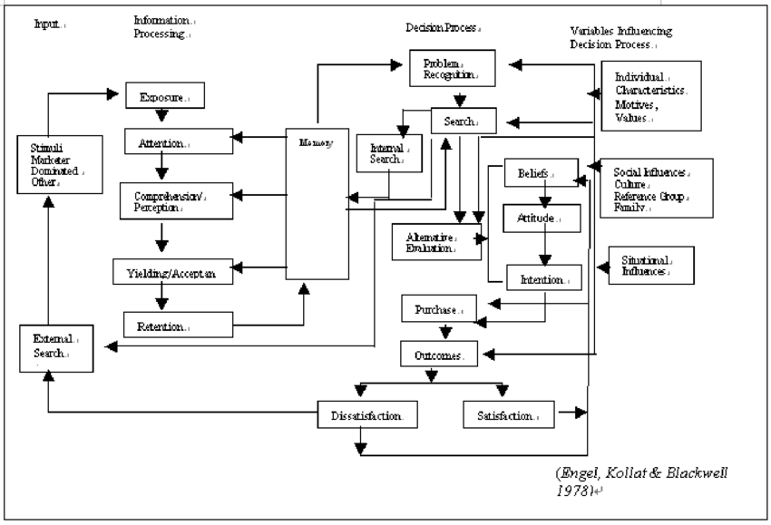
Appendix B – Gantt Chart


Appendix C- Questionnaire Raw Data

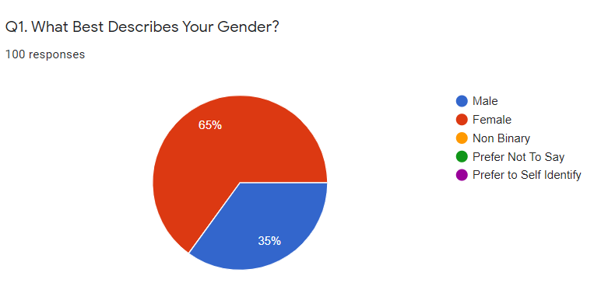
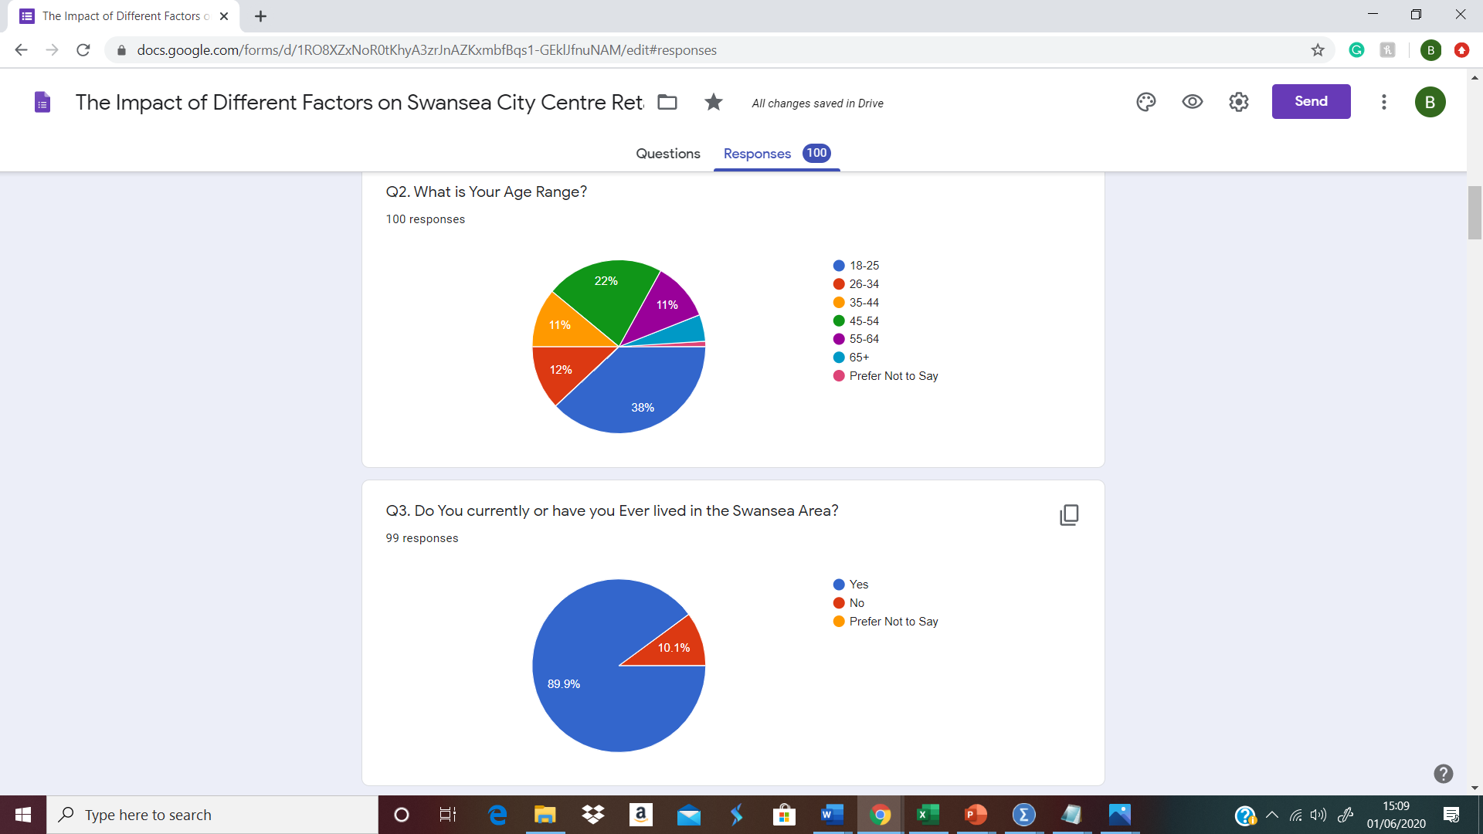
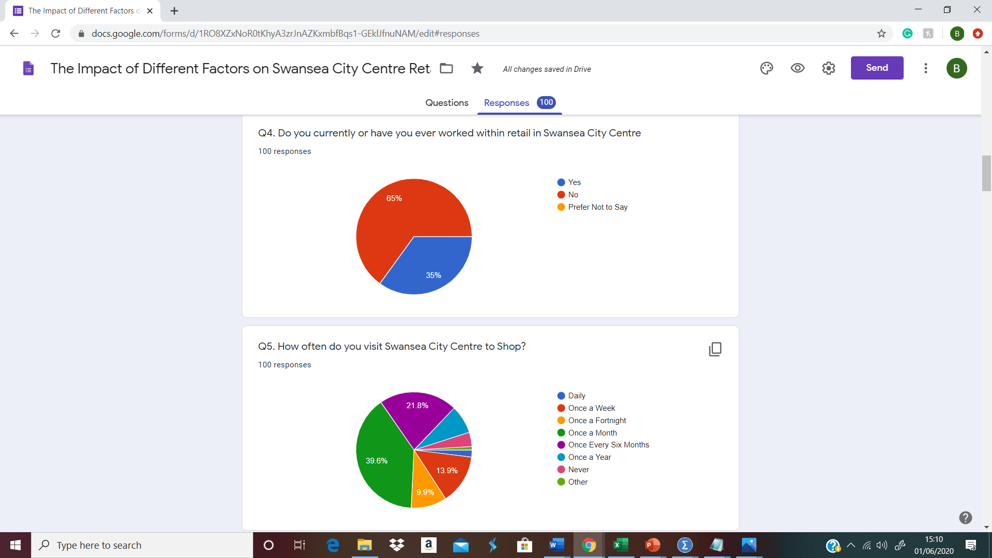
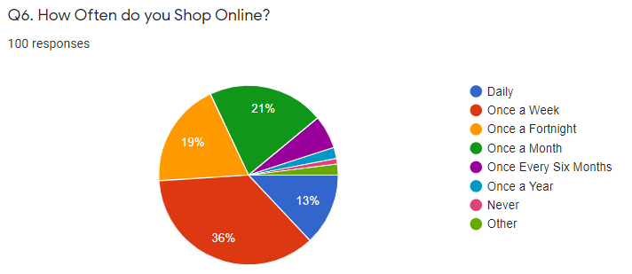

Q.7
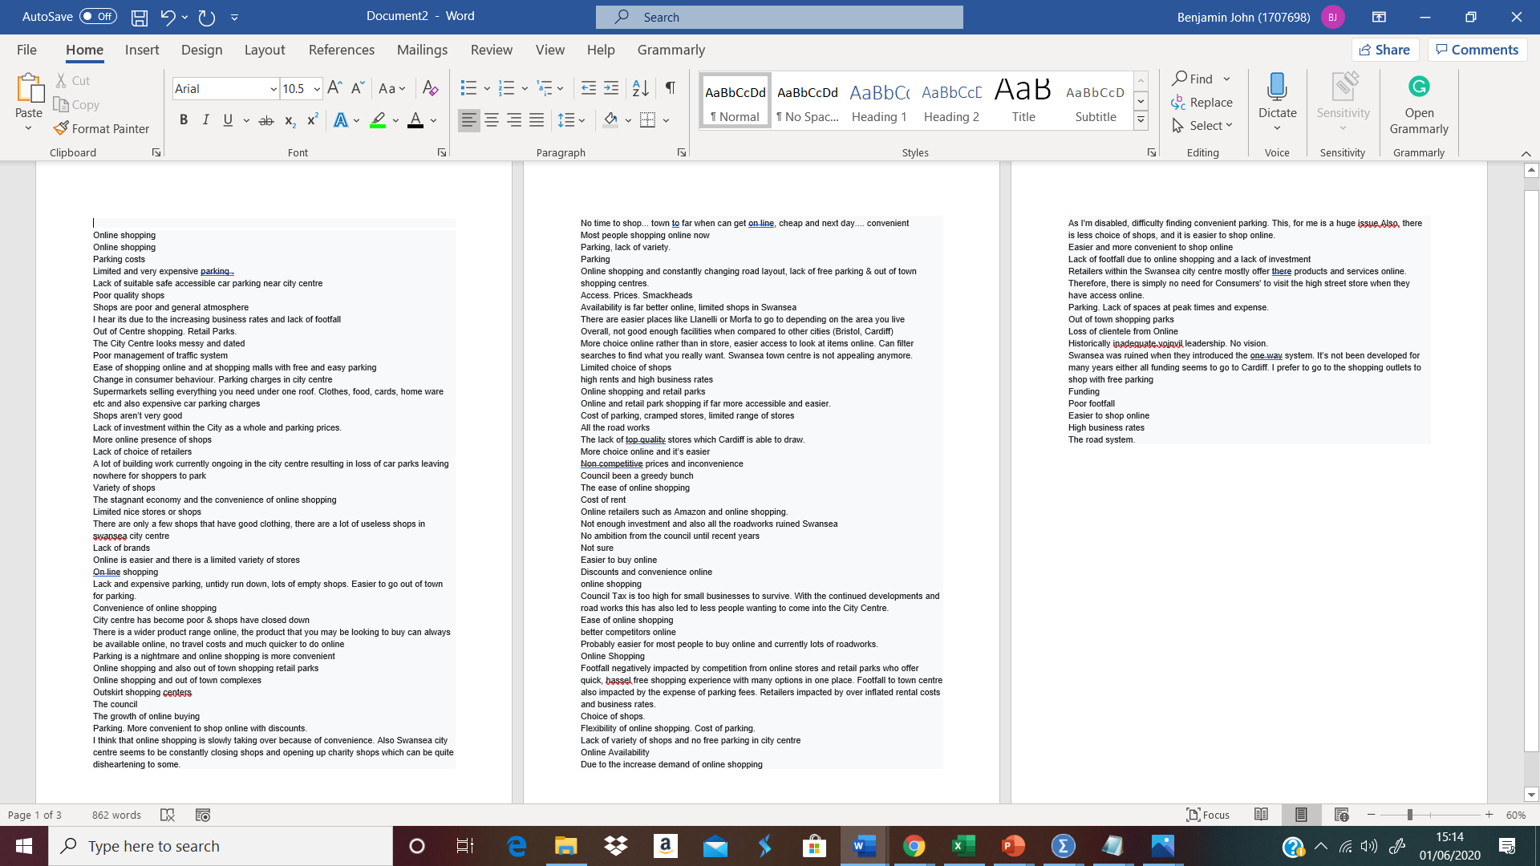
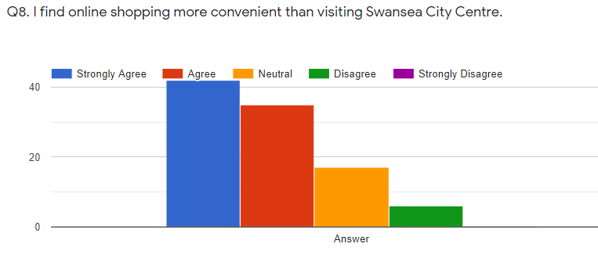
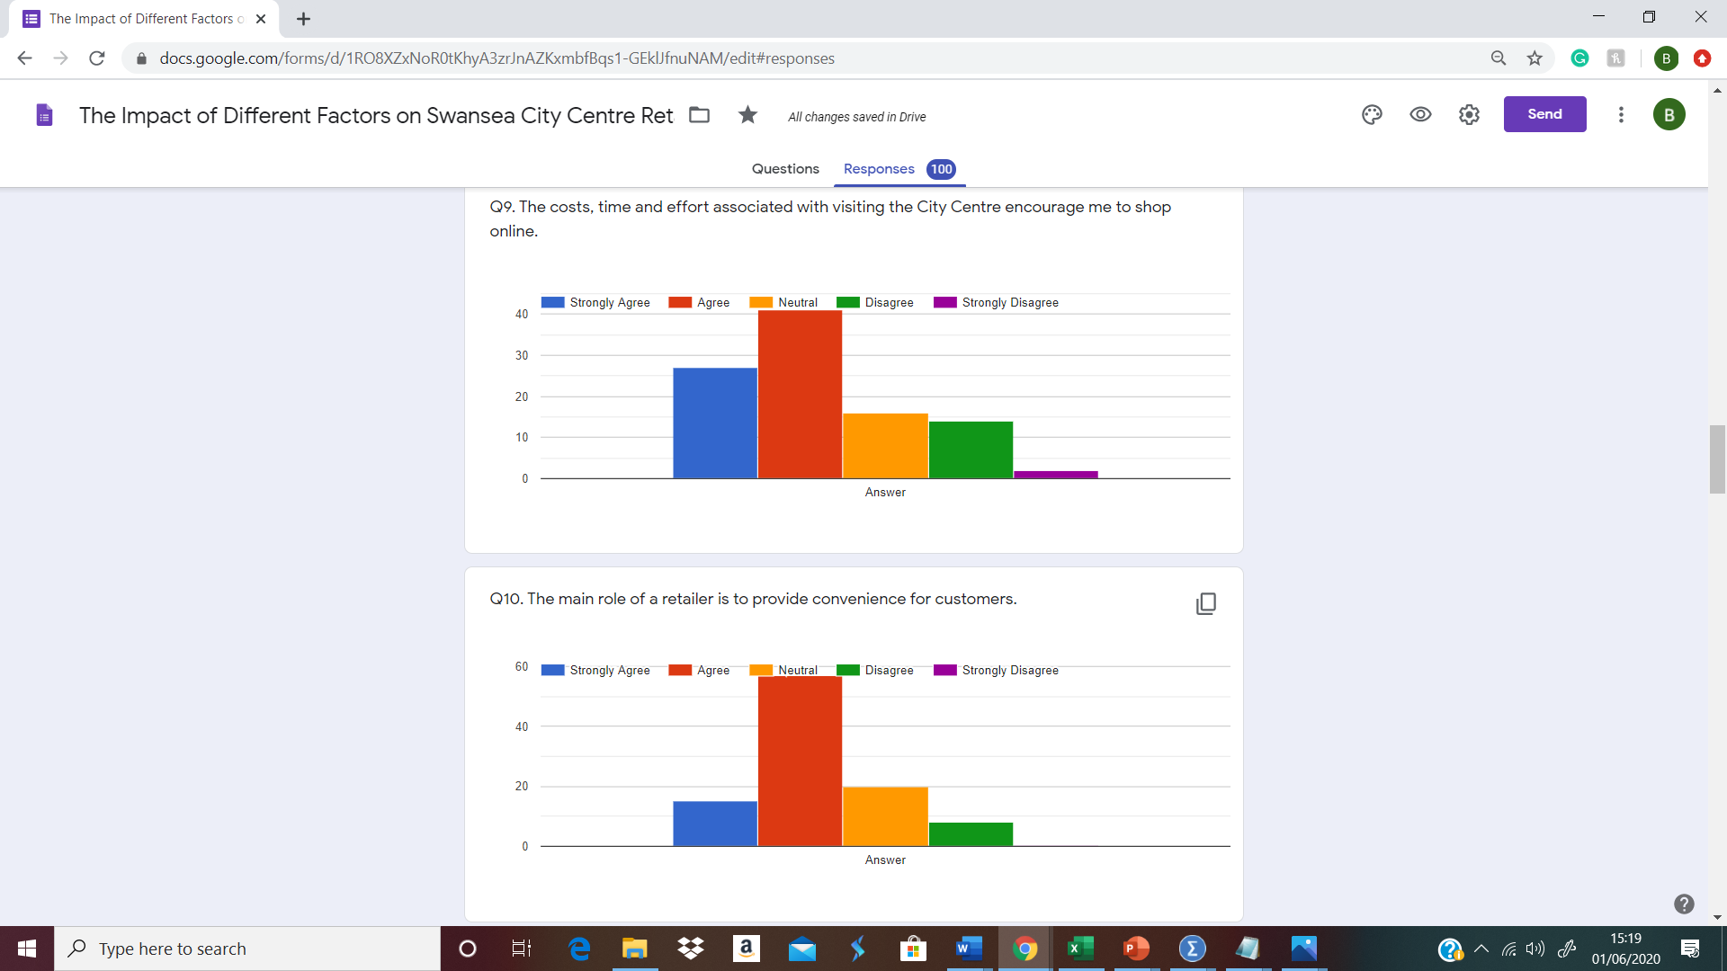
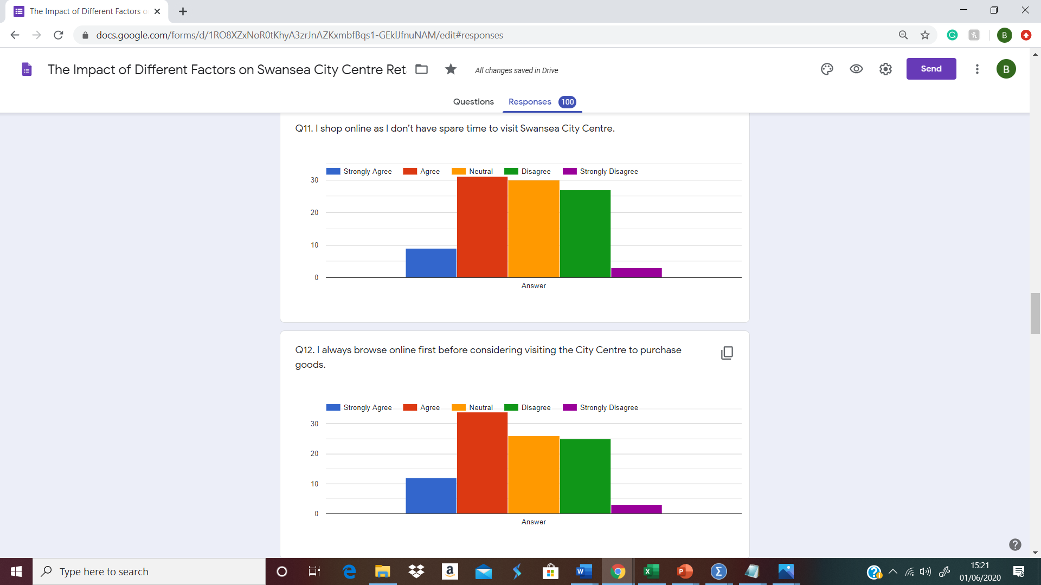
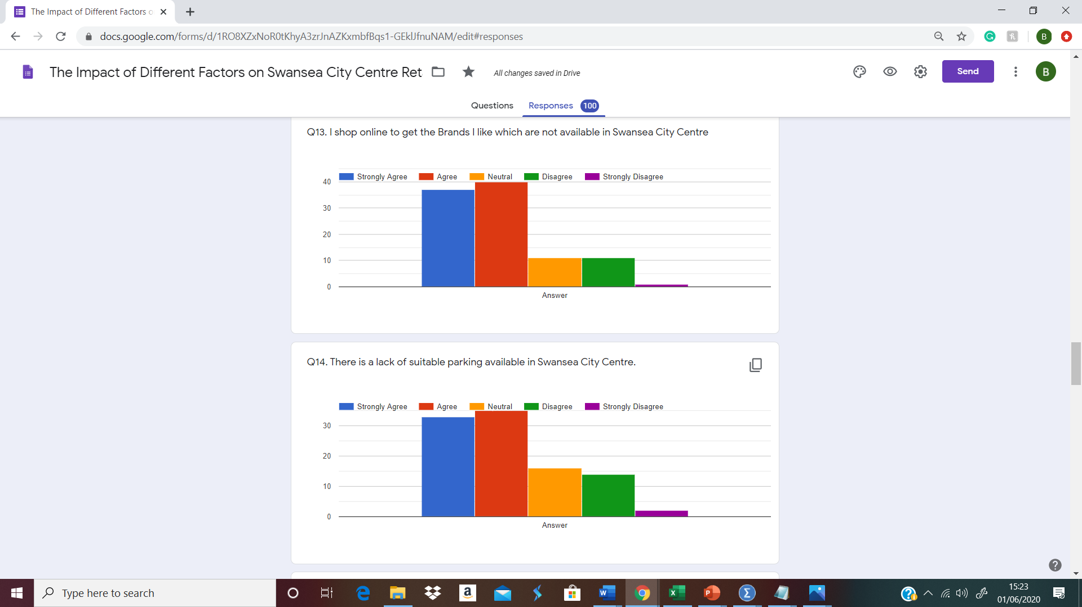
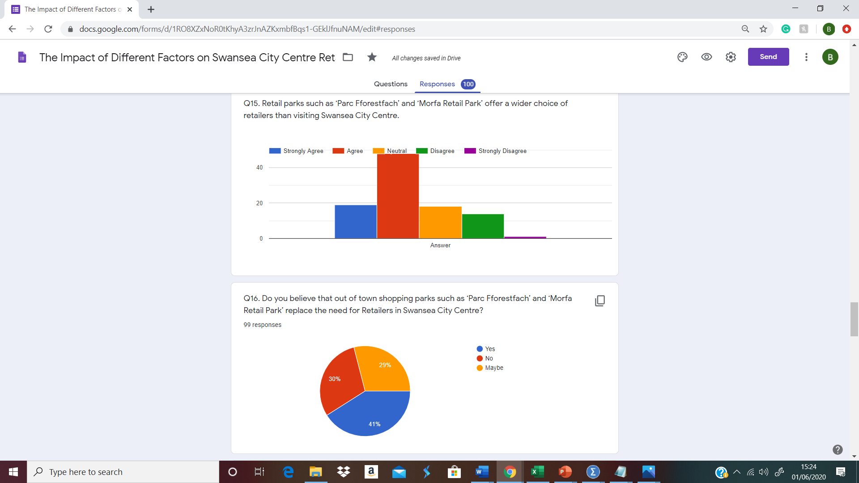

Q16.1
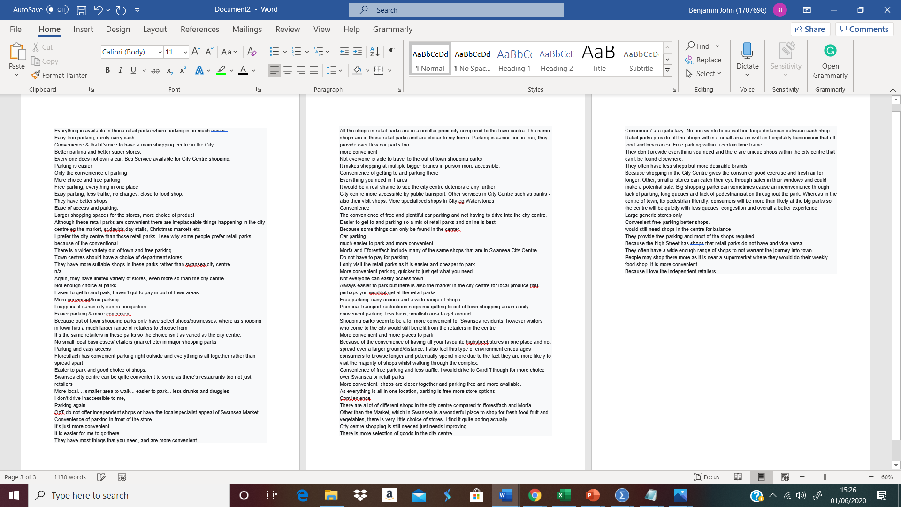

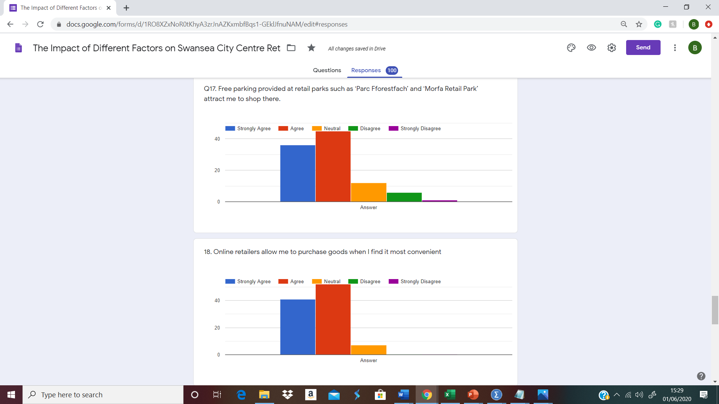
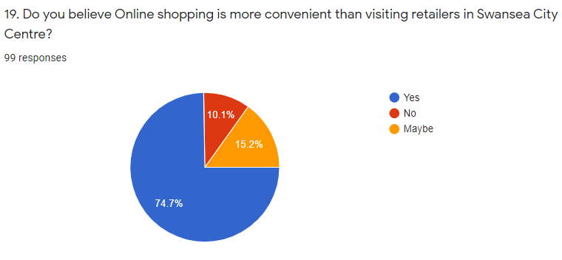

Q. 19.1
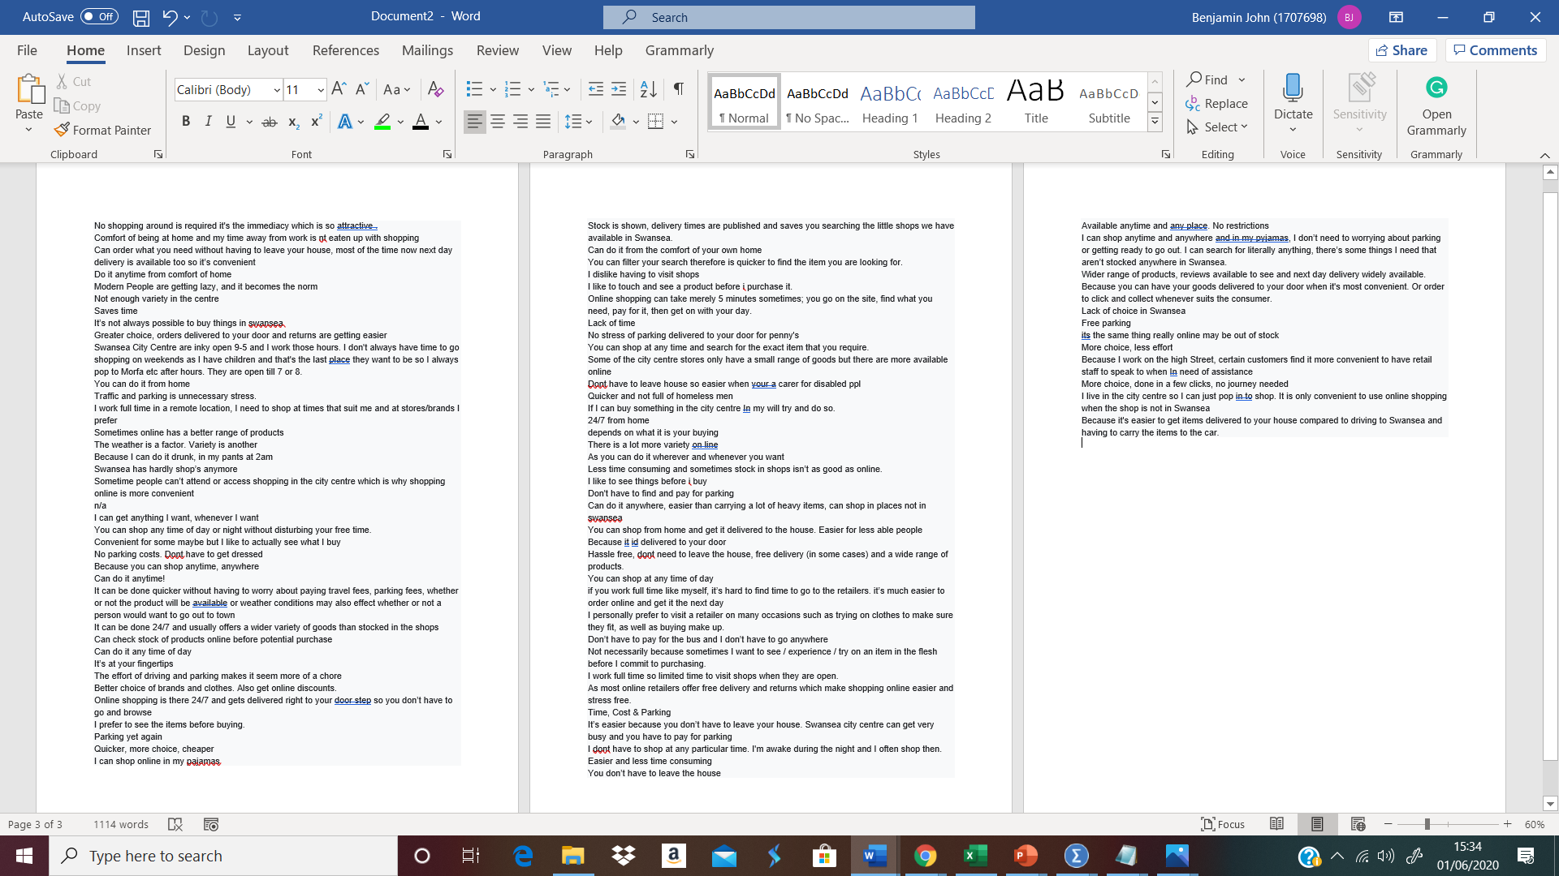

Q. 20
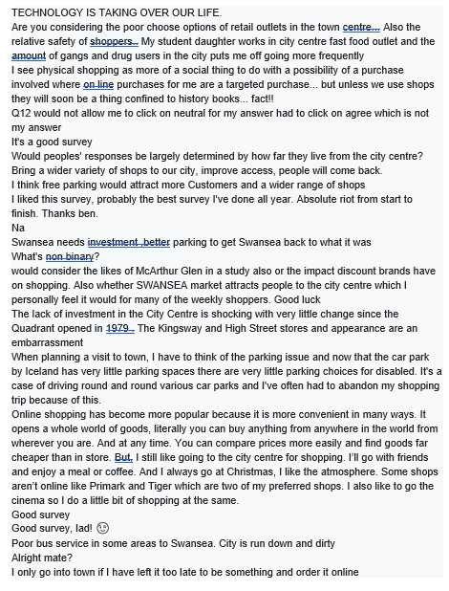

Appendix D – Questionnaire Literature Review Matrix
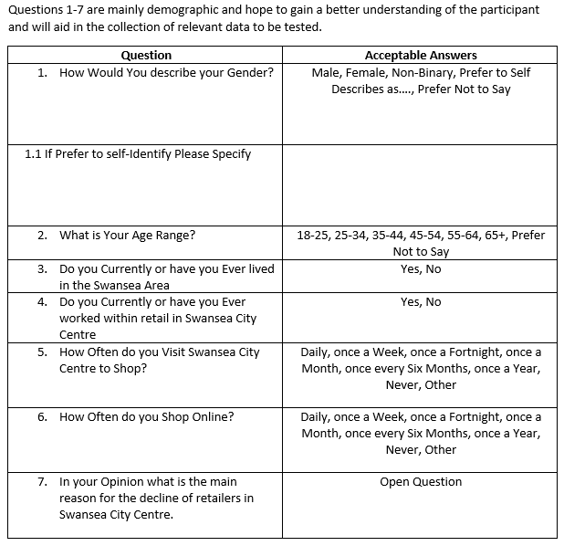
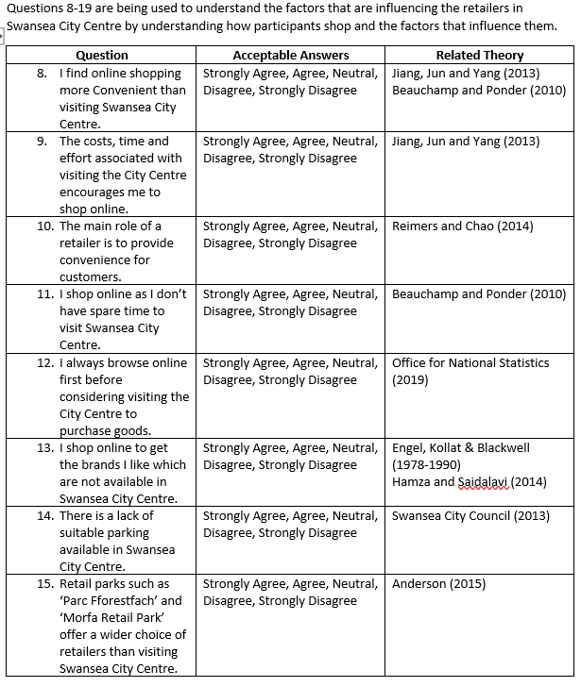

Appendix E – Ethics Form
The UWTSD ethical consideration form was completed by the researcher before any research was conducted and it was stated that all participants would be over the age of 18 and kept anonymous at all times. As the survey is voluntary with participants choosing to opt in without any obligations as well as the lack of personal information that is asked of the participants, the ethical risks that could arise as a result of the research are very limited.
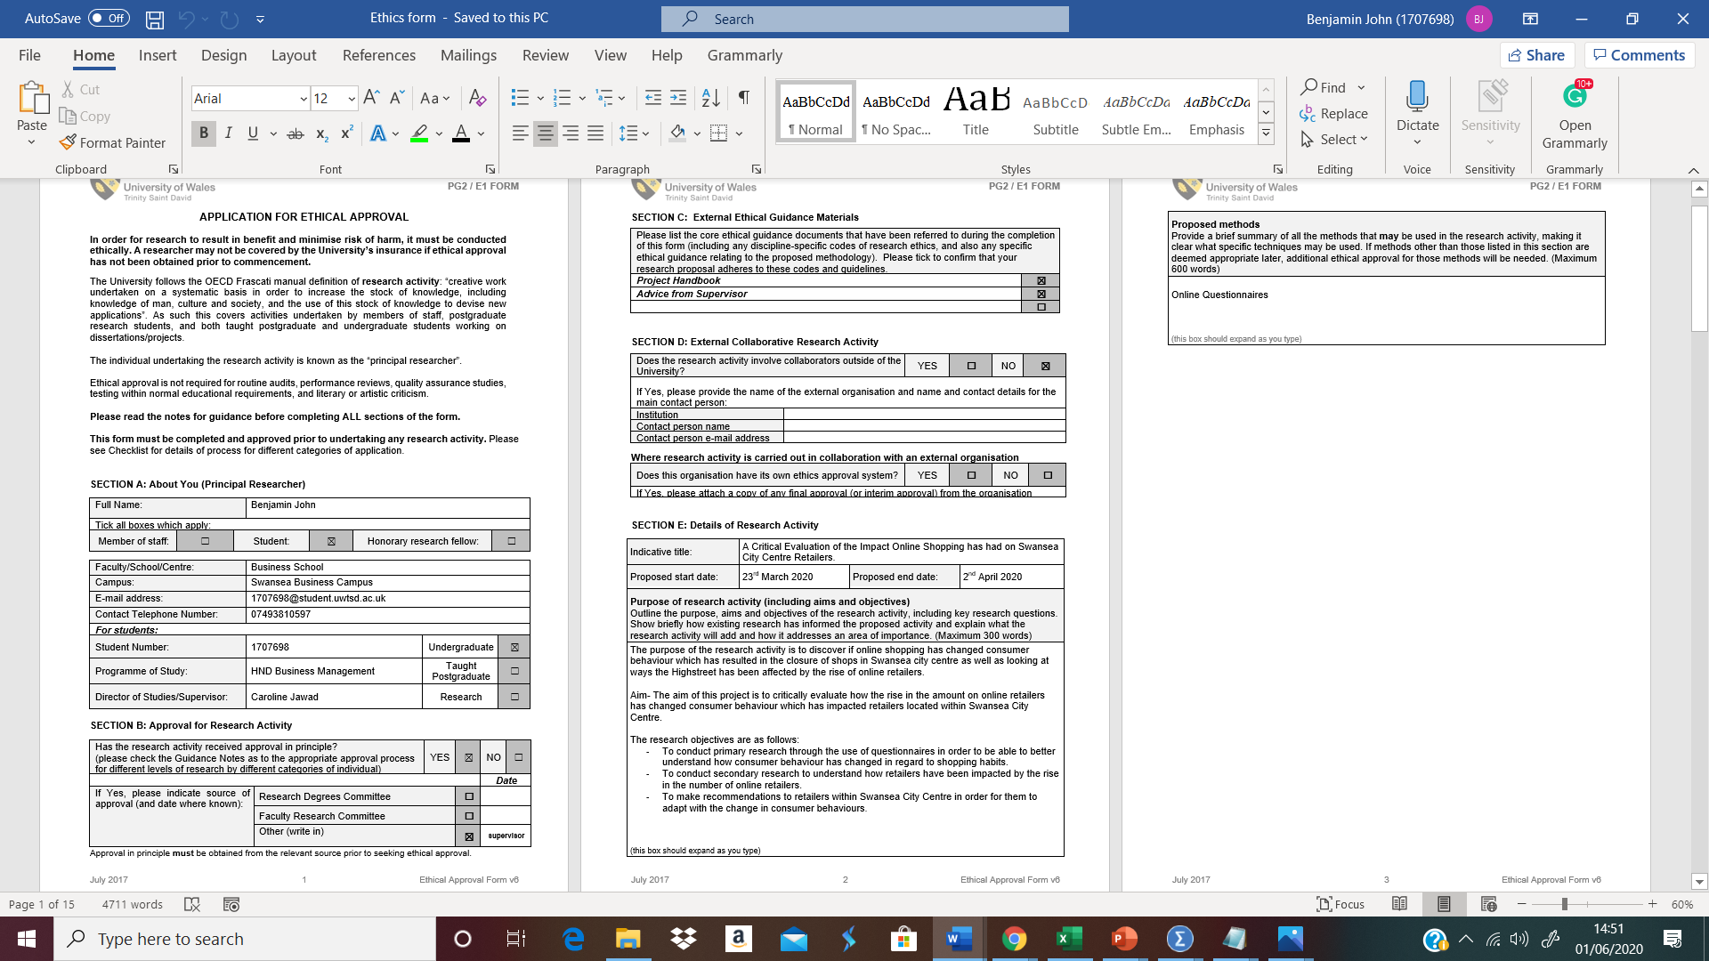
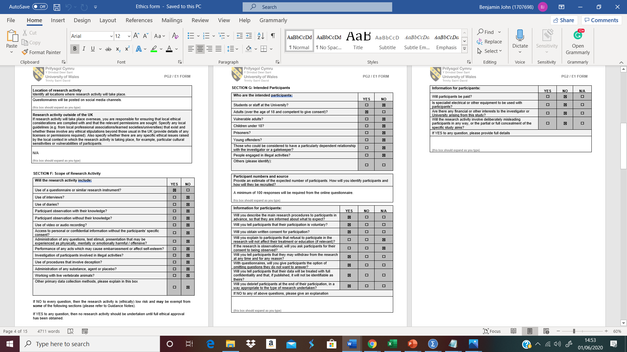
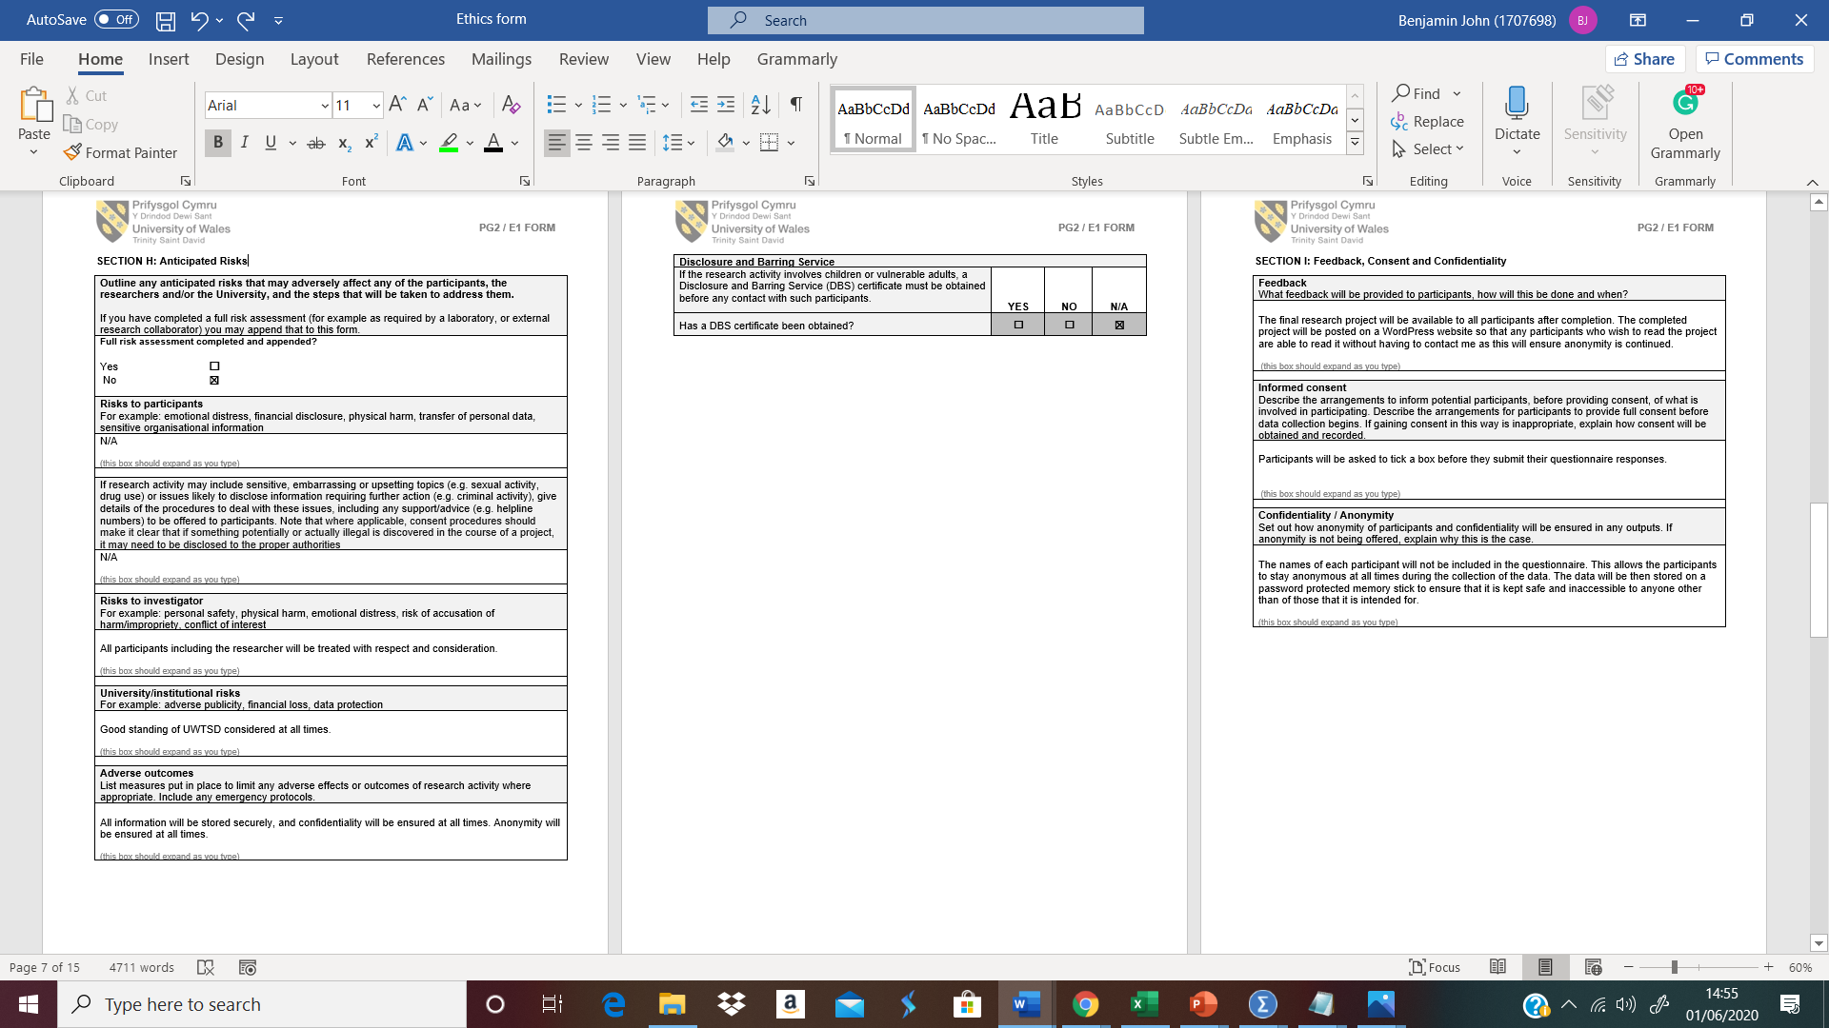
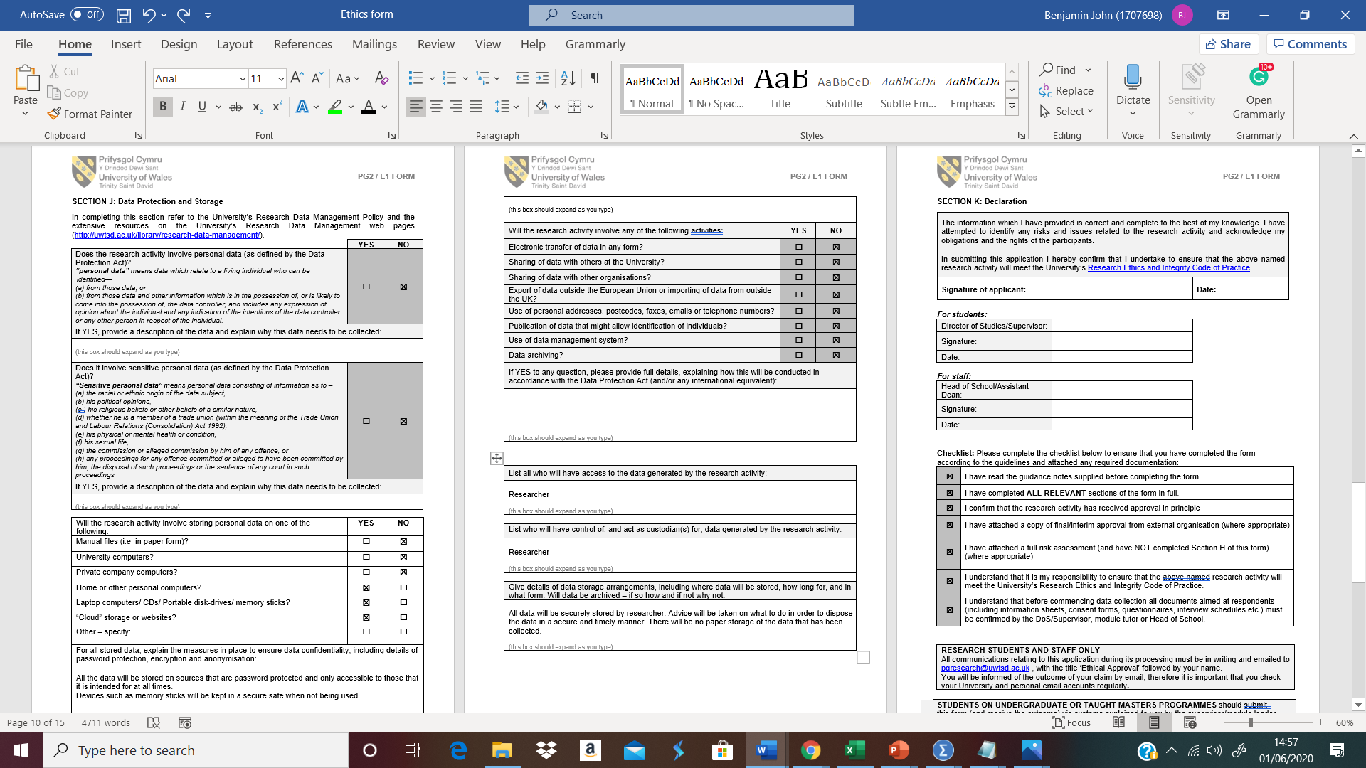

Further Testing Results
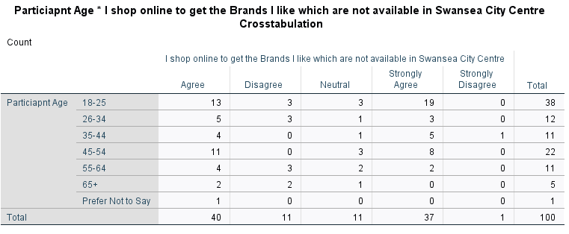
The crosstabulation anlaysis as seen in the table above shows that 77 of the 100 participants either agree or strongly agree that they shop online to get the brands which aren’t available to purchase in Swasnea city centre. These results correspond to those found by Hamza and Saidalavi (2014) when they mentioned that online shopping provides the consumer with a greater range of products to purchase.
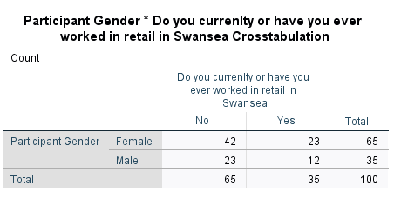
The Table above represents the gender of the particiapnts and whether or not they have worked in retail in Swansea City Centre. The figure shows that 23 of the Female participants have worked in retail in Swansea City Centre, compared to just 12 of the Male participants. This could account for the higher number of female particiants who decided to take part in the questionniare.

