

PROGRAMME: MASTER OF BUSINESS ADMINISTRATION
MODULE: STRATEGIC MANAGEMENT
MODULE CODE: LCMB7003
LECTURER NAME -Zulfiqar Khan
STUDENT NAME : SAURABH BISHT
Student ID: 2433287
Word count: 5096

Executive summary
Business expansion plan for Greggs Plc in the US has been valued in the report by evaluating external environment in terms of competition and factors such as economic, political, legal and others. Challenges for the company in this business expansion plan can be analysed taking the inflation growth and existing businesses reputation into account. This critically evaluates the potential of Greggs Plc to expand into the US based on Porter's Five Forces and the Ansoff Matrix. VRIO analysis and competitive positioning can help to determine current competencies of the company. This identifies the competitor forces, the strategic opportunities and the suggestions to develop the market with products adhering to long term growth.

Table of Contents
Introduction 4
1. Selection of Organisation and Target Market 4
1.1 Overview of organisation 4
1.2 Purpose of expansion in the US 5
1.3 Justification and strategic considerations 6
2. Comprehensive Strategic Analysis 6
2.1 Macro-environmental analysis using PESTLE 6
2.2 Porter's Five Forces and Diamond model to demonstrate competitive landscape 9
2.3 Critical evaluation effectiveness of tools and limitations 12
PESTLE’s effectiveness of tools and limitations 12
3. Strategy Development and Formulation 13
3.1 Applications of Strategic Models 13
Ansoff Matrix 13
CSR Model 14
3.2 Outlining Competitive Advantages in the chosen market by leveraging opportunities and threats 17
VRIO 17
BCG Matrix 19
Competitive Analysis 20
3.3 Formulating market entry strategy aligned with organisational objectives 21
4. Performance Evaluation Framework 22
4.1 Application of Balance Scorecard performance tool 22
4.2 Application of Triple Bottom Line for performance measurement of Greggs Plc 26
Recommendations 27
Conclusion 27
References 28

Introduction
Business expansion is a strategic process for organisations to enhance growth in foreign markets by offering unique products and attracting new customers. The report has been designed to elaborate on the market expansion plan of Greggs Plc in the United States, aiming to enhance its business competitiveness in the global market. The macroeconomic environment and competitive landscape for the company have been analysed based on PESTLE and Porter's Five Forces, while other frameworks are also considered to evaluate the performance and strategic development of Greggs Plc. Performance measurement of the company is included in the report to represent its progress in the foreign market and future growth opportunities.

1. Selection of Organisation and Target Market

1.1 Overview of organisation
In the UK retail bakery industry, Greggs Plc has positioned itself as the largest and most reputable company by offering high-quality fresh bakery items. Over the last 85 years, Greggs Plc has offered fresh food at a low price to its customers with a friendly service that has made it a trusted brand (Greggs, 2025). The company owns its supply chain that helps it to ensure meeting high standards in every stage of operation, starting from manufacturing to food delivery. Greggs has experienced steady growth in the UK quick service restaurant industry by introducing vegan sausage rolls, in terms of showing awareness about modern tastes and values (Statista, 2025). In the context of Greggs’ popularity among customers, its environmentally conscious operating practice has helped it to establish a position among customers who prefer sustainable businesses.
The company is not only known for bakery items but also for other food items, such as sandwiches, salads, drinks and others. Greggs Plc has reported an expected turnover of £2 billion in 2024 and opened its 2600th shop, which reflects its continuous growth over the last 40 years (Greggs, 2025). Nevertheless, the financial performance of the company has been impacted because of the changes in the UK market, such as inflation, changes in customer behaviour, involvement of new businesses and others. Greggs’ Board has anticipated that operating profit in 2025 can be below the achieved profit in 2024, because of low sales and less demand in the second half of the year (Riley, 2025). Despite current 6financial issues, Greggs ' business strategy to improve its operational efficiency by taking digital ordering and third-party delivery services has made a strong contribution to its sales that helps to develop competitive advantages.

1.2 Purpose of expansion in the US
The rapid growth of the US bakery/food industry and structural demand for bakery items from customers are beneficial for new businesses to bring financial opportunities. Additionally, expected growth of the bakery products market in the US is 1.62% CAGR from 2023 to 2029 (Yahoo, 2024). Current trend of the US market reflects growing demand from customers for healthy bakery items, which indicates customers' awareness about nutrition and wellness. However, the main purpose of expanding Greggs’ operation in the US market is to create a strong customer base in the international market by offering affordable food items, which is coherent with business competitiveness and financial growth. The US market has witnessed a strong recovery in demand for bakery items after the Covid-19 pandemic, especially for products made from organic ingredients and containing low sugar, along with gluten-free and vegan products. In the US, 25% bakeries launched gluten-free product making claims, while high protein claims accounted for 14% during 2021 to 2022 (More, 2024). Sustainability in operation and production is the core to ensure success in the US market in terms of operational expansion to strengthen position as well as revenue/profit maximisation.
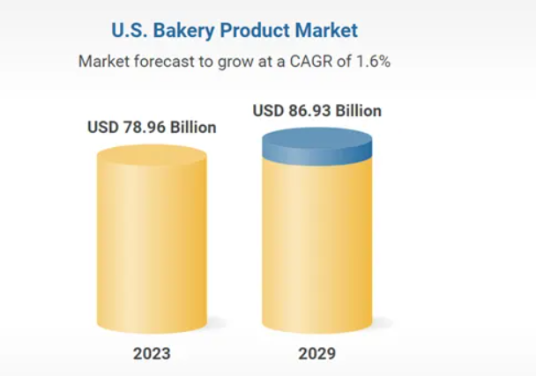
Figure 1: US bakery market growth
(Source: Yahoo, 2025)

1.3 Justification and strategic considerations
The business reputation and operating strategy of Greggs in the UK market reflect its capability to stabilise its performance in the US market by maintaining its supply chain and launching innovative products. Greggs’ gluten control and testing regimes, apart from managing cross-contamination, ensure specific bakery items are free from gluten (Greggs, 2025). Selection of the company for expanding operations in the US has been considered to represent how a company can use its current business strategy to ensure success in a new market. In the context of business expansion, the US market has proved suitable for Greggs because of high demand for bakery items and strong future growth.

2. Comprehensive Strategic Analysis

2.1 Macro-environmental analysis using PESTLE
Factors | Overview | Impact
Political | - The U.S.-UK Economic Prosperity Deal, or EPD, has been signed by the governments to ensure mutual benefits and remove barriers for both countries' business operations (Whitehouse, 2025). | Positive
Economy | - Real GDP of the US reflects an annual growth of 3.3% in the second quarter of 2025, indicating a low import and an increase in consumer spending (BEA, 2025).  - The US consumer price has increased by 3% in 2025 compared to the previous year (Statista, 2025). | Moderate
Social | - Food/breakfast consumption behaviour among Americans shows the preference for taste rather than health, which is mainly fast food (Kruczko, 2024). | Positive
Technology | - Online food delivery market of the US is estimated to generate a revenue $353 billion, while DoorDash and UberEATS are dominating the industry (Statista, 2025). | Positive
Legal | - Food Safety Modernization Act, or FSMA, has been enforced by the FDA to transform the nation's food safety system as well as to respond to foodborne illness (FDA, 2024). | Negative
Environment | - Sustainability consideration of the US Environmental Protection Agency involves reduction of single-use plastic and waste, aligning with Waste diversion programs (EPA, 2024). | Positive
Table 1: PESTLE model for the US market
(Source: Self-developed)
Analysis:
Entering the US market involves some challenges and opportunities for Greggs in terms of the potential positive/negative impact of the current macroeconomic environment. Taking the political relationship between the US and the UK, a smooth business expansion for the company can be recorded. In addition, the focus of governments to eliminate trade barriers can bring opportunities for the company to reduce business expansion complexity, but complying with regulatory requirements is crucial. Considering the economic growth (GDP) of the US, Greggs’s competitive position in the upcoming years can be analysed, especially in business cost reduction. Nevertheless, the food price of the country is increasing rapidly, 3.2% inflation in August from 2.9% in July (Trading economics, 2025). Negative impact of inflation on customers' purchase behaviour can affect the company's financial performance. Rapid growth of the US food technology industry has a significant impact on Greggs' business expansion in terms of increasing revenue by ensuring quick food delivery. In other words, customers' food ordering behaviour is changing continuously, and preference among the US customers to order food online indicates the importance of partnering with food delivery apps. The company is required to comply with legal and environmental policies to avoid legal charges and maintain its reputation.
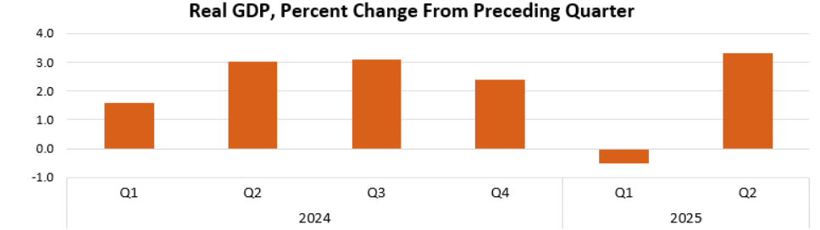
Figure 2: GDP of the US
(Source: BEA, 2025)

2.2 Porter's Five Forces and Diamond model to demonstrate competitive landscape
Porter's Diamond Model application:
Factors | Evaluation
Factor conditions | A diverse workforce and skilled employees can ensure the company's operations, but compared to the UK wage structure, labour wages in the US can be high.
Demand conditions | Greggs' efficiency in maintaining taste and health in its food items is effective in meeting customers' expectations.
Supporting industry | DoorDash is the largest online food delivery app in the US, with approximately 42 million users in 2024 (The guardian, 2025).
Firm strategy, structure and rivalry | Competition in the QSR market is high for Greggs because of the involvement of reputed companies like Starbucks, Dunkin and others.
Table 2: Porter's Diamond Model
(Source: Self-developed)
Analysis:
Operational efficiency of Greggs is highly dependent on the workforce and their capability to achieve business goals, while the different wage structure in the US and UK may affect financial performance by increasing operating costs. However, demand improvement for bakery items among the customers in the country highlights future opportunities for Greggs to maximise sales and profit, as well as strengthen its customer base. Bread sales in the US is increased by 6.8% and 5.3% for the packaged and unpackaged categories, respectively (Agriculture, 2025). In the context of supporting industry, business expansion objectives of Greggs can be achieved by establishing a strong partnership with DoorDash. More specifically, as this food delivery app has a huge existing customer base, it can help Greggs to connect with its target audience easily. Nevertheless, the US market is highly competitive for the company because customers' loyalty to Starbucks and Dunkin can create difficulties for Greggs to position itself.
Porter’s 5 Force to Demonstrate Competitive Landscape:
Threat of New Entrants
Small independent companies can enter the US bakery industry although scaling within the US can be difficult for companies like Greggs Plc. Making a large chain takes a lot of investment in the supply chain, recognition of the brand, and location of prime retail outlets. For instance, economies of scale and customer loyalty have already been gained by large brands like Panera Bread with 2,114 stores (Panera bread, 2025). Entry costs are also high because of the regulatory differences among states in the US due to health and food safety codes. Overall, there is a moderate threat of new entrants.
Bargaining Power of Suppliers
The market structure of the US bakery cafe depends on commodities such as flour, dairy and meat where numerous suppliers are present in the market and the power of any single supplier is limited. The power of suppliers with premium ingredients like plant-based inputs could be stronger as these techniques are used for producing meat substitutes (Mylan et al., 2023). The geographic dispersion in the US increases the logistical reliance on the large distributors, which increases bargaining strength. There are also risks of commodity price volatility in grain, dairy, fuel and this creates business risks. Therefore, power of suppliers is low to moderate for Greggs Plc while expanding in the US market.
Bargaining Power of Buyers
The US consumer market is significantly fragmented and switching costs are very low. This is indicating that US customers can easily switch between bakery cafes, coffee chains, supermarkets and convenience stores. The market size of the “US bakery cafe” is around $18.3 billion, indicating the wide range of consumer demand yet a great level of choice (IBISWorld, 2025). The increasing health awareness will provide buyers with power, as they will request clean-label, vegan, or healthier products with greater frequency. The power of buyers is average, suggesting a better opportunity for Greggs Plc to expand in the US.
Threat of Substitutes
Various alternatives in the US market operate including fast-food restaurants and cafes, grocery store bakery, meal delivery service, and packaged snacks that compete with the bakery cafes. The health trend also adds to the threat of substitution, where consumers can choose smoothies, protein snacks or fruit over baked goods. The threat of substitutes is high due to the large presence of substitutes. Vegetarian and vegan plant-based diets have been associated with a myriad of health benefits (Storz et al., 2021). The demand by consumers to have convenience and off-premise consumption also substantially enhances the possibility of substitution. In particular, Greggs PLC needs to dedicate resources to online ordering, kiosks, and delivery in the US.
Competitive Rivalry
The US bakery cafe market has a high level of competition where Panera Bread, Au Bon Pain, Starbucks, and standalone bakeries dominate the urban centres. Competition on prices is intense particularly in breakfast and lunch segments and premiumisation strategies emphasize on quality and ambience. In the UK, Greggs PLC total sales came to $2 billion in 2024, increased 11.3% from 2023 (Yahoo, 2025). The market is very fragmented and this means that there is continuous pressure on margins. Therefore, the US urban areas have limited and high-priced prime retail real estate, which adds to the competition. Competitive rivalry is high.

2.3 Critical evaluation effectiveness of tools and limitations

PESTLE’s effectiveness of tools and limitations
PESTLE is a supportive tool for businesses in getting an insight into a new market in terms of assessing potential risk and creating mitigation plans. PESTLE provides information, valuing external issues that can be a threat to an organisation, apart from measuring practices that need to be considered to overcome challenges (Gechkova and Kaleeva, 2021). Nevertheless, the model does not consider the impact of future events such as inflation or labour laws on business performance, while difficulties in measuring actual impact are one of the major drawbacks.
Effectiveness and Limitations of Porter’s 5 Force
Effectiveness
Porter's Five Forces is useful as it explains the competitive forces Greggs would be exposed to although it provides a systematic approach to analyzing the competitive environment of the US bakery cafe market. Porter’s Five Force is a competitive analysis obtained from the results of analysis of the mix of the five competitive forces (Putera and Heikal, 2021). This assists Greggs to determine its strategic priorities that include differentiation, supply chain leverage and brand positioning. Porter's Five Forces framework is helpful to comprehend the external forces and evaluate the possibility of them, and not to invest too much money in the expansion.
Limitations
There are significant limitations of Porter's Five Forces as it gives a one-point in time view. Porter's Five Forces also fails to consider the dynamic nature of aspects such as shifting consumer preferences, digital upheaval, or post-pandemic developments toward delivery and convenience. As per Pangarkar and Prabhudesai, (2024), porter's five force is less relevant in a homogeneous industry. Therefore, Porter's Five Forces model impacts Greggs and it would operate within the similar categories like bakery cafes, fast food, and groceries.

3. Strategy Development and Formulation

3.1 Applications of Strategic Models

Ansoff Matrix
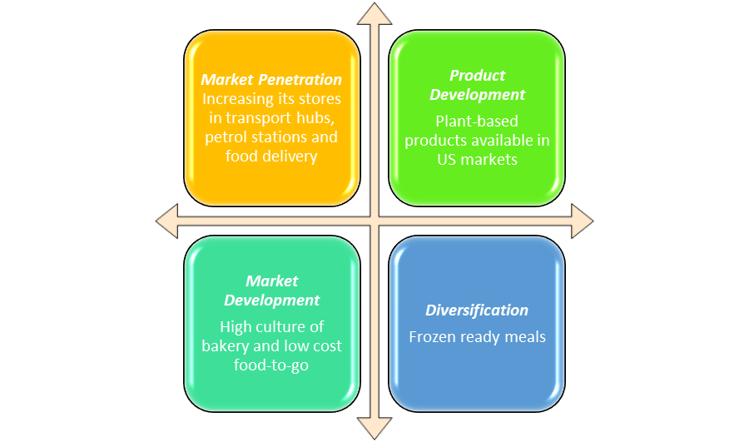
Figure 3: Ansoff Matrix
(Source: Created by Author)
Market Penetration
Greggs has exploited the penetration in the UK by increasing its stores in transport hubs, petrol stations and food delivery arrangements. This strategy is only useful in the domestic arena and does not give extensive international entry.
Market Development
Market development is the most applicable entry strategy of Greggs. This will include expansion to new geographical locations, including the US, where there is a high culture of bakery and low cost food-to-go. Greggs will also have the opportunity to use other channels such as airport stores and international delivery service to target more customers.
Product Development
Greggs needs to modify its menu according to local tastes in order to achieve success in the US market. Plant-based products are available in US market that are health-conscious and halal-certified (Halalfoundation, 2024). The cultural fit is provided by product adaptation and competitive advantage is enhanced.
Diversification
Diversification into other fields such as frozen ready meals in foreign supermarkets would provide a new stream of revenue but it is very risky and would help in taking away focus in the actual operation of Greggs PLC.
Ansoff Matrix indicates that the best mode of entry is Market Development with the assistance of Product Development. This will be a growth/risk balance when Greggs is aiming at growing out of the UK and still offering an affordable and accessible price point.

CSR Model
Application of the corporate social responsibility model is essential for Greggs Plc to successfully enter the USA market and achieve strong competitive advantages through ethical operation. As opined by Mai et al. (2021), CSR model can help the company to develop competitive advantages through satisfying standard business needs. Carrol’s CSR pyramid has 4 stages of operation that can help the company to achieve standards in the global operation and promote responsibility through operational growth. The lowest level of the pyramid is the economic responsibility and it helps the business to become profitable in the global operation. Gregg’s Plc has achieved 2,014m global revenue as of 2024 which are increased from 1810m in the year 2023 (Fidelity, 2025). Below figure indicates that net income of the company increased to 153m in the year 2024 from 143m in the year 2023. Thus, the data highlighted that the company is successful in achieving economic responsibility.
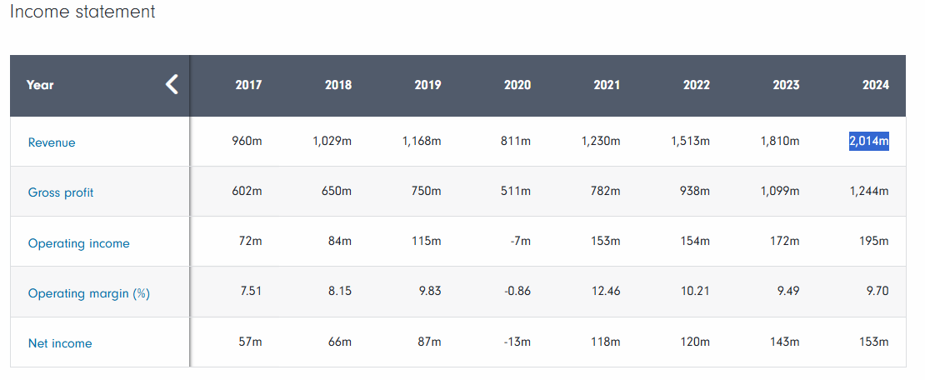
Figure 4: Income statement of Greggs Plc
(Source: Fidelity, 2025)
The second level of the pyramid is the legal responsibility that helps the company to abide by the global rules of operation. Greggs Plc followed legal rules such as UK governance regulation, corporate governance rules and data privacy for protecting customer data in the online shopping. Greggs Plc follows Data Protection Act, UK GDPR for managing security in the personal data use collected through website and app (Greggs, 2024). The third layer of the pyramid is described as an ethical operational strategy and avoiding any harm to the society. Greggs Plc has committed that by the end of 2025 the company will create 25% less food waste than 2018 (a.storyblok, 2024). Moreover, a 28.4% proportion of the food redistributed from the retail stores helps the company to reduce waste. This is highlighted that Greggs Plc is successful in achieving ethical operation and responsibility. The top most level of the pyramid is philanthropic responsibility and Greggs has distributed over £4 million a year towards the charitable trust (Corporate.greggs, 2025). Thus, the above CSR model has highlighted that Greggs Plc’s ethical operation can help the company to gain strong advantages in the expansion in the USA.
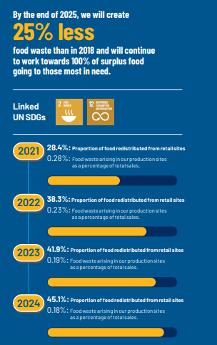
Figure 5: Reduction of Food waste in Greggs Plc supply chain
(Source: a.storyblok, 2024)

3.2 Outlining Competitive Advantages in the chosen market by leveraging opportunities and threats

VRIO
Factors | Variable | Rare | Imitable | Organised | Competitive advantages
Revenue | Yes | Yes | Yes | Yes | Strong competitive advantages
Sustainable operation | Yes | No | Yes | Yes | Partial competitive advantages
Strong global presence | Yes | Yes | Yes | Yes | Long term sustainable competitive advantages
Consumers’ reputation | Yes | No | Yes | No | Sustained competitive advantages
Innovation | Yes | Yes | Yes | Yes | Long term competitive advantages
Table 3: VRIO analysis
(Source: self created)
Analysis:
The above internal competency analysis has highlighted that Greggs has sufficient internal strength and opportunity that can help the company to successfully expand in the global market of USA. Below mentioned figure estimates that Greggs Plc pretax profit estimated at 189.8 million pounds as of 2025 which is increased from the 167.7 million pounds in the year 2023 (a.storyblok, 2024). Strong revenue of the company and long-term growth opportunity can help to expand in the market of USA by providing financial resources in the supply. Greggs Plc has been named as the UK’s strongest brand in the year 2025 by the valuation granted by the consultancy brand finance (Riley, 2025). Thus, strong value can help the company to engage local customers in the global expansion in the USA market. On the other hand, in recent years transformation in supply chain technology has helped the company to create a centralised food on the go business model for achieving customers' intentions. Greggs app and CRM system clearly communicates with the customers to engage brand value in the global growth (Corporate.greggs, 2025). The enhanced growth of the USA food and bakery industry can help the company to get strong competitive advantages in the expansion by using the strong innovation along with revenue. Managing sustainability in the global operation can help Greggs Plc to achieve standards of operation and reduce risk of food waste in the global expansion USA market.
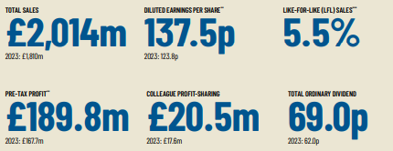
Figure 6: Greggs Plc Pre-tax profit
(Source: a.storyblok, 2024)

BCG Matrix
Star products  - Breakfast Bacon and Sausage Baguette, Greggs Sausage Roll, Bean and cheese melt (Greggs, 2021) | Question mark  - Gregg's recent launch of a wide range of veggie rolls and began sausage has relatively low market share and growth in the bakery market.
Cow  - Greggs has introduced new menu items such as BBQ crispy chicken burger, chicken goujon wrap can help the company to beat market share of McDonald's and KFC (Economictimes.indiatimes, 2025) | Dog  - Baking Rolls, salad  - Savouries and bakes (Greggs, 2025)
Table 4: BCG matrix analysis of product of greggs
(Source: self-created)
The above product grid matrix has highlighted that the start products with relatively high market growth and market share can help Greggs to expand in the USA market. Strong recovery of bakery items demand in the USA market can help the company to showcase its star products in front of the key players. Gregg’s recent launch of BBQ items and sausage roll can help the company to gain strong competitive advantages in front of the key players in the USA market such as KFC and McDonalds (Economictimes.indiatimes, 2025). Gregg's hot food, sandwiches and salad can help the company to successfully gain customer intervention in the expansion in the USA.

Competitive Analysis
Name of the company | revenue | Global brand value | employees | Innovation
Greggs Plc | 2.08 billion as of 2025 (Markets.ft, 2025) | $2.2B as of 2023 (Globaldata, 2025) | 33,000 as of 2025 (Corporate.greggs, 2025) | Centralised automation with real time food delivery system
Dominos | 669.20 million (Markets.ft, 2025) | $14.9B as of 2023 (Globaldata, 2025) | 10700 as of 2023 (Globaldata, 2025) | AI powered tools and data tracking agents
McDonald's | Global revenue estimated at $6.843B as of 2025 that increases 5.44% year on year from 2024 (Macrotrends, 2025) | McDonalds is the world's most valuable restaurant brand. The company achieved $40.5 billion brand value as of 2025 (Brandfinance, 2025) | As of 2024 total 150,000 employees worked in the company (Macrotrends, 2025) | Integrated AI, self-service Kiosk and mobile ordering facility for improving customer engagement
Table 5: Competitor analysis of Greggs Plc
(Source: self-created)
Analysis
The above competitor analysis has highlighted that the Greggs Plc has generated global revenue greater than Domino's but less than McDonald's in the global market. Moreover, Gregg Plc’s strong market capitalization value can help the company to successfully expand in the USA market by following the core automation facility. Moreover, Gregg Plc has achieved 2.014 million pound total sales in the year 2025, which can help the company to increase profit in the global expansion (a.storyblok, 2024). Thus, implication of the strong sales value in the company expansion can help to make a successful international facility for Greggs Plc.

3.3 Formulating market entry strategy aligned with organisational objectives
Market entry strategy is essential for Greggs Plc to successfully enter the USA market and develop products. Franchising market entry mode can help Gregg Plc to successfully enter the USA market and distribute products in front of the customer at a lower price as compared to its competitors. As opined by Sanford and Lorimer (2022), the idea of large franchises offering vegan products can exhibit the community in the sustainable product selection. Franchising market entry mode can help Greggs Plc to directly invest in the product portfolio development and gather resources in the new market entry in the USA market. Gregg's business model depends on the four pillars such as manufacturing, logistics, people and channelizes products. Greggs has over 2,600 stores operated in the UK and more than 500 franchise stores along with wholesale dealers (corporate.greggs, 2025). Following this franchise model can help the company to align with internationalisation goals and expand in the bakery market of the USA. Thus, franchise market entry strategy can help Greggs Plc to develop a strong customer relationship status in the USA market.

4. Performance Evaluation Framework

4.1 Application of Balance Scorecard performance tool
 | Strategy Map | Balance Scorecard
 | Objectives | Measures (KPIs) | Targets | Current Score  (1-5)
Financial Perspective | To enhance financial growth and generate revenue that assist in achieving revenue generation of 4 billion by 2027 and increase profitability by 5% | Implementing Net Profit Margin (NPM) as key KPI for analysing the business profitability within the next few years | To reach revenue generation by 4 billion pounds and profitability by 5% through market expansion | 2
Customer Perceptive | Increase customer satisfaction for driving revenue and brand loyalty while expanding to US region consumer market | Measure customer satisfaction measurement using Customer Satisfaction Score (CSAT) on quarterly basis | To increase customer satisfaction rates by 10% through offering continuous customer support and meeting increased customer demands of bakery/food products | 4
Process Perspective | To enhance processes efficiency and effectiveness through facilitating supply chain transparency and sustainable supply chain | To integrate Output Per Input (OPI) KPI for analysing business productivity for analysing process efficiency and value creation | To enhance operational efficiency and processes by 10% for expanding business operations in the US food and bakery industry | 3
Learning and Growth Perceptive | To invest in training and development of Greggs Plc’s human capital for enhancing operational performance while expanding to US food and bakery industry | To integrate Employee Turnover & Retention Rate for analysing the productivity and human resource management for business growth | To improve employee engagement and human capital management of Greggs Plc by 15%. | 3
Table 6: Balance Score card for analysing performance of Greggs Plc
(Source: Created by the author)
The aforementioned balance scorecard outlines the key objectives, a target that is approached by Greggs Plc for expanding its business operations to the US by entering into the US Food and Bakery sector. Mio et al. (2022) have defined that a balance scorecard is a performance measurement and management tool used by global businesses for achieving sustainable goals and improving organizational performance. The aforementioned balance scorecard has been designed to evaluate the performance of Greggs Plc while expanding its operations to the US bakery and food sector. Moreover, Ahmad et al. (2023) have outlined that BSC is an effective management tool, working as an inclusive instrument to evaluate and appraise performance of business in the global context. Accordingly, the BSC is being utilised and designed for evaluating the performance of Greggs Plc based on four key aspects including financial perspective, customer perceptive, process perspective, learning and growth perceptive.
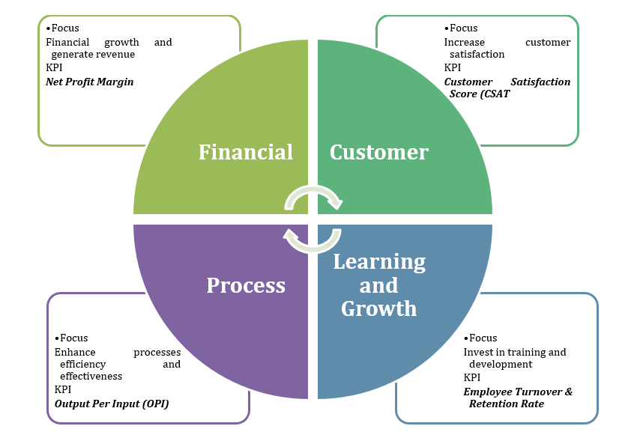
Figure 7: Balance scorecard
(Source: Created by the author)

- Financial Perspective- The BSC is effective in accessing the financial performance of the business that is crucial for value creation and economic growth of the company. Currently, the sales of Greggs Plc in the UK have increased by 5.5% along with its operating profits that increased to £189.8 million from £167.7 million in 2023 (Greggs, 2025). Expanding the business options of Greggs Plc to the US will be measured using Net Profit Margin (NPM) KPIs that would assist in expanding profitability rates by 5% to achieve higher financial growth.
- Customer Perceptive- The customer perceptive of Greggs Plc outlines the ability of the business to enhance its customer satisfaction rates. Sari et al. (2025) have outlined that CSAT is a widely integrated tool that is used by organizations for analysing the user experience through rating the customer interaction and `engagement. For measuring customer satisfaction, Customer Satisfaction Score (CSAT) would be effective for analysing customer satisfaction with the provided services and products in the US food and bakery industry.
- Process Perspective- The internal processes efficiency and effectiveness of Greggs Plc is analysed and evaluated through the implication of Output per Input (OPI) as key KPIs. Greggs Plc has a vertical integration strategy implemented within its global supply chain that assists the business to enhance its supply chain efficiency (Greggs, 2025). Through enhancing its supply chain management while expanding to the US, transparency and ownership of its distribution network and supply chain assists the business to enhance its operational processes. The implication of the OPI KPI is associated with enhancing operational efficiency of Greggs Plc by 10% while expanding its operations to the US.
- Learning and Growth Perceptive- The learning and development of the business is addressed and enhanced for improving production capability of its employees to expand its operations in the US. The Employee Turnover & Retention Rate KPIs will be utilized and integrated for evaluating the learning and development capability of Greggs for handling its global business operations. Thus, engagement is analysed and assessed for undermining learning and development capabilities of the business.

4.2 Application of Triple Bottom Line for performance measurement of Greggs Plc
Three dimensions | Objectives | KPIs for measurement
People | To improve productivity of employees through continuous learning and development for expanding to US | Implementing “Time spent on training” KPI for measuring productivity rates
Planet | To achieve Net Zero Target through achieving 25% reduction in carbon emission to enhance performance | Utilise Carbon footprint reduction KPIs for evaluating the carbon emission reduction
Profit | To achieve profitability rates of 5% while expanding to US through offering bakery and food products to meet consumer demands | Implement Operating Profit Margin KPI for analysing the quarterly and annual profits margin of the business
Table 7: Implementing TBL for performance measurement of the business
(Source: Created by the author)
The aforementioned table outlines the key KPIs and objectives of Greggs Plc for expanding its business operations to the US using TBL as a significant performance measurement tool. Ibrahim et al. (2023) has outlined that Triple Bottom Line (TBL) is an efficient tool for measuring organisational performance based on people, profit and plant as key measuring elements. The performance of the audience while expanding to the US will be evaluated through analysing Greggs Plc’s ability to facilitate continuous learning and development for its human capital management. The “Time spent on training” KPI will be utilized and implemented for measuring the efficiency of the company’s ability to manage its human capital. On the other hand, Operating Profit Margin KPI is also implemented for ensuring the profitability targets of Greggs Plc for analysing its operational efficiency and financial growth in the US.

Recommendations
- Enhancing supply chain efficiency by integrating technology or automation can be suggested to the company for reducing waste as well as improving business profitability.
- Focusing on an effective promotional strategy is crucial for Greggs Plc in terms of offering targeted promotions to increase customer visit frequency, apart from attracting new customers.
- Considering financial performance of the company, investment in profitable projects and improving resource allocation are essential for long-term growth.
- Digital transformation can create a positive impact on the company's internal performance, such as supply chain and operational efficiency, along with improving its sustainable practices.

Conclusion
It can be concluded that selection of the USA market can be a strong opportunity for the market expansion for Greggs Plc. The USA bakery and confectionary market is rapidly growing and selection of sustainable products can help Greggs to successfully expand in the market. Greggs Plc has successfully developed its brand value as a largest bakery chain in the UK market that can help the company to expand in the USA market with its diverse product ranges. Sustainability in the operation and production can help Greggs Plc to manage ethical responsibility in the expansion in the USA market. Greggs gluten control and testing regimes can help to reduce cross contamination in the product and increase product viability in the standardised operation. Reduction of the food waste in the supply chain can help Greggs Plc to achieve competitive advantages by managing the cost of the inventory.

References
a.storyblok (2024). greggs-annual-report-and-accounts-2024.pdf. Available at: https://a.storyblok.com/f/162306/x/85edb88f68/greggs-annual-report-and-accounts-2024.pdf (Accessed: 19 September 2025).
a.storyblok (2024). Sustainability Report 2024. Available at: https://a.storyblok.com/f/162306/x/ef8c789ecc/greggs-pledge-2024.pdf (Accessed: 19 September 2025).
Agriculture (2025). Sector Trend Analysis – Bakery products in the United States. Available at: https://agriculture.canada.ca/en/international-trade/market-intelligence/reports-and-guides/sector-trend-analysis-bakery-products-united-states (Accessed: 19 September 2025).
Ahmad, F., Hamid, N.A., Ahmad, A.N.A., Nawi, M.N.M., Rahman, N.A.A.A. and Hamid, N.A.A., (2022). THE IMPACT OF TQM ON BUSINESS PERFORMANCES BASED ON BALANCED SCORECARD APPROACH IN MALAYSIA SMEs. International Journal for Quality Research, 16(1). Available at: http://ijqr.net/journal/v16-n1/16.pdf
BEA (2025). Gross Domestic Product, 2nd Quarter 2025 (Second Estimate) and Corporate Profits (Preliminary). Available at: https://www.bea.gov/news/2025/gross-domestic-product-2nd-quarter-2025-second-estimate-and-corporate-profits-preliminary (Accessed: 19 September 2025).
Brandfinance (2025). McDonald’s is the world’s most valuable restaurant brand; Starbucks drops to second place. Available at: https://brandfinance.com/press-releases/mcdonalds-is-the-worlds-most-valuable-restaurant-brand-starbucks-drops-to-second-place#:~:text=LONDON%2C%2020%20March%202024%20%E2%80%93Starbucks,5%20billion (Accessed: 19 September 2025).
Corporate.greggs (2025). Our strategy. Available at: https://corporate.greggs.co.uk/about-us/our-strategy (Accessed: 19 September 2025).
Corporate.greggs (2025). Results and regulatory news. Available at: https://corporate.greggs.co.uk/investors/results-and-regulatory-news (Accessed: 19 September 2025).
Corporate.greggs (2025). Stronger, healthier communities. Available at: https://corporate.greggs.co.uk/doing-good/stronger-healthier-communities#giving-something-back (Accessed: 19 September 2025).
Economictimes.indiatimes (2025). Greggs' bold menu shake-up: New flavors ready to rival McDonald's and KFC. Available at: https://economictimes.indiatimes.com/news/international/uk/greggs-bold-menu-shake-up-new-flavors-ready-to-rival-mcdonalds-and-kfc/articleshow/117958617.cms?from=mdr#:~:text=By%20introducing%20items%20like%20the,in%20the%20fast-food%20industry. (Accessed: 19 September 2025).
EPA (2024). Sustainable Packaging. Available at: https://www.epa.gov/greenerproducts/identifying-sustainable-food-service-and-food-service-ware (Accessed: 19 September 2025).
FDA (2024). Food Safety Modernization Act (FSMA). Available at: https://www.fda.gov/food/guidance-regulation-food-and-dietary-supplements/food-safety-modernization-act-fsma (Accessed: 19 September 2025).
Fidelity (2025). Greggs PLC (GRG). Available at: https://www.fidelity.co.uk/factsheet-data/factsheet/GB00B63QSB39-greggs/financials (Accessed: 19 September 2025).
Gechkova, T. and Kaleeva, T., (2021). HARBOUR INFRASTRUCTURE PROTECTION–PESTLE ANALYSIS. KNOWLEDGE-International Journal, 49(5), pp.961-967. Available at: https://ojs.ikm.mk/index.php/kij/article/download/4508/4503 (Accessed: 19 September 2025).
Globaldata (2025). Domino's Pizza Inc: Overview. Available at: https://www.globaldata.com/company-profile/dominos-pizza-inc/ (Accessed: 19 September 2025).
Globaldata (2025). Greggs Plc: Overview. Available at: https://www.globaldata.com/company-profile/greggs-plc/ (Accessed: 19 September 2025).
Greggs (2021) What your star sign says about your Greggs order. Available at: https://www.greggs.com/news/mystic-gregg (Accessed: 19 September 2025).
Greggs (2024). Terms and conditions for Greggs digital services. Available at: https://www.greggs.com/legals/terms-and-conditions#greggs-gift-cards-and-vouchers (Accessed: 19 September 2025).
Greggs (2025). About us. Available at: https://corporate.greggs.co.uk/about-us (Accessed: 19 September 2025).
Greggs (2025). Greggs-annual-report-and-accounts-2024. Available at: https://a.storyblok.com/f/162306/x/85edb88f68/greggs-annual-report-and-accounts-2024.pdf (Accessed: 19 September 2025).
Greggs (2025). Nothing but the best. Available at: https://www.greggs.com/nutrition (Accessed: 19 September 2025).
Greggs (2025). Our Menu. Available at: https://www.greggs.com/ (Accessed: 19 September 2025).
Greggs (2025). Privacy Policy for Greggs Digital and Customer Services. Available at: https://www.greggs.com/legals/privacy-policy#privacy-policy (Accessed: 19 September 2025).
Greggs, (2025), Our strategy, Available at: https://corporate.greggs.co.uk/about-us/our-strategy (Accessed: 19 September 2025).
Greggs, (2025), Results and regulatory news, Available at: https://corporate.greggs.co.uk/investors/results-and-regulatory-news (Accessed: 19 September 2025).
Halalfoundation (2024). Rise of Plant-Based and Clean-Label Halal Food Products. Available at: https://halalfoundation.org/rise-of-plant-based-and-clean-label-halal-food-products/ (Accessed: 19 September 2025)
Ibisworld (2025). Bakery Cafes in the US - Market Research Report (2015-2030). Available at: https://www.ibisworld.com/united-states/industry/bakery-cafes/4319/ (Accessed: 19 September 2025).
Ibrahim, H., Elsayed, M.S., Moustafa, W.S. and Abdou, H.M., (2023). Functional analysis as a method on sustainable building design: A case study in educational buildings implementing the triple bottom line. Alexandria Engineering Journal, 62, pp.63-73. Available at: https://www.researchgate.net/profile/Priyanka-Mishra- 55/publication/385382701_Sustainability_in_Supply_Chain_Considering_the_Triple_Bottom_Line_to_Determine_Business_Development/links/679cb6a752b58d39f25f4084/Sustainability-in-Supply-Chain-Considering-the-Triple-Bottom-Line-to-Determine-Business-Development.pdf
Kruczko, A. (2024) Breakfast culture: America vs. the world. Available at: https://ghfalcon.com/16686/news/breakfast-culture-america-vs-the-world/ (Accessed: 19 September 2025).
Macrotrends (2025). McDonald's Revenue 2010-2025. Available at: https://macrotrends.net/stocks/charts/MCD/mcdonalds/revenue (Accessed: 19 September 2025).
Macrotrends (2025). McDonald's: Number of Employees 2010-2025 | MCD. Available at: https://www.macrotrends.net/stocks/charts/MCD/mcdonalds/number-of-employees (Accessed: 19 September 2025).
Mai, N.K., Nguyen, A.K.T. and Nguyen, T.T., (2021). Implementation of corporate social responsibility strategy to enhance firm reputation and competitive advantage. Journal of Competitiveness, (4). Available at: https://doi.org/10.7441/joc.2021.04.06
Markets.ft (2025). Greggs PLC. Available at: https://markets.ft.com/data/equities/tearsheet/profile?s=GRG:LSE (Accessed: 19 September 2025).
Mio, C., Costantini, A. and Panfilo, S., (2022). Performance measurement tools for sustainable business: A systematic literature review on the sustainability balanced scorecard use. Corporate social responsibility and environmental management, 29(2), pp.367-384. Available at: https://onlinelibrary.wiley.com/doi/pdf/10.1002/csr.2206
More, A. (2024) Bakery Product Market Value to Hit USD 372.6 Billion in 2033. Available at: https://www.news.market.us/bakery-product-market-new/ (Accessed: 19 September 2025).
Mylan, J., Andrews, J. and Maye, D., (2023). The big business of sustainable food production and consumption: Exploring the transition to alternative proteins. Proceedings of the National Academy of Sciences, 120(47), p.e2207782120. Available at: https://doi.org/10.1073/pnas.2207782120
Panerabread (2025). PANERA TARGETS EXPANSION IN URBAN MARKETS DRIVEN BY PORTFOLIO OF DIGITALLY-LED NEW BAKERY-CAFE FORMATS. Available at: https://www.panerabread.com/en-us/press/press-room/panera-targets-expansion-in-urban-markets.html (Accessed: 19 September 2025).
Pangarkar, N. and Prabhudesai, R., (2024). Using Porter's Five Forces analysis to drive strategy. Global Business and Organizational Excellence, 43(5), pp.24-34. Available at: https://doi.org/10.1002/joe.22250
Putera, G.A. and Heikal, J., (2021). Business strategy of indah kiat pulp and paper Perawang Mill, Riau, Indonesia using PESTLE, Porter’s five forces, and SWOT Analysis under SOSTAC Framework. International Journal of Scientific Research in Science and Technology, 8(6), pp.252-270. Available at: https://doi.org/10.32628/IJSRST218624
Riley (2025). Gregg’s named UK’s strongest brand in 2025. Available at: https://bakeryinfo.co.uk/finance/greggs-named-uks-strongest-brand-in-2025/706979.article (Accessed: 19 September 2025).
Riley, D. (2025) Greggs issues 2025 profit warning as sales impacted by heatwave. Available at: https://bakeryinfo.co.uk/finance/greggs-issues-2025-profit-warning-as-sales-impacted-by-heatwave/706371.article (Accessed: 19 September 2025).
Sanford, M. and Lorimer, J., (2022). Veganuary and the vegan sausage (t) rolls: Conflict and commercial engagement in online climate-diet discourse. Humanities and Social Sciences Communications, 9 (1), pp.1-13. Available at: https://doi.org/10.1057/s41599-022-01464-2
Sari, N.C., Putra, Y., Nabilah, A.H. and Puspitasari, R.J., (2025). Evaluating Usability And Customer Satisfaction in E-Marketplaces Using System Usability Scale and Customer Satisfaction Score. Journal of Computing and Smart Ecosystems, 1(1). Available at: https://jurnalnew.unimus.ac.id/index.php/J-CaSE/article/download/753/1256
Statista (2025). Greggs - statistics & facts. Available at: https://www.statista.com/topics/13051/greggs/?srsltid=AfmBOoqvg3UB2Ue0I09gBdbfDwrS6Rp2Tt6CLnzmOYz1-yHVXybIa_fu#topicOverview (Accessed: 19 September 2025).
Statista (2025). Monthly 12-month inflation rate in the United States from January 2021 to January 2025. Available at: https://www.statista.com/statistics/273418/unadjusted-monthly-inflation-rate-in-the-us/ (Accessed: 19 September 2025).
Statista (2025). Online food delivery in the United States – statistics & facts. Available at: https://www.statista.com/topics/3294/online-food-delivery-services-in-the-us/?srsltid=AfmBOootO_AFC4COpCQFq2cq3d2g9ttqoVPux5fgbFgTt-3by5oeFInI#topicOverview (Accessed: 19 September 2025).
Storz, M.A., Müller, A. and Lombardo, M., (2021). Diet and consumer behavior in US vegetarians: a National Health and Nutrition Examination Survey (NHANES) data report. International Journal of Environmental Research and Public Health, 19(1), p.67. Available at: https://doi.org/10.3390/ijerph19010067
Theguardian (2025). US food delivery app DoorDash offers to buy UK rival Deliveroo for $3.6bn. Available at: https://www.theguardian.com/business/2025/apr/26/doordash-buy-deliveroo (Accessed: 19 September 2025).
Tradingeconomics (2025). United States Inflation Rate. Available at: https://tradingeconomics.com/united-states/inflation-cpi (Accessed: 19 September 2025).
Whitehouse (2025). General Terms for the United States of America and the United Kingdom of Great Britain and Northern Ireland Economic Prosperity Deal. Available at: https://www.whitehouse.gov/briefings-statements/2025/05/general-terms-for-the-united-states-of-america-and-the-united-kingdom-of-great-britain-and-northern-ireland-economic-prosperity-deal/ (Accessed: 19 September 2025).
Yahoo (2024). United States Bakery Products Market Insights, 2024-2029: Uncover Regional Trends and Opportunities for Bread & Rolls, Biscuits & Cookies, Cakes & Pastries, and Other Bakery Products. Available at: https://finance.yahoo.com/news/united-states-bakery-products-market-104100574.html (Accessed: 19 September 2025).
Yahoo (2025). Greggs tops £2bn annual sales and serves up £20m to staff. . Available at: https://uk.finance.yahoo.com/news/greggs-tops-2bn-annual-sales-073642222.html?guccounter=1&guce_referrer=aHR0cHM6Ly93d3cuZ29vZ2xlLmNvbS8&guce_referrer_sig=AQAAAKbmDAfDGLpKJ9E8irLoya4rsW8VgX2emmUlUBGaaHNI5ysNk97FrRQ_-RWNwb4nTwY7pwL-ZvC6BFZbHJesgiMUAIYyAyc7FkaWxhNyHjYT-3_fjTB4HMsfKGL0iL8b_t7EFELIAAZLtPO4Ixl89-NDtS9DPNVJpqwgRinTUeJy (Accessed: 19 September 2025).

