Evaluation of Emotional Intelligence in
Workplace Context

By

Nargas Ahmadzai (2106756)
Module_ Developing Intelligence Skills for the Workplace
Module Code_ BMSW 6106_BIRM
Lectures By _ Essa Bah

Table of Contents

1. Introduction 4
2. Role of Emotional Intelligence in the Workplace 4
3. Models of Emotional Intelligence 6
3.1The Ability Model of the Mayor and Salovey 7
3.2The Goleman Model 9
3.3 The Trait EI Model 10
4. The Four Pillars of Emotional Intelligence to Improve Performance 10
5. Development of Emotional Intelligence by Using Mindfulness and Relationship Management 13
6. Recommendations Highlighting the Importance of Mindfulness in the Workplace 15
7. Conclusion 16
8. References 17

Table of Figures

Figure 1 five ways to use emotional intelligence at work. 5
Figure 2 The Emotional Intelligence Model 7
Figure 3 components of emotional intelligence 8
Figure 4 Emotional Intelligence book summary by Daniel Goleman 10

Introduction

This report is based on a case study of an organisation recently sold to a private equity firm. Since the acquisition, the company has undergone significant re-organisation. The new owners are preparing the company for an IPO (Initial Public Offering). Daniel, the new COO, has the primary mission of building SE's value and preparing it to go public.
During this mission, the company's previous employees, for instance, Anita, and her colleagues in the finance and IT departments, have had some conflicts with the new agreements.
This report aims to apply three theories of emotional intelligence to enhance their abilities and find a solution for Daniel and his team to reach an agreement successfully. Further, it outlines how self-awareness, self-management, social awareness, and relationship management are essential in evaluating emotional intelligence. It also analyses how to develop emotional intelligence using mindfulness and relationship management. The final part of the report includes a narrative of recommendations that emphasise the relevance of consciousness in the workplace.

2. Role of Emotional Intelligence in the Workplace

Management and leadership are crucial elements of organisational success because they impact planning, organising, directing, and coordinating a group of people to work together toward achieving a specific goal.

Chaung (2013) has mentioned in his journal that effective leadership and management take into consideration the values of employees and their differences. People from diverse cultural backgrounds may have varying conceptions and expectations of leadership. One of the key qualities of effective leaders is their ability to understand their followers' emotions. Recognising and empathising with the emotions of employees helps leaders make decisions that consider the feelings of their team.

Frijda (1986) wrote in her book that emotions are the result of how individuals perceive the world and react to different situations. Their reactions show how they feel about these situations, such as happiness, sadness, or anger. Emotions encompass psychological states that include thinking and ideas, feelings and expressive behaviours, and desire to act.



Therefore, successful management requires a good understanding of emotions and the ability to identify, understand, and effectively manage emotions, primarily in oneself and others. This is called emotional intelligence. This report aims to portray the importance of emotional intelligence skills for workplace management.

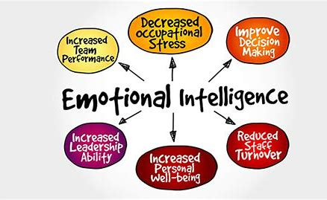
Figure 1 five ways to use emotional intelligence at work.
Source: (Staff,2019)

Emotional intelligence is not a quality by birth it is a skill that can be developed by learning, self-reflecting, active listening and building connections with others by showing empathy and understanding. As shown in Figure 1, this has a very important connection with the workplace and a great impact on productivity. Employees with high emotional intelligence tend to excel in their performance due to their ability to form strong, reliable relationships with their colleagues. They maintain a positive attitude and demonstrate active listening skills when making decisions. Additionally, leaders with high emotional intelligence effectively navigate work environments and promote efficient teamwork. They adeptly navigate challenging situations, approaching conflict with positivity, and positively influencing productive behaviours. Individuals such as leaders and managers with high emotional intelligence have the ability of good decisions that impact on positive environment and reduce staff turnover.

The world is transitioning to artificial intelligence, and in fact, more workplaces are now being influenced by robots, especially in warehouses, factories etc. Employees with high emotional intelligence, such as medical and health workers, are not easily replaced by machines. However, technology is evolving to integrate emotional intelligence skills into machines soon (Goleman,2020).

Emotional intelligence plays a crucial role in achieving success in the workplace. In some instances, having high emotional intelligence (EI) is more important than having a high IQ, as it allows individuals to effectively utilise emotions and be more creative in tackling problems and challenges. Understanding and managing emotions is essential for success in the professional environment. Emotional intelligence (EI) is particularly valuable as it empowers individuals to harness their emotions and think innovatively when solving problems and facing obstacles.

3. Models of Emotional Intelligence


People perceive and analyse situations differently, leading to their descriptions and portrayals of facts. They use models and theories to support their ideas and demonstrate their reasoning. Literature has developed and introduced several models and tools for businesses to apply and solve their challenges. A model is a conceptual representation created by humans to aid in comprehending and analysing real-world systems. It serves as a framework for individuals to address problems within specific contexts (Chambers and Hastie, 2017).

Referring to the report emotional intelligence also has four models that increase knowledge and ideas to improve emotional intelligence skills for best performance.

Ability Model
- The Mayer-Salovey Model
Mixed Models
- The Goleman Model
- The Bar- On Model
Trait Model
- The Trait EI Model

Based on the case study the report is designed to effectively describe and implement three models. Its purpose is to offer actionable recommendations for enhancing workplace abilities for both new and existing employees within the chosen firm.

The ability model of the Mayor and Salovey

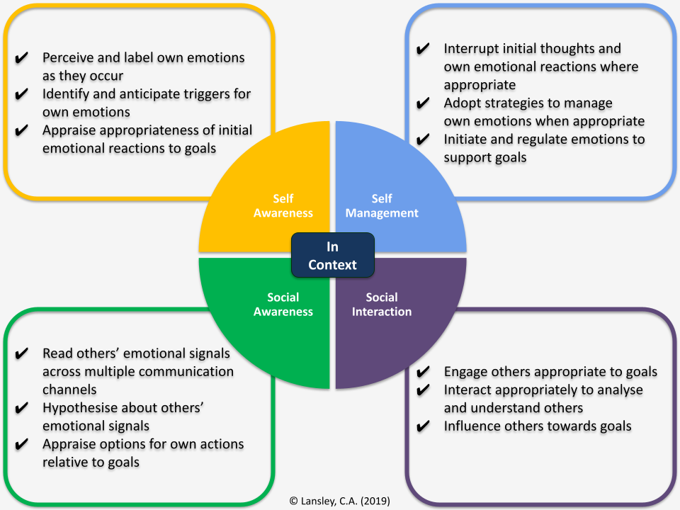

Figure 2 The Emotional Intelligence Model
Source: (EIA Group, 2023)

In 1997, Mayor and Salovey revised and developed the ability model of EI, which intends that individuals are distinct in their abilities to process information of an emotional nature he categorised this model into four sections perception, facilitation, understanding and regulation or management shown in figure 2.

- Perceiving emotions: The first step of the ability model is understanding emotions which is accurately perceiving them, which often involves interpreting nonverbal signals like body language and facial expressions (Neubauer and Freudenthaler, 2005).
- Reasoning and facilitation with emotions: This component involves leveraging emotions to enhance thinking and cognitive activity. Emotions aid in prioritising how individuals pay attention to and react to; humans have emotional responses to things that capture their attention.
- Understanding emotions: the emotions that humans grasp have several meanings. If someone expresses anger, the observer or viewer must interpret the reason for the person's emotion and what it could mean. For example, if someone's boss is angry, he might be not happy with their work, or it could be because they got some traffic tickets on the way to work that morning or they have been facing family issues.
- Managing emotions: This is the important section of this model the capability to manage emotions effectively by controlling and adjusting emotions, responding to others appropriately, and being aware of the feelings of others are all key aspects of emotional management (Neubauer and Freudenthaler,2005).

2. The Goleman Model

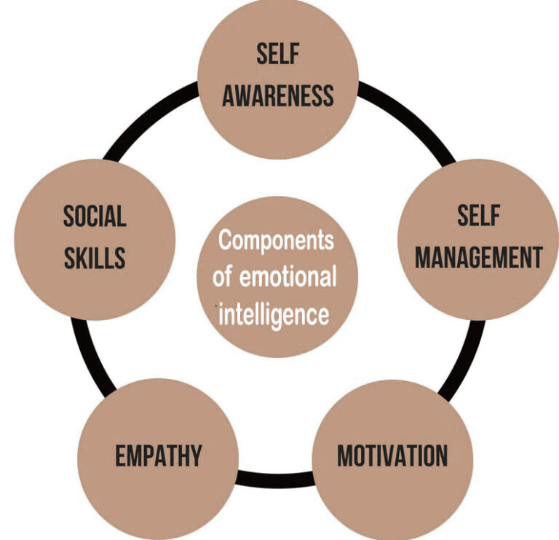

Figure 3 components of emotional intelligence.
Source: (Global intelligentsia, 2020)

Figure 3 outlines the second most important and widely used model of emotional intelligence which was developed by Daniel Goleman, a scientific journalist, author, and psychologist known for introducing and promoting the concept. However, the term "emotional intelligence" was initially introduced in 1990 by Peter Salovey and John Mayer in their article "Emotional Intelligence," published in the journal Imagination, Cognition, and Personality (Channell,2021). Goleman explained that (EI) has learned capabilities that must be worked on and expanded to achieve great performance, it highlights five essential components of emotional intelligence:

- Self-Awareness: Recognising, understanding, and being mindful of individuals' emotions, as well as how they impact others, is a crucial aspect of empathy.
- Self-Regulation: Practicing emotional control and considering potential outcomes before making impulsive decisions.
- Motivation: Keep motivated by internal factors and set and achieve goals with a positive attitude (Channell, 2021).
- Empathy: Showing empathy involves understanding and sharing the feelings of others, actively listening, and demonstrating compassion.
- Social Skills: Being able to communicate effectively, collaborate with others, and build strong relationships.
Goleman’s work has significantly influenced education, emphasising that emotional intelligence is as crucial as intellectual abilities in learning and personal development. Many schools worldwide now incorporate “social and emotional learning” into their curricula.

3.3 The Trait EI Model

The Trait Emotional Intelligence (Trait EI) model, developed by Konstantinos V. Petrides, represents a departure from the notion that EI is solely dependent on ability. Instead, it emphasises that individuals possess emotional self-perceptions and traits as part of their personalities. In simpler terms, Trait EI revolves around how individuals perceive their emotional abilities. In contrast to cognitive ability-based EI, which is inherently subjective, Trait EI focuses on individuals' perceptions of their emotional capabilities, which in turn influence their behaviours, as well as their perceived cognitive and behavioural abilities (Petrides and Mavroveli,2018).

4. The Four Pillars of Emotional Intelligence to Improve Performance

The report has outlined three models of emotional intelligence and their connection to real-world emotions and situations. Furthermore, to expand the knowledge Daniel Goleman categorised emotional intelligence skills into four different components. Figure 4 categorises each component of emotional intelligence.

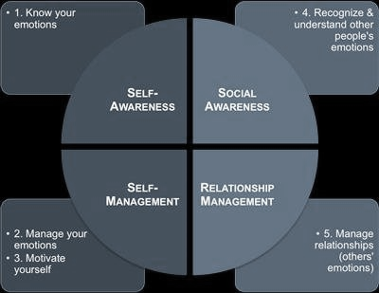

Figure 4 Emotional Intelligence book summary by Daniel Goleman
Source: (Shortform,2021)

- Self-awareness- involves a deep understanding and recognition of one's emotional intelligence. It requires a comprehensive evaluation of how individuals' emotional intelligence impacts their thoughts, decisions, and actions. This type of awareness enables them to observe and comprehend the intricate ways in which their emotional intelligence influences their behaviour and empowers them to make informed and constructive choices.
- Self-management is the practice of recognising, understanding, and regulating one's emotions, as well as effectively adjusting to changes in one's surroundings.
- Social awareness- refers to the ability to understand and empathetically respond to the emotions of others within a social group. (Shortform,2021).
- Relationship management- refers to the way one interacts and works with others in a social setting. It involves the ability to effectively encourage and persuade others interactively. This competency is widely applicable in the area of conflict management.

The study utilises Daniel Goleman's model of emotional intelligence to cautiously analyse and understand the correlation between organisational commitment and emotional intelligence. The insightful findings of this comprehensive study have unveiled new revelations, shedding light on previously unexplored dimensions within this critical area of research.

When organisations merge or are acquired by another company, the business grows, and the organisations undergo re-organisation. This involves new teams, projects, and management changes. The dynamic environment introduces numerous challenges and changes that have a direct impact on management. As a result, management needs to possess essential skills to effectively navigate all changes and adeptly overcome challenges. One of the important and useful skills is emotional intelligence.

Connecting this to the case study, the firm has undergone some changes after being acquired by a private company. This includes the appointment of a new COO, while some staff members have remained the same. The firm plans to discuss the initial public offering (IPO) project, led by the new COO Daniel, involving Anita from the previous finance and IT departments. As the staff members are having some conflict based on this new agreement. The report outlines the application of emotional intelligence models to enhance the abilities of staff members to reach a deal successfully and to fine-tune their work for best practices.
The Goleman model is an excellent method for enhancing emotional intelligence and addressing conflicts among employees. Self-awareness and then self-management are a crucial skill, and individuals such as leaders and managers who possess self-awareness understand their strengths and weaknesses. They also comprehend how their actions affect others. In this case, Daniel needs to improve his self-awareness and self-management ability. As a leader, his decisions impact other staff, and this can lead to disagreements and reduced productivity. Showing empathy is another skill that builds connection and trust among employees. The other important component of the model is social skills. Daniel must develop these skills as COO to communicate effectively by listening to others' opinions and ideas because the previous employees must have good experience with this company (Kanesan and Fauzan, 2019).

Communicating and collaborating might lead to achieving goals successfully.
The ability model is the best technique for Anita and Patric to enhance their abilities to manage their emotions and understand other emotions. People who can manage their emotions are better able to express their feelings. Although Anita is not happy with the COO, she should express her feelings in a better way to convince him. Similarly, understanding other emotions enables people to perceive that there are different meanings to people's emotions. This observation allows them to interpret these emotions and provides them with a chance to communicate effectively. For instance, Daniel is new to this company, so the first meeting is not enough to judge him. Build trust and connection by using emotional intelligence.

5. Development of Emotional Intelligence by Using Mindfulness and Relationship Management

In the previous section of the report, an overview was provided outlining the various models of emotional intelligence, as well as the four main pillars of emotional intelligence. In this part of the report, the focus shifts to the development of emotional intelligence through the application of mindfulness and effective relationship management strategies.

Mindfulness is a state of consciousness and awareness characterised by open and receptive attention to both inner thoughts and the outside world. Increased mindfulness has been linked to various positive outcomes, such as improved mental health, enhanced relationship satisfaction, and better pain management. It may also encourage individuals to accurately perceive their and others’ emotions and effectively manage and control them (Schutte and Malouff,2011).

Leaders with a growth mindset and mindfulness tend to exhibit more positivity, leading to improved performance that contributes to organisational success because mindfulness is an essential key for improving emotional intelligence skills. For instance, Google, a prominent and highly successful organisation, made significant and strategic investments in developing a comprehensive mindfulness program. They specifically designed this program to impart and enhance emotional intelligence skills among its employees through the practice of mindfulness techniques. The company recognised the importance of fostering emotional intelligence in its workforce and took deliberate steps to create a program that addressed this critical aspect of professional development (McCutcheon, 2024).

Nehrt, (2011) argued that the role of today's manager is getting more complicated and demanding. As organisations become more streamlined and adaptable, managers' responsibilities are increasing through direct reporting and even multiple bosses. Therefore, he suggests that building effective teams and working with a larger number of people across different cultures and organisational boundaries requires the ability to build and manage trust and connections effectively.
He added in his suggestions that contemporary business environment, it is imperative for managers to cultivate proficiency in relationship management skills to effectively lead their teams. This entails developing emotional intelligence through a process of self-discovery, stress management, and empathetic handling of their own emotions as well as those of others. Emotions are regarded as a complex mental attribute intricately linked with conceptual acumen and the capacity to grasp the broader perspective, making it crucial for managers to comprehend and navigate the emotional landscape in the workplace.

The other important feature of mindfulness is that it is often referred to as a state of heightened awareness and attention to the present moment while maintaining a nonjudgmental and non-evaluative approach. Numerous authors assert that this increased focus and understanding associated with mindfulness significantly contribute to promoting higher-quality workplace relationships. This comprehensive literature review definitively establishes a strong connection between mindfulness and workplace relationship satisfaction, consistently demonstrating that higher levels of mindfulness, whether dispositional or learned, are connected with trusted relationships and more satisfaction (Kimmes, et al., 2018).

Leaders have a significant impact on employees and outcomes at various levels, which is why organisations invest in leadership development programs to enhance the crucial leadership skills of individual leaders. Effective leadership hinges on the leader's self-awareness and social awareness, which in turn affect their ability to act responsibly within the organisational context (Urilla,2022).
Leaders and managers who possess high mindfulness and strong relationship management skills tend to be good listeners and facilitators. They do not dominate conversations or intimidate others. One of their key abilities is to encourage employees to provide feedback. Based on this feedback, these leaders can adjust and improve their performance. The research proves that mindfulness can be a particularly supportive skill for leaders and managers as it may increase leadership as a general ability (Reb, et al.,2015).

The report outlines that emotionally intelligent leaders and managers are more likely good at building a trustful relationship with employees which motivates them to achieve their goals more successfully. The ability of mindfulness empowers individuals to be more courageous and intentional. Their listening skills empower them to make good decisions because the ability of high emotional skills enable them to increase their self-awareness and social awareness and understand their emotions, thoughts, and actions.

6. Recommendations Highlighting the Importance of Mindfulness in the Workplace

The report outlined that emotional intelligence has a strong connection with mindfulness. The more individuals are mindful, the better they can lead in situations. It is also added that workplace performances are based on the measures of emotional intelligence. Leaders and managers who have high emotional intelligence seem to be more open-minded, good listeners and apologize when they realize their mistakes. They handle the criticism without blaming it on others. On the other hand, leaders with low emotional intelligence, abilities have low self-awareness and self-management. They always take someone to blame, with very low empathy and understanding capabilities.
Mindfulness is an essential tool that enhances emotional intelligence, and it also increases employees' well-being and performance levels.
Here are some recommendations that highlight how mindfulness impacts workplace productivity.

- Reducing stress levels - individuals can embrace mindfulness practices in their daily routines because they involve focusing on the present moment and being fully aware of their thoughts and feelings without assuming judgment. By consistently practising mindfulness, employees can cultivate resilience and develop the capacity to cope with the pressures and demands of the workplace effectively. This can lead to improved emotional well-being and overall job satisfaction (Chantrey,2021).
- Improving Productivity and Focus: Research has connected mindfulness to increased focus and better concentration. Employees who possess this mental clarity are more productive because they can handle tasks expertly and focus effortlessly.
- Positive interactions in the workplace are encouraged by mindfulness. Employees who practice mindfulness are more likely to understand and respond thoughtfully to their colleagues' perspectives when promoting awareness and empathy.
- Encourage leadership to place emphasis on well-being and set an example by focusing on mindfulness and slowing down.
- Take regular breaks from work to improve productivity.
- Allow for time for reflection and mindfulness between meetings by creating gaps between meetings (Chantrey, 2021).

7. Conclusion

The report concluded that emotional intelligence is not just emotions it is the ability to manage your emotions and understand others' emotions. As mentioned earlier emotional intelligence is not an inborn quality it can be learned and improved. It has five elements self-awareness, self-regulation, motivation, empathy, and social skills. Each one of these elements has an important role in workplace performance and employee well-being.
The four models Mayor-Salovey, The Goleman, Bar-on, and Trait models outline various components to enhance the abilities of emotional intelligence for better work productivity and employee performance.
Mindfulness and relationship management skills are essential elements for effective leadership and management. It increases the ability to understand others' emotions, by active listening, showing empathy and self and social management.
Mindfulness is a great tool for reducing stress levels and improving productivity and focus in the workplace.
Organisations need people with high emotional intelligence abilities therefore to enhance these skills they need to focus providing on opportunities and training sessions for employees to avoid conflict and unproductivity. Leaders and managers with strong emotional intelligence skills and abilities will enable them to empathise with employees more effectively and manage conflict with effective communication.

8. References

- Aamir, A., (2023). Emotional Intelligence and Organizational Commitment-Application of the Goleman’s Model of Emotional Intelligence. International Journal of Intellectual Human Resource Management (IJIHRM), 4(01), pp.01-06.
- Chambers, J.M. and Hastie, T.J., (2017). Statistical models. In Statistical Models in S (pp. 13-44). Routledge.
- Channell, M. (2021). Daniel Goleman’s Emotional Intelligence in Leadership: How to Improve Motivation in Your Team. [online] www.tsw.co.uk. Available at: https://www.tsw.co.uk/blog/leadership-and-management/daniel-goleman-emotional-intelligence/.
- Chantrey, T., (2021). The Little Book of Zen. Hachette UK.
- Chuang, S.F., (2013). Essential skills for leadership effectiveness in diverse workplace development. Online Journal for Workforce Education and Development, 6(1), p.5.
- EIA Group. (2023). EmotionIntell - The Emotional Intelligence Model. [online] Available at: https://www.eiagroup.com/white-paper/emotionintell-the-emotional-intelligence-model/.
- Frijda, N.H., (1986). The emotions. Cambridge University Press.
- Globalintelligentsia.com (2020.). Component s of emotional intelligence - Daniel Goleman's leadership of EQ. [online] Available at: https://globalintelligentsia.com/components-of-emotional-intelligence/.
- Goleman, D., (2020). Emotional intelligence. Bloomsbury Publishing.
- Kanesan, P. and Fauzan, N., (2019). Models of emotional intelligence: A review. e-BANGI Journal, 16(7).
- Kimmes, J.G., Jaurequi, M.E., May, R.W., Srivastava, S. and Fincham, F.D., (2018). Mindfulness in the context of romantic relationships: Initial development and validation of the Relationship Mindfulness Measure. Journal of Marital and Family Therapy, 44(4), pp.575-589.
- McCutcheon, D.S. (2024). 10 Mind-blowing benefits of mindfulness at work. [online] CHAMPION HEALTH. Available at: https://championhealth.co.uk/insights/benefits-mindfulness-at-work/#:~:text=Benefits%20of%20mindfulness%20a [Accessed 2 Jul. 2024].
- Nehrt, C., (2011). Conceptual ability, emotional intelligence, and relationship management: A multinational study. Journal of Management, 12(4), p.59.
- Neubauer, A.C. and Freudenthaler, H.H., (2005). Models of emotional intelligence. Emotional intelligence: An international handbook, 2005, pp.31-50.
- ‌Petrides, K.V. and Mavroveli, S., (2018). Theory and applications of trait emotional intelligence. Psychology: The Journal of the Hellenic Psychological Society, 23(1), pp.24-36.
- Reb, J., Sim, S., Chintakananda, K. and Bhave, D.P., (2015). Leading with mindfulness: Exploring the relation of mindfulness with leadership behaviours, styles, and development. Mindfulness in organizations: Foundations, research, and applications, 24, pp.256-284.
- Schutte, N.S. and Malouff, J.M., (2011). Emotional intelligence mediates the relationship between mindfulness and subjective well-being. Personality and individual differences, 50(7), pp.1116-1119.
- Shortform. (2021). Emotional Intelligence Book Summary by Daniel Goleman. [online] Available at: https://www.shortform.com/summary/emotional-intelligence-summary-daniel-goleman?utm_source=bing&utm_medium=cpc&utm_campaign=316551771&msclkid=2579ad4b3bd214919ef0cb366fd48af6 [Accessed 27 Jun. 2024].
- Staff, W. (2019). Five ways to use emotional intelligence at work. [online] Human Resources Online. Available at: https://www.humanresourcesonline.net/five-ways-to-use-emotional-intelligence-at-work [Accessed 27 Jun. 2024].
- Urrila, L.I., (2022). From personal wellbeing to relationships: A systematic review on the impact of mindfulness interventions and practices on leaders. Human Resource Management Review, 32(3), p.100837.

