
Skills for the Workplace
Module Assignment Submission
Student Name: | Rachel Witheridge
Student Number: | 2106781
Module No: | BMSK5012
Module Title: | Understanding & Engaging in the Customer Experience

Statement of Confirmation of Authenticity
By the act of making this submission, the student declares that this is the work of the student named above. The work has not, in whole or in part, been knowingly presented elsewhere for assessment, or where assessment has been built on a previous assessment, this has been identified. Where materials have been used from other sources it has been properly acknowledged. If this statement is untrue, the student acknowledges that an assessment offence has been committed.
Attention is drawn to the plagiarism and unfair practice policies of both the University and of ILM.

Table of Contents
INTRODUCTION 3
Section 1: Customer Value 3
Section 2: Customer relationship management 10
Section 3: CUSTOMER CENTRALITY 11
Section 4: 5 STAGES OF CUSTOMER RELATIONSHIP 12
Section 5: SATIFICATION Vs LOYALTY 14
Section 6: LEAN THINKING 14
References 16
Appendix A 17
Appendix B 17
Appendix C 17
Appendix D 17

INTRODUCTION

I have gained knowledge about customer value, perceived value, and the significance of each throughout this course. Understanding the value of customer involvement and the customer experience. The advantages of customer relationship management and how they apply to my own workplace have been made clear to me. knowing how to gauge customer happiness and loyalty, as well as the five stages of customer interactions. I now know more about the seven lean waste management principles and how to apply them to my own systems.

Section 1: CUSTOMER VALUE
What is customer value?
The greatest way to describe customer value is how much a product or service is worth to a customer. It's a way to calculate the total expenses and advantages of a commodity or service. Examples include the cost, the level of quality, and what the goods or service can do for the individual. When determining the worth of a purchase, buyers also take into account financial, time, energy, and emotional expenditures.
What is customer perceived value?
What a customer is willing to spend on a product or service is known as perceived value. This is decided by a product or service's capacity to satisfy the needs of the customer and arouse desire, particularly in contrast to rivals.
A company may position itself correctly and use marketing to effectively highlight the benefits that customers are most willing to pay for if it understands how they see value from the perspective of its customers. Convenience, cost-effectiveness, and innovative or visually beautiful design are just a few of the advantages that might draw customers.
There are two ways to determine a customer's value: by intended value or perceived value. The customer's expectation before purchasing the product is the desired value. Cost is taken into account when calculating perceived value. Perceived value can be calculated as follows: Tangible benefits/Costs paid.
Real value is revealed when the thing is purchased and used. The customer value is very high if actual value exceeds perceived value. Buyer's remorse occurs at the other end of the spectrum when the actual value is less than the perceived value (low customer value), and the consumer is likely to stop making further purchases. The main metric through which better product and service offers can reach the market is customer value.
(Diaz, What is customer perceived value? 2022)

Why is customer value important?
Maintaining long-term relationships with current consumers and obtaining repeat business depend on providing value to them. It's crucial to understanding the demands and expectations of customers and how they evolve over time. Building customer loyalty and boosting customer lifetime value depends on understanding how people feel about your product and the service you provide.
(Maza &amp; Writer, What is customer value? definition, formula &amp; importance 2022)

Good service can increase consumer value. According to Zendesk’s 2022 Customer Experience Trends Report:
- 93% of customers will spend more money with businesses that give them a convenient way to contact customer support.
- 90% of customers will increase their spending with businesses that offer them personalised customer service.
- 64 % of business leaders say that customer service has a positive impact on their company’s growth.
- 64% of business executives, providing excellent customer service helps their business expand.
- 60 % of business leaders say it improves customer retention
- 47 % of business leaders report an increase in their ability to cross-sell due to good customer service.
(CX Trends 2023)
The four categories of customer value
In the article "The 30 Things That Customers Really Value," Eric Almquist and his colleagues categorised consumer values into four groups.
- Functional
- Emotional
- Life changing
- Social
Functional - The effectiveness and efficiency with which the product can carry out its intended job is what gives it this kind of value. For instance, a computers usefulness is determined by how well it handles activities like word processing, web browsing, and software application use. Customers seek out goods with a high level of functionality.
(StudySmarter, Customer value)
Emotional - Customer emotion is a gauge of how satisfied a customer feels with their interactions with a given business or brand. Depending on how a customer interacts with a brand, they may feel different things. The objective is to provide customers a happy, emotionally fulfilling experience.
A customer's emotional dynamics are quite complex. Customers might not recall the calibre of your products, but they'll always remember how you made them feel.
(Villegas, Customer emotion: What it is &amp; how to measure it 2022)
Life changing - These customer values, sometimes known as "self-expressive values," are concerned with a customer's self-perception and need for personal expression. Customers love how others view them when they buy from specific brands since these goods and services appeal to their tastes and personalities.
Social impact - When a customer makes a purchase that has a beneficial impact on the lives of others, they experience regions of appreciation and happiness known as social-impact customer values. Customers are encouraged by these beliefs to buy goods and services that support their morals and social causes.
(12 customer value examples that businesses can offer)
The customer value pyramid
The 30 components of value are divided into four categories: social impact, life-changing, emotional, and functional.
The consumer value pyramid is made up of these four areas, which are grouped into a four level hierarchical model with social effect at the top and functional demands at the bottom. The consumer value pyramid is shown below as an illustration.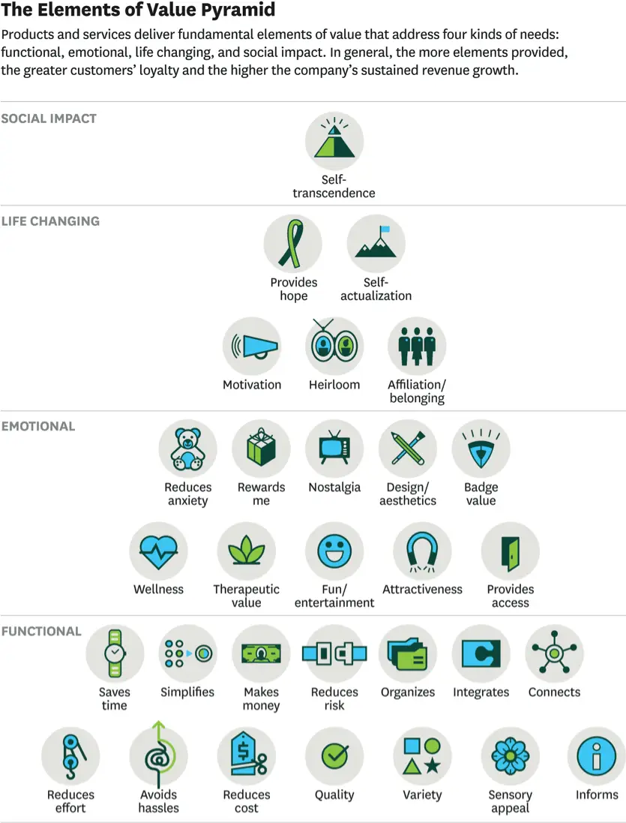
The consumer value pyramid may have drawn your attention to the fact that this model and Maslow's hierarchy of requirements appear to be pretty similar.
This is due to the fact that Maslow's hierarchy of needs, which was first proposed by psychologist Abraham Maslow in 1843, serves as the conceptual foundation for the consumer value pyramid.
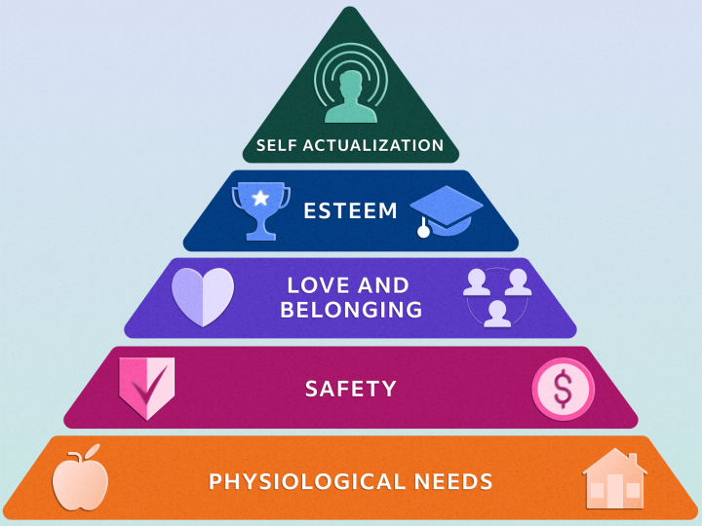
According to Maslow's hierarchy of needs theory, all human behaviour is driven by an innate desire to satiate needs. These needs can range from those that are essential for our survival, like food, security, water, and rest, to more complex ones, like power, self-esteem, and the ability to express one's creativity.
The consumer value pyramid and Maslow's model both examine human motivations as they relate to their behaviours as consumers.
The demands at the bottom of the pyramid are inherently more important than those at the top, albeit not necessarily more gratifying, according to Maslow's hierarchy of requirements.
(Cleverism, The 30 elements of consumer value: A Hierarchy 2020)

I work in healthcare and my job role is the administrator for the children's physiotherapy service. Patients that come in for treatment and bring a parent or carer are our customers. Their value is receiving the greatest evaluation and care for their child.
An unhappy patient would be one who was kept in the waiting area well past the appointment time. They may not value us or our service because they feel we have let them down, even though the doctor's delay may have been the cause. But, it would be helpful if there were a procedure that allowed administrative staff to keep track of patients and be aware of how long they have been waiting. Staff would then be able to let the patient and their parent or carer know there is a delay. Although the patient might not be completely content, they would comprehend and respect the information more and feel that they were being thought of. In this way, customers would value our service more.

Our Vision, Purpose and Values within the NHS supply chain
Our Vision - As the preferred supply chain partner for the NHS, we improve lives through our passion and performance.
Our purpose- With innovation, service, and clinical knowledge, we are happy to provide NHS clients and patients with supply chain excellence and the best value.
Our Values -
Innovative – Be The Difference
In order to improve and make a difference for NHS suppliers, customers, and patients, we always look for new and better ways to do things differently and question the status quo. At the core of who we are and what we do is our enthusiasm for performing tasks as effectively and ethically as possible.
Respectful – Be Inclusive
The secret to our success is our workforce. To support employees' success, and our culture values, respects, and includes all of its members. We pay attention and respect divergent points of view. To accomplish our objectives, we all collaborate as a single team.
Ambitious – Be Driven
We have the desire and the ability to provide what is required in the best possible way. We understand the value of processes, but we also possess the bravery, passion, and desire to innovate and go above and beyond while continually providing value for our customer.
Integrity – Be Authentic
We adhere to the highest standards and make the finest decisions. We show stakeholders, each other, and our consumers that we are trustworthy by acting with integrity. We demonstrate to others that our behaviours and actions are consistent with our ideals by being authentic. We keep our promises.
Future focussed – Be Enterprising
We always survey the horizon and anticipate the future. We have a thorough understanding of the market, and we establish trends that will keep us one step ahead of our rivals. We know who our consumers are, and we're motivated to give them the services they'll require in the future.
(NHS choices)
Understanding customer experience
Many aspects make up customer experience, but in general, it may be summed up as how a customer or business feels about a product or service. Each connection has the potential to strengthen or weaken the bond between the business and the customer since it is ingrained into every interaction.
Building a relationship with customers entails being aware of their wants, needs, and values. It extends beyond only using the good or service: Pre-buy connections with the brand (via marketing or brand awareness), the research and purchase process (either in-store or online), and post-purchase interactions (concerning service, repairs, additions, and more) all contribute to the overall experience. The objective is to establish effective and seamless relationships between the brand and the customer.
A good customer experience can help you stand out from the competition. Customer experience offers a technique to position your product and brand at the forefront as more brands vie for consumers' attention and as more options are easily accessible. Brands need to consider providing more outstanding experiences and engaging with customers in more dynamic ways if they want to enhance customer acquisition, customer loyalty, and customer engagement.
(Accenture, 2023)
Customer engagement value CEV
Customers can contribute to a company's profitability in two different ways: directly through their purchases and indirectly through non-purchase actions, such as making referrals to potential customers, influencing current and potential customers in their network, or using their own reviews and feedback to make improvements.
Indirect contributions to profits
Customer referral value (CRV) - Customer recommendations and word-of-mouth (WOM) communication are not new ideas. To enhance the adoption of their brand or product, businesses invest a lot of resources in creating incentive-driven referral programmes.
The success or failure of a referral is unpredictable. As a result, CRV can be negative, positive, or zero without affecting the company's profit, depending on the influence of recommendations.
Referrals have been a popular method for many new businesses to spread the word and increase their customer base. Other businesses use incentive referrals, where the referee gets paid for each successful referral they make, which incentivizes them to refer more people.
Customer influence value (CIV) - Current customers might affect potential customers conduct in more ways besides just through referrals. By now, we are aware that a customer's feelings and readiness to interact with others might have an impact on a company's revenue and earnings.
Customer influences are typically driven by word of mouth (WOM) initiatives that reduce buyer's regret, boost share of wallet (SOW), and persuade and convert prospects into customers. Customers are given a platform to openly share their customer experience and so exchange reviews and opinions about a good or service thanks to the ever-growing social media network.
Customer knowledge (CKV)
Customers appreciate a company that will tailor a product to their needs. Businesses should pay close attention to what customers claim they want and need. Highly engaged customers are more than happy to provide feedback to the company for modifications or improvements to the product being offered. A corporation can gain valuable information through comments about what its customers think of its product or service. This might be really important for a business developing new products. Companies can lower the failure rate of their products and enhance their service if they pay attention to their customers.
Being able to use customer knowledge effectively is crucial to getting customer feedback. To accomplish this, businesses must provide a rapid and simple communication channel. Giving feedback should be effortless, natural, and interactive. Social media has evolved into a particularly helpful tool for maximising the value of customer knowledge.
Direct contributions to profit
Customer lifetime value (CLV)
Under the CEV framework, CLV is a fundamental metric that directly affects the firm's probability. CLV is a prospective metric that forecasts future profits from both existing customers and potential consumers in addition to accounting for the contributions to profit based on a customer's historical behaviour.
In essence, CLV gives businesses the ability to treat each customer uniquely based on what they have contributed to the company. Firms are able to determine how much they can and should invest in a customer in order to have a good return on investment by being able to quantify this value.
(Maund, 2018)

Section 2: Customer relationship management
From the perspective of the organisation, this entire connection includes all interactions with customers directly, including sales and service-related procedures, forecasting, and the examination of consumer trends and behaviours. CRM's ultimate goal is to improve the customer experience.
CRM includes a variety of components, such as a company's website, emails, mass mailings, and phone calls. One way businesses respond to developments that help their bottom line is through social media. The entire purpose of CRM is to generate satisfying customer experiences that encourage repeat business so that a business can amass a growing customer base.
The word CRM is increasingly being used to describe the technological solutions businesses can employ to manage their external interactions with customers at all phases along the customer lifecycle, from discovery to education, purchase, and post-purchase.
Benefits of CRM
Organisations can more easily access and provide customer support with the use of a CRM system, which helps organisations organise and centralise their client information. CRM systems are used by businesses to enhance customer retention and boost sales and marketing. Additionally, data analytics makes it much simpler for businesses to monitor the success of various initiatives or campaigns, spot trends, deduce associations, and design aesthetically pleasing data dashboards.
(Hargrave, 2022)
What does CRM software do?
CRM software keeps track of customer contact data, including phone, email, website, social network profile, and more. Additionally, it can automatically pull in additional data, like recent company activity news, and store specifics like a customer's individual communication preferences.
The CRM system arranges this data to provide you with a thorough record of people and organisations so you can understand your relationship through time.
Whys is CRM Important?
Using CRM, a company can strengthen connections with its customers, service users, employees, partners, and suppliers.
For customer acquisition and retention, which is at the core of a CRM's purpose, building strong relationships and keeping track of prospects and customers are essential. An easy-to-use, customizable dashboard lets you see everything in one place. It can tell you about a customer's previous interactions with you, the status of their orders, any unresolved customer support issues, and more.
(Salesforce, What is CRM?)

Paz, Pims, and DMS are patient record systems used by the NHS. These assist us in managing appointments, keeping patient information current, and tracking recent history. Keep an eye on DNA rate changes. Health and care data are always gathered, stored, evaluated, and shared securely and legally thanks to the NHS GPDR (General Data Protection Regulation). Within our paediatric team, patient paper records must be kept on file until the patient turns 26.

Section 3: CUSTOMER CENTRALITY
What is customer centrality and how is it implemented?
Customer centricity or placing the customer at the centre of everything you do, is essential if you want your business to succeed. It's the capacity of employees within an organisation to comprehend the circumstances, viewpoints, and expectations of customers. To foster customer pleasure, loyalty, and advocacy, the customer should be at the centre of all choices relating to the delivery of goods, services, and experiences.
Finding needs and meeting them is the essence of customer centricity, as opposed to creating things and marketing them. The idea of putting the needs of the consumer first is simple. It should be rather clear that offering poor service or providing subpar items will lead to customers taking their business elsewhere.
Three factors that affect how market-oriented a company is were found by Narver & Slater in 1990. Customer focus, co-ordination between functions, and teamwork attitude. According to these authors, customer orientation refers to how well an organisation understands its clients. The firm is better able to add value for the customer with a greater understanding. The first step is to understand your customers. Customers appear to have a set of common requirements, including-
Current product needs - Based on a product's features and advantages, all clients for that product are determined. In terms of the quantity of the goods they purchase and any potential usage issues, they can also have similar needs.
Future needs- An important component of customer orientation is anticipating future demands of current consumers. Normally, this is a function of marketing research, but the customer centrality principle holds that even though the company is being helpful, we shouldn't wear out our customers by asking them questions.
Desired pricing levels - Customers will only pay what they consider to be a "fair" price (based on the benefits they see in owning the goods), but price is also a sign of quality. Cutting costs could be counterproductive since it communicates that the product is of inferior quality because consumers naturally believe that a product that costs more is of higher quality.
Information needs- Customers must be informed about a product and the repercussions of purchasing it. including disadvantages and benefits. Customers will ask other buyers and users of the product for this information therefore it needs to be accurate and offered in the right area and manner.
Product availability - Products must be accessible at the appropriate time and location. In order to ensure that the product can be discovered where the customer expects to find it, the company must hire the proper intermediates.
The points raised above are generic and apply to all customers, whether they are business clients, consumers, those purchasing for friends and family, or even buyers from organisations.
(Blythe, 2009)

Why is customer centrality important?
Consider client centricity to be both a strategy and a culture. It must become ingrained in an organisation for the customer—who makes the final decision—to recognise it.
Customers won't purchase from you if they are unhappy. You cannot run a business without customers. Consider who you frequently purchase from and why. What do they do that you continue to support them? They aren't making it difficult for you to work with them, or you wouldn't.
Instead, they simplify things. They use the channels you will have asked them to use to connect with you effectively. At the exact moment you want to make a purchase, they may even display offers for items that you personally find interesting. Rather to creating items and selling them, customer centrality involves identifying needs and meeting them.
(Ramich, 2022)

Section 4: 5 STAGES OF CUSTOMER RELATIONSHIP
The stages a consumer goes through to develop into a devoted customer are defined by the customer life cycle. It includes all of the interactions a customer will have with your business, from the first moment they learn about you to a continuing partnership.
Understanding the phases that make up the customer life cycle can help you decide how to best attract new customers and what tactics will help you maintain and develop a client's connection with your business.
The customer life cycle comprises five stages.
- Awareness - The awareness phase is the first stage of the customer life cycle. At this stage, a customer first learns about your company's products and services. There are several ways for a customer to find your company. When people use a search engine like Google, for instance, they can find your company listed among the results. The consumer may learn about your company through other typical channels such as advertisements, word-of-mouth recommendations, or social media.

- Consideration -The consumer has learned about your company and is now gathering data to evaluate the benefits and drawbacks of your offers. This is known as the consideration stage. This evaluation occasionally pits you against your rivals. Other times, the customer is thinking about how well your products match their needs, whether those needs are related to their budget, the results they want to achieve with your products, or other aspects like usability.

- Purchase - We have now reached the moment where a prospect turns into a customer. They considered your offerings and made the decision to purchase from you. However, just because a customer gets to this point does not indicate the sale is assured. A consumer may leave their choice in the virtual shopping cart on your website if you run an e-commerce business. The customer is more likely to quit up if your website doesn't make it apparent how to make a purchase or if there are too many steps involved in the purchasing procedure.

- Retention - The goal of the retention phase is to strengthen your relationship with the consumer after they make a purchase so they will be more inclined to do it again. This is accomplished by sending clients follow-up emails, emails with reminders, and emails with promotions. Consider what related products a consumer might be interested in after they make a purchase and suggest those to them. To maintain all of your customer information in one place, your client management software will be useful once more.

- Advocacy - The final stage occurs when a customer likes your business so much that they recommend it to others. They mention it to their friends and co-workers and suggest your company online. With the help of these brand advocates, you may grow your consumer base while also generating more sales.

Once you've established your plans for each stage of the life cycle of your business, you should revisit to confirm they are effective in guiding customers through each stage. Analyse the customer's life cycle to assess and improve your existing techniques.
(Izquierdo, 2022)

Section 5: SATIFICATION Vs LOYALTY

Customer satisfaction is a measurement of a customer's attitude toward a product, a service, or a brand. It's usually measured by a customer satisfaction survey on a numerical scale. Customer loyalty is a set of behaviors and attitudes that a customer exhibits that demonstrate loyalty to a product, service, or brand, such as repeat purchases or choosing the brand over a competitor.

How to Measure Customer Satisfaction
The feeling a customer has after making a purchase from your company is called customer satisfaction. It might help you determine whether the customer experience lived up to your expectations. It's also a terrific opportunity for irate consumers to vent, allowing them a private forum to share their opinions as opposed to airing their grievances in a review or on social media.
Customer satisfaction score (CSAT), the simplest simple customer experience indicator, will assist you in determining whether your store is carrying out its most basic duties. A high CSAT indicates that a customer will have an easy, predictable, and practicable time making a purchase at your store. A poor CSAT could mean you're losing customers before they've finished their purchases.
How to Measure Customer Loyalty
Being subjective and varying by company or industry, customer loyalty is challenging to quantify. To ascertain how devoted your consumers are to your business, you can utilise a combination of qualitative and quantitative data. Start by reviewing customer reviews, then contrast these trends with other data such as product usage, repeat sales, churn rate, etc.
Customer loyalty may be even more critical for your company than CSAT, despite the importance of both metrics. Positive online reviews, word-of-mouth advertising, and returning customers who spend more money all help to bring in new clients and repeat business for your firm.
Additionally, customer loyalty is more proactive than customer happiness. It is an indicator of the potential long-term value of your clients. By having this knowledge, you can improve the customer experience and give your active user base constant value.
(Rodriguez, 2019)

Section 6: LEAN THINKING
Waste can be summed up simply as "Something that adds no Value." Any activity we perform that does not bring value to what our customers genuinely desire would not be pleased to pay for, and neither should we.
Why remove wastes - your corporations no matter how you look at it, the selling price is mostly determined by the market, not by you. Profit is your selling price less your costs. Customers will leave if you price too much, and even if you charge too little, you risk losing them since they may think there is something wrong with what you are providing. The only method to increase revenues is therefore to decrease costs, which entails eliminating all waste from your processes.
You'll discover that waste has a significant impact on your customers' pleasure with your goods and services in addition to increasing your revenues. Your customers expect products delivered promptly, flawlessly, and affordably. Something that is impossible to accomplish if the 7 wastes are allowed to exist within your systems.
- Transport wastes
- Inventory waste
- Motion waste
- Waiting waste
- Overproduction waste
- Overprocessing waste
- Defects waste
(Seven wastes: 7 Mudas of Lean Manufacturing 2016)
There are 5 principles of Lean thinking
Value - Value is the first lean thinking principle, and it demands organisations to truly comprehend what value entails for their clients. You can give value once you've identified it. The first of the five lean thinking concepts, value, serves as the cornerstone, without which it is impossible to apply the remaining four.
Value stream - Organisations must first understand how to correctly recognise value before defining how to achieve it. To put it another way, organisations need to be able to list every stage of the various processes that turn concepts and materials into usable goods and services.
Flow - You can then apply the flow lean thinking method after determining the value stream. When flow has been established, your work is not in any way being slowed down or blocked. But creating flow is not a simple task. You might need to introduce and implement changes inside your organisation that are first challenging and controversial in order to achieve it successfully. The core of lean thinking is continual improvement driven by a common objective. Even while entering your flow can be difficult, a cohesive team will always benefit from it.
Perfection - Perfection is the final tenet of lean thinking. Your company will have undergone a comprehensive lean transformation in order to achieve perfection. This indicates that you have accurately defined value, streamlined and improved your value chain, achieved a smooth flow, and satisfied customer wants and requests with the appropriate number of products at the appropriate time. It's critical to know that your organisation is constantly pursuing perfection, which is a journey rather than a final goal.
(Simplilearn, 2023)

Conclusion
To succeed in today's competitive business environment, a company must comprehend and participate in the customer experience. Businesses may foster great encounters and enduring connections by putting the needs of their consumers first. Customer loyalty can be raised by actively hearing what they have to say and making adjustments to better suit their needs.

References

12 customer value examples that businesses can offer. (n.d.). Retrieved April 25, 2023, from https://uk.indeed.com/career-advice/career-development/customer-value-examples
The 30 elements of consumer value: A Hierarchy. Cleverism. (2020, January 23). Retrieved April 25, 2023, from https://www.cleverism.com/the-30-elements-of-consumer-value-a-hierarchy/#:~:text=The%2030%20elements%20of%20value%20are%20grouped%20into,top%20%E2%80%93%20to%20form%20the%20consumer%20value%20pyramid.
Maund, A. (2018). Ba in Leadership and Management: Skills for the workplace student yearbook. SAGE PUBLICATIONS.
Blythe, J. (2009). Key concepts in marketing. SAGE.
Seven wastes: 7 Mudas of Lean Manufacturing. Lean Manufacturing Tools | Lean Manufacturing Tools, Techniques and Philosophy | Lean and Related Business Improvement Ideas. (2016, November 7). Retrieved May 7, 2023, from https://leanmanufacturingtools.org/77/the-seven-wastes-7-mudas/
Rodriguez, J. (2019, December 16). Customer satisfaction vs. customer loyalty (&amp; how to improve them). HubSpot Blog. Retrieved May 7, 2023, from https://blog.hubspot.com/service/whats-the-difference-between-customer-satisfaction-and-customer-loyalty
2020Reply, R. 17 N., Geektonight Team 17 November 2020ReplyI m glad you liked it. Thanks, 2020Reply, G. T. 17 N., 2021Reply, E. 11 J., 2022Reply, B. E. 2 F., 2023Reply, dreslam 14 J., &amp; Enter your name or username to comment. (2021, April 17). What is attitude? definition, types, components, formation, functions, characteristics, importance. Geektonight. Retrieved April 19, 2023, from https://www.geektonight.com/what-is-attitude-meaning-functions-types-importance-components/
Villegas, F. (2022, August 1). Customer emotion: What it is &amp; how to measure it. QuestionPro. Retrieved April 25, 2023, from https://www.questionpro.com/blog/customer-emotion/#:~:text=Emotions%20build%20loyal%2C%20valuable%20clients.%20It%E2%80%99s%20a%20key,Emotion%20drives%20individual%20decisions%20and%20long-term%20customer%20loyalty.
Izquierdo, R. (2022, August 5). 5 stages of the customer life cycle (updated 2023). The Motley Fool. Retrieved May 6, 2023, from https://www.fool.com/the-ascent/small-business/e-commerce/articles/customer-life-cycle/#:~:text=Stages%20of%20the%20customer%20life%20cycle%201%201.,4%204.%20Retention%20...%205%205.%20Advocacy%20
Diaz, D. (2022, September 1). What is customer perceived value? Keele University - Study online. Retrieved April 24, 2023, from https://online.keele.ac.uk/what-is-customer-perceived-value/
Hargrave, M. (2022, October 2). What is CRM? customer relationship management defined. Investopedia. Retrieved May 1, 2023, from https://www.investopedia.com/terms/c/customer_relation_management.asp
Ramich, A. (2022, October 12). Council post: What is customer centricity? Forbes. Retrieved May 1, 2023, from https://www.forbes.com/sites/forbesagencycouncil/2022/01/20/what-is-customer-centricity/?sh=592b9668ade9
Accenture. (2023, March 3). What is Customer Experience &amp; Why is it important. Accenture. Retrieved April 26, 2023, from https://www.accenture.com/us-en/insights/song/customer-experience-index
Simplilearn. (2023, March 13). Lean thinking: Overview, principles, benefits, &amp; applications explained. Simplilearn.com. Retrieved May 7, 2023, from https://www.simplilearn.com/lean-thinking-article#what_is_lean_thinking
NHS. (n.d.). NHS choices. Retrieved April 6, 2023, from https://www.supplychain.nhs.uk/about-us/vacancies/our-vision-purpose-and-values/
Customer value. StudySmarter UK. (n.d.). Retrieved April 25, 2023, from https://www.studysmarter.co.uk/explanations/marketing/introduction-to-marketing/customer-value/#:~:text=The%204%20customer%20values%20are%3A%201%20Functional%20value,Social%20Value%203%20Emotional%20Value%204%20Epistemic%20Value
What is CRM? Salesforce. (n.d.). Retrieved May 1, 2023, from https://www.salesforce.com/uk/learning-centre/crm/what-is-crm/

