Effective Team Working and Communication
Student: Forhad Ali
ID: 1707076
Lecturer: Jhon Paul

Contents
Introduction 2
How well employers perform at communicating? 3
How workplace communication and performance of employers can be improved 7
Conclusion 9
References 10

Introduction

Communication can be defined as the process through which information is transmitted between and among parties so as to assist in the decision making process. It ensures that all employees are aware of their duties and responsibilities. Moreover, it facilitates congruence of goals within an organization (Topchik, 2007). On the other hand, improper communication can often lead to conflicts at the workplace, inappropriate decision making, rise in organistional politicking and an overall fall in the functionality of the firm. Thus, Effective communication is essential for successful business management and operations (Topchik, 2007). This report will explore some of the core aspects of communication from a workplace context. It will evaluate the extent to which employers perform well at communicating at the workplace. Moreover, it will provide insight as to how this performance can be enhanced.

How well employers perform at communicating?

The extent to which employers perform at communicating at their workplace varies in my friends experiences. Some employers are quite good at conveying the message that they want whereas others often fail to communicate their core message in a proper manner.

Firstly, it is seen that the employers perform much better at written communication. The reason behind this is that written communications often have a predefined structure clearly segregated into introduction, the body containing the main message, the conclusion urging for an action etc. Moreover, written communications are often supported by attached documents/files/presentations which provide further insight to the recipient regarding what is being communicated. This results in better communication from the employer (Witte and Davis, 2014). For example, one of my friends work at the Barclay’s bank. Upon my query, he informed that most important communication is don’t in written form there in a “no nonsense” approach whereby the mail directly go’s to the focal area of the communication. This results in better communication. Furthermore, the employers also perform at written communication because it is less susceptible to the individual biases and external noise that often disrupts verbal communication (Parker, 2011). However, some employers also perform poorly at written communication and this often happens due to improper choice of words, wrong medium usage, over usage of clichés, use of incorrect salutation and greetings etc. (Raelin, 2008). For example, a friend of mine working at Tesco told me how his supervisor sent a 2000+ word report by simply pasting it in a mail body and then sending the mail. This shows a blatant failure while choosing the medium of communication. Similarly, an official mail communicating the demise of a fellow colleague did not have a somber tone to it and this had a negative impression on the staff there.

Secondly, employers seem to be poor at face to face verbal communication. However, this too varies from employer to employer. In general, it is seen that employers emphasize overtly on their verbal abilities while communicating face to face while not giving due importance the para-verbal events and the non-verbal signals that they were giving off through their body language (Altman, 2013). For example, Tesco stores often conduct “morning huddles” prior to the opening of the store to discuss service issues and to commit towards providing excellent service to the customers during the day. A friend told me how these huddles failed to have any impact on the employees at his store because of the extremely boring and monotonous para-verbal events of the line manager conducting the huddle. Thus, the communications were futile on a daily event due to the absence of appropriate para-verbal cues. Moreover, employers often fail to adjust the speed of their communications based on the recipient’s ability to perceive the information (Ancona, 2013). For example, one of my colleagues, who was an immigrant, always struggled with the fluent English spoken by our line manager. Whilst the onus to improve communication skills here lies with my colleague the line manager also has some responsibility to speak in a slower pace. Similarly, misleading or conflicting non-verbal cues often undermine the message that is being communicated by the employers (Hellriegel and Slocum, 2011). For example, one manager at my previous workplace always used to “yawn” and “scoff” whilst urging us (his subordinates) to work hard and exert greater effort at the workplace. This gave off the impression that he was being sarcastic and thus his communication failed to have its full impact on us. In addition, other aspects of non-verbal communication are also important. I had a colleague who was a gifted communicator with the ability to engage his audience. I noticed how he always maintained steady eye contact with the audience, smiled thereby appearing confident, did not feign fake attention etc. Whereas, I also had a supervisor who always appeared as if he was angry or irritated for some reason. He often had his arms folded tightly against each other, constantly looked at the surroundings instead of looking at the communicator and stood to close. This non-verbal gestures discouraged people from approaching him to communicate. Finally, one of the major lacking that employers have while communicating verbally is their failure to listen attentively (Kreitner and Kinicki, 2013). In other words, employers often engage in “one way” communicating by stating what they have to say and do not listen to what the employees have to say. Moreover, even when they try they often fail to maintain proper attention span, feign listening, interrupt the speaker etc. This problem in listening is not exclusive to employers but rather is seen among the employees as well. In fact, it has been statistically seen that an individual listens (120 words a minute) at a much slower speed than he thinks (3000 words a minute) (Kreitner and Kinicki, 2013).

It is apparent from above that there are various issues which hinders employer’s performance at communicating in the workplace. Based on the above analysis, it can broadly be said that there is much room for improvement in employer’s communication skills. According to a survey conducted by CIPD in 2017, 57% of the employees in UK feel that employers are not communicating enough or communicating appropriately.

Moroever, CIPD also asked employers about their opinion regarding scope for improvement in communication ability. An outstanding 72% of the employers believe that there is still room for improvement whilst communicating at the workplace.

A survey conducted by “Harris Poll” shows the main areas in which employers are lagging behind whilst communicating in their own eyes.

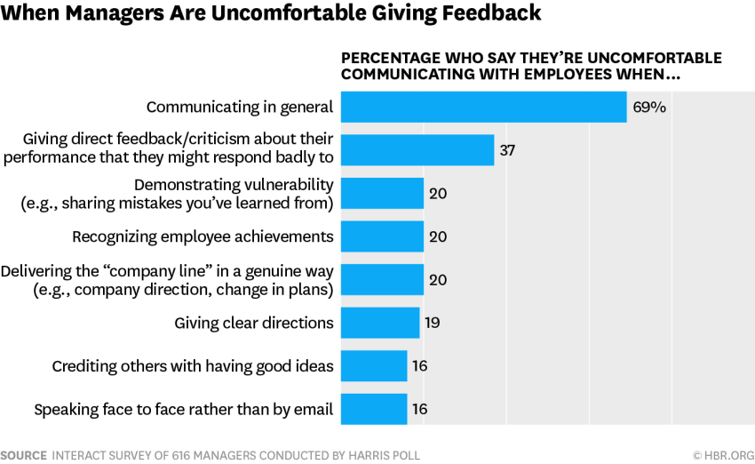
The results of the survey shows that 69% of the employers are uncomfortable with communicating with their subordinates in general. 37% are uncomfortable whilst providing direct feedback or criticism to the employees and so on.

All in All, the overall performance of the employers whilst communicating at the workplace is not that good. There is much room for improvement and all firms should take proactive measures to improve communication from their side (Topchik, 2007).

How workplace communication and performance of employers can be improved

In order to improve the workplace communication and performance of improvers, the management of firms need to take some firm actions and strategies. These are discussed below as follows:

- Set up a culture conducive of open communication: As shown previously, many employers are not comfortable while communicating and a lot of this has to do with the culture of the organization. Some organisations have a culture where there is a huge distance between the employers and the employees. This inhibits the employees from freely communicating with the employers and vice versa. Thus, the management of a firm should institutionalize a workplace culture where people can freely express their ideas and opinions. The culture should promote expression of opinion and high level of tolerance to others views. This should result in better workplace communication from the employers (Kreitner and Kinicki, 2013).

- Providing training to the staff: Firms should take necessary actions to ensure that all staffs undergo training on how to communicate effectively and adeptly. These trainings will help them avoid the usual pitfalls that undermine the communication process such as improper structure of written communication, inappropriate tones, misleading non-verbal gestures, poor para-verbal events, not listening to others etc. Moreover, the training will also increase the cultural, gender and racial sensitivity of the employers. This will come in handy when they communicate with a diverse group of employees (Robbins and Judge, 2017).

- Match the communication style with the external environment: Different countries, regions and organisations have different external environment. In order to improve employers performance and workplace communication, a sync has to be established between their communication style and the external environment. For example, in a country like Italy where there is “high power distance” and “high uncertainty avoidance” the communication style should focus on the contextual situation (Raelin, 2008). There will exist some barriers and exclusion of subordinates during the communication process. Anything to the contrary, might not be perceived well by the staff. In contrast, in a country like UK where there is “low power distance” and “low uncertainty avoidance” the communication style should emphasize on a personal focus and should look to eliminate barriers by building a common ground for the employers and employees. A restrictive communication style will not be effective in such an external environment (Kreitner and Kinicki, 2013).

- Switch between communication styles depending on the situation: The communication style of employers can broadly be categorized into four types as illustrated below.

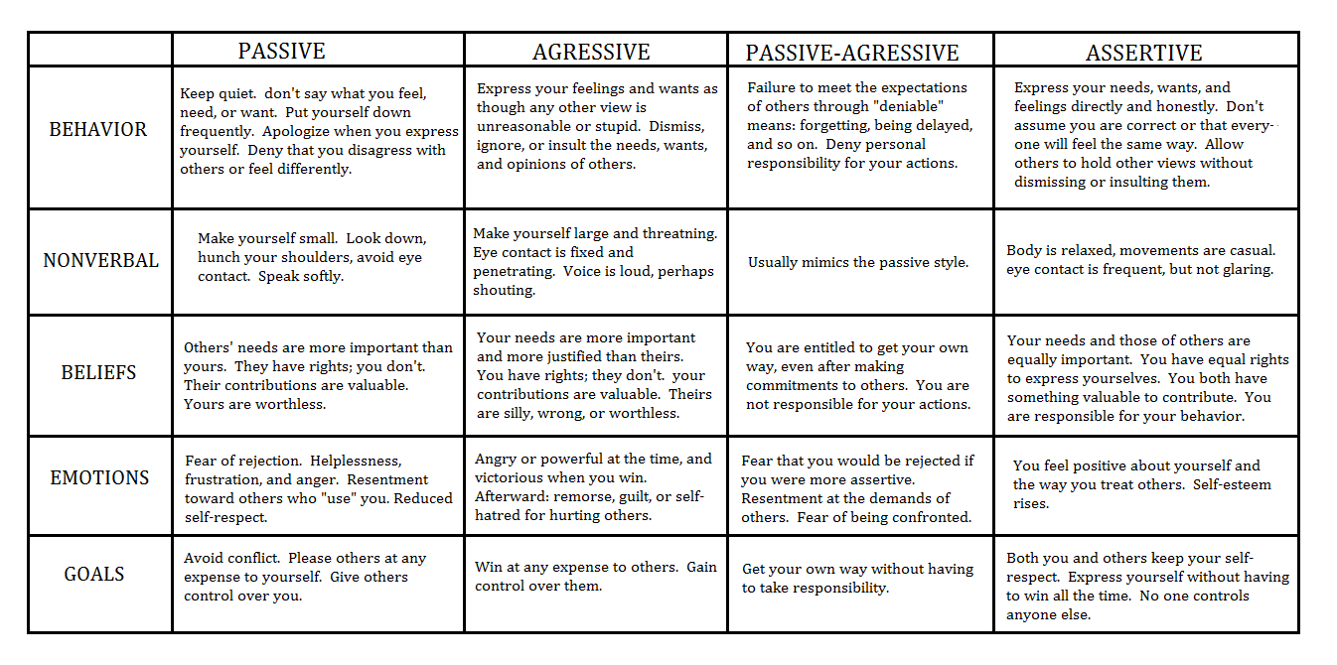

The problem arises when employers fail to adapt or change their style of communication depending on the situation. This could result in a fall in organizational functionality. For example, an assertive communication style might be well received in a firm going through a good time. However, the employees might need to be dealt with in an “aggressive manner” at the same firm in a time of crisis. An assertive style at a time of crisis might fail to communicate the gravity of the crisis to the employees and thus might not elicit the response sought from them. Thus, the communication style of the employers needs to be flexible depending on the situation (Jemielniak, 2016).

- Removal of common hindrances that affect during the communication process: The communication process might be hindered by several factors at any stage like the sourcing stage, encoding stage, channel transmission stage, decoding stage or even the feedback stage (Witte and Davis, 2014).

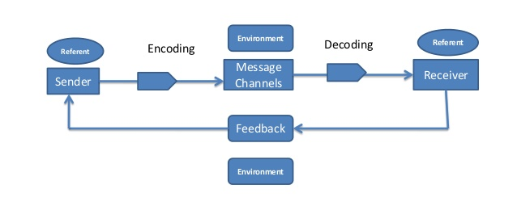

The employers need to identify these hindrances and take measures to ensure that they do not occur. For example, lack of credibility of the sender, physical attributes of the sender, level of power held by the sender impact the quality of communication at the sourcing stage. Similarly, incorrect assumptions about the receiver, insensitivity to culture are common pitfalls during the encoding stage. Usage of wrong medium can harm the communication quality during the message channeling stage etc. The employers need to be wary of this and should take necessary actions to avoid them (Ancona, 2013).

Conclusion

In conclusion, it can be said that effective communication is required at all stages of a firms operations if it is to be successful. Poor quality communication from the employers can have severe detrimental effect on the operations of the firm.

References

- Altman, S. (2013). Organizational Behavior. Elsevier Science.
- Ancona, G. (2013). Team work. New York: Crowell.
- Hellriegel, D. and Slocum, J. (2011). Organizational behavior. Mason, OH: South-Western
- Jemielniak, D. (2016). Communication Styles. London: Routledge.
- Kreitner, R. and Kinicki, A. (2013). Barriers to communication. New York, NY: McGraw-Hill/Irwin.
- Parker, G. (2011). Team Players and Teamwork. Hoboken: John Wiley & Sons, Inc.
- Raelin, J. (2008). Employer’s flaws in communication. San Francisco: Jossey-Bass.
- Robbins, S. and Judge, T. (2017). Organizational behavior. Harlow: Pearson Education Limited.
- Topchik, G. (2007). Business Communication. New York: AMACOM.
- Witte, E. and Davis, J. (2014). Essentials of Business Communication. Hoboken: Taylor and Francis.

