

Programme: Master of Business Administration

Module: Marketing Management
Module code: LCMB7024
Lecturer: Laila Maazouz
Assignment Title: Marketing Environment Analysis

Student Name: Ms Vidhi Solanki
Student ID Number: 2523538
Word Count: 2557

Table of Contents
1.0 Task 1: Analysis of the Marketing Environment 3
1.1 Overview of the Selected Metals or Mining Company 3
1.2 Critical Evaluation of Two External Marketing Environment Actors 3
1.2.1 Natural Environment Actor 3
1.2.2 Political–Legal and Regulatory Environment Actor 6
2.0 Task 2: Strategic Growth and Competitive Positioning 8
2.1 Application of the Ansoff Matrix to Tata Steel’s Lower-Carbon Transition 8
2.2 Recommended Strategic Growth Strategy 11
2.3 Developing Competitive Advantage Through a Lower-Carbon Business Model 11
3.0 Task 3: Critical Reflection on AI Usage 13
3.1 Disclosure of AI Tools Used 13
3.2 Critical Assessment of AI-Generated Outputs 13
3.3 Analysis of AI and Personal Contributions 13
3.4 Ethical and Professional Considerations of AI Use 14
Reference List 15

1.0 Task 1: Analysis of the Marketing Environment

1.1 Overview of the Selected Metals or Mining Company
Tata Steel is a vertically integrated steel-producing company that was established in 1907 and is based in Mumbai and has mining and manufacturing units in five continents (Tata Steel, 2024). The group is capable of 35 million tonnes of crude-steel per annum and hires over 76,000 individuals. Consolidated revenue was 2.321 trillion, EBITDA ₹348.48 billion and profit after tax ₹108.86 billion in FY202526 and ₹23.48 million tonnes of crude steel were generated in Tata Steel India (Tata Steel, 2026a). It strategically integrates scale, captive resources and digital manufacturing and a net-zero target by 2045 (Tata Steel, 2026b).

1.2 Critical Evaluation of Two External Marketing Environment Actors

1.2.1 Natural Environment Actor
The most relevant marketing external actor as far as Tata Steel is concerned is its natural environment, as its blast-furnace model relies on coal, iron ore, energy and water, and steelmaking produces about 7% of CO 2 emissions to the global energy-system (Tata Steel Limited, 2026). Climate change, water stress, air pollution and biodiversity degradation thus not only impact operational legitimacy, but also the perceptions of customers regarding the credibility of Tata Steel products as lower-carbon alternatives. Tata Steel recognizes that its blast furnaces, which are high in carbon emissions, put it at the risk of changing customer and investor demand towards low-carbon content materials.
But the present performance shows change instead of change. Tata Steel has consolidated Scope 1 emissions of 78 million tonnes CO₂e in FY202526, and Scope 2 of 6 million tonnes. At 2.7 tonnes CO₂e per tonne of crude steel, the intensity of emissions was the same as last year (Tata Steel Limited, 2026). This undermines the short-term plausibility of its 2045 net-zero target since there is no fall in carbon intensity at the group-level yet. However, the 0.75-million-tonne Ludhiana scrap-based electric-arc furnace, which should be commissioned in March 2026 and is designed to produce less than 0.3 tonnes of CO₂ per tonne of steel, is a concrete step in the direction of lower-carbon long products (Tata Steel, 2025a).
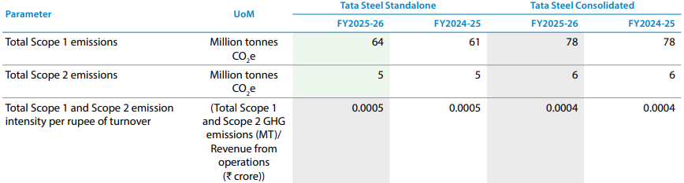
Fig 01: Tata Steel Scope 1 and Scope 2 Greenhouse Gas Emissions
Source: (Tata Steel Limited, 2026)
Electric-arc production is not automatically beneficial to the environment. Its life cycle footprint requires renewable electricity, effective scrap collection and sufficient and high-quality scrap, or some of the emissions are moved upstream. Scalability of commerce is also doubtful. According to Reuters, about half of the global green-steel projects planned had been postponed, and the lack of financing, the lack of green hydrogen, and unwillingness by customers to pay high prices were limiting investment (Lv and Jackson, 2026). In this way, natural-environment pressure generates opportunities of differentiation but might not provide enough demand to pay back the transition costs.
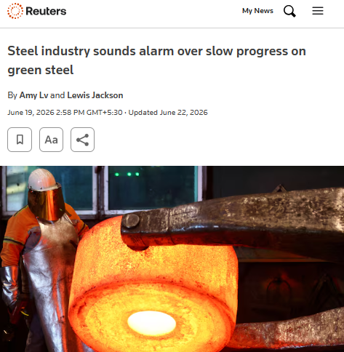
Fig 02: Reuters Report on Slow Progress in the Green Steel Industry
Source: (Reuters, 2026b)
There are other natural pressures besides carbon. In FY202526, Tata Steel consolidated its water consumption to 126,350 million litres compared to 4.08 to 3.99 kilolitres per tonne (Tata Steel Limited, 2026). Meanwhile, the consolidated NOx, SOx and particulate emissions were growing to 35, 73 and 11 kilotonnes correspondingly. Its lifecycle analysis includes products that constitute about 76% of the Indian revenue, which enhances transparency (Tata Steel Limited, 2026). Nonetheless, plausible lower-carbon positioning eventually entails substantiated product-level statistics, cleaner electricity and absolute decreases in carbon, water and pollution. Otherwise, the process of selective environmental marketing might result into greenwashing criticism.

1.2.2 Political–Legal and Regulatory Environment Actor
Political and legal factors are at play on which lower-carbon steel products Tata Steel can create, the certification of these products and the premium that customers would be willing to pay. The Green Steel Taxonomy which is used in India is a recognition of steel that is manufactured with less than 2.2 tonnes of CO₂e per tonne of finished steel, and the five-star recognition of steel with less than 1.6 tonnes (Ministry of Steel, 2025). This provides Tata steel product-development levels and a reputable brand to automotive and construction purchasers. Nonetheless, the taxonomy does not assess performance of plants based on their lifecycle footprint, but the lifecycle of the individual products. Tata steel will thus have to integrate certification with product level carbon statements, lest green statements will ruin confidence and open up to criticism.
Carbon Credit Trading Scheme in India alters the economy of less carbonated products. The compliance framework includes iron and steel with companies that outperform the stipulated emissions-intensity levels being allowed to receive carbon-credit certificates whereas underperformers are required to buy or relinquish certificates (BEE, 2025). This increases the production cost of the traditional production and may enhance the business case of electric-arc furnace, renewable electricity and low-emission product lines. However, unpredictable certificate prices can result in a situation whereby the cost of production cannot be easily predicted, and Tata Steel cannot charge green-steel premiums.
There is an immediate market impact of European regulation. The EU Carbon Border Adjustment Mechanism got into the final stage in January 2026 and imposes a price on the imported iron and stee based on the cost of carbon (European Commission, 2025). The second quarter of 2026 saw the price of the CBAM certificate stand at 75.28 per tonne (EU, 2026). Lower certified embedded emissions of Tata Steel products can thus be more land-price competitive and maintain access to European customers. On the other hand, poor emissions reports or inadvertent checking may push the importers to higher liability and traceability, assurance, as well as carbon documentation should be regarded as vital elements of the product offer.
The pace and magnitude of the transition are dependent upon government assistance. UK is also contributing 500 million to the Tata Steel Port Talbot electric-arc-furnace project worth 1.25 billion speeding up the build of lower-carbon-produced flat-steel, and lowering capital risk (Koolen and Vidovic, 2026). Public support of up to €2 billion might be made in the Netherlands to promote low- CO₂ steelmaking at IJmuiden, although the commitment is not binding, which leaves the timing of the launch of the products and the supply volumes in the air (Tata Steel, 2025b). In general, regulation has the potential to differentiate and provide access to markets, although only when Tata Steel transforms subsidies, carbon costs and certification regulations into quantifiable, competitively priced and reliably supplied lower-carbon products.
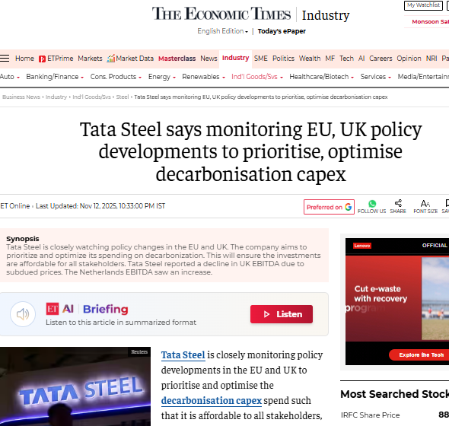
Fig 03: Economic Times Report on Tata Steel Monitoring EU and UK Policy Developments
Source: (The Economic Times, 2025)

2.0 Task 2: Strategic Growth and Competitive Positioning

2.1 Application of the Ansoff Matrix to Tata Steel’s Lower-Carbon Transition
Market Penetration
Tata Steel ought to expand on the current European markets by transforming more of the current customer base into purchases of Zeremis instead of trying to get unknown customers. In FY2026, Tata Steel Netherlands supplied 6.14 million tonnes that will offer a strong base of installed accounts to convert to (Tata Steel, 2026b). Sales teams are encouraged to leverage on current automotive, packaging and engineering projects with bundled Zeremis Carbon Lite, Recycled and Delivered solutions so that buyers can minimize their product, recycled-content, and logistics footprints in a single supplier (Tata Steel, 2026d).
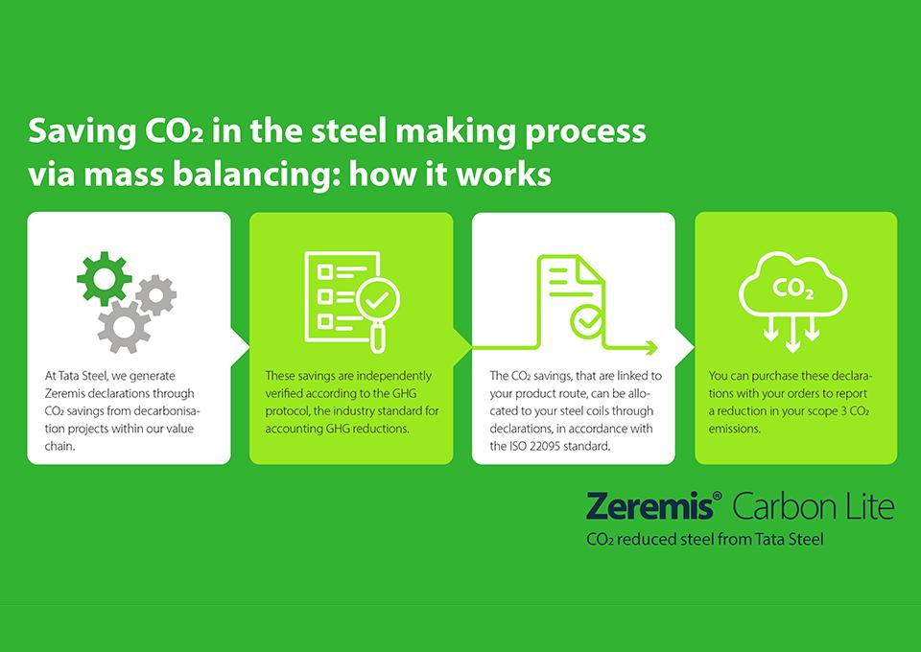
Fig 04: Zeremis Carbon Lite Carbon Reduction and Reinvestment Process
Source: (Tata Steel, 2026d)
This reduces the costs of acquisition and technical reapproval since Carbon Lite can be added to existing steel specification without altering the performance (Tata Steel, 2026d). But mass-balanced claims can cause buyer scepticism. The growth must hence be based on self-assured statements, multi-year volumes and defined levels of premiums. The attraction of penetration happens when Tata Steel transforms substantiated environmental evidence into quantifiable customer value instead of wide-ranging green branding.
Market Development
Instead of changing the core product, Tata Steel should employ market development where it takes Zeremis Carbon Lite and EPD-supported steel to the neighbouring customer groups (Tata Steel, 2026e). Food and aerosol packaging are appealing in Europe as the EU Packaging and Packaging Waste Regulation is usually enforced since 12 August 2026 and thus more and more recyclable and traceable materials are required (European Commission, 2026). The TCCT packaging line of Tata Steel Nederland, ordered in January 2026, offers an avenue through which cross-selling of lower-carbon steel to these customers can be made. In India, the identical low-carbon proposal must aim at the modular and zero-energy construction. December 2025 Tata Steel demonstration (1,836-square-foot light-gauge steel building), required 3.5 months to demonstrate that this method is replicable (Tata Steel, 2025c). Nonetheless, new product penetration must start with pilot contracts due to the possibility of slow adoption caused by packaging qualification cycles and price-sensitive construction procurement.
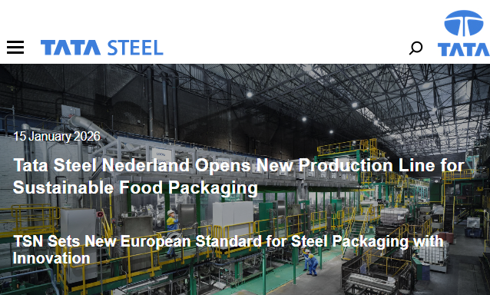
Fig 05: Tata Steel Nederland Sustainable Food Packaging Production Line
Source: (Tata Steel, 2026c)
Product Development
Tata Tata Steel ought to establish certified lower-carbon flat steel to automotive and construction clientele by connecting its proposed 1 MTPA HIsarna demonstration facility in Jamshedpur with grade-specific Digital Product Passports. This strategy has an industrial route instead of being at the laboratory level, as approved by the board in December 2025 (Tata Steel Newsroom, 2026).
The EU Digital Product Passport standards that are implemented in July 2026 show that auditable lifecycle, circularity and compliance data will become more expected by steel buyers (EU, 2026b). In March 2026, Reuters reported that proposed EU vehicle regulations would allow lower-carbon steel to offset the leftover automotive emissions, which would further boost demand in the established accounts of Tata Steel (Mannes et al., 2026). Tata Steel ought to thus co-create grades with customers, certify embodied carbon separately and combine traceability with closed loop scrap services. Nevertheless, HIsarna scale-up, certification compatibility and uncertain premiums warrant pilot contracts prior to full launch.
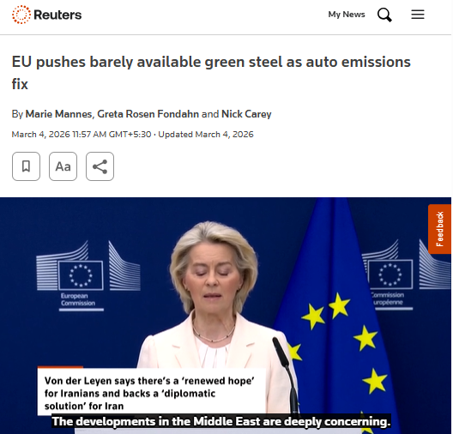
Fig 06: Reuters Report on EU Green Steel Requirements for Automotive Emissions Reduction
Source: (Reuters, 2026a)

Diversification
Tata Steel needs to consider diversification to closed-loop urban-mining services, whereby it collects automotive, construction and appliance end of life steel, and sells certified scrap and recycled-steel contracts to companies other than its purchasers. The company has a 10-15 million tonnes of production on the recycling-route target in 10-15 years, implying that a circular-materials business will have enough scale (The New Indian Express, 2025). This might ensure feedstock, generate service income and enhance traceability. Nevertheless, in June 2026, Reuters stated that the proposed EU scrap-export limitations can narrow supply and increase procurement expenses (Kumar and Arora, 2026). Diversification thus provides control and differentiation, however, at the cost of acquisitions, digital tracking and quality segregation, and at the expense of subjecting Tata Steel to logistics, commodity-price and integration risks.

2.2 Recommended Strategic Growth Strategy
The most powerful strategy is product development since it will be based on existing customers of Tata Steel, manufacturing capacities, and regulatory expertise and develop certified lower-carbon grades, traceability services and closed-loop solutions. Plant-specific studies indicate that decarbonisation of steel necessitates technology options that suit specific assets and more recent data reveal that cost-efficient routes necessitate the integration of technology instead of a single route (Xu et al., 2023; Wu et al., 2025). Phased pilots, customer co-development and independent certification should thus be focused on by Tata Steel before scaling across its automotive, construction and packaging markets.

2.3 Developing Competitive Advantage Through a Lower-Carbon Business Model
By incorporating low-carbon production, proven product data and customer lock-in, Tata Steel can gain competitive advantage, and no longer compete using technology as the sole point of difference. Recycled construction steel can be found in the Ludhiana EAF, with EASyMelt and university collaboration expanding its technology range (Tata Steel, 2025d).
These capabilities must be transformed into sustainable competitive advantage by issuing product passports that are independently verified, buying renewable-power and high-quality scrap contracts, and developing grades via multi-year offtake contracts. According to recent studies, digital product passports enhance traceability and coordination of closed-loop material flows in a circular supply-chain, and steel decarbonisation is increasingly based on the control of closed-loop material flows (Georgali et al., 2026).
This would be hard to replicate as it would combine the production assets, guaranteed data, feedstock security, and embedded customer relationships. It would increase switching costs, defend the market entry and defend evidence-based premiums. Non-binding Dutch funding, however, means that capital must be disbursed only once demand and policy milestones are met, which will avoid excessive investments until customers recognize the value of lower-carbon steel (European Commission, 2025).

3.0 Task 3: Critical Reflection on AI Usage

3.1 Disclosure of AI Tools Used
Relevant academic, governmental, corporate and news sources on Tata Steel's lower carbon transition journey were identified using the ChatGPT tool. It was also used to summarise documents, to compare evidence and to enhance the clarity of draft wording. I took no note of the responses as authoritative. The assessment allows for support with research and proofreading by AI technologies; it does not allow for AI-generated writing of the submission or its argumentation, but only allows for review and rewording, which I have done. It is therefore vital to provide an accurate AI-use acknowledgement, and not stating that only used the AI tool as a search engine.

3.2 Critical Assessment of AI-Generated Outputs
I used source triangulation to evaluate all of the claims supported by AI. The statements made by companies were verified with the government, peer-reviewed studies, and with reliable news reporting and statistics were documented back to the original report. I looked for the existence of each source, matched the author(s) with the title, year and DOI, and analyzed the evidence for the sentence. Walters and Wilder (2023), discovered that generative AI can generate references and make substantive citation errors, indicating that there is no guarantee of accuracy when confidently presenting information. Logical errors were found by comparing figures over the reporting periods and by separating targets from outcomes and eliminating claims of 'lower carbon' production rather than 'carbon neutral' steel.

3.3 Analysis of AI and Personal Contributions
AI played primarily a role in information discovery, initial summarisations, comparison prompts and language refinement. My task was to choose Tata Steel, determine how to use the appropriate evidence, use the Ansoff Matrix, analyse the options and make the final decisions. I continued to accept, reject or modify AI recommendations, and bridge the environmental and regulatory factors with pricing, positioning, market access and competitive advantage. Routinely discredited and promotional sources were rejected as were insufficiently verifiable sources. There are reasons for this difference as AI should aid but not supplant human critical thinking. Moorhouse et al. (2023), maintain that the skilled use of AI will demand AI literacy and transparent communication of the rules on responsible use.

3.4 Ethical and Professional Considerations of AI Use
The primary ethical concerns were inaccuracy of evidence, hidden bias, IP issues and confidentiality and overdependence. There was no organisational information entered into ChatGPT which could be used as confidential information. All interpretations, citations and conclusions were my responsibility. Unverified AI-generated content may mislead decision-makers or over-emphasize sustainability aspects, leading to greenwashing and risk to the brand. As mentioned in the article by Grewal et al. (2024), the concerns with generative AI in marketing include: Hallucinations, Privacy, Bias, Opacity, Misinformation and Intellectual Property Infringement. Transparency, human oversight, source verification and proportional reliance are thus important elements that form the basis for ethical use. My primary takeaway was that AI can broaden the scope of research but that requires the human touch to evaluate the evidence, identify uncertainty and make sure the final analysis is accurate, original and accountable.

Reference List
BEE (2025). Bureau of Energy efficiency (BEE). [online] Beeindia.gov.in. Available at: https://beeindia.gov.in/show_content.php?lang=1&level=1&lid=294&ls_id=189 [Accessed 20 July 2026].
EU (2026a). New digital product passport (DPP) web page launched. [online] Internal market, industry, entrepreneurship and SMEs. Available at: https://single-market-economy.ec.europa.eu/news/new-digital-product-passport-dpp-web-page-launched-2026-07-17_en [Accessed 20 July 2026a].
EU (2026b). Price of CBAM certificates. [online] Taxation and Customs Union. Available at: https://taxation-customs.ec.europa.eu/carbon-border-adjustment-mechanism/price-cbam-certificates_en [Accessed 20 July 2026b].
European Commission (2025). Carbon border adjustment mechanism. [online] European Commission. Available at: https://taxation-customs.ec.europa.eu/carbon-border-adjustment-mechanism_en [Accessed 20 July 2026].
European Commission (2026). Packaging waste. [online] environment.ec.europa.eu. Available at: https://environment.ec.europa.eu/topics/waste-and-recycling/packaging-waste_en [Accessed 20 July 2026].
Georgali, S., Lekawska-Andrinopoulou, L., Chatziioannou, K., Theodoropoulos, T., Tsimiklis, G. and Amditis, A. (2026). Dynamic digital product passports: Advancing circularity and sustainable innovation in the steel industry supply chain. Life cycle management from Global to local, pp.63–72. doi:10.1007/978-3-032-17987-6_6.
Grewal, D., Satornino, C.B., Davenport, T. and Guha, A. (2024). How generative AI is shaping the future of marketing. Journal of the academy of Marketing science, [online] 53, pp.702–722. doi:10.1007/s11747-024-01064-3.
Koolen, D. and Vidovic, D. (2026). Greenhouse gas intensities of the EU steel industry and its trading partners. [online] doi:10.2760/170198.
Kumar, M. and Arora, N. (2026). India seeks EU scrap export relief as curbs threaten trade pact gains. [online] Reuters. Available at: https://www.reuters.com/world/india/india-seeks-eu-scrap-export-relief-curbs-threaten-trade-pact-gains-2026-06-29 [Accessed 20 July 2026].
Lv, A. and Jackson, L. (2026). Steel industry sounds alarm over slow progress on green steel. [online] Reuters. Available at: https://www.reuters.com/business/environment/steel-industry-sounds-alarm-over-slow-progress-green-steel-2026-06-19 [Accessed 20 July 2026].
Mannes, M., Fondahn, G. and Carey, N. (2026). EU pushes barely available green steel as auto emissions fix. [online] Reuters. Available at: https://www.reuters.com/sustainability/climate-energy/eu-pushes-barely-available-green-steel-auto-emissions-fix-2026-03-04 [Accessed 15 July 2026].
Ministry of Steel (2025). Green steel initiative | steel ministry. [online] Steel.gov.in. Available at: https://steel.gov.in/green-steel-initiative [Accessed 12 July 2026].
Moorhouse, B.L., Yeo, M.A. and Wan, Y. (2023). Generative AI tools and assessment: Guidelines of the world’s top-ranking universities. Computers and education open, [online] 5(15), p.100151. doi:10.1016/j.caeo.2023.100151.
Reuters (2026a). EU pushes barely available green steel as auto emissions fix. [online] Reuters. Available at: https://www.reuters.com/sustainability/climate-energy/eu-pushes-barely-available-green-steel-auto-emissions-fix-2026-03-04 [Accessed 16 July 2026].
Reuters (2026b). Steel industry sounds alarm over slow progress on green steel. [online] Reuters. Available at: https://www.reuters.com/business/environment/steel-industry-sounds-alarm-over-slow-progress-green-steel-2026-06-19 [Accessed 10 July 2026].
Tata Steel (2024). Tata steel | company profile & details. [online] www.tatasteel.com. Available at: https://www.tatasteel.com/corporate/our-organisation/company-profile [Accessed 12 July 2026].
Tata Steel (2025a). Tata steel. [online] Tatasteel.com. Available at: https://www.tatasteel.com/newsroom/press-releases/india/2026/tata-steel-inaugurates-its-first-scrap-based-electric-arc-furnace-in-india [Accessed 20 July 2026].
Tata Steel (2025b). Tata steel. [online] Tatasteel.com. Available at: https://www.tatasteel.com/newsroom/press-releases/india/2025/tata-steel-signs-the-non-binding-joint-letter-of-intent-with-the-government-of-the-netherlands-and-the-province-of-north-holland-on-integrated-decarbonisation-and-health-measures-project/ [Accessed 13 July 2026].
Tata Steel (2025c). Tata steel. [online] Tatasteel.com. Available at: https://www.tatasteel.com/newsroom/press-releases/india/2025/tata-steel-and-constructsteel-unveil-a-steel-based-zero-energy-building-in-bhubaneswar-odisha [Accessed 15 July 2026].
Tata Steel (2025d). Tata steel. [online] Tatasteel.com. Available at: https://www.tatasteel.com/newsroom/press-releases/india/2026/tata-steel-signs-mou-with-university-of-science-and-technology-beijing-to-advance-low-carbon-steelmaking [Accessed 5 July 2026].
Tata Steel (2026a). Tata steel. [online] Tatasteel.com. Available at: https://www.tatasteel.com/newsroom/press-releases/india/2026/tata-steel-reports-consolidated-ebitda-of-rs-34-848-crores-and-profit-after-tax-of-rs-10-886-crores-for-the-twelve-months-ended-march-31-2026 [Accessed 12 July 2026].
Tata Steel (2026b). Tata steel: 4QFY2026 and FY2026 production and delivery volumes (provisional). [online] Tatasteel.com. Available at: https://www.tatasteel.com/newsroom/press-releases/india/2026/tata-steel-4qfy2026-and-fy2026-production-and-delivery-volumes-provisional [Accessed 10 July 2026].
Tata Steel (2026c). Tata steel nederland opens new production line for sustainable food packaging. [online] Tata steel nederland opens new production line for sustainable food packaging. Available at: https://www.tatasteelnederland.com/nieuws/en/tata-steel-nederland-opens-new-production-line-for-sustainable-food-packaging [Accessed 8 July 2026].
Tata Steel (2026d). Zeremis carbon lite. [online] Tata steel. Available at: https://products.tatasteelnederland.com/services/sustainable-solutions/zeremis/carbon-lite [Accessed 11 July 2026].
Tata Steel (2026e). Zeremis®. [online] Tata steel. Available at: https://products.tatasteelnederland.com/services/sustainable-solutions/zeremis [Accessed 7 July 2026].
Tata Steel Limited (2026) Business Responsibility and Sustainability Report, Financial Year 2025–26. Available at
https://www.tatasteel.com/media/25901/brsr.pdf
Accessed 20 July 2026.
Tata Steel Newsroom (2026). Tata steel. [online] Tatasteel.com. Available at: https://www.tatasteel.com/newsroom/press-releases/india/2025/tata-steel-board-affirms-the-long-term-strategy-for-growth-in-india [Accessed 5 July 2026].
The Economic Times (2025). Tata steel says monitoring EU, UK policy developments to prioritise, optimise decarbonisation capex. [online] The Economic Times. Available at: https://economictimes.indiatimes.com/industry/indl-goods/svs/steel/tata-steel-says-monitoring-eu-uk-policy-developments-to-prioritise-optimise-decarbonisation-capex/articleshow/125276299.cms?from=mdr [Accessed 10 July 2026].
The New Indian Express (2025). Tata steel aims 15 MT production via recycling in 10-15 years: CEO t v narendran. [online] The new indian express. Available at: https://www.newindianexpress.com/business/2025/jun/15/tata-steel-aims-15-mt-production-via-recycling-in-10-15-years-ceo-t-v-narendran-2 [Accessed 20 July 2026].
Walters, W.H. and Wilder, E.I. (2023). Fabrication and errors in the bibliographic citations generated by ChatGPT. Scientific reports, [online] 13(1), p.14045. doi:10.1038/s41598-023-41032-5.
Wu, X., Meng, J., Liang, X., Sun, L., Coffman, D.M., Kontoleon, A. and Guan, D. (2025). Technological pathways for cost-effective steel decarbonization. Nature. doi:10.1038/s41586-025-09658-9.
Xu, R., Tong, D., Davis, S.J., Qin, X., Cheng, J., Shi, Q., Liu, Y., Chen, C., Yan, L., Yan, X., Wang, H., Zheng, D., He, K. and Zhang, Q. (2023). Plant-by-plant decarbonization strategies for the global steel industry. Nature climate change, 13(10), pp.1067–1074. doi:10.1038/s41558-023-01808-z.

