Celebrating Language and Culture Belonging to Wales

ECIE5004

Erin Mair Walker

2316333
Contents Page

Rationale – Page 3

Welsh Curriculum and Policies – Pages 3 to 4

Practice Links to Theory – Pages 4 to 5

Activities – Pages 5 to 6

Evaluation – Pages 6 to 7

Appendices – Pages 8 to 9

Reference List – Pages 10 to 13

Rationale
Throughout this essay it will be discussed and evaluated how language and culture is important, focussing on how the Welsh language and culture is promoted within schools in Wales. Schools throughout Wales help to support the learning of Welsh language and culture through integrated practice of communicating daily using the language. As well as this, Welsh cultural events such as St Davids Day and Shwmae Day are acknowledged and used to promote the importance and highlight the cultural heritage and language of Wales. According to (Brain, 2018) the Welsh language evolved from a Celtic language known as Brythonic and is the oldest language in Britain dating back to 4000 years with the first Welsh word being persevered around 700 AD. Throughout the history of the language it has faced many challenges to its existence, including migration and the lack of teaching of the language through generations (Denbighshire.gov.uk, 2023).
In 2017 the Welsh Government put in place a scheme named Cymraeg 2050 to increase the number of Welsh speakers in Wales to one million by 2050 (see appendix A) another educational target of the Welsh Governments is to ensure 70% of learners leaving secondary school can speak Welsh by 2050. To reach this target, job opportunities are on the rise for secondary school teachers offering from 500 to 900 jobs by 2031 and 1,2oo by 2050 to educators who can teach in Welsh (Welsh Government, 2017).

Welsh Curriculum and Policies:
The Curriculum for Wales (2022)
According to the Curriculum for Wales 2022 (n.d) the new Welsh curriculum promotes the use of bilingualism within their framework to support learners in their Welsh language skills, this includes making Welsh a mandatory subject with the intent to build confident Welsh speakers. The curriculum outlines the impact bilingualism provides by offering more opportunities to learners. In addition to this the curriculum hopes to embed the Welsh language and culture for use “beyond the classroom”.
The Welsh Language Standards
According to Powys County Council (2016) the standards main aims are to improve the quality and consistency of Welsh Language services in Wales and to ensure organisations are aware of their responsibilities in relation to promoting and supporting the Welsh Language. The Welsh Language Standards recognises that there are two official languages in Wales –Welsh and English. Welsh and English. The legislation supports individuals who choose to use Welsh and ensures both languages are treated equally, so that Welsh is not regarded as less favourable. “As of1 April 2018, the Welsh Language Standards replaced the Welsh Language Act 1993.” (South, 2018).
Donaldson’s Successful Futures
In 2014 Professor Donaldson reviewed the Welsh curriculum to ensure the young people of Wales were receiving the best possible education. Wales were receiving the best possible education. Donaldson’s review concluded that the curriculum should be based on four key purposes (see appendix B). Donaldson’s review emphasised the importance of promoting the Welsh language and recommended making it statutory for learners up to age 16. Other key recommendations included focusing on practical skills such as speaking, listening, and applying language in real-life situations (Donaldson, 2015).
Practice Links to Theory
In 1967 The Welsh Language Act made a significant impact by legally permitting the use of the Welsh language in courts and public services, granting it the same validity as the English language. The main effects from the act were giving Welsh speakers the right to use their language and authorising the translation of official documents into Welsh (Legislation.gov.uk, 2011). The Siarter Iaith Cymraeg Campus framework was made to increase the social use of Welsh language and develop a stronger Welsh ethos throughout schools. The framework encourages and supports learners to develop their Welsh language skills by providing achievable targets, when these targets are met learners are able to earn awards. The Siarter Iaith awards include three levels of achievement, bronze, silver and gold. The purpose of these awards is to make learning Welsh enjoyable and to encourage involvement in the development of language skills (School A, 2023). The use of rewards makes links to Skinners’ Operant Conditioning Theory, Skinner believed in using reinforcements (rewards) to encourage positive behaviours to be repeated (McLeod, 2025b).
Following Professor Donaldson’s review on the Welsh curriculum schools in Wales adapted their curriculum to include the 4 key purposes to build and support “ambitious, capable learners; healthy, confident individuals; enterprising, creative contributors; and ethical, informed citizens”. The purposes were designed to support integrated learning and build a structured curriculum that supports the learning and development of all learners in Wales. The 4 purposes are used within schools to create teaching and learning that addresses learners’ needs and important areas of their learning and development, helping to build confident individuals (Dauncey, 2015). One of the 4 key purpose of being an ethically, informed citizen helps to promote the use of bilingualism and supports the learning of Welsh heritage and culture. This makes strong links to Maslow’s Hierarchy of Needs (see appendix C) of having a sense of belonging and connection to Welsh culture (McLeod, 2025a). According to This is Wales (2018) This sense of belonging can be made through engaging in Welsh language, history and traditions, helping to provide a sense of cultural identity. Participation is celebrating Welsh traditions is encouraged throughout schools in Wales by encompassing historic Welsh events such as St Davids Day and the national Eisteddfodd through the Curriculum for Wales Framework, supporting a sense of connection to Welsh heritage and bilingualism through use of the Welsh language (Development - Cwmni Cynnal 2016-2017, 2021). An example of this is the Eisteddfodd, the celebration of the national Eisteddfodd within schools underpins inclusivity and supports a sense of belonging by welcoming people who aren’t familiar with Welsh language and culture to celebrate and get involved, including minority communities (BBC NEWS, 2022).
According to GOV.WALES (2024) The incorporation of the Welsh language and culture into the curriculum has had a significant impact on increasing cultural understanding, identity and opportunities for learners. Schools have been primarily responsible for empowering young people to strengthen their sense of belonging by providing opportunities for them to develop their language skills. According to GOV.WALES (2023) Schools in Wales have been more efficient in making the Welsh language compulsory for children aged up to sixteen. The 2021 census results showed that only 17.8% of the Welsh population can speak Welsh. “That’s 538,000 people ages three or older”. Unfortunately, according to previous census results it has shown that the number of Welsh speakers has been decreasing since 2001. Attempting to support the increase of Welsh speakers, Dysgu Cymraeg - The National Centre for Learning Welsh, deliver courses to adults wanting to learn or improve their Welsh. The scheme consists of tutor-led courses, available online or face to face and provides a different level including, Entry (for beginners); Foundation; Intermediate; Advanced and Proficiency. Also running schemes to target different groups of speakers, including ‘at home’ speakers and ‘Welsh for young people’. The centre aims to create confident Welsh speakers and support the development and quality of Welsh language speakers (Welsh Language Commissioner, 2021; Learn Welsh, n.d). Another scheme encouraging and supporting the use of Welsh is Cwlwm Busnes Gwent, a group for professionals who live or work in Gwent to use to support the inclusion of Welsh within their businesses. Comparable to Dysgu Cymraeg, Cwlwm Busnes are eager to increase the number of Welsh speakers in their area through helping business to incorporate the language into their practice (Menter Casnewydd, 2025).

Activities promoting Welsh language and culture
Siarter Iaith (Criw Cymraeg)
The Siarter Iaith awards are presented by a group of children within schools known as “Criw Cymraeg” who help encourage the use of daily Welsh. The Criw Cymraeg team are responsible for promoting the use of Welsh language and traditions through organizing Welsh assemblies and competitions. These assemblies usually take place on a weekly basis and keep to a routine of teaching simple phrases and sentences in Welsh. Learners can then be awarded a “Siaradwyr yr Wythnos” award for their efforts to use their Welsh throughout the week. The award ceremony provides an opportunity for learners to be recognised and praised by other peers for their determination to practice their Welsh. This helps to create a goal for learners to work towards throughout the week to earn their reward certificate. The main aim of the Siarter Iaith framework underpins the Cymraeg 5050 scheme by encouraging and supporting the increase and use of Welsh language within schools, these awards help to promote this by praising the effort and involvement of learners (School B, 2023; School C, 2024; Welsh Government, 2017).
St David’s Day
According to BBC Newsround (2025) A traditional Welsh celebration that is celebrated within schools and supports the promotion of both Welsh language and culture is St David’s Day. St Davids Day is celebrated all over Wales on the 1st of March every year, remembering the patron saint, St David, who lived in the 6th century. Schools remember and celebrate St David by representing Welsh culture, by wearing daffodils and leeks as national emblems, eating traditional Welsh foods, wearing traditional Welsh costumes or organizing concerts or parades. Often costumes of a red dragon are worn in parades, as a symbol of the Welsh flag. These celebrations bring attention to Welsh heritage and culture and promote better knowledge and understanding, also supporting the learning and development of the Welsh language (Visit Cardiff, 2025).
Tric a Chlic
Another scheme that supports the learning of the Welsh language for children aged 3-7 is the Tric a Chlic programme. The programme promotes the learning of both reading and writing Welsh, whilst supporting the inclusion of both Welsh-medium schools and English-medium schools by building on existing phonics knowledge. As well as supporting English-medium schools the scheme uses interactive and multi-sensory games, songs and visuals to be inclusive to all learners (see appendix D) and support accessibility, helping to reach out and support more learners to develop their language skills (School D, 2022). The scheme is structured into three stages, first supporting the recognition of sounds, then moving forward onto combining sounds to build and read words, whilst finally segmenting the sounds. By using a systematic method of phonics, Tric a Chlic aims to build a foundation of literacy skills from a young age and encourage fluency and expression in reading and writing in Welsh (Tric a Chlic, n.d). This scheme is followed in schools to teach the Welsh language, using all methods of the programme to support reading, writing and speaking. The Tric a Chlic programme is used weekly in schools to encourage and promote the use of Welsh, the learning is presented through a phonics-style lesson and learners and arranged into groups by following the stages given by the scheme. Depending on the level of ability and stage of the programme, learners are supported to read through a book as a group and ask questions. This is to support a better understanding of their reading and dive deeper into their knowledge of the Welsh language, supporting more opportunities. To reinforce the learning and development of Welsh, schools also use modern technology and physical materials to promote accessibility and support the learning of the language at home (Tric a Chlic, n.d).

Evaluation
Siarter Iaith (Criw Cymraeg)
In conclusion it is clear that the Siarter Iaith awards are an effective and beneficial scheme to promote the use of the Welsh language within schools. The recognition and rewarding of the use of Welsh throughout the week helps to embed a sense of achievement within learners, which then leads to support the reoccurrence of participation in learning, showing links to Skinners operant conditioning theory (McLeod, 2025b). The benefits surrounding the language of the Criw Cymraeg team are that members are encouraged to speak Welsh regularly to improve fluency and confidence whilst encouraging involvement from others. (School E, 2025). A negative that could be highlighted around the Siarter Iaith awards assembly might be that some children don’t like to attract attention and would purposely avoid speaking Welsh to escape being publicly awarded in an assembly. According to Persike (2023) This could have the opposite impact of supporting and encouraging the development and learning of Welsh, as learners may deliberately not use their Welsh language skills to avoid recognition. This could then lead to fostering a negative view on the Welsh language due to the anxiety of receiving an award.
St David’s Day
St Davids Day is a traditional Welsh cultural day that is celebrated all over Wales. It highlights and promotes the Welsh ethos and supports the creation of a sense of belonging for people for people living in Wales through celebrations. Schools provide activities to celebrate the work of St David and rely heavily on looking back on the history of the Welsh heritage to teach a better understanding of Welsh culture. Schools support the celebration of Welsh heritage on St Davids Day by wearing traditional Welsh costumes and symbols, such as leeks and daffodils to promote Welsh identity and express national pride and unity. As part of celebrating St Davids Day some schools in Wales have competitions to create a piece of art of a Welsh symbol or landscape, this helps to get all children involved on creating a piece of art based on Wales. The artwork is then judged, and the winner receives an award in a St Davids Day assembly, along with a picture in the local newspaper with their artwork (Hotchin, 2024). Celebrating historical events like St Davids Day helps learners to build on their identity as a Welsh citizen and develop their knowledge on the history surrounding Wales (BBC Newsround, 2025; Wales, 2022).

Tric a Chlic
It is evident that the Tric a Chlic scheme provides a lot of support, whether it is being used to learn or teach Welsh. It shows inclusivity by catering to a variety of ages and offering levels to work up to, supporting the progression of learners. The programmes can be used through different methods to support the accessibility of leaners who may have additional needs. This programme is used in both English-medium schools and Welsh-medium schools to support and encourage the use of speaking and learning Welsh. The programme supports a healthy relationship with learning and speaking Welsh and supports learners in their journey of becoming bilingual. The Welsh language can offer important opportunities for both professional and personal development. According to Büttler and Inlingua (2023) bilingual and multilingual skills can support and improve overall literacy skills as well as supporting opportunities and providing learners in the future with better job prospects and a better understanding of the Welsh language and culture (Tric a Chlic, n.d).
It can clearly be seen that schools are working towards providing ways to support and encourage the learning of the Welsh language and culture. Programmes are being developed to encourage learners to access the Welsh language and to support the increase of Welsh speakers in Wales.

Cymraeg 2050 - Appendix A - (Bowyer, 2021)
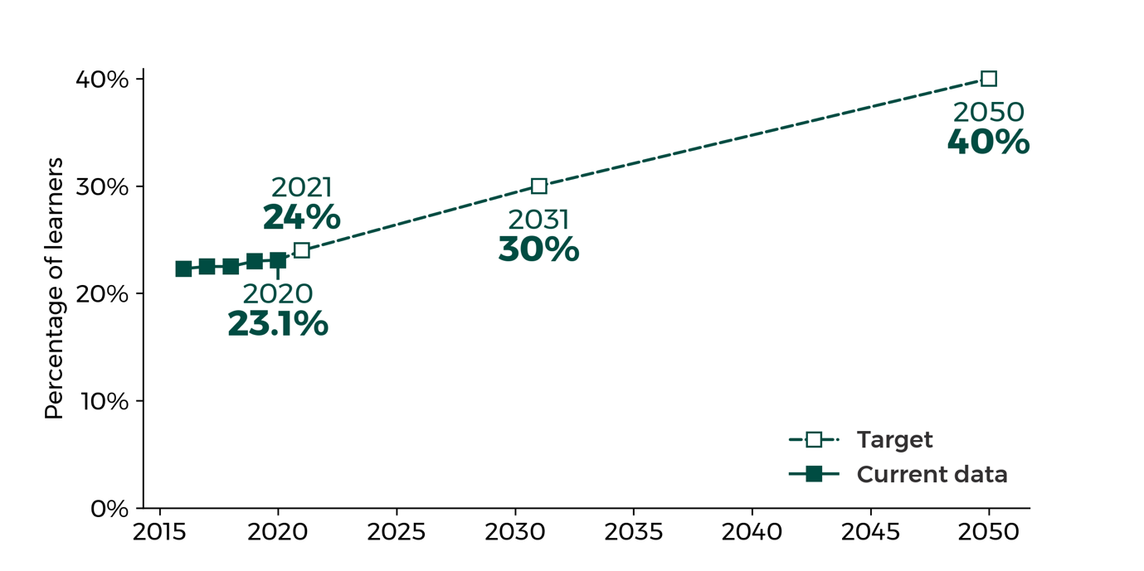

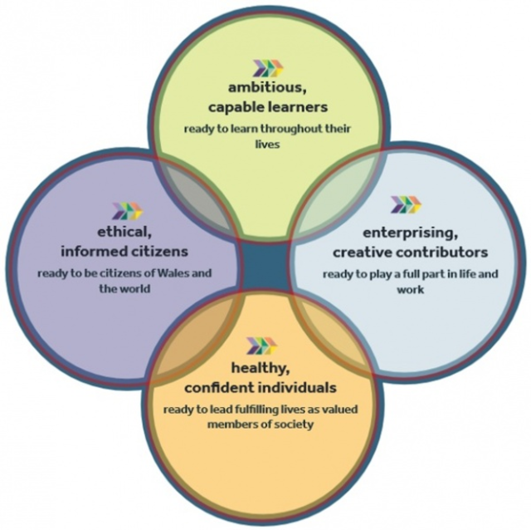

Successful Futures Review - Appendix B – (Wisechs, J, 2021)

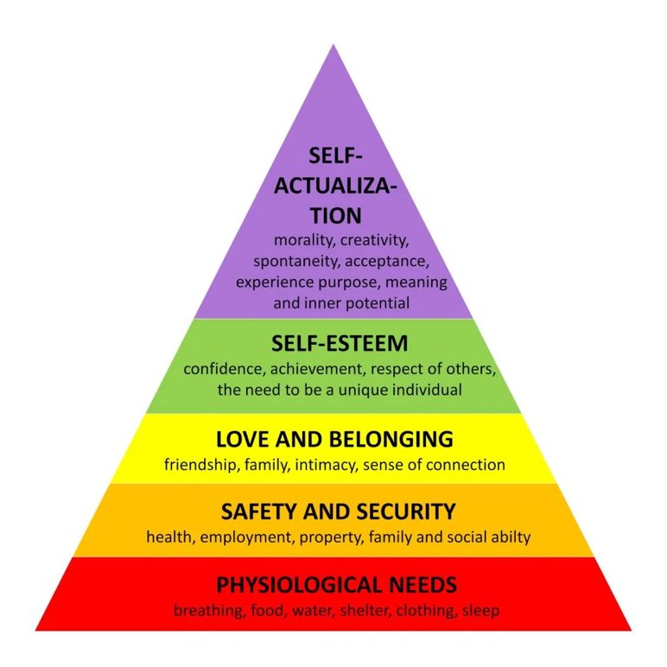

Maslow’s Hierarchy of Needs – Appendix C - (McLeod, 2025a)

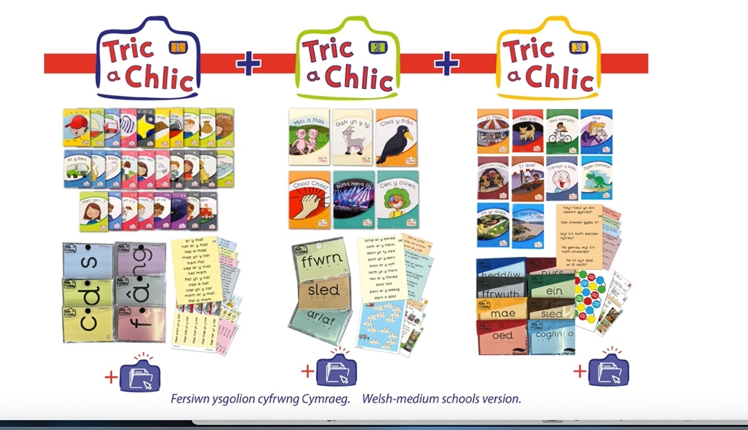

Tric a Chlic – Appendix D - (Tric a Chlic, n.d.)

Reference List
Alaw Primary School. (2023). Criw Cymraeg | Alaw Primary School. [online] Available at: https://www.alawprimaryschool.co.uk/criw-cymraeg/ [Accessed 3 Dec. 2025].
BBC NEWS (2022). Diversity: Does the National Eisteddfod reflect modern Wales? Diversity: Does the National Eisteddfod reflect modern Wales? [online] 6 Aug. Available at: https://www.bbc.co.uk/news/uk-wales-62429851.
BBC Newsround (2025). St David’s Day 2025: Everything you need to know. [online] BBC Newsround. Available at: https://www.bbc.co.uk/newsround/articles/c4g03y1w9pdo.
Bowyer, O. (2021). Is a million Welsh speakers by 2050 achievable? [online] research.senedd.wales. Available at: https://research.senedd.wales/research-articles/is-a-million-welsh-speakers-by-2050-achievable/.
Brain, J. (2018). The Welsh Language. [online] Historic UK. Available at: https://www.historic-uk.com/HistoryUK/HistoryofWales/Welsh-Language/.
Bryn Awel Primary School. (2025). Criw Cymraeg | Bryn Awel Primary School. [online] Available at: https://www.brynawel-primary.co.uk/criw-cymraeg/ [Accessed 4 Dec. 2025].
Büttler, C. and Inlingua (2023). The benefits of being bilingual. [online] inlingua. Available at: https://www.inlingua.com/2023/08/22/learn-a-new-language-at-a-certain-ageabsolutelypodcasts-help-learn-languages-2-2-2/.
Curriculum for Wales 2022 A guide to. (n.d.). Available at: https://hwb.gov.wales/storage/f8f9760c-64a1-48ea-80fd-db130ad9050b/a-guide-to-curriculum-for-wales-2022.pdf.
Dauncey, M. (2015). Donaldson Review: The ‘purposes’ and content of a Curriculum for Wales. [online] research.senedd.wales. Available at: https://research.senedd.wales/research-articles/donaldson-review-the-purposes-and-content-of-a-curriculum-for-wales/.
Denbighshire.gov.uk. (2023). Welsh Language Strategy 2023 to 2028: summary of the challenges | Denbighshire County Council. [online] Available at: https://www.denbighshire.gov.uk/en/your-council/strategies-plans-and-policies/strategies/welsh-language-strategy/summary-of-the-challenges.aspx.
Development - Cwmni Cynnal 2016-2017 (2021). [online] Gwasanaethdysgudigidol.cymru. Available at: https://www.gwasanaethdysgudigidol.cymru/e-gylchgrawnCrefyddGwerthoeddMoeseg/cylchgrawn_22/en/erthygl_2.html.
Donaldson, G. (2015). Successful Futures Looking at the Curriculum and Assessment Arrangements in Wales. [online] Available at: https://www.gov.wales/sites/default/files/publications/2018-03/succesful-futures-a-summary-of-professor-graham-donaldsons-report.pdf.
GOV.WALES. (2023). Welsh Language Education Bill: integrated impact assessment [HTML]. [online] Available at: https://www.gov.wales/welsh-language-education-bill-integrated-impact-assessment-html.
GOV.WALES. (2024). Welsh language linguistic infrastructure policy: children’s rights impact assessment [HTML] | GOV.WALES. [online] Available at: https://www.gov.wales/welsh-language-linguistic-infrastructure-policy-childrens-rights-impact-assessment-html.
Hotchin, B. (2024). Photos- Pembrokeshire schools enjoy St David’s Day. [online] Western Telegraph. Available at: https://www.westerntelegraph.co.uk/news/24157775.photos--pembrokeshire-schools-enjoy-st-davids-day/ [Accessed 6 Dec. 2025].
Learn Welsh. (n.d.). Learn Welsh. [online] Available at: https://learnwelsh.cymru/about-us/the-national-centre-for-learning-welsh/.
Legislation.gov.uk. (2011). Welsh Language Act 1967. [online] Available at: https://www.legislation.gov.uk/ukpga/1967/66/enacted.
McLeod, S. (2025a). Maslow’s hierarchy of needs. [online] Simply Psychology. Available at: https://www.simplypsychology.org/maslow.html.
McLeod, S. (2025b). Operant conditioning: What it is, how it works, and examples. [online] Simply Psychology. Available at: https://www.simplypsychology.org/operant-conditioning.html.
Menter Casnewydd. (2025). Cwlwm Busnes Gwent | Menter Casnewydd. [online] Available at: https://mentercasnewydd.cymru/en/business/cwlwm-busnes-gwent-2 [Accessed 2 Dec. 2025].
Penllergaer Primary School. (2022). Tric a Chlic | Penllergaer Primary School. [online] Available at: https://www.penllergaerprimaryschool.co.uk/tric-a-chlic-1/ [Accessed 4 Dec. 2025].
Persike, C. (2023). The Dark Side of Rewards, Part 1: Why Incentives Do More Harm Than Good in the Classroom - Alliance Against Seclusion and Restraint. [online] endseclusion.org. Available at: https://endseclusion.org/2023/05/06/the-dark-side-of-rewards-why-incentives-do-more-harm-than-good-in-the-classroom/.
Pontarddulais Primary School. (2024). Siarter Iaith | Pontarddulais Primary School. [online] Available at: https://www.pontarddulaisprimaryschool.co.uk/siarter-iaith/ [Accessed 3 Dec. 2025].
Powys County Council. (2016). Welsh Language Standards - Powys County Council. [online] Available at: https://en.powys.gov.uk/article/3268/Welsh-Language-Standards.
South (2018). Welsh Language Standards. [online] University of South Wales. Available at: https://www.southwales.ac.uk/welsh-language--standards/.
St Cyres School. (2023). Siarter Iaith Cymraeg - Welsh Language Charter. [online] Available at: https://www.stcyres.org/page/?title=Siarter+Iaith+Cymraeg+%2D+Welsh+Language+Charter%2E&pid=108.
This is Wales. (2018). Discover Wales: our rich history, culture, heritage, and the Wales of today. [online] Available at: https://www.wales.com/about/welcome-wales/welcome-wales.
Tric a Chlic. (n.d.). Tric a Chlic. [online] Available at: https://tricachlic.cymru/?lang=en.
Visit Cardiff. (2025). ST DAVID’S DAY | DYDD GŴYL DEWI. [online] Available at: https://www.visitcardiff.com/saint-davids-day-dydd-gwyl-dewi/ [Accessed 4 Dec. 2025].
Wales. (2022). Welsh national dress. [online] Available at: https://www.wales.com/about/history-and-heritage/welsh-traditions-myths-and-legends/welsh-national-dress.
Welsh Government (2017). Cymraeg 2050 A million Welsh speakers. [online] Available at: https://www.gov.wales/sites/default/files/publications/2018-12/cymraeg-2050-welsh-language-strategy.pdf.
Welsh Language Commissioner (2021). 2021 Census. [online] Welshlanguagecommissioner.wales. Available at: https://www.welshlanguagecommissioner.wales/policy-and-research/the-position-of-the-welsh-language/2021-census.
Wisechs, J (2021). Why? [online] It’s Where You’re Between. Available at: https://itswhereyourebetweencom.wordpress.com/2021/10/28/why/ [Accessed 29 Nov. 2025].

