Regeneration of Blaenavon

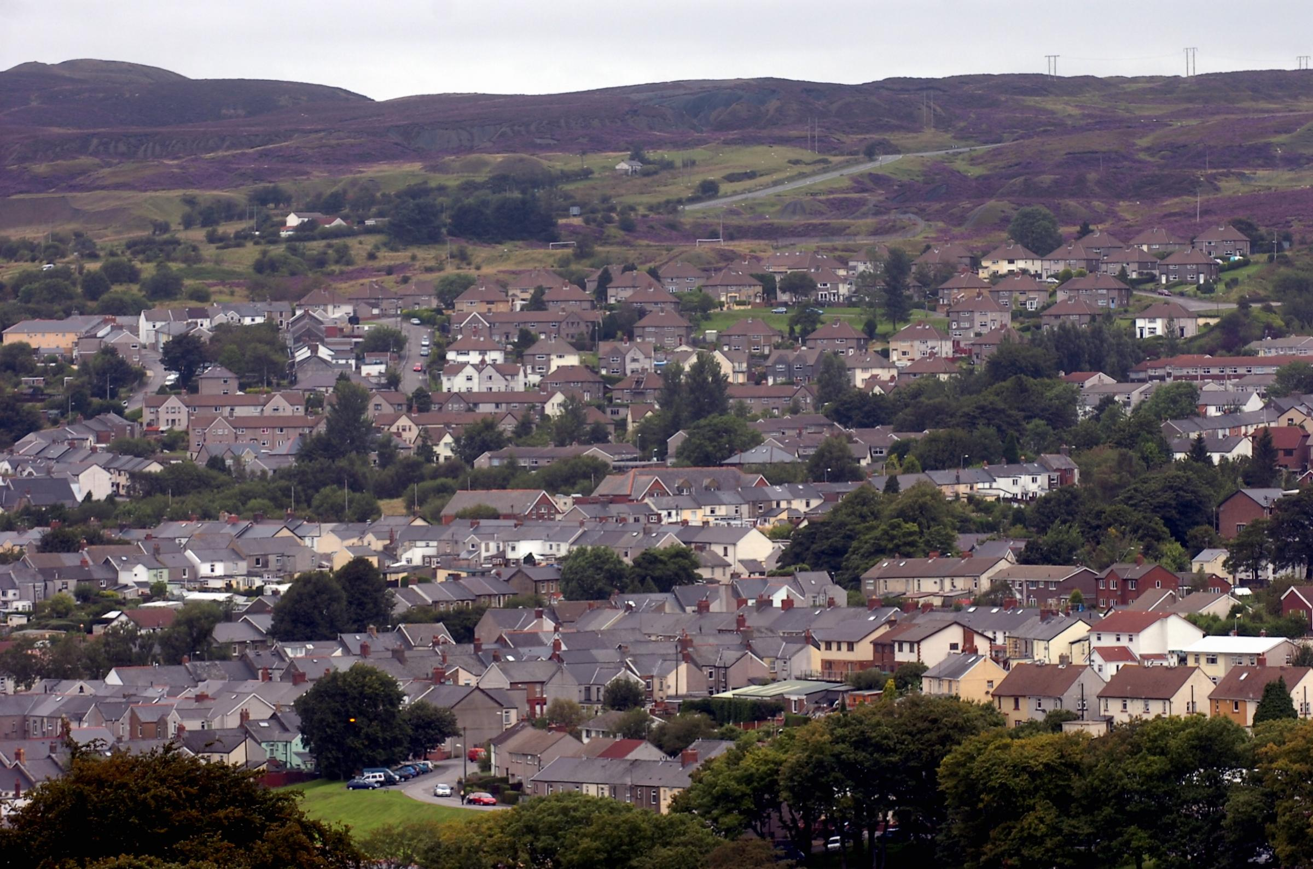

(Free Press,2019)

George Howell

Executive summary

This report looks at the significant role Blaenavon played during the industrial revolution and analyses why the town struggled to adapt to a changing economy after industrialisation. Blaenavon was incredibly prosperous during the 19th century, and considerable investment transformed the area into a vast industrial landscape. In contrast, the 20th century was when the coal industry in Blaenavon declined, and the town has struggled to recover ever since. The report looks at how local authorities capitalised on achieving World Heritage Status and created a successful tourism product. However, despite attracting thousands of visitors each year, Blaenavon has several social and economic issues. There have been several regeneration projects in the past, and the report examines how successful they have been. A stakeholder analysis is included in the document and helps identify the key stakeholder groups for future regeneration. Finally, the report proposes two regeneration projects that will add economic and social value to the town.

Contents page

- Introduction

- Main body

    - Historical development

    - Changing fortunes

    - Existing assets, structures and economic character

    - Key stakeholders and interest groups

    - Local development strategies

  - Regeneration ideas

2.2.1 Proposal one

2.2.2 Proposal two

3 Conclusion

4 Bibliography

- Introduction
Regeneration is a broad term that can apply to many different situations. Pemberton (2019) argues that regeneration is often thought of as maintaining urban areas by focusing on physical redevelopment of city centres and former hubs of industry.
The author goes on to state that regeneration is equally as important in rural and coastal areas. Regeneration needs to focus on physical, social, economic or environmental issues to be successful. The general purpose of regeneration is to revitalise an area through projects that focus on the community's needs. Every location has different challenges and needs. Therefore, regeneration projects need to be appropriate to each area and add long-term value to the community.
For example, many rural areas often have limited job opportunities and high levels of unemployment. Therefore, economic regeneration that focusses on creating jobs would be appropriate and good for that area's long-term prosperity. This could be achieved through education and training programmes or business grants to encourage start-ups. Social regeneration is another type of redevelopment. For instance, a deprived urban area with high crime rates would benefit from social regeneration which focusses on combatting anti-social behaviour. Social regeneration is vital for deprived areas because it builds a sense of community and creates a support network. Blaenavon is a town located in South Wales in the Torfaen County Borough and is 28 miles north of Cardiff. The population of Blaenavon is 6,000. (Office for National Statistics, 2011). Blaenavon is a rural area and historically has always had a strong sense of community.
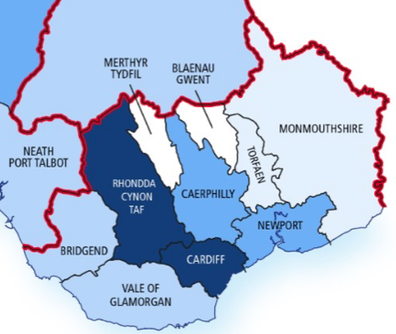

Blaenavon

(Gov.Wales, 2020)

2. Main body

2.1.1 Historical development
In 2000, Blaenavon was listed as a World Heritage site by the United Nations Educational, Scientific and Cultural Organisation ‘UNESCO’. (UNESCO, 2000)
The town of Blaenavon was awarded the honour because of the significant role the area played during the industrial revolution. During this period, iron was in high demand and was used for many purposes. Investors saw Blaenavon as an excellent location for iron production because the landscape was rich in raw materials. In 1788 the Blaenavon ironworks was constructed. The ironworks was a great success and by 1812 annual production of iron rose to 14,000 tons. (Blaenavon Word Heritage, 2010)
Consequently, houses were built within the area, and the population increased rapidly. Many people moved to the area to set up businesses, and the local economy thrived. Towards the end of the 19th century, iron production declined and the ironworks closed. The image below shows the remains of the ironworks.
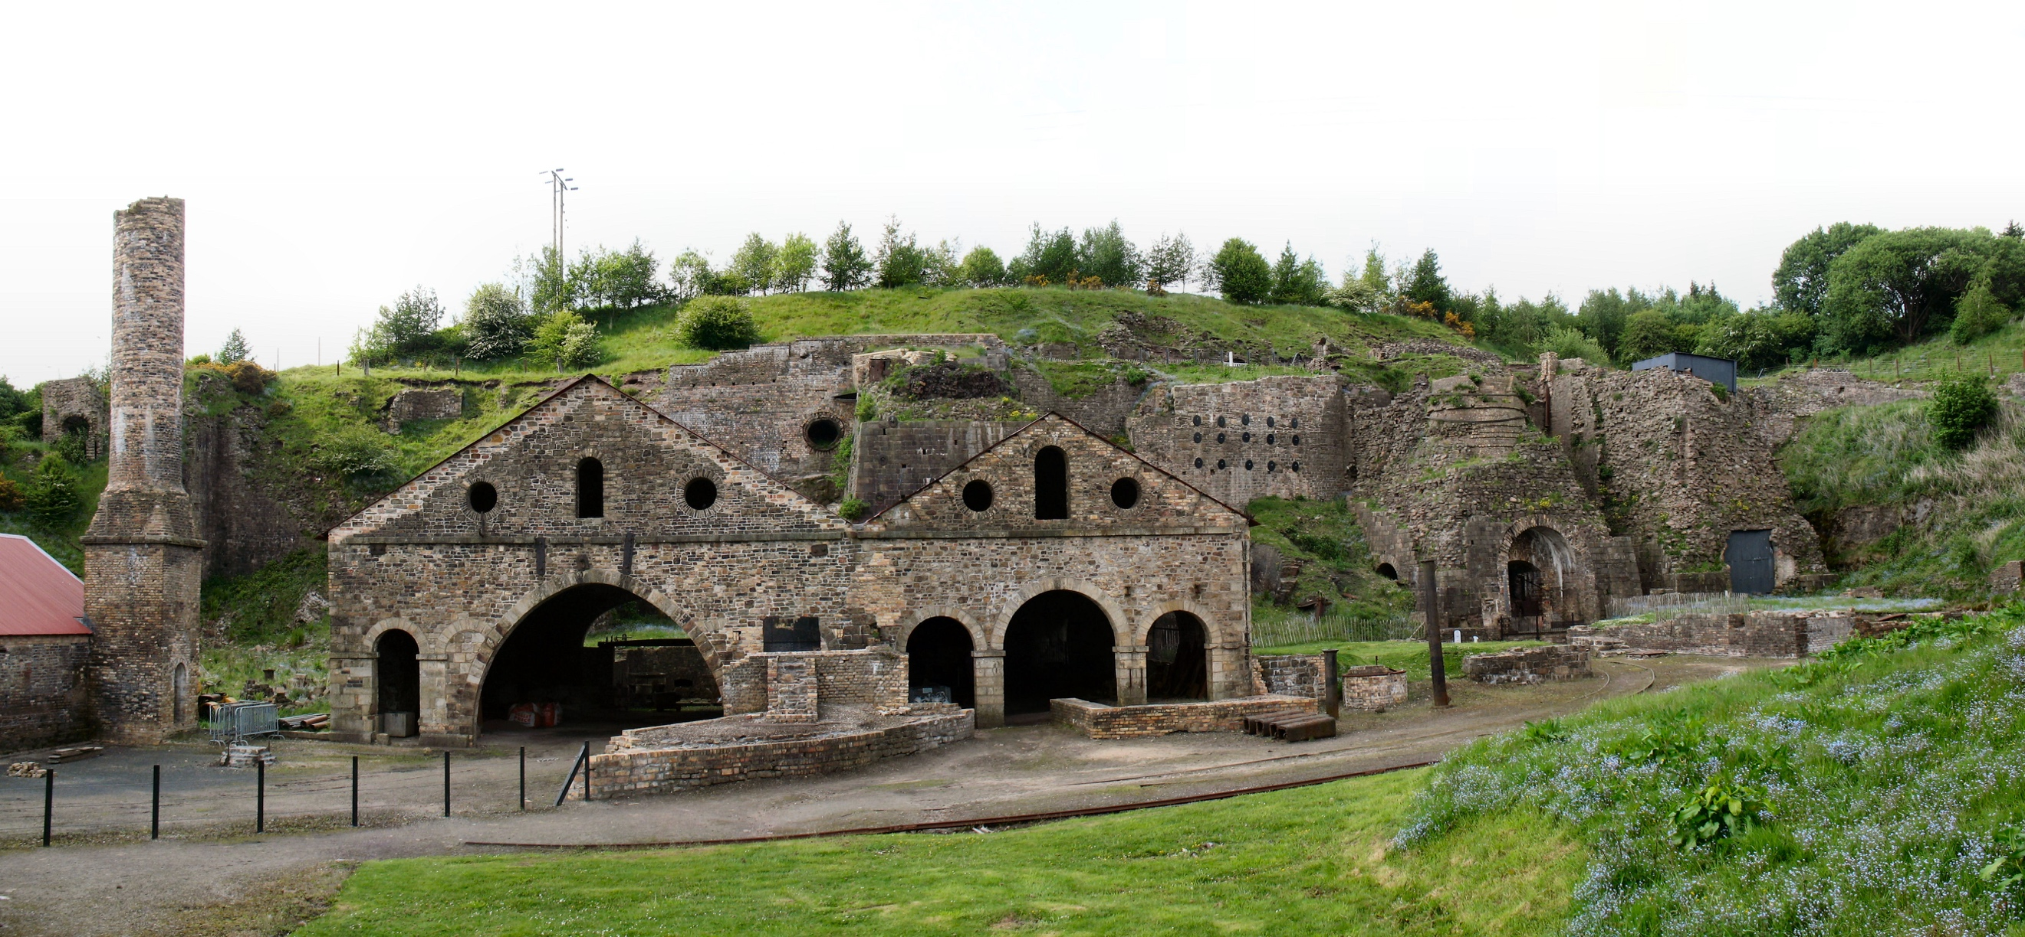

(Blaenavon Word Heritage, 2010)

Since 2008 the ironworks site has been managed by Welsh Assembly agency 'Cadw'.
In the 19th century collieries were a big part of the industrial landscape at Blaenavon. ‘Big Pit’ was at the forefront of coal production in South Wales, and coal mined from Blaenavon was exported worldwide. At the beginning of the 20th century, an estimated 1,300 men worked at the colliery. The majority of Blaenavon workers worked at the coal mine, which helped create a strong community spirit. (Blaenavon World Heritage, 2010)
In 1894 a new facility called the ‘Blaenavon Workmen’s Hall’ was constructed. The building was used as a venue for social gatherings, committee meetings, parties, and entertainment. The facility was a central hub for the town and created a strong sense of community.
The building is still in use today and is used for social events and a museum.
(Blaenavon Workmen’s Hall, 2013)
In two hundred years the area had transformed from a remote landscape to a place of great historical importance.

2.1.2 Changing fortunes

The population of Blaenavon peaked at the beginning of the 20th century to an estimated 12,000 people and industry was thriving. However, the Great Depression in 1929 had catastrophic impacts for Blaenavon. Demand for coal drastically fell, and industry in Blaenavon was heavily reliant on coal mining. After the global economic crisis, Britain faced increased competition from abroad, and coal exports began to fall. Fall in demand resulted in mass unemployment, and many collieries in South Wales had to close. (Historic UK, 2019)
'Big Pit' closed in 1980 and was the last coal mine to operate in Blaenavon. Closure of the mine had a devastating impact on the community. Unemployment rose, and many families had to relocate to find work. During the 1950s the 'Workmen's Hall' also started to decline. Families were more inclined to stay at home in the evenings because of the rise of radio and television. The revolutionary technology changed how people chose to spend their time, and communities became disconnected. A combination of digital entertainment and a declining population meant fewer people were using the building's facilities. (Blaenavon Workmen’s Hall, 2013)
At the beginning of the 21st century, the town's population was 6,000, and an estimated 70% of the town's buildings were boarded up. (Heritage Fund, 2019) Blaenavon did not adapt well to the changing economic climate, and 200 years of industry came to a halt.

2.1.3 Existing assets, structures and economic character

Blaenavon was recognised as a World Heritage site in 2000, and this status helped the town strengthen its brand image. Tourism in Blaenavon has been a big focus for Torfaen County Council for the past two decades. The ‘Big Pit National Coal Museum’ is a valuable asset to the town and attracts many people to the area. In 2017 an estimated 141,000 people visited the museum. (Visit Wales,2017)
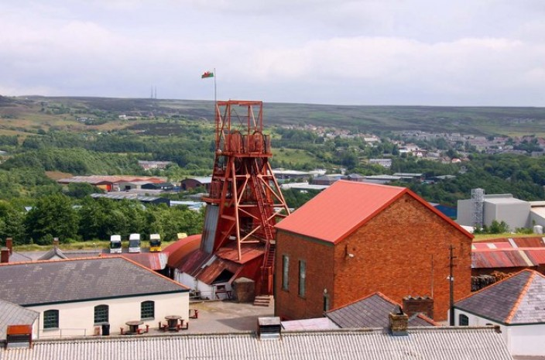

(Brecon Beacon, n.d)

The Blaenavon Ironworks is another prominent tourist attraction which attracts around 42,000 people each year. In total, the World Heritage site has an estimated 475,000 visitors a year. (Visit Wales,2017) Tourism is vital for the area’s cultural identity and improving the town’s image. The people of Blaenavon are proud of their town, and each year the community celebrates World Heritage Day.
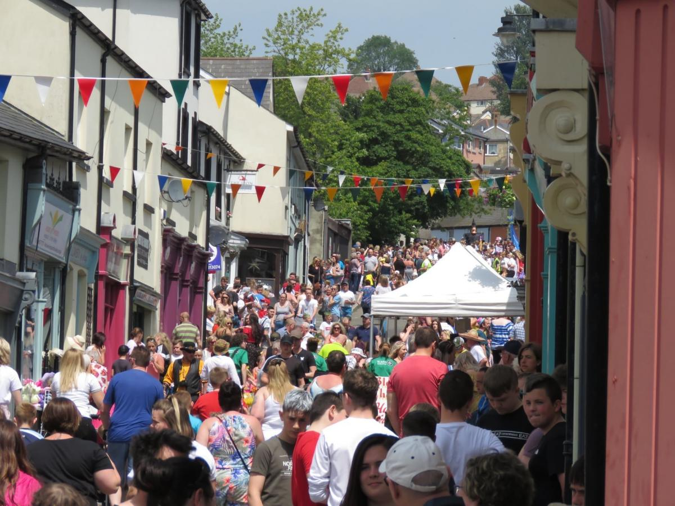

(South Wales Argus, 2019)

However, despite developing successful tourism attractions, the town of Blaenavon is not economically prosperous. One-fifth of Blaenavon's residents are income deprived, and the number of residents aged between 16-24 who are unemployed is 2.1%. This is 1.2% higher than the national average. (Torfaen Public Service Board, 2017) An estimated 37 % of residents are in full-time employment, and the town's leading industry is manufacturing. (Torfaen Public Service Board, 2017) There is a lack of job opportunities for young adults living in Blaenavon, and this issue needs to be resolved. The percentage for anti-social behaviour in Blaenavon is high compared to the national figure.
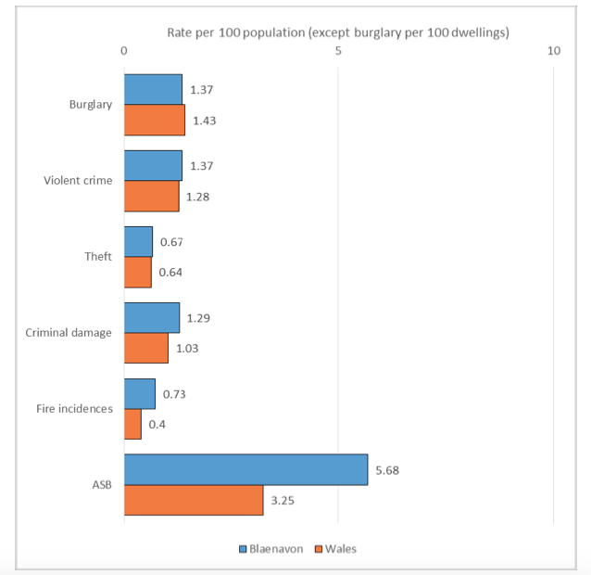

(Torfaen Public Service Board, 2017)

A survey conducted in 2016 by Torfaen Council asked residents about their thoughts regarding Blaenavon. The survey found that people valued the sense of community spirit and neighbourliness within the area. However, respondents expressed that the town needs to tackle anti-social behaviour and invest in more leisure facilities. (Torfaen Public Service Board, 2016)

2.1.4 Key stakeholders and interest groups

It is essential to conduct a stakeholder analysis whilst planning a regeneration project to identify which groups of people need to be considered during the development process. (Product plan, 2019) Identifying stakeholders ensures that all key groups are involved in the planning process, and issues can be resolved. However, it is unlikely that all stakeholder groups will approve of every detail within a regeneration plan, so both sides need to compromise.
The first stakeholder group for Blaenavon is residents. Regeneration projects can only be successful if residents are enthusiastic about any potential proposals. If residents feel like a suggested proposal is out of the touch with the town’s needs, they will object the idea. Therefore, it is vital to understand their needs to ensure regeneration adds value to the area. Local MP's and councillors are another important stakeholder group. They have a significant influence on key decisions regarding the area and understand the local community's needs.
For this reason, it is essential to involve them in any development plans from the early stages. Business owners are also an important stakeholder group. Regeneration of the area needs to support local businesses and not have negative consequences. Similarly, landlords of local buildings are a key stakeholder and need to be considered if regeneration plans involve their premises.
Another stakeholder is the World Heritage Centre. This stakeholder wants to preserve the landscape and ensure regeneration is in keeping with the town’s historical structure. The final stakeholder group is the media. The local media may be critical of regeneration projects, and this can influence public opinion. Below is a stakeholder matrix that categorises each stakeholder based on their interest and influence regarding Blaenavon's regeneration.
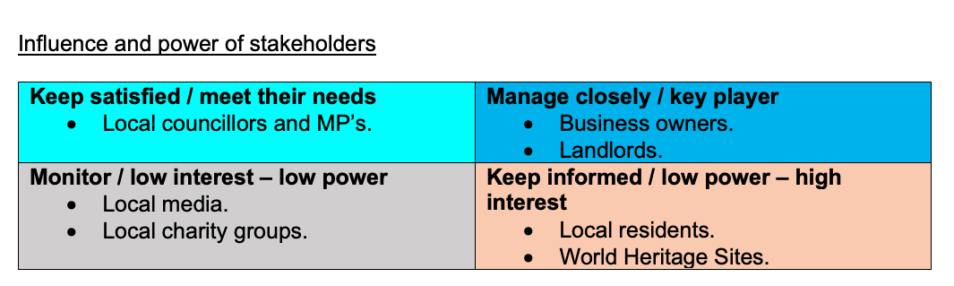

2.1.5 Local development strategies

Previous regeneration has focussed on preserving historic buildings and developing the town centre. At the beginning of the 21st century, local authorities introduced plans to invest in Blaenavon's tourism industry. Torfaen County Council saw tourism as a suitable option for improving the local economy and establishing a sense of pride within the community. Investments from organisations such as the ‘National Lottery Heritage Fund’ helped Blaenavon improve its World Heritage Site and create a successful tourism industry.
(Heritage fund, 2019) St. Peters school was one of the historic buildings that were renovated and converted into the World Heritage Centre. The regeneration project has been successful, and an estimated 40,000 people visit the building each year. (Visit Wales, 2017) There has also been regeneration focused on the development of the high street. In the early 2000s, some commercial properties on Broad Street were restored. (Torfaen County Council, 2017) Since regeneration, there have been several independent businesses that have opened on Broad Street. ‘Quirkey HQ’ is an independent located on Broad Street which opened in 2016. The business sells a range of products including gifts, upcycled furniture and toys. (Torfaen County News, 2016) There were a further two independents that opened on Broad Street in 2019, indicating that regeneration of the street has been successful. One business owner expressed that they feel the regeneration of the high street has positively impacted the town. (South Wales Argus, 2019) However, local authorities have stated that the high street still needs further regeneration. (Torfaen County Council, 2017)

2.2 Regeneration proposals

2.2.1 Proposal one

- The first proposal is to build a youth hub facility in Blaenavon town.

As referred in section '2.1.3' of the report, one of the main areas of concern for Blaenavon residents is the lack of leisure facilities within the town. Respondents stated the area needed more facilities for young people. As a consequence of a lack of facilities, there are increasingly more young people out on the streets, which encourages anti-social behaviour. Blaenavon currently has one leisure facility situated in the town. The ‘Blaenavon Active Living Centre’ has a fitness suite and sports hall. (Blaenavon Leisure) However, the facility has been there for many years, and the building is run down. For this reason, the facility does not appeal to the majority of young people in the area. The town needs a youth centre that caters for the needs of all young people within the community.

The youth facility would consist of several functions each serving a different purpose. The facility would be specifically for young people aged between 11 and 21. The youth facility would operate on a membership basis, and members would pay a monthly fee. The facility would include:

- A multi-purpose sports hall.
- An arts and crafts studio.
- A recreation area.
- A kitchen and café.

The sports hall will cater to several sporting activities including football, tennis, badminton, netball and table tennis. The room will also be used to facilitate social events such as conferences, seminars and group discussions. Regular workshops will take place at the facility. Local business owners will be invited to meet with youth members and discuss how their business operates. Youth members will develop their employability skills and receive insights into several businesses across multiple industries. It is important to inform the younger generation of the history of Blaenavon. One way of achieving this could be through hosting workshops in the arts and crafts studio. Local members of the community would be invited to the facility to explain the history of Blaenavon. Youth members could then use their knowledge to create art which tells the story of the town. This function will allow members to develop their creative skills and appreciate the town’s heritage. Members of the club will also have access to a recreation room with digital entertainment and a reading area. Youth members can use this space to interact and meet new people from within the community. The final function of the youth facility will be a kitchen and café. The kitchen will promote healthy eating by cooking nutritious foods and drinks. The food and beverage service could also provide employment opportunities for some members of the youth facility. The development would provide a secure environment for young people to spend their time and would reassure parents that their children are safe.

The first potential barrier to the regeneration project is funding. The development would be expensive and therefore, would require detailed planning. However, having a World Heritage status means Blaenavon may be eligible for financial support. Local councillors and community leaders will play a crucial role in seeking financial support for the regeneration project. Local members of the community could also host fundraising events to help generate revenue. The 'Blaenavon appraisal and management plan' specifies that all developments within the heritage area need to follow guidelines. Some of the guidelines include using specific building materials, windows and doors. Following the guidelines will restrict the design of the building. One solution could be to complete the regeneration project outside of the heritage area. Another solution may be to work within the guidelines and add modern touches where acceptable.

The regeneration project would have several positive implications for Blaenavon. Firstly, there would be a mix of activities scheduled each night at the facility. This would combat anti-social behaviour as there would be fewer young people out on the streets. Secondly, the development would create new jobs for the area. This would reduce Blaenavon’s unemployment figure and offer new opportunities for local residents. Finally, young people would develop employability skills through workshop programmes. The regeneration would add value to the area and would be welcomed by the majority of the community.

2.2.2 Proposal 2

- The second proposal is to develop Broad Street.

As mentioned in section ‘2.1.5’ of the report, Broad Street requires further regeneration, and there are several properties currently unoccupied. Repurposing vacant buildings will increase footfall and attract visitors to the town centre. Currently, many tourists visit historic World Heritage attractions but do not visit the town centre. Therefore, regeneration is needed to enhance the aesthetic appeal of the street and attract new customers.

The regeneration proposal for Broad Street consists of three elements. These are:

- A new public square.
- New street furniture.
- Reduced rent on commercial buildings for the first 12 months.

A new public square will create a large space for pedestrians and new opportunities for the community. The area will provide an open space for the public to interact and socialise. There will also be the potential to launch a regular farmers market. A weekly food market would boost trade and also attract visitors to the town centre.

The next element of the regeneration proposal is to add street furniture. Appearance is crucial for a successful high street, and visitors are more likely to visit the area if the street is aesthetically pleasing. The first measure is to plant hanging baskets and flowers throughout the street. A team of volunteers could implement the measure, and this would help create a welcoming environment. Secondly, a new bike rack could be placed on the street. A secure bike parking station will encourage more people to cycle to the area and will also help reduce air pollution. The final measure is to place more litter bins and a recycling station on the street. This will help to keep the street clean and tidy.

The final element is to reduce rent on commercial properties for business start-ups. A rent scheme would be in place for the first 12 months of trading and would be reduced by 20 or 30%. To implement this proposal Torfaen County Council and other community groups will need to work with landlords to get their approval regarding the rent scheme. To optimise the town centre's potential all commercial properties must be occupied. Reducing the price of rent will encourage start-ups and offer an incentive for business owners. Independent businesses increase footfall to the town centre and increase trade within the area. For example, ‘Blaenavon Cheddar Company’ is the only business in the UK that matures cheddar 300 feet below ground in a coal mine. (Welsh Government, 2019) The business is respected within the area and is popular among residents.

A potential barrier to the regeneration project is that a rent scheme for new start-ups may be perceived as unfair by current business owners. Business owners located on Broad Street will feel they are also entitled to a reduction in rent. Another potential barrier is that some landlords may be unwilling to reduce the rent for a property. A support package could be arranged to subsidise both business owners and landlords to overcome these barriers. Another barrier is that some community groups may be opposed to the public square development. The new space may attract young people at night, and this may encourage anti-social behaviour. Measures could be imposed to restrict activity in the public square late at night. Another barrier is that Broad Street is narrow and constructing a public square may be challenging. However, there are unused buildings at the top of the street so it would be possible to construct.

The regeneration of the town centre would have many positive impacts on Blaenavon. Firstly, the local economy would benefit from increased trade within the town. Local authorities would receive extra tax revenue as a result of new business start-ups. The revenue would be re-invested into the area to maintain and improve public services. Secondly, there would be increased footfall as tourists would be more inclined to visit the town centre. Thirdly, there would be new job opportunities for residents of Blaenavon.

3. Conclusion

In conclusion, Blaenavon would benefit from both regeneration proposals. Both projects tackle social and economic issues. A high percentage of Blaenavon's residents are income deprived. Both proposals will create several job opportunities for the younger and older generation. A lack of job opportunities will result in residents leaving the area to find work. This would not be good for the town's future prosperity. Regular workshops held at the facility will ensure young adults are prepared for future job opportunities. Young adults will be educated about the history of Blaenavon through creative activities. This will ensure young adults are engaged when learning about their town's history and will feel proud of their heritage. For many decades the high street has been neglected due to a lack of investment in the area. There is a stark difference between footfall at tourist attractions and footfall at the high street. Regenerating the street should help the entire area benefit from tourism and not just the World Heritage Sites. The regeneration projects focus on the community's needs and will have a positive impact on the town if implemented.

4. Bibliography

Blaenavon World Heritage. (n.d) Image Gallery. Photograph of ironworks.
https://www.visitblaenavon.co.uk/en/WorldHeritageSite/ImageGallery.aspx#11 (Accessed 11/01/2021)

Blaenavon World Heritage site. (2010) History of Big Pit. https://www.visitblaenavon.co.uk/en/Publications/Blaenavon-Story/Big-Pit.pdf
(12/01/2021)

Blaenavon Workmen’s Hall. (2011). History. https://blaenavonworkmenshall.uk/history
(Accessed 12/01/2021)

Blaenavon World Heritage. (2010). Blaenavon ironworks a brief history. https://www.visitblaenavon.co.uk/en/Publications/Blaenavon-Story/Blaenavon-Ironworks.pdf (Accessed 11/01/2021)

Brecon Beacons. (n.d). Photograph of Big Pit National museum. https://www.breconbeacons.org/business/attraction-big-pit-national-coal-museum
(Accessed 13/01/2021)

Department for Economy, Science and Transport. (2017). Visits to tourists’ attractions in Wales. https://gov.wales/sites/default/files/statistics-and-research/2019-05/visits-tourist-attractions-2017-summary.pdf
(Accessed 13/01/2021)

Free Press. (2019). Photograph of Blaenavon. https://www.freepressseries.co.uk/news/18017821.three-councillors-resign-blaenavon-town-council-less-six-months/
(Accessed 10/01/2020)

Heritage Fund UK. (2019). Restoring the prosperity and pride of Blaenavon.
https://www.heritagefund.org.uk/news/25-years-restoring-prosperity-and-pride-blaenavon
(Accessed 12/01/2021)

Historic UK. (2019). The Great Depression in Britain. https://www.historic-uk.com/HistoryUK/HistoryofBritain/Great-Depression/
(Accessed 12/01/2021)

Office of National Statistics. (2011). Census 2011: Population and household estimates for Wales.https://www.ons.gov.uk/peoplepopulationandcommunity/populationandmigration/populationestimates/bulletins/2011censuspopulationandhouseholdestimatesforwales/2012-07-16 (Accessed 10/01/2021

Pemberton, S. (2019). Rural regeneration in the UK. (1st Ed, pp.08-12). Taylor and Francis.

Product Plan. (2019). Stakeholder analysis. https://www.productplan.com/glossary/stakeholder-analysis/
(Accessed 13/01/2021)

South Wales Argus. (2019). Small businesses are helping boost town.
https://www.southwalesargus.co.uk/news/17965807.small-businesses-helping-boost-town/
(Accessed 14/01/2021)

Torfaen Public Service Board. (2017). Well-being of Blaenavon and its communities.
http://www.torfaenpublicservicesboard.co.uk/en/Documents/Assessment-of-Well-being/Part-2-Well-being-of-Blaenavon-and-its-communities.pdf
(Accessed 13/01/2021)

Torfaen Public Service Board. (2016). Well-being survey results. http://www.torfaenpublicservicesboard.co.uk/en/Documents/Assessment-of-Well-being/Appendix-1-Well-being-Questionnaire-Survey-Result.pdf
(Accessed 13/01/2021)

Torfaen County Council. (2017). Blaenavon town centre conservation area appraisal and management plan. https://www.visitblaenavon.co.uk/en/Publications/Blaenavon-Townscape-Heritage-Programme/Blaenavon-Town-Centre-Conservation-Area-Appraisal-and-Management-Plan-2017-2022.pdf
(Accessed 14/01/2021)

Torfaen County News. (2016). Quirkey business opens on Blaenavon high street.
https://www.torfaen.gov.uk/en/News/2016/June/22-Quirkey-business-opens-on-Blaenavon-high-street.aspx
(Accessed 14/01/2021)

United Nations Educational, Scientific and Cultural Organisation. (2000). Blaenavon industrial landscape. https://whc.unesco.org/en/list/984/ (Accessed 10/01/2021)

Welsh Assembly Government. (2020). Summary statistics by regions of Wales. https://gov.wales/sites/default/files/statistics-and-research/2020-05/summary-statistics-regions-wales-2020-629.pdf (Accessed 10/01/2021)

Welsh Government. (26/02/2020). Blaenavon case study [Video]. YouTube. https://www.youtube.com/watch?v=aXZNAvOChHM
(Accessed 14/01/2021)

