Workplace Culture
BMSW 5105

Student - Rume Meah
ID - 1813924
Lecturer – Eric Osei

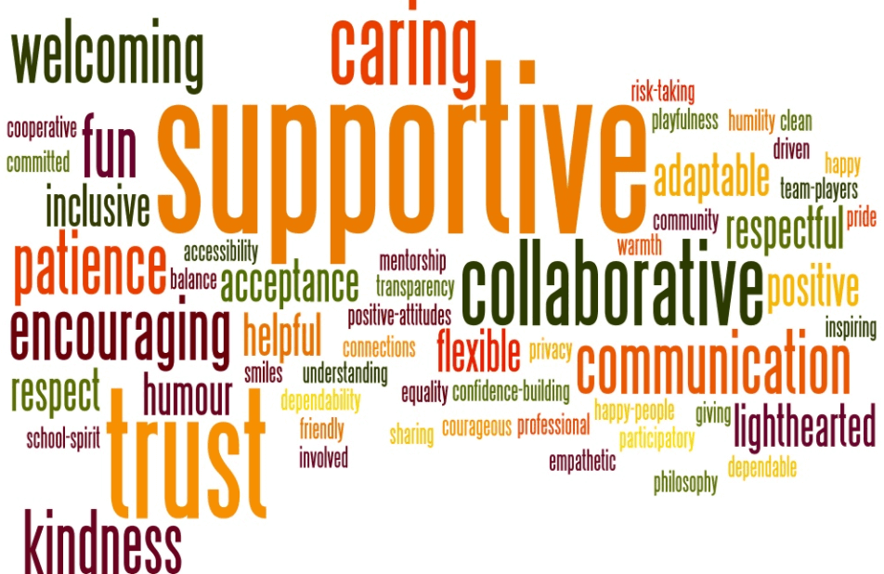

Table of Contents
Page
- Introduction……………………………………………………………………….…..3
- Industry Analysis using PESTEL…………………………………………………..4
- Analysis of the Balfor Recruitments Culture using Mckinseys 7S……………...7
3.1 Strategy …………………………………………………………………………………7
3.2 Structure………………………………………………………………………………… 9
3.3 Systems………………………………………………………………………….……. 10
3.4 Skills…………………………………………………………………………………….10
3.5 Staff………………………………………………………………………..………….. 11
3.6 Style…………………………………………………………………………………… 11
3.7 Shared Values…………………………………………………………………….…..12
4. Barriers to Balfor Recruitments Culture – Beers Model…………………….14
5. Globalisation on Organisational Culture……………………….……….……15
6. Conclusion…………………………………………………………………..…..16
7.References…………………………………………………………………..…..17
8. Appendix…………………………………………………………………………19

- Introduction
Workplace Culture
Culture is the personality of your organisation, positive culture attracts the best talent, satisfaction, drives engagement and is made up of an individual’s values, beliefs, tradition, behaviour, interaction and attitude.
Aim
To assess workplace culture, the environment that’s it resides in and how beneficial or not it is within the modern world that we now live in. This will include analysing various concepts and ideology that is being applied throughout organisations.
I will be basing my assignment on Balfor Recruitment, who are at based at 3 Brindley Place, Birmingham, B1 2JB.
According to companies’ house (2020), it is a private limited company owed by Jaswinder Singh Bal, with no additional shareholder. This company has been running since 1st November 2016.
Methodology
I will be using Qualitative primary and secondary methods which includes research into Balfors organisation, interviewing the CEO Jaz Bal, using McKenzie’s 7S to ascertain any need for improvement within the company.

- Industry Analysis using PESTEL
In any organisation, external research is imperative to the success of a company i.e. Risk management. One tool which is widely used is PESTLE, (Rastogi, Trivedi, 2016) it is a strategic analytical tool which helps define external (macro) influences on a business. The areas it covers are Political, Economic, Social, Technological, Legal and Environmental.
PESTLE ANALYSIS of Balfor Recruitment (Appendix 1)
Political factors
These factors have a direct influence on the Recruitment process. All these factors must be considered in making a sound decision on recruiting i.e. relocation a candidate abroad, family may need to be considered, each country will have selective opportunities and strengths, the more information that is gathered will be beneficial to the company and candidate.
BREXIT will affect (Salemme, 2017) the UK’s anti-trust law, by being outside of the EU and the single market, the legal requirements of public and private competition will need to be re-established. Principles of Legality for businesses must be formed for the UK, as any short-term radical changes will be detrimental for the UK Market.
Economic
These points must be considered to fully comprehend company profit, is it beneficial? By researching tax, inflation, exchange rates etc, you can determine if it will affect business profit and candidate’s salary. It is critical, as to get this right as it will heavily influence the candidate in whether they will accept given position.
Social
Social directives are important, as it will impact the candidate’s lifestyle. By researching into these factors you can determine the social and cultural differences within the environment that you will be placing the candidate, as the environment the candidate will be placed in must be acceptable, else it will influence the permanency of the candidates placement.
Technological
Technology is the way forward to keep up with competitors, it enhances a company’s reach, they can maximise profit if it is used the right way. It produces opportunities by increasing the geographical scope of the company i.e. candidates abroad etc. As with anything the companies need to determine which technology will be beneficial to them i.e. profit/ loss, long-term investment, what the network coverage is, knowledge, the availability etc.
Environmental
A countries environmental standard will have an impact on different markets, Governments provide incentives where companies are using eco-friendly products, Balfor can invest in energy efficient Green Car’s for a company car. Should Balfor extend to globalisation, market research would be required to find niche to enter in the best way.
Legal
Company’s must consider that not all legal frameworks and institutions are robust enough to protect intellectual rights which is an organisations idea, concepts, information, unregistered/ registered patents, data, copyright, trademarks, design rights. By overlooking these legal requirements, it can lead to company theft, therefore impacting your competitive advantage. Companies must on point with legalities.
How does UK Recruitment agency compare to Slovakia Recruitment?
According to Kundracikova, A (2015), due to Political instability within Slovakia, will impact the emplyoment and Government stability is a huge factor. Economically, by becoming an independent Republic the business legislation has been changed, hindering up and coming entrepreneurs, in general the economy slowed down because of this. Socially - the “minimum income support” has not been based on actual living cost. Therefore, the government is not helping people who are on the poverty line. Slovakia heavily relies on funding via Foreign Direct Investment, this has significantly decreased impacting investments in Technological advancements ie Research and Development, therefore negatively impacting intellectual property, cluster development. Even though there are Laws in place for Legality, in reality due to the decline in income, companies who are owed monies, do not have support to extract monies back, there are no penalty structure in place, so alternative routes have to be taken, thus legal proceeding in Slovakia are very lengthy. Environmentally, in 2012, 76.7% of their municipal waste was deposited in landfills, this begs the question how well they are recycling waste? There has been a new waste act December 2014, as Europe’s recycling target set for 2020 is at 50%.
Recruitment is now a globalised market, with the support of FDI, worldwide franchises can be formed to help with R and D, intellectual properties.
To summarise business environments directly influence growth, the use of PESTLE in a business/ country is important to ascertain how to develop the company to full potential by considering in depth ALL macro factors, businesses strategize by alternative routes, minimalizing disruptions. i.e. Covid 19 pandemic, since first identified in November 2019, employers in most countries have placed protocols for employees to work from home. Balfor recruitment must regularly keeping track and make necessary changes to keep up with competition within the industry.

- Analysis of the Balfor Recruitments Culture using Mckinseys 7S
McKinseys 7s is a tool which analysis’s the internal layout of an organisation by looking at 7 key components, hard – strategy, structure, systems and soft - shared values, staff, style, and skills, to see of the organisations is aligned to meet their objectives (diagram 1), and find where improvement is required.
Diagram 1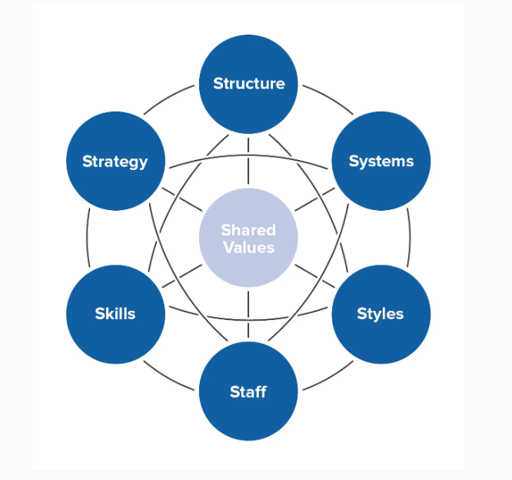
  - Strategy
Balfors strategies are based on their core values, mission statement (appendix 2) to “create and manage client and candidate relationships”.
Long Term Strategy
Balfor has been in business for over 20 years, they have a brand name (logo) providing a competitive edge, Jaz Bal (CEO) promotes himself as self-starter entrepreneur from a consultant to CEO of the company. Their strategy is recruiting experienced staff in the field, additional training, and precision marketing, interaction with the staff and managers.

Short term strategy
Balfor Education uses a short-term marketing strategy, campaigning in sourcing candidates over the summer period June to August, this involves heavily marketing via adverts in local schools, word of mouth, emails, job fairs etc. This involves sifting and interviewing 15 candidates a day, obtaining all documentation required to register.
However consistently recruiting candidates does not mean longevity in a placement is guaranteed, there is the factor of whether there will be a cultural fit, a consultant may have the ability to choose the candidate but not necessarily a culture fit. Within any organisation, cultural fit is important (Testa, Mueller, Thomas, 2003), deeply held values and behavioural norms rooted within the national culture help predict positive behaviour, higher performance, and self-efficiency. If this is not aligned, employees will be less satisfied, not motivated and lead to less productivity.
Balfors objectives are to bring in new customers/ clients. Managers/ consultants identify where the shortfall of vacancies are, by obtaining contact details i.e. education – schools, via phone internet, by data analysis of local/ national market trends, background research to see potential gap, marketing via social media campaigns, job fairs, telephone, emails, price promotions. Focus is on customer relationships for competitive sustainability. However, in this pandemic climate, video calling candidates/ clients are being held (Soleck-Borowska, 2019), this takes away from building quality relationships, and infringe upon data confidentiality.
There are many self-start up recruitment agencies, competitive pressure is very high as long as you have the right skill set and finances in place it can be considered relatively easy to get into, but finding the right clients and skill set candidates can be hard. It is all down to how strong relationship skills employees have.
Customer demands are dealt with by focusing on real world problems, using feedback to innovate the recruitment process, collaboration within the organisations and candidates, making processes in the most user friendly, simpler way possible.
Balfor is gearing towards a paperless environment, paperwork is now scanned into the system, but originals are kept for storage in accordance to Companies Act. Carpooling is encouraged for employees and when there are client visits, making sure that appointments count collectively as a business.

  - Structure
Balfor is organised through coordination, the upper level employees are primary overseers, they coordinate and develop plans to achieve their vision. The divisional structure focus on niche market, helping build a common work culture which contribute to a better knowledge of their sector and help their portfolio. However, a disadvantage of a divisional structure is that there is negativity for competitiveness within each team, therefore office politics may undermine strategic thinking i.e. – allocation of company budget etc
Balfor use the traditional organisational hierarchical structure (appendix 3) organised into specialist sub set departments, each department has its own skill set employees, reporting back to their hierarchical manager, who then report back to the upper level management.
Employees have a goal-oriented strategy, working day is broken down to segments, there are time constraints to meet daily objectives (appendix 5)
Centralised Management decisions incorporate feedback from employees, data analysis of current trend in client’s requirements/ candidates, reporting back to the CEO, to implement strategies.
The communication network (Condruz-Bacescu, 2020) is defined as the environment that information and messages are exchanged, factors include having a good communication plan, mutual understanding of employees, quality of listening.
Balfor’s information is shared through weekly formal collaboration via team/ management meetings – discussing targets, where they are now, where they need to be, email/ telephone correspondences, access to client/ candidate database. Informal information is shared through casual and a conversational way within the workplace and outside. These channels create a balance of positive atmosphere to help promote productivity. However, where formal information is structured, informal information is relayed within an additional context of opinions, emotions, gossip which are uncontrollable and continuously changing, impacting the environment positively or negatively.

  - Systems
Balfor have an initial candidate application which is completed via their website, enabling CV upload onto the software recruitment system, designed to incorporate all client/ candidate information, helping match sector and experience. Database manages potential client marketing lists that are contacted to encourage business. The day is broken down via tasks assigned (Appendix 5)
Each level employees have access to what is required to do their job via passwords. i.e. Accounts access to payroll and invoices, consultant access to candidate and client information, admin access to candidate information. These are controlled by management and helps organise employees focusing on the tasks assigned to them.
Progress is tracked through analysing data i.e. number of clients, candidates, positions available, cost margin of roles, potential marketing etc.
Employees sign contracts, outlines what is expected of them in the course of their employment. These are confidentiality agreements and salary, working time etc.

  - Skills
Employees are recruited in accordance to their Job requirements (Appendix 4).
To match candidate vacancies to suitable clients, employees are recruited to have certain natural characteristics (Kinnunen, Parviainen, 2016), in addition to a CV, for affective decision making, consultants must have flare for recognising potential candidates skills and characteristics to match the job requirement. Good vibrations and gut feelings help consultants in selecting an ‘organisations person fit’. Even though these skills can be learnt, there is an element of natural abilities. Trainees require on the job learning, interactive tools, handbooks. All Employees have quarterly 1-2-1 assessments, this is monitored whether they have hit their personal weekly, team monthly targets.
The organisation is known being in the business for well over 20 years, they have won multiple awards and help charitable trusts i.e. Birmingham Children’s Hospital – CEO Jaz Bal took part in Sutton Coldfield Run, 2017 (JustGiving, 2017). They are part of the community of Birmingham which makes them influential as a business.
  - Staff
They consist of 26 employees and CEO. Staff are recruited via identifying market research gap as Education, Healthcare and IT sector are higher value-added markets these have been predominant in Balfors success.
A good atmosphere is required to meet the fast-paced working, they have an open plan office, with an open-door policy to the CEO, helping with communication. Consultants have a basic salary which is boosted by commission – incentive. Incentives are provided by means of “Employee of the Month” recognition, which is based on sales, the individuals photo would be framed and placed in a prominent position for all to see, also annual functions held for best team, employee – win all-inclusive weekend away.
Consultants have access inhouse candidate database, job boards, indeed, Monster, government job boards to upload job vacancies. Trainee staff are recruited with underlying characteristics needed to do the job (appendix 4). They are trained on the job with the manager overseeing their development by means of a personal development plan, any additional training needs are incorporated into the work schedule.
According to Jaz Bal, CEO (Appendix 10) there is an impact on retention of employees, due to the fast passed and pressure of environment.
  - Style
The management style is lead from example, paternalistic, managers have over 5 years’ experience in given fields. As it is an open plan office, even though it’s a fast-paced environment, employees share banter throughout the day. Individuals have various characteristics by shared common underlying traits (appendix 4) however trainee consultants will require resilience to succeed.
Managers resolve issues as soon as possible, however there are employees who aren’t teamwork orientated, when they’re initially recruited on paper, they have the desirable traits but, under pressure employees may act out. Management address these issues and provide feedback as what is expected, if this does not improve within a timescale then they are dismissed.
Within teams, employees function collaboratively but amongst sectors there is a form of competitiveness to do the best. Recruitment is all about meeting goals, to do this, they must have energy and motivation to do well, nominal behaviour is not at all acceptable.
  - Shared Values
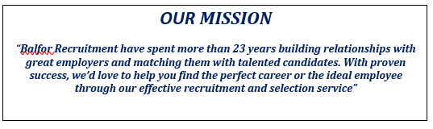
Balfor’s commitment is to supply skilled candidates to the right organisations, by creating a database which records, candidate data, vacancies attended – feedback from clients helps provide a good knowledge of future profitable placements.
Ideally Balfor employees should have shared values, but as there a mixture of personalities, values may differ. There is a natural competitiveness within teams as there may be a candidate that both consultants may require, this leads to passive aggressive attitude. These scenarios are often left to the candidate to decide which position they would like to take. If these feelings are not aired, then there will be resentment within the colleagues.
Recruitment is fast paced, and heavy workloads/ goals can lead resentment and this manifests in office politics, creating workplace bullying (Giorgi, 2012), affecting health and indirectly the organisation. The organisation climate must become the mediator to counteract the problem arising.
To summarise (Appendix 10) in this pandemic Balfor are not achieving (Diagram 2) retention of employees, they lack diversity in their present staff, mostly of the white ethnicity. The candidate client relation will help if they diversify their employee for candidate engagement as lower end of the social care candidates are primarily of foreign ethnicity, people who have come into the UK found that with minimal training and 6 months experience can easily lead to becoming a carer. In the UK (The Health Foundation, 2020) found that Black and Minority workers make a large share of key workers in London (Diagram 3).

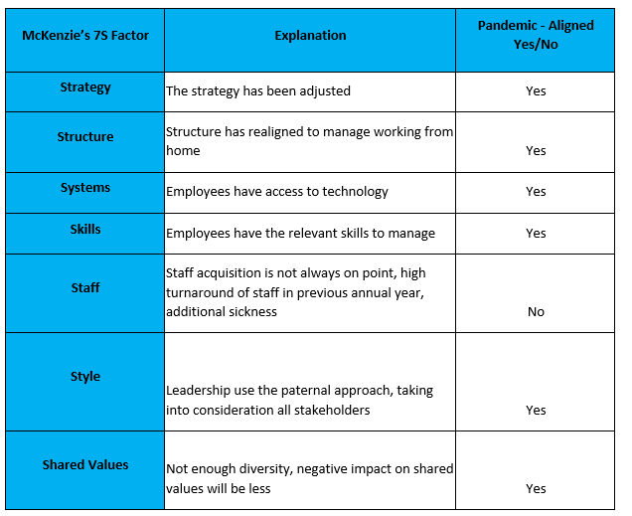
Diagram 2

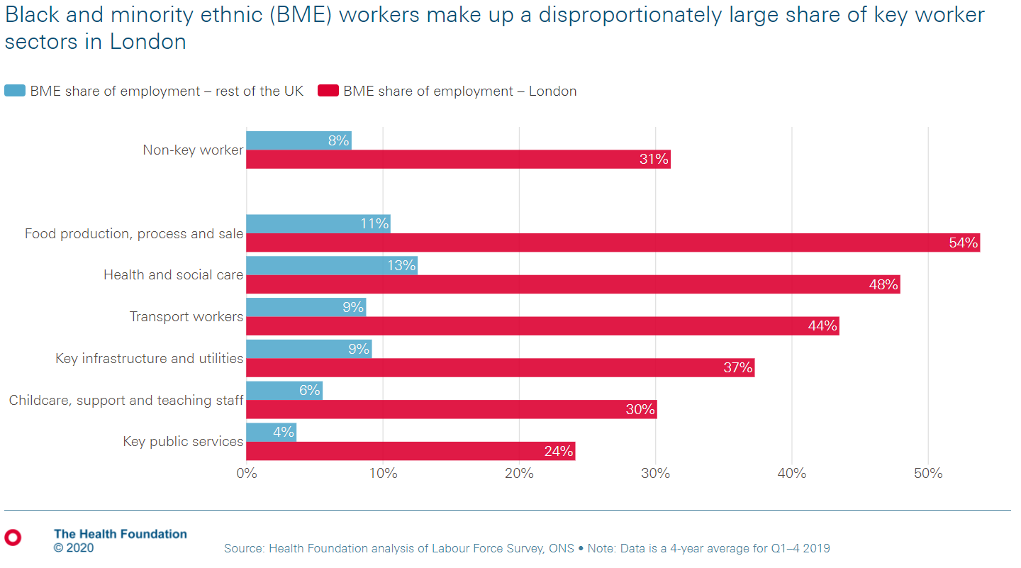
Diagram 3
- Barriers to Balfor Recruitments Culture - Beers model
Beers model identifies that there are underlying weaknesses in organisations, that even though are paramount in a successful organisation, if overlooked will have a detrimental effect if not addressed. Strategic Fitness Model (Beer, Voelpel and Leibold, 2005) help understand management level to identify problems and tackle this with systematic strategy based on the real time data.
Balfors organisation structure does not accommodate horizontal collaboration amongst lower level employees therefore affecting key communication.
Within this COVID 19 pandemic, Balfor will need to realign its organisational structure (appendix 7) to show transparency amongst shareholders, collaborating all lower level employees, keeping clients in the know. Employee workload may increase/ decrease, pandemic sickness will require all employees to be cross trained across all sectors. Employees who work from home, must have accessible data, IT technology (servers) must adapt to enable this change, concerns must be transparent, feedback required from all shareholders to realign strategies. Goals must be realistic and obtainable, as employees all have the same underlying traits values and vision, training must consistent.

5. Globalisation and culture in Recruiting
Globalisation (Tomlinson, 1999) is a complex course as it involves simultaneous changes across world economy, a country’s politics, cross channel communications, the physical environment, and its culture, across international boundaries. In short globalization refers to interdependent and interconnections which symbolise modern societal life.
Globalisation is an opportunity for the recruiting arena. Due to advanced technology and skilled workers, recruitment mobility between countries has become easier.
Recruitment agencies who are gearing towards globalisation must restructure their business corporate value, culture to diversity. Expanding talent pools with low barrier to entry will create new opportunities however this is also causing more competition within the market. You will need to ascertain where the opportunities arise with high cost effectiveness with minimal disruption.
Balfor don’t have a diversity of ethnicity within the organisation, so culture is limited. A research and Development team will need to see how they can break into overseas recruitment i.e. Tax Laws & Employment laws, Corporate and Cultural differences, Long distance communication challenges Implementation of needs assessment conduct surveys to ascertain best market to break into i.e. Vietnam has low labour costs, etc. Strategically recruiting skilled foreign national and practicing inclusiveness. By eliminating cultural/ language barriers will help retain employees. Adapting procedures to include language instruction and training etc. In depth stakeholder (appendix 9) analysis is required to find how adaptable Balfor can be should they globalise.
Globalisation for Balfor is will not necessarily mean saving costs as global labour is increasing i.e. Russian engineers (Overman, 2016) are paid more than someone who is doing the same job at Silicon Valley. Every society have different cultural norm, and expectations from jobs. In the EU, females in a managerial position is at 36% (Europa, 2019).

6. Conclusion
Culture is pinnacle in any environment, it defines the person from their core. The nature of the organisations is influenced by everything, people, policies, management, leadership are some aspects that impact culture. Diversity is key in embracing the differences. McKenzies 7 has provided an insight into Balfor and highlighted that they must work on their employee retention, Balfor need expand the ethnicity of the current staff for full potential should they branch to globalisation. Emphasis is in providing Talent acquisition - if you cannot put the right people in the right positions then it is detrimental to any organisation. HR must select the right person fit to meet their cultural environment to retain staff and expand and apply awareness courses.
In this global pandemic Balfor will struggle as they are a medium sized business, their well-known brand in being in the business will provide edge but retainment of staff/ candidates and clients will be difficult as their diversity is limited. In addition, office politics can have an adverse influence in the environment, leadership must pinpoint the reasons and address these according.

7. References

- Balfor Group Limited. (2020) Companies House Available at: https://beta.companieshouse.gov.uk/company/10455124 (Accessed: 21 September 2020).

- Beer, M., Voelpel, S.C., Leibold, M. and Tekie, E.B., 2005. Strategic management as organizational learning: Developing fit and alignment through a disciplined process. Long Range Planning, 38(5), pp.445-465.

- Condruz-Bacescu, M., 2020. Professional communication in companies. Journal of Languages for Specific Purposes, 7, pp.43-55.

- Eurostat, (2019) International Women’s Day Only 1 Manager out of 3 in the EU is a women…..even less in senior management positions. Available at: https://ec.europa.eu/eurostat/documents/2995521/9643473/3-07032019-BP-EN.pdf/e7f12d4b-facb-4d3b-984f-bfea6b39bb72 (Accessed: 19 November 2020).

- Giorgi, G., 2012. Workplace bullying in academia creates a negative work environment. An Italian study. Employee Responsibilities and Rights Journal, 24(4), pp.261-275.

- Just Giving (2017) Jaz’s Page. Available at: https://www.justgiving.com/fundraising/jazbal (Accessed: 17 November 2020).

- Kinnunen, T. and Parviainen, J., 2016. Feeling the right personality. Recruitment consultants’ affective decision making in interviews with employee candidates. Nordic Journal of Working Life Studies, 6(3), pp.5-21.

- Kundračiková, A., 2015. Recruitment agency “Applause, sro”-searching Slovak animators for hotels in Algarve (Business plan) (Doctoral dissertation).

- Rastogi, N.I.T.A.N.K. and Trivedi, M.K., 2016. PESTLE technique–a tool to identify external risks in construction projects. International Research Journal of Engineering and Technology (IRJET), 3(1), pp.384-388.

- Salemme, E., 2018. The implication of Brexit on UK antitrust law. KritV Kritische Vierteljahresschrift für Gesetzgebung und Rechtswissensc.

- SHRM (2016) Finding the Right Talent Round the Globe. Available at: https://www.shrm.org/hr-today/news/hr-magazine/pages/0216-global-talent-acquisition.aspx (Accessed: 19 November 2020).

- Sołek-Borowska, C., 2019. Benefits and Disadvantages of Adopting Video Recruitment. Bartłomiej Balawejder, Robert Dankiewicz, Anna Ostrowska-Dankiewicz, p.157.

- Testa, M.R., Mueller, S.L. and Thomas, A.S., 2003. Cultural fit and job satisfaction in a global service environment. MIR: Management International Review, pp.129-148.

- The Health Foundation (2020) Black and minority ethnic workers make a disproportionately large share of key worker sectors in London. Available at: https://www.health.org.uk/chart/black-and-minority-ethnic-workers-make-up-a-disproportionately-large-share-of-key-worker (Accessed: 21 November 2020).

- Tomlinson, J, 1999. Globalization and culture. University of Chicago Press.

8. Appendixes
Appendix 1
Pestle Analysis of Balfor Recruitment Agency
Political
- Tariff and trade regulations regarding services provided
- Worldwide Trade Agreement/ restriction
- Tax increasing/ decreasing
- BREXIT – impact on UK’s working regulations
- Working week/ wage legislation
- Anti-Trust laws

Economic
- Cost of living
- Costs of Labour
- Interest/ Inflation Rates
- Growth/ decline of economy
- Disposable income of consumers
- Infrastructure Quality
- Workforce – skill level
- Rate of unemployment
- Economic System
Social
- Level of Education
- Population Growth/ demographic
- Culture in society

Technological
- Software Upgrades
- Disruptive technologies
- Technology impact - are they fit for present objectives and for the future
- Innovative Technology
Environmental
- Environmental Pollution Regulation Law
- Waste Management
- Climate change/ weather
- Renewable Energy/ Ecological products
Legal
- Anti-Trust Law
- Employment Law
- Health and Safety Law
- Data Protection
- Equality Law
- Immigration Law
- Discrimination Law

Appendix 2

Appendix 3

Appendix 4
Position | Education | Skills Set Required | Role
CEO | Related Degree OR Relevant Experience 5 years + | Visionary, Ability to be innovated, Calculated Risk taker, Optimistic, ability to act, excellent communication & coordination skills, controlled emotions, include others in decision making, ability to trust others, motivation skills | Setting strategies and direction for company, decision on marketing, setting Budget, build work culture, value, and behaviours, leads senior managers
Managing Director | Related Degree OR Relevant Experience 5 years + | Visionary, Leadership, Excellent Communication/ Interpersonal/ negotiating skills, complex and affective decisions making skills, Analysis/ use of information, ability to motivate, effective management / delegate, planning/ forecasting/ PR/ Presenting/ financial acumen skills | Help develop and execute business strategies, give directive in accordance to business mission and objectives
General / HR Manager | Related Degree OR Relevant Experience 5 years + | Leadership, Organisational skills, Strong work ethics, Excellent Communication & Interpersonal, negotiation/ sales skills, Problem Solving, Self-motivation/ confidence, ambition, team working, creativity, meet deadlines/ targets, goal orientated, | Market Research from data analysis for marketing strategies. Prepare tenders for potential clients, stay up to date with government legislation. Review recruiting software and suggest improvements, performance management and review process, provide professional development, provide support for payroll requirements.  HR - Internal recruitment process, determine salaries/ remuneration, develop induction/ training,
Manager - Compliance/ Education/ Social Care/ IT  Manager – HR/ Accounts | Related Degree OR Relevant Experience | Leadership, Organisational skills, strong work ethics, Excellent Communication & Interpersonal, negotiation/ sales skills, Problem Solving, Self-motivation/ confidence, ambition, team working, creativity, meet deadlines/ targets, goal orientated. | Compliance/ Education/ Social Care/ IT - Supervise team and performance reporting, implement new sourcing methods, Coordinate with department managers to help forecast future hiring requirements, participate in job fairs, build company professional network, recommend new ways to improve company brand, stay up to date on government legislations  HR/ Accounts – Support HR manager, point of contact for clients payments, develop and maintain strong relationships with clients, prepare accounts, auditing, financial forecasting and risk analysis, prepare and monitor budget reports, ensure financial statements/ records comply with laws and regulations, advise how to reduce cost and increase profits.
Senior Recruitment Consultant OR Recruitment Consultant | Related Degree OR Relevant Experience | Excellent / good communication & Interpersonal, negotiation/ sales skills, Problem Solving, Self-motivation/ confidence, ambition, team working, creativity, meet deadlines/ targets, goal orientated, ambition. | Business development, marketing, networking to attract new business, visiting clients, in-depth knowledge of client company, advertising vacancies, headhunting, using candidate data t match clients, reviewing applicants, prepare CV’s for clients, organising interviews for candidates, negotiation pay/ salary rates, briefing candidates about responsibilities, offering advice to clients/ candidates on pay rates, career progression and training.
Trainee Recruitment Consultant | Related Degree OR Relevant Experience | Excellent / good communication & Interpersonal, negotiation/ sales skills, Problem Solving, Self-motivation/ confidence, ambition, team working, creativity, meet deadlines/ targets, goal orientated, ambition | Training - Business development, marketing, networking to attract new business, visiting clients, in-depth knowledge of client company, advertising vacancies, headhunting, using candidate data t match clients, reviewing applicants, prepare CV’s for clients, organising interviews for candidates, negotiation pay/ salary rates, briefing candidates about responsibilities, offering advice to clients/ candidates on pay rates, career progression and training.
Recruitment Account Manager | Related Degree OR Relevant experience | Communication & Interpersonal, negotiation, Problem Solving, financial acumen, Self-motivation/ confidence, ambition, team working, meet deadlines/ targets, goal orientated | Manage client accounts, coordinate work schedules between candidate and clients, assist with client requests, build and maintain strong relationships with clients, develop trust with key account holders ,stakeholders, develop new business with existing clients/ identify trends, collaborate with team to identify growth opportunities
Compliance, Accounts, IT Admin | Related Degree OR Relevant experience | Communication & Interpersonal, Problem Solving, Self-motivation/ confidence, ambition, team working, meet deadlines/ targets, goal orientated, attention to detail in core area. | Compliance and IT - Manage and update database, in accordance with company guideline and legislation, administer preemployment checks, issue offer of employment, place adverts, liaising with candidates, support HR assistant,  HR/ Accounts – Reviewing and reconciling client accounts, process payments, maintain update records of receipts and invoices, maintain employee/ candidates/ client records, update database of maternity/ sick leave, Renew company policies and legal compliance.

Appendix 5 * Team meetings are every Monday am between 9am -9.15, everyday there a informal pep talk in teams.
 | 7.30am - | 8.30am start for employees | 9.00am | 10am – 11am | 11am – 12pm | 12pm – 2.pm  LUNCH – break taken with cover in place | 2pm – 5.30pm
CEO |  |  | Emails, concerns, issues etc | Management meeting |  | CEO duties
Managing Director |  |  | Emails, concerns, issues etc | Management meeting |  | Director duties
General Manager |  | Emails, concerns, issues etc | Emails, concerns, issues etc | Management meeting |  | Manager duties
Sector Managers |  | Emails, concerns, issues etc | Pep talk with teams – strategy for the day | Management meeting |  | Manager duties
Education Team | Early start required – to place education candidates into schools where teachers are required. | Emails, concerns, issues etc | Pep talk – strategy for the day – client/ candidate calls/ interviews | Time allocated to Marketing calls, leads, follow up calls | client/candidate calls/ interviews |  | client/candidate calls/ interviews  * Education sector finish at 4.30pm
Education compliance admin |  |  |  | All duties regarding compliance |  |  | * Education sector finish at 4.30pm
Healthcare Team |  | Emails, concerns, issues etc | Pep talk – strategy for the day – client/candidate calls/ interviews | Time allocated to Marketing calls, leads, follow up calls | client/candidate calls/ interviews |  | client/candidate calls/ interviews
Healthcare compliance admin |  |  |  | All duties regarding compliance
IT Team |  | Emails, concerns, issues etc | Pep talk – strategy for the day – client/candidate calls/ interviews | Time allocated to Marketing calls, leads, follow up calls | client/candidate calls/ interviews |  | client/candidate calls/ interviews
IT compliance admin |  |  |  | All duties regarding compliance
Accounts admin |  | Accounts ledger | Account ledger/ ad hoc | Invoicing/ client calls/ ad hoc | Invoicing/ client calls |  | Payroll

Appendix 6

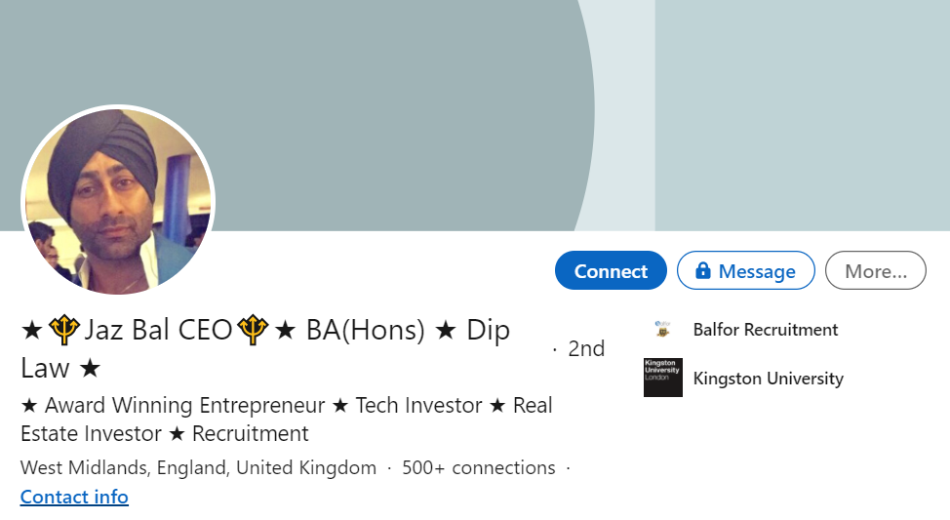

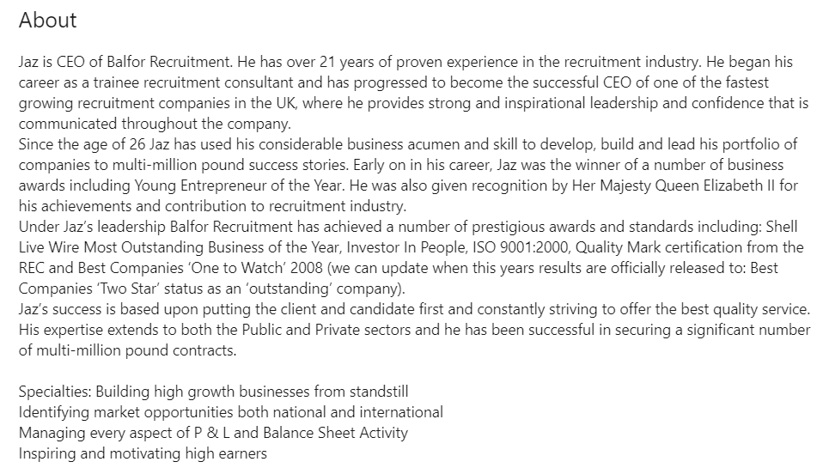

Appendix 7
COVID pandemic - Cross collaboration required – working from home
Appendix 8
eers Model | Upper Level Management |  | Lower Level Management |  | Lower level employees |  | Realign to COVID 19 pandemic
 | Pros | Cons | Pros | Cons | Pros | Cons
Unclear strategy & Values, conflicting priorities | Weekly/ monthy meetings to define strategy, by real time & historical data. | None | Weekly/ monthy meetings to define strategy, by real time & historical data. | None | Meetings to redefine targets for the week. | None | Change strategy to working from home, access to internet – meeting via Zoom, laptop, telephone, printer - how are candidates are adapting, relay information to stakeholders.
Ineffective senior team | CEO has started from the bottom up, has hands on experience. Management have experience. | None | Experienced managers in sectors, have broad knowledge, shared, Weekly Motivational team talk, morning pep talk. | None | Managerial support in place, | None | Require regular communication across all management and stakeholders via Zoom.
Leadership style too top-down or laissez faire | None | Too top down |  | Too top down |  | Too top down | Leadership style must change to cross collaboration (appendix)
Poor horizontal coordination and communication | Management meetings | horizontal coordination/ communication outside sectors is marginal | Management meetings | horizontal coordination/ communication outside sectors is marginal | Helps with concentration on the task in sight | No horizontal coordination/ communication outside sectors | Pandemic will affect sickness amongst employees, all sectors need to be centralised, cross collaboration to use data to its utmost capability.
Poor leadership, management skills & development | Over 5 years experienced management, leadership and how to identify niche, apply strategy. |  | Quarterly 1-2-1’s held to identify strengths and weaknesses, which are addressed accordingly |  | Quarterly 1-2-1’s held to identify strengths and weaknesses, which are addressed accordingly |  | Management will need to restructure achievable goals, based on feedback and real-time data from shareholders.
Poor or closed vertical communication | CEO – Open door policy but still only report via hierarchy |  | Negative office politics can be contained | Organisation structure – only report to upper chain |  | Organisation structure – only report to upper chain | Trust, Communication must be clear and concise to flow throughout all employees, motivation must be addressed.

Appendix 9

Appendix 10



