Appendix A1 - Blank copy of questionnaire for pupils

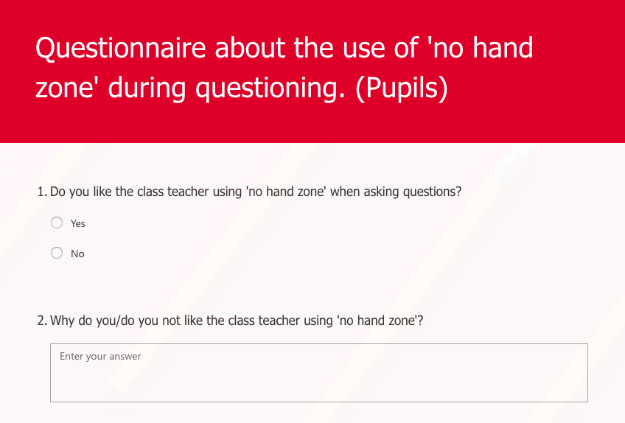
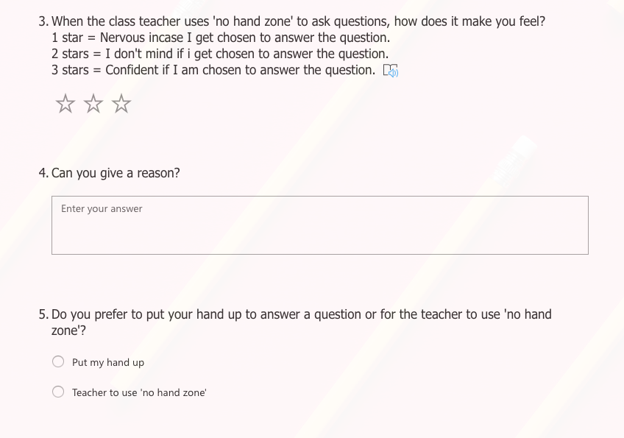
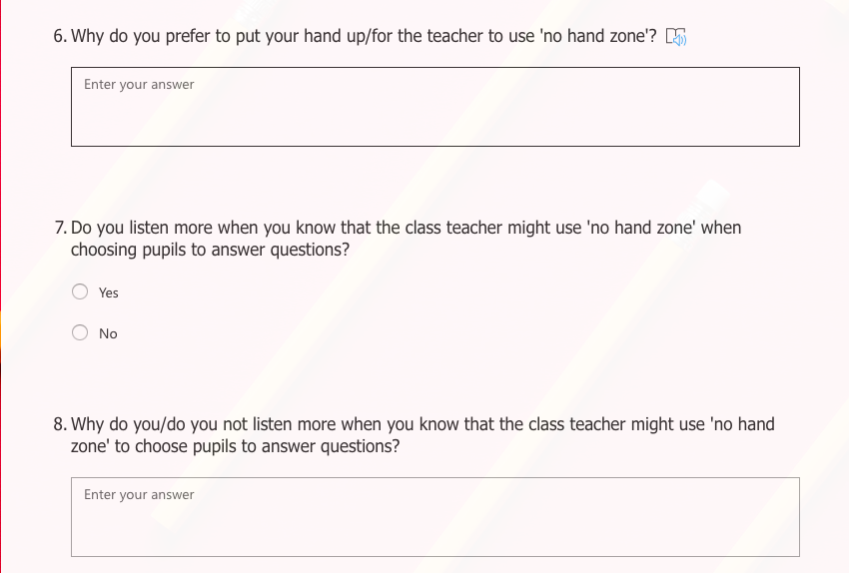
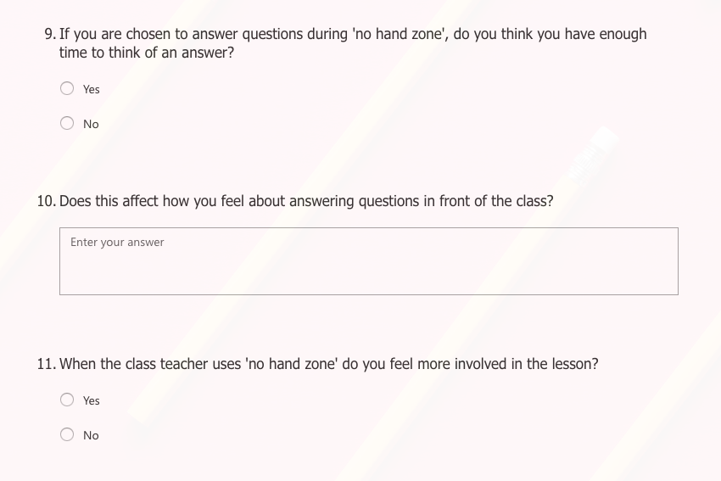
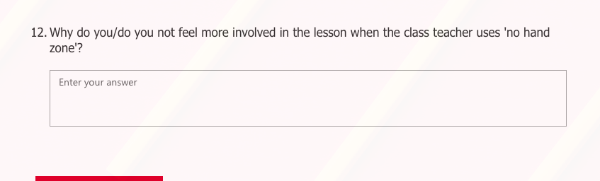

Appendix A2 – Blank copy of questionnaire for teachers

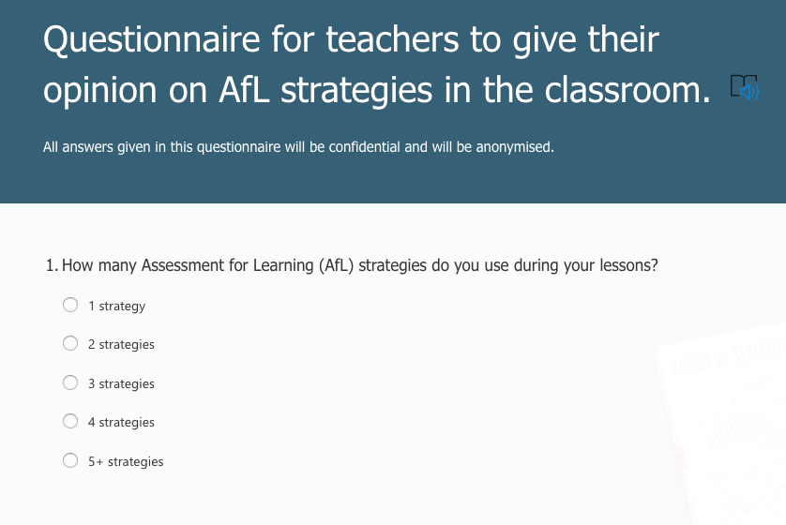
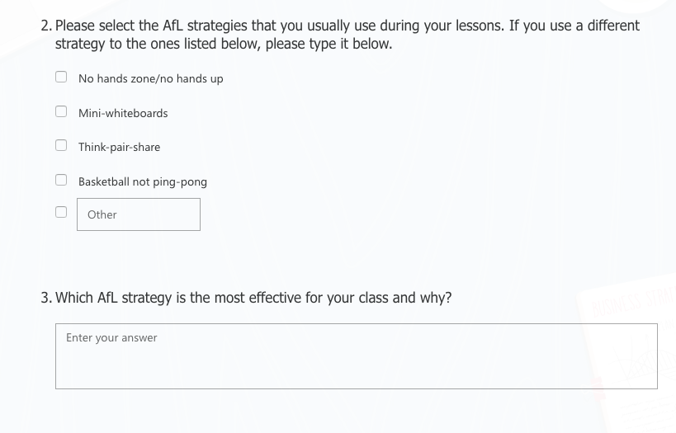
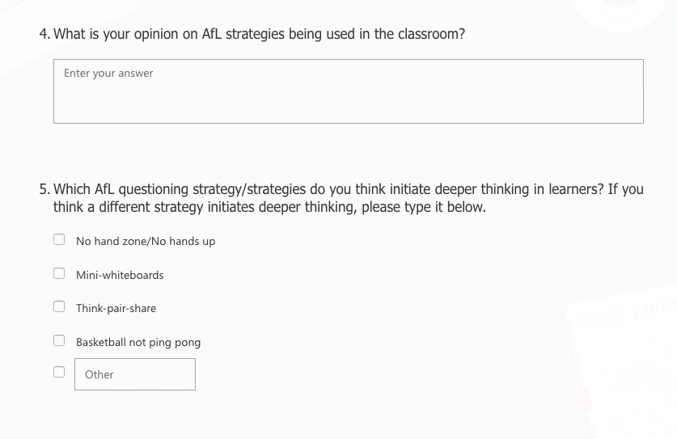
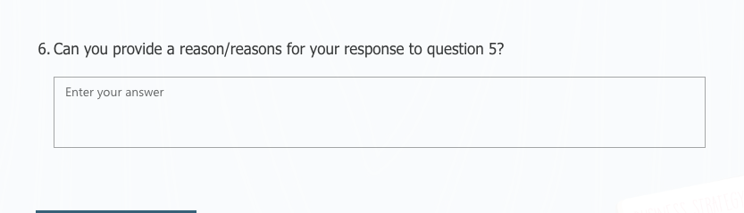

Appendix A3 – Interview questions for pupils (structured)

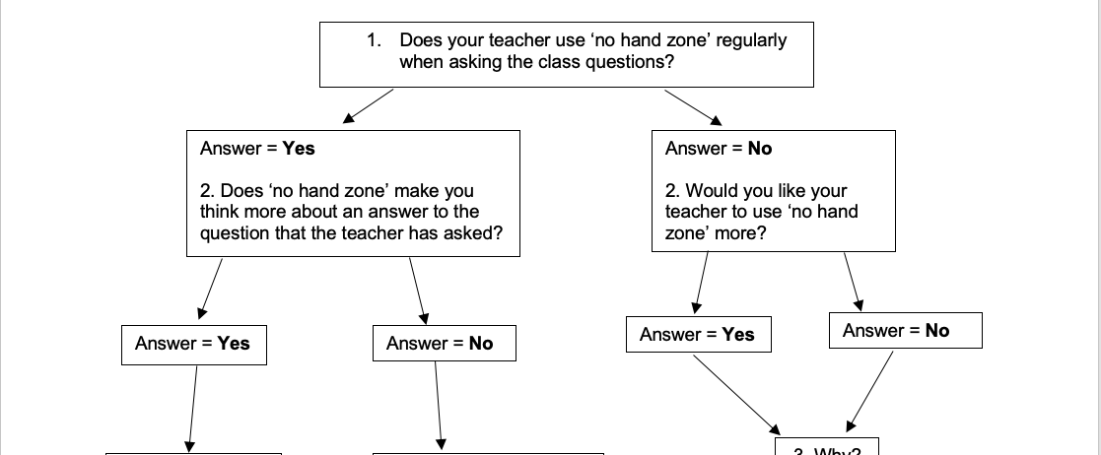
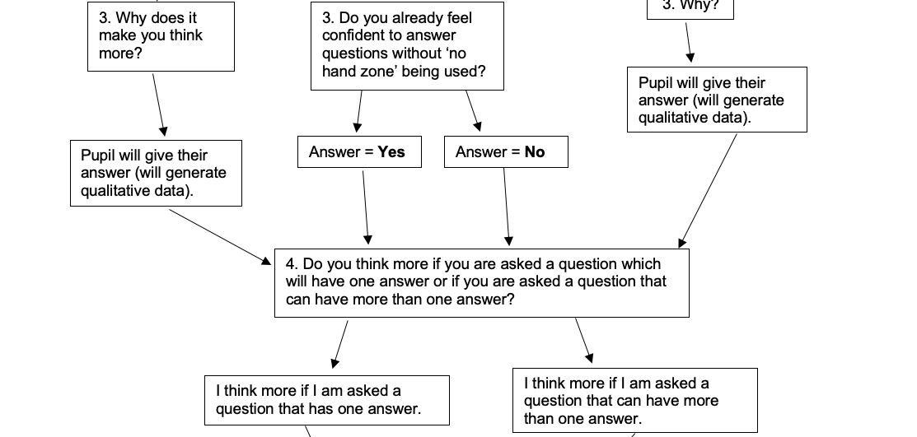

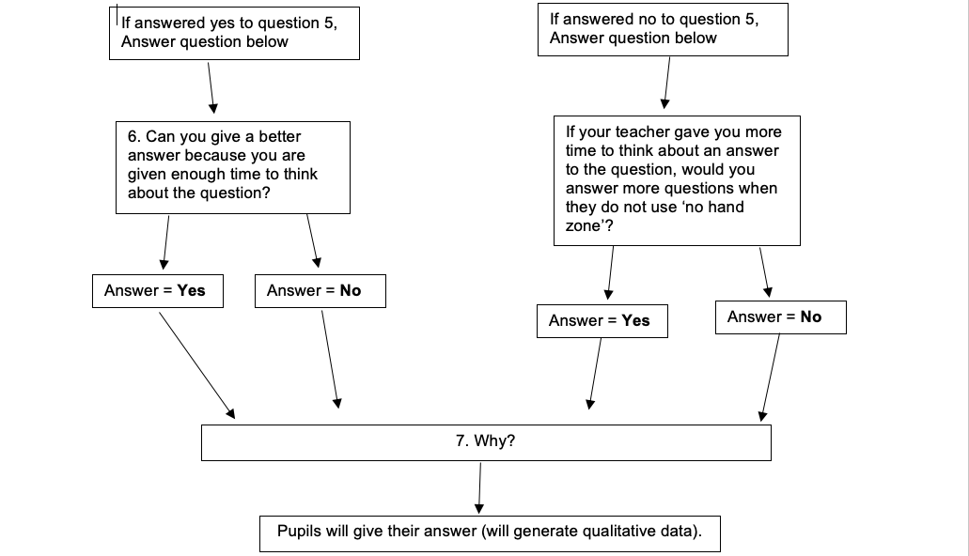

Appendix A4 – Blank observation tool
Observation

How many times did the teacher use each strategy below? | The number of times that the teacher used each strategy.
No hand zone (no hands up)
Think-pair-share
Ask a closed question
Ask an open question
Gave a pupil thinking time
Used basketball not ping-pong (asked pupils to expand on each-other’s answers/questions).

Comments
No Hand Zone

Think-pair-share

Asked a closed question

Asked an open question

Gave a pupil thinking time

Used basketball not ping-pong

Appendix B – Ethics Form

APPLICATION FOR ETHICAL APPROVAL

In order for research to result in benefit and minimise risk of harm, it must be conducted ethically. A researcher may not be covered by the University’s insurance if ethical approval has not been obtained prior to commencement.

The University follows the OECD Frascati manual definition of research activity: “creative work undertaken on a systematic basis in order to increase the stock of knowledge, including knowledge of man, culture and society, and the use of this stock of knowledge to devise new applications”. As such this covers activities undertaken by members of staff, postgraduate research students, and both taught postgraduate and undergraduate students working on dissertations/projects.

The individual undertaking the research activity is known as the “principal researcher”.

Ethical approval is not required for routine audits, performance reviews, quality assurance studies, testing within normal educational requirements, and literary or artistic criticism.

Please read the notes for guidance before completing ALL sections of the form.

This form must be completed and approved prior to undertaking any research activity. Please see Checklist for details of process for different categories of application.

Delete the Guidance Notes at the end of the form BEFORE submitting your application

SECTION A: About You (Principal Researcher)
Full Name: |  | Amy Strelley
Tick all boxes which apply: |  | Member of staff: | ☐ | Honorary research fellow: | ☐
Undergraduate Student | ☒ | Taught Postgraduate Student | ☐ | Postgraduate Research Student | ☐

Faculty/School/Centre: | Initial Teacher Education, Yr Athrofa
Campus: | Carmarthen
E-mail address: | 1800077@student.uwtsd.ac.uk
Contact Telephone Number: | 07534129273
For students:
Student Number: | 1800077@student.uwtsd.ac.uk
Programme of Study: | BA Primary Education with QTS
Director of Studies/Supervisor: | Dr. Sioned V. Hughes

SECTION B: Approval for Research Activity
Has the research activity received approval in principle?  (please check the Guidance Notes as to the appropriate approval process for different levels of research by different categories of individual) |  | YES | ☒ | NO | ☐
 |  |  |  | Date
If Yes, please indicate source of approval (and date where known): Approval in principle must be obtained from the relevant source prior to seeking ethical approval | Research Degrees Committee |  | ☐
 | Faculty Research Committee |  | ☐
 | Other (write in) ECAD5010 Module Lead |  | ☒ | 27.02.20

SECTION C: Internal and External Ethical Guidance Materials
Please list the core ethical guidance documents that have been referred to during the completion of this form (including any discipline-specific codes of research ethics, and also any specific ethical guidance relating to the proposed methodology). Please tick to confirm that your research proposal adheres to these codes and guidelines.
UWTSD Research Ethics & Integrity Code of Practice | ☒
UWTSD Research Data Management Policy | ☒
BERA (2018) Ethical guidelines for educational research. Fourth Edition, London. | ☒
 | ☐

SECTION D: External Collaborative Research Activity
Does the research activity involve collaborators outside of the University? |  | YES | ☐ | NO | ☒
If Yes, please provide the name of the external organisation and name and contact details for the main contact person and confirmation this person has consented to their personal data being shared.as part of this collaboration.
Institution
Contact person name
Contact person e-mail address

Has this individual consented to sharing their details on this form? |  | YES | ☐ | NO |  |  | ☐
Are you in receipt of a KESS scholarship? |  | YES | ☐ | NO |  |  | ☐
Is your research externally funded |  | YES | ☐ | NO |  |  | ☐
Are you specifically employed to undertake this research in either a paid or voluntary capacity? | Voluntary | YES | ☐ | NO |  | ☐
 | Employed | YES | ☐ | NO |  | ☐
Is the research being undertaken within an existing UWTSD Athrofa Professional Learning Partnership (APLP) | If YES then the permission question below does not need to be answered. | YES | ☒ | NO |  |  | ☐
Permission to undertake the research has been provided by the partner organisation | (If YES attach copy)  If NO the application cannot continue | YES | ☐ | NO |  |  | ☐

Where research activity is carried out in collaboration with an external organisation
Does this organisation have its own ethics approval system? | YES | ☐ | NO | ☒
If Yes, please attach a copy of any final approval (or interim approval) from the organisation

SECTION E: Details of Research Activity
Indicative title: | Is questioning an effective AfL tool in the classroom for deepening thinking?
Proposed start date: | 02.03.20 | Proposed end date: | 01.04.20
Introduction to the Research (maximum 300 words)
Ensure that you write for a Non-Specialist Audience when outlining your response to the three points below:
- Purpose of Research Activity
- Proposed Research Question
- Aims of Research Activity
- Objectives of Research Activity
Demonstrate, briefly, how Existing Research has informed the proposed activity and explain
- What the research activity will add to the body of knowledge
- How it addresses an area of importance.
Purpose of Research Activity
- To explore the questioning element of AfL.
- To trial different research tools in practice.

Research Question

Is questioning an effective AfL tool in the classroom for deepening thinking?

Aims of Research Activity

- To explore staff and learners’ perceptions of the questioning element of AfL.
- To critically evaluate the different research tools.
- To further develop personal knowledge and understanding of AfL to improve professional practice.
Objectives of Research Activity

- To explore the AfL questioning strategies and approaches used by staff to support and develop pupils’ learning using a questionnaire, interview and observation.
- To give a questionnaire to teachers and pupils to capture their views on AfL questioning strategies.
- To interview five 10/11-year old learners to capture their views about AfL questioning strategies.
- To observe questioning strategies used in the introduction and plenary of a lesson by the teacher and to observe how the pupils respond to the strategies used.
- To critically reflect on the process of using different research tools to collect data.
Proposed methods (maximum 600 words)
Provide a brief summary of all the methods that may be used in the research activity, making it clear what specific techniques may be used. If methods other than those listed in this section are deemed appropriate later, additional ethical approval for those methods will be needed.
Questionnaire – 5 children from a Year 6 class will be asked to complete a questionnaire on a laptop via Microsoft Forms. For example, ‘when the class teacher uses ‘no hand zone’ do you feel more involved in the lesson?’. These questionnaires will be conducted in an informal setting and the data from the questionnaires will be stored on Microsoft forms and the responses will be anonymous. The children will not be forced to participate, they will be made aware that they do not have to answer all of the questions and can stop completing the form at any time. All children will be asked if they wish to be involved. The children will be asked before they start, if they are happy to complete the questionnaire and will be told from the start that they do not have to answer all of the questions or carry on completing the questionnaire if they do not wish to.
3 teachers from Key Stage 2 and 3 teachers from Foundation Phase will be asked to complete a questionnaire via Microsoft Forms. For example, ‘what is your opinion on AfL strategies being used in the classroom?’. These questionnaires can be completed in the teachers’ own time and they will be asked to complete the questionnaires by 3rd March. The data from the questionnaires will be stored on Microsoft Forms and the responses will be anonymous. The teachers will not be forced to participate, they will be made aware that they do not have to answer all of the questions and can stop completing the form at any time. All teachers will be asked if they wish to participate.

Interviews – There will be 5 children interviewed individually from a Year 6 class, where they will be invited to respond to key questions. For example, ‘does your class teacher use ‘no hand zone’ regularly when asking the class questions?’ These interviews will be conducted in an informal setting and I will be using a dictation facility on Microsoft Word to type the questions and responses between myself and the child. The children will not be forced to participate, they will made aware that they do not have to answer any questions and that they can stop at any time. All children will be asked if they wish to be involved. The children will be asked at the beginning of the interview, if they are happy to answer questions and will be told from the start that they can withdraw to answer any question or carry on with the interview at any time. No names will be recorded.

Observation – I will observe the questioning strategies used by the class teacher during the introduction and plenary of a lesson. I have made an observation tool which includes a table with numerous questioning strategies, a column to note down a tally of how many times/if the questioning strategies are used and a comments box at the bottom of the sheet for any additional comments on each questioning strategy. The teacher and the children will be aware that I will be observing the introduction and the plenary of the lesson. All observation notes will be anonymised and there will be no confidentiality broken.

Location of research activity
Identify all locations where research activity will take place.
The research activity will take place in a large school on the outskirts of a city in South Wales with approximately 385 pupils.

Research activity outside of the UK
If research activity will take place overseas, you are responsible for ensuring that local ethical considerations are complied with and that the relevant permissions are sought. Specify any local guidelines (e.g. from local professional associations/learned societies/universities) that exist and whether these involve any ethical stipulations beyond those usual in the UK (provide details of any licenses or permissions required). Also specify whether there are any specific ethical issues raised by the local context in which the research activity is taking place, for example, particular cultural and/or legal sensitivities or vulnerabilities of participants.
N/A

(this box should expand as you type)
Use of documentation not in the public domain: Are any documents NOT publicly available? | NO | ☒
 | YES | ☐
If Yes, please provide details here of how you will gain access to specific documentation that is not in the public domain and that this is in accordance with prevailing data protection law of the country in question and England and Wales.

(this box should expand as you type)

SECTION F: Scope of Research Activity
Will the research activity include: | YES | NO
Use of a questionnaire or similar research instrument? | ☒ | ☐
Use of interviews? | ☒ | ☐
Use of diaries? | ☐ | ☒
Participant observation with their knowledge? | ☒ | ☐
Participant observation without their knowledge? | ☐ | ☒
Use of video or audio recording? | ☐ | ☒
Access to personal or confidential information without the participants’ specific consent? | ☐ | ☒
Administration of any questions, test stimuli, presentation that may be experienced as physically, mentally or emotionally harmful / offensive? | ☐ | ☒
Performance of any acts which may cause embarrassment or affect self-esteem? | ☐ | ☒
Investigation of participants involved in illegal activities? | ☐ | ☒
Use of procedures that involve deception? | ☐ | ☒
Administration of any substance, agent or placebo? | ☐ | ☒
Working with live vertebrate animals? | ☐ | ☒
Other primary data collection methods, please explain in this box  For example, ‘focus groups’. Please indicate the type of data collection method(s) in this box and tick the accompany box. | ☐ | ☒
Details of any other primary data collection method:  (this box should expand as you type) | ☐ | ☒
If NO to every question, then the research activity is (ethically) low risk and may be exempt from some of the following sections (please refer to Guidance Notes).

If YES to any question, then no research activity should be undertaken until full ethical approval has been obtained.

SECTION G: Intended Participants
Who are the intended participants: | YES | NO
Students or staff at the University? | ☐ | ☐
Adults (over the age of 18 and competent to give consent)? | ☒ | ☐
Vulnerable adults? | ☐ | ☐
Children and Young People under the age of 8? (Consent from Parent, Carer or Guardian will be required) | ☒ | ☐
Prisoners? | ☐ | ☐
Young offenders? | ☐ | ☐
Those who could be considered to have a particularly dependent relationship with the investigator or a gatekeeper? | ☐ | ☐
People engaged in illegal activities? | ☐ | ☐
Others (please identify specifically any group who may be unable to give consent) please indicate here and tick the appropriate box. | ☐ | ☐
Other – please indicate here:  (this box should expand as you type) | ☐ | ☐

Participant numbers and source
How will you identify participants and how will they be recruited?
How many participants are expected? | 33 participants
Who will the participants be? | 5 of the same children for the interviews and questionnaires.  6 teachers for the questionnaires.  27 children (including the 5 children mentioned above) during the observation of the introduction and plenary.
How will you identify the participants? | Previous PTE2 experience in the school.

Information for participants: | YES | NO | N/A
Will you describe the main research procedures to participants in advance, so that they are informed about what to expect? | ☒ | ☐ | ☐
Will you tell participants that their participation is voluntary? | ☒ | ☐ | ☐
Will you obtain written consent for participation? | ☐ | ☐ | ☒
Will you explain to participants that refusal to participate in the research will not affect their treatment or education (if relevant)? | ☒ | ☐ | ☐
If the research is observational, will you ask participants for their consent to being observed? | ☒ | ☐ | ☐
Will you tell participants that they may withdraw from the research at any time and for any reason? | ☒ | ☐ | ☐
With questionnaires, will you give participants the option of omitting questions they do not want to answer? | ☒ | ☐ | ☐
Will you tell participants that their data will be treated with full confidentiality and that, if published, it will not be identifiable as theirs? | ☒ | ☐ | ☐
Will you debrief participants at the end of their participation, in a way appropriate to the type of research undertaken? | ☐ | ☐ | ☒
If NO to any of above questions, please give an explanation
(this box should expand as you type)

Information for participants: | YES | NO | N/A
Will participants be paid? | ☐ | ☒ | ☐
Is specialist electrical or other equipment to be used with participants? | ☐ | ☒ | ☐
Are there any financial or other interests to the investigator or University arising from this study? | ☐ | ☒ | ☐
Will the research activity involve deliberately misleading participants in any way, or the partial or full concealment of the specific study aims? | ☐ | ☒ | ☐
If YES to any question, please provide full details
(this box should expand as you type)

SECTION H: Anticipated Risks

Outline any anticipated risks that may adversely affect any of the participants, the researchers and/or the University, and the steps that will be taken to address them.

If you have completed a full risk assessment (for example as required by a laboratory, or external research collaborator) you may append that to this form.
Full risk assessment completed and appended? |  | Yes | ☐
 |  | No | ☒
Risks to participants
For example: emotional distress, financial disclosure, physical harm, transfer of personal data, sensitive organisational information
Risk to Participant:  Pupils may feel under pressure to give the correct answer to the questions.  Physical harm.  Transfer of personal data.  Sensitive organisational information. | How will you mitigate the Risk to Participant  Pupils will be told that there is no consequence for anything they say. I will make it clear that I want open and honest answers. I will make it clear that the answers they give will affect their education in no way and there will be no repercussions for their actions and answers in regard to the research.  There will be no risk of physical harm as the questionnaires and interviews will be done in the presence of another adult and will be conducted in a professional manor.  All data that will be collected will be anonymised, kept confidential and stored securely to ensure that no one else will be able to view/handle the data that has been collected.  The context of the school will be anonymised, and all data collected from the research day will be stored securely.
If research activity may include sensitive, embarrassing or upsetting topics (e.g. sexual activity, drug use) or issues likely to disclose information requiring further action (e.g. criminal activity), give details of the procedures to deal with these issues, including any support/advice (e.g. helpline numbers) to be offered to participants. Note that where applicable, consent procedures should make it clear that if something potentially or actually illegal is discovered in the course of a project, it may need to be disclosed to the proper authorities
N/A
(this box should expand as you type)
Risks to investigator
For example: personal safety, physical harm, emotional distress, risk of accusation of harm/impropriety, conflict of interest
Risk to Investigator:  Allegations from pupils in the classroom while completing the research.  Physical harm/emotion distress. | How will you mitigate the Risk to Investigator:  The majority of the research will be during a normal activity in the classroom. There will be another adult present at all times.  If there was a risk of any harm physically or emotionally to myself, I would stop carrying out the research task and plan for another suitable time to conduct the research.
University/institutional risks
For example: adverse publicity, financial loss, data protection
Risk to University:  Not behaving in a way that could impact the relationship between school and university. | How will you mitigate the Risk to University:  I will behave in a professional manner, at all times.

Disclosure and Barring Service
If the research activity involves children or vulnerable adults, a Disclosure and Barring Service (DBS) certificate must be obtained before any contact with such participants. | YES | NO | N/A
Does your research require you to hold a current DBS Certificate? | ☒ | ☐ | ☐

SECTION I: Feedback, Consent and Confidentiality
Feedback
What de-briefing and feedback will be provided to participants, how will this be done and when?
N/A

(this box should expand as you type)
Informed consent
Describe the arrangements to inform potential participants, before providing consent, of what is involved in participating. Describe the arrangements for participants to provide full consent before data collection begins. If gaining consent in this way is inappropriate, explain how consent will be I obtained and recorded in accordance with prevailing data protection legislation.
I have emailed my class teacher to inform him about the research that I will be undertaking during the research day. I have provided a reason and rationale behind the research. However, I will verbally ask the children identified to participate if they wish to or not. The pupils identified will be able to verbally tell me if they wish to participate or not. This will be an individual exercise so that the children are encouraged to respond honestly with their interest and well-being in mind. Children will also be informed that they can approach me at any time to ask questions and discuss their contribution to the project.

Confidentiality / Anonymity
Set out how anonymity of participants and confidentiality will be ensured in any outputs. If anonymity is not being offered, explain why this is the case.
No names will be recorded. I will not disclose names…I will ensure that no individual data (raw scores, individual identifiable performance outcomes) are made available to schools/parents etc.

SECTION J: Data Protection and Storage
In completing this section refer to the University’s Research Data Management Policy and the extensive resources on the University’s Research Data Management web pages (http://uwtsd.ac.uk/library/research-data-management/).
Does the research activity involve personal data (as defined by the General Data Protection Regulation 2016 “GDPR” and the Data Protection Act 2018 “DPA”)? | YES | NO
“Personal data” means any information relating to an identified or identifiable natural person (‘data subject’). An identifiable natural person is one who can be identified, directly or indirectly, in particular by reference to an identifier such as a name, an identification number, location data, an online identifier or to one or more factors specific to the physical, physiological, genetic, mental, economic, cultural or social identity of that natural person. | ☐ | ☐
If YES, provide a description of the data and explain why this data needs to be collected:
(this box should expand as you type)
Does it involve special category data (as defined by the GDPR)? | YES | NO
“Special category data” means sensitive personal data consisting of information as to the data subjects’ –  (a) racial or ethnic origin,  (b) political opinions,  (c ) religious beliefs or other beliefs of a similar nature,  (d) membership of a trade union (within the meaning of the Trade Union and Labour Relations (Consolidation) Act 1992),  (e) physical or mental health or condition,  (f) sexual life,  (g) genetics,  (h) biometric data (as used for ID purposes), | ☐ | ☐
If YES, provide a description of the special category data and explain why this data needs to be collected:
(this box should expand as you type)
Will the research activity involve storing personal data and/or special category data on one of the following: | YES | NO
Manual files (i.e. in paper form)? | ☐ | ☐
University computers? | ☐ | ☐
Private company computers? | ☐ | ☐
Home or other personal computers? | ☐ | ☐
Laptop computers/ CDs/ Portable disk-drives/ memory sticks? | ☐ | ☐
“Cloud” storage or websites? | ☐ | ☐
Other – specify: | ☐ | ☐
For all stored data, explain the measures in place to ensure the security of the data collected, data confidentiality, including details of password protection, encryption, anonymisation and pseudonymisation:
(this box should expand as you type)
All Data Storage
Will the research activity involve any of the following activities: | YES | NO
Electronic transfer of data in any form? | ☐ | ☐
Sharing of data with others at the University? | ☐ | ☐
Sharing of data with other organisations? | ☐ | ☐
Export of data outside the European Union or importing of data from outside the UK? | ☐ | ☐
Use of personal addresses, postcodes, faxes, emails or telephone numbers? | ☐ | ☐
Publication of data that might allow identification of individuals? | ☐ | ☐
Use of data management system? | ☐ | ☐
Data archiving? | ☐ | ☐
If YES to any question, please provide full details, explaining how this will be conducted in accordance with the GDPR and DPA (and/or any international equivalent):
(this box should expand as you type)
List all who will have access to the data generated by the research activity:
(this box should expand as you type)
List who will have control of, and act as custodian(s) for, data generated by the research activity:
(this box should expand as you type)
Give details of data storage arrangements, including security measures in place to protect the data, where data will be stored, how long for, and in what form. Will data be archived – if so how and if not why not.
(this box should expand as you type)
Please indicate if your data will be stored in the UWTSD Research Data Repository (see https://researchdata.uwtsd.ac.uk/ ). If so please explain. (Most relevant to academic staff)
(this box should expand as you type)
Confirm that you have read the UWTSD guidance on data management (see https://www.uwtsd.ac.uk/library/research-data-management/) | YES | ☐
 | NO | ☐
Confirm that you are aware that you need to keep all data until after your research has completed or the end of your funding | YES | ☐
 | NO | ☐

SECTION K: Declaration
The information which I have provided is correct and complete to the best of my knowledge. I have attempted to identify any risks and issues related to the research activity and acknowledge my obligations and the rights of the participants.

In submitting this application I hereby confirm that I undertake to ensure that the above named research activity will meet the University’s Research Ethics and Integrity Code of Practice
Signature of applicant: |  | Date: 27.02.20

For STUDENT Submissions:
Director of Studies/Supervisor: | Dr. Sioned V. Hughes | Date:  27.02.20
Signature: | S.V.Hughes | Date:  27.02.20

For STAFF Submissions:
Head of School/Assistant Dean: |  | Date:
Signature: |  | Date:

Checklist: Please complete the checklist below to ensure that you have completed the form according to the guidelines and attached any required documentation:
☒ | I have read the guidance notes supplied before completing the form.
☒ | I have completed ALL RELEVANT sections of the form in full.
☒ | I confirm that the research activity has received approval in principle
☐ | I have attached a copy of final/interim approval from external organisation (where appropriate)
☐ | I have attached a full risk assessment (and have NOT completed Section H of this form) (where appropriate) ONLY TICK IF YOU HAVE ATTACHED A FULL RISK ASSESSMENT
☒ | I understand that it is my responsibility to ensure that the above named research activity will meet the University’s Research Ethics and Integrity Code of Practice.
☒ | I understand that before commencing data collection all documents aimed at respondents (including information sheets, consent forms, questionnaires, interview schedules etc.) must be confirmed by the DoS/Supervisor, module tutor or Head of School.
☒ | I have deleted the guidance notes before submitting the PG2 for consideration

Appendix C – Consent Form
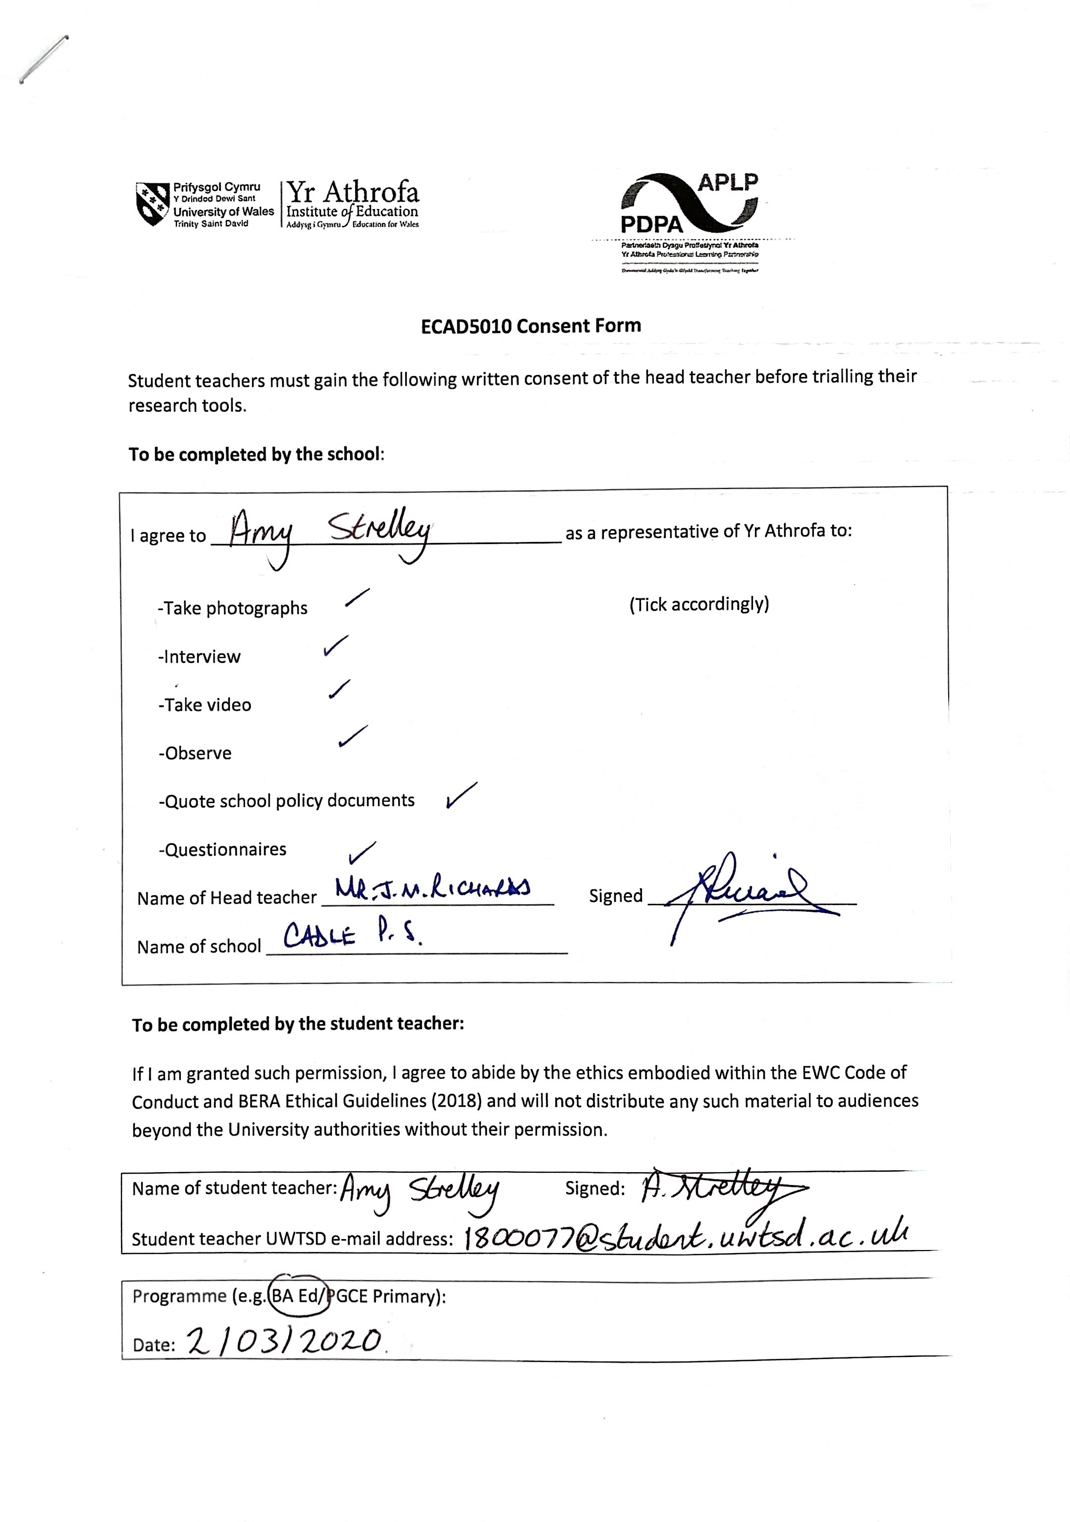

Appendix D – Questionnaire data from pupils

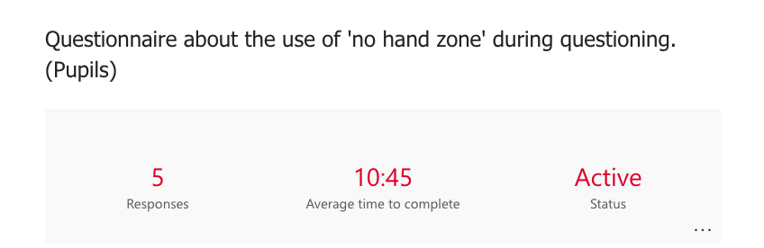
D1
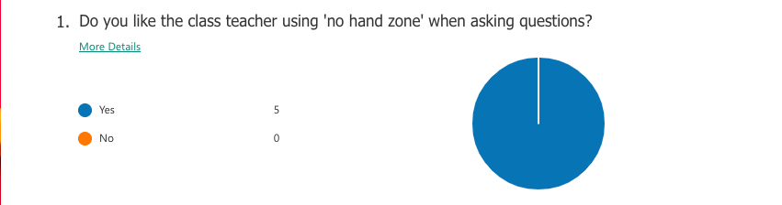
D2
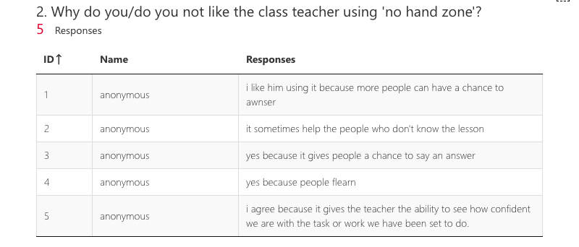

D3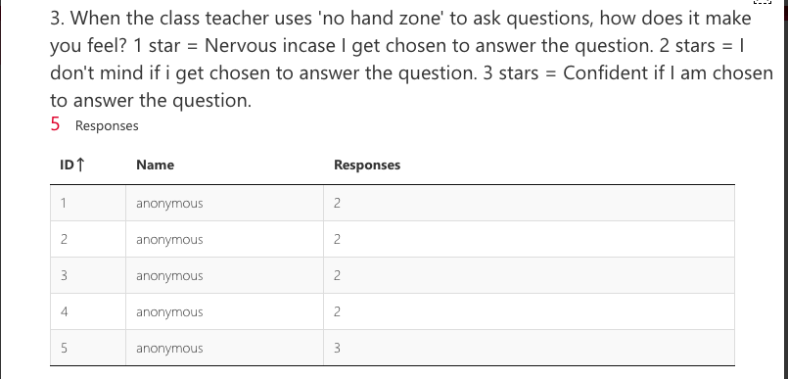
D4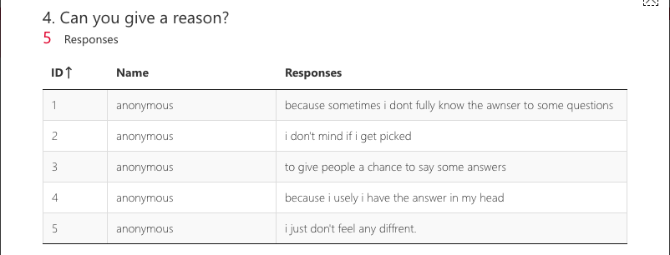
D5
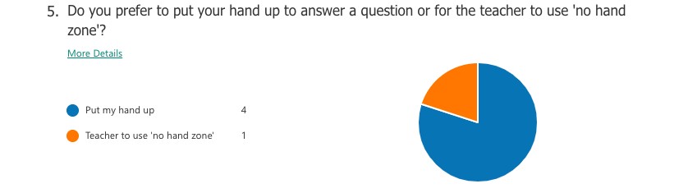

D6
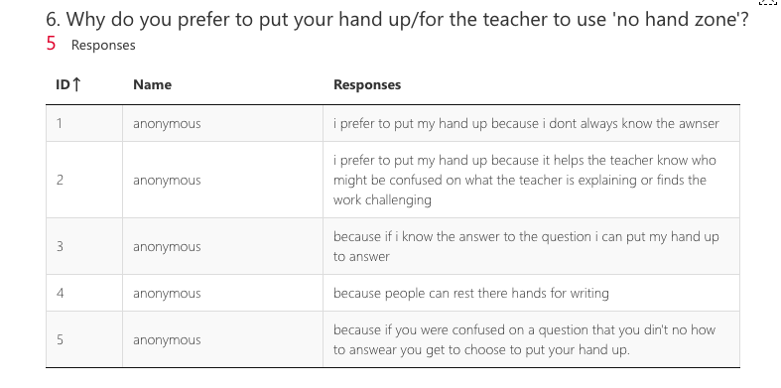
D7
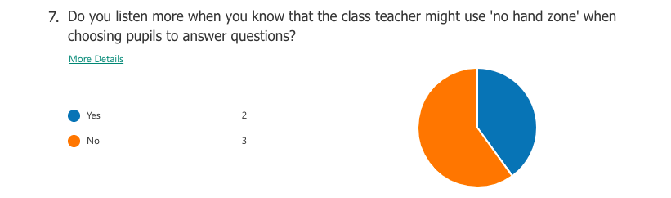
D8
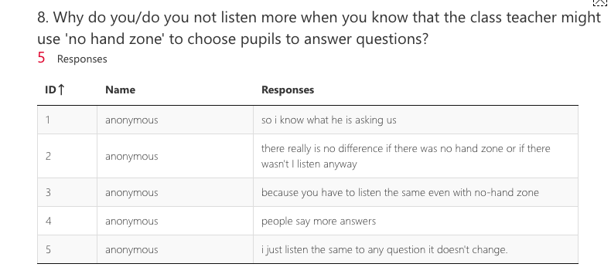

D9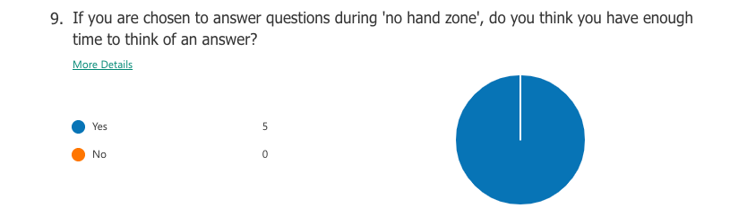
D10
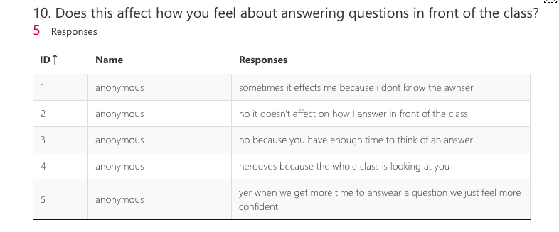
D11
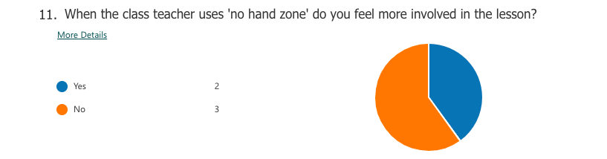

D12
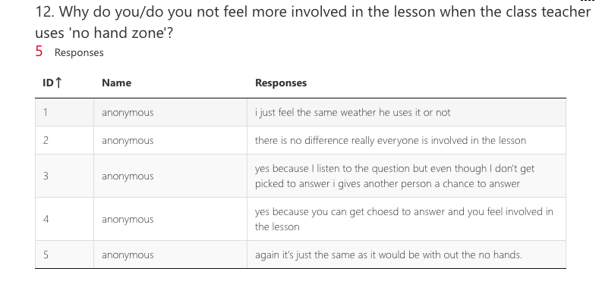

Appendix E – Questionnaire data from teachers

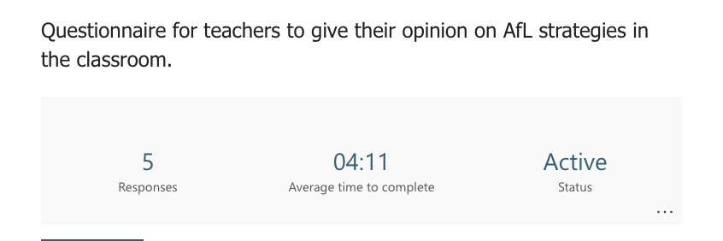
E1
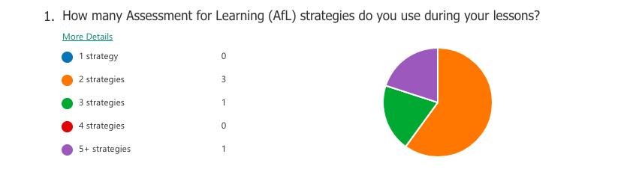
E2
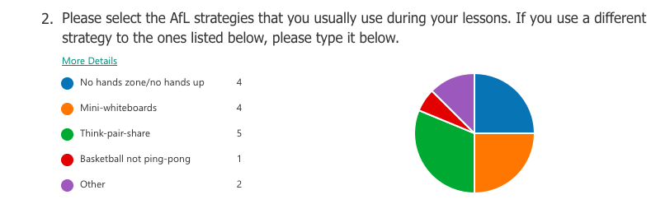
E3
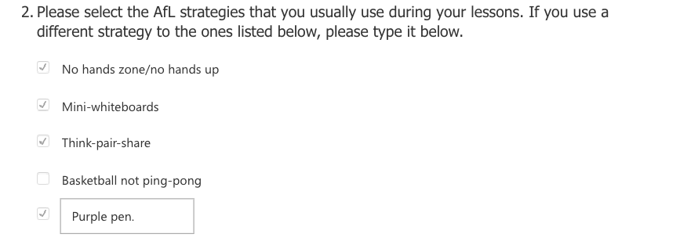
*One respondent chose other and typed ‘purple pen’ as their ‘other’ strategy
for question 2.

E4
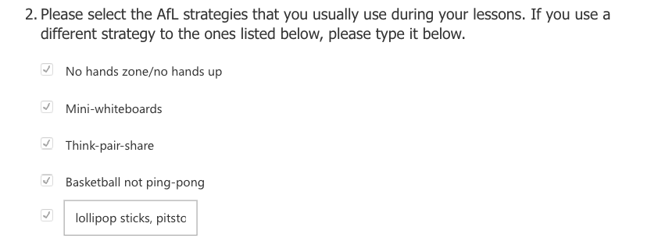
*One respondent chose other and typed ‘lollypop sticks, pitstops’ as their ‘other’ strategy for question 2.

E5
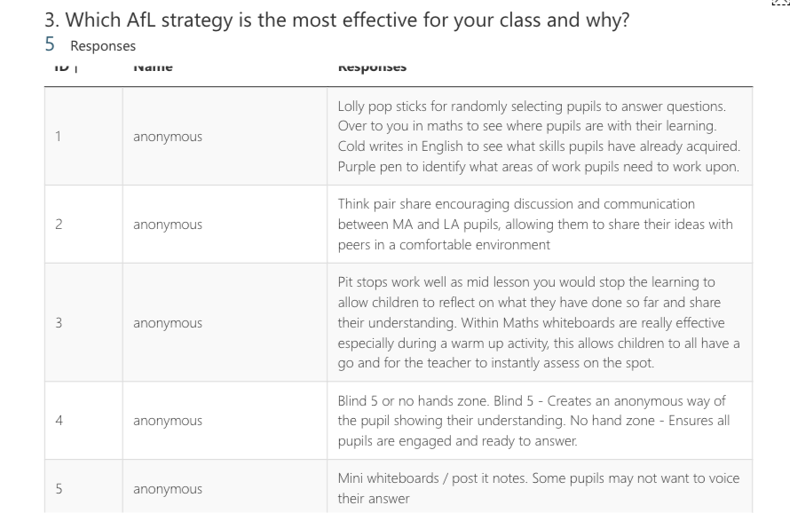

E6
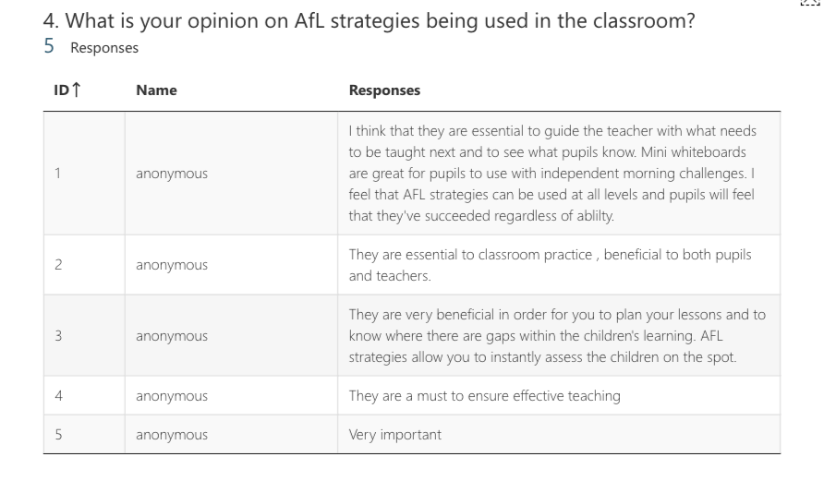E7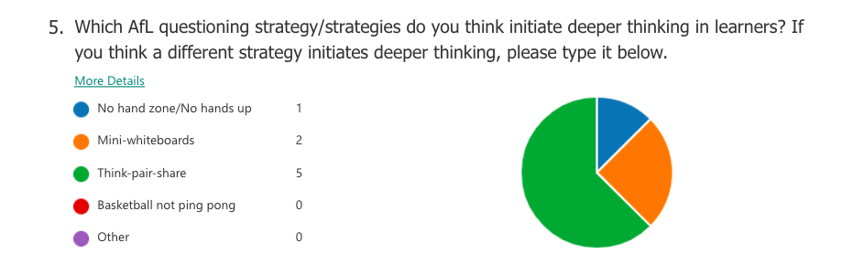

E8
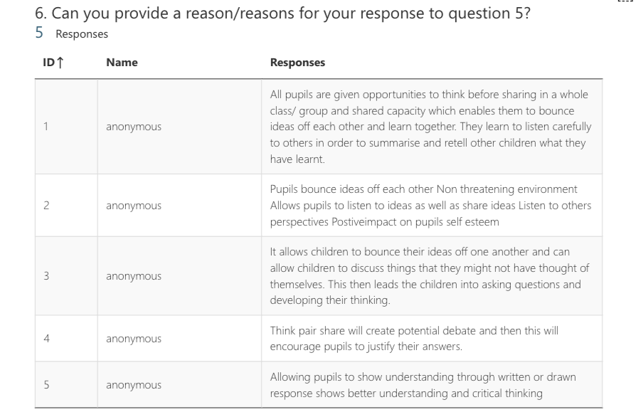

Appendix F – Interview transcriptions

F1 - Interview 1

Interviewer: Does your teacher use ‘no hand zone’ regularly when asking the class questions?

Child A: No.

Interviewer: Would you like your teacher to use ‘no hand zone’ more?

Child A: Yes.

Interviewer: Why?

Child A: It’s better for the class, the teacher can pick the ones that don’t know what the lesson’s about or who is confused about what Mr X is explaining.

Interviewer: Do you think more if you were asked a question which will have one answer or if you were asked a question that can have more than one answer.

Child A: I think more if I am asked a question that can have more than one answer.

Interviewer: When your teacher chooses you to answer a question, do they give you enough time to think of an answer?

Child A: Yes.

Interviewer: Can you give a better answer because you are given enough time to think about the question?

Child A: Yes.

Interviewer: Why?

Child A: It hasn't happened to me but when I was in maths a couple of days ago someone was asked a question and he gave them enough time to like work it out the answer. He normally gives people time if they were like working something out from the board.

F2 - Interview 2

Interviewer: Does your teacher use ‘no hand zone’ regularly when asking the class questions?

Child B: Yes pretty much all the time he uses it between different lessons depending on how confident we are with what we're being taught.

Interviewer: Does ‘no hand zone’ make you think more about an answer to the question that the teacher has asked?

Child B: no not really, I don't feel any different with it it's just gives the teachers the opportunity to see how confident we are with the work we’re learning about.

Interviewer: Do you already feel confident to answer questions without ‘no hand zone’ being used?

Child B: Yes, it gives the teacher the opportunity to see if we’re confident with the work but it doesn’t change anything.

Interviewer: Do you think more if you were asked a question which can have one answer or if you were asked a question that can have more than one answer?

Child B: I think more if I am asked a question that has one answer.

Interviewer: When your teacher chooses you to answer a question, do they give you enough time to think of an answer?

Child B: Yes, we have our share partners so there are enough opportunities to be able to talk about the work.

Interviewer: Can you give a better answer because you are given enough time to think about the question?

Child B: Yes.

Interviewer: Why?

Child B: When we have enough time, it gets more answers out of us.

F3 - Interview 3

Interviewer: Does your teacher use ‘no hands zone’ regularly when asking the class questions?

Child C: No.

Interviewer: Would you like your teacher to use ‘no hand zone’ more?

Child C: Yes.

Interviewer: Why?

Child C: Because we have a better chance of getting more ideas from people.

Interviewer: Do you think more if you are asked a question which will have one answer or if you are asked a question that can have more than one answer?

Child C: I think more if I am asked a question that can have more than one answer.

Interviewer: When your teacher chooses you to answer a question, do they give you enough time to think of an answer?

Child C: Yes.

Interviewer: Can you give a better answer because you are given enough time to think about the question?

Child C: Yes.

Interviewer: Why?

Child C: Because more people answer, and it gives you more ideas.

F4 - Interview 4

Interviewer: Does your teacher use ‘no hands zone’ regularly it when asking the class questions?

Child D: Yes.

Interviewer: Does ‘no hands zone’ make you think more about an answer to the question that the teacher has asked?

Child D: Yes.

Interviewer: Why does it make you think more?

Child D: So I know what question he [the teacher] is asking and I understand.

Interviewer: Do you think more if you are asked a question which will have one answer or if you are asked a question that can have more than one answer?

Child D: I think more if I am asked a question that can have more than one answer.

Interviewer: When your teacher chooses you to answer a question, do they give you enough time to think of an answer?

Child D: Yes.

Interviewer: Can you give a better answer because you are given enough time to think about the question?

Child D: Yes.

Interviewer: Why?

Child D: So I can think better than I normally do.

F5 - Interview 5

Interviewer: Does your teacher use ‘no hand zone’ regularly when asking the class questions?

Child E: No.

Interviewer: Would you like the teacher to use no hand zone more?

Child E: Yes.

Interviewer: Why?

Child E: Because it gives more people chance to give an answer because sometimes people are nervous to say the answer.

Interviewer: Do you think more if you are asked a question which will have one answer or if you are asked a question that can have more than one answer?

Child E: I think more if I am asked a question that can have more than one answer.

Interviewer: When your teacher chooses you to answer a question, do they give you enough time to think of an answer?

Child E: Yes.

Interviewer: Can you give a better answer because you are given enough time to think about the question?

Interviewer: Why?

Child E: Because you’ve got more time, you can put the answer into more detail.

Appendix G – Observation Notes



