Lecturer’s Name: Dr. Kwame Assa-Agyei

Student ID: 2346557

Student Name: Anane Frimpong

Group: 3

software solutions for bussiness
Module Code: ACCA4026

Table of Contents
Introduction 1
Task 1: e-Commerce Website builders or software solutions 1
1.1 WooCommerce 1
1.2 Wix 2
Task 2. Mind-map of contemporary software applications 2
a. Mind mapping and explaining the benefits of using mind mapping in business operations 2
b. Create a mind map of contemporary software applications 3
Task 3. Office Applications 4
a. Four office software solutions for business operations 4
MS Word 4
MS PowerPoint 5
MS Excel 6
MS Access 7
b. Practical demonstration of Two Office Features 9
Mail Merge 9
If Statement 12
Task 4. Communication and Collaboration applications, contemporary Communication, and one Online Collaboration application/tool 12
MS Outlook 12
MS Teams 14
a. One feature of a freely available Communication (1) and one feature of a Collaboration (1) application 16
MS Outlook 16
Ms Teams 17
Conclusion 19
References 19

Introduction

Today, in the digital business world, software systems are crucial for the success and normal functioning of a company. This report considers the various forms of present-day software that companies use to establish an online presence, operate their businesses and facilitate ways for employees to communicate.
The analysis begins with e-commerce platforms, including WooCommerce and Wix, two of the most easy-to-use for setting up and maintaining an online store appropriately. We then explore the concept of mind mapping and how this tool could be used in business. That is a demonstration of how visual thinking can assist in planning and decision-making. The report then spends a lot of time on the core Microsoft Office programs—Word, PowerPoint, Excel, and Access— which are broken down based on their standout features as well as an evaluation of their most significant pros and cons for business use. Mail merge and its IF functions are just the beginning, as real-world examples demonstrate just how powerful these tools really are. Finally, the report examines modern communication and collaboration tools like Microsoft Outlook and Teams that allow people to work together and stay connected in the modern workplace. Through extensive research, the report reveals how integrated software solutions enhance productivity, efficiency and collaboration in today’s workplaces.

Task 1: e-Commerce Website builders or software solutions

WooCommerce

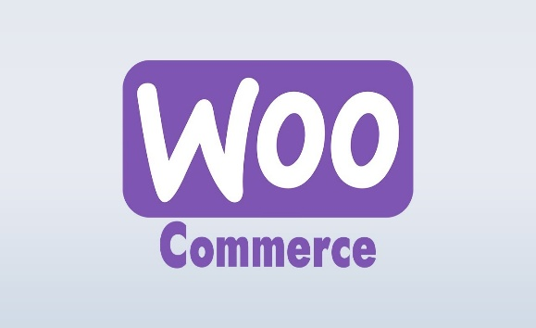
Woo Commerce is a free open-source eCommerce plugin that allows users with limited technical knowledge to turn any WordPress website into a fully functioning online store. Benefits of using WooCommerce are its beginner friendly nature as well as its flexibility, allowing for using plugins without coding knowledge. It also allows for easily adding security measures to your website design [1].
Woo Commerce has been around for a decade indicating the robustness of the of the plugin. Woo Commerce also allows for the development of websites with no coding, instead opting for simple menus and controls, users only require knowledge of WordPress to build online stores. WooCommerce is also extremely flexible allowing for the creation of different types of stores such as those that create physical or digital products, drop shipping stores, or even those that charge monthly fee for accessing content. WooCommerce boast of a huge library of extensions, each with different features, a number of which are free. A large number of apps can also be integrated with WooCommerce easily. WooCommerce accepts Stripe and Papal payments, Stripe in particular allowing you to create a store that accept payments from a range of cards [1].

Wix

Wix is a website builder that requires no coding. Wix allows for the creation of simple or more complicated websites. Wix can be used by people of varying levels of experience to build professional functional websites. Wix has incorporated the utility of AI in its website creation tools which can be used in text creation, layout design the inclusion of a chat box as well as others. Wix also has hundreds of websites, categorised by business use making it even easier to use. [2]
Wix Marketplace allows you to outsource features of website building, connecting you with professionals which specialise in logo design, blog content and much more.
Wix even has a built in App builder which allows users the freedom to create apps and use them as an extension of their created business.[2]
Wix also monitors website security 24/7 and with constant upgrades keeps the created sites and customers safe. The tool looks to upkeep its content management security, payment security as well as the user account security using two-step verification.[2]

Task 2. Mind-map of contemporary software applications

Mind mapping and explaining the benefits of using mind mapping in business operations

Mind mapping is the practice of visually organising information around a central concept. This technique can aid in learning by linking new information to existing knowledge and allows for the linkage of connected information. In business operations the main advantage of mind mapping is increased productivity. The structure makes it easier for teams to share information and communicate effectively, boosting productivity as a result.[3]
Mind mapping also boost creativity as the easily communicated connections between different ideas establishes links which can spark new ones. It also allows for teams to quickly get their ideas out onto paper, which typical linear notetaking does not usually allow for.[3]
Mind mapping also improves problem-solving and decision-making skills. By visually displaying problems and possible solutions, the best source of action can be easily identified, evaluated and agreed upon. This both improves the process of comparing ideas as well as the time to identify and pick the correct solution.[3]
Mind maps can also be adapted to a wide variety of business applications. As a visual tool they can aid with the communication of complex ideas to teams, they can be used to solve business problems, they can be used to develop organizational charts and many more.[3]
The most effective mind maps can be colour coded, to section off ideas as well as include images to better communicate information, rather than a large wall of text. [3]
Mind maps can be messy on paper, especially if using pen and paper leading to loss of information due to the unstructured nature of building this tool. To mitigate this care should be taken to filter out superfluous details to avoid overcrowding.[4]
Mind maps are also not ideal for complex plans. When too many branches are added, the mind map can become harder to follow and the connections between ideas can be hard to follow. [4]
Mind maps can be very individualised due to their flexibility, leading to miscommunication in ideas.[4]

Create a mind map of contemporary software applications
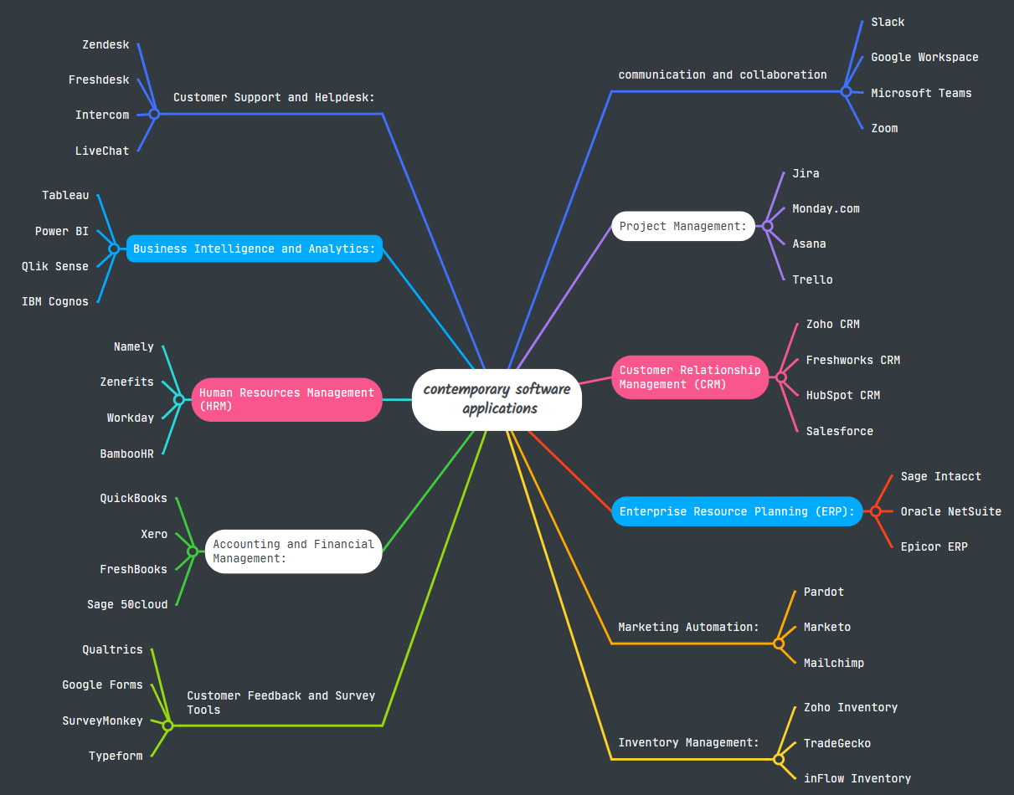

Task 3. Office Applications

Four office software solutions for business operations

MS Word

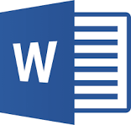
MS Word is part of the Microsoft Office suite, which has been deployed in millions of businesses worldwide since its introduction in 1983 [1]. The software is designed to assist people in creating, editing, formatting and printing professional documents. This has made it a staple for people who use computers at work nowadays.

Key Features
Microsoft Word includes many tools that let you do more than just create text for documents. For instance, some options allow users to create and format documents with various fonts, colours, and styles, making it easier to produce documents that appear professional. One of Word's advantages is that the application can use templates, allowing companies to ensure all letters, memos and other business correspondence look alike [2].
Word’s features for working together have enabled teams to collaborate much more efficiently. Multiple users are allowed to work on the document at the same time using real-time co-authoring. Word is also formatting with other Microsoft Office applications, such as Excel and PowerPoint, allowing users to insert charts, tables, or data into their documents [1]. Mail merge could be particularly beneficial for companies as it can automatically send personalised documents to a large number of people, based on data and template merging. This smooths the way for communication assignments and saves you a lot of time [2].
Advantages
Microsoft Word is user-friendly for anyone and everyone, and many people use it; it works with a lot of platforms and businesses. Additionally, with Word's integration with OneDrive, users can store files in the cloud, a handy feature in this work-from-anywhere world [1]. The software is also a timesaver when it comes to making documents, as you have features such as spell check, grammar checker and pre-made templates [2]. Word is also environmentally conscious by saving on using so much paper in daily business tasks such as archiving and letters.
Limitations
Microsoft Word has some definite advantages, but some of its features are disconcerting. Sharing documents across different versions of Word may lead to formatting issues as they are incompatible. While the software’s collaboration tools function adequately, many users perceive them to be less robust than those of competitors such as Google Docs, which makes it more challenging for people to work together in real time. Word files also tend to be larger than plain text, which can make it difficult to email a document or work on machines with limited disk space.


MS PowerPoint

Created by Robert Gaskins and Dennis Austin for the Macintosh, it was sold to Microsoft in 1987 for $14 million and became PowerPoint [1]. Microsoft Office's PowerPoint allows for the creation of slide-based presentations containing text, photos, videos, audio, animations, and transitions.
Major Features
There are countless PowerPoint features that can assist you when creating presentations. Users of various abilities can generate visually stunning presentations with ease using the interface and intuitive design tools, select from pre-designed templates or themes, and alter colour schemes. Multimedia integration in PowerPoint allows for the use of photos, audio/video clips and infographics and animations to engage an audience. The real-time collaboration options with Microsoft 365 and OneDrive allow several people to work on the same presentation, so it works great for team projects and remote working [1].
PowerPoint may be used for designing CVs, flyers, posters and social media. The tool also allows presenters to export and share their presentations in PDF, MP4 and image formats for worldwide use on any device. PowerPoint’s presenter view displays talking points and the next slide, which can help presenters keep on track. Interfacing with related Microsoft Office applications also makes it simple for presenters to include Excel and Word data [2].
Advantages
PowerPoint provides a number of proven business advantages. The multimedia capabilities of PowerPoint can clarify difficult concepts and keep the audience engaged. Cloud storage for today’s business operator is a key factor which carries out to makes presentations portable. With slides, bullet points and titles, PowerPoint help presenters arrange their content logically for efficient, effective business communication.
Limitations
The excessive use of slides by presenters can contribute to drudgery and non-involvement of the viewers. As presentations have a dependence on working computers with projector systems, issues such as connection problems, updates (software) and bad fonts/media files on several machines would introduce problems. Despite this flexibility, slides can confuse the audience, and complex transitions may distract from the message you are trying to get across [1]. Poorly executed PowerPoint presentations can get boring and read like a textbook, disengaging your audience.

MS Excel

More than 750 million people rely on Microsoft Excel, a robust spreadsheet application [1]. What started as a basic number-crunching program for Apple Macs in 1984 and Windows versions after, has now become a complex data tool [2]. The software can be applied for managing, manipulating, analysing, and visualising data amongst business professionals in various industries who use the software’s formulas, functions, charts and other advanced analytical models.
Major Features
Excel features several tools to make it easy for business analysis and data management. Critical skills encompass PivotTables that let you build summaries and analyses of large, disparate data sets with structure and relevance to fit a specific need. The program comes with functions for everything from basic arithmetic to advanced statistical operations, like IF, VLOOKUP and SUM PRODUCT used to sort, organise and otherwise rearrange data. Conditional formatting shades cells that meet certain conditions so analysts can identify outliers, duplication, and trends.
Macros and Visual Basic for Applications enable users to automate repetitive tasks and even develop their own small business-focused applications using Excel [1]. Power Query allows integration with other Microsoft Office tools and external data sources, enhancing business analysis.

Advantages
As majority of businesses all over the world use Excel for storing data sets, it becomes an industry standard and allows for compatibility and teamwork [1]. Finance teams can use the software to manage budgets and ROI, marketing teams track ad campaign performance, and human resources departments keep on top of payroll and employee data. Because a vast number of businesses have Microsoft Office licenses, Excel provides analysis features without the added expense for specialised software. Decision-makers can generate plans of action and prospects using the platform’s complex analysis, calculations, and insights [1]. Excel also assists upcoming business analysts to understand fundamental analytical concepts.
Limitations
Individual spreadsheets are limited to 1.05 million rows and 16,384 columns, which is not suitable for anything exceeding this amount of data [2]. The lack of real-time co-authoring and change tracking tools in Excel also raises version control issues and can result in disputes where large numbers of users collaborate [3]. The complicated interface of Excel and its significant learning curve for advanced features could impede productivity and efficiency. The lack of access to, applying and audit trail features of Excel is threatening organisations that are involved in handling critical data [4].

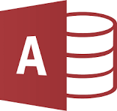
MS Access
Microsoft Access has been in high demand for small and medium-sized organisations since its 1992 deployment as a Relational Database Management System [1]. Access, an Office product, provides an easy-to-use development environment for Rapid Application Development, including a database engine and a broad collection of developers’ tools. Offering 53,000 customers a structured approach to managing data, Access has an 8.84% share [2].
Major Features
Microsoft Access contains numerous functions for enterprise database management. The software's intuitive interface allows users to create databases, define table relationships and design complex queries, forms, and reports without a deep knowledge of the application [3]. Access includes templates for asset tracking, inventory management & event planning, etc., which provide users with the ability to immediately use and create a working database according to specific application requirements. Another one is the ability for businesses to connect the data from SQL Server and Microsoft Azure SQL through the Access Connector library, to enable them to have more control over data as their usage scales.
Visual Basic for Applications, a programming language, allows end-users to easily automate routine processes, manipulate and customise data, including creating business-to-business tools [2]. Access enables importing data from Excel spreadsheets, text files, XML files and other databases into one database, thus facilitating easy consolidation of data [1]. Access also works together with other Microsoft Office applications, such as allowing you to attach business reports to an Outlook message and link or export data to an Excel spreadsheet. The application allows up to 40 individuals the ability to share and edit databases at any one time. User-level permissions are included, which dictate who can and cannot access a database, while password encryption is available to protect sensitive information [1].
Advantages
There are many advantages in utilising Microsoft Access for business operations. Access is more affordable in terms of development and maintenance costs compared to Oracle and SQL Server, which are viable options for small companies considering costs [2]. The installation is well-supported by the Windows Desktop Wizard, which includes quick access to all operating functions, and its easy-to-follow prompts can enable even the most computer neophyte of users to make simple databases in minutes [3]. Access is commonly bundled with business editions of Microsoft Office, so many companies already have licences and are not paying anything extra for software. Users with no full licence can run such applications in Microsoft’s free runtime version of Access.
Integrating with the Microsoft Office environment enables frictionless data movement between apps and results in increased departmental use of data [1]. Databases can be easily 'upgraded' to SQL Server on an as-needed basis, when Access is unable to meet the requirements and provide greater performance, yet still offer the familiar Access interface with a more powerful database engine behind it [2]. Access also enables all data to be assigned with identification that makes actual data input much more accurate and credible as an exercise in insights and reporting of the business [3].
Limitations
The largest downside is the 2GB maximum file size for any single database, which will likely become problematic as growing businesses process larger and larger datasets or store photographs [2]. Performance is another issue, since Access is a desktop-based tool and can be sluggish when processing large data sets or handling numerous simultaneous users [3].
In collaborative settings, the software lacks scalability and concurrency support along with multi-user capabilities, which may result in data inconsistencies or conflicts when accessed for concurrent usage [4]. Lack of integrating version control and collaboration tools complicates control of changes, data integrity and avoiding conflicting changes if multiple users are involved in the work process.
With the increasing prominence of remote working and the need for online access, poor web integration means remote accessibility and online collaboration suffer. Although the basic functions can be used relatively easily on Access, a substantial alteration and developmental effort require Visual Basic for Applications, which non-programmers can find troublesome to use, requiring professional training or developer assistance [1].

Practical demonstration of Two Office Features

Mail Merge

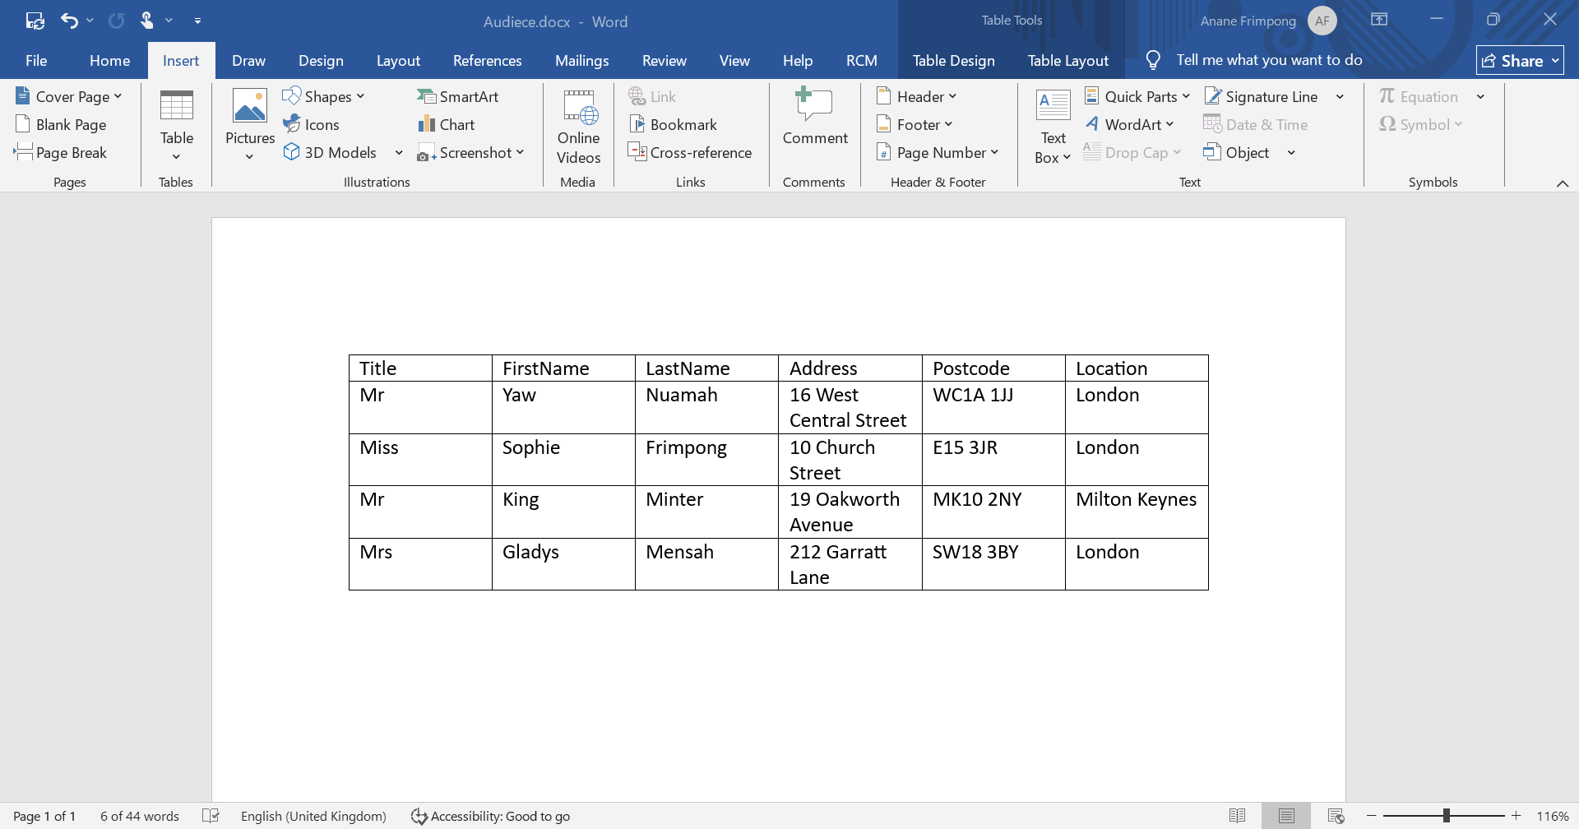
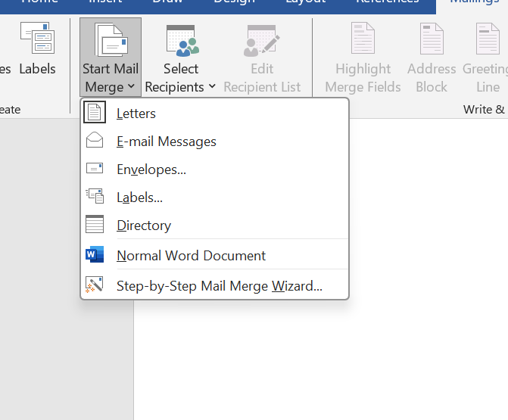

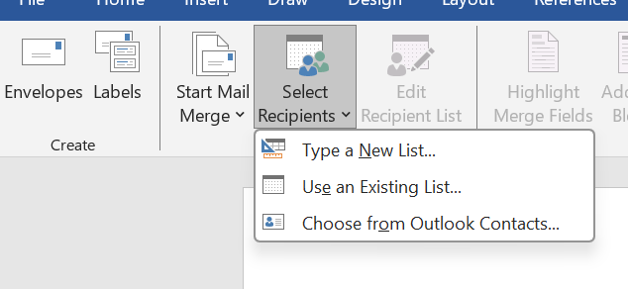
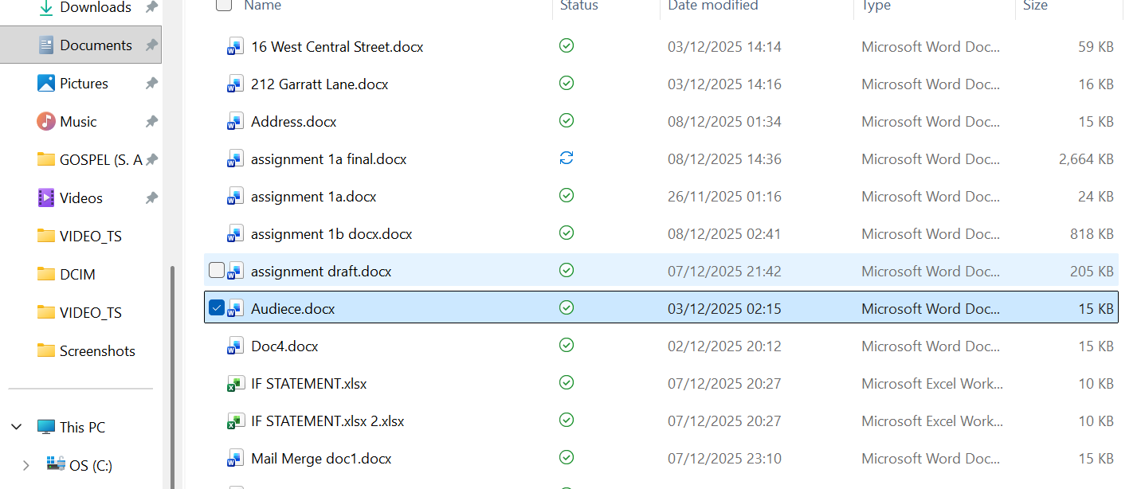

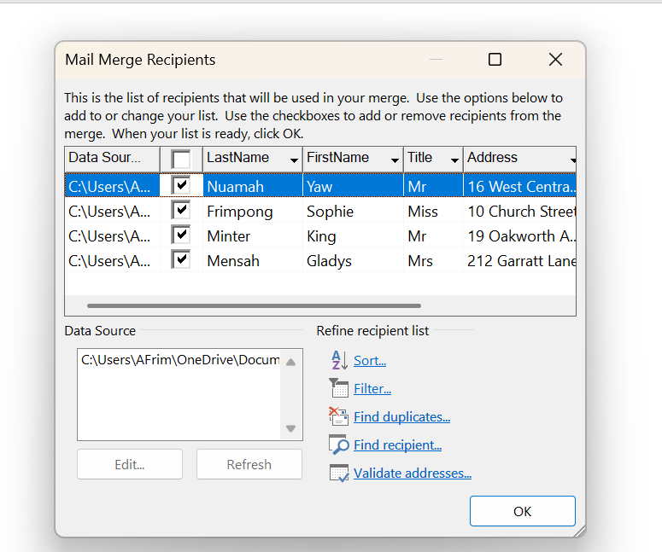

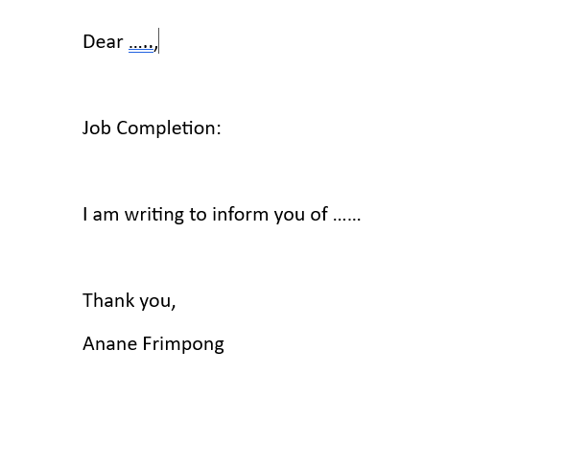
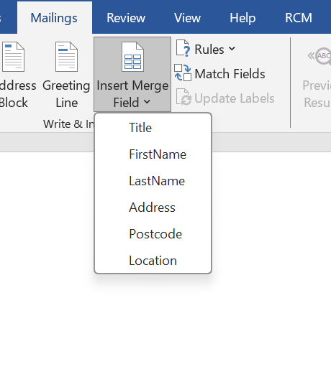
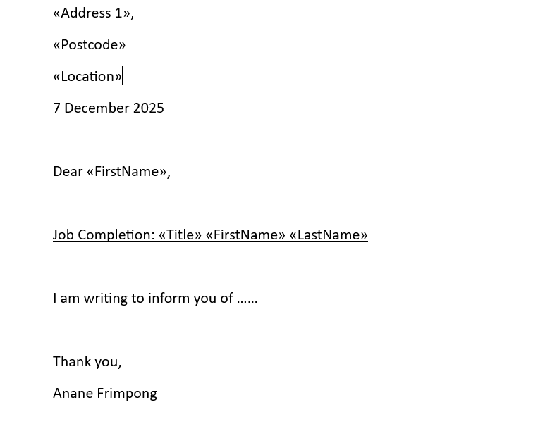

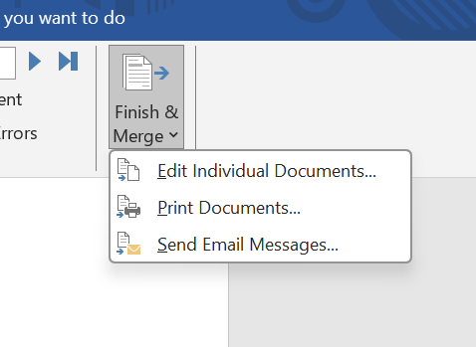

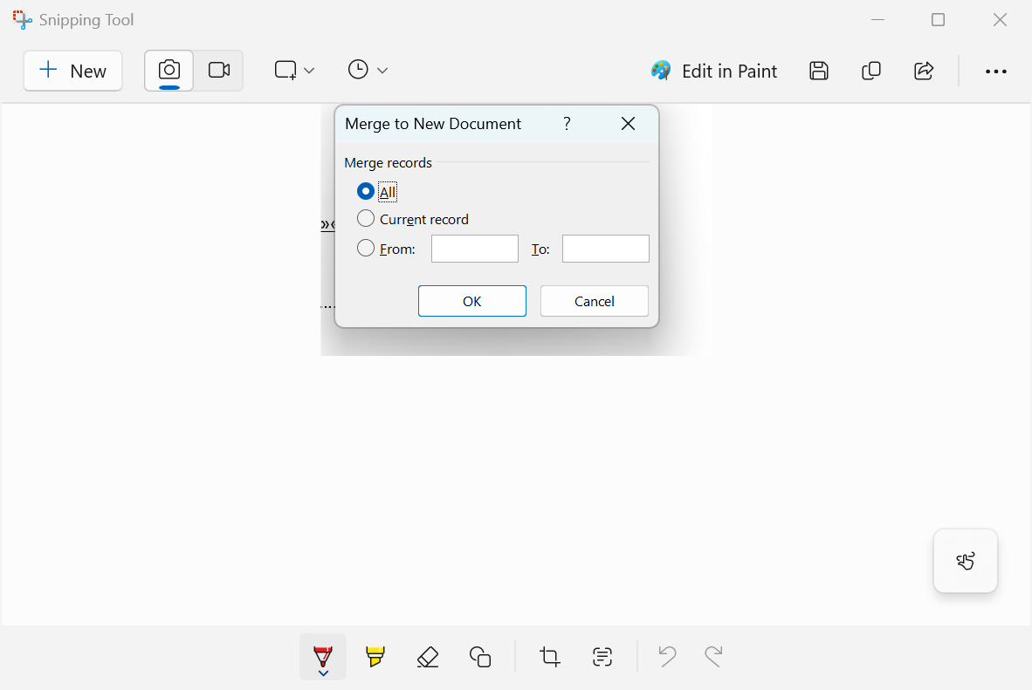

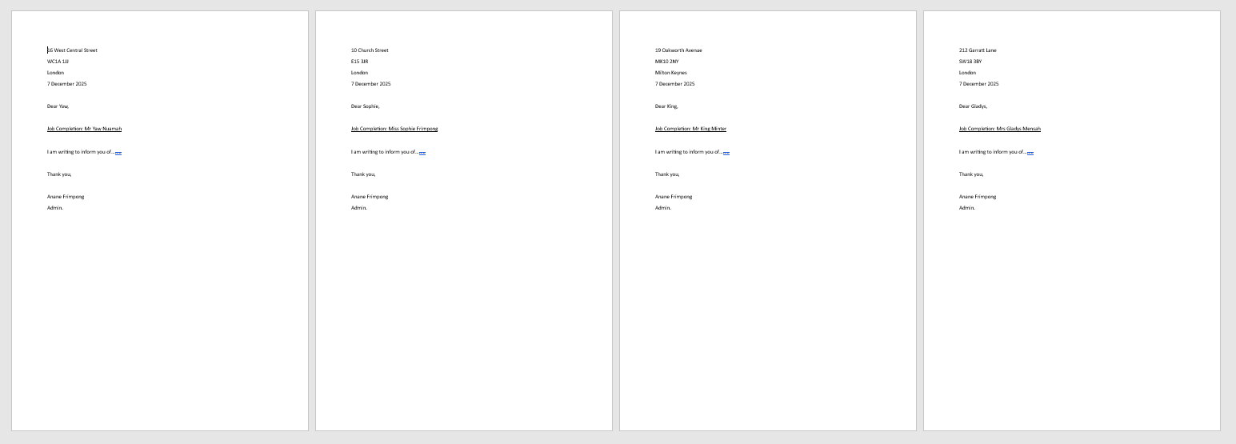

If Statement
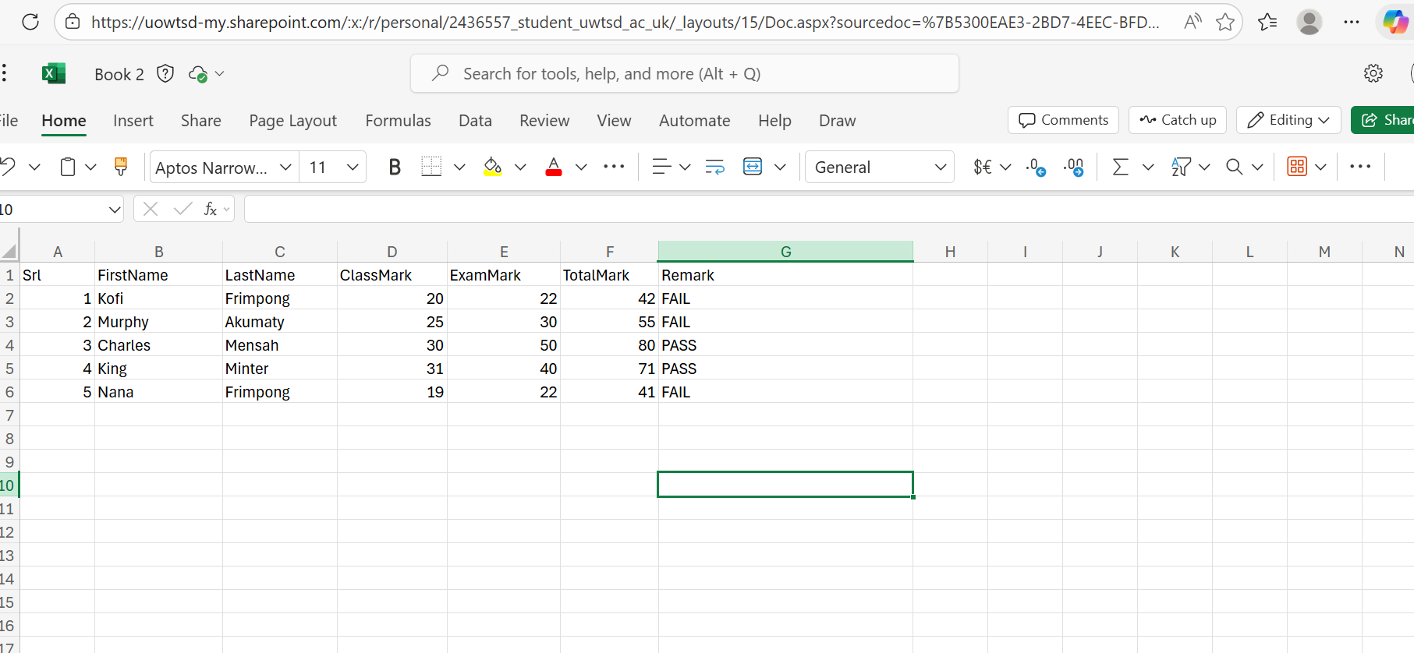
This is my excel outcome

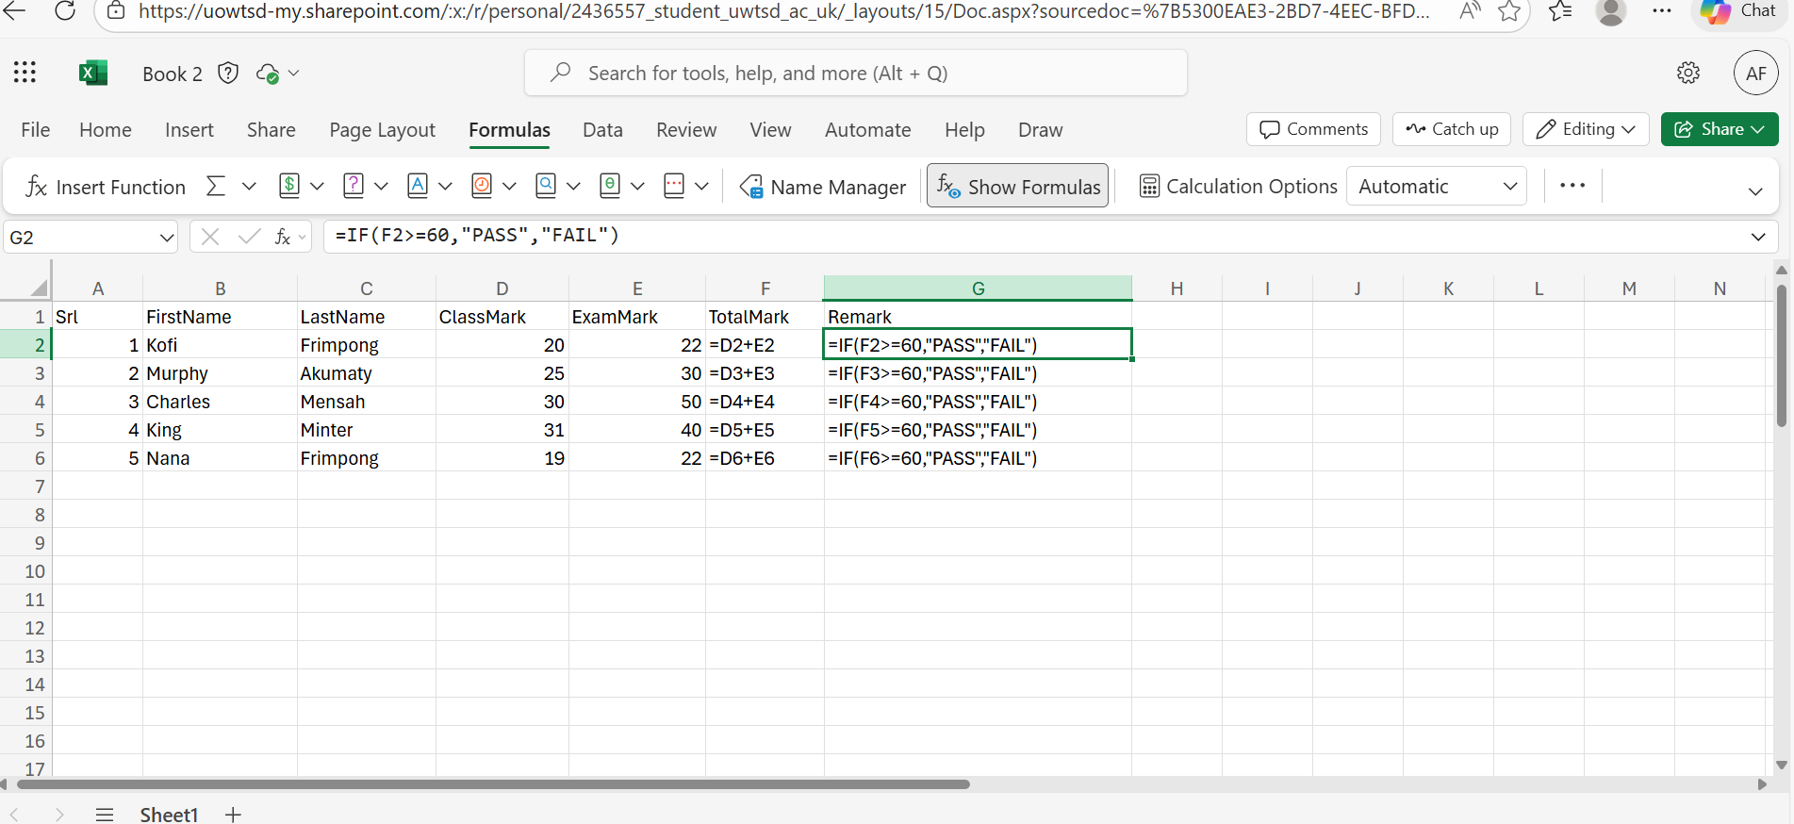
Shows formulas used

Task 4. Communication and Collaboration applications, contemporary Communication, and one Online Collaboration application/tool

MS Outlook

Microsoft Outlook is the most widely used business email client and an integrated communications and personal information-management system [1]. Outlook, a component of Microsoft Office, combines email, scheduling, task management contact organisation to work and communicate more effectively [2]. For professional users, although an upgrade is, several advanced capabilities in Outlook can enhance productivity and teamwork.
Key Features
Microsoft Outlook aggregation several inboxes into a single interface, they can concentrate on their work, and features such as focused Inbox, which divides vital mail from trivial or disruptive messages.
A transformation of the Outlook calendar is indispensable in business, ranging from being able to add a number of time zones for planning with your global team, sharing calendars with colleagues and seeing everyone’s availability, enabling you to plan meetings on even the busiest schedule [1]. The scheduling assistant tool provides slots for all invitees according to their agendas, eradicating the need for emails coordinating a meeting [2]. Microsoft Teams integration enables users to engage with meeting participants directly from their calendar, schedule meetings effortlessly and work on a single hub for messaging, meetings, and file sharing [3].
Outlook and Microsoft To-Do sync task management together to make, manage & track tasks in the same place and organise work across devices, including due dates, follow-ups for priority tasks [4]. Outlook also has morphed into much more than an email client with custom rules and alerts to keep your emails and tasks moving, quick steps to streamline repetitive tasks and responses, and email templates [5].
Enterprise-level security, including email encryption, two-factor authentication, anti-phishing capabilities and data transmission and storage encryption, as well as compliance tools that safeguard confidential business information and continuously
update threat definitions to protect against Internet threats [1]. Outlook also links to file storage in OneDrive, collaboration with SharePoint, and professional connections with LinkedIn users who can share attachments, access contacts, and view professional profiles to optimise data use across departments [4].

MS Teams

Microsoft Teams, first released in 2017, has revolutionised how we communicate and collaborate in the workplace – emerging as one of the most used enterprise collaboration tools throughout the world [1]. As of 2024, Teams is available to approximately 320 million monthly active users across more than 500,000 organisations globally. Team members can work together effectively regardless of their location through the integrated, single workspace that combines chat, video conference and voice calls, file sharing, and collaborative document editing [1]. Teams, an integral aspect of Microsoft 365, are used to give businesses both efficient and cost-effective systems that consolidate communication and improve working standards for remote and hybrid employees.
Key Features
Microsoft Teams is packed with features meant to make your workdays more pleasant and more productive. Channels structure communication and enable users to arrange their workspaces into topic-focused areas to promote focused, efficient team collaboration when keeping conversations relevant, targeted these on-point [1]. Teams supports up to 1000 people on a call, so it's perfect for anything from a huge presentation or company-wide meeting. Functions such as schedule aid, note taking at meetings, which is real-time recording of screens, live captions and customizable layouts all contribute to an enhanced user experience and therefore more productive virtual collaboration [1].
Real-time collaboration with Teams allows people to edit the same document together while chatting, thereby avoiding sending around different versions and keeping everybody up to date. Intuitively, Microsoft 365 applications such as Word, Excel, PowerPoint, OneNote, SharePoint and Outlook are successfully integrated with Teams for quick access to files and to edit them without having to navigate away from a user’s primary application, while Web Client users of Work Service can experience better workflows and productivity [1]. Microsoft Copilot, a bot that uses sophisticated artificial intelligence to help teams quickly recap meetings, assign next steps, compile agendas, ask questions and pinpoint key insights without interrupting the flow of the conversation [2].
Guest access and external collaboration, which makes it possible to invite people from outside of the for-Business network, such as external partners and suppliers, for messaging. meetings and file sharing, helping toward business-to-business project management in a secure, admin-controlled environment [3]. Teams Connect also allows organisations to chat, communicate, and edit documents with third-party partners in a shared workspace without sharing sensitive information [4]. Teams partners with business intelligence tools like Salesforce, Zendesk, Asana and Miro in order to broaden its capabilities and enable enterprises to tailor their own collaboration environments [5].
Benefits
The advantages of using Microsoft Teams for business collaboration are numerous, according to studies and businesses themselves. The Total Economic Impact study of Forrester Research for Teams also helped employees save time and money by giving them better employee efficiency, resulting in $19.6 million in savings over three years, while the ROI was 291% and total benefits exceeded $35 [1]. Teams cut the number of meetings and length, resulting in $6.9 million in savings over three years, with a cost savings for the telecommunication solution $648,727 [2].
Microsoft Teams integrates communication, collaboration and project management in one tool, thus saving businesses money on telephone systems and conference calls. Productivity of information workers increases by four hours per week – Co-authoring, document search, version control and centralised communication [1]. Teams reduces the time lost transitioning between applications and cognitive re-engagement, which is reducing time by sustaining difficult accreditations, saving over $4.8m in time, and increasing call quality, reducing calls by 7.6 minutes per day [1]. With Teams Cloud functionality, any team member can access it anywhere using desktop or mobile apps for iOS and Android, even while they are working from home, boosting morale by keeping teams connected, but also in the case of remote learning or flexible work arrangements, while preserving business continuity and sustainability as well [1].

One feature of a freely available Communication (1) and one feature of a Collaboration (1) application

MS Outlook

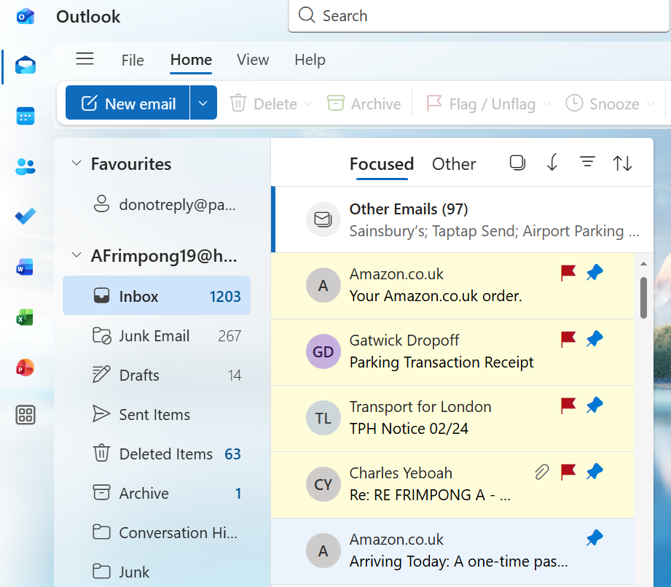
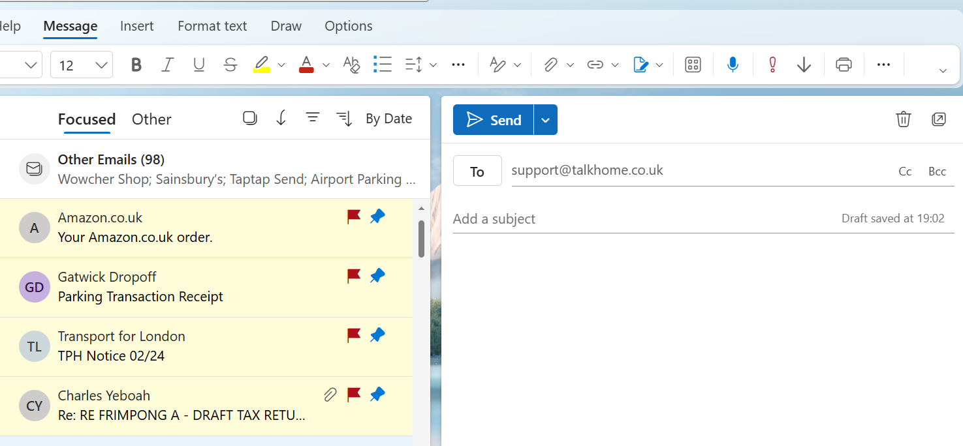
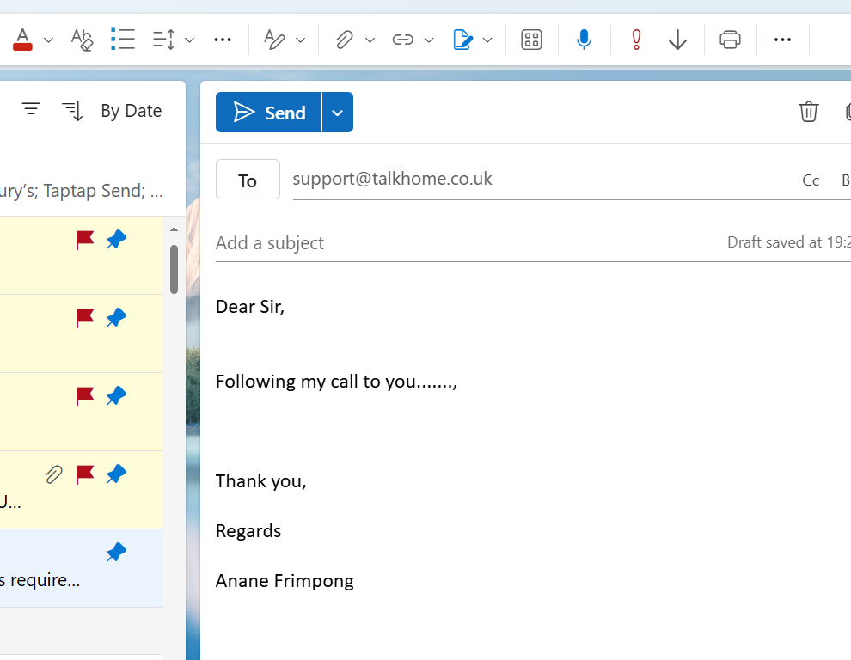

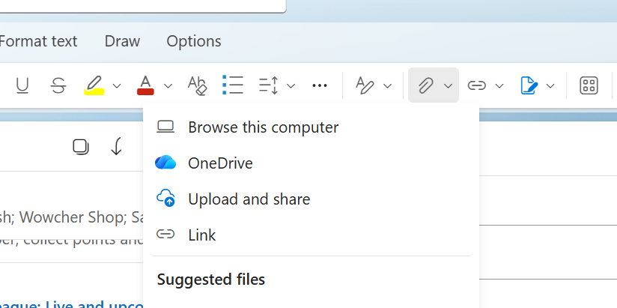
Select to attach a file
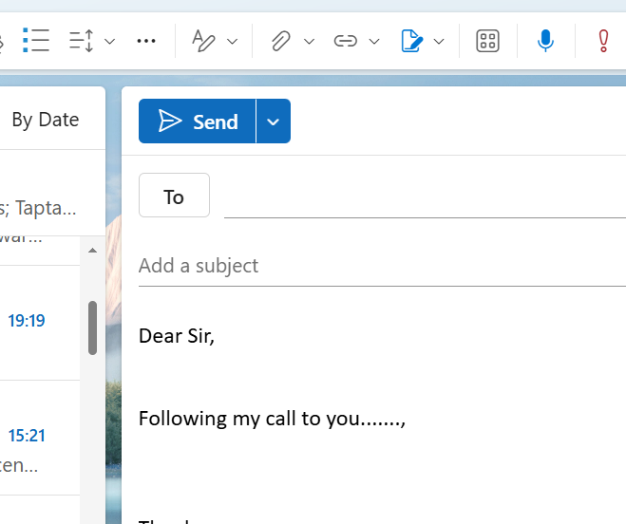

Ms Teams



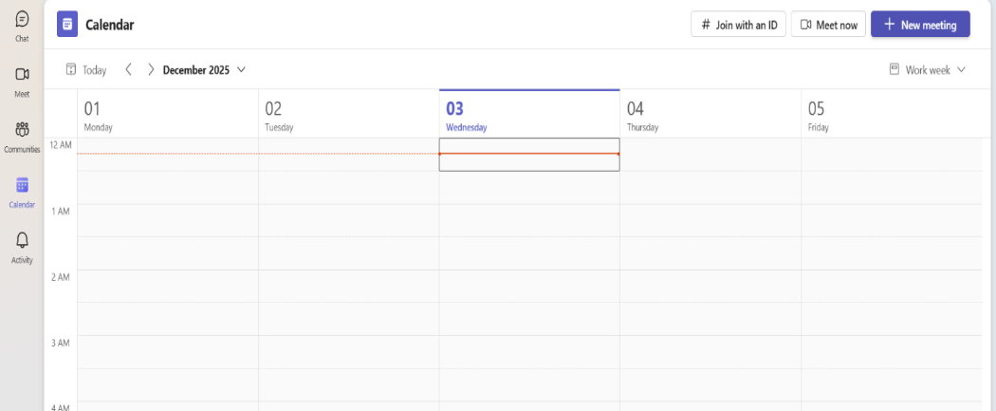
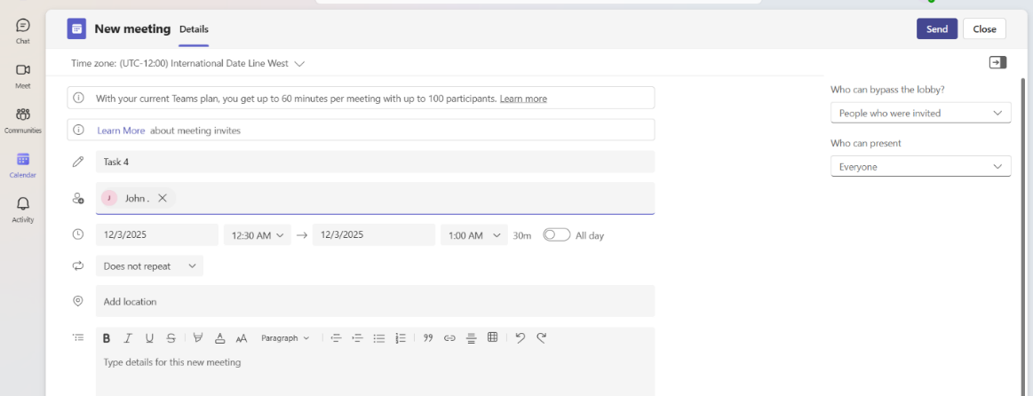
Select Date and Time
Select Participants
Select Date and Time
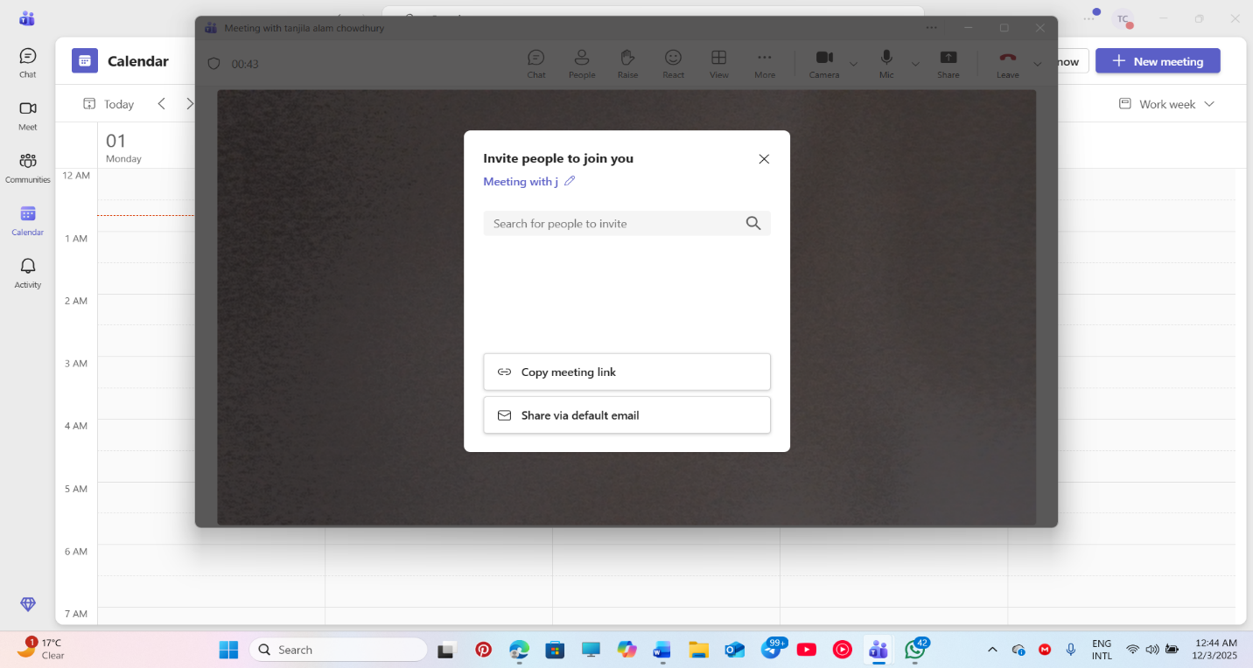

Conclusion
Software programs of the modern age have transformed the way companies function and communicate with each other, and how they compete in the digital marketplace. Today, these tools are a must-have for any modern business. They extend to e-commerce platforms like WooCommerce and Wix that allow people to sell things online, and Microsoft Office programs used for everyday tasks.
The technique can actually be used for visualising complex information and enhancing group planning. Office applications such as Word, PowerPoint, Excel and Access serve a variety of business needs from making documents to poring over data. The concrete examples of mail merge and IF demonstrate how these features simplify life, work. Microsoft Outlook and Teams have revolutionised the way we communicate and work with one another at work, particularly during the rise of remote and hybrid work.
While each of those pieces of software has its issues, when combined into an entire ecosystem, they would meet most business needs. Industry standard. Their widespread use has established industry standards that make it easier for organisations to work or be compatible with each other. While technology has evolved and business models have adapted to accommodate changing market needs, these pieces of software are still essential to maintaining a competitive advantage, operating with the efficiency that businesses demand, and working well with others in today’s business climate.

References

S. Pawar, “What Is WooCommerce? Features, Benefits, Cost and More!” WP Astra, [Online]. Available: https://wpastra.com/woocommerce-tutorial/what-is-woocommerce/. . [Accessed: Nov. 18, 2025]
E. Shwake, “What is Wix, you ask? Let us show you,” Wix Blog, Sep. 8, 2023. [Online]. Available: https://www.wix.com/blog/what-is-wix. . [Accessed: Nov. 18, 2025].
S. McKenzie, “Benefits of mind mapping for professionals,” Business.com, Sep. 13, 2023. [Online]. Available: https://www.business.com/articles/benefits-of-mind-mapping-for-professionals/. . [Accessed: Nov. 18, 2025].
Olivia, E. “15 Best Advantages and Disadvantages of Mind Mapping,” AdvantagesList, 25 June 2022. [Online]. Available: https://advantageslist.com/15-best-advantages-and-disadvantages-of-mind-mapping/
Art of Presentations (2023) 9 disadvantages of using PowerPoint presentations! Available at: https://artofpresentations.com/disadvantages-of-powerpoint/
BDO (2019) The impact of Microsoft Teams. Available at: https://www.bdo.com/insights/digital/the-impact-of-microsoft-teams (Accessed: 2 December 2025).
Bizmanualz (2023). How to use MS-Word for business. Available at: https://www.bizmanualz.com/microsoft-word/how-to-use-ms-word-for-business.html
CareerFoundry (2023). Best 10 features for data analysis in Excel. Available at: https://careerfoundry.com/en/blog/data-analytics/data-analysis-in-excel/ (Accessed: 2 December 2025).
Centric Consulting (2025). 7 benefits of using Microsoft Teams for business. Available at: https://centricconsulting.com/blog/remote-work-how-microsoft-teams-can-keep-your-business-running/ (Accessed: 2 December 2025).
Coggno (2025) 8 best ways to use Microsoft Word in the workplace. Available at: https://coggno.com/blog/what-is-microsoft-word-used-for-in-the-workplace/
ClickUp (2024) Top Microsoft Teams features you need to know about. Available at: https://clickup.com/blog/microsoft-teams-features/ (Accessed: 2 December 2025).
CloudFuze (2025) Microsoft Teams features for effective collaboration in 2025. Available at: https://www.cloudfuze.com/best-microsoft-teams-features-for-effective-collaboration/ (Accessed: 2 December 2025).
Chron (2019) Uses of Microsoft Word in business. Available at: https://smallbusiness.chron.com/uses-microsoft-word-business-60168.html
Codeless ONE (2024) 8 drawbacks of using Excel. Available at: https://www.codelessone.com/blog/8-drawbacks-of-using-excel/
Hevo Data (2024) Microsoft Excel for data analysts: 7 unique features. Available at: https://hevodata.com/learn/excel-for-data-analysts/
Indigo Software (2023) Streamlining business communications with advanced features of Microsoft Outlook. Available at: https://indigosoftwarecompany.com/streamlining-business-communications-with-advanced-features-of-microsoft-outlook/
IT Release (2024) Advantages and disadvantages of Microsoft PowerPoint. Available at: https://itrelease.com/2022/05/advantages-and-disadvantages-of-microsoft-powerpoint/
Influential Software (2024) Enhancing team collaboration with Microsoft Teams. Available at: https://www.influentialsoftware.com/enhancing-team-collaboration-with-microsoft-teams/
Infinity Group (2025) The business benefits of Microsoft Teams. Available at: https://www.infinitygroup.co.uk/blog/business-benefits-microsoft-teams/
Lenovo (n.d.) What is Microsoft Access? Advantages & security tips. Available at: https://www.lenovo.com/us/en/glossary/what-is-microsoft-access/
Layer Blog (2024) Excel limitations: problems, issues, disadvantages. Available at: https://golayer.io/blog/excel/excel-limitations
Microsoft Learn (2024) Use Microsoft Teams for collaboration. Available at: https://learn.microsoft.com/en-us/microsoft-365/business-premium/create-teams-for-collaboration?view=o365-worldwide (Accessed: 2 December 2025).
Noble Desktop (2025) How do business analysts use Excel? Available at: https://www.nobledesktop.com/classes-near-me/blog/how-business-analysts-use-excel
Prodware (2022) Microsoft Outlook: Efficient working and communication tool. Available at: https://www.prodwaregroup.com/en-ge/our-solutions/microsoft-office-365/microsoft-outlook/
Reclaim (2025) What is Microsoft Outlook? (2025 guide). Available at: https://reclaim.ai/blog/what-is-microsoft-outlook
Science Online (2025) What are advantages and disadvantages of Microsoft Word? Available at: https://www.online-sciences.com/technology/what-are-the-advantages-and-disadvantages-of-microsoft-word/
ScaleupAlly (2025) Advantages & disadvantages of MS Access. Available at: https://scaleupally.io/blog/advantages-disadvantages-of-ms-access/
SlideUplift (2025) Advantages and disadvantages of Microsoft PowerPoint for effective presentations. Available at: https://slideuplift.com/blog/advantages-and-disadvantages-of-using-powerpoint-for-presentations/
Stanfield IT (2024) The best 40 features of Microsoft Teams in 2024. Available at: https://www.stanfieldit.com/microsoft-teams/ (Accessed: 2 December 2025).
Tackle (2024) Unleash the power of Outlook time tracking in 2024. Available at: https://www.timetackle.com/unleash-the-power-of-outlook-time-tracking-in-2024/
Techwalla (2010) Uses of Microsoft Word in business. Available at: https://www.techwalla.com/articles/uses-of-microsoft-word-in-business
The Knowledge Academy (n.d.) Key benefits of Microsoft Office: An overview. Available at: https://www.theknowledgeacademy.com/blog/benefits-of-microsoft-office/
VC Solutions (2025) The benefits of Outlook for effective business communication. Available at: https://www.vcsolutions.com/blog/business-communication-simplified-outlook-email-solutions/
UrbanPro (2023) What are the major disadvantages of Microsoft Access? Available at: https://www.urbanpro.com/ms-access/what-are-the-major-disadvantages-of-microsoft-access/38403686
YittBox (n.d.) 6 key benefits to Microsoft Access. Available at: https://yittbox.com/blog-detail/6-key-benefits-to-microsoft-access

