

Programme: | BA (Hons) Leadership and Management Skills for the Workplace
Module: | Workplace Culture and its impact on Organisational Efficiency
Module code: | BMSW5105 | Contribution to Overall Module Assessment (%): | 100%
Lecturer: | Md Kalam | Internal Verifier: | Dr. Hossein Shokri
Assignment Title: | Task 1 (75%)- Individual written report on  “How do broader external environmental factors along with COVID-19 and ethical dilemmas affect organisational culture and its performance?”  Task 2 (25%)- Individual Reflective Essay | Word count (or equivalent): | Task 1- 4000 + 10%  Task 2- 500 + 10%

Table of Contents
Table of Figures 3
Introduction 4
Task 1: Individual Report 5
Hilton Hotel Culture 5
Analytical tools of Business Environment 7
Ethical Dilemma 12
Corporate Culture Transformation at Hilton 13
Task 2: Individual Reflective Essay 17
Conclusion 18
References 19

Table of Figures
Figure 1: Hilton Hotel's Leaders Team 5
Figure 2: Hofstede Dimensions of Cultural Differences 6
Figure 3: Porter's Five Forces Analysis 10
Figure 4: Income earned comparison 10
Figure 6: Employee satisfaction of Hilton Hotel 14
Figure 7: Cultural Web Model 15

Introduction
In today's time, COVID19's emergence has been a great impact on the working of the organisation all over the world which included the impact on the operations, impact on the human resource management of the organisation, impact on the culture of working of the organisation. Due to the emergence of the COVID 19 with some external environmental factors have impacted the work-life balance of the employees of the organisation which means that the workplace of the organisation has been replaced by the bedroom offices of the employees which means that the employees are working at their home rather than be under observation at the workplace. This has impacted and is a great challenge to the culture of the corporate and the people working in it on a great level (Nhamo et al., 2020).
This report is a support to the above discussion of the impact of COVID 19 on the working of the organisations. Here in this report, there will be a discussion on how do broader external environmental factors along with COVID-19 and ethical dilemmas affect organisational culture and its performance? This will be discussed in Task 1. In Task 1 there will discussion of the culture of the chosen organisation, the discussion of the environment of the organisation with the use of SWOT and PESTLE analysis and the impact of COVID 19 on the culture of the organisation. This report also includes Task 2 which is Individual Reflective Essay where there will be a discussion on the learning from the discussion done in Task 1. The organisation which has been chosen here is Hilton Hotel United Kingdom.

Task 1: Individual Report

Hilton Hotel Culture
One of the most competitive organisations in the hospitality industry is Hilton Hotel UK which is also known as Hilton Hotels and Resorts. Hilton Hotel is one of the most respected hotels in the hospitality industry which has inspired a large number of other organisations through its work. The company was founded on 31st May 1919 which is almost 102 years to date. The company was founded by Conrad Hilton and its headquarters is in McLean, Virginia, U.S. the hotels' numbers in the hotel as per the records is 584 till December 31st, 2019. The hotel has more than 219,264 rooms and the company has been rewarded for the best customer services and the top hotel amongst 100 hotels by Fortune Magazine which makes the company top in the hospitality industry (Hilton Hotel, 2021).
Hilton has more than 6,500 properties and the team members in the organisation worldwide are more than 460,000 and from them, about 55,000 are alone residing in the US. The culture of the organisation has been a great impact on the working of the employees in the organisation and how the company stands in the market and this has become possible just because of Matt Schuyler who is the leader in the Hilton Hotel who was not from the hospitality industry and has endeavoured the culture which was set by Chris Nassetta (Mannion et al., 2018).
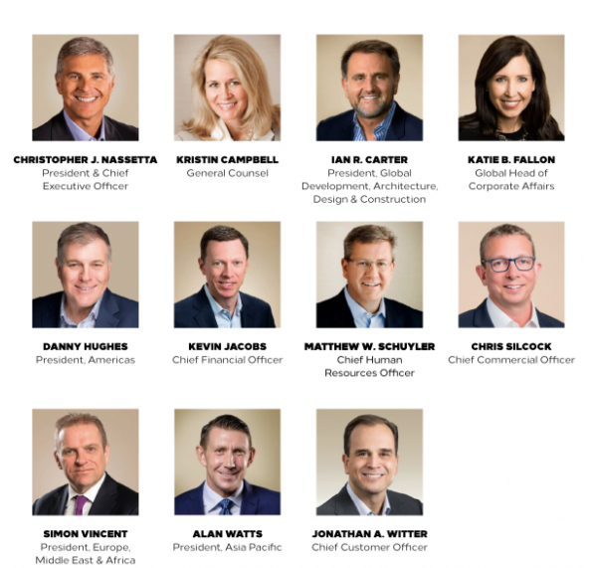
Figure 1: Hilton Hotel's Leaders Team
(Source: Hilton Hotel, 2021)
The organisational culture which is in Hilton Hotel UK can be understood with the help of the 5D theory which has been brought out by Schein. 5D theory has another name which is Hofstede dimensions of cultural differences which include 5 diverse factors which are taken into consideration for the understanding of the culture of Hilton Hotels UK. The model has been described below and it is as follows:
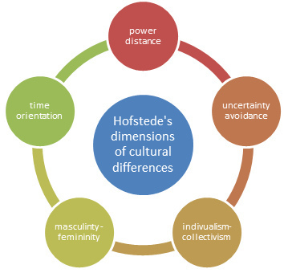
Figure 2: Hofstede Dimensions of Cultural Differences
(Source: Litvin, 2019)
- Power Distance – this is where the power in the organisation is to be distributed in an equal manner amongst the employees in the organisation. Power is such a thing in the organisation that is in full control of the management of the organisation which means that the distribution of the power in the organisation is done by the management and in Hilton Hotel UK the power gets distributed in the organisation to the employees in an equal manner and when COVID 19 came into action the employees were given full power and responsibility which brought balance in the working of the employees when working from home. Employees for Hilton Hotel is a very precious and significant asset and they have been are still treated equally pre- COVID and post- COVID (Szydło et al., 2020).
- Individualism – individualism is where the employees in the organisation tend to play as an individual rather than being working in a team. This brings great issues for the completion of the tasks and has a great impact on the productivity of the organisation. As discussed in the above point the Hilton Hotel distributed the power and responsibilities to the employees in an equal manner and provide the employees with equal opportunities; this helps in keeping the organisation safe from individualism which helps in the smooth flow of work and enhances the chances of growth for the company post- COVID (Huang et al., 2019).
- Masculinity – this is the area where the organisation tends to give more focus on the performance of the employees rather than on the lives of the employees. This brings demotivation in the employees of the organisation which affects their performance and directly impacts the productivity of the organisation. Now when the COVID 19 came into action it impacted the whole performance of the employees as well as the organisation but on other hand, the main impact which came into action is the impact on the lives of the employees for which the Hilton Hotel, UK has taken various actions and protocols which has helped the lives of the employees and brought work-life balance. The various actions which Hilton Hotel, UK took are flexible working timing, medical support to the employees and many others (Minkov et al., 2020).
- Avoidance of Uncertainty – This is the stage where the organisation makes the employees learn how they need to avoid the uncertainties which come into action in the organisation or while working in the organisation but here Hilton Hotel makes sure that the employees get the proper training in which they can face the uncertainties in an effective manner and does not let it get forced on their working system. As COVID 19 came into action all the employees were given proper training and development for coping up with the situation (Szydło et al., 2020).
- Long Term Orientation - this feature is where the staffs of the organization are more attentive on the long term aims relatively than concentrating on the small term aims which makes them less operational in the small-term goals. Hilton Hotel UK has skilled the staff in such a method that they tend to keep functioning for the minor aims as well as the plot for the long term aims (Huang et al., 2019).

Analytical tools of Business Environment
The business environment is the combination of all the internal and external factors which affects the working of the organisation and also affects the profit and productivity of the organisation. This is why every business needs to analyse the internal factors and the external factors which could of a great impact on the functioning of the organisation. The business environment plays a very important role in the functioning of the organisation which means that all the actions which happen in the organisation are done by keeping into consideration all the internal and external factors of the business environment. The decision making of the organisation and the performance of the organisation gets affected by the business environment as the business environment is very dynamic which makes it very difficult for the organisations to make the correct analysis or interpretation of the future happenings. The business success completely depends on its functioning and the functioning gets impacted by the decision making and hence this all get affected by the business environment (Cherunilam, 2021).
The business environment can be explained as the environment which consists of both internal factors which means that factors that are directly connected to the business and the external factors which means they are external parties but have a direct connection and interest in the working of the business, which helps as well as affects the working of the organisation and these factors differ from place to place, country to country (Fabus, 2018).
The tools which can be used by the businesses for the analysis of the internal environment of the business is SWOT analysis which helps in understanding the Strengths, Weaknesses, Opportunities and Threats which a company has and for the study of the external environment the tool which is used is the PESTLE model which helps in analysis of Political, Economic, Social, Technological, Legal and Environmental factors which might affect the working of the organisation. Another analytical tool that is used by the organisations is the PORTERS FIVE FORCES model. These tools will be used here for Hilton Hotel, UK for understanding the internal and external environment of the hotel and its relation with the COVID 19 outburst (Cherunilam, 2021).
PESTLE ANALYSIS
PESTLE analysis is the tool that is used for the study of the external environment of the business which affects the functioning of the business. PESTLE model helps in the analysis of Political, Economic, Social, Technological, Legal and Environmental factors which might affect the working of the organisation. PESTLE analysis is a strategic framework and an analytical tool that is used by entire organisations for the study of the external environment. These 6 factors which are analysed in the PESTLE analysis are not directly connected with the organisations but can be of a great impact on the performance of the organisation. In this part of the report, there will be an analysis done of Hilton Hotel, UK and its connection with the COVID 19 outburst. By doing this there will be a clear understanding of the external environment of the organisation and how COVID 19 has impacted the 6 factors here (Perera, 2017).
The PESTLE analysis of Hilton Hotel, UK is as follows:
- Political Factor- Hilton Hotel is one of the most renowned hotels in the hospitality industry and for hotels, political stability is one of the most crucial aspects for the smooth working of the business. For instance, if a particular country is not stable then people will have fear of visiting that country for their business purpose as well for their leisure stay which will reduce the number of guests in the hotel which will affect the profitability of the business. Here Hilton Hotel operates in various countries and with the emergence of COVID 19, there has been a great fear in the air of every country which has been a great impact on the business of the hotel. The implementation of lockdown impacted the working of the hotel but as gradually lockdown got eased up the hotel will get great support in working and earning good revenue (AKMAN, 2020).
- Economic Factor- the economic factors such as interest rates, the inflation rate, growth rate and the gross domestic product of the country impact the working of the business and even the starting of the business. Hilton hotel here should target that country that has a high number of people with disposable income as well as where there is stability in the economic environment. With the emergence of COVID 19, the interest rate has been reduced drastically with which leans are available in the countries which can be a great help for the hotel industry if they are willing to start their hotel in that particular country. But on other hand, the impact which the hotel industry might face is the low productivity in the countries because of the nationwide lockdown (Perera, 2017).
- Social Factor- Hilton Hotel is one of the most renowned hotels in the hospitality industry and the finance of the hotel gets affected by social factors such as the behaviour of the customers, culture of the customers, age of the customers, etc. before COVID 19 came into action the income of the people were high which made them spend it on leisure activities and stay at the hotel which increased the revenue of the business but as COVID 19 came into action people started to get fear to interact with each other and have reduced the social gathering which has affected the business of Hilton Hotel (Hilton Hotel, 2021).
- Technological Factor- in technology there is continuous development and this is the aspect that cannot be ignored by any business. So here Hilton Hotel needs to upgrade its technology and bring in advanced technology for working which will help in increasing the productivity of the business and hence help in smooth functioning as well. The hotel should include the digitalization of payments which will be a great help to both customers and the hotel. After COVID 19 the use of social media has increased drastically which made it a great platform to connect with each other and hence here Hilton Hotel need to implement the same in its work.
- Legal Factor- the laws and regulations which prevails in a country affect the working of the business and the laws here are Employee law, customer laws and other legal laws. Various laws have come into action as COVID 19 came into action such as the law of social distancing, laws such a customer safety which includes the sanitization of the rooms of the hotel and many other. These are the laws that need to be kept in mind by Hilton Hotel.
- Environmental Factor- the environmental factors which need to be kept into consideration by Hilton Hotel are the climate change which is going on because of COVID 19 which has affected the health of the people in the market as well as the employees in the organisation (Perera, 2017).
HILTON PORTER’S FIVE FORCES ANALYSIS

Porter's Five Forces analysis is developed by Michael Porter (1979) which helps in the analysis of completion in the market and Porter's Five Forces analysis of Hilton Hotel is as follows:
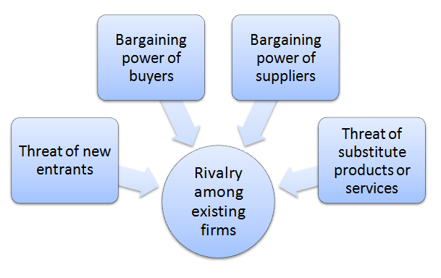
Figure 3: Porter's Five Forces Analysis
(Source: Varelas et al., 2017)
- Rivalry among existing firms - the competitors of Hilton Hotel are Marriott, Hyatt Regency, Sheraton, Radisson Blu, Westin, Sofitel, Renaissance and various other hotels. As a result of the study about the massive investment in the hotel chain industry, Hilton Hotels are the fastest growing and fastest income-earning hotel as compared to the other competitors in the marketplace. As per the records Hilton Hotel has grown by 106.67 per cent and the income of other companies are 61.98 per cent (Hilton Hotel, 2021).
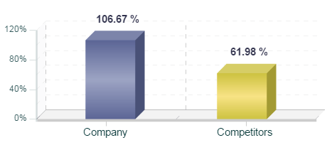
Figure 4: Income earned comparison
(Source: Hilton Hotel, 2021)
- Bargaining power of Hilton suppliers – The bargaining power of Hilton Hotel suppliers is low as the purchase of Hilton Hotel is done by more than 4000 suppliers on a global basis and the bargaining power of most of the suppliers is low as there is a lack of products and services with uniqueness. This is the reason where the suppliers have no power for the bargaining as Hilton Hotel has the next best option of the supplier to buy the resources for their functioning (Varelas et al., 2017).
- The threat of substitute products or services – the threat of substitution of products and services provided by Hilton Hotel or any other hotel industry is not significant as the people can substitute the stay at a hotel with the stay at any friend's house but this takes time for arranging the stuff and everything which makes this concept not significant in Hilton Hotel aspect (Varelas et al., 2017).
- Threats of New Entrants – Hilton can take good use of the economies of scale which it is having in the industry and this can be done by competing with the new entrants with the use of the cost advantage which Hilton Hotel is having. Hilton Hotel can focus on the innovation strategy which it can bring into the working which can bring a difference in the products and services of Hilton Hotel of that of the other organisations (Bruijl, 2018).

HILTON SWOT ANALYSIS
The tool which can be used by the businesses for the analysis of the internal environment of the business is SWOT analysis which helps in understanding the Strengths, Weaknesses, Opportunities and Threats which a company has (GURL, 2017). The SWOT analysis of Hilton Hotels is as follows:
SWOT ANALYSIS | DESCRIPTION
STRENGTHS | - Hilton has a high brand reputation in the marketplace.  - Employee retention in the organisation is stable and effective.  - Hilton hotel has more than 540 hotels in around 78 countries all over the world.  - The company has been in the hospitality industry for more than 93 years.  - The Hilton Hotel has a good market reputation.  - The company is good at technical innovation and adaptation.
WEAKNESSES | - The market share of Hilton Hotel in the market is very limited even after having good market brand value.  - The government policies and rules and regulations affect the operations of Hilton Hotels (Elavarasan et al., 2020).
OPPORTUNITIES | - In emerging markets, Hilton Hotels has a high potential for standing and growth in the market.  - Hilton Hotel has the opportunity for innovation in the customer service sector.  - The Hilton Hotel can involve digitalization and innovation in technology in its working which can help in gaining more of the customer base and market share.
THREATS | - New entrants in the marketplace with a stronghold on knowledge and a stronghold on innovation and technology.  - Stagnated growth in the market is a crucial threat for Hilton Hotel.  - Political and economic turbulence in most of the countries in the world (GURL, 2017).

Ethical Dilemma
Ethical Dilemma is an issue that arises in the organisation while the decision-making process between the two possible options which are present for choosing which not acceptable from the ethical point of view of the organisation (Astrachan et al., 2020).
An ethical dilemma is a great challenge for an organisation that cannot be solved easily by the management of the organisation. These ethical dilemmas affect the working of the organisation.
The examples of ethical dilemmas that an organisation faces are as follows:
- Diversity and Discrimination – as everyone knows that in an organisation there are some people who are treated differently based on their ethics, colour, age, gender, sexual preferences, etc. according to various records it has been found that about 61 per cent of American and Australian employees have witnessed discrimination based on their gender, their age, LGBTQ identity which has been a great impact on their working conditions and even it affects the name and value of the business in the market.
On the other hand, people with a disease which are from genetics are also discriminated against in the organisation which means that people with genetic diseases are treated differently from those who are not suffering from the same (Stevanović, 2019).
What Hilton Hotel can do for this in their business?
Here the Hilton Hotel can educate the employees in the organisation which means that each and every employee in the organisation should be well aware of the rules and regulations which are followed by the organisation and the rules and laws which are set by the government for Discrimination in the organisation.
The second best way in which Hilton Hotel can solve this is by hiring people from different backgrounds and characteristics. Having diverse people in the team in the organisation will not only make people learn and respect each other but this will also help the organisation in fighting against discrimination in the organisation (Baker, 2017).
The Hilton Hotel need to makeup policies regarding discrimination in the organisation and make rules for the employees and implement it in an effective manner so that if any employee miss to follow it comes under action and observation which will help that particular employee to learn as well it will give a good lesson to the other employees as well.
- Health and Safety – Health and Safety is the main concern which comes up in every other organisation and it is the most serious topic which needs to be considered by every organisation for their employees working in the workplace and even at their home. According to the record of 2019 in the US, there were about 5,300 fatal injuries that happened in organisations because of various reasons.
The organisation need to keep in mind the health and safety of the employees as employees are the most important asset of the organisation because of which the organisation functions (Motter et al., 2017).
What Hilton Hotel can do for this in their business?
Hilton Hotel can have regular inspections of the surrounding in which the employee works and there should be medical check-up for every employee who is part of the hotel. According to World Health Organisation the following things which an organisation needs to do are as follows:
- The organisation need to regularly inspect the working place.
- The employees should be educated about the health protocol and safety.
- Provide employees with health insurance.
- Recognize the hard and smart work of the employees in the organisation.
- Have periodical meetings for the health and safety concerns of the employees (Baker, 2017).

Corporate Culture Transformation at Hilton
The corporate culture has been changed since COVID 19 came into action and the concept of business of people serving people came up which was introduced by Matt. Hilton wants to become one of the most profitable and most hospitable businesses in the world. Hilton hotel keeps in mind serving and treatment of the people who are connected to the organisation which are the team members, employees, vendors, suppliers. Etc. which helps in providing them with an effective and positive working environment for working. Matt one of the most trusted leaders understood that when the people in the organisation are given the right and effective working environment then the service which is or will be provided by them will be effective and in a good manner. From this, the various concepts were introduced in the culture of Hilton and they are:
- Understanding that the business of Hilton is people serving people
This is where the work which is done by the Hilton Hotel by keeping in mind the people who are connected to the business and give them with all the amenities which are required by them for the better performance in the organisation. Hilton hotel has achieved a lot while working on the concept of people serving people and this can be shown by seeing the survey done by the Great Place to Work Trust Index Survey.
According to the survey which was done with the employees of the Hilton Hotel it has been found according to Great Place to Work Trust Index Survey, that about 96 per cent of employees are very happy and satisfied with the working environment where they work and about 97 per cent of the employees are very proud to be part of the business (Great place to work, 2021).
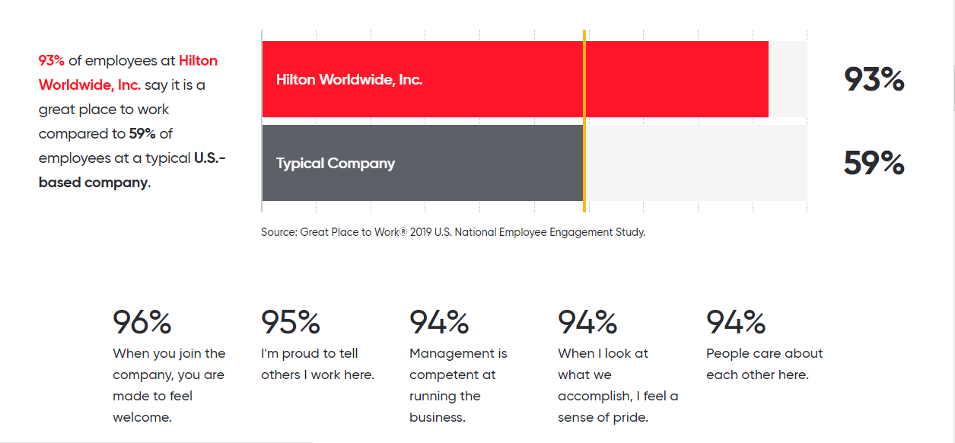
Figure 6: Employee satisfaction of Hilton Hotel
(Source: Great place to work, 2021)
The current culture or the appraisal in the culture of Hilton Hotel can be done with the use of the Cultural Web model. The Cultural web model is a model which helps in breaking down the culture of the organisation into small-small parts to have a better understanding of it (Thompson et al., 2017).
Organisational culture is built with the situation and assumptions which is made by the business or the surroundings which are prevailing in the business. The Cultural Web Model of Hilton Hotel is as follows:
- Rituals and Routines: Hilton Hotel makes sure that the rules and ethics of the organisation are followed by the employees and certain rules such as turn of the light close the door is the regular working of all the employees. The packaging and delivering method of Hilton Hotel is also a great part of the routine and rituals of the hotel.
- Organisational Structures: the employees whether they are new or old are encouraged for training, induction and mentoring for making their performance way better than what they are performing right now. Here the employees are given a set of understanding of the cost awareness, the humbleness among themselves and teamwork for growth (Cooper et al., 2019).
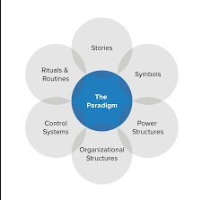
Figure 7: Cultural Web Model
(Source: Thompson et al., 2017)
- Stories: the story of Matt Schuyler and his involvement in the organisation and its development has been a great inspiration for not just the management or the employees but also for the other companies in the world.
- Symbols: the symbols of Hilton Hotel involve the title, logo, the language which is used in the working surroundings.
- Power Structure: in Hilton Hotel UK the power gets distributed in the organisation to the employees in an equal manner and when COVID 19 came into action the employees were given full power and responsibility which brought balance in the working of the employees when working from home.
- Control System: As discussed in the above point the Hilton Hotel distributed the power and responsibilities to the employees in an equal manner and provide the employees with equal opportunities; this helps in keeping the organisation safe from individualism which helps in the smooth flow of work and enhances the chances of growth for the company post- COVID.
According to the Great Place to Work Trust Index Survey, the Hilton Hotel has won various awards in the year 2021 which are:
- #3 in Fortune 100 Best Companies to Work For® 2021
- #1 in Fortune Best Big Companies to Work For™ 2021
- #2 in Great Place to Work's Best Workplaces in Texas™ 2021(Large) (Hilton Hotel, 2021).
- #3 in Fortune Best Workplaces for Millennials™ 2021(Large).

Task 2: Individual Reflective Essay
From the study above which has been done about Hilton Hotel workplace culture and its impact on the organisation efficiency in accordance with the emergence of COVID 19, I have understood various things from the study. A reflective essay is an essay that is written by an individual with relation to the experience which he or she has come across in his or her life. Reflective essay helps in understanding what are the things which we have learned and what are the areas in which we to improve in ourselves (Gaus, 2017).
From the study above the various points which I have learned from the study of Hilton Hotel is that:
- Teamwork is a very important aspect in professional as well as in personal life as it helps in making the working easy and it helps in effective completion of the work. So from this, I have understood that I will be working effectively in a team by being cooperative with the team members and by having effective communication skills. This will help in building a strong team and will help in the timely completion of all my and team members tasks.
- As COVID 19 came into action it is the responsibility of the organisation as well as the employees to be supportive with each other and have effective communication with each other to have effective working. So from this, I have understood that I need to have effective communication skills which will help me in being open to the person in front of me and share my thoughts, ideas which would be helpful for me as well as for the other person.
- Thirdly I have understood that I should have time management skills which would help me in reducing my stress about the deadline of the work and which will help me complete my work in a timely manner (Gaus, 2017).
Being an effective and active participation in bringing change and working with changes helps a lot as an individual as it is well known that business environment and even normal environment for the people in the market is very dynamic and it keeps changing continuously which affects everything and by being active change manager it becomes very helpful and easy to identify the changes which comes up in the environment and it becomes very easy to make strategic plans and actions for overcoming the challenges and obstacles which comes up with the changes.
So these all are the things which I have learned from the study which I have done in task 1 about Hilton Hotel with relation with the emergence of COVID 19 in the business environment.

Conclusion
From the discussion above it can be concluded that COVID 19 has been a great impact on the workplace culture of the organisation and which has impacted the performance and organisational efficiency of the organisation but here by the study of the Hilton Hotel case it has been understood that Hilton Hotel has been very active in serving the people who are connected with them and they have been very effective in working and coping up with the impact of COVID 19. It has also been observed that the transformation of organisational culture has been very positive.
The report above covers two tasks, In Task 1 there is the discussion of the culture of the chosen organisation, the discussion of the environment of the organisation with the use of SWOT and PESTLE analysis and the impact of COVID 19 on the culture of the organisation. This report also includes Task 2 which is Individual Reflective Essay where there will be a discussion on the learning from the discussion done in Task 1.

References
AKMAN, M.K., (2020). DEFENCE MANAGEMENT AND PESTLE ANALYSIS. ANTE PORTAS.
Astrachan, J.H., Astrachan, C.B., Campopiano, G. and Baù, M., (2020). Values, spirituality and religion: Family business and the roots of sustainable ethical behavior. Journal of Business Ethics, 163(4).
Baker, D.F., (2017). Teaching empathy and ethical decision making in business schools. Journal of Management Education, 41(4).
Bruijl, G.H.T., (2018). The relevance of Porter's five forces in today's innovative and changing business environment. Available at SSRN 3192207.
Cherunilam, F., (2021). Business environment. Himalaya Publishing House Pvt. Ltd.
Cooper, M.D., Collins, M., Bernard, R., Schwann, S. and Knox, R.J., (2019). Criterion-related validity of the cultural web when assessing safety culture. Safety science, 111.
Elavarasan, R.M., Afridhis, S., Vijayaraghavan, R.R., Subramaniam, U. and Nurunnabi, M., (2020). SWOT analysis: A framework for comprehensive evaluation of drivers and barriers for renewable energy development in significant countries. Energy Reports, 6.
Fabus, M., (2018). BUSINESS ENVIRONMENT ANALYSIS BASED ON THE GLOBAL COMPETITIVENESS INDEX (GCI) AND DOING BUSINESS (DB): CASE STUDY SLOVAKIA. Journal of Security & Sustainability Issues, 7(4).
Gaus, N., (2017). Selecting research approaches and research designs: A reflective essay. Qualitative Research Journal.
Great place to work (2021). Certified-company. [Online]. Available from: www.greatplacetowork.com [Accessed on 20/08/2021].
GURL, E., (2017). SWOT analysis: A theoretical review.
Harral, E., (2019). Ethical Dilemma.
Hilton Hotel (2021). Corporate. [Online]. Available from: www.hilton.com [Accessed on 20/08/2021].
Huang, S.S. and Crotts, J., (2019). Relationships between Hofstede's cultural dimensions and tourist satisfaction: A cross-country cross-sample examination. Tourism management, 72.
Litvin, S.W., (2019). Hofstede, cultural differences, and TripAdvisor hotel reviews. International Journal of Tourism Research, 21(5).
Mannion, R. and Davies, H., (2018). Understanding organisational culture for healthcare quality improvement. Bmj.
Minkov, M. and Kaasa, A., (2020). A test of Hofstede's model of culture following his own approach. Cross Cultural & Strategic Management.
Motter, A.A. and Santos, M., (2017). The importance of communication for the maintenance of health and safety in work operations in ports. Safety science, 96.
Nhamo, G., Dube, K. and Chikodzi, D., 2020. Impacts and implications of COVID-19 on the global hotel industry and Airbnb. In Counting the Cost of COVID-19 on the global tourism industry. Springer, Cham.
Öneren, M., Arar, T. and Yurdakul, G., (2017). Developing competitive strategies based on SWOT analysis in Porter’s five forces model by DANP. İşletme Araştırmaları Dergisi, 9(2).
Perera, R., (2017). The PESTLE analysis. Nerdynaut.
Stevanović, M., (2019). Diversity and discrimination at the workplace (Doctoral dissertation, University of Rijeka. Faculty of Economics and Business.).
Szydło, J. and Grześ-Bukłaho, J., (2020). Relations between National and Organisational Culture—Case Study. Sustainability, 12(4).
Thompson, N., Rukshan, A. and Murray, D., (2017). Cross-Cultural Web Usability Model. Web Information Systems Engineering–WISE 2017. WISE 2017. Lecture Notes in Computer Science, 10570.
Varelas, S. and Georgopoulos, N., (2017). Porter’s competitive forces in the modern globalized hospitality sector–the case of a Greek tourism destination. J Tour Res, 18.

