Name: Ossian De’Ath

Student Number: 2520279

WORKSHEET 4 – TESTING (Dice Duel)

- Original code:
[Copy and paste your original code from Moodle into this box. Do not change it.]
# Worksheet 4 - 23/03/2026

# Write a program which generates three random numbers for the user, and then three for the computer.
# Add the numbers for each player - the player with the highest total wins the round.

# Import random - and then create varaiable for user and computer dice.
import random

#score counter
UserScore = 0
ComputerScore = 0
DrawCounter = 0

# if statement for user to play game.
print("Lets play the dice game.")
print("You will roll the dice 3 times against the computer. Whoever has the highest score wins.")
print("Are you ready? (Y/N)")
playGameAnswer = input()
playGameAnswer = playGameAnswer.lower()
print("================")

# do validation outside of session.....

while playGameAnswer == "y" or playGameAnswer == "yes":
# Lists
UserDiceList = []
ComputerDiceList = []
print()

# loop for User dicey

for x in range(3):
UserDice = random.randint(1, 6)
UserDiceList.append(UserDice)

# loop for Computer dice
for y in range(3):
ComputerDice = random.randint(1, 6)
ComputerDiceList.append(ComputerDice)

# compare results
print("Comparing Results.")
print("==================")
print()

# User results.
UserDiceListTotal = sum(UserDiceList)
print("You scored: ", UserDiceListTotal)
print("==============")
print()
for UserDice in UserDiceList:
print(UserDice, end=" ")

print("\n")

# Computer Results.
ComputerDiceListTotal = sum(ComputerDiceList)
print("The computer scored: ", ComputerDiceListTotal)
print("=======================")
print()
for ComputerDice in ComputerDiceList:
print(ComputerDice, end=" ")

print()
# display winner
print("\nWho won????")
print("===========")
print()
if UserDiceListTotal == ComputerDiceListTotal:
DrawCounter = DrawCounter + 1
print("It was a draw! ")
print("No one scores a point!")
print("======================")

elif ComputerDiceListTotal > UserDiceListTotal:
print("You have lost!\n\nThe computers total score was: ", ComputerDiceListTotal)
ComputerScore = ComputerScore + 1
print("The Computer Scored a Point!")
print("============================")
elif UserDiceListTotal > ComputerDiceListTotal:
print("You have won!\n\nYour total was: ", UserDiceListTotal)
UserScore = UserScore + 1
print("You scored a point!")
print("===================")

# scores
print()
print("The scores are in!")
print("==================")
print()
print("Your score is: ", UserScore)
print("The computers Score is: ", ComputerScore)
print("Games Drawn: ", DrawCounter)

# clear lists
UserDiceList.clear()
ComputerDiceList.clear()

print()

playGameAnswer = input("Would you like to play again? (Y/N): ")
playGameAnswer = playGameAnswer.lower()

else:
print()
print("That's okay. We'll play soon.")

- Code Testing
For each test below (i – ix), run your code and show the results of the scenarios below. Present a screenshot of what happened when the programme ran. Did the programme behave correctly or did it do something unexpected, and if so, why?

Part a)
- Computer wins round
- User wins round
- Draw
- “Go again” – enter y
- “Go again” – enter n
- “Go again” – enter Y
- “Go again” – enter b

Part b)
- Show score/score tracking (depending on how you have implemented your program)
- Show an overall win (however this is achieved eg first to 5, best of 12 etc)

Part c)
x. Analyse your code and write a short paragraph commenting on the efficiency of the original code. Could efficiency be improved and if so comment on what is currently inefficient?

Template for tests:
Test: i
Computer Wins round

Screenshot(s) of output:
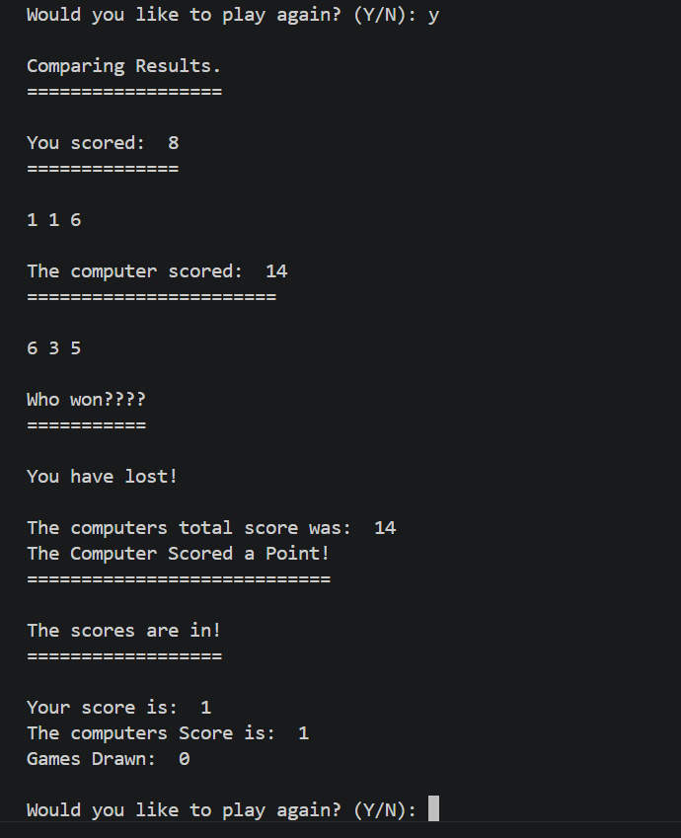
Result: Did the programme behave as expected ie syntactically and logically correct?
YES
If YES, comment on what happened.
The computer scored more points than me so the computer won and got the point.

Test: ii
User wins.

Screenshot(s) of output:
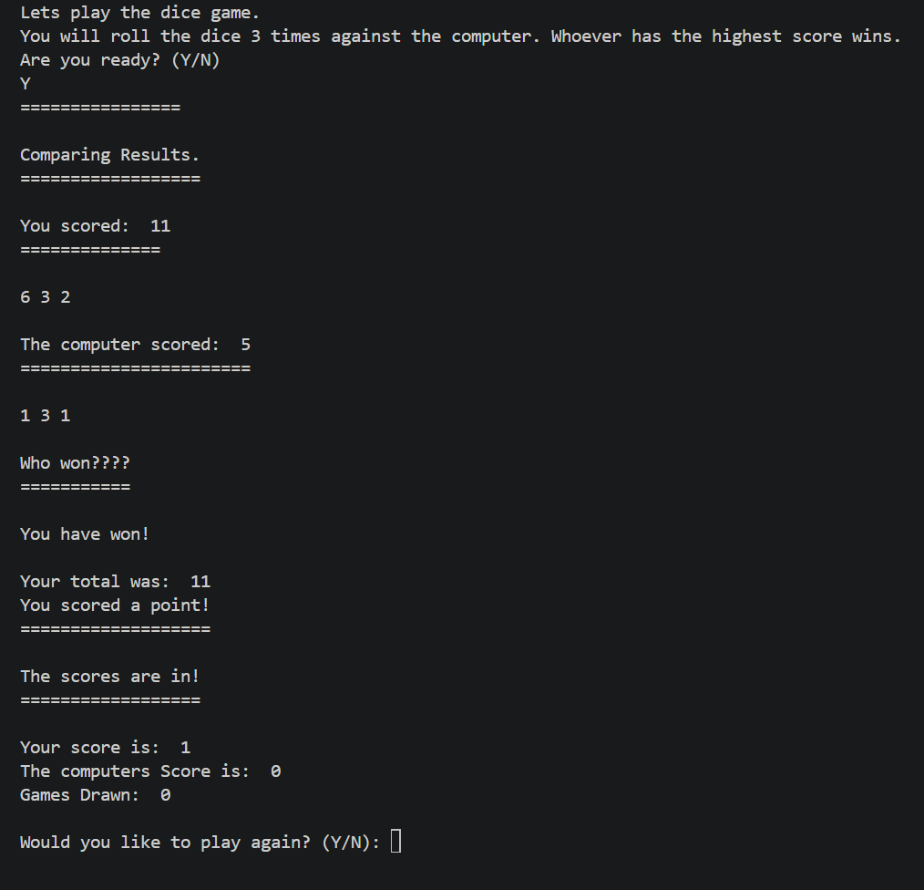
Result: Did the programme behave as expected ie syntactically and logically correct?
YES
If YES, comment on what happened.
My roll was higher than the computers score, so I won, and it also counted the win as my win.

Test: iii
Draw

Screenshot(s) of output:
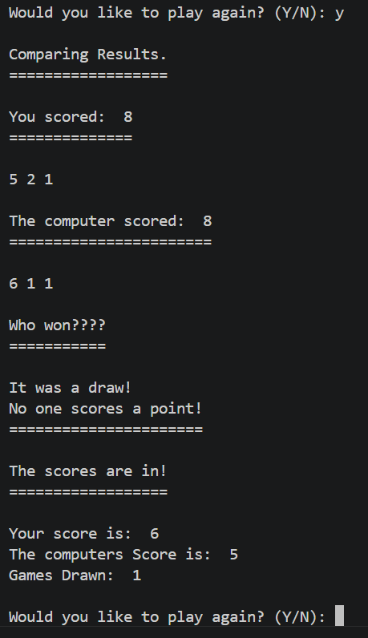
Result: Did the programme behave as expected ie syntactically and logically correct?
YES
If YES, comment on what happened.
We both scored the same score. This means we will get a draw as you can see the games drawn.

Test: iv
Go again “y”

Screenshot(s) of output:
Result: Did the programme behave as expected ie syntactically and logically correct?
YES
If YES, comment on what happened.
I typed “y” and the game was played again, successfully.

Test: v
Go again “n”

Screenshot(s) of output:
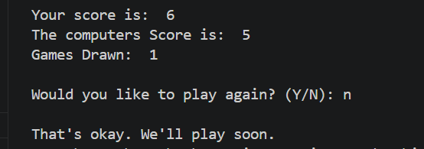
Result: Did the programme behave as expected ie syntactically and logically correct?
YES
If YES, comment on what happened.
When I typed “n” the game cancelled and said that’s okay we’ll play again soon. This function worked as it should have.

Test: vi
Go again “Y”

Screenshot(s) of output:
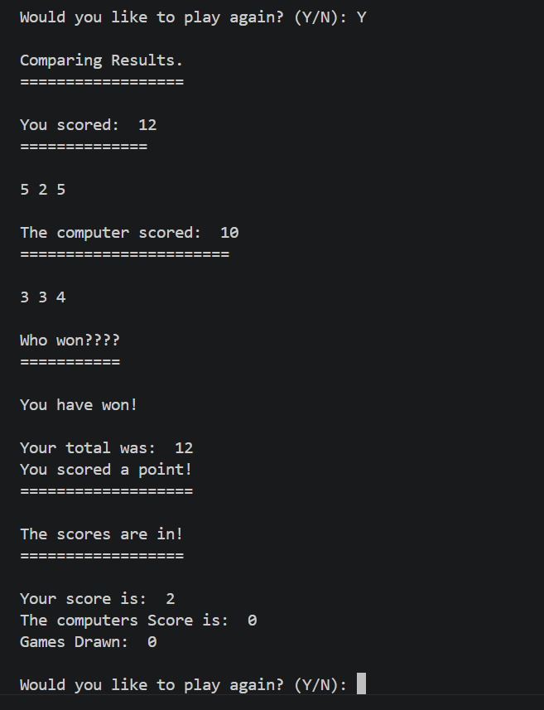
Result: Did the programme behave as expected ie syntactically and logically correct?
YES
If YES, comment on what happened.
My code is validated for lower case and upper case yes and no. (y and n)

Test: vii
Go again “b”

Screenshot(s) of output:
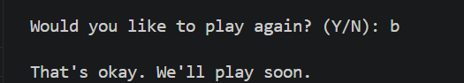
Result: Did the programme behave as expected ie syntactically and logically correct?
NO
If NO, what went wrong and why? Suggest how things could be improved
I typed b and the game ended. Code should be validated so only y or n is accepted, anything else it should be in a loop until an appropriate answer is provided.

Test: viii
Score tracking, displays scores equally.

Screenshot(s) of output:
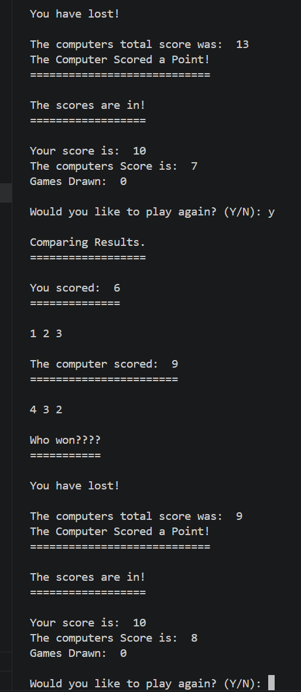
Result: Did the programme behave as expected ie syntactically and logically correct?
YES
If YES, comment on what happened.
Scores get displayed correctly, after whoever wins they get a point, etc. If there’s a draw a point is given to the draw category.

Test: ix
Shows an overall score / winner of the game.

Screenshot(s) of output:
Result: Did the programme behave as expected ie syntactically and logically correct?
YES and NO
If YES, comment on what happened.
So the scoring is fine and you can see the overall score and who wins!
If NO, what went wrong and why? Suggest how things could be improved
However, the only way to win currently is saying no to playing again, so there’s no like first to 5 etc, I could add this as an improvement.

(Copy and paste box above for each of the rest of the tests)
- Consider the results of the above tests and your analysis of program efficiency and revisit your original code in order to address any tests that failed and/or improve code efficiency.

I have added better validation, so if the user does not input y or n, the game will make them enter one of these values.

I have also added a scoring system allow for the game to get a winner when someone hits 5 points.

(Note: you may not be able to solve all of the problems that were encountered, but solve as many as you can.)

Paste your full revised code here :

[Copy and paste your full revised code here – note, do not use a screenshot]
# Worksheet 4 - 23/03/2026

# Write a program which generates three random numbers for the user, and then three for the computer.
# Add the numbers for each player - the player with the highest total wins the round.

# Import random - and then create varaiable for user and computer dice.
import random

#score counter
UserScore = 0
ComputerScore = 0
DrawCounter = 0

# if statement for user to play game.
print("Lets play the dice game.")
print("You will roll the dice 3 times against the computer. Whoever has the highest score wins.")
print("First to 5 points wins the game.")
print("Are you ready? (Y/N)")
print("================")

# input validation using flag and try except
flag = 0
while flag == 0:
try:
playGameAnswer = input().lower()

if playGameAnswer == "y" or playGameAnswer == "yes":
flag = 1
elif playGameAnswer == "n" or playGameAnswer == "no":
print("\nThat's okay. We'll play soon.")
exit()
else:
raise ValueError
except ValueError:
print("Invalid input. Please enter Y or N.")

# updated game loop
while playGameAnswer == "y" or playGameAnswer == "yes":

# stop game when someone reaches 5
if UserScore == 5 or ComputerScore == 5:
break

# Lists
UserDiceList = []
ComputerDiceList = []
print()

# loop for User dice
for x in range(3):
UserDice = random.randint(1, 6)
UserDiceList.append(UserDice)

# loop for Computer dice
for y in range(3):
ComputerDice = random.randint(1, 6)
ComputerDiceList.append(ComputerDice)

# compare results
print("Comparing Results.")
print("==================")
print()

# User results.
UserDiceListTotal = sum(UserDiceList)
print("You scored: ", UserDiceListTotal)
print("==============")
print()
for UserDice in UserDiceList:
print(UserDice, end=" ")

print("\n")

# Computer Results.
ComputerDiceListTotal = sum(ComputerDiceList)
print("The computer scored: ", ComputerDiceListTotal)
print("=======================")
print()
for ComputerDice in ComputerDiceList:
print(ComputerDice, end=" ")

print()
# display winner
print("\nWho won????")
print("===========")
print()

if UserDiceListTotal == ComputerDiceListTotal:
DrawCounter = DrawCounter + 1
print("It was a draw! ")
print("No one scores a point!")
print("======================")

elif ComputerDiceListTotal > UserDiceListTotal:
print("You have lost!\n\nThe computers total score was: ", ComputerDiceListTotal)
ComputerScore = ComputerScore + 1
print("The Computer Scored a Point!")
print("============================")

elif UserDiceListTotal > ComputerDiceListTotal:
print("You have won!\n\nYour total was: ", UserDiceListTotal)
UserScore = UserScore + 1
print("You scored a point!")
print("===================")

# scores
print()
print("The scores are in!")
print("==================")
print()
print("Your score is: ", UserScore)
print("The computers Score is: ", ComputerScore)
print("Games Drawn: ", DrawCounter)

# clear lists
UserDiceList.clear()
ComputerDiceList.clear()
print()

# new play again validation
flag = 0
while flag == 0:
try:
playGameAnswer = input("Would you like to play again? (Y/N): ").lower()
if playGameAnswer == "y" or playGameAnswer == "yes":
flag = 1
elif playGameAnswer == "n" or playGameAnswer == "no":
print("\nThat's okay. We'll play soon.")
exit()
else:
raise ValueError
except ValueError:
print("Invalid input. Please enter Y or N.")

# ---- final winner ----
print("\nGame Over!")
print("==========")
if UserScore == 5:
print("You reached 5 points first. You win!")
elif ComputerScore == 5:
print("The computer reached 5 points first. You lose!")

