Community Care and Management of Longer-term Conditions
Student Name: Danielle Gotz Colombo das Candeias
Student Number: 2231187

Module Code: LCHS7003
Component 1: Information Booklet of Long-term
Condition Management
Focused Long-term Condition: Dementia
Instructor’s Name: Muhammad Khan.
Date: 17/07/2026
Executive Summary
This information booklet offers an evidence-based overview of dementia as a significant long-term condition impacting people, families and the health and aged care system. It reviews the definition, incidence, burden, risk factors and etiology of dementia, with an emphasis on its increasing public health burden. The booklet also addresses the physical, psychological and social effects of the condition as well as the effects on family caregivers. In addition, it covers evidence-based NHS treatments and health and social care management approaches and includes relevant UK and international frameworks and policies. Finally, it offers recommendations for further strengthening person-centred care, supporting self-management as appropriate, and improving end-of-life care to improve health outcomes and quality of life for individuals with dementia.
- Introduction
Dementia is a condition of gradual deterioration of cognitive function, involving loss of memory, reasoning, communication, behaviour and the ability to complete daily activities without assistance. It is not a natural aspect of ageing but rather the result of a variety of underlying neurological diseases that slowly damage brain cells. With rising life expectancy, dementia has emerged as one of the greatest long-term conditions in the world and poses a major challenge for individuals, families, health care practitioners and the community. This is a condition that typically demands ongoing health and social care assistance, which can add significant burden to the health care system and to informal caregivers, in addition to financial costs. Dementia not only has physical effects but also psychological, emotional and social impacts which can have a negative impact on quality of life and independence. Effective management goes beyond medical management to include person centred care, working with multi-disciplinary teams, early diagnosis, support for the carer and strategies that encourage dignity and wellbeing across the course of the disease. This information booklet addresses the issue of dementia critically, by looking at the definition, prevalence, the risk factors for dementia, the impact of dementia, evidence-based management strategies, theories of dementia and relevant health and social care policies, and recommendations for the future to improve long-term outcomes and person-centred care.
- Definition, Prevalence, and Burden of Dementia
The World Health Organisation (2025) defines dementia as a syndrome where there is an “ongoing decline in cognitive function beyond what is expected from normal ageing”. It alters memory, thinking ability, orientation, comprehension, learning ability, language, judgment and independence in the performance of routine tasks. Likewise, according to the Alzheimer's Association (2025), dementia is a broad term that refers to a variety of conditions affecting the brain, causing a person's mental abilities to decline to the extent that it effects daily activities and social interactions. Dementia is not one disease, but a group of conditions, such as Alzheimer's disease, vascular dementia, dementia with Lewy bodies and frontotemporal dementia, which have different pathologies, clinical presentations and progression (Gale et al., 2018).
Population ageing and longevity is a driver for Dementia becoming one of the most pressing public health concerns worldwide. According to the World Health Organisation (2025), there are currently over 57 million people living with dementia around the world and nearly 10 million new cases are diagnosed each year. The prevalence is expected to grow significantly in the next few decades, as a result of demographic ageing in both developed and developing nations. Similarly, Alzheimer's Disease International (2020) predicts that the world population of people living with dementia will reach 78 million by 2030 and will be at around 139 million by 2050. These projections point to a key area of increasing disability and dependency in older adults namely dementia. 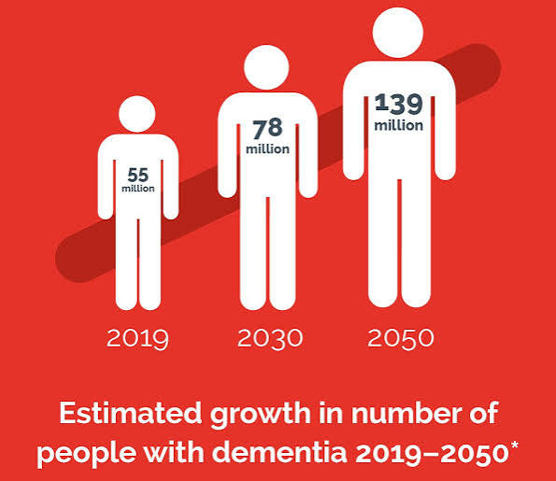
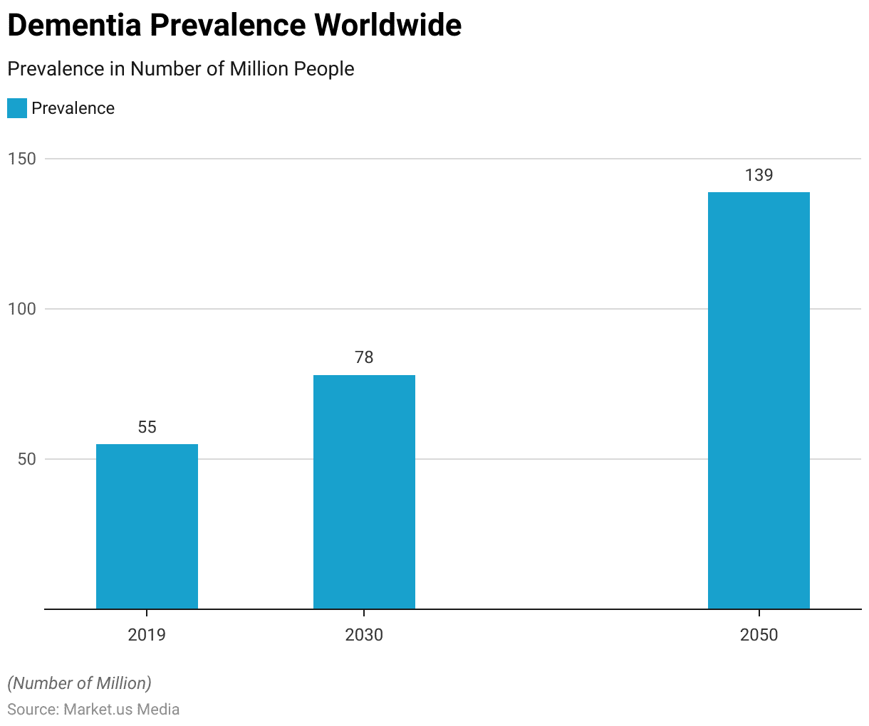Figure 1: Estimated Growth of People with Dementia by 2030

UK prevalence
Beyond the clinical effects of dementia, there are substantial social, economic and healthcare impacts. As the dementia progresses, people with the condition often have progressive loss of functional ability, become less independent, and need to rely more on formal health and social care services (CDC, 2024). The provision of long-term care also puts additional emotional, physical and economic burdens on families and informal caregivers, which can have a negative impact on their own health and quality of life (Zhang et al., 2025). Moreover, dementia demands significant health system resources by way of hospitalisation, long-term care and increased health expenditure.
- Risk Factors and Aetiology
Dementia is a result of a combination of several neurodegenerative, vascular, genetic and other causes that slowly damage the brain cells and impact the cognitive function of the brain. Sarhan et al. (2025) state pathologies vary based on the nature of dementia and this gives rise to differences in symptoms and disease trajectory. The most common type of dementia is Alzheimer's dementia, accounting for approximately 60-70% of all dementias worldwide (World Health Organisation, 2025).
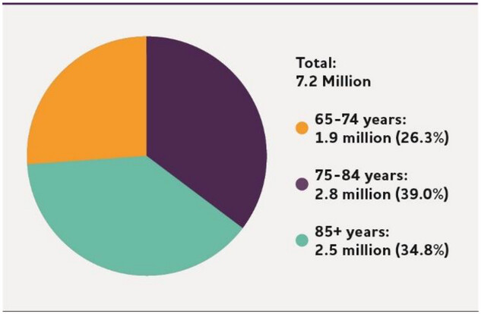
Figure 2: Alzheimer’s Facts and Figures
Gale et al. (2018) reports that vascular dementia is the result of a lack of blood flow to the brain, while dementia with Lewy bodies and frontotemporal dementia occur because of abnormalities in different proteins in different parts of the brain. An understanding of these disease-specific mechanisms is crucial for the diagnosis, prognosis and choice of management strategies of these diseases (Dementia UK, 2023).
Other factors that do not change may also increase a person's risk of developing dementia. Advancing age is the biggest risk factor, with the risk growing significantly with age of over 65 years due to accumulation of neurodegenerative changes (World Health Organisation, 2025). According to CDC (2024), dementia is not a normal part of the ageing process, although some people may get it before the age of 65. The risk can also be increased by genetic risk factors such as a family history of Alzheimer's disease or the presence of mutations that increase a person's risk of developing early onset Alzheimer's (Alzheimer's Association, 2025). Further, Hachinski et al. (2019) provide that women are at greater risk for dementia than men, due mainly to their greater longevity, and people with Down syndrome are at higher risk for developing Alzheimer's disease during their lifetime.
Even with these non-modifiable determinants there are many dementia cases linked with avoidable lifestyle and cardiovascular risk factors. Addressing modifiable risks throughout the life course can prevent or delay up to 45% of dementia, according to World Health Organisation (2025) estimates. These include high blood pressure, diabetes, overweight and obesity, smoking, lack of physical activity, excessive alcohol consumption, hearing loss, depression, low level of education, air pollution and social isolation (World Health Organisation, 2019). Alzheimer's Disease International (2020) estimates that by 2030, there will be 78 million people with dementia and by 2050, 139 million. These figures highlight the importance of finding effective prevention measures. These are precisely the results needed to show that healthy lifestyles and reduced cardiovascular risk factors have a significant contribution to reducing the burden of dementia in the future.
- Physical, Psychological and Social Impacts on Individuals and Families
Dementia can cause significant physical effects which gradually take the person's ability to function and carry out activities of daily living. As the disease progresses, patients lose mobility, balance, coordination, bladder and bowel control, their ability to swallow and communicate, and become vulnerable to falls, malnutrition, infections, frailty and hospitalisation (Lisko et al., 2021). As neurological degeneration progresses, it also affects executive functioning and motor function, which makes it harder to dress, bathe, eat, and take medications, among other activities, says Gale et al. (2018). As the brain damage worsens, people with advanced dementia typically lose all cognitive and physical function, making personal care and safety completely dependent upon the caregiver(s) (CDC, 2024). There is also evidence that physical deterioration contributes to readmissions to hospital and long-term institutional care, which puts strain on the health and social care system (Cipriani et al., 2020). While medicines and non-medicines treatments can help relieve symptoms, there is no current cure that stops the disease getting worse.
Dementia can also have a profound psychological effect on the mental health, emotional wellbeing and identities of the person, impacting their self-esteem and mental health over the course of the disease (Scott, 2021). Early symptoms of the disease include anxiety, depression, fear, frustration, irritability and emotional upset (Alzheimer's Society, 2022).
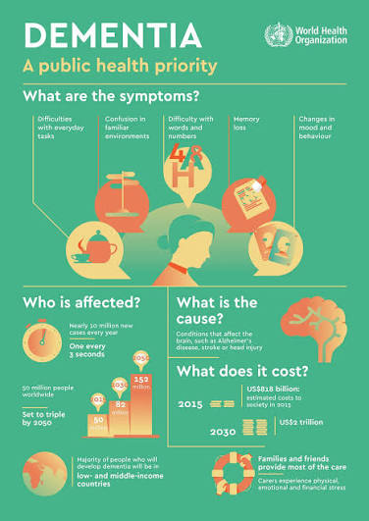Figure 3: Impacts of Dementia

The quality of interpersonal relationship and the emotional attitudes and communicative strategies used by care providers have significant effects on the psychological well-being of persons living with dementia, as articulated by Safavi et al. (2023). Supportive, empathetic relationships foster emotional stability and resilience, while negative interactions, criticism, or too much control can further exacerbate the behavioural and psychological issues. Scott (2021) share that there are also significant behavioural and psychological issues, such as agitation, hallucinations, aggression, apathy, disturbed sleep patterns and mood disorders that occur in many people with dementia and often lead to institutionalisation. The World Health Organisation (2025) thus proposes that psychological support, cognitive stimulation, effective handling of symptoms and person centred communication should be included in dementia care in order to maintain emotional health and minimise emotional distress. Addressing these psychological challenges is essential as there is a direct link between mental well-being and adherence to treatment, social participation and quality of life.
Dementia has a significant impact on the person in addition to physical and psychological effects, as it interferes with social functioning and participatory role within the community. As memory declines and there is a deterioration in the ability to communicate, confidence in social situations is diminished, leading to withdrawal and loss of meaningful relationships and community engagement (WHO, 2019). Siette et al. (2023) emphasise that loneliness and social isolation are common issues for people with dementia, with stigma being one of the factors that can be attributed to stigma because of the misconceptions about dementia. These problems are often exacerbated by the loss of work, less economic independence, impaired driving ability and diminished ability to perform pre-aging social roles (CDC, 2024). Alzheimer's Association (2025) states that social interaction and engagement through meaningful activities, cognitive stimulation, and supportive environments can improve well-being, even as cognitive decline progresses. There is therefore a need to develop dementia-friendly communities, educate the public, and increase support services within communities to foster inclusion, social participation and dignity in the face of dementia.
The impact of dementia is far reaching and affects not only the person but also the family members who often are responsible for long term care. Relatives usually give support for personal care, medication, finances, behaviour and decision making, resulting in significant emotional and physical demands, as cognitive and functional capacity declines (Donna et al. 2026). The family members and partners often experience grief, chronic stress, uncertainty, changes in relationships, and emotional exhaustion as they see the person's personality gradually disappear, and their independence and communication skills diminish. In an Asian context, Abayon et al. (2024) identified that there is significant psychosocial burden among informal caregivers in high-income and low and middle-income Asian countries, such as anxiety, depression, social isolation, and caregiver burnout. Additionally, the World Health Organisation (2025) estimates that worldwide, about 70% of dementia care is provided by informal caregivers, highlighting the important contribution of family members to supporting individuals with dementia. These findings suggest that dementia is a family-based disease and a whole of family Education, respite services, psychosocial support and financial support is needed for caregivers (Bressan et al., 2020). Supporting caregivers is essential since the physical and emotional health of the caregiver affects the quality, continuity and effectiveness of the care given to the person with dementia.
- Evidence-Based NHS Treatments and Management
Dementia management in the UK is a person-centred, multi-disciplinary approach with a focus on maintaining cognitive function, optimising independence, symptom management and enhancing quality of life. Dementia is currently not treatable but early diagnosis is strongly supported as this allows for easy access to treatment, individual care planning and community support services. The National Institute for Health and Care Excellence (2022) suggest that diagnosis should be provided by specialist memory services and be conducted through a full cognitive, physical, psychological and functional assessment. Likewise, NHS England (2024) states that multimodal assessment, coordinated by a multidisciplinary team, is crucial to ensure treatment and interventions are appropriate for the stage of the disease and for the individual. Early diagnosis can also support advance care planning, informed decision making, and increased participation in the management of the condition throughout its trajectory, as well as improve access to evidence-based interventions (World Health Organisation, 2025).
Pharmacological treatment aims to reduce symptoms and to slow down cognitive deterioration without curing the disease. Acetylcholinesterase inhibitors, such as Donepezil, Galantamine and Rivastigmine, are recommended by the National Institute for Health and Care Excellence (2022) as first-line treatments for mild to moderate Alzheimer's disease, and Memantine is recommended as a treatment for moderate Alzheimer's disease when these other medicines are unsuitable or as a treatment for severe Alzheimer's disease. Gale et al (2018) state that these drugs, although they have the ability of improving cognition, daily functioning and behavioural symptoms in the short term, do not affect everyone and disease progression still occurs while under treatment. Regular medication reviews are therefore critical to assess the therapeutic effectiveness of treatment, to monitor the side effects of medications and to review treatment options and adjust as clinical needs change (NHS England, 2024). In addition, Alzheimer's Association (2025) notes that treatment must always be combined with other supportive treatments to achieve the best possible health outcomes.
Non-pharmacological interventions are equally effective and essential parts of NHS dementia care as shown by the evidence. Cognitive stimulation therapy, reminiscence therapy, occupational therapy, structured physical activity and personalised psychosocial interventions are recommended by the National Institute for Health and Care Excellence (2022) to maintain cognitive abilities, promote independence and manage behavioural and psychological symptoms. World Health Organisation (2025) recommends that the complex needs of people with dementia are met through integrated multidisciplinary care by general practitioners, psychiatrists, specialist nurses, psychologists, physiotherapists, occupational therapists, speech and language therapists and social workers. Similarly, NHS England (2024) states that education, respite, assessment of family carers, community support and advance care planning are all important to supporting family caregivers, which can impact on the outcome of the patient.

6.UK and International Models/Frameworks
The person-centred approach to dementia care in the UK is reflected in the NHS England dementia Well Pathway, which sets out a structured programme of action for people's care journey. The pathway facilitates early diagnosis, individualised care planning, multidisciplinary care, appropriate management of behavioural and psychological symptoms and quality end-of-life care. NHS England (2024) highlights the need for a coordinated service for people with dementia, acknowledging they have physical, psychological and social needs and supporting family carers throughout their illness. Likewise, National Institute for Health and Care Excellence (2022) suggests person-centred assessments, shared decision making, and co-ordinated health and social support to ensure that individuals are as independent and able to live their lives as they wish to be. This philosophy is based on the principles of holistic care, which takes the view that the management of dementia is not just about medication.
The World Health Organisation Global Action Plan on the Public Health Response to Dementia 2017–2025 offers a broad plan at the international level to build the capacity of dementia care all over the world (WHO, 2017). The framework outlines seven strategic action a]reas, such as increasing awareness, reducing risk factors, improving diagnosis and treatment, making dementia a public health priority, supporting caregivers, strengthening health information systems, and promoting research and innovation (World Health Organisation, 2025). This global approach is supported by Alzheimer's Disease International (2020) who promotes the coordinated ND in each country that incorporates prevention, early diagnosis, community care, and caregiver support. The WHO framework is more population-health based than the NHS Dementia Well Pathway, by promoting governments to create sustainable policies to tackle the global burden of dementia (Nair et al., 2026).
- UK Health and Social Care Policies
The UK has adopted a number of health and social care policies to drive the prevention, diagnosis, treatment and long term management of dementia and to strengthen person-centred care. The Department of Health National Dementia Strategy (Department of Health, 2009) is one of the most influential policies, setting priorities for early diagnosis, raising public awareness, improving the quality of health and social care services and supporting people to live independently for as long as possible. The NHS England Long Term Plan (NHS England, 2019) builds on this approach to make dementia a national priority, further develop memory assessment services, increase the use of personalised care planning, enhance integrated community services, and improve support for unpaid carers. Likewise the National Institute for Health and Care Excellence (NICE) Dementia Guideline (NG97) (NICE, 2018) gives evidence-supported suggestions regarding assessment, diagnosis, pharmacological treatment and non-pharmacological treatments and coordinated multidisciplinary care to ensure consistency and quality in NHS services.
These policies all aim to foster the development of integrated health and social care systems, which accept dementia as a chronic condition and one that requires ongoing support throughout the disease journey. Surr et al. (2017) highlight the need to integrate medical care alongside psychological care, rehabilitation, education for carers and community services into the effective care of people with dementia, which is reflected in the policy framework in the UK. Moreover, NHS England Long Term Plan (NHS England, 2019) encourages the integration of primary care, specialist memory services, local authorities and voluntary groups to enhance continuity of care and to reduce unnecessary hospital admissions. Despite these developments, there are ongoing issues, such as inequalities in service provision, lack of staff, and a delayed diagnosis, and rising demand due to ageing populations (World Health Organisation, 2025). There is therefore a need to invest further in dementia services, dementia workforce, digital innovation and dementia caregiver support to enable future UK health and social care policies to provide equitable, high quality and person centred dementia care.

- Recommendations: Person-Centred Care, Self-Management and End-of-Life Care
Healthcare systems need to be more invested in providing person-centred care, which takes into account the individual's preferences, values, culture and care needs. Shared decision making between health and social care professionals and individual people with dementia and their families, where possible, to create a personalised care plan. NICE (2018) guidelines suggest a coordinated multidisciplinary approach, based on medical, psychological and social support, throughout the disease course. In a similar way NHS England (2024) promotes a collaborative approach between primary care, specialist memory services, community teams and voluntary organisations to ensure continuity of care and improve the quality of life and reduce avoidable hospital admissions. Such strategies should also foster dementia friendly communities which reduce stigma, increase social engagement and support people to remain independent for as long as they can (Godard-Sebillotte et al., 2024).
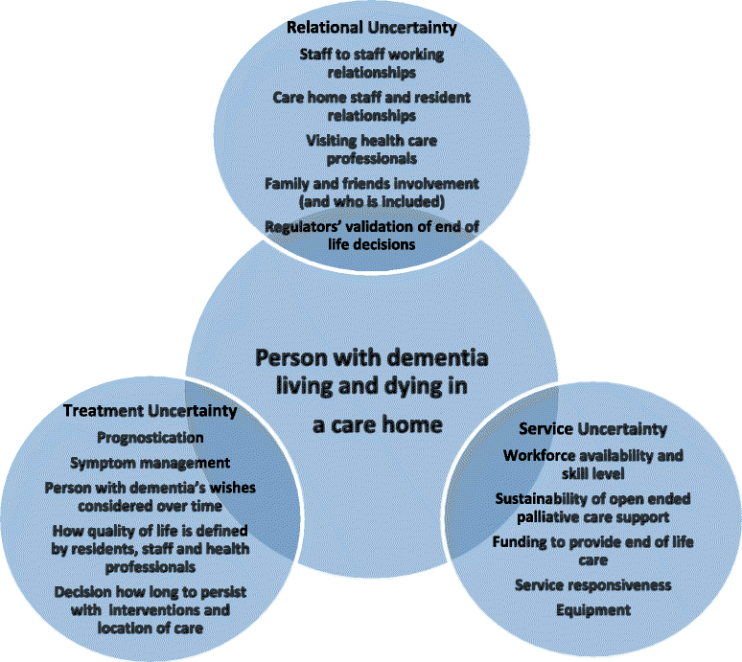
Figure 4: End of Care Interventions

While the progressive nature of dementia diminishes the person's ability to manage their condition independently, there are interventions that can help empower the person to play an active role in managing their dementia (Döpp et al., 2021). Education programmes, cognitive stimulation therapy, regular physical activity, healthy nutrition, adherence to drugs and the use of digital support technologies should be encouraged to maintain cognitive function and improve well-being (NICE, 2018). In addition, advance care planning should be begun early to make sure future treatment plans, legal considerations, and end-of-life goals are documented (Bosisio et al., 2021). Good end-of-life care will focus on maintaining dignity, comfort, effective symptom management, emotional support, and communication that is compassionate and involves family members in care planning and bereavement support.

- Conclusion
Dementia is a long-term condition with a complex and progressive nature which poses a great challenge for people, families, healthcare professionals and health systems around the world. With the aging of the population, the incidence of dementia continues to rise and calls for holistic and systemic strategies, focusing on early detection, evidence-based treatment, multidisciplinary management and ongoing support of caregivers. This booklet has shown that dementia goes beyond the decline in cognitive function, significantly impacting physical health, mental health, social inclusion and family functioning. In addition, there are frameworks and policies in the UK and internationally that offer support and guidance in providing consistent, equitable and holistic dementia care, though there are challenges that remain including delayed diagnosis, workforce shortages and inequities in access to services. Going forward, the need is to build on the quality of integrated health and social care provision, increase community-based support, improve training for carers and respite care and create dementia friendly communities.

References
Abayon, A.A.P., Raymonds, M., Brahmbhatt, P., Samnani, S. and Hanna, F. (2024) “The Impact of Dementia on the Psychosocial Well-Being of Informal Caregivers in Asia: A Scoping Review Comparing High-Income and Low–Middle-Income Countries..” Psych 6(1), pp. 260–272. Available at: https://www.mdpi.com/2624-8611/6/1/16.
Alzheimer’s Society (2022) The Psychological and Emotional Impact of Dementia. Available at: https://www.alzheimers.org.uk/get-support/help-dementia-care/understanding-supporting-person-dementia-psychological-emotional-impact (Accessed: 6 July 2026).
Alzheimer’s Association (2025) What is dementia? Available at: https://www.alz.org/alzheimers-dementia/what-is-dementia (Accessed: 6 July 2026).
Alzheimer’s Disease International (2020) Dementia statistics. Available at: https://www.alzint.org/about/dementia-facts-figures/dementia-statistics/ (Accessed: 6 July 2026).
Bosisio, F., Sterie, A.-C., Rubli Truchard, E. and Jox, R.J. (2021) “Implementing Advance Care Planning in Early Dementia care: Results and Insights from a Pilot Interventional Trial..” BMC Geriatrics 21(1). Available at: https://bmcgeriatr.biomedcentral.com/articles/10.1186/s12877-021-02529-8 (Accessed: 6 July 2026).
Bressan, V., Visintini, C. and Palese, A. (2020) “What do family caregivers of people with dementia need? A mixed‐method systematic review..” Health & Social Care in the Community 28(6). doi: 10.1111/hsc.13048.
CDC (2024) About Dementia. Available at: https://www.cdc.gov/alzheimers-dementia/about/index.html (Accessed: 6 July 2026).
Cipriani, G., Danti, S., Picchi, L., Nuti, A. and Fiorino, M. Di (2020) “Daily Functioning and Dementia..” Dementia & Neuropsychologia 14(2), pp. 93–102. Available at: https://pmc.ncbi.nlm.nih.gov/articles/PMC7304278/ (Accessed: 6 July 2026).
Dementia UK (2023) Dealing with Stigma and Discrimination against People Affected by Dementia. Available at: https://www.dementiauk.org/information-and-support/living-with-dementia/dealing-with-stigma/ (Accessed: 6 July 2026).
Department of Health and Social Care (2009) Living Well With Dementia: A national dementia strategy. Available at: https://www.gov.uk/government/publications/living-well-with-dementia-a-national-dementia-strategy (Accessed: 6 July 2026)
Donna, R., Kasselman, L.J., Drewes, W., Wolff, I., Betlow, L., Leon, J. De and Reiss, A.B. (2026) “The Impact of Dementia Caregiving on the Health of the Spousal Caregiver..” Medicina 62(4), p. 796. Available at: https://www.mdpi.com/1648-9144/62/4/796 (Accessed: 6 July 2026).
Döpp, C.M.E., Drenth, H., Verkade, P.-J., Francke, A.F. and van der Heide, I. (2021) “Interventions for improving self-direction in people with dementia: A systematic review..” BMC Geriatrics 21(1). doi: 10.1186/s12877-021-02133-w.
Gale, S.A., Acar, D. and Daffner, K.R. (2018) “Dementia.” The American Journal of Medicine 131(10), pp. 1161–1169. Available at: https://pubmed.ncbi.nlm.nih.gov/29425707/.
Godard-Sebillotte, C., Sanjna Navani, Hacker, G. and Vedel, I. (2024) “Considering inequities in national dementia strategies: Breadth, depth, and scope..” International journal for equity in health 23(1). doi: 10.1186/s12939-024-02166-8.
Hachinski, V. et al. (2019) “Preventing dementia by preventing stroke: The Berlin Manifesto..” Alzheimer’s & Dementia 15(7), pp. 961–984. doi: 10.1016/j.jalz.2019.06.001.
Lisko, I., Kulmala, J., Annetorp, M., Ngandu, T., Mangialasche, F. and Kivipelto, M. (2021) “How can dementia and disability be prevented in older adults: Where are we today and where are we going?..” Journal of Internal Medicine 289(6), pp. 807–830. doi: 10.1111/joim.13227.
Nair, P., Junghans, C., Kay, M., Harris, M., Majeed, A. and Hayhoe, B. (2026) “Transforming dementia care pathway: Why shifting to a universal, comprehensive, proactive, local, and integrated model is imperative to improve outcomes..” Frontiers in Dementia 4. doi: 10.3389/frdem.2025.1719630.
National Institute for Health and Care Excellence (NICE) (2018) Dementia: Assessment, Management and Support for People Living with Dementia and Their Carers. NICE. Available at: https://www.nice.org.uk/guidance/ng97 (Accessed: 6 July 2026).
NHS England (2019) The NHS Long Term Plan. Available at: https://www.longtermplan.nhs.uk/wp-content/uploads/2019/08/nhs-long-term-plan-version-1.2.pdf (Accessed: 5 July 2026).
NHS England (2024) Dementia diagnoses in England at record high. Available at: https://www.england.nhs.uk/2024/07/dementia-diagnoses-in-england-at-record-high/ (Accessed: 6 July 2026).
Safavi, R., Wearden, A. and Berry, K. (2023) “Psychological well‐being in persons with dementia: The role of caregiver expressed emotion..” British Journal of Clinical Psychology 62(2). doi: 10.1111/bjc.12416.
Sarhan, M. et al. (2025) “The pathophysiology of mixed Alzheimer’s disease and vascular dementia..” Theranostics 15(18), pp. 9793–9818. Available at: https://pmc.ncbi.nlm.nih.gov/articles/PMC12486426/ (Accessed: 6 July 2026).
Scott, H. (2021) “The changing self: The impact of dementia on the personal and social identity of women (findings from the improving the experience of dementia and enhancing active life programme)..” Dementia 21(2), pp. 503–518. doi: 10.1177/14713012211047351.
Shah, R., Salek, M.S., Ali, F.M., Nixon, S.J., Otwombe, K., Ingram, J.R. and Finlay, A.Y. (2024) “Dementia and Its Profound Impact on Family Members and Partners..” Alzheimer Disease & Associated Disorders 38(4). Available at: https://journals.lww.com/alzheimerjournal/fulltext/9900/dementia_and_its_profound_impact_on_family_members.133.aspx#JCL-P-32.
Siette, J., Meka, A. and Antoniades, J. (2023) “Breaking the barriers: Overcoming dementia-related stigma in minority communities..” Frontiers in Psychiatry 14(1), p. 1278944. Available at: https://www.ncbi.nlm.nih.gov/pmc/articles/PMC10765564/ (Accessed: 6 July 2026).
Surr, C.A. et al. (2017) “Effective Dementia Education and Training for the Health and Social Care Workforce: A Systematic Review of the Literature..” Review of Educational Research 87(5), pp. 966–1002.
World Health Organisation (2025) Dementia. Available at: https://www.who.int/news-room/fact-sheets/detail/dementia (Accessed: 6 July 2026).
World Health Organisation (2019) Dementia. Available at: https://www.who.int/health-topics/dementia#tab=tab_1 (Accessed: 6 July 2026).
WHO (2017) Global Action Plan on the Public Health Response to Dementia 2017 - 2025. Available at: https://www.who.int/publications/i/item/global-action-plan-on-the-public-health-response-to-dementia-2017---2025 (Accessed: 6 July 2026).
Zhang, W., Xu, W., Duan, J., Tang, J., Zhu, Q., Pi, X. and Huang, J. (2025) “Exploring how family caregivers of people with Alzheimer’s disease experience role captivity: A qualitative study..” International Psychogeriatrics , p. 100114. Available at: https://www.intpsychogeriatrics.org/article/S1041-6102(25)00352-7/fulltext (Accessed: 6 July 2026).

