HR Skills Development of PSBC

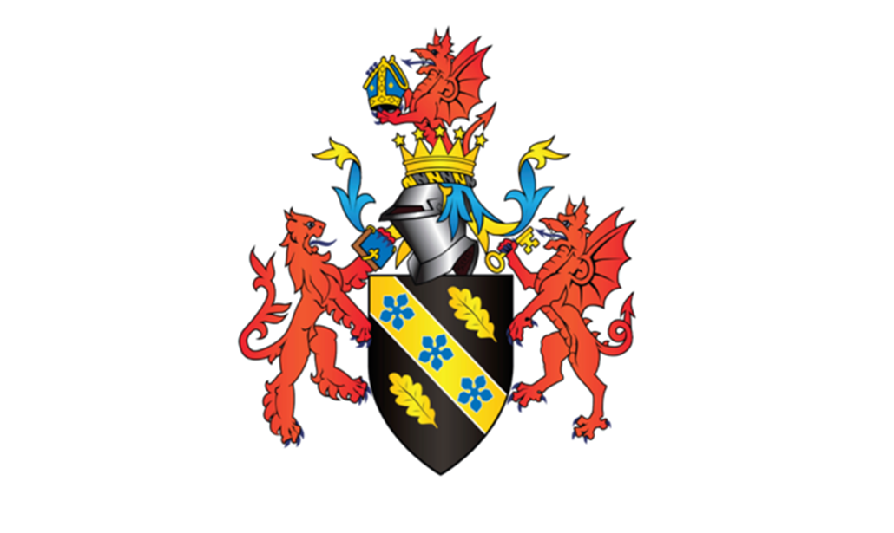

MODULE NAME： Human Resource Management
MODULE CODE： BMMB7007
NAME: Gao Xu
STUDENT NUMBER:2200517

Link to my video on Microsoft Stream:
https://web.microsoftstream.com/video/45b7e0fe-5d89-44ee-a71b-1167c6a9ebc7

Reference List:
- BRUMMANS, B. H., HIGHAM, L. & COOREN, F. 2022. The work of conflict mediation: Actors, vectors, and communicative relationality. 75, 764-791.
- BURNS, N. 2021. Experiencing the Value of Performance Improvement in the Age of Disruption. Performance Improvement, 60, 6-13.
- CROSS, D. & SWART, J. 2021. The (ir)relevance of human resource management in independent work: Challenging assumptions. Human Resource Management Journal, 32, 232-246.
- EINOLA, K. & KHOREVA, V. 2022. Best friend or broken tool? Exploring the co‐existence of humans and artificial intelligence in the workplace ecosystem. Human Resource Management, 62, 117-135.
- HALE, J. & BURNS, N. 2022. SPECIAL FEATURE: KNOW YOUR COLLEAGUES—MARGO MURRAY AND NANCY CRAIN BURNS. Performance Improvement, 61, 19-22.
- HALE, J. 2022. SPECIAL FEATURE: KNOW YOUR COLLEAGUES—ROBERT DAMELIO AND CARL BINDER. Performance Improvement, 61, 61-65.
- LAPSHUN, A. & FUSCH, G. 2021. Trust and Safety as Fundamental Conditions for a High‐Performance Team. Performance Improvement, 60, 15-19.
- MECKEL, K., ROSSIN-SLATER, M. & UNIAT, L. 2023. Efficiency versus Equity in the Provision of In-Kind Benefits. Journal of Human Resources, 58, 363-392.
- PSBC (2022) Annual Report 2021. Available at: https://www.psbc.com/cn/gyyc/tzzgx/cwxx/cwbg/cwxxagbg/202203/P020220330722507558806. pdf (Accessed: 25 April 2023).
- ROY, R. 2022. EMPATHY AS A PANACEA TO THE GREAT RESIGNATION: IS OUR BUSINESS LANDSCAPE AND ITS LEADERS CAPABLE TO ACCOMMODATE FOR REAL EMPATHY? Performance Improvement, 61, 23-27.
- SNELL, S., SWART, J., MORRIS, S. & BOON, C. 2022. The HR ecosystem: Emerging trends and a future research agenda. Human Resource Management, 62, 5-14.
- VIERA, C. 2022. GUIDEPOSTS OF PERFORMANCE IMPROVEMENT. Performance Improvement, 61, 28-29.
- VIERA, C. 2023. TRANSLATING CORE VALUES INTO ACTIONABLE STRATEGIES. Performance Improvement, 62, 1-2.
- ZHANG, Y., SUN, J. M., SHAFFER, M. & LIN, C. H. 2021. High commitment work systems and employee well‐being: The roles of workplace friendship and task interdependence. Human Resource Management, 61, 399-421.

