University of Wales Trinity Saint David’s
Part 1 b - Report
Games Architecture & Mechanics (ACCA5017) – Gordon Dickers
Jack Partridge – 1702918
May 7th, 2019
Table of Contents
A. Game Loops 1
Implementation: 1
Appendix 2

Game Loops
Implementation: I started with a game that consisted of a while loop and contained 3 methods for processing the game; processInput(), update() & render(). This game loop is that the faster the computer the faster the loop and thus meaning the player(s) can’t see what’s going on due to it going too fast.
The input can stay where it is but go to a bool methods that will return false unless user sets to true to close the application and essentially quit the game loop. I had then moved the rendering
Finally, I have a fixed update time step along with a variable rendering. This is good for both fast and slow machines, it will update in real time and the game will not fall behind. Such game engines like small platformers might use this or arcade like games.

Frames Per Seconds
Adding a “FPS” counter to show the number of Frames Per Seconds. This allows me to see how fast the frames have passed since the last one.
Game engines such as Unity uses a similar game loop approach only with more functions broken down with classes to organise their objects and game engine.
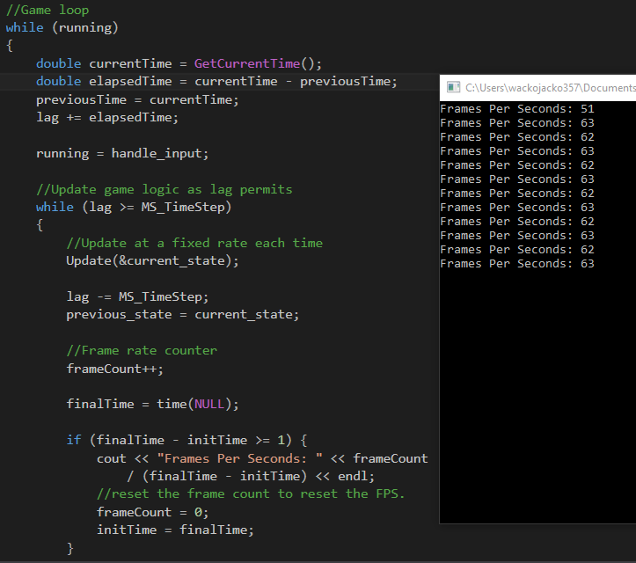
From here I can make a container class such as a fake game object and make it an array with values in just to test if the update function is getting called from the game engines update function and the classes update function.
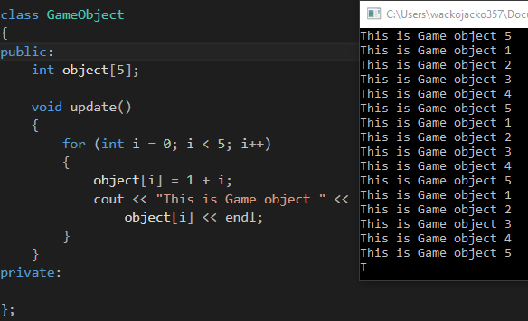
In order to read the .OBJ file I first needed to create the structs for the .obj file formats.

I did this by doing coordinates for the vertices, a struct for the faces, coordinates for the normals. 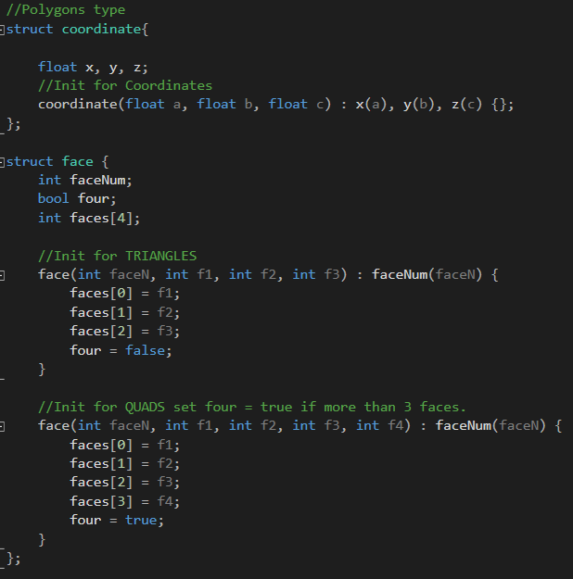
I made sure that there was a bool in place to check if there was more than 3 faces then it would equal a quad and select the corresponding option.
I will then need to make a file stream and use that file stream.
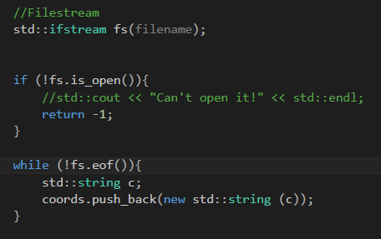
I will then be using the file stream I just opened to read through to find the Vertices (v). When all vertices are found you can then get faces and do this by link the coordinates of the vertices to make up the faces (f). Within the .OBJ the faces show what vertices coordinates are in order with what Faces. Then In order to read in the normal you will need to read through the file stream to find what is located inside the .OBJ as (VN) and with these coordinates you get the normal for the texture.
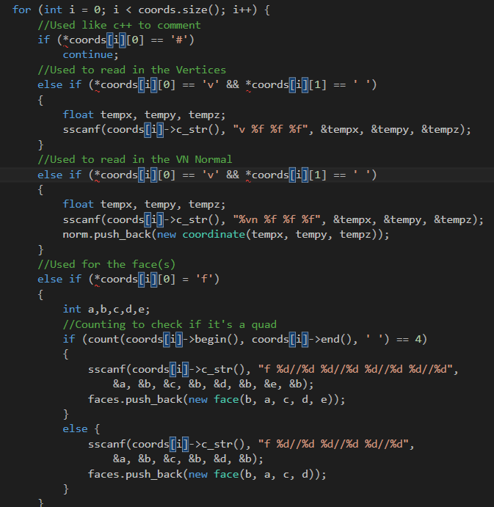
Lastly, this is all that’s needed for reading the obj wavefront loader. For the obj loader I will need to delete the sizes of the structs by making a for loop for each one and call the delete() function to clear memory.
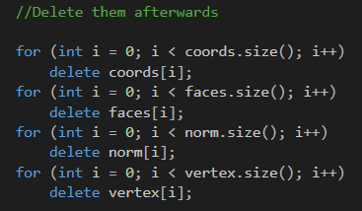

Appendix

Game loop
/*===============================================
Game Loop
By Jack Partridge-1702918
=================================================*/

//Header files used
#include <iostream>
#include <ctime>
#include <Windows.h>
#include "glut.h"
#include "include\sdl2\SDL.h"

using namespace std;

//Global var
const double MS_TimeStep = 16;
int initTime = time(NULL);
int finalTime;
int frameCount = 0;

class GameObject
{
public:
int object[5];

void update()
{
for (int i = 0; i < 5; i++)
{
object[i] = 1 + i;
cout << "This is Game object " <<
object[i] << endl;
}
}
private:

};

//This is the game's state such as: velocities and positions
struct game_state {

};

//Handle the input devices
bool handle_input() {

return false; //Set this to true if the user wants to quit
}

//Update the game's logic
void Update(game_state *) {
GameObject go;
go.update();

}

//Grapghics rendering is handled here
void Render(game_state const &) {

//Draw inside here

}

// interpolate between previous and current
game_state interpolate(game_state const & current, game_state const & previous) {
game_state interpolated_state;

return interpolated_state;
}

//Main loop
int main(int argc, char** argv) {

float lag = 0.0;
double previousTime = GetTickCount();
bool running = true;

game_state current_state;
game_state previous_state;

//Game loop
while (running)
{
double currentTime = GetCurrentTime();
double elapsedTime = currentTime - previousTime;
previousTime = currentTime;
lag += elapsedTime;

running = handle_input;

//Update game logic as lag permits
while (lag >= MS_TimeStep)
{
//Update at a fixed rate each time
Update(&current_state);

lag -= MS_TimeStep;
previous_state = current_state;

//Frame rate counter
frameCount++;

finalTime = time(NULL);

if (finalTime - initTime >= 1) {
cout << "Frames Per Seconds: " << frameCount
/ (finalTime - initTime) << endl;
//reset the frame count to reset the FPS.
frameCount = 0;
initTime = finalTime;
}

}

auto interpolated_state = interpolate(current_state, previous_state);
Render(interpolated_state);
}
return 0;
}

OBJLOADER

//////////////////////////////////////////////
//Source.cpp
//////////////////////////////////////////////
#include "mesh.h"
#include "display.h"
#include "glut.h"
#include <Windows.h>
#include <iostream>
#include <fstream>

using namespace std;

int main(int argc, char *args[])
{

Display myDisplay(800, 800, "OGL Window"); //create and open a window

//specify a list of vertices to draw - this will be loaded into our mesh object
//we'll replace this array with a file mesh loader later - see .obj loader notes.

Vertex vertices[48];
Vertex myV;

Mesh* pmesh = new Mesh(vertices, sizeof(vertices) / sizeof(vertices[0]));

while (!myDisplay.isClosed()) // Application loop - it's ok as a first attempt
{

myDisplay.clear();// makes the point that the frame buffer is usually cleared before redrawing
glLoadIdentity();
glTranslatef(-5, -2, -10);//
gluLookAt(5.0, 5.0, 5.0, 0.0, 0.0, 0.0, 0.0, 1.0, 0.0);
//// 5,5,5 - place camera ; 0,0,0 - aim lens towards 0,0,0;
//// 0,1,0 - the up vector defines an unique orientation

static unsigned long dwOldTime = GetTickCount();
static unsigned long dwTimeElapsed;
static int fps = 0; //frame count;
dwTimeElapsed = GetTickCount() - dwOldTime;
fps++;
if (dwTimeElapsed > 5000) {

cout << "frames per sec = " << (float)fps / 5.0 << endl;
fps = 0;
dwOldTime = GetTickCount();
}
myDisplay.update();
myDisplay.render(pmesh);

//This will soon need to be revised so we can update model positions, look after timers/ do physics/ deal with events.
}
return 0;
}

//////////////////////////////////////////////
//MESH.H
//////////////////////////////////////////////

#ifndef MESH_H
#define MESH_H

#include "include\GL\glew.h"
#include "include\glm\glm.hpp"
#include "include\SOIL\SOIL.h"
#include <iostream>
#include <vector>
#include <string>
#include <sstream>
#include <algorithm>
#include <fstream>
#include <cstdio>

#define MAX_VERTICES 1000
#define MAX_POLYGONS 200
#define NUM_BUFFERS 1

typedef struct {
glm::vec3 pos;
}Vertex;

//Polygons type
struct coordinate {
float x, y, z;
//Init for Coordinates
coordinate(float a, float b, float c) : x(a), y(b), z(c) {};
};

//Faces type
struct face {
int faceNum;
bool four;
int faces[4];

//Init for TRIANGLES
face(int faceN, int f1, int f2, int f3) : faceNum(faceN) {
faces[0] = f1;
faces[1] = f2;
faces[2] = f3;
four = false;
}

//Init for QUADS set four = true if more than 3 faces.
face(int faceN, int f1, int f2, int f3, int f4) : faceNum(faceN) {
faces[0] = f1;
faces[1] = f2;
faces[2] = f3;
faces[3] = f4;
four = true;
}
};

class Mesh
{
public:
Mesh(Vertex* vertices, unsigned int numVertices);
int loadOBJ(const char * filename);
void draw();
virtual ~Mesh();
private:
Vertex *pVertices;
GLuint vertexArrayObject; //for use with Modern OGL
GLuint vertexArrayBuffers[NUM_BUFFERS]; //for use with Modern OGL
GLuint vertexCount;

};

#endif

//////////////////////////////////////////////
//MESH.CPP
//////////////////////////////////////////////

#include "mesh.h"

Mesh::Mesh(Vertex* vertices, unsigned int numVertices)
{
vertexCount = numVertices;
pVertices = vertices;
//glGenVertexArrays(1, &vertexArrayObject);
//glBindVertexArray(vertexArrayObject);
//glGenBuffers(NUM_BUFFERS, vertexArrayBuffers);
//glBindBuffer(GL_ARRAY_BUFFER,vertexArrayBuffers[0]);
//glBufferData(GL_ARRAY_BUFFER, numVertices * sizeof(vertices[0]), vertices, GL_STATIC_DRAW);
//
//glEnableVertexAttribArray(0);
//glVertexAttribPointer(0, 3, GL_FLOAT, GL_FALSE, 0, 0);
//glBindVertexArray(0);
}

Mesh::~Mesh()
{
//glDeleteVertexArrays(1, &vertexArrayObject);
}

void Mesh::draw()
{
glBindVertexArray(vertexArrayObject);
glDrawArrays(GL_TRIANGLES, 0, vertexCount);
for (int i = 0; i < vertexCount; i+=3)
{
glBegin(GL_TRIANGLES);

glVertex3f(pVertices[i].pos.x, pVertices[i].pos.y, pVertices[i].pos.z);

glVertex3f(pVertices[i+1].pos.x, pVertices[i+1].pos.y, pVertices[i+1].pos.z);

glVertex3f(pVertices[i+2].pos.x, pVertices[i+2].pos.y, pVertices[i+2].pos.z);

glEnd();
}
}

int Mesh::loadOBJ(const char * filename) {

//Pointer in order to dynamic allocate memory
std::vector<std::string*> coords;
std::vector<coordinate*> vertex;
std::vector<face*> faces;
std::vector<coordinate*> norm;

//Filestream
std::ifstream fs(filename);

if (!fs.is_open()){
//std::cout << "Can't open it!" << std::endl;
return -1;
}

while (!fs.eof()){
std::string c;
coords.push_back(new std::string (c));
}

for (int i = 0; i < coords.size(); i++) {
//Used like c++ to comment
if (*coords[i][0] == '#')
continue;
//Used to read in the Vertices
else if (*coords[i][0] == 'v' && *coords[i][1] == ' ')
{
float tempx, tempy, tempz;
sscanf(coords[i]->c_str(), "v %f %f %f", &tempx, &tempy, &tempz);
}
//Used to read in the VN Normal
else if (*coords[i][0] == 'v' && *coords[i][1] == ' ')
{
float tempx, tempy, tempz;
sscanf(coords[i]->c_str(), "%vn %f %f %f", &tempx, &tempy, &tempz);
norm.push_back(new coordinate(tempx, tempy, tempz));
}
//Used for the face(s)
else if (*coords[i][0] = 'f')
{
int a,b,c,d,e;
//Counting to check if it's a quad
if (count(coords[i]->begin(), coords[i]->end(), ' ') == 4)
{
sscanf(coords[i]->c_str(), "f %d//%d %d//%d %d//%d %d//%d",
&a, &b, &c, &b, &d, &b, &e, &b);
faces.push_back(new face(b, a, c, d, e));
}
else {
sscanf(coords[i]->c_str(), "f %d//%d %d//%d %d//%d",
&a, &b, &c, &b, &d, &b);
faces.push_back(new face(b, a, c, d));
}
}
}

//Delete them afterwards

for (int i = 0; i < coords.size(); i++)
delete coords[i];
for (int i = 0; i < faces.size(); i++)
delete faces[i];
for (int i = 0; i < faces.size(); i++)
delete norm[i];
for (int i = 0; i < faces.size(); i++)
delete vertex[i];

return 0;
}

