Paola Andrea Izquierdo Escobar (2315723)
Rameses Manalang
21/04/2026
Business Research PROPOSAL (lclm6004)

Examining the Role of Employee Motivation in Enhancing Workplace Engagement: Evidence from Pret a Manger U.K
Table of Contents
0
0
Examining the Role of Employee Motivation in Enhancing Workplace Engagement: Evidence from Pret a Manger U.K 0
CHAPTER 1 3
1.1 Introduction 3
1.2 Key Issues Affecting Workplace Motivation and Engagement at Pret a Manger U.K 4
1.3 Organisational Background and Issues Impacting Employee Engagement 4
CHAPTER 2 5
2.1 Research Aim 5
2.2 Research Objectives 5
2.3 Research Questions 5
CHAPTER 3 6
3.1 Literature Review 6
Herzberg’s Two-Factor Theory 7
3.2 Identifying Gaps in Existing Literature 8
CHAPTER 4 8
4.1 Research Methodology and Design (Quantitative) 8
4.2 Data Collection 8
4.3 Data Analysis 9
4.4 Sampling Strategy 9
4.5 Ethical Considerations 9
4.6 Reliability and Validity 9
CHAPTER 5 9
5.1 Research relevant and Practical Implications 9
References 11

CHAPTER 1

1.1 Introduction
Founded in 1983, Pret A Manger is a UK-based fast-food and coffee chain known for fresh food, quick service, and a welcoming customer experience. Its employees work in high-pressure, customer-facing roles, making motivation essential for engagement, performance, and retention. Like many hospitality organisations, Pret faces challenges such as high staff turnover, long hours, and workplace stress. Research shows that motivated employees are more productive, committed, and deliver better service, while low motivation can lead to disengagement, errors, absenteeism, and financial losses (Armstrong and Taylor, 2026). This study aims to investigate the relationship between employee motivation and engagement using a SMART approach, supported by clear objectives and research questions. It draws on Maslow’s Hierarchy of Needs and Herzberg’s Two-Factor Theory to understand motivation. Using a quantitative survey method, the research will analyse key factors such as recognition, pay, career development, and management support. The findings will support better decision-making by providing practical recommendations, innovative strategies, and effective approaches to improve motivation, enhance engagement, and strengthen organisational performance

1.2 Key Issues Affecting Workplace Motivation and Engagement at Pret a Manger U.K
In this proposal, the research will be to examine the role of employee motivation in enhancing workplace engagement, using evidence from Pret a Manger in the UK. A key challenge for the organisation is maintaining high levels of motivation and engagement in a fast-paced and demanding work environment. Employees are expected to deliver high-quality service under constant pressure, which can reduce motivation and negatively affect engagement levels.
Understanding this issue is important because low motivation and engagement can directly impact employee performance, customer satisfaction, and overall business success. Therefore, this research aims to explore how employee motivation can be improved to foster higher levels of workplace engagement, drawing insights from the practices and experiences of Pret a Manger in the UK

1.3 Organisational Background and Issues Impacting Employee Engagement
Pret a Manger operates in a fast-paced and highly competitive retail food market. Employees are expected to deliver quick service while maintaining high customer satisfaction. This creates a demanding work environment where motivation and engagement are essential
However, the retail sector is known for challenges such as high staff turnover, job stress, and low engagement levels. Employees often face long working hours, pressure from customers, and repetitive tasks. These conditions can reduce both motivation and engagement.
This situation represents a complex or “messy” business problem because it involves multiple interconnected factors:
- Motivation strategies may not be effective
- Work pressure may reduce engagement
- Employee satisfaction may vary across locations
Even though Pret a Manger is known for its strong organizational culture and employee
rewards, it is unclear whether these strategies are enough to maintain high engagement levels.
Research shows that low engagement can lead to poor performance and high turnover (Maidaani Adelaide Matare, 2020). Therefore, understanding the relationship between motivation and engagement is important for improving business performance.

CHAPTER 2

2.1 Research Aim

The aim of this research is to examine the relationship between employee motivation and workplace engagement at Pret a Manger in the UK by collecting and analysing quantitative survey data from employees within a defined study period. The study will focus on identifying key motivational factors, such as recognition, pay, career development, and management support, and evaluating their impact on employee performance, satisfaction, and retention.

2.2 Research Objectives
- To measure the current level of employee motivation and engagement among Pret a Manger employees using survey data.
- To identify and analyse key factors influencing employee motivation, including recognition, workload, pay, and career development.

To develop practical recommendations for improving motivation and engagement based on research findings.

2.3 Research Questions
- What is the current level of employee motivation and engagement at Pret a Manger?
- What is the level of employee engagement? Which motivation strategies are most effective?.
- How does employee motivation impact workplace engagement, performance, and satisfaction?
- What strategies can be implemented to improve motivation and engagement at Pret a Manger?

CHAPTER 3

3.1 Literature Review

Employee motivation is widely recognised as a key driver of workplace engagement, particularly in service-based organisations such as Pret a Manger, where employees are expected to deliver high-quality customer service under time pressure. Motivation affects how employees approach their tasks, the effort they invest, and their overall commitment to the organisation. Highly motivated employees are generally more engaged, demonstrating focus, productivity, and a willingness to contribute positively to the workplace. Research shows that engagement is influenced not only by individual drive but also by organisational practices, such as recognition, career development opportunities, and supportive work culture. Understanding the factors that shape motivation is therefore critical for managers seeking to enhance engagement and performance. To frame this understanding, well-established motivation theories such as Maslow’s Hierarchy of Needs and Herzberg’s Two-Factor Theory offer valuable perspectives on the different elements that influence employee satisfaction and engagement in the workplace.

Maslow’s Hierarchy of Needs
According to (Maslow, 1943, pp. 370–396), employees are motivated by different levels of needs, starting from basic needs such as salary and job security, and moving towards higher-level needs such as recognition and personal growth. In Pret a Manger, basic needs are supported through fair pay and working conditions, while higher-level needs are addressed through recognition systems and opportunities for development. When these needs are met, employees are more likely to feel valued and engaged in their roles.
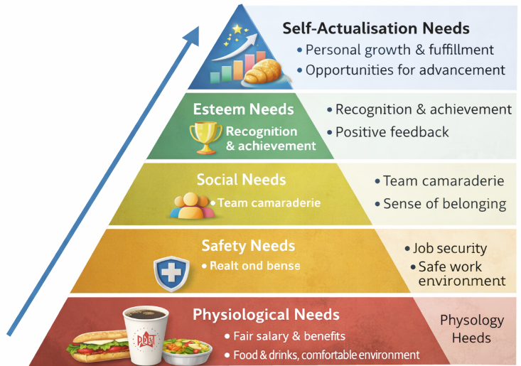
Figure 1Herberg's Two-Factors Theory adapted to Pret a Manger (Maslow, 1943, pp. 370–396)

Herzberg’s Two-Factor Theory
Similarly, (Herzberg, 1959) explains that motivation depends on both hygiene factors and motivators. In the context of Pret a Manger, hygiene factors such as pay and working conditions help prevent dissatisfaction, while motivators such as recognition, responsibility, and achievement increase engagement. This suggests that employee engagement can only be improved when organisations focus on both maintaining good working conditions and providing meaningful rewards.
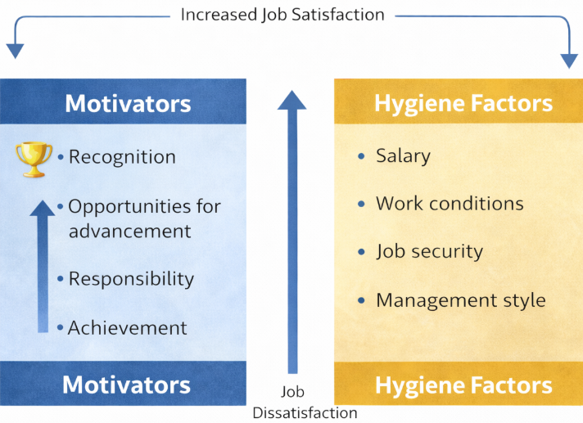
Figure 2 Maslow's Hierarchy of Needs adapted to Pret a Manger (Herzberg, 1959)

3.2 Identifying Gaps in Existing Literature
After examining these theories, it was identified that there are challenges in applying them within real organisational settings. In a fast-paced environment such as Pret A Manger, employees often experience high workloads, time pressure, and workplace stress. These factors can reduce motivation even when basic needs are met. This shows that motivation is not only influenced by internal organisational strategies but also by external working conditions.
In addition, there is limited quantitative evidence showing how motivation directly improves engagement in organisations like Pret a Manger. Many studies discuss motivation in theory, but do not measure its actual impact on employee behaviour. This creates a gap in understanding which strategies are most effective in practice.
Therefore, this study aims to examine the relationship between employee motivation and workplace engagement at Pret a Manger using quantitative survey data. By measuring employee responses, the research will provide clear evidence on how motivation influences engagement and help identify the most effective strategies to improve employee performance and satisfaction.

CHAPTER 4

4.1 Research Methodology and Design (Quantitative)
This research adopts a positivist research philosophy, as it focuses on objective measurement, numerical data, and the identification of measurable relationships between variables. Positivism is appropriate because the investigation examines the relationship between employee motivation and workplace engagement at Pret a Manger through observable and quantifiable data, allowing findings to be tested statistically rather than interpreted subjectively. A quantitative research approach is therefore used, as it enables the collection of structured numerical data that can be analysed to produce clear, reliable, and objective results. This approach is more suitable than qualitative methods, as it supports the identification of patterns and relationships across a wider group of employees.

4.2 Data Collection
• An online structured survey is used to gather data from employees.
• The survey content measures motivation, engagement, job satisfaction, and perceptions of management.
• Likert scale questions (1–5) are used to quantify responses, allowing statistical analysis of trends and relationships.

4.3 Data Analysis
• Descriptive statistics are used to calculate averages, percentages, and overall patterns in motivation and engagement levels.
• Correlation analysis is applied to identify relationships between employee motivation and workplace engagement.
• The results provide clear, evidence-based insights to support organisational decision-making and strategy development.

4.4 Sampling Strategy
• Approximately 50 employees from different branches, roles, and experience levels are selected as participants.
• Purposive sampling is used to ensure representation from different parts of the organisation.
• This approach ensures a range of perspectives, experiences, and job roles are included in the study.

4.5 Ethical Considerations
• Participation in the study is voluntary.
• All responses are anonymous to protect participant identity.
• Participants have the right to withdraw at any stage without consequence.
• All collected data is stored securely and used solely for the purpose of this research.

4.6 Reliability and Validity
• The survey instrument is piloted before full distribution to ensure clarity and ease of understanding.
• Questions are aligned directly with the research objectives to ensure validity.
• Quantitative methods of analysis enhance objectivity, consistency, and comparability of results across participants.

CHAPTER 5

5.1 Research relevant and Practical Implications
This research is highly relevant to organisations such as Pret a Manger, where employees work in fast-paced and customer-focused environments. In the hospitality sector, employee motivation and engagement are closely linked to service quality, customer satisfaction, and staff retention. High staff turnover and workplace stress are common challenges in this industry, making it important to understand how motivation strategies can improve employee engagement and performance. Previous research shows that motivated employees are more productive, provide better customer service, and are less likely to leave their jobs (Armstrong and Taylor, 2020). Therefore, studying motivation and engagement at Pret a Manger is important for addressing real business challenges and improving organisational outcomes.
This research is also relevant because it applies well-known motivation theories, such as Maslow’s Hierarchy of Needs and Herzberg’s Two-Factor Theory, to a real workplace situation. For example, (Maslow, 1943, pp. 370–396) explains that employees must have their basic needs met, such as fair pay and job security, before they can achieve higher levels of motivation. Similarly, (Herzberg, 1959) found that factors such as recognition, achievement, and responsibility increase job satisfaction, while poor working conditions and low pay can lead to dissatisfaction. Applying these theories to Pret a Manger helps managers understand how different motivation factors influence employee engagement in practice.
The practical implications of this research are significant because the findings can support better business decision-making. For example, studies have shown that organisations that invest in employee recognition programmes and career development opportunities experience higher engagement and improved performance (Harter, Schmidt and Hayes, 2002). In the case of Pret a Manger, this research may recommend strategies such as improving reward systems, offering training and development opportunities, and strengthening management support. These actions can help employees feel valued and motivated, leading to better teamwork and improved customer service.
A real example from the hospitality industry shows the importance of motivation strategies. Research on employee engagement in service organisations found that companies that provide supportive leadership and clear career progression opportunities experience lower staff turnover and higher job satisfaction (Bakker and Demerouti, 2017). This suggests that Pret a Manger can benefit from implementing structured motivation strategies based on research findings. However, some challenges may occur, such as financial costs or resistance to change from management. These challenges can be managed through careful planning, gradual implementation, and regular evaluation of outcomes.
Overall, this research will provide valuable insights that can help Pret a Manger improve employee motivation, increase workplace engagement, and enhance organisational performance. By using quantitative data and applying established motivation theories, the study will produce evidence-based recommendations that support innovation, better decision-making, and long-term business success.

References
Cybellium (2024) Employee Engagement Exam Review. Cybellium Ltd.
Maidaani Adelaide Matare (2020) An Investigation into Employee Engagement and its Impact on Organisational Performance. GRIN Verlag.
Herzberg, F. (1959) The motivation to work. Transaction Publishers.
Maslow, A. (1943) A Theory of Human Motivation. Psychological Review, pp. 370–396.
Byrne, Z.S. (2014) Understanding Employee Engagement. Routledge.
Bakker, A.B. and Demerouti, E. (2017) ‘Job demands–resources theory: Taking stock and looking forward.’, Journal of Occupational Health Psychology, 22(3), pp. 273–285. Available at: https://doi.org/10.1037/ocp0000056.
Armstrong, M. and Taylor, S. (2020) Armstrong’s Handbook of Strategic Human Resource Management . 15th edn. Kogan Page.
Kuvaas, B. et al. (2017) ‘Do Intrinsic and Extrinsic Motivation Relate Differently to Employee outcomes?’, Journal of Economic Psychology, 61(1), pp. 244–258. Available at: https://doi.org/10.1016/j.joep.2017.05.004.
Harter, J.K., Schmidt, F.L. and Hayes, T.L. (2002) ‘Business-unit-level Relationship between Employee satisfaction, Employee engagement, and Business outcomes: a meta-analysis.’, Journal of Applied Psychology, 87(2), pp. 268–279. Available at: https://doi.org/10.1037/0021-9010.87.2.268.
Macey, W. H., & Schneider, B. (2008). The Meaning of Employee Engagement. Industrial and Organizational Psychology, 1(1), 3–30. https://doi.org/10.1111/j.1754-9434.2007.0002.x
Saunders, M. N. K., Lewis, P., & Thornhill, A. (2019). Research methods for business students (Eighth edition.). Pearson.
Adams, J., Khan, H. T. A., & Raeside, R. (2008). Research methods for business and social science students (Second edition.). Sage Publications.
Crowther, D., & Lancaster, G. (2009) Research Methods: A Concise Introduction to
Research in Management and Business Consultancy. 2nd Elsevier Butterworth-Heinemann,
Oxford.

