Organisation’s quality
systems and customer
relationship management

Module Code: BMSW5103
Tutor: Nandish Patel
Student: Daniel Costache
Student ID: 1916533

Table of Contents

Introduction 3
Customer Relationship Management at Amazon 3
CRM Models Review 5
Model Selection for Amazon 8
Using IDIC Model in Amazon 9
Recommendations 10
Conclusion 11
References 12

Introduction

This report is focused on analysing Amazon’s customer relationship management strategy and the way it affects the customer experience. In the following sections the company’s CRM system will be analysed and the problems identified, different CRM frameworks will be analysed and the most appropriate one will be selected to resolve the identified problem. Furthermore, the selected model will be applied to the company’s existing systems and it’s benefits and challenges will be identified. Lastly recommendations will be made on what modifications Amazon will have to undertake in order to achieve success with implementation and achieve the desired result.
Customer relationship management has great importance for companies as it allows to create and maintain relationships with the customer. Generally, it is used to understand the customer’s needs and formulate specific actions to satisfy them, creating value to a customer relationship. A CRM framework contains a detailed history of customer data and provides an analysis of it which helps identify their wishes and aspects considered desirable thus creating an understanding of their needs and aiding in developing effective responses. By developing strong CRM practices businesses can automate and generate reliable data upon which the customers’ needs can be addressed in an efficient manner, improving their experience and thus increasing satisfaction and helping to establish long lasting relationships which in turn generate monetary benefits for the company (Salesforce, 2021) . Different customers have different needs and by being able to serve contribute to a business’s success. The benefits of a CRM practice are that it provides a comprehensive view of the customer, it aids to identify purchase cycles and profitable groups of customers thus helping to target desired segments and design effective responses in dealing with interactions that can be scaled and applied to both existing and potential customers. CRM enables businesses to organise data and develop segmented processes for different types of customers, automating some aspects of the interaction. These aspects decrease the costs associated with customer service and bring value to both the business and customer improving the bottom-line profits for the business. It is a helpful tool in developing relationships which increase loyalty and customer retention. Customer loyalty is a quality that affects a company’s income, therefore creating effective CRM strategies results in increased revenue for the business (Bergeron, 2002).

Customer Relationship Management at Amazon

Amazon is a US based company founded in 1995 as an online bookseller and has since developed in one of the worlds largest destinations for online shopping. The company has a reputation of being very customer-centric and provides great quality products and services to customers, sellers and enterprises. Currently it has around 200 million active members and their biggest revenue sector is retail products (Coppola, 2021). It manages to serve and maintain relations with millions of customers worldwide through its portal by using the advances systems it has developed and a well-defined eCRM strategy.
The company has built its own eCRM software which focuses on data storage and mining and the use of algorithms to provide a personalised experience for their customers. The purpose of this system is to automate the CRM strategy and formulate adequate responses before any human intervention is necessary. It provides the customer with information regarding products, payment options, delivery times, service policies, etc. reducing the need of customer service staff. When a customer shops from Amazon, they are required to make an account and all their personal data like card details, address and personal details is stored for easy use in future purchases and also provide the company with the opportunity to use data mining techniques to find meaningful patterns and relationships. Their shopping preferences, past buying behaviour, searches and effectively any interaction taken is stored and analysed to provide a personalised experience on their portal (How Amazon Collects Your Personal Information, 2021). Advertising campaigns are shaped according to results from data mining and relevant products are offered sometimes with very little profit in order to generate value for the customer (Zatari, 2015). In case of a problem, the portal offers a wide collection of support materials, with frequently asked questions, directions and forms to deal with any type of problem from orders and account interface and general accessibility (Help & Customer Service, 2021) . In case there is the need for a human help, the customer data is readily available for support operators, increasing the effectiveness of dealing with the problem thus contributing to the brand image and loyalty of the customers (Zatari, 2015). Amazon’s is the pioneer in giving product recommendations. By the use of an algorithm the company recommends a number of products in which the customer might be interested. A process named Collaborative Filtering predicts a customer’s preference using what other customers purchased. Products are associated on the basis that if a customer who bought product A also bought product B, another customer who bought product A might also be interested in product B. Different data points are included in the calculation to shape the likeliness of the product B being purchased and recommendations are made in accordance with the results (Hardesty, 2019).
By developing the CRM process around previous data and using solely calculations to identify and shape desirable interactions, Amazon hopes to serve millions of different customers across the world with a personalised experience on the platform and with very little human intervention. There is a challenge in effectively achieving this goal due to the many particularities than can be found in a large customer base (Kehoe, n.d.). For Amazon, this system creates a standardised experience to serve everyone and it has the negative effect of feeling feels mechanical and unpersonal. The product recommendation is tailored to every customer based on trends and past purchases but the same approach is applied to every customer . The sole use of past data to predict future behaviour has a bureaucratic sense and collaborative filtering applies the same formula to every customer prediction, failing to consider the different customer categories and their needs, generating an inorganic type of personalisation. Customer satisfaction is directly linked with customer expectations and by addressing the problem, Amazon can improve the personalization process and create an experience that better satisfies the different types of customers and their needs. People are different and have different needs, and by considering the categories like highly profitable or not profitable customers they can differentiate between them and adjust the interactions to create more value for them and improve the customer experience, and ultimately benefitting the company.

CRM Models Review

The purposes and viewpoints of CRM models can be different and there are varied frameworks that a company can use to improve the customer experience and develop an effective CRM strategy according to their goals depending on the company type, capabilities and needs.
Francis Buttle’s Value Chain model (fig. 1) indicates the activities required to develop relationships with the customer.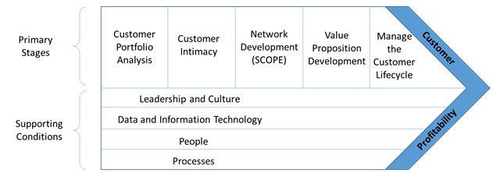
It has five primary stages and four supporting conditions and their purpose is to integrate the company’s activities to create value for the customer and profit for the company. The primary stages represent three phases to building a CRM strategy: the customer portfolio analysis and customer intimacy comprise the analytical stage, network development and value proposition development are part of developing resources to create and deliver value to the customer and managing the customer lifecycle is focused on implementing the strategy to acquire and maintain customers (Buttle, 2004). These stages serve to identify the right customers, understand their habits, develop and maintain a relationship with them. According to Buttle (2004), these steps are repetitive and continuous and don’t result in a strategy that is applicable for ever. They are also interdependent so if the company can’t develop a value proposition or maintain a type of customer they will have to go back and reanalyse their target market. The supportive conditions enable the business to perform the primary stages. The leadership, culture and people influence the ability to create value for the customer depending on the customer-centricity, the information technology and processes impact the ability to deliver and maintain the relationship. If these conditions are not supportive of the CRM strategy, the implementation may fail. This model is the most effective when all the processes are shaped to create value for the strategically significant customer. A notable advantage is that is has the potential to integrate all the company’s activities towards serving the identified type of customer. Its shortcomings are that due to the requirements in technology and customer focus it may not be applicable for many types of businesses like brick-and-mortar stores or companies with rewards based on sales volume. Furthermore, it does not consider external factors like competitors which in a busy market can affect the business brand awareness and revenue. This framework is better suited to businesses where the revenue comes from a smaller number of customers.
The IDIC CRM model was developed by Peppers and Rogers and is based on four steps a company should take to build closer relationships with the customer that can be further broken down in two categories. Analytical: identify, differentiate and operational: interact, customise (fig. 2)
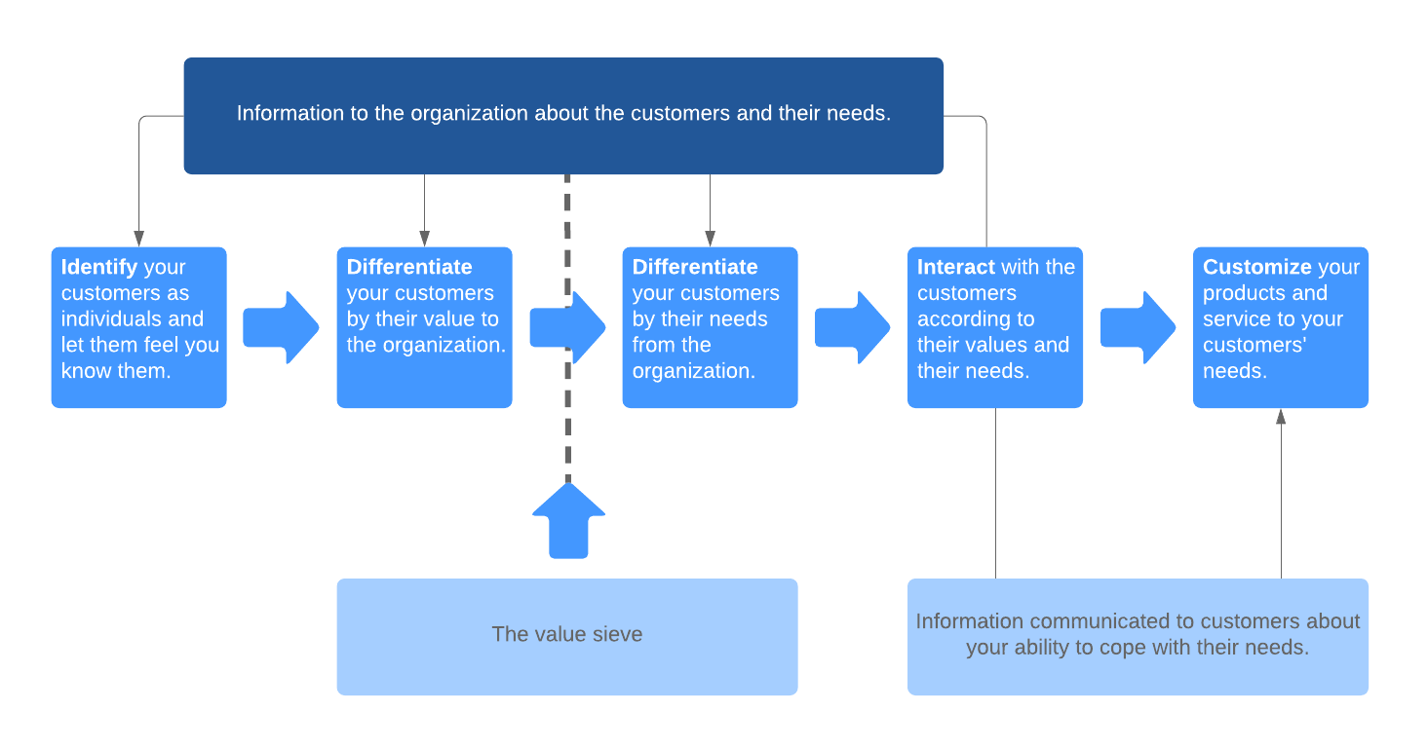
The idea behind this model is to understand the customers individually and take more effective actions in implementing a strategy for a beneficial relationship. Identifying customer nature and expectations allows to develop a better understanding of them and how the relationship should be shaped (Peppers and Rogers, 2004). Some customers are more active while others rarely make purchases. Differentiate between groups of customers in terms of loyalty, profitability, shopping behaviour allowing to focus on those who bring the most value to the company. Also, segmenting them according to their needs can help build better promotions and to serve them more closely. Interactions serve to better understand expectations, take their opinions, gain insight in how they relate to the brand and can help to build better customer-oriented products and services. After the first three steps are taken, the company’s behaviour can be tailored to reflect the customers needs. The customisation can be applied to products and communication with the benefit of creating a closer relationship from which both the customer and company can benefit. This model provides a good framework for businesses to shape their customer engagement processes and take steps to better serve them and benefit towards their own success in return. A drawback to it is that companies that don’t deal directly with the end-user like manufacturers who sell their products to intermediaries might not have a way to collect first hand information from the consumer to draw benefits from the knowledge obtained through feedback and interactions that communication with the consumer entails. For the same reason relationships beneficial to brand loyalty can be difficult to establish and the reliance on intermediaries can incur higher costs and less effectiveness than when done directly.

The supporting
conditions of leadership and culture, data and IT, people and processes enable the CRM
strategy to function effectively and efficiently
The supporting
conditions of leadership and culture, data and IT, people and processes enable the CRM
strategy to function effectively and efficiently
Payne’s Five Process is a comprehensive model focused on the strategic aspects of developing a CRM framework. It was developed through an interactive approach using executives from CRM consulting firms, managers of companies and relevant literature to identify five conceptual processes crucial in the development of a CRM strategy (fig. 3). The focus is on interlinked processes in a cross functional approach that contributes to the effectiveness of the system (Payne and Frow, 2005). The data repository plays a central role in the framework and is based on IT systems that collect and analyse data to gain insight in the customer behaviour. The extensive use of data collection can create privacy risks and have a negative effect on the customer experience.
The strategy development process considers the business strategy central in developing a customer strategy that identifies the segments of customers to focus on and develop a strategy to address them. This information is used in the value creation process where the business understands what processes can add value to the customers and vice versa. In the multichannel integration articulate concepts based on the value exchange get converted into activities and integrated to sales channels to create positive and unified experiences for the customers. However, no means are provided to take feedback from these activities and asses each one’s effectiveness. The performance assessment process focuses understanding how well the value proposition is being applied and if it contributes to the business performance. It is based on a strategic view of performance using metrics and results for the company rather than direct feedback from the customer. The five processes are driven by key performance objectives based on the customer needs. The comprehensive view on these processes broadens the scope the CRM application and help formulate a complete strategy. This model is well suited to large companies that have the resources to apply it in an effective manner.
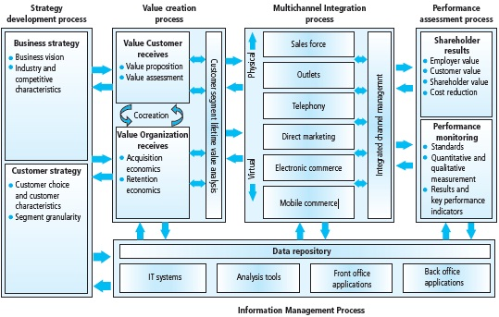
Each of these models are similar but are better suited to different types of organisations and business setups.

.

Model Selection for Amazon

In order to solve Amazon’s problem of a generalised approach in managing the relationship with customers and the result of a personalised experience that is standard for everyone, the IDIC CRM model has been selected due to it’s ability to discover the individuals needs and use them as a foundation in developing a relationship with the customer. Even though it might be better suited for companies with smaller numbers of clients, this model can be successfully adapted to a giant company like Amazon given that they already use extensive data collection and analysis systems and a personalisation framework that they apply to the online portal.
In the IDIC framework, the first step aspect with identification of the customer to create an understanding of their needs and values to be used in building a better relationship on a more personal basis. It is important to identify the target customers and collect as much data as possible to identify particularities and understand what they see as valuable in order to achieve a closer relationship. Data points like demographics, buying habits, support interactions are valuable in building customer profiles and generate an understanding of them (Peppers and Rogers, 2004).
Secondly, by differentiating customers and segmenting them according to their needs and the value they bring to the company, will allow Amazon to create specific strategies for different categories of consumer and allocate resources efficiently in a way that brings in the most profits. Differentiation can also be used to understand their own needs and better categorise their values in functional segments that can be used practically. Segmentation based on data mining enables the company to analyse the customer value and loyalty. By modelling specific strategies to each category more value can be created for the customer, their expectations can be more closely met and the satisfaction increased as a result (Chen, et. al, 2006).
The third step of the model is interacting with the customer. Here Amazon can develop tailored interactions based on the categories resulted from the previous process in line with their needs and values. Different groups of customers like younger/older, more or less technologically inclined might prefer different channels of interaction like phone/email/mail and by addressing them in the right manner marketing campaigns and promotional offers can be better tailored and directed yielding better results. This will enable them to collect feedback through different channels to gain insight in the customer experience, better anticipate the complaints of each group and improve the support efficiency. It will also allow for customising the products and services along those lines. This active personalisation is most effective in e-channels, because it can be applied to a large number of customers at a low cost (Fairhurst, 2000). According to Peppers and Rogers (2004) providing deeper interactions improves the relationship with the customer and makes it less vulnerable to competition.
Lastly customer communications can be personalised based on the categories identified and they can be addressed better, using effective channels like email or phone depending on particularities of groups like older/younger, more or less technological inclined. Communications can be mass customised depending on the segments identified in the second stage, valuable customers can receive more personalised benefits like better discounts and less loyal ones can be addressed with incentives designed to improve that. If communications are carried out in a more personal way it will help develop trust in the brand and increase loyalty. Thanks to the personal approach that this model takes, more stable relationships can be developed and a more organic personalisation process tailored to fit different types of customers and their needs. The business benefits from gaining trust, better retaining the valuable customers and using less resources for the least profitable, while still delivering personalisation according to their needs.

Using IDIC Model in Amazon

Given that the company already uses a comprehensive eCRM system, the IDIC framework can be used to enhance its effectiveness and build a more organic approach in personalising the customer experience.
In the analytical category of the model, the identify phase can be applied to the existing systems where the company conducts data collection activities. Amazon collects a large variety of data from their customers from correspondence with the company, personal data, orders and searches, to devices used GPS location and every single action taken on their portal which the call clickstream data (Coluccini, 2018). The great extent at which this happens underpins the effectiveness of this framework. According to the first phase, all this information should be categorised in analytical batches like demographic data which contains age, gender, income, language, marital status, education levels, home ownership if applicable. The next batch is behavioural data with purchases, buying habits, interactions, preferred communication channels, company share of wallet and clickstream data. The last batch contains attitudinal data like opinions, lifestyle, brand preferences, satisfaction levels, personal values, competitive positioning, desired features and unmet needs. By further categorising some of it can be considered static data like birth date, gender, language and it will not be changed or adaptive like income, buying habits, etc. that will need to be updated when there are changes. The categories should be used to identify customers and build individual profiles.
The profiles are to be used in the next phase, differentiating customers. This phase recognises than not all customers are the same so they should be differentiated and categorised first according to the value they bring to the business and secondly according to their own needs in order to pave the way for an articulate strategy to be developed. The points from the behavioural and attitudinal batches should be used to determine the actual and potential value of a customer and differentiate between high and low value (Chen, et. al 2006). The RFV (recency, frequency, value) model should be used to get clear measures of the customer value (Foster, 2019). Those that bought in the last month, have a number of buys in the last year and spend more than a set amount per year can be considered high value, the ones at the opposite spectrum low value, and anywhere in between can be assigned to a relative scale of value. The customer needs can be differentiated by categories of products that the company has available. For example, the artist category will be interested in paints, photo cameras, hand tools, graphic devices etc, the engineer will want measuring tools, speciality books, high tech devices etc, the actor is interested in costumes, videos, books etc. In this case the ultimate goal is to better understand the different types of customers in order to provide them with a more personalised experience according to their individual needs and will have the added benefit of decreasing the company’s overall cost of interaction.
Moving on to the operational category from the model the data collected and differentiated is used to make decisions and formulate specific actions. In the interaction phase the behavioural data must be interpreted to understand the type of interactions a customer might prefer. Coupled with demographic data a picture can be formed on how to approach each customer and what type of interactions are appropriate. Mass communications can be tailored to customer needs and use specific channels to better reach the customer and achieve higher success. Using the appropriate channels and considering the customer needs a dialogue can be established that the customer could consider valuable. This will have the benefit of receiving more direct feedback and make the customer feel more valued thus improving their experience and creating loyalty.
The customisation phase can make use of Amazon’s recommendation algorithm and adapt the collaborative filtering to include the different categories of customer value and needs identified in the previous steps. Where the normal function is if a customer who bought product A also bought product B and another customer who bought product A might also be interested in product B (Hardesty, 2019), the adaptation may take the following forms:
- If customer X (high value) who bought product A from E (engineer category) also bought product B from E category, then another X customer that bought product A from E category might also be interested in product B from E – for this customer recommendations can be made based on the same category of products.
- If customer X who bought product A from E also bough product B from F ( actor category), then another X customer might not be interested to purchase the same product – for this customer recommendations should be made from the engineer category rather than actor.
- If customer Y (low value) who bought product A from E also bought product B from E there is a lower chance that another Y customer that bought product A from E might also buy product B from E – in this case less consideration should be given to product B and the customer should receive recommendations from the most popular products in category E.
- If customer Y who bought product A from E also bought product B from F, there is a slight chance that another Y customer will buy the same product – in this case product B should not be recommended to the customer at all.
There might be difficulties in introducing new functions to the algorithm and the initial results might not be perfect. These can be overcome with further testing and refining of the importance given to each new category until a balance is achieved and the results are satisfactory. Upon successful implementation the benefit will be that with consideration to the customers’ needs categories their experience will be better tailored for the specific customer and the company will maximise the value obtained from each of them.

Recommendations

Derive different analytical batches from customer data like demographic, behavioural, attitudinal and further categorise it in static and adaptive data. Use this data to identify customers and build individual profiles.
Use the individual profiles to determine the value the customers bring to the company using the RFV model to create a scale of value and assign profiles to it accordingly. Differentiate the customer needs and build relevant categories like actor, artist, engineer, etc. to gain an understanding of what different types of customers prefer.
Determine the optimal communication channels using demographic and attitudinal data and couple it with the preference categories to develop interactions tailored to the customers’ needs to optimise promotions and establish direct communication. Also make the individual profiles available to customer service representatives to improve the support activities.
Adapt Amazon’s recommendation algorithm to include the new categories of customer identified previously. Modify collaborative filtering to give recommendations based on the customers’ needs and consider the customer value.

Conclusion

This report represents a plan for Amazon to improve the customer experience on their retail platform. While the company uses a complex eCRM system to that uses previous customer data to give recommendations based on purchase associations and personalise the experience of their customers the negative aspect is that it fails to consider different categories of customer and their wishes creating a standardised experience that is more or less the same for everyone. By using the IDIC framework with its benefits in individualising the customer and categorising them according to their needs and values, the system can be improved to differentiate between customer value and include the different customer wishes, also to establish more effective direct communications based on the type of customer and improve relationships thus increasing customer satisfaction. This will denote that the company will shift its focus from product-based recommendations to a more individualised approach towards its customers. By applying this framework, the company will benefit through better identifying the customers’ expectations and thus allow them to improve their satisfaction and ultimately gain more loyal customers that bring more value to the company.

References

Salesforce, 2021. Benefits of CRM. [online] Salesforce.com. Available at: <https://www.salesforce.com/ap/resources/articles/benefits-of-crm/>
Bergeron, B., 2002. Essentials of CRM. New York: Wiley, pp.37-53.
Coppola, D., 2021. Topic: Amazon. [online] Statista. Available at: <https://www.statista.com/topics/846/amazon/> .
Amazon.co.uk. 2021. How Amazon Collects Your Personal Information. [online] Available at: <https://www.amazon.co.uk/gp/help/customer/display.html?nodeId=GSXETHUPY4UM7CRD> .
Zatari, T., 2015. Data Mining by Amazon. International Journal of Scientific & Engineering Research, 6(6), pp.867-868.
Amazon.com. 2021. Help & Customer Service. [online] Available at: <https://www.amazon.com/gp/help/customer/display.html> .
Hardesty, L., 2019. The history of Amazon's recommendation algorithm. [online] Amazon Science. Available at: <https://www.amazon.science/the-history-of-amazons-recommendation-algorithm> .
Kehoe, P., n.d. Traditional CRM Won't Work in the Age of Amazon | Messagepoint. [online] Messagepoint. Available at: <https://www.messagepoint.com/resources/traditional-crm-wont-work-in-the-age-of-amazon/> .
Payne, A. and Frow, P., 2005. A Strategic Framework for Customer Relationship Management. Journal of Marketing, 69(4), pp.167-175.
Chen, Y., Zhang, G., Hu, D. and Wang, S., 2006. Customer segmentation in customer relationship management based on data mining. International Federation for Information Processing (IFIP), 207, pp.290.293.
Fairhurst, P., 2000. e-CRM. The Journal of Database Marketing, 8(2), pp.138-140.
Buttle, F., 2004. Customer relationship management Concepts and Tools. Elsevier, pp.39-42.
Peppers, D. and Rogers, M., 2004. Managing customer experience and relationships. John Wiley & Sons, Inc., pp.88-103 137-172.
Coluccini, R., 2018. Tutti i dati che Amazon ha su di me. [online] Vice.com. Available at: <https://www.vice.com/it/article/yw4n4v/dati-amazon-raccolta-sorveglianza> .
Foster, S., 2019. What is RFV analysis?. [online] MarketingIQ - Media Planning, Evaluation and Effectiveness Insight. Available at: <https://www.marketingiq.co.uk/what-is-rfv-analysis/> .

