Understanding and Engaging in the Customer Experience (BMSK5003)

Student name – Amrik Singh
Student No - 1714039
Module Name - Workplace Culture and its impact on Organizational Efficiency
Module Tutor – Mr. Charles Oham
Contents
Introduction 3
Company Overview 3
Factors that Maximizes the Customer values 4
The four clusters of emotions which drive or destroy the value of Rosewood PLC 5
Understanding the customer behaviors and attitudes of different market segments to maximize customer value. 7
Customer Experience Map and Customer Journey Model of Rosewood 9
Critical understanding of the organizations quality systems and their effectiveness in meeting customer requirements 12
Illustrating customer service strategies in the selected organization context. 13
How customer service strategies create and develop the customer experience in a way that meets the needs of the customer and required business standards? 15
Definition of Customer Experience Management (CEM), how (the organization) apply effective customer experience management to maximize customer engagement 15
Definition of Customer Relationship Management (CRM) systems in light of Rosewood. 17
Different social media platforms to raise awareness of products and services and communicate with customers 18
18
How digital technologies employed in managing the customer experience within the organization to effectively acquire and retain customers. 19
Recommendations for improvement to be considered by the organization to further enhance the overall customer experience quality 20
Conclusion 21
References 22

Introduction
Marketing Management has become the most powerful department of the organization nowadays. Every organization needs to understand the needs and demands of the customers and incorporate theses into the products and services of the organization. There are some factors hitch signifies the customer value and they should devise the customer-centric strategies to satisfy the customers and make a lifetime relationship with customers. Customer experience map and customer journey model helps the organization to get involved with the requirement of the customers. At the spur of the moment, customer relationship management has become the most sign9ficant tool for cultivating the relationship with the customers (Sarangi, 2009).
To the preparation of the report, the tourism giant Rosewood PLC has been selected to analyze the customer value systems and other related strategies. It has the most experienced and skilled staff to support the customer services promptly with ensuring standard quality. The vision statement of the company Rosewood clarifies that their heart and soul of culture is the relationship hospitality. The mission statement comprises of nurturing and cultivating true customer relationship with the communities and guests. The motto of Rosewood PLC is to get engaged with the customers from the most parts.

Company Overview
Rosewood London is the giant hotel public limited company operated in the United Kingdom. The hotel provides the most comfortable services to the customers. It has the most experienced and skilled staff to support the customer services promptly with ensuring standard quality. The vision statement of the company Rosewood clarifies that their heart and soul of culture is the relationship hospitality. The mission statement comprises of nurturing and cultivating true customer relationship with the communities and guests. The motto of Rosewood PLC is to get engaged with the customers from the most parts. The value of the Rosewood PLC is the beliefs and behavioral norms of the employees that they treat the customers as the family members of Rosewood PLC. They, the employees of Rosewood prefer to work collaboratively to advance the best experience with the organization the same (Rosewood PLC,2019).

Factors that Maximizes the Customer values
The ultimate goal of any organization is to create a lifetime relationship with the customers to maximize the value if the organization. The organization can be well benefitted from loyal customers with ensuring its value from the customer. Once the company Rosewood has acquired a new customer, the ultimate goal of the marketing management department is to the retention of the customers and engaged with the relationship to maximize the value of the organization (Sarangi, 2009). The afterward discussion uncovers the factors that maximize customer value:
- Giving compelling offers: Rosewood provides compelling offers to customers. They have a different package of bundle offer including a luxurious gift to the customers that the customers feel the better experience with the journey of the organization. Rosewood provides a bundle of offers frequently targeting different occasions and festivals. Among these offers, the customers' survey report provides the greatest insight to give the customers the most dominated and powerful offers that they may get engaged with the organization, Rosewood.
- Loyalty Programs: Another factor that maximizes the customer value of Rosewood that is the installation of the successful loyalty programs. It includes making the list of loyal customers and providing the most benefits to them from time to time. It comprises the 10% price back to the customers and giving a seasonal discount to loyal customers especially that make a frequent purchase from the organization (Sheehan, 2018).
- Competitive Prices: Rosewood provides the most standard services to its customers at the most competitive process. The world-class services with the most skyscraper apartment along with the prestigious environment make the customer the most beneficiary services with Rosewood PLC.
- Staying relevant with the online presence: Rosewood provides the most relevant online presence of the organization. the customers get on-time facilities from the website of Rosewood PLC. Ease of accessibly to the websites, prompt complaint solve by the quick response team and ease interaction to the support staff of the organization make the journey more comfortable with Rosewood (Berguson, 2012).
The aforementioned unique programs instilled by Rosewood make the customer journey with the company more valuable and positively experienced one.

The four clusters of emotions which drive or destroy the value of Rosewood PLC
The widely discussed Colin’s customers experience DNA presents four pillars which may destroy or drive the value of the organization. the four pillars comprise by advocacy cluster, recommendation cluster, attention cluster, and the destroying cluster (Sarangi, 2009). The following discussion upholds the four clusters which may destroy or drive the value of Rosewood.

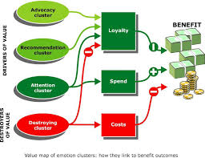
Figure: Four Clusters of Customer Experience Source: (Collins, 2016)
The aforementioned figure eloquently represents the customer experience DNA which is composed of four clusters.
Destroying Cluster:
It is the responsibility of the organization to mitigate the destroying image as it is impossible to eradicate the destroying image from the customers, Rosewood takes an exemplary attempt to reduce the destroying experience from the customers. Managing complaints with quick responses and solving the problems help the organization to be a sort of mitigation from the destroying behavior (Sheehan, 2018).
Attention Cluster: this cluster comprises the instilling emotions to attract the customers to the organization. In this phase, Rosewood tries to develop a perfect bundle of an offer to the customer so that it will be more engaged with the customers, these offers instantly instigate the customer to pick up the offers of the organization. but permanently it may have some negative impacts on the customers.
Recommendation Cluster: In this cluster, the organization offers the most services to the customers as they felt valued or resected from the organization, this is the game of emotions. Rosewood always tries to develop a close ties relationship with the customers so that they may feel some sort of receptiveness from the organization. the customers refer others to get involved with the organization (Sarangi, 2009).
Advocacy Cluster: the most top Custer is the advocacy cluster. This the top tier of the pyramid. The best form of marketing-the word of mouth. This cluster indicates that the customers will be most happy with the organization. Rosewood always tries to make the customers most happy so that they will be better engaged with the organization, almost all of the customers in this tier make the people vigilant to buy and get experienced the services from Rosewood.

Understanding the customer behaviors and attitudes of different market segments to maximize customer value
There are different segments of the market. Broadly speaking, Rosewood makes market segmentation based on the numerous levels of people in the United Kingdom. The following figure demonstrates the market segmentation procedures of Rosewood.

Figure: Market segmentation method of Rosewood Source: (Rosewood PLC, 2019)

Furthermore, Rosewood creates market behavioral and attitudinal segmentation in the following way.
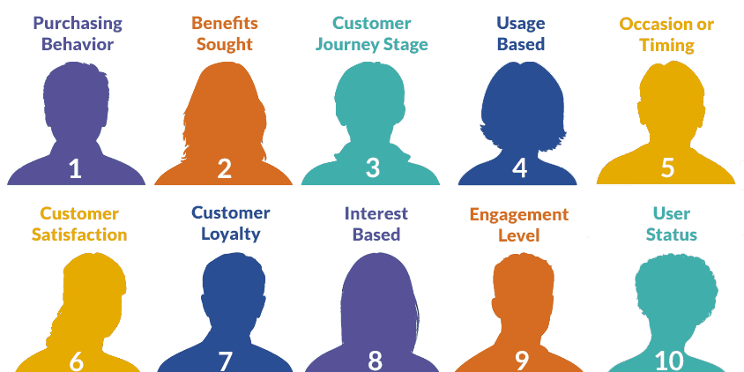
Figure: 10 Behavioral Segments of Rosewood Source: (Rosewood PLC, 2019)
It is inevitable for any organization to understand the attitudes and behaviors of the customers in every market segment. So, the organization will be capable of exploiting the greatest opportunities for the market. Based on the customer's behavior and the attitudes Rosewood divides all the customers into 10 categories. At the very outset, the organization divides the customers as the stage of purchasing behaviour to the last stage of user status. The customers are going through the tunnel of the depicted 10 stages shown in the above figure. The customers of Rosewood PLC have been treated very carefully with the greatest respect and attachment. Rosewood PLC has the data profile of the customers where every customer has an identity with the potential offering bundle to them. Thus, Rosewood understands the value of the customers.

Reviewing how customer value factors determine customer on-boarding strategies for different target customer groups within Rosewood.
As the organization, Rosewood creates a sense of place where al the recreational and entertainment activities can be performed in one place it is the holistic and immense corporate place with themed of living canvas. To give enriched experience to the customers, Rosewood depicts the strategies where they divide the customers into numerous segmentations especially based on the behavior and attitudes of the customers (Sarangi, 2009). the customers' segmentation is a significant emergent for Rosewood as it clarifies the ways organizations set the strategies in the long run. The term strategies implied that an action plan targeting to achieve the long-run objectives of the organization. Rosewood sets strategies dividing the customers into ten behavioral segmentation and frames a time-bound action plan so that the organizations can achieve the objectives of the strategies depicted earlier. The overall strategic goal of Rosewood is to capture a pre-planned number of customers to reach the customer's lifetime relationship. Rosewood decides the strategies in such a way so that the firm will be capable to achieve the premium business by exploiting the opportunities existed in the market segmentation. Additionally, the company rosewood has action bound time plan so that it can give proper feedback to the management of the customer relationship management department.
The value factors determined by Rosewood targeting the customer group at large. The customer segmentation of the upper-class segment is targeted by the company Rosewood to give them priorities the bundle offer provided including the residential facilities with dinner and other facilities with gift packages. The loyalty program is also instilled by the corporation rosewood to target the loyal customers and give them the discount along with the cashback offer.

Customer Experience Map and Customer Journey Model of Rosewood
Customer experience mapping is the most powerful tool for visualizing the experience of customers to the organization.

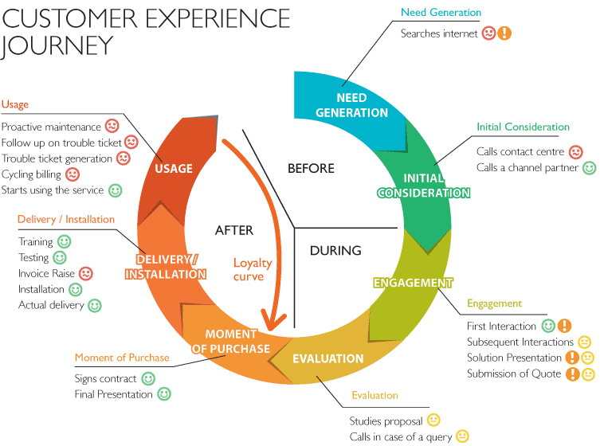
Figure: Customer Experience Map of Rosewood Source: (Sarangi, 2009)

In general, the customer's interaction is created when they feel some sorts of needs for the product or service. In the case of Rosewood, the customers of different countries who are used travel in the United Kingdom feel that they need to take residential facilities so that they first try to find the available options seeking into the internet. After sorting out then they have different alternative options for residential facilities (Sarangi, 2009). The customers at this stage try to weight out all the alternative courses of actions and as per the cost and benefit analysis, the customers find the hotel Rosewood as it provides the most standard services at the most competitive prices to the customers. the customers come to the hotel Rosewood and make a contract to the authority of the hotel and after getting an immensely positive experience with the hotel Rosewood PLC, customers are well satisfied by the supporting staff of the hotel. They feel to continue the relationship with Rosewood PLC.
Customer journey map: The customer journey map represents the collaborative interactions of customers with the organization. Rosewood tries to develop the customer journey model followed by the widely accepted model of customer journey model.
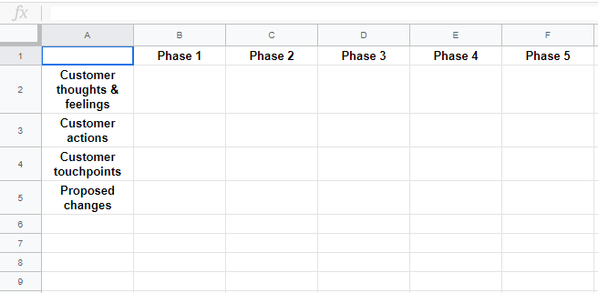
Figure: Customer journey map Source: (Sarangi, 2009)
Customers journey map with Rosewood PLC begins with the feelings and thoughts of the customers about the organization. In general, in the market customers have enough information about the service quality of the organization. Rosewood has a brand value in the United Kingdom tourism industry. It is the tourism giant in the United Kingdom. Thus, Rosewood can create a positive among the mindsets of the customers. After going through the initial stages, customers then act to enter into the contract of Rosewood PLC. The hotel authority tries to give the optimal services to the customers of Rosewood PLC. Customer touchpoints are the most important ways that customers need to be engaged with Rosewood PLC. In all the touchpoints the organization tries to give the optimal positive experience to the customers as like as the family members of Rosewood. After having a positive
e experience with the organization, the customers continue the relationship as they think that they get the best services from the organization. the following lists are the organizational touchpoint of Rosewood to the customers.
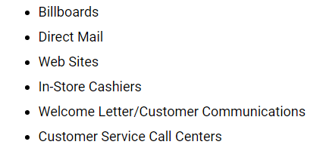
Figure: Touchpoint of Rosewood Source: (Rosewood, 2019)

Critical understanding of the organizations quality systems and their effectiveness in meeting customer requirements
The organization needs to understand the significance of the quality system. Every organization creates a positive valiance among the customers by its quality system. There should a standard quality system which fully meet up the requirement of the customers at large irrespective of the manufacturing or service-based organization. the following figure demonstrates the quality system of Rosewood which fully capable of meeting the requirement of the customers.
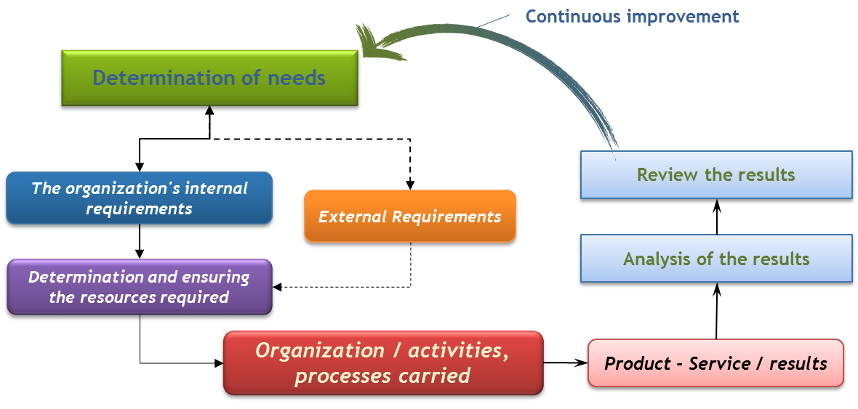
Figure: Quality System of Rosewood Source: (Hollensen, 2019)
As the organization, Rosewood is committed to devoting the supreme services to the customers. The services provided by Rosewood is based on the basic needs and demand analysis of the customers. Initially, the Rosewood determines the internal need s and requirement of the customers. in the process of the determination, Rosewood analysis the needs of the whole customers and according to the needs and demands of the customers Rosewood designs the environment of the hotel and other related services also provided by the organization (Hollensen, 2019). The satisfaction of the customers is always evaluated by the authority of Rosewood. Thus, Rosewood is a heavily customer-oriented organization.

Illustrating customer service strategies in the selected organization context
According to the research of the MIT Sloan, the strategies that provide the best services for the customers can be used by any competitive organization. The most common strategies can be used by the organization to exploit the advantages in the market and be the customer-centric organization. According to research, 87% of the customers want to be treated with dignity from the organization and almost 80% of the customers want that the thing of mistakes should not be repeated. As per the research, Rosewood designs the work environment where the customers can get the most competitive services at reasonable prices. Rosewood treats the customers as the members of the family and wants to cultivate the relationship with the customers in the long run. The following are the initiatives taken by Rosewood to cultivate the long-term relationship with the customer:
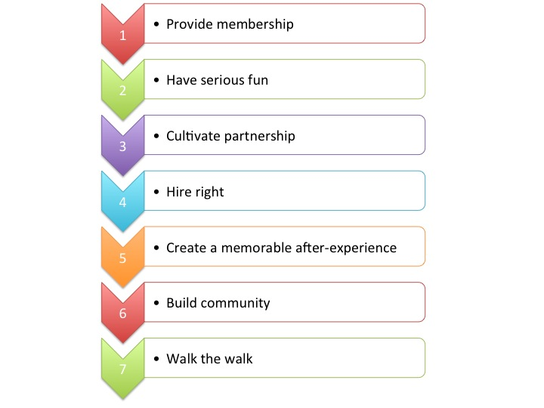
Figure: Illustrating Customer Service Strategies Source: (Hollensen, 2019)
To be engaged with customers, Rosewood designs the environment where the organization provides opportunities for the organization to be a member of the organization. the organization creates a jovial work environment where the customers artificially having fun with the services of the organization and the organization cultivates a lifetime relationship in order so that the organization hires the right supporting staff for the organization. Thus, the customers of Rosewood have a memory that can feel after getting devices from the organization. Finally, all the efforts of the organization are triggered to build a community where the customers can engage with the organization in the long term. Thus, Rosewood sets the path where both of the customers and the organization walk together and creating a win-win situation.

How customer service strategies create and develop the customer experience in a way that meets the needs of the customer and required business standards?
The strategies undertaken by Rosewood have a significant power to promote the customer experience in such a way that fulfills the needs and demands of the customers and also fueled the business standard of the organization the same (Hollensen, 2019). Rosewood undertakes that it popularly tries to make the experience of the customers better with the organization having fun and making a jovial work environment. The journey of the organization with customers is very exclusive which takes the long-term relationship through standard services. Customers get benefitted from the organization as the organization gets settled the price competitively and at the same time ensuring the long-term profitability which upholds the business standards if Rosewood. Fulfilling the needs and demands of the customers the organization provides the best services as such the customers' lifetime wants to get engaged with organization Rosewood. These services and the environment of the hotel Rosewood creates an extraordinary taste that should never be forgettable.
Thus, the aforementioned strategies making loyal customers, having fun with customers and hiring the standard and skilled employees for the organization, at the sometimes making jovial work environment and making and cultivating the lifetime relationship with the customers make the business standard and set the same time fulfills the demands of the customer requirement.

Definition of Customer Experience Management (CEM), how (the organization) apply effective customer experience management to maximize customer engagement
Customer experience management is designing the product and services in such a way that interacts with the customers and make the customers loyal, satisfied and advocacy to the organization (Du Plessis, Strydom & Jooste, 2012). Customer experience management is a significant tool of the organization as such the organization which manages the customer experience effectively it contributes to the organization's positive valence accordingly. The following figure represents the customer experience management process of the organization.
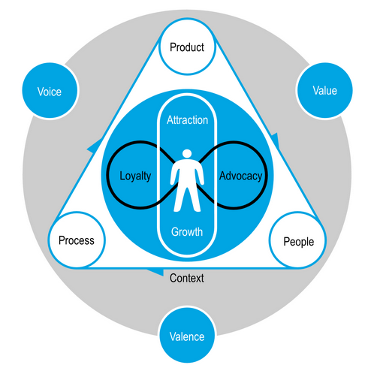Figure: Customer experience management Source:
Effective management of the organization’s customer experience makes the organization more productive and effective. This also increases the profitability of the organization. Rosewood manages the customer experience in such a way that it makes s the long-term relationship with the customers and make the organization more profitable one. Thus, customer experience management so a vital tool for any organization especially the case of a service-centric organization. the customer relationship management department of Rosewood management and listen to the voice of the customers immediately and incorporates the voice of the customers to the services so that the customers feel satiated with the services provided by the organization. at the juncture of the organization, value the voice of the customers which create s appositive valence among the mindset of the customers as such the customers feel that they are positively evaluated from the organization so they try to get engaged with organization lifetime and get benefitted from the services of the organization. It creates the organization more profitability and ensures the survival and growth and profitability of the organi9zatuion. And in the long-run, I create the organization more effective and make the customer loyal, advocacy and satisfied with the services provided by Rosewood.

Definition of Customer Relationship Management (CRM) systems in light of Rosewood.
Customer relationship management is the management of the lifetime relationship of customers so that customers will be more satisfied with the organization where every organization collects, store and manage all the related data of the customers about their current, past and potential customers (Du Plessis, Strydom & Jooste, 2012). Rosewood manage the customer relationship management system more significantly with the help of the Digital Alchemy. The following figure shows the logo of the customer relationship management systems of Rosewood.

Figure: logo CRM department of Rosewood Source: (Rosewood, 2019)
With an effective partnership of the organization digital Alchemy, Rosewood manages the customer relationship management process more efficiently with the hand of the up-to-the-minute digital technology. The following are the techniques of the customer relationship of Rosewood.
- Enabling the most recent technology so that the organization will be more adaptive about the interactive communication of the customers a due confirm about their pre and post-stay information.
- Instilling an online comment box which enables the customer to promptly communicate with the organization and inform the complainant and the organization ensure the positive solution of the complaints (Assael, 2015).
- Designing a very important Concierge service, which identifies the most important and valuable guest with their specific preferences and interests.
- E-mail marketing helps Rosewood to speed the news of facilities among the mass of the people or customers so that they may get engaged with the organization.
- Another important feature of the customer relationship management department of Rosewood is that Digital Alchemy's patent-pending and the Smartest Send technology to promptly accelerates the email open rates of the employees and solve the problems or be more responsive to the customers and the effectiveness of the marketing.

Different social media platforms to raise awareness of products and services and communicate with customers
The social networking sites help the organization be more responsive to the customers. it raises the awareness of products and services and communicate with the customers. the following figure uncovers the social media platform which is used by Rosewood to raise brand awareness and communicate with the customers effectively.


Figure: Social media platform Source: (Assael, 2015)
Rosewood provides an up-to-the-minute discount and promotional news with the customers so that the customers can be updated with the promotional news from the organization. Rosewood shares content and context and promoting promotional messages from the customer relationship department to potential customers. thus, social networking sites provide a promotional message to most of the customers that the users of the social networking sites within a few seconds with the cheapest costs.

How digital technologies employed in managing the customer experience within the organization to effectively acquire and retain customers.
Digital technology provides the most benefits of the organization so that the organization can be benefitted to be the most profitable business organization (Assael, 2015). Digital technology provides a platform for the customers as well as the organization to get the most up-to-date services. The following figures express the digital technology experience with the customers.

Figure: Great customer experience with digital technology Source: (Du Plessis, Strydom & Jooste, 2012)

Customer Service Technology
There are some important areas where digital technology effectively acquires and retains customers. These are the websites of Rosewood, e-mail of the organization to the customers, different unifying communication so that the customers can have a decent voice from the organization and instilled software so that the organization can be up-to-date with the organization. this digital platform makes the organization more viable to communicate with the customers and vigilantly manage and inquiry the response of the customers. thus, customers get the most recent and unique promotional message from the organization (Du Plessis, Strydom & Jooste, 2012). And the organization with the benefits of the great technology reaches to the front of the customers more effectively.

Recommendations for improvement to be considered by the organization to further enhance the overall customer experience quality
Beyond the afore discussed policies and systems, Rosewood can instill a bit more progress to additionally enhance the total customer experience quality of the organization. the following points uncover these recommendations:
- Instilling the most recent up-to-date technology to effectively manage the customer relationship management procedure so that Rosewood would be more capable to manage the complaints of the customers more effectively and promptly,
- The organization should develop the touchpoints so that it would become more responsive to the organization’s incorporating needs and demands of the customers in the value creation process of the services.
- The organization needs to be more adaptive to get the response and understand the current fashion of the market environment and indulge these fashions into the services of the organization.
- The priority should be given according to the segmentation systems and the customer who lies down in the top behavioral segment give and treat them with the most dignity.
- Loyalty programs should be installed and membership duration with the customer would need to extend as such it should make the lifetime member of the organization.

Conclusion
Rosewood is a giant hospitality firm in the United Kingdom. It develops some unique and distinct customer relationship strategies (Du Plessis, Strydom & Jooste, 2012). It makes the customers more satisfied with the organization. it makes the loyal customers and advice of the organization. it uses the social networking technology and digital technology platform to create positive valence among the customers of Rosewood. The effective market segmentation and unique target marketing help Rosewood to be more responsive with the needs, want and demand of the customers. Thus, exploiting the market opportunities, Rosewood becomes the giant tourism firm and fulfills the demands of the customers being the first choice of customers around the world.

References
- Assael, H. (2015). Consumer Behavior and Marketing Action. 5th ed. Cincinnati, Ohio: South-Western College Pub.
- Berguson, B. P. (2012): Essentials of CRM: a guide to customer relationship management. (Online) New York: Wiley. http://www.tsd.ac.uk/en/lrc/onlineresources/e-books/ (Accessed 15 August 2019)
- Du Plessis, P., Strydom, J., & Jooste, C. (2012). Marketing management. Cape Town: Juta.
- Goodman, J. A. (2009). Strategic customer service: managing the customer experience to increase positive word of mouth, build loyalty and maximize profits. (Online) New York: AMACOM. http://www.tsd.ac.uk/en/lrc/onlineresources/e-books/ (Accessed 17 August 2019)
- Gummesson, E. (2002). Total Relationship Marketing: Marketing Strategy Moving from the 4Ps Product, Price, Promotion, Place of Traditional Marketing Management to the 30Rs the Thirty Relationships of a New Marketing Paradigm. 2nd ed. Oxford: Butterworth- Heinemann.
- Hollensen, S. (2019). Marketing Management. Harlow, United Kingdom: Pearson Education Limited.
- Leppard, J. and Molyneux, L. (1994). Auditing Your Customer Service: The Foundation for Success. London: Routledge.
- Rosewood (2019). https://www.rosewoodhotels.com/en/luxury-hotel-offers/more-rosewood?gclid=CjwKCAjw98rpBRAuEiwALmo-yqZojpBOjTE9b736Xej dYKsh_xAaDgJqAYhAXfUhSGgMVl6LOp5RoC2PEQAvD_BwE&gclsrc=aw.s (Accessed 20 August 2019)
- Sarangi, S. (2009). Marketing management. New Delhi: Asian Books.
- Sheehan, B. (2018). Marketing management. Lausanne: AVA Publishing SA.

