Assignment feedback

Student Name: Matthew Cowley
Student University Email: 1700561@student.uwtsd.ac.uk
Module code: AHAH4005  Module title: Introduction to Fieldwork | Student ID number:  1700561 |  | Educational support needs:  No
Assignment title: Reflective Journal

Assignment due date: 27/03/2018
Assignment Number: 1
(i.e. 1,2,3)
Marker’s signature: |  | Date:
Provisional.
NB. All marks are provisional until confirmed by the final examination board.

Reflective Journal – By Matthew Cowley

“The popular image of the archaeologist is of an intrepid hole digger looking for buried treasure, probably dressed in eccentric clothes. Though there are some archaeologists that cultivate this image, there are many archaeologists who wear suits to work and might never have held a trowel in their lives” (Catling, 2014, pp. 8 – 9).
This quote by Christopher Catling clearly states that there are many different aspects to archaeology, such as mapping, surveying, excavating, and place-name analysis, some of which I have been developing over the past few months (Catling, 2014, p. 11). As well as improving these basic archaeological skills, I have also been taught how to use a variety of tools and techniques, and by reflecting on my own progress, I hope to discover ways to improve myself as an archaeologist. Just to clarify here, the following sessions occurred on a Thursday, between 2 pm and 4 pm, during January, February, and March of 2018.
Following the introductory session (01/02/18), the second lecture (08/02/18) focused on map reading, with terms such as ‘Ordnance Survey’ and ‘Ordnance Datum’ being used. Beforehand, I had never heard of these terms, but now I understand that the former is an ‘official survey organisation that creates a detailed map of the entire country on a large scale’ (Oxford University, 2010, Ordnance Survey), while the latter is what the ‘Ordnance Survey deems to be the mean sea level’ (Oxford University, 2010, Ordnance Datum). Furthermore, in order to test whether or not we understood the content correctly, we were given an extract from the Ordnance Survey of our surrounding area and had to work our way round it to answer set questions. Although initially I struggled, after a while, and with the aid of Evan Fray and Nadia Seale, we managed to complete all the tasks except one, which was difficult due to the bad photocopying of the maps. Overall, I was pleasantly surprised with how simple the concept of map reading was once I got to grips with it and, in hindsight, it was this session that enabled me to understand a later practical session.
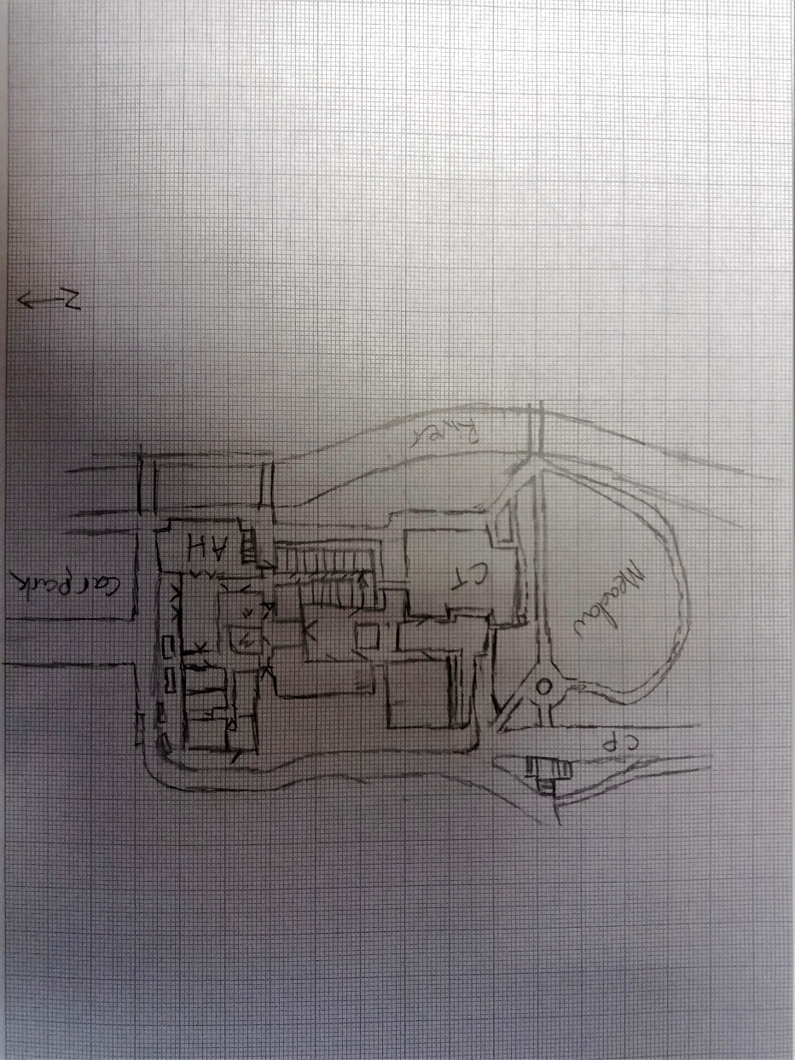
Continuing from this, the next session (15/02/18) focused on the concept of surveying, a completely new idea to me. For the first part of the session, we were informed of the different methods of surveying, from the older technique of field walking to the more advanced technique of GPS (Catling, 2014, pp. 36 - 37). However, based on the works of Colin Renfrew and Paul Bahn, there seems to be many other surveying techniques that we did not study in this lecture, most noticeably aerial reconnaissance (surveying from the air) and subsurface detection (using probes to see stratigraphy) (Renfrew/Bahn, 2004, pp. 83 – 98). Following this, we then went out into the cold wind to test out some of these basic techniques for ourselves, which was excellent practice for budding archaeologists as we quickly learnt that you cannot wait for better weather if there is work to be done. We were asked to produce a site plan of the ‘Arts’ building, paying close attention to the positioning of the building and the surrounding area (see Figure 1). My partner, Sam Smith, led the way and recorded the plan while I helped by lending a second pair of eyes and pointing out anything that he missed. Looking back, I would have liked to have helped a bit more, maybe splitting the recording phase in half so we both had a chance to draw. In the end though, I was reasonably happy with what we had produced, but we had forgotten to include a title and the compass directions, which were both flagged up, so now I know they need to be included the next time I produce a site plan.
Figure 1: Site plan of Arts Building and Surrounding Area. Drawn by Matthew Cowley and Sam Smith, on 15 / 02 / 18.
Following on from this, session four (22/02/18) was slightly duller than its predecessors as it was concerned with what graveyards can tell us instead of an actual archaeological exercise. That being said, it was definitely a surprise to learn of all the different aspects of a person’s life that could be gathered from their grave stone. Also, this session reinforced my interest in burials and help me decide that, for the assessed graveyard survey, I will look at the correlation between location and religion, similar to the works of Harold Mytum. In his book, ‘Mortuary Monuments and Burial Grounds’, Mytum suggests that the design, language and images on a gravestone, as well as the way in which a grave is looked after, a factor that I had not considered beforehand, can indicate the religion of the deceased (Mytum, 2004, pp. 240 – 260). Due to all of this, I found this lecture surprisingly thought-provoking as it helped me decide what I was going to look at in my graveyard survey assessment.
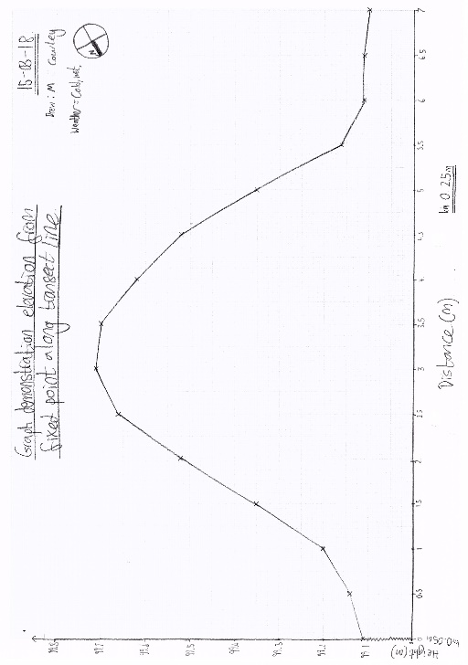
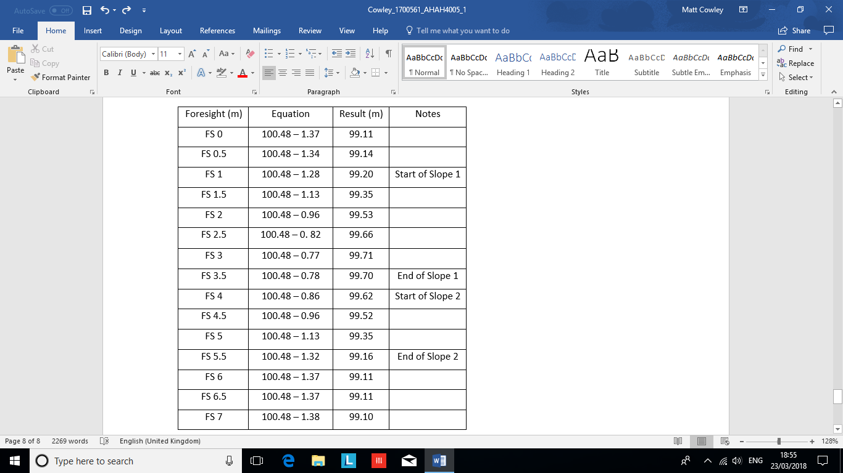
The following Thursday (08/03/18), we were undertaking an outdoor activity in which we were using a dumpy level to plot the height of a small mound. After the lecturers demonstrated how to set up the dumpy level and use it safely and effectively, we got into our usual groups (myself, Evan Fray, Nadia Seale, and Sam Smith) to complete this task. First off, Evan and Nadia set up the dumpy level while Sam and myself created the cross section of the mound that could be used to measure the height. Once this was completed, Nadia made her way to our benchmark, the corner of a concrete slab, with a measuring rod so that the rest of us could gage what the instrument height was. To work this out, we gave the benchmark a value of 100 metres above sea level and then, using the measuring rod, worked out the value of the gap in between the benchmark and the height of our dumpy level. We worked out that this gap, or foresight, was 0.48 metres above the benchmark, so our instrument height was 100.48 metres above sea level. On completing this set-up stage, Nadia went to hold the measuring rod along the cross section at equal intervals, Evan and myself looked through the dumpy level, taking turns so that our observations had a second opinion, and Sam recorded the results. Our first foresight of 0 metres along the cross section gave us a figure of 1.37 metres up the measuring rod. We then subtracted this from our benchmark in order to conclude that this initial position on our cross section was 99.11 metres above sea level. The rest of our results continued as one would expect, in a positive manner and peaking at 99.71 metres above sea level when we got to 3 metres along the cross section, before decreasing as we measured down the other side of the mound (see Figure 2 for full set of results). I believe this exercise had the aim of introducing us to the methodology behind a dumpy level, as well as the practical and effective use of archaeological equipment. In this sense, I believe that I achieved this aim as I now know how a dumpy level works, and following the completion of the task, we were informed on how to clean the equipment, an essential skill of any archaeologist in order to maintain the condition of their equipment. Furthermore, Evan, Nadia, and myself continued to switch roles from holding the measuring rod to looking through the dumpy level, so that we all had the opportunity to take part in each aspect of the exercise and at the end, myself and Sam had a go at setting up the dumpy level, which was difficult to set straight in the cold and wet weather. In doing this, I feel that everyone in my group had a chance to engage with the equipment and in turn, achieve the aim of the exercise.
Figure 3: Graph of results from Dumpy Level exercise. Created by Matthew Cowley, on 15 / 03 / 18.
Figure 2: Table of results from Dumpy Level exercise. Collected by Matthew Cowley, Evan Frey, Nadia Seale, and Sam Smith, on 08 / 03 / 18.
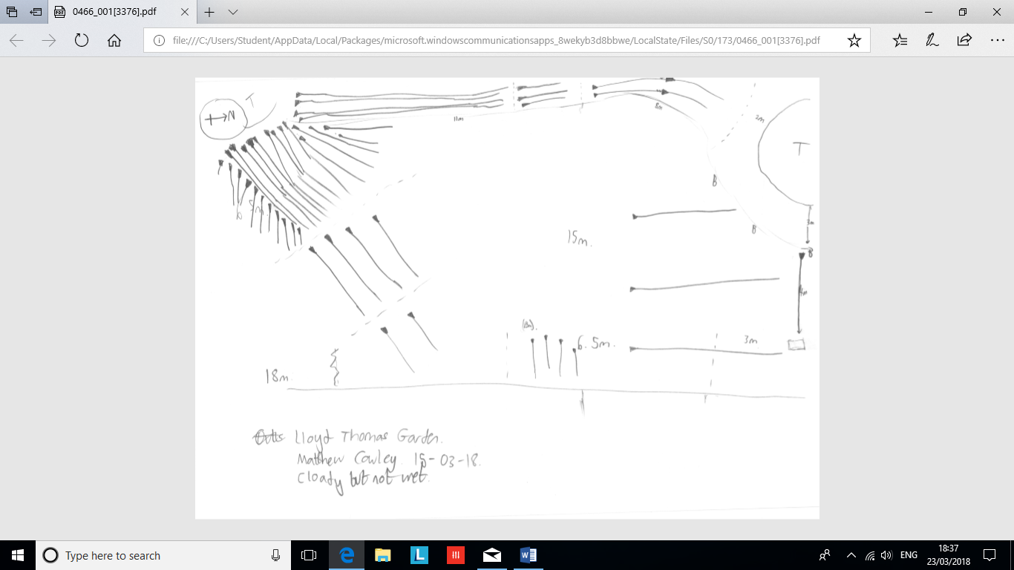
Continuing from this, the next session (15/03/18) acted as a write up for this previous exercise, where we plotted our results on a graph (see Figure 3). Personally, this task was relatively straight forward as it was simply analysing the results and imputing them on the graph, with the most challenging part taking the form of precisely plotting the points on their correct millimetre lines. Again, the point of this task was to continue the process of gathering data, while reinforcing our ability of plotting information on a graph, an aim in which I believe was thoroughly achieved. Following this, the lecturers informed us that ‘hachures’ were used in archaeological drawings to depict the direction and steepness of a hill. The length of these parallel lines indicates how far each section of a slope continues on for, while the quantity and in turn, closeness, of the hachures suggest the steepness of the slope (Oxford University, 2010, Hachures). To further reinforce this, we were split into groups and asked to go and make a hachure map of a slope. As usual, I worked with Evan Fray, Nadia Seale and Sam Smith, and we decided to look at the slopes in the ‘Lloyd Thomas Gardens’, where Evan, being the person who perfected the metre stride, took the role of measuring the distance between landmarks in our slope. While this was happening, Sam and Nadia watched Evan in order to double check his step count, before relaying it to me so that I could input it into the drawing (see Figure 4). I believe that this task’s aim was to again, introduce us to archaeological methods of presenting data, as well as to reinforce the key elements (north, date, weather, scale, name of artist, and site code) that should be included on all archaeological field documents. In terms of these goals, I feel that I partially achieved them in that we included the specific elements, but I am personally unhappy with my drawing as my lines are not parallel and originally, they were curving instead of being multiple straight hachures. Also, according to ‘The Archaeology Coursebook’ by Jim Grant et. al, my hachures’ head should be located at the top of the slope, but unfortunately, they are not (Grant/Gorin/Fleming, 2005, p. 309). As such, I would need to make sure that my hachures were straight and mimicked the environment the next time I use hachures.
Figure 4: Landscape overview with hachures exercise. Drawn by Matthew Cowley, Evan Frey, Nadia Seale, and Sam Smith, on 15 / 03 / 18.
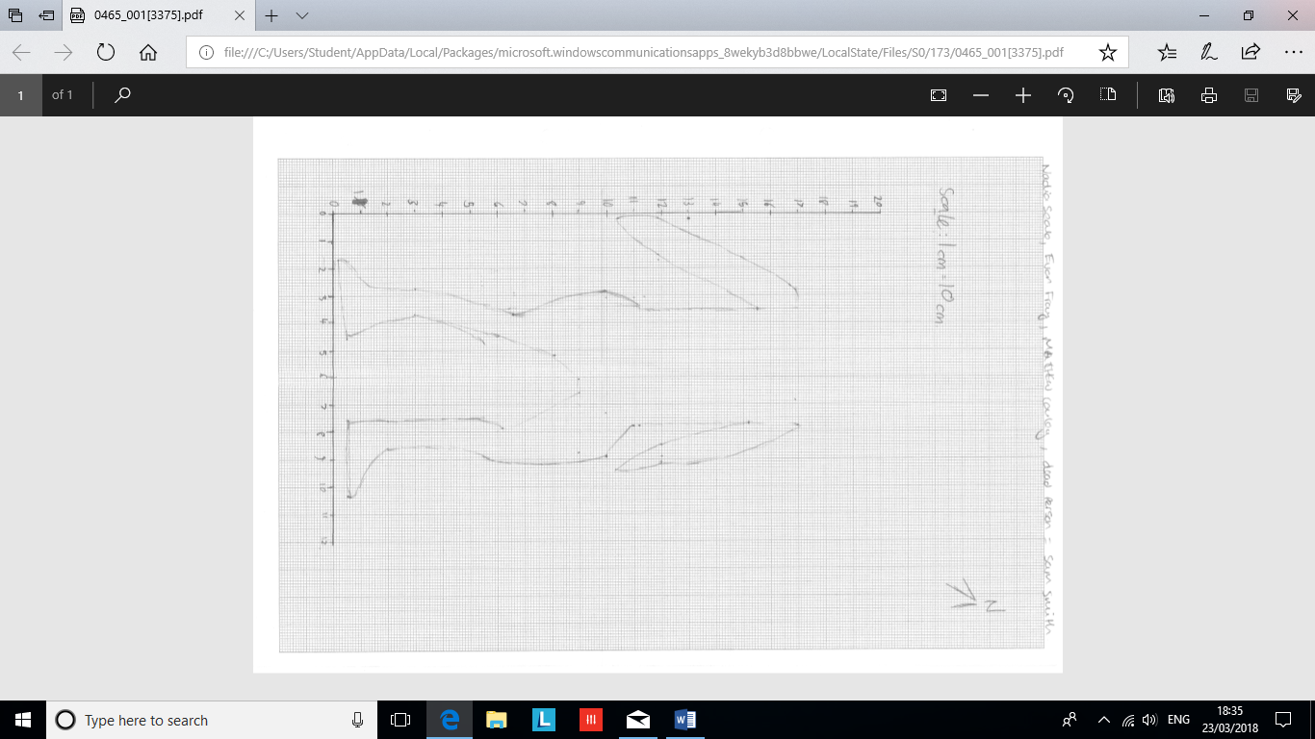
Finally, the most recent session (22/03/18) focused on the ideas of drawing to scale, whether that be to a scale of 1cm:100cm or 1cm:10cm. It is this latter scale that we used in the second part of the session, where we had to ‘kill’ someone, and then draw their body to scale. As usual, I worked with Evan Fray, Nadia Seale and Sam Smith, the latter of whom volunteered to be our corpse, so, once Sam took his corpse position, myself and Evan laid out two long measuring tapes perpendicular to one another so that they enclosed the body. We decided to do this as this method allowed us to maintain a constant ‘base point’ which could be used to measure the main aspects of the body. From this, Evan and myself started measuring Sam, so that our artist, Nadia, could create a comprehensive image of the corpse (see Figure 5). As well as being a lot of fun, this task also had a practical element of demonstrating to us how hard it is to draw something exactly to scale, with many of the drawings being slightly out of proportion with their real-life counterparts. Furthermore, although this task was difficult to complete, and the lecturers commented on how our final image looked a bit like a penguin, I believe that my group did relatively well as we took the activity in turns, so that myself, Evan and Nadia all had the opportunity to measure the body and input the data into the drawing. However, I am slightly annoyed that we failed to finish our image completely, with our corpse being decapitated in our depiction of him, which is why I personally can only claim that I partially completed the aims of this task.
Figure 5: Body to scale exercise drawing. Drawn by Matthew Cowley, Evan Frey, Nadia Seale, and ft. Sam Smith, on 22 / 03 / 18. Axis on graph reflect position of long measuring tapes.

In conclusion, over the past seven weeks or so, I believe that most of my archaeological skills have developed in one way or another, whether that be introducing me to new skills that I did not know I had, or nurturing skills that I had only scratched the surface of previously. Of all the sessions, my favourite was the dumpy level exercise as this was the first time I had ever used archaeological equipment. Also, I personally found the map reading task the easiest once I got my head around it, while I would suggest that I struggled the most with the hachures task as I was the least comfortable with this activity and it took me a while to get my head around some of the equations, causing the group to work at a slower pace. Overall though, I believe that I have really developed as an archaeologist over this period and, even if my training is slow and difficult, I feel that if I continue this path then I will achieve my goals in archaeology.
Words: 2168 (+ 126 Words Including Captions).

Bibliography
- Catling, C. 2014. A Practical Handbook of Archaeology: A Beginners Guide to Unearthing the Past. London: Hermes House. pp. 8 – 11 & 36 - 37.
- Grant, J. / Gorin, S. / Fleming, M. 2005. The Archaeology Coursebook: An Introduction to Study Skills, Topics and Methods. 2nd Edition [2005]. Abingdon: Routledge. p. 309.
- Mytum, H. 2004. Mortuary Monuments and Burial Grounds of the Historic Period. Manuals in Archaeological Method, Theory, and Technique. New York: Springer Science + Business Media. pp. 240 – 260.
- Oxford University, Ed. by Stevenson, A. 2010. Hachures, Oxford English Dictionary 3rd Edition. Oxford: Oxford University Press. Accessed from Oxford Referencing (http://www.oxfordreference.com.ezproxy.uwtsd.ac.uk/search?source=%2F10.1093%2Facref%2F9780199571123.001.0001%2Facref-9780199571123&q=hachures).
- Oxford University, Ed. by Stevenson, A. 2010. Ordnance Datum, Oxford English Dictionary 3rd Edition. Oxford: Oxford University Press. Accessed from Oxford Referencing (http://www.oxfordreference.com.ezproxy.uwtsd.ac.uk/view/10.1093/acref/9780199571123.001.0001/m_en_gb0585190?rskey=kvoxIg&result=3).
- Oxford University, Ed. by Stevenson, A. 2010. Ordnance Survey, Oxford English Dictionary 3rd Edition. Oxford: Oxford University Press. Accessed from Oxford Referencing (http://www.oxfordreference.com.ezproxy.uwtsd.ac.uk/view/10.1093/acref/9780199571123.001.0001/m_en_gb0585200?rskey=kvoxIg&result=4).
- Renfrew, C. / Bahn, P. 2004 [1991]. Archaeology: Theories, Methods and Practice. Fourth Edition. London: Thames & Hudson Ltd. pp. 83 – 98.

SELF-REFLECTION SHEET.

PLEASE COMPLETE BEFORE SUBMISSION AND ATTACH TO YOUR WORK

Date: 27/03/2018 Module: AHAH4005 Name: Matthew Cowley

Guidance: You might consider the following elements:

- Argument: does it have one/ is it backed by sufficient evidence/ how lucid is it?
- Structure: how clear is it / is my essay easy to follow/ does it help my argument?
- Analysis: is more/less analytical than narrative/ does it address the question?
- Reading: was this sufficiently broad/ have I referenced properly?
- How might I improve my performance in future?

Strengths
I have referred to all of the lectures we have had and have attempted to reflect on my experiences.

Weaknesses:
I am still slightly unsure with this referencing system, but I do feel I am getting better. Also, I have never written a reflective journal before, so it was a daunting new style.

General Comments:

Overall, I am relatively happy with my work as I have tried to include everything that I have learnt as well as using other sources, but I am not sure if I have structured it right.

Please give a mark for your work: 56

(for eg: 1st = 70+: 2/1 = 69-60: 2/2 = 59-50: 3rd = 45-49: pass = 40-44: fail = 39- )

