

University of Wales Trinity Saint David

School of Engineering

Manufacturing Systems

Reflective Project Report
Group Project ACMA5009

Total Word Count: 5980
Adjusted Word Count: 4995

Joseph Lancastle
2214707
26th May 2023

Abstract

The report will be comprised of a detailed explanation of a previously completed project. In this situation, the design and manufacture of an environmentally friendly, collapsible trailer. The detail is communicated by imparting knowledge and reasoning for decisions made and processes adopted in the project process. The concepts are supported by credible academic sources which methods are frequently employed by project leaders to ensure a quality project is completed to stringent timelines.
The report will subsequently evaluate the conducted projects benefits and shortcomings using academic theories and analytical strategies gained from exposure to manufacturing environments. Improvements are suggested based on the highlighted certain oversites critical areas of the project plan and design.

Contents
Abstract 2
List of Figures 4
Introduction 5
Project Detail 6
Design Brief and Research 6
Time Management 7
Product Design Specification 11
Feasibility Study 14
Final Design 15
CAD Drawings 17
Component Drawings 17
Assembly Drawings 18
Production Costs 20
Secondary PDS 21
Communicating the Project 21
Analysis and Evaluation of the Project 22
Evaluation of Models Using Computer Aided Design 22
Accuracy of Production Costs 26
Conclusion 30
References 31
Appendices 33
Appendix A 33
Appendix B 38

List of Figures

Figure 1: Lancastle, J. (2019) Gantt Chart 1 Engineering Project - Foldable Trailer. rep. Bridgend: Bridgend College pp. 13. 9
Figure 2: Lancastle, J. (2019) Gantt Chart 2 Engineering Project - Foldable Trailer. rep. Bridgend: Bridgend College pp. 14. 10
Figure 3: Lancastle, J. (2019) Gantt Chart 3 Engineering Project - Foldable Trailer. rep. Bridgend: Bridgend College pp. 15. 11
Figure 5: Lancastle, J. (2019) Engineering Project - Foldable Trailer. rep. Bridgend: Bridgend College pp. 20–21. 12
Figure 6: Lancastle, J. (2019) Solution 1: Engineering Project - Foldable Trailer. rep. Bridgend: Bridgend College pp. 30. 13
Figure 7: Lancastle, J. (2019) Solution 2: Engineering Project - Foldable Trailer. rep. Bridgend: Bridgend College pp. 31 13
Figure 8: Lancastle, J. (2019) Solution 3: Engineering Project - Foldable Trailer. rep. Bridgend: Bridgend College pp. 32 14
Figure 9: Lancastle, J. (2019) Matrix Analysis Engineering Project - Foldable Trailer. rep. Bridgend: Bridgend College pp. 33 14
Figure 10: Lancastle, J. (2019) Engineering Project - Foldable Trailer. rep. Bridgend: Bridgend College pp. 39 16
Figure 11 : Lancastle, J. (2019) Engineering Project - Foldable Trailer. rep. Bridgend: Bridgend College pp. 40 17
Figure 12: Lancastle, J. (2019) “Trailer Base” Engineering Project - Foldable Trailer. rep. Bridgend: Bridgend College pp. 43. 18
Figure 13: Lancastle, J. (2019) “Full Trailer Assy” Engineering Project - Foldable Trailer. rep. Bridgend: Bridgend College pp. 58. 19
Figure 14: Lancastle, J. (2019) “Trailer Assembly Dismantled” Engineering Project - Foldable Trailer. rep. Bridgend: Bridgend College pp. 5. 20
Figure 15: Generated Weight of Full Trailer Assembly 23
Figure 16: Tow Hitch Strength Testing 24
Figure 17: Redesigned Tow Hitch Strength 25
Figure 18: Fatigue Testing of Trailer Assembly 1 25
Figure 19: Fatigue Analysis Load Spot 26
Figure 22: Software Generated Machining 28
Figure 23: Taught Machining Paths 29
Figure 24: Taught Welding Paths 29
Figure 25: Welding and Machining Operations Timings 30
Figure 26: Employee Cost Calculations 30

Introduction

The project in question was conducted in between 2018 and 2019. It involved designing and manufacturing a trailer that’s competitively priced, financially viable to manufacture whilst meeting the requirements stipulated by the design brief.
The fundamental points were that the trailer did not occupy a large footprint to maximise storage space in people’s residences. The trailer also needed to be light and sized appropriately so one can easily manoeuvre the trailer with ease, whilst simultaneously being large enough to carry small loads of domestic recycling waste. This project was conducted within the academic year that dictated a stringent timeframe.
The concept design, development, and selection process used in the project will follow a process known as Total Design, coined by Pugh et al. (1998). This process has been streamlined and simplified by Eppinger et al. (2002) in lectures from the Massachusetts Institute of Technology and is a widely used process which is corroborated by Concept selection using matrix analysis on (businessgrowthhub.com 2020). This method in its abstract follows four simple steps: Understand Customer Needs, Developing PDS, Generating Concepts and, finally, establishing the final Concept Selection.
The understanding of customer needs comes from relevant research and consideration of the customer requirements as outlined in the Design Brief. The Product Design Specification (PDS) will illustrate how the customer needs will be fulfilled. The following Generation of Concepts will be based consideration the previous two points. Concept Selection will be based on the final designs using methods such as Matrix Analyses and Feasibility Studies to establish the best course of action.

Project Detail

Design Brief and Research

The project required market research to understand what trailer options were already on the market and what methods they utilised to dismantle. To consider the sizes of the trailers, the volumes of the load space, and the competition’s price points. The price, size and materials trade-off were evaluated to understand the direction of the project whilst considering the potential design flaws due to the folding mechanisms of competitors’ trailers. Furthermore, the sizes and weights for towing on UK roads and the average amount of free space customers had at their residence were of particular interest for this research, which were key points of the Design Brief.
The primary reason for the request of the trailer design was in the interest of environmental health, for individuals to properly dispose of household waste in the correct manner. The ability to collapse and store the trailer would entice a wider clientele.
The trailer, alongside being small, must have the ability to carry a max, 200Kg mass of household waste to a local disposal centre, a volumetric figure was not specified. There were also regulatory issues to consider, according to the DLVA (2022), the overall weight of the trailer combined with its load cannot exceed 750kg. This largely influenced the design to ensure the trailer is lightweight,
when unloaded.

Time Management

Following the completion of the research, a series of Gantt charts were formulated in order to make the process clearer and ensure the project was completed by the allotted due date. whilst also being able to be observed by others who could quickly view the chart and understand at what stage in the process the project was in to ensure the project trajectory was on course. as illustrated in the Gantt chart weekly Logbook meetings were scheduled and available to all involved parties.
The visible evolution of the three Gantt charts highlights that the time allocated to some tasks wasn’t sufficient and the addition of tasks illustrates that there were many factors not anticipated at the time of the initial Gantt chart creation observable in Figure 1, 2, and 3.
The time frames used in the creation of the Gantt charts were estimated using the Program Evaluation and Review Technique (PERT) developed by Desmond L. Cook (1996). This technique generates the time taken for the tasks to be completed by using the formula:
(P+4M+O)/6 = Estimate Completion time.
Where “O” is the time to optimistically complete a task, a pessimistic or worst-case scenario “P” and a most likely amount of time to complete a task “M”, all measured in weeks, to simplify the data entry into the Gantt chart. This provided total figure of 24.4286 weeks, rounded to 24.5 weeks.
One component of note which had the biggest differential between anticipated and actual time taken, Figures 1 and 3, was when designing the components and assemblies using CAD software. This can partly be attributed to the poor initial sketches and final ideas phase, where many changes had to be conducted whilst in the final design phase due to apparent errors in the initial design ideas, which should have been rectified prior to beginning the final CAD designs. The use of PERT relies on anecdotal figures and estimated times based on personal observation, not driven in fact and unlike CPM, PERT doesn’t have the capacity to identify tasks more critical than others, resulting in time being incorrectly allocated.
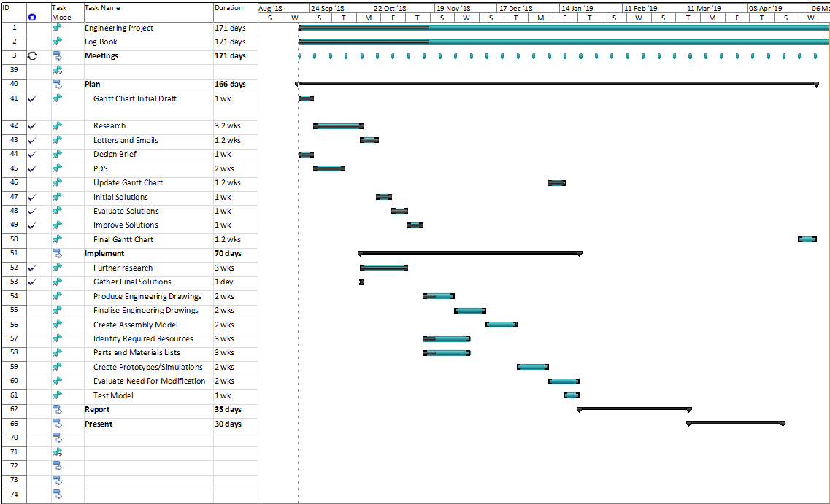
Figure 1: Lancastle, J. (2019) Gantt Chart 1 Engineering Project - Foldable Trailer. rep. Bridgend: Bridgend College pp. 13.
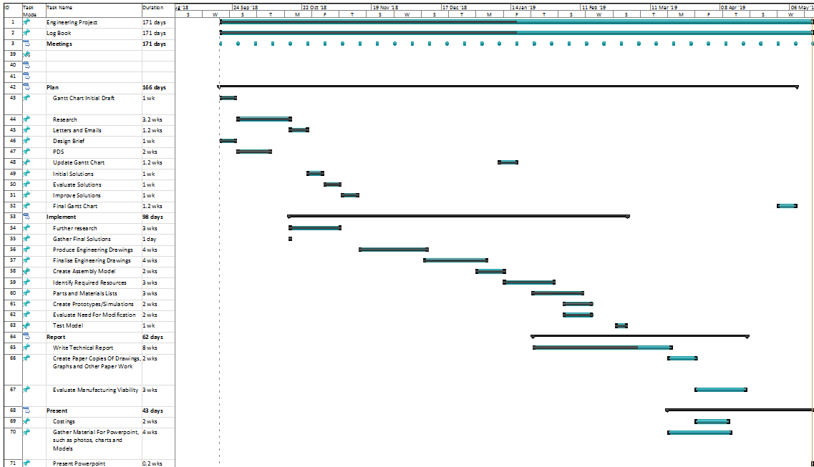
Figure 2: Lancastle, J. (2019) Gantt Chart 2 Engineering Project - Foldable Trailer. rep. Bridgend: Bridgend College pp. 14.
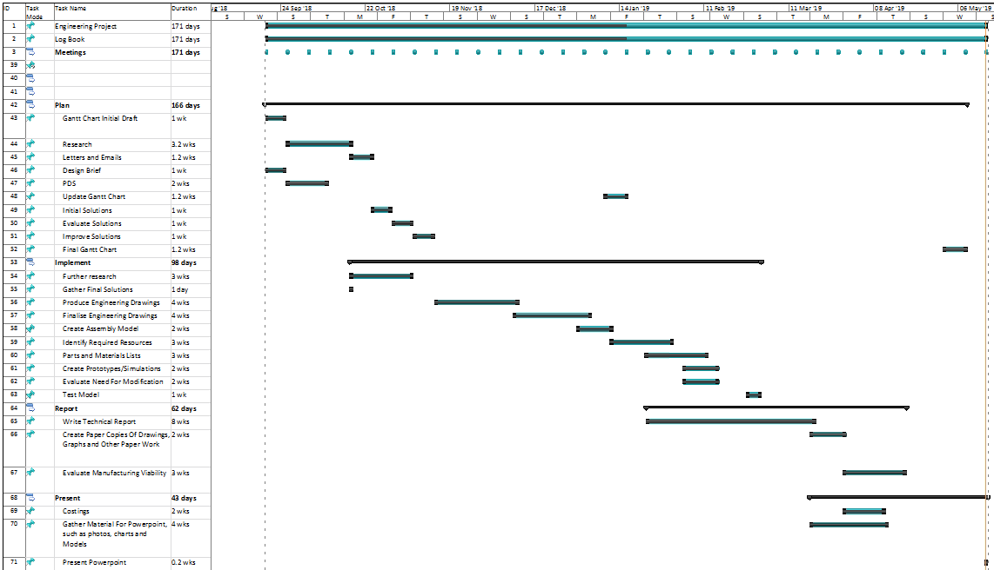
Figure 3: Lancastle, J. (2019) Gantt Chart 3 Engineering Project - Foldable Trailer. rep. Bridgend: Bridgend College pp. 15.

Product Design Specification

A Product Design Specification (PDS) was then conducted. The PDS is a concise method in which to identify the customer’s specific requirements, focusing on areas such as the material the product is constructed from, its dimensions, production methods, customer use, ergonomics, environmental implications, and legal requirements.
The PDS focuses on the realities of how to achieve the end-product from what the Design Brief stipulates. Geddes, D. (2022) states that a PDS “should be a clear list with detailed information outlining every aspect of the design brief and fulfil SMART criteria”; SMART being an acronym for Specific, Measurable, Achievable, Realistic, and Testable. This acronym was considered throughout the PDS process, as detailed in the extract from the original project PDS, shown below.

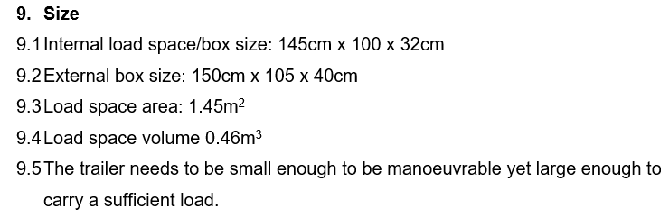
Figure 5: Lancastle, J. (2019) Engineering Project - Foldable Trailer. rep. Bridgend: Bridgend College pp. 20–21.

As per the report excerpt, the SMART criterion is adhered to throughout the PDS as was BS7373 guidance. BS7373 is guidance provided by the British Standards Institution that gives a more critical and methodical approach to developing a product or service by having a strong foundation early in the design stages, this ensures that performance and regulatory targets are achieved, that the target market is clearly identified, and the spiralling costs associated with not hitting these targets are known. Once a thorough PDS was completed, the next step was to translate into the form of initial designs.

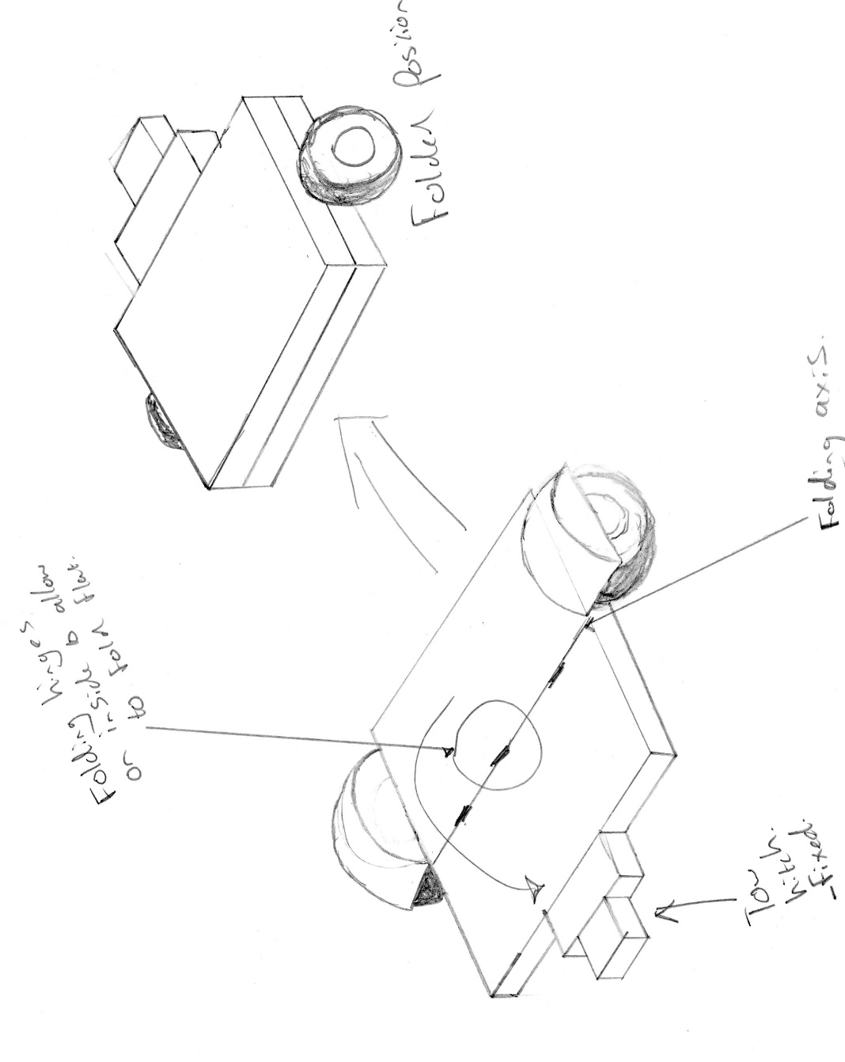
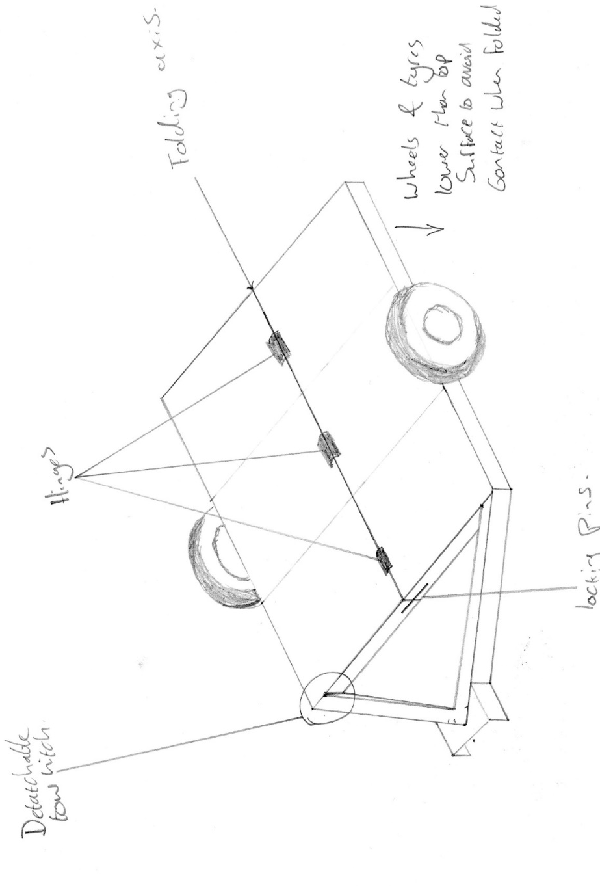
Figure 6: Lancastle, J. (2019) Solution 1: Engineering Project - Foldable Trailer. rep. Bridgend: Bridgend College pp. 30.
Figure 7: Lancastle, J. (2019) Solution 2: Engineering Project - Foldable Trailer. rep. Bridgend: Bridgend College pp. 31
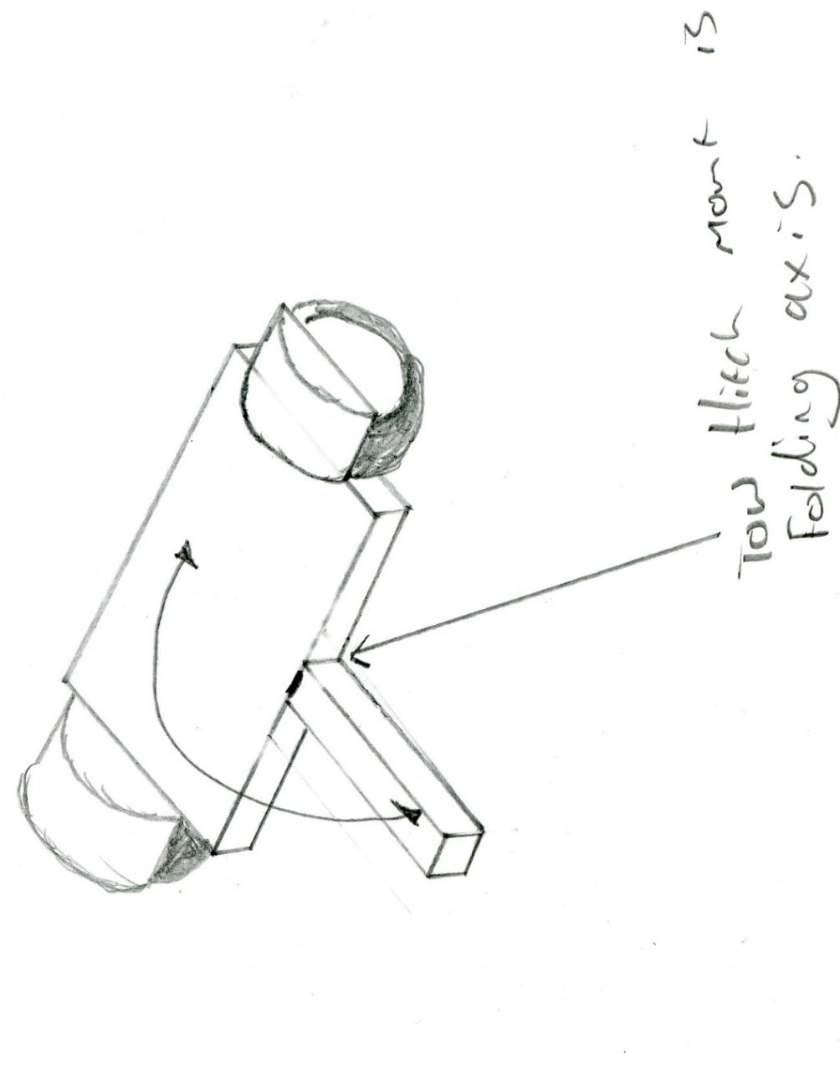
Figure 8: Lancastle, J. (2019) Solution 3: Engineering Project - Foldable Trailer. rep. Bridgend: Bridgend College pp. 32
The purpose of the initial designs was to identify what methods of folding would be used to collapse the trailer, how it would be orientated, and create a visualisation of each trailer based on the PDS, design brief and market research knowledge.
These designs were then evaluated against one another in the form of a Matrix Analysis (a relative scoring system with pre-defined criteria) to establish the most viable approach to proceed with.
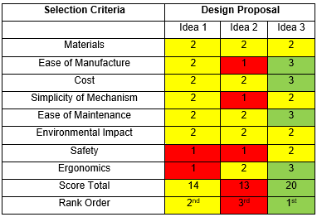
Figure 9: Lancastle, J. (2019) Matrix Analysis Engineering Project - Foldable Trailer. rep. Bridgend: Bridgend College pp. 33
From the Matrix Analysis table detailed in Fig 8, it is evident that Solution 3 prevailed as it was identified as superior to the other designs based on its score. The Materials and Environmental Impact Criteria are all equally scored. This is owed to the materials that are to be used would be similar across all three trailers.
Ease of Manufacture: as a result of the design challenges and reduced strength associated with including hinges in the assembly, extra measures would be incorporated into design one and two. Idea three was deemed the most suitable from the manufacturing viewpoint.
Regarding cost, the implications would be similar between each design. However, due to the additional components in the first two designs, solution three would be more cost effective.
The Simplicity of Mechanism criteria was scored equally for designs one and three. However, design two was marked down due to the additional demountable tow bar resulting from the different folding axis.
All three designs will require an element of preventative maintenance to ensure their longevity, although, trailer three is graded higher as the Ease of Maintenance would be increased due to the reduced number of hinges, likewise the same considerations apply from a safety viewpoint. Regarding ergonomics, trailer three would be less unwieldy than the other two in the collapsed position and scored higher as a result.
An element that is not included in the Analysis Selection Criteria is the strength of the folding mechanism. The simplicity of the mechanism has been identified, which typically is the strongest, however simplicity in the situation is from the ease of manufacture viewpoint. Due to the nature and uses of a trailer being exposed to public roads and weathering, it is going to be subject to continual cyclic loading and will be at risk of premature fatigue and has not been considered in this situation, which may have affected the outcome. Furthermore, it has not been identified if the Materials section refers to cost, weight or strength of the materials as these factors would potentially influence the scores.

Feasibility Study

Following the insights gained from the PDS, initial designs and the Matrix Analysis and subsequent evaluations, a clear choice was identified. A feasibility study was then undertaken. This follows a set procedure, establishing if the project has potential, referencing the following points: Executive Summary, Description of Product/Service, Technology Considerations, Project such as Technology considerations, Product/Service Marketplace, Marketing Strategy, the project Schedule, and Financial Projections.
The final point of any Feasibility Study is Findings and Recommendations, whilst considering the description of the product. This led to the original PDS and Design Brief being alluded to, which stipulated that the trailer could collapse in such a manner that it can be discretely stored at a customer’s home or garage and that the trailer should be robust enough to carry loads of up to 200kg.
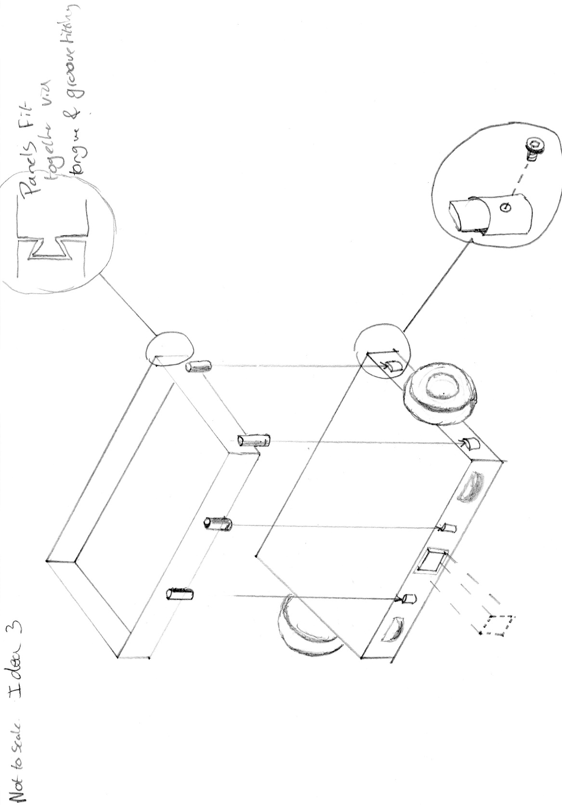
This led to concerns regarding the folding mechanism of the tow hitch and the difficulty manoeuvring the trailer. Some retrospective amendments were made to the design,. The tow hitch was redesigned, instead o folding it would retract back into the trailer body and be secured in position using steel locking pins. Furthermore, the trailer would be outfitted with castors to enable it to be tilted up onto its side and wheeled easily in confined spaces. The containment walls were designed to be fitted around the perimeter of the trailer. Thus, an initial final design was produced.
Figure 10: Lancastle, J. (2019) Engineering Project - Foldable Trailer. rep. Bridgend: Bridgend College pp. 39

Final Design

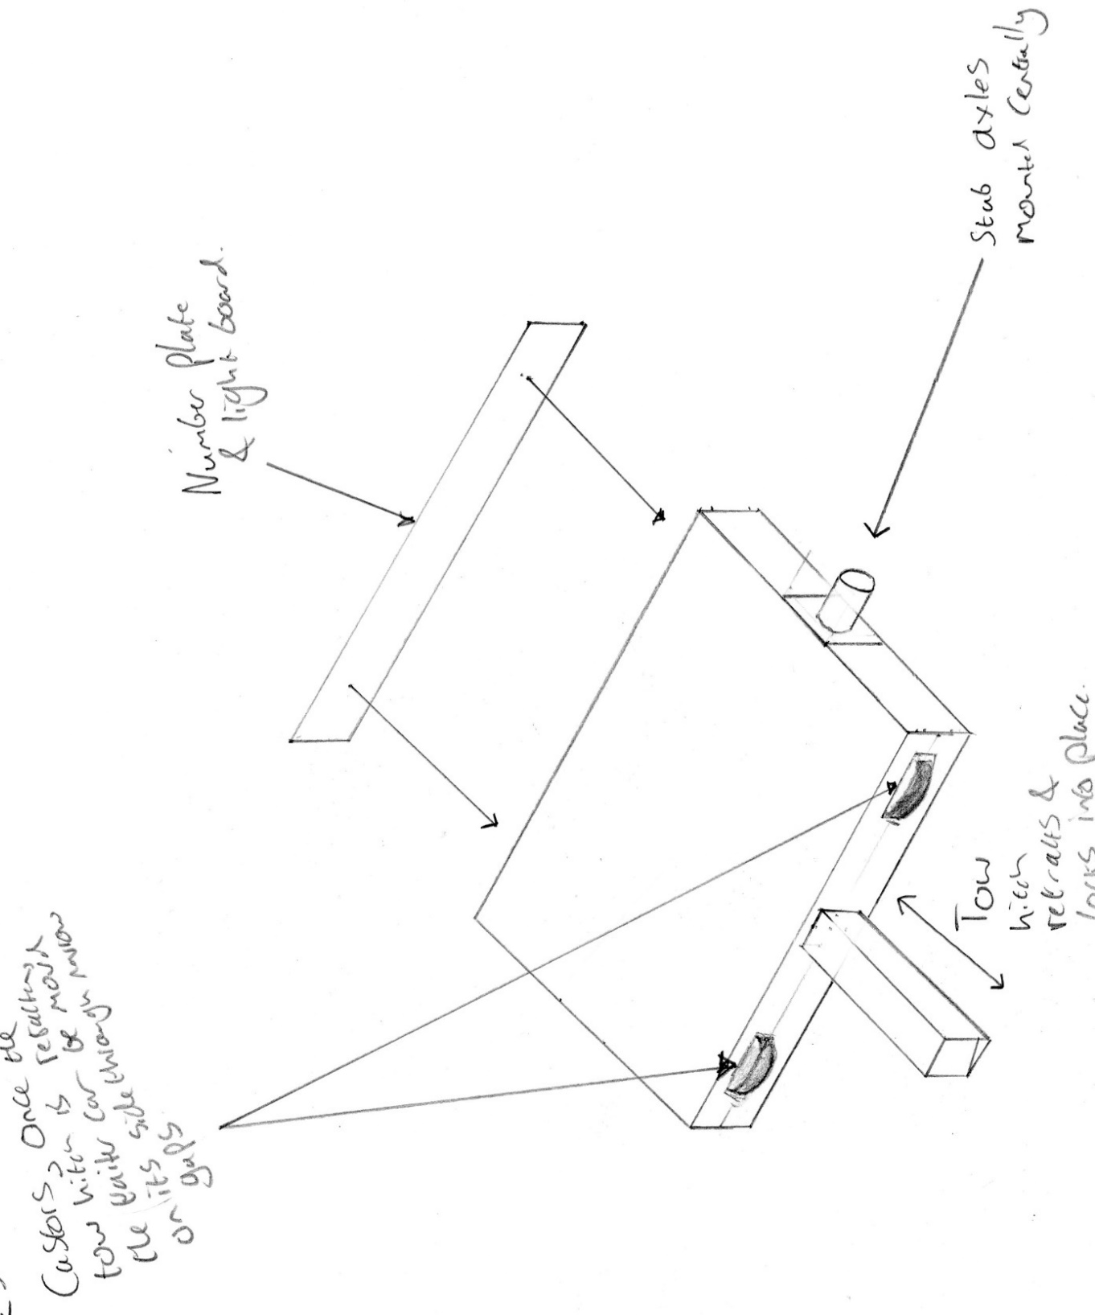
Sketching the final design prior to developing the design using CAD software highlighted some issues. One being that the wheels to manoeuvre the trailer in the upright position are on the same side as the tow hitch which would interfere with movement, so these have been relocated to the rear side, enabling the tow hitch, even in the retracted position, to be utilised as a form of handle.
Figure 11 : Lancastle, J. (2019) Engineering Project - Foldable Trailer. rep. Bridgend: Bridgend College pp. 40

CAD Drawings

Component Drawings

The final design stage was to design each component part from scratch. Some designs were newly created, such as in Fig 11, whereas others were parts purchased externally and to be used in the final trailer assembly, as at this stage, it was considered not to be efficient manufacture these parts. The remaining component parts can be found in Appendices A..
The CAD models that were created included individual component drawings, assembly drawings, and parts lists. The benefit of the individual part drawings and assembly drawings is that, when gathering costings for materials and parts, the information is conveniently curated.
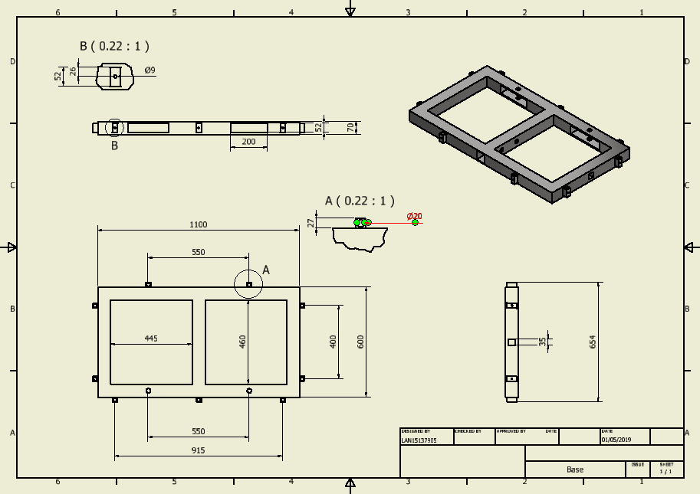
Figure 12: Lancastle, J. (2019) “Trailer Base” Engineering Project - Foldable Trailer. rep. Bridgend: Bridgend College pp. 43.

Assembly Drawings

The component drawings were compiled into assembly drawings and displayed in first angle orthographic projection. Standardised parts such as screws and nuts, were already in the Autodesk Inventor database and are accounted for in the final parts lists. There are two drawings, one in the assembled form ready for use with the vehicle and one dismantled for storage.
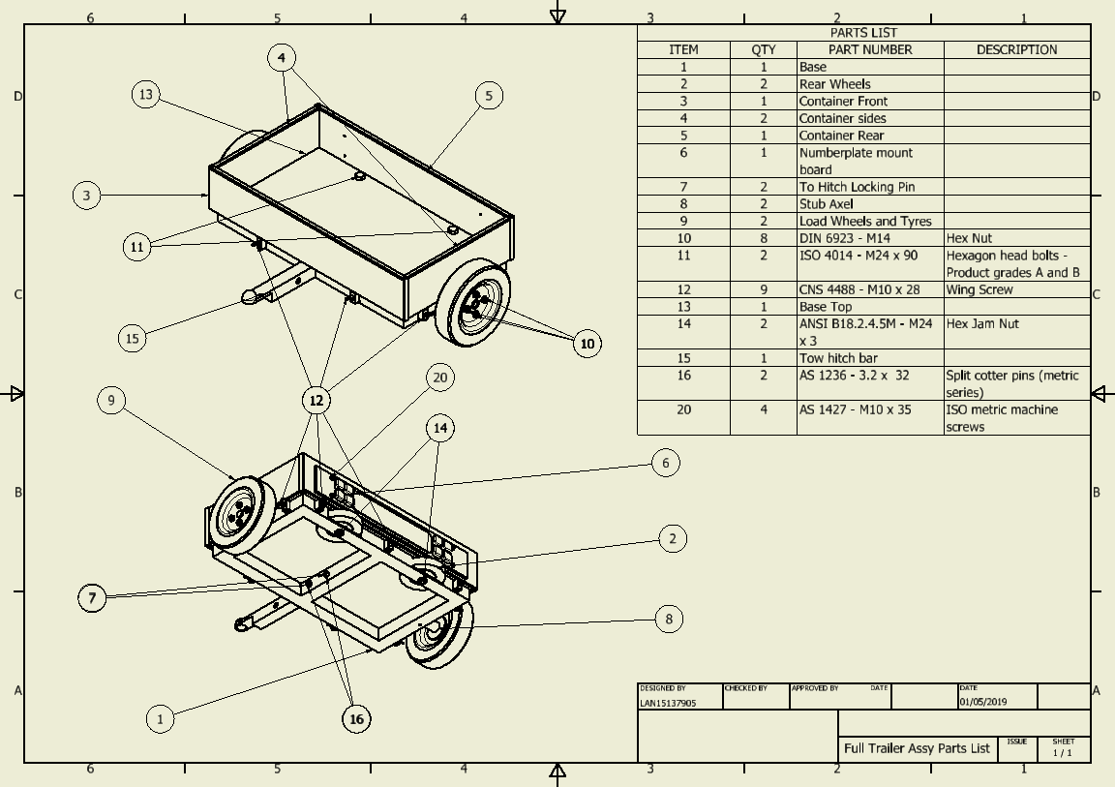
As per the customer requirements, the trailer can be dismantled without the use of tooling. To fulfil this purpose, the extendable tow hitch can be locked in its extended or retracted positions via use of two tow hitch locking pins, secured into position using split pins. This enables strengthening for use of towing in excess of what is required and additionally provides a failsafe should one fail whilst in use. Secondly, the side panels used for containing loads are secured into place using M10 wingnuts to further ensure there is no necessity to use tools. The dismantled version of the trailer can be observed in the differences between Fig 13 and Fig 14.
Figure 13: Lancastle, J. (2019) “Full Trailer Assy” Engineering Project - Foldable Trailer. rep. Bridgend: Bridgend College pp. 58.

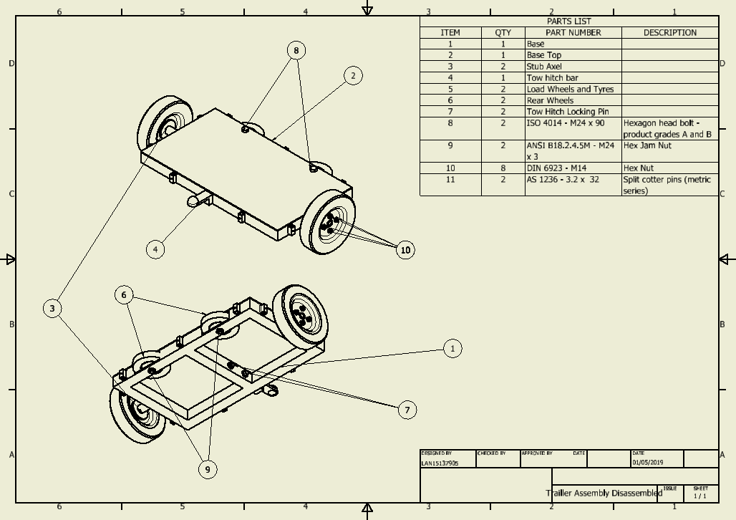
Figure 14: Lancastle, J. (2019) “Trailer Assembly Dismantled” Engineering Project - Foldable Trailer. rep. Bridgend: Bridgend College pp. 5.

Production Costs

The production costs were generated by itemising production into three categories: material cost, labour costs, and tool costs. The cost of raw materials and purchased parts were calculated per single trailer, which output £720.91. This was combined with an estimated time taken for welding, machining, and assembly and multiplied by the average hourly cost of these employees. These hourly costs were sourced from Pay & salary | Indeed.com UK (2019) and totalled £272.81. Finally, the cumulative cost of all tooling and consumables amounted to £2766.87, the high price is due to the cost of expensive tooling such as welders and machine tools totalling £993.72.
The retail cost of the trailer would be in the region of £1495 which ensures a competitive price for the market average resulting in a profit margin £501.28, or 33.53%. The initial outlay of tooling would require the sale of six trailers to break even. The initial high production cost and diminished earnings are a result of the manufacturing in small batches, as a result of the economy of scale, as the production gets more efficient profits would increase or costs to the consumer would be reduced. Production time could be reduced by investing in machinery that could improve process speed, such as jigs to ensure the welding of the box section frame are accurate, repeatable and faster to align. Vacuum forming processes could be adopted for the trailer enclosure walls. This would increase speed of manufacture and reduce material cost, price of purchasing sheet metal and welding. CNC machining of parts creates reduced machine interaction time and an additional saving is from the reduced TAKT time for employee interaction thus reducing labour charges. This combination of cost saving methods represents a significant investment and would only be perpetuated by the demand for the product, otherwise the outlay would not be financially viable.

Secondary PDS

The purpose of the secondary PDS is to compare the methods originally considered to achieve the complete assembly based on the Design Brief and create a comparative PDS, based on the methods adopted in the manufacture of the trailer and to see how far they aligned. A multitude of vast differences between the tow PDS’ would be indicative of poor planning and execution of the project.
Overall, this outlined the project was a success, however, as with any theoretical project that didn’t end up with a manufactured product, there was concerns that were derived from the lack of real world, functional testing. Areas such a cyclic loading and corrosion of parts affecting the longevity of the trailer. Further concerns were in the regulatory, legislative and legal area. Due to the nature of the product, being used on public roads would require some form of testing for it to be ascertained as roadworthy.

Communicating the Project
All of those who were involved in the project had scheduled weekly meetings to ensure that everything was running smoothly and provided an opportunity to gather ideas and concerns and put them into practice and rectify them at the source.
Upon completion of the project, it is a requirement to present the findings gathered to justify the project and its viability as a production assembly. This communication came in two forms, a project report and a summarised presentation.
The project report contained information akin to what has been referenced throughout the Production Detail section of this report. Similarly, this report included the overall aims and objectives of the project, evidence and calculations of budget implications, its estimated timeline and the expected production readiness date. However, the Project Report contained further detail for relevant individuals observing the report to aid arriving at their conclusions.
The presentation was for the relevant members to establish if the project, on face value, is viable. This is a summarised overview of the project, presenting the process and the product to the evaluators. Explanations of why the project was conducted originally, how the customer’s criteria was achieved and how to do this in a revenue generated and time efficient manner.

Analysis and Evaluation of the Project

The aim of the project evaluation is to reflect upon the product design and development of the project to analyse its efficacy as a project based on knowledge from experience gained in real world manufacturing environments. The expectation of the evaluation is to highlight potential flaws in the project planning and design outcome and to provide developmental opportunities for those involved.

Evaluation of Models Using Computer Aided Design

To reiterate the legislation stipulated by the DLVA (2022), the overall weight of the trailer combined with its load cannot exceed 750kg whilst simultaneously remaining under 3.5 metric tonnes. Whilst the original project was being conducted, the calculation of these weights was assumed to be within specification, revealing a potential flaw in the entire project. If this trailer was overweight whilst carrying its 200Kg allowable cargo, it would be not suitable for road use and therefore not fit for purpose.
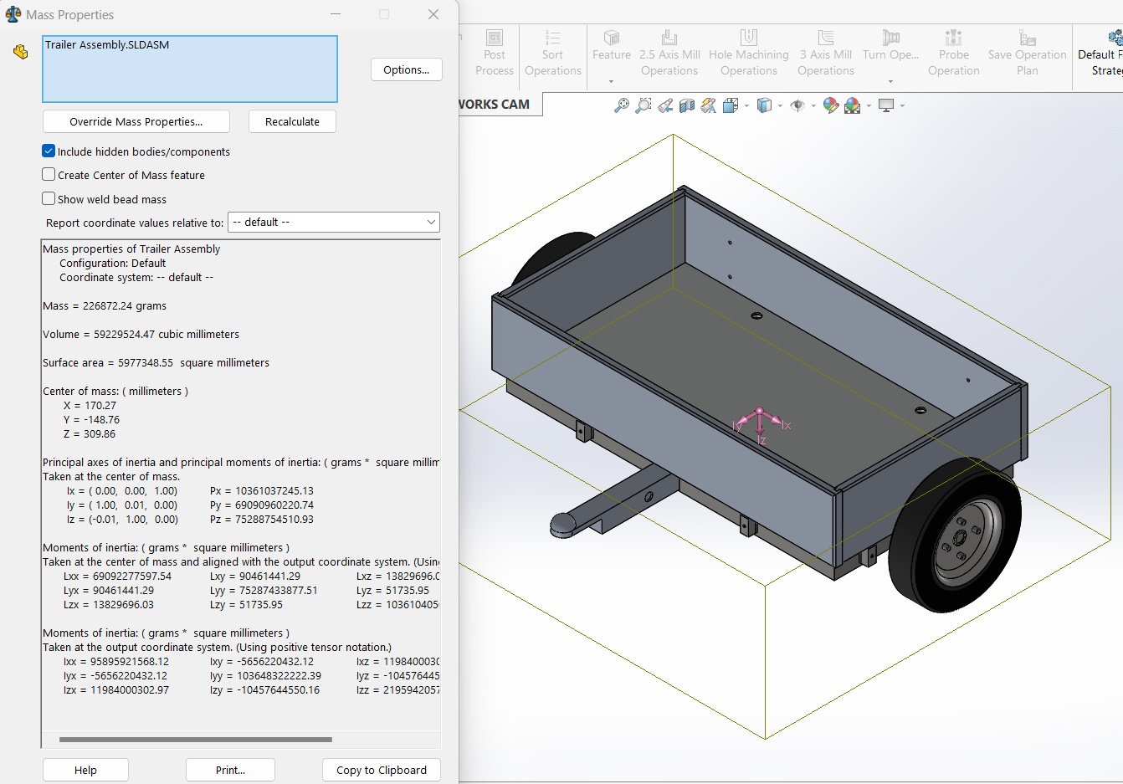
Figure 15: Generated Weight of Full Trailer Assembly

The design software Solid Works was employed to calculate an estimated mass based on the dimensions and materials used in the trailer assembly. The calculated weight of the assembly was extracted from the software and arrived at 226.872 kg as per Fig 15. This combined with the 200 kg load would not exceed the 750 kg gross trailer weight outlined by the DVLA.
The hubs and wheels were not attached to the final assembly for testing due to issues that arose when trying to apply loads to the wheels combined with the downward force of the theoretical maximum 200Kg load added too many interactions in the overall assembly for any available PCs to have the available computing power to complete the analysis.
To continue testing, it was established that, as the stub axles and main load wheels were items purchased externally, they would be of the load carrying capacity and strength advertised and would not be wholly relevant to the experiment. The element of focus was the trailer tow hitch, so the applied load was added as an upward force through the stub axel mount recesses in the main chassis of the model, allowing for the experimentation to continue.
The most notable point of weakness is of the extendable tow-hitch bar assembly. More specifically it was of particular interest how the assembly made up of 60 mm x 60 mm x 5mm wall box section aluminium would fair against the continuous weathering and cyclic loading and potential fatigue failures resulting from these factors.
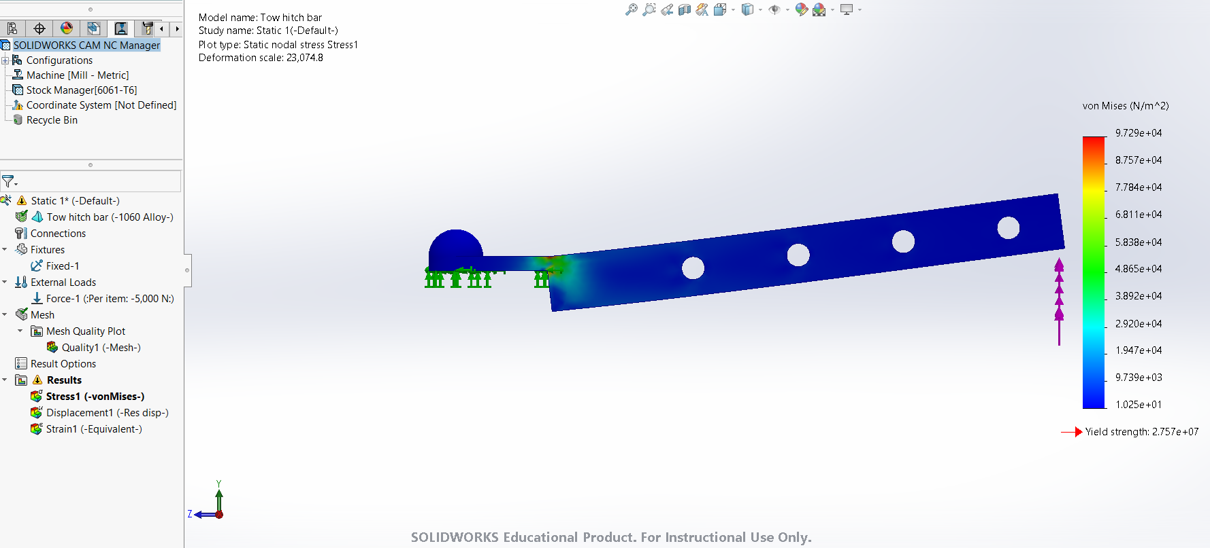
Initially, the tow hitch bar was tested to observe any weak areas prior to running time consuming fatigue analysis. This highlighted an inherent weak spot with the trailer tow hitch mount, as in Figure 16 where it adjoins to the bar, it plastically deforms with relative ease. In the original project, this design was illustrative only, so a similar tow hitch was designed and added to the testing.
Figure 16: Tow Hitch Strength Testing

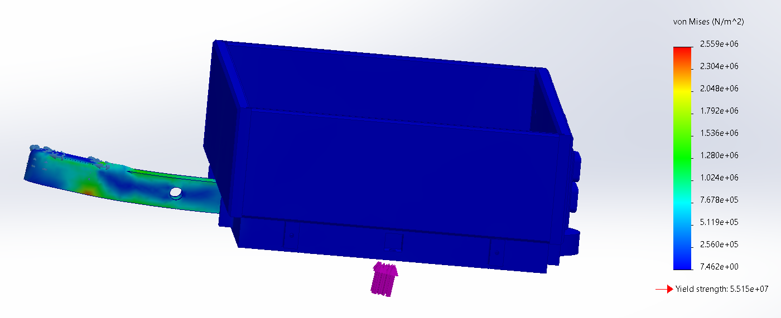
Figure 17: Redesigned Tow Hitch Strength
Figure 17 displayed the result of the redesigned tow hitch, showing a deformation result that would be expected with the entire bar deforming universally, however this result is a visualisation only, and not indicative of real-world usage conditions.
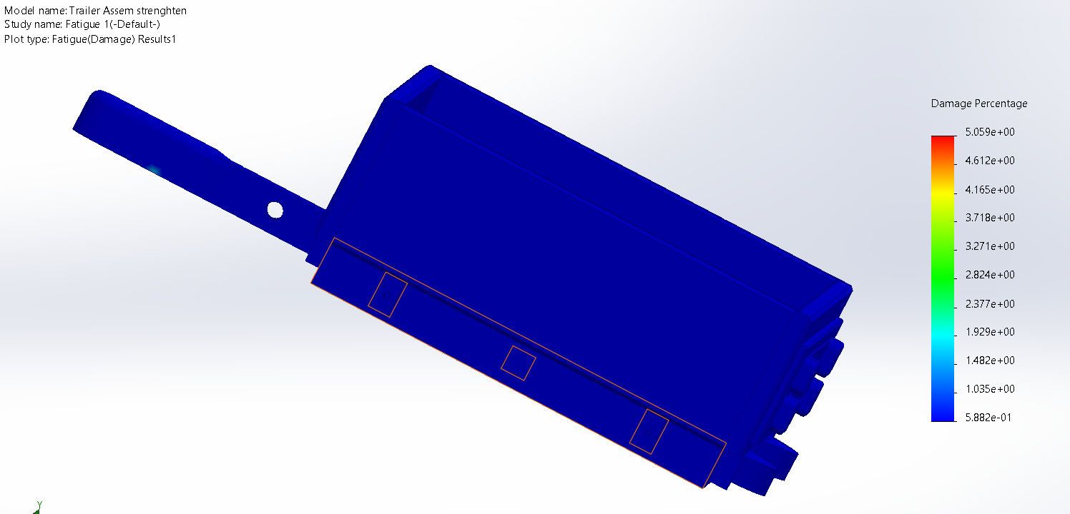
For more realistic results, a fatigue study was conducted. According to Facchinetti (2015), referring to automotive chassis parts, “this model is supposed to hold from 10⁴ up to 10⁶ cycles”. This figure range is corroborated by Tartaglia (2023) who explains that High Cycle Fatigue (HCF) such as this, is especially relevant for automotive applications. This information outlined parameters that could be used for the fatigue testing. The number of cycles was set to 100,000, the lower end estimate. Should the software exceed this parameter, it will continue until theoretical failure. The load type applied to the assembly was zero based, meaning that the load was pushed up at the same point vertically against the trailer then released to the set number of cycles, as to be as similar as possible to normal road going situations.
Figure 18: Fatigue Testing of Trailer Assembly 1

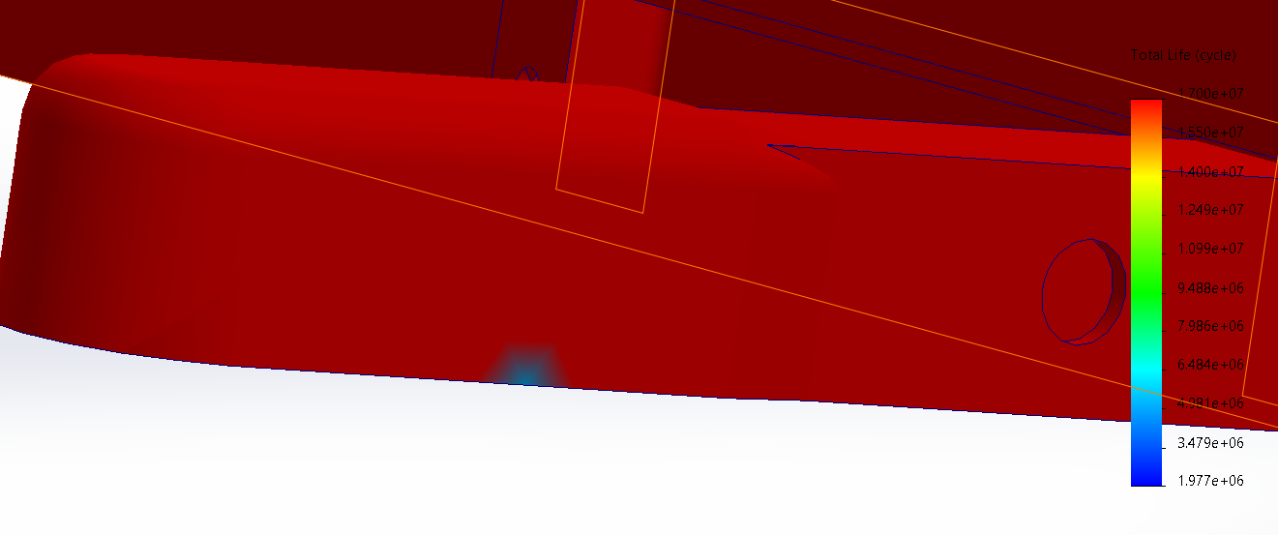
Figure 19: Fatigue Analysis Load Spot
The results fatigue study has shown that the trailer is robust enough to endure cyclic loading associated with standard road use, with the addition of the 200 kg required payload. The results show that, at the weakest point where the tow hitch meets the tow bar illustrated in the cyclic loading figure, fatigue crack propagation can occur at 1.977x10⁶ cycles. This is in excess of what was required for automotive purposes.
The sources cited that, regarding the number of cyclic loads automotive components should be able to receive without failing, are referencing automobiles, not trailers. Given that the trailer is unlikely to be in use for the same amount of time as a car, the number of cycles is far in excess of what is required, leading to questions that the trailer is overengineered and has strength levels unnecessary for its application. The use of aluminium was considered due to the lighter weight compared to steel and the environmentally friendly prerequisite of the Design Brief. The lighter weight would yield greater fuel efficiency when in transport, furthermore, another condition of the design brief was for the trailer to be manoeuvrable, which a lightweight aluminium construction would satisfy.
As a result of conducting the fatigue analysis, the cost of the trailer could be reduced by reducing the cross-sectional area of the box section used for the chassis, or by using a cheaper grade of aluminium for its construction, increasing the profit margins. Had this methodology been employed in the original project, the revenue and expenditure figures would have been more accurate, thus making the project more viable. The addition of CAD model testing ensures that the design is fit for purpose, ensuring confidence in the product. However, due to the time constraints of the original project as evident in the Gantt charts, this additional time constraint may not have been feasible.

Accuracy of Production Costs

The production costs of the trailer, as detailed in the project, shows a profit margin of £501.28 or 33.53%. Upon further analysation, this figure may not be accurate due to omissions now visible upon revisiting the project.
The principles of Design for Manufacture and Assembly, a methodology coined by Boothroyd et al. (2013), were employed in the design of the assembly. This was largely attributed to the Design Brief stipulating that the requirements for the trailer are to be light, portable and collapsible, and that the use of tools should be kept to a minimum for dismantling the assembly, lend itself well to the DFMA process.
Using the Boothroyd & Dewhurst Assembly Time Estimation Technique, the scoring charts detailed in Appendix B, a tool traditionally used for analysing an assembly in the early design stage will be used retrospectively to evaluate if the assembly time allocated in the project was accurate. To use this model, certain data was required to be gathered about each component, including the Alpha Symmetry, Beta Symmetry, thickness, size, and weight of the components, which were generated and extracted from CAD software, calculations visible in Appendix B.
The project estimation was that assembly time would average 1.5 hours using Boothroyd and Dewhurst’s method; the outcome generated a figure of circa 5 minutes. The vast differences between the figures can be attributed the lack of consideration of the human component in Boothroyd and Dewhurst’s model. It does not account for any stoppage such as comfort breaks, it only outlines the leanest form of assembly.
This does not mean this model is without its benefits. Whilst calculating the outcomes of assembly time using the model as detailed Figure 21, it highlights any activities that can be made leaner. For example, the rear numberplate board, to mount it to the rear containment requires: “holding down during subsequent processes to maintain orientation” (Boothroyd, G. and Dewhurst, P., 1989). This results in an increased time attributed to this task. Had this method been conducted during the initial design process, a feature would have been designed to support this fixture in place. Another possibility would be to assemble the two parts together whilst led down and not attached to the main trailer assembly.
Furthermore, this model highlights that the fixation of 16-wheel nuts to the trailer represents the most significant assembly time investment, where using single nut fixture wheels would reduce this assembly time. With the potential redesigns, it would be necessary to evaluate which had the greater time saving to establish the best course of action.

Using the integrated systems on the available CAD software, Solid Works, it is possible to calculate the total welding time and machining times by applying features to the components. Figure 22 and Fig 23 highlight the methods used for machining. Fig 24 illustrates the software generating its own tool paths for the most efficient turning of the tow hitch pins, whereas the software couldn’t complete this box section material in Fig 23 as it would assume the entire assembly was billet aluminium. To do this, the holes in the tow hitch that receive the pins were manually taught using the most time effective orientations, methods, directions and tool paths.

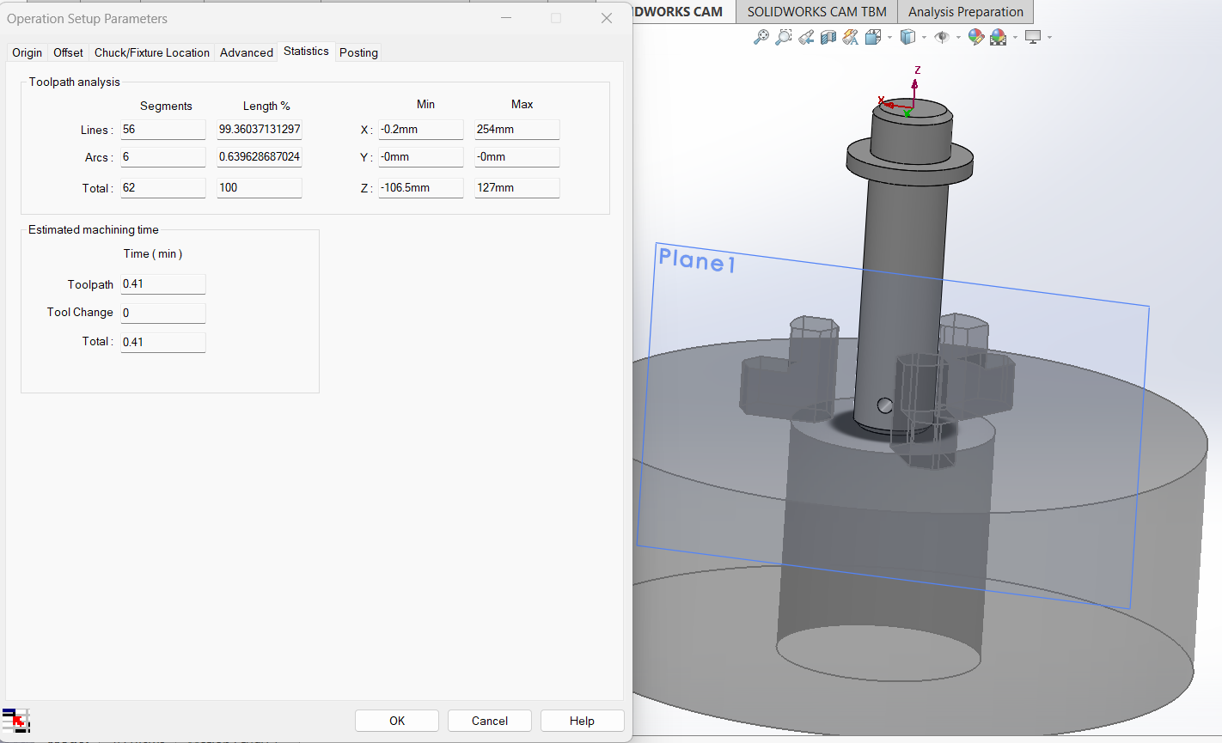
Figure 22: Software Generated Machining

Using the tow hitch assembly as an example, the weld time was estimated using the calculation methods’ inbuilt the software. A welding path had to be outlined where practicable, a continuous bead was used to ensure proper adhesion between the welded components and to aid process speed.
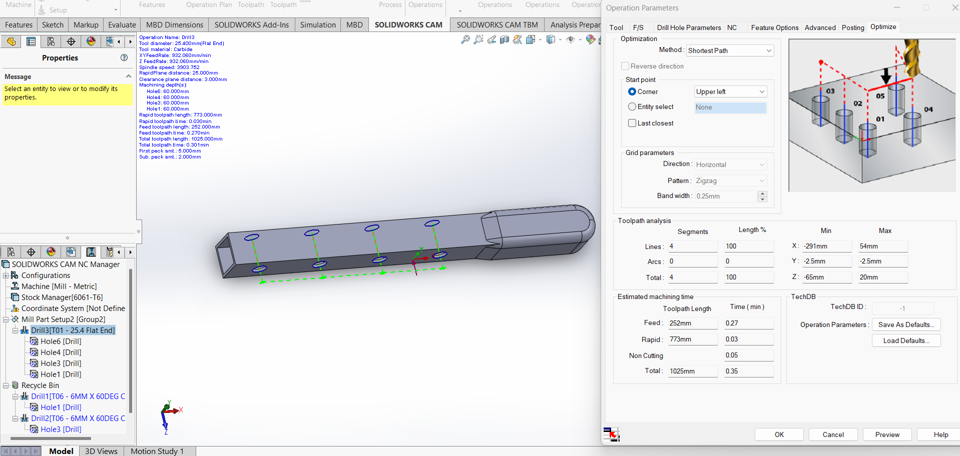
Figure 23: Taught Machining Paths

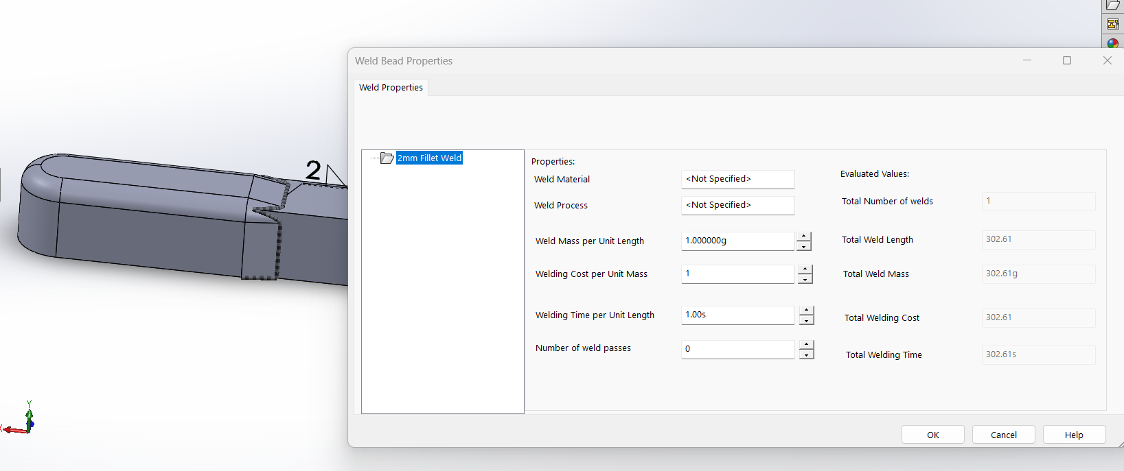

Figure 24: Taught Welding Paths

The same methodology was employed for each part in the assembly and the output times were gathered. The welding and machining time total was 15255 and 1766 seconds, respectively. These figures combined with the calculated assembly time outputs.
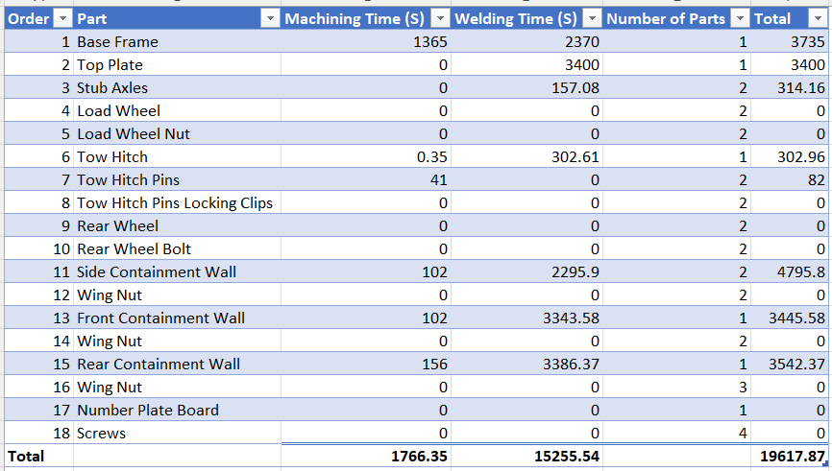
Figure 25: Welding and Machining Operations Timings

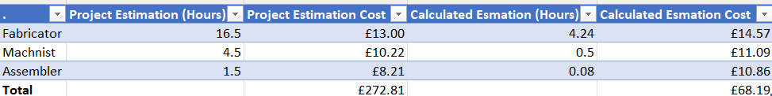
Figure 26: Employee Cost Calculations

The same source for gathering the average wage for each role was used via Pay & salary | Indeed.com UK (2023). Despite the wage increase, overall, based on the calculated estimations, the labour rates are much cheaper which creates a more attractive prospect as a manufacturing opportunity. When presenting the project, the addition of data driven metrics strengthens the project proposal validity and its acceptance to be put into production is increased as a result.
Another notable factor regarding errors in the development of production costs is the omission large overheads such as business rates, power, rent, insurance etc, so the project estimated profit margin of 33% is inflated. However, this figure cannot be attained in a theoretical project as the price per square meter would be generated from a physical premises

Conclusion

Despite the relative lack of project planning knowledge at the time of the project creation, it was successful by definition of its own criteria. The trailer performed as it should, met the customer requirements and was completed within the timeframe allotted.
However, as is evident with the project evaluation, there are flaws with the project and it seems much of successes were down to chance. Using CAD software to observe how the trailer would act under certain conditions and its resultant failures in its tow hitch, prior to redesign and the remaining components of the trailer strength levels in excess of its requirement, perpetuates this point as the design could have been made more cost efficient and safer had these tests been run initially.
Furthermore, the wild inaccuracies between the estimated labour costs in the original project and the calculated labour fees conducted in this project report and the omission of any consideration of relevant overheads that might be incurred as part of the project again show a lack of introspective thought regarding the project realities.
Realities such as when designing for manufacture, the outcome needs to be as robust as possible as any failures of parts or inaccuracies of costings will result in a failed product once it reaches the assembly line.
Had there been more opportunity for evaluation of the project, limited by wordcount, it is likely more errors and strengths could have been established. However, the detail to evaluate so few points was potentially a poor judgement call and more rounded evaluation of fewer points would have been preferable and more beneficial for the purposes of the project review.

References
Boothroyd, G. and Dewhurst, P. (1989) Product Design for Assembly. Wakefield, RI: Boothroyd Dewhurst.
Boothroyd, G., Dewhurst, P. and Knight, W.A. (2013) Product design for manufacture and assembly. Boca Raton, Fl: CRC Press.
Bridges, J. (2023) What is a feasibility study? how to conduct one for your project, ProjectManager. Available at: https://www.projectmanager.com/training/how-to-conduct-a-feasibility-study (Accessed: 24 May 2023).
Concept selection using matrix analysis - businessgrowthhub.com (2020) Concept Selection using Matrix Analysis. Available at: https://www.businessgrowthhub.com/media/1067895/concept-selection-using-matrix-analysis.pdf (Accessed: 21 May 2023).
Desmond L. Cook (1966), Program Evaluation and Review Technique. p. 12
DVLA (2022) Requirements for towing trailers in Great Britain. London: Department for Transport.
Eppinger, S.D. et al. (2002) 15.783j / 2.739J / ESD.32J Product Design and Development, spring 2002, 15.783J / 2.739J / ESD.32J Product Design and Development, Spring 2002. Available at: https://dspace.mit.edu/handle/1721.1/34891 (Accessed: 01 May 2023).
FACCHINETTI, M.L. (2015) Fatigue tests for automotive design: optimization of the test protocol and improvement of the fatigue strength parameters estimation. Amsterdam, Netherlands: Elsevier Ltd.
Geddes, D. (2022) What is a product design specification (PDS)?, Technical Foam Services. Available at: https://technicalfoamservices.co.uk/blog/what-is-a-product-design-specification-pds/#:~:text=A%20product%20design%20specification%20(PDS)%20is%20a%20document%20that%20contains,new%20product%20must%20adhere%20to. (Accessed: 11 April 2023).
Huang, G.Q. (2012) Design for X: Concurrent engineering imperatives. Dordrecht: Springer-Science+Business Media, B.V.
Kashyzadeh , K.R. and Farrahi, G.H. (2023) Engineering Failure Analysis Vol 143. Amsterdam, Netherlands: elsevier.
Kenton, W. (2023) Variable cost: What it is and how to calculate it, Investopedia. Available at: https://www.investopedia.com/terms/v/variablecost.asp (Accessed: 24 May 2023).
Lancastle, J.G. (2019) Engineering Project - Foldable Trailer. rep. Bridgend: Bridgend College.
McMenamin, E. (2016) ‘The Future of Fatigue Testing’, https://www.qualitymag.com, 1 November. Available at: https://www.qualitymag.com/articles/93664-the-future-of-fatigue-testing (Accessed: 24 May 2023).
Pay & salary | Indeed.com UK (2019) Indeed Pay & Salary. Available at: https://uk.indeed.com/career-advice/pay-salary (Accessed: 08 May 2019).
Pugh, S., Clausing, D. and Andrade, R. (1998) Creating innovative products using total design: The living legacy of stuart pugh. Reading, Massachusetts: Addison-Wesley.
Strzelecki, P., Correia, J.A. and Sempruch, J. (2021) Estimation of fatigue S-N curves for aluminium based on tensile strength – proposed method. rep. Bydgoszcz, Poland: UTP, pp. 1–8.
Syahrom, Dr.A. (2011) Concept Selection. rep. Skudi, Johor: Universiti Teknologi Malaysia, pp. 1–27.
Tartaglia, Dr.J. (2023) ARTICLE Fatigue Testing in the Automotive Industry, https://www.element.com/. Available at: https://www.element.com/nucleus/2016/fatigue-testing-in-the-automotive-industry (Accessed: 01 May 2023).
Website designed and developed by Zarr - https://www.zarr.com (2023) Metal Fatigue Analysis in Solidworks 3D CAD Design, Metal Fatigue Analysis in SOLIDWORKS 3D CAD Design. Available at: https://www.solidsolutions.co.uk/solidworks/simulation/features/metal-fatigue.aspx (Accessed: 24 May 2023).

Appendices

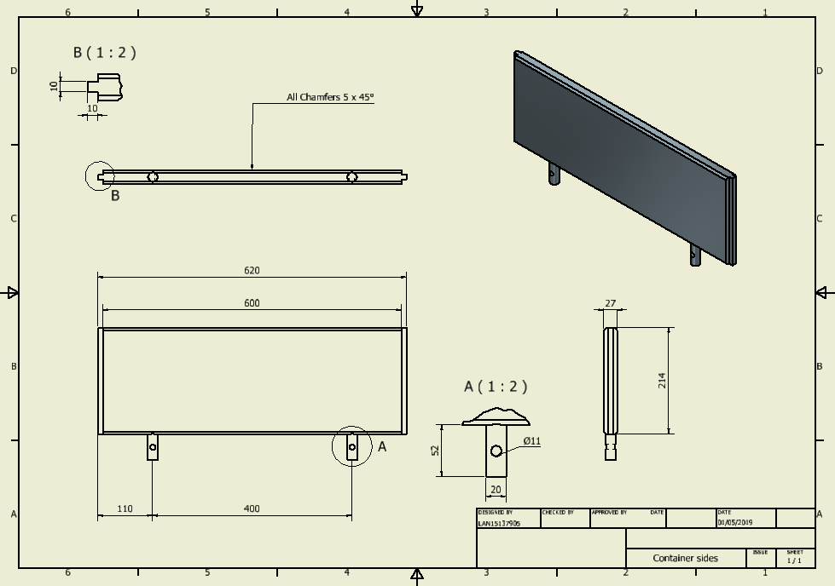
Appendix A
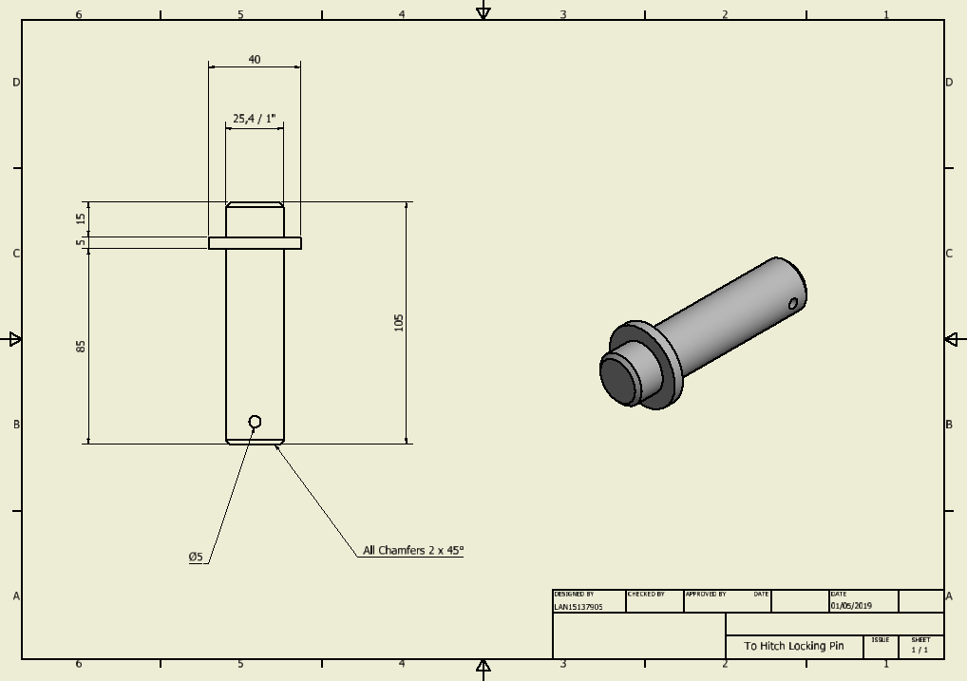

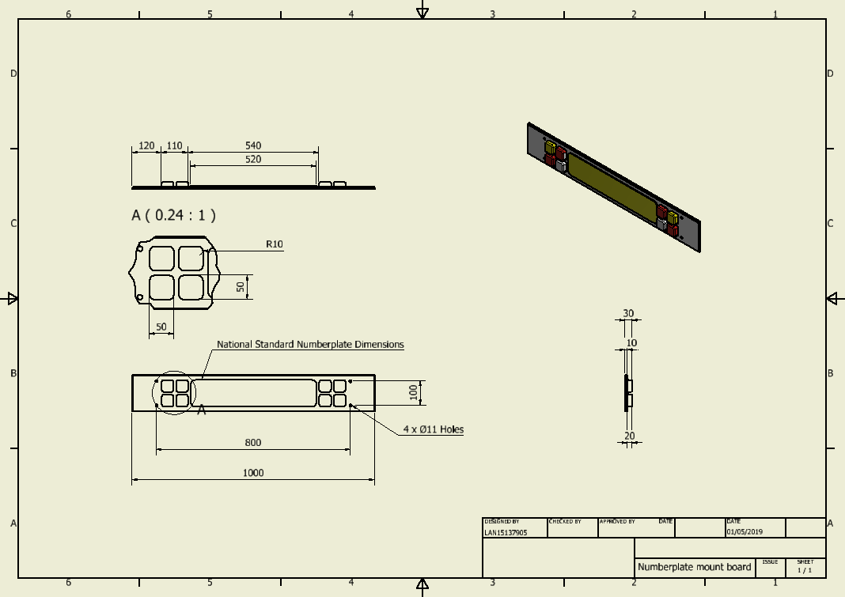
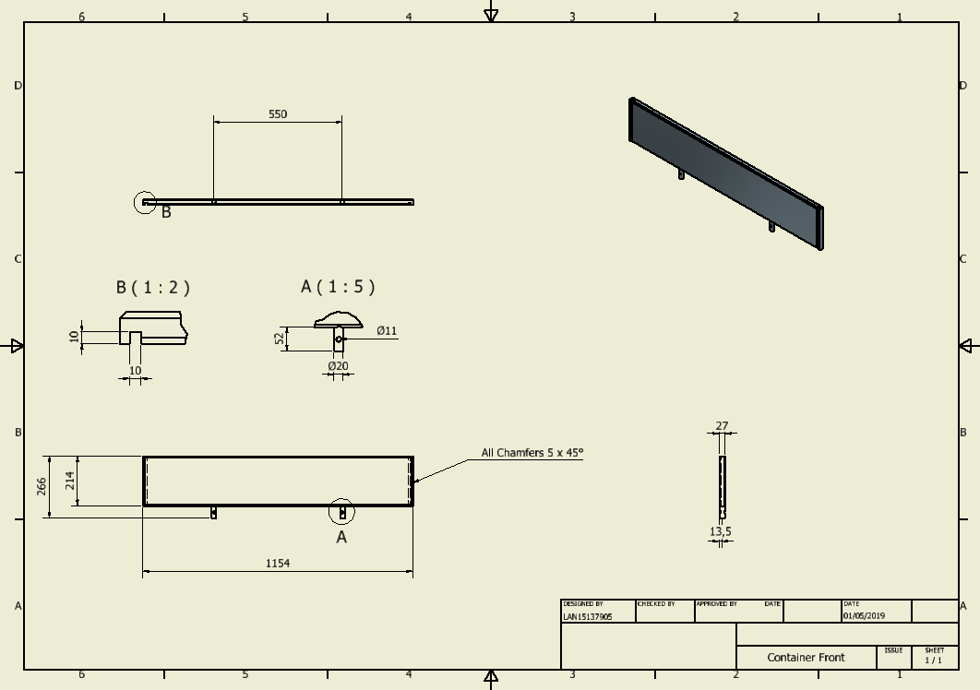
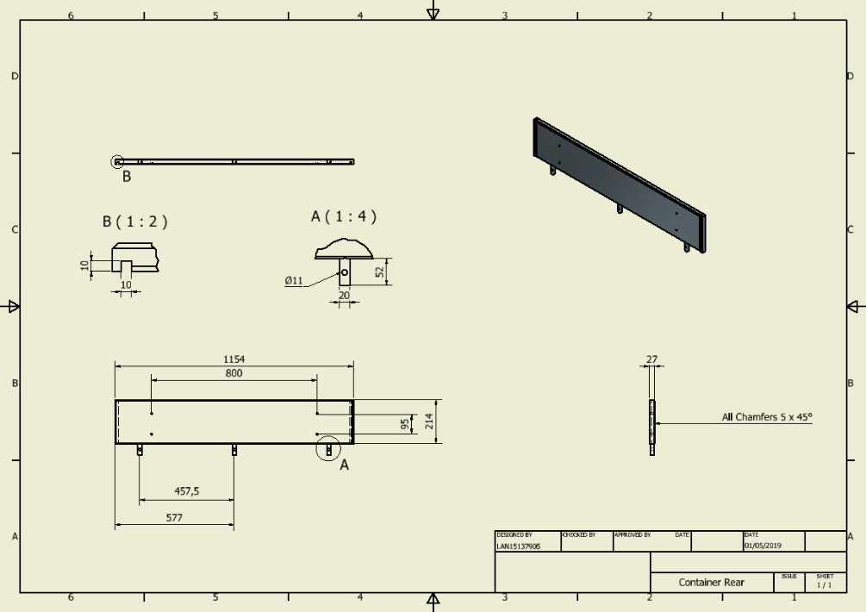
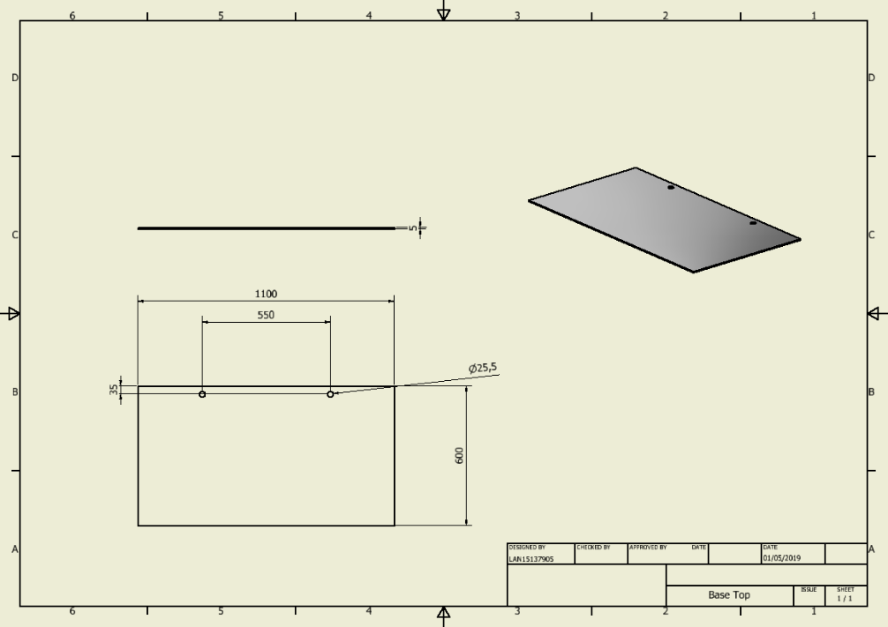
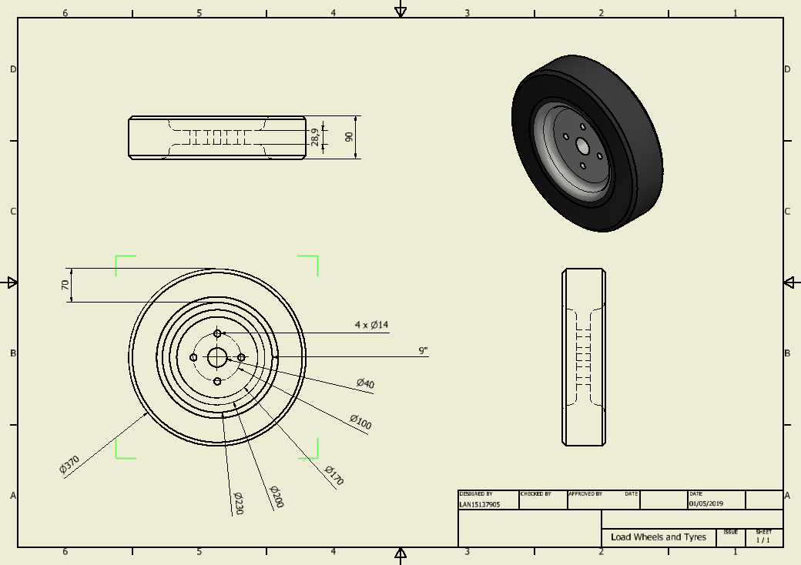
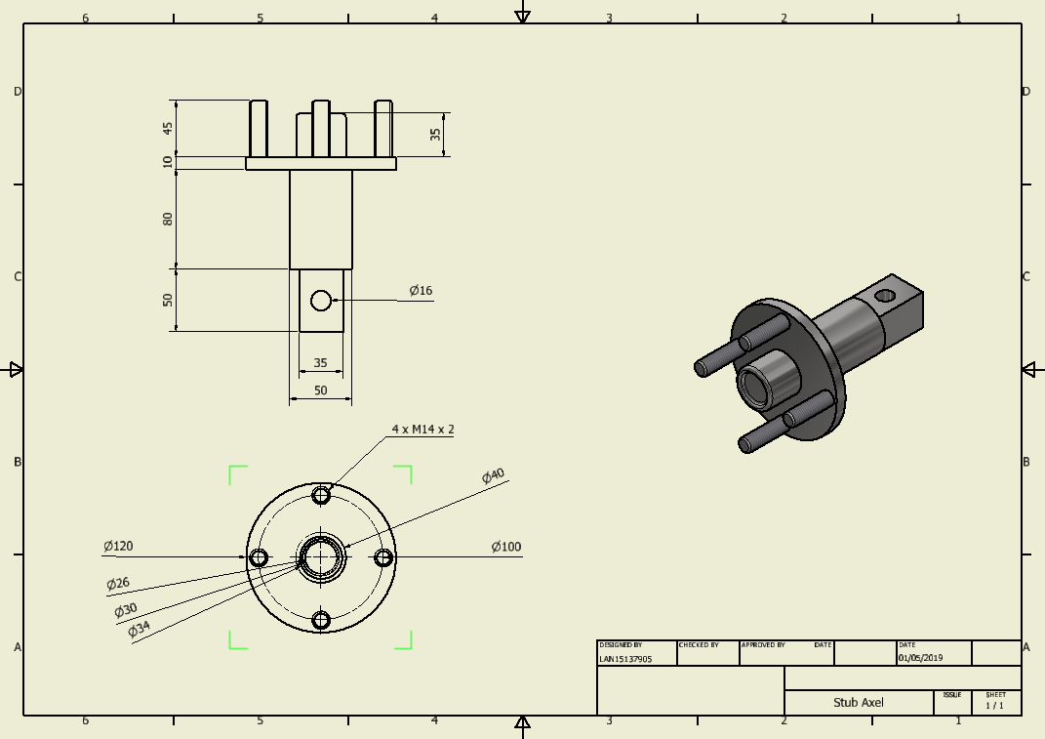
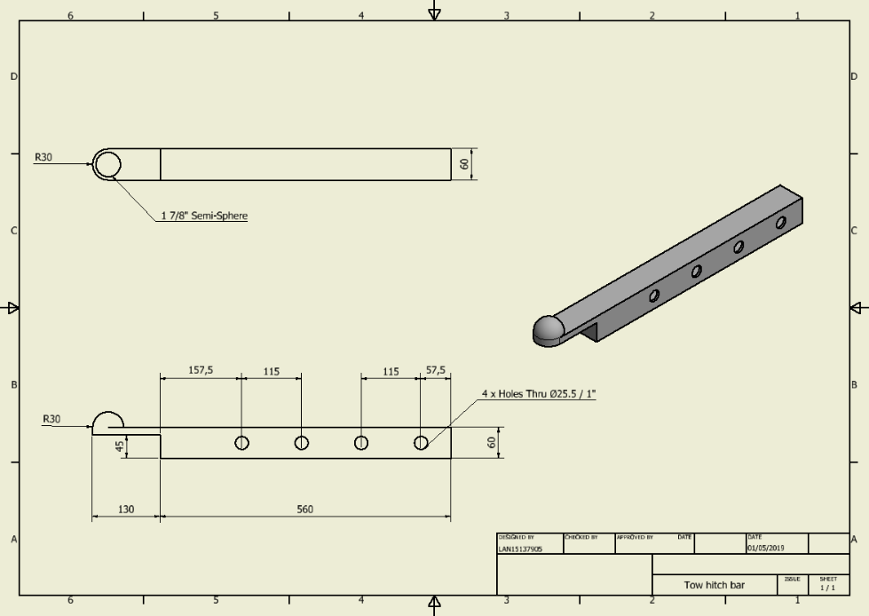
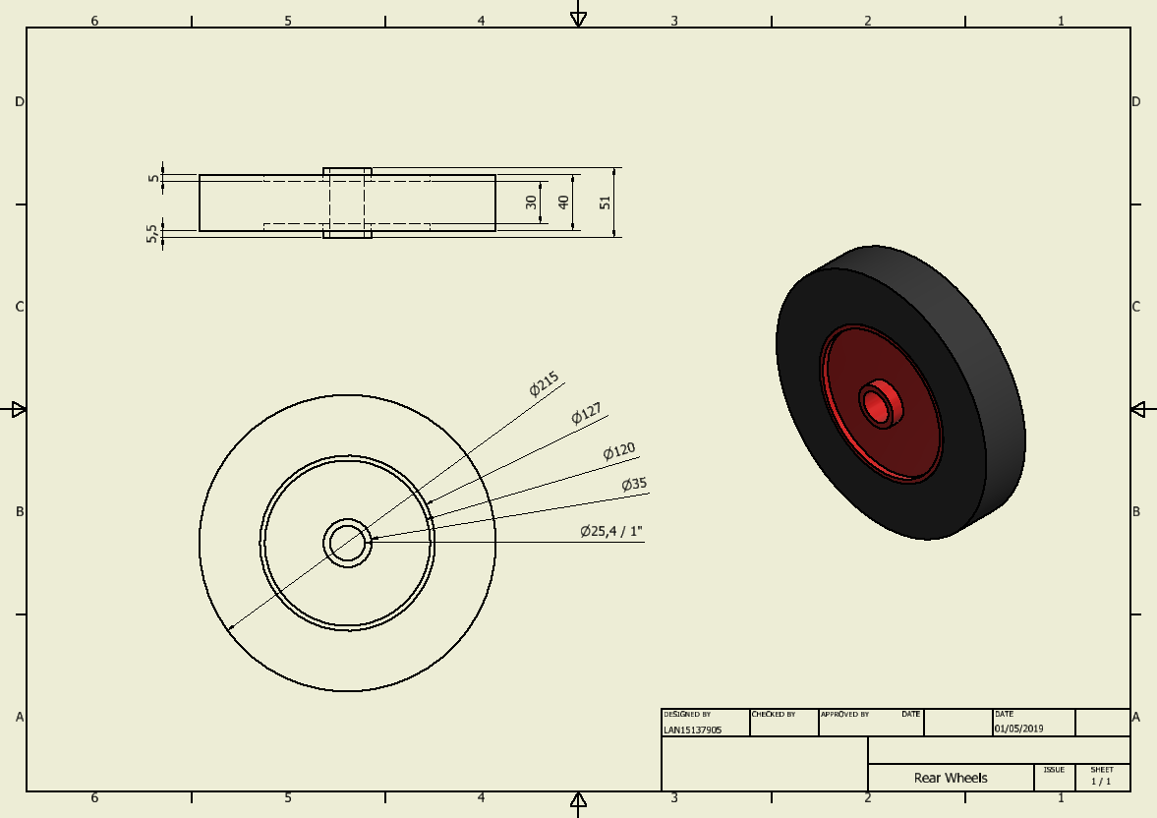

Appendix B
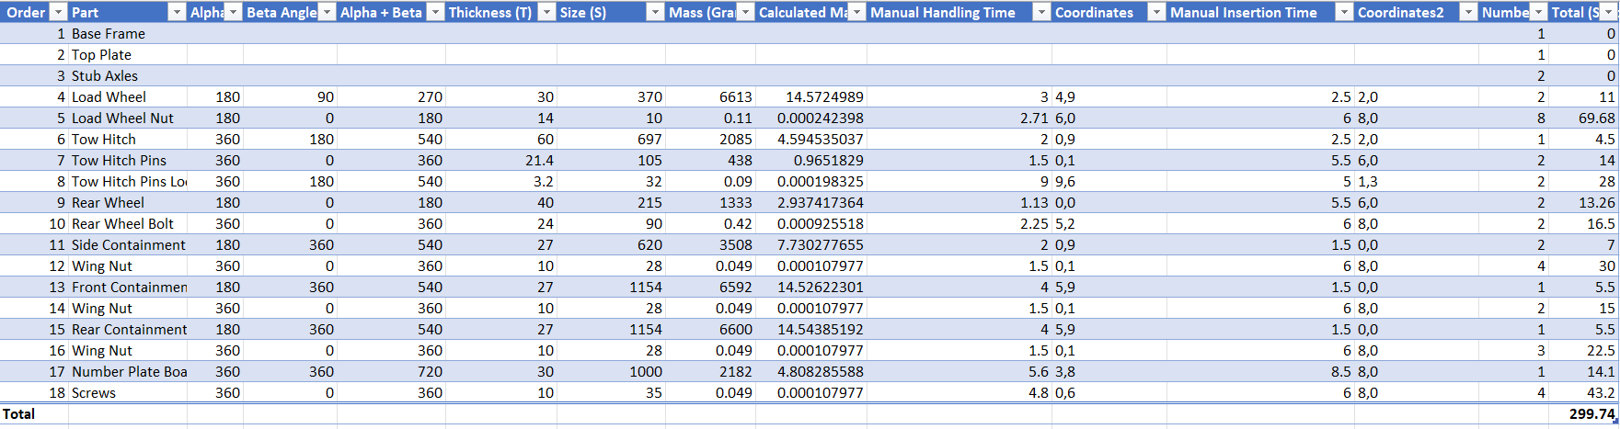
Table 1: Assembly Calculation Times and figures

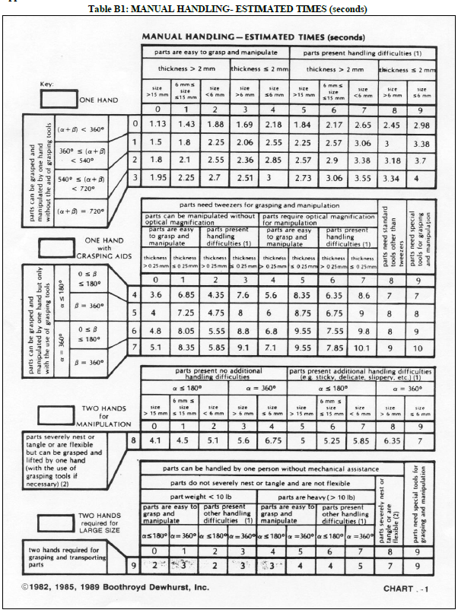
Table 2:

Table 3: Boothroyd, G. and Dewhurst, P. (1989) Product Design for Assembly. Wakefield, RI: Boothroyd Dewhurst.

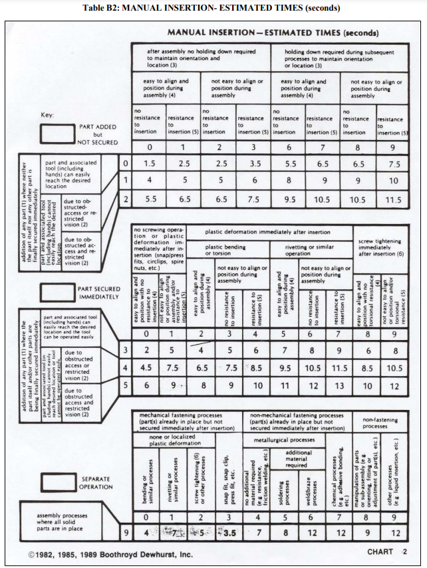
Table 4: Boothroyd, G. and Dewhurst, P. (1989) Product Design for Assembly. Wakefield, RI: Boothroyd Dewhurst.

