

Student Name: | Faiz Hussain
Student ID Number: | 2527683
Programme: | Certificate of Higher Education Skills for the Workplace (Health & Social Care)
Module Title: | Introduction to Health and Social Care
Module Code: | LCHS4003
Lecturer: | Dr Helen Parsons

Table of Contents
- Introduction ...................................................................................... 3
- Importance of Effective Communication ....................................... 3
2.1 Application of Shannon–Weaver Communication Model ............ 5
- Importance of Good Administrative Skills in Professional Practice …………………………………………………………………... 5
- Importance of Inter-Professional Collaboration ........................... 6
- Conclusion ....................................................................................... 7
- References ....................................................................................... 8

1. Introduction

Mrs Thompson is an elderly patient, aged 84, who has been recently discharged from a hospital after suffering from pneumonia. Mrs Thompson currently resides alone in a sheltered housing environment, receives domiciliary care twice daily, and suffers from mild dementia, which led to non-adherence to prescribed medications and confusion. In addition, there is an issue related to her being found outdoors with inadequate clothing, which raises safeguarding issues that need to be investigated by the local council. This situation reveals some of the challenges faced by older people living at home and the importance of providing safe person-centered health and social care. Effective communication, accurate documentation, and collaboration between multidisciplinary professionals are key to ensuring continuity of care and good health outcomes (Sharkiya, 2023). This paper aims to examine the care of Mrs Thompson in a critical way by analyzing her case in the light of such acts as the Equality Act 2010, the Data Protection Act 2018, and the Shannon and Weaver Communication Model.

2. Effective Communication within the Context of Mrs Thompson's Care
Proper communication is essential for ensuring safety through personalized care after Mrs Thompson has been discharged from the hospital. Given her mild dementia, recent pneumonia diagnosis, missed medications and safeguarding issues, there is a possibility that she may misinterpret vital information, and therefore communication is an important element that could prevent her condition from deteriorating. Instead of relying on conventional means of communication, it would be important for professionals to use techniques of communication that would suit Mrs Thompson's cognitive level to help her interpret information and make decisions regarding her healthcare needs (Sharkiya, 2023)
While discussing the medication, the GP or community nurse will provide instructions on medication step-by-step, using layman terms, and giving additional time for the patient to assimilate the information. Having explained the dose, the healthcare provider should invite her to retell the instructions in her own words to see whether she has understood the information before ending the consultation. As Mrs. Thompson once forgot her medication twice, the domiciliary care worker should verify the medicine chart during each visit, reminding her to take medicines prescribed by the GP and reporting the missed dose immediately to the GP to prevent further negative outcomes. It is also recommended to give a printed chart with pictures that can be put into her kitchen and a dosette box to promote Mrs. Thompson’s independence and reduce the risk of future medication mistakes. Such communication strategies have proved effective in promoting the quality of life and engagement in patients with dementia (Hockley et al., 2023).
Another step that should be taken is involving the family of Mrs Thompson as well, who will help to monitor the changes in the health status of the patient and ensure continuity of care. The GP will be able to share the results of the assessment conducted concerning the medications with the consent of the patient and provide recommendations to the family about how they can assist in ensuring that the established medication regime is observed between the domiciliary care visits. In case of such an event when the patient was found outside inappropriately dressed, family members will need to notify the community nurse or social worker about similar situations in the future (Hockley et al., 2023).
The Shannon and Weaver Communication Model can be applied directly to Mrs Thompson's care. The GP is the sender, medication advice is the message, the face-to-face consultation is the channel, and Mrs Thompson is the receiver. Dementia, anxiety following hospital discharge, memory impairment, and environmental distractions represent noise that may distort the message. Feedback is obtained when Mrs Thompson accurately repeats the medication instructions, allowing the GP to identify misunderstandings and clarify information immediately.
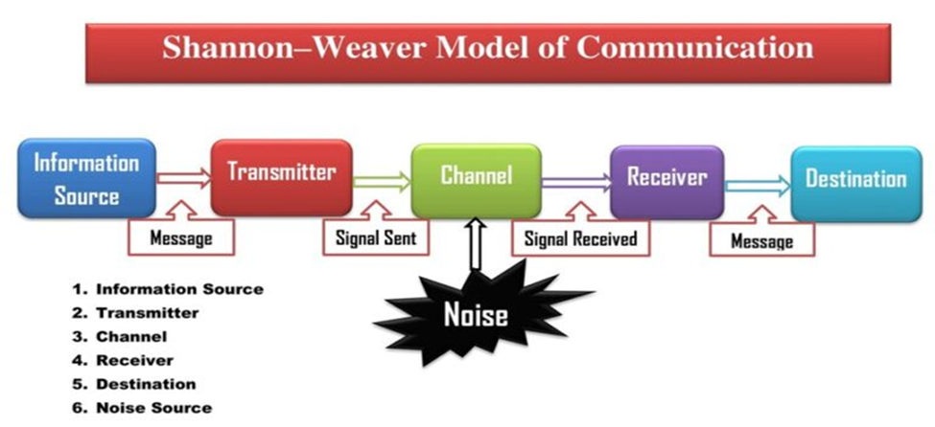
(Kobiruzzaman, 2026)

Table 1: Application of the Shannon and Weaver Communication Model
Shannon and Weaver Model Component | Application to Mrs Thompson's Care
Sender | GP or community nurse explains medication instructions.
Message | Clear guidance on medication, follow-up care, and safety advice.
Channel | Face-to-face consultation supported by written medication reminders.
Receiver | Mrs Thompson, with family involvement where appropriate and with her consent.
Noise | Mild dementia, memory impairment, anxiety after hospital discharge, and environmental distractions may reduce understanding.
Feedback | Mrs Thompson repeats the instructions (teach-back method), allowing the professional to clarify misunderstandings immediately (Shannon and Weaver, 1949; Sharkiya, 2023).

These approaches to communication are in line with those that are enshrined by the Equality Act 2010, which states that reasonable adjustments should be made for people whose disability impacts on their ability to communicate. Longer consultations, written information, appropriate involvement of relatives, and adaptations in communication according to Mrs. Thompson's cognitive capacity ensure equality, dignity, and safety.

3. Good Administrative Skills within Professional Practice in the Context of Mrs Thompson's Care
Effective administration is crucial for ensuring that Mrs. Thompson gets safe and efficient person-centered care post-discharge from the hospital. Since Mrs. Thompson suffers from mild dementia, receives twice-daily domiciliary care, and has failed to take her medicines on time for two consecutive days, proper documentation is key to preventing medicine-related errors, ensuring smooth continuity of care, and receiving timely interventions. Lack of documentation may result in poor communication, duplicate treatment, delays in care, and greater risk to patients' safety while quality documentation enhances clinical practice (Davis & Shepheard, 2024).
For Mrs Thompson's case, the domiciliary care worker must document all the medication visits immediately afterwards. In the event of any missing doses, the document must indicate the date, time, dose that was missed, the state of health of Mrs Thompson, the reasons for missing out on the dose and whatever action was taken such as referring Mrs Thompson to her GP for a medication review. In addition, in the event that Mrs Thompson was found outside with no appropriate dressing, the staff must document an incident in which there is objective documentation of the incident with actions to be taken following safeguarding referral to the local council (NHS England, 2021; Davis & Shepheard, 2024).
Administrative practices must also conform to the provisions of the Data Protection Act 2018 and UK General Data Protection Regulation (UK GDPR), which demand that personal information is to be processed in a lawful, fair, accurate, and secure manner. In actuality, only the professionals who are involved in the provision of healthcare for Mrs. Thompson, such as the general practitioner, community nurse, domiciliary care workers, pharmacist, and social worker, should have access to her health information on the need-to-know basis. For instance, when the general practitioner requests a review of medications, the necessary clinical information should be securely provided to the community pharmacist and community nurse, whereas information that does not pertain to her treatment must remain confidential (NHS England, 2021).
Information sharing should be guided by the Caldicott Principles which state that the information needs to be shared in accordance with the principle of necessity, proportionality and in the best interest of the patient. In this particular case, sharing Mrs Thompson’s case regarding her walking around the hospital is justified as it will allow for the conducting of a thorough risk assessment and ensuring her protection. This is also in line with the Care Act 2014 that puts a statutory duty on healthcare and social care organizations to collaborate in order to protect adults at risk of abuse or neglect (NHS England, 2021).

4. Collaborative Working in Mrs Thompson's Care
A collaborative approach is necessary for providing healthcare and social care to Mrs Thompson, since she was discharged from the hospital recently, suffers from mild dementia, has poor medication compliance, and is vulnerable to abuse. Multidisciplinary collaboration allows for quick exchange of information, consistent delivery of care, and timely identification of risks, minimizing the chances of avoidable hospitalizations (Khemai et al., 2022).
Post-medication failure, the domiciliary care worker needs to record the occurrence and alert the GP to make an appointment for reviewing the medicines of the patient. The community nurse would need to carry out an assessment of the physical state, mental condition, and medication management capacity of Mrs Thompson upon discharge from the hospital. If any fears of self-neglect and wandering continue to exist post-discharge, the social worker will need to conduct a safeguarding risk assessment using the guidelines stipulated under the Care Act 2014 and collaborate with the council for putting measures in place to minimize the risks in the future. All professionals involved in the case must ensure the updating of the shared care plan (NHS England, 2022).
Good teamwork can be achieved through routine MDT meeting, joint electronic patient records, and effective communication tools like SBAR (situation, background, assessment, recommendation). In the case of failure of Mrs. Thompson’s medication being taken, the use of SBAR helps the GP and community nurse obtain accurate and relevant information about the situation in order to make quick decisions and avoid miscommunication (Royal College of Nursing, 2021).

Multi-agency cooperation might encounter difficulties, such as delays in the exchange of information, differences between professional concerns, workload, and lack of clarity over responsibilities. These obstacles could lead to poor coordination and interventions. To address these problems, it is necessary for organizations to define professional roles, conduct MDT meetings regularly, offer interprofessional training and secure electronic files that meet the information governance standards. These strategies will facilitate effective communication, better decision making and provide Mrs. Thompson with safe, person-centered and integrated care that considers her health and social care needs (NHS England, 2022).

Conclusion

In the case of Mrs Thompson, the use of good communication, proper administration and collaboration have shown the significance of such elements for provision of safe and person-centred care in the UK healthcare and social care system. The adaptation of communication methods in consideration of Mrs Thompson's cognitive abilities using Shannon and Weaver Communication Model along with reasonable adjustment according to the Equality Act 2010 helps her to make sense of the information and to be involved in the decision-making process while retaining her dignity and independence. Moreover, the proper documentation and appropriate information exchange as per the Data Protection Act 2018, UK GDPR and NHS Records Management Code of Practice allow for continuous care, accountability and safety of the patient. In addition, collaboration among the GP, community nurse, domiciliary care workers, social worker and local authority allows for comprehensive care regarding the issues with medication management, safeguarding concerns and the health of the patient.

References

Care Act 2014. (2014) Chapter 23. London: The Stationery Office. Available at: https://www.legislation.gov.uk/ukpga/2014/23/contents
Data Protection Act 2018. (2018) Chapter 12. London: The Stationery Office. Available at: https://www.legislation.gov.uk/ukpga/2018/12/contents
Davis, J. and Shepheard, J. (2024) ‘Clinical documentation integrity: Its role in health data integrity, patient safety and quality outcomes and its impact on clinical coding and health information management’, Health Information Management Journal, 53(2), pp. 53–60.
Equality Act 2010. (2010) Chapter 15. London: The Stationery Office. Available at: https://www.legislation.gov.uk/ukpga/2010/15/contents
Hockley, A., Moll, D., Littlejohns, J., Collett, Z. and Henshall, C. (2023) ‘Do communication interventions affect the quality-of-life of people with dementia and their families? A systematic review’, Aging & Mental Health, 27(9), pp. 1666–1675. https://doi.org/10.1080/13607863.2023.2202635.
Khemai, C., Meijers, J.M., Mujezinovic, I., Bolt, S.R., Pieters, S., Moser, A., Schols, J.M.G.A. and Janssen, D.J.A. (2022) ‘Interprofessional collaboration in palliative dementia care through the eyes of informal caregivers’, Dementia, 21(6), pp. 1890–1913. https://doi.org/10.1177/14713012221098259.
National Data Guardian (2020) The Caldicott Principles. London: Department of Health and Social Care. Available at: https://www.gov.uk/government/publications/the-caldicott-principles
NHS England (2021) Records Management Code of Practice 2021. Leeds: NHS England. Available at: https://www.england.nhs.uk
Royal College of Nursing (2021) SBAR: Situation, Background, Assessment, Recommendation. London: Royal College of Nursing. Available at: https://www.rcn.org.uk/clinical-topics/patient-safety/situation-background-assessment-recommendation-tool
Sharkiya, S.H. (2023) ‘Quality communication can improve patient-centred health outcomes among older patients: A rapid review’, BMC Health Services Research, 23, Article 886. https://doi.org/10.1186/s12913-023-09869-8.

