
Skills for the Workplace
Module Assignment Submission
Student Name: | Shanice Elizabeth Taylor
Student Number: | 2017374
Module No: | BMSK4005
Module Title: | Professional Career Development

Statement of Confirmation of Authenticity
By the act of making this submission, the student declares that this is the work of the student named above. The work has not, in whole or in part, been knowingly presented elsewhere for assessment, or where assessment has been built on a previous assessment, this has been identified. Where materials have been used from other sources it has been properly acknowledged. If this statement is untrue, the student acknowledges that an assessment offence has been committed.
Attention is drawn to the plagiarism and unfair practice policies of both the University and of ILM.

Table of Contents
Section 1 1
1.1 Identify learning styles for self and another 2
1.2 Development Needs 5
1.3 Identify potential barriers to learning for self and another. 5
1.4 Barriers to Learning. 7
Section 2 7
2.1 Development Options. 7
2.2 Support Mechanisms 8
2.3 Plan of Action 8
2.4 Monitor Progress. 9
Section 3 9
3.1 Identify a suitable job and explain the process of doing so 9
3.2 Reflection on Recruitment Process 10
Conclusion……………………………………………………………………………………………….11
References 12
Appendix 1 13
Appendix 2 14
Appendix 3 15
Appendix 4 16
Appendix 5……………………………………………………………………………………………….17
Appendix 6……………………………………………………………………………………………….18
Appendix 7……………………………………………………………………………………………….20
Appendix 8……………………………………………………………………………………………….21

Introduction
In this assignment, I will look deeper into professional career development and the different methods you can use to self-assess, such as learning styles. This helps to become self-aware of barriers to learning through SWOT analysis and the use of Personal Development Plans. Learning styles are important to know as you may be hindering your progress by learning in a different way. I will try to show why knowing your learning style is so crucial in your personal development. I also seek to shed light on SWOT analysis and learning barriers and how being self-aware is vital for professional development. The use of Personal Development Plans is universal; however, I will discuss and evaluate how they are used in practice and in what ways a manager could effectively use them. Finally, I will reflect on my past interview experiences and incorporate methods used in practice. I will highlight areas where I could improve my interviews in the future. Overall, I want to find out how a person can best improve in a professional manner.

Section 1

Identify learning styles for self and another
There are various models people can use to identify what works best for them. Two key models used in practice are Honey and Mumford’s Learning Styles (1982) and the VARK Questionnaire (1987). You use these methods if you are looking to maximise your own personal learning. For instance, looking for a new job, whilst studying or to simply reach your full potential.

Honey and Mumford

Honey and Mumford wanted to find out what types of learners there are in the world. They discovered that there are four main types of learning styles that people acquire. They named them: Activist, Reflector, Theorist and Pragmatist. So that the public can learn what style of learning a person uses, Honey and Mumford created a questionnaire (Honey and Mumford, 1982).
After completing the Honey and Mumford questionnaire, I found that the learning style I answered the most yes’ for was ‘Reflector.’ A reflective learner thinks deeply about what they are learning and situations. They prefer learning material that is visual. I agree with this. I am a listener. I enjoy listening and observing when in social situations. I can absorb information more easily when being told personal stories. I think deeply about what I am learning, which is highlighted when listening to others’ stories, ideas or thoughts.
I asked a peer to take the test. Her results were the same as mine, she was a reflector. She, however, did not agree with the test. She thought she would be a theorist as she is very cautious and thinks before applying things to practice. She said that she does not learn via visual sources and finds it easier to absorb information by reading and writing. My peer realised that although she may think she has found her preferred learning style, there are other ways for her to learn.
In conclusion, the questionnaire has shown me that I can be confident and opinionated without expressing my thoughts and feelings to the group. I find myself swallowed up by social situations and sometimes am unable to word exactly how I am feeling, which is reflected in my results.

Vark
Another model used is the VARK questionnaire (1987). Fleming (1987) suggests that there are four main types of learners: visual, auditory, reading/writing and kinesthetic.
According to the VARK questionnaire, I am a very strong kinesthetic learner. A kinesthetic person likes physical activities. They do not like reading and are often poor at spelling. I agree that this accurately represents me. I learn better when doing active tasks. Similar to the Honey and Mumford study, the VARK questionnaire showed that I can learn better when in social situations. I am a visual learner and find it difficult to focus on large passages of reading.
My peer also took the VARK questionnaire. Her result showed mild read/write, meaning that she learns best when reading and writing. She was shocked to find that her results differed from the Honey and Mumford questionnaire. She agreed with the VARK questionnaire as has always been good at writing and finds it easy to write essays. The fact that my peer and I have different results suggests that there are more ways than one in which a person can learn and absorb information.
Both the VARK model and the Honey and Mumford’s study gave me similar results. I agree with both conclusions. With regard to the VARK model, I am definitely a visual learner. I am able to learn when completing activity-based tasks, rather than reading. I also find learning much more enjoyable and interesting when I am working practically. However, it is interesting that my peer did not get similar results for either test and disagreed with her Honey and Mumford results. This suggests that although the learning style questionnaires are insightful, they may not always be correct.

Dantec
I also completed the Dantec questionnaire. This informed me I was a Reflective learner. I agree with this. Much like my Honey and Mumford results, I can clearly see I am a visual learner who prefers learning via past experiences (Dantec, 2006).

Conclusion
As a manager, it is important to recognise that each employee may have different learning styles so they cannot expect everybody to learn in the same way. For instance, during meetings, a manager needs to ensure that they have reading material for those who prefer reading, a PowerPoint for the visual learners and open discussions for those who learn better when communicating. I feel that it would be a good idea to have different types of learners on your team so that there are strengths in different areas.

1.2 Development Needs
There are other ways you can develop. One model used is the SWOT analysis (Humphrey, 1960). Although the models main use is to help businesses thrive, it can also be used for individuals to independently improve themselves. Leiber, Stensaker and Harvey believe that SWOT analysis is a tool for bridging the gap between personal challenges and how to use them within the workplace (Leiber, Stensaker & Harvey, pp 351, 2018). This is shown through the constant use of SWOT analysis.
This table shows the process of a SWOT analysis:
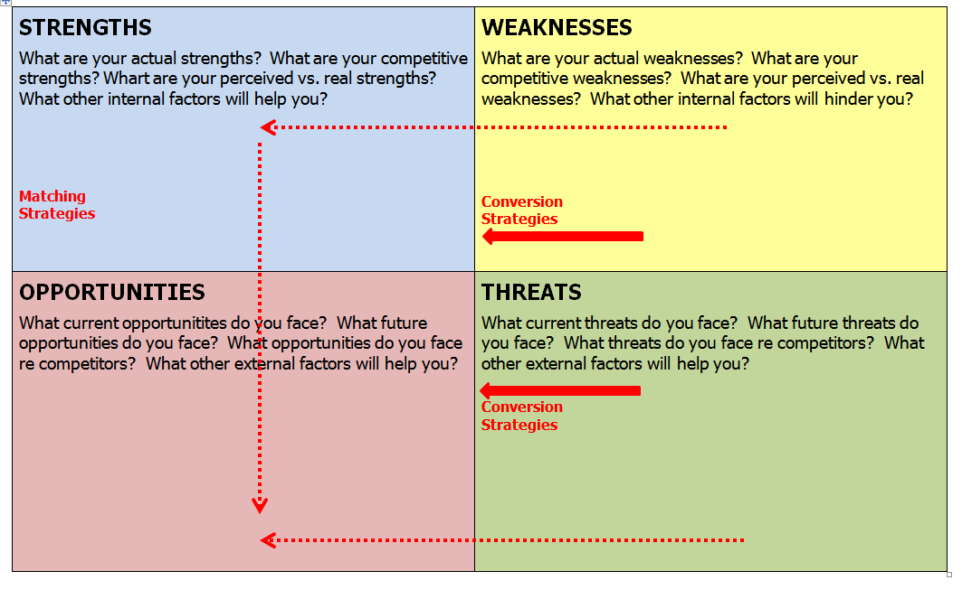

I used the SWOT model to identify areas that I could improve on (see Appendix 1). I will now continue to discuss my SWOT analysis in detail (Humphrey, 1960).
I work in a school. There is no progression for me without further education. I need to have a degree to move forward in my job. Therefore, I have applied for a University degree. This enables me to have the confidence to grow and find a job that allows me to progress. Another way to overcome this threat is by doing a GAP analysis. I am currently a TA but in 5 years I would like to be a teacher. GAP analysis allows you to identify your desired skill level and position, as well as setting aims to achieve this. A GAP diagram is shown below (Westland, 2019):
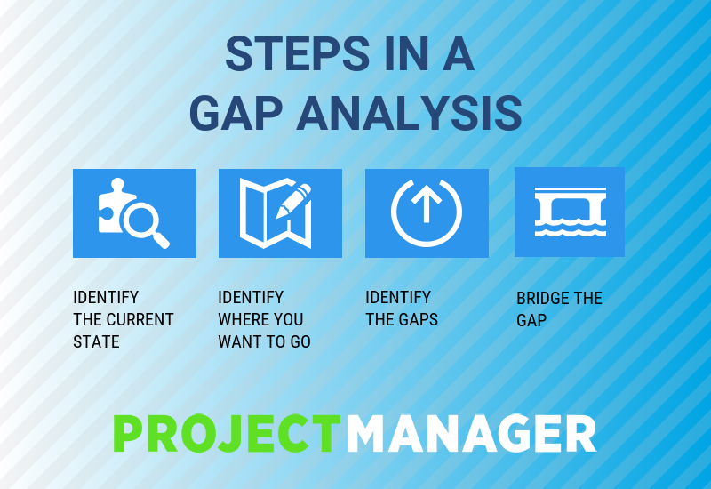
I also suffer with anxiety. Anxiety has restricted my self-growth. I can tackle my anxiety through mindfulness and meditation. Another threat is that in my workplace there are too many tasks that need to be completed and not enough staff. I am always overworked. I can change this is by bringing work home. To turn this threat into an opportunity I could ask my headteacher if it would be possible to hold intervention groups with children in my class. This will allow me to grow as a Teaching Assistant and give me experience of working as a teacher.
When completing the SWOT analysis, I identified more weaknesses than strengths. This did not surprise me as I have low self-esteem and lack self-belief. These weaknesses have stemmed from me feeling that I am not good enough. Not going to University at 17 has had a major impact on my adult life. If I had better qualifictions, I feel I would not be scared to leave my job. I have applied for a University course, which will give me the qualifications I need.
I also find it difficult to communicate verbally. This has had an impact in my workplace and life. I can overcome this by attending study sessions and applying for communication courses. A study investigating SWOT analysis argued that certain weaknesses can be overcome, while others cannot (Leiber, Stensaker and Harvery, pp 351, 2018). The SWOT analysis allows you to identify your weaknesses and improve them.
My peer also did their own personal analysis (see Appendix 2). She found it difficult to identify her weaknesses. However, she recognised that she is a very organised person who can adapt herself into various working environments. One of her strengths is that she is good on computers. This is something I have placed in my “Threat” section. This is due to our differing backgrounds and job roles. For my peer it is vital that she is good on computers, where as my job is much more practical and hands on.
Additionally, I recognised that there is no progression in my job, yet my peer has put promotions as an opportunity. This could be a reason for my lack of confidence. I am self-aware and know that there is no room for progression in my job. However, my peer feels confident in her abilities because she is working to achieve a greater goal.
I would argue that the SWOT analysis is effective. It is a reflection of the individuals self-representation. Self-development is key to success, by completing the SWOT analysis you can evidently see areas to work on and become the best person, colleague, or employee that you can.

1.3 Barriers to learning
Even though a person is self-aware there may still be barriers that could restrict them from learning. Some barriers maybe external, whilst others are internal.
My peer and I outlined our learning barriers together (see Appendix 3). We both thought it would be difficult to deal with the financial commitments linked with University. This is an external barrier. It restricts us from growing and developing our skills. To overcome this, we decided to research the different ways in which you can repay your loan, and this eased our concerns.
For a long time I thought I could not attend University as I worked full-time. I thought that if I left my job, I would have no income to pay the bills. I overcame this external barrier by applying for a flexible course. This allowed me to study and work at the same time.
My weight has been a constant barrier for me. It has had a negative effect on my confidence and has stopped me applying for jobs that I desire. I would love to be a decorator or work in a car garage but would not be able to due to my weight. At the start of this year I changed my lifestyle. My confidence and attitude have improved dramatically. My peer, however, does not struggle with her weight. She does not think about her physiology and has the confidence to apply for any job she wishes. I will overcome this barrier by carrying on with my weight loss journey and getting professional help.
Anxiety has been a constant internal barrier for me and has held me back from various opportunities. My anxiety stops me from completing simple tasks, which results in me being extremely frustrated. I will overcome this barrier by speaking to my GP and receiving professional help. I also know that I can use meditation and mindfulness techniques that will help me mentally.

Section 2

2.1 Development options
My colleague and I have identified areas to improve. My colleague has suggested that she would like to work on her listening skills and patience, whilst I have identified my organisational and technological skills. To develop, we both need to work on these skills so that we can fulfil our potential.
I could improve my technological skills by signing up for courses and following YouTube tutorials. These will allow me to visually learn how to improve on computer applications, such as Microsoft Word. I also identified my organisation as a weakness. I could purchase a diary to overcome this. I could also sign up to a buddy scheme. I will highlight this weakness to my buddy and ask them to prompt me to be more organised.
My colleague identified her patience and listening skills as weaknesses. To develop her listening skills, my colleague could sign up for coaching and attend sessions with a business coach. They will arrange tasks for my colleague to attend meetings with her business coach. Similarly, my colleague could sign up to mindfulness classes that will allow her to process information slower. She will also learn techniques that will allow her to acknowledge her triggers and perform tasks to the best of her ability.
As a manager, I would be aware that each employee has different areas to improve on. To ensure that each employee is fulfilling their potentials, I would arrange monthly meetings in which we set targets and objectives for the employee to meet. These meetings will allow the employee to identify areas of concern. They can then discuss development options that will improve their performance.

2.2 Support Mechanisms
GOMAD is a model used to highlight areas of concern and see what resources are available for improvement. (Chackrovaity, 2001). I completed a GOMAD diagram, with my main goal being to get a degree. I then had to look at how ways to reach this goal by suggesting tasks I can complete; support I can receive and the reasons behind my objective. A big factor for me is the support I receive from my family, fiancée, and friends. Knowing that these people are supporting me, my confidence increases, and I have more self-belief.
My colleague also completed the GOMAD diagram (Chackrovaity, 2001). In comparison, she believed that the most important support mechanism for herself was the tasks she set. Having tasks to complete allows her to feel secure and stable with an end goal insight.

2.3 Plan of Action
A method used by many global companies is a Personal Development Plan. A PDP will enable the employee and manager to discuss what areas the employee needs to work on to be successful. It is important that the employee is motivated to complete the tasks discussed on their PDP, otherwise there will be a lack of progress. It is also important for the organisation to support the employee and ensure they are hitting their targets so that the company is successful (Eisele, 2013).
Regarding my own PDP (see Appendix 4), I outlined some areas I can improve. I decided that I would be more vocal in my lectures, improve my technological skills and become more organised. The three skills mentioned are important in my education and can allow me to reach my full potential. I feel that the PDP has helped me outline my weaknesses and identify ways to overcome them.
The PDP allowed me to see my next steps. I took my initiative to complete the tasks set out in my PDP (arranging meetings with student support services, being more vocal and purchasing a diary). The PDP is a particularly useful way for people to develop their skills. My actions ensured that the PDP was successful as I was proactive and motivated. My biggest achievement, after successfully completing all my tasks, was improving my technological skills. By attending sessions with the SST, I have been able to work tirelessly on computers which made learning a lot easier. As with most things once you try something multiple times you will eventually perfect it.
In the future, I can return to my PDP when I am struggling with me skills and redo the actions I set. Next time, I would seek help from professionals, rather than peers. When I saw the SST, I felt they knew what they were doing and could assess my needs.
Similarly, my colleague created a PDP outlining areas of concern (see Appendix 5). She suggested she could work on her communication skills, patience, and confidence. After discussing our achievements, I think my colleague’s PDP was more successful than mine as she got help from professionals and those who work alongside her, rather than friends. This ensured that her tasks and actions were tailored to her job. Her PDP was also very adaptable. She could complete tasks in her workplace without external influences affecting her.
The PDP is an amazingly effective way of assessing ones needs and how they can successfully reach their full potential. As a manager, I would ensure that all my employees are familiar with the use of PDP’s and have tasks that they can complete to achieve their goals. They are extremely useful and allow employees to improve themselves and develop skills they may be struggling with.

2.4 Monitor Progress
Without any evidence there is no proof that a PDP was successful. As a manager, you would have monthly meetings with your employee to make sure they are hitting their targets and objectives. By having meetings with employees, a manager can give feedback to them, and vice versa. This will then allow the manager to learn what ways the individual learns, and ensure the employee feels supported. For instance, it would be crucial for my colleague to receive feedback on presenting without notes for her PDP to be successful. If she did not receive feedback, she may feel that she had completed the task correctly, whilst others may have different opinions.
A common way of monitoring progress is through reports and performance reviews. Reports are usually sent frequently, whilst performance reviews are quarterly (Morgan, 2017). These don’t only allow employees to monitor their own progress, but also keep the company and managers informed on the employee’s development. It would be beneficial for me to have a quarterly review on my PDP so that I can address areas that I may be struggling with or exceeding. For instance, if I felt my communicational skills weren’t improving, my manager and I could discuss different techniques and actions I could do.

Section 3

3.1 Identify a suitable job and explain what is involved in deciding this.
When applying for a job you need to plan properly. You need to have self-awareness and make certain that this is the correct career move for you. Nowadays, you can work in all sorts of fields, so it is vital that you end up in the right environment for you. By having several occupational options, you ensure that you find the correct job.
I decided to apply for a job as a Legal and General Team Manager (see Appendix 6). Although, I have identified a job I am keen to apply for, I need to research the organisation. I should find how the company trains its staff, what they aim to achieve and what procedures or protocols they abide by. This ensures I apply for the right job. By researching the job, I will be able to match my skills and evidence to what they are looking for. For instance, Legal and General are looking for somebody who has experience managing a group of 15 people. As a teaching assistant, I manage a classroom of 30 students a day, so feel I am well equipped for this job role.
Before applying, you need to create a CV and cover letter. Both of these should be tailored towards the job you are applying for (see Appendix 7-8). To create these, I used the USP method (Unique Selling Point). I outlined what I have done, who I am, my experiences and responsibilities. This then shows the organisation who you are and what skills you have that match the ones they are looking for.

3.2 Reflection on Recruitment Process
Interviews are the most important part of the recruitment process. From within seconds, a person will judge you, so it gives you an advantage or disadvantage. Recruitment is the process of identifying several applicants who are willing to apply for certain roles. As a recruiter, you need to make sure you have the right person, at the right time and, most importantly, that they want the job. You also need to be wise about your applicant selection. Under the Equality Act 2010, recruiters are not allowed to discriminate applicants due to their age, gender, race, sexual orientation etc. The Equality Act protects those in vulnerable categories and gives them equal opportunities. Previously, companies may have rejected applicants due to their names, hence why the Equality Act was introduced. Companies are now required, by law, to ask certain questions on their job applications to ensure that their workplaces are diverse (Equality Act, 2010).
Companies also have codes of conduct in which employees, applicants and visitors need to abide by. Common codes of conduct include not wearing certain clothes, following data protection and not sending sensitive or highly confidential material to private emails. Organisations also have common law practices in which they follow. The most common being work contracts. These are not contracts where you can break the law, but could be penalised as are breaching the companies legislations. As an applicant, it is important to read companies legislations and codes of conduct to ensure that you are abiding by their rules when attending interviews.
Gibb’s created a Model of Reflection which is focused on the ability to self-reflect (Gibbs, 1988). His work is used to examine and analyse past experiences. This can be used when analysing previous interviews.
My most recent interview was for a teaching assistant job. I had the benefit of having had work experience in the school so was already familiar with the staff. I was told by my mentor that the school were looking to offer me a permanent position. I then received an email from the Head Teacher inviting me for an interview. I would usually be anxious for an event like this. However, as I was familiar with the staff and knew what the conversation would entail, I was fine. The interview was informal and felt I was amongst friends, rather than colleagues. Although the informal nature was nice as the interviewee, I feel that the staff could have been more formal and professional. All interviews should be conducted to a high standard and shouldn’t change depending on the interviewee. However, if the interview had been formal and professional, I would have been much more anxious. I can understand why the staff would be relaxed, as I was too. If the interview was to be retaken, I would be more formal and uphold my professional manner so that the interview is conducted correctly.
In comparison, I attended an interview to be a Team Member at KFC. I had no prior contact or explanation before my interview and was only told a time and place that I had to be there. When I arrived at the interview, there was around 50 people in a large room. This was extremely daunting. I had prepared myself to be one on one with a manager and wasn’t expecting an audience. The managers then explained the plan for the day and how we’d be split into groups to perform team building exercises. One of these exercises was to sell an item to the other people in my group. Having had no previous sales experience, I was overwhelmed by this part of the interview and would have liked some preparation beforehand. The last stage was typical of an interview. I spoke to the managers 1-2-1 and was asked about my skills and previous experience. I then had to perform a series of tests online. I, again, was not prepared for this, nor had I been told this would be included in the interview. Hours later, I was informed that I had got the job. Overall, my KFC interview experience was appalling. I had little to no understanding of how the day would pan out and wasn’t aware of the various different tasks I’d have to undertake. If I was the interviewer, I would have created a plan and sent this out to the applicants so that they were aware of the days schedule. However, I could have reached out to the company and asked for more information. In my next interview I will be sure to contact the company beforehand. Although, I do feel that it is the organisations job to inform its applicants about interview activities, rather than the interviewee searching for this information.

3.5 Conclusion
Through self-assessment I have become more self-aware. I was unaware of my preferred learning style and can now adapt my learning techniques to my results. By knowing my learning style, my University experience will be fulfilled, and I won’t struggle as much as I thought. I knew I preferred learning through task-based activities, but wasn’t aware of how much it could hinder my experience if I was to learn other ways. This assignment has been extremely insightful and allowed me to look within myself and at my past experiences, so that now in the future I have a foundation to build upon with the knowledge I have acquired from this essay.

References
Dantec, C., Diouri, M., Goodchild, L. (2006) ‘Dantec’ Southampton: University of Southampton
Dantec, C., Mozzon-McPherson, M., (2006) ‘Supporting Independent Learning through Explicit Strategy Based training,’ Berlin: Peter Lang
Eisele, L., Grohnert, T., Beusaert, S. and Segers, M. (2013) ‘Employee Motivation for Personal development plan effectiveness’ London: Emerald Group Publishing LTD
Equality Act (2010)
Flemming N. (1987) ‘Vark’ New Zealand
Froggatt, C. (2018) ‘Learning Styles: How to Recognise What You’re Great At’ Nottingham: University of Nottingham
Gibbs, G. (1988) ‘Learning by doing: A guide to teaching and learning methods’. London: FEU
Gilbert, A. and Chackrovaity, I. (2001) ‘Go Mad: about coaching’. Bath. Bath Press
Honey, P. & Mumford, A. (1982) ‘Manual of Learning Styles’ London: P Honey
Howes, A. (2014) ‘Honey and Mumford Learning Styles,’ London: PDG
Humphrey A. (1960) ‘SWOT Analysis’, California: Stanford Research Institute.
Leiber T, Stensaker B, and Harvey LC. (2018) ‘A SWOT Analysis: Bridging theory and practice of impact evaluation of quality management in higher education institutions’, Augsburg: European Journal of Higher Education
Morgan, P. (2017) ‘The Business Students Guide to Study and Employability’ London: SAGE
Westland, J. (2019) ‘How Gap Analysis Can Improve Your Project Management,’ Texas: PMC

Appendix 1

Appendix 2

Appendix 3

Appendix 4

Appendix 5

Appendix 6

Appendix 7

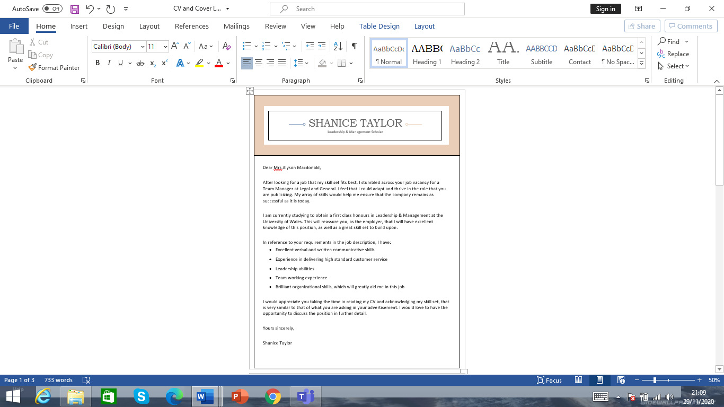

Appendix 8


