Abstract

Introduction..............1
Cloud services...........1
Wireless Networks......2
Comprehensive Policies........2
BYOT........................3
DFD.........................6
Implementation.......6
Conclusion..............7
References............9

Introduction
In this assignment, I will be looking at BYOT and looking on how I can improve their online and offline security and I will be recommending guidelines on a security policy in a report. I will be also using Packet Tracer to implement all aspects of the company’s enterprise network.

Cloud services
Cloud services are something that you can use as a backup to save documents and other important things to it. Examples of cloud services include ‘Google Drive’ and ‘Dropbox’. When putting things on these services, you don’t need to save anything as they automatically save onto your device. Advantages of this is that they will be on the device for as much as you want it to, also that you won’t need a USB to use it; hence the name. [1]
The service made available to users on demand via the Internet.

Wireless Networks
Wireless networks are networks that are not using cables of any kind to connect devices. [1]Wireless networks use radio waves to connect devices such as laptops to the Internet, the company’s network and also the applications. When the devises are connected to a WiFi hotspot in a public place, then the connection is connected to the particular company’s wireless network connection. The four main types of wireless network are LAN; this is short for Local Area Network. This means that it links either two or more devices at the same time. This is using a wireless distribution method that is providing a connection through access points to the wider internet. Another type is a MAN: this is used by connecting a few wireless LANs. The third one is called a WAN, and this is when it covers large things like towns and cities. Lastly, there are PANs. These interconnect devices in a short span that is generally within a step away from someone.

Comprehensive Policies
In the company, there has to be policies and standards to make sure that it is going good and it is running well.

[6] The Mobile Device Management Software that I am going for my BYOT is software called “Hexnode MDM”. The reason I have chosen this because firstly, this is relatively cheap software to have as the company will get a free trail to start off with, then if the company chooses, they can have a free version of it as the starting price is not given out. Along with the price, the features of this is that it is cloud deployment and this is compatible with Hyper-fort as they use cloud services to deliver IT services to its staff and clients. The deployment of types of devices is good as you can install it on Mac, Windows, Mobile on Android and also Mobile on IOS. There is 24/7 live rep support so if any worker has an issue at any point of the day, it can be sorted whatever the time of the day. The features that this has include:
[7] Automatic Device Recognition:
Automatic Device Recognition makes configuration and management of servers easier and that is because it is detecting which type of server, router or even switch is connected. The benefits of this are it automatically detects and recognizes the attached device.
Data Management
[8] Data management is a process where it includes storing, protecting and also processing data to insure accessibility and the reliability of the data for the users, which would be the workers and the client.
Deployment Management
[9] Deployment management includes the planning, designing, building and also the testing of the new software and also the hardware components in the working environment.
Inventory Management
[10] Inventory management is when the company’s inventory is being used, things like raw materials, components and also finished products. It’s also referring to the process of ordering and also stoning it. In this case, it’s the MDM software.
Maintenance Utilities
[11]This would be used by the company because it will perform maintenance tasks on the devices. For example, anti viruses and firewall programs, these types of programs come with additional features that’ll help the already built in software.
Procurement Management
[12] Procurement management is systematic approach used for buying all the goods and services needed for a company to stay sustainable.

Remote Update / Installation
Remote update/installation means that the network administrators are allowed to install and also uninstall software on any remote device on the network.

Software Management
[13] Management software is a term that is refers to any kinds of software that is designed to manage and help manage some of project.

BYOT
[3] BYOT (Bring your own technology) is a new and continuing developing phase where the employees of a company buy their own devises, with these devices being mostly computer devices like smart phones, tablets and even sat navs. BYOT is normally referred as the consumerization of IT and that is because it is representing the public’s increasing usage of their mobile phone and other devices along with their expectation of having personalized devices. [4] The advantages of BYOT is that it will lead to the employees to be more satisfied than if they used a device that is issued to them, this is because they enjoy using the device that own to the one that is owned by the company. Another advantage is that as it is BYOT, it’s more likely the devices are going to be up to date as technology is updating all of the time and also the companies will benefit from this because they will experience and will reap the features of new devices. With no BYOT, it would be really hard for the companies to keep on upgrading depending on how big they are. Small companies alone would thrive at this as they’ll save enough money for other areas of the businesses. Saving money for other companies will be another advantage. The worker pays for their own device and potentially will get a pay rise from the company, that’s if the worker brings more profits into it from using their device. Another advantage of BYOT is that the worker will enhance their productivity when they are working. This is because they are more comfortable and also used to using the device they use on a daily basis. They will respond to requests faster when they are using a device which has been given to them from their employers. [5] However, there are also disadvantages for BYOT; one is the cost of the worker. They would have to buy the devices without recognising other situations, for example if a worker doesn’t have the latest devices or that they can’t afford particular devices that are needed at work. Another disadvantage of BYOT is that it may not as secure as being at home with the device. Although the companies may spend some money on having good security, the workers may not have important software that will protect their device. The issue that may occur from this is the possibility of having secret information stolen and other important things taken from other people on the network.

What type of data is retained by the mobile devices connecting to Hyper-fort network?

The data that is retained by Hyper-fort is secret information that already was on the device such as mobile numbers, email, location and also banking details. This is because the only information that doesn’t already go on the device is information belonging to the company.

What is the potential for data leakage when the device leaves the office environment?

The potential data leakage if a device leaves the office is that there is a danger that any information important to the company is being leaked to the public. This is important for the reputation for the company.

How to address the blending of personal and business usage when devices are in office?
To address the blending of personal and business usage when devices are in office, the company should have a policy that the workers cannot use things like social media and other things like online games and gambling websites.

What strategy to deploy to deal with different brands of devices?

One worker could have an expensive device that costs a lot of money compared to different workers who may only have cheaper one and for that the company will have to have a policy that will have a certain requirements for the worker meaning that if a certain person can’t afford the requirements, then the company would have to give the worker a device or they can help them with upgrading to the requirements.

What strategy to deploy to deal with different Operating System platforms?
The strategy that will be deployed to deal with different operating system platforms is that there will be a recommendation to use the same operating system in order to make life easier.

What strategy to deploy to deal with different application on user devices?

The strategy that I would like to deploy is to recommend that the company’s network users only use things like Microsoft Word or Visio.
What strategy will be deployed when the owner of a participating device leaves their employment or the device is lost, stolen or fails?
The strategy that will be deployed if the device is lost, stolen or if the worker decides to leave their employment is that the account will have to be looked at and wiped from the device meaning that the individual will no longer have access to the network. They will have to sign a terms and conditions agreement when they start working at the company

From looking at the information above, I can gather a policy that will suit the company, Hyper-fort. The security policy is that all of the employees of Hyper-fort will have to have to have their own username and password to keep all of their information to themselves. With the passwords, they will have to have a certain number of words in there to make sure that they are secure and safe from hackers. Depending on their department, the workers at Hyper-fort will have requirements for what device they can use. Along with that, there would have to be a requirement on the operating system that they can use, this is because it would make it easier for the other employees of the company. Also, to combat any blending on office and personal work on the device when in office, I would have the policy of having any sites which would make the employee not do work or distract them in any way. These sites are: social networking, gambling, and other inappropriate websites. If there is a data leak to any of the information if a device leaves the office, the way to combat any leak and dangerous hacking is by making sure that every device is not carrying any sort of info that is shouldn’t be. This shall be done by making sure only trusted people should be having very important information.

DFD

No User login
Yes

Create the login
Customer Worker
Not much access to web browsing

Customer access worker access
Implementation
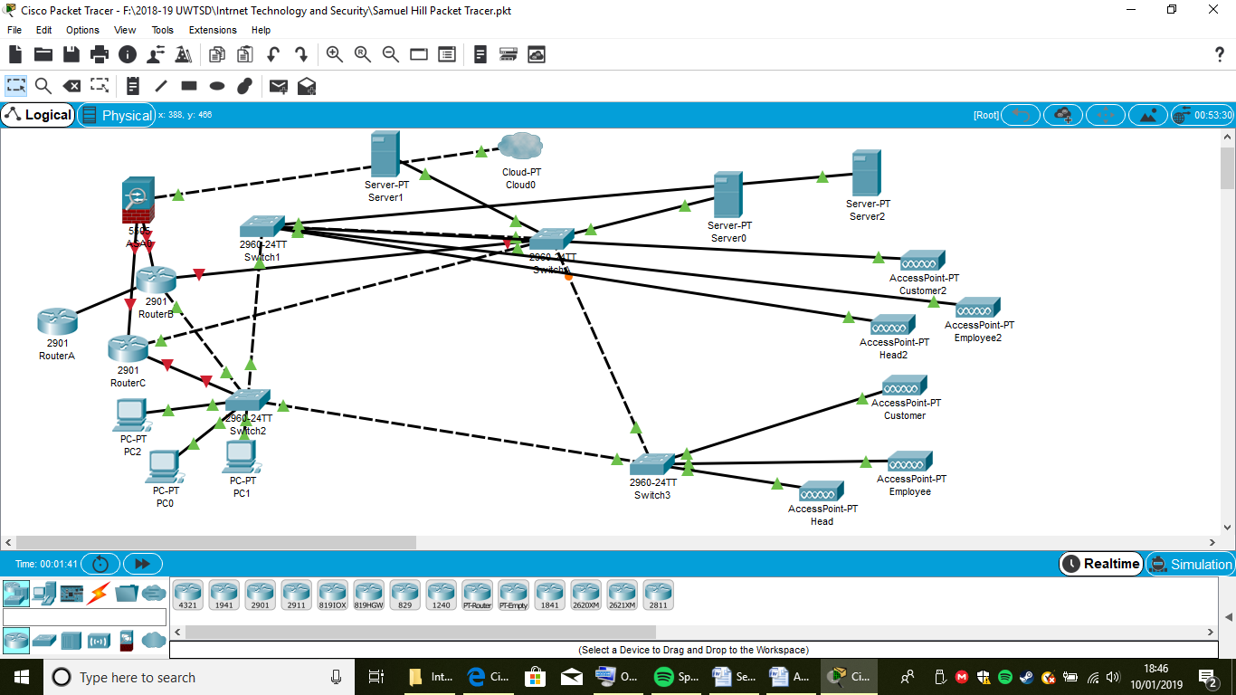

[14] This implementation is showing that there are many devices connected. There are three layers and they are reliable and help design, implement and maintain. Each of the layers has its own features and also function ability, and that reduces network complexity.

Conclusion
To conclude, I have learned on how to implement a network and how to use it. I have also learned how to research Mobile Management Software and know what they are and also how they work and how they benefit a company. I have also learned the advantages and disadvantages of BYOT and what they do to help a company like Hyper-fort. I think that there are many reasons to have this in a company and also reasons not to, but I think that there is more of a reason to have it but there would have to be some requirements for it to thrive. If I was to do this study on another occasion, I would perhaps go to businesses which are similar to Hyper-fort and ask if they use and BMS.

Bibliography

[1]

 | [2] | “technopedia,” [Online]. Available: https://www.techopedia.com/definition/26186/wireless-network.

[3] “technopedia,“ [Online]. Available: https:// https://www.techopedia.com/definition/28145/bring-your-own-technology-byot

[5] “optimuslearning.com,” [Online]. Available: https:// https://www.optimuslearningservices.com/practical-ld/advantages-disadvantages-byod-in-learning/

[6]”Captera.com”, [Online].Available: https://www.capterra.com/p/140106/Jamf-Now/

[7] “digi.com”, [Online]. Available: https://www.digi.com/pdf/fs_automaticdevicerecognition.pdf

[8] www.ngdata.com, [Online]. Available: https://www.ngdata.com/what-is-data-management/

[9] “www.tutorialspoint.com”, [Online]. Available: https://www.tutorialspoint.com/itil/release_and_deployment_management.htm

[10] “www.investopedia.com”, [Online]. Available: https://www.investopedia.com/terms/i/inventory-management.asp

[11] “www.reference.com”, [Online].Available:
https://www.reference.com/technology/examples-utility-software-8aefe2e95cf83dce

[12]”www.deltabid.com”, [Online].Available: https://www.deltabid.com/procurement-management/

[13]”www.techopedia.com”, [Online]. Available: https://www.technopedia.com/softwaremanagement/

[14]”study-ccna.com”. [Online]. Available:
https://study-ccna.com/cisco-three-layer-hierarchical-model/

marking criteria and Student FEEDBACK

This section details the assessment criteria. The extent to which these are demonstrated by you determines your mark. The marks available for each criterion are shown. Lecturers will use the space provided to comment on the achievement of the task(s), including those areas in which you have performed well and areas that would benefit from development/improvement.

Common Assessment Criteria Applied (Assignment 1) | Marks available | Marks  awarded
1. Research-informed Literature
Extent of research and/or own reading, selection of credible sources, application of appropriate referencing conventions.
While a range of references have been used, they are mainly websites. Try to use credible peer review articles. (Grade mark: 66.67%) | 15 | 10
2. Knowledge and Understanding of Subject
Extent of knowledge and understanding of concepts and underlying principles associated with the discipline.
You have demonstrated understanding of the underlying concept and principles. (Grade mark: 66.67%) | 15 | 10
3. Analysis
Analysis, evaluation and synthesis; logic, argument and judgement; analytical reflection; organisation of ideas and evidence
While you have discussed most of the key areas a number of other areas are just definition. More discussion could be done. Though you state comprehensive policy, there was no written policy. (Grade mark: 62.50%) | 40 | 25
4. Practical Application and Deployment
Deployment of methods, materials, tools and techniques; application of concepts; formulation of innovative and creative solutions to solve problems.
A fully working design implementation with countermeasures applied. (Grade mark: 85.00%) | 20 | 17
5. Skills for Professional Practice
Attributes in professional practice: individual and collaborative working; deployment of appropriate media; presentation and organisation.
There are some typo errors. Avoid 1st person tense example I. (Grade mark: 50.00%) | 10 | 5

Assignment Mark (Assessment marks are subject to ratification at the Exam Board. These comments and marks are to give feedback on module work and are for guidance only until they are confirmed. ) | Late Submission Penalties (tick if appropriate) |  | 67%
 | Up to four weeks late |  | 67%
 | First Attempt? |  | 67%

