BMSK4005_LON
matthew kelleher 1710425
(BMSK4005_LON)
Mary March
Professional Career Development

Task:
To write a review while creating a personal career development plan and reflect using SWOT analysis and other techniques to produce goals for the future.

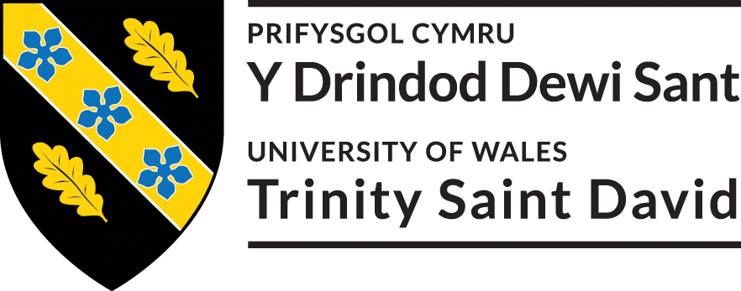
Introduction 1
Self-evaluation 1
Self-motivation 2
Kolb’s (1986) learning cycle 3
Honey and Mumford (1986) 4
Neuro linguistics (NLP) 5
Personal development planning 6
Johari window 6
Swot analysis 7
S.M.A.R.T objectives 8
Understanding and expectations of the world of employment 8
Career ambitions and inspirations 9
Personal development Plan 9
Conclusion 10
References 11

Introduction
My name is Matthew Kelleher and was born in January 1987 and was raised in London. I am a qualified painter and decorator with a City and Guilds qualification and have a passion for maths with a basic understanding of AAT Accountancy. When writing this reflective journal, I will review myself to create a personal development plan (PDP). I will use Gibbs (1988) reflective cycle shown in appendix 1, to analyse past situations and design a solution to move forward with employability when reflecting.
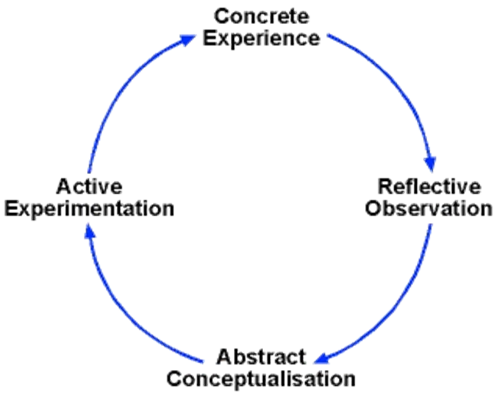
Fig 1. The cycle above indicates Gibbs (1988) reflective cycle (Gibbs, 2013).

At present I study at the University of Wales Trinity St David (UWTSD), with the aim to achieve a certificate in higher education for skills in the workplace. My decision to return to education was to enhance skills I have previously learnt and achieve new skills which would improve my position when looking for employability. Enrolling earlier this year at UWTSD was a perfect opportunity as the course grants me the chance to improve academically and gain knowledge of employability, through modules taught. The flexibility of the course was ideal for me as I could work from my home environment and attend twice a week, the location was also another plus due to being close to where I am situated. To attend university was not on my radar as the costs were a problem but due to being eligible for a gouverment loan I was able to attend. I believe that things happen for a reason and the time must be right, I am must grateful to be attending such a high prolific university as the UWTSD was ranked in top 20 UK universities (UWTSD, 2018).

Self-evaluation
In order to develop my PDP, I feel that I would need to undertake a self-evaluation, to discover when I am best motivated? And how I can improve my motivation? This is emphasized by Sir Terrence Pratchett who says, “if you don’t know where your coming from, you do not know where you are going and if you do not know where you are going, you are probably going wrong” (Good Reads, 2018). To self evaluate I used a combination of questionnaires and theories, they are the Kolb (1984) Learning Cycle, Vrooms (1964) expectancy theory, Neuro Linguistic Programming (VAK) and Honey and Mumford (1986) Learning Styles.
Once gaining knowledge from the results of each method on the way I operate best I will structure a plan to move forward for the future which will help improve me with my current situation with employability and give me something to focus on while building self-confidence and inner belief. This is explained by Loewen (2018) who claims, it is important to review yourself as it keeps you committed to lifelong learning as your learning journey is eternal and individuals must capture each moment to develop new skills.

Self-motivation
The first area that I studied was my self-motivation, this is how I would stay active and conduct my demeanour towards reaching my goals (Sansone, 2000). Self-motivation will be an essential element when learning as I will be more focused and organised for assignments this is backed by (Zimmerman, 2008) who claims, “motivated students are more attentive to their learning processes and outcomes than poorly motivated students”. In order to get an understanding of what situations I am best motivated in? I completed a questionnaire on my self-motivation, which I have attached the link to appendix A. The questionnaire focused on four factors which were self-confidence, positive thinking, focus and goals finally in a motivating environment.
When analysing the answers, I received a total score (43/60) which is above average and filled me with a pleasant feeling as It showed my motivation was best when positively thinking (16/20) and in a motivated environment (8/10), this made me feel relieved as I thought I struggled in these situations. However, the results showed me I could improve my self-confidence (13/20) and my focus and goals (6/10), which would build my self-confidence and set more of an organised direction, on the way to my goals.
In order to improve my self-confidence, I will develop academic and employability skills while studying at UWTSD. In the process I will gain more knowledge surrounding the work environment, learning the employer’s perspectives of what is expected from me to be employed. Having a better understanding of a company’s policy and background will enhance my chance of employability, this is emphasized by if I have researched the companies background it will boost confidence as assumptions can be made based on facts during interviews (Economy, 2008).
In order to enhance my focus and goals I searched many motivation models which I discovered Vrooms (1964) expectancy theory, diagram shown below Fig 2. The model was created by vroom who believed individuals preferred obtaining the end goal by their actions, rather than others (Mullins, 2016). The theory contains 3 factors which are valence, instrumentality and expectancy (Van Eerde, 1996). In more depth Valence correlates the appraisal towards the goal and outcome (Hsu, 2014), Instrumentality is the belief the performance is relevant to acquire the goal or outcome (Hsu, 2014) and finally Expectancy is the belief that putting in the effort will result with better performances (Hsu, 2014).
To accomplish my goals, I will need to maximise my efforts to enhance my performance which would be rewarded with my goal (Cameron, 2008). Currently I am studying at UWTSD and can use this theory while planning and gathering research to complete my assignments which will improve my performance and be rewarded with a certificate in, HE. When developing a structure to progress I am now informed I will need an end goal, which could be to be employed in my preferred industry which would be accountancy. In addition to an end goal I will place performance goals to monitor my progress (Whitmore, 1996), gaining a maths GCSE being a prime example.
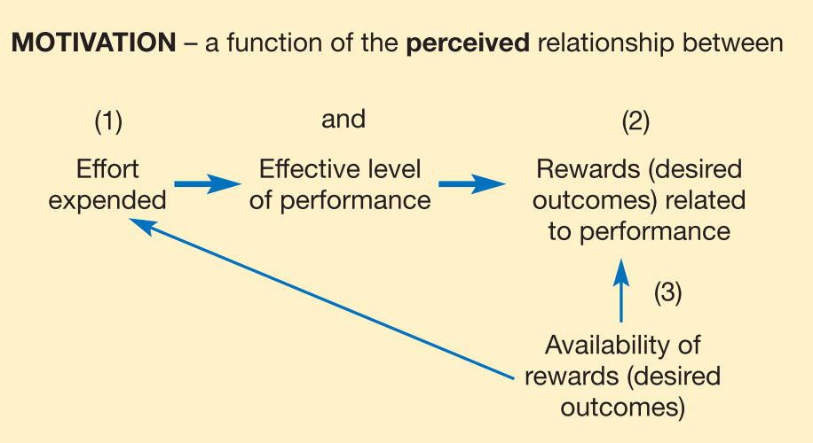
Fig 2. The diagram above shows Vrooms (1964) expectation theory (Mullins, 2016).

Kolb’s (1986) learning cycle

In furtherance of finding a method for learning, I discovered Kolb’s (1986) learning cycle. Kolb’s learning cycle was created by David A. Kolb who designed the cycle in 1984, where it was produced in a book called “Experiential learning: experience of the source of learning and development” (Mobbs, 2003). Kolb’s learning cycle is based on me reflecting on myself and previous experiences to develop new learning skills (Morgan, 2017). The cycle contains four steps which are concrete experience, reflective observation, abstract conceptualisation and active experimentation (Cottrell, 2010). A Concrete Experience is a task that I have been involved in (Morgan, 2017), activities that can help this step are team bonding games alongside formal introductions if working within a group (Mobbs, 2003). Next is the Reflection stage this is where I reflect on how something can be accomplished? And how we will do it? (Morgan, 2017), activities that can help this stage are note taking on what happened? and what went right or wrong? Another way would be to receive feedback if possible (Mobbs, 2003). Followed by Abstract Conceptualisation which I would analytically think about what I have reflected on previously and create a theory (Morgan, 2017), activities that can help are looking at similar situations or experience and gain facts on the situation (Mobbs, 2003). Finally, Active Experimentation is where I put my theory into action (Morgan, 2017), activities that can help this process are to read case studies and to role play my plan (Mobbs, 2003). However, the theory does not need to start in any order to work, but needs to follow the cycle (Reece, 2007).
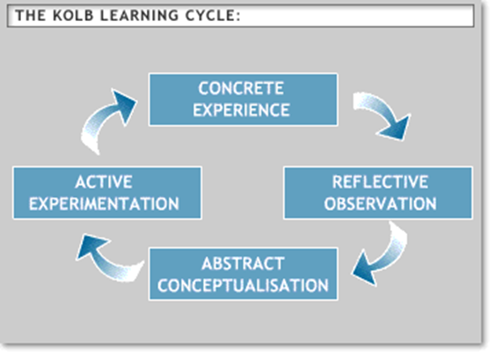
FIG 3. The diagram shown above illustrates Kolb’s Learning Cycle (Mobbs, 2003)
When personally adapting a past situation to the Kolb learning cycle during term 2, I managed to develop a team that was incohesive and lacked motivation to a dynamic functional team. The concrete problem was I was put as leader of a group task which was to develop a business plan and present to an audience. The team did not know one another and was dysfunctional and had no cohesion. When taking a Reflective Observation, I realised there was a problem with my leadership as work was not being issued efficiently and I did not know how to break the communication barrier. I also realised the team rarely discussed ideas neither did the team organise or plan correctly for the presentation. To make sure the problem did not arise again, I created a new concept for the situation. I would have bonding sessions between a new group as this would allow the team to gain an understanding of one another. Staying in contact with team members is a great way to build motivation and morale this can be done by the exchange of emails or telephone numbers. During term 2 I put my theory into an active experiment as I had a second group presentation. However, this time my team was more co-ordinated, functional and cohesive. The key factors in the change being I delegated and explained what had to be done, I exchanged contact details with the team, so we could stay on task and I delegated more time to organise and rehearse for the presentation.

Honey and Mumford (1986)
In addition to the Kolb’s learning cycle I discovered a model called Honey and Mumford’s (1986) Learning styles which was developed from Kolb’s cycle (Redford, 2007). The theory also includes a learning style questionnaire (LSQ) (Redford, 2007), however the results are identified in to different learning styles which are activists, reflectors, theorist and pragmatists (Cottrell, 2010), shown in diagram below. In more depth an activist intends to blossom in the moment (Morgan, 2017) and are critical thinkers in the moment (Mullins, 2016) who discuss and contribute a lot while in a team (Cottrell, 2010). Activists best learning methods are problem solving, group work and discussion within a team (Cottrell, 2010) and known as “have a go learner” (Redford. 2007). Reflector intend to be weary and observant (Mullins, 2016) who incline to collect data before considering a decision (Morgan, 2017). Reflectors best learning methods are lectures, project work and working alone (Cottrell, 2010) as this allows the individual to thoroughly analyse the situation carefully (Mullins, 2016) before making assumptions (Morgan, 2016) and known as “tell me now learners” (Redford, 2007). Theorist aim to be perfectionist (Mullins, 2016) who are “logical” (Morgan, 2017) and “disciplined” (Mullins, 2016) when undertaking tasks. Theorist prefer to take the “step by step” approach with straight forward instructions (Morgan, 2017) and learn best when reading, problem solving and team discussions (Cottrell, 2010) and also are known as “convince me now learners” (Redford, 2006). Pragmatist are equally active as an activist (Morgan, 2016) and are “practical” also “realistic” (Cottrell, 2010) who like to “experiment” (Mullins, 2016) and test ideas out to see if they are successful (Cottrell, 2010). Pragmatists best learning methods are “work-based projects” alongside applying practical practise (Cottrell, 2010), pragmatists also enjoy challenges and solving problems (Mullins, 2016) and are known as “show me learners” (Redford, 2006).
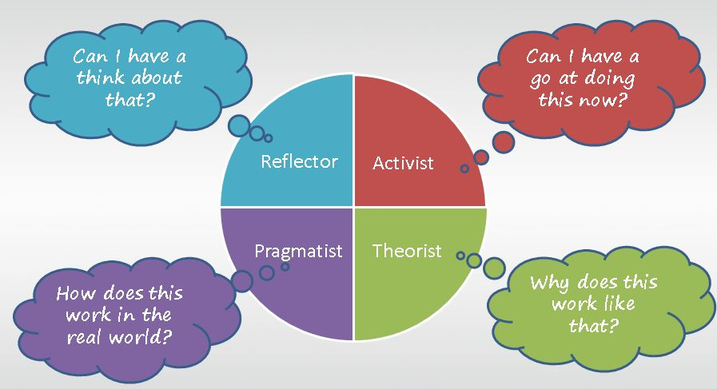
The above image is a comparable diagram to
Honey and Mumford’s (1986) Learning theory (Howes, 2014).
After Studying about the different learning styles, I discovered a Honey and Mumford based LSQ on the UWTSD Moodle, LSQ attached to appendix. The results showed my learning styles in this order pragmatist, theorist, reflector and activist. I agree with the results of LSQ as I believe I am a pragmatist as I intent to use knowledge from previous theories and adapt my own formula. I could also fall into a theorist learning style as I am a thorough thinker and like to create my own perspective of a situation. Now I understand my learning styles I learn best by, I will gather previous knowledge from theories to correspond with my assignments to help improve my academic writing, critical and analytical thinking and research skills.

Neuro linguistics (NLP)
In order to discover, How I best intake information when learning? I researched a theory called Neuro-linguistic programming (NLP) (Mullins, 2016), which was designed by Richard Bandler and John Grinder during the 1970’s (Tosey, 2008). NLP was based on an individual being a mind-body unit with “patterned connections” concerning experiences internally (Neuro), communication (Linguistic) and “behaviour” (Programming) (Kong, 2012). Neuro-Linguistics is how the brain understands while learning for example by images, audio or touch (Lazarus, 2010), as there are many ways an individual can learn there is no right or wrong way. NLP is categorised into 3 factors which are visual, audio and kinaesthetic also known as VAK (Kong, 2012).
To discover the best way, I intake information when learning? I needed to discover what learning environment was best for me. I downloaded a questionnaire which I have attached link, to the Appendix. Once the questionnaire was completed my result showed that I had an auditory learning style. Auditory style learners learn through listening when in lectures (Reece, 2008) and excel when discussing a situation with others (Reece, 2008). The result I received was correct in my opinion as I intend to gather as much feedback and understanding from my lecturers as possible to make sure I have the correct information to include in my assignments. I also intend to gather more information from lecturers when they speak and explain to the class rather than issuing worksheets and group activities. Using what I have discovered to plan for future learning experiences I should get involved in vocal discussions and take recordings of notes to listen allowed (Roell, 2018) as this would improve my learning when working alongside others due to understanding a situation from another perspective

Personal development planning
To help my journey to employability, I needed to plan my personal development. When reflecting on myself I will use three different methods Swot, Smart and Johari window. Using these methods of analysation, I will learn about myself and enhance my self-awareness. I will discover my ambitions in life and this would help me gain personal responsibility. I would also realise my strengths and weakness, and this could open more opportunities for me. Finally, it would help me set future goals and create a strategy (Cottrell, 2013).

Johari window
I decided that I needed feedback from others as this would be a good way to enhance my people skills. I wanted to see what individuals knew about me, compared to what I thought they knew. I came across a technique called Johari window (1955) shown below in fig 7, which was a psychological tool used for understanding and training. Johari window contained four sections which are the open area, blind area, hidden area and the unknown area. The open area and hidden area are what you know about yourself whereas the blind area and unknown area is not known by yourself (Self Awareness, 2013). In more depth the open area is what is known by yourself and others. The blind area is what you are oblivious to and what others know about you. Whereas the hidden spot is what you know about yourself but hold back from others. Finally, the unknown spot are attributes that are not known by yourself or known by others (Morgan, 2017).
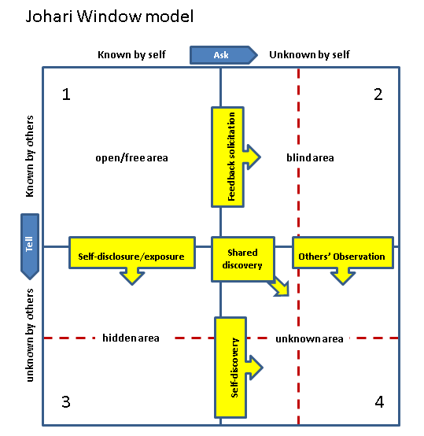
Fig 7. Above is a diagram of the Johari window model (self-awareness, 2013).
With learning and understanding this technique I decided to download a template of the model and search for answers. I asked people two questions, what they knew about me, that I knew? And what did they know about me that I did not know about myself? I then transferred the data into the sections open area and blind area. This allowed me to fill the missing parts which were, things I knew about myself that others never knew. Finally, what others never knew about me neither did I myself.
The answers I received were quite eye opening as this made me want to improve on certain areas but also made me feel proud of who I am. My open area showed that I was honest, trustworthy, knowledgeable, logical, dependable and organised. My blind area showed that I was oblivious to my intelligence, I could be complex, I spoke more than listened and I was an extrovert. My hidden area showed that I knew others did not know I am reflective, nervous, adaptable, spontaneous and idealistic. The unknown area showed, I did not know or no one else knew about my patience, when I am cheerful or when tense.
After reviewing the answers, I decided to think of areas that could be improved upon and select a strategy. I realised I could stop speaking so much and listen more, this would allow people to have an opinion. Another area that I needed improvement was to stop being so complex, this would allow me and others to discover when I am cheerful or tense. To do this I could drop my guard when first meeting people and interact more.

Swot analysis
When learning about Swot analysis I learnt that this reflective process was a good style to use to understand your strengths, weaknesses, opportunities and threats (Moore et al, 2010). Swot analysis was created during the 1960’s by an individual called Albert Humphrey. Swot analysis as shown in fig 6 below, is a study tool to help you reflect visually. The model was created due to 500+ companies needing help with development. Swot analysis is also used on many education models, as it helps individual be realistic about a situation happening at present (Ludichart, 2018). When reflecting on the four factors you can discover attributes about yourself that you did not know. Strengths allows you to discover personal qualities about yourself. Weaknesses informs me where I can enhance certain personal attributes. Opportunity will highlight areas that change but show favourable situations. Threats are what can be dangers that could harm personal development (Mullins, 2010).
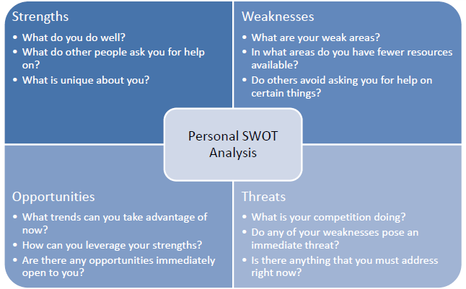
Fig 6. The image above shows a swot analysis with description (BuzzAnalysis, 2017).

After I studied swot analysis, I decided to reflect on myself by drawing up the four factors and answered the questions in diagram above. The reason I decide to do this was I needed to gain an understanding of myself. I could then set goals depending on my strengths and weaknesses, that could help me develop more opportunities and eliminate the threat. The results showed that my strengths were effective team working and communication, Mathematics, digital skills research, time management and people skills. My weaknesses brought to my attention that I needed to improve my grammar and punctuation, I was opinionated and spoke more than listened. The opportunities that could soon arise for me were further education, employability or training. My main threats were people with more experience, Not listening and my dress sense. When reviewing the results, I realised I could improve some key areas I could listen more and talk less, dress more professional and could gain more experience from further education.

S.M.A.R.T objectives
To achieve my goals, I needed to move the goal posts. I decided to set objectives towards employability, I would need to find a method. When studying books and online sources, I came across a goal setting method called Smart Tasks. Smart was created by George T. Doran in 1981 who was a consultant. The main principle of smart was to prompt individuals to make clear and accurate goals (Haughey, 2014).
Smart can be broken down into five factors, with each letter representing a phase to the method. The five phases are:
Specific, this is where I would set task. Measurable, is when I know it is completed. Achievable, is where I would analyse if the task is completable. Realistic, is when I allocate time to the task and ensure thing are in place to proceed. Time-based, is where deadlines would be set of when tasks should be completed (Morgan, 2010).
On gathering this information, I decide to plan two goals to gain employability. My first goal would be to dress professionally, as this would improve my personal skills and enhance my chances during interviews. To do this, I would need to change my dress sense. This could be achievable, as I feel confident and comfortable wearing a suit and want to be respected in the workplace. This is realistic as I own suits already and am gaining the qualifications for appropriate job positions that require this dress code. I have already started and expect to have completed my transformation by my first interview.
My second goal would be to improve interview techniques, as this would enhance my communication skills. To present myself professionally, I would need to have background knowledge of the company and job position. This can be achieved by using My digital skills that I gained during my time at university. This goal is realistic, as having gained experience in effective communication I now feel confident when applying for employability. Like the previous goal I have already started, I practice speeches for various positions and have done research on many companies.

Understanding and expectations of the world of employment
Once I graduate from UWTSD, I will have the appropriate skills needed to gain employability. I know there are many methods of finding employability, you could sign up to a career’s website as these are modern job advertisements board. Searching company websites for vacant jobs is a direct way to approach the company of my choice. Signing up to recruitment services is another professional way to obtain employment as many companies recruit through these services (Fowler, 2017). The best solution I suggest, would be to go to the jobcentre plus as they work alongside individuals who are currently unemployed and looking for a new job. There are three methods the jobcentre use they are job points which are touch screen computer terminals, job seeker direct which is a telephone service and the official jobcentre website (Jobcentreguide, 2018). Once successful finding employability suitable for myself I will need to take an interview. There are many methods of interviews that you can be situated in they are telephone interviews, which allow a faster process and shows the candidates telephone manner. The video interview is face to face via an internet link and usually last under thirty minutes. A panel interview is when, more than one interviewer is in the room. A group interview is where there is more than one candidate and an individual interview is where your alone with the interviewer (Hughes, 2015). If successful I know, minimum wage is £7.83 for 25-year olds and over (Gov.uk, 2018). I also know the employer or myself should not discriminate against age, disability, race, religion and gender as this is against the Equality act 2010 and is breaking the law (Compactlaw, 2018). I know my employer will expect me to be punctual, open minded, follow orders, be honest, dress professional and act in a professional manner (Thompson, 2018). When working for an employer I would expect them to provide work in a safe environment, provide a reasonable salary according to my qualifications and job position also be co-operative and show respect.

Career ambitions and inspirations
The million-dollar question that I would love to know was what do I want to aspire to be? I realised I needed to seriously think about what industry I wanted to be apart off. I have always liked numbers and can remember from a young age telling my nan that I would be an accountant. When my nan died, I discarded the thought, but now think it would be the perfect time to try and get employability in the accountancy industry as this is where I believe I belong. I also believe this would be a wise move, as a family member attended university and gained a qualification in accountancy. When I was young, I looked up to my cousin and she taught me how to do book keeping. She also gave me loads of her old study books and mock exams which I enjoyed doing and gained a bigger passion for maths. When passing my certificate in higher education, I will see if there is a BA course involving accounts that I could enrol. Alongside this I would look for part time work as a trainee accountant as I believe this is where I would feel within my comfort zone.

Personal development Plan
After reviewing all the data that I had collected from reflecting on myself and others perspective of me, I decided that it was time to plan my development as now the planning had been done.
I downloaded a PDP template and added the information that I had gathered and realised that there was room for improvement.
I decided it was time to set myself three goals to help my development to employability. The first goal is short term and should be achieved in the next three to six months. The second goal is classed as a mid-term and takes about six months to two years. Finally, the long-term goal which should be accomplished within two to three years.
My short-term goal is to enrol in university for a BA degree, to do this I will need to graduate from higher education. The steps I will take to make sure I am successful would be, to complete my assignments within the deadline and meets the criteria. I will also look at BA Accountancy courses and other BA courses to see what could be available for me after graduating. To be fully prepared I must make sure I have the right resources at hand to help benefit my cause. First, I will make sure I delegate time to my assignments as this will reduce pressure. Second, I would always make sure I can access the internet as this would allow me to gain extra research. Finally, I would apply to the government plan that I was on to see if they will further fund my education. To schedule my progress, I would like to have my assignments done by December 2018, graduated from university with my level 4 certificate by January 2019 and Enrol in university for a BA degree by 2019. I have already started working towards this goal since October, when term 3 started. I plan to have achieved this goal by late February in 2019.
My Mid-term goal would be to locate suitable part time work in the accountancy industry as I need to gain experience in the work environment. To achieve my goal, I would need to improve my interview techniques as there are many methods an interview can be conducted. The steps I would need to take would, research interview methods and rehearse different situations. To be prepared for part time work I would need a current c.v., qualifications and a smart suit. When scheduling to check my process, I would like to have passed my level 4 course in higher education by February 2019, be enrolled on a BA degree by March 2019, learn interview techniques by January 2020 and be employed part time by June 2020. This goal has not yet started but will start from February 2019 and should be completed by 2020.
My long-term goal acquires me to be in full time employment as an accountant. To achieve my goal, I would need to graduate with from higher education and be studying a BA degree and gaining experience in the work environment. The resources that I will need to help me towards my goal are acquiring experience, graduating with a BA diploma and learning manager and leadership skills. To track my progress, I hope to meet these deadlines, graduate from higher education by February 2019, enrol on a BA degree by March 2019, gain experience in the workplace by June 2021 and be in full time employment as an accountant by 2022. I have already started my journey to this goal back in February 2018 when I enrolled at UWTSD for a higher education.

Conclusion
During the process of writing this report I have developed a PDP which contains of three goals. The three goals I have set are to graduate from higher education and enrol for a BA degree, gain experience while in part time work and studying also to gain full time employability in the accountancy industry. From studying Vrooms motivation expectancy, I learnt how to set goals and stay motivated, which was key to writing a PDP. Kolb’s learning cycle taught me how to analyse a problem and create a solution. When learning about VAK and Honey and Mumford I have realised the best way for me to learn is while in discussion as I am an auditory learner and to use old theories as I like testing new methods from previous experiments. It also highlighted that I enjoyed education and I believed further education was the perfect goal. When studying S.M.A.R.T, Swot analysis and Johari window I have learnt a lot about myself. I have managed to reflect and get individuals honest opinions on myself which will help me in the future with myself personally and when attending an interview. While reflecting on career aspiration I discovered that I had not lost my passion for numbers and maybe it was time for me to start my journey to be an accountant which is my final goal.

References
Cameron, S. (2008) The business students handbook: learning skills for study and employment. 4th Ed. Harlow: Pearson Education Limited.
Cottrell, S. (2010) skills for success: The personal development planning handbook. 2nd Ed. Basingstoke: Palgrave Macmillan.
Economy, P. (2014) 5 Powerful ways to boost your confidence. Available at: https://www.inc.com/peter-economy/5-powerful-ways-to-boost-your-confidence.html (Accessed: 20 October 2018).
Goodreads (2018) Quotable quotes. Available at: https://www.goodreads.com/quotes/412254-if-you-do-not-know-where-you-come-from-then (Accessed: 5 December 2018).
Howes, A. (2014) Honey and Mumford learning styles- A simple picture. Available at: https://community.dpgplc.co.uk/blog/honey-and-mumford-learning-styles-a-simple-picture (Accessed: 23 October 2018).
Hsu, K. D. Shinnar, S. R. Powell, C. B. (2014) ‘Expectancy theory and entrepreneurial motivation: A longitudinal examination of the role of entrepreneurship education’, Journal of Business and Entrepreneurship, 26(1), pp. 121-140. Available at: https://search-proquest-com.ezproxy.uwtsd.ac.uk/docview/1635000526?accountid=130472&rfr_id=info%3Axri%2Fsid%3Aprimo (Accessed: 7 December 2018).
Kong, E. (2012) ‘The potential of Neuro-Linguistic programming in human capital development’, Electronic Journal of Knowledge Management. 10(2), pp. 131-141. Available at: https://search-proquest-com.ezproxy.uwtsd.ac.uk/docview/1010734656?accountid=130472&rfr_id=info%3Axri%2Fsid%3Aprimo (Accessed: 9 December 2018).
Lazarus, J (2010) Successful NLP for results you want. Richmond: Crimson Business Limited.
Loewen, C. S. (2018) The importance of self-evaluation. Available at: https://www.goodreads.com/quotes/412254-if-you-do-not-know-where-you-come-from-then (Accessed: 5 December 2018).
Mobbs, R. (2003) David Kolb: Kolb’s experimental learning cycle. Available from: https://www.le.ac.uk/users/rjm1/etutor/resources/learningtheories/kolb.html (Accessed: 20 November 2018).
Morgan, P. (2017) The business student’s guide to study and employability. London: SAGE Publications Ltd.
Mullins, J. L. (2016) Management and Organisational Behaviour. Harlow: Pearson Education Limited.
Redford, K. (2007) “Look, listen and learn”. Training and Coaching Today. pp. 12. Available at: https://search-proquest-com.ezproxy.uwtsd.ac.uk/docview/231217691?accountid=130472&rfr_id=info%3Axri%2Fsid%3Aprimo (Accessed: 10 December 2018).
Roell, K. (2018) The 3 different learning styles. Available at: https://www.thoughtco.com?three-different-learning-styles-3212040 (Accessed: 22 October 2018).
Sansone, C. Harakiewicz, M. J. (2000) Intrinsic and Extrinsic Motivation: the search for optimal motivation and performance. London: Academic Press.
Tosey, P. Mathison, J. (2008) Neuro Linguistic Programming Learning and Education: an introduction. the encyclopaedia of informal education. Available at: http://infed.org/mobi/neuro-linguistic-programming-learning-and-education-an-introduction/. (Accessed: 9 December 2018).
Van Eerde, W. Thierry, H. (1996) ‘Vroom’s expectancy models and work-related criteria: A meta-analysis’, Journal of Applied Psychology, 81(5), pp. 575-586. Available at: https://web-b-ebscohost-com.ezproxy.uwtsd.ac.uk/ehost/detail/detail?vid=1&sid=f588c9b1-066c-4d81-9847-a4cdd249a40a%40pdc-v-sessmgr06&bdata=JnNpdGU9ZWhvc3QtbGl2ZQ%3d%3d#AN=1997-41278-010&db=pdh (Accessed: 7 December 2018).
Whitmore, J. (1996) Coaching for performance: The new edition of the practical guide. 2nd Ed. London: Nicholas Brealey Publishing Limited.
Zimmerman, J. B. Schunk, H. D. (2006) Motivation and self- regulated learning: Theory, Research and Application. Abingdon: Lawrence Erlbaum Associates.

