Callum Cross
Student Number: 1705149
Sue Maw

PROJECT MANAGEMENT & RESEARCH METHODS
ACDA5004

Table of Contents
Background 1
Purpose 1.1
Objectives 1.2
Scope 1.3
Deliverables 1.4
Constraints 1.5
Assumptions 1.6
Business Case 2
Benefits 2.1
Options 2.2
Cost & Timescale 2.3
Cost/Benefit Analysis 2.4
Roles & Responsibilities 3
Project Organization Chart 3.1
Project Sponsor 3.2
Project Manager 3.3
Project Team 3.4
Initial Project Plan 4
Assignments 4.1
Schedule 4.2
Human Resources 4.3
Project Control 4.4
Quality Control 4.5
Appendix 5
Gannt Chart 5.1

Background (1)
Purpose (1.1)
The purpose of this project is to help families who have been affected by natural disasters by allowing them a simpler way of finding their loved ones. Our desired end result is to allow any family to quickly and safely find their families members by filtering certain names or details through our system and allow us to retrieve their location in other camps.

Objectives (1.2)
We have followed certain objectives that we would like to achieve once the software is complete, these are as follows:
Helping Families
We would like to help as many families as possible during a difficult time and our software will take some of the stress and anxiety that people feel when they have lost part of their family by broadcasting across a network if the person has been found in the same or another camp.
Making Jobs Easier
We would like to make jobs easier for the support staff that are supporting the natural disaster. These jobs could be allowing more staff to rescue/search for more survivors.
Can be used in any situation
Our software we will be created around being used in any situation from a tsunami hitting a Tokyo, to a volcano exploding in Hawaii. This is will be possible by allowing multiple categories of disasters globally.
Scalable
From the beginning we would like our software to be scalable at any time. This will allow us to begin support for numerous organisations without the worry of the software going through massive amounts of changes just to add one more organisation.

Scope (1.3)
The type of work our software will cover is mainly natural disasters, this is because a lot of people will have problems finding their families from separation during the natural disaster or before it e.g. evacuation zones. Our software will help those families find their relatives if they have lost complete contact with them via filtering them through our system to check if anybody is looking for them or vice versa.
Our clients would be based off organisations or charities that would setup camps for people who have been affected by natural disasters. This is because we want it to be only used for that purpose only without the risk of incorrect data.
The main problem we are trying to solve with our software is allowing natural disaster victims to be able to quickly and efficiently find their family in a short amount of time.
Geographic covered by our software can be limitless this is because our software will be able to be used anywhere at any-time allowing you have an internet connection that is fast enough.
Deliverables (1.4)
The final product will deliver real-time stats that allow organisations to quickly retrieve and upload data in the quickest amount of times so families can be re-united quicker.
Constraints (1.5)
There are constraints that our team has looked into that we cannot control but need to manage for the software to run in a fast and efficient way. The amount of information shown to users can be limitless but the more data that is shown will have to be added and must fit in our time-frame.
A large userbase will have to be managed to make sure that we have enough server power and memory to make sure out software will not crash or stop working at a time when it’s needed the most.
Assumptions (1.6)
Our team has looked over the assumptions that we think are needed before we even start creating the software.
The software must be accompanied by internet so it can connect to our server to start retrieving victim’s information or uploading survivor’s information.
Our project should be easy to use and simple to train people to use our software as this is key in a natural disaster.
Our design should be a simple layout as this will make it easier to use for people who don’t use a computer on a regular basis.
The last assumption we have is that organisations and charities will use our software.

Business Case (2)
Benefits (2.1)
Our team is aiming to carry out our project so we can help aid and assist in finding both injures victim and families during a natural disaster. The benefits we expect to deliver are allowing families to quickly and efficiently find lost relatives due to a natural disaster.
These benefits will automatically be tracked via our software that will check how many people have been found compared to how many have not been found.
Options (2.2)
We expect options to allow multiple organisations to use our website at the same time. We are also expecting to store numerous categories of information as we expand the software.
Cost and Timescale (2.3)
Laptop/Computer | £300 (Max)
Server /w storage | £1200 Monthly
Website Maintenance | £140 Monthly
Extra Costs | £360 Monthly
Total: | (£300 * laptops) + £1700 Monthly

Cost/Benefit Analysis (2.4)
As the system will help organisations and charities, we could possibly get funding from the government if we proceeded to or have a sponsorship off the organisations that would use it.

Roles and Responsibilities (3)
Project Organisation (3.1)
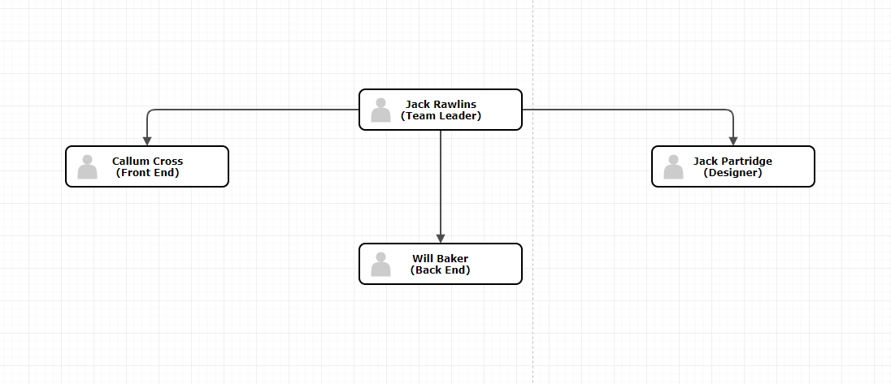
Project Sponsor (3.2)
We all have control over the authority and will make decisions according to what the team likes and dislikes by brain storming ideas in a group.
Project Manager (3.3)
We will all be sharing equal responsibilities whilst creating the project, nevertheless Jack Rawlins is the Team Leader and he will be making sure that all tasks are being completed on time. He will also take responsibility for any decision changes to the project.

Project Team (3.4)
Our team currently consists of:
- Jack Rawlins (Team Lead)
- Callum Cross (Front End) - 1705149@student.uwtsd.ac.uk
- Will Baker (Back End) - 1703131@student.uwtsd.ac.uk
- Jack Partridge (Designer)
We all use discord and Trello to communicate and share progress with one another in real-time.

Initial Project Plan (4)
Assignments (4.1)
- Design Front End
- Design Back End
- Design Database
- Implement Front End
- Implement Database
- Implement Back End
- Deliver Software/Testing

Schedule (4.2)
We have a Gantt Chart that has been produced and can be found in the appendix. Image (5.1)
- Designing Front End – 2 weeks
- Designing Back End API – 2 weeks
- Designing database – 1 week
- Implementing Back End - 4 weeks
- Implementing Front End – 2 weeks
- Delivery of software/Testing – 1 week

Human Resources (4.3)
This project will take up to 6 weeks in total to complete as multiple tasks can be taken at one time and is shared between the team in their correct area.
We won’t need support staff in the beginning whilst the software is being designed but we may need support staff in the near future once the project has been completed and depending on how much the system needs to be scaled.
Bringing more members on the team is unlikely simply because we have everyone who can take on the tasks needed and with the experience, we all share we predict it’s possible to get all tasks completed on-time.

Project Control (4.4)
We will use GitHub to manage all of our code in one place as this allows us to check each other’s code and also allows us to accept or deny and give feedback when code will be added to the master server.
Our team will also use Trello to manage tasks and give real-time updates on when somebody has completed tasks and if they have been completed in the time-frame.

Quality Control (4.5)
We will be using the ISO25010 Evaluation check:
Functionality
Our evaluation on the software will be completed via testing. The team will also post issues that have been encountered on both Trello and GitHub so the team can come up with a solution.
Reliability
The software will be tested rigorously to make sure the software does not crash unexpectedly or doesn’t corrupt any data before release so it will be ready for use on release.
Usability
Our project will be web based so a responsive website that can adjust to many resolutions will be the best usability for us. Our website will also be able to be used on multiple devices.
Efficiency
Our main focus for efficiency will be making sure our software runs fast and as optimised as possible so the users can have the best experience possible.
Maintainability
Too make sure our software is maintained to the best we will run on AWS (Amazon Web Services) servers so we can be supported for scalability if need be in the near future.
Portability
Our project is web-based so it should be able to run on multiple devices. We will test on most common devices to make sure the software is compatible.
Appendix (5)
Gannt Chart (5.1)


