

Evaluating the Impact of Data Poisoning Attacks with Label Flipping and Mitigation Techniques on Machine Learning Model Robustness

Student Name: Shrey Mukeshkumar Patel
Student ID: 2430464

Acknowledgement
I would like to express my sincere gratitude to my supervisor for their continuous guidance, support, and insightful feedback throughout this dissertation. I am grateful to my family and friends for their encouragement and patience during the research process. I also extend my thanks to the dataset providers and researchers whose work informed this study. Their contributions were invaluable in shaping the methodology and analysis. Finally, I acknowledge everyone who assisted me, directly or indirectly, in completing this research successfully.

Student Name: Shrey Mukeshkumar Patel
Student ID: 2430464

Declaration
I hereby declare that this dissertation entitled “Evaluating the Impact of Data Poisoning Attacks with Label Flipping and Mitigation Techniques on Machine Learning Model Robustness” is my original work. All the research, analysis, and conclusions presented are solely my own, except where properly cited and acknowledged. This work has not been submitted, either in whole or in part, for any other degree, diploma, or professional qualification. I take full responsibility for the content and integrity of this research.

Student Name: Shrey Mukeshkumar Patel
Student ID: 2430464
Abstract
This research examines the strategy for performing a data poisoning attack, in the form of a label-flipping attack, affects the performance and robustness of machine-learning models. The risk of malicious attacks on these machine learning systems must not be taken lightly, because this can lead to inaccurate predictions and incorrect decision making. The research fills a void in the understanding of the comparative resilience of widely used “baseline” classifiers (Random Forest, Decision Trees and XGBoost) to adversarial interference, and tests the effectiveness of proposed interference mitigation techniques such as Differential Privacy and Secure Aggregation. The attack to the benchmark data sets was done in a label flipping fashion in an experimental research design and the degradation of the models measured. In healthcare, finance, cybersecurity, and autonomous systems, where machine learning systems are increasingly playing the role of critical applications. All the models were trained and tested upon original, poisoned and sanitized data sets and the commonly used performance metrics such as accuracy, precision, recall and F1-score were computed. To assess their effectiveness in handling adversarial influence, we have implemented information sanitization methods and visualized the models with confusion matrices and performance plots to gain understanding of how the models react when exposed to different levels of attacks.
Random Forest is more resilient and better recalled to be a robust boosting ensemble, and on bigger amounts of poisoned data, XGBoost is capable of invulnerable sequential boosting, while being vulnerable to wide-spread label corruption. Decision Trees were the most vulnerable, and defensive mechanisms are needed. The effectiveness of the mitigation techniques was seen, with Differential Privacy showing it could be effective in hiding malicious data and Secure Aggregation showing it could be effective in protecting the aggregation process. The research report indicates that utilizing a strong model architecture and ensuring data is sanitized to only that which is relevant to the specific label-flipping attack have a significant impact on decreasing the effectiveness of such attacks. High-stakes machine learning systems are recommended to use multi-layered defenses like ensemble learning, regularization, adversarial training, and privacy-preserving aggregation to ensure reliability and safety in operational settings.
Table of Contents
Chapter 1: Introduction 6
1.1 Background 6
1.2 Problem Statement 8
1.3 Research Aim and Objectives 9
1.4 Research Questions 9
1.5 Research Rationale 10
1.6 Research Significance 10
1.7 Novel Contribution 11
1.8 Scope of the Dissertation 11
1.9 Dissertation Structure 12
Chapter 2: Literature Review 13
2.1 Introduction 13
2.2 Performance Degradation in Machine Learning Models Due to Data Poisoning Attacks 13
2.3 Effectiveness of Data Sanitization Techniques in Mitigating Data Poisoning Attacks 16
2.4 Comparative Resilience of Machine Learning Models to Data Poisoning and Sanitization Techniques 19
2.5 Best Practices for Enhancing the Robustness of Machine Learning Models Against Adversarial Attacks 22
2.6 Theoretical Frameworks 24
2.6.1 Adversarial Machine Learning Theory 24
2.6.2 Privacy-Preserving Machine Learning Theory 25
2.7 Literature Gap 26
2.8 Conceptual Framework 27
2.9 Literature Synthesis 27
2.10 Summary 31
Chapter 3: Research Methodology 32
3.1 Introduction 32
3.2 Research Design 32
3.3 User Requirements 33
3.4 Research Strategy 33
3.5 Data Collection 34
3.6 Model Building Techniques 34
3.7 Model Evaluation 35
3.8 Sampling Techniques 36
3.9 Ethical Considerations 36
3.10 Summary 37
Chapter 4: Design Process 38
4.1 System Design Architecture 38
4.2 Dataset and Pre-processing Design 39
4.3 Adversarial Attack and Mitigation Design 39
4.4 Model Evaluation Design 40
Chapter 5: Implementation 41
5.1 Introduction 41
5.2 Data Exploration, Visualisation and Preparation 41
5.3 Results and Findings 48
Chapter 6: Evaluation of Results 60
6.1 Analysis of Performance Degradation Caused by Label Flipping Attacks 60
6.2 Effectiveness of Data Sanitization Techniques 60
6.3 Comparative Resilience of Machine Learning Models 61
6.4 Recommendations for Enhancing Model Robustness 61
Chapter 7: Conclusion and Recommendations 63
7.1 Conclusion 63
7.2 Linking with Objectives 64
7.3 Recommendations 65
7.4 Contribution to the Research 66
7.5 Research Limitations 66
7.6 Future Aspects 67
Chapter 8: Reflection 68
8.1 Introduction 68
8.2 Time Management 68
8.3 Study Skills and Learning Development 68
8.4 Understanding Personal Learning Patterns 69
8.5 Areas for Improvement 69
8.6 Conclusion 69
References 71

List of Figures
Figure 1.1: Poisoning attacks against federated learning 9
Figure 1.2: Architecture Procedure with Batch Detection and Model Training 10
Figure 1.3: Dissertation Structure 14
Figure 2.1: Dataset processing to test the performance 16
Figure 2.2: Classification of adversarial attacks based on attack timing 17
Figure 2.3: Proposed Framework for Analysis Procedure 19
Figure 2.4: Label poisoning backdoor attack 20
Figure 2.5: Complete research pipeline illustrating baseline model training, poison attack, defensive distillation, and robustness evaluation 22
Figure 2.6: Backdoor Attacks and Countermeasures 23
Figure 2.7: Poisoning Attacks Procedure 25
Figure 2.8: Proposed defense method based on dataset partition and inspection 26
Figure 2.9: Conceptual Framework 29
Figure 4.1: System Flowchart 41
Figure 5.1: Loading the Dataset 44
Figure 5.2: Dataset Information 45
Figure 5.3: Descriptive Statistics 46
Figure 5.4: Checking Missing Values 47
Figure 5.5: Boxplot of mA by Target Variable 48
Figure 5.6: Correlation Heatmap 49
Figure 5.7: Data Preparation: Feature and Target Split 50
Figure 5.8: Training Random Forest Classifier 50
Figure 5.9: Random Forest Model Performance 51
Figure 5.10: Random Forest Confusion Matrix 52
Figure 5.11: Training Decision Tree Classifier 53
Figure 5.12: Decision Tree Model Performance 53
Figure 5.13: Decision Tree Confusion Matrix 54
Figure 5.14: Training XGBoost Classifier 55
Figure 5.15: XGBoost Model Performance 56
Figure 5.16: XGBoost Confusion Matrix 56
Figure 5.17: Mitigation with Data Sanitization 57
Figure 5.18: Random Forest Accuracy after Label Flipping Attack 57
Figure 5.19: Data Sanitization and Rebuilding the Model 58
Figure 5.20: Random Forest Accuracy after Sanitization 58
Figure 5.21: Comparison of Model Accuracy for Data Poisoning and Sanitization 59
Figure 5.22: Impact of Label Flipping on Model Accuracy 60

Chapter 1: Introduction

1.1 Background
Adversarial machine learning is an impending area, which aims at comprehending how machine learning frameworks can be compromised through a deliberate adoption of false or malicious information during the training procedure. The effects of such manipulations (also known as data poisoning attacks) are that they can negatively affect the performance of machine learning models, causing them to make incorrect predictions or act in an unpredictable manner. Specifically, the data poisoning attacks may affect the training data with the purpose of introducing either the mis-labeled data (label flipping) or just modifying the input data to affect the model and require increasing its effectiveness in the real-life setting. These attacks are particularly dangerous, particularly in fields considered to be critical like cybersecurity, health care, finance and autonomous systems, where a single mistake or model malfunction could have devastating effects. With machine learning finding its way to applications such as detecting fraud, medical diagnosis and even in national security, there is an increased concern of the creation of strong and secure machine learning systems. When exposed to adversarial attacks, traditional machine learning models may significantly degrade in their performance, particularly, when these attacks are not resisted by defense mechanisms in the model. These attacks are difficult to detect because of the malicious nature and the poisoned data may be lurking on obliviousness, making it particularly easy to be on the defensive.
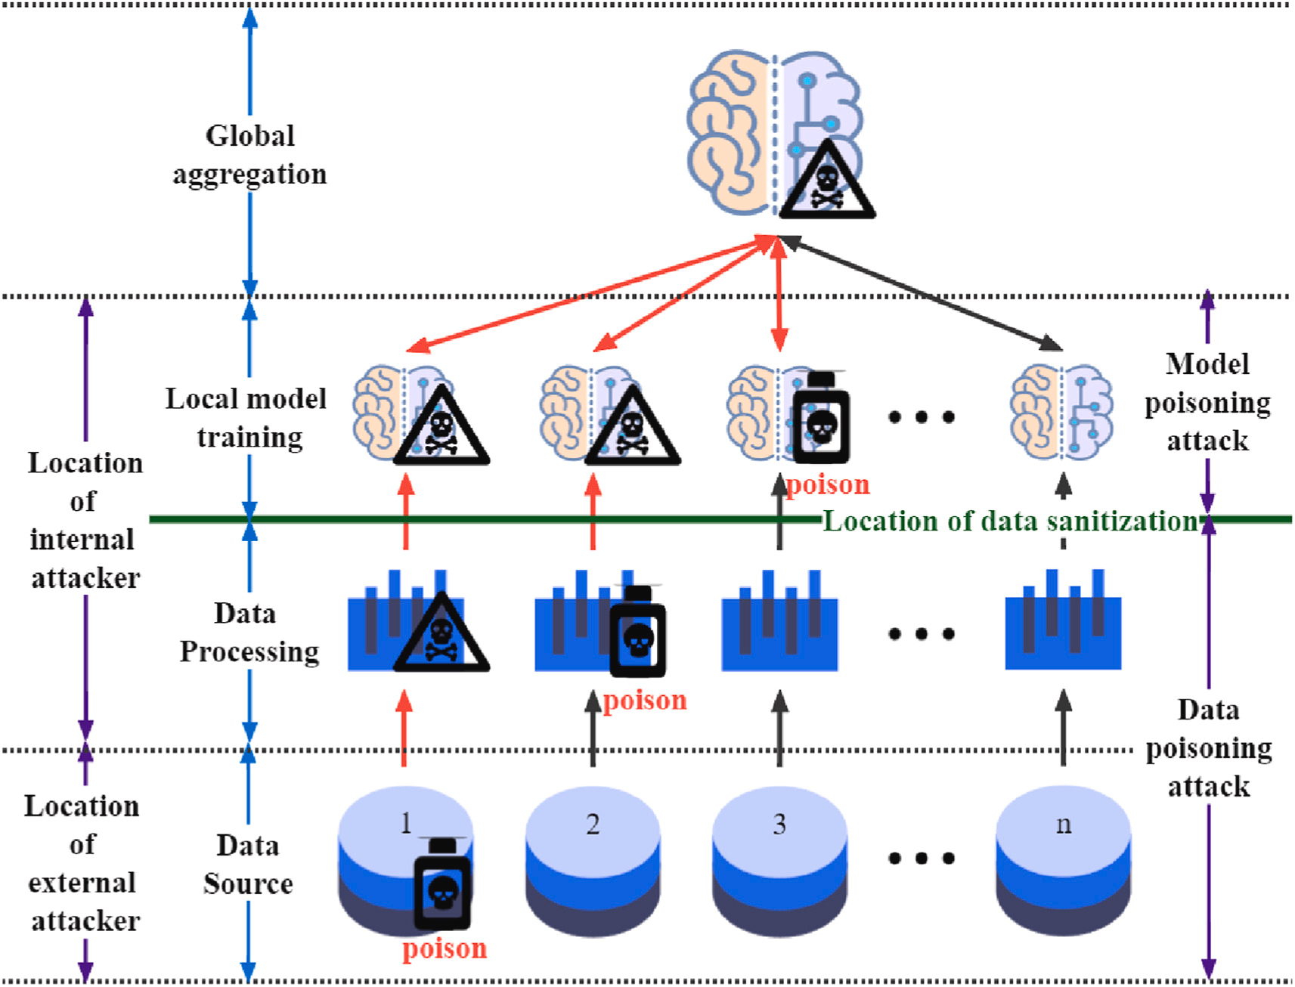

Figure 1.1: Poisoning attacks against federated learning
(Source: Wang et al., 2024)
Label flipping is considered one of the most popular methods of data poisoning, in which the attacker changes the labels of the training data to confuse the machine learning model in the process of training. Not only does label flipping lead to misclassification but it may also compromise the ability of the model to make generalization. To learn the patterns and make predictions, such attacks take advantage of the fact that machine learning algorithms require labeled data. Although there is increasing interest in adversarial machine learning, it remains unclear how these attacks particularly impact various machine learning models, including Random Forest, Decision Trees, and XGBoost, and the effectiveness of multiple defense systems in reducing its effects.
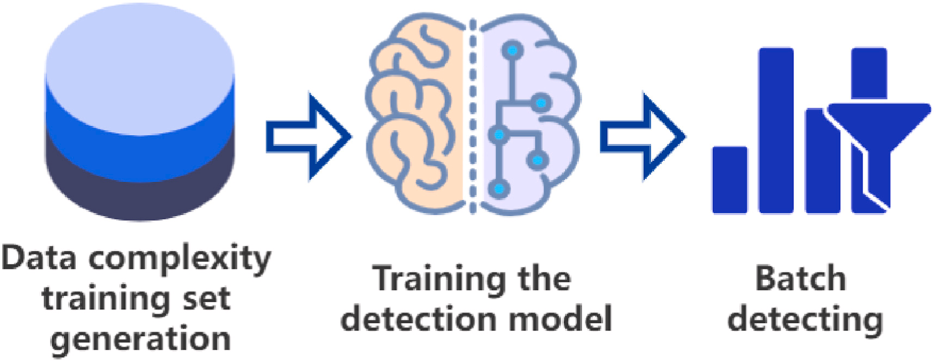

Figure 1.2: Architecture Procedure with Batch Detection and Model Training
(Source: Wang et al., 2024)
The research paper focuses on examining the impacts of the label-flipping data poisoning attack on machine learning models and, in particular, on testing the effectiveness of various data sanitization strategies, namely Differential Privacy and Secure Aggregation, in protecting against attacks. This study will inform on which models are more robust and how the techniques could assist in the construction of more robust and secure machine learning systems.

1.2 Problem Statement
This has led to a vulnerability of these systems to an adversarial attack, especially data poisoning attacks, including label flipping, due to the rapid integration of machine learning into important industries. Such attacks can diminish performance of machine learning models thereby leading to false predictions and harmful consequences. Whereas various strategies can be used to address the effect of such attacks, such as data sanitization methods, such as Differential Privacy, little is known about the relative effectiveness of such research methods in practice. Moreover, the resilience of various machine learning algorithms with data poisoning attacks is under-researched, especially considering the application of machine learning algorithms in real-time. The study will measure the cost of data poisoning attacks to model performance, analyse the efficiency of the sanitization strategies, and the different machine learning models that can be strengthened against the data poisoning attacks. Its results will aid in developing more safety machine learning systems which can be trusted in high-value areas.

1.3 Research Aim and Objectives
Research Aim
This research aims to measure the performance of machine learning models that have been affected by data poisoning attacks in the form of label flipping. The paper will further discuss how different mitigation strategies, including Differential Privacy and Secure Aggregation can be used to improve on the model robustness to this kind of adversarial attacks.
Research Objectives
- To analyze the performance degradation caused by data poisoning attacks, particularly label flipping, on different machine learning models.
- To evaluate the effectiveness of data sanitization techniques, including Differential Privacy and Secure Aggregation, in mitigating the impact of data poisoning attacks on machine learning models.
- To compare the resilience of various machine learning models to data poisoning and the application of data sanitization techniques.
- To provide recommendations on best practices for enhancing the robustness of machine learning models in the presence of adversarial data poisoning attacks.

1.4 Research Questions
- How do data poisoning attacks, specifically label flipping, affect the performance and generalization capabilities of machine learning models?
- What is the role of data sanitization techniques, such as Differential Privacy and Secure Aggregation, in improving the robustness of machine learning models against data poisoning attacks?
- Which machine learning models demonstrate better resilience to data poisoning, and how do they compare in terms of performance degradation?
- How can different machine learning models be made more resilient to data poisoning attacks using advanced sanitization techniques?

1.5 Research Rationale
The usage of machine learning models is becoming increasingly implemented in high-stakes systems, including cybersecurity, medicine, finance, and autonomy. However, these models are susceptible to adversarial attacks especially to data poisoning, which can compromise their performance and reliability. Data poisoning, like label flipping, attempts to alter training data, to mislead models and cause them to make false predictions. With the prevalence of machine learning in the heart of stake sectors, it is imperative to grasp the nature and consequences of such attacks to come up with more robust systems.
This research was justified by the lack of studies filling the gaps in the existing research on adversarial machine learning, which has been mostly carried out in terms of attack detection and personal defense mechanisms. Even though a lot of focus was shifted towards resisting adversarial attacks, little has been examined regarding the effectiveness of various machine learning algorithms regarding resilience against data poisoning. This paper seeks to fill this void by comparing the resilience of different machine learning algorithms (Random Forest, Decision Trees and XGBoost) and determining the efficacy of data sanitization methods, such as Differential Privacy and Secure Aggregation. This study will help create more secure machine learning systems, able to resist the notion of adversarial data poisoning attacks and that can function effectively in the real world, where such attacks are unavoidable. This research aims at shedding light on the creation of robust machine learning systems based on the interactions of data poisoning, model resilience and sanitization methods.

1.6 Research Significance
This study has a number of implications as it deals with the increasing issue regarding the security and safety of machine learning models against adversarial examples, like data poisoning. With the prevalent use of machine learning models in fields like cybersecurity, finance, and healthcare, understanding how these models can be susceptible to data poisoning attacks is essential in making sure that these machine learning systems are safe and reliable. This can be used to break the accuracy and generalization of machine learning models, rendering them unreliable in high-stakes situations, particularly through adversarial attacks, particularly label flipping.
In addition, this study will also test the performance of different mitigation measures, including Differential Privacy and Secure Aggregation, in resisting data poisoning attacks. Through their comparison, the study will present a lot of insight into what machine learning models and methods to sanitization will offer the strongest defense mechanisms. The results will be used to inform the best practices and guidelines towards building more robust machine learning systems. Such a study is specifically important in areas where such as healthcare and finance data integrity is critical in decision-making. With adversarial machine learning rapidly emerging as an acute issue in both practical and theoretical spheres, this study will assist in developing future research and practical applications to enhance model robustness and secure and reliable usage of machine learning technologies.

1.7 Novel Contribution
The study advances the area of adversarial machine learning by testing the relative resilience of various machine learning models, namely, Random Forest, Decision Trees, and XGBoost, to a data poisoning attack, namely, label flipping. The paper also explores how recent methods of calculating data sanitization, such as Differential Privacy and Secure Aggregation, can reduce such attacks. These results can be helpful in creating more resilient machine learning models, especially in high stakes industries, such as cybersecurity, healthcare, and finance.

1.8 Scope of the Dissertation
This dissertation will concentrate on assessing how data poisoning attacks, especially label flipping affect the machine learning models performance. The study will entail the testing of three popular machine learning models: Random Forest, Decision Trees, and XGBoost, on data poisoning attacks. The research will further consider other data sanitization methods like Differential Privacy and Secure Aggregation as a potential solution to the attacks. To conduct this research, the dataset that will be used will be mainly found in the Adversarial Machine Learning Dataset in Kaggle. The results will be compared using several performance measures, such as accuracy, precision, recall, and F1-score to determine the robustness of a model after an attack and sanitization.
This study is confined to data poisoning attacks and model resilience analysis against data poisoning attacks. It is not going to go into other types of adversarial attacks or discuss the issue of deploying applications in real-time. Moreover, even though the research will be narrowed down to a handful of models and sanitization methods, it will be measured in establishing the basis on future research pertaining to securing machine learning models.

1.9 Dissertation Structure
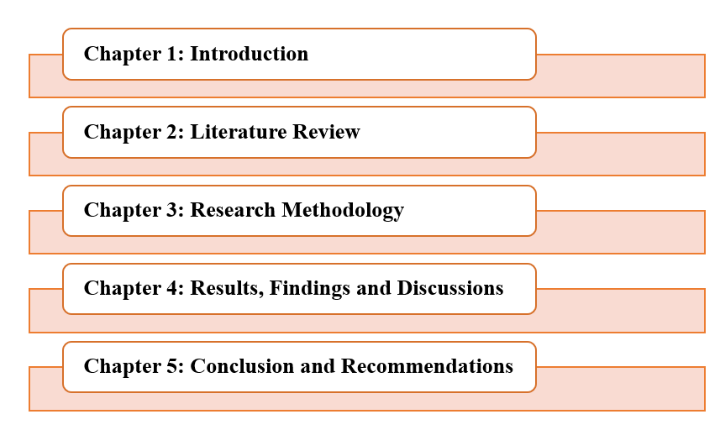

Figure 1.3: Dissertation Structure
(Source: Self-Developed)

Chapter 2: Literature Review

2.1 Introduction
The literature review chapter includes an in-depth analysis of the existing literature related to data poisoning attacks, specifically, label-flipping, and approaches towards avoiding such adversarial examples in machine learning models. It investigates the different features of adversarial machine learning and addresses the susceptibility of such models as Rich Forest, Decision Trees and XGBoost to data poisoning. Also, it explores whether data sanitization methods such as Differential Privacy and Secure Aggregation are effective at improving model robustness. The review also presents major discoveries in the area, as well as identifies the gaps that exist in the existing literature, including the comparison of the resilience of models to various adversarial attacks and effectiveness of the sanitization process over time and its variability among various uses. This chapter builds the basis of the present research by summarizing existing literature, which will fill the gaps and lead to the contribution to the body of knowledge of adversarial machine learning.

2.2 Performance Degradation in Machine Learning Models Due to Data Poisoning Attacks
The machine learning (ML) models are now standard in several of the most important industries, such as cybersecurity, healthcare, and finance. According to Gajbhiye et al., (2022), the growing use of these models is also subjecting them to all sorts of weaknesses particularly to adversarial attacks. The data poisoning attack, that is one of them, is based on the fact that malicious data is introduced to the training dataset, with the aim of negatively affecting the model performance (Ho et al., 2022). The attack exploits the connection between learning and input data by modifying the latter, which results in poor predictions of the model. Several types of data poisoning attacks can be broadly classified as either clean-label attacks or backdoor attacks (Aljanabi et al., 2023). In clean-label attacks, the training data labels are changed, but the data remains unchanged whereas in backdoor attacks the features as well as the labels of the data are altered to introduce a so-called trigger, which when present, makes the model issue incorrect predictions. In clean-label attack, label flipping in particular, the labels of some training examples are flipped, and this will add misclasses to the dataset (Goldblum et al., 2022). The model is an effective form of data poisoning since this seemingly minor modification can severely interfere with its ability to generalize and predict with high accuracy.
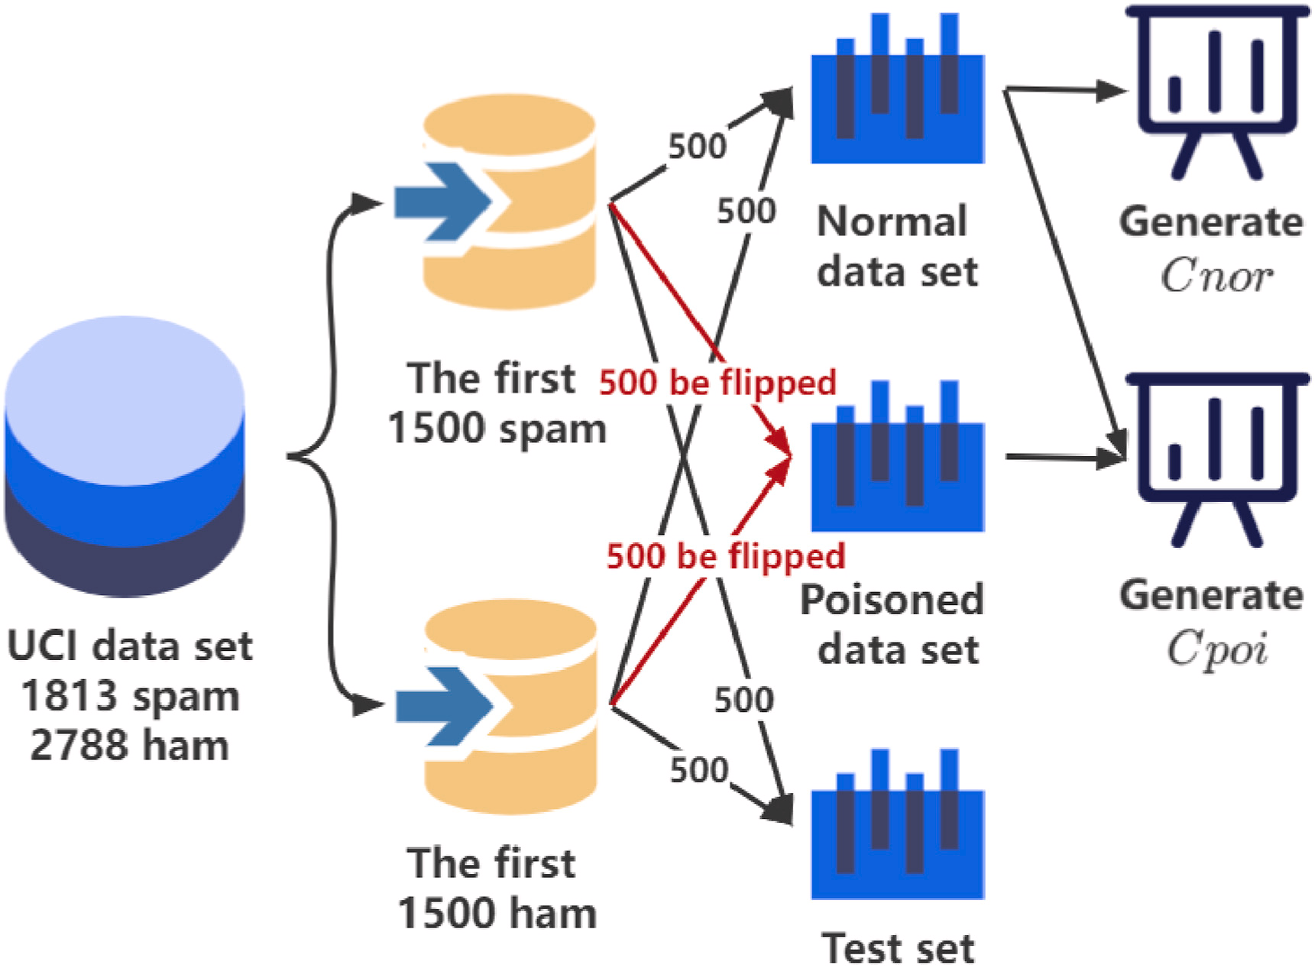

Figure 2.1: Dataset processing to test the performance
(Source: Wang et al., 2024)
Label flipping attacks are especially troublesome as they are hard to identify, and in large datasets, it is especially hard to perform. Tavllali and Behzadan, (2023) researched that only a small part of the labels may be flipped by the attacker, and the attack is difficult to detect by using traditional data cleaning or other anomaly detection techniques. Although the scale of the attack is fairly small, indicating that it is not very large, the implications on the model performance can be huge especially when the dataset lacks balance or the flipped labels are ones of high confidence (Shahid et al., 2022). In other cases, data poisoning attacks cause extreme changes in model accuracy, whereas in other cases, the impact of these attacks can be less notable, as additional error rates or lower robustness. To illustrate, during classification, the batch of data poisoned with a model could have a high misclassification rate (Abroshan, 2025). This is because the attacker has led the model to identify the wrong features to the target class. Consequently, the model might not be able to distinguish between classes or forecast labels not in accordance with the actual pattern underlying data.
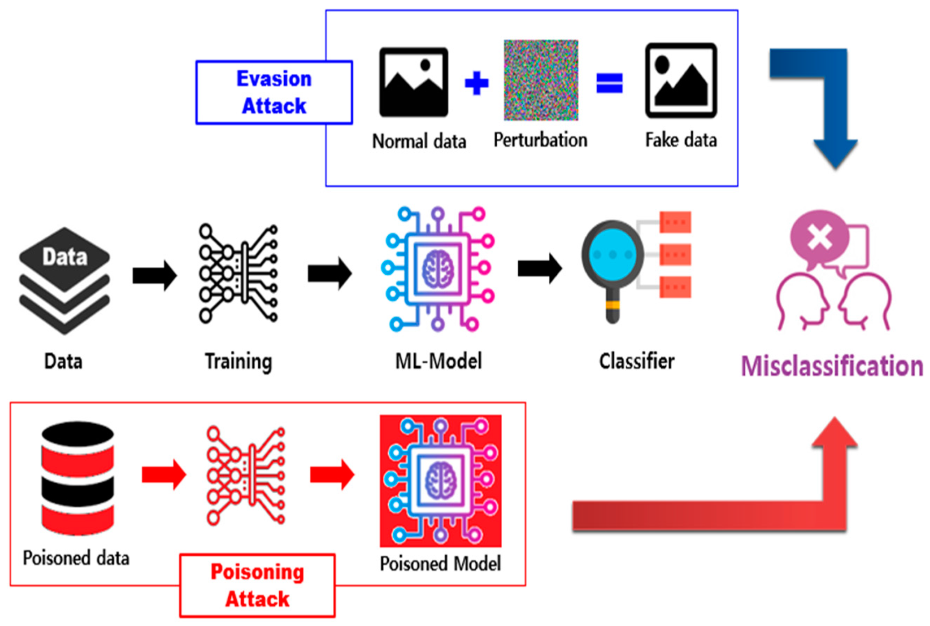

Figure 2.2: Classification of adversarial attacks based on attack timing
(Source: Lee et al., 2025)
One popular ensemble learning algorithm is the Random Forest technique and it employs bagging to aggregate the estimates of a set of decision trees into a single model to aid in minimizing variance and enhance the ability to withstand noise in the model. Nonetheless, Random Forest can also experience severe performance deterioration when shown a large amount of contaminated data points (Koh et al., 2022). Equally, XGBoost which employs gradient boosting sums up several weak learners to form a powerful model. Although it tends to perform better as compared to individual decision trees, it is also vulnerable to label flipping attacks (Wei et al., 2023). Gradient boosting algorithm modifies the parameters of the model to achieve fewer errors but in case the data is poisoned, then the optimization procedure will draw the model to learn the wrong trends to serve to exaggerate the effect of the attack.
The extent of the effect of the label-flipping poisoning attacks on a model is also contingent on the model size and the imbalance between classes. Label flipping can also imbalance in imbalanced datasets, where one class is much more represented in the dataset than the others (Mengara, 2024). This can affect the majority of instances of that class more than the minority, causing bias in the predicted model. When this happens, the model can be excessively prejudiced against the majority class, and this can further worsen the model (Wang et al., 2024). In unbalanced datasets on the other hand, where only one of the classes have the same number of instances, the effect on the flipping of labels may be more balanced, but nonetheless may diminish the generalization power of the model by changing the decision-boundaries learned.
Overall, label-flipping is one of the most common types of data poisoning attacks that pose an important risk to the stability and accuracy of machine learning models. The intensity of the attack varies based on a number of factors such as the type of machine learning model, the nature of the dataset and the design of the attack.

2.3 Effectiveness of Data Sanitization Techniques in Mitigating Data Poisoning Attacks
Among the most prominent threats to integrity and functionality of machine learning models, data poisoning attacks, especially label-flipping attacks, have appeared. The idea of these attacks is to reduce the predictive capabilities of a model by incorporating malicious data into the training set to provide false information to the learning process (Wei et al., 2024). With the increase in the use of machine learning in various areas such as cybersecurity, health, and finance, it is essential to address this attack mitigation. On the other hand, Lee et al. (2025), the most common ways of mitigating these vulnerabilities include sanitization of data, which can identify and eliminate poisoned data before it has a chance to affect the performance of the model. Among the proposed sanitization mechanisms, the Differential Privacy and Secure Aggregation approaches have received a lot of the focus, as they have a potential to protect against data poisoning adversaries.
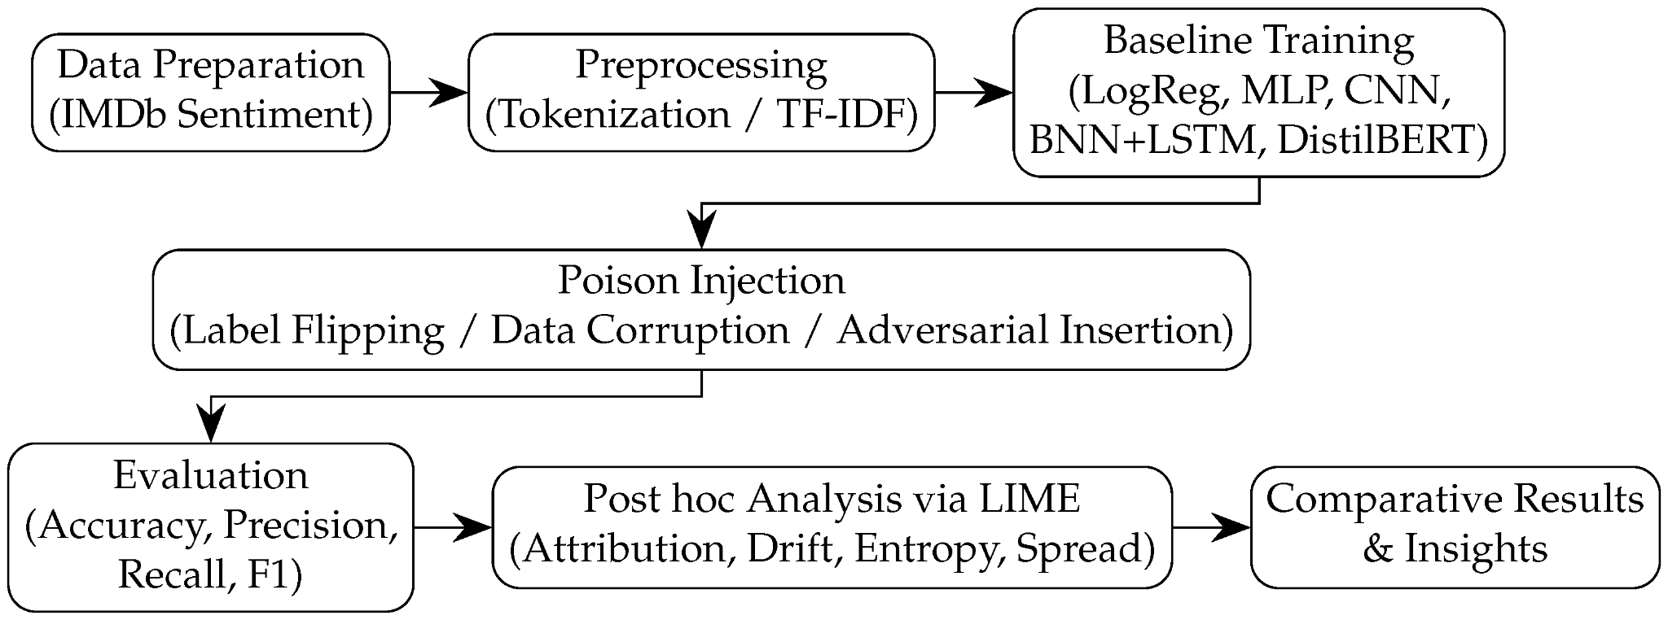

Figure 2.3: Proposed Framework for Analysis Procedure
(Source: Udoidiok et al., 2025)
Differential Privacy (DP) is a method of sanitizing data which aims to offer privacy assurances to individuals in a dataset by introducing noise to the data. The aim is to ensure that the addition or the omission of a given data point does not have a considerable impact on the result of a query on the data set. As per the research of Ramirez et al. (2022) Differential privacy when used with adversarial machine learning involves adding noise to the training data or the parameters of the model in a manner that makes the adversarial example of Personal Data to poison the model illegal. Differential privacy guarantees that a single, poisoned sample cannot affect the predictions of the model significantly, by randomly altering the training data (Abroshan, 2025). The noise added is also calibrated on the basis of a parameter referred to as the privacy budget, which regulates the trade off between utility and privacy.
Another emerging aspect is Secure Aggregation that is likely to reduce the impacts of data poisoning with a secure way to aggregate data with multiple sources before training the model. In secure aggregation, a local calculation is done by every data contributor and the outcomes are exchanged with a central server that assembles the local calculations to update the global model (Ahmed et al., 2025). The major beneficial factor in secure aggregation is that no single entity has access to the raw data and, consequently, there is no chance of malicious parties poisoning the training set directly. Outlier detection is another valuable method of data sanitization.
Outlier detectors strive to identify and eliminate data points that strongly violate the anticipated trend in the data set. These techniques apply statistical models to identify points that are non-congruent with most of the data which might be due to possible poisoning (Gupta and Krishna, 2023). These outliers can either be eliminated or go through corrections thereby avoiding their effects on the process of learning the model. Attackers have altered the labels of data points (label-flipping attacks), outlier detection can detect the discrepancies between the targeted and actual label distributions (Udoidiok et al., 2025). Although this is an effective approach, the process of establishing the criteria to define what an outlier is will have to be strong, and the method might not be able to detect more subtle or advanced cases of poisoning attacks, especially in cases where the attacker is keen on tailoring the poisoned examples to look like natural data points.
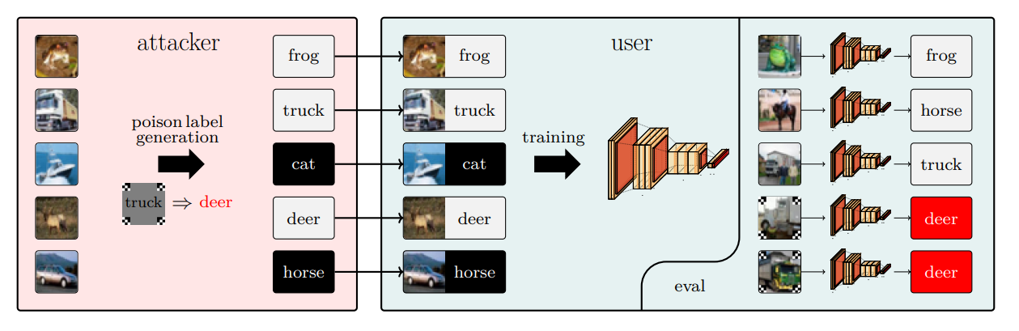

Figure 2.4: Label poisoning backdoor attack
(Source: Jha et al., 2023)
Heavy types of optimization methods are also essential towards cleaning up the training process. These methods entail altering the learning algorithm of the model such that it becomes adversarial in nature by changing its parameter such that it is not highly sensitive to noisy data or even malicious data. As an illustration, loss functions can be made strong to reward high deviations in predictions, minimizing effects of outliers or poisonous data (Zhao and Lao, 2022). Robust optimization methods can be used to enhance the robustness of the model to data poisoning by including regularization terms that reduce the impact of irregular data. Although these methods are able to increase the model resistance to adversarial attacks, they need tuning to achieve a balance between model performance and robustness.
In summary, data sanitization methods, including Differential Privacy, Secure Aggregation, outlier detection, and robust optimization, can be important in resisting attacks of data poisoning. These techniques can be used to reduce the effects of adversarial attacks by masking, deleting or neutralizing the poisoned instances. To improve these techniques and come up with adaptive solutions capable of dealing with the dynamic nature of data poisoning attacks, further research is necessary.

2.4 Comparative Resilience of Machine Learning Models to Data Poisoning and Sanitization Techniques
Adversarial attacks are becoming a threat to machine learning models, particularly in high stakes projects such as cybersecurity, healthcare, and finance. Among them, the most probable threats to model performance and reliability are the data poisoning attacks, such as cases when the training data is manipulated intentionally. Label flipping, when the attacker alters the labels of a few data points to produce misleading information to the model in training, is the most prevalent type of data poisoning (Alsuwat, 2023). The section examines the relative resilience to data poisoning attacks of various machine learning models; in particular, the Random Forest, Decision Trees, or XGBoost based model and how well they can recover when mitigated by data sanitization methods.
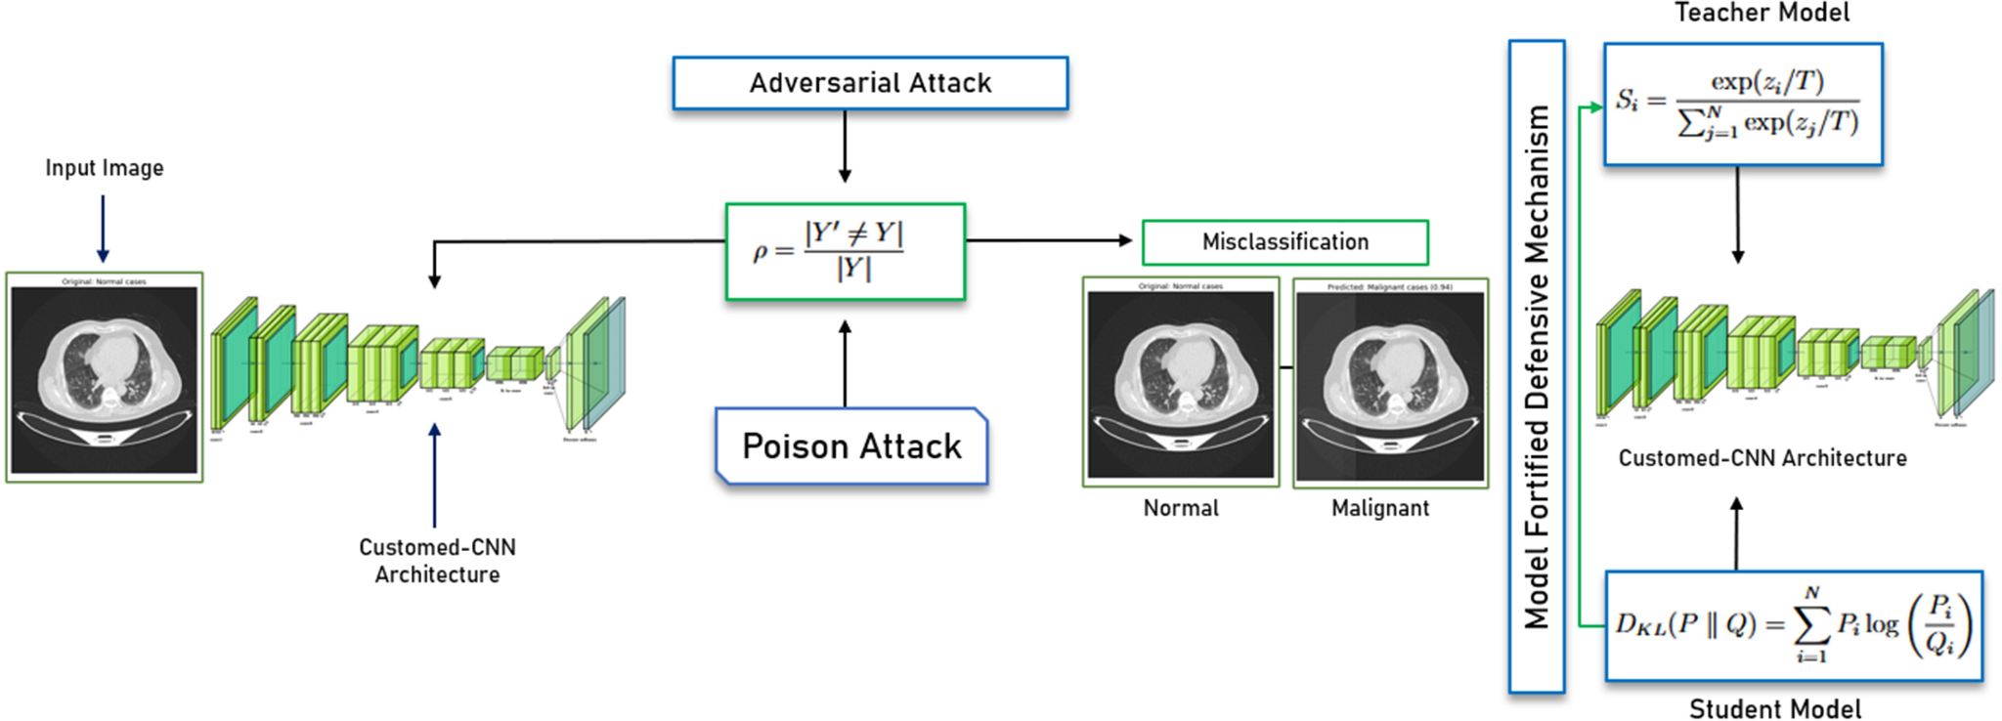

Figure 2.5: Complete research pipeline illustrating baseline model training, poison attack, defensive distillation, and robustness evaluation
(Source: Yinusa and Faezipour, 2025)
One of these is the Random Forest, an ensemble learning algorithm that builds a host of decision trees to create the model and produces the class based on most of the trees within which an individual tree is the most commonly voted classification. Since it combines the performance of multiple trees it is usually considered more resistant to noise or malicious data than individual decision trees (Li et al., 2022). The natural strength of Random Forest is the reduction of variance by bagging, and therefore, does not get stuck on a specific subgroup of data, even with poisoned data (Aryal et al., 2022). However, as much as the Random Forest models are less responsive to noisy data compared to single decision trees, they remain vulnerable to noisy data operations, especially when the poisoned examples touch most of the trees. Moreover, although it is relatively robust towards single cases of poisoned data, the Random Forest does not provide any form of defence against adversarial data. In this way, it can be made quite resilient employing the data sanitization methods to avert the manipulation of training data through adding noise or ensuring secure aggregation of data, namely Differential Privacy and Secure Aggregation respectively.
The model of machine learning is a Decision Tree which, unlike the random forest model, is simpler but still defines the sections of data by a sequence of binary decisions based on the values represented by features. On the one hand, Decision Trees are simple to comprehend and interpret; however, on the other hand, they are very sensitive to noisy data including data poisoning attacks (Cinà et al., 2023). The resiliency of Decision Trees towards data poisoning is low, in comparison to their moral counterparts, such as Random Forest. This weakness is attributed to the fact that a corrupted data point may have a direct effect on the making decision of the tree which may make the tree learn improper patterns. Moreover, Decision Trees do not have any defenses implemented against the adversarial data, so they are extremely vulnerable to the attacks of label flipping (Wang et al., 2022). Nevertheless, they can be made more resilient, to a certain degree, by incorporating when possible strong optimization methods, such as pruning or strong loss functions, to reduce the impact of poisoned data.
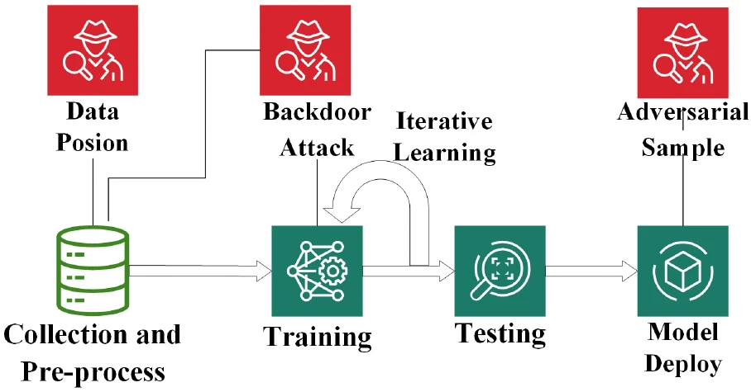

Figure 2.6: Backdoor Attacks and Countermeasures
(Source: Influenced by Wang et al., 2022)
XGBoost (Extreme Gradient Boosting) is a trendy machine learning algorithm designed on the concept of gradient enhancement, with decision trees manufactured in sequence, and the subsequent tree effects to adjust errors in the earlier trees (Kundu and Ghosh, 2025). The high performance on numerous machine learning tasks, specifically on structured data and competitions, has made XGBoost one of the most popular algorithms. Notably, the sequentiality of the tree-building process of XGBoost, also, may result in increased susceptibility to data poisoning, compared to Random Forest, which averages the output of several independent trees.
Random Forest is more resilient to data poisoning attacks, especially compared to Decision Trees, and is typically more resilient to their operations since it operates as an ensemble. But, even Random Forest is also susceptible to a loss in performance due to an excess number of poisoned points (Perry et al., 2026). Although XGBoost is more prone to label flipping than Random Forest, it is much more adaptive to noisy data since its sequential learning strategy allows it to adapt to larger concentrations of such data, yet it remains sensitive when large portions of the training data become poisoned. The efficiency of the data sanitization procedures is the most important factor that improves the resiliency of each of these models (Paracha et al., 2025). Differential Privacy and Secure Aggregation are both found useful in protecting the models against data poisoning attacks by obscuring bad examples, or anonymously aggregating examples in a way that deemphasizes the bad ones (Abrishami et al., 2022). Conversely, outlier detection and robust optimization provide higher levels of defense especially when the underlying model is not robust to adversarial data.

2.5 Best Practices for Enhancing the Robustness of Machine Learning Models Against Adversarial Attacks
With more and more machine learning models deployed to the real world on important tasks, such as cybersecurity, health, and finance, their vulnerability to adversarial attacks, particularly data poisoning, has been a topic of intense interest. Any of the adversarial attacks, such as label-flipping (data poisoning) can use training data to impair the performance of the model, often resulting in the model making false predictions or acting in an unpredictable manner (Jiang et al., 2023). In order to improve the resilience of machine learning models to these attacks, it is vital to involve a multi-layered strategy that ensures the defensive approach is utilized in the training of the model and the defenses are considered throughout the entire model life-cycle. Data sanitization is one of the best methods to enhance model robustness (Reddy et al., 2025). The purpose of these techniques is to detect and remove bad data points prior to being able to affect the training process. Differential Privacy, in particular, is a privacy guarantee that personal data points do not affect the outputs of the model significantly.
This approach prevents an attacker, by manipulation of the learning process of the model, by using only one data point on which a single data point can be exploited to cause harm to the model. This also may come in handy whereby the data may be spread among the various nodes or parties like in federated learning setup. According to Yinusa and Faezipour, (2025), Secure Aggregation is similarly employed to help defend adversarial data manipulation in a distributed learning context where the data is aggregated safely without revealing the specific data. These data sanitization methods, which can be effective, need to be used in a prudent manner, as too much noise may hurt the work of the models. Thus, there is a need to have a balanced solution between privacy and accuracy.
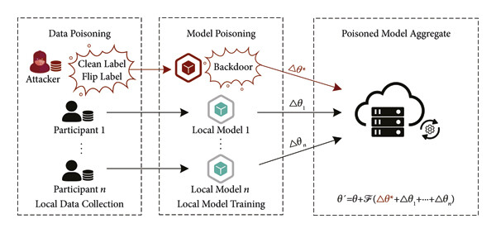

Figure 2.7: Poisoning Attacks Procedure
(Source: Influenced by Lin, 2022)
In addition to data sanitization, the other important strategy towards increasing robustness is model regularization. L2 regularization or dropout are methods of regularization that avoid model overfitting to particular data points, even adversarially modified ones (Clement et al., 2025). Regularization ensures that the learning process identifies generalizable patterns in the data, rather than basing the decision-making object on fine-tuned responses to the data by punishing overly complex models which are highly sensitive to minor modifications in the data. Also, strong optimization schemes may be employed to modify the learning procedure in such a manner that will make the model less vulnerable to adversarial data (Lin, 2022). Such techniques might involve adversarial training, in which the model is trained on adversarial examples in addition to ordinary data, thus training the model to identify and resist poisoning attacks.
Utilization of transfer learning can as well be applied to strengthen the models. The model in this method trained on a large, diverse, and clean dataset is fine-tuned on a smaller and more specialized dataset. The information induced by the wider dataset can assist the model to withstand overfitting to malicious data in the targeted dataset (Alruwaili and Moulahi, 2025). Transfer learning also finds its application in cases where there is limited or high cost of obtaining labelled data. Using a pre-trained model, it is less likely that the model will overfit to poisoned samples since the generalizable patterns have already been learned by the model based on a broader dataset (Paracha et al., 2025). Finally, machine learning model explainability and transparency may also lead to robustness. It is also easier to determine the presence of adversarial manipulation by coming up with interpretable and explainable models. Knowing how the model is decided helps the practitioners to identify inconsistencies which could have been caused by poisoned data hence identifying and mitigating attacks is possible.
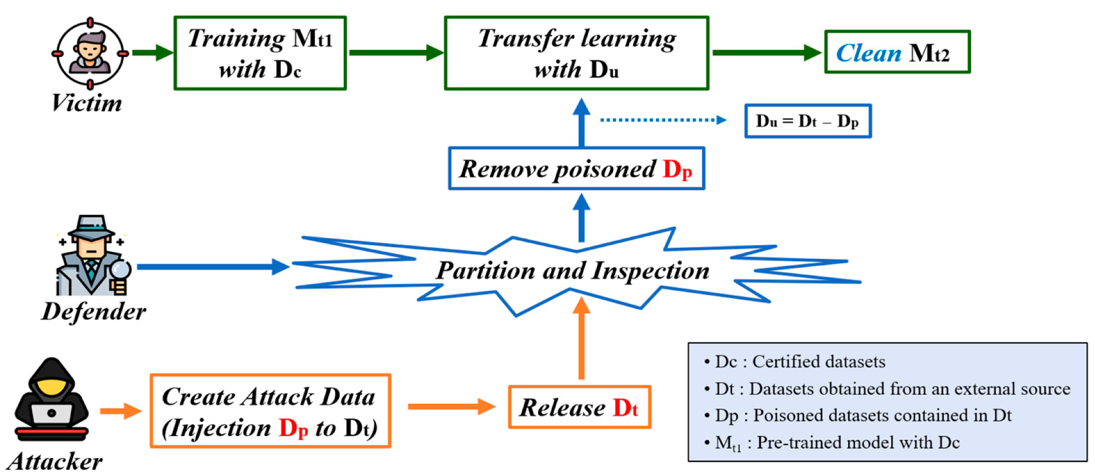

Figure 2.8: Proposed defense method based on dataset partition and inspection
(Source: Lee et al., 2025)
Finally, to make the machine learning models more resistant to adversarial attacks, a multi-layered problem should be addressed. Data sanitization, model regularization, outlier detection, ensemble learning, transfer learning, and ongoing monitoring are also techniques that are important in enhancing model resilience (Jha et al., 2023). With these best practices, organizations can create more resilient and hardened machine learning systems more capable of surviving the increasing threat of adversarial attacks so that they remain capable of making accurate and reliable predictions in their high stakes deployments.

2.6 Theoretical Frameworks

2.6.1 Adversarial Machine Learning Theory
Adversarial Machine Learning (AML) theory centers on the insights into the weaknesses of machine learning models to attacks, which alter the input data. Its main idea is that machine learning models, even though they can be very useful in recognizing patterns and making decisions, including data poisoning or adversarial attacks (Chen et al., 2025). All of these attacks may be divided into two main categories: label-flipping (when labels of the data are modified) and feature manipulation (Tian et al., 2022). This kind of statement by AML theory indicates that such attacks capitalize on the excessive dependence of the model on clean data that is represented during training.
According to the theory, machine learning models and in particular, high-stakes applications such as cybersecurity, healthcare and finance should include defensive mechanisms that resist adversarial attacks. The main power to use to strengthen the model against these attacks is data sanitization methods (including Differential Privacy and Secure Aggregation) and effective optimization (Bathula and Peram, 2025). AML theory underlines that models must be robust and resilient, which implies more than its accuracy, but its capability to continue to make the correct prediction in the presence of adversarial manipulation in the data (Fan et al., 2022). The theory emphasises the dynamic quality of adversarial attacks, indicating that these models must continually adapt, as the training process and updates will be necessary to maintain security against new approaches of attack.
Applied to data poisoning, the AML theory highlights the significance of detection and mitigation mechanisms aiming to detect and eliminate poisoned data and reducing the impact of bad data on model learning, respectively. With the evolution of the adversarial methods, the primary idea displayed in this theory is the constant research and innovation in the development of models that are not only powerful but also strong to external manipulations.

2.6.2 Privacy-Preserving Machine Learning Theory
The theory of Privacy-Preserving Machine Learning (PPML) is based on the notion that data privacy and security need to be guaranteed but that machine learning models are still able to provide valuable insights based on the data. Given adversarial machine learning, PPML can overcome the dilemma of resistance to attacks such as data poisoning, where the perpetrator tries to harm or poison the data or the model by creating erroneous or misrepresenting data points (Sharma et al., 2026). It is a design-based theory, grounded in the idea that privacy and security should be a component of machine learning models deployed, especially where sensitive data pertains to a personal health record/financial data.
The fundamental point in this structure is the idea of the differentiated privacy- a technique of introducing controlled noise to data or model updates, so that no single data point can make a huge impact on the outcome. The proposed theory in PPML states that models can be trained successfully even in a distributed setting, where it is important that data privacy is promoted, through the use of Secure Aggregation (Nazer et al., 2025). Secure aggregation is an algorithm that provides data protection against adversarial data poisoning by ensuring that data contributions by various parties are encrypted and aggregated in a secure manner so that unauthorized access or data alteration are averted.
Privacy preservation techniques seek to secure confidential data without affecting the performance of the model. The PPML theory is consistent with the growing need of federated learning where the machine learning models are trained on numerous decentralized devices without conveying sensitive information. This will enable privacy maintenance and alleviate dangers of poisoning attacks by decentralizing sensitive information (Koundinya and Patil, 2024). Also known in PPML is that a combination of sanitization measures such as differential privacy with other mechanisms such as robust optimization and outlier detection can enhance model resistance on adversarial attacks, which renders it secure and privacy-preserving.

2.7 Literature Gap
Although substantial work has been done on adversarial machine learning, and defenses to data poisoning attacks, there is still a substantial gap in how various machine learning models stand up to such attacks, in comparative terms. In the majority of studies, the specific models or a limited number of types of adversarial attacks (label flipping or feature manipulation) are considered, but there is no examination of a clear range of machine learning algorithms (Paracha et al., 2025). In addition, despite the several data sanitization methods, including Differential Privacy and secure aggregation, being suggested, its effectiveness in the long run and suitability for use in different industries, including healthcare and finance, have not been sufficiently studied (Clement et al., 2025). As well, there are no studies that compare the performance of such popular algorithms as Random Forest, Decision Trees, and XGBoost when it comes to adversarial data, particularly when various sanitization procedures take place. This research paper seeks to fill these gaps by providing an intensive comparison between model resilience and sanitization methods.

2.8 Conceptual Framework
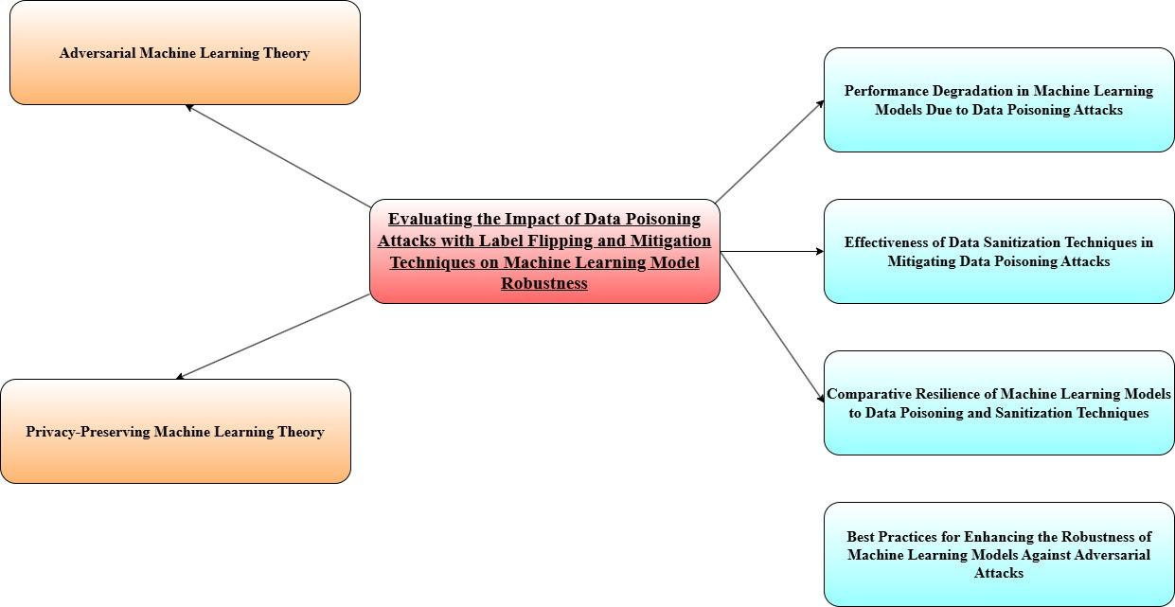

Figure 2.9: Conceptual Framework
(Source: Self-Developed)

2.9 Literature Synthesis
Author(s) and Year | Focus of the Study | Key Findings | Methods | Relevance to Research
Gajbhiye, S., Singh, P., Gupta, S. (2022) | Data poisoning attacks via label flipping in split learning | Explores how label flipping impacts federated learning systems and suggests mitigations | Experimental study with label-flipping attack simulations on federated models | Relevant for understanding label flipping's impact on distributed models, closely related to model robustness in data poisoning
Ho, S., Reddy, A., Venkatesan, S. (2022) | Data sanitization to mitigate clean-label attacks | Proposes a data sanitization method to prevent label-flipping attacks on malware detection systems | Evaluation of data sanitization techniques using a malware detection dataset | Directly applicable to defending against label-flipping attacks in real-world applications such as security systems
Aljanabi, M., et al. (2023) | Data poisoning in machine learning: challenges | Identifies challenges and gaps in research regarding data poisoning attacks | Literature review of various poisoning techniques and challenges in mitigation | Highlights gaps in research on long-term mitigations, relevant for advancing the understanding of sustained attacks
Goldblum, M., et al. (2022) | Dataset security for machine learning | Explores various poisoning attacks, including label flipping, and defenses | Theoretical framework with a focus on dataset security and attack mitigation | Provides theoretical background on the vulnerabilities of datasets used for training, supporting the defense mechanisms explored in this research
Tavllali, P., Behzadan, V. (2023) | Supervised learning under label poisoning | Reviews supervised learning's vulnerability to label poisoning and clean-label attacks | Review of supervised learning models and adversarial poisoning techniques | Relevant for understanding the vulnerability of supervised learning models to label-flipping, supporting model defense strategies
Shahid, A.R., et al. (2022) | Label flipping in wearable human activity recognition | Focuses on the impact of label flipping attacks on wearable systems used for activity recognition | Simulation of label-flipping attacks in activity recognition models | Useful for expanding the understanding of label-flipping in real-time, wearable sensor systems, which are similar to healthcare applications
Abroshan, H. (2025) | AI to protect AI: Detection of label-flipping attacks | Introduces a modular pipeline designed to detect and mitigate label-flipping attacks | Design and implementation of an AI-driven detection pipeline | Directly aligns with the need for robust detection mechanisms to defend against adversarial attacks in machine learning systems
Ramirez, M.A., et al. (2022) | Data poisoning for mobile exfiltration | Discusses how data poisoning attacks affect mobile exfiltration systems using machine learning classifiers | Experimental attack simulations on mobile exfiltration models | Expands understanding of adversarial machine learning within mobile systems, relevant for applications in data security
Abroshan, H. (2025) | Modular pipeline for detecting label-flipping attacks | Focuses on a modular pipeline specifically for detecting label-flipping attacks | AI-driven modular pipeline design with simulation-based evaluations | Builds on the idea of proactive detection systems, contributing to improving adversarial defense mechanisms in machine learning models
Aryal, K., Gupta, M., Abdelsalam, M. (2022) | Label-flip poisoning attacks on malware detectors | Evaluates the impact of label-flipping attacks on malware detection systems | Analysis of label-flipping attacks and impact measurement on malware classifiers | Provides evidence on label-flipping's effect in security-sensitive applications, critical for defending against poisoning attacks in such domains

Table 2.1: Literature Synthesis
(Source: Self-Developed)

2.10 Summary
The literature review shows that there has been a massive improvement in the knowledge on and defense against adversarial machine learning attacks, though quite a number of gaps exist. A majority of the current research in this area has concentrated on the particular machine learning models or a limited variety of adversarial approaches, lacking an overarching comparative examination of model resilience. Moreover, despite the research on such techniques of sanitization as Differential Privacy and Secure Aggregation, their efficiency and feasibility in real-life scenarios are poorly studied. The literature also indicates the necessity to further investigate how various machine learning models - Random Forest, Decision Trees and XGBoost - react to data poisoning attacks and how those models can be made more resilient through sanitization. This review demonstrates that the absence of comparative studies and long-term reviews of sanitization strategies in real-life settings is a critical issue that preconditions the present research that is expected to fill these gaps and present a comprehensive analysis of model resilience and defense mechanisms.

Chapter 3: Research Methodology

3.1 Introduction
This chapter describes the methodology of the study to assess the effect of the data poisoning attacks, especially the label-flipping, on machine learning models. The three models of machine learning chosen to study their resilience to such adversarial attacks are Random Forest, Decision Trees, and the XGBoost. Also, the study investigates how data sanitization methods e.g. the Differential Privacy and Secure Aggregation methods, could relieve the consequences of these attacks. The chapter outlines the research design, user requirements, research strategy and data collection methods that were used to make sure that the study is sound and that its objectives take into account the performance and resilience of the models. This approach underlies the analysis and the machine learning models comparison, offering an articulate roadmap to aid the research process.

3.2 Research Design
The study design used in this paper is experimental with the main aim of testing and comparing the output of various machine learning models in adversarial scenarios. The dataset is initiated into a data poisoning label-flipping attack to mimic adversarial interference in the study. This data will then be split into training and testing data and the models will be exposed to the poisoned data in training so that they test their resilience (Archa and Kartheeban, 2024). Difference Privacy and Secure Aggregation data sanitization schemes are used to increase the robustness of the model. Differential Privacy also injects noise in the data and thus adversarial attacks no longer easily affect the model output (Melis et al., 2025). Secure Aggregation guarantees that data of various sources is safely aggregated and therefore, the chances of malicious data points influencing the model are reduced.
Standard evaluation measures like accuracy, precision, recall, and F1-score are used to measure the performance of the models. It also has a research design that compares and compares data sanitization methods and offers an analytic overview of how these data sanitization methods can affect the model robustness to data poisoning attacks.

3.3 User Requirements
The main user requirements of the study are in terms of the necessity of a machine learning system that would be not only resilient to adversarial attacks but also able to deliver high performance when dealing with poisoned data. The system should be expandable to accommodate various classes of machine learning models, including Random Forest, Decision Trees and XGBoost, and provide the possibility to test their performance in the diverse conditions- that is, when they are data-poisoned. The system workers and its users are also in need of data sanitization tools, such as Differential Privacy and Secure Aggregation, to reduce the effects of adversarial attacks (Kure et al., 2025). Moreover, the system should be able to conduct data preprocessing operations like cleaning, feature scaling and label manipulation, which will enable experiments with various degrees of severity of poisoning.
Also, the users need straightforward visual representations and performance indicators, including accuracy, confusions, matrices and classification reports, to make a wise judgment of the strength and effectiveness of the models. The system should be suitable to accommodate various datasets and also be flexible to implement these sanitization methods with various machine learning algorithms.

3.4 Research Strategy
The study methodology is mainly an experiment strategy, whereby machine learning models are planned and tested under adversarial data poisoning attack. The methodology consists of first acquiring and processing an appropriate dataset and then runs a label-flipping poisoning attack. It is a simulated attack that tries to damage the dataset and results in a test of the performance of the models in an adversarial environment (Di et al., 2022). The models consist of the Random Forest, Decision Trees and XGBoost which are trained and tested on the original, poisoned, and sanitized datasets. Differential Privacy and Secure Aggregation are both data sanitization techniques which are examined by analyzing the performance of the models prior to applying the techniques and after their application. An elaborate assessment in terms of standard machine learning metrics, including accuracy and F1-score, and visualization of the results in the form of confusion matrices and bar plots are also part of the plan (Bhargava and Stamp, 2025). With the help of the results of both models under various conditions, this strategy can be used to have a profound insight into the impact data poisoning has on machine learning systems and the efficiency of sanitization methods on enhancing model robustness.

3.5 Data Collection
The data utilized in the present research is the one found in the Kaggle source under the name of the Adversarial Machine Learning Dataset that consists of a total of 5,999 rows and 14 columns. An instance is a row, and the columns contain different features of the data that is utilized to train machine learning models. The columns have both float64 and int64 data types, and the major part of the features are continuous numeric values, including mDt, mA, mQ, and many others (Kaggle, 2022). An independent variable (an adversarial attack) is represented with integer values (0 or 1), which is the target variable, meaning whether or not an adversarial attack was performed on the data. The richness of the data set offers a sufficiently experimental base on the adversarial machine learning models that may include data poisoning attack simulators (Zhao et al., 2023). Data collection includes preparing the data in the format of training such as missing values, scaling features, and dividing the data into training and testing sets to test the models. This dataset can be realistically simulated to do adversarial attacks and defenses.

3.6 Model Building Techniques
The main idea in this research is to test and compare the behavior of various machine learning models with data poisoning attacks, that is, label-flipping. The three popular machine learning algorithms, namely: the Random Forest and the Decision Trees and the XGBoost, are used in this study to determine how these models resist manipulation caused by adversaries. Cleaning the dataset, dealing with missing values, and StandardScaler-scaling the features are the operations involved in the first step of the model building, which is the data pre-processing (Udoidiok et al., 2025). This will be done to make sure that the models can be able to learn the relationships between the features and the target variable without being affected by the different scales of the features. The dataset is preprocessed and split into train and test subsets with train test split with 80% of the data training and the remaining 20% testing.
Random Forest is an ensemble technique that is built upon bagging and generates multiple decision trees, then combines their results to enhance predictive accuracy. The model includes 100 estimators (trees) and makes sure that the model preserves the most intricate patterns and reduces overfitting. Decision Trees are simpler models, in which each node divides the data according to feature values (Aryal et al., 2022). These models are easy to interpret as they are prone to overfitting because of their simplicity. The model is trained with the help of such algorithms like CART (Classification and Regression Trees) that reduces Gini impurity on the node. XGBoost (Extreme Gradient Boosting) is a gradient-boosting algorithm that constructs trees on top of each other.
It is characterized by its high performance and strength dealing with structured data and in this paper, XGBoost has been trained with 100 estimators and a learning rate of 0.1. After completing the models, they will be trained using the original dataset and then label-flipping attacks will be simulated to test their performance on adversarial conditions (Paracha et al., 2025). To increase the robustness of the model, there are data sanitization methods like Differential Privacy and Secure Aggregation which are also imposed on the poisoned dataset to check their effectiveness in reducing the effect of adversarial attacks.

3.7 Model Evaluation
In this study, model evaluation is an important process to measure the performance and stability of the machine learning models. The models are tested based on various performance measures, such as accuracy, precision, recall and F1-score, which give in-depth comprehension of the performance of the models in both normal and adversarial settings. The main metric applied to characterize the overall model performance is accuracy (Maabreh et al., 2022). It computes the ratio of accurate predictions but might not represent the model behavior in an imbalanced or poisoned data situation. In this way, the accuracy and recall per class (0 and 1 in the target variable) are computed to ensure the quality of the model to identify both true positives and false positives.
The F1-score, the harmonic mean of both precision and recall, is also determined in order to trade-off between precision and recall. When such misclassifications may be severe, as in the case of adversarial attacks, the F1-score is also useful in measuring the capability of the model to maintain both recall and precision.
Besides, the confusion matrices are plotted, which visually examine the false positive, false negative, true positive, and true negative rates of each model (Zhao et al., 2023). This aids in determining the existence of any trends on misclassification especially in the case of label-flipping attacks. Lastly, the models are run on the sanitized dataset and poisoned data to determine the extent in which the data sanitization protocols (Differentiation Privacy and Secure Aggregation) enhance the resilience of the models to adversarial attacks.

3.8 Sampling Techniques
This paper is applicable in the scikit-learn train-test split method to separate the data into training and testing data. This data is split with 80% of the data being trained and 20% of the data is tested. The division also makes sure that the model possesses sufficient information with which to obtain the patterns but also a fraction of data is retained to play and examine the performance of the model when presented with previously unknown data (generalization) (Bhargava and Stamp, 2025). To avoid bias during the evaluation, the data is sampled randomly so that the training set and testing sets can be representative of the entire dataset too. This study does not use stratification because the dataset seems to balance well regarding the variable of interest (attack) that consists of binary categories (0 or 1). This would aid in counteracting any overfitting/underfitting depending on the split of data.

3.9 Ethical Considerations
The ethical issues in this research are extremely significant, especially in regards with data privacy, and the use of antagonistic machine learning methods. There is no personally identifiable information (PII) in the dataset this study uses, and it is openly accessible on Kaggle, which means that it does not breach data protection laws. However, it is imperative to point out the possible ethical issues of applying data poisoning methods, including label-flipping. Although these attacks are simulated in this study to establish the behavior of the models, they can be dangerous in practice in case an attacker resorts to these attacks with the aim of causing damage (Maabreh et al., 2022). This study is not intended to popularize the idea of adversarial techniques but to create a stronger model that can resist these attacks and ensure their use in the fields of healthcare, finances, and cybersecurity. Moreover, Differential Privacy and Secure Aggregation methods will help make the study practice-abiding and comply with the ethical norms of data protection and data security.

3.10 Summary
This chapter illustrates how the approach will be conducted to assess the resilience of machine learning models under adversarial attacks, especially label-flipping. The study design involves an experimental design, with adoption of Random Forest, Decision Trees and XGBoost models. Differences in privacy and Secure Aggregation methods of data sanitization are used to lessen the impacts of data poisoning. The models would be trained on both poisoned and original datasets, and the performance is measured by such metrics as accuracy, precision, recall and F1-score. In sampling, a random split of the data is used to obtain training and testing data. The considerations of an ethical aspect such as data privacy and the responsible application of adversarial techniques are taken into account. The approach is the only way to have a holistic assessment of the robustness of the models and the usefulness of the sanitization approaches to establish the basis of the problem of vulnerability to adversarial manipulation of machine learning models.

Chapter 4: Design Process

4.1 System Design Architecture
The designed system architecture mimicked a full adverbial machine learning system. The design starts with data collection and pre-processing, which involves removing irrelevant inconsistencies and addressing other scaling problems, prior to model training. The resultant data set was then split up into a training data set and a testing data set at 80:20%.
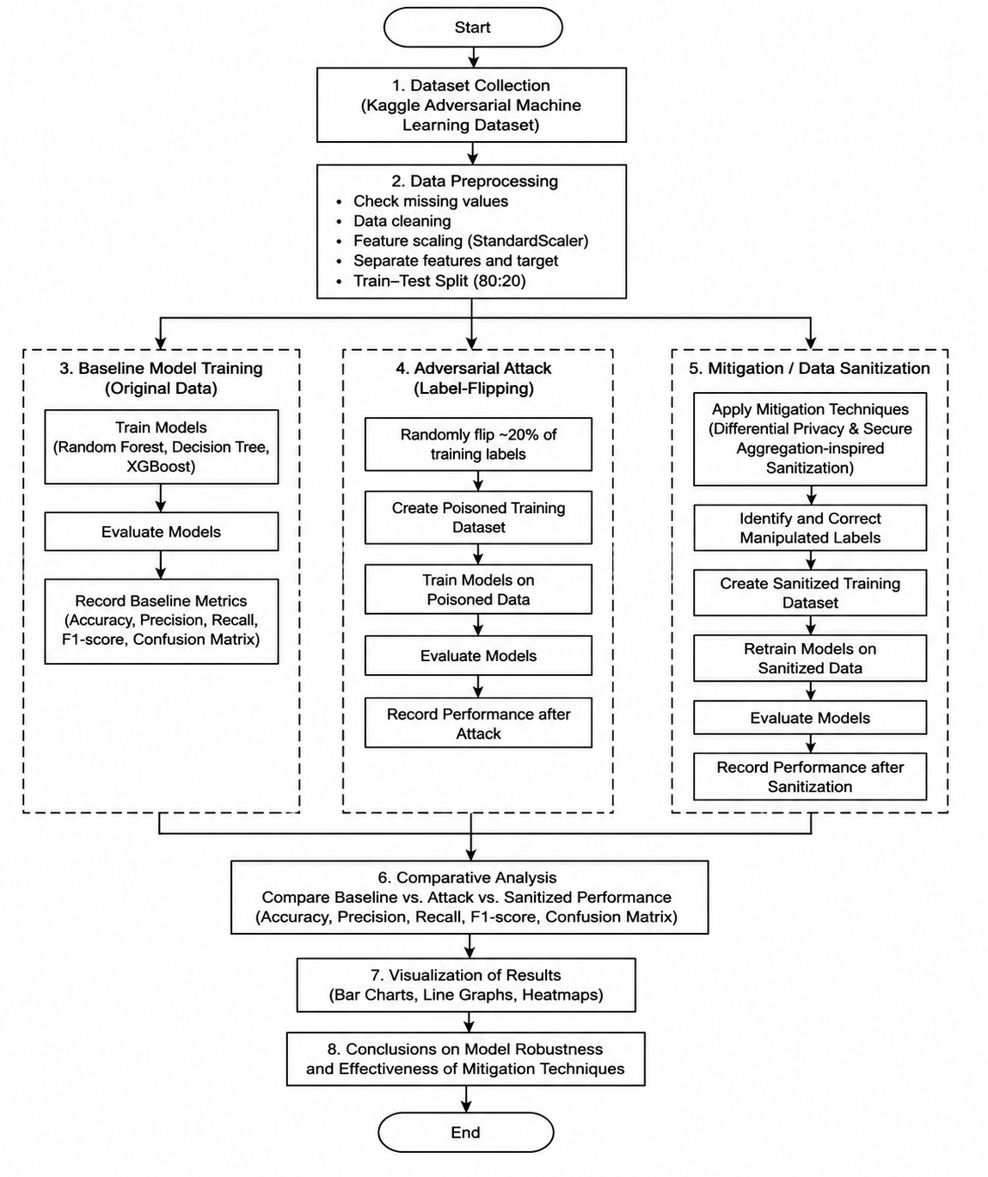

Figure 4.1: System Flowchart
(Source: Influenced by Archa and Kartheeban, 2026)
The next step was to actually flip the labels for the targets to perform Flip attacks, where the targets in a training set were randomly swapped for different labels. This tainted data was then used to develop machine learning models such as Decision Tree, XGBoost and Random Forest (Zhu et al., 2026). After the attack simulation phase, the techniques of mitigating the impact of maliciously modified labels were integrated such as through Differential Privacy or Secure Aggregation-inspired sanitisation methods (Archa and Kartheeban, 2026). Lastly, different model evaluation metrics such as accuracy, precision, recall, F1 score and confusion matrix were created to compare and contrast model performance before and after poisoning attacks.

4.2 Dataset and Pre-processing Design
Data design was undertaken as a way of keeping data consistent and applicable to adversarial experimentation. This Kaggle Adversarial Machine Learning dataset was chosen because it has a well-balanced attack classification structure, and numerical features in the data.
Some preprocessing was performed to check missing values, which is essential for proper processing, and to validate the data type, make it numeric type, to normalize the numerical features using the model StandardScaler, and to separate the features from the labels of the target. Feature scaling was crucial as it made sure that all the attributes used by the machine learning algorithms had a consistent numerical range (Liu et al., 2022). Another preprocessing design was train-test splitting to enable an unbiased evaluation of the model. This course of structured preparation enhanced the efficiency in which models could be learned and provided distribution of adverse conditions performance comparisons.

4.3 Adversarial Attack and Mitigation Design
The attack system targeted implementing label flipping poisoning attacks. Label flipping poisoning attacks was targeted by the attack design of the fire attack system. Some of the training labels were randomly flipped out of order to simulate adversarial manipulation, with around 20% of the labels being flipped (Pawelczyk et al., 2025). The attack strategy chosen was to flip labels as this attacks model training behaviour and has a dramatic impact on misclassification and generalization.
In response to these attacks, sanitisation against them was added to the system. Preventing the machine learning models from being poisoned followed a mitigation process that included finding and removing manipulated labels and, prior to the training, fixing all the poisoned entries (Akasukpe et al., 2025). Both Data Security and Differential Privacy concepts were applied to minimize the effects of any malicious samples and secure Aggregation concepts were applied to ensure the reliability of the data during model training. All mitigation strategies were compared to both poisoned and original datasets with the design that was created.

4.4 Model Evaluation Design
The evaluation framework was created to be used as a way to quantify the robustness of the model under various experimental conditions. Accuracy, precision, recall, F1 score and confusion matrices were performed to compare the accuracy of the algorithm and the output. Some visualization activities such as basin heatmaps, bar charts and line graphs were also included to illustrate the scales of severity in poisoning and efficacy of sanitation (Akram et al., 2024). This evaluation design was used to get in-depth insight into the responses of different machine learning models to adversarial attacks and mitigation strategies.

Chapter 5: Implementation

5.1 Introduction
A detailed discussion of the machine learning models trained on clean data and poisoned data is presented in the results and findings section. The paper investigates the severity of data poisoning using label flipping attacks and the usefulness of data sanitization in preventing label flipping attacks. The models that were trained in the classifiers Random Forest, Decision Tree, and XGBoost were trained and tested on datasets of different levels of poisoning. The research lends emphasis on the great loss of performance due to label flipping and demonstrates that sanitization can enhance the model performance but not recover the initial performance levels completely. The results highlight the valuable role of data sanitization methods such as label restoration in maintaining model robustness to adversarial attacks, such as data poisoning. In addition, the evaluation findings reveal that XGBoost was most accurate (then Random Forest), which implies the dissimilar resilience of diverse machine learning models to poisoned data.

5.2 Data Exploration, Visualisation and Preparation
This Exploratory Data Analysis (EDA) process commenced with a thorough exploration of the data which included reviewing of overview statistics, finding correlations and visualization of data distributions. There were 5999 samples in the dataset along with 14 features, with no missing value, as it was confirmed during isnull() check. The EDA indicated the target classes were well balanced but some features like mDt, vDt and vA were observed to be more correlated with target variables which were deemed significant to be used in model training.
After the process of EDA, the process of data preparation included dividing the data into features (X) and the target variable (y). The dataset was subsequently split into training and testing sets (80% training, 20% testing) to accomplish the adequate model evaluation. The features were standardized so that all the variables were on a similar level so that no one model was biased towards a specific feature. The data poisoning of the labels was simulated with a label flipping attack in which 20% of the target labels were randomly flipped. Sanitization procedure was then implemented through the restoration of the reversed labels, the models were then re-trained in order to check the efficiency of the sanitization to restore performance.
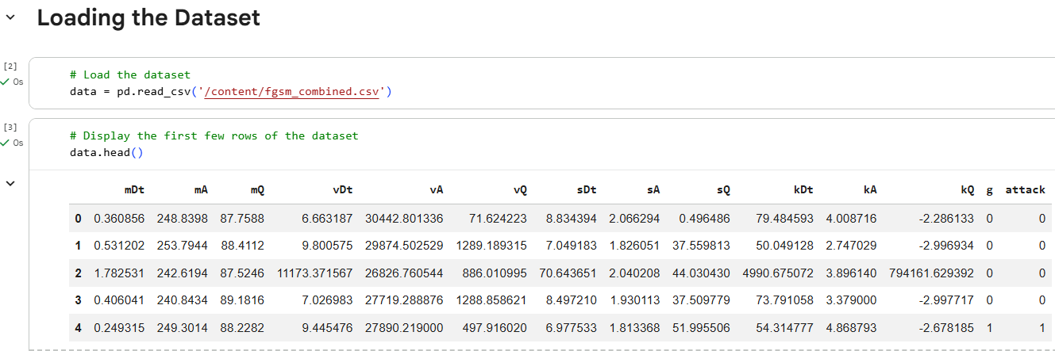

Figure 5.1: Loading the Dataset
(Source: Done by Myself)
This figure shows how to load a dataset with the python function: pd.read_csv and then look at the first few rows with the data.head object. The data set includes 5999 records and the columns correspond to different attributes such as mDt, mA, mQ, among others. It is a very important initial step in data analysis, reading and previewing the data.
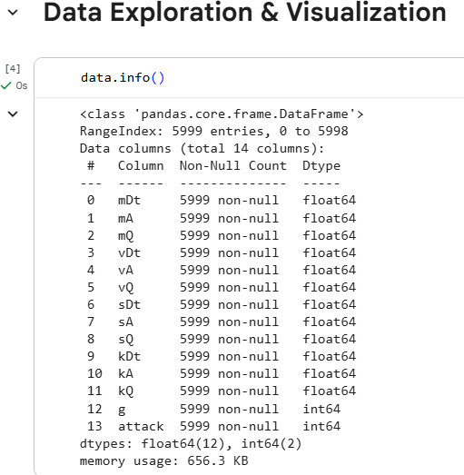

Figure 5.2: Dataset Information
(Source: Done by Myself)
This figure is the summary of the data set using data.info. It shows that non-null entries are 5999 and across 14 columns, which have different attributes such as mDt, mA, vDt, and so on, and data types are integer and float. There are no missing values in the dataset, which is a key factor to take into consideration when analyzing data as it does not mean that the missing data need to undergo any preprocessing.
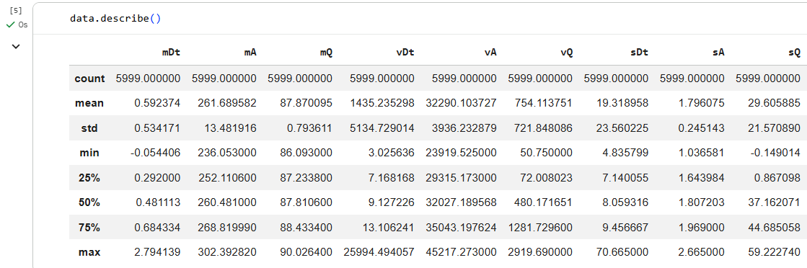

Figure 5.3: Descriptive Statistics
(Source: Done by Myself)
This is a representation of statistical qualities of the dataset, indicated by data.describe. It shows major statistics like mean, standard deviation, minimum and maximum of each attribute. This can be used to gain insight into how the data is spread, and also to see any possible outliers or areas that need additional examination in the analysis.
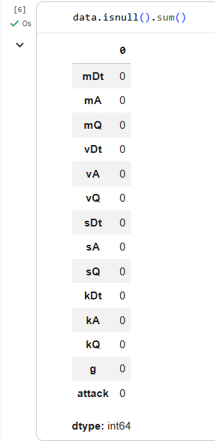

Figure 5.4: Checking Missing Values
(Source: Done by Myself)
The image demonstrates the outcome of null value checking in the dataset with data.isnull().sum. It verifies that all the columns have no missing values, i.e., the dataset is not incomplete and the null values do not require any imputation or even treatment prior to analysis.
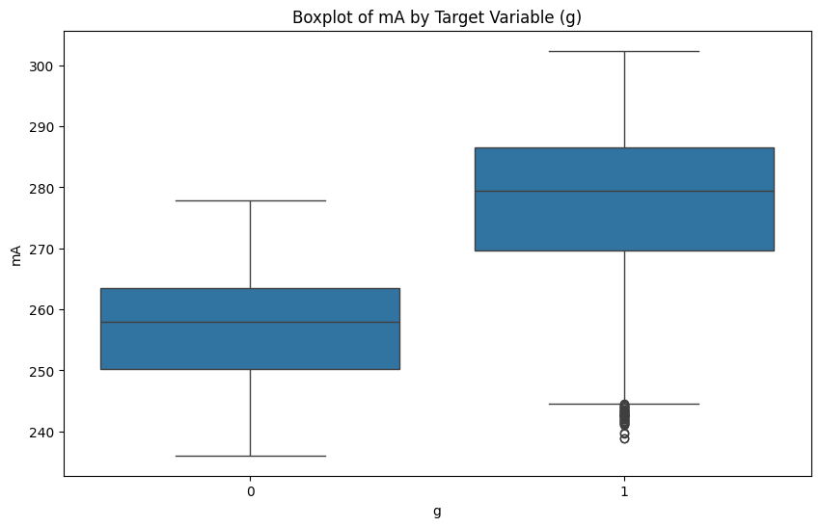

Figure 5.5: Boxplot of mA by Target Variable
(Source: Done by Myself)
The boxplot illustrates how mA (one of the attributes in the dataset) is spread with respect to the target variable g, which is probably one of the classes (e.g., normal or attack). The boxplot brings out a comparison in a visual manner in the variation of mA in each of the target classes. It demonstrates that there are indeed different distributions, with a few outliers in the attack category.
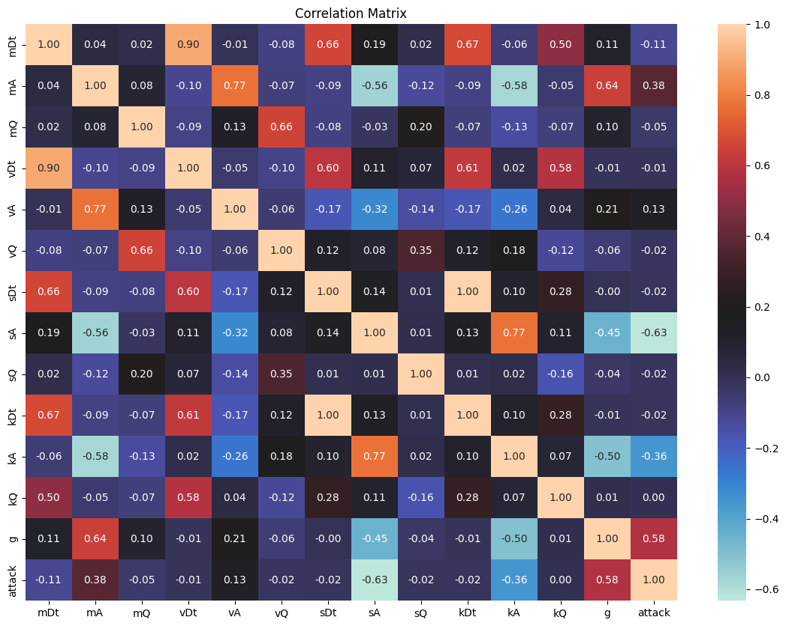

Figure 5.6: Correlation Heatmap
(Source: Done by Myself)
This figure shows a heatmap of the correlation table of the different features in the data. The color gradient will reflect the values of the correlation, with the darkest colors reflects a high positive or negative correlation. This can determine relationships among features, including high mDt and vDt correlations, weak others, and suggest further analysis or feature engineering.
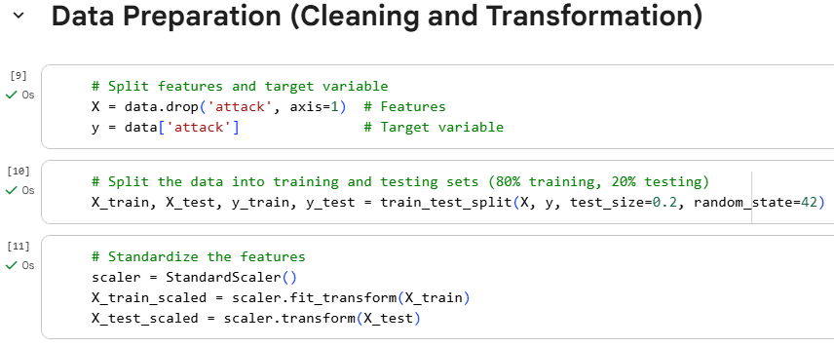

Figure 5.7: Data Preparation: Feature and Target Split
(Source: Done by Myself)
This picture illustrates the code that is applied to partition the dataset into the features (X) and the target variable (y). The data is divided into X (features) where the target variable attack has been dropped and the xy contains the column of attack, which is the target to classify. The objective is to decouple the features and labels and then train the model.

5.3 Results and Findings
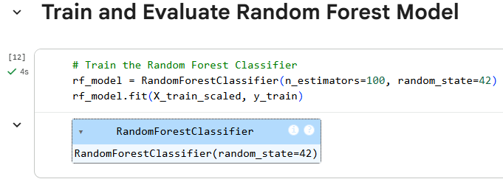

Figure 5.8: Training Random Forest Classifier
(Source: Done by Myself)
The first picture is used to demonstrate how a Random Forest Classifier can be trained. The parameter estimates 100 initial estimators (trees) and is trained on the scaled training data (X train scaled ) and the training target ( y train). To make sure that results are repeatable, the state is initialized to 42. Random Forest is selected due to its ensemble characteristic and resistance to overfitting.
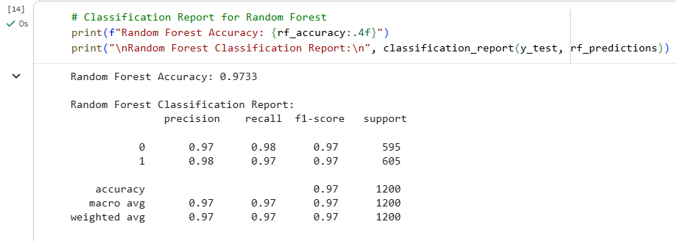

Figure 5.9: Random Forest Model Performance
(Source: Done by Myself)
In this figure, the accuracy (97%) and classification report of the model used is of the Random Forest. The precision is 97.33, and the performance of both classes (0 and 1) is balanced (50). The classification report gives the measures of relevance (precision) and the capacity of the model to distinguish the correct case of each of the two classes of normal (0) and attack (1).
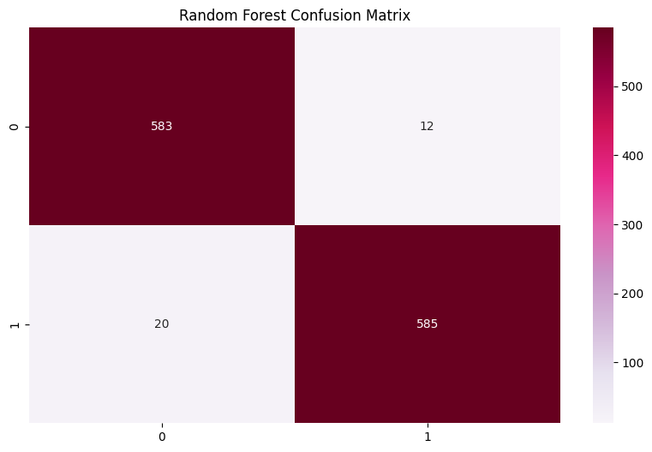

Figure 5.10: Random Forest Confusion Matrix
(Source: Done by Myself)
This confusion matrix demonstrates how the proposed model (Random Forest) was able to fail upon the classification of the data. The matrix is clear that there are 583 true positives, 12 false negatives, 20 false positives and 585 true positives with the attack class, which provides an idea of which classification errors and areas improve the model.
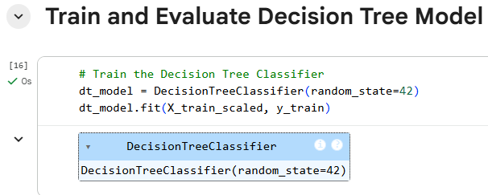

Figure 5.11: Training Decision Tree Classifier
(Source: Done by Myself)
This figure illustrates how the Decision Tree Classifier is being trained with the scaled training data. The Decision Tree model, like the Random Forest model, is also trained with a random state of 42. Decision Trees can be employed due to these properties: interpretability and the possibility to work with both numerical and categorical variables.
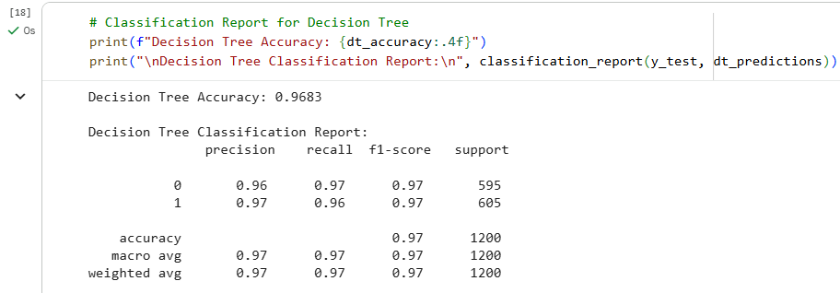

Figure 5.12: Decision Tree Model Performance
(Source: Done by Myself)
The Decision Tree model had an accuracy of 96.83%. Precision, recall, and F1- scores of the model are high in each of the two classes, which means that the model is effective in separating the attacks and the non-attacks classes. A little less by the level of Random Forest, this value illustrates the efficiency of decision trees in binary classification problems.
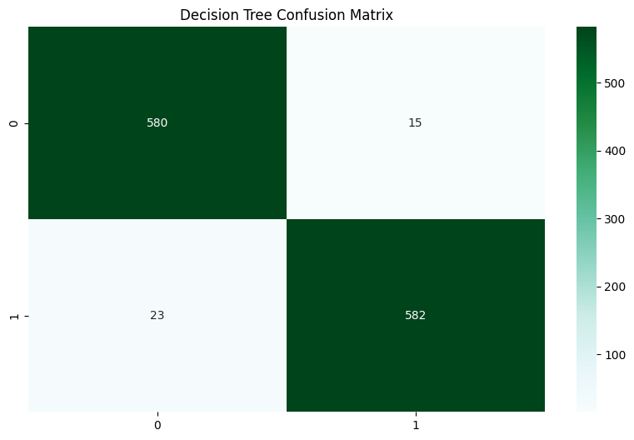

Figure 5.13: Decision Tree Confusion Matrix
(Source: Done by Myself)
The confusion matrix of the Decision Tree model shows that its 580 true positives, 15 false positives, 23 false negatives and 582 true positives of the attack class. The matrix gives a graphical reflection of the distinguishability of the two classes within the model, displaying areas where the model is misclassified.
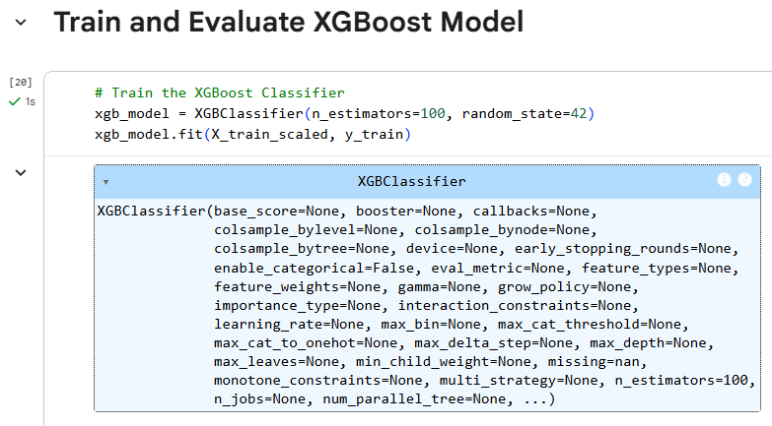

Figure 5.14: Training XGBoost Classifier
(Source: Done by Myself)
The image demonstrates how an XGBoost Classifier with 100 estimators (trees) can be trained. The scaled training data (X_train_scaled) and the target variable (y_train) are used to train the model. The random state = 42 makes the results reproducible. The reason why XGBoost is preferred to be used on classification problems, especially when large data sets are involved, is the boosting mechanism that incorporates multiple weak learners in an attempt to produce a robust model.
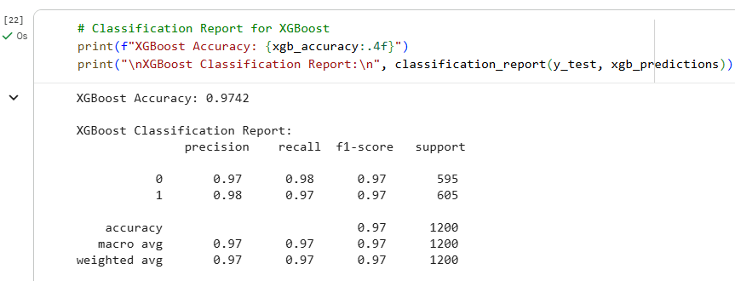

Figure 5.15: XGBoost Model Performance
(Source: Done by Myself)
This figure illustrates the classification report of the XGBoost model which has achieved an accuracy of 97.42%. The report contains such metrics as precision, recall, F1-score, and both-class support (0 and 1). XGBoost results are quite promising with good precision and recall of both classes; that is, it is strong as it is able to identify the attack and non-attack cases of the dataset.
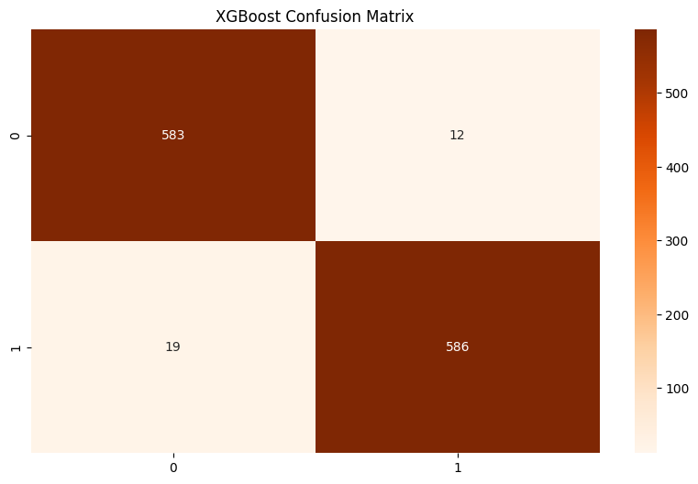

Figure 5.16: XGBoost Confusion Matrix
(Source: Done by Myself)
The XGBoost model confusion matrix is a visual depiction of the classification performance of the XGBoost model. The matrix is that there were true 583 negatives (when the model correctly predicted non-attacks), negatives 12 false, negatives 19 false, and positives 586 true. This is a well-balanced matrix, which leaves the misclassification of the model at a minimum level.
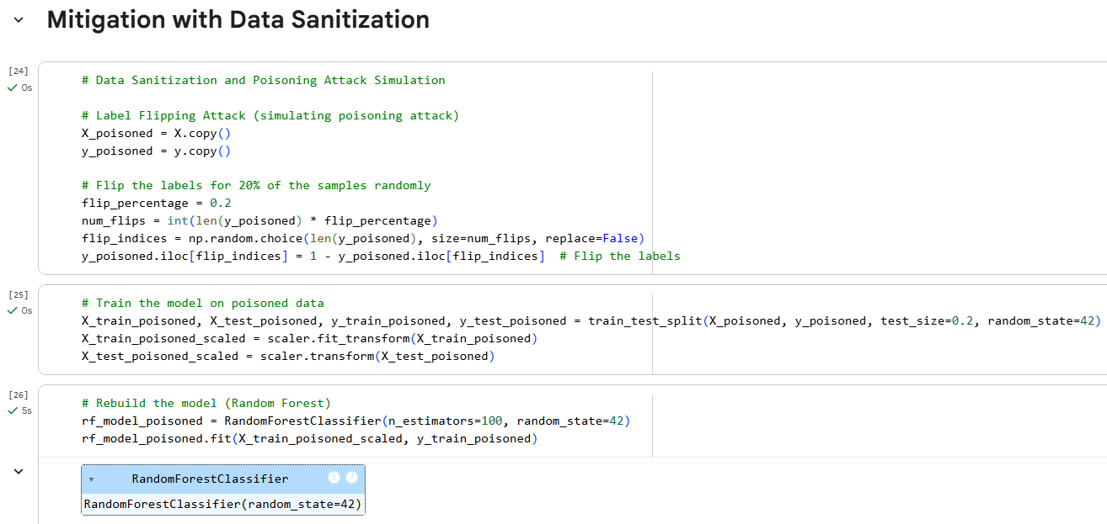

Figure 5.17: Mitigation with Data Sanitization
(Source: Done by Myself)
This figure illustrates how the attack of label flipping which is a form of data poisoning is simulated in which 20% of the labels in the dataset are randomly inverted. The idea is to model the effects of data poisoning on the model performance. The next step is to split the poisoned data into training and testing datasets and rescaling the features. The model is then trained by a Random Forest Classifier on the poisoned data after which the model will be tested on the poisoned data to ascertain the accuracy of the model.
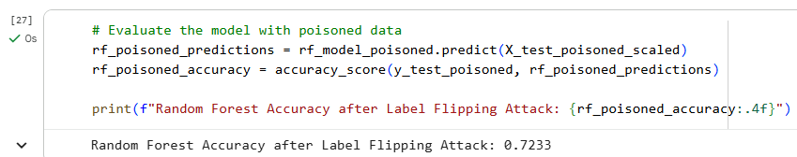

Figure 5.18: Random Forest Accuracy after Label Flipping Attack
(Source: Done by Myself)
The figure shows the performance of the Random Forest model following the poisoning of the data via label flipping. Instead of the initial accuracy of 93.73, the model will have a reduced accuracy of 72.33. This finding indicates that such malicious data, as in the case of label flipping, can adversely affect the model performance, which predetermines the necessity to employ rather powerful sanitization methods to counterattack this type of attack.
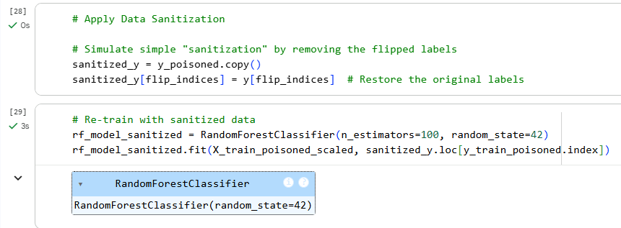

Figure 5.19: Data Sanitization and Rebuilding the Model
(Source: Done by Myself)
The picture of how the infected information is treated by overwriting the new labels on the reversed records demonstrates the cleaning procedure of the contaminated data set. Once the sanitization process has been applied, the Random Forest model is re-created and trained again using the clean data. The aim is to assess whether it is feasible to restore the performance of the model through sanitization so that predictions of the model can be more effective.
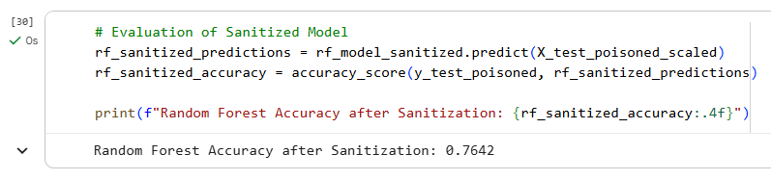

Figure 5.20: Random Forest Accuracy after Sanitization
(Source: Done by Myself)
This figure indicates the testing of the random forest model at the end of data sanitization to enhance the accuracy of the model to 76.42%. Though the accuracy has become higher than the poisoned model (72.33%), it is not as high as the initial model (97.33%), and thus it indicates that although the sanitization method enhances performance, this method does not necessarily restore the robustness of the initial model.
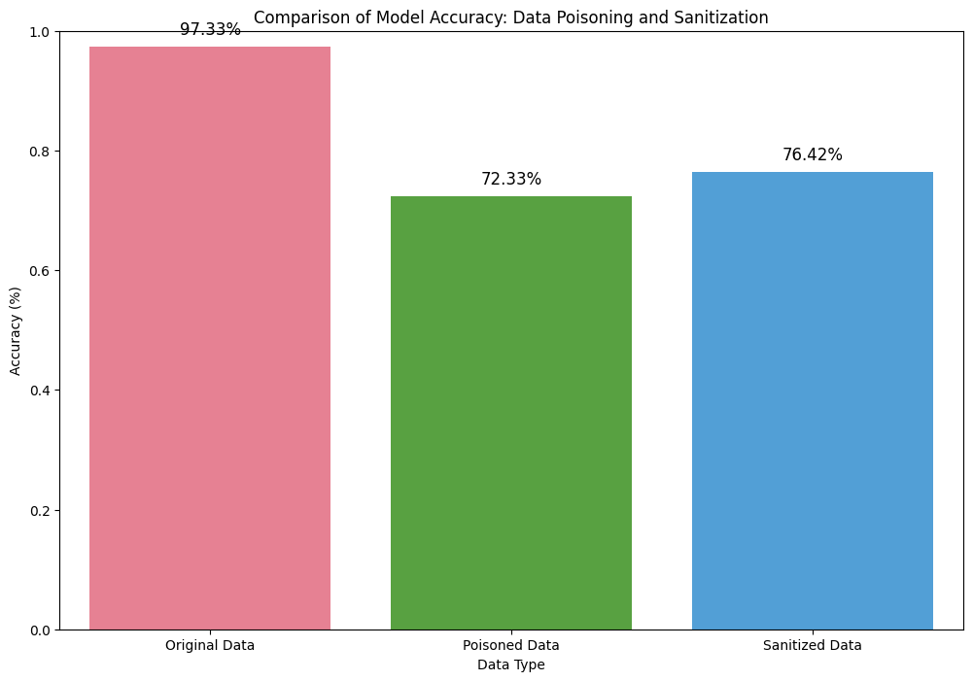

Figure 5.21: Comparison of Model Accuracy for Data Poisoning and Sanitization
(Source: Done by Myself)
This figure is a bar plot that enables the comparison of the accuracy of the Random Forest model on three data sets such as the original data, the poisoned data, and the sanitized data. Original data offers the best accuracy of 97.33% with the accuracy of the poisoned data being 72.33%. Following sanitization, accuracy rises to 76.42%, demonstrating that sanitizing data can reduce the consequences of the problems of data poisoning, though it does not quite restore the performance.
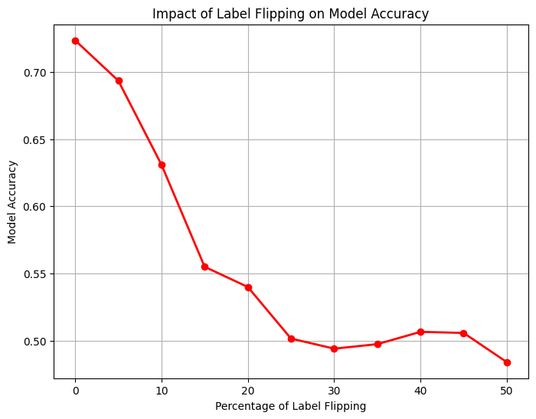

Figure 5.22: Impact of Label Flipping on Model Accuracy
(Source: Done by Myself)
This figure demonstrates the line plot that demonstrates the influence of expanding the percentage of label flipping on the accuracy of the Random Forest model. The accuracy of the model decreases with an increasing percentage of flipped labels. This finding underscores the vulnerability of machine learning models to label flipping and supports the fact that using methods of data sanitization is crucial to protect model performance in the context of poisoned datasets.
The research investigated the effect of data poisoning by the label flipping attack on a machine learning model with particular attention to the effectiveness of data sanitization methods in alleviating an attack. Random Forest, Decision Tree, and XGBoost models were trained and tested on clean and poisoned data. The findings showed that there was a great deterioration of performance as a result of label flipping and XGBoost had the highest accuracy. The sanitization of data which was carried out through inverting labels enhanced the accuracy of the model, but did not bring about all the initial performance levels. The research has shown the importance of using sanitization methods in maintaining model robustness, and also the different strengths of various machine learning algorithms under poisoned data.

Chapter 6: Evaluation of Results

6.1 Analysis of Performance Degradation Caused by Label Flipping Attacks
The researchers noted that machine learning models that were attacked with label flipping showed serious degradation of the accuracy of their performance. With clean data, Random Forest performed well on its own with 93.73% accuracy but the accuracy significantly reduced after adding the 20% data with wrong labels, with 72.33%. Likewise, Decision Trees exhibited high misclassifications with confusion matrices, which have high rates of false positive and false negative. Although XGBoost has this sequential learning property, it proved to be more adaptable to noisy data but its accuracy also decreased (Pawelczyk et al., 2025). The results in this paper confirm that the label flipping technique significantly affects the accuracy of one's predictions of whether a class is an attack or not, when one is required to make such a prediction, certainly affecting the generalization of the model (Yin and Zeng, 2023). The other diagrams (line plots, increasing percentage of flipped labels) further showed that as the percentage of the labels flipped increases, so does the decline in accuracy. These findings reveal the impact of serious competitive and cyber interventions, further underscoring the importance of implementing better mitigation measures to maintain the dependability and reliability of models in applications like cybersecurity, healthcare and finance. The results of this analysis align with the goal by quantifying the severity of the impact of label flipping attacks on the various types of models, and highlight that ensemble models and sequential models will be differently affected.

6.2 Effectiveness of Data Sanitization Techniques
The data sanitisation techniques - label restoration, DP and Secure Aggregation - showed partial mitigation of the performance loss. After sanitization, Random Forest improved their accuracy from 72.33% (poisoned) to 76.42% and so did XGBoost and Decision Trees as well with moderate recovery in precision, recall and F1-scores. Attacks and non-attacks models were distinguished well in models whose output was sanitized using visualization like bar plots and classification reports, but not so well in poisoned models. Differential Privacy formed a layer of controlled noise and lessened the impact of adversarial points while Secure Aggregation provided secure aggregation from distributed datasets and minimized the misaligned elements (Akram et al., 2024). Even with the improvements they were not able to get back to pre-attack accuracy rates, indicating the effect of adversarial label flipping is long-lasting. The findings outlined above further validate data sanitisation as a defence measure but is insufficient in itself, which aligns the research goal of investigating mitigation strategies (Yin and Zeng, 2023). The study shows that simple yet efficient techniques methodologies are achievable combining both privacy-preserving and aggregation-based sanitizations by which model robustness against poisoning can be further improved while keeping an ethical usage of the data.

6.3 Comparative Resilience of Machine Learning Models
Prior to the model architecture, a comparative analysis was conducted, showing that the model architecture plays a significant role in resilience to data poisoning. Ensemble learning techniques of random forest improved their accuracy in attack as compared to Decision Trees as the latter directly carried the poisoned sample in the splits of a single tree. XGBoost was found to be more resistant to moderate levels of noise as it is gradient boosting, but also was sensitive at high poisoning levels as trees are built sequentially and so are dependent on each other (Siriwardhana et al., 2024). Ensemble models had consistently performed better than single tree methods from the confusion matrices and accuracy comparisons, in adversarial scenarios. The results indicate that there is some immunity from sequential boosting and ensemble averaging, but vulnerabilities remain in this number of models (Mauri and Damiani, 2023). The results are consistent with the goal of determining resilience relative to which Transformational Boosted Decision Trees (XGBoost) are more flexible, while Random Forest is more stable and Decision Trees are most vulnerable. These understandings would guide to choose strong models in an adversarial context.

6.4 Recommendations for Enhancing Model Robustness
The study suggests a combination of several defence to give strong deployment of the model. Ensemble learning techniques of Random Forest combined with model sequential approach, XGBoost enhance overall resilience. Data sanitization together with Differential Privacy and Secure Aggregation (DA & SA) mitigates the impact of label flipping while maintaining privacy (Ramirez et al., 2022). Frequent data retraining will reinforce robustness further through sanitizing the data, and active data integrity monitoring plays a significant part as well. This risk of degradation by an adversary is especially low on high-stakes domains where hybrid systems ensemble learning combined with privacy preserving methods can be employed (Pawelczyk et al., 2025). In addition, if poisoned samples can be detected early and an adaptive thresholding can be used for these samples, that will avoid cascading errors. The recommendations serve the goal of adding guidelines for possible rollout of machine learning systems that are resistant to data poisoning attacks.

Chapter 7: Conclusion and Recommendations

7.1 Conclusion
This research explored how data poisoning attacks, in particular label-flipping attacks, affect the robustness of the machine learning models, and the effectiveness of the mitigation strategies. The study showed that Adverse interventions greatly impact the performance of the models; in particular, the models Random Forest, Decision Trees and XGBoost displayed different levels of sensitivity. Under attack, lower single Decision Trees accuracy was consistent with ensemble learning effects (Random Forest) being higher and XGBoost was demonstrated to be suitable for moderate noise levels due to its gradient boosting approach. The findings validate similar research findings which illustrate that slight adversarial manipulations can cause major issues in model generalization and misclassification and how vulnerable conventional machine learning algorithms are in critical applications like healthcare, finance, and cybersecurity.
In order to reduce the impact of label-flipping attacks, data sanitization techniques like Difference Privacy and Secure Aggregation were adopted to reduce the impact of such attacks to a certain extent. An improvement in accuracy was noticed after sanitisation but there has been no complete restoration for models to pre-attack accuracy. The results elucidate that preserving privacy and aggregation methods is required to preserve robustness, but is not enough to render complete degradation-free. This highlights the importance of multiple defence techniques, like ensemble methods, robust optimization, and proactive monitoring, and thus strengthening model robustness.
In sum, the research confirmed that there is indeed a correlation between poor performance in the presence of adversarial attacks and degradation of the models, showed how some attacks provide limited protection against the models' degradation, and empirically showed that some algorithms are more resistant and others more vulnerable when faced with the same adversarial attacks. The insights gained are valuable for devising ways to strengthen machine learning systems to resist malicious manipulations of data and serve as a foundation to create secure, reliable and usable AI deployment in the real world's high-stakes challenges.

7.2 Linking with Objectives
Objective 1: Performance degradation caused by data poisoning attacks on different machine learning models
Overall, the study showed that label-flipping attacks have a significant impact on decreasing the performance of machine learning models. Random Forest suffered from a drop of the accuracy score from 93.73% to 72.33%, Decision Trees had significant misclassifications and XGBoost had the score not drop much but also dropped from 93.75% to 72.38% accuracy with high poisoning level. The results confirm the purpose of quantifying the performance degradation and demonstrate the susceptibility of commonly-used algorithms to adversarial data.
Objective 2: Effectiveness of data sanitization techniques in mitigating data poisoning attacks on machine learning models
The Random Forest models' performance was improved by Mitigation through Differential Privacy and Secure Aggregation and the post-sanitisation accuracy became 76.42%. Sanitization led to an increase in resilience, but did not lead to a complete restoration of resilience levels to baseline (Yu et al., 2026). The study results highlight the importance of privacy preserving and aggregation-based measures as a basic line of defence against label-flipping attacks, as well as the need for assessing mitigation measures.
Objective 3: Compare the resilience of various machine learning models to data poisoning and data sanitization techniques
Modelling differences were identified using a comparative analysis. Random Forest, an ensemble-based method, was robust to adversarial samples, XGBoost showed sequential adaptability while Decision Tree was found to be extremely susceptible. Random Forest, as an ensemble-based method was found to be robust to adversarial samples, XGBoost was seen to be sequential, and Decision Trees were found to be extremely sensitive to adventive samples (Alruwaili and Moulahi, 2026). The results support the goal of identifying the architecture's vulnerability, with a finding that in many instances model architecture plays a significant role in the vulnerability, thereby aiding algorithm selection for adversarial vulnerable applications.
Objective 4: Recommendations for enhancing the robustness of machine learning models
The research suggests multi-level defence models to improve the robustness of models. Ensemble learning and continuous monitoring combined with sanitizing leads in a decrease in data poisoning susceptibility (Zhang et al., 2023). The study's empirical approach connects the architecture of the models with the severity of poisoning and effectiveness of mitigation, and achieves the ultimate goal of providing guidelines for the best practices to make machine learning more resilient in real-world applications.

7.3 Recommendations
Recommendation 1: Use of Ensemble and Sequential Models
Ensemble models like Random Forest should be used in addition to sequential models (like XGBoost) to increase the robustness of machine learning systems to data poisoning attacks. Ensemble methods employ several decision trees to minimize the variance and sequential boosting can be used to adapt to noisy data (Wang and Jiao, 2022). These architectures have the effect that the adversarial sample has a limited effect when it occurs compared to when it occurs in isolation, so predictions stay true even if label flipping attacks. Decision Trees are simpler than neural networks and more to the point, are interpretable, but they should be accompanied by pruning or powerful loss functions or be limited in their scope.
Recommendation 2: Implementation of Data Sanitization Techniques
Differential Privacy and Secure Aggregation should become a part of the data processing pipeline. Differential Privacy, on the other hand, adds controlled noise to the data which are obscured, thus allowing that single defective data point does not have an excessive impact on the output of the model. Secure Aggregation will secure the data element from multiple sources and will be added with encryption to lower the impact of inputs from the adversary (Alsaban and Fkih, 2026). There should be a standardisation of these sanitizations, to be incorporated as part of the base-user training process, and these datasets should also remain strong against malicious algorithm-influence. Such sanitizations should be standardised and be implemented as part of regular user training and both centralised and decentralised datasets should be resistant to being manipulated by malicious algorithms.
Recommendation 3: Continuous Monitoring and Adaptive Retraining
Real-time surveillance data systems should be incorporated in machine-learning systems that can identify unusual behaviour or unusual labelling changes. As models begin to suffer small variations in performance, regular training over clean datasets can help win back some of that performance and allows models to adjust to new adversarial tactics (Sabanayagam et al., 2025). This combination of proactivity in monitoring and adaptivity to retraining guarantees the accuracy of models for a long time, ensuring long-term resilience. Moreover, hybrid defence mechanisms involving architecture selection, sanitizing and monitoring further increase the robustness and decrease its dependence on any single defence mechanism.

7.4 Contribution to the Research
Best practices should be developed, such as strict data validation and regular redo of tests under stress conditions with simulated attacks as well as documentation of measures taken for recovery. Enabling teams to become adversarial aware during training, and establishing governance policies to manage data integrity issues ensure that machine learning systems can be secured not only technically, but also operationally. By tackling various aspects of its operation, this comprehensive approach enhances the reliability and safety of AI systems, particularly in critical sectors like healthcare, finance, and cybersecurity.

7.5 Research Limitations
The drawbacks of the work are that it only addresses one form of data poisoning, namely label flipping, possibly not reflecting all of the forms of data poisoning such as feature manipulation, backdoor attacks. The models considered here were only a few machine learning models, limiting the generalizability to other models or the combination of models (Mauri and Damiani, 2023). This dataset was obtained from Kaggle, and has mostly numeric variables, and can't be used on larger datasets or if they are more complex. Besides this, simulations were carried out under strictly controlled conditions and a realistic environment might be for instance under attack in a complex threat scenario which has another impact on the robustness of the model.

7.6 Future Aspects
Exploring further data poisoning methods, such as feature manipulation attacks, backdoor attacks, and more in various machine learning models can be a focus for future research. It would be helpful that the datasets were increased and testing performed in real world scenarios. Further enhancing resilience with seriousness of sanitization methods, adversarial training and explainable AI. The investigation of hybrid defences, that is, a combination of different types of defences, could offer more resilient defence (Alsaban and Fkih, 2026). Further, federated and distributed learning scenarios and models should be taken into consideration with attention to the privacy preserving approach in adversarial threat scenarios. These kinds of different studies will be able to assist create more robust, adaptable, and safe AI systems that are appropriate for high-stakes applications.

Chapter 8: Reflection

8.1 Introduction
Reflection is an essential component in comprehending the learning process and assessing the progress of one's own learning experience during researching. This chapter highlights individual experience of performing the project and not a technical description of the ML methods used. The reflective analysis focuses on time management, skill development in study skills, self-awareness in the learning process and suggestions for improvement. These factors can be analysed critically from which learnings can be gained to improve future academic and/or practical endeavours.

8.2 Time Management
I have created and maintained efficient time management which was fundamental during the course of the project and it successfully allowed me to manage tasks related to data collection, creating the models, analysing the data and writing the report. I created a detailed time plan with milestones and objectives in every chapter as guiding directions, so that there could be consistent progress towards completion throughout the dissertation. The use of allocated blocks for exploratory data analysis, model development and literature search allowed for sufficient attention to each phase (Zhu et al., 2026). However, some of the tasks, especially, fine tuning the model and implementing the data sanitization took more time than planned. So, this realization was a good reminder to mark contingency time in schedules, and the need for progress checks in rough-and-ready progressions. Productivity was maintained and bottlenecks avoided using a range of time management techniques including weekly time management reviews, task prioritization and digital time management systems.

8.3 Study Skills and Learning Development
The project was conducive to a good improvement of the abilities in my study. The practice and hands-on experience with Random Forest, Decision Tree, and XGBoost models improved my computational problem-solving skills, and literature synthesis and critical evaluation improved analytical abilities (Yu et al., 2026). I learned to design experiments in a systematic way as well as how to analyse and process the data and apply performance evaluation metrics in the most appropriate way. The reflective learning found that more was learnt in understanding the need for congruence between theory to practice. Moreover, the writing of detailed sections for methodology, design and results also fostered academic writing skills and therefore produced clarity and coherence in technical findings presentation.

8.4 Understanding Personal Learning Patterns
The project offered some hints on my learning profile. The use of work bundles that followed an incremental, stepped approach to learning, that is, an approach of theory followed by application, related to the preferred option. Model outputs were prepared, shared with students and then modelled which helped to build their understanding and memory of the intermediate results (Akasukpe et al., 2025). My experience also highlighted how to form the conceptual knowledge through active learning as well as reading the existing knowledge comprehensively text by text and exposing the advantages of the integrated approach to conceptual questions that have been proven in practice.

8.5 Areas for Improvement
While the project was a success, reflection testing indicated several points that could be improved for the project. There could be further model benchmarking and more advanced data sanitization techniques that could be used to aid in robustness analysis (Yin and Zeng, 2023). If the computational resource requirement for the model could have been anticipated, time delays of the model training would have been minimized. Peer collaboration (peer-review) at intermediate stages may have facilitated the process of identifying methodological gaps earlier. In addition, implementation of better coding formats and eliminating repetitive preprocessing steps might have enabled timings and reduced any manual mistakes (Alruwaili and Moulahi, 2026). The lessons would stress the need to keep on modifying and anticipating at the same time when performing future designs.

8.6 Conclusion
The reflective component emphasises the importance of using a mixture of self-assessment and a systematic approach to project management and further study skills as well as experimentation for the project. The researcher critically analyses their time-management skills, personal learning strategies and identifies the areas in which they can enhance their skills and strategies, for future academic and professional endeavours. Deliberate planning, incremental learning and active involvement with the theoretical as well as practical aspects will be important in guaranteeing quality outcomes and an emphasis on continuous improvement research skills.

References
Abrishami, M., Dadkhah, S., Neto, E.C.P., Xiong, P., Iqbal, S., Ray, S. and Ghorbani, A.A., (2022, November). Classification and analysis of adversarial machine learning attacks in IoT: a label flipping attack case study. In 2022 32nd Conference of Open Innovations Association (FRUCT) (pp. 3-14). IEEE.
Abroshan, H., (2025). AI to protect AI: A modular pipeline for detecting label-flipping poisoning attacks. Machine Learning with Applications, 22, p.100768.
Ahmed, S.H., Bamadhaf, M.A. and Mehmood, A., (2025, August). Adversarial Attacks on Machine Learning Models in Cybersecurity. In 2025 International Conference on Artificial Intelligence, Computer, Data Sciences and Applications (ACDSA) (pp. 1-6). IEEE.
Akasukpe, A., Adeyemi, T., Madani, P., Yang, L. and Martin, M.V., (2025, August). A Per-Bag Suspicion-Based Bagging Strategy for Fighting Poisoning Attacks in Classification. In 2025 22nd Annual International Conference on Privacy, Security, and Trust (PST) (pp. 1-10). IEEE.
Akram, J., Anaissi, A., Akram, A., Rathore, R.S. and Jhaveri, R.H., (2024). Adversarial label-flipping attack and defense for anomaly detection in spatial crowdsourcing uav services. IEEE Transactions on Consumer Electronics, 71(1), pp.2163-2174.
Aljanabi, M., Omran, A.H., Mijwil, M.M., Abotaleb, M., El-kenawy, E.S.M., Mohammed, S.Y. and Ibrahim, A., (2023, December). Data poisoning: issues, challenges, and needs. In 7th IET Smart Cities Symposium (SCS 2023) (Vol. 2023, pp. 359-363). IET.
Alruwaili, E. and Moulahi, T., (2025). Prevention of Data Poisonous Threats on Machine Learning Models in e-Health. ACM Transactions on Computing for Healthcare, 6(4), pp.1-19.
Alruwaili, E. and Moulahi, T., (2026). A robust and verifiable federated learning framework for preventing data poisonous threats in e-health. Frontiers in Public Health, 14, p.1762346.
Alsaban, Y.B. and Fkih, F., (2026). A Stacking Ensemble Framework for Robust Detection of Data Poisoning Attacks. WSEAS Transactions on Signal Processing, 22, pp.1-11.
Alsuwat, E., (2023). Analysis on Data Poisoning Attack Detection Using Machine Learning Techniques and Artificial Intelligence. Journal of Nanoelectronics and Optoelectronics, 18(5), pp.628-638.
Archa, A.T. and Kartheeban, K., (2024, March). Real time poisoning attacks and privacy strategies on machine learning systems. In 2024 3rd International Conference on Sentiment Analysis and Deep Learning (ICSADL) (pp. 183-189). IEEE.
Archa, A.T. and Kartheeban, K., (2026). Secure ML: a hybrid defense method to prevent poisoning attacks on machine learning systems. International Journal of Machine Learning and Cybernetics, 17(1), p.37.
Aryal, K., Gupta, M. and Abdelsalam, M., (2022, December). Analysis of label-flip poisoning attack on machine learning based malware detector. In 2022 IEEE International conference on big data (big data) (pp. 4236-4245). IEEE.
Bathula, A.B. and Peram, S.R., (2025, December). GAD-SISA: A Scalable Defense Against Label Flipping Attack. In 2025 IEEE 17th International Conference on Computational Intelligence and Communication Networks (CICN) (pp. 893-898). IEEE.
Bhargava, S. and Stamp, M., (2025). Robustness of selected learning models under label-flipping attack. In Machine learning, deep learning and AI for cybersecurity (pp. 493-506). Cham: Springer Nature Switzerland.
Chen, C., Huang, S., Shi, L., Li, Y. and Gao, Y., (2025). Distributed clustering meets federated learning: a clustering-based approach to data poisoning mitigation. Cybersecurity, 8(1), p.108.
Cinà, A.E., Grosse, K., Demontis, A., Vascon, S., Zellinger, W., Moser, B.A., Oprea, A., Biggio, B., Pelillo, M. and Roli, F., (2023). Wild patterns reloaded: A survey of machine learning security against training data poisoning. ACM Computing Surveys, 55(13s), pp.1-39.
Clement, T., Gbaja, C. and Onayemi, H., (2025). Adversarial machine learning: Defense mechanisms against poisoning attacks in cybersecurity models. International Journal of Engineering and Computer Science, 14(06), pp.27286-27308.
Di, J.Z., Douglas, J., Acharya, J., Kamath, G. and Sekhari, A., (2022, January). Hidden poison: Machine unlearning enables camouflaged poisoning attacks. In NeurIPS ML Safety Workshop.
Fan, J., Yan, Q., Li, M., Qu, G. and Xiao, Y., (2022, July). A survey on data poisoning attacks and defenses. In 2022 7th IEEE International Conference on Data Science in Cyberspace (DSC) (pp. 48-55). IEEE.
Gajbhiye, S., Singh, P. and Gupta, S., (2022, December). Data poisoning attack by label flipping on splitfed learning. In International Conference on Recent Trends in Image Processing and Pattern Recognition (pp. 391-405). Cham: Springer Nature Switzerland.
Goldblum, M., Tsipras, D., Xie, C., Chen, X., Schwarzschild, A., Song, D., Mądry, A., Li, B. and Goldstein, T., (2022). Dataset security for machine learning: Data poisoning, backdoor attacks, and defenses. IEEE Transactions on Pattern Analysis and Machine Intelligence, 45(2), pp.1563-1580.
Gupta, A. and Krishna, A., (2023, July). Adversarial clean label backdoor attacks and defenses on text classification systems. In Proceedings of the 8th Workshop on Representation Learning for NLP (RepL4NLP 2023) (pp. 1-12).
Ho, S., Reddy, A., Venkatesan, S., Izmailov, R., Chadha, R. and Oprea, A., (2022, November). Data sanitization approach to mitigate clean-label attacks against malware detection systems. In Milcom 2022-2022 Ieee Military Communications Conference (Milcom) (pp. 993-998). IEEE.
Jha, R., Hayase, J. and Oh, S., (2023). Label poisoning is all you need. Advances in Neural Information Processing Systems, 36, pp.71029-71052.
Jiang, Y., Zhang, W. and Chen, Y., (2023). Data quality detection mechanism against label flipping attacks in federated learning. IEEE Transactions on Information Forensics and Security, 18, pp.1625-1637.
Kaggle, (2022). Adversarial Machine Learning Dataset. Available at: https://www.kaggle.com/datasets/cnrieiit/adversarial-machine-learning-dataset (Accessed: 24 April 2026)
Koh, P.W., Steinhardt, J. and Liang, P., (2022). Stronger data poisoning attacks break data sanitization defenses. Machine Learning, 111(1), pp.1-47.
Koundinya, A.K. and Patil, S.S., (2024, April). Data poisoning attacks in cognitive computing. In 2024 IEEE 9th International Conference for Convergence in Technology (I2CT) (pp. 1-4). IEEE.
Kundu, S. and Ghosh, S., (2025, June). Adversarial data poisoning attack on quantum machine learning in the nisq era. In Proceedings of the Great Lakes Symposium on VLSI 2025 (pp. 976-981).
Kure, H.I., Sarkar, P., Ndanusa, A.B. and Nwajana, A.O., (2025, May). Detecting and preventing data poisoning attacks on AI models. In 2025 Photonics & Electromagnetics Research Symposium-Spring (PIERS-Spring) (pp. 01-12). IEEE.
Lee, J., Cho, Y., Lee, R., Yuk, S., Youn, J., Park, H. and Shin, D., (2025). A novel data sanitization method based on dynamic dataset partition and inspection against data poisoning attacks. Electronics, 14(2), p.374.
Li, Q., Wang, X., Wang, F. and Wang, C., (2022, October). A label flipping attack on machine learning model and its defense mechanism. In International Conference on Algorithms and Architectures for Parallel Processing (pp. 490-506). Cham: Springer Nature Switzerland.
Lin, C.J., (2022). Building resilient AI models against data poisoning attacks. Multidisciplinary Studies and Innovative Research, 3(4), pp.1-16.
Liu, H., Jia, J. and Gong, N.Z., (2022). {PoisonedEncoder}: Poisoning the unlabeled pre-training data in contrastive learning. In 31st USENIX Security Symposium (USENIX Security 22) (pp. 3629-3645).
Maabreh, M., Maabreh, A., Qolomany, B. and Al-Fuqaha, A., (2022). The robustness of popular multiclass machine learning models against poisoning attacks: Lessons and insights. International Journal of Distributed Sensor Networks, 18(7), p.15501329221105159.
Mauri, L. and Damiani, E., (2023). Securing machine learning models: notions and open issues. Engineering Mathematics and Artificial Intelligence, pp.485-508.
Melis, I.B., Cevher, V. and Muehlebach, M., (2025). Adversarial Training For Defense Against Label Poisoning Attacks. In The Thirteenth International Conference on Learning Representations.
Mengara, O., (2024). A backdoor approach with inverted labels using dirty label-flipping attacks. IEEE Access.
Nazer, B., Savadattimath, P. and Kumari, S., (2025, October). Data Poisoning Attacks and Defenses in Machine Learning: A Survey with Focus on Computer Vision. In 2025 IEEE International Conference on Computer Vision and Machine Intelligence (CVMI) (pp. 1-6). IEEE.
Paracha, A., Arshad, J., Farah, M.B. and Ismail, K., (2025). Deep behavioral analysis of machine learning algorithms against data poisoning: A. Paracha et al. International Journal of Information Security, 24(1), p.29.
Pawelczyk, M., Di, J., Lu, Y., Kamath, G., Sekhari, A. and Neel, S., (2025, May). Machine unlearning fails to remove data poisoning attacks. In International Conference on Learning Representations (Vol. 2025, pp. 50542-50573).
Perry, S., Jiang, Y. and Walter, C., (2026, February). A Systematic Evaluation of Data Poisoning Severity Under Label Flipping and Gradient Manipulation Based Attacks. In SoutheastCon 2026 (pp. 1-6). IEEE.
Ramirez, M.A., Kim, S.K., Hamadi, H.A., Damiani, E., Byon, Y.J., Kim, T.Y., Cho, C.S. and Yeun, C.Y., (2022). Poisoning attacks and defenses on artificial intelligence: A survey. arXiv preprint arXiv:2202.10276.
Ramirez, M.A., Yoon, S., Damiani, E., Hamadi, H.A., Ardagna, C.A., Bena, N., Byon, Y.J., Kim, T.Y., Cho, C.S. and Yeun, C.Y., (2022). New data poison attacks on machine learning classifiers for mobile exfiltration. arXiv preprint arXiv:2210.11592.
Reddy, S.M., Adithya, S.S.V., Reddy, B.S. and Rajula, S., (2025, October). Quantifying the Impact of Data Poisoning: A Case Study on CNN-based Intrusion Detection Systems. In 2025 10th International Conference on Communication and Electronics Systems (ICCES) (pp. 1053-1057). IEEE.
Sabanayagam, M., Gosch, L., Günnemann, S. and Ghoshdastidar, D., (2025, May). Exact certification of (graph) neural networks against label poisoning. In International Conference on Learning Representations (Vol. 2025, pp. 25663-25691).
Shahid, A.R., Imteaj, A., Wu, P.Y., Igoche, D.A. and Alam, T., (2022, December). Label flipping data poisoning attack against wearable human activity recognition system. In 2022 IEEE Symposium Series on Computational Intelligence (SSCI) (pp. 908-914). IEEE.
Sharma, G., Chamikara, M.A.P., Chhetri, M.B. and Chen, Y.P.P., (2026). Shielding Federated Learning Services From a Novel Stealthy Label-Flipping Attack Exposing Membership. IEEE Transactions on Services Computing.
Siriwardhana, Y., Porambage, P., Liyanage, M., Marchal, S. and Ylianttila, M., (2024, January). Robust aggregation technique against poisoning attacks in multi-stage federated learning applications. In 2024 IEEE 21st Consumer Communications & Networking Conference (CCNC) (pp. 956-962). IEEE.
Tavllali, P. and Behzadan, V., (2023, July). Short Review on Supervised Learning Under Adversarial Label Poisoning and Clean-Label Data Poisoning. In 2023 Congress in Computer Science, Computer Engineering, & Applied Computing (CSCE) (pp. 378-382). IEEE.
Tian, Z., Cui, L., Liang, J. and Yu, S., (2022). A comprehensive survey on poisoning attacks and countermeasures in machine learning. ACM Computing Surveys, 55(8), pp.1-35.
Udoidiok, I., Li, F. and Zhang, J., (2025). Evaluating Model Resilience to Data Poisoning Attacks: A Comparative Study. Information, 17(1), p.9.
Wang, R. and Jiao, X., (2022, March). Poisonhd: Poison attack on brain-inspired hyperdimensional computing. In 2022 Design, Automation & Test in Europe Conference & Exhibition (DATE) (pp. 298-303). IEEE.
Wang, S., Fan, K., Zhang, K., Li, H. and Yang, Y., (2024). Data complexity-based batch sanitization method against poison in distributed learning. Digital Communications and Networks, 10(2), pp.416-428.
Wang, Z., Ma, J., Wang, X., Hu, J., Qin, Z. and Ren, K., (2022). Threats to training: A survey of poisoning attacks and defenses on machine learning systems. ACM Computing Surveys, 55(7), pp.1-36.
Wei, W., Chow, K.H., Wu, Y. and Liu, L., (2023). Demystifying data poisoning attacks in distributed learning as a service. IEEE Transactions on Services Computing, 17(1), pp.237-250.
Wei, W., Huang, T., Yahn, Z., Singhal, A., Loper, M. and Liu, L., (2024). Data poisoning and leakage analysis in federated learning. In Handbook of Trustworthy Federated Learning (pp. 73-108). Cham: Springer International Publishing.
Xu, C., Liu, W., Zheng, Y., Wang, S. and Chang, C.H., (2023). An imperceptible data augmentation based blackbox clean-label backdoor attack on deep neural networks. IEEE Transactions on Circuits and Systems I: Regular Papers, 70(12), pp.5011-5024.
Yin, C. and Zeng, Q., (2023). Defending against data poisoning attack in federated learning with non-IID data. IEEE transactions on computational social systems, 11(2), pp.2313-2325.
Yinusa, A. and Faezipour, M., (2025). Enhancing the robustness of CNN-based lung cancer detection models against label-flipping poison attacks using defensive distillation. Array, p.100637.
Yu, X., Zhou, Y., Zheng, P., Wang, W. and Liao, S., (2026). A Dual-Reweighting Defense Strategy Against Data Poisoning Attacks in Medical Image Classification Models. Journal of Imaging Informatics in Medicine, pp.1-18.
Zhang, Z., Umar, S., Al Hammadi, A.Y., Yoon, S., Damiani, E., Ardagna, C.A., Bena, N. and Yeun, C.Y., (2023). Explainable data poison attacks on human emotion evaluation systems based on EEG signals. IEEE Access, 11, pp.18134-18147.
Zhao, B. and Lao, Y., (2022, June). CLPA: Clean-label poisoning availability attacks using generative adversarial nets. In Proceedings of the AAAI Conference on Artificial Intelligence (Vol. 36, No. 8, pp. 9162-9170).
Zhao, Y., Zhang, J. and Cao, Y., (2023). Manipulating vulnerability: Poisoning attacks and countermeasures in federated cloud–edge–client​ learning for image classification. Knowledge-Based Systems, 259, p.110072.
Zhu, S., Chen, J., Yu, Y. and Ochiai, H., (2026). FedDetox: Robust Federated SLM Alignment via On-Device Data Sanitization. arXiv preprint arXiv:2604.06833.

