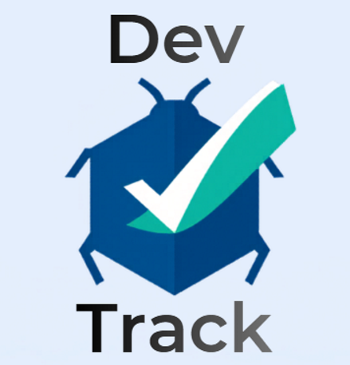  Assignment 2: Practical & Professional Development  Changemakers: Creativity and Value | Module Code: ACCA5033 Project Title: DevTrack – Agile-Based Bug Tracking & DevOps Management System Name: Ethan Furbert Student ID: 2308071 Lecturer: James MG Williams Submission Date: 7th May 2026

Abstract
This report describes the development of DevTrack, a web-based system designed to help software development teams manage bugs, track progress, and organise their work using Agile methods. The project focuses on solving common problems such as poor task organisation, limited visibility of progress, and lack of connection between development and operations.
The system was built using technologies such as React, Node.js, and MySQL. It includes features like issue tracking, sprint management, and a dashboard to monitor progress. It also includes simple smart features, such as automatically suggesting issue priority and indicating potential sprint risks.
In addition to the technical development, the project explores a business idea called DevTrack Solutions Ltd, including a basic business strategy and analysis of external factors using a PEST framework. Feedback was collected from users to evaluate the system and identify areas for improvement.
Overall, the project shows how a practical and easy-to-use tool can support small development teams. It also demonstrates the development of technical skills and highlights the importance of planning, testing, and continuous improvement.

Table of Contents
Abstract 1
Introduction 3
Task 1: Practical Development 3
Initial Feedback 3
Implementation 4
Login page 5
Repository page 7
Issues page 9
Overall UI/UX Evaluation 11
Task 2: Enterprise & Innovation 12
Tech Start-up Concept 12
Innovation Implementation 13
PEST Analysis 13
Task 3: Project Feedback & Reflection 14
Practical Feedback 14
Project Progress Diary (Reflection) 14
Skills Development 14
Positive Social Impact (PSI) 15
Conclusion 15
References 16
Appendices 17
Summary 22

Introduction
This report explores the development and evaluation of a software engineering project titled DevTrack – Agile-Based Bug Tracking and DevOps Management System. The project aims to design and implement a web-based application that supports software development teams in managing issues, tracking sprint progress, and integrating DevOps practices within an Agile framework.
The report is structured into three main sections. The first section focuses on the practical implementation of the system, including feedback collection, system development, and evaluation of the implementation process. The second section examines the enterprise and innovation aspects of the project, including the development of a start-up concept, business strategy, and external analysis using a PEST framework. The final section provides a reflective evaluation of the project, highlighting feedback, skills development, and the potential positive social impact of the system.
By combining technical implementation with business and innovation analysis, this report demonstrates how software engineering principles can be applied to create practical and scalable solutions within real-world contexts.

Task 1: Practical Development

Initial Feedback
While the system introduces intelligent features, the use of rule-based logic limits adaptability compared to more advanced machine learning approaches. A structured feedback method was used to evaluate the DevTrack system. Feedback was collected from four participants using a short questionnaire and informal discussions.
Participants highlighted several strengths:
- Simple and intuitive interface
- Clear issue tracking workflow
- Effective sprint dashboard
However, limitations were identified:
- Limited filtering options
- Basic AI priority system
- Lack of custom sprint settings
As a result, several improvements were proposed:
- Adding advanced search and filtering functionality
- Allowing custom sprint configurations
- Enhancing the priority suggestion system using more refined logic
This feedback demonstrates the importance of user-centred design and iterative improvement within Agile development practices.

Implementation

Technologies Used
- Front-end: HTML, CSS, JavaScript, React
- Back-end: Node.js, Express
- Database: MySQL
- Tools: Git, GitHub, Docker, AWS

System Implementation
The DevTrack system includes:
- Issue tracking functionality
- Sprint management features
- Real-time dashboard
- Role-Based Access Control (RBAC)
The system follows a layered architecture:
- Presentation Layer
- Business Logic Layer
- Data Access Layer
This structure improves scalability and maintainability.

Challenges and Solutions
- Integration complexity → resolved using modular design
- Time constraints → managed through Agile planning
- Testing limitations → improved through iterative feedback
While the system provides strong functionality, the integration of multiple components increased development complexity, demonstrating the trade-off between flexibility and implementation effort.

Login page
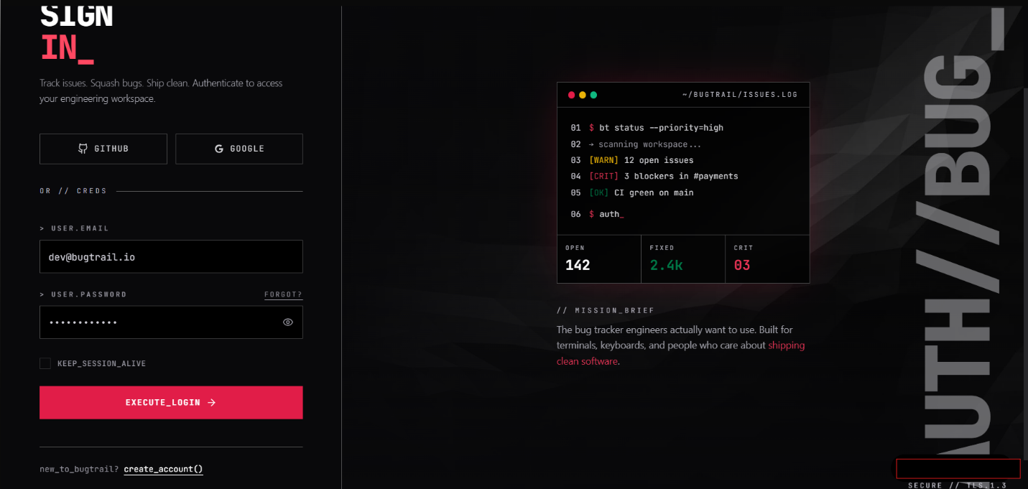
Pros
- Modern and Professional Design
The dark-themed interface with terminal-style elements creates a strong developer-focused aesthetic, making the system feel aligned with real-world software tools.
- Clear Purpose and Messaging
The tagline “Track issues. Squash bugs. Ship clean.” clearly communicates the purpose of the platform.
- Multiple Login Options
Integration with GitHub and Google provides convenient authentication methods, improving accessibility and user experience.
- Structured Layout
The page is well-organised, separating authentication (left side) and system preview (right side), which helps users understand the platform before logging in.

Cons
- Limited User Guidance
New users may not fully understand what to do, as there are minimal instructions or onboarding hints.
- Password Recovery Not Prominent
The “Forgot?” option is small and not clearly visible, which may reduce usability.
- Accessibility Concerns
The dark theme and low-contrast text may be difficult for some users to read.
- Technical Language
Terms like “EXECUTE_LOGIN” and terminal-style text may be confusing for non-technical users.

Future Improvements
- Add a Clear “Home” or Landing Page
Introduce a homepage before login to explain features, benefits, and how the system works.
- Improve User Guidance
  - Add tooltips or short instructions
  - Provide clearer labels (e.g. “Login” instead of “EXECUTE_LOGIN”)
- Enhance Accessibility
  - Increase text contrast
  - Provide light/dark mode toggle
- Improve Account Support
  - Make “Forgot Password” more visible
  - Add email verification and reset functionality
- User Onboarding
  - Add a short introduction or walkthrough after first login

Summary
The login page provides a strong first impression with a modern and developer-oriented design. It effectively supports authentication and reflects the system’s purpose. However, improvements in accessibility, user guidance, and clarity would make the system more inclusive and easier to use, particularly for less technical users.

Repository page
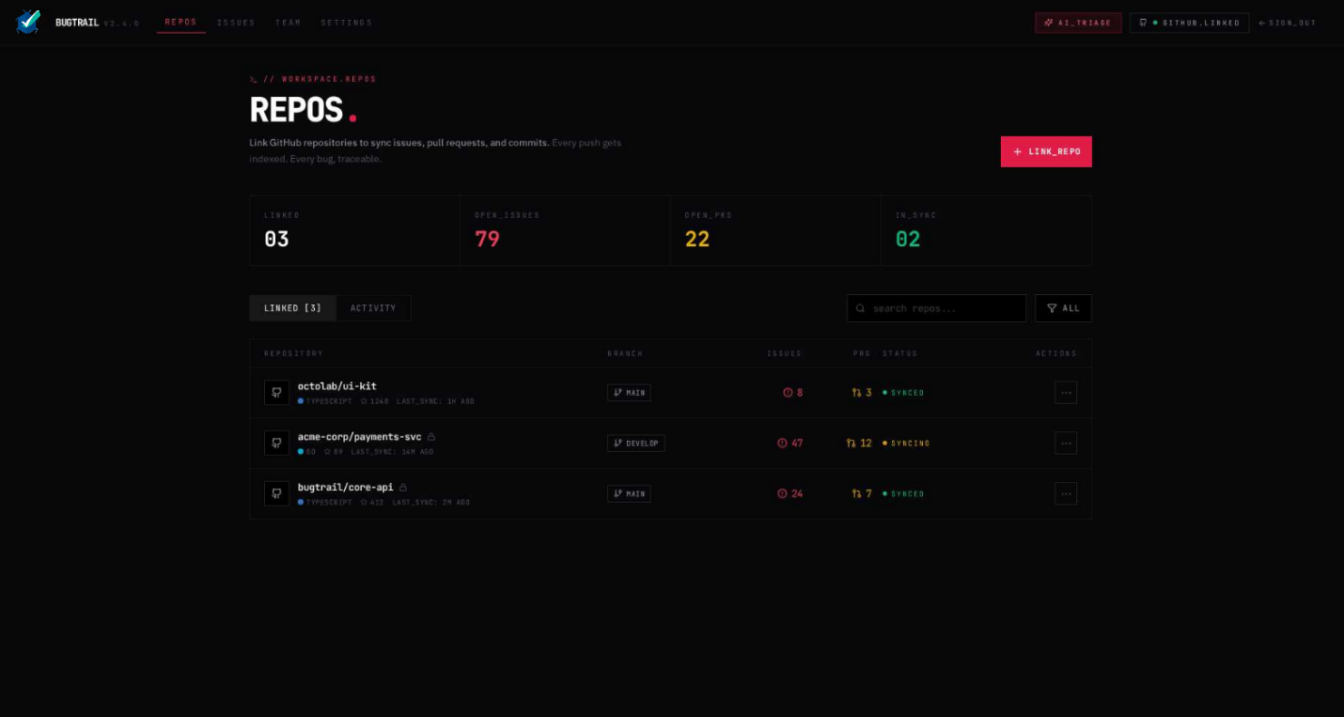
Pros
- Clear Overview of Project Data
The page provides a structured overview of repositories, including key metrics such as open issues, pull requests, and sync status. This supports quick decision-making.
- Integration with Version Control (GitHub)
The ability to link repositories and track commits demonstrates real-world DevOps integration, improving traceability between code and issues.
- Data Visualisation
Summary statistics (e.g. number of linked repos, open issues, PRs) are clearly displayed, allowing users to quickly assess project status.
- Search and Filtering Functionality
The inclusion of a search bar and filtering options improves usability, especially for projects with multiple repositories.
- Professional and Consistent UI Design
The dark-themed interface and consistent layout align with modern development tools, enhancing the user experience.

Cons
- Information Density
The page contains a large amount of data, which may be overwhelming for new or less experienced users.
- Limited User Guidance
There are no tooltips or explanations for elements such as “sync status” or branch labels, which may cause confusion.
- Navigation Complexity
Users may not immediately understand how this page connects to issues or sprint tracking without prior knowledge.
- Minimal Visual Hierarchy
Important information (e.g. critical issues) is not strongly highlighted, making it harder to prioritise tasks quickly.

Future Improvements
- Improve Visual Hierarchy
  - Highlight critical repositories or high-risk issues
  - Use colour coding more clearly for priorities
- Add User Guidance
  - Tooltips explaining metrics (e.g. “syncing”, “PRs”)
  - Short descriptions for new users
- Enhance Navigation
  - Add quick links from repositories to related issues
  - Include breadcrumb navigation for better user flow
- Introduce Activity Timeline
  - Show recent commits, updates, and issue activity
  - Improve visibility of ongoing development work
- Dashboard Integration
  - Link repository insights to a central home/dashboard page
  - Provide a more complete system overview

Summary
The repository page demonstrates strong practical implementation by integrating version control data with issue tracking functionality. It effectively supports development workflows and reflects real-world DevOps practices. However, improvements in usability, navigation, and user guidance would make the system more accessible and easier to understand, particularly for new users.

Issues page
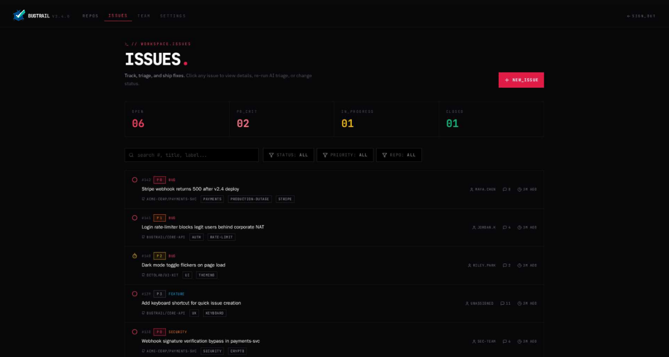
Pros
- Clear Issue Overview and Status Tracking
The page provides a structured view of all issues, including status categories such as open, in-progress, and closed. This supports effective task management and aligns with Agile workflows.
- Priority and Label System
Issues are categorised using priorities (e.g. P1, P2) and tags, allowing users to quickly identify critical tasks and organise work efficiently.
- Search and Filtering Features
The ability to filter issues by status, priority, and repository improves usability and enables users to locate specific tasks quickly.
- Integration with Development Workflow
Issue titles and metadata (e.g. timestamps, assigned users) reflect real-world development practices, improving collaboration and traceability.
- Consistent and Professional UI Design
The interface maintains a clean, modern design consistent with the rest of the system, improving user experience and readability.

Cons
- Limited Visual Differentiation
While priorities are shown, critical issues are not strongly highlighted, which may make urgent tasks less noticeable.
- Information Density
The list format may become overwhelming as the number of issues increases, especially for large projects.
- Lack of Visual Workflow (Kanban View)
Issues are displayed in a list rather than a board format, which may reduce clarity for users familiar with Agile tools like Kanban boards.
- Minimal User Guidance
New users may not fully understand how to use filters, priorities, or labels without additional instructions.

Future Improvements
- Introduce Kanban Board View
  - Display issues across columns (To Do, In Progress, Done)
  - Improve visual understanding of workflow
- Enhance Priority Visibility
  - Use stronger colour coding for critical issues
  - Highlight overdue or high-risk tasks
- Add Issue Details Page
  - Provide full descriptions, comments, and activity logs
  - Improve collaboration and communication
- Improve User Guidance
  - Add tooltips explaining filters and labels
  - Provide onboarding tips for first-time users
- Advanced Filtering and Sorting
  - Filter by assigned user, date, or sprint
  - Improve efficiency for large-scale projects

Overall UI/UX Evaluation
The DevTrack system demonstrates a consistent and modern user interface across the login, repository, and issue tracking pages. The dark-themed design, combined with clean layouts and developer-focused styling, creates a professional appearance that aligns with industry-standard tools. Consistency in typography, colour scheme, and navigation contributes to a cohesive user experience.
Across all pages, the system effectively supports its core purpose of managing software development workflows. The login page provides secure access, the repository page integrates version control data, and the issue tracking page enables structured task management. Together, these pages reflect a logical user journey, moving from authentication to project overview and then to detailed issue handling.
However, while the interface is visually strong, usability could be improved, particularly for less technical users. The use of technical terminology and terminal-style elements may reduce accessibility, and limited user guidance across pages makes it harder for new users to understand system functionality. Additionally, the absence of a central home or dashboard page reduces overall navigation clarity.
To enhance the user experience, future improvements should focus on simplifying navigation, introducing a clear homepage/dashboard, improving accessibility (e.g. contrast and readability), and providing onboarding support such as tooltips or guided walkthroughs. These enhancements would make the system more intuitive while maintaining its professional and developer-oriented design.

Summary
The issue tracking page demonstrates strong practical implementation by supporting structured task management, prioritisation, and filtering. It reflects key Agile principles and enables effective collaboration within development teams. However, improvements in visual workflow representation, user guidance, and the visibility of prioritisation would further enhance usability and scalability.

Implementation Reflection
The development of DevTrack highlighted several practical challenges, including integrating frontend and backend components, managing state across the application, and ensuring consistent data flow between features such as issue tracking and repository management. Time constraints required prioritisation of core functionality over advanced features. Despite these challenges, the system successfully demonstrates key software engineering principles, including modular design, iterative development, and version control. Future iterations would focus on improving system scalability, enhancing UI usability, and implementing more advanced DevOps integrations.

Task 2: Enterprise & Innovation

Tech Start-up Concept
The layered architecture improves maintainability; however, it may increase development complexity due to the need for integration across multiple components.

Start-up Name
DevTrack Solutions Ltd

Business Type
Private Limited Company (Ltd)

Business Strategy
DevTrack is positioned as a lightweight alternative to complex tools such as Jira, targeting:
- Small to medium-sized teams
- Start-ups and freelance developers

Revenue Model
- Freemium model
- Subscription plans
- Team licensing

Funding Options
- Angel investors
- Government grants
- Crowdfunding
- University incubators
While DevTrack offers simplicity and accessibility, it may lack advanced configurability required by large enterprises.

Innovation Implementation
The system introduces innovative features:
- Smart issue prioritisation
- Sprint risk indicators
- DevOps automation
- Data-driven dashboards
These represent incremental innovation, enhancing existing systems through automation and analytics rather than replacing them entirely.

PEST Analysis
Political
- Data protection regulations (GDPR)
- Government support for digital innovation
Economic
- Growth in software development industry
- Demand for cost-effective tools
Social
- Increased adoption of Agile practices
- Demand for user-friendly platforms
Technological
- Growth of DevOps and cloud computing
- Integration with platforms such as GitHub
Legal & Ethical Considerations
- Data protection compliance
- Secure authentication
- Responsible use of automation
Rapid technological change may require continuous updates, increasing long-term maintenance costs. The iterative development of DevTrack reflects Agile principles, where features were developed incrementally and refined based on ongoing evaluation.

Task 3: Project Feedback & Reflection

Practical Feedback
Feedback identified usability strengths but highlighted areas for improvement, such as filtering and AI functionality. Enhancements were proposed accordingly.

Project Progress Diary (Reflection)
Throughout the project, weekly progress logs were used to track development and planning activities (see Appendix C). This helped maintain structure and monitor progress across different stages.
One key strength was the ability to break down tasks into manageable sections, which improved organization and focus. However, time management emerged as a challenge, particularly when balancing technical implementation with report writing.
If the project were to be undertaken again, a more structured sprint schedule would be implemented with clearly defined milestones and deadlines. Additionally, more time would be allocated to testing and refinement to improve system quality, such as the system following a RESTful architecture, enabling efficient communication between the frontend and backend components.
This reflection highlights the importance of planning, time allocation, and continuous monitoring in project management.

Skills Development
The project contributed to the development of several technical and transferable skills:

Technical Skills:
- Web development (React, Node.js, MySQL)
- System design and architecture
- Understanding of Agile and DevOps practices

Transferable Skills:
- Problem-solving and analytical thinking
- Time management and organisation
- Independent research and learning
- Communication of technical concepts
These skills are directly relevant to professional roles in software engineering and demonstrate readiness for industry environments.

Positive Social Impact (PSI)
The DevTrack system has the potential to create a positive impact by improving accessibility to software development tools for small teams and independent developers.
Many existing platforms are complex and expensive, creating barriers for smaller organisations. DevTrack addresses this issue by providing a simplified and cost-effective alternative, enabling more inclusive participation in software development.
Additionally, the system promotes collaboration, transparency, and efficient workflow management, which can improve productivity and reduce project delays.
The skills developed during this project also contribute to personal and professional growth, enabling the application of knowledge to real-world challenges and future career opportunities.

Conclusion
In conclusion, the DevTrack project demonstrates the successful integration of software engineering principles, Agile methodologies, and DevOps practices in the development of a functional and scalable system. The project addressed key challenges in software development environments by providing a centralised platform for issue tracking, sprint management, and team collaboration.
The enterprise analysis highlighted the viability of DevTrack as a start-up concept, supported by a clear business strategy, scalable architecture, and a sustainable revenue model. The PEST analysis further emphasised the importance of external factors such as technological advancements, economic conditions, and regulatory requirements in shaping the long-term success of the system.
The reflection process identified key strengths in project planning, problem-solving, and technical development, while also recognising areas for improvement, particularly in time management and system integration. The project also demonstrated the development of transferable skills, including critical thinking, communication, and independent learning.
Overall, the project has significant potential to contribute positively to software development practices by improving collaboration, efficiency, and accessibility for small to medium-sized teams. The experience gained from this project provides a strong foundation for future professional development within the software engineering field.
This project demonstrates not only technical implementation but also the ability to design a practical, user-focused solution aligned with modern software development practices.
Future Work
- Implementation of Kanban board for improved workflow visualisation
- Advanced AI-based issue prioritisation
- Real-time collaboration features
- Mobile-responsive design improvements
Just potential ideas to further develop/grow the web application, ensure longevity, and widespread use for a variety of quality of life/work for users.

References
[1] D. for Science, Innovation and Technology, “AI Skills for Life and Work: General Public Survey Findings,” GOV.UK, Jan. 2026. [Online]. Available: https://www.gov.uk/government/publications/ai-skills-for-life-and-work-general-public-survey-findings

[2] I. Sommerville, Software Engineering, 10th ed. Boston, MA, USA: Pearson, 2016.

[3] K. Schwaber and J. Sutherland, The Scrum Guide. Scrum.org, 2020. [Online]. Available: https://scrumguides.org

[4] Project Management Institute, Agile Practice Guide. Newtown Square, PA, USA: PMI, 2017.

[5] G. Booch, J. Rumbaugh, and I. Jacobson, The Unified Modeling Language User Guide, 2nd ed. Boston, MA, USA: Addison-Wesley, 2005.

[6] Object Management Group, Unified Modeling Language (UML) Specification, Version 2.5.1, 2017. [Online]. Available: https://www.omg.org/spec/UML

[7] J. Humble and D. Farley, Continuous Delivery: Reliable Software Releases through Build, Test, and Deployment Automation. Boston, MA, USA: Addison-Wesley, 2011.

[8] G. Kim, J. Humble, P. Debois, and J. Willis, The DevOps Handbook. Portland, OR, USA: IT Revolution Press, 2016.

[9] GitHub, “GitHub Documentation.” [Online]. Available: https://docs.github.com

[10] Atlassian, “Jira Software Documentation.” [Online]. Available: https://www.atlassian.com/software/jira

[11] N. Forsgren, J. Humble, and G. Kim, Accelerate: The Science of Lean Software and DevOps. Portland, OR, USA: IT Revolution Press, 2018.

[12] T. Dingsøyr, T. Nerur, V. Balijepally, and N. Moe, “A decade of agile methodologies: Towards explaining agile software development,” Journal of Systems and Software, vol. 85, no. 6, pp. 1213–1221, 2012.

Appendices
Appendix A: System Design Diagrams
Figure A1: System Use Case Diagram
The use case diagram illustrates the interaction between system users and the DevTrack platform. Three primary user roles are identified: Administrator, Project Manager, and Developer.
- The Administrator is responsible for system-level management, including user registration, role assignment, and project creation.
- The Project Manager manages Agile workflows by creating sprints, assigning issues, generating reports, and monitoring sprint progress.
- The Developer interacts with the system by creating issues, updating issue status, adding comments, and viewing commit history.
This role-based structure reflects real-world software development environments and supports controlled access to system features, improving both usability and security.

Figure A2: System Architecture / Database Design
The system design follows a structured relational model to support Agile project workflows.
The key relationships include:
- Role → User (1:M): One role can be assigned to multiple users
- User → Project (1:M): A user can create multiple projects
- Project → Sprint (1:M): Each project contains multiple sprints
- Project → Issue (1:M): Each project can contain multiple issues
- Sprint → Issue (1:M): Each sprint consists of multiple issues
- Issue → Comment (1:M): Each issue can have multiple comments
- User → Issue (1:M): Users can create and be assigned multiple issues
- Project → Repository (1:1): Each project is linked to a single repository
These relationships ensure efficient data organisation and reflect Agile development practices, where work is structured into projects, sprints, and tasks. The model supports scalability and enables effective tracking of development activities.

Appendix B: System Roles and Permissions
The DevTrack system implements Role-Based Access Control (RBAC) to ensure secure and efficient system usage.
Administrator
- Register users
- Manage user roles
- Create and manage projects
Project Manager
- Create and manage sprints
- Assign issues to developers
- Generate reports
- Track sprint progress
Developer
- Create and update issues
- Change issue status
- Add comments
- View commit history
This structured role system ensures that users only access relevant features, reducing complexity and enhancing system security.

Appendix C: Weekly Project Progress Logs
Week 1
Date: 25/03/2026
Progress:
- Developed initial draft of Enterprise and Innovation implementation
- Defined key features of the DevTrack system
- Began structuring the project report
Challenges:
- Difficulty aligning technical system features with business concepts
Actions Taken:
- Reviewed Agile and DevOps literature to improve understanding
- Refined project scope to better match assignment requirements
Next Review Date: 01/04/2026

Weeks 2–3
Progress:
- Completed detailed Enterprise and Innovation sections
- Developed PEST analysis example for a global company
- Expanded system feature descriptions
Challenges:
- Ensuring sufficient analytical depth in PEST analysis
Actions Taken:
- Incorporated external research on industry trends
- Improved structure and clarity of analysis

Week 4
Date: 29/04/2026
Progress:
- Continued development of Assignment 2 report
- Created additional weekly progress logs
- Began drafting reflection and conclusion sections
- Gathered evidence of CPD (online certified course)
Challenges:
- Managing time across multiple assignment sections
Actions Taken:
- Prioritised remaining tasks
- Structured final stages of report writing
Next Review Date: 06/05/2026

Appendix D: Example PEST Analysis – Unity Technologies
This example demonstrates how macro-environmental factors influence strategic decisions in a global technology company.
Political Factors
- Increased regulation of digital markets (EU, US, China)
- Data privacy laws affecting platform services
- Government support for gaming and AR/VR innovation
- Content regulation in certain regions
👉 These factors highlight the importance of compliance and adaptability in global operations.

Economic Factors
- Growth of the global gaming industry
- Impact of economic downturns on development budgets
- Sensitivity to pricing models and developer response
- Currency fluctuations affecting revenue
👉 Economic conditions directly influence pricing strategies and market demand.

Social Factors
- Growth of global gaming culture
- Strong adoption among indie developers
- Increased use in education and training
- Rising expectations for high-quality user experiences
👉 Social trends drive demand for accessible and powerful development tools.

Technological Factors
- Advancements in real-time 3D technologies
- Growth of AR/VR platforms
- Increasing integration of AI in development
- Expansion of cloud and multiplayer services
- Cross-platform development capabilities
👉 Continuous innovation is essential to remain competitive in the technology sector.

Summary
Unity Technologies operates in a highly dynamic and competitive environment. Its success depends on maintaining developer trust, adapting to technological advancements, complying with regulations, and responding effectively to market competition.
This analysis demonstrates the relevance of PEST frameworks when evaluating external factors, which can also be applied to the DevTrack system’s business strategy.

