David Sheppard (2306723) - 15th January 2024
2306723@student.uwtsd.ac.uk
Abstract
This report describes the components of my HTML & CSS website along with relevant testing and research, and is based on my local football team
ACCA4023: INTRODUCTION TO WEB AND DATABASE CONCEPTS
HTML & CSS Web Development

Table of Contents
Introduction 2
Requirements 3
Purpose 3
Subject matter 3
Intended Audience 3
Wireframe design 4
Implementation 8
Website: Home page 8
Website page 2: Fixtures 9
Website page 3: Teams 9
Website page 4: About Us 10
Website page 5: Contact Us 10
Website validation 11
Evaluation 13
Website usability 13
Search Engine Optimisation (SEO) 14
Accessibility 15
References 19
Appendices 21
HTML home page 21
HTML fixtures page 25
HTLM teams page 28
HTML about us page 30
HTML contact us page 33
CSS style page 35

Introduction

This report considers the standards, concepts, principles, and practice that are required when developing and implementing websites.
In doing this, a hand-coded website using HTML and CSS has been developed. The website includes five pages and is themed around my local football team, Gorseinon Athletic A.F.C.
The report is broken down into the following sections:
- Requirements: Where the website is introduced, intended audiences are identified, purpose established, and a wireframe conceptual drawing is produced.
- Implementation: Screenshots of the finalised website are provided, and web standards are investigated. Validation of the code for the HTML home page and CSS style has been undertaken and the results included, with a log of errors encountered and resolutions.
- Evaluation: Website usability, accessibility, and search engine optimisation are researched. These areas are then evaluated against my website.
- References: Included for research sources.
- Appendices: Including text copies of HTML and CSS code.

Requirements

A website can be designed by one person with a basic understanding of the general principles, but for larger organisations, whole teams are devoted to the development of a website, each with individual roles and responsibilities that contribute to the overall package. [1]
As I am designing and building this website alone, I have decided to base my website on my son’s local football team, Gorseinon Athletic A.F.C. as a good place to start due to the smaller scale. I have some knowledge of the subject area and a colour scheme to follow, which is based on the club’s badge and kit. The initial website will be more simplistic, with more complex elements to be built once the general framework and design is in place.

Purpose

Websites are extremely powerful tools for sharing information, promoting brands and increasing awareness of a particular area. The purpose of this website is to increase awareness of the football team and to provide a one-stop place where news related to the team can be shared, fixtures, results and tables can be viewed. Additionally, information related to the wider local area will promote the image of the area. With no website currently devoted to the team, most information is shared in other ways, such as via social media platforms like Facebook, WhatsApp groups or simply word of mouth.

Subject matter

Based on a football team, all information is relative to this subject. This means that latest match news is provided, details of in season performance, social media posts with the team tagged in and other related subjects. Supporting commercial interests means inclusion of links to sponsor websites.

Intended Audience

One consideration in the design of any website is user research and testing. Understanding the needs and desires of the audience is central to the design. Typically, website designers would undertake user-research at each stage of development to influence the design of the website. [1]
Due to time constraints, this has not been possible for my website, but with my understanding of the subject area, and being an audience member for this subject myself, I have designed this website to cater for what I consider to be the needs and interests of anyone following the club. Additionally, information such as a map are included so that visiting teams and their supporters can easily find us and have a bit more information about the club and the area.

Wireframe design

A wireframe design shows the basic structure of a website, using outlines of each type of content. It indicates where functionality and content are to be placed within the design without the distraction of decoration. This allows a focus on usability, helps the build team follow the planned design and is an important phase in developing any website. [1]
Once you have considered these elements and the purpose of the website, you can start sketching some ideas and think about how you would like the website to look and feel and it allows you to consider appropriate web standards to follow.
“Sticking with web standards is your primary tool for ensuring your site is as consistent as possible.” [1]
The World Wide Web Consortium (W3C) sets out HTML, CSS and JavaScript standards, which are blueprints of a consistent and harmonious connected world, used in browsers, blogs, search engines and other software powering our experience on the web. [2]
I created the wireframe design for the five pages of my website considering the consistency introduced in the web standards. The wireframe design, shown in figures 1 to 5, set out the main functions of each page, including the navigation buttons on the top banner, placement of supporting images and the positioning of the text areas, with relevant headings.
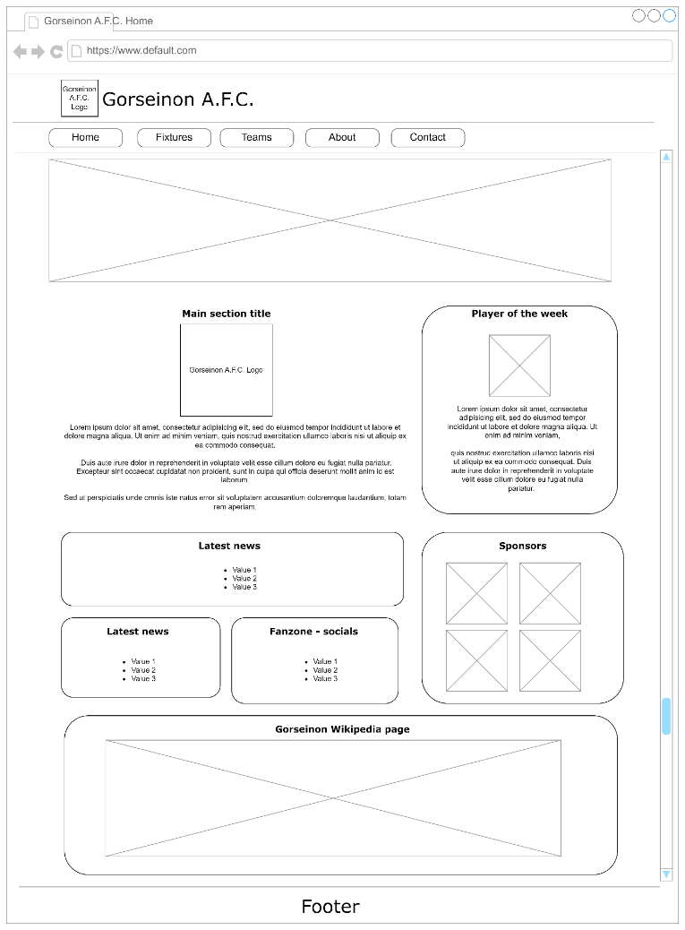
Fig 1. Wireframe home page
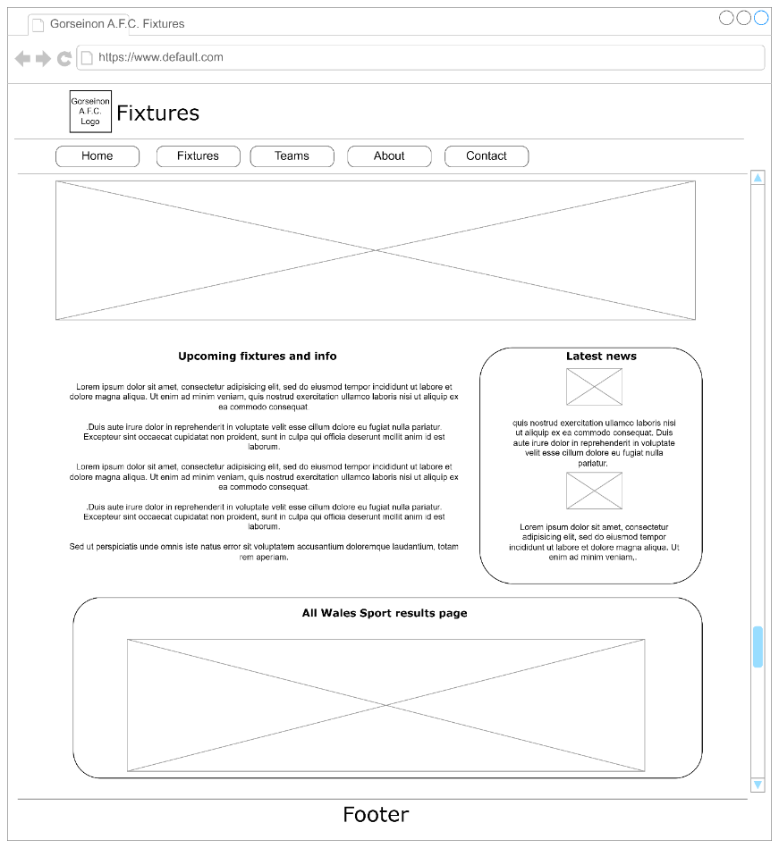
Fig 2. Wireframe page 2: Fixtures
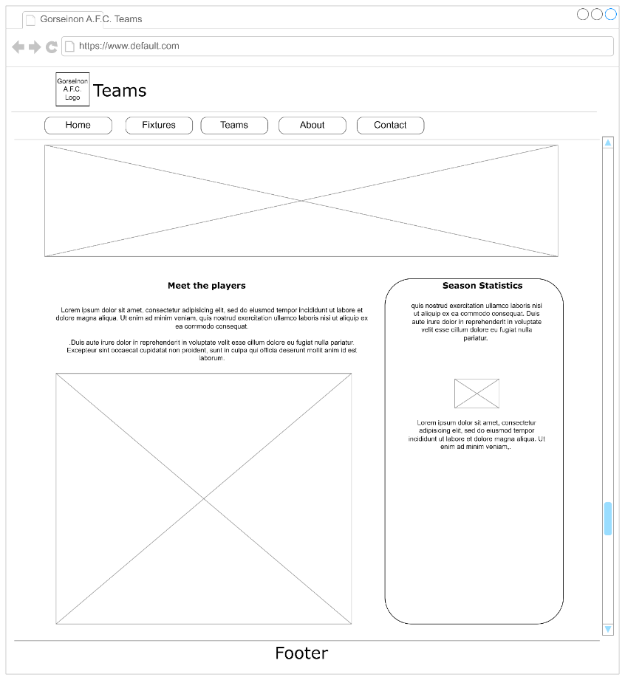
Fig 3. Wireframe page 3: Teams

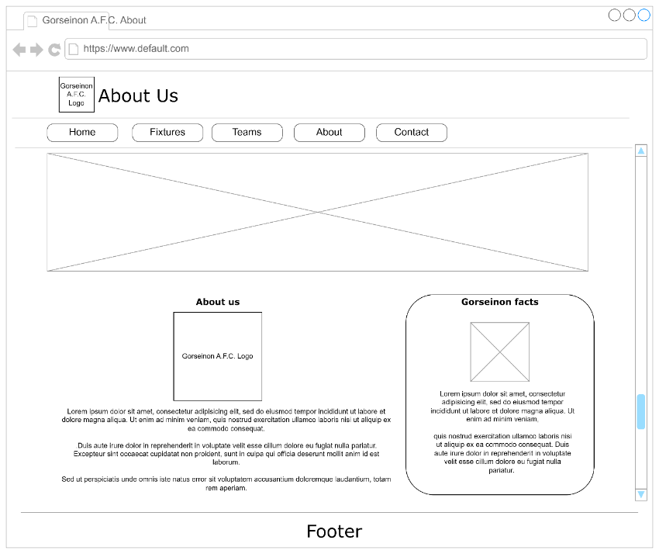
Fig 4. Wireframe page 4: About us

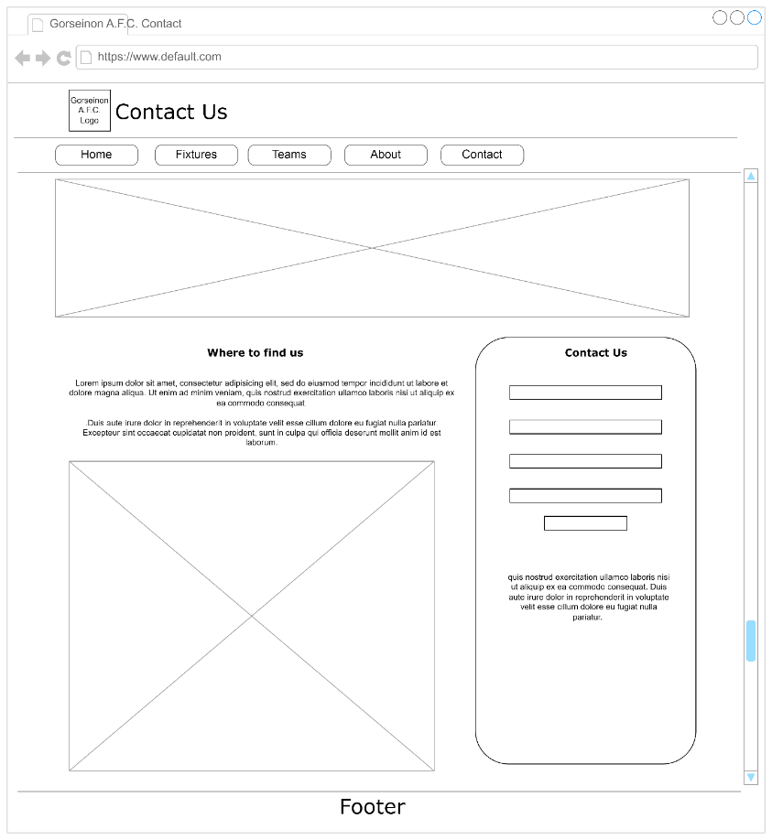
Fig 5. Wireframe page 5: Contact us.

When designing my website, I wanted to have a clean and simple design, with tiles used to separate the various sections of the individual pages. This would draw the user’s eye into the relevant sections, and assist with reading in a natural order, left to right and down.
I wanted to keep the design consistent across all pages to increase the brand awareness and to be visually appealing.
I had already decided on the colour scheme based on the team’s kit colours for use in the implementation stage. I considered these colours would be compatible with web accessibility and contrast rules.

Implementation

Following the elements in my wireframe design, I then moved onto the coding of the 5 HTML pages along with the CSS styles sheet to assist with the visualisations.
The following images show the pages from my completed website prior to any validation of the code. I am happy with the overall look and feel of the pages and think I have achieved the purpose of the website and satisfied the needs of the users. With more time and resources, I would consider refinement of some of the images and content. I would also like build on the interactivity within the website.

Website: Home page
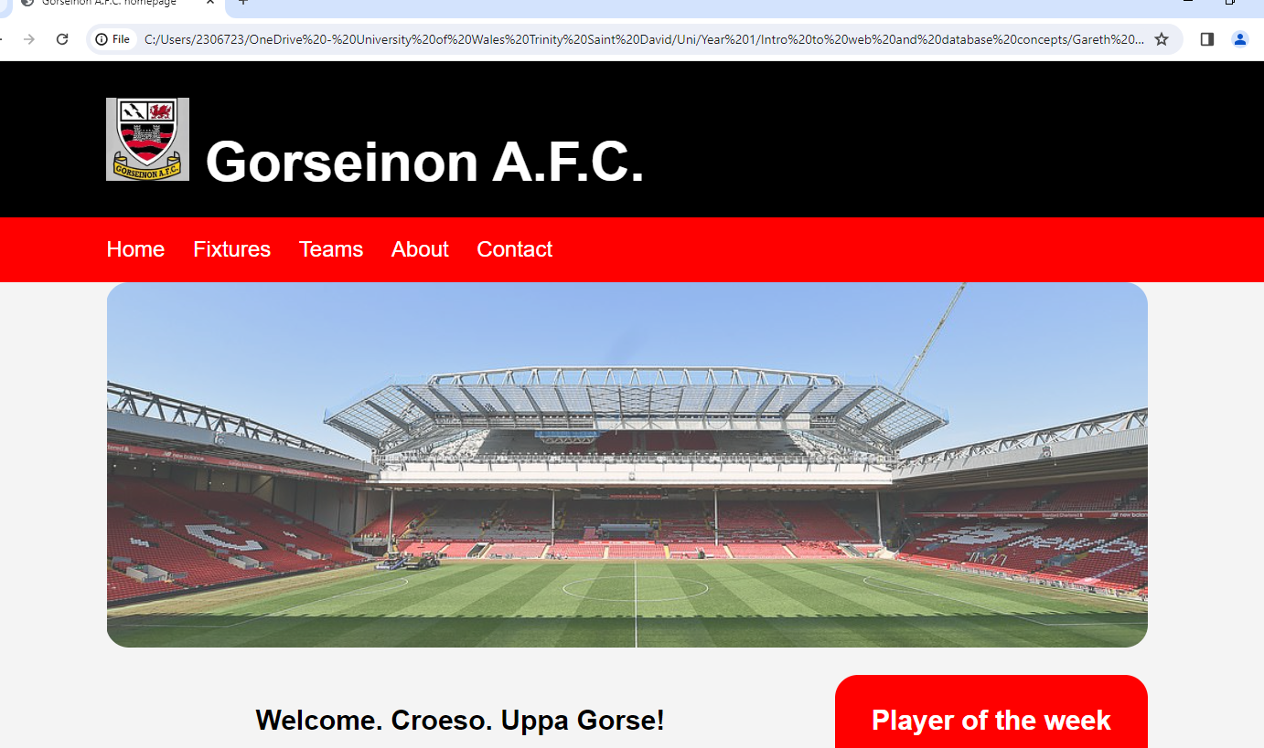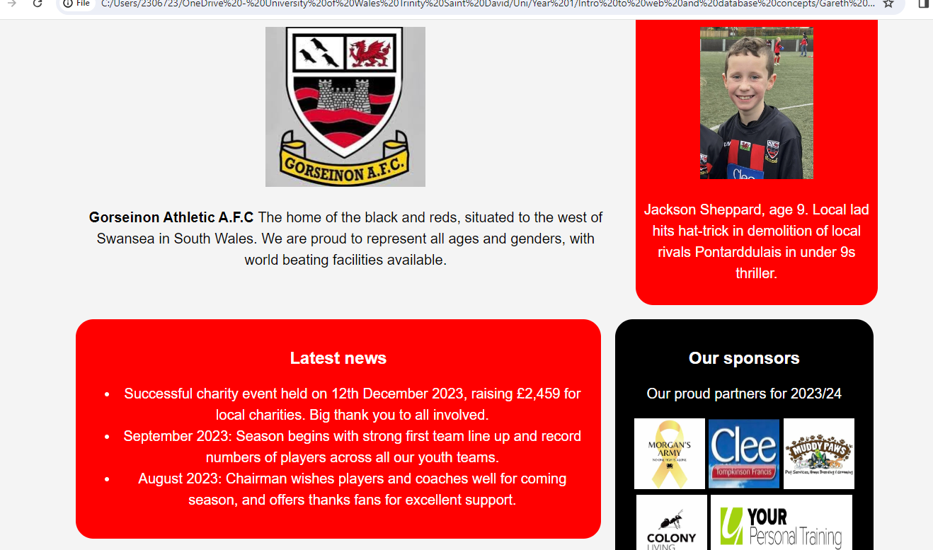
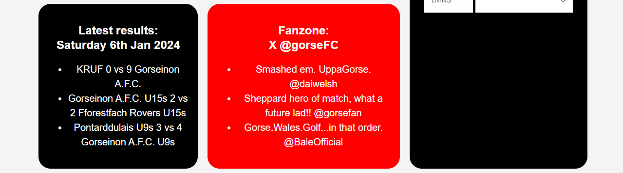
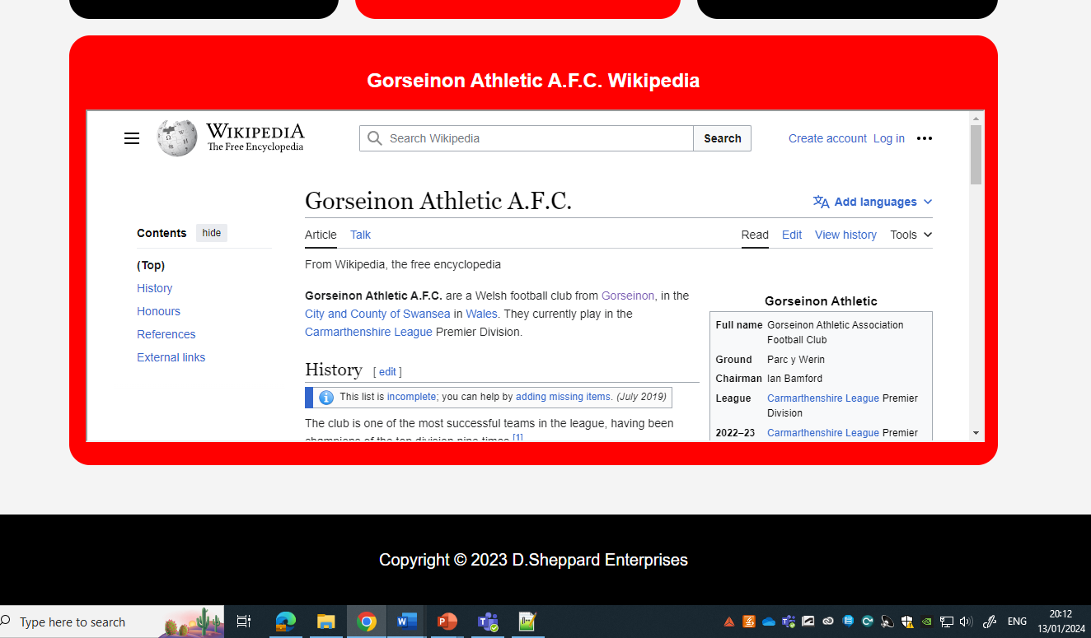
Fig 5 – 8. Screenshots of home page appended due to screen size.

Website page 2: Fixtures

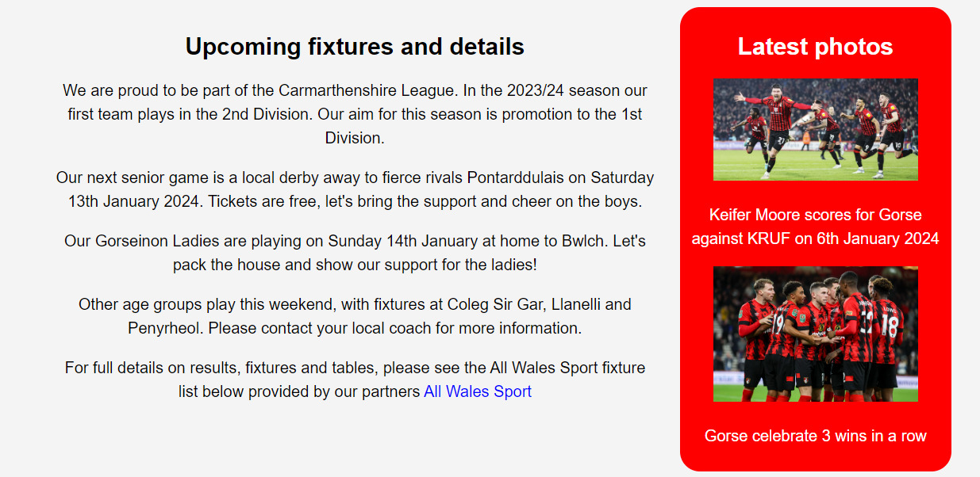
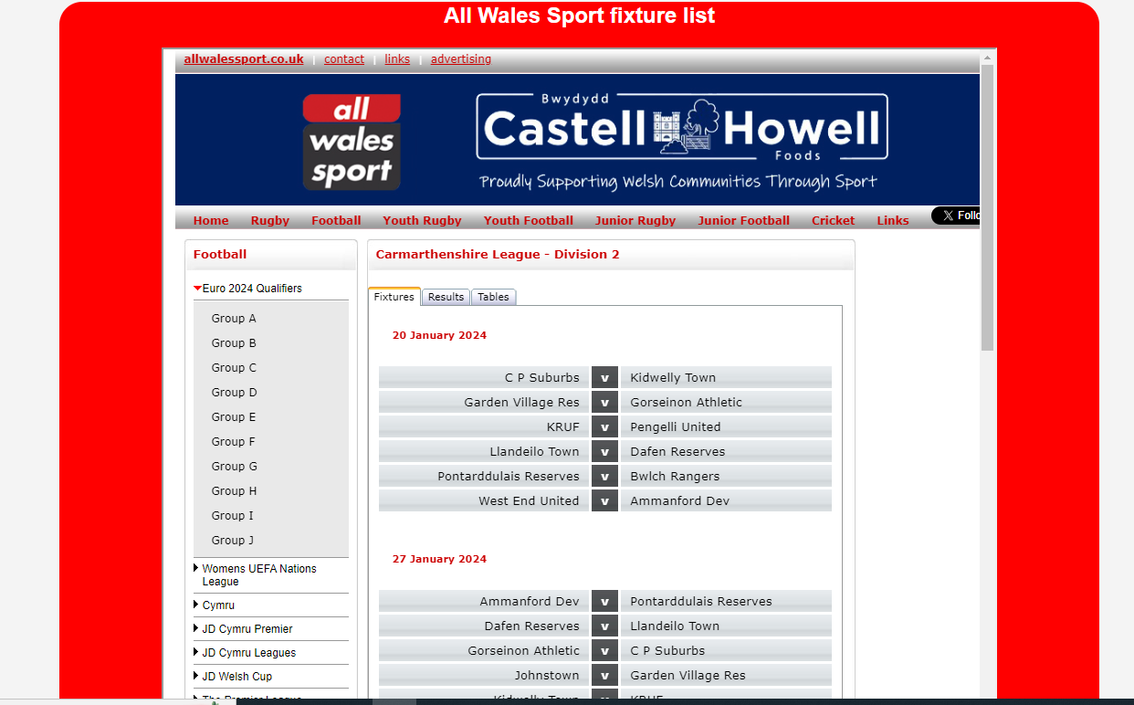
Fig 9 – 11. Screenshots of Fixtures page appended due to screen size.

Website page 3: Teams
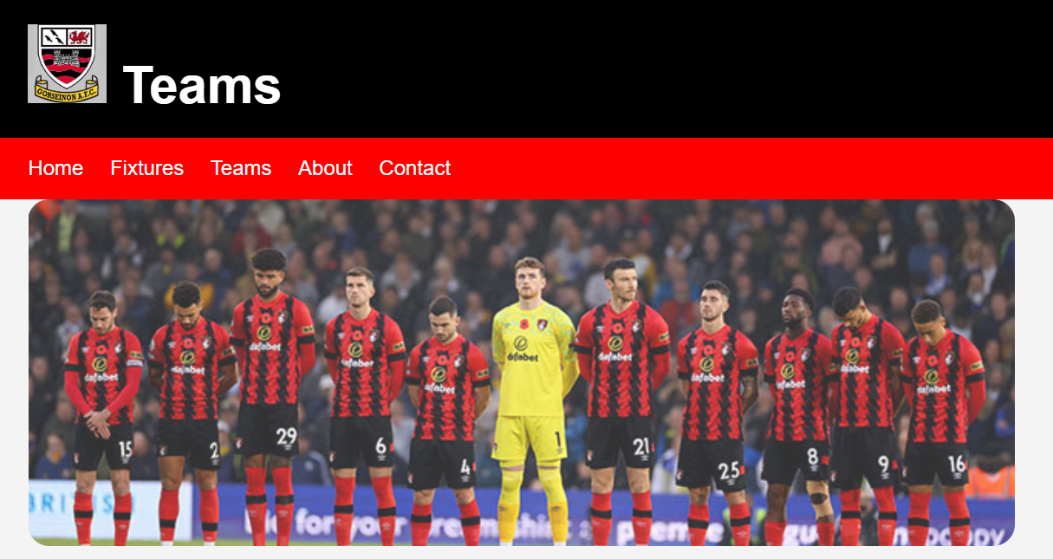
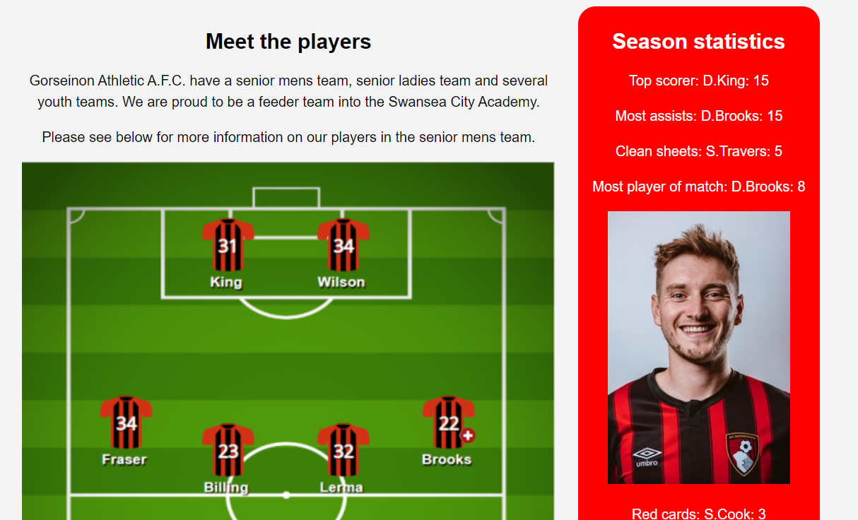
Fig 12 – 13. Screenshots of Teams page appended due to screen size.

Website page 4: About Us
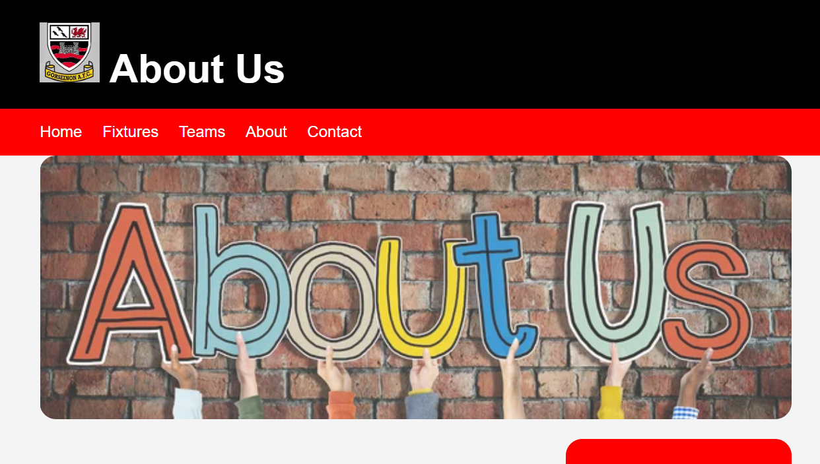
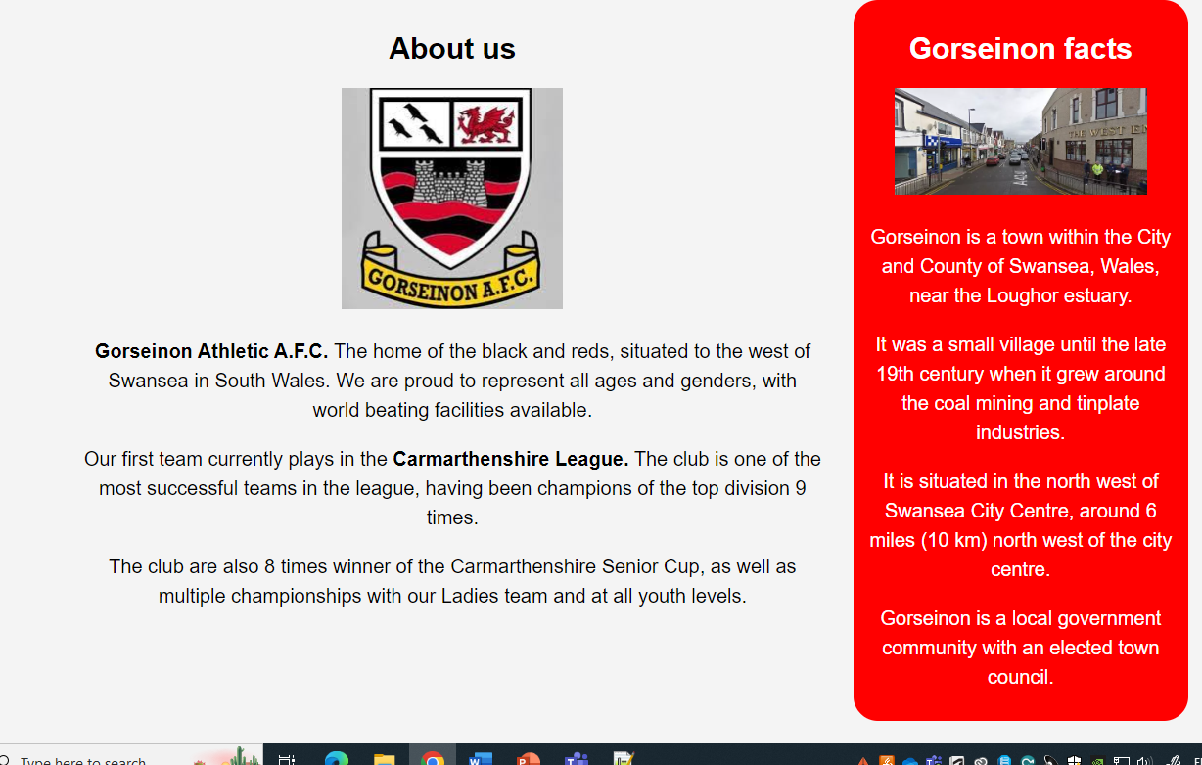
Fig 14 – 15. Screenshots of About Us page appended due to screen size.

Website page 5: Contact Us


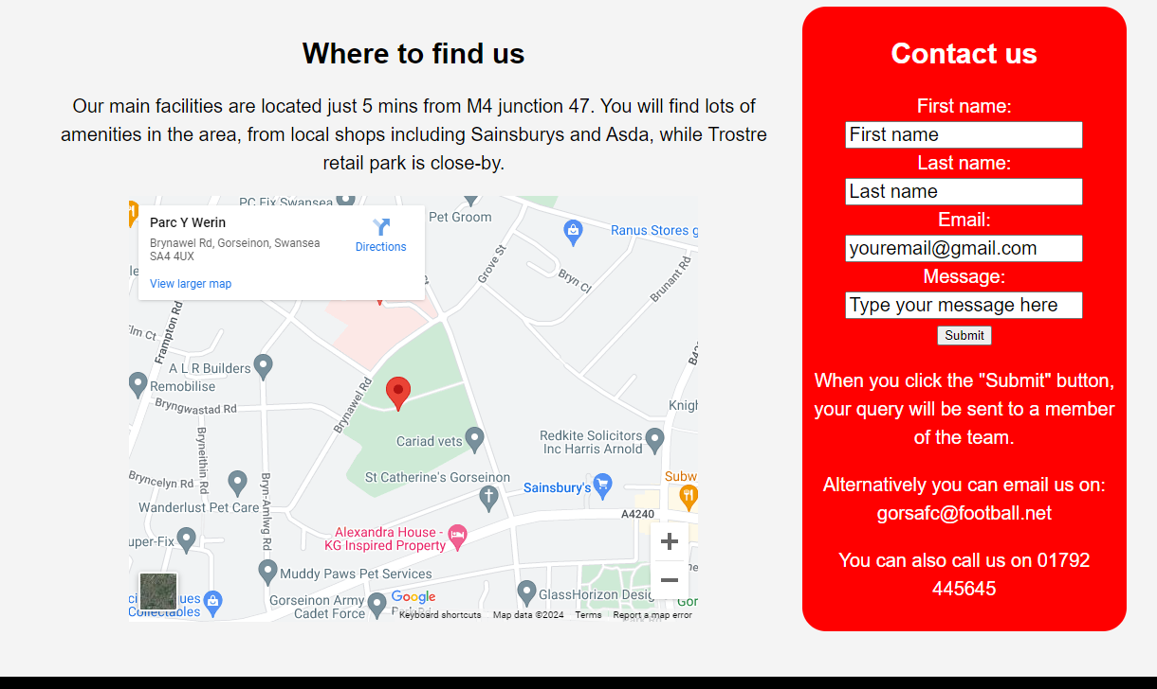
Fig 16 – 17. Screenshots of Contact Us page appended due to screen size.

Website validation

Validation is another important component in the implementation of a website. It allows checking of the markup via online tools and provides important information, warnings, and errors that can be investigated and resolved, making the website as efficient as possible.
My index.html homepage validation results are provided below.
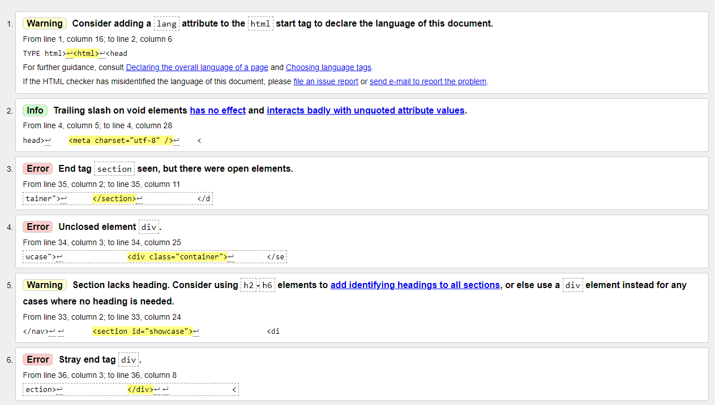
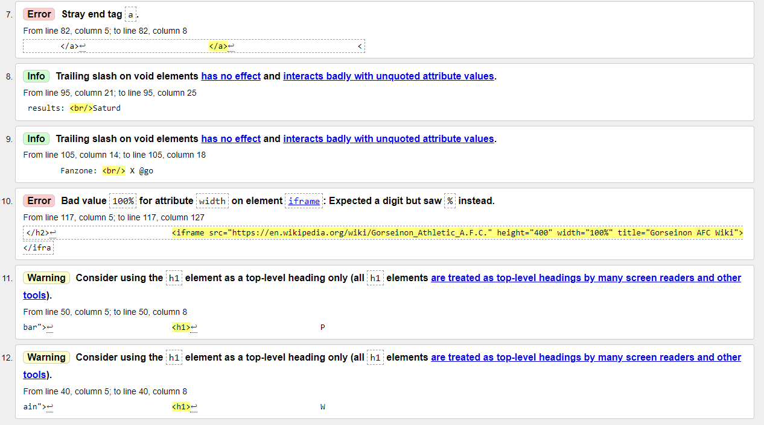
Fig 18 - 19. HTML homepage validation results
For error number 3, 4 and 6 in figure 18, I had the </div> and </section> commands on the wrong rows. I rectified these errors by moving the </div> from row 35 to 36, and the </section> from row 36 to row 35, closing both sections appropriately and correctly.
For error number 7 in figure 19, I had included a duplicate </a> command. This was not needed so I deleted the command.
For error number 10 in figure 19, I had included the width as 100% of the grid size. I did this so that the insert would scale with different screen sizes. However, the validator picked up an error due to an unexpected % symbol for the width. To rectify the error, I removed the inverted commas from the 100% for the width.
My style.css validation results are provided below.
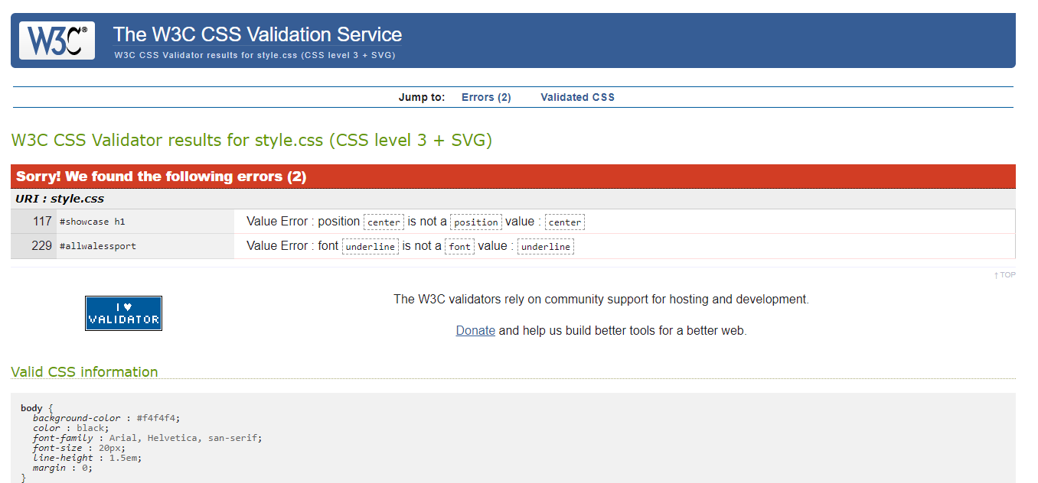
Fig 20. CSS validation results

For the first error in figure 20, which was shown to be on row 117 of the CSS code, the error was related to some code I had entered to centre text. However, I already had text-align:center on the next row, which is the correct code, and therefore I deleted the entry on row 117.
For the second error, shown on row 229, I was experimenting with underlining the hyperlink text, but noticed that it hadn’t worked correctly. The hyperlink is now displayed as blue font. I should have deleted the row when I realised my original idea didn’t work.

Evaluation

Now that my website has been designed, developed and the code validated, and before publishing, it is necessary to evaluate several aspects of the website, including accessibility, usability and search engine optimisation.

Website usability

The peer-reviewed Journal of Retailing and Consumer Services defined aspects of website usability as [3]:
- The ease of understanding for users of the structure, functions, interface and contents of a website.
- Simplicity.
- Speed that users can find what they are looking for.
- Ease of navigation.
- Ability for users to control their navigation.
There is consensus that satisfied customers are more likely to re-use a firm’s products or services and have less intentions to shop around. Using this logic, a satisfied user of a website is more likely to visit again.
The Journal found that “satisfaction has a positive effect on consumer intention to use a website” [3].
It concluded that usability is of critical importance in achieving user satisfaction, and quality of the interface and availability of information have a significant effect on user satisfaction. [3]
Flavian et al (2006) found usability of a website increases customer loyalty. It has also been noted that ease of use has positively affected the intention to shop. [3]
Producing a user-friendly website is a very important search engine factor, as satisfied users are more likely to become paying customers. The main factors of website usability can be described as [4]:
- Uniqueness – create something that is quickly clear to understand what the website is about. Include a homepage and a memorable slogan.
- Structure – easy navigation, a sensible number of buttons. Include a logo to increase brand recognition.
- Consistency – ensure format of buttons, logos and graphic elements are consistent. Use a content style guide to keep text and writing style consistent.
- Appeal – create a clear visual hierarchy using images and sub-headings. Peace and order beats gimmicks.
A user-friendly website tends to create a more positive attitude towards a brand. The brand becomes memorable. As an example, in a retail environment, think about a physical shop that is very untidy, with stock mixed up in all different areas. This would be memorable for the wrong reasons, and customers are less likely to make a purchase. Flip that to a shop that is very well organised, easy to locate what you need and very organised. Customers are likely to trust the brand and part with their heard-earned cash. The same thinking applies to the virtual world. A usable website is more likely to build trust and encourage repeat visits. Think of the big brands with a web presence like Facebook, Amazon, BBC. All use a distinctive style and all rise to the top in a crowded market.
Usefulness, utility and usability of my website
Using the usability checklist on the IONOS website as a guide [4], I provide an evaluation of my website.
Area | Evaluation
Understanding | The opening statement clearly explains the brand and provides a bit of information about the team. In hindsight, more detail around the purpose of the website would have been good to include at the very top level to enhance the understanding.
Navigation | I believe the navigation options are simple using the top navigation bar. Possibly the labelling of the pages could have been slightly clearer. I think anyone with basic understanding of navigating website would find it easy.
Consistency | Themes and structure are consistent.
Legibility | Text is clear and consistent size and font. Headings are clear. Bullet lists could have been a bit neater if aligned left.
Devices | Images resize for different screen sizes and works on booth Safari and Chrome browsers. However, there are some limitations in the resizing of text elements on smaller screens. With more time I would have liked to improve this.

In summary, I believe my website is user-friendly, although there are areas that could be improved with more time and experience.

Search Engine Optimisation (SEO)

With the web being such a large information source, with millions of different websites across the globe, a person can only realistically find a tiny fraction of the information out there. Therefore, search engines are vitally important in ensuring that users can find information easily. Subsequently, it is vitally important that you do everything in your power to make your website discoverable.
According to a conference within the IEEE Transactions on Professional Communication, for any successful website, it is important to be aware that a search engine’s rankings are determined by three types of participants [5]:
- Search engine companies (i.e. Google)
- SEO practitioners
- Users
According to the Search Engine Marketers Professional Organization, search engine optimization (SEO) is “the process of editing a web site's content and code in order to improve visibility within one or more search engines”. [5]
Another Term, Search Engine Marketing, describes how companies fund paid results with the search engine companies to ensure their results are visible towards the top [5]. This gives an advantage and is a technique widely used among bigger companies.
In order to make it easier to find their content through search engines, developers need to [5]:
- Use keywords on the website to make content appear on search engine results pages. This means naming web domains, directories, and files based on keywords and prioritising key words in titles.
- Consider their audience and their website’s competitors.
- Involve web content with other content creators to build brand association. This includes having links from other websites to yours and developing a community through social media.
It is important to consider the audience’s understanding of your website. If there is limited understanding of the subject, and therefore less specific search terms used in the search engine, there is less chance of being found. For example, if you type Amazon into Google, it will appear at the top of the search. If you try searching for information on a specific tribe in the Amazon rainforest, you need to be a lot more specific in your search terms – you could not simply just type Amazon for the results to appear.
Evaluation of my website against SEO
The on-page SEO techniques I have used in my website are:
- Use of Gorseinon Athletic A.F.C. logo on every page, using the alt name for the images so that screen readers can pick up the term.
- Added in key words such as web page titles including the football team’s name, clear headings for sections for latest results, fixtures, where to find us.
- Considered other websites with the same purpose, including from large football teams with large following, and the sections they use as guidance.
- Provided links to sponsors pages, with the view that they could add us as a link to our website on theirs.
Overall, to find my website, you would need to have a little bit of knowledge of what you are looking for. Simply typing Gorseinon may not bring my website to the top of the search, but being a little more specific could allow users to narrow down the search. I think this is an appropriate level of expectation for a website based on a fairly small local football team.

Accessibility

Web accessibility in basic terms means that people with disabilities can use the web. Disabilities are wide ranging, such as visual, auditory, physical, speech, cognitive, neurological [6], so there are a range of techniques to cater for these users, and websites should be designed with accessibility in mind.
In the peer reviewed Journal Progress on Website Accessibility?, the principles for successful website accessibility include [7]:
- Providing text alternatives to non-text content.
- Subtitles for audio/video content.
- Visual elements are to be accessible. i.e. colour alone not used to convey information.
- Keyboard use for all website functionalities.
- Provide ways to stop/hide dynamic content.
- Provide page titles that describe the topic.
- Specify the default language.
- Labels and instructions are provided.
- Ensure pages are compatible with assistive technologies.
Figure 21 shows more information on the principles and guidance.
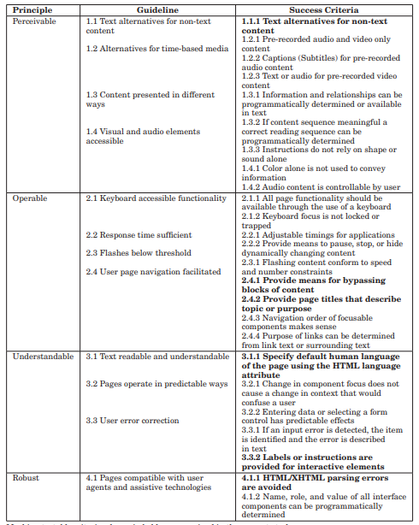
Fig. 21. Principles and guidance for accessibility success [7]
Evaluation of my website against web accessibility criteria
One of the tests I evaluated my website against was the aXe: The Accessibility Engine. I installed it as a browser extension and then run an inspection on each page of my website. Figure 22 shows the results of the accessibility check using aXe on my home page. 21 errors were showing. 20 of these were related to contrast. 1 was related to the setting of the default language.
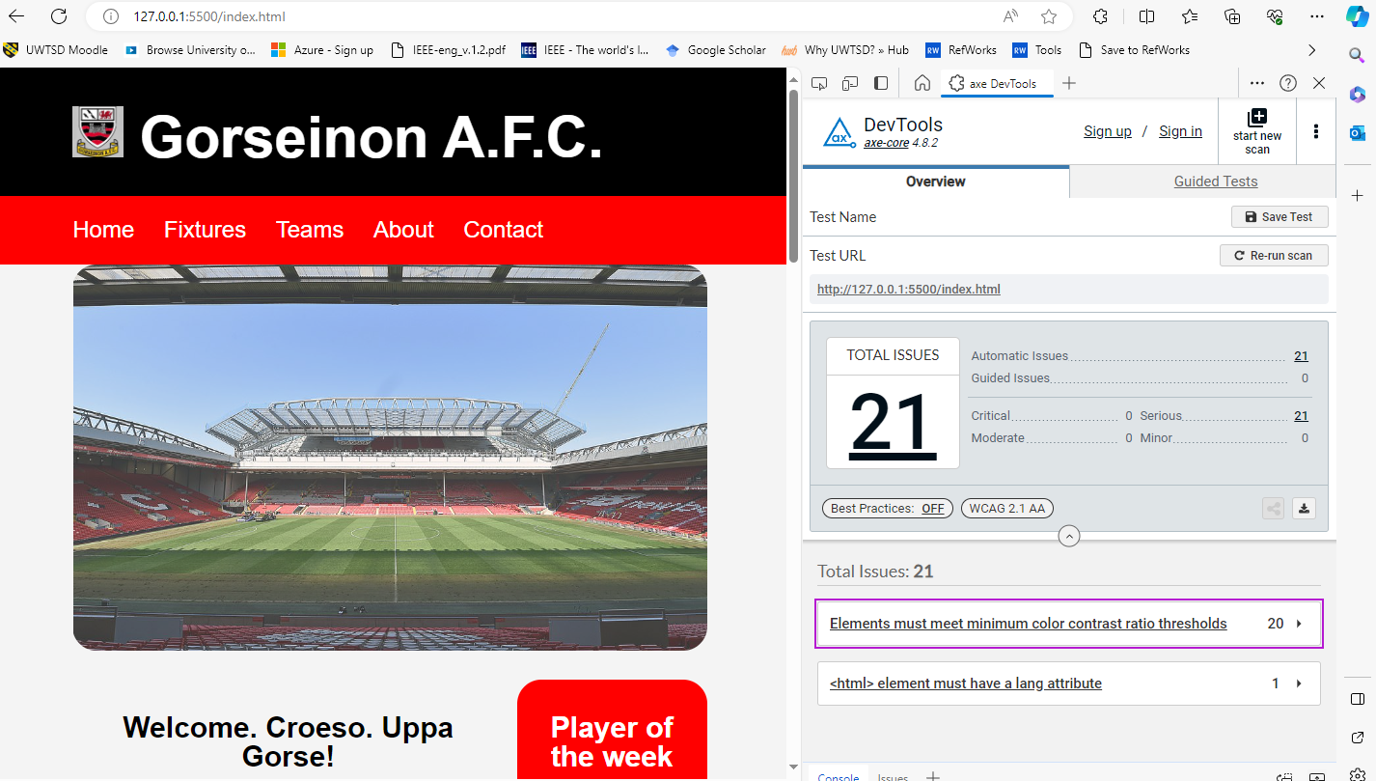
Fig. 22. aXe accessibility checker
Figure 23 shows the results of the colour contrast check using contrastchecker.com. The red background with white text showed I passed the margin and 18 size font but failed the rest.
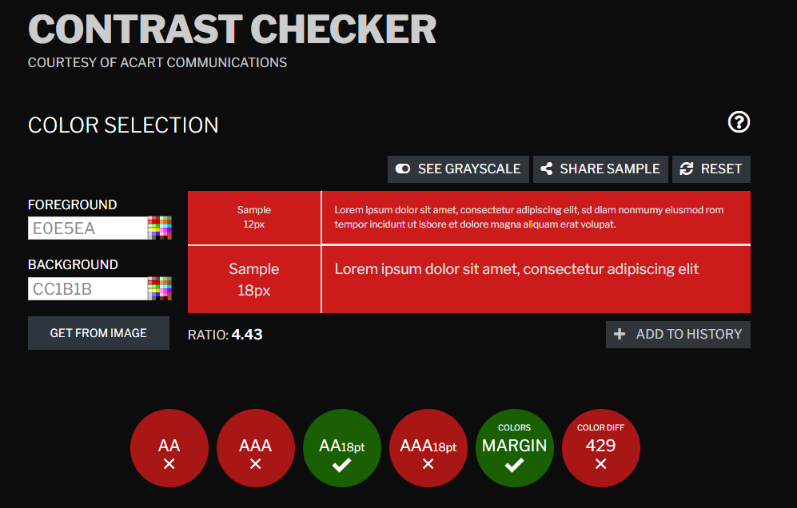
Fig. 23. Contrast checker for red background with white text
Figure 24 shows that where I have used black background with white text, all contrast checks have passed, therefore this is a more appropriate colour to use. In future, I would ensure colour contrast throughout my website was more appropriate.
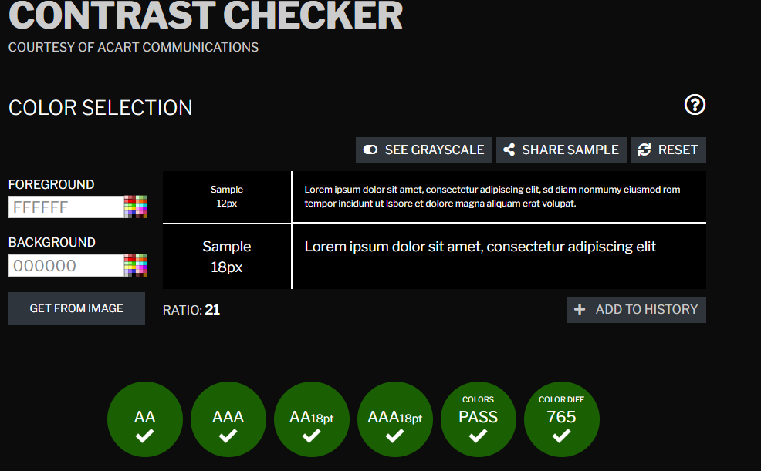
Fig. 24. Contrast checker for black background with white text

References
[1] J. N. Robbins, Learning Web design: a beginner's guide to HTML, CSS, JavaScript, and web graphics, fourth Ed. Sebastopol, Canada: O'Reilly, 2012.
[2] "Web Standards." W3C. https://www.w3.org/standards/ (accessed Jan 14,).
[3] D. Belanche, "Website usability, consumer satisfaction and the intention to use a website: The moderating effect of perceived risk," Journal of Retailing and Consumer Services, 12 November 2011. Accessed: Jan 14, 2024, [Online]. Available: https://pdf.sciencedirectassets.com/271706/1-s2.0-S0969698911X00073/1-s2.0-S0969698911001160/main.pdf?X-Amz-Security-Token=IQoJb3JpZ2luX2VjENj%2F%2F%2F%2F%2F%2F%2F%2F%2F%2FwEaCXVzLWVhc3QtMSJHMEUCIQDRsXi%2BRC5m9%2FffCQriOQKxS10AFL7%2F%2FH4eyngn3bq1%2BQIgR%2BI9Sc259SpCg1mlx6uQ%2BBx5GmHG1YllDHKlVuwHUCUqvAUIgf%2F%2F%2F%2F%2F%2F%2F%2F%2F%2FARAFGgwwNTkwMDM1NDY4NjUiDG6y7Iv%2BioKepg2BqyqQBfNfUr2cmqJWpxCM9P5P7pAcpieK4QM%2BXqXOm4BojPnCvcOZLnGRualnRqsnIbqAbbEsQu%2FO9uZ2aNM7c19R24TIiSZayEJXhJhatj7ItOSs2wNuO9nFgWY91LsYK2js3pBBxKb5UaF59sFU0%2BzzxlTBVfNZo3wuLnDLsevkcWU0MWVjswNF8cf6mJZK29fcbSRtyXHaWzLkhuTVhLszgsJmY3NGr4Hnx211LVT0vK93Y6BNhH%2BESXpXhINWatYjZ%2F4FG%2FJ5ygOEpDo283XKgDM1aZ6bMBy6KCDvcsL%2BO81HEfsAo3wCU0qplV05TVcXFSf1MeN43RgTQYUm7Ho5qQacEc%2BGhpFD90SwKqv2Ew0gSwNPJayBvSXVHBHeYKm5YJe6O52FiXPr7mqMnazavfL%2BfgjojSrjVRbrKRdQDWPco2TJdUkoTcZgZszuip4u4cJgmE8PKg4nJiBubJ98eAWZTSsYMW6kQTL%2BVeTo0oTdWKtyBsVzGrC76umROv2nA%2F7TWHwiqkwgxDlJpZYRHhBnB%2BFxD7I3gmi8sJHkP7hL8x6OXT7b%2FXmmiZz3YrDOkD8%2B4YUABA%2B2b2nJCJ0%2Fr9oJwiKgFRfuQ2yufUoFryg9QaiMEyVz%2BqaKGGZoX78P1%2Fsay7VJ%2Bt7%2F%2Ft%2BDvUaCWFdKWK30Cg7V3ddqs%2BSNdbYgI3AS%2FRacNuMfjwq9PPjAW57OPr%2B%2BrD7utxj0P%2BrQ9iajaz5ZdSv4rVmyRS4kCPH5nO1wrPHIs6cmeBJXV5%2Fi%2FVbkUt0Xu2K8RcgNZXza%2FQaxPdfk1GveAWCHvLltMNIRmMQBtvj5f2iDrZr%2BQWbxnsOQIcVi16ElYdR1nfVfLLhLTNMxLgjwnmMWXcPoWvPuMKDeka0GOrEBi%2FiKe2%2BY53CnYvnnk5EglFtINpwhMEawl%2BHE1QcsEx8gplobq4ENKxN7MuGKXjtKAg9SDymBecjGwuqRmlm4E16cKhn3dq6XF6fAhhdbRp2vPFUz%2F1Get951yJ%2FW%2FpJW4lzaYMn4%2FgoOMYH5Vf%2B%2BXVUA9V%2Fw1Q%2BdXo0wxYd3WuuTo2757u7oEYc0%2BwKMmAW8cXRtGptNgUXwksUnz49XiuEKEnsLm61FgyFJ5HKBl5dE&X-Amz-Algorithm=AWS4-HMAC-SHA256&X-Amz-Date=20240114T233904Z&X-Amz-SignedHeaders=host&X-Amz-Expires=300&X-Amz-Credential=ASIAQ3PHCVTYV7UB77W2%2F20240114%2Fus-east-1%2Fs3%2Faws4_request&X-Amz-Signature=e7b3c7e4539620612339a903af243dc7d7479ad501ab4ee1395cca442c59228c&hash=a7d4b0fac543449cdc3fd20af8473aaf0b921ad9d12a23794e900c2d826a803e&host=68042c943591013ac2b2430a89b270f6af2c76d8dfd086a07176afe7c76c2c61&pii=S0969698911001160&tid=spdf-16cf6512-922e-4985-a8d3-80266d030436&sid=fa505373935f65481e8a4ed165f5516999c2gxrqb&type=client&tsoh=d3d3LXNjaWVuY2VkaXJlY3QtY29tLmV6cHJveHkudXd0c2QuYWMudWs%3D&ua=1d045b5b56560256505706&rr=8459b757aefa732a&cc=gb
[4] IONOS. "Web usability: How user-friendly is your site?" IONOS Digital Guide. https://www.ionos.co.uk/digitalguide/online-marketing/online-sales/what-is-good-web-usability/ (accessed Jan 15,).
[5] J. B. Killoran, "How to Use Search Engine Optimization Techniques to Increase Website Visibility | IEEE Journals & Magazine | IEEE Xplore," IEEE Transactions on Professional Communication, vol. 56, no. 1, 15 February 2013. Accessed: Jan 15, 2024, [Online]. Available: https://ieeexplore.ieee.org/document/6463486
[6] J. Thatcher, Web Accessibility: Web standards and regulatory compliance, Friends of ED, 2007. [Online]. Available: https://r2.vlereader.com/Reader?ean=9781430201885#
[7] V. Hanson, "Progress on Website Accessibility?" ACM Transactions on the Web, vol. 7, no. 1, March 2013. doi: 10.1145/2435215.2435217. Accessed: Jan 15, 2024, [Online]. Available: https://dl-acm-org.ezproxy.uwtsd.ac.uk/doi/epdf/10.1145/2435215.2435217

Appendices

HTML home page

<!DOCTYPE html>
<html>
<head>
<meta charset="utf-8" />
<title>
Gorseinon A.F.C. homepage
</title>

<link rel="stylesheet" type="text/css"
href="styles/style.css">
</head>
<body>
<header id="main-header">
<div class="container">
<h1>
<img src="images/gorseinon_afc.jpg" alt="Gorseinon AFC logo" style="width:8%;height:8%" > Gorseinon A.F.C.
</h1>
</div>
</header>

<nav id="navbar">
<div class="container">
<ul>
<li><a href="index.html">Home</a></li>
<li><a href="fixtures.html">Fixtures</a></li>
<li><a href="teams.html">Teams</a></li>
<li><a href="about.html">About</a></li>
<li><a href="contact.html">Contact</a></li>
</ul>
</div>
</nav>

<section id="showcase">
<div class="container">
</div>
</section>

<div class="container">
<section id="main">
<h1>
Welcome. Croeso. Uppa Gorse!
</h1>
<img src="images/gorseinon_afc.jpg" alt="Gorseinon AFC logo" style="width:30%;height:30%" >
<p>
<b>Gorseinon Athletic A.F.C </b>The home of the black and reds, situated to the west of Swansea in South Wales. We are proud to represent all ages and genders, with world beating facilities available.
</p>
</section>

<aside id="sidebar">
<h1>
Player of the week
</h1>
<img src="images/jackson_sheppard.jpg" alt="Jackson Sheppard player of the week" style="width:50%;height:50%" >
<p>
Jackson Sheppard, age 9. Local lad hits hat-trick in demolition of local rivals Pontarddulais in under 9s thriller.
</p>
</aside>
</div>

<div class="grid-container">
<div class="grid-item item1">
<h2>
Latest news
</h2>
<ul>
<li>Successful charity event held on 12th December 2023, raising £2,459 for local charities. Big thank you to all involved.</li>
<li>September 2023: Season begins with strong first team line up and record numbers of players across all our youth teams.</li>
<li>August 2023: Chairman wishes players and coaches well for coming season, and offers thanks fans for excellent support.</li>
</ul>
</div>
<div class="grid-item item2">
<h2>
Our sponsors
</h2>
<p>Our proud partners for 2023/24</p>
<a href="https://morgansarmy.co.uk/">
<img src="images/morgans_army.jfif" alt="Morgan's Army" style="width:100px;height:100px">
</a>
<a href="https://www.ctf-uk.com/">
<img src="images/clee.webp" alt="Clee Estate Agents" style="width:100px;height:100px">
</a>
<a href="https://www.facebook.com/muddypawsswansea/">
<img src="images/muddy_paws.jfif" alt="Muddy Paws" style="width:100px;height:100px">
</a>
<a href="https://www.colonyliving.co.uk/">
<img src="images/colony_living.jfif" alt="Colony Living" style="width:100px;height:100px">
</a>
<a href="https://www.yourpersonaltraininguk.co.uk/">
<img src="images/your_personal_training.png" alt="Your Personal Training" style="width:200px;height:100px">
</a>
</div>
<div class="grid-item item3">
<h2>
Latest results: <br/>Saturday 6th Jan 2024
</h2>
<ul>
<li>KRUF 0 vs 9 Gorseinon A.F.C.</li>
<li>Gorseinon A.F.C. U15s 2 vs 2 Fforestfach Rovers U15s</li>
<li>Pontarddulais U9s 3 vs 4 Gorseinon A.F.C. U9s</li>
</ul>
</div>
<div class="grid-item item4">
<h2>
Fanzone: <br/> X @gorseFC
</h2>
<ul>
<li>Smashed em. UppaGorse. @daiwelsh</li>
<li>Sheppard hero of match, what a future lad!! @gorsefan</li>
<li>Gorse.Wales.Golf...in that order. @BaleOfficial</li>
</ul>
</div>
<div class="grid-item item5">
<h2>
Gorseinon Athletic A.F.C. Wikipedia
</h2>
<iframe src="https://en.wikipedia.org/wiki/Gorseinon_Athletic_A.F.C." height="400" width=100% title="Gorseinon AFC Wiki"></iframe>
</div>
</div>

<footer id="main-footer">
<p> Copyright &copy; 2023 D.Sheppard Enterprises</p>
</footer>
</body>
</html>

HTML fixtures page

<!DOCTYPE html>
<html>
<head>
<meta charset="utf-8" />
<title>
Gorseinon A.F.C. fixtures
</title>

<link rel="stylesheet" type="text/css"
href="styles/style.css">
</head>
<body>
<header id="main-header">
<div class="container">
<h1>
<img src="images/gorseinon_afc.jpg" alt="Gorseinon AFC logo" style="width:8%;height:8%" > Fixtures
</h1>
</div>
</header>

<nav id="navbar">
<div class="container">
<ul>
<li><a href="index.html">Home</a></li>
<li><a href="fixtures.html">Fixtures</a></li>
<li><a href="teams.html">Teams</a></li>
<li><a href="about.html">About</a></li>
<li><a href="contact.html">Contact</a></li>
</ul>
</div>
</nav>

<section id="showcase_fixtures">
<div class="container">
</div>
</section>

<div class="container">
<section id="main">
<h1>
Upcoming fixtures and details
</h1>
<p>We are proud to be part of the Carmarthenshire League. In the 2023/24 season our first team plays in the 2nd Division. Our aim for this season is promotion to the 1st Division.</p>
<p>Our next senior game is a local derby away to fierce rivals Pontarddulais on Saturday 13th January 2024. Tickets are free, let's bring the support and cheer on the boys.</p>
<p>Our Gorseinon Ladies are playing on Sunday 14th January at home to Bwlch. Let's pack the house and show our support for the ladies!</p>
<p>Other age groups play this weekend, with fixtures at Coleg Sir Gar, Llanelli and Penyrheol. Please contact your local coach for more information.</p>
<p>For full details on results, fixtures and tables, please see the All Wales Sport fixture list below provided by our partners
<a id="allwalessport" href="https://www.allwalessport.co.uk/"> All Wales Sport</a>
</p>
</section>

<aside id="sidebar">
<h1>
Latest photos
</h1>
<img src="images/winning_goal_g.a.f.c.-6.01.24.jpg" alt="KRUF vs Gorseinon 06.01.24" style="width:80%;height:80%" >
<p>Keifer Moore scores for Gorse against KRUF on 6th January 2024</p>
<img src="images/celebrations_6th_jan.jpg" alt="Celebrations" style="width:80%;height:80%" >
<p>Gorse celebrate 3 wins in a row</p>
</aside>
</div>

<section id="grid_item_1_fixtures">
<h2>
All Wales Sport fixture list
</h2>
<iframe src="https://www.allwalessport.co.uk/football.aspx?cid=12868" height="800" width="80%" title="All Wales Sport fixture list"></iframe>
</section>

<footer id="main-footer">
<p> Copyright &copy; 2023 D.Sheppard Enterprises</p>
</footer>
</body>
</html>

HTLM teams page

<!DOCTYPE html>
<html>
<head>
<meta charset="utf-8" />
<title>
Gorseinon A.F.C. teams
</title>

<link rel="stylesheet" type="text/css"
href="styles/style.css">
</head>
<body>
<header id="main-header">
<div class="container">
<h1>
<img src="images/gorseinon_afc.jpg" alt="Gorseinon AFC logo" style="width:8%;height:8%" > Teams
</h1>
</div>
</header>

<nav id="navbar">
<div class="container">
<ul>
<li><a href="index.html">Home</a></li>
<li><a href="fixtures.html">Fixtures</a></li>
<li><a href="teams.html">Teams</a></li>
<li><a href="about.html">About</a></li>
<li><a href="contact.html">Contact</a></li>
</ul>
</div>
</nav>

<section id="showcase_teams">
<div class="container">
</div>
</section>

<div class="container">
<section id="main">
<h1>
Meet the players
</h1>
<p>Gorseinon Athletic A.F.C. have a senior mens team, senior ladies team and several youth teams. We are proud to be a feeder team into the Swansea City Academy.</p>
<p>Please see below for more information on our players in the senior mens team.</p>
<img src="images/gorseinon_first_team.webp" alt="Gorseinon AFC first team" style="width:100%;height:100%" >
</section>

<aside id="sidebar">
<h1>
Season statistics
</h1>
<p>Top scorer: D.King: 15</p>
<p>Most assists: D.Brooks: 15</p>
<p>Clean sheets: S.Travers: 5</p>
<p>Most player of match: D.Brooks: 8</p>
<img src="images/d.brooks_man_of_match.jpg" alt="David Brooks man of match" style="width:80%;height:80%" >
<p>Red cards: S.Cook: 3</p>
<p>Fan favourite: D.Brooks</p>

</div>

<footer id="main-footer">
<p> Copyright &copy; 2023 D.Sheppard Enterprises</p>
</footer>
</body>
</html>

HTML about us page

<!DOCTYPE html>
<html>
<head>
<meta charset="utf-8" />
<title>
Gorseinon A.F.C. about
</title>

<link rel="stylesheet" type="text/css"
href="styles/style.css">
</head>
<body>
<header id="main-header">
<div class="container">
<h1><img src="images/gorseinon_afc.jpg" alt="Gorseinon AFC logo" style="width:8%;height:8%" > About Us</h1>
</div>
</header>

<nav id="navbar">
<div class="container">
<ul>
<li><a href="index.html">Home</a></li>
<li><a href="fixtures.html">Fixtures</a></li>
<li><a href="teams.html">Teams</a></li>
<li><a href="about.html">About</a></li>
<li><a href="contact.html">Contact</a></li>
</ul>
</div>
</nav>

<section id="showcase_about">
<div class="container">
</div>
</section>

<div class="container">
<section id="main">
<h1>
About us
</h1>
<img src="images/gorseinon_afc.jpg" alt="Gorseinon AFC logo" style="width:30%;height:30%" >
<p><b>Gorseinon Athletic A.F.C. </b>The home of the black and reds, situated to the west of Swansea in South Wales.
We are proud to represent all ages and genders, with world beating facilities available.
</p>
<p>Our first team currently plays in the <b>Carmarthenshire League.</b>
The club is one of the most successful teams in the league, having been champions of the top division 9 times.
</p>
<p>The club are also 8 times winner of the Carmarthenshire Senior Cup, as well as multiple championships with our Ladies team and at all youth levels.</P>
</section>

<aside id="sidebar">
<h1>
Gorseinon facts
</h1>
<img src="images/gorseinon_high_street.webp" alt="Gorseinon High Street" style="width:80%;height:80%" >
<p>Gorseinon is a town within the City and County of Swansea, Wales, near the Loughor estuary.</p>
<p>It was a small village until the late 19th century when it grew around the coal mining and tinplate industries.</p>
<p>It is situated in the north west of Swansea City Centre, around 6 miles (10 km) north west of the city centre.</p>
<p>Gorseinon is a local government community with an elected town council.</p>
</aside>
</div>

<footer id="main-footer">
<p> Copyright &copy; 2023 D.Sheppard Enterprises</p>
</footer>
</body>
</html>

HTML contact us page

<!DOCTYPE html>
<html>
<head>
<meta charset="utf-8" />
<title>
Gorseinon A.F.C. contact
</title>

<link rel="stylesheet" type="text/css"
href="styles/style.css">
</head>
<body>
<header id="main-header">
<div class="container">
<h1><img src="images/gorseinon_afc.jpg" alt="Gorseinon AFC logo" style="width:8%;height:8%" > Contact Us</h1>
</div>
</header>

<nav id="navbar">
<div class="container">
<ul>
<li><a href="index.html">Home</a></li>
<li><a href="fixtures.html">Fixtures</a></li>
<li><a href="teams.html">Teams</a></li>
<li><a href="about.html">About</a></li>
<li><a href="contact.html">Contact</a></li>
</ul>
</div>
</nav>

<section id="showcase_contact">
<div class="container">
</div>
</section>

<div class="container">
<section id="main">
<h1>
Where to find us
</h1>
<p>Our main facilities are located just 5 mins from M4 junction 47. You will find lots of amenities in the area, from local shops including Sainsburys and Asda, while Trostre retail park is close-by. </p>
<iframe src="https://www.google.com/maps/embed?pb=!1m18!1m12!1m3!1d2474.3980083805077!2d-4.049837423540721!3d51.67085739874937!2m3!1f0!2f0!3f0!3m2!1i1024!2i768!4f13.1!3m3!1m2!1s0x486ef396ba1d9e5b%3A0x9c3e9171751bd85b!2sParc%20Y%20Werin%2C%20Brynawel%20Rd%2C%20Gorseinon%2C%20Swansea%20SA4%204UX!5e0!3m2!1sen!2suk!4v1704902052727!5m2!1sen!2suk" width="600" height="450" style="border:0;" allowfullscreen="" loading="lazy" referrerpolicy="no-referrer-when-downgrade"></iframe>
</section>

<aside id="sidebar">
<h1>
Contact us
</h1>
<form action="/action_page.php">
<label for="fname">First name:</label><br>
<input type="text" id="fname" name="fname" value="First name"><br>

<label for="lname">Last name:</label><br>
<input type="text" id="lname" name="lname" value="Last name"><br>

<label for="email">Email:</label><br>
<input type="text" id="email" name="email" value="youremail@gmail.com"><br>

<label for="message">Message:</label><br>
<input type="text" id="message" name="message" value="Type your message here"><br>

<input type="submit" value="Submit">
</form>

<p>When you click the "Submit" button, your query will be sent to a member of the team.</p>
<p>Alternatively you can email us on:
<a href="mailto:gorsafc@football.net" > gorsafc@football.net </a>
</p>
<p>You can also call us on 01792 445645</p>
</aside>
</div>

<footer id="main-footer">
<p> Copyright &copy; 2023 D.Sheppard Enterprises</p>
</footer>
</body>
</html>

CSS style page

/* This section outlines the styles of the main framework of the web pages */

body
{
background-color:#f4f4f4;
color:black;
font-family:Arial, Helvetica, san-serif;
font-size:20px;
line-height:1.5em;
margin:0;
}

.container
{
width:80%;
margin:auto;
overflow:hidden;
}

#main-header
{
background-color:black;
color:#fff;
font-size:30px;
}

#navbar
{
background-color:red;
color:#fff;
vertical-align:center;
}

#navbar ul
{
padding:0;
list-style:none;
}

#navbar li
{
display:inline;
}

#navbar a
{
font-size:24px;
padding-right:25px;
}

a
{
color:white;
text-decoration: none;
}

a:hover
{
color:black;
}

#main-footer
{
background:black;
color:#fff;
text-align:center;
padding:20px;
margin-top:40px;
}

#main
{
float:left;
width:68%;
padding:10px;
box-sizing: border-box;
color:black;
text-align:center;
}

#sidebar
{
float:right;
width:30%;
background:red;
color:white;
padding:10px;
box-sizing: border-box;
text-align:center;
border-radius:25px;
}

#showcase
{
width:80%;
background-image:url("homepage.jpg");
background-repeat: no-repeat;
background-size: 100%;
opacity:0.8;
background-position:right;
min-height:400px;
margin-bottom:30px;
margin-left:10%;
margin-right:10%;
text-align:center;
border-radius:25px;
}

#showcase h1
{
color:black;
font-size:30px;
line-height:1.5em;
padding:10px;
text-align:center
}

@media(max-width:600px)
{
#main
{
width:100%;
float:none;
}

#sidebar
{
width:100%;
float:none;
}

#navbar li
{
display:block;
}

}

.grid-container
{
display: grid;
gap: 20px;
background-color: #f4f4f4;
padding: 20px;
margin-left:9%;
margin-right:9%;
color:white;
}

.grid-item
{
text-align: center;
padding: 20px;
border-radius:25px;
}

.item1
{
grid-column: 1 / span 2;
grid-row: 1;
background-color: red;
}

.item2
{
grid-column: 3;
grid-row: 1 / span 2;
background-color: black;
color:white;
}
.item3
{
background-color: black;
}

.item4
{
background-color: red;
}

.item5
{
grid-column: 1 / span 3;
grid-row: 3;
background-color: red;
}

h2
{
color:white;
text-align:center;
font-size:24px;
}

/* The section below covers the styling for some elements of the second page of the web site - fixtures */

#showcase_fixtures
{
width:80%;
background-image:url("football_fixtures.jpg");
background-repeat: no-repeat;
background-size: 100%;
opacity:0.8;
background-position:right;
min-height:400px;
margin-bottom:30px;
margin-left:10%;
margin-right:10%;
text-align:center;
border-radius:25px;
}

#grid_item_1_fixtures
{
background-color:red;
margin-left:10%;
margin-right:10%;
margin-left:10%;
text-align:center;
border-radius:25px;
}

#allwalessport
{
color:blue;
}

/* The section below covers the styling for some elements of the third page of the web site - teams */

#showcase_teams
{
width:80%;
background-image:url("team_lineup.jpg");
background-repeat: no-repeat;
background-size: 100%;
opacity:0.8;
background-position:right;
min-height:400px;
margin-bottom:30px;
margin-left:10%;
margin-right:10%;
text-align:center;
border-radius:25px;
}

/* The section below covers the styling for some elements of the fourth page of the web site - about */

#showcase_about
{
width:80%;
background-image:url("about_us.jpg");
background-repeat: no-repeat;
background-size: 100%;
opacity:0.8;
background-position:right;
min-height:400px;
margin-bottom:30px;
margin-left:10%;
margin-right:10%;
text-align:center;
border-radius:25px;
}

/* The section below covers the styling for some elements of the fifth page of the web site - contact */

#showcase_contact
{
width:80%;
background-image:url("contact_us.jpg");
background-repeat: no-repeat;
background-size: 100%;
opacity:0.8;
background-position:right;
min-height:400px;
margin-bottom:30px;
margin-left:10%;
margin-right:10%;
text-align:center;
border-radius:25px;
}

#fname
{
font-size:20px;
font-family:Arial, Helvetica, san-serif;
}

#lname
{
font-size:20px;
font-family:Arial, Helvetica, san-serif;
}

#email
{
font-size:20px;
font-family:Arial, Helvetica, san-serif;
}

#message
{
font-size:20px;
font-family:Arial, Helvetica, san-serif;
}

#submit
{
font-size:20px;
font-family:Arial, Helvetica, san-serif;
}

