
APPENDIX GA36c

LEVEL 6 ASSESSMENT SPECIFICATION

Student name: | Hannah Nicole Scandone | Student ID number: | 1300374
Programme: | Primary
Module: | Principles of Pedagogy
Module code: | M6X01438/C | Contribution to Overall Module Assessment (%): | 100%
Lecturer: | Siân Brooks | Internal Verifier: | Siân Brooks
Assignment Title: | ‘Describe a learning event which has happened during your recent school experience. Reflect upon what took place, connecting events to theories of learning and teaching. Make recommendations about how you could improve your own practice in the light of this. Produce a poster to illustrate how you would develop the elements of an effective learning environment.’ | Word count (or equivalent): | 5,000 or equivalent.
Submission deadline: | 17/10/18 (23.59) | Return date of provisional marks & written feedback: | 14/11/18
Submission method: | All written assessments, where practical and possible, must be submitted via Turnitin unless otherwise instructed by the Lecturer. (Please DO NOT put this assessment specification into Turnitin or it will match many similarities with other students’ submissions.)  Alternative submission method (if applicable):  Late submission of the assessment will result in a late penalty mark. Penalties for late submission: Up to one week late, maximum mark of 40%. Over one week late, 0%. Only the Extenuating Circumstances Panel may approve a change to submission dates.
Academic honesty / referencing: | Academic honesty is required. In the main body of your submission you must give credit to authors on whose research and ideas your work is based. Append to your submission a reference list that indicates the books, articles, etc. that you have used, cited or quoted in order to complete this assessment.

Module Learning Outcomes
(from module syllabus)
1. understand, synthesise and evaluate the main theories that underpinning learning, behaviour and assessment in the primary school
2. reflect critically on how learning theories inform the planning and provision of high quality learning environments, demonstrating a clear understanding of how theory and practice are interrelated
3. organise knowledge and learning through the use of a range of information sources, and present work appropriately.

Word Count: 5414

Introduction

There are educational theorists that have based their research on how children learn, individuals include Lev Vygotsky (1978) and Jean Piaget (1954). Both theorists believe that children’s social, physical and cognitive development is shaped in a different way. Learning theories can underpin events that occur in schools which support children’s learning. Examples of learning events include behavioural management (Downing, Keating and Bennett, 2005), questioning (Taba, Levine and Elzey, 1964) and active learning (Stephen, Ellis and Martlew, 2010). Research surrounding educational learning theories can form the basis of a high-quality learning environment. This essay will describe a learning event that I observed during my classroom observation. I will discuss educational theories and previous research that underpins the learning event I observed. Furthermore, I will use my understanding of the constructs of an effective learning environment to underpin my future teaching.

I observed a learning event in a large English medium primary school in West Wales. The primary school was attended by 620 pupils and contained a nursery, infants and juniors. Estyn (2016a) reported the school’s existing performance as ‘good’ and prospects for improvement as ‘excellent’. Prior to entering the classroom, I gained an understanding of the school’s child protection policy and health and safety policy. I sought written consent from a senior leadership member before taking pictures and observing teachers and pupils (see Appendix A). Throughout this essay the school name, teachers and pupils involved in my observation are reported as anonymous to preserve confidentiality, supporting British Educational Research Association (BERA, 2018) Ethical Guidelines for Educational Research.

Observation

The learning event I observed took place in a Year 6 class of 28 pupils. Pupils were divided into four small groups based on reading ability. I observed five pupils participating in reading comprehension, led by the class teacher. Pupils had been learning about examples of persuasive writing. Pupils were given a reading comprehension based on the holiday destination Rhodes, Greece. Pupils were asked to scan the text and consider what information was contained within the pictures, tables and key headings. The teacher asked pupils to talk to the person sitting next to them and discuss why they thought people went to Rhodes. Following this, the teacher asked pupils a series of warm-up questions lasting 5 minutes. Warm-up questions helped the teacher gain an understanding of pupils past holiday experiences, previous knowledge on Rhodes and predictions of what the text may consider. Prior to reading the text, four out of five children did not know why people travel to Rhodes, Greece. Pupils then read the comprehension passage, guided by the teacher. The teacher highlighted key headings of importance along the way. The teacher then spent 20 minutes asking questions that related to the text. The teacher supported pupils when scanning the text and constructing answers. Through teacher questioning, all children gained an understanding as to why people visit Rhodes. The final question assessed children’s understanding of the text. Following the comprehension exercise, each pupil answered the final question confidently. An example of the comprehension passage is displayed in Appendix B. Questions asked by the teacher and pupil responses in the warm-up and main questions are displayed in Appendix C and D.

To observe the teacher’s questioning strategies, I used an event sampling method. I waited for the teacher to begin an activity that involved the teacher questioning pupils, I then recorded details of the event. Details of the event included event duration, content and those involved (MacNaughton, Rolfe and Siraj-Blatchford, 2010). I was fully focused when obtaining event information (Nicolson and Shipstead, 2002). Hobart, Frankel and Walker (2009) identified that pupil behaviour changes if they are aware they are being observed. I overcame this by ensuring both teacher and pupils were unaware of the event I was sampling.

I used a written method to transcribe my observation. A written observation method required little equipment (notebook and pen) and involved little planning and preparation. Both teacher and pupils were unaware of my observation, my presence did not influence their behaviour. However, events within the classroom unfolded rapidly, leaving inadequate time to write down all event details. Furthermore, due to having little experience using a written record method, I found that I was recording irrelevant information. Hobart, Frankel and Walker (2009) found that inexperienced observers struggled to record relevant information. My future practice will utilise video sampling to capture a detailed conversation between pupils and teacher (Papatheodorou, Luff and Gill, 2011). Video recording the event will allow an accurate representation of data and observers can efficiently analyse information. Nevertheless, video recording can influence confidentiality, anonymity and can be intrusive (Papatheodorou, Luff and Gill, 2011).

Learning event

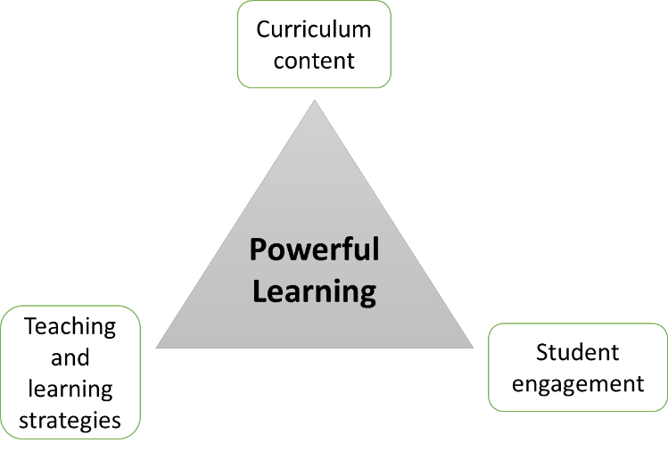
The learning event I observed demonstrated a clear representation of questioning from teacher to pupils. Questioning is “the single most influential teaching act” (Taba, Levine and Elzey, 1964) and plays an important role in developing the three elements of the instructional core. The instructional core is made up of key elements in learning and teaching, which include the teacher, student and content (Cohen, Raudenbush and Ball, 2003). Effective learning, student engagement and teaching derive from a positive interaction between the three instructional core elements (City et al. 2009). Effective questioning enhances the collaboration between students, teachers and content which increases pupil achievement and engagement (Walsh and Sattes, 2011).
Figure 3 - The Instructional Core Model. Source: City et al. (2009).

Cotton (2003) recognised teachers spend between 35% and 50% of their time questioning, between 30-120 questions per hour (Graessar and Person, 1994). Questioning develops comprehension, assesses pupil knowledge (formative assessment), develops critical thinking skills, enables peer interaction (Tofade, Elsner and Haines, 2013) and enhances confidence (Gose, 2009).

To begin, the teacher asked children simple warm-up questions (see Appendix C) to understand their previous knowledge of Rhodes. Hayes (2006) identified teachers used simple questions when beginning a topic to involve all pupils; challenging questions can limit pupil participation (Hayes, 2006). Within the warm-up and main questions, the teacher used open and closed questions (see Appendix C and D). Closed questions involved the teacher asking one pupil at a time to discover the correct answer (Hayes, 2006), ‘what is the hottest month pupil 1?’. Pupil response is usually a single word, the teacher can find out what a pupil knows and does not know (Hayes, 2006). Open questions asked by the teacher, for example, ‘so why do people go to Rhodes?’ can explore a range of responses from pupils (Hayes, 2006). Open questions can encourage pupils to think deeply, explain and justify their answers (Hayes, 2006). However, children may need prompting to gain an in-depth answer to open-ended questions (Hayes, 2006). Lee and Kinzie (2012) argued that open-ended question promoted students’ higher-level cognitive thinking compared to closed-ended questions.

Bloom (1956) developed Bloom’s Taxonomy to categorise different levels of thinking. Levels of thinking were grouped into lower order and higher order thinking skills. Research displays that teachers are more likely to ask lower order questions (closed questions) that focus on recall of previous knowledge and fact response, compared to divergent questions that lead to higher order thinking (Tofade, Elsner and Haines, 2013). Perrott (1982) recognised lower order questions fail to advance a pupil’s higher order thinking. Whereas, higher order questions (open questions) develop critical thinking which encourage pupils to look beyond their current knowledge and retain information (Tofade, Elsner and Haines, 2013). Borg et al. (1970) recognised that 38% of questions used in discussions between teachers and pupils were higher order questions. Nevertheless, questions that develop both lower and higher order thinking should be encouraged in teaching (Christenbury and Kelly, 1983). Furthermore, research demonstrates that teachers wait only for 0.9 seconds before looking for an answer in response to questions (Bond, 2008). However, longer wait time following teacher questioning results in thoughtful and meaningful responses from pupils (Price and Nelson, 2007). Within my future practice, I will utilise open and closed questions. I will use closed questions as a form of formative feedback, to identify gaps in children’s knowledge. I will use open questions to stretch children’s understanding of topics. Additionally, I will coordinate thinking time with question complexity (Kerry, 1982).

I have observed the teachers questioning strategy in Appendix C and D as a ‘teacher versus the class’ approach. The teacher asked a question and received a response from a volunteer, or the teacher selected a nominated pupil to answer. Due to the time constraints of the activity, all questions asked were initiated by the teacher. I found the teacher’s questioning approach effective as all children were engaged and ready to answer a question. However, Hayes (2006) suggests that pupil-initiated curiosity, along with the pupil’s opportunity and desire to reflect on information is limited during this question structure. In my future practice, I would encourage children to adopt a think-pair-share strategy when responding to questions. Think-pair-share involves giving children a question and allowing children time to think of a response individually. Then in pairs, children discuss individual verdicts and see if they can come up with a conclusion on the question. The class reunites and individuals within the pairs voice their discoveries with the class (Sampsel, 2013). Throughout think-pair-share, all children are involved in discussing answers and critiquing possible findings (Sampsel, 2013). Sampsel (2013) found that children were more obliged to voice their answers with the class and teacher when their answer had previously been communicated with a peer. Furthermore, think-pair-share increases wait time after a question is asked by the teacher (McTighe and Lyman, 1988), which provides children with greater think time, enhancing response quality (Rowe, 1974). Think-pair-share is used as a source of formative assessment for teachers to determine children’s level of understanding (Cooper and Robinson, 2000). When teachers are aware of children’s level of understanding, questions and instructions can be adapted to facilitate children’s learning (Boston, 2002).

Learning theories

Piaget (1954) and Vygotsky (1978) explored diverse educational theories surrounding how children learn. Piaget believed that children construct knowledge, leading to the theory of constructivism (Bates, 2016). Constructivists believe that knowledge and meaning is constructed by an individual, through collaboration between their ideas and environmental experiences (Weegar and Pacis, 2012). A teacher should encourage children to construct knowledge through their own individual experiences (Rummel, 2008; Weegar and Pacis, 2012). Piaget recognised this interaction was related to the internal process (children making sense of information for themselves), the mental construction and that learning happens on the inside. Piaget (1954) identified children as lone scientists who create their own sense of the world, to establish meaning (Bush, 2006). Furthermore, Piaget suggests that children learn and develop at a specific developmental stage, connected to an age specific time (Weegar and Pacis, 2012). Piaget believed as children, grow, develop and get older they can now take part in a different piece of learning. Implying that children are only able to learn certain information and skills once they have reached a certain stage in their development.

Due to the small sample size of Piaget’s previous work (his three children), his findings can be considered as unreliable as they cannot be generalised to a given population (Aubrey and Riley, 2016). Aubrey and Riley (2016) identified the main implication of Piaget’s theory was the concept that children learn better on their own. Later research, specifically Vygotsky, believed that children’s learning improved when they are in pairs, groups and with a more knowledgeable other (MKO). Ackermann (2001) supports Vygotsky’s research and recognises the importance of technological and environmental resources that influence children’s learning, such as educational books which Piaget overlooks.

Vygotsky, like Piaget’s theory of constructivism believed that children actively learn at different developmental stages (Rummel, 2008). In contrast, Vygotsky regarded learning as a social process, whereas Piaget concluded that cognitive development was accomplished through experimentation and observation (Weegar and Pacis, 2012). Vygotsky added to Piaget’s work of constructivism but developed social constructivism, he placed more value on the social context of learning (Weegar and Pacis, 2012). He agreed with Piaget that children had to make meanings for themselves, and the environment contributes to children’s learning. He also agreed learning was an internal process. However, Vygotsky disagreed with Piaget’s theory which states that children are lone scientists. Vygotsky suggested that you could not separate the social context learning. Vygotsky believed that learning happens with others, in groups and in pairs (Weegar and Pacis, 2012). Due to the social context of constructivism, language and communication plays an essential role in learning (Aubrey and Riley, 2016). Children need to be able to talk and interact with their peers, teachers and the society around them for them to learn. In Piaget’s theory of constructivism, the teacher will provide children with knowledge, whereas in Vygotsky’s theory, the teacher plays a prominent role in guiding, questioning and challenging learners to take responsibility for their own learning (White-Clark, DiCarlo and Gilchriest, 2008) and to assist children to distinguish their own thoughts based on their own previous experiences (Weegar and Pacis, 2012).

I believe social constructivism relates to the learning event that I observed. During the reading task the teacher said to pupils, ‘with the person sitting next to you, think about places you have been on holiday and talk about why you think people visit Rhodes’. Watson (2001) Identifies the importance of social interaction between peers and teacher which firmly supports a social constructivist approach. Watson (2001) recognised that when children talk to each other, children’s metacognitive awareness increases as they gain an understanding of different points of view. Furthermore, communicating with peers allows children to justify their views and opinions, stimulating higher-order thinking (Watson, 2001). Furthermore, in the class I observed, children’s social context of learning was enhanced through communicating answers in response to the teacher’s questions (see Appendix C and D). Numerous studies have reported the benefits of children interacting with both peers and adults (Oliver, 2000; Mackey, Oliver and Leeman, 2003). Hamre and Pianta (2001) recognised that a positive teacher-child relationship enhanced children’s social and academic development. Throughout my future practice, I will ensure that children are provided with the opportunity to work collaboratively in pairs and small groups. I will also focus on establishing a positive teacher-pupil relationship, to transform the classroom into a supportive area where children can immerse in a positive productive learning environment (Hamre & Pianta, 2001).

Vygotsky is recognised for the Zone of Proximal Development (ZPD) (Wells, 1999). The ZPD is the distance between what a pupil can achieve with and without help (Vygotsky, 1978). Vygotsky believed if you give children something they can do, it’s too simple and they get bored. If you give children something too complicated, they become frustrated. However, if you give children a task that is just out of their reach, with support from an MKO, they can achieve it. In the activity I observed the teacher gave children an opportunity to work in the ZPD. The teacher enabled pupils to engage in the ZPD by giving them a topic that they had little previous knowledge on. Children drew upon their previous holiday experiences and the teacher assisted when constructing answers. Vygotsky identified that the ZPD contributes to an increased level of cognitive thinking and understanding in children, specifically though solving problems with adult guidance (Vygotsky, 1978). My future practice should therefore seek to draw on children’s previous experiences when setting new and challenging activities. I will also ensure I provide adequate and adaptable support for children based on their prior knowledge and ability level. Furthermore, Tharpe and Gallimore (1988) supported Vygotsky’s ideas of social interaction and enhanced the importance of teachers assisting children by providing structure in class tasks. It is within this collaboration between children and teacher that scaffolding can occur.

Scaffolding is the term given to what happens within the ZPD for development to occur (Keenan, 2002). It is recognised as the ‘zone of teaching’ within the ZPD (Wells, 1999). When a child receives assistance from the MKO (teacher) to complete a task, the process is known as scaffolding (Scott, 2008). The interaction between a child and guidance provided by the adult should result in a positive learning outcome (Aubrey and Riley, 2016). Once a child completes a task successfully with the help of an MKO the child can then go onto complete a similar task, confidently with reduced help or without support (Aubrey and Riley, 2016). The language that the adult uses towards the child can be adapted to the child’s specific requirements, but also be used to stretch the child’s thinking to enhance learning (Urquhard, 2000).

Previous research has applied scaffolding to reading tasks that assist children in making sense of texts (Avery and Graves, 1997). Test, Cunningham and Lee (2010) identified that teachers are involved in the process of scaffolding when asking questions that encourage children to think. Eggen and Kauchak (1999) supports Test, Cunningham and Lee (2010) and found that adult support through scaffolding can be distinguished through questioning. Kong (2002) researched into how teachers use scaffolding to develop children’s social, linguistic and cognitive development through questioning strategies. Research found that through using teacher questioning as a scaffolding technique, teachers could build on children’s existing knowledge, encourage children to participate in in-depth discussions and challenge children’s thoughts (Kong, 2002). In the class I observed, the teacher challenged children’s thoughts by asking children to justify their answers. Pupil 2 responded to the question of ‘if the time is 9am in the UK, what time is it on the island?’ correctly. The teacher then encouraged the pupil 2 to justify their answer by asking ‘Pupil 2 how did you work that out?’. Based on these findings, my future practice will utilise scaffolding to support children’s learning and encourage children add reasoning to their answers.

Verenikina (2008) identified for scaffolding to occur, the task set out needs to be one that children cannot complete on their own. Through the teacher asking, ‘Why do people like going to Rhodes?’ the teacher found that prior to the reading comprehension, the children did not know why people visited Rhodes. Secondly, to utilise scaffolding in teaching, learners need to be able to complete the task successfully on their own, displaying evidence of increased competency and independence (Wells, 1999; Verenikina, 2008). In the class I observed, this was displayed when the children read through the comprehension with the support of the teacher, the teacher highlighted key headings and their importance along the way. Through teacher questioning, children gained an understanding as to why people went to Rhodes. The last question from the teacher was to finally assess children’s level of understanding as to why people visit Rhodes, following the comprehension by asking ‘so why do people go to Rhodes?’ and each pupil could answer the question. Which implied the children were confident in understanding why people visit Rhodes.

Scaffolding does not come without its limitations. An important part of scaffolding is that the teacher needs to be aware of the child’s capabilities so that the level of support can be adapted accordingly (Keenan, 2002). Wood (1998) identified that the MKO may provide too much help and underestimate the child’s potential. Aubrey and Riley (2016) recognised that the child may depend too much on the adult, and in a classroom setting this may be considered cheating. Furthermore, Stone (1998) identified the term ‘scaffolding’ could be interpreted in the wrong context and give the impression of the teacher imposing structure on the pupil. This could imply that scaffolding could be interpreted as a ‘adult-driven’ and ‘one-sided’ act (Verenikina, 2008). Aubrey and Riley (2016) supports Verenikina (2008) and recognised that the focus of scaffolding was on the adult being the proficient knowledgeable other. Therefore, Vygotsky fails to consider the child’s role in relation to the adult in the process of scaffolding. Rogoff (1990) overcomes this by suggesting an inclusive concept of scaffolding. Rogoff (1990) found that children and adults can solve problems, support and learn from each other in a shared cultural and social environment. Furthermore, Verenikina (2008) suggests that teachers should be educated on the theory that underpins scaffolding. I found when the teacher used questioning to scaffold a small group of children, it was difficult for the teacher to apply an individual scaffolding approach to each child, as children in a group varied in ability and past knowledge of the topic. Throughout my future teaching, I will ensure that I am aware of children’s current knowledge of a topic prior to setting activities. I will ensure that when questioning children, I ask a variety of open and closed questions to children who are struggling to grasp new concepts. I use a variety of open style questions to challenge more knowledgeable children. I will also use questioning as a form of formative assessment to assess pupil’s prior knowledge and identify what they have learnt.

Ideal learning environment
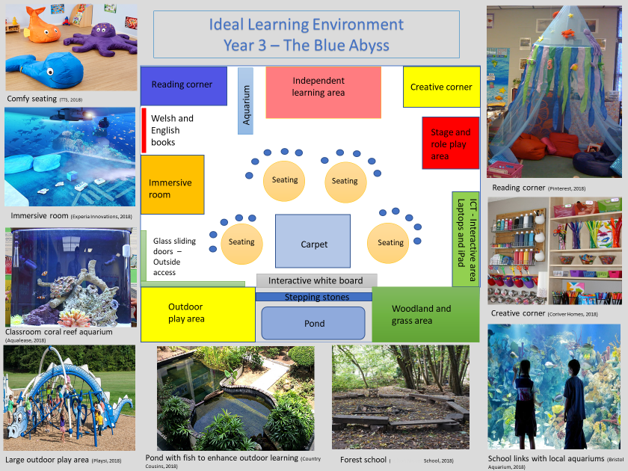
Figure 4 – My ideal learning environment.

Teachers should design a learning environment that inspires children to be actively involved in their learning, to build on their previous experiences and participate in new and challenging activities. The learning environment should encourage children to collaborate with their peers and participate in meaningful activities (Rao, 2003).

A utilised outdoor learning facility will be essential in my ideal learning environment. Outdoor learning involves learning beyond the classroom through first hand experiences, learning about the natural environment, problem solving and developing heritage and social skills (Grigg and Lewis, 2016). Outdoor learning can involve cultural visits, fieldwork, adventure activities and outdoor play (Grigg and Lewis, 2016). Sigman (2007) recognised that more than 1 million children between 8-12 had not seen the UK countryside. Estyn (2011) reported that children’s knowledge of the world improved when they are outside, which will help children to be ‘ethical, informed citizens’ (Donaldson, 2015).

Within my learning environment, outdoor learning will originate on the school grounds. There will be a large climbing frame, woodland area, pond, forest school and links to nearby cultural sites. Research identified that children feel safe and relaxed to explore different areas within school grounds, such as woodland and ponds (Alexander, 2010). However, some school grounds are limited in outdoor learning opportunities. Estyn (2017) reported only ¾ of schools have adequate outdoor learning environments that link specifically to schools and classrooms. As a teacher, I will overcome school outdoor space limitations by visiting local woodlands or parks. (Grigg and Lewis, 2016). Furthermore, Estyn (2011) reported that outdoor space is not utilised adequately to support cross-curricular activities such as the Welsh language and Information Communication Technology (ICT). Waite (2010) identified the curriculum can be developed through outdoor learning as children are motivated to explore, enabling the curriculum to be seen in a different perspective. Within my future practice, I will utilise outdoor learning within a range of mainstream curriculum subjects. For example, as a class, we could explore fairy woodland gardens, that could be utilised to form a short descriptive story.
Learning outside the classroom can reduce prevalence of childhood inactivity, obesity (Hughes, 2015) and stress (Wells, 2000), contributing to ‘healthy, confident individuals’ (Donaldson, 2015). Outdoor learning can increase children’s confidence and challenge confident children through providing new experiences (Grigg and Lewis, 2016). Despite the benefits of outdoor learning, Estyn (2011) reported that schools only make ‘adequate’ use of outdoor learning.

Schools around Wales have made a conscious effort to apply good practice of outdoor learning to their school. A primary school in Rhyl, North Wales has developed a ‘Beach School’ initiative. The school has organised trips to the beach, where children gain knowledge surrounding sea wildlife, examine beach features and learn skills on water safety. The school offers trained school beach leaders that deliver the school curriculum using the beach. An example includes ‘Science on the Sands’. Following this outdoor learning, pupil’s literacy skills (18%), wellbeing and social skills improved (Estyn 2012). Furthermore, a primary school in Rhos on Sea, in Conwy also benefited from outdoor learning. The primary school developed a Forest School outdoor classroom. The outdoor classroom has incorporated a seating area, fire-pit, pond and a bug hotel. Children developed awareness and knowledge about the environment, social skills and outdoor life skills. The outdoor learning environment also increased children’s literacy and numeracy attainment (Estyn 2016b).

Griggs and Lewis (2016) recognised that outdoor learning involves precise preparation and planning. Griggs and Lewis (2016) recommend visiting outdoor learning sites beforehand, to be aware of any risks the trip may pose. Following a pre-site visit, a risk assessment plan can be uncovered. To ensure safety management of outdoor learning, the teacher needs to consider the needs of pupils including age, behaviour, special needs and ability. The amount of support staff and volunteers also need to be considered (Griggs & Lewis, 2016). Furthermore, the weather can prevent some outdoor activities from taking place. In the UK, 76% of teachers believed that the weather stops them from taking lessons outdoors (Outdoor Classroom Day, 2018).

ICT

ICT will play a key feature in my ideal learning environment. Within the new national curriculum, digital competence is to be embedded across the curriculum in to all subjects in the same way that literacy and numeracy framework suggests (Donaldson, 2015). ICT within primary schools should focus on developing skills (problem solving, critical thinking, resilience to change) and transferring these skills into different environments (Donaldson, 2015). Bolstad (2004) states that ICT is a useful learning tool in education. ICT can enhance children’s creativity, desire to play, social skills and cognitive development (Bolstad, 2004). In contrast, some research suggests (Healy, 2003) that ICT can hinder child language development and lead to poor concentration.

Estyn (2013) reported that around 50% of primary schools in Wales deliver good and excellent ICT standards. Quality of ICT in Foundation Phase is reported better compared to KS2 (Estyn, 2013). KS2 teachers do not feel confident when delivering ICT to pupils (Estyn, 2013). The British Educational Communications and Technology Agency (BECTA, 2004) identified barriers that prevented the use of ICT in the classroom. These barriers included insufficient time, low confidence and competence due to inadequate training and minimal access to ICT resources. Pelgrum (2001) also identified that schools had insufficient computer resources and software and teachers had insufficient knowledge to integrate ICT into the classroom. In my ideal learning environment, I will ensure that all teachers are trained to use ICT competently. Furthermore, I will ensure that all classrooms are equipped with enough laptops, computers, iPad’s and interactive white boards. Furthermore, ICT equipment will be up to date with the latest software.

A primary school in South Wales use ‘QR’ codes to engage pupils in interactive activities. In Foundation Phase, teachers can make a ‘QR’ code phonic treasure hunt. Children scan the ‘QR’ code and go in search of letters around the school; this encourages word construction (Estyn, 2013). Some of the advantages to this approach include increase student engagement, enhanced thinking skills, enhanced reading and research skills (Estyn, 2013). An activity utilising ‘QR’ codes will encourage pupils to be ‘ambitious, capable learners’ and ‘enterprising, creative contributors’ through developing problem-solving skills and utilising digital technologies to find and analyse information (Donaldson, 2015). Using a ‘QR’ code treasure hunt will also enable children to be ‘healthy, confident individuals’ by encouraging children to take part in physical activity and overcome challenges when learning and constructing new words (Donaldson, 2015).

Independent Learning Area

Within my ideal learning environment there will be an independent learning area where children will be responsible for their own learning and development (Meyer, 2010). When children take responsibility for their own learning, children develop one of Donaldson’s four purposes as ‘ambitious, capable learners’ (Donaldson, 2015). During independent learning children monitor and assess their own learning in relation to learning objectives (Meyer, 2010). It is essential that children are aware of how they learn, which should be guided by teachers (Meyer, 2010). During independent learning, teachers structure the learning environment by giving children clear activity outlines, a specific time to complete tasks (Meyer, 2010) and organising group work (Meyer et al. 2008).

Within my future practice, an example of a class activity that will take place in the independent learning area is as follows. Continuing with the topic of the Blue Abyss, children will be placed in small groups and will be given a task of designing a fact file containing information of different sea creatures. Information can be presented in a leaflet, poster or power point presentation (children choose method of presentation). Children research information needed for their sea creature fact file utilising the internet, DVD’s, newspapers, magazines and books of their choice. Children will use RAG (Red, Amber, Green) colour scoring system to self-assess their work in relation to learning objectives. Red implies they found the work difficult, amber implies they found the work challenging but were able to complete it and green implies they completed work confidently. Through self-assessment, children can see where improvements to their work can be made (Jones, 2005) and as a teacher you can identify children who may require additional support.

A primary school in West Wales encourages an independent learning environment within the school (Estyn, 2016c). The school identified that through children taking part in independent learning activities, children take responsibility for their own learning and set personal goals and challenges. Children within the school also seek opportunities to succeed and move forward in their learning confidently (Estyn, 2016c).

Meyer et al. (2008) identified that the benefits of independent learning for children include enhanced confidence and motivation towards activities. Research demonstrated that children are more motivated to learn as they are actively involved in the learning process, compared to restricted teacher-controlled environments (Meyer et al. 2008). Research demonstrated through self-assessment, children gained an awareness of academic strengths and weaknesses (Meyer et al. 2008). Independent learning has been recognised to improve academic performance, however, there may be additional contributing factors (Meyer et al. 2008). Furthermore, setting children independent learning tasks enables teacher to adapt activities based on academic ability and provide specific groups (low ability) with additional support as others work independently (Mayer et al. 2008).

The first barrier that teachers may come across when initiating independent learning is that a teacher may be reluctant to allow children to take responsibility for their learning. However, a whole-class approach to teaching can hinder children’s opportunities for independent learning as the teacher is in control of the learning (Gorman, 1998). Some teachers believe that children are not able to learn independently, therefore these teachers may be unable to implement an independent learning environment into their classroom (Wood and Millichamp, 2000). It is important to educate teachers of the benefits of child independent learning and the importance of a teacher’s role in this process (Wood and Millichamp, 2000). For children to undertake independent learning, children need to be aware of the skills used to assess their own learning (Meyer, 2010). Children need to be motivated within themselves to undertake independent learning (Meyer, 2010). Motivation can be defined as willingness to overcome difficulties. Through learning independently, children can gain motivation (Bishop, 2006). An additional challenge that teachers may face from children during their independent learning tasks; children may take advantage of their new-found freedom, this hinders the implementation of independent learning (Kane, 2004). To overcome this barrier, within future teaching, I will ensure that all children are aware of behaviour expectations during independent learning tasks and independent learning needs to be suitably structured and planned (Meyer, 2010).

Conclusion

In conclusion, the learning event I observed identified how questioning from a teacher to children can help children develop their knowledge and understanding of a new topic. Through teacher questioning, children were able to build on prior knowledge, develop lower and higher-order thinking skills and collaborate thoughts with peers. Teacher questioning supported Vygotsky’s social constructivist approach, which suggests that social interaction with others and speech between individuals is essential for a child to learn and build knowledge (Vygotsky, 1978; Keenan, 2002). Furthermore, teacher questioning provides a scaffold for children’s learning. Questioning follows a scaffolding structure as it encourages children to think, expand on their existing subject knowledge and challenge existing thoughts (Kong, 2002) with teacher support. Within my future practice, I will utilise a range of open and closed questions to develop both lower and high-order thinking skills. Furthermore, within my future practice, I will enhance the provision for social interaction between peers to optimise children’s learning. I will use my knowledge surrounding how children learn to form the constructs of a high-quality learning environment within my future practice. My ideal learning environment will utilise outdoor learning, ICT and independent learning to positively influence children’s learning and facilitate optimal childhood development.

Key References

- Ackermann, E. (2001) ‘Piaget’s constructivism, Papert’s constructionism: What’s the difference’, Future of Learning Group Publication, 5(3), pp. 438.
- Alexander, R.J. (2010) Children, Their World, Their Education. Abingdon: Routledge.
- Aqualease (2018) Aqualease Coral Reef Project in Schools. Available at: https://www.aqualease.co.uk/aqualease-coral-reef-project-in-schools/ (Accessed: 29th September 2018).
- Aubrey, K. and Riley, A. (2016) Understanding and using educational theories. London: Sage Publications Ltd.
- Avery, P.G. and Graves, M.F. (1997) ‘Scaffolding young learners' reading of social studies text’, Social studies and the young learners, 9(4), pp. 10-14.
- Bates, B. (2016) Learning Theories Simplified. London: Sage Publications Ltd.
- Bishop, G. (2006) ‘True independent learning - an andragogical approach: giving control to the learner over choice of material and design of the study session’, Language Learning Journal, 33, pp. 40-6.
- Bloom, B.S. (1956) Taxonomy of Educational Objectives: The Classification of Educational Goals: Handbook 1: Cognitive Domain. New York: David McKay Co Inc.
- Bolstad, R. (2004) The Role and Potential of ICT in Early Childhood Education: A Review of New Zealand and International Literature. Wellington: Ministry of Education.
- Bond, N. (2008) ‘Questioning strategies that minimize behaviour problems’, The Education Digest, 73(6), pp. 41-45.
- Borg, W.R., Kelly, M.L., Langer, P. and Gall, M. (1970) A micro-teaching approach to teacher education. Beverly Hills, CA: Macmillan Educational Services.
- Boston, C. (2002) ‘The concept of formative assessment. Practical Assessment’, Research & Evaluation, 8(9).
- Bristol Aquarium (2018) Birthday Parties. Available at: https:///www.bristolaquarium.co.uk (Accessed: 29th September 2018).
- British Educational Communications and Technology Agency (BECTA) (2004) A review of the research literature on barriers to the uptake of ICT by teachers. Available at: http://www.becta.org.uk (Accessed: 5th October 2018).
- British Educational Research Association (BERA) (2018) Ethical Guidelines for Educational Research. Available at: file:///C:/Users/Hannah/Downloads/BERA-Ethical-Guidelines-for-Educational-Research_4thEdn_2018.pdf (Accessed: 28th September 2018).
- Bush, G. (2006) ‘Learning about learning: from theories to trends’, Teacher Librarian, 34(2), pp. 14-19.
- Chin, C. (2007) ‘Teacher questioning in science classrooms: what approaches stimulate productive thinking?’ Journal of Research in Science Teaching, 44(6), pp. 815–843.
- Christenbury, L. and Kelly, P.P. (1983) Questioning: A Path to Critical Thinking. Urbana, IL: National Council of Teachers of English.
- City, E.A., Elmore, R. F., Fiarman, S. E. and Teitel, L. (2009) ‘Instructional Rounds in Education: A Network Approach to Improving Teaching and Learning’, Harvard Educational Press, pp. 24-27.
- Cohen, D., Raudenbush, S. and Ball, D.L. (2003) ‘Resources, instruction, and research’, Educational Evaluation and Policy Analysis, 25(2), pp. 1–24.
- Cooper, J.L. and Robinson, P. (2002) ‘Getting started: Informal small-group strategies in large classes’, New Directions for Teaching & Learning, (81), pp. 17.
- Coriver Homes (2018) Holly Arts Crafts Corner Our New Art Room. Available at: http://coriverbasin.org/15-simple-art-and-craft-storage-ideas-photo/holly-arts-crafts-corner-our-new-art-room/ (Accessed: 29th September 2018).
- Cotton, K. (2003) Classroom Questioning. School Improvement Research Series. Portland, OR: Northwest Regional Educational Laboratory.
- Country Cousins (2018) Aquariums, Ponds and Gardens. Available at: http://www.countrycousins.com.sg/ (Accessed: 29th September 2018).
- Donaldson, G. (2015) Successful Futures. Available at: file:///C:/Users/Hannah/Downloads/Donaldson%20Report%20-%20Successful%20Futures%20-%20Independent%20Review%20of%20Curriculum%20and%20Assessment%20Arrangements%20in%20Wales%20(2).pdf (Accessed: 10th October 2018).
- Downing, J., Keating, T. and Bennett, C. (2005) ‘Effective Reinforcement Techniques in Elementary Physical Education: The Key to Behavior Management’, Physical Educator, 62(3), pp. 114-122.
- Eggen, P. and Kauchak, D. (1999) Educational Psychology. New Jersey: Prentice-Hall.
- Estyn (2011) Outdoor Learning an evaluation of learning in the outdoors for children under five in the Foundation Phase. Available at: https://www.estyn.gov.wales/sites/default/files/documents/Outdoor%20learning%3A%20%20an%20evaluation%20of%20learning%20in%20the%20outdoors%20for%20children%20under%20five%20in%20the%20Foundation%20Phase%20-%20September%202011.pdf (Accessed: 10th October 2018).
- Estyn (2012) Outdoor learning at the beach. Available at: https://www.estyn.gov.wales/effective-practice/outdoor-learning-beach (Accessed: 10th October 2018)
- Estyn (2013) The impact of ICT on pupil’s learning in primary schools. Available at: https://www.estyn.gov.wales/sites/default/files/documents/The%20impact%20of%20ICT%20on%20pupils%C3%A2%E2%82%AC%E2%84%A2%20learning%20in%20primary%20schools%20-%20July%202013.pdf (Accessed: 10th October 2018).
- Estyn (2016a) Pembroke Dock CP School Estyn Report. Available at: https://www.estyn.gov.wales/sites/default/files/documents/Pembroke%20Dock%20CP%20School.pdf (Accessed: 4th October 2018).
- Estyn (2016b) A School environment that benefits pupil wellbeing. Available at: https://www.estyn.gov.wales/effective-practice/school-environment-benefits-pupil-wellbeing (Accessed: 10th October 2018).
- Estyn (2016c) Encouraging independent learners. Available at: https://www.estyn.gov.wales/effective-practice/encouraging-independent-learners (Accessed: 10th October 2018).
- Estyn (2017) The Annual Report of Her Majesty’s Chief Inspector of Education Training in Wales. Available at: https://www.estyn.gov.wales/sites/default/files/documents/Estyn_Annual%20Report_2018_English_Accessible.pdf (Accessed: 10th October 2018).
- Experia Innovations (2018) Wanderlust – The Immersive Room. Available at: https://www.experia-innovations.co.uk/wanderlust-the-immersive-room.html (Accessed: 29th September 2018).
- Gorman, M. (1998) ‘The 'structured enquiry' is not a contradiction in terms: focused teaching for independent learning’, Teaching History, 92, pp. 20-5.
- Gose, M. (2009) ‘When Socratic dialogue is flagging: questions and strategies for engaging students’, Journal of College Teaching and Learning, 57(1), pp. 45–49.
- Graesser, A.C. and Person, N.K. (1994) ‘Question asking during tutoring’, American Educational Research Journal, 31, pp. 104-137.
- Grigg, R. and Lewis, H. (2016) A-Z of learning Outside the Classroom. Available at: https://www-dawsonera-com.ezproxy.uwtsd.ac.uk/abstract/9781472921215 (Accessed: 10th October 2018).
- Hamre, B.K. and Pianta, R.C. (2001) ‘Early teacher–child relationships and the trajectory of children’s school outcomes through eighth grade’, Child Development, 72(2), pp. 625-638.
- Hayes, D. (2006) Inspiring Primary Teaching: Insights into excellent primary practice. Exeter: Learning matters Ltd.
- Healy, J.M. (2003) ‘Cybertots: Technology and the Preschool Child’, in Olfman, S. (ed.) In All Work and no Play: How Educational Reforms are Harming Our Preschoolers. Westport: Praeger Publishers.
- Hobart, C., Frankel, J. and Walker, M. (2009) A Practical Guide to Child observation and assessment. 4th Ed. Cheltenham, UK: Nelson Thornes Ltd.
- Hughes, D. (2015) ‘Child obesity rates “levelling off” among under-19s’, BBC News. 30th January 2015. Available at: https://www.bbc.co.uk/news/health-31041864 (Accessed: 16th October 2018).
- Jones, C.A. (2005) Assessment for Learning. Available at: http://dera.ioe.ac.uk/7800/1/AssessmentforLearning.pdf (Accessed: 10th October 2018).
- Kane. L. (2004) ‘Educators, learners and active learning methodologies’, International Journal of Lifelong Education, 23(3), pp. 275-286.
- Keenan, T. (2002) An introduction to child development. London: Sage.
- Kerry, T. (1982) Effective Questioning: A teaching skills workbook. Baskingstoke, Hampshire: Macmillan Education Limited.
- Kong, A. (2002) Scaffolding in a Learning Community of Practice: A Case Study of a Gradual Release of Responsibility from the Teacher to the Students. Available at: https://files.eric.ed.gov/fulltext/ED465995.pdf (Accessed:16th October 2018).
- Lee, Y. and Kinzie, M. (2012) ‘Teacher question and student response with regard to cognition and language use’, Instructional Science, 40(6), pp. 857–874.
- Mackey, A., Oliver, R. and Leeman, J. (2003) ‘Interactional input and the incorporation of feedback: an exploration of NS-NNS and NNS-NNS adult and child dyads’, Language Learning, 53, pp. 35–66.
- MacNaughton, G., Rolfe, S. and Siraj-Blatchford, I. (2010) Doing early childhood research: International perspectives on theory and practice. (2nd Ed). Australia: Allen & Unwin.
- McTighe, J. and Lyman Jr, F.T. (1988) ‘Cueing thinking in the classroom: The promise of theory-embedded tool’, Educational Leadership, 45(7), pp. 18.
- Meyer, B., Heywood, N., Sachdev, D. and Faraday, S. (2008) What is independent learning and what are the benefits for students? Available at: http://www.curee.co.uk/files/publication/[site-timestamp]/Whatisindependentlearningandwhatarethebenefits.pdf (Accessed: 12th October 2018).
- Meyer, W.R. (2010) Independent learning: a literature review and a new project. Available at: http://www.leeds.ac.uk/educol/documents/193305.pdf (Accessed: 16th October 2016).
- Milton Mount School (2018) Forest Schools. Available at: https://www.miltonmount.co.uk/about-us/forest-schools/ (Accessed: 29th September 2018).
- Nicolson, S. and Shipstead, S. (2002) Through the Looking Glass: Observations in the Early Childhood Classroom. 3rd ed. Upper Saddle River, NJ: Merrill Prentice Hall.
- Oliver, R. (2000) ‘Age Differences in Negotiation and Feedback in Classroom and Pairwork’, Language Learning, 50, pp. 119–51.
- Outdoor Classroom Day (2018) The impact of outdoor learning and playtime at school – and beyond. Available at: https://outdoorclassroomday.org.uk/wp-content/uploads/sites/2/2018/05/FINAL-Project-Dirt-Survey-Outdoor-Play-and-Learning-at-School-2018-15.05.18.pdf (Accessed: 10th October 2018).
- Papatheodorou, T., Luff, P. and Gill, J. (2011) Child Observation for learning and research. Pearson Education Limited: England.
- Papert, S. (1993) The Children’s machine: Rethinking school in the age of the computer. New York: Basic Books, Inc.
- Pelgrum, W.J. (2001) ‘Obstacles to the integration of ICT in education: results from a worldwide educational assessment’, Computer & Education, 37, pp. 163-178.
- Perrott, E. (1982) Effective teaching: A practical guide to improving your teaching. Available at: https://books.google.co.uk/books?id=R5HZBAAAQBAJ&pg=PA192&lpg=PA192&dq=groisser,+P+(1964)+HOW+TO+USE+THE+FINE+ART+OF+QUESTIONING&source=bl&ots=uhXIjzOdUw&sig=py8nIaiOTLI65QJLGUapX4oTa_c&hl=en&sa=X&ved=2ahUKEwi9qcTO4OLdAhXlLsAKHQsGAL0Q6AEwBnoECAUQAQ#v=onepage&q=QUESTIONING&f=false (Accessed: 3rd October 2018).
- Piaget, J. (1954) The Construction of Reality in the Child. New York: Basic Books.
- Pinterest (2018) Discover ideas about Classroom Displays. Available at: https://www.pinterest.co.uk/pin/332281278727529713/ (Accessed: 16th September 2018).
- Playlsi (2018) Playground Overview. Available at: https://www.playlsi.com/en/commercial-playground-equipment/playgrounds/shaffner-park/ (Accessed: 29th September 2018).
- Price, K.M. and Nelson, K.L. (2007) Planning effective instruction: Diversity responsive methods and management. California: Thomson Wadsworth.
- Rao, D.B. (2003) Successful Schooling. New Delhi: Discovery Publishing House.
- Rogoff, B. (1990) Apprenticeship in thinking: Cognitive development in social context. Oxford: Oxford University press.
- Rowe, M. (1974) ‘Wait-time and rewards as instructional variables, their influence on language, logic, and fate control: Part one-wait-time’, Journal of Research Science Teaching. 11(2).
- Rummel, E. (2008) ‘Constructing cognition’, American Scientist, 96(1), pp. 80-82.
- Sampsel, A. (2013) Finding the Effects of Think-Pair-Share on Student Confidence and Participation. Available at: https://scholarworks.bgsu.edu/cgi/viewcontent.cgi?article=1029&context=honorsprojects (Accessed: 13th October 2018).
- Scott, D. (2008) Critical Essays on Major Curriculum Theorists. Abingdon: Routledge.
- Sigman, E. (2007) Agricultural literacy. Giving concrete children food for thought. Available at: https://slidex.tips/download/agricultural-literacy (Accessed: 16th October 2018).
- Stephen, C., Ellis, J. and Martlew, J. (2010) ‘Taking active learning into the primary school: a matter of new practices?’, International Journal of Early Years Education. (18)4, pp. 315-329.
- Stone, A. (1998) ‘The Metaphor of Scaffolding: Its Utility for the Field of Learning Disabilities’, Journal of Learning Disabilities, 3(4), pp. 344-364.
- Taba, H., Levine, S. and Elzey, F. (1964) Thinking in Elementary School Children. Research Project. San Francisco: San Francisco State College.
- Test, J. E., Cunningham, D. D. and Lee, A. C. (2010) Talking with young children: How Teachers Encourage Learning. Available at: https://www.southernearlychildhood.org/upload/pdf/Talking_With_Young_Children.pdf (Accessed: 6th October 2018).
- Tharpe, R.G. and Gallimore, R. (1988) Rousing Minds to Life: Teaching, Learning, and Schooling in a Social Context. New York: Cambridge University Press.
- Tofade, T., Elsner, J. and Haines, S.T. (2013) ‘Best Practice Strategies for Effective Use of Questions as a Teaching tool’, The American Journal of Pharmaceutical Education, 77(7), pp. 155.
- TTS (2018) Sea Life Animal Bean Bags. Available at: https://www.tts-group.co.uk/sea-life-animal-bean-bags/1008102.html (Accessed: 29th September 2018).
- Urquhard, I. (2000) ‘Communicating Well with children’, in Whitebreas, D. (ed.) The Psychology of Teaching and Learning in the Primary School. London: Routledge.
- Verenikina, I. (2008) Scaffolding and learning: its role in nurturing new learning. Available at: https://ro.uow.edu.au/cgi/viewcontent.cgi?referer=https://www.google.co.uk/&httpsredir=1&article=1043&context=edupapers (Accessed: 6th October 2018).
- Vygotsky, L.S. (1978) Mind and Society. Massachusettes: Harvard University Press.
- Waite, S. (2010) ‘Teaching and learning outside the classroom: personal values, alternative pedagogies and standards’, International Journal of Primary, Elementary and Early Years Education, 39(1).
- Walsh, J.A. and Sattes, B.D. (2011) Thinking through Quality Questioning- Deepening student engagement. California: Corwin A SAGE Company.
- Watson, J. (2001) Social constructivism in the classroom. Available at: https://onlinelibrary.wiley.com/doi/pdf/10.1111/1467-9604.00206 (Accessed: 10th October 2018).
- Weegar, M.A. and Pacis, D. (2012) A Comparison of Two Theories of Learning - Behaviorism and Constructivism as applied to Face-to-Face and Online Learning. Available at: https://www.g-casa.com/conferences/manila/papers/Weegar.pdf (Accessed: 10th October 2018).
- Wells, G. (1999) Dialogic Inquiry: Towards a Sociocultural Practice and Theory of Education. New York: Cambridge University Press.
- Wells, N. (2000) ‘At home with nature: effects of “greenness” on children’s cognitive functioning’, Environment and Behaviour, 32, pp. 775-95.
- White-Clark, R., DiCarlo, M. and Gilchriest, N. (2008) “Guide on the side”: An instructional approach to meet mathematics standards’, The High School Journal, 91(4), pp. 40-45.
- Wood, D. (1998) How Children Think and Learn. 2nd Ed. Oxford: Blackwell.
- Wood, E.K. and Millichamp, P. (2000) ‘Changing the learning ethos in school. Journal of Inservice Education’, 26(3), pp. 499-515.

Appendices

Appendix A

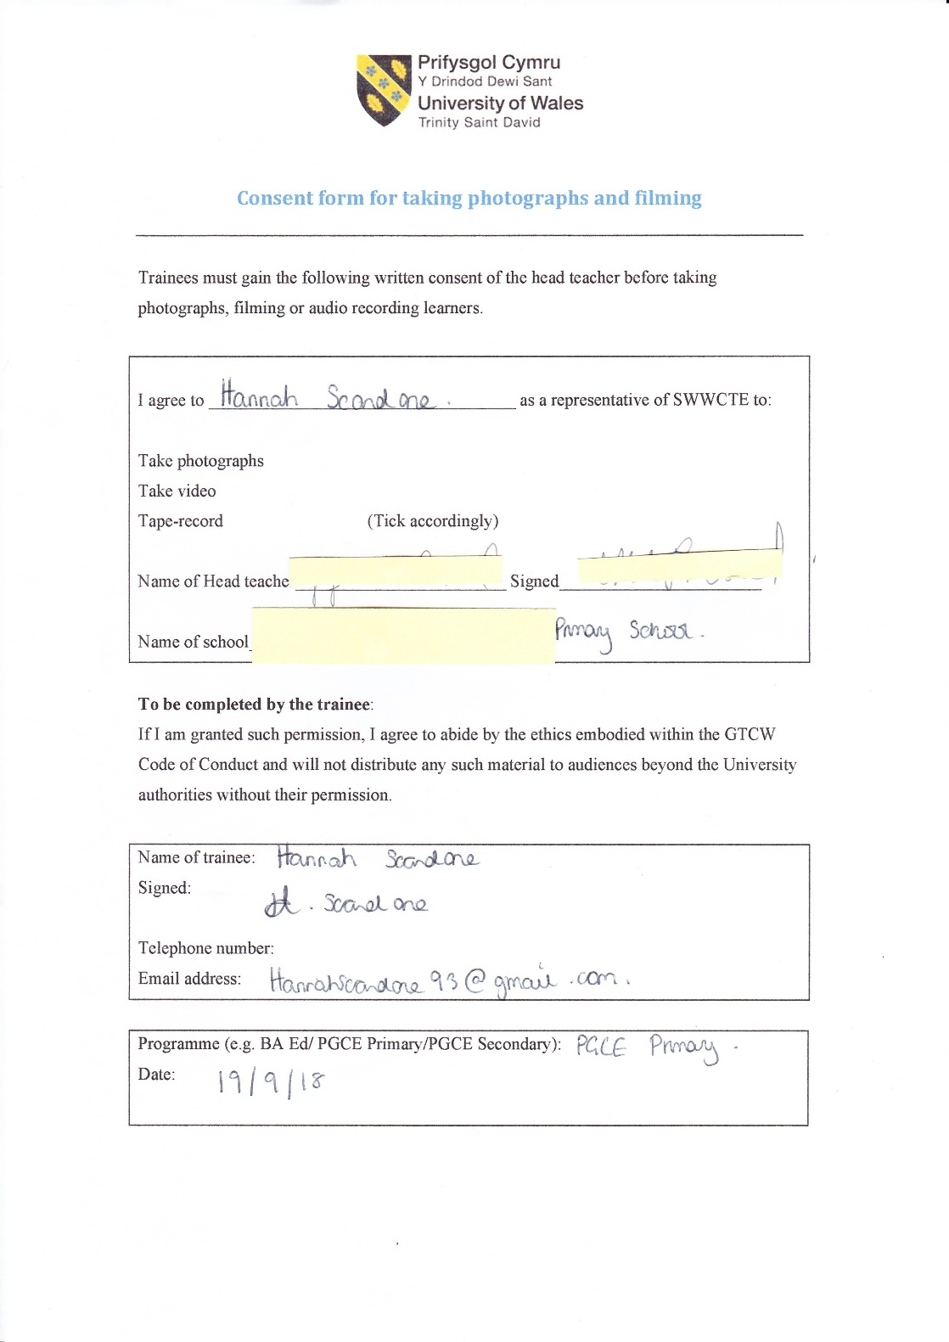
Figure 1- Consent form for photography and filming in my observation school.

Appendix B
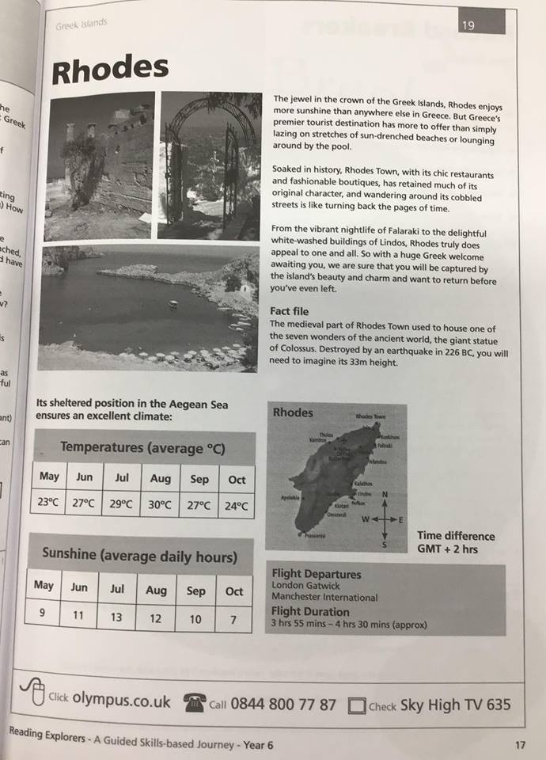
Figure 2- Higher order reading comprehension fact sheet on Rhodes, Greece.

Appendix C

Table 1 - Warm up questions transcript between teacher and pupils.
Teacher | Which Greek Island are we going to look at today?
Pupils | Rhodes (Pupil 1)
Teacher | With the person sitting next to you, think about places you have been on holiday and talk about why you think people visit Rhodes.
Teacher | Why do people like going to Rhodes?
Pupils | They go on holiday (Pupil 3)  I don’t know (Pupil 1, 2, 4 and 5)
Teacher | Where would you find holiday information about Rhodes?
Pupils | You can find it in the travel agent (Pupil 2)  On the computer (Pupil 3)  You can call people to talk to (Pupil 5)  I don’t know (Pupil 4)

Appendix D

Table 2 - Main questions transcript between teacher and pupils.
Teacher | Pupil 1 do you want to have a go at reading?
Teacher | Pupil 3 do you want to read the fact file
Teacher | Pupil 5 do you want to continue reading?
Teacher | Pupil 6 What does the first table show you?
Pupil 6 | It shows you the temperature…
Teacher | Rhodes is a very hot country in the summer
Teacher | What is the hottest month Pupil 1?
Pupil 1 | August
Teacher | In June Pupil 2 how many hours of sunshine does Rhodes get?
Pupil 2 | 11 hours
Teacher | Pupil 3 in what month do you get the most sunshine?
Pupil 3 | July
Teacher | Any ideas what GMT stands for?
All pupils | No
Teacher | Pupil 4 if the time is 9am in the UK, what time is it on the island?
Pupil 4 | I don’t know
Teacher | Pupil 2?
Pupil 2 | 11am
Teacher | Pupil 2 how did you work that out?
Pupil 2 | you count forward, if the time was 7am in the UK, it would be 9am in Rhodes
Teacher | Can anyone tell me the airport you can travel from to get to Rhodes?
Pupil | Manchester (Pupil 3)  London Gatwick (Pupil 5)
Teacher | Do you think people would read this page before, during or after their holiday?
Pupils | Pupil 1 before, so they know what the weather is going to be like  Pupil 2 before, they know if it is going to hot  Pupil 3 before.
Teacher | So why do people go to Rhodes?
Pupils | People go there on holiday (Pupil 1)  It is a warm place (Pupil 2)  There are lots of beaches (Pupil 3)  I went to Dubai and it was hot (Pupil 4)  It is sunny all the time (Pupil 3)  It is hot in the summer (Pupil 1)  You can go and see the history (Pupil 5)

