Assessment 1 Marketing Report

Name: Charlie Macdonald

Student ID: 2304849

Module: Niche Marketing and Social Media (BMTP4014)

Lecturer: Chris Wilkin

Assignment: Marketing Report

Introduction
The purpose of this marketing plan is to find the best way to market the Swansea Arena House Party. It is also trying to find the problems with the event and what is the best way around them. In the marketing report I used SOSTAC (Chaffey, 2022) to discover the best way to market the event and it helps the planning of the marketing. The marketing plan is designed for the arena so they can promote the event in the best way possible and attract as many people as possible.

Situation Analysis

SWOT Analysis

SWOT analysis is designed to find the strengths, weaknesses, opportunity and threats for the event and then the arena can see what the best way to market around this and to attract as many people as possible. The SWAT table for this event can be found in the appendix.

On average 27,604 people visit the Swansea arena website per month and 89% of those people live in the UK, and the most common customer is male between 25-34. This is a good customer for the House Party as the arena is marketing to that age group, the second customer profile the arena is targeting is Women between 25-34 years old as they are most likely to attend this event. The highest percentage of people get to the website through organic search which shows that they have an interest in what shows are being put on by the arena. Also the highest link destinations from the Swansea Arena website are to atgtickets, this shows us that a high percentage of people book tickets after looking at the Swansea Arena website (SimilarWeb, 2023). Swansea Arena is one of the newest music venues in Wales but there is lots of competition around Wales especially from Cardiff and that makes it harder to attract the biggest names however it is becoming more popular and it is attracting bigger names such as Royal Blood and Nothing but Thieves. The biggest competitors for Swansea Arena are in Cardiff such as the millennium centre and the New Theatre, but they also face competition from stadiums such as the Swansea.com stadium and the Principality stadium in Cardiff (Visit Wales, 2023).

This event will launch a new “ground-breaking partnership with Music Venue Trust” (Swansea Arena, 2023). Swansea arena is also working with University of Wales Trinity Saint David’s tourism and events students. This event will attract a lot of people as it “isn’t just a gig; it’s a commemoration of the two-year anniversary of the venue’s original test events, which drew a remarkable 2750 attendees.” (Event industry news, 2023). The tickets are available to purchase from the Swansea Arena website for £10 and the Music Venue Trust are trying to raise £20,000 and that will go towards helping smaller venues around Wales (Music Venue Trust, 2023).

PESTLE Analysis
The PESTLE analysis is designed to find the threats the arena faces from the outside and it helps them plan for all eventualities and that will make the event go much smoother for everyone attending. PESTLE table can be found in the Appendix.

Objective’s
The target for this event is to get 500 people to post on social media about the event, if people post pictures and videos on social media the event and the arena is getting good publicity and it shows that people are having a good time. The arena can meet this target if they interact with people on social media and offer them rewards like sharing or tagging the post.

Strategy
Ansoff’s matrix
Market Penetration - This is the concept of increasing sales of existing products in existing markets. The arena could use this technique to sell tickets for the event to customers that have been to the arena before through sending out emails to people who have signed up with the arena.

Market Development- This is focusing on selling existing products to new customers. This technique will be used by the arena to attract new people and this event should attract local people and once they have been to the arena the arena will have their emails and will be able to send information about other show’s to them and hopefully attract them back to the arena again.

Product development- This technique is focusing on introducing new products to an existing market. The arena will use this technique to sell tickets to people who like this sort of music. In Swansea there are smaller venue’s where these band’s usually play like The Bunk House and Elysium, the arena could promote the event there and it will attract people who visit these venue’s as they would like the sort of music the bands play.

Diversification- This is the concept of entering a new market with a new product. This event is different from most event’s that take place in the arena so the arena will need to attract people who would be interested in coming to this event. They are trying to get a younger audience and are hoping that these young bands would attract them to attend this event. This event is in partnership with UWTSD and the university can promote the event to all the students and that will help get a younger audience to attend the event (Corporate Finance Institute, 2023).

Marketing Mix

The marketing mix is designed to satisfy the needs of customers, the marketing is made up of 7 P’s which are: Product, Price, Place, Promotion, People, Process and Physical Evidence. The first 4 P’s were created in 1960, (McCarthy, 1960) and the additional 3 were added in 1982 (Booms & Bitner, 1982).

The arena will use the 7 P’s of marketing to promote the event and to sell tickets, by using this technique the arena will be able to understand what the customers want and what would attract them to this event.

Product- The arena has created a new product and it’s hoping it’s going to attract local people as well as people across Wales, as this event is giving local bands a chance to perform at the biggest stage it’s hopeful that it will give them a chance to become better known.

Price- The price is very important because if tickets are too expensive then people won’t attend but if they are too cheap the arena won’t be making enough profit, so it’s important to do research to find out what price people would be willing to pay to attend this event.

Place- This is an important part of marketing as it’s where people buy tickets. It could be in the arena, online or through intermediaries. It’s important for people to know where to get tickets from and to make it as easy as possible to purchase the tickets.

Promotion- It is important to promote the event in the best way possible and some of the best ways of doing this is by advertising, social media and personal selling, through using these techniques the event will be able to reach more people and hopefully sell more tickets.

People- The people who work for the arena have an important role to play in marketing this event as they can answer questions from the public and they can help with any problems. If a company has a good and motivated workforce then it will have an advantage over it’s competitors and that will allow the arena to focus on putting on events and making sure that everyone has a good time.

Process- It is important for the arena to create a customer-friendly experience for the guests and having a good process is crucial for that to happen. It is important for the arena to understand the steps that the customers take whilst finding tickets, buying tickets, getting to the arena and so on. It’s all about creating a positive experience for the customer and then that will attract them back again in the future.

Physical Evidence- Physical Evidence gives reassurance to the customers that it is worth spending money in this place. Physical evidence can be a review online or making sure that the workers have a matching uniform. If the arena is getting good reviews then new customers are more likely to buy a ticket for a event, and if the workers are all wearing matching uniforms then they are representing the brand and people will see that and it shows that it is professional and people will trust them more.
Tactics

RACE is used by companies to find the best way to take advantage of low cost opportunities, and the arena can use this technique to market the event and to promote the event in different places (Chaffey, 2023).

Reach- This is when you market the event through social networks, search engines and publishers. The arena uses this tactic to give information and to promote the event to all the people that follow their social media and give information to publishers to promote the event.

Act- When using this technique the information will be on the arena’s website which will allow lots of people to access all of the information. This marketing technique can also be used with interactive tools and by using this technique people can interact with the arena and give them reviews and to show their interest in events.

Convert- This will allow the arena to capitalise on marketing through looking at price, product and promotion. This tactic will allow the arena to market itself to the right people by looking at data to decide who to market to.

Engage- This means that the arena can engage with customers and see who is a returning customer and who is a new customer. Through using this tactic the arena can see what events are popular and how the marketing for that event has attracted people to buy tickets (Smart Insights, 2022).

Communication Mix
The communication mix finds the best way to get information out to people about the event and hopefully attract lots of people. It also helps the arena find what marketing method people interact with most for future events. Communication mix can be found in the Appendix.

The arena could use the tactics from the marketing and communication mix to promote the event to a lot of people and that will attract the people who like listening to Indie Rock. The arena could also share information about the bands so people know more about them and that might make people more inclined to buy tickets once they know that they like the music.

The arena’s social media is good at posting information about the shows but one way it could improve is to post more about the event so people will keep seeing it and they would be thinking more about the event and that could make them want to purchase a ticket.

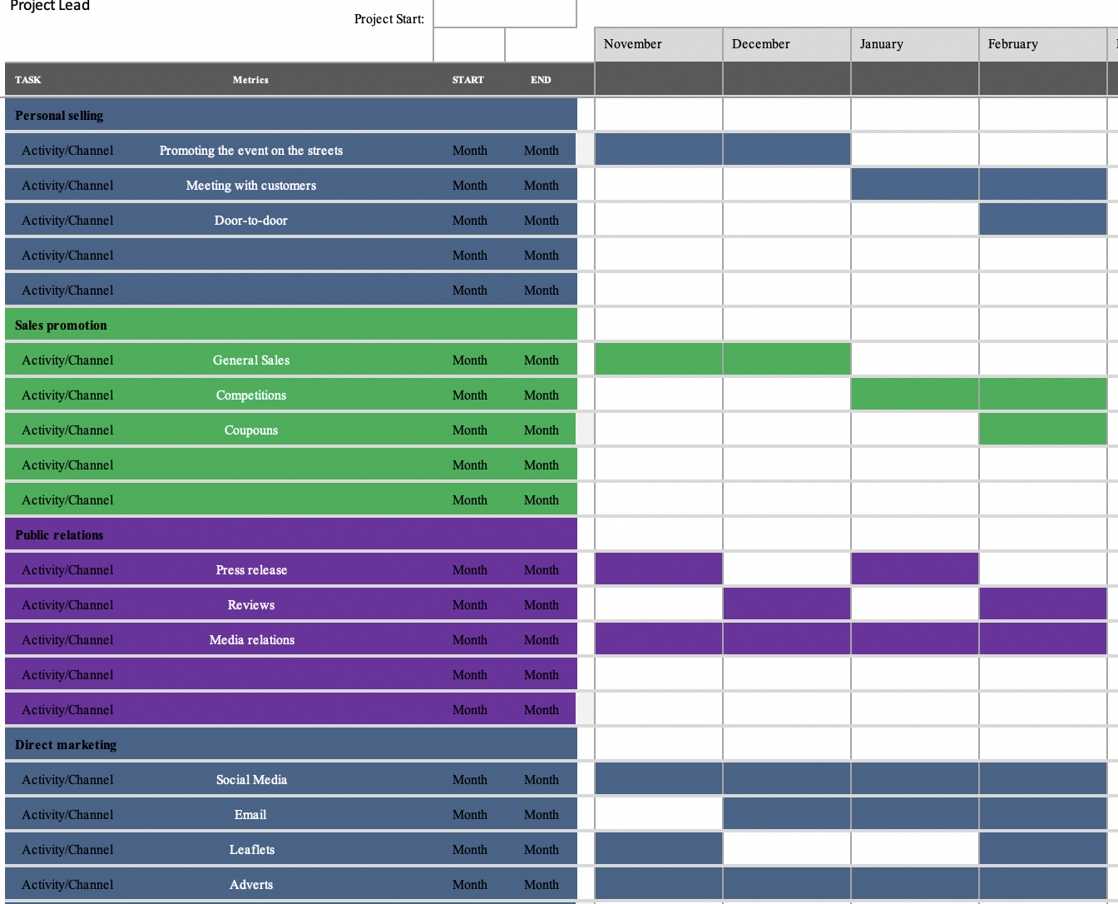
After looking at Swansea Arena’s social media I decided the best way to promote the event was in different stages so people will be reminded about the event until it happens and hopefully that will allow people more time to get their tickets. I believe that releasing different forms of advertising at different times will get more people to pay attention as it’s something new. If everything is released at the same time people might not notice some content and it would be wasted effort, but through releasing things periodically it will get more attention (Association for Project Management, 2022).

Control

The arena will measure the success of the event by getting new customers to attend and also by getting people to interact through social media. The more new customers the arena gets the better, as they will receive emails after the event about future events and that will attract them back. If people interact with social media about the event it will be good publicity for the arena and it will help promote the event and if the arena gets good reviews online it will attract more people.

Conclusion

This event will bring some challenges for the arena but if they market it well then the event will be a success. In my opinion if the arena keep posting content about the event on social media it will attract a lot of people, and if the university and music venue trust promote the event it will be able to reach a lot of people and hopefully they will be interested in attending the event. One of the biggest challenges is to promote the local bands to people who are not from Swansea, however if the arena puts their music in the background of the social media posts people will get to know the music and it will attract them to what can hopefully be a very successful and entertaining event.

Appendix

SWOT
Strengths  This event will promote local bands from Swansea and the headliner will attract people who follow them.  This event is raising money for music venue trust to help local venues around Wales. | Weaknesses  The bands all play a similar style of music and if people are not a fan of this music then they won’t buy tickets so we have to market to a certain group of people who like their music.
Opportunity  It is a brilliant opportunity for these local bands to perform on a big stage in front of a big audience. This event could be the big opportunity they have been waiting for to become better known around Wales and the UK. | Threats  All of the bands apart from the headliner are local bands from Swansea and aren’t very well known so people might not be inclined to buy tickets.
(Chartered Institute of Personnel and Development, 2021)

Pestle
Political  There have been a lot of train strikes recently and that could be a problem if people are travelling to Swansea on the train. | Economical  Cost of living has increased a lot recently and people are less likely to spend money on concerts and shows. | Sociological  After the Covid-19 pandemic some people are more cautious and won’t want to attend a concert, also some people would prefer to attend an event online instead of travelling a long distance.
Technological  Some people don’t like buying things online and as most of the tickets will be sold online that could put some people off, some people might not know how to buy tickets online. | Legal  There will be a lot of people attending this event and quite a few people will come in cars so there needs to be plenty of space for people to park close by. | Environmental  The arena needs to ensure that all the rubbish is collected and put in the right bins as it is important for the arena to be environmentally friendly.
(CPD online college, 2021)

Communication Mix
Advertising  This is a form of paid promotions mostly used on TV’s and radios to promote an event, the arena could use this tactic to promote the event to a bigger audience. | Personal selling  This technique is usually done face-to-face, this technique isn’t very popular these days but the arena could use this technique to sell tickets closer to the event. | Sales promotions  Using this technique means that you are giving money off the tickets or a discount on food and drinks, it could even be a competition where you could win money off.
Public Relations  Public relations try’s to create a good reputation for the business and it’s all about creating a positive story | Direct Marketing  This is used to send information via social media or email and it is a very effective way of sharing information as it can be accessed by many people quickly. The arena uses this technique efficiently as it post a lot of information. | Packaging  This technique is usually used to sell all inclusive holidays but the arena could use this tactic to sell a package with food and drink included.
(Kotler, 2019)

Reference list

(Chaffey, 2022b)
Chaffey, D. (2022b). SOSTAC® marketing plan model definition - What is? - Digital marketing Glossary. [online] Dr Dave Chaffey : Digital Insights. Available at: https://www.davechaffey.com/digital-marketing-glossary/sostac-marketing-plan-model/#:~:text=What%20is%20SOSTAC.
(SimilarWeb, 2023)
SimilarWeb (2023). SimilarWeb Identity. [online] secure.similarweb.com. Available at: https://pro.similarweb.com/#/digitalsuite/websiteanalysis/audience-demographics/.
(www.swansea-arena.co.uk, n.d.)
www.swansea-arena.co.uk. (n.d.). Swansea Arena | Official Box Office. [online] Available at: https://www.swansea-arena.co.uk [Accessed 23 Nov. 2023].
(www.visitwales.com, n.d.)
www.visitwales.com. (n.d.). Concerts | VisitWales. [online] Available at: https://www.visitwales.com/concerts [Accessed 23 Nov. 2023].
(Parry, 2023)
Parry, A. (2023). The Swansea Arena House Party: Uniting for music with Music Venue Trust. [online] Event Industry News. Available at: https://www.eventindustrynews.com/news/uk-and-europe/the-swansea-arena-house-party-uniting-for-music-with-music-venue-trust.
(Music Venue Trust, 2023)
Music Venue Trust. (2023). News. [online] Available at: https://www.musicvenuetrust.com/news/.
(Peterdy, 2023)
Peterdy, K. (2023). Ansoff Matrix. [online] Corporate Finance Institute. Available at: https://corporatefinanceinstitute.com/resources/management/ansoff-matrix/.
(McCarthy, 1960)
McCarthy (1960). Unindexed Front Matter - ProQuest. [online] www.proquest.com. Available at: https://www.proquest.com/openview/85e357bb318253231be1c5c6a150173e/1?pq-origsite=gscholar&cbl=1816480.

(Booms and Bitner, 1981)
Booms, B.H. and Bitner, M.J. (1981). Booms, B.H. and Bitner, M.J. (1981) Marketing Strategies and Organization Structures for Service Firms. In Marketing of Services, American Marketing Association, Chicago, 47-51. - References - Scientific Research Publishing. [online] scirp.org. Available at: https://scirp.org/reference/referencespapers.aspx?referenceid=2530717.
(Chaffey, 2023)
Chaffey, D. (2023). RACE marketing model definition - What is? | Digital marketing Glossary. [online] Dr Dave Chaffey: Digital Insights. Available at: https://www.davechaffey.com/digital-marketing-glossary/race-marketing-planning-model/.
(Chaffey, 2022)
Chaffey, D. (2022). Introducing RACE: a Practical Framework to Improve Your Digital Marketing | Smart Insights. [online] Smart Insights. Available at: https://www.smartinsights.com/digital-marketing-strategy/race-a-practical-framework-to-improve-your-digital-marketing/.
(Association for Project Management, 2022)
Association for Project Management (2022). What Is a Gantt Chart? | Definition & Examples | APM. [online] www.apm.org.uk. Available at: https://www.apm.org.uk/resources/find-a-resource/gantt-chart/#:~:text=A%20Gantt%20chart%20is%20defined.
(CIPD, 2021)
CIPD (2021). CIPD | SWOT Analysis | Factsheets. [online] CIPD. Available at: https://www.cipd.org/uk/knowledge/factsheets/swot-analysis-factsheet/#:~:text=A%20SWOT%20analysis%20is%20a.
(Reding, 2021)
Reding, M. (2021). What is a PESTLE analysis? [online] CPD Online College. Available at: https://cpdonline.co.uk/knowledge-base/business/pestle-analysis/#:~:text=The%20PESTLE%20analysis%20was%20invented.
(Kotler, 2019)
Kotler, P. (2019). Kotler, Principles of Marketing, 8th European Edition. [online] www.pearson.com. Available at: https://www.pearson.com/nl/en_NL/higher-education/subject-catalogue/marketing/kotler-principles-of-marketing-european-edition-8e.html.

