Why is Psychology important when working as a Nursery assistant?
Mevish T Sheikh. (2026547), Psychology for health and social care. BMHP4003.

Erikson’s theory of psychosocial development
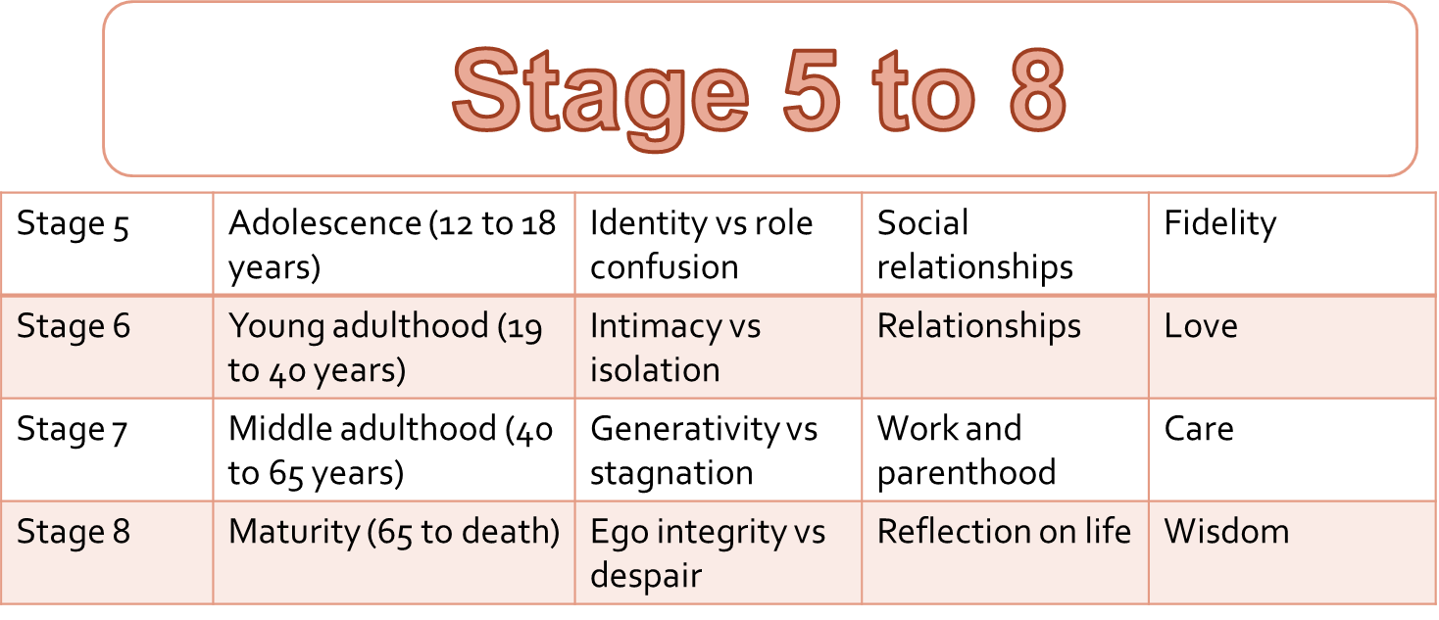
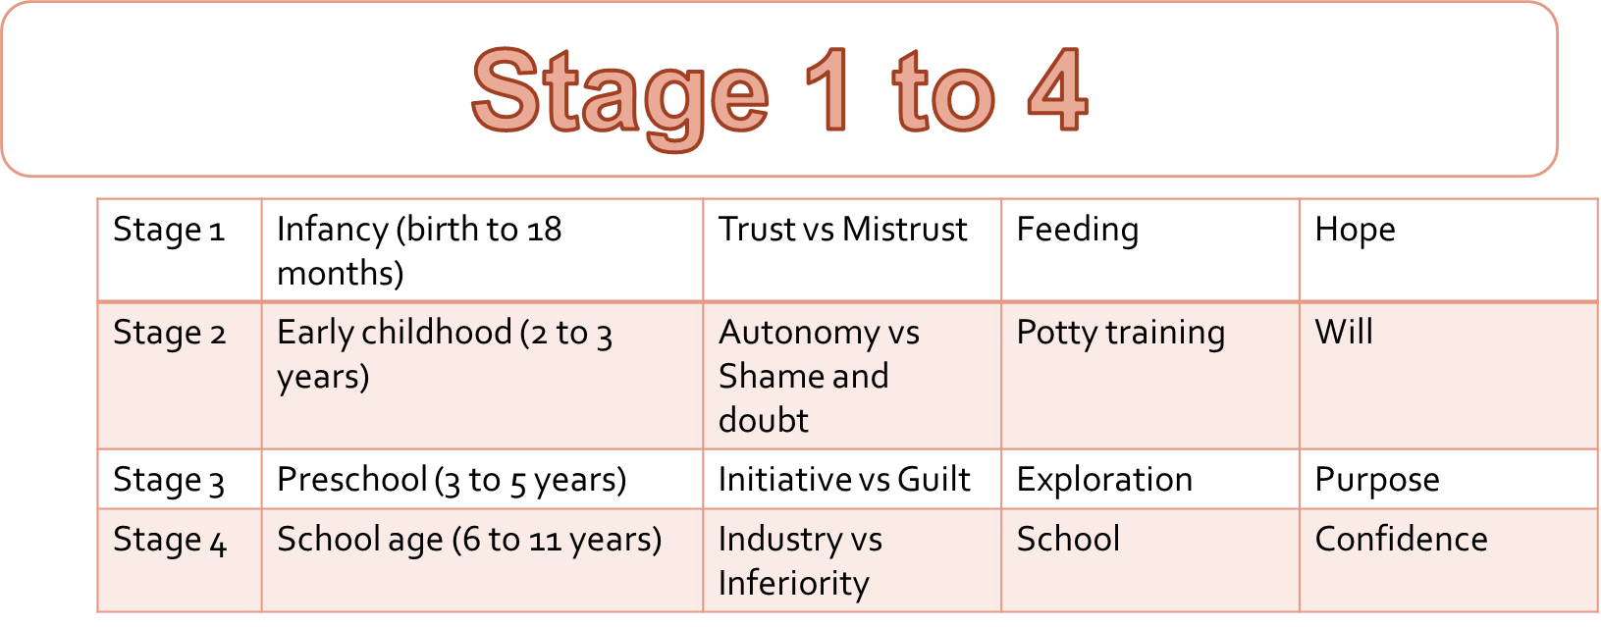
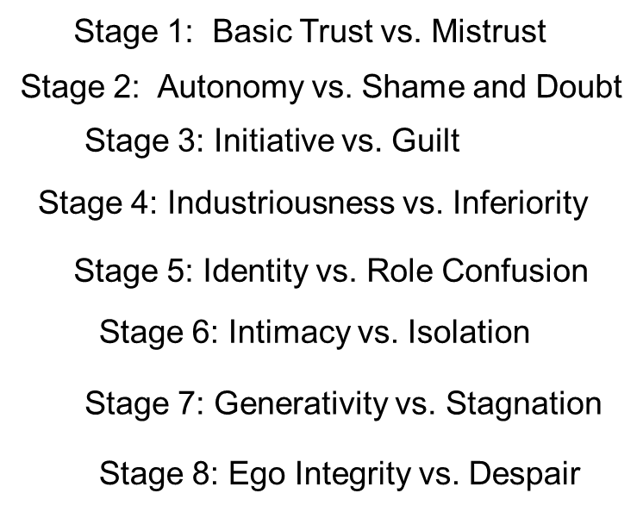
Cherry (2021) said “Erikson's theory described the impact of social experience across the whole lifespan. Erikson was interested in how social interaction and relationships played a role in the development and growth of human beings.” 
Mevish T Sheikh. (2026547),
Psychology for health and social care (BMHP4003)


