

Student Name: Adam Ibrahim
Submited 15/05/2026
Resonance Lab

Abstract
This report presents a computer simulation and an experiment to investigate the frequency response of RLC circuits in terms of resonance and selectivity. A series RLC circuit was excited by a 2 V peak-to-peak sinusoid and the voltage across the inductor, VL, was measured at a number of frequencies. The attenuation of the voltages at the various points in the circuit was determined from the voltage ratios VL/Vin. The attenuation was plotted on a log-log graph against frequency. From the graphs of the frequency characteristics of the circuit the resonant frequency (fr) and the quality factor (Q) of the series RLC circuit were determined graphically and compared with theoretical values. The computer simulation yielded values for the resonant frequency of 5000 Hz and the quality factor of 22 for the series RLC circuit. The values for the resonant frequency agreed well with theoretical values but the quality factor determined in the experiment was greatly below theoretical values. This is due to the resistance of the wire of the inductor and additional resistance in the leads to the measurement points.

Table of Contents
Abstract 1
Introduction 3
Theoretical Background 3
The components : 3
Inductive Reactance 4
Capacitive Reactance 5
Resonant Frequency 5
Attenuation(dB) 5
Quality Factor (Q) 6
Simulation 6
Results 8
Simulation Results (Proteus) 8
Practical Results (Laboratory) 10
Comparison of Results 12
Discussion 13
Conclusion 14
References 15

Introduction

A series RLC circuit consists of a resistor R, an inductor L and a capacitor C. Series RLC circuits can be used as filters as well as in tuning circuits for radio receivers and other audio equipment. Because a RLC circuit is very sensitive to the frequency of a signal, the current through the circuit is maximum at a specific frequency, i.e. the resonant frequency of the circuit. At the resonant frequency the current through the inductor is equal to the voltage over the resistance in the circuit. The frequency response of a series RLC circuit near its resonant frequency is sharp and is described by the quality factor Q of the circuit. The higher the Q factor of a circuit the more selective the circuit is and it has a small bandwidth. At resonance current through the inductor is equal to the voltage drop across the resistance in the circuit. The frequency response of a series RLC circuit near the resonant frequency is very sharp and is described by the quality factor Q of the circuit. This factor Q characterizes the selectivity of a circuit, i.e. for higher Q values the circuit has a smaller bandwidth. In the following chapters the results of the real and the virtual circuit are compared to each other, discussed and concluded. The goal of the experiment was to examine a series RLC circuit, to determine the resonance frequency and to calculate the quality factor Q of the circuit [1].

Theoretical Background
An RLC circuit consists of a single Resistor (R), a single Inductor (L), and a single Capacitor (C). The RLC circuits are very common and are used in many types of equipment and communication systems. Depending on frequency, an RLC circuit can be used as a radio tuning circuit, as a filter, an amplifier, or as an oscillator or other signal processing circuit. A resistor R in an RLC circuit is dissipated as heat in the circuit. An inductor L stores electrical energy in a magnetic field. A capacitor C stores electrical energy in an electric field. When AC is placed across an RLC circuit, both the inductor and capacitor oppose current in the circuit with reactance. The amount of reactance presented by the inductor and capacitor can vary greatly with frequency [2] [3].

The components :

- Resistor
- Capacitor
- Inductor

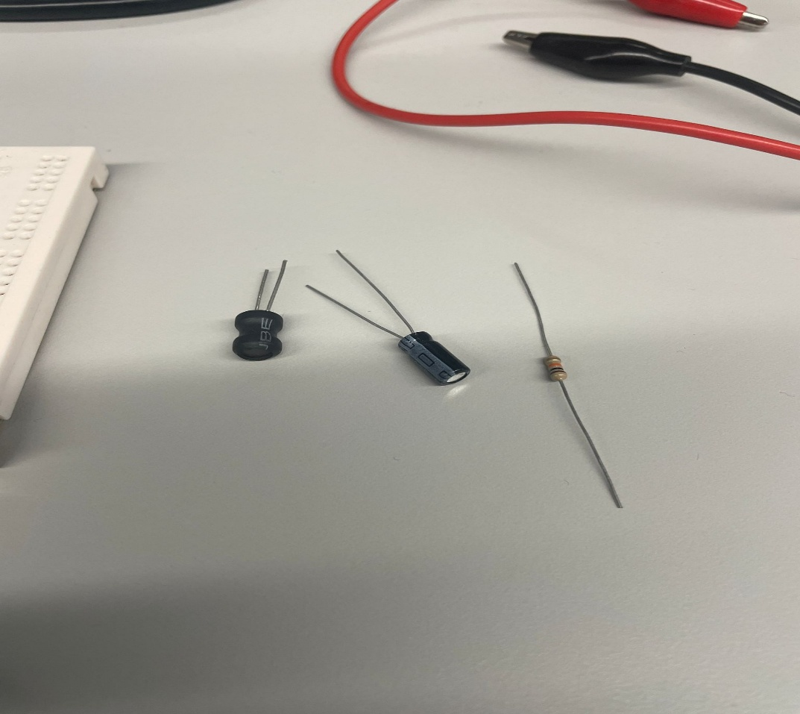

Figure 1: The components used in Circuit

Inductive Reactance
Inductive reactance is the opposition that an inductor offers to current in AC (Alternating Current) circuits. The opposition of an inductor to current in an AC circuit is known as inductive reactance and it is determined by the frequency of the AC and the inductance of the inductor coil. As the frequency of an AC signal is increased the inductive reactance of an inductor also increases. Therefore, inductors are able to oppose high frequency AC currents a lot more than low frequency AC currents [4].
Equation:
XL = 2πfL
Where:
XL = inductive reactance (Ω)
f = frequency (Hz)
L = inductance (H)
Inductor XL at low frequencies has a small value, allowing for a high current flow. At high frequencies, XL value increases, thus limiting current flow through inductor.

Capacitive Reactance
Capacitive reactance (symbol: Xc) is the opposition that a capacitor offers to an AC current. This form of opposition is the complete reverse of inductive reactance which increases as frequency increases. Therefore, a capacitor will oppose low frequency signals more than high frequency signals.
Equation:
XC = 1 / (2πfC)
Where:
XC = capacitive reactance (Ω)
f = frequency (Hz)
C = capacitance (F)
At low frequencies, the capacitor has a high reactance and limits current flow. At high frequencies, the reactance becomes smaller and allows more current to pass through the circuit.

Resonant Frequency
Inductive reactance is equal to Capacitive reactance at resonance. When both have been cancelled out the circuit behaves as a simple Resistor. In a series RLC circuit the maximum current is going through the circuit and the maximum voltage is at the reactive components during resonance. The frequency, at which a circuit is at resonance, is called resonant frequency. It is used a lot in electronics to select signals or to amplification signals of a specific frequency.
Equation:
fr = 1 / (2π√LC)
Where:
fr = resonant frequency (Hz)
L = inductance (H)
C = capacitance (F)
The resonant frequency depends only on the values of the inductor and capacitor.

Attenuation(dB)
Attenuation is the decrease in the input signal amplitude at the circuit output. Attenuation is usually expressed in decibels (dB). In this experiment attenuation has been used to measure the voltage dropped across the inductor as frequency has increased. By minimizing the attenuation near the resonant frequency the output signal has its maximum value at this point. This corresponds with a maximum voltage over the inductor.
Equation:
A = 20 log10(VL / Vin)
Where:
A = attenuation (dB)
VL = voltage across the inductor (V)
Vin = input voltage (V)

Quality Factor (Q)
Q or quality factor: The quality factor of an RLC circuit is a measure for the sharpness of a resonance peak or the selectivity of a circuit at a given frequency. The quality factor is a measure of energy loss of a circuit and the resulting bandwidth. A high Q value indicates a low energy loss and a narrow bandwidth of a circuit at a very small bandwidth around a given frequency.
A low Q value indicates a high energy loss and a broad bandwidth of a circuit at a constant intensity. When working with communications or filtering, it is usually required to select a specific frequency. The Q factor of the RLC circuit is an important parameter in such cases. For a theoretical RLC circuit, the value of the Q factor is higher than for a corresponding practical RLC circuit. This is due to the internal resistance of the components and the resulting energy losses. The values of the measured characteristics of a practical RLC circuit can deviate significantly from the theoretical values for several reasons. These reasons include the imperfections of the used components (tolerance of passive components, internal resistance of components, etc.) and additional losses that occur in the wiring. The measured values for the resonant frequency, the attenuation and the quality factor of a RLC circuit can deviate from the calculated values [5].
Equation:
Q = fr / (f2 - f1)
Where:
Q = quality factor
fr = resonant frequency (Hz)
f1 = lower half-power frequency (Hz)
f2 = upper half-power frequency (Hz)
The difference between f2 and f1 is called the bandwidth of the circuit. A smaller bandwidth produces a higher Q factor and a more selective circuit.

Simulation
A circuit for this experiment was created and simulated using Proteus Design Suite. A simple series RLC circuit was designed using a resistor R, inductor L and capacitor C. An AC signal generator was used to supply the circuit and was set to supply a constant amplitude 2 V peak-to-peak sinusoid starting at 100 Hz and increasing to 20 kHz. The voltage across the inductor was measured at each frequency and the readings recorded using virtual measuring instruments. The frequency interval was reduced progressively as the resonant frequency was approached in order to obtain accurate measurements of the peak voltage as well as the circuit’s half-power points.
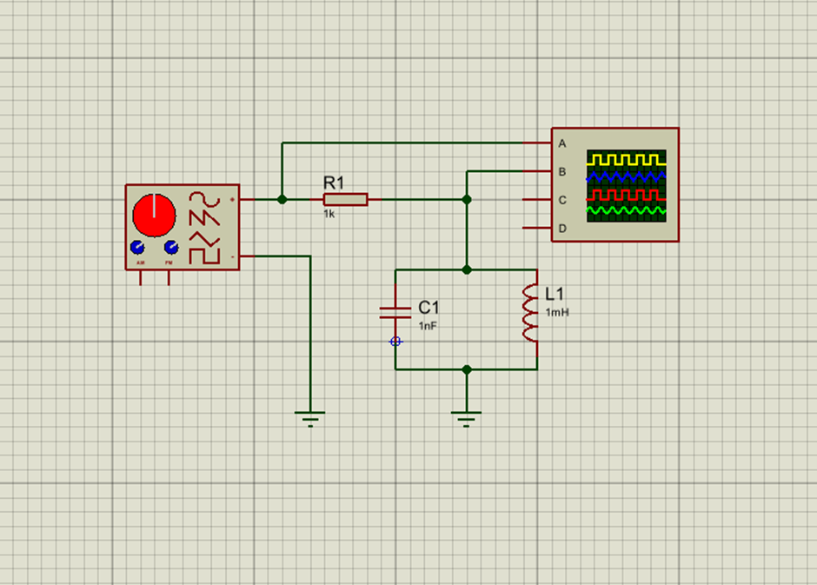
Figure 2: Simulated RLC circuit in Proteus Design

A simulation was set up to represent the same circuit and an experiment was conducted to cross-check the results. An RLC circuit was built up on a breadboard. The function generator was set to 2V p-p and swept over the same frequency range as before. The voltage over the inductor was measured and displayed on the oscilloscope. In order to replicate the connections from the Simulation to real life components, all connections on the breadboard were identical. There are, however, additional factors which affect the real life circuit. Inductors and Resistors have their own internal resistance. Connecting wires have resistance. Other objects nearby the breadboard also can affect the results. Also the process of measurement can introduce additional affects. Many of these real world factors were not replicated in the simulation and caused many differences between the results of the two experiments. The data that we have collected from both the simulation and the practical work has been used to calculate the degree of attenuation at different frequencies. These results have been plotted onto a graph to produce a clearer image of the results [6].

Results
The results obtained from both the simulation using Proteus Design and the practical laboratory experiment show a clear frequency response characteristic of an RLC circuit.

Simulation Results (Proteus)

Frequency (Hz) | Vin(VPP) | VL(VPP) | dB
100 | 2 | 0 | #NUM!
500 | 2 | 0 | #NUM!
1000 | 2 | 0.01478 | -42.6271
2000 | 2 | 0.03068 | -36.2835
3000 | 2 | 0.05986 | -30.4779
3500 | 2 | 0.0884 | -27.0916
4000 | 2 | 0.151 | -22.4411
4500 | 2 | 0.32478 | -15.7888
4800 | 2 | 0.86082 | -7.32235
4900 | 2 | 1.39354 | -3.13821
5000 | 2 | 1.6 | -1.9382
5100 | 2 | 1 | -6.0206
5200 | 2 | 0.62656 | -10.0813
5300 | 2 | 0.45788 | -12.8056
5400 | 2 | 0.36148 | -14.8589
6000 | 2 | 0.1687 | -21.4783
7000 | 2 | 0.0964 | -26.3391
10000 | 2 | 0.0421 | -33.535
20000 | 2 | 0.01694 | -41.4423

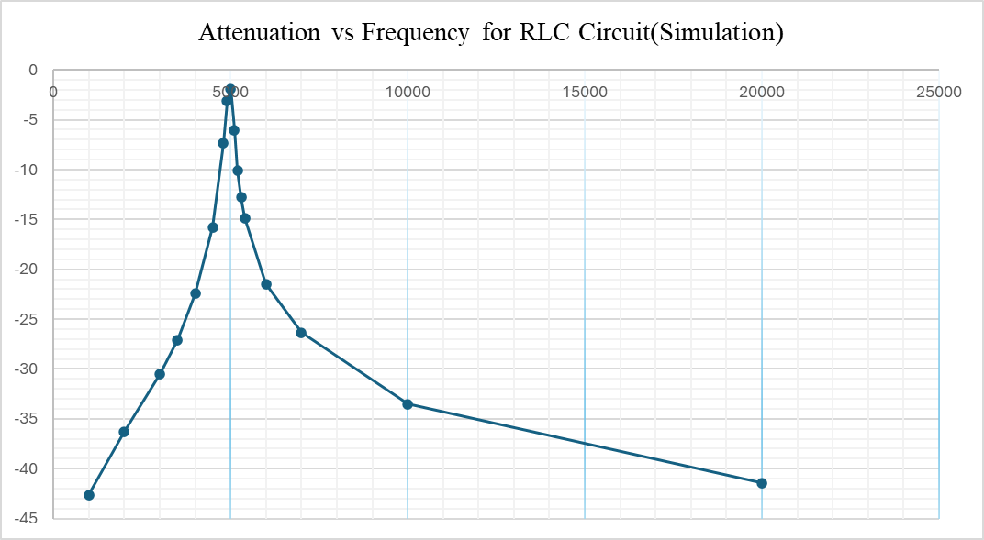
Figure 3: Attenuation vs frequency for the simulated RLC circuit (log scale)

The voltage at the inductor’s connections increases with frequency, reaching its maximum value of approximately 1.6 V at 5000 Hz (the resonant frequency of the given circuit). With increasing frequency the voltage then again decreases. The attenuation follows a similar trend, the lowest attenuation occurs at the resonant frequency. From the above graph the half-power points are 4800 Hz and 5200 Hz. The bandwidth is therefore 400 Hz, the Q factor is therefore 12.5, showing a very sharp and selective resonance.

Practical Results (Laboratory)
The practical experiment, it behaved roughly the same way but with greatly reduced voltage. The maximum voltage across the inductor was approximately 0.0244 V at 5100 Hz. The calculated resonant frequency is just above that of the simulated experiment.
Frequency (Hz) | Vin(VPP) | VL(VPP) |  | Attenuation (dB)
100 | 2 | 3.2 | 0.0032 | -55.9176
500 | 2 | 3.4 | 0.0034 | -55.391
1000 | 2 | 3.6 | 0.0036 | -54.8945
2000 | 2 | 4.9 | 0.0049 | -52.2167
3000 | 2 | 7.6 | 0.0076 | -48.4043
3500 | 2 | 9.6 | 0.0096 | -46.3752
4000 | 2 | 13.4 | 0.0134 | -43.4785
4500 | 2 | 18 | 0.018 | -40.9151
4800 | 2 | 21.6 | 0.0216 | -39.3315
4900 | 2 | 22.4 | 0.0224 | -39.0156
5000 | 2 | 23.6 | 0.0236 | -38.5624
5100 | 2 | 24.4 | 0.0244 | -38.2728
5200 | 2 | 24 | 0.024 | -38.4164
5300 | 2 | 23.6 | 0.0236 | -38.5624
5400 | 2 | 23.2 | 0.0232 | -38.7108
6000 | 2 | 18 | 0.018 | -40.9151
7000 | 2 | 11.6 | 0.0116 | -44.7314
10000 | 2 | 6.8 | 0.0068 | -49.3704
20000 | 2 | 4.4 | 0.0044 | -53.1515

In practice, the response curve is much broader than it is in the simulation. The half power points of the response are approximately at 4000 Hz and 7000 Hz. The calculated Q value for this filter is approximately 1.7, meaning that it is not very selective.

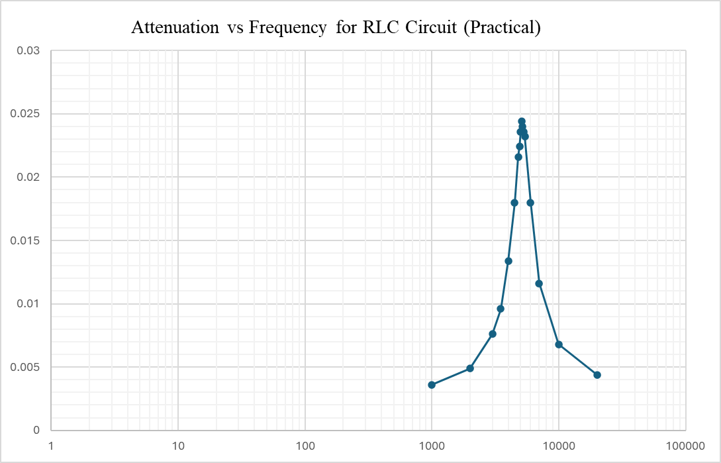
Figure 4: Attenuation vs frequency for the practical RLC circuit (log scale)
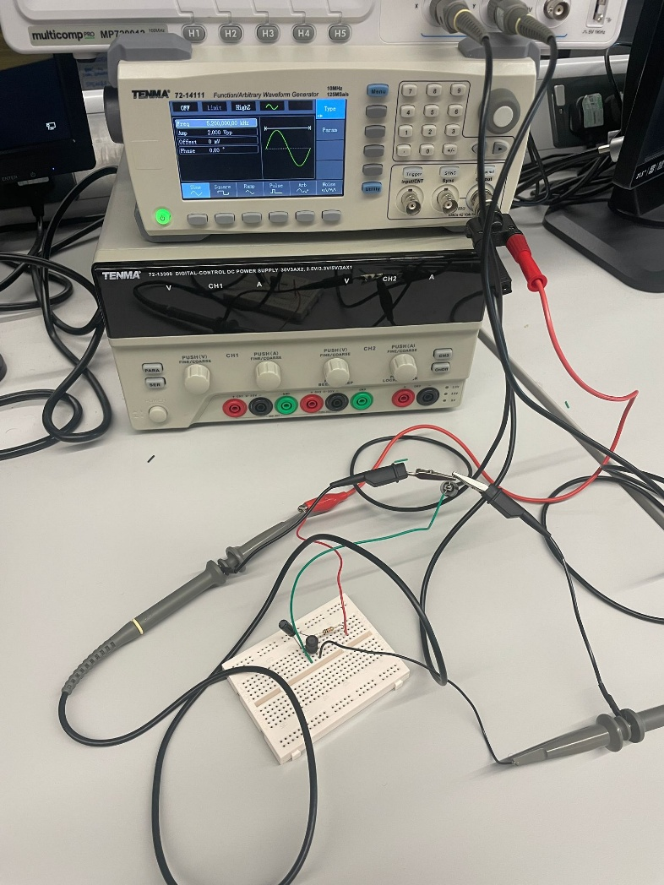
Figure 5: Practical (Laboratory) testing the RLC Circuit

Comparison of Results
Parameter | Simulation (Proteus) | Practical (Lab)
Resonant Frequency | 5000 Hz | 5100 Hz
Peak Voltage (VL) | 1.6 V | 0.0244 V
Half-Power Frequencies | 4800 – 5200 Hz | 4000 – 7000 Hz
Q Factor | 12.5 | 1.7

Discussion
For the lab experiment we looked at a simulated RLC series circuit in the Proteus Design Suite as well as a real RLC series circuit in the actual lab. For the theoretical RLC series circuit we calculated the voltage across the inductor for a given frequency. For the simulated RLC series circuit we did the same calculations. For the actual lab experiment for the real RLC series circuit we calculated the voltage across the inductor for a given frequency for the experiment and compared the results to that of the simulated RLC series circuit.
The results from the practical circuit are compared with those of the experimental setup. Like in the experimental setup, the voltage of the inductor increased with the frequency, had a maximum value at the resonance frequency and then decreased. The point of resonance for this RLC-series circuit was approximately 5100 Hz, where the maximum inductor voltage of 24.4 mV was achieved. However, the resonance curve was very broad, unlike that of the simulation where a narrow and very sharp peak was observed. The Q factor of this RLC-series circuit was found to be approximately 1.7.
The main reason for the large difference in between the simulated results and the practical results, is because of the big differences in the Q factor. The Q factor in the simulator is around 12.5, this means that the ideal RLC circuit has very low energy loss. The Q factor in the practical experiment is around 1.7. This means that there is a lot of energy lost in the real RLC circuit. This energy loss is caused by the non-ideal components in the circuit. These non-ideal components have resistance in them, which means that energy is lost as heat. This resistance can be due to the insulation on the wires, the connections between the components, or the internal resistance and inductance of the resistor, capacitor, and inductor.
Both simulated and practical RLC series circuits are acting as would be expected. The ideal results from the simulation were compared to results obtained by using practical circuit components, to highlight the losses that there are in real life circuit components. From the results obtained, it is clear to see that there is a vast amount of difference between the two circuits, and it is very obvious that the real life components are not performing as well as the ideal circuit in the simulation.

Conclusion
A simulation using proteus to RLC circuit and compared with a physical lab experiment with a similar RLC circuit. In the lab experiment, the voltage across the inductor was taken at frequencies from 100 Hz to 20 kHz to observe the resonant frequency of a series RLC circuit.
The resonant frequency for the simulated series RLC circuit was calculated to be 5000 Hz and for the experimental series RLC circuit, the resonant frequency was found to be 5100 Hz. Both values for resonant frequency agreed with the theoretical value for a series RLC circuit.
The Q factor for the simulated circuit was around 12.5. This meant that the circuit would have a very narrow bandpass region around the resonant frequency and would be very selective to any frequency within the bandpass region. The voltage across the inductor would also be very high for any frequency within the bandpass region.
The results from the experiment show that there is a lower Q factor and wider peak width for the experiment results than for the ideal results. The causes for this are the non-ideal characteristics of the actual circuit components (high resistance of inductor and wiring resistance in the circuit etc), as well as the tolerance of the circuit components. This causes the voltage across the inductor to be less than for an ideal circuit, with the result that there is a lower Q factor for the series RLC circuit.
By using the SPICE-software and the experimental setup for a series RLC-circuit, the resonant characteristics for this kind of circuit can be found and examined in detail. A big difference between the results for the idealized circuit in the SPICE-software and the real, non-ideal circuit can be observed.

References

[1] | M. Tooley, “Operational amplifiers,” in Electronics' Circuits, New York , Routledge, 2015, pp. 161-186.
[2] | M. Tooley, “Passive components,” in Electronic Circuits Hand Book Second Edition, Newnes, 1993, pp. 5-34.
[3] | M. A. A.-O. J. H. C. a. D. Peroulis, “Capacitors and Inductors,” in Electrical engineering fundamentals., Indiana, Purdue University Press, Lafayette, 2025, pp. 151-189.
[4] | IEEE, IEEE Master Test Guide for Electrical Measurements in Power Circuits, New York : Copyright © 2024 IEEE. All rights reserved, Approved 21 September 2023, pp. 1-118.
[5] | D. F. Peelo, “RLC Circuits,” in Current Interruption Transients Calculation, John Wiley & Sons Ltd, 2020, pp. 9-45.
[6] | J. E. M. K. Thomas F. Schubert, “Oscillator Circuits,” in Fundamentals of Electronics Book 4, Morgan & Claypool, 2016, pp. 19-59.

