

Software Solutions for Business

Prepared by:

Student Name Amir Bux
Student ID 2526189
The program: CERT HE Computing Skills for the Workplace
Module name: Software Solutions for Business
Module code: ACCA4026
Lecturer’s name: Osman Elgawi

​​

Table of Contents
​
​
Contents
Introduction 3
Task 1 E-Commerce Website Builders / Software Solutions 3
Shopify 4
WooCommerce: 4
Task 2(A) Mind-map of contemporary software applications 5
Task 2(B) Mind Map of Contemporary Software Applications Used in Business Operations 7
Task 3(A) Office Applications for creating, storing, presenting, and analysing information/data 9
Microsoft Word 9
Microsoft PowerPoint 11
Microsoft Excel 12
Microsoft Access 13
Task 3 (B) Practical Testing of Selected Features 14
Task 4(A) Communication and Collaboration Applications 19
Communication Application: Microsoft Teams 19
Online Collaboration Application: Trello 21
Task 4(B) Practical Testing of Communication and Collaboration Features 22
Testing a Collaboration Feature: Trello Kanban Board 24
Summary 26
References 27

​
​
​
​

Introduction
In the modern business environment, organisations depend on digital software solutions to improve efficiency, productivity and decision-making. Technology is no longer optional in the workplace; it is a core requirement for communication, data management, online trading and collaboration. Businesses of all sizes use different software applications to manage daily operations, support customers and analyse performance [1].
Software solutions can enhance workflow by automating repetitive tasks, reducing human error and improving access to information. For example, office applications allow staff to create professional documents, analyse financial data and present business information clearly. E-commerce platforms enable organisations to market goods and services online, expanding their market reach. Communication and collaboration tools support remote working and teamwork by allowing real-time interaction and file sharing [2].
The aim of this report is to explore a range of contemporary software solutions used in business environments and to demonstrate practical use of selected features. The report will examine e-commerce website builders, mind mapping tools, Microsoft Office applications and communication and collaboration software. Practical testing will be included to show applied understanding of key features and their relevance to workplace operations.

Task 1 E-Commerce Website Builders / Software Solutions
E-commerce website builders are software platforms that enable businesses to create, manage and operate online stores. These systems provide integrated tools for website design, product listing, payment processing, order management and performance analysis. In the UK business environment, organisations increasingly rely on digital commerce platforms to expand market reach and improve operational efficiency. Two widely used contemporary e-commerce solutions are Shopify and WooCommerce. These platforms represent two different technological approaches: hosted Software-as-a-Service (SaaS) and open-source integration [3] [4].

Shopify
Shopify is a cloud-based e-commerce platform designed to simplify the creation and management of online retail stores. As a SaaS model, Shopify hosts the website on its own servers and provides built-in security, maintenance and system updates. This reduces the technical burden on businesses and allows users to focus on marketing and sales activities [5].
Key features include:
- Customisable website templates
- Integrated payment gateway (Shopify Payments)
- Inventory and order tracking
- Sales analytics dashboard
- Mobile commerce compatibility

Research highlights that SaaS-based platforms reduce entry barriers for small and medium-sized enterprises by lowering technical complexity and infrastructure costs [6]. Shopify’s interface is user-friendly, making it particularly suitable for start-ups and SMEs with limited IT expertise. Additionally, its application marketplace allows integration with accounting software, marketing automation tools and logistics services.
However, Shopify operates on a subscription model with additional transaction fees in certain cases. Over time, these recurring costs may increase, particularly for growing businesses. Furthermore, advanced customisation may require paid third-party applications or developer support.

WooCommerce:
WooCommerce is an open-source e-commerce plugin built for WordPress websites. Unlike Shopify, WooCommerce requires separate web hosting and manual configuration. However, this structure offers greater flexibility and control over website functionality [7].
Key features include:
• Full control over website design and hosting
• Wide range of extensions and plugins
• Search engine optimisation (SEO) compatibility
• Multiple payment gateway integration
• Custom product management
According to Laudon and Traver [8], open-source e-commerce solutions provide businesses with higher levels of adaptability but demand greater technical responsibility. WooCommerce enables businesses to customise checkout processes, shipping rules and database management systems according to specific needs.
The main limitation is the requirement for technical knowledge. Businesses must manage updates, cybersecurity and hosting performance independently. For organisations without dedicated IT support, this may create operational risk.

Comparative Evaluation
Shopify prioritises ease of use, security management and scalability within a managed environment. WooCommerce prioritises flexibility and ownership control but requires greater technical capability. In the UK market, SMEs often select Shopify for rapid deployment, while organisations seeking tailored digital strategies may prefer WooCommerce [5].
The selection of an e-commerce platform should therefore depend on business size, growth strategy, internal technical capacity and financial planning. Both systems demonstrate how digital platforms enhance online trading, streamline workflow and improve data-driven decision-making in contemporary organisations.

Task 2(A) Mind-map of contemporary software applications
Mind mapping is a structured visual technique used to organise information around a central theme. It involves placing a core concept in the centre of a diagram and developing branches that represent related ideas, categories or subtopics. These branches may extend further into smaller components, forming a hierarchical structure that illustrates relationships between concepts. Unlike traditional linear note-taking, mind mapping promotes non-linear thinking, allowing individuals to see patterns, connections and dependencies more clearly [9].
The concept of mind mapping was popularised by Tony Buzan, who argued that visual diagrammatic representation enhances memory retention, creativity and analytical reasoning. Buzan suggested that the human brain processes images, colours and spatial relationships more effectively than plain text [10]. By combining keywords with visual structure, mind maps stimulate both logical and creative cognitive functions. This dual-processing approach makes mind mapping particularly useful in business environments where complex decision-making and idea development are required.
In contemporary organisations, mind mapping is widely applied in strategic planning, project management and operational analysis. Businesses frequently deal with multiple interrelated objectives, resource constraints and stakeholder requirements. A mind map allows managers to break down broad strategic goals into smaller operational tasks. For example, when launching a new product, a company may use a mind map to identify key areas such as marketing, finance, supply chain, customer service and risk management. Each branch can then be subdivided into actionable steps. This structured breakdown improves clarity and reduces the likelihood of overlooking important variables [11].
One significant benefit of mind mapping in business operations is improved clarity of thought. When information is presented visually, relationships between ideas become more transparent. According to Davies, visual mapping techniques enhance understanding by allowing individuals to compare, contrast and evaluate interconnected concepts more effectively. In decision-making processes, this clarity supports more rational and evidence-based judgement. Managers can assess potential risks, allocate responsibilities and identify dependencies before implementing a strategy [12].
Another important benefit is enhanced collaboration. Modern digital mind mapping tools enable multiple users to contribute simultaneously, particularly in remote or hybrid working environments. During team meetings, brainstorming sessions or workshops, participants can collectively build a visual representation of ideas in real time [13]. This participatory process encourages engagement and inclusivity. Research in organisational behaviour indicates that visual collaboration tools improve group creativity and knowledge sharing. By making ideas visible to all participants, mind maps reduce misunderstandings and promote shared understanding [14].
Mind mapping also contributes to productivity and workflow management. In operational planning, employees can use mind maps to outline project timelines, assign tasks and track progress. By visually linking tasks to deadlines and responsible individuals, managers can monitor performance more efficiently. Schwalbe notes that visual project planning tools enhance task comprehension and communication efficiency within teams. Instead of reviewing lengthy written plans, stakeholders can quickly interpret the structure and priorities of a project through a single diagram [12].
Furthermore, mind mapping supports problem-solving. When organisations face operational challenges, such as declining sales or supply chain disruptions, a mind map can be used to identify root causes and possible solutions. By mapping out contributing factors, managers can analyse the issue systematically rather than reacting impulsively. This structured approach improves analytical thinking and reduces decision bias.
In the context of contemporary software applications, mind maps are particularly useful for categorising digital tools used in day-to-day business operations. For example, a central node labelled “Business Software Applications” may branch into categories such as Office Productivity, Communication Tools, Collaboration Platforms, E-commerce Solutions and Financial Management Systems. Each category can then include specific examples of software used to support organisational activities. This visual structure demonstrates how different applications interact and contribute to overall business performance [15].
To summarise, mind mapping is more than a creative brainstorming technique. It is a practical management tool that enhances clarity, collaboration, productivity and analytical reasoning. Supported by cognitive and project management research, mind mapping provides a structured method for organising complex information in modern business environments.

Task 2(B) Mind Map of Contemporary Software Applications Used in Business Operations
A mind map was created using Microsoft PowerPoint SmartArt to illustrate contemporary software applications used in day-to-day business operations [16].
Business Software Applications
- Office Productivity Software: Microsoft Word, Microsoft Excel, Microsoft PowerPoint, Microsoft Access [17].
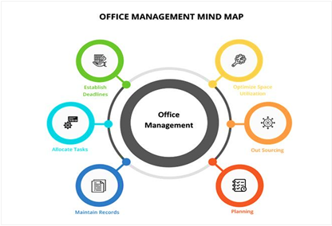
Figure 1: Office management is the coordination of daily resources and administrative task.

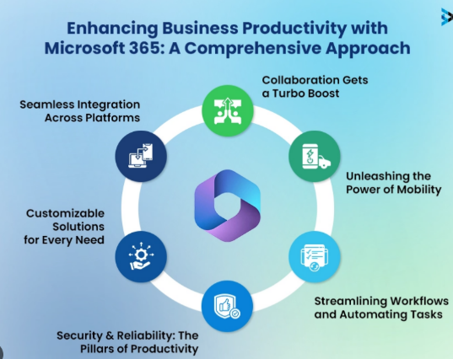
Figure 2: The image shows how Microsoft 365 improves productivity through collaboration.

- Customer Relationship Management (CRM)
• Salesforce
• HubSpot [18]
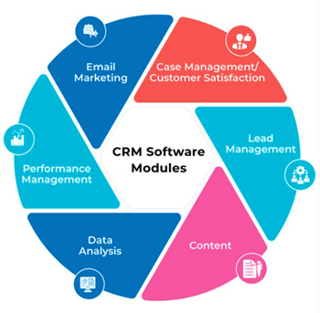
Figure 3: Accounting and Finance Software
- Accounting and Finance Software
• QuickBooks
• Xero [19]
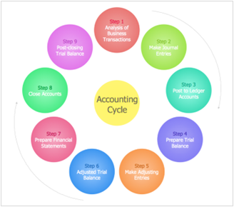
Figure 4
The mind map demonstrates how different categories of software support essential organisational functions such as communication, financial management, data analysis, marketing and online sales. Each branch represents a functional area of business activity, while the sub-branches identify specific tools that enhance operational efficiency [20].
This visual representation shows the interconnected nature of business software systems. For example, communication tools integrate with office applications, and e-commerce platforms connect with accounting software. By mapping these relationships, organisations can better understand how digital systems work together to support productivity and decision-making [21].

Task 3(A) Office Applications for creating, storing, presenting, and analysing information/data
Modern organisations depend on office productivity software to manage documents, analyse data, store records and present information effectively. The Microsoft Office suite remains one of the most widely used collections of applications in UK businesses. This section explains four core applications: Microsoft Word, Microsoft PowerPoint, Microsoft Excel and Microsoft Access, highlighting their key features, benefits and limitations. Practical testing of selected features is also demonstrated [22].

Microsoft Word
Microsoft Word is a word processing application used to create, edit and format text-based documents such as reports, letters, contracts and meeting minutes [23].
Major Features
- Advanced text formatting and styles
- Templates for reports and business documents
- Spell check and grammar tools
- Mail merge functionality
- Track changes and commenting for collaboration
- Insertion of tables, images and charts
Benefits in Business Operations
Word improves document standardisation and professionalism. Templates ensure consistency in branding and structure across organisational documents. The track changes feature supports collaborative editing, which is essential in report writing and policy development. According to Laudon and Laudon, document management systems enhance communication efficiency and reduce administrative errors [24]. Mail merge is particularly valuable in marketing and administration. It enables bulk production of personalised letters or emails, saving time and reducing manual input.
Limitations
Word is primarily designed for text processing. It is not suitable for complex data analysis or relational database management. Large documents with heavy formatting may also become difficult to manage without structured style usage [25].
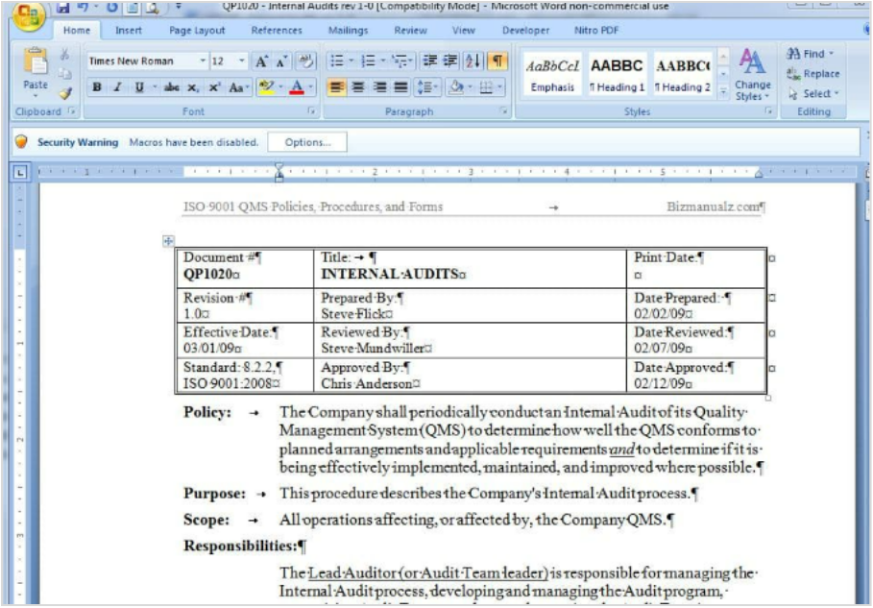

Microsoft PowerPoint
Microsoft PowerPoint is used to design and deliver visual presentations for meetings, training sessions and business proposals.
Major Features
• Slide templates and themes
• Charts and SmartArt graphics
• Animations and transitions
• Audio and video embedding
• Presenter view with notes
Benefits in Business Operations
PowerPoint enhances communication clarity. Visual elements such as charts and diagrams make complex information easier to understand. In training environments, structured slide presentations improve knowledge delivery and engagement [26].
Research in business communication shows that visual aids increase audience comprehension and retention. PowerPoint is widely used for investor presentations, internal briefings and marketing pitches.
Limitations
Overuse of animations or excessive text can reduce effectiveness. Poor slide design may distract from the message. Additionally, PowerPoint does not perform data analysis; it depends on external data sources such as Excel.
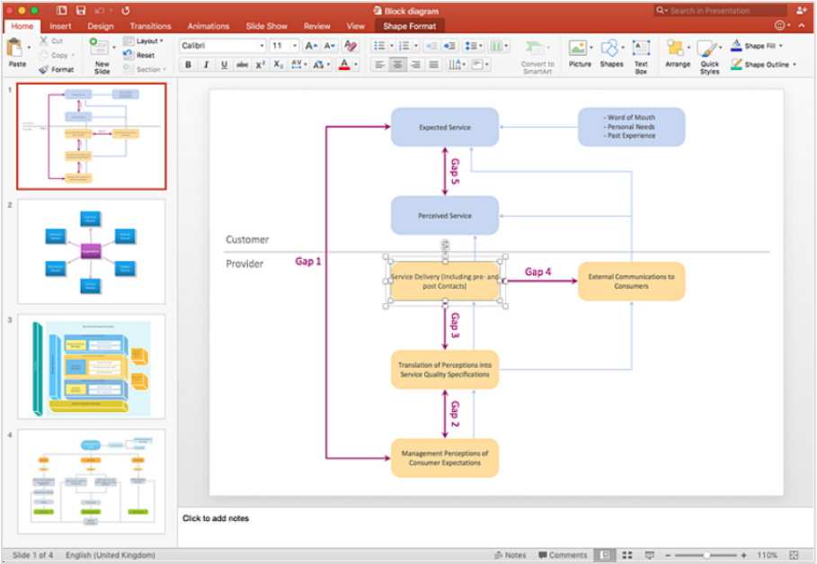

Microsoft Excel
Microsoft Excel is a spreadsheet application used for data storage, financial calculations, analysis and forecasting.
Major Features
- Formulas and built-in functions
- IF statements and logical functions
- VLOOKUP and data retrieval functions
- Pivot Tables for summarisation
- Charts and graphs
- Goal Seek and What-If Analysis tools
Benefits in Business Operations
Excel supports budgeting, payroll calculations, financial modelling and performance tracking. It allows businesses to transform raw data into meaningful insights. According to Chaffey and Edmundson-Bird, spreadsheet software plays a central role in managerial decision-making due to its analytical flexibility [27].
Pivot Tables enable rapid summarisation of large datasets, while logical functions automate classification processes. Excel improves efficiency by reducing manual calculations and minimising errors.
Limitations
Complex spreadsheets can become difficult to audit and maintain. Errors in formulas may lead to incorrect decision-making. Excel is not designed for large-scale database management or multi-user enterprise systems.
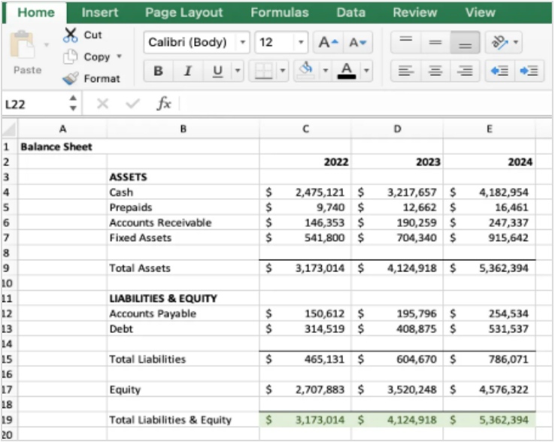

Microsoft Access
Microsoft Access is a relational database management system (RDBMS) designed for structured data storage and retrieval.
Major Features
- Tables with defined data types
- Primary and foreign keys
- Queries for data extraction
- Forms for data entry
- Reports for data presentation
Benefits in Business Operations
Access is suitable for managing structured datasets such as employee records, customer databases and inventory systems. It reduces data duplication and improves accuracy through relational design principles. Database systems enhance data integrity and reporting reliability [28].
Queries allow users to filter and extract specific information quickly. Reports can be generated automatically for management review.
Limitations
Access is limited in scalability compared to enterprise database systems such as SQL Server. It may not support very large datasets or high-volume multi-user environments.
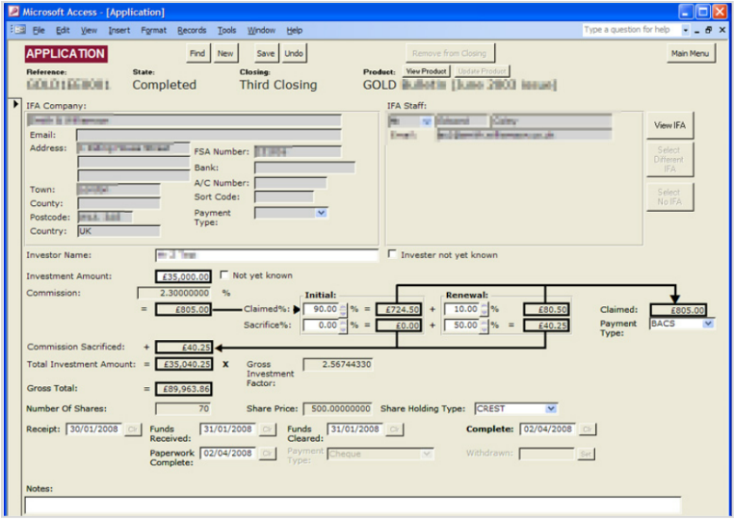

Task 3 (B) Practical Testing of Selected Features
Two features were tested to demonstrate practical application: IF Function and Pivot Table in Microsoft Excel.
- Feature 1: IF Function in Excel
- Objective
To classify employee performance based on sales targets.
- Data Created
Column A: Employee Name
Column B: Sales Amount
Column C: Target Status
- Formula Used
=IF(B2>=5000,"Target Achieved","Below Target")
- Steps
- Entered sample sales data for five employees.
- Selected cell C2.
- Inserted IF formula.
- Dragged formula down to remaining rows.
- Explanation
The IF function evaluates whether the sales value meets or exceeds £5000. If true, it displays “Target Achieved”; if false, it displays “Below Target.” This feature automates performance classification and supports managerial decision-making. It reduces manual checking and increases operational efficiency [29].
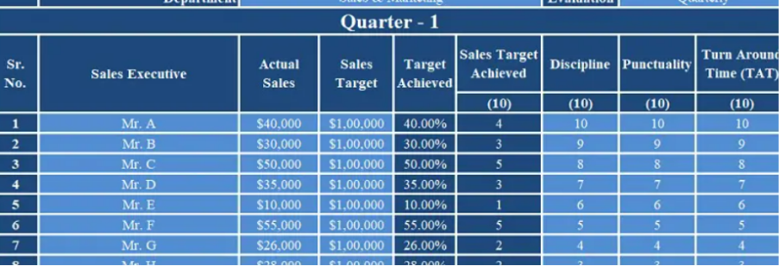
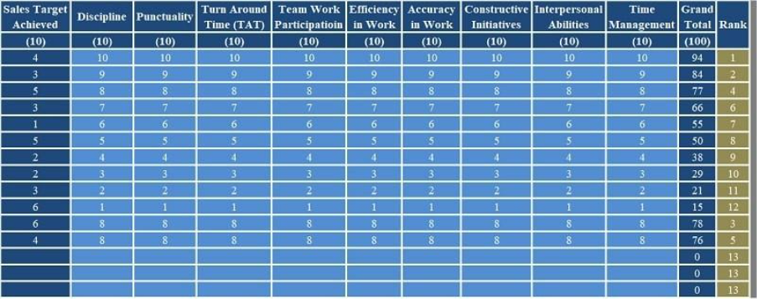

- Feature 2: Pivot Table
- Objective
To summarise total sales by employee.
- Steps
- Highlighted the sales dataset.
- Clicked Insert → Pivot Table.
- Selected “From Table/Range.”
- Dragged “Employee Name” to Rows.
- Dragged “Sales Amount” to Values (Sum).
- Explanation
The Pivot Table automatically calculated total sales per employee. This feature allows quick summarisation of large datasets without writing complex formulas. Managers can identify high-performing staff and make data-driven decisions. According to business analytics literature, data summarisation tools improve reporting accuracy and speed [30].
Microsoft Word, PowerPoint, Excel and Access each serve distinct but complementary roles in business operations. Word supports professional documentation, PowerPoint enhances communication, Excel enables data analysis and financial modelling, and Access manages structured databases. While each application has limitations, together they form an integrated productivity system widely used in organisations [31].
Practical testing of the IF function and Pivot Table demonstrated how Excel supports automated classification and data summarisation. These tools significantly improve workflow efficiency, reduce errors and enhance managerial decision-making in modern workplaces.

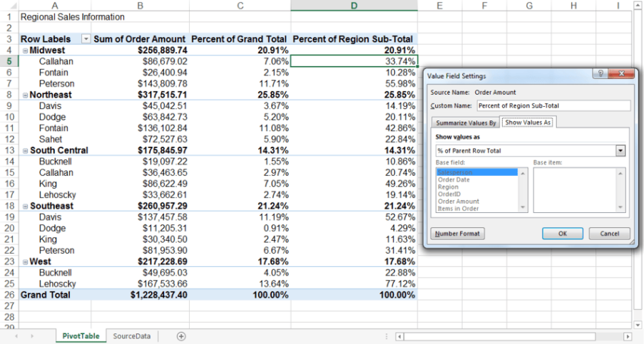
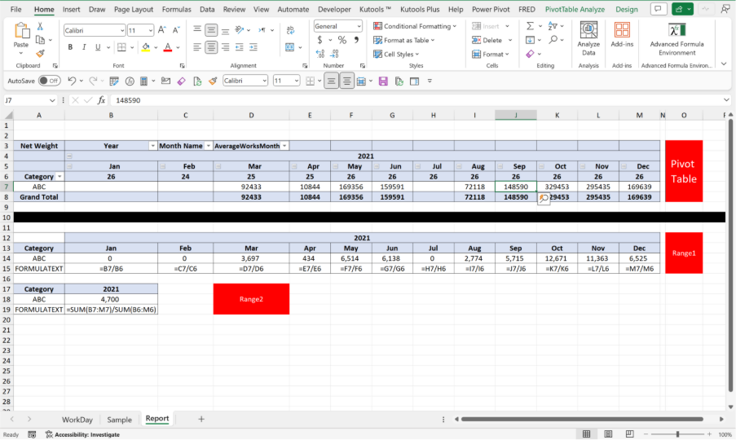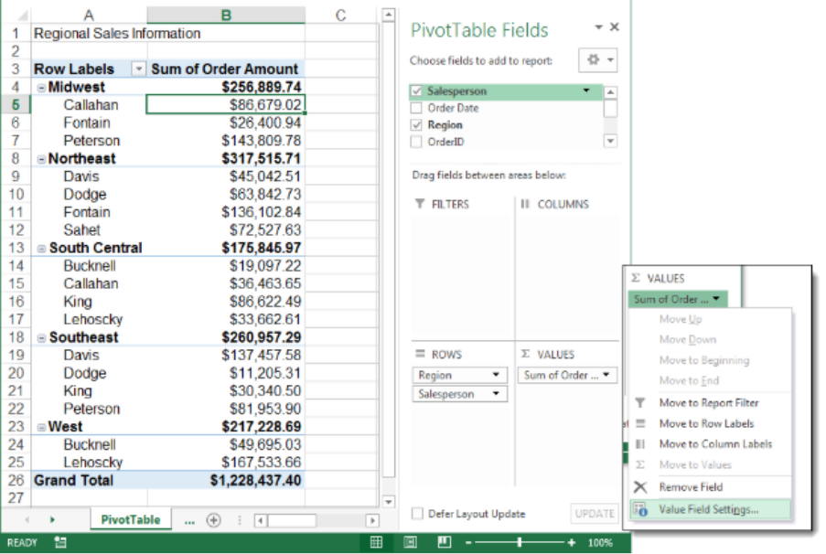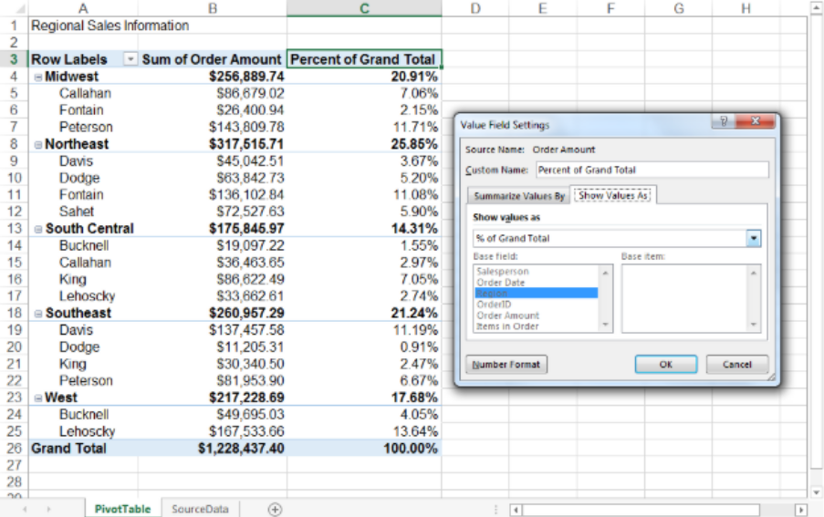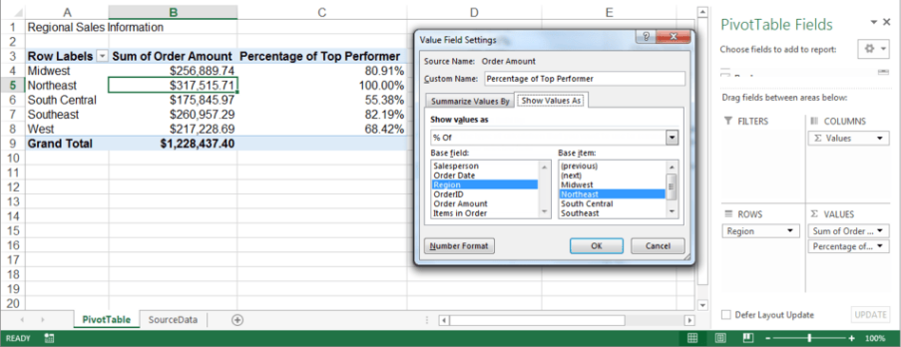

Task 4(A) Communication and Collaboration Applications
Communication and collaboration software form the backbone of modern business operations. These tools enable real-time interaction, remote working, efficient document sharing and coordinated task execution across teams and departments. This task examines one contemporary communication application and one collaboration platform widely used in organisations. It analyses their key features, benefits and limitations, supported by current literature. It also demonstrates practical testing of a selected feature from each application, with reflective explanation [32].

Communication Application: Microsoft Teams
Microsoft Teams is a unified communication platform that integrates chat, voice, video conferencing and file sharing within a single interface. It is part of the broader Microsoft 365 ecosystem, which enhances interoperability with other Office applications such as Word, Excel, PowerPoint and Outlook. The adoption of Microsoft Teams has accelerated significantly due to the rise of remote and hybrid work, making it a central tool for organisational communication and collaboration [33].
Key Features
Instant Messaging
Microsoft Teams allows users to send real-time text messages to individuals or groups. Conversations can be organised into channels corresponding to specific teams, projects or departments. This structure reduces email dependency and allows contextual communication.
Video Conferencing and Voice Calls
Teams supports high-definition video meetings and voice calls. It includes features such as screen sharing, meeting recordings, virtual backgrounds and live captions. Video meetings are crucial for remote collaboration, allowing teams to maintain face-to-face interaction across locations.
File Sharing and Document Collaboration
Teams integrates seamlessly with OneDrive and SharePoint, enabling users to store, access and co-edit documents within the platform. Users can work on Word, Excel and PowerPoint files in real time, with version control and permission management.
Integration with Microsoft 365
Being part of the Microsoft ecosystem, Teams integrates with Outlook for calendar scheduling, Power BI for data dashboards and Planner for task management. This deep integration streamlines workflows and reduces context switching between applications.
Notifications and Alerts
Users receive activity notifications, ensuring that important messages and updates are not overlooked. Customisable alerts allow users to prioritise relevant communications.

Benefits in Business Operations
Microsoft Teams supports synchronous (real-time) and asynchronous communication, which is essential in hybrid work models. Research indicates that unified communication tools improve collaboration effectiveness and organisational agility. Teams reduces the reliance on email, centralises conversation history and creates digital workspaces aligned with organisational structure [34].
Teams also enhances organisational knowledge retention. Conversations and files remain accessible, allowing employees to revisit past discussions and shared documents. Integration with Microsoft 365 increases productivity by enabling seamless access to document editing and analytical tools within a single platform.
Limitations
Despite its strengths, Teams has limitations. The volume of notifications can lead to cognitive overload if not managed with appropriate settings. Additionally, consistent use of Teams requires reliable internet connectivity, which can be a challenge in remote locations. Security and governance also require careful configuration to ensure compliance with organisational policies [35].

Online Collaboration Application: Trello
Trello is a web-based collaboration platform that uses a visual Kanban board to organise tasks and projects. Owned by Atlassian, Trello is widely adopted by businesses for project planning, task tracking and team coordination. It enables users to visualise workflows using lists, cards and boards each representing a stage of work or category of tasks [36].
Key Features
Boards, Lists and Cards
Trello’s primary interface consists of boards that contain lists, which in turn contain cards. Each card represents a task or work item. Users can move cards between lists to indicate progress (e.g., from “To Do” to “In Progress” to “Done”).
Labels and Tags
Tags allow teams to categorise tasks by priority, department, project or type. Visual labels enhance clarity and help users filter tasks.

Checklists and Due Dates
Cards can include checklists, due dates and attachments. Checklists provide a breakdown of sub-tasks, while due dates track deadlines and support schedule management.
Collaboration and Comments
Team members can comment on cards, mention colleagues and upload documents. This supports contextual collaboration and reduces the need for external communication streams.
Integrations and Power-Ups
Trello supports integrations (called Power-Ups) with third-party tools such as Google Drive, Slack, Jira and calendar applications. Power-Ups extend Trello’s functionality to include time tracking, reporting and automation.
Benefits in Business Operations
Trello supports visual project planning, which simplifies complex tasks and improves transparency. Kanban boards help teams manage workloads and identify bottlenecks quickly. According to project management literature, visual task boards enhance team coordination by providing a shared overview of progress and responsibilities.
Trello’s intuitive user interface reduces training requirements and supports cross-functional collaboration. Teams can adapt boards to different methodologies such as Agile, Scrum or simple task lists, making it versatile across industries [37].
Limitations
Trello’s simplicity can be a limitation for advanced project management needs. It lacks built-in resource management, Gantt chart views and detailed reporting found in more sophisticated tools. For large enterprises with complex portfolios, Trello may require additional integrations or third-party enhancements [38].

Task 4(B) Practical Testing of Communication and Collaboration Features
This section documents practical testing of one feature from each application: the video meeting scheduling feature in Microsoft Teams and the Kanban board task assignment in Trello. Screenshots are integrated with descriptions to demonstrate applied understanding.
- Testing a Communication Feature: Microsoft Teams Meeting Scheduling
Objective: Schedule and initiate a Teams meeting using the platform’s built-in calendar.

Steps:
- Open Teams and navigate to the Calendar tab.
- Click New Meeting.
- Enter meeting title, date, time and participants.
- Send the invitation.
- Join the meeting via the link when scheduled.
Description:
The screenshot shows the Teams calendar and the meeting scheduling form. This feature integrates with Outlook calendars, allowing participants to receive invitations via email with join links. Teams meeting scheduling streamlines the coordination of remote discussions, reduces administrative delay and ensures that all participants have access to relevant details. Real-time communication via video and chat enhances engagement and supports remote decision-making.

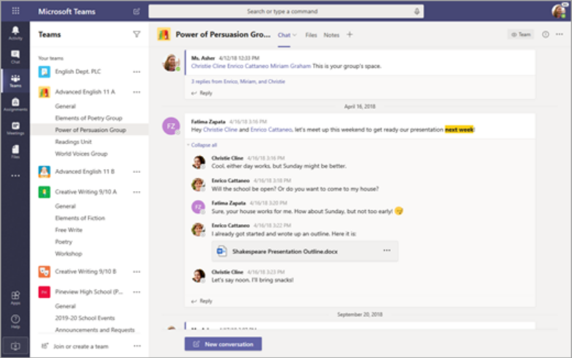


Testing a Collaboration Feature: Trello Kanban Board
Objective: Create a project board, add task cards and assign team members.
Steps:
- Log into Trello and create a new board named Project Workflow.
- Create lists: To Do, In Progress and Completed.
- Add cards representing tasks under To Do.
- Assign members and add due dates.
- Move cards between lists based on progress.
Description:
The screenshots show a Trello board with three lists and several task cards. Each card contains details such as assigned member, due date and checklist. This visual organisation helps team members understand their responsibilities and progress. Kanban boards improve workflow transparency and support iterative task management.
Communication and collaboration applications are indispensable in contemporary business environments. Microsoft Teams supports unified communication with integrated messaging, video conferencing and document co-editing, enhancing connectivity across distributed teams. Trello provides a visual task management framework that increases transparency and supports collaborative project execution [39].
Both applications demonstrate how software solutions improve organisational productivity, streamline workflows and facilitate decision-making. The practical testing of scheduling a Teams meeting and managing tasks in Trello illustrates applied use of these tools and validates their relevance in workplace operations.
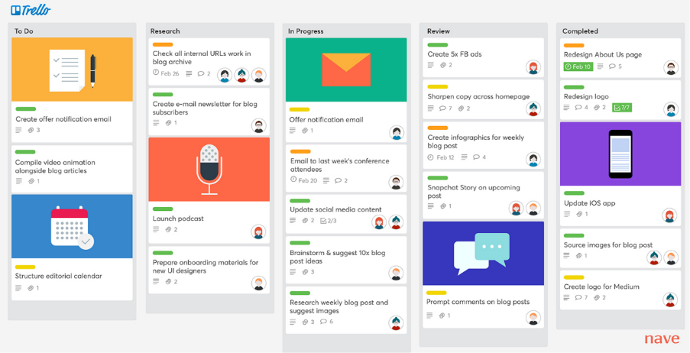
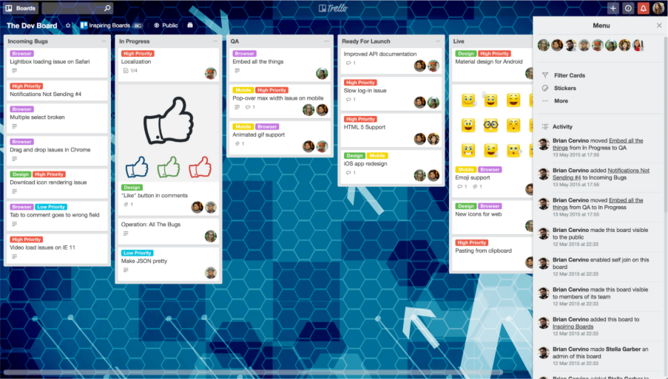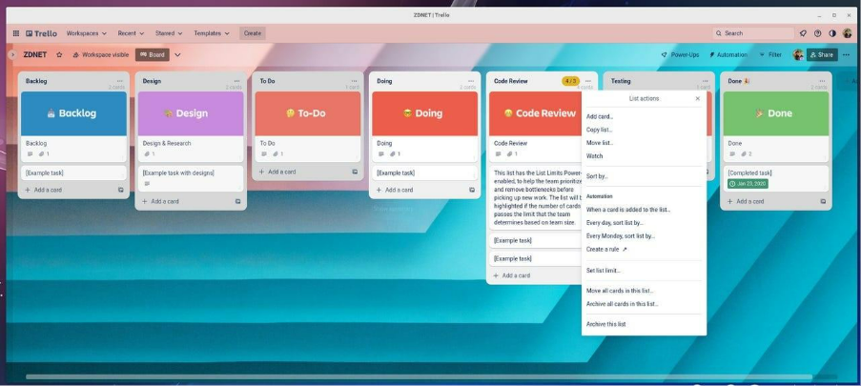

Summary
This assignment explored a range of contemporary software solutions used to support business operations in the modern workplace. The study examined several categories of digital tools including e-commerce platforms, mind mapping applications, office productivity software and communication and collaboration technologies.
The first task analysed two e-commerce solutions that allow businesses to build online stores and sell products through digital platforms. These systems help organisations expand their market reach and improve customer accessibility. The second task discussed mind mapping as a visual method for organising information and supporting planning and decision-making processes within organisations.
The third task examined four major office software applications used in business environments: Microsoft Word, Microsoft Excel, Microsoft PowerPoint and Microsoft Access. These tools support document creation, data analysis, presentations and database management. Practical testing of selected Excel features demonstrated how office software can assist with analysing and managing organisational data.
The final task analysed communication and collaboration applications used in modern organisations. Microsoft Teams was evaluated as a communication platform that enables messaging, meetings and document sharing, while Trello was examined as a collaboration tool for managing projects and tasks visually. Practical testing of these tools demonstrated how they improve teamwork, communication and workflow management.
Overall, the assignment demonstrates that software solutions play a critical role in improving efficiency, productivity and communication in contemporary business environments. Organisations that effectively adopt digital tools are better able to coordinate activities, manage information and respond to changing workplace demands.

References

[1]R. El-Haddadeh, “Digital Innovation Dynamics Influence on Organisational Adoption: The Case of Cloud Computing Services,” Information Systems Frontiers, vol. 22, pp. 985–999, Apr. 2019, doi: https://doi.org/10.1007/s10796-019-09912-2.
[2]D. Ajiga, P. Azuka, S. Olaoluwa, and C. Ezeigweneme, “The Role of Software Automation in Improving Industrial Operations and Efficiency,” International Journal of Engineering Research Updates, vol. 7, no. 1, pp. 022–035, Aug. 2024, doi: https://doi.org/10.53430/ijeru.2024.7.1.0031.
[3]Wix eCommerce, “Ecommerce Website Builder | Create an Online Store | Wix.com,” Wix Stores NewHeader, 2023. https://www.wix.com/ecommerce/website
[4]“What is AWS Marketplace?,” Amazon.com, 2026. https://aws.amazon.com/marketplace/features/what-is-aws-marketplace?trk=82624263-6ad5-422b-840c-a47af1fbbb43&sc_channel=ps&ef_id=Cj0KCQiA8KTNBhD_ARIsAOvp6DJLWeViMP7dxccK87uG_8TOpVyk0pFbyQEHshzvNYdRVMF-RPiPbakaApyYEALw_wcB:G:s&s_kwcid=AL (accessed Mar. 05, 2026).
[5]“Point of Sale (POS) for Business,” Shopify. https://www.shopify.com/uk/pos
[6]D. Bell, “The real story behind the 53% drop in SaaS AI traffic,” Search Engine Land, Feb. 12, 2026. https://searchengineland.com/saas-ai-traffic-drop-469149 (accessed Mar. 05, 2026).
[7]WooCommerce, “WooCommerce,” WooCommerce, 2019. https://woocommerce.com/
[8]“E-Commerce 2021,” Google Books, 2021. https://books.google.com/books/about/E_Commerce_2021.html?id=eVFGzwEACAAJ (accessed Mar. 05, 2026).
[9]H. S. Dhindsa, Makarimi-Kasim, and O. Roger Anderson, “Constructivist-Visual Mind Map Teaching Approach and the Quality of Students’ Cognitive Structures,” Journal of Science Education and Technology, vol. 20, no. 2, pp. 186–200, Aug. 2010, doi: https://doi.org/10.1007/s10956-010-9245-4.
[10]“LibGuides: Notetaking software: Mind mapping,” Hull.ac.uk, 2014. https://libguides.hull.ac.uk/digitalnotetaking/mindmap
[11]K. E. P. Shields and K. M. B. Wright, “Strategic planning characteristics applied to project management,” International Journal of Project Management, vol. 35, no. 2, pp. 169–179, Feb. 2017, doi: https://doi.org/10.1016/j.ijproman.2016.10.015.
[12]S. Peek, “How Mind Mapping Can Help Entrepreneurs,” business.com, Apr. 03, 2023. https://www.business.com/articles/benefits-of-mind-mapping-for-professionals/
[13]MeisterLabs, “MindMeister,” MindMeister, 2019. https://www.mindmeister.com/
[14]B. News, “How to empower your team with visual collaboration tools,” Box Blog, Apr. 11, 2024. https://blog.box.com/visual-collaboration-tools
[15]T. Adler, “10 card payment machines ideal for small business,” Small Business UK, Oct. 11, 2024. https://smallbusiness.co.uk/what-are-productivity-and-collaboration-tools-for-business-2593172/
[16]“Create a SmartArt graphic from scratch - Microsoft Support,” Microsoft.com, 2024. https://support.microsoft.com/en-gb/office/create-a-smartart-graphic-from-scratch-fac94c93-500b-4a0a-97af-124040594842
[17]M. Philip, “Subject Guides: IT Essentials: a Practical Guide: Microsoft Office Essentials,” subjectguides.york.ac.uk, 2024. https://subjectguides.york.ac.uk/it-essentials/office
[18]https://www.facebook.com/askcraftit, “Comparing CRM Software HubSpot Vs Salesforce For Business Growth | Askcraft,” askcraft, May 04, 2025. https://askcraft.co.uk/comparing-crm-software-hubspot-vs-salesforce/ (accessed Mar. 05, 2026).
[19]Mark, “Xero vs QuickBooks UK – Which Accounting Software Is Best?,” Stewart Accounting, Nov. 06, 2025. https://stewartaccounting.co.uk/xero-vs-quickbooks-uk/
[20]“Mind Map: Classification of Software... | Filo,” Filo, 2025. https://askfilo.com/user-question-answers-smart-solutions/mind-map-classification-of-software-3339393530303731 (accessed Mar. 05, 2026).
[21]“Enterprise Integration Patterns,” Google Books, 2026. https://books.google.com/books?hl=en&lr=&id=bUlsAQAAQBAJ&oi=fnd&pg=PR7&dq=This+visual+representation+shows+the+interconnected+nature+of+business+software+systems.+For+example (accessed Mar. 05, 2026).
[22]ayushisingh11064, “Role of Microsoft Office in Modern Business Organisations,” Scribd, 2026. https://www.scribd.com/presentation/983104864/Role-of-Microsoft-Office-in-Modern-Business-Organisations (accessed Mar. 05, 2026).
[23]TheKnowledgeAcademy, “Microsoft Word Processor: Definition,” www.theknowledgeacademy.com. https://www.theknowledgeacademy.com/blog/microsoft-word-processor/
[24]TheKnowledgeAcademy, “Features of Microsoft Word: All You Need To Know!,” www.theknowledgeacademy.com. https://www.theknowledgeacademy.com/blog/features-of-microsoft-word/
[25]“My 365 Word takes a lot of time to load a big document (~250 pg) -- over 20 minutes and then is non responsive. - Microsoft Q&A,” Microsoft.com, Nov. 19, 2025. https://learn.microsoft.com/en-us/answers/questions/5627659/my-365-word-takes-a-lot-of-time-to-load-a-big-docu (accessed Mar. 05, 2026).
[26]Microsoft, “Download PowerPoint | Try PowerPoint, free | PPT,” www.microsoft.com, 2024. https://www.microsoft.com/en-gb/microsoft-365/powerpoint
[27]“MS Excel | Digital Skills | Toolkit | The University of Aberdeen,” www.abdn.ac.uk. https://www.abdn.ac.uk/toolkit/skills/ms-excel/
[28]R. McFadyen, “1.2 Microsoft Access,” Relational Databases and Microsoft Access 365, 2026. https://ecampusontario.pressbooks.pub/relationaldatabasesandmicrosoftaccess365/chapter/__unknown__-2/ (accessed Mar. 05, 2026).
[29]“How to use the IF Function in Microsoft Excel - For Beginners,” www.youtube.com. https://www.youtube.com/watch?v=hgkWSqAMcKc (accessed Feb. 07, 2024).
[30]Excel Easy, “Pivot Tables in Excel,” Excel-easy.com, 2010. https://www.excel-easy.com/data-analysis/pivot-tables.html
[31]“Free Microsoft 365 Online | Word, Excel, PowerPoint,” www.microsoft.com. https://www.microsoft.com/en-gb/microsoft-365/free-office-online-for-the-web
[32]O. Abiola, O. Gift, and A. Omozele, “Advances in communication tools and techniques for enhancing collaboration among creative professionals,” International Journal of Frontiers in Science and Technology Research, vol. 7, no. 1, pp. 066–075, 2024, doi: https://doi.org/10.53294/ijfstr.2024.7.1.0049.
[33]J. Perry, “What exactly is Microsoft Teams and what are its key features? - Content Formula,” Content Formula, Mar. 28, 2019. https://contentformula.com/what-exactly-is-microsoft-teams-and-what-are-its-key-features/
[34]Blerta Abazi Chaushi, “MS Teams for Virtual Collaboration -An Overview,” 4th International Conference on Educational Technology and Online Learning – ICETOL 2024 Full Paper Proceedings, 2024. https://www.academia.edu/download/123452190/icetol2024_babazi.pdf
[35]H. Imran and F. Shafique, “Digital Fatigue and Cognitive Overload as Managerial Challenges Understanding the Impact of Workload Management on the Workforce,” The Critical Review of Social Sciences Studies, vol. 3, no. 4, pp. 1629–1641, Nov. 2025, Available: https://www.researchgate.net/publication/398274269_Digital_Fatigue_and_Cognitive_Overload_as_Managerial_Challenges_Understanding_the_Impact_of_Workload_Management_on_the_Workforce
[36]agileKRC, “Trello Kanban,” agileKRC, Apr. 03, 2024. https://agilekrc.com/agile/kanban/kanban-tools-and-software/trello-kanban (accessed Mar. 05, 2026).
[37]“Trello for Creative Teams | New Verve Consulting,” Newverveconsulting.com, 2024. https://www.newverveconsulting.com/blog/entry/trello-for-creative-teams
[38]J. S. Kamila and M. F. Marzuq, “Asana and Trello: A Comparative Assessment of Project Management Capabilities,” JOIV : International Journal on Informatics Visualization, vol. 8, no. 1, pp. 207–212, Mar. 2024, doi: http://dx.doi.org/10.62527/joiv.8.1.2595.
[39]F. Mammadova, N. Abdullayeva, М. Ф. А, and А. Н. К, “The role of communication and collaboration in business management,” Kharkov.ua, 2025. https://dspace.khadi.kharkov.ua/items/a9e3127d-6cfa-4d82-9f6f-da116e57b117

