EAEE6005
Sustainability in the Early Years
Section A- scrapbook
1904695

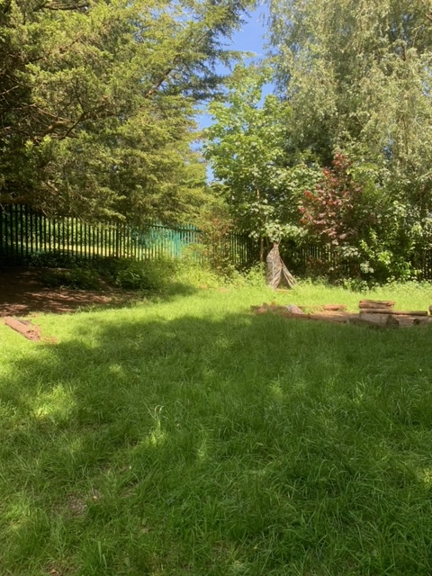
Our school woodland(Source: Davies, 2021a)

My John Muir Experience

Discover…

Growing up as a child in Swansea, I had the pleasure of having a woodland in my primary school. My woodland experience allowed me to grow an interest from a young age, for wildlife and minibeasts. I am now a teaching assistant in my old primary school and my goal is to teach the children on how crucial minibeasts are for our survival. I would love the children to share the same woodland experiences and interests that I did when I was a child. Undertaking the John Muir award, it has enabled me to teach the children the importance of the woodland and to explore what lives and grows there.

Discover the area…

In Swansea, we are surrounded by woodlands and wildlife. Undertaking the John Muir award in the summer, the woodlands are bursting in colour from the wild-flowers and the dark green trees. There are bright coloured bees and butterflies flying around and you can hear the whirring insects and chirping birds.
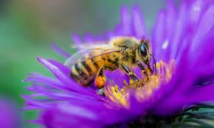
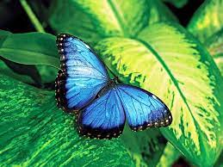

(Britannica, 2021) (Ideas.Ted, 2021)

In the woodland, there are lots of different animals. It is interesting to see where in the woodland the different animals live. The children and I went on a hunt to see what animals we could find. The photos below are what we found in the school woodland. (Source: Davies, 2021c)
Slugs
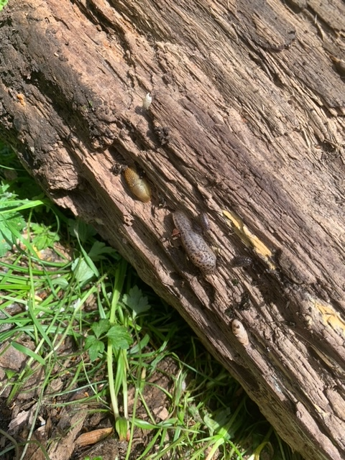
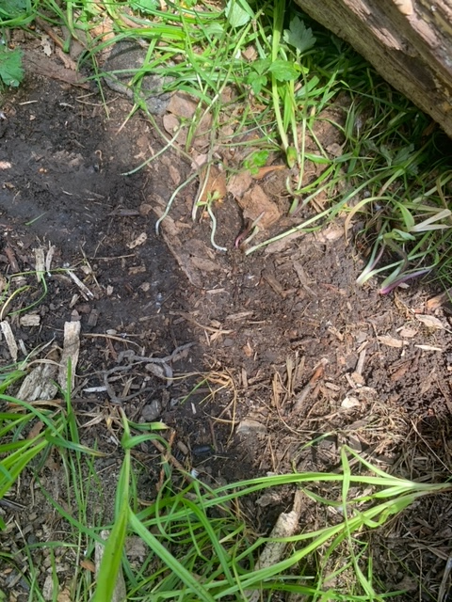

(Source: Davies, 2021b)

Worms
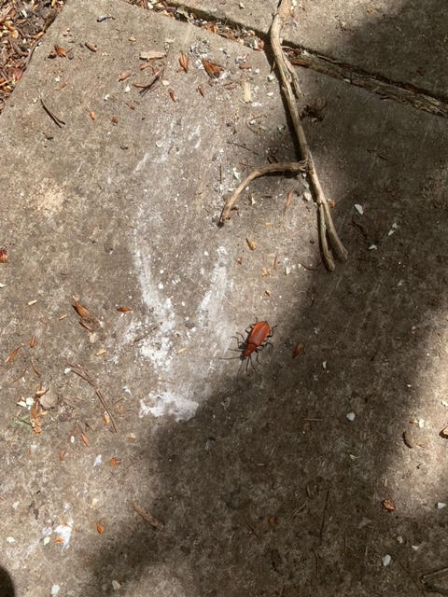
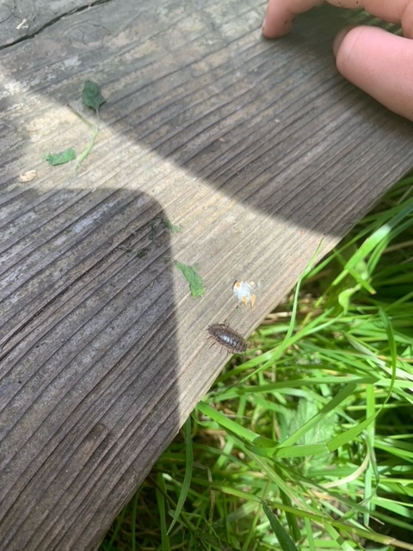
Cockroach

Woodlice

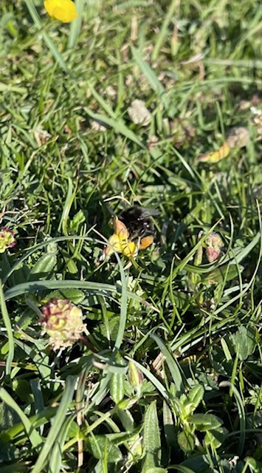
(Source: Davies, 2021d) (Source: Davies, 2021e)
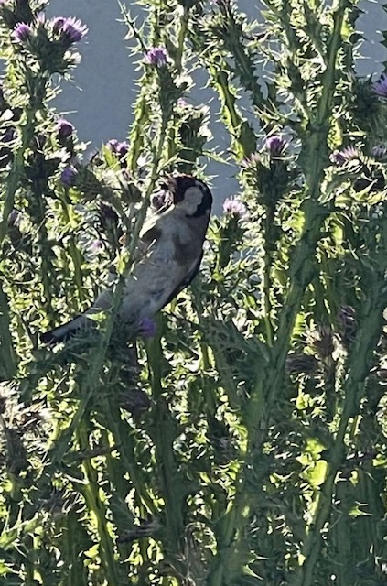
Magpie
Bee
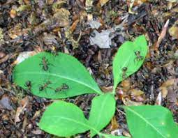
(Source: Davies, 2021f) (Source: Davies, 2021g)
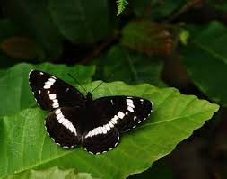

Butterfly
Ants
(Woodlands, 2021) (The Wildlife Trusts, No Date)
Explore…

Whilst exploring the school woodland, the children and I realised that the environment was child friendly however, it had limited resources for wildlife and minibeasts. There were limited plants for the bees and butterflies and due to the woodland being a place where the children always visit, the insects were not safe to lay their eggs and raise their children. So, I decided to make a plan, to build a bug hotel to encourage and keep the insects safe within the school woodland. The children were keen to get involved with the project and develop their understanding.

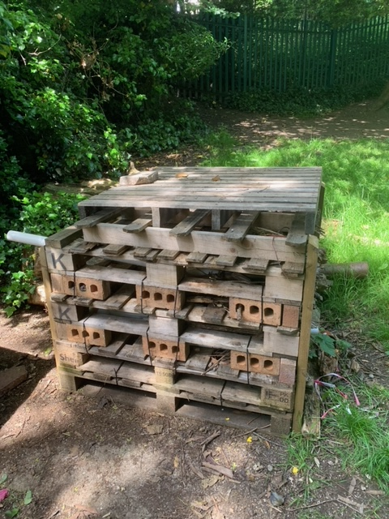

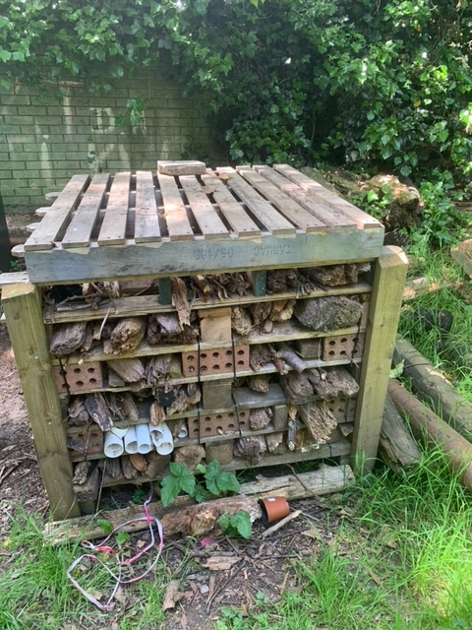

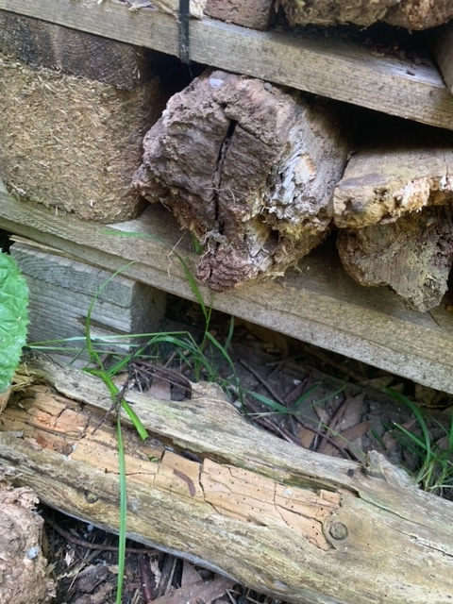

(Source: Davies, 2021h)

(Source: Davies, 2021i)

Here’s our bug hotel we made.

(Source: Davies, 2021j)

Why will the bug hotel benefit the woodland?

Not only was the bug hotel a safe place for insects to lay their eggs and live, it was also a place they would be able to feed from. By adding twigs and logs to bug hotel it meant that in time they would rot, this would encourage insects to feed off the rotting wood and to make use of these nutrients. The bug hotel would be a quiet place for insects, meaning they would not be disturbed allowing them to feel safe. Due to the bug hotel being habitat for many insects, it would attract other wildlife such as birds, hedgehogs, fox’s, badgers and owls to the woodland.

What animals will live in the bug hotel?

Slugs

Ladybirds
Worms

Snails

Centipedes

Bees

Moths

Wasps

Spiders

Butterflies

Four simple steps on how to build a bug hotel to support wildlife and benefit your woodland.

- Place pallet down on a levelled surface
- Add 3 bricks on top of the pallet (first floor of bug hotel)
- Add another pallet and another set of 3 bricks on top (repeat this until floor 6)
- Add twigs, logs and pieces of wood through-out

What Materials we used to build our bug hotel
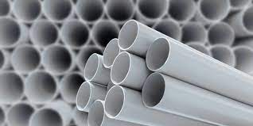

Pallets

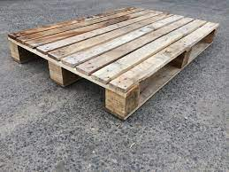 (Plastic Pipe, 2020)
Plastic Pipes

(Sandmpallets, No Date)

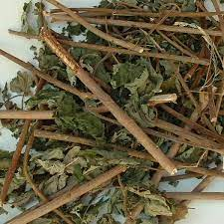
Bricks
Sticks
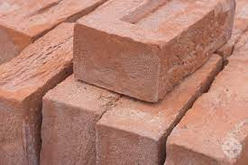

(Galen’s Garden, 2014)

(Cornish Lime, 2021)
Logs
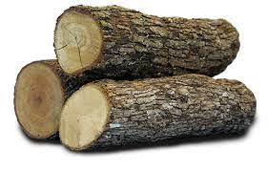

(Cisco Umbrella, No Date)
Photos of the school woodland in the summer (Source: Davies, 2021l)

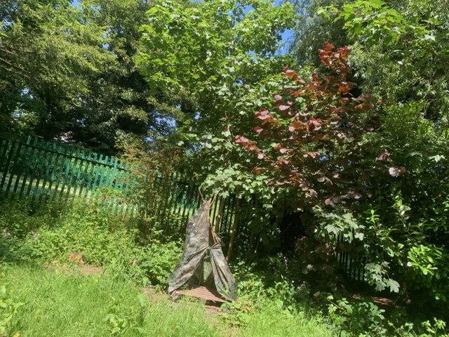
(Source: Davies, 2021)
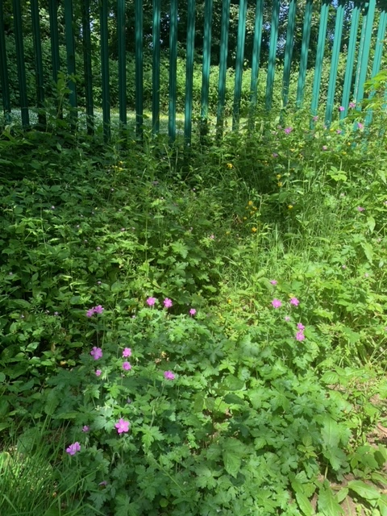
(Source: Davies, 2021k)

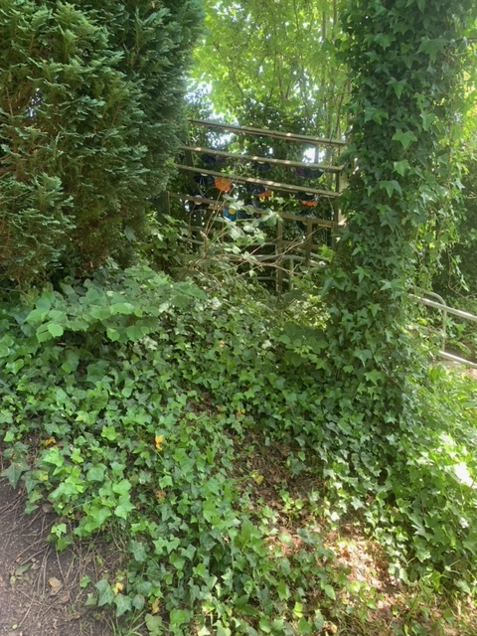

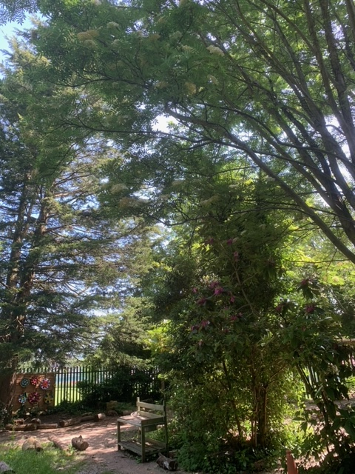

(Source: Davies, 2021m)
(Source: Davies, 2021n)
I have created a story to educate children on the benefits of the bug hotel to animals and mankind. The story states what different animals live inside the bug hotel. The purpose of the story is to teach children the importance of how each animal plays an important role in maintaining the balance of life. So, bug hotels are important to keep the animals healthy and productive so it can help nesting facilities overall, increasing the population of animals.

The story promotes the Reggio Emilia approach 100 languages of children, as children learn better by reading and listening to stories rather than just being told something. The story will also encourage the children to build a bug hotel which will enable them to express themselves in a creative manor.

Completing the bug hotel for my John Muir award it has inspired me. Before completing the award, I always looked negatively on aniamls

I never understood that there was a loss of habitat. I have now realised that by taking part in something as small as a bug hotel, it could have such a big impact on the environment and life cycle. Without the animals it would not be possible to live. The bug hotel also enabled me to see the animals in their natural habitat and it inspired me to keep providing a safe home for them.

Reflection…

On reflection, due to Covid 19 and the woodland not being used, it has encouraged myself and the children to engage and explore with the outdoors and nature more. I now feel after Covid 19 and the John Muir award, I am confident to support the wildlife and minibeasts in our woodland overall, helping to improve the world I live in.

The Bug Hotel

(Source: Davies, 2021o)
By Brooklyn Davies

A bug hotel is a six-story habitat where insects of all shapes and sizes live. People make bug hotels from natural materials such as wood, sticks and stones. Bug hotels can be built in parks, back gardens and woodlands.

Let’s see who has checked in to the bug hotel today. Butterfly. Butterflies are good for the environment as they help flowers produce pollen and they eat all the weedy plants. Without butterflies, it would stop food crops growing as no pollen would be produced.
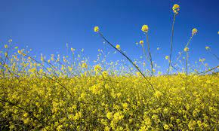

(Britannica, 2021) (Opernicus, 2019)
Who else has checked in to the bug hotel? Lady bird. Lady birds are good for the environment as they eat insects such as aphid. By lady birds eating insects that are herbivores, it helps to protect crops. This stops our fruit and vegetables being damaged.
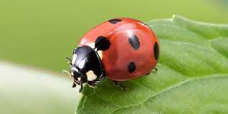

(Ark Wildlife, 2020)

Who else has checked in to the bug hotel? Snail and slug. Snails and slugs are good for the environment as they provide food for animals such as birds, worms and insects. Slugs help the process of compost making.
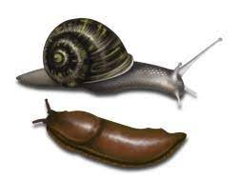

(Orkin, No Date)
Who else has checked in to the bug hotel? Bee. Bees are good for the environment as they are pollinators. Bees help to grow trees and plants. This helps provide food and shelter to other animals. If we do not protect bees, it could affect other animals, survival as they depend on pollen to source foods such as nuts, berries, fruits and seeds.

(Ideas.Ted, 2021)

Now it is your turn to have a go building your own bug hotel. Remember, this can be done in any outdoor space, and this will help to protect insects. Remember, to use natural materials.

Davies, B. (2021) The Bug Hotel. [Student’s Original Story].

