


Analysing Risk in Vulnerability Assessment and
Penetration Testing Methodology

By

Sakthi Sangeetha Kandaswamy

Supervisor: Carlene E-A Campbell

Project submitted as part of the requirements for the award of MSc Cybersecurity and Digital Forensics

Sept 2024

Declaration of Originality

I, Sakthi Sangeetha Kandaswamy, declare that I am the sole author of this Project; that all references cited have been consulted; that I have conducted all work of which this is a record, and that the finished work lies within the prescribed word limits.

This work has not previously been accepted as part of any other degree submission.

Signed: SAKTHI SANGEETHA KANDASWAMY

Date: 28-08-2024

FORM OF CONSENT

I, Sakthi Sangeetha Kandaswamy, hereby consent that my Project, submitted in candidature for the MSc Cybersecurity and Digital Forensics degree, if successful, may be made available for inter-library loan or photocopying (subject to the law of copyright), and that the title and abstract may be made available to outside organisations.

Signed: SAKTHI SANGEETHA KANDASWAMY

Date: 28-08-2024

Copyright Acknowledgement

I acknowledge that the copyright of this project report, and any product developed as part of the project, belong to University of Wales Trinity Saint David, Swansea.

Abstract/Synopsis
The study addresses the growing challenges of sophisticated cybersecurity threats, revealing the limitations of traditional Vulnerability Assessment and Penetration Testing (VAPT) methods in detecting and mitigating complex vulnerabilities. The importance of an effective VAPT assessment is closely tied to setting the right scope of penetration testing. A limited scope risks leaving critical systems, vulnerabilities in untested areas, while an overly broad scope can increase complexity, costs, and resource strain. To overcome these challenges, the research seeks to expand the scope of penetration testing by developing and validating an optimized VAPT methodology through the integration of the MITRE ATT&CK framework, which provides a structured approach by understanding adversarial tactics and techniques.
This integration allows for a more comprehensive evaluation of security vulnerabilities. The study involves a redesign of VAPT processes, using advanced tools like Caldera, Metasploit and Nmap to simulate real-world attack scenarios, including Denial of Service (DoS) and unauthorized domain controller access. A derived Attack Vector model not only improves vulnerability detection and reduces response times but also increases the adaptability of security assessments. A significant contribution of this research is the expanded scope of penetration testing, enabling more effective risk analysis and better identification and mitigation of security vulnerabilities. This study addresses current gaps and sets the foundation for future research into automating and continuously improving security assessments, providing organizations with a robust methodology to counter evolving cyber threats.

Table of Content

Abstract/Synopsis
Table of Content
List of Figures
List of Tables

Copyright Acknowledgement ii
Chapter 1 1
1.1 Introduction 1
1.2 Background 1
1.3 Aim 4
1.4 Objectives 4
1.5 Structure of the Project 4
1.6 Conclusion 5
Chapter 2 Research and Review of Literature 7
2.1 Introduction 7
2.2 Principles of Cybersecurity 8
2.3 Vulnerabilities, Attacks, Threats & Exploits 9
2.3.1 Vulnerabilities 9
2.3.2 Attacks 9
2.3.3 Threats 9
2.3.4 Exploits 9
2.4 Vulnerability Assessment 10
2.4.1 Vulnerability Lifecycle 10
2.4.2 Vulnerability Management Lifecycle 11
2.4.3 Why Vulnerability Assessment is important? 12
2.4.4 Vulnerability Assessment Technique 13
2.4.5 Types of Vulnerability Scanners 14
2.4.6 Challenges in Vulnerability Assessment 14
2.5 Penetration Testing 15
2.5.1 Penetration Testing Phases 15
2.5.2 Penetration Testing Techniques 17
2.5.3 Types of Penetration Testing 17
2.5.4 Why Penetration Testing is Important? 18
2.5.5 Challenges in Penetration Testing 19
2.6 VAPT Methodology 19
2.6.1 Lifecycle of VAPT Methodology 19
2.6.2 Stages of VAPT Methodology 21
2.6.3 Web Application Penetration Testing Method 22
2.6.4 Systematics Problem Solving Method 23
2.6.5 Advantages of VAPT Methodology 25
2.6.6 Disadvantages of VAPT Methodology 26
2.7 Penetration Testing Methodology 27
2.7.1 Penetration Testing Phases 27
2.7.2 Code of Conduct for Ethical Hackers 29
2.7.3 Applications 29
2.8 Hacking Methodology 30
2.8.1 Open Source Security Testing Methodology Manual (OSSTMM) 30
2.8.2 Information Systems Security Assessment Framework 31
2.8.3 Penetration Testing Execution Standard 32
2.8.4 Open Web Application Security Project 32
2.8.5 National Institute of Standards and Technology Cybersecurity Framework 33
2.9 MITRE ATT&CK Framework 34
2.10 Related Work 38
2.10.1 VAPT Methodology 38
2.10.1.1 Vulnerability Assessment 38
2.10.1.2 Penetration Testing 40
2.10.1.3 Reporting 42
2.10.2 Penetration Testing Methodology 43
2.10.2.1 Penetration Testing Environment 43
2.10.2.2 Penetration Test Execution 43
2.10.2.3 Vulnerability Scanning 43
2.10.2.4 Exploitation 44
2.10.2.5 Post-Exploitation 45
2.10.2.6 Reporting 45
2.11 Conclusion 46
Chapter 3 Research Methodology 47
3.1 Introduction: 47
3.2 Research Overview 47
3.3 Research Process 47
3.3.1 Research Philosophy 48
3.3.2 Research Approach 48
3.3.3 Research Strategy 48
3.3.4 Research Choices 50
3.3.5 Time Horizons 50
3.3.6 Risks & Limitations 51
3.3.7 Validity, Reliability & Generalisability 51
3.3.7.1 Validity 51
3.3.7.2 Reliability 51
3.3.7.3 Generalisability 52
3.3.8 Data Evaluation Methods 52
3.3.8.1 Data Collection 52
3.3.8.2 Data Evaluation 52
3.4 Development Methodology 53
3.4.1 Software Development Methodology 53
3.5 Resources 53
3.5.1 Hardware Resources 53
3.5.2 Software Resources 54
3.6 Conclusion 54

Chapter 4 Design and Implementation 55
4.1 Introduction 55
4.2 Problem Formulation 55
4.3 Design 57
4.4 Implementation 61
4.4.1 Metasploitable 2 Vulnerable Virtual machine 61
4.4.2 Kali Linux Virtual machine 64
4.4.3 Ubuntu 24 LTS desktop Virtual machine 65
4.4.4 Windows 10 Home Virtual machine 68
4.4.5 Internal Network Communication 71
4.4.6 Windows 10 Home Virtual machine 73
4.4.7 Windows 2019 Server Virtual machine 76
4.4.8 Windows 10 Pro Virtual machine 78
4.4.9 Host-Only Adapter Network Communication 81
4.4.10 Oracle VirtualBox Setup 85
4.5 Conclusion 86
Chapter 5 Testing and Evaluation 87
5.1 Introduction 87
5.2 VAPT Methodology 87
5.3 Testing 87
5.3.1 Metasploitable Test Scenario 87
5.3.1.1 Vulnerability Assessment 88
5.3.1.2 Penetration Testing 93
5.3.1.3 Reporting 105
5.3.1.4 Summary 109
5.3.2 Windows Domain Test Scenario 110
5.3.2.1 Vulnerability Assessment 110
5.3.2.2 Penetration Testing 114
5.3.2.3 Reporting 123
5.3.2.4 Summary 126
5.4 Evaluation 127
5.5 Conclusion 135
Chapter 6 Conclusion and Recommendations 136
6.1 Summary 136
6.2 Conclusion 137
6.3 Recommendations for further Research 137
Chapter 7 Reflection 138
7.1 Introduction 138
7.2 Objective 1: Review of VAPT Methodology 138
7.3 Objective 2: Re-design VAPT with MITRE ATT&CK Framework 138
7.4 Objective 3: Analyze Real-World Attack Scenarios 139
7.5 Objective 4: Investigate Attack Strategies and Techniques 139
7.6 Objective 5: Evaluate Network Gaps and Scope Re-Evaluation 140
7.7 Aim: Improving Scope and the Risk Analysis process of VAPT Methodology 140
7.8 Conclusion 141
Chapter 8 References 142

APPENDIX 145

PROJECT MANAGEMENT 145

ETHICS FORM 149

List of Figures

Figure 1 VAPT Lifecycle [2] 1
Figure 2 VAPT Process Diagram [3] 2
Figure 3 Technical Knowledge of attackers versus attack complexity [6] 6
Figure 4 Three Dimensions of Cybersecurity [6] 7
Figure 5 Vulnerability Lifecycle [4] 9
Figure 6 Vulnerability Management Life Cycle [1] 10
Figure 7 Vulnerability Assessment Method [10] 11
Figure 8 Penetration Testing Phases [15] 15
Figure 9 Life Cycle of VAPT Methodology [13] 19
Figure 10 Stages of VAPT Methodology [4] 21
Figure 11 Web Application Penetration Testing Method [17] 22
Figure 12 Systematics of Problem Solving [18] 23
Figure 13 Penetration Testing Phases [19] 27
Figure 14 MITRE ATT&CK Tactics and its Stages [29] 34
Figure 15 Threat Hunting using MITRE Framework [31] 35
Figure 16 Atomic Test Cycle using ATT&CK [31] 36
Figure 17 Windows 11 nmap scan results [4] 38
Figure 18 Ubuntu nmap scan results [4] 38
Figure 19 MacOS nmap scan results [4] 38
Figure 20 Nmap scan results - Open ports [2] 39
Figure 21 Windows Target Meterpreter session [4] 40
Figure 22 MacOS Meterpreter session [4] 40
Figure 23 Exploit Module [2] 40
Figure 24 Session created [2] 41
Figure 25 PenTest Environment[19] 42
Figure 26 Nmap Scan Results [19] 43
Figure 27 Webmin - Gained Shell access [19] 43
Figure 28 Admin-level access [19] 44
Figure 29 Research Process [32] 46
Figure 30 Accessing shared drives in local system [31] 48
Figure 31 Stages of VAPT Methodology [4] 55
Figure 32 Network Setup 57
Figure 33 Metasploitable VM Setup 60
Figure 34 Metasploitable VM Creation 61
Figure 35 Metasploitable Static IP Address Configuration 61
Figure 36 Metasploitable Ifconfig output 62
Figure 37 Metasploitable Network Connectivity 62
Figure 38 Kali Linux VM Setup 63
Figure 39 Kali Linux VM Creation 63
Figure 40 Kali Linux Network Connectivity 64
Figure 41 Ubuntu VM Setup 64
Figure 42 Ubuntu VM Creation 65
Figure 43 Ubuntu ISO Image Mapping 65
Figure 44 Ubuntu OS Installation 66
Figure 45 Ubuntu Login Account Creation 66
Figure 46 Ubuntu Static IP Address Configuration 66
Figure 47 Ubuntu Network Connectivity 67
Figure 48 Windows 10 Home VM Setup 67
Figure 49 Windows 10 Home VM Creation 68
Figure 50 Windows 10 Home OS Selection 68
Figure 51 Limited Network Installation process 69
Figure 52 Windows Static IP Address Configuration 69
Figure 53 Internal Network Setup 70
Figure 54 Windows 10 Home Internal Network Connectivity 71
Figure 55 Ubuntu Internal Network Connectivity 71
Figure 56 Metasploitable Internal Network Connectivity 72
Figure 57 Windows 10 Home VM Setup 72
Figure 58 Windows 10 Home VM Creation 73
Figure 59 Windows 10 Home OS Selection 73
Figure 60 Limited Network Installation process 74
Figure 61 Windows 10 Home Network Connectivity 74
Figure 62 Windows 2019 Server VM Setup 75
Figure 63 Windows 2019 Server VM Creation 75
Figure 64 Windows 2019 Server OS Installation 76
Figure 65 Windows 2019 Server Login Account Setup 76
Figure 66 Windows 2019 Server Network Connectivity 77
Figure 67 Windows 10 Pro VM Setup 78
Figure 68 Windows 10 Pro VM Creation 78
Figure 69 Windows 10 Pro OS Selection 79
Figure 70 Personal Use Setup & Installation process 79
Figure 71 Windows 10 Pro Network Connectivity 80
Figure 72 Host-only Adapter Network Setup 81
Figure 73 Kali Linux/Metaspoitable Host-only Adapter Network Connectivity 81
Figure 74 Metaspoitable/Kali Linux Host-only Adapter Network Connectivity 82
Figure 75 Kali Linux/Windows Domain Host-only Adapter Network Connectivity 82
Figure 76 Windows 2019 Server Host-only Adapter Network Setup & Connectivity 83
Figure 77 Windows 10 Pro Host-only Adapter Network Setup & Connectivity 83
Figure 78 Windows 10 Home Host-only Adapter Network Setup & Connectivity 84
Figure 79 Oracle VirtualBox Network Setup 84
Figure 80 Metasploitable Test Setup 87
Figure 81 Kali Linux - Ifconfig Output 88
Figure 82 Kali Linux - TCPDUMP Output 89
Figure 83 Kali Linux - Active Reconnaissance Tools 89
Figure 84 Kali Linux - Spiderfoot Open TCP Ports 90
Figure 85 Kali Linux - Spiderfoot Open TCP Port Banner 90
Figure 86 Kali Linux - Openvas Scan Results 91
Figure 87 Kali Linux - Metasploit Distcc Exploit Execution 92
Figure 88 Kali Linux - Metasploitable Ifconfig Output 93
Figure 89 Kali Linux - Metasploitable Nmap Port Scan Results 94
Figure 90 Windows 10 Home - Wireshark SYN Packet Capture 95
Figure 91 Windows 10 Home - Wireshark RST Packet Capture 96
Figure 92 Kali Linux - Metasploitable Nmap Scan Results 97
Figure 93 Kali Linux - Metasploitable Shell Command Outputs 98
Figure 94 Kali Linux - Johnny Password Cracker 99
Figure 95 Ubuntu VM - Ifconfig Output 99
Figure 96 Ubuntu VM - SMB File Share Access Outputs 100
Figure 97 Kali Linux - Metasploit SSH Login Options 101
Figure 98 Kali Linux - Metasploit SSH Login - Connection Expired 102
Figure 99 Kali Linux - Metasploit SSH Login Succeeded 102
Figure 100 Kali Linux - SSH Login Command Output 103
Figure 101 Kali Linux - SCP Access Successful 104
Figure 102 Windows 10 Home - SMB File Share Upload Output 106
Figure 103 Kali Linux - SCP File Download Output 106
Figure 104 Windows 10 Home - SMB File Share Access Control 107
Figure 105 Kali Linux - SSH Session Logout 108
Figure 106 Windows Domain Test Setup 109
Figure 107 Kali Linux - Ifconfig Output 110
Figure 108 Kali Linux - Active Reconnaissance Tools 111
Figure 109 Kali Linux - OpenVas Scan Results 112
Figure 110 Kali Linux - Caldera Sandcat Agent 113
Figure 111 Kali Linux - Password-protected RAR File Creation 114
Figure 112 Windows 10 Pro - Spearphishing Email Access 115
Figure 113 Windows 10 Pro – Caldera Sandcat Agent Execution 116
Figure 114 Kali Linux – Caldera Sandcat Agent Deployed 117
Figure 115 Kali Linux - Caldera Discovery Operation Creation 118
Figure 116 Kali Linux - Calera - Windows 10 Pro Username 119
Figure 117 Kali Linux - Calera - Domain Controller Details 120
Figure 118 Kali Linux - Calera Discovery Operation Output 121
Figure 119 Rogue Windows 10 Home - Ifconfig Output 122
Figure 120 Rogue Windows 10 Home - RDP Session User Creation 123
Figure 121 Rogue Windows 10 Home - RDP Session Domain Admin Privileges 124
Figure 122 Rogue Windows 10 Home - RDP Session Using New User Account 126
Figure 123 Rogue Windows 10 Home - Unauthorized User Account Deletion 127
Figure 124 Rogue Windows 10 Home - RDP Session Disconnected 128
Figure 125 Attack Vector Model 133

List of Tables
Table 1 VAPT Methodology 130
Table 2 MITRE ATT&CK Integrated VAPT Methodology 131
Table 3 Old Gantt chart 148
Table 4 Current Gantt chart 149

Introduction
Vulnerability Assessment and Penetration Testing (VAPT), is a procedure utilized to detect and assess vulnerabilities within a system or network. Vulnerability assessment and penetration testing are two distinct but complimentary methodologies that can be employed to detect and resolve security vulnerabilities in the computer systems, networks, and applications Automated and manual methods are used in vulnerability assessment to identify and rank security vulnerabilities in the infrastructure, applications, and systems. Its goal is to spot potential issues before attackers do. Penetration testing tries to exploit these weaknesses to see if they can lead to unauthorized access, testing the effectiveness of security measures. [1] Administrators must conduct a complete testing cycle to detect and mitigate vulnerabilities using patches and updates, thereby eliminating them from the system. Subsequently, attackers encountering the system will find no open vulnerabilities, thwarting their exploitation efforts and strengthening cyber defense.

Background
Strong cybersecurity measures are more vital than ever since cyberattacks are becoming more sophisticated. Vulnerability assessment and penetration testing, or VAPT, are crucial steps in this defense method that identify and minimize potential security threats in an organization's networks, systems, or online applications. Figure 1 depicts the nine phases of VAPT methodologies lifecycle - scope, reconnaissance, vulnerability detection, information analysis, penetration, privilege escalation, result analysis, reporting and cleanup.
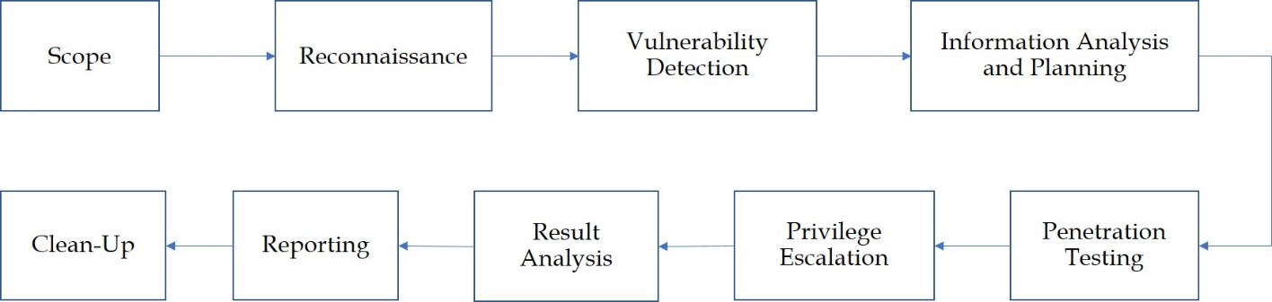
Figure 1 VAPT Lifecycle [2]
Initially, the scope is defined, outlining parameters and limitations. During reconnaissance, basic information about the target is gathered. Vulnerability detection identifies system weaknesses. Information analysis and planning follow, assessing risks and planning attacks. Penetration involves executing the attack. Privilege escalation seeks higher access levels. Result analysis identifies the root cause and fixes. Finally, detailed reports are generated, and the system is restored to its original state. [2]
To enhance efficiency, the VAPT methodology can be streamlined into two main stages: Vulnerability Assessment and Penetration Testing. Figure 2 depicts the analysis at each stage of the VAPT process.
Vulnerability Assessment

Information Gathering

Scanning

Result Analysis

Reporting

Penetration Testing
Attack Preparation and Threat Modeling

Exploitation - Attack

Result Analysis

Figure 2 VAPT Process Diagram [3]
Vulnerability assessment is the process of finding security flaws or vulnerabilities in a business's network, computer system, or online applications. It requires the right combination of expertise, risk awareness, and understanding of infrastructure. A thorough report is produced at the end of the assessment process, which can be utilized in the penetration testing procedure. [3]
Testing professionals use a method called penetration testing to try and breach security flaws in computer systems, networks, or web applications that they find during the vulnerability assessment stage. It is also called ethical hacking. Through the use of penetration testing, the tester is able to determine which vulnerabilities in the system are false positives and which are genuine threats, offering insights into the real security posture of the system. [3]
Regular VAPT offers several benefits: improved security by identifying and prioritizing vulnerabilities, enhanced compliance with regulations, reduced risk by mitigating threats, and increased efficiency by focusing on critical issues. [4] As a cyber defense technology, VAPT identifies and mitigates vulnerabilities, preventing attacks like DoS, RA flooding, and ARP poisoning. It helps administrators patch systems, reducing the risk of exploitation and enhancing overall security. [2]
Despite its benefits, VAPT faces drawbacks: trust issues with hiring hackers, high costs, lengthy processes, limited testing scope due to resource constraints, method limitations depending on system compatibility.[2] In addition to that, it is time-consuming, resource-intensive, potentially disrupting operations, and offering only a snapshot of security, lacking ongoing protection against future threats. [4]
The effectiveness of a VAPT assessment heavily relies on its scope. A constrained scope limits the breadth and depth of the testing, potentially leaving important systems and vulnerabilities unchecked. Conversely, expanding the scope increases the complexity and costs, straining resources and potentially disrupting normal operations.
Given these challenges, there is a pressing need for a better VAPT model that amplifies results by optimizing the scope and improving the overall methodology. The enhanced model should thoroughly evaluate all critical systems and vulnerabilities, minimizing false positives and negatives with precise detection and analysis techniques. It must balance comprehensive assessments with practical resource management and integrate advanced tools and frameworks to automate and streamline the process, reducing human error and improving consistency.
Leveraging the MITRE ATT&CK framework, [5] the optimized VAPT methodology will ensure robust security coverage, improve resource efficiency by balancing thoroughness and cost, and enhance detection accuracy through advanced tools. It will also support proactive defense with continuous monitoring and timely updates, leading to better risk mitigation through detailed vulnerability analysis and reporting.
The improved VAPT methodology will benefit organizations by enhancing their security posture and reducing cyber threat risks. Security professionals will find the testing process more effective and streamlined. Compliance officers will be better able to meet regulatory requirements, and IT departments will experience reduced operational disruptions and better resource management.

Aim
The aim of this research is to develop and validate an optimized Vulnerability Assessment and Penetration Testing (VAPT) methodology by integrating the MITRE ATT&CK framework that enhances the scope and risk analysis process to improve the identification and mitigation of security vulnerabilities.

Objectives
- To review the Vulnerability Assessment and Penetration Testing (VAPT) methodology, its phases, re-design and analyze the issues faced
- To re-design the current VAPT methodology by incorporating the MITRE ATT&CK Framework to improve effectiveness.
- To analyze the real-world attack scenarios so the scope parameter can be enhanced for future penetration testing activities.
- To investigate various attack strategies, methods, plans and techniques employed by attackers to get the complete understanding of the compromised access into the network.
- To evaluate the network for any gaps in the penetration testing efforts so the defined scope will be improved in future testing so as to provide comprehensive security.

Structure of the Project
The project consists of three parts: Theoretical Framework part involves reviewing existing literature and previous studies on VAPT and Penetration Testing methodologies, expanding the knowledge base essential for the project’s outcome. Design and Implementation part details problem formulation and design implementation, focusing on analyzing the VAPT methodology using the MITRE ATT&CK framework during the penetration testing phase. Findings and Conclusion section presents an analysis of applying MITRE ATT&CK tactics and techniques in penetration testing, discussing experimental results, summarizing previous chapters, drawing final conclusions, and suggesting future work or development.
Chapter one provides an overview of the report, detailing the aim and highlighting the objectives essential for achieving a successful outcome.
Chapter two examines the current studies in Vulnerability Assessment and Penetration Testing phases in VAPT methodologies, Penetration testing methodologies, detailing their designs. It also explores how the MITRE ATT&CK framework addresses scope limitations through comprehensive coverage methods.
Chapter three details the research approach and design, presenting a systematic method that includes research philosophy, approach, strategy, and data collection techniques based on the research onion model.
Chapter four outlines enhancing VAPT methodology by integrating with the MITRE ATT&CK framework, detailing network setup and project implementation for comprehensive assessments and effective risk mitigation.
Chapter five explores the experimental study by reviewing VAPT's nine-phase process which incorporates MITRE ATT&CK, using vulnerability assessment and penetration testing phased approach for improved accuracy and resource efficiency and gets evaluated experimentally. Attack Vector model is designed using the outcome of the experimental study.
Chapter six focuses on advancing VAPT through MITRE ATT&CK integration, improving vulnerability detection, and drawing conclusions with future research suggestions.

Conclusion
This chapter underscores the importance of Vulnerability Assessment and Penetration Testing (VAPT) in identifying security weaknesses. Despite challenges like limited scope and high costs, integrating the MITRE ATT&CK framework can enhance VAPT's effectiveness. This approach improves scope of threat detection, addresses testing gaps, and strengthens organizational cybersecurity defenses against evolving threats.

Research and Review of Literature

Introduction
Cybersecurity's evolution reflects the rising complexity of cybercrime, demanding robust defenses like network, and information security as shown in Figure 3. [6] As cyber threats become more sophisticated, with diverse attack surfaces, the importance of vigilant cybersecurity practices grows. Frameworks that offer a thorough grasp of adversary tactics, improve detection, and strengthen response capabilities like MITRE ATT&CK play a vital role. These measures are essential to protect against significant financial and operational risks.
Attack
Complexity
Attacker Knowledge

Ransom attacks

Malware-stuxnet,dragonfly
Malware-as-a
service
Network Attacks

Cyber-attack-as-a-
service
Packet Capture

APT
Types of Attacks
DDoS attacks

Exploiting known vulnerabilities

Session Hijacking

Disabling audits

Password cracking

Viruses

Password guessing
Year
1980 1990 2000 2010 2020
Figure 3 Technical Knowledge of attackers versus attack complexity [6]

Principles of Cybersecurity
The principles of information security are crucial, focusing on confidentiality, integrity, and availability (CIA). Confidentiality protects information from unauthorized access, integrity ensures data accuracy and consistency, and availability guarantees data access when needed. These principles, along with policies, new technologies, and user awareness, form the comprehensive approach necessary to safeguard cyberspace from evolving cyber threats as described in Figure 4. [6]

Countermeasures

Policies and Practice

Information States
Technologies
Transmission
Users
Processing
Confidentiality
Storage

Integrity

Availability

Security Principles

Figure 4 Three Dimensions of Cybersecurity [6]

Vulnerabilities, Attacks, Threats & Exploits

Vulnerabilities
Vulnerabilities are system flaws or design weaknesses that enable attackers to execute malicious commands, gain unauthorized data access, or carry out denial-of-service attacks. [8] Vulnerabilities span software bugs, firewall misconfigurations, and network protocol flaws, each presenting unique exploitation risks. Critically, these weaknesses compromise system confidentiality, integrity, and availability, emphasizing the need for robust security measures. [6]

Attacks
Attacks involve exploiting system vulnerabilities to disrupt operations or compromise security. Attackers employ diverse tools and techniques for malicious gain, from financial motives to ideological reasons. [7] Technological advancements have expanded information access but also intensified cyber-attacks across sectors. Social engineering, application exploits, cryptography vulnerabilities, hijacking, malware, botnets, password breaches, and man-in-the-middle attacks underscore the need for robust security measures like encryption, intrusion detection, and user education. [6]

Threats
Threats are acts that take advantage of security flaws to harm systems for the benefit of the attacker. [7] From straightforward breaches to complex attacks that take advantage of identity theft, data forging, cybercrime, and wireless proliferation, threats have changed throughout time. To effectively combat these dynamic dangers, non-technical measures like physical protection and user training must be combined with technical solutions like encryption and AI-driven detection. [6]

Exploits
Exploits are malicious actions that take advantage of vulnerabilities to execute unauthorized commands, access data, or disrupt services. They involve exploiting software bugs, misconfigurations, and protocol flaws, compromising system integrity, confidentiality, and availability. Robust security measures are crucial to defend against these sophisticated cyber threats.

Vulnerability Assessment
Vulnerability assessment, as part of the VAPT approach, systematically identifies, quantifies, and ranks vulnerabilities in networks, systems, or applications using specialized tools. This process scans for vulnerabilities or security weaknesses and potential risks, enabling organizations to apply patches, adjust settings, or update systems to mitigate these vulnerabilities before attackers can exploit them.

Vulnerability Lifecycle
The vulnerability life cycle in operating systems is generally divided into five key stages: creation, discovery, disclosure, patch availability, and patch installation as portrayed in Figure 5. [4] Initially, a vulnerability is created within the OS. Next, it is discovered by the vendor, who then discloses it publicly. Following disclosure, a patch is developed and made available. Finally, users install the patch to address the vulnerability. An additional stage, the "exploit stage," may occur, where the vulnerability could be exploited before a patch is released. This structured approach helps to highlight how the progression happens from vulnerability identification to mitigation.

Figure 5 Vulnerability Lifecycle [4]

Vulnerability Management Lifecycle
The vulnerability management life cycle, as depicted in Figure 6, is an essential framework in the literature on vulnerability management, guiding the process of identifying, assessing, prioritizing, remediating, and monitoring vulnerabilities within an organization's information systems. This iterative process ensures continuous defense against potential attacks. [1] Another significant study describes this lifecycle, beginning with the discovery of the vulnerability within the organization, followed by its disclosure to security professionals, the release of a patch, full public disclosure, availability of an exploit, and ultimately, the resolution of the vulnerability. [1], [8]
Discover

Organize Assets
Verify

Remediate
Assess

Report

Figure 6 Vulnerability Management Life Cycle [1]

Figure 6 illustrates the stages of the Vulnerability Management life cycle, which include identifying vulnerabilities through scanning and testing, evaluating their severity and impact with scoring and analysis, prioritizing them according to their seriousness and potential consequences, remediating vulnerabilities through patching or updates, confirming the success of remediation efforts by rescanning and retesting, and continuously monitoring systems to prevent the recurrence of vulnerabilities or the emergence of new ones. Following this life cycle allows organizations to systematically protect their information systems and manage vulnerabilities effectively.

Why Vulnerability Assessment is important?
Conducting vulnerability assessments is crucial for an organization's security strategy, as it identifies and addresses vulnerabilities that attackers could exploit. Key benefits include prioritizing vulnerabilities, validating security controls, reducing breach risks, ensuring regulatory compliance, and adopting a proactive security stance. These assessments help uncover known vulnerabilities and misconfigurations, validate defenses, minimize breach impact, and maintain compliance with industry standards, ultimately enhancing overall security resilience. [1]

Test Preparation Phase

Information Gathering

Test Phase
Vulnerability Analysis

Vulnerability Exploit

Test Analysis Phase

Figure 7 Vulnerability Assessment Method [10]
Figure 7 outlines crucial stages in vulnerability assessment: Planning establishes goals and boundaries; the Test Phase (Reconnaissance, Scanning, Gaining Access, Maintaining Access, and Exploitation) identifies system vulnerabilities. In the Test Analysis Phase, Evidence Collection and Reporting assess findings, documenting vulnerability severity and potential security risks. This comprehensive approach ensures thorough identification, analysis, and reporting of vulnerabilities, enabling effective remediation and bolstering overall system security. [10]
Vulnerability analysis involves evaluating identified vulnerabilities to assess the likelihood and severity of exploitation, determining their potential impact on an organization's security. This process includes a thorough examination to understand the probability and seriousness of successful attacks, as well as the potential consequences for data and systems. The OWASP methodology evaluates flaw risk through two steps: first, it averages the likelihood factors (prevalence, detectability, and exploitability), then multiplies this by a technical impact factor. Both likelihood and technical impact are rated on a scale from 1 to 3. [11]
Risk = Likelihood * Impact
This paper introduces an alternative risk formula in a scenario where key actions include erasing failed login attempts, clearing error messages, and reconfiguring logging mechanisms. These steps are vital for establishing trust in system logs, which are essential for detecting potential intrusions or security breaches. The proposed risk formula incorporates the likelihood of a threat exploiting vulnerabilities and the potential impact, offering a comprehensive method for risk assessment. [12]
Risk = Threat * Vulnerability * Impact

Vulnerability Assessment Technique
Identifying, assessing, and prioritizing security vulnerabilities in systems, networks, or applications is systematically processed using vulnerability assessment techniques. With the use of suitable security actions like patches, updates, or configuration changes, businesses can effectively mitigate these vulnerabilities by using the insights on potential risks. Here are the known testing techniques. [13]
Static Analysis: It involves analyzing code structure and content without executing test cases, identifying vulnerabilities but requiring significant time and resources.
Manual Testing: Relies on human expertise to discover vulnerabilities either systematically with a test plan or explanatively without one, offering cost savings but demanding substantial human effort.
Automated Testing: Utilizes automated tools to execute test cases efficiently, reducing time and human resources while maintaining accuracy, yet incurring costs for specialized tools and potentially missing certain vulnerability types.
Fuzz Testing: Also known as fuzzing, injects random or invalid data to provoke system crashes or failures, akin to robustness testing. It's less human-intensive and can uncover zero-day vulnerabilities, contingent on effective test cases and tools.
Each technique addresses specific aspects of vulnerability assessment, balancing manual insight with automated efficiency to comprehensively evaluate and mitigate system vulnerabilities.

Types of Vulnerability Scanners
Types of vulnerability scanners include: [14]
Host-Based Scanners: These identify risks within a host, deploying intermediary software to trace events and report vulnerabilities to security analysts.
Network-Based Scanners: These detect open ports and unknown services on them, identifying network vulnerabilities.
Database-Based Scanners: These tools find security weaknesses in database systems, preventing SQL injection through specialized techniques

Challenges in Vulnerability Assessment
Vulnerability assessments are crucial for identifying system weaknesses but come with challenges. False positives, where tools flag non-exploitable issues, waste resources. False negatives miss real vulnerabilities, giving a false sense of security. Assessments have limited scope, missing new threats, and complex systems pose testing difficulties. Costs and human errors further complicate assessments.[1] The program lacks the ability to efficiently discover developing vulnerabilities and logical attack paths, creates enormous amounts of data, and has a high false positive rate that is easily identified by intrusion detection systems. [14] Vulnerability Assessment tools often overlook logical attack vectors, focusing solely on predefined policies set by testers. This approach may miss critical aspects, leading to unnecessary data and false positives in the analysis.[3]

Penetration Testing
In order to identify and take advantage of security flaws, penetration testing, as part of VAPT methodology, simulates cyberattacks on a system, application, or network. Through simulation of the tactics used by adversaries, this process assesses the effectiveness of security measures. There is no universally defined model for penetration testing due to the dynamic nature of cyber threats, diverse IT environments, varied organizational objectives, and resource constraints. These factors necessitate a flexible approach, as static models cannot adequately cover all scenarios, technologies, and attack vectors, making customized methodologies essential for effective penetration testing.

Penetration Testing Phases
Penetration testing involves attempting to exploit vulnerabilities in networks, systems, and applications. Vulnerability scanning is often integrated into this process to aid in identifying potential weak points. Given the potential legal complexities, it is crucial to establish a formal agreement between the penetration testers and the client. Figure 8 illustrates the phases of penetration testing can be broadly classified as follows: [15]
Agreement: Establish a mutual agreement outlining the scope and limitations of the penetration test due to its offensive nature.
Planning and Reconnaissance: Collect information, define goals and objectives, identify assets, planning attacks and identifying targets.
Scanning: Utilize tools such as vulnerability scanners and port scanners to perform active reconnaissance, identifying network configurations and potential entry points.
Gaining Access: Use data from previous phases to infiltrate the system or network through methods like WEP cracking or ARP request replay. Tools such as Metasploit facilitate this step.
Maintaining Access: Ensure prolonged access to the compromised system to explore further resources.
Exploitation: Employ tools like Burp Suite, Metasploit, Wireshark, and Hydra to exploit identified vulnerabilities.
Evidence and Reporting: Document and report identified vulnerabilities, provide mitigation strategies, and ensure the organization understands the security gaps and remediation measures.

Agreement

Planning and Reconnaissance

Scanning

Gaining Access

Maintains Access

Exploitation

Evidence and Reporting

Figure 8 Penetration Testing Phases [15]

Penetration Testing Techniques
Penetration testing is a critical component of cybersecurity, simulating cyber-attacks on systems, networks, or web applications to evaluate their security. These tests are categorized based on their scope, goals, and methods: [4], [13]
Black Box Testing: Testers operate without prior system knowledge, mimicking real attacker behavior by probing for weaknesses without any internal insight.
White Box Testing: Testers possess complete system knowledge, allowing for a holistic assessment of security measures and identification of flaws with full awareness of the system architecture.
Grey Box Testing: Integrates features of white-box and black-box testing. Testers have partial system information, blending blind and informed approaches to efficiently reveal vulnerabilities.
These varied methods provide organizations with a comprehensive evaluation of their security posture, helping to identify and mitigate vulnerabilities effectively against different threat scenarios, thereby enhancing overall cybersecurity defenses.

Types of Penetration Testing
Each kind of penetration testing is crucial in identifying and resolving specific vulnerabilities so that comprehensive security measures are in place to protect corporate assets. [16]
Web application penetration testing: involves assessing web applications for security vulnerabilities that attackers could exploit. It includes testing user authentication to prevent unauthorized access and identifying flaws like XSS and SQL injection. Configuration checks ensure web browsers are secure, and database and web server security is maintained.
Internal network penetration testing: evaluates vulnerabilities accessible by authenticated and non-authenticated users within the organization’s network. It targets misconfigurations and potential data leaks or unauthorized access.
External network penetration testing: identifies and exploits vulnerabilities in external infrastructure, verifying robust authentication and secure data transfer mechanisms.
Social engineering penetration testing: assesses staff susceptibility to phishing and social engineering attacks, complementing technical security measures.
Wireless network penetration testing: evaluates Wi-Fi network vulnerabilities, including encryption weaknesses and potential access points for network penetration.
Red team penetration testing: mimics real-world attacker strategies to breach network defenses and gain unauthorized access, encompassing various methods, including physical access.
Organizations should adopt a multi-faceted approach to penetration testing, combining technical assessments with social engineering evaluations and comprehensive red team simulations to safeguard against evolving cyber threats effectively.

Why Penetration Testing is Important?
Organizations must use vulnerability assessment and penetration testing as fundamental security procedures to find weaknesses in their systems and infrastructure. Vulnerability assessment uses automated tools to scan for weaknesses in networks, systems, and applications, providing a detailed report on identified vulnerabilities and their severity. It is less intrusive and costly compared to penetration testing, which involves simulating real-world attacks to exploit vulnerabilities and assess system defenses comprehensively. Penetration testing is performed by skilled professionals who employ both automated tools and manual techniques to simulate attacks realistically. While vulnerability assessment identifies potential weaknesses systematically, penetration testing evaluates how vulnerabilities can be exploited to gain unauthorized access, making it a critical step in strengthening overall cybersecurity defenses. Both methods are integral to an organization's security strategy, helping to mitigate risks and safeguard against potential cyber threats effectively. [1]
Penetration tests simulate real-world attacks, chaining vulnerabilities to reveal deep-seated risks. They aim to eliminate false positives across all layers and provide realistic evidence of security issues, offering comprehensive insights for enhancing defenses effectively. [15] By conducting these tests, organizations can proactively prevent or minimize potential damage caused by security breaches. Regular penetration testing helps identify and resolve security flaws, ensures the effectiveness of existing controls, discovers bugs in software, and supports compliance with regulations like GDPR and PCI DSS. A comprehensive engagement should meticulously assess an organization’s attack surface, including unsecured ports, vulnerabilities, misconfigurations, and weak passwords. Testers then attempt to exploit these entry points to gain network access, assess for sensitive data exposure, and potentially escalate privileges to assess network security thoroughly.[16]

Challenges in Penetration Testing
Penetration testing, despite its crucial role in assessing cybersecurity defenses, presents several challenges. Firstly, it demands significant time and expertise due to its complexity in identifying and exploiting vulnerabilities effectively. Secondly, inexperienced penetration testers may inadvertently cause data loss or corruption if not properly skilled in executing tests. Furthermore, performing detailed penetration tests can be both costly and resource-intensive, necessitating specialized tools and experienced professionals. Another critical challenge is the exposure of source code to third parties during testing, posing potential risks if not managed securely. Organizations must carefully balance these challenges by investing in qualified testers, ensuring robust protocols to safeguard sensitive data, and weighing the costs against the potential security benefits. Despite the fact that penetration testing is an essential instrument for identifying and mitigating security risks, addressing these problems is ultimately vital to ensure its effectiveness and lower associated risks. [14]

VAPT Methodology
Vulnerability assessment (VA) and penetration testing (PT) are pivotal in cybersecurity, with VA identifying system weaknesses through scanning, while PT simulates attacks to evaluate defenses. Employing VAPT (Vulnerability Assessment and Penetration Testing) helps preemptively pinpoint vulnerabilities like DoS, RA flooding, or ARP poisoning, mitigating risks. By executing the full VAPT lifecycle—scan, test, remediate—organizations bolster security, minimizing threats. Robust VAPT ensures once vulnerabilities are addressed, attackers struggle to breach systems, safeguarding vital assets and upholding strong cybersecurity protocols.

Lifecycle of VAPT Methodology
The nine-phase Vulnerability Assessment and Penetration Testing (VAPT) methodology is a systematic approach vital for uncovering and addressing security weaknesses in systems. Figure 9 illustrates the nine stages of VAPT methodology. [13], [14]
Scope: Testers determine the testing approach—Black box, Grey box, or White box—to define the level of access and information available during testing.
Reconnaissance: Gathering information about the target network, IP addresses, and systems to understand their structure and potential vulnerabilities.

Scope

Reconnaissance

Vulnerability Detection

Information Analysis and Planning

Penetration Testing

Privilege Escalation

Result Analysis

Reporting

Clean-up

Figure 9 Life Cycle of VAPT Methodology [13]
Vulnerability detection: Utilizing various Vulnerability Assessment (VA) techniques to identify weaknesses in the target system.
Information Analysis and Planning: Analyzing the results from the vulnerability assessment to strategize and plan the penetration testing phase effectively.
Penetration testing: Executing the planned strategies to simulate real-world attacks and exploit identified vulnerabilities within the system.
Privilege Escalation: After gaining initial access, escalating privileges to gain deeper access into the system, facilitating easier and persistent exploitation.
Result Analysis: Thoroughly analyzing the outcomes from each testing phase to understand the implications of vulnerabilities and potential security gaps.
Reporting: Compiling detailed documentation containing findings, recommendations, and proposed solutions to mitigate identified vulnerabilities effectively.
The iterative nature of VAPT allows organizations to continuously improve their security posture by proactively addressing emerging threats and vulnerabilities. Ultimately, by following the complete VAPT lifecycle and adhering to best practices, organizations can successfully protect vital assets and strengthen their resistance to cyberattacks.

Stages of VAPT Methodology
The VAPT process is iterative and encompasses several critical stages as in Figure 10. [4]
Planning and Scope Definition: This initial stage involves setting clear goals and defining the scope of the assessment. It establishes what aspects of the system or network will be evaluated and the specific objectives to be achieved.
Vulnerability Assessment: Here, potential vulnerabilities within the system are identified and meticulously cataloged. This stage typically involves using automated tools to scan for weaknesses in networks, systems, and applications.
Penetration Testing: In this phase, the identified vulnerabilities are actively exploited to simulate real-world attack scenarios. Skilled professionals use a combination of automated tools and manual techniques to attempt unauthorized access to the system or network.
Reporting: After completing the assessment and testing phases, a detailed report is compiled. This document outlines all vulnerabilities discovered, the severity of each, and any successful exploitation attempts. It serves as a crucial resource for stakeholders to understand the security posture of the system.
Remediation: The final stage focuses on addressing the vulnerabilities identified during the assessment. Remediation efforts involve implementing fixes, patches, or configuration changes to enhance the security posture and mitigate risks.
Each stage is integral to the VAPT process, ensuring thorough evaluation and enhancement of system security while critically reviewing each phase for efficacy and accuracy
Planning and Scope Definition

Vulnerability Assessment

Penetration Testing

Reporting

Remediation

Figure 10 Stages of VAPT Methodology [4]

Web Application Penetration Testing Method
The enhanced Vulnerability Assessment and Penetration Testing (VAPT) model incorporates data extraction to handle SQL injection (SQLi) attacks more effectively as indicated in Figure 11. Initially, the planning phase sets clear goals and objectives, defining the scope as black box, grey box, or white box testing. During reconnaissance, critical information such as IP addresses and system details are gathered. Vulnerability detection uses VA techniques to identify potential weaknesses. The information analysis and planning stage involves evaluating VA results to strategize penetration testing. [17]

In the penetration testing phase, testers exploit identified vulnerabilities to gain unauthorized access. Privilege escalation further deepens system penetration. Subsequent result analysis critically examines the penetration outcomes, and comprehensive reports offer actionable recommendations. Data extraction, following a successful SQLi attack, allows testers to retrieve sensitive information like database table and column names, enhancing the identification of security gaps.
This structured methodology, iterating from vulnerability exploitation back to discovery, ensures continuous improvement. The process underscores the importance of thorough VAPT implementation for robust cybersecurity, particularly for financial web applications, by enabling precise identification and mitigation of vulnerabilities
Planning

Discovery
- Information Gathering
- Scanning
- Vulnerability Analysis

Attack
- Vulnerability Extraction
- Extraction of Data

Report Analysis

Figure 11 Web Application Penetration Testing Method [17]

Systematics Problem Solving Method
Figure 12 depicts the study of penetration testing on XYZ website. This is divided into four stages namely: Initial Stage, Testing Stage, Analysis Stage and Final Stage. [18]

Systematics of Problem Solving

Stage`
Stage

Entry Stage
Scope of Problem
Formulation of Problem
Literature Study

Planning
Testing Stage
Discovery

Attack

Reporting
Result of Analysis
Result of Exploitation
Analysis Stage
Recommendation

Conclusion
Final Stage
Finish

Figure 12 Systematics of Problem Solving [18]

Initial Stage: Entails defining the problem's boundaries and conducting a literature review. This phase aims to set precise research objectives by narrowing the scope of the study. The literature review involves examining reputable sources, including books, papers, and tutorials, to provide a solid foundation for the research.
Testing Stage: Implements exploitation techniques on the XYZ website, adhering to NIST 800-115 standards. Tools such as Nmap, OWASP ZAP, and Burp Suite are utilized. This phase involves several steps: information gathering, vulnerability scanning, and planning. The collected data guides the identification of vulnerabilities to be exploited in the study.
Analysis Stage: In this stage, the study examines the vulnerabilities identified during testing using the scanning tools' findings. This analysis informs the subsequent exploitation efforts and forms the basis for the final reporting.
Final Stage: Concludes the research by compiling the results from the exploitation and vulnerability analysis. This phase includes drawing conclusions from the study and providing recommendations for system hardening and future research. The recommendations target the XYZ website owner and suggest directions for further investigation.
By following these systematic stages, the research ensures a thorough and structured approach to identifying and mitigating vulnerabilities in the XYZ website.

Advantages of VAPT Methodology
Vulnerability Assessment and Penetration Testing (VAPT) offer significant benefits in enhancing system security. VAPT provides detailed insights into potential threats within an application, allowing for a comprehensive understanding of security risks. By identifying programming flaws and system vulnerabilities, VAPT helps prevent breaches that could lead to substantial financial and reputational damage for businesses and organizations. [2]
Additionally, VAPT mitigates the risk of both internal and external attacks by securing systems against malicious threats. It systematically discovers and identifies vulnerabilities that could harm the system, enabling organizations to address these issues proactively. This process also detects loopholes and security gaps, ensuring that user-sensitive information is protected from unauthorized access. [2]
By tackling the most serious threats, VAPT finds and prioritizes vulnerabilities in networks and systems. By evaluating security posture unbiased and objectively, it reveals flaws and vulnerabilities that internal teams could miss. Furthermore, VAPT offers insightful analysis and recommendations for improving security overall, including the adoption of new security procedures and controls. [4]
In summary, VAPT is a crucial tool in cybersecurity, offering detailed threat analysis, flaw detection, and robust protection against various attack vectors, ultimately safeguarding an organization’s assets and reputation.

Disadvantages of VAPT Methodology
The scope limitation in Vulnerability Assessment and Penetration Testing (VAPT) is a significant drawback, particularly for large organizations with complex IT infrastructures. Comprehensive VAPT can be time-consuming and resource-intensive, requiring significant financial investment to hire specialized security consultants. This process often disrupts normal operations as it involves extensive testing and probing, which can impact system performance and availability.[4]
One of the critical issues is that VAPT provides only a snapshot of an organization's security posture at a specific point in time, failing to ensure ongoing protection against future threats. Due to resource and budget constraints, not all components of an organization's IT system can be tested, leaving some vulnerabilities undetected. This incomplete testing can lead to a false sense of security.
Furthermore, the limitations of testing methods and the varying capabilities of different systems can complicate comprehensive assessment. The expertise required for effective VAPT is often narrowly focused, with specialists possessing deep knowledge in specific areas but lacking a broader understanding of diverse technologies. This can result in a time-consuming process that may not fully address all potential vulnerabilities. [4]
Overall, the scope limitation impacts the results by potentially leaving critical vulnerabilities unaddressed, reducing the effectiveness of the VAPT process and leaving organizations exposed to cyber threats.

Penetration Testing Methodology
By mimicking actual attacks, penetration testing methodology offers an organized way to evaluate an organization's cybersecurity. It entails assessing the security of networks, apps, and systems in order to find weak points that bad actors can exploit. Organizations can identify vulnerabilities, evaluate the efficacy of current defenses, and understand their security posture with the aid of this methodical methodology. Penetration testing offers important insights into potential dangers and aids in enhancing security measures to better protect against real cyber threats by simulating attack scenarios.

Penetration Testing Phases
We can see from Figure 13, Penetration testing involves seven key phases [19]
Pre-Engagement Scoping is critical for defining the test’s scope to prevent disruption of essential services. It requires a detailed agreement between the client and testing company.
Reconnaissance, or footprinting, gathers extensive information about the target organization using tools like Nmap and techniques such as social engineering and OSINT.
Threat Modeling/Vulnerability Identification uses gathered data to design threat models and identify vulnerabilities with tools like Nessus or OpenVAS.
Exploitation involves leveraging these vulnerabilities to compromise the system, documenting each step for future phases.
Post-Exploitation documents the compromise and reverts the system to its original state.
Reporting provides a detailed account of the vulnerabilities, exploitation methods, and mitigation strategies.
Resolution/Re-Testing ensures that vulnerabilities have been addressed and resolved.

Pre-Engagement Scoping

Reconnaissance

Threat Modeling / Vulnerability Identification

Exploitation

Post-Exploitation

Reporting

Resolution / Retesting

Figure 13 Penetration Testing Phases [19]

Code of Conduct for Ethical Hackers
Ethical issues in penetration testing involve securing proper authorization, respecting privacy and property rights, and maintaining transparency. Concerns include balancing beneficence and non-maleficence, responsibly managing vulnerabilities, and adhering to ethical standards to mitigate legal and reputational risks. [20] Ethical hackers are bound by a strict code of conduct to ensure responsible and legal hacking practices. [21]
Data Privacy and Confidentiality: Establish and adhere to privacy agreements, ensuring no violations of the organization's data protection rules.
Transparency: Maintain clear communication with clients and organization owners throughout the engagement process.
Non-Malicious Intent: Ensure that the hacking activities are intended solely to identify and resolve vulnerabilities without causing harm.
Scope Limitation: Conduct activities only within the defined target area, respecting boundaries set by the agreement.
Confidentiality: Safeguard and keep all information discovered during the hacking process confidential, without disclosing it to unauthorized parties

Applications
Agile methodologies enhance security design in penetration testing by integrating security practices throughout iterative development cycles. Security concerns are addressed continuously through security backlogs, enhanced user stories, and automated testing, ensuring that vulnerabilities are identified and mitigated promptly within rapid, incremental releases. [22] Cyber resilient solutions enhance penetration testing by enabling organizations to thoroughly assess and understand vulnerabilities. By simulating attacks, these tests identify weaknesses, ensuring robust security measures are in place before external threats exploit potential system flaws. [23]
Using cyber terrain in reinforcement learning enhances penetration testing by integrating realistic network conditions, such as firewalls, into attack graph models. This approach improves the accuracy of simulated attacks, enabling more effective identification of vulnerabilities in complex network environments. [24] Deep reinforcement learning in automated penetration testing optimizes the process by discovering the most exploitable attack paths. This approach leverages real network data to model scenarios, improving the efficiency and accuracy of penetration tests while aiding cybersecurity training. [25]

Hacking Methodology
Hacking methodology encompasses the structured approaches used by security professionals to identify and exploit vulnerabilities within systems to improve their security. This process is crucial for understanding potential weaknesses and enhancing defenses. The methodologies include various types, each focusing on different aspects of security. For instance, penetration testing simulates attacks to uncover vulnerabilities before malicious hackers can exploit them. Vulnerability assessments identify weaknesses without exploiting them. Ethical hacking involves legal and authorized testing to strengthen security
Frameworks like the Open Source Security Testing Methodology Manual (OSSTMM), Information Systems Security Assessment Framework (ISSAF), and Penetration Testing Execution Standard (PTES) provide structured approaches for evaluating different security domains. Open Web Application Security Project (OWASP) specifically addresses web application vulnerabilities. Together, these methodologies form a comprehensive toolkit for assessing and improving cybersecurity.

Open Source Security Testing Methodology Manual (OSSTMM)
The OSSTMM is a comprehensive framework for various forms of security inspection, including vulnerability assessments, ethical hacking, and penetration testing. It provides a structured methodology for improving corporate security strategies and quality. The manual establishes standards for measuring security performance and metrics for evaluating the effectiveness of security measures. It aims to provide a clear understanding of security risks and the potential impact on an organization. Key aspects of OSSTMM include: [26]
Physical Security Testing: Evaluates physical security measures to identify vulnerabilities affecting the organization’s infrastructure and access controls.
Process Testing: Assesses security processes, including the review of security procedures, compliance requirements, and trustworthiness of processes and personnel.
Internet Technology Security Testing: Tests the security of internet-based systems and services, including intrusion detection systems and service configurations.
Communications Security Testing: Focuses on the security of communication systems, such as voice communications, remote access controls, IP-based systems, and other communication protocols.
Wireless Security Testing: Identifies vulnerabilities in wireless networks and systems, assessing their resilience against potential attacks.
Each section of OSSTMM includes specific test modules tailored to these areas, ensuring thorough and effective security assessments.

Information Systems Security Assessment Framework
The Information Systems Security Assessment Framework (ISSAF) is an organized approach for assessing the security of information systems. It includes phases for planning, assessing, analyzing, and reporting, covering network, application, and operational security. The steps involve defining assessment scope, evaluating and analyzing security controls, and documenting vulnerabilities comprehensively. ISSAF uses qualitative and quantitative methods, emphasizing detailed documentation and alignment with industry best practices. Penetration testing procedures involve: [26]
Information Gathering: Collecting data from online sources to understand the system and identify vulnerabilities.
Network Mapping: Analyzing gathered data to map network infrastructure and access points.
Vulnerability Identification: Detecting and testing security weaknesses.
Penetration: Exploiting vulnerabilities to gain unauthorized access.
Privilege Escalation: Exploring potential entry points to gain elevated access.
Enumeration: Analyzing captured traffic and session data to establish passwords.
Compromise Remote Users: Testing access permissions for remote users.
Maintaining Access: Concealing access within the system using techniques like rootkits or backdoors.
Cover the Tracks: Erasing traces of the penetration activities by hiding files or removing logs.
In summary, ISSAF provides a structured and methodical approach to security assessment, ensuring that all critical aspects of an organization's information systems are thoroughly evaluated and documented.

Penetration Testing Execution Standard
The Penetration Testing Execution Standard (PTES) provides a flexible framework for conducting penetration tests by outlining key phases such as planning, scanning, and exploitation. While PTES doesn’t prescribe a fixed structure, it allows customization based on organizational needs and integrates other resources, ensuring thorough assessments, consistency and actionable results for improving security. [21] PTES provides guidelines for various stages of penetration testing, including, [27]
Pre-Engagement Interactions: Defining the scope, objectives, and rules of engagement with the client before starting the test.
Information Gathering: Collecting data about the target system to identify potential vulnerabilities.
Threat Modeling: Analyzing the information gathered to understand potential threats and attack vectors.
Vulnerability Analysis: Finding and evaluating weaknesses in the intended system.
Exploitation: The process of attempting to obtain unauthorized access by utilizing vulnerabilities that have been identified.
Exploitation: Attempting to exploit vulnerabilities that have been discovered in order to get unauthorized access.
Post-Exploitation: Evaluating the effects of successful exploitation, taking into account privilege escalation and access maintenance.
Reporting: Documenting the findings, including vulnerabilities, exploited issues, and recommendations for remediation.
PTES aims to ensure that penetration tests are thorough, reliable, and useful for improving security by providing clear, actionable insights and recommendations.

Open Web Application Security Project
The Open Web Application Security Project (OWASP), a non-profit entity, provides valuable open-source cybersecurity resources, including the OWASP Testing Guide (OTG). This guide is structured into three main parts: web application development, testing methodologies, and reporting. It is designed to help developers build secure applications through rigorous penetration testing. The OTG framework encompasses several critical components: [26] [27]
Information Gathering: Collect data on the target application using network scans and web crawling to understand its environment and potential weaknesses.
Configuration Testing: Analyze application settings for misconfigurations or insecure configurations that could be exploited.
Authentication Testing: Assess the security of login mechanisms, checking for weaknesses in authentication procedures.
Session Management Testing: Evaluate how sessions are managed, including session IDs and cookies, to ensure secure session handling.
Authorization Testing: Verify that users can only access authorized resources and cannot escalate privileges beyond their permissions.
Each phase contributes to a comprehensive security assessment, helping to identify and mitigate potential vulnerabilities in web applications.

National Institute of Standards and Technology Cybersecurity Framework
The National Institute of Standards and Technology Cybersecurity Framework (NIST CSF) is a comprehensive set of guidelines designed to enhance organizational cybersecurity practices. Developed by NIST, it provides a structured approach to manage and mitigate cybersecurity risks. The framework is based on existing standards and practices, integrating them into a cohesive set of activities that organizations can follow to improve their cybersecurity posture. [28]
NIST CSF is significant because it offers a flexible, risk-based approach that organizations of all sizes can tailor to their specific needs. It highlights important topics like risk identification, asset protection, incident detection, threat response, and attack recovery. By following the NIST CSF, organizations can systematically address security challenges, align their practices with industry standards, and ensure regulatory compliance. Its structured approach supports continuous improvement and helps organizations stay resilient against evolving cyber threats, making it a crucial tool for managing and strengthening cybersecurity.

MITRE ATT&CK Framework
An open-source knowledge base, the MITRE ATT&CK framework describes enemy tactics and strategies based on real-world data. The framework captures adversary and defender behaviors to enhance threat detection. It stands for Adversarial Tactics, Techniques, and Common Knowledge, providing a comprehensive registry of adversary actions recognized universally in cybersecurity. It serves as a benchmark for cyber adversary behavior and a carefully curated information source that illustrates the different phases of an adversary's attack lifecycle in addition to the platforms they are known to target. [21] It provides a framework for creating threat models and approaches used by the government, business, and cybersecurity communities. [5]
Manual threat modeling and attack simulations are time-consuming and error-prone. Applebaum et al. developed an automated adversary emulation testbed using the ATT&CK framework for Windows networks. Similarly, CALDERA 6 automates network assessments but neither covers all MITRE ATT&CK techniques, highlighting a gap in comprehensive automated threat modeling. [29], [30]
The framework uses 14 core tactics to structure attack strategies, reflecting various stages of an adversary's attack lifecycle. This standardization facilitates understanding, categorizing, and defending against cyber threats. Figure 14 depicts the 14 MITRE ATTACK tactics.
Reconnaissance: Gathering information before launching attacks, such as social engineering. Awareness training and protecting sensitive information can limit reconnaissance success.
Resource Development: Acquiring necessary resources for operations, like creating infrastructure or obtaining exploits. Intelligence gathering on threat actors and pre-emptive takedowns can disrupt this phase’s information can limit reconnaissance success.
Initial Access: Entry methods into a network, such as exploiting vulnerabilities, phishing, or hardware additions. It is often the initial failure point, necessitating strong user education and system fortification.
Execution: Running adversary-controlled code on a system via scripts, command-line interfaces, or APIs. Continuous monitoring and strict execution policies are needed to thwart unauthorized code execution
Persistence: Maintaining access despite reboots or credential changes, like modifying startup files or creating new accounts. Detection is difficult, requiring robust logging and regular system audits.
Privilege Escalation: Gaining higher permissions through design flaws or configuration errors. Emphasizes the importance of patch management and enforcing least privilege principles.
Defense Evasion: Avoiding detection through methods like obfuscation or disabling security tools. Advanced, behavior-based detection mechanisms are essential.
Credential Access: Stealing credentials via keylogging or credential dumping. Multi-factor authentication and frequent credential updates are crucial defenses.
Discovery: Gathering information about the network and systems, such as network scanning. Network segmentation and real-time monitoring can mitigate successful discoveries.
Lateral Movement: Moving through a network using protocols like SMB or exploiting trust relationships. Zero Trust architecture and continuous authentication are key countermeasures.

Reconnaissance
Resource Development
Initial Access

Execution
Persistence
Privilege Escalation

Credential Access
Defense Evasion
Discovery

Command and Control
Lateral Movement
Collection

Impact
Exfiltration

Figure 14 MITRE ATT&CK Tactics and its Stages [29]
Collection: Gathering sensitive data from systems, like keylogging or accessing network shares. It is essential to encrypt data and implement stringent access controls.
Exfiltration: Stealing data from the network through methods like HTTP or removable media. Data loss prevention tools and monitoring outbound traffic are vital.
Command and Control: Establishing communication channels with compromised systems, often using encrypted tunnels or C2 servers. Analyzing network traffic and anomaly detection are crucial.
Impact: Disrupting operations or destroying data, including ransomware attacks. Regular backups and robust incident response plans are essential.
Each tactic underscores the necessity for a multi-layered defense approach, emphasizing proactive measures, continuous monitoring, and response strategies to fortify cybersecurity against evolving threats.
Tactics, such as Initial Access or Privilege Escalation, represent the adversary’s goals in the MITRE ATTA&CK paradigm. In Figure 15, each tactic encompasses various techniques, like spear-phishing for Initial Access or process injection for Privilege Escalation. Techniques are methods used to perform specific threat activities, providing detailed descriptions, examples, and mitigation approaches. For instance, Credential Access can involve password cracking or brute force techniques. Procedures detail the step-by-step implementation of these techniques, simulating attacks with software.[31]
Adversary Group
Techniques
Uses

Accomplishes
Implements
Uses

Tactics
Software

Figure 15 Threat Hunting using MITRE Framework [31]

Figure 16 demonstrates how to step-by-step test and analyze attack strategies using Atomic Red Team and the Caldera emulator. Testing one technique is the first step, and further examination is done using the others. Initially, an attack-based scenario is constructed, a certain ATT&CK technique is selected, and the attack's behavior is replicated. This approach aids in the comprehension of attacks but highlights the necessity of extensive testing to account for all potential adversary activities. [31]

Create a scenario and Choose ATT&CK technique
Make Improvements to your defenses
Select a test for that technique

Execute test command and check behavior
Analyze your detections on test procedures

Figure 16 Atomic Test Cycle using ATT&CK [31]
Using the Common Vulnerability Scoring System (CVSS), we assess techniques in the ATT&CK matrix on impact and exploitability.[29] Impact, the potential risk or damage from a successful attack, and Exploitability, the complexity an attacker faces in executing the technique. For example, escalating local privileges has high impact due to extensive access but high exploitability due to difficulty. Executing malware discreetly also has high impact but medium exploitability because methods are well-documented. Supply chain compromises have high impact and high exploitability due to execution difficulty. Archiving data is low impact and low exploitability as it involves simple data compression. This classification framework, based on industry experience, helps evaluate and improve cybersecurity defenses.
A standardized taxonomy offered by MITRE ATT&CK facilitates the creation of strong security programs that concentrate on threat detection and response. It categorizes adversarial behaviors into a matrix of tactics and techniques, covering a wide array of methods such as network penetration, phishing, malware deployment, data exfiltration, and malicious advertising. Grounded in real-world observations, ATT&CK serves as a foundational resource for creating effective threat models and methodologies adopted globally by cybersecurity professionals and organizations. This open-access framework fosters collaboration and strengthens cybersecurity defenses against sophisticated cyberattacks, contributing to overall resilience in the face of evolving threats.

Related Work
Ethical hacking involves examining an organization's security weaknesses to prevent unauthorized access to sensitive information. Ethical hackers, or penetration testers (pentesters), conduct these assessments by simulating potential attacks while adhering to legal and ethical standards with the organization's consent. Finding vulnerabilities that malicious hackers could exploit is their goal. The findings are compiled into a security report, which the organization uses to address and fix these vulnerabilities. While manual testing is thorough but time-consuming and complex, automated testing leverages tools for faster and more efficient vulnerability detection. Both methods are crucial for a comprehensive security evaluation.

VAPT Methodology
VAPT effectively identifies system vulnerabilities, enabling administrators to apply necessary patches and updates. This process mitigates risks, ultimately strengthening cybersecurity defenses and safeguarding critical resources and information.

Vulnerability Assessment
Vulnerability Assessment involves identifying security weaknesses in the target system. Various scanners and automated tools are used to detect system flaws. This assessment identifies vulnerabilities within the organization before cybercriminals could exploit.
The target machine and Kali Linux OS which is pre-installed with all the automated tools are imported into virtual environment. For instance, an Nmap scan installed on Kali Linux OS, reveals information about open ports, allowing analysis of the services running through them. Suspicious files identified through these ports help pinpoint vulnerabilities in the target system. By exploiting these vulnerabilities, penetration testers can gain access to the target machine.

Case: 1 Reverse TCP Shell
The study by Jasmin & Zanin underscores the effectiveness of continuous VAPT with free tools in identifying and mitigating security risks. Nmap command “nmap -A -v T1,T2,T3” from a Kali Linux machine, is used to scan Windows, Linux, and MacOS targets for vulnerabilities using CVE, ExploitDB, and OpenVas databases, finding none as shown in the below figures. [4]

Figure 17 Windows 11 nmap scan results [4]

Figure 18 Ubuntu nmap scan results [4]

Figure 19 MacOS nmap scan results [4]

Case: 2 vsftpd Exploit

The Metasploitable VM, was scanned using script, “nmap -A -v 192.168.197.130” depicted in Figure 20 to identify open ports, running services and potential vulnerabilities. The scan, using aggressive and verbose modes, revealed various vulnerabilities including vsftp on port 21. These findings highlight the effectiveness of Nmap in identifying system vulnerabilities. Using Metasploit, these vulnerabilities were exploited to gain a session, demonstrating effective use of these tools for security testing. [2]
Figure 20 Nmap scan results - Open ports [2]

Penetration Testing
Penetration testing encompasses scanning the target system to uncover vulnerabilities and gaining access. Once inside, pentesters seek to extract data and produce comprehensive reports detailing system weaknesses along with recommendations for mitigating them. In the attack phase, pentesters exploit identified vulnerabilities to penetrate the target machine. They start by using existing exploits to breach the system, then endeavor to elevate their privileges to root or admin levels, which is essential for thorough penetration testing.
Metasploit is a versatile framework offering exploits and payloads to assess system security and uncover vulnerabilities. It serves both security professionals for testing networks and applications, and malicious actors for unauthorized system access. Compatible with Windows, Linux, and MacOS, Metasploit facilitates comprehensive security assessments across diverse operating systems.
Case: 1 Reverse TCP Shell
Using Venum and Metasploit, all targets were infected with a reverse TCP meterpreter payload after scanning. Metasploit's collection of exploits and payloads helps test system security across various OSs. In this study, only Windows and MacOS targets were compromised, establishing a remote shell to execute commands and manage processes. This work highlights Metasploit's effectiveness in identifying and exploiting security vulnerabilities. [4]
Figure 21 Windows Target Meterpreter session [4]
Figure 22 MacOS Meterpreter session [4]

Case: 2 vsftpd Exploit
The study identified VSFTP 2.3.4 running on the Metasploitable server, potentially vulnerable. Using Metasploit's “vsftpd_234_backdoor” exploit module as in Figure 23, a session was created with the target machine. This allowed full unauthorized access to the system, demonstrating how Metasploit can exploit known vulnerabilities to test security. It showcased the ability to transition from vulnerability detection to exploitation. This method effectively highlights the critical need for robust security measures. [2]
Figure 23 Exploit Module [2]

Figure 24 Session created [2]

The target system has been compromised, granting the user access to view all files as depicted in Figure 24. Furthermore, other open ports and their versions can be identified and cross-referenced with modules in Metasploit to determine possible exploits. [2]

Reporting
In the final stage, the penetration tester compiles and analyzes findings to present the organization's owner with a comprehensive overview of security weaknesses. This structured approach allows the owner to pinpoint vulnerabilities and take corrective actions. Once testing concludes, the system is restored to its pre-test state, ensuring all findings and simulated attacks are removed. This phase, known as clearing and exiting, ensures the system resumes normal operations securely. The generated report aids in eliminating potential threats identified during testing.

Penetration Testing Methodology
The study finds that penetration testing effectively identifies and mitigates vulnerabilities in IT systems by ethically hacking to expose weaknesses. Companies use these detailed tests, based on pre-agreed scopes, to secure their infrastructure against potential threats, with outcomes documented in comprehensive reports.

Penetration Testing Environment
In Figure 25, the penetration test environment employs a semi-automated system, using open-source tools on a Raspberry Pi running Kali Linux, to scan, monitor, and report vulnerabilities within a network. It simulates internal and external attacks, assessing incident response readiness and providing critical security insights.[19]
Figure 25 PenTest Environment[19]

Penetration Test Execution
The execution of penetration testing in the internal LAN involved seven phases, starting with defining the testing scope to prevent service disruptions. During the reconnaissance phase, passive information about the network and connected devices was gathered using various tools, preparing for penetration testing.

Vulnerability Scanning
In the threat modeling and vulnerability identification phase, we utilized port scanners and vulnerability assessments, such as Nessus and Nmap, to identify open ports, services, and operating systems on the network. [19] This process revealed vulnerabilities including critical ones like remote code execution on a router, guiding subsequent remediation efforts to enhance network security as in Figure 26.

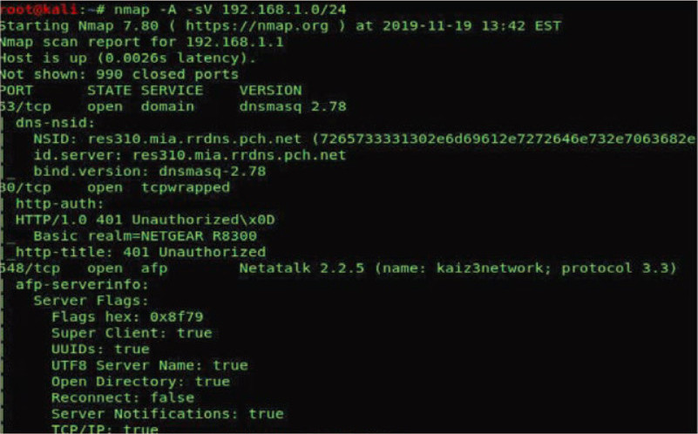
Figure 26 Nmap Scan Results [19]

Exploitation
In the exploitation phase, vulnerabilities were targeted using Metasploit. By exploiting a Webmin backdoor module, “use exploit/unix/webapp/webmin backdoor”, we gained root access to a VM as captured in Figure 27, demonstrating severe security risks. This enabled control over the system and potential further attacks or data breaches. [19]

Figure 27 Webmin - Gained Shell access [19]

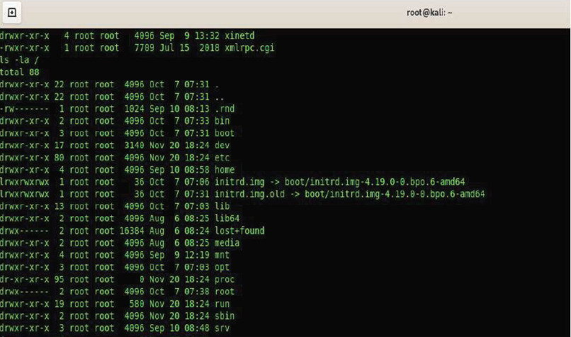
Figure 28 Admin-level access [19]

Post-Exploitation
In the post-exploitation phase, all methods and results are documented, including screenshots and system changes. Systems are cleaned and restored to baseline configurations, with detailed reporting on tested and successful techniques. [19]

Reporting
The reporting phase involves creating a detailed report on discovered vulnerabilities and their exploitation methods. This report is crucial for IT management to understand and address security flaws. It includes precise documentation of findings and exploitation steps, ensuring clarity for remediation. The final phase also involves recommending solutions and re-testing to confirm effective patching and improved security.

Conclusion
Vulnerability Assessment and Penetration Testing (VAPT) plays a crucial role in preemptively protecting systems against hackers by identifying and addressing security weaknesses before they can be exploited. During the penetration testing phase, the scope typically focuses on achieving privilege escalation within the system. However, expanding the scope to incorporate MITRE ATT&CK tactics can significantly enhance the effectiveness of VAPT. Attackers in the real world use techniques including exfiltration, command and control, and lateral movement; MITRE ATT&CK provides a thorough framework that covers these and other tactics. By integrating these tactics into VAPT assessments, organizations can identify gaps in their defenses. This approach not only helps in fortifying systems against a wider range of cyber threats but also ensures that organizations are better prepared to detect, respond to, and mitigate sophisticated attacks. VAPT assessments and continuous monitoring are essential for minimizing the risk factors that can lead to system compromises, such as outdated software, weak passwords, and human errors like phishing.

Research Methodology

Introduction:
This chapter outlines the entire research process to achieve the previously stated aims and objectives. It uses the Research Onion model, a widely accepted framework for constructing research design across various disciplines. The chapter focuses on the layers of the research onion: research philosophy, approach, strategy, choices, and time horizons, with data collection techniques and analysis procedures discussed later. [32]

Research Overview
Research methodology is a systematic plan guiding the entire research process, covering methods and techniques for data collection and analysis. It involves selecting appropriate tools to address research questions, ensuring findings' reliability and validity. [32] This structured approach helps achieve research aims and objectives by providing a framework for gathering evidence, interpreting results, and drawing conclusions. By rigorously testing hypotheses, identifying patterns, and making informed recommendations, researchers ensure the study's credibility and effectiveness.

Research Process

Research Process
Positivism
Deductivismm

Quantitative and Quantitative Research
Experimental
Mixed Method
Cross-Sectional
Data Collection - Analysis

Figure 29 Research Process [32]

Research Philosophy
The research adopts a mixed-method approach, focusing positivist philosophy for empirical testing to enhance VAPT methodologies using the MITRE ATT&CK framework. By simulating real-world attacks, the study aims to expand the scope of future penetration tests, ensuring comprehensive security assessments with reliable, replicable results and deeper insights into broader security implications.

Research Approach
The research employs a deductive approach, transitioning from theoretical foundations to empirical data collection, to enhance VAPT methodologies with the MITRE ATT&CK Framework. This hypothesis is set to prove that integrating this framework will improve the detection and mitigation of security vulnerabilities. By systematically analyzing attack vectors and vulnerabilities across entire scenarios, and gathering both quantitative and qualitative data, the deductive approach aims to validate the prediction through comprehensive security assessments. The mixed-methods strategy leverages deductive reasoning for empirical testing while providing insights that deepen the understanding of broader security implications.

Research Strategy
The MITRE ATT&CK framework is an essential tool in cybersecurity, categorizing adversarial tactics and techniques into a structured taxonomy. [31] It covers attack techniques throughout the attack lifecycle, including initial access, execution, persistence, privilege escalation, defense evasion, credential access, discovery, lateral movement, collection, exfiltration, and impact. This comprehensive framework enables security professionals to map specific attack techniques to their environment and understand potential attack paths that adversaries might exploit.
The Vulnerability Assessment and Penetration Testing (VAPT) methodology leverages the MITRE ATT&CK framework by defining the scope of tests through the selection of target systems and networks. The subsequent phase involves identifying and prioritizing attack vectors based on known vulnerabilities and weaknesses, which is crucial for determining the relevant MITRE ATT&CK techniques to simulate during penetration testing.
Penetration testing, conducted by ethical hackers or pentesters, aims to exploit identified vulnerabilities using techniques from the MITRE ATT&CK framework. This process often involves using tools and scripts to execute commands remotely, escalate privileges, or move laterally across networks. The goal is to showcase how attackers could potentially compromise systems and data if these vulnerabilities are exploited maliciously.
The research strategy, aligning with an experimental approach, involves systematically testing various attack scenarios on a Metasploitable machine using the enhanced VAPT techniques. This approach focuses on evaluating the effectiveness of different attack scenarios and is guided by empirical data collected during testing.
From the literature review, the VAPT methodology has effectively exposed critical vulnerabilities through several attack scenarios. For instance, the vsftpd exploit highlighted server weaknesses, while the reverse shell attack demonstrated risks related to unauthorized access. Additionally, penetration testing on Raspberry Pi with Kali Linux revealed significant security flaws. These findings, validated through literature review, experimentation, and case studies, underline the methodology’s capability to assess and improve security measures.
SAMBA Exploit
The SAMBA exploit further illustrates the application of adversary emulation in cybersecurity. Red teams simulate potential threats to understand adversary tactics outlined in the MITRE ATT&CK framework. Unlike standard penetration tests, adversary emulation thoroughly tests defenses against simulated threats. The MITRE framework provides a repository of tactics and techniques for analyzing adversary behaviors, which defense teams use to enhance security. For example, Atomic Red Team scripts are employed across various platforms, including Windows, Mac OS, and Linux. Techniques such as Network Share Discovery (T1135) are used to identify shared resources, as illustrated in the Figure 30. [31]
Figure 30 Accessing shared drives in local system [31]
The experiment simulates real-world hacker tactics in alignment with MITRE ATT&CK techniques to measure system compromise. Data collection includes capturing empirical evidence from test results, which are then analyzed to assess the scope coverage and effectiveness of the applied attack strategies. This methodical approach ensures that findings are attributable to specific attack interventions, reinforcing the credibility and practical application of the results within cybersecurity contexts.

Research Choices
Incorporating attack strategies with a mixed-method approach in the VAPT project for MITRE ATT&CK involves both quantitative and qualitative methods. Researchers define the scope, select target systems, and identify vulnerabilities using tools like Nmap. Attacks are simulated using MITRE ATT&CK techniques, such as SAMBA exploits. Quantitative data, such as exploit success rates and impact severity, is collected and analyzed statistically to gauge effectiveness. Qualitative analysis includes evaluating the broader implications of attack outcomes, such as identifying potential attack vectors and assessing defensive measures. This mixed-method approach ensures a thorough evaluation of cybersecurity risks, informing strategies to enhance defenses based on both empirical data and contextual insights.

Time Horizons
Here's a summary based on the scope of penetration testing using cross-sectional and longitudinal research approaches:
Cross-Sectional Research: Cross-sectional research in the context of penetration testing defines the scope by providing a snapshot of vulnerabilities and attack surfaces at a specific point in time. It focuses on immediate assessment to identify prevalent attack vectors and evaluate current security postures efficiently. This approach is ideal for projects aiming to assess the current state of cybersecurity defenses and identify immediate threats.
Improvements of Scope Achieved Using Longitudinal Research: In contrast, longitudinal research enhances the scope of penetration testing by tracking changes over time. It offers insights into the evolution of cybersecurity threats, the effectiveness of adaptive security measures, and the persistence of vulnerabilities and exploitation tactics. By monitoring trends and changes in attacker behaviors, longitudinal research enables a deeper understanding of how cybersecurity landscapes evolve and provides valuable data for long-term strategic planning and defense enhancement.
This study incorporates cross-sectional research and provides immediate insights into current vulnerabilities and attack methods while a longitudinal research offers a broader perspective by capturing trends and changes over time. Combining both approaches can enhance the overall effectiveness of penetration testing strategies, ensuring that cybersecurity defenses are adaptive and resilient against evolving threats.

Risks & Limitations
Testing in a virtual environment using Oracle Virtual Box and Kali Linux tools presents challenges due to limited tool knowledge and options, potentially delaying problem identification and solution implementation. Time constraints may prevent thorough testing of all identified vulnerabilities. Despite feasible cost analysis and time management in lab setups, approximations may occur. Resource constraints, such as limited processing power and memory, can impact virtual environment performance. Security risks, including data breaches and system compromises, underscore the need for careful handling of sensitive information. Virtual environments may not fully replicate real-world scenarios, potentially affecting security assessment accuracy. External risks include changes in cybersecurity regulations, technological advancements, and resource limitations. Mitigation strategies include monitoring regulatory updates, adapting to new technologies, and agile resource management. Addressing dynamic cyber threats and ethical considerations requires continuous monitoring, agile project management, adherence to ethical guidelines, stakeholder collaboration, and ongoing personnel training and project reviews.

Validity, Reliability & Generalisability

Validity
This research method employs a systematic research methodology, integrating the MITRE ATT&CK framework with VAPT techniques to simulate real-world cyber threats. By focusing on empirical data collection, rigorous testing of attack scenarios, and structured analysis, the approach ensures the credibility and validity of findings. It also adapts to the dynamic nature of cybersecurity, offering insights into vulnerabilities, attack paths, and defensive strategies essential for enhancing organizational security measures.

Reliability
Given the systematic application of the MITRE ATT&CK framework within the VAPT methodology, along with standardized tools and procedures for data collection and analysis, it is probable that another researcher would achieve similar results. This consistency is supported by the structured approach to testing and documenting cyber threats, which aims to minimize variability and ensure replicability in outcomes across different research efforts.

Generalisability
The research methodology outlined utilizes the MITRE ATT&CK framework integrated within the VAPT approach to simulate real-world cyber threats comprehensively. It focuses on empirical data collection, rigorous testing of attack scenarios, and structured analysis to ensure the credibility and validity of findings. The insights gained from testing specific vulnerabilities, can inform similar organizations about effective mitigation strategies and security controls. These methodologies and findings are transferable across industries facing comparable cybersecurity risks, adapting methodologies to address common vulnerabilities in sectors like finance, healthcare, or government. By documenting procedures, standardizing methodologies, and continuously updating practices to reflect evolving cyber threats, the research ensures its relevance and applicability in enhancing cybersecurity resilience across diverse organizational contexts and datasets.

Data Evaluation Methods

Data Collection
Data collection combines quantitative and qualitative methods to enhance VAPT with the MITRE ATT&CK framework. Quantitative data comes from empirical tests and simulations, providing metrics on attack success and vulnerability impact. Qualitative insights are drawn from documentation and analysis of test results. Secondary sources, such as academic literature and industry reports, supplement primary data when needed. Comparative analyses validate results, ensuring a thorough understanding and effective identification and mitigation of network vulnerabilities.

Data Evaluation
To evaluate VAPT methodologies with the MITRE ATT&CK framework, both quantitative and qualitative data will be analyzed. Quantitative analysis will use descriptive statistics to summarize attack success rates, detection rates, and severity. Inferential statistics will test hypotheses about the effectiveness of MITRE ATT&CK-aligned VAPT strategies in improving security. Qualitative data will provide insights from test results and documentation. This approach ensures a comprehensive evaluation of the effectiveness and impact of the VAPT enhancements.

Development Methodology

Software Development Methodology
Methodology: Adopting an iterative development approach ensures this cybersecurity penetration testing project remains responsive to evolving threats and vulnerabilities. This method allows for continual refinement of testing strategies based on real-time feedback and emerging security challenges. The iterative approach facilitates frequent testing cycles, enabling early detection and mitigation of vulnerabilities. It promotes close collaboration between penetration testers and stakeholders, ensuring alignment with security objectives throughout the project lifecycle.
Mitigation Strategies: To effectively manage iterative development in cybersecurity, maintaining a prioritized backlog of test scenarios and ensuring robust communication with stakeholders are paramount. Regular evaluations and adjustments of testing methods based on empirical findings enhance the project's efficacy.
Tools and Software: Leveraging tools like Nmap, Metasploit Framework, and Kali Linux enhances the project's penetration testing capabilities, aligning with the MITRE ATT&CK framework. These tools enable comprehensive network scanning, exploit testing, and simulation of realistic cyber threats.
Hardware Requirements: High-performance hardware supports intensive tasks such as large-scale network analysis and exploit simulations, essential for thorough vulnerability assessment and attack scenario testing.

Resources

Hardware Resources
Executing this scenario on a Windows 10 workstation using Oracle Virtual Box involves creating a virtualized environment for cybersecurity penetration testing. Oracle Virtual Box facilitates the setup of a Metasploitable virtual machine (VM), which serves as the intentionally vulnerable target. The VM runs independently from the host system, ensuring isolation and security.
The Windows 10 workstation provides robust hardware resources, including processing power, memory, and storage, to support Oracle Virtual Box and the VMs hosted within it. Networking configurations within Virtual Box enable the emulation of complex network environments necessary for realistic testing scenarios. Virtual Box's network settings allow for configuring network adapters, NAT, and bridged networking to simulate interactions between VMs and external networks.
Throughout the penetration testing process, essential tools such as Nmap, Metasploit, and Wireshark are utilized within the Virtual Box environment. This setup ensures comprehensive evaluation and analysis of vulnerabilities and exploits while maintaining the integrity and security of the Windows 10 host system.

Software Resources
The cybersecurity penetration testing experiment requires specific software resources tailored for testing vulnerabilities and simulating attacks. Key tools include the Metasploit Framework, essential for exploiting vulnerabilities. Nmap aids in network reconnaissance and vulnerability scanning, providing detailed insights into potential entry points for attackers. Wireshark is crucial for capturing and analyzing network traffic during penetration tests to validate vulnerabilities and assess their impact.
Atomic Red Team tools like Caldera are adaptable across Windows, Mac OS, and Linux platforms, emulate real-world adversary tactics aligned with the MITRE ATT&CK framework, enhancing the realism of simulated attacks. Oracle Virtual Box hosts the Metasploitable virtual machine, replicating typical network environments for controlled testing. All software is obtained from reputable sources to ensure reliability, security, and compatibility throughout the experimentation process.

Conclusion
In conclusion, Chapter 3 provides a comprehensive framework for conducting the cybersecurity penetration testing project, integrating the MITRE ATT&CK framework with VAPT methodologies. The methodology outlines a systematic approach encompassing research philosophy, approach, strategy, and data collection techniques. By adopting a positivist research philosophy and a deductive approach, the study aims to rigorously test hypotheses and derive empirical insights into cybersecurity vulnerabilities and attack scenarios.
The iterative development methodology ensures flexibility and responsiveness to evolving threats, supported by tools like Nmap, Metasploit, and Wireshark within the Oracle Virtual Box environment on a Windows 10 workstation. These resources enable thorough evaluation of attack vectors and mitigation strategies, crucial for enhancing organizational cybersecurity resilience. The chapter emphasizes reliability, validity, and generalizability of findings through structured data evaluation methods, ensuring the credibility and applicability of research outcomes in real-world cybersecurity contexts.

Design and Implementation

Introduction
To detect and reduce security threats in systems, networks, or web applications, vulnerability assessment and penetration testing, or VAPT, are essential. This project aims to enhance VAPT methodology by integrating the MITRE ATT&CK framework into the penetration testing phase, providing realistic simulations of adversary tactics and techniques. This approach ensures comprehensive security assessments and effective risk mitigation. The project also involves analyzing the network setup to implement these improvements, aiming for a more efficient and accurate security assessment process.

Problem Formulation
The primary problem addressed in this project is the inefficiency and inaccuracy of traditional VAPT methodologies, which often result in missed vulnerabilities and inefficient use of resources. These issues can leave critical systems exposed to attacks, jeopardizing the security posture of an organization. To address this problem, the project proposes VAPT methodology that integrates advanced tools and the MITRE ATT&CK framework to optimize the scope and accuracy of assessments.
Planning and Scope Definition: Defining clear goals and the scope of the assessment ensures comprehensive coverage of critical assets and efficient resource allocation. This stage involves determining the specific objectives, assets to be tested, and the boundaries of the testing environment. Project management tools and scoping templates are utilized to perform the task.
Vulnerability Assessment: Automated tools are used to scan networks, systems, and applications to identify and catalog potential vulnerabilities. These tools enhance efficiency and accuracy in finding weaknesses, reducing the risk of human error. Current industry standard automated vulnerability scanners are Nessus, OpenVAS.
Penetration Testing: This phase tests the effectiveness of existing security measures and identifies vulnerabilities that can lead to significant security breaches. During this phase, the identified vulnerabilities are actively exploited to simulate real-world attack scenarios. The MITRE ATT&CK framework is integrated to replicate adversary tactics, techniques, and procedures (TTPs), providing a more realistic assessment of the system’s security posture. Exploitation frameworks (e.g., Metasploit), manual testing tools (e.g., Burp Suite), and the MITRE ATT&CK framework tool like Caldera are deployed.
Reporting: Detailed reports are generated outlining all discovered vulnerabilities, their severity, and any successful exploitation attempts. These reports are crucial for stakeholders to understand the security posture and prioritize remediation efforts. Reporting tools and templates are aligned with industry standards.
Remediation: The final stage focuses on addressing the identified vulnerabilities through fixes, patches, or configuration changes. Continuous monitoring tools help maintain an ongoing defense against emerging threats, ensuring long-term security improvements. Patch management systems and continuous monitoring tools are used to solve the problem.
Planning and Scope Definition

Vulnerability Assessment

Penetration Testing

Scope Re-Evaluation
Reporting

Remediation

Figure 31 Stages of VAPT Methodology [4]

A block diagram (Figure 31) visually represents the VAPT process, detailing the integration of tools, methods, and the MITRE ATT&CK framework specifically within the Penetration Testing stage. This diagram enhances understanding by clearly showing the flow and interaction of various components, ultimately improving the efficiency and effectiveness of the testing process. It offers a clear, structured view, aiding in better planning and execution of security assessments.

Design
The design of the enhanced VAPT methodology is informed by insights from the literature review, ensuring a comprehensive, efficient, and accurate assessment process. The five-stage VAPT process, with the integration of the MITRE ATT&CK framework specifically during the Penetration Testing phase, provides a robust approach to security testing.
This MITRE ATT&CK integrated VAPT methodology will be implemented in an Oracle Virtual Box network setup, utilizing various virtual machines to represent different components of the network and security tools. This setup ensures an isolated and controlled environment, ideal for simulating real-world scenarios effectively.

Network Configuration:
1. Network Layout and Structure
Host-Only Network: Ensures that VMs can communicate with each other but are isolated from the external network, simulating an internal network environment.
Internal Network: Configures an internal network for VMs to interact directly without internet access, ensuring a controlled test environment. 192.168.100.0/24 is the internal network represented in Figure 32.

2. Virtual Machines
Kali Linux Virtual Machine: Equipped with Caldera and Metasploit, Kali Linux serves as the primary attacker machine for penetration testing. These tools are essential for executing sophisticated attacks like DoS, Man-in-the-Middle and testing the security posture like security controls, patch management of the target systems.
Ubuntu Virtual Machine: Acts as an additional attacker machine or can be used for other testing purposes, adding flexibility to the testing environment.
Metasploitable Vulnerable Machine: Acts as the primary target with known vulnerabilities. It is connected to the network to simulate an internal system that can be attacked and assessed.


Windows 10 Home Rogue VM
IP Address:
192.168.56.104

Windows 10 Pro VM
IP Address: 192.168.56.107

Windows 2019 Server VM
Domain Controller
IP Address: 192.168.56.106


Attacker: Kali Linux VM
IP Address: 192.168.56.103

Metasploitable 2 VM
External IP Address: 192.168.56.102
Internal IP Address:
192.168.1.100

Ubuntu 24 VM
IP Address:
192.168.1.101

Windows 10 Home VM
IP Address:
192.168.1.102



Figure 32 Network Setup

Windows 2019 Server: Positioned as a central server within the network, it requires thorough security testing to ensure its integrity and protection against attacks.
Windows 10 Pro and Windows 10 Home: Representing typical user workstations, these VMs allow testing of different security measures and potential vulnerabilities from a user perspective.

Functional Setup:
1. VirtualBox Configuration
Network Adapters: Configure network adapters in VirtualBox for the host-only and internal networks. This setup ensures proper communication flow between VMs and maintains the isolation necessary for accurate testing.
Resource Allocation: Allocate sufficient resources (CPU, memory, disk space) to each VM for optimal performance during scanning and testing. This allocation is critical to avoid performance bottlenecks that could skew the results.

2. Communication Flow
Kali Linux, Rogue Windows 10 Home and Ubuntu VMs initiate vulnerability scans and penetration testing activities on the target systems (Metasploitable, Windows 2019 Server, Windows 10 Pro, and Windows 10 Home).
The Metasploitable Machine serves as the primary target for initial vulnerability assessments and exploitation attempts.
The Windows 2019 Server and Windows 10 VMs are tested for vulnerabilities and their response to simulated attacks.
Detailed Reports generated from these tests are analyzed to identify weaknesses and prioritize remediation efforts.
Remediation involves using patch management systems and continuous monitoring tools to address identified vulnerabilities and improve the security posture.

The literature review highlights the limitations of traditional VAPT methodologies, such as inefficiency, inaccuracy, and missed vulnerabilities. By incorporating advanced tools and the MITRE ATT&CK framework, VAPT methodology addresses these issues, providing a more comprehensive and realistic assessment of security risks. The iterative nature of the process, supported by continuous re-evaluation and targeted remediation efforts, ensures that the scope of assessments is continually refined and optimized.

Based on the results from the reports and the effectiveness of remediation efforts, the scope of the next assessment can be dynamically adjusted to cover new areas of concern or previously missed vulnerabilities. This iterative approach fosters continuous improvement in the VAPT process, ensuring that the methodology evolves to address new threats and vulnerabilities as they emerge.

The block diagram of the proposed VAPT methodology not only provides a structured view of the process but also underscores the importance of iterative re-evaluation and targeted remediation efforts. This approach ensures that the scope of assessments is continually refined and optimized, leading to more accurate and effective vulnerability management. The design, with its comprehensive layout and structured network setup, exemplifies the integration of literature review insights into practical application, thus enhancing the overall security posture of the organization.

Implementation
This implementation guide provides detailed steps for setting up virtual machines (VMs) including Metasploitable 2, Kali Linux, Ubuntu 24 LTS, Windows 10 Home, and Windows Server 2019 in Oracle VirtualBox. It covers the VM creation process, operating system installation, and network setup according to specified configurations. Then, it concludes with verifying IP settings and network connectivity, ensuring that each VM is properly configured and operational.

Metasploitable 2 Vulnerable Virtual machine

Setting up the Virtual Machine:
Open Oracle VirtualBox and build a new virtual machine to install Metasploitable 2. Give it the name "Metasploitable-2", select "Oracle Linux (64-bit)" as the version, and set the type to "Linux". With 4096 MB of RAM allocated, choose "Use an existing virtual hard disk file" and the Metasploitable.vmdk file, as seen in the figures below.

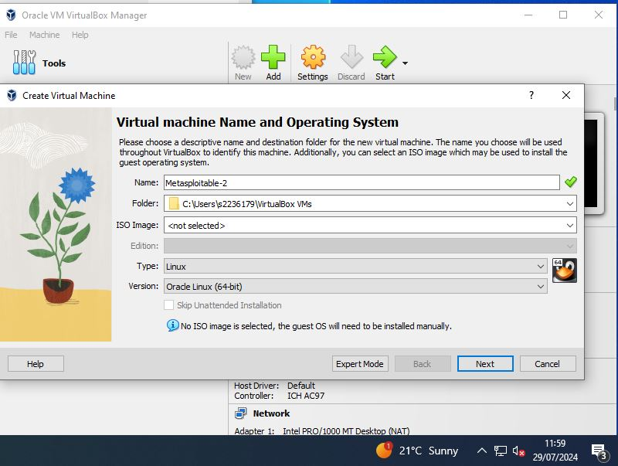
Figure 33 Metasploitable VM Setup

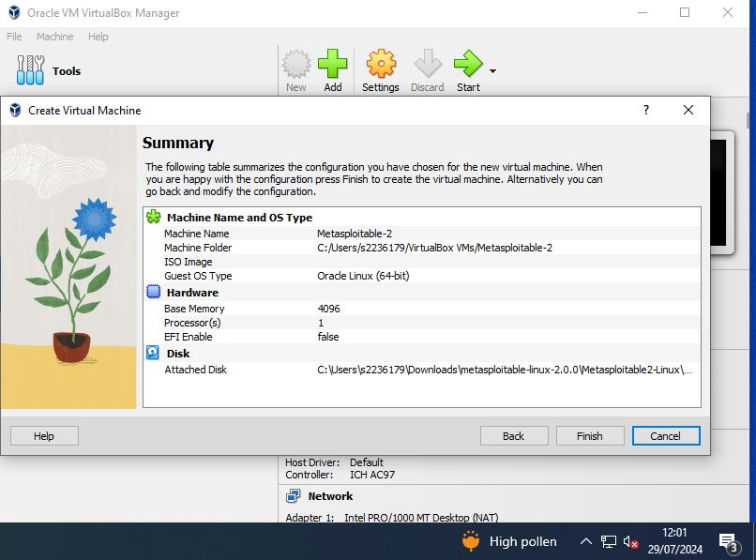
Figure 34 Metasploitable VM Creation

Starting up Metasploitable-2 Virtual Machine:
To start the VM, select "Metasploitable-2" and click "Start". Log in using the default credentials (username: msfadmin, password: msfadmin).
To configure network settings for the virtual machine, set up two adapters. For the first adapter, assign an internal network, static IP address. For the second adapter, configure DHCP with a Host-Only network.
To configure a static IP address in the “/etc/network/interfaces” file, open the file using a text editor with superuser privileges. Edit the configuration for the network interface by specifying the static IP details. Provide 192.168.1.100, 255.255.255.0, and 192.168.1.1 as the desired IP address, subnet mask, and gateway respectively as narrated in Figure 30. Save the changes and restart the networking service using “sudo /etc/init.d/networking restart” to apply the new settings. Use ifconfig to check the assigned IP address and ping command output to confirm network connectivity as shown in the below figures.
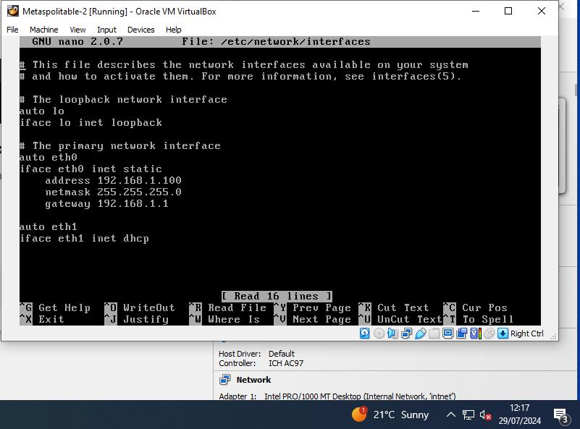
Figure 35 Metasploitable Static IP Address Configuration
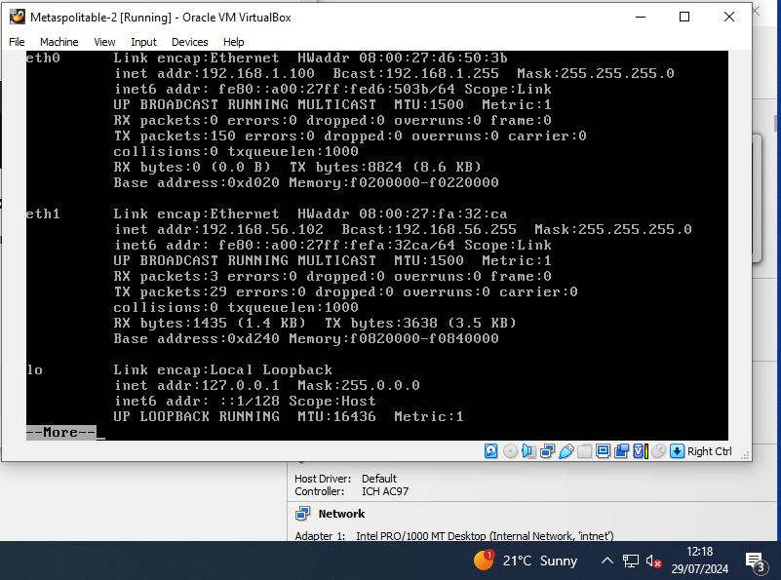
Figure 36 Metasploitable Ifconfig output

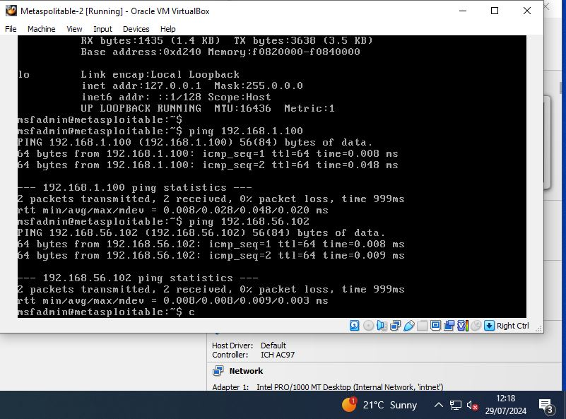
Figure 37 Metasploitable Network Connectivity

Kali Linux Virtual machine
To install Kali Linux in Oracle VirtualBox with a Host-Only Adapter, first launch VirtualBox and create a new VM named "Kali-Box," selecting "Linux" and "Oracle Linux (64-bit)." Allocate 6144 MB RAM and select "Use an existing virtual hard disk file", and choose the VDI file. Configure the network adapter to "Host-Only Adapter," then start the VM and follow the installation prompts. After installation, log in with default credentials "kali/kali," check the IP address with ifconfig, and test connectivity using ping command as confirmed in the below figures.

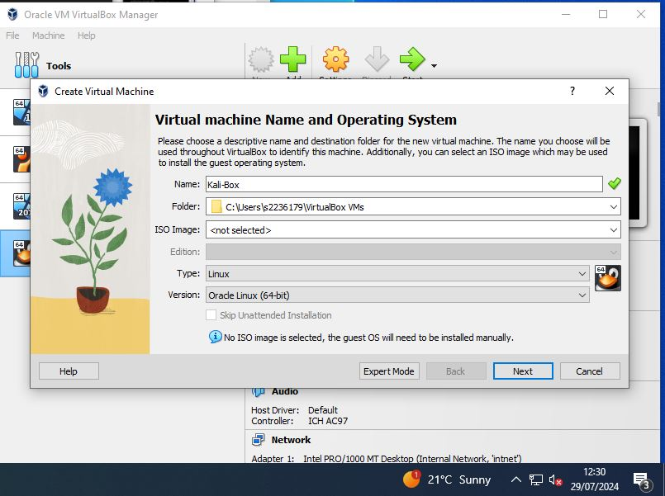
Figure 38 Kali Linux VM Setup

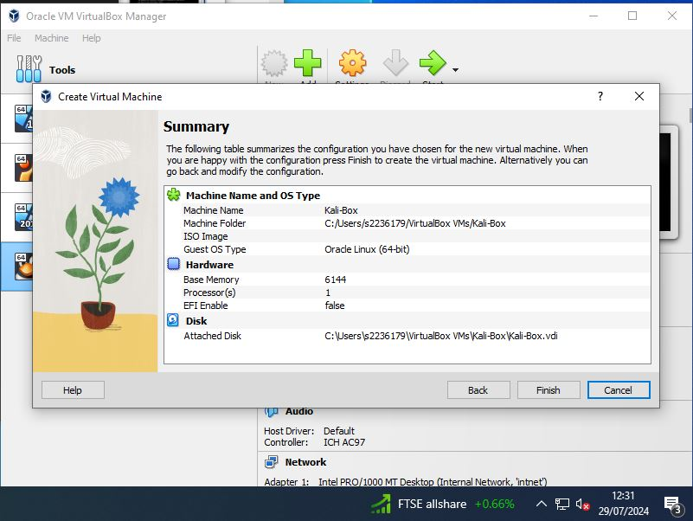
Figure 39 Kali Linux VM Creation

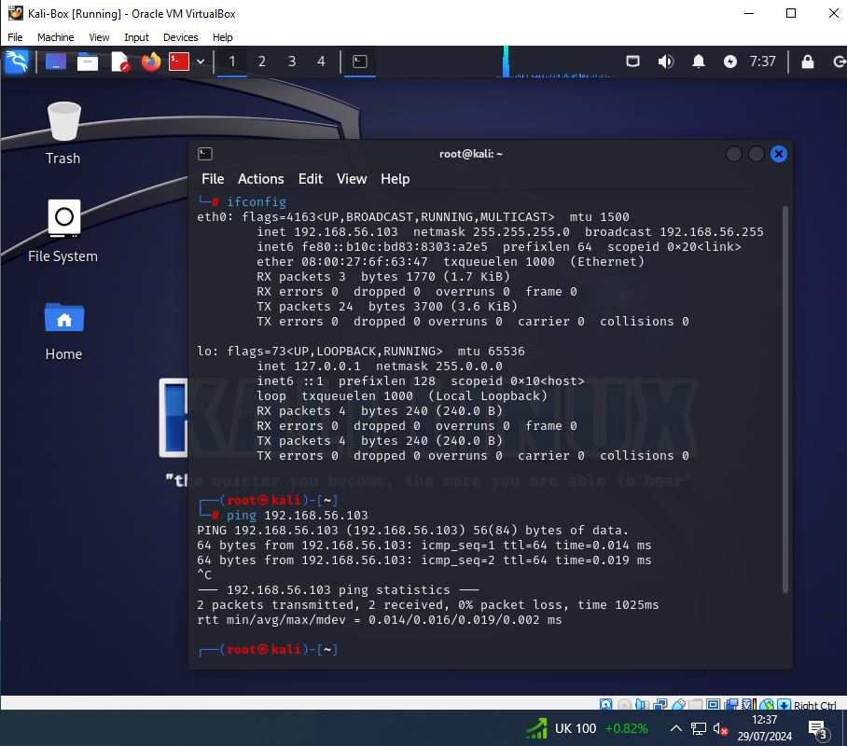
Figure 40 Kali Linux Network Connectivity

Ubuntu 24 LTS desktop Virtual machine
Setting up the Virtual Machine:
Start Oracle VirtualBox on your computer. Click "New" to open the VM creation wizard. Name the VM "Ubuntu-24," choose the VM storage location, set "Type" to "Linux," and "Version" to "Ubuntu (64-bit)." Click "Next." Assign at least 8192 MB of RAM for optimal performance and allocate disk size of 80 GB to create the virtual machine as in the below figures.
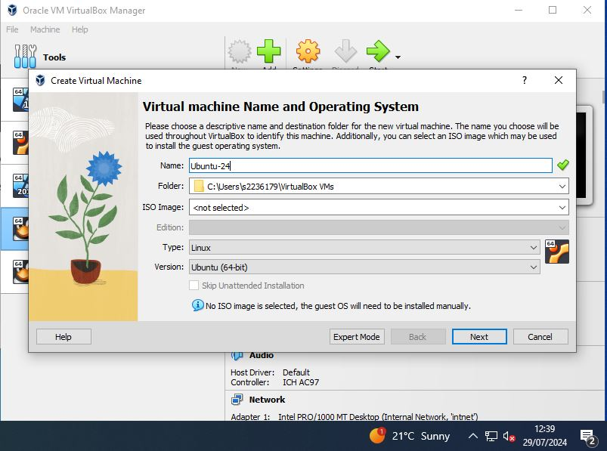
Figure 41 Ubuntu VM Setup
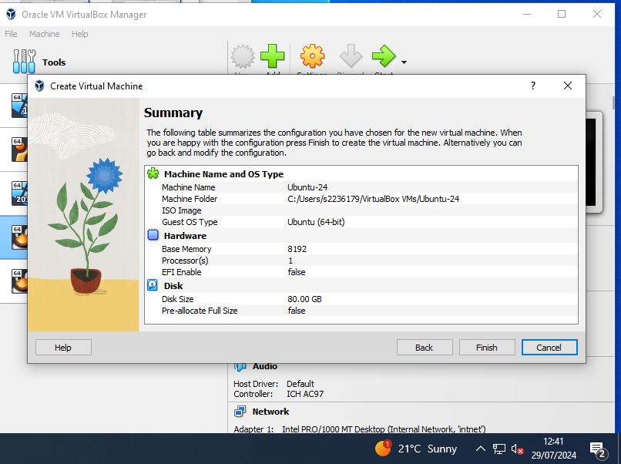
Figure 42 Ubuntu VM Creation
Attaching the ISO Image:
Select the VM, go to "Settings," then the "Storage" tab. Click on the empty optical drive, select "Choose a disk file," find the Ubuntu 24 LTS ISO, and click "Open” as illustrated in Figure 38. Click "OK" to save settings, select the VM, and click "Start."
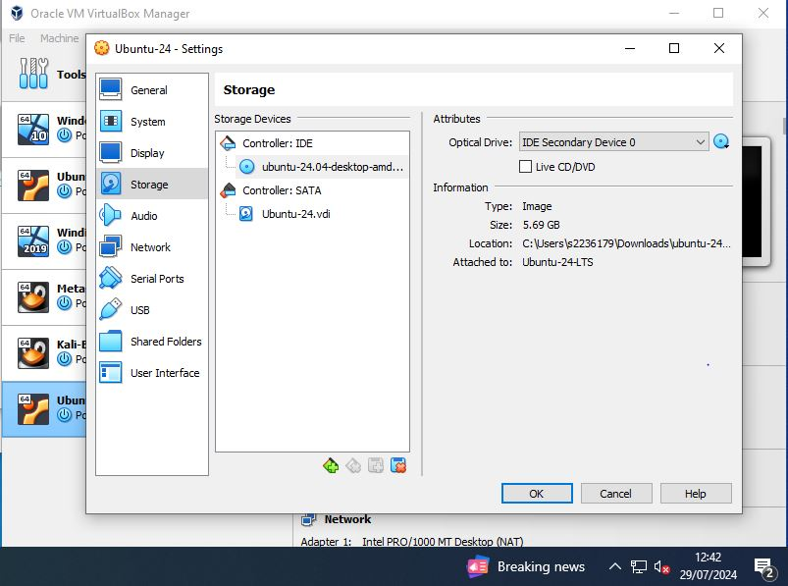
Figure 43 Ubuntu ISO Image Mapping
Starting up Ubuntu-24 Virtual Machine:
The VM will boot from the ISO to begin the installation. Follow the on-screen prompts to set up the user-defined username, password, and computer name. Complete the installation by configuring the basic preferences. Once Ubuntu is installed, open Settings, navigate to Network, select the wired connection, click the gear icon, set IPv4 to Manual, enter the static IP address, Netmask, and Gateway and Click "Apply" to save. Use the ifconfig command to check the IP address and ping command to test network connectivity as confirmed in the below figures.
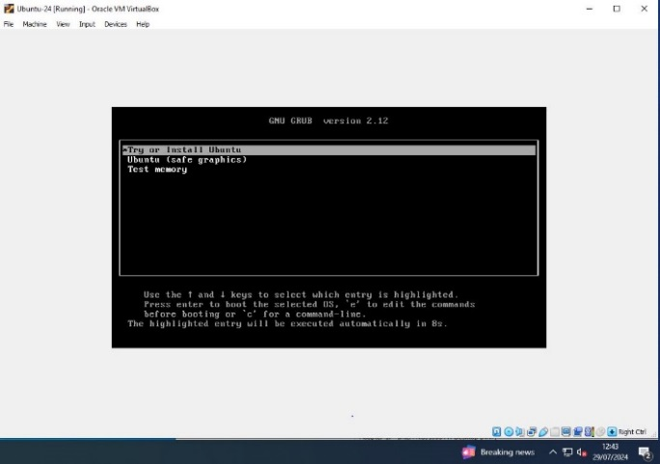
Figure 44 Ubuntu OS Installation

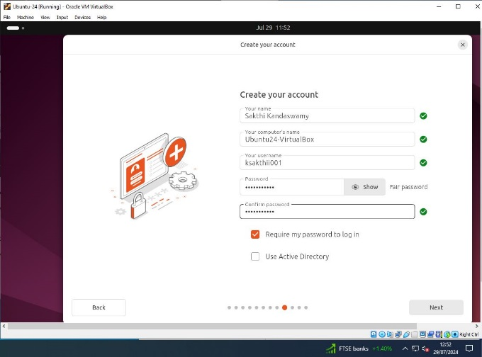
Figure 45 Ubuntu Login Account Creation

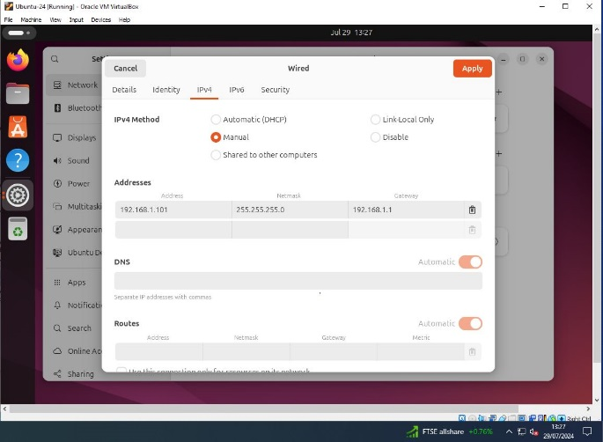
Figure 46 Ubuntu Static IP Address Configuration

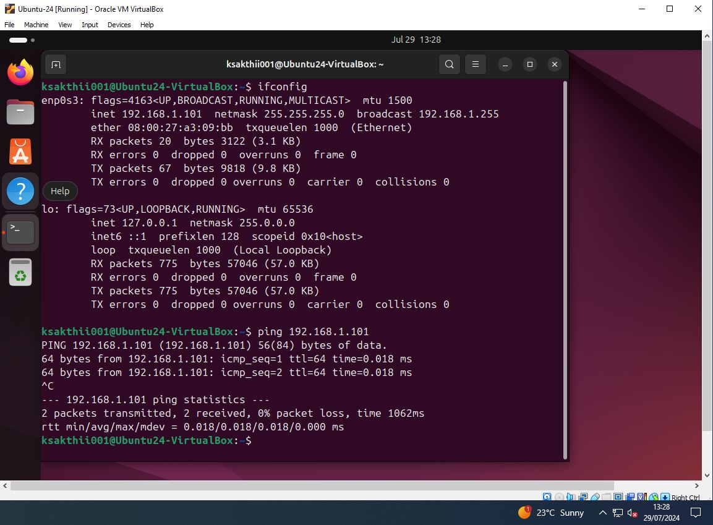
Figure 47 Ubuntu Network Connectivity

Windows 10 Home Virtual machine
Setting up the Virtual Machine:
Start Oracle VirtualBox on the host computer to begin the virtual machine setup process. Click "New" to initiate the virtual machine creation wizard. Enter "Windows-10-Home" as the VM name. Choose a location for VM files and select the ISO file from the local drive. Set the type to "Windows" and version to "Windows 10 (64-bit)." Click "Next." Assign 8192MB of RAM and allocate 80GB of disk space and click "Create” as in below figures.
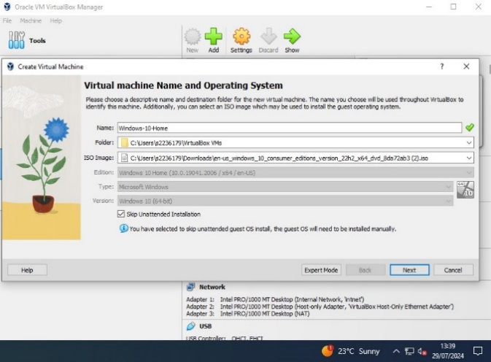
Figure 48 Windows 10 Home VM Setup

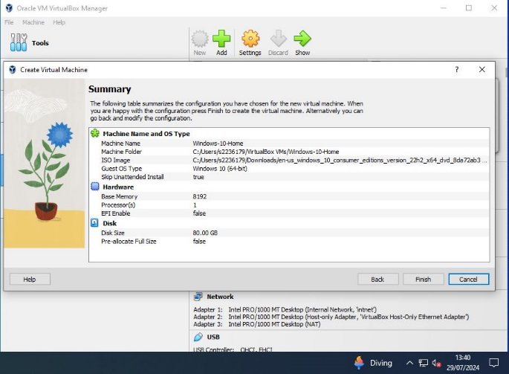
Figure 49 Windows 10 Home VM Creation

Starting up Windows-10-Home Virtual Machine:
Click "Start" to boot the VM from the ISO, which will initiate the Windows 10 installation. Follow the installation prompts to set up Windows 10 Home, which allows user account creation and password setup on limited internet setup as in the below figures.

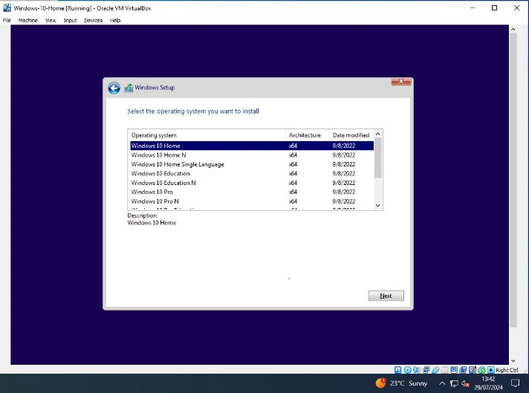
Figure 50 Windows 10 Home OS Selection
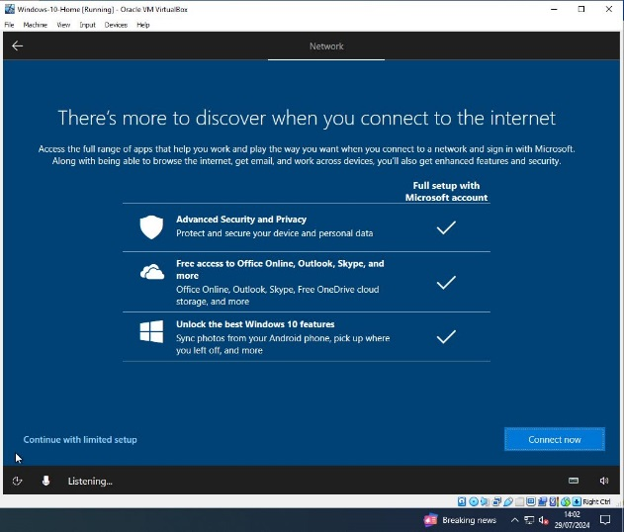
Figure 51 Limited Network Installation process

Configuring Static IP Address:
After the installation is finished, select "Settings," then "Network & Internet," and finally "Status." Once you have selected "Change adapter options," right-click on "Ethernet," and choose "Properties." Select "Internet Protocol Version 4 (TCP/IPv4)," After choosing "Use the following IP address," enter the default gateway, subnet mask, and static IP address. To apply, click "OK". By following these steps, we have successfully installed Windows 10 Home, configured a static IP address, by setting up an internal network with limited internet connectivity as shown in Figure 52.
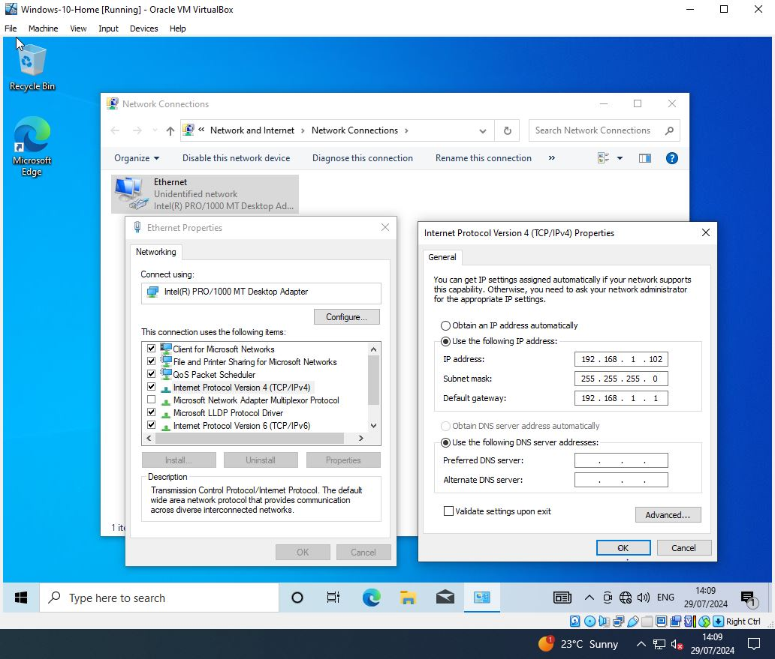
Figure 52 Windows Static IP Address Configuration

Internal Network Communication
The Metasploitable VM, Ubuntu VM, and Windows 10 Home VM are set up on an internal network, isolated from the Kali Linux VM as depicted in Figure 53. Each VM is assigned a unique static IP address, ensuring they can communicate with one another. This network setup is verified, by executing the ping command from each VM, confirming successful reachability to the other VMs within the internal network.

Attacker: Kali Linux VM
IP Address: 192.168.56.103

Metasploitable 2 VM
External IP Address: 192.168.56.102
Internal IP Address:
192.168.1.100

Ubuntu 24 VM
IP Address:
192.168.1.101

Windows 10 Home VM
IP Address:
192.168.1.102

Figure 53 Internal Network Setup

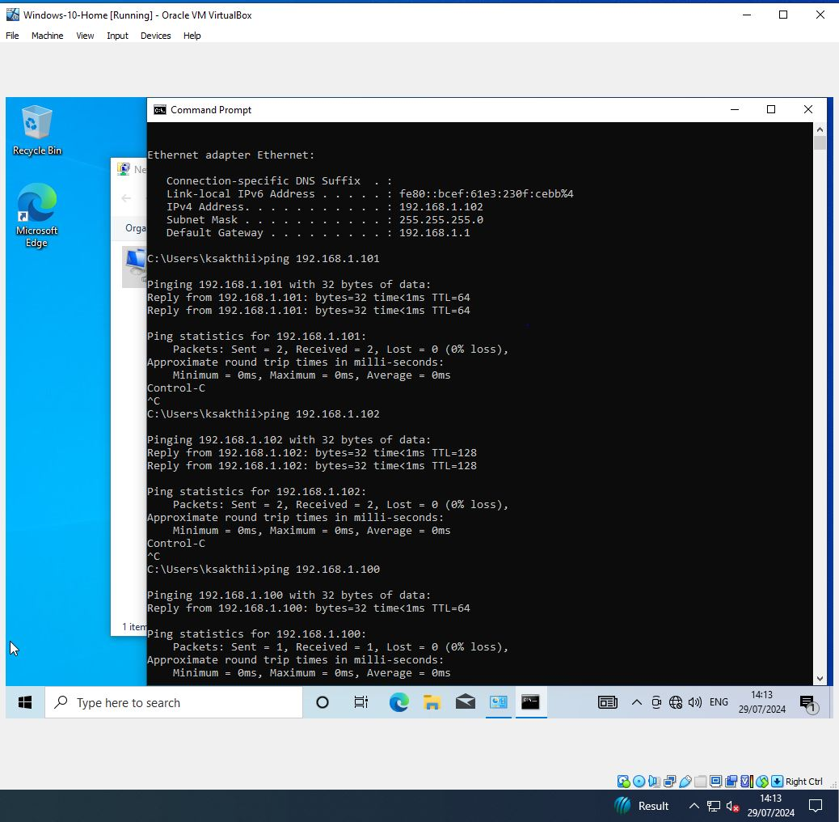
Figure 54 Windows 10 Home Internal Network Connectivity

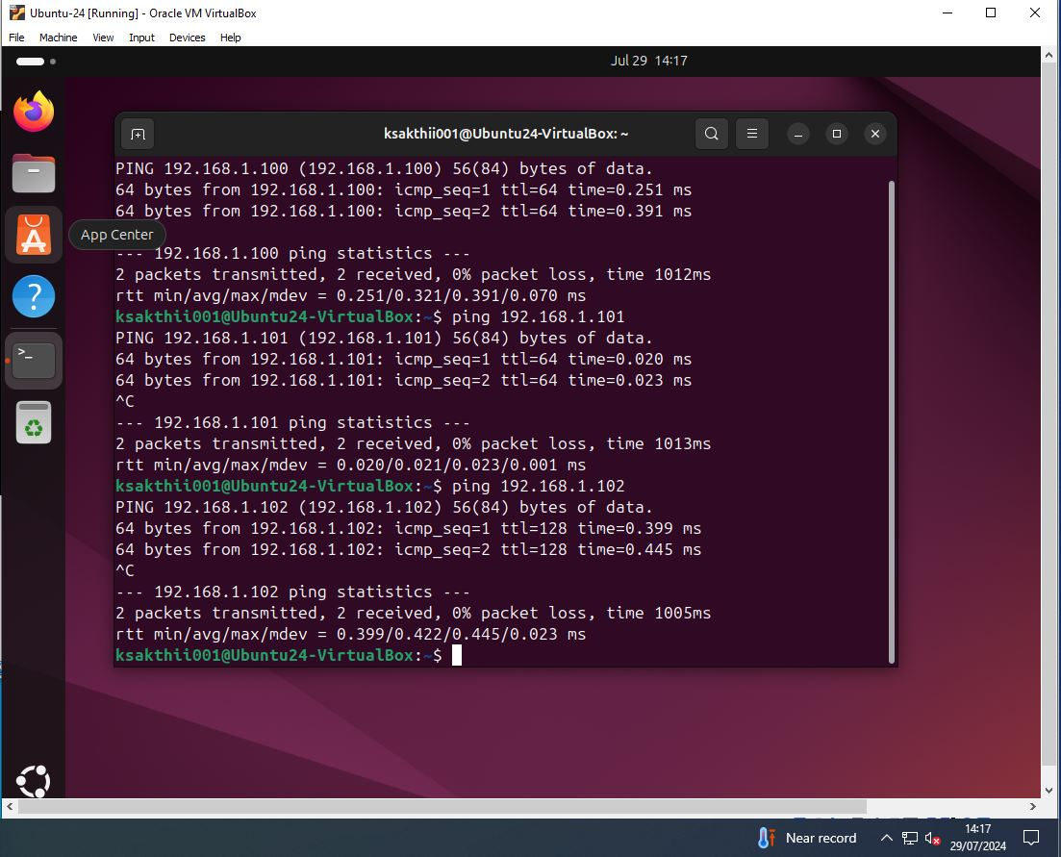
Figure 55 Ubuntu Internal Network Connectivity
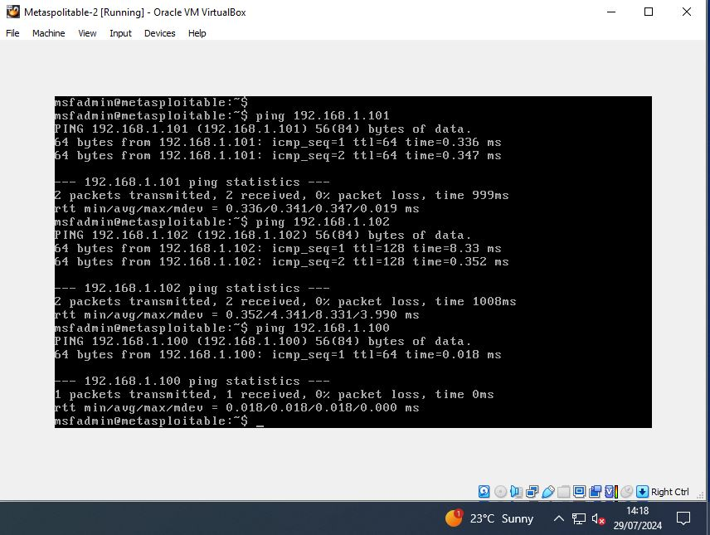
Figure 56 Metasploitable Internal Network Connectivity

Windows 10 Home Virtual machine
Setting up the Virtual Machine:
Similar to the previous installation, Launch the virtual machine creation wizard. Name the VM "Rogue-Windows-10,” with the same settings to create another Windows 10 Home VM as shown in the below figures.
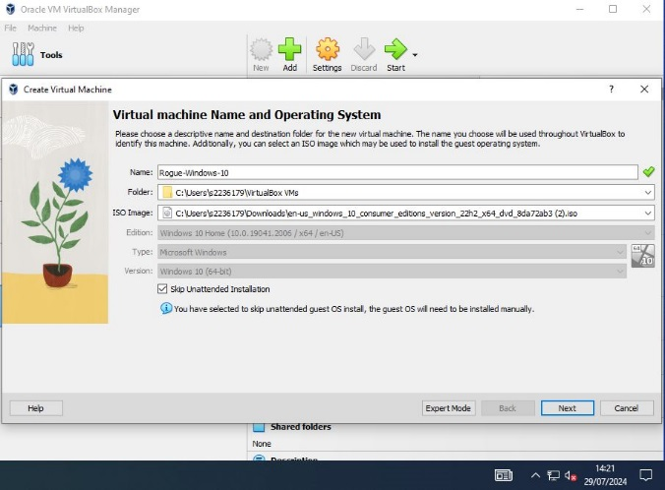
Figure 57 Windows 10 Home VM Setup

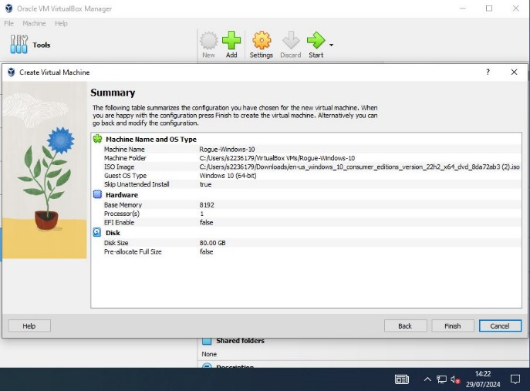
Figure 58 Windows 10 Home VM Creation

Starting up Windows-10-Home Virtual Machine:
Click "Start" to boot the VM from the ISO, following the same Windows 10 installation process. Set the network adapter to "Host-Only Adapter," start the VM, log in with the credentials, verify the IP address using ifconfig, and test connectivity with the ping command as seen in the below figures.

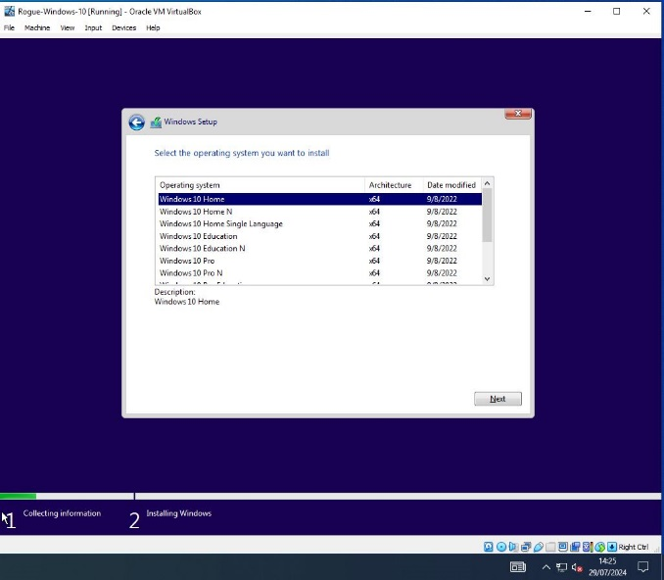
Figure 59 Windows 10 Home OS Selection
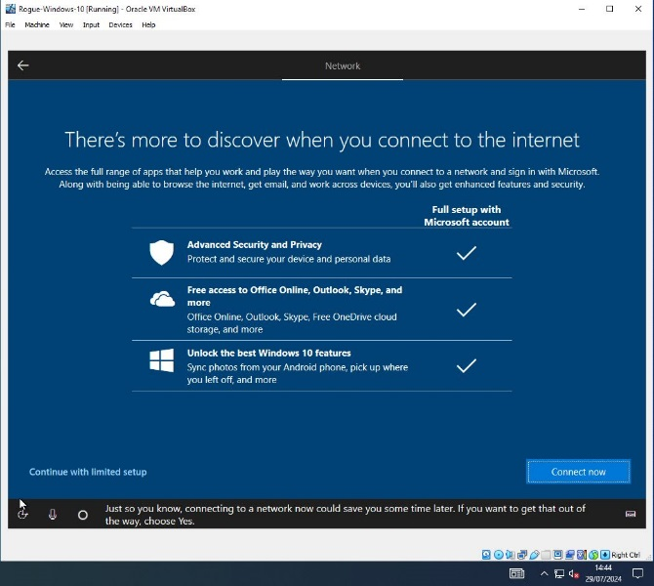
Figure 60 Limited Network Installation process

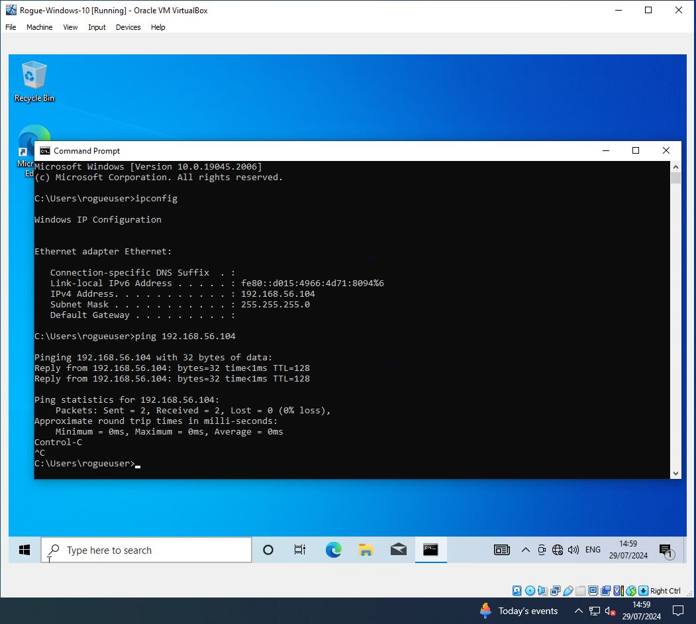
Figure 61 Windows 10 Home Network Connectivity

Windows 2019 Server Virtual machine
Setting up the Virtual Machine:
Start Oracle Virtual Box and open the virtual machine creation wizard by clicking “New". Name the VM "Windows-2019-Server" choose the storage location for VM files and the ISO image, select "Microsoft Windows" as the type, and "Windows 2019 (64-bit)" as the version. Click "Next." Assign 8192MB of RAM and specify 120GB of storage space for the virtual hard drive to create the virtual machine as depicted in the below figures.

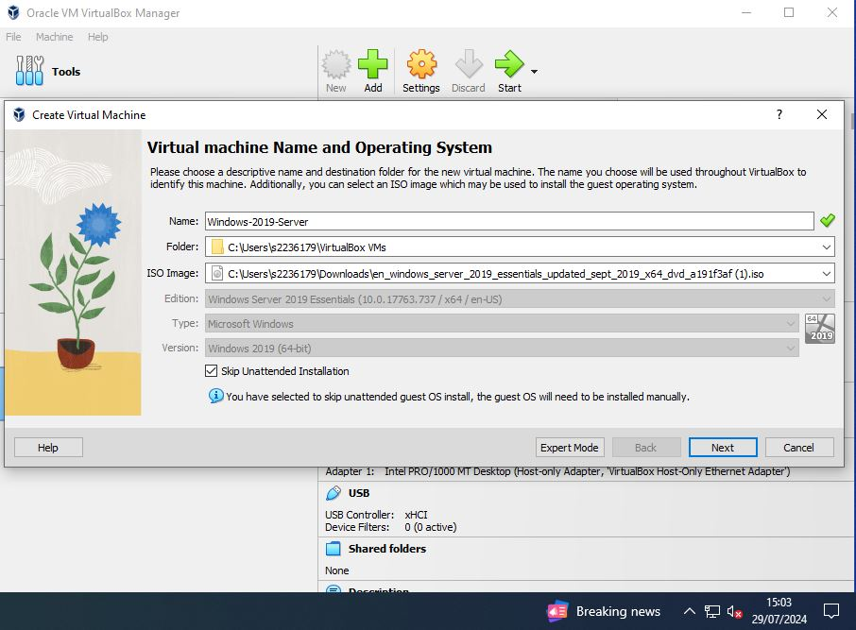
Figure 62 Windows 2019 Server VM Setup

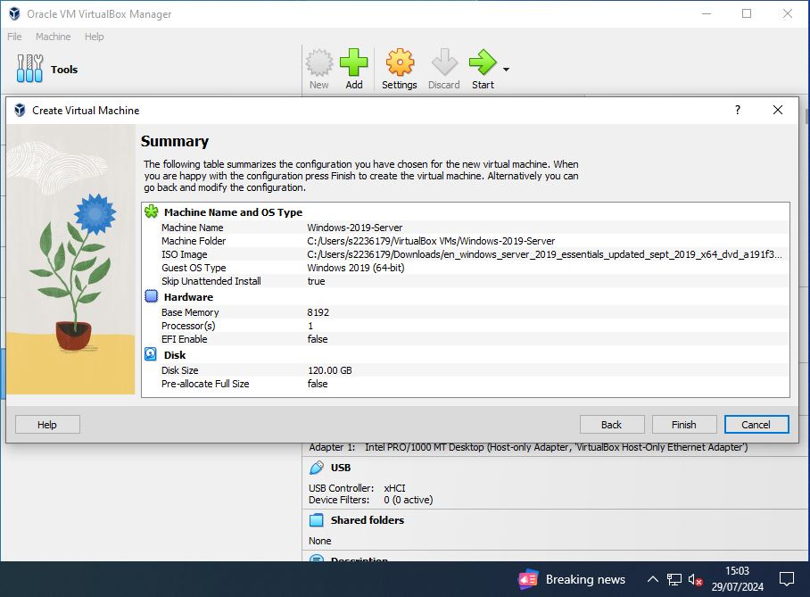
Figure 63 Windows 2019 Server VM Creation

Starting up Windows-2019-Server Virtual Machine:
Set the network adapter to "Host-Only Adapter". Select the VM and click "Start" to boot from the ISO. Follow the installation prompts to complete the Windows Server 2019 setup, including user account creation and system configuration. After installation, open Command Prompt, use ipconfig to check the IP address, and ping command to verify network connectivity as confirmed in the following figures.

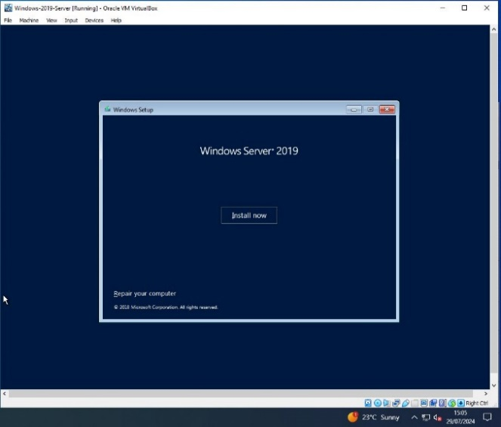
Figure 64 Windows 2019 Server OS Installation
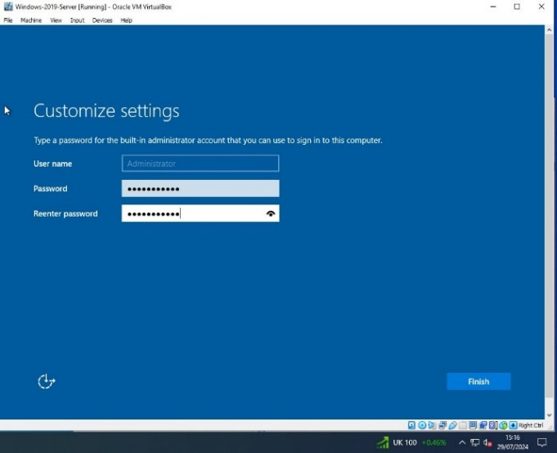
Figure 65 Windows 2019 Server Login Account Setup

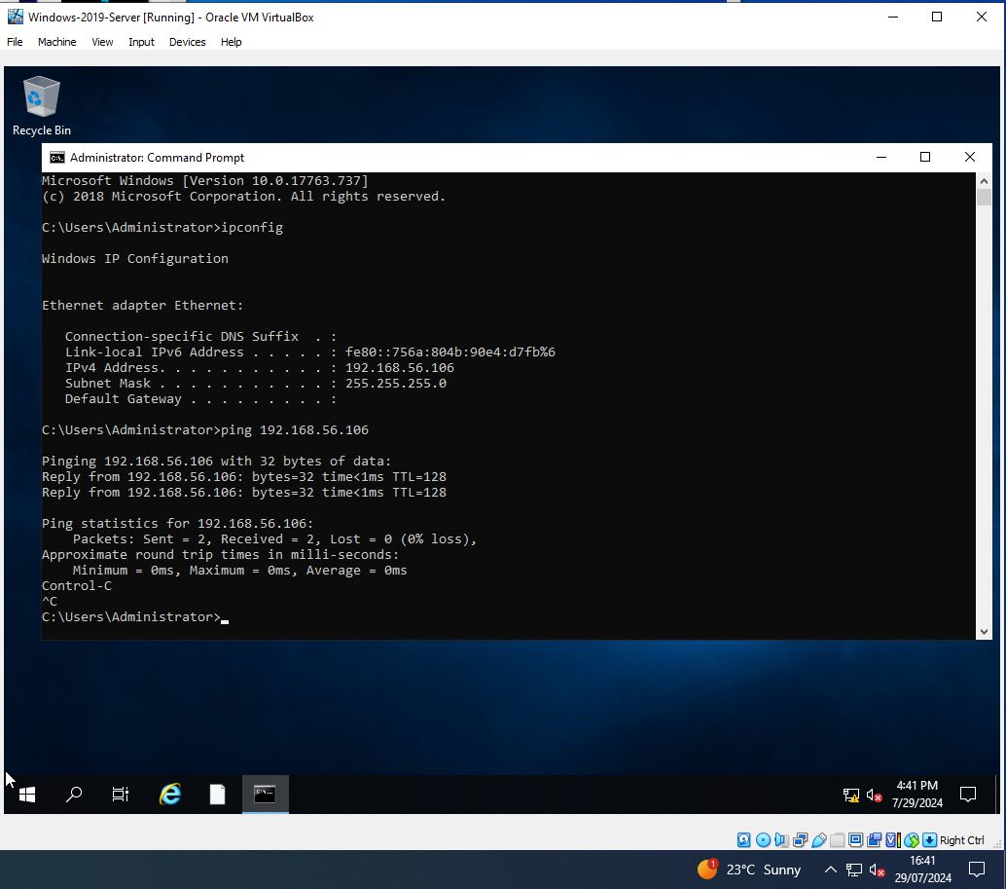
Figure 66 Windows 2019 Server Network Connectivity

Windows 10 Pro Virtual machine
Setting up the Virtual Machine:
Open Oracle VirtualBox and click "New" to launch the VM creation wizard. Configure the VM with the name "Windows-10-Pro," select the storage location for VM files and ISO image from the local drive. Choose "Windows" as the type and "Windows 10 (64-bit)" as the version, then click "Next." Allocate 8192 MB of RAM and 80 GB of disk space, then click "Create”.

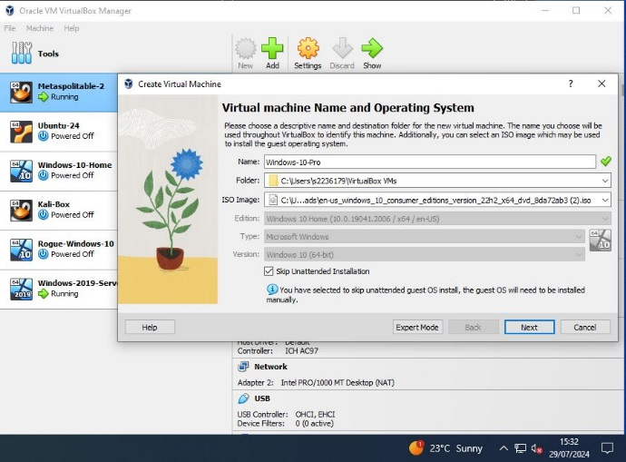
Figure 67 Windows 10 Pro VM Setup

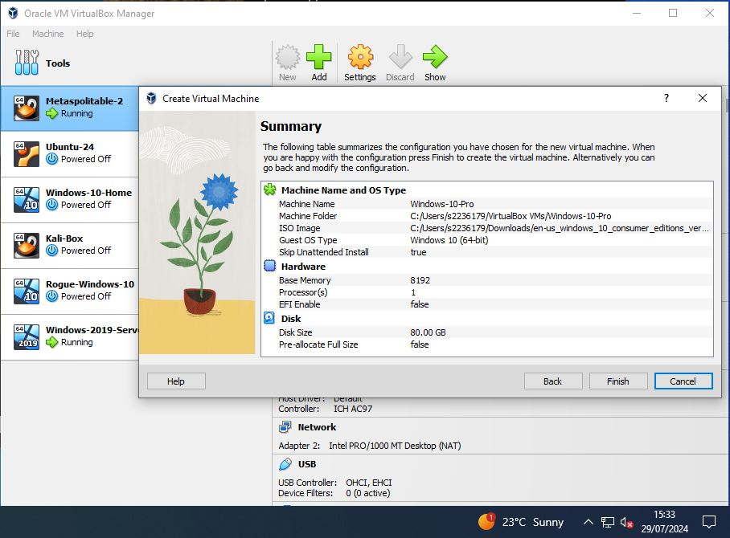
Figure 68 Windows 10 Pro VM Creation

Starting up Windows-10-Pro Virtual Machine:
Set the network adapter to "Host-Only Adapter". Boot the VM from the ISO to initiate the Windows 10 Pro installation. Follow the installation prompts to set up Windows 10 Pro, including user account creation, PIN and system personalization. Open Command Prompt, use ipconfig to check IP configuration, and employ the ping command to confirm connectivity within the host-only network as depicted in the below figures.

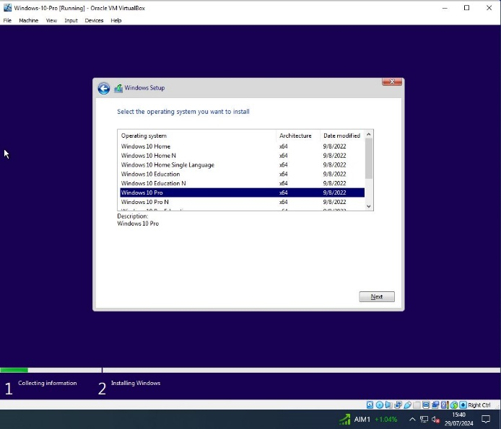
Figure 69 Windows 10 Pro OS Selection

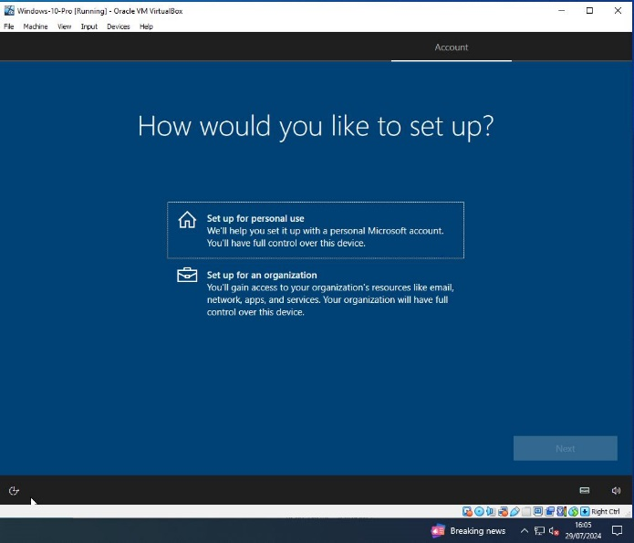
Figure 70 Personal Use Setup & Installation process

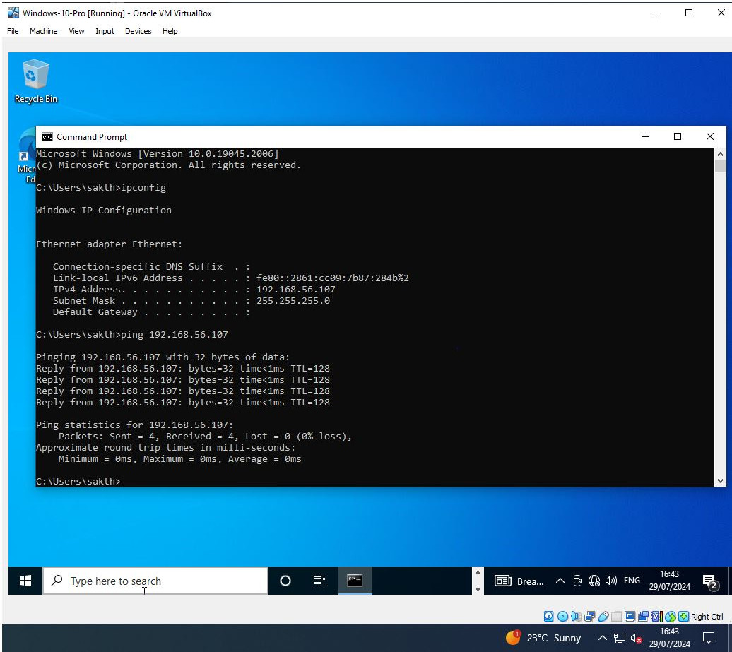

Figure 71 Windows 10 Pro Network Connectivity

Host-Only Adapter Network Communication

The Windows 2019 Server VM, Windows 10 Pro VM, Windows 10 Home VM, Kali Linux VM, and Metasploitable VM are configured on a host-only adapter network as shown in Figure 72. Two distinct test environments have been established: one focuses on testing the Metasploitable VM for vulnerabilities using the Kali VM, and the other uses Caldera in the Kali VM and Windows 10 Home VM to assess the security posture of the Windows 2019 Server acting as a domain controller. Each VM is assigned a unique DHCP IP address, and network connectivity is verified by successfully pinging between the VMs as confirmed in the following figures.

Windows 10 Home Rogue VM
IP Address:
192.168.56.104

Windows 10 Pro VM
IP Address: 192.168.56.107

Windows 2019 Server VM
Domain Controller
IP Address: 192.168.56.106

Attacker: Kali Linux VM
IP Address: 192.168.56.103

Metasploitable 2 VM
External IP Address: 192.168.56.102
Internal IP Address:
192.168.1.100

Figure 72 Host-only Adapter Network Setup

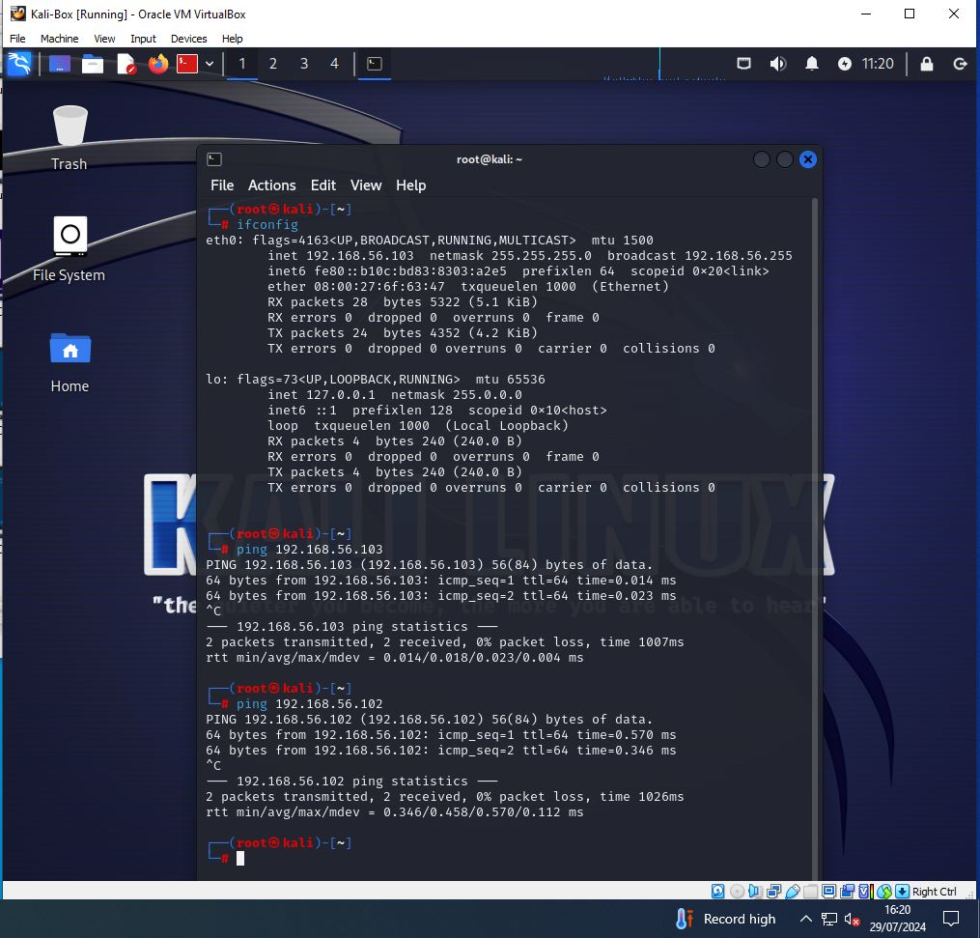
Figure 73 Kali Linux/Metaspoitable Host-only Adapter Network Connectivity
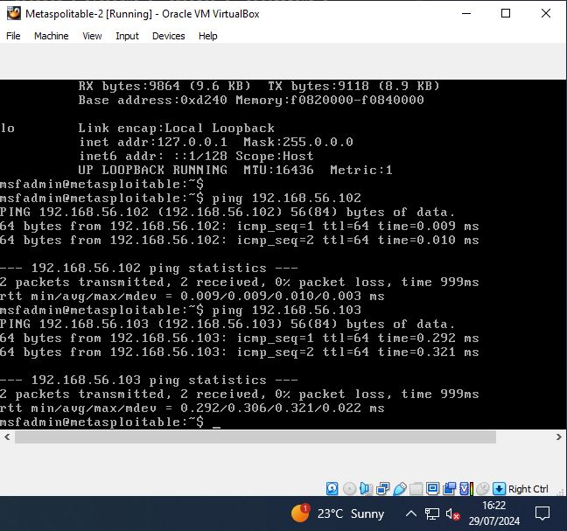
Figure 74 Metaspoitable/Kali Linux Host-only Adapter Network Connectivity

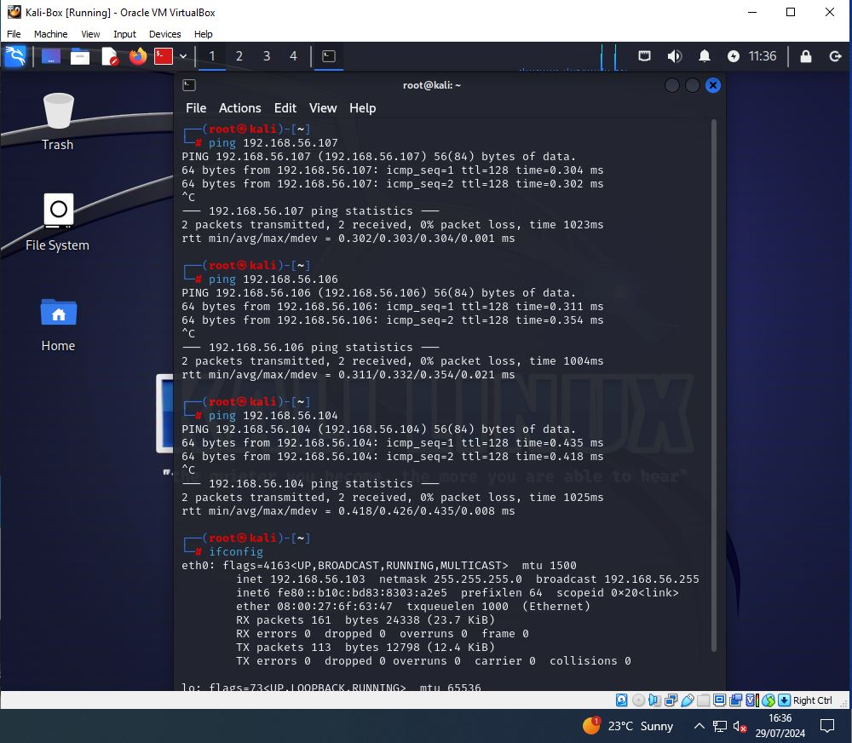
Figure 75 Kali Linux/Windows Domain Host-only Adapter Network Connectivity

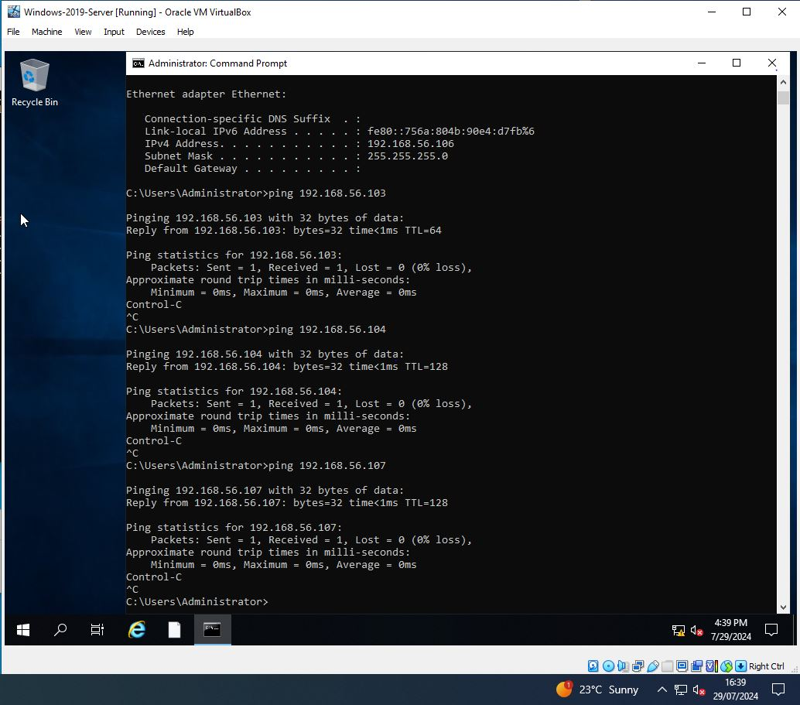
Figure 76 Windows 2019 Server Host-only Adapter Network Setup & Connectivity

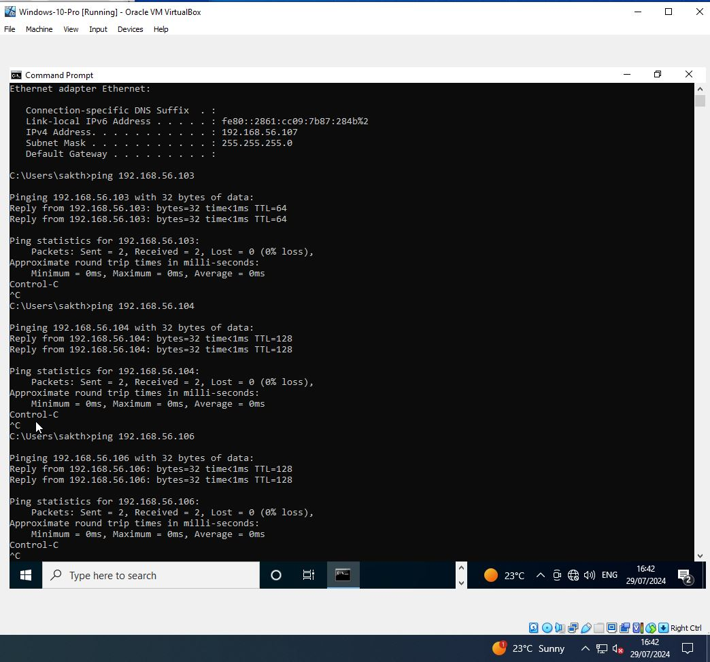
Figure 77 Windows 10 Pro Host-only Adapter Network Setup & Connectivity
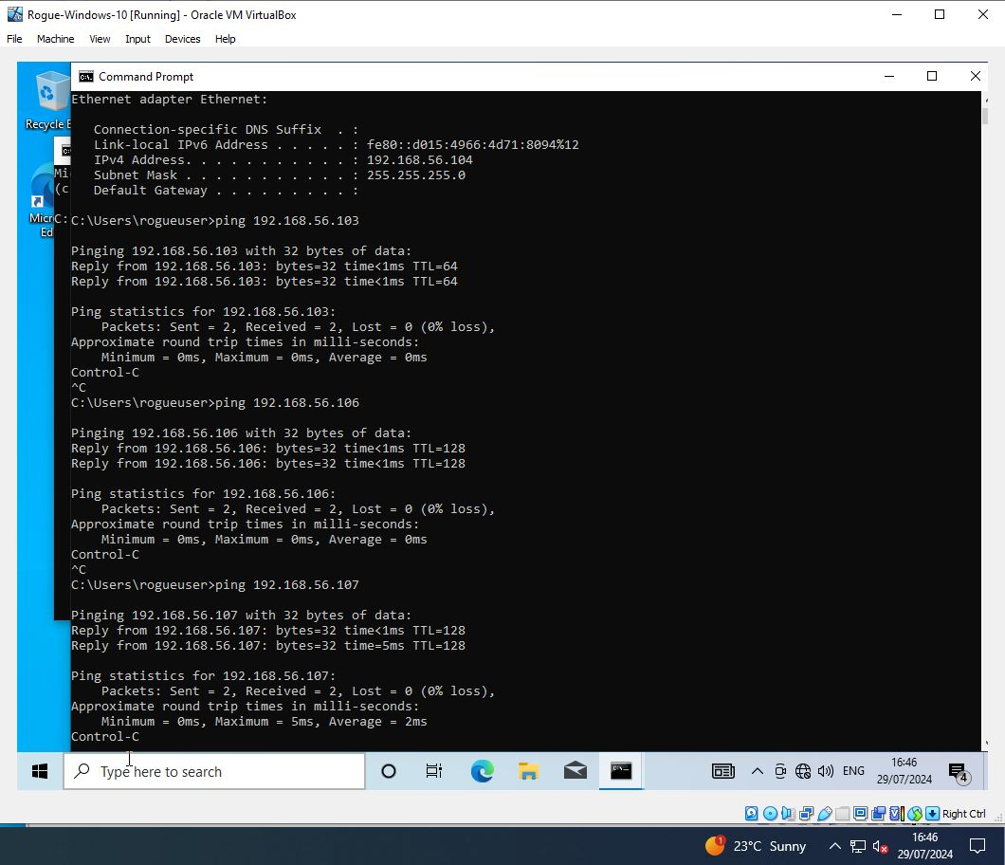

Figure 78 Windows 10 Home Host-only Adapter Network Setup & Connectivity

Oracle VirtualBox Setup
The setup of VMs including Metasploitable 2, Kali Linux, Ubuntu 24, Windows 10 Home, and Windows Server 2019 in Oracle VirtualBox is complete as shown in Figure 79. We can now proceed with experiments using this configured network environment.
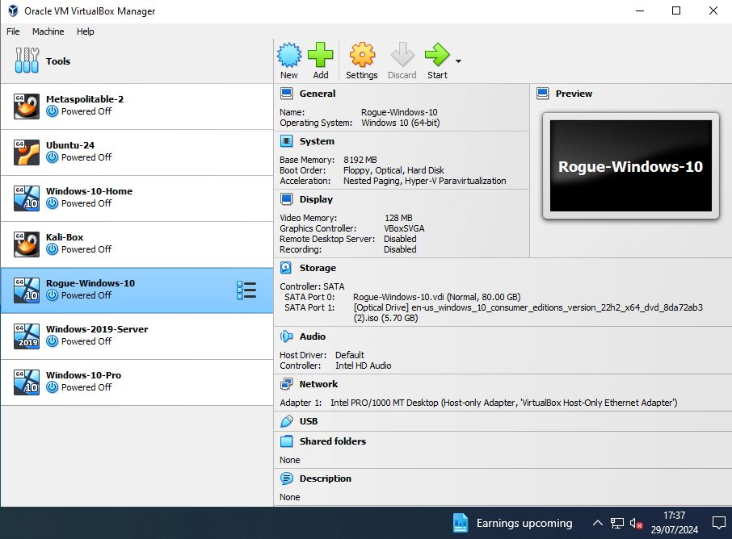
Figure 79 Oracle VirtualBox Network Setup

Conclusion
This chapter details the setup of various virtual machines in Oracle VirtualBox, including Metasploitable 2, Kali Linux, Ubuntu 24 LTS, Windows 10 Home, and Windows Server 2019, for a comprehensive Vulnerability Assessment and Penetration Testing (VAPT) environment. The configuration utilizes host-only and internal network settings to simulate an isolated network. Key tools like Metasploit, Caldera, and the MITRE ATT&CK framework are integrated to enhance testing realism. This setup allows for thorough vulnerability identification, exploitation, and remediation, ensuring a robust assessment and improvement of the security posture. The design and implementation underscore the importance of a methodical and iterative process in cybersecurity assessments.

Testing and Evaluation

Introduction
Integrating MITRE ATT&CK with VAPT's nine stages improves threat modeling, attack coverage, and testing realism, enhancing vulnerability detection, risk management, and security. This approach is useful for penetration testers and security professionals, ensuring accuracy and resource efficiency, validated through experimental assessment and analysis.

VAPT Methodology
The Vulnerability Assessment and Penetration Testing (VAPT) methodology is a structured approach for identifying and mitigating security vulnerabilities. It consists of nine phases:
Scope: The testing approach is defined
Reconnaissance: Gathering target information
Vulnerability Detection: Identifying system weaknesses
Information Analysis and Planning: Strategizing for penetration testing.
Penetration Testing: Simulating attacks
Privilege Escalation: Gaining deeper access
Result Analysis: Understanding vulnerability implications
Reporting: Documenting findings and recommendations.
Cleanup: Remove threats, restore systems, and secure access.

Testing

Metasploitable Test Scenario
Metasploitable, Windows 10, and Ubuntu VMs are in the internal network [192.168.1.0/24], while Kali VM [192.168.56.103] attacks Metasploitable [192.168.56.102] as in Figure 80. We’ll explore penetration testing activities at each stage of the VAPT methodology including SSH Login Exploit, DISTCC Remote Code Execution on Metasploitable VM, and SAMBA Exploit and DOS attack on the Windows VM.

Attacker: Kali Linux VM
IP Address: 192.168.56.103

Metasploitable 2 VM
External IP Address: 192.168.56.102
Internal IP Address:
192.168.1.100

Ubuntu 24 VM
IP Address:
192.168.1.101

Windows 10 Home VM
IP Address:
192.168.1.102

Figure 80 Metasploitable Test Setup

Vulnerability Assessment
Vulnerability assessment identifies and analyzes system weaknesses to protect businesses before attackers exploit them. It focuses on gathering information to uncover vulnerabilities and strengthen security, ensuring that potential threats are addressed proactively. Key phases from VAPT includes,
- Scope
- Reconnaissance
- Vulnerability Detection
- Information Analysis and Planning

Scope:
The scope phase in VAPT helps pentesters focus on agreed-upon vulnerabilities, ensuring targeted testing, while benefiting stakeholders by aligning security efforts with business priorities and risks. Understanding network layout is essential, with “ifconfig” aiding in identifying interfaces and IP addresses as shown in Figure 81.

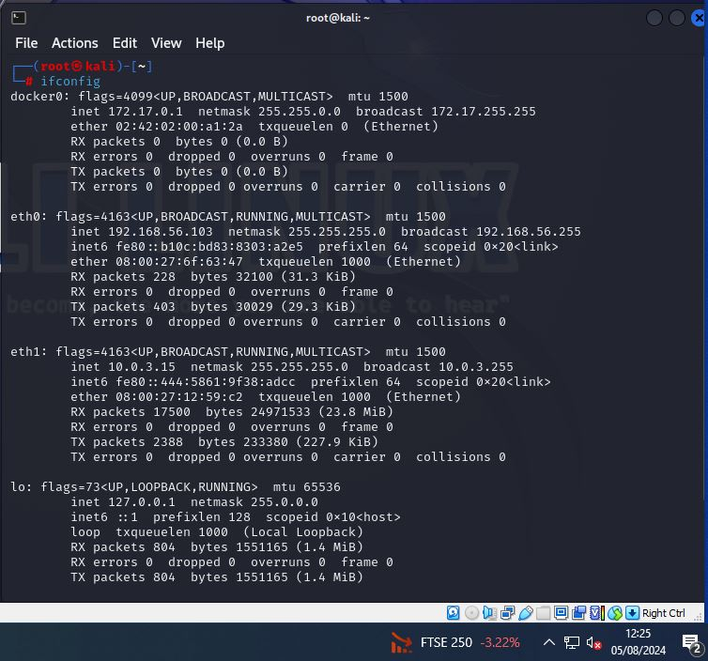
Figure 81 Kali Linux - Ifconfig Output

Reconnaissance:
The reconnaissance phase in VAPT helps pentesters identify potential vulnerabilities, benefiting companies by enabling targeted, efficient security testing. Figure 82 shows how “ifconfig” for passive reconnaissance with “tcpdump” discreetly identify host IPs in the [192.168.56.0/24] network.

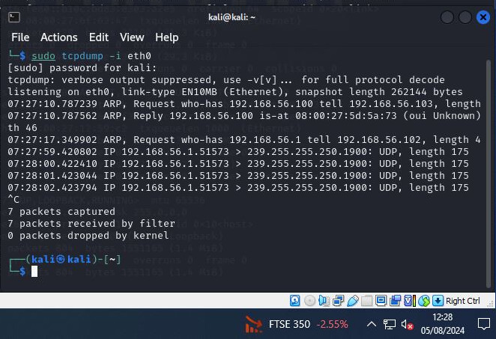
Figure 82 Kali Linux - TCPDUMP Output

Figure 83 shows "Netdiscover" confirms active hosts from "tcpdump" data, refining scope. "Nmblookup" identifies a Metasploitable machine, highlighting its exploitation potential.
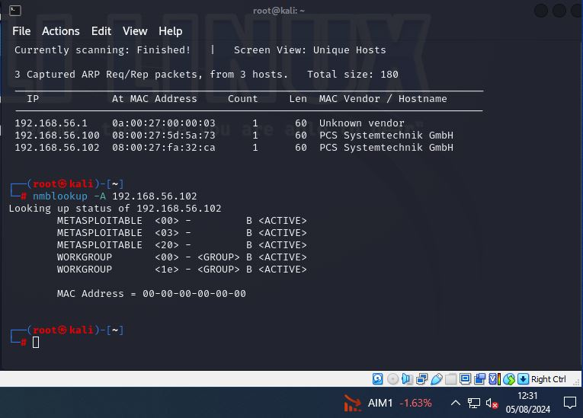
Figure 83 Kali Linux - Active Reconnaissance Tools

Spiderfoot's active scan on the Metasploitable machine identifies vulnerable ports, notably SSH banner on port 22, providing comprehensive security insights as in below Figures.
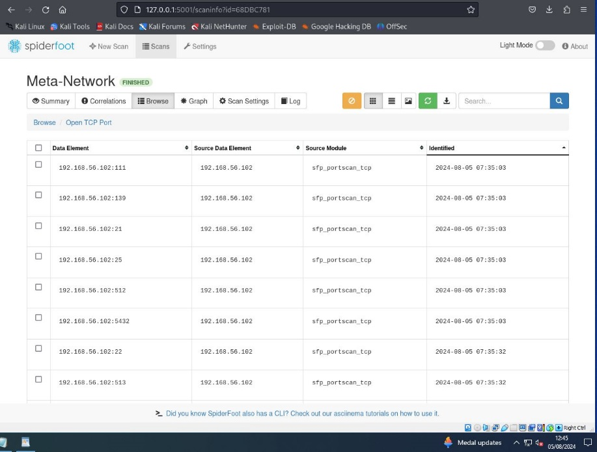
Figure 84 Kali Linux - Spiderfoot Open TCP Ports

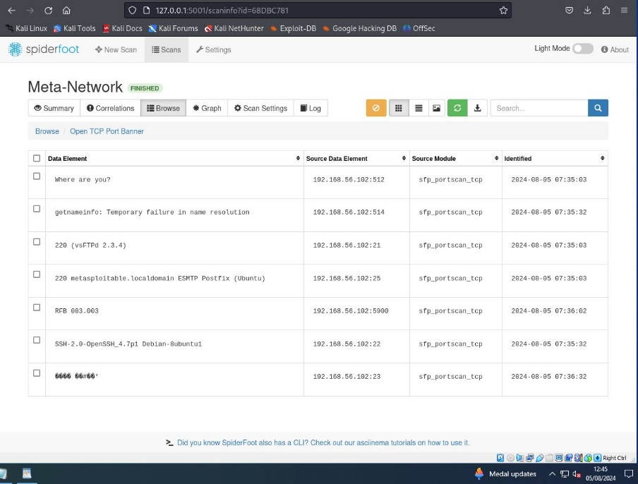
Figure 85 Kali Linux - Spiderfoot Open TCP Port Banner

Vulnerability Detection:
Reconnaissance findings guide pentesters execute targeted vulnerability detection, optimizing scope and effectiveness. OpenVAS identified 13 high-severity vulnerabilities, including critical Distcc RCE, on the Metasploitable VM, essential for focused remediation and enhancing security posture, as shown in Figure 86.
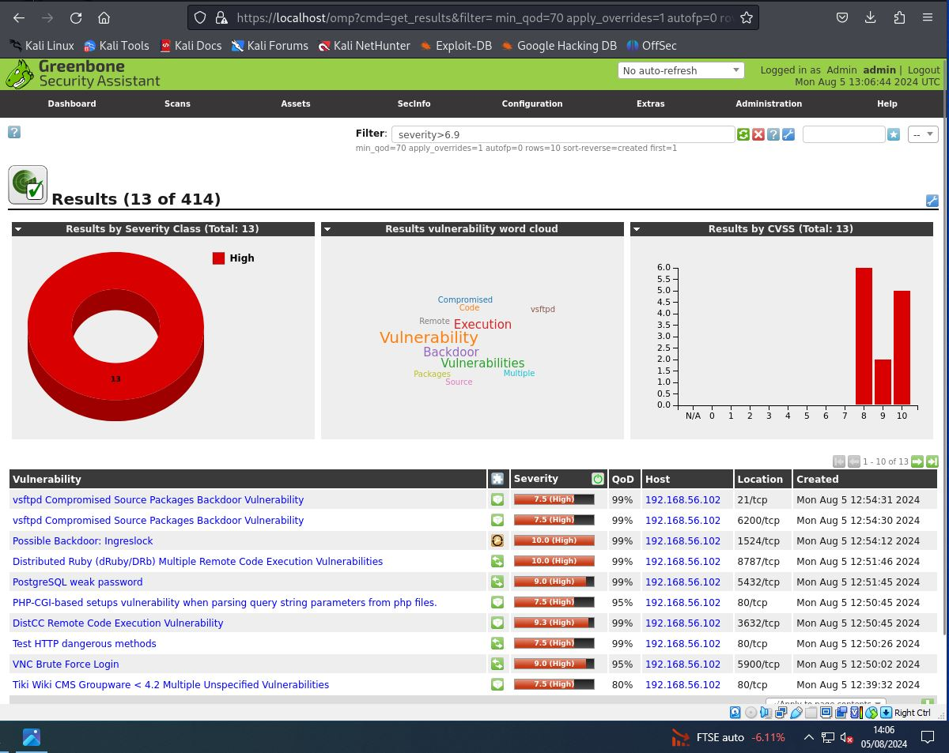
Figure 86 Kali Linux - Openvas Scan Results

Information Analysis and Planning:
Information analysis reveals critical vulnerabilities like Distcc RCE and SSH Login Banner on port 22, guiding focused penetration testing to exploit and address these security weaknesses effectively.

Penetration Testing
Incorporating MITRE ATT&CK in penetration testing aligns with real-world attack techniques, enhancing threat simulations and improving security defenses for companies. It helps to optimize resource use for a thorough security assessment, demonstrated on Metasploitable VM.

Session: 1 DistCC Remote Code Execution
DistCC 2.x in XCode 1.5 allows remote attackers to execute commands due to unrestricted port access, posing significant risks. [33] A remote session is established with the Metasploitable machine as shown in Figure 87. This attack method help pentesters simulate command execution vulnerabilities, improving detection and remediation.
Tactic: Execution
Technique: Exploitation for Client Execution [T1203]
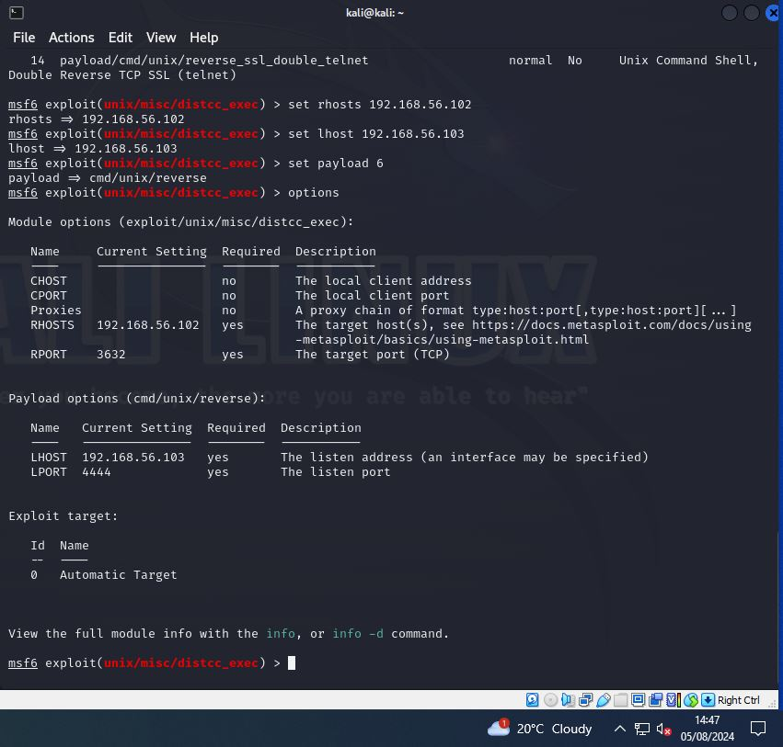
Figure 87 Kali Linux - Metasploit Distcc Exploit Execution

After establishing a remote shell, executing the “ifconfig” command in Figure 88, reveals available network interfaces and IP addresses. This attack method help pentesters map networks and identify exploitable targets.
Tactic: Discovery
Technique: Remote System Discovery [T1018]
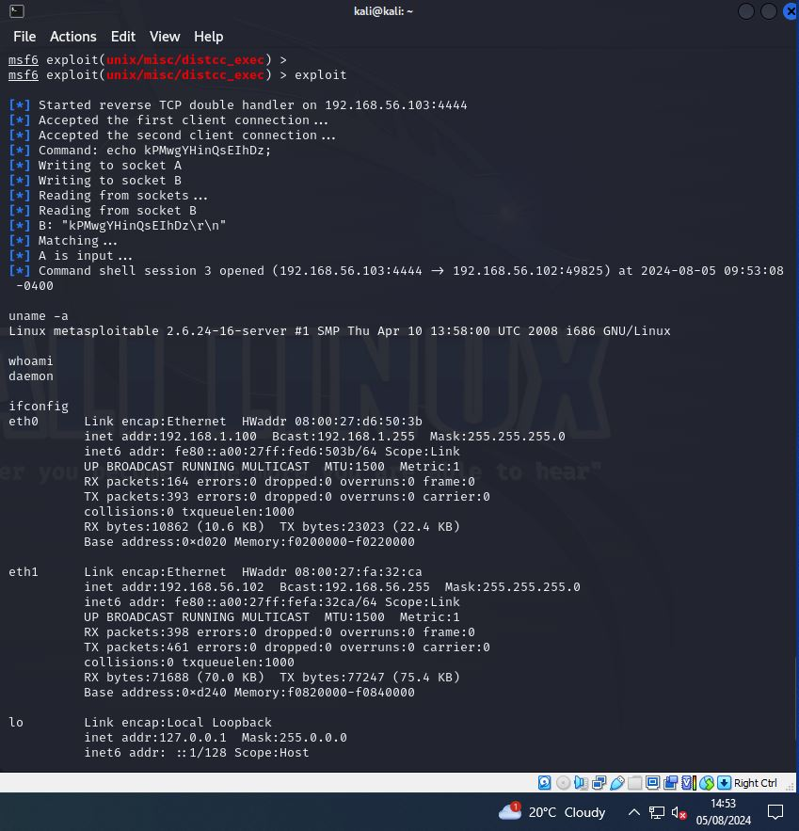
Figure 88 Kali Linux - Metasploitable Ifconfig Output

An internal network is found on Metasploitable VM. An Nmap scan on the network, 192.168.1.0/24” reveals one active host, 192.168.1.102, with open ports and another host, 192.168.1.101 with all the closed ports as in Figure 89. This attack method help pentesters identify open ports and active hosts.
Tactic: Discovery
Technique: Network Service Discovery [T1046]

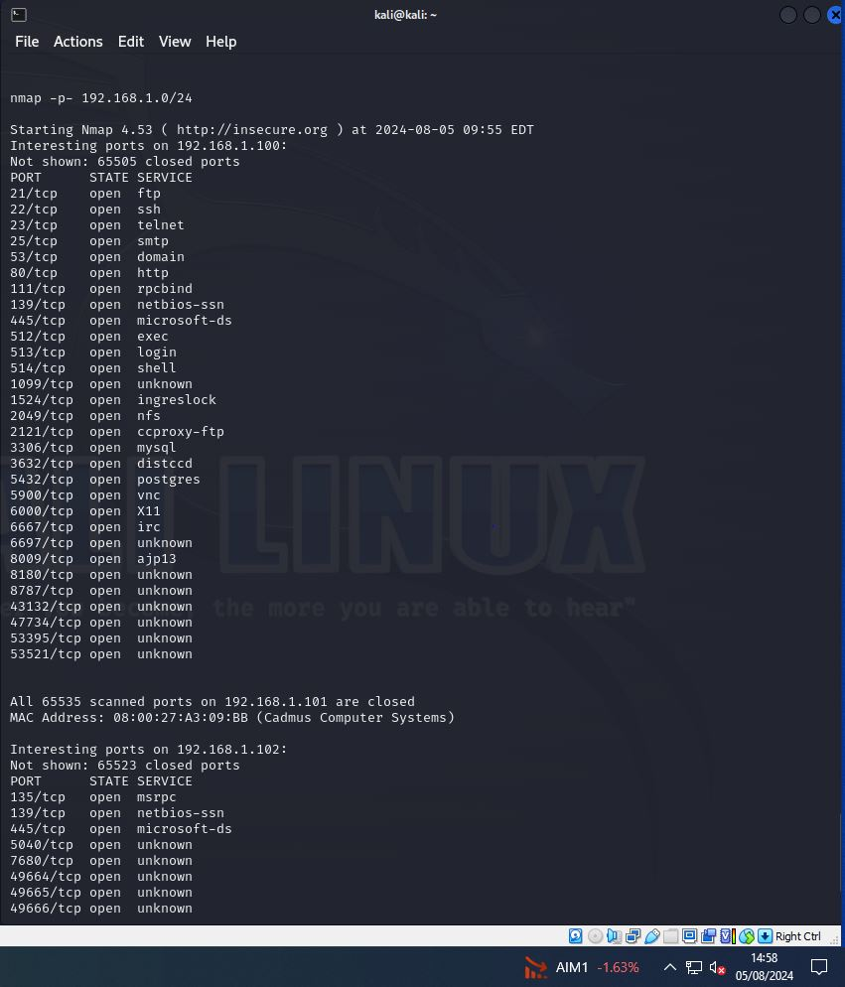
Figure 89 Kali Linux - Metasploitable Nmap Port Scan Results

Case: 1 DOS Attack Scenario
DOS attack is launched using the command “nmap –sS 192.168.1.102” in Figure 92, floods the Windows 10 Home VM in the internal network with SYN packets as in Figure 90, causing potential disruption or unavailability. DOS attack scenario in MITRE ATT&CK Framework impacts the system availability by overwhelming it with the traffic. This attack method help pentesters assess system resilience and mitigate disruption risks
Tactic: Impact
Technique: Network Denial of Service [T1498]
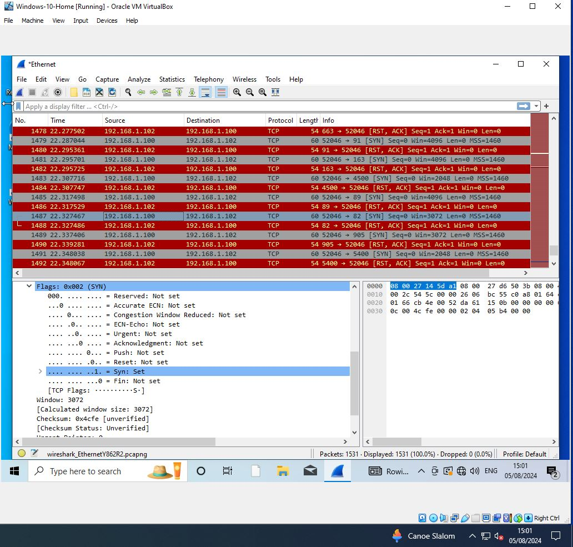
Figure 90 Windows 10 Home - Wireshark SYN Packet Capture

The Windows 10 Home VM responds to the SYN flood with RST flags as indicated in Figure 91, indicating it rejects the connection attempts. This response shows the system's defensive behavior against SYN floods. As a result, the DOS attack resulted in system disruption and connection rejection. This attack method help pentesters evaluate and improve system defenses against attacks.
Tactic: Defense Evasion
Technique: Network Denial of Service Mitigation [T1499.001]

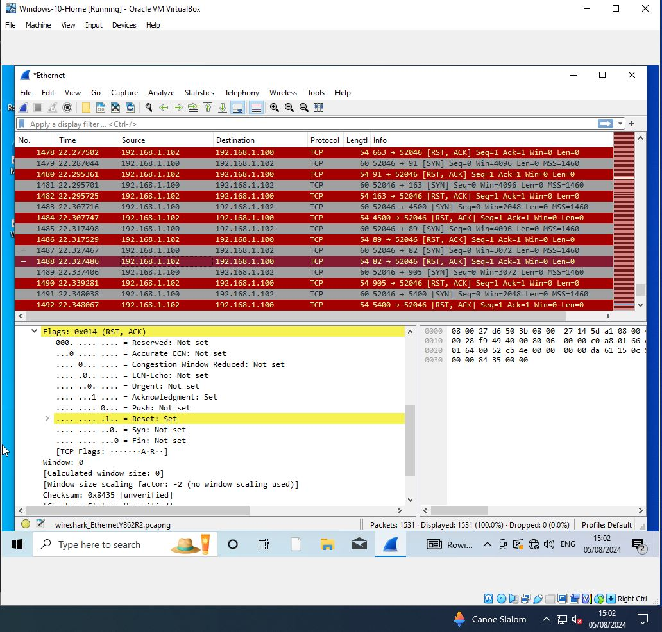
Figure 91 Windows 10 Home - Wireshark RST Packet Capture

Case: 2 SMB Attack Scenario
An Nmap SYN scan followed by an Nmap service scan revealed active SMB services on ports 139 and 445 on the Windows 10 VM. These open ports indicate potential vulnerabilities in network file sharing, warranting further exploitation. SMB port discovery identifies potential vulnerabilities for targeted exploitation.
Tactic: Discovery
Technique: Network Service Discovery [T1046]
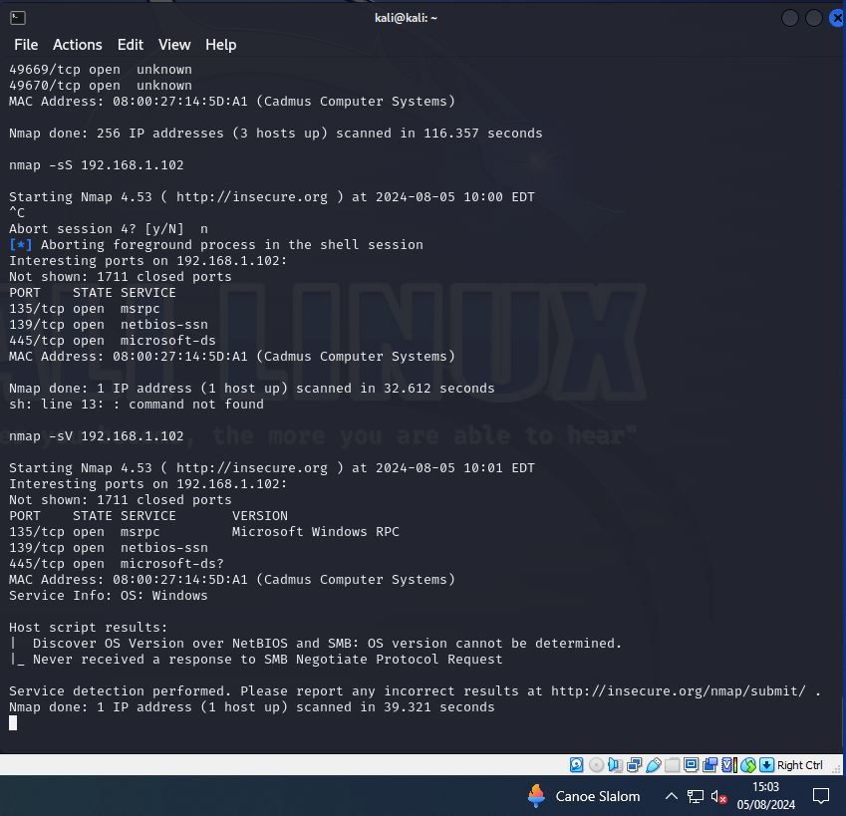
Figure 92 Kali Linux - Metasploitable Nmap Scan Results

“nmap –interactive” enables command execution during scans; “!sh” invokes a shell, aiding privilege escalation to execute commands as in Figure 93. This attack method allows command execution, aiding privilege escalation by exploiting control mechanisms.
Tactic: Privilege Escalation
Technique: Abuse Elevation Control Mechanism [T1548]
The “cat /etc/shadow” command reveals hashed passwords as in Figure 93. This attack method reveals hashed passwords aids pentesters in cracking credentials for access.
Tactic: Credential Access
Technique: OS Credential Dumping - /etc/shadow [T1003.008]
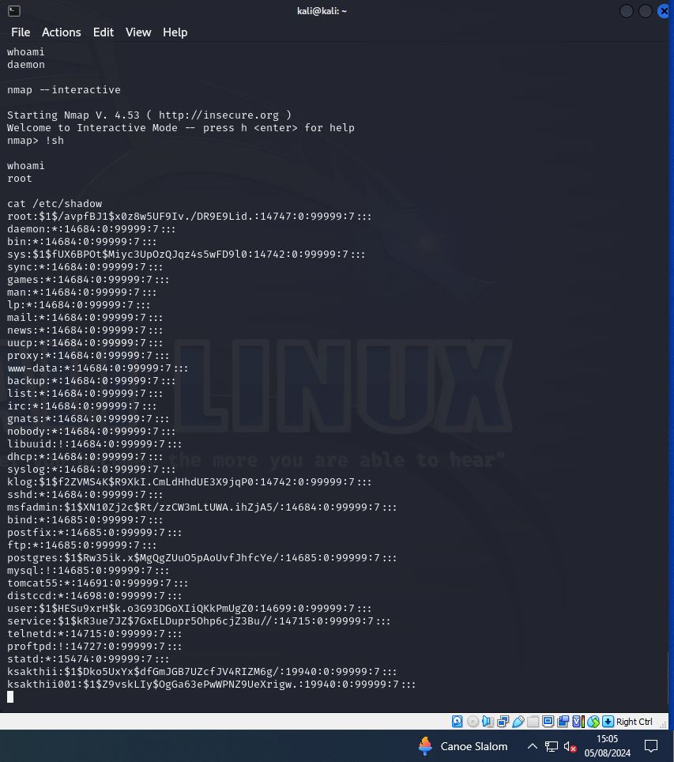
Figure 93 Kali Linux - Metasploitable Shell Command Outputs

“Johnny”, a GUI for John the Ripper, facilitates password cracking, revealing weak passwords for three user accounts, highlighting critical vulnerabilities in account security. Brute force cracking reveals weak passwords, aiding in credential access.
Tactic: Credential Access
Technique: Brute Force - Password Cracking [T1110.002]
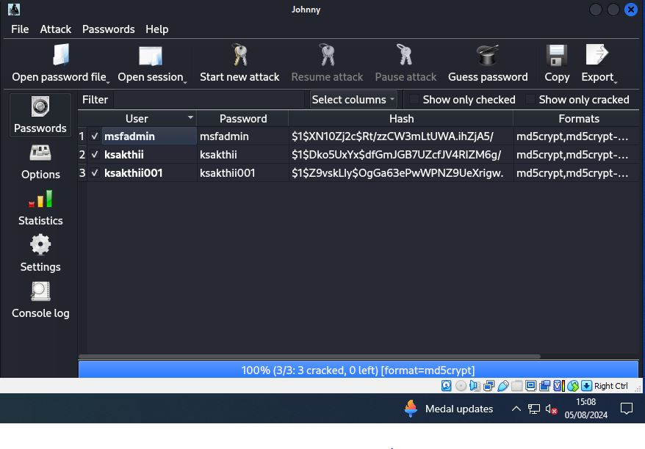
Figure 94 Kali Linux - Johnny Password Cracker

Despite no open ports on Ubuntu, it is used to access SMB services on Windows 10 VM. The IP address [192.168.1.101] identifies Ubuntu within the internal network, as shown in Figure 95.
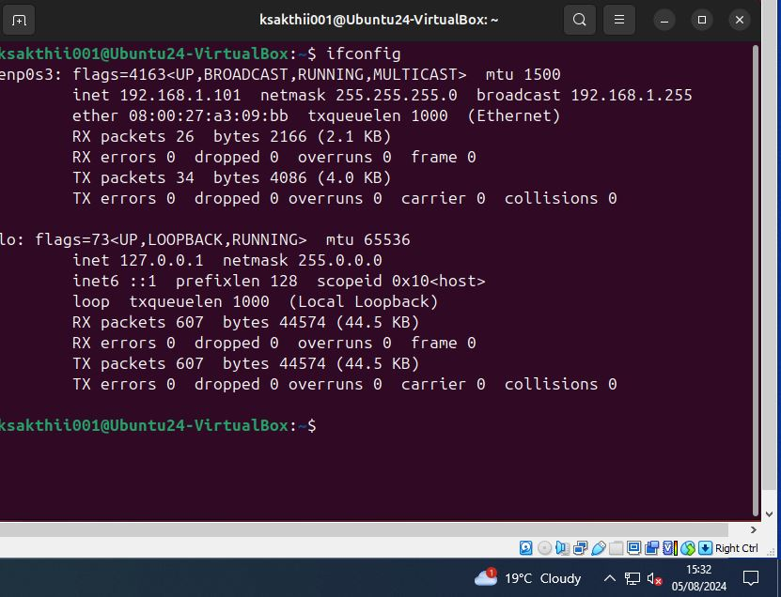
Figure 95 Ubuntu VM - Ifconfig Output

Figure 96 shows the access to the "share" folder on the Windows 10 VM is gained from the Ubuntu VM, allowing file upload using “smbclient”. Gaining SMB access allows pentesters to control remote systems and test security.
Tactic: Lateral Movement
Technique: Remote Services - SMB/Windows Admin Shares [T1021.002]
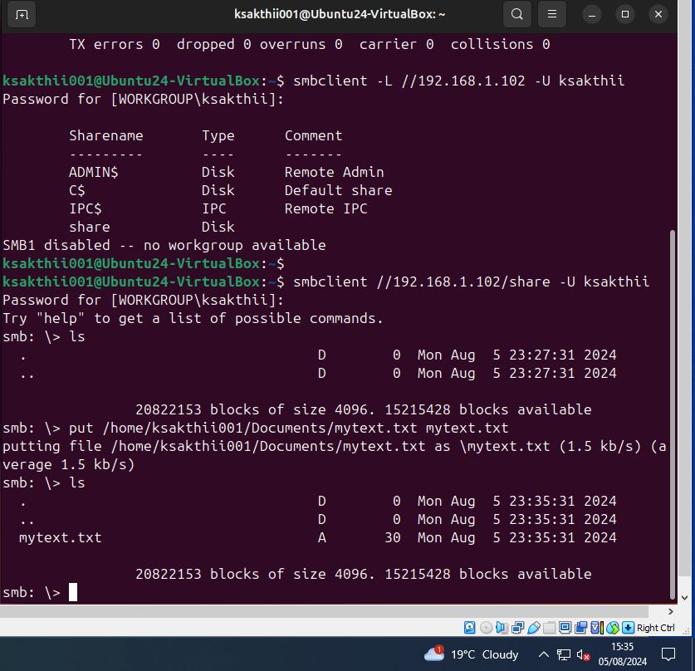

Figure 96 Ubuntu VM - SMB File Share Access Outputs

This attack scenario effectively uses SMB for discovering vulnerabilities, escalating privileges, accessing credentials, and performing lateral movements within the network.

Session: 2
Case: 3 SSH Login Attack Scenario
The “auxiliary/scanner/ssh/ssh_login” Metasploit module brute-forces SSH credentials on the Metasploitable VM, exploiting weak passwords by using predefined username and password files to gain unauthorized access shown in Figure 97. Using Metasploit to brute-force weak SSH credentials simulates a Credential Access attack scenario. Brute-forcing weak SSH credentials reveals vulnerabilities and assesses security robustness.
Tactic: Credential Access
Technique: Brute Force - Credential Stuffing [T1110.004]
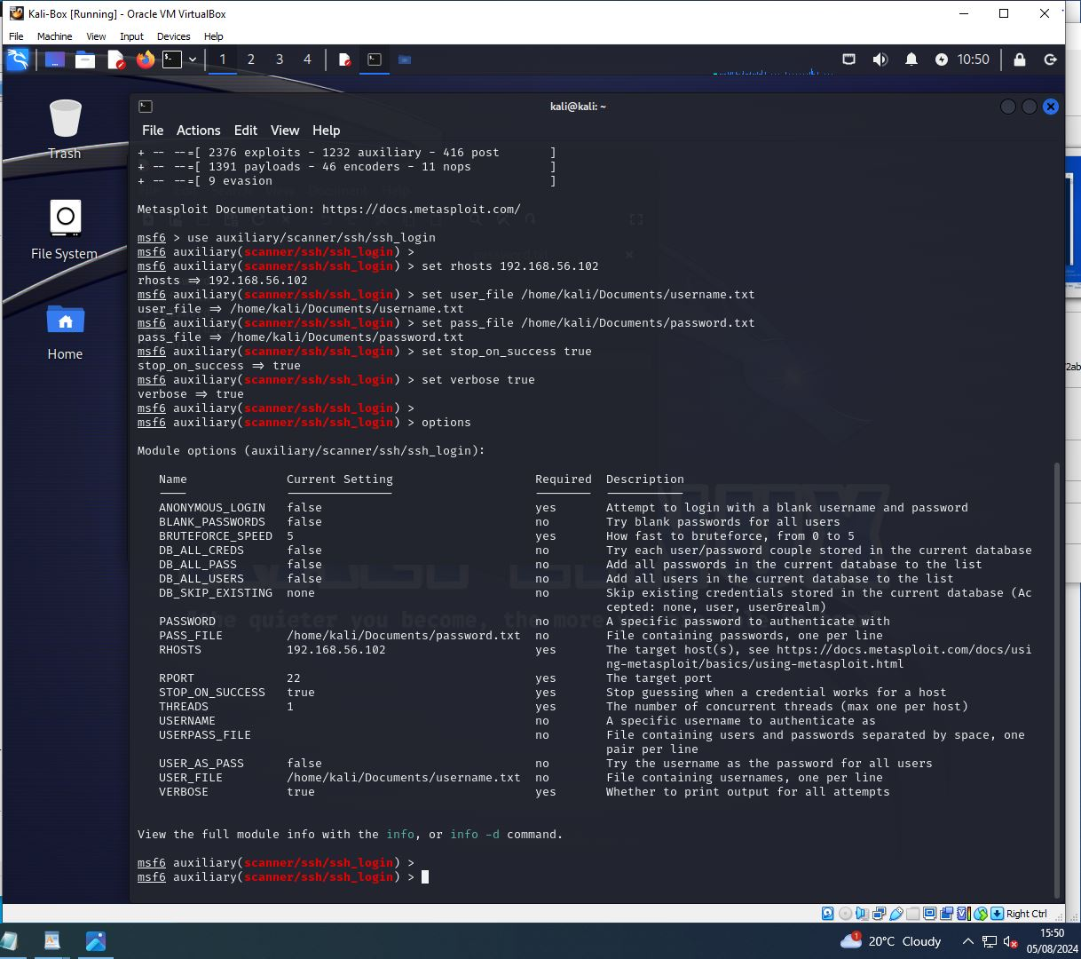
Figure 97 Kali Linux - Metasploit SSH Login Options

Metasploit’s SSH brute-force attempt failed due to consistent timeouts, even with adjusted “Bruteforce_speed” and “threads”, blocking access as in Figure 98.
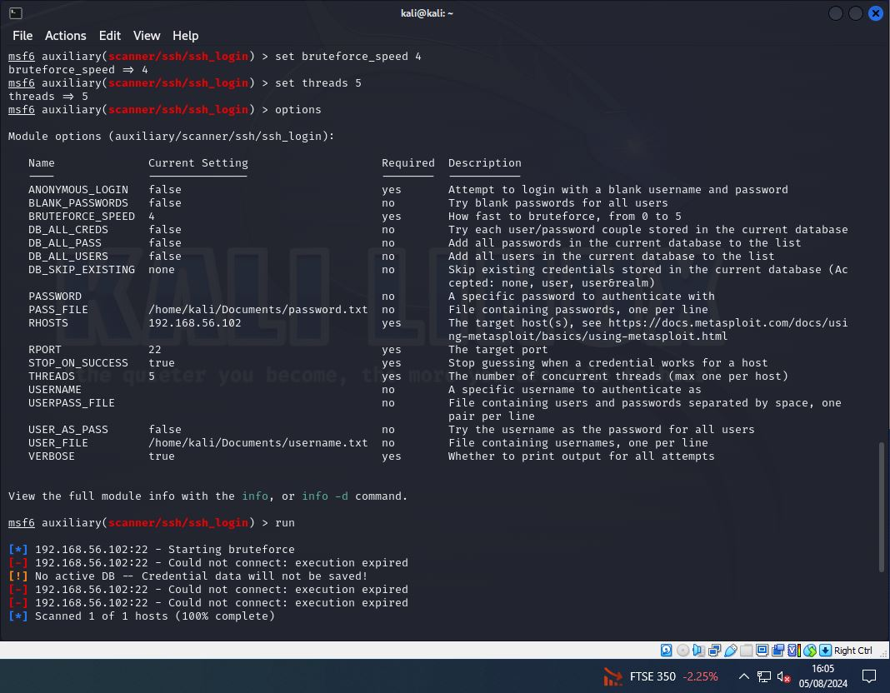
Figure 98 Kali Linux - Metasploit SSH Login - Connection Expired

Figure 99 depicts successful SSH login with default credentials (msfadmin) validated the exploit and bypassed timeout issues.
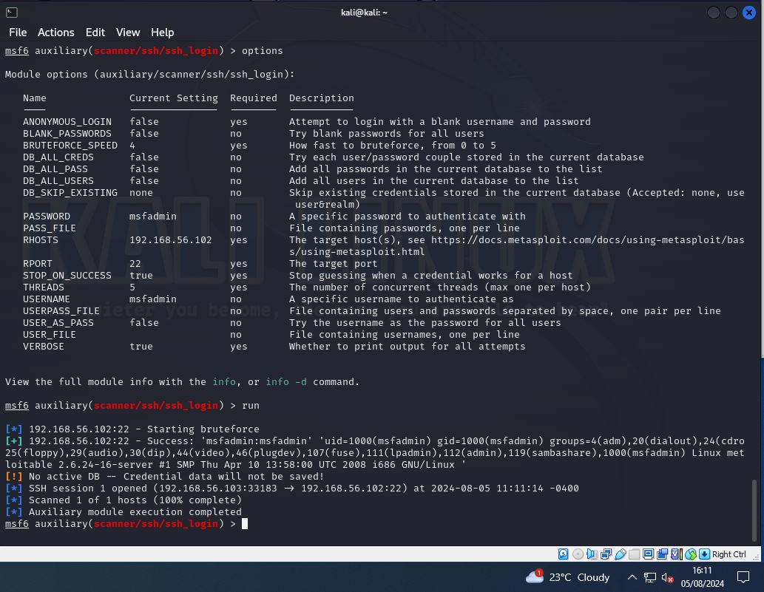
Figure 99 Kali Linux - Metasploit SSH Login Succeeded

SSH access is gained successfully from Kali Linux VM using default credentials, confirming login to the Metasploitable VM depicted in Figure 100. Validating default credentials enables initial access and verifies weak security controls.
Tactic: Initial Access
Technique: Valid Accounts - Default Accounts [T1078.001]

Successful privilege escalation is achieved using “sudo su” command, gaining root access on the system as illustrated in Figure 100. Gaining root access via “sudo” exposes privilege escalation vulnerabilities for testing.
Tactic: Privilege Escalation
Technique: Abuse Elevation Control Mechanism - Sudo and Sudo Caching [T1548.003]
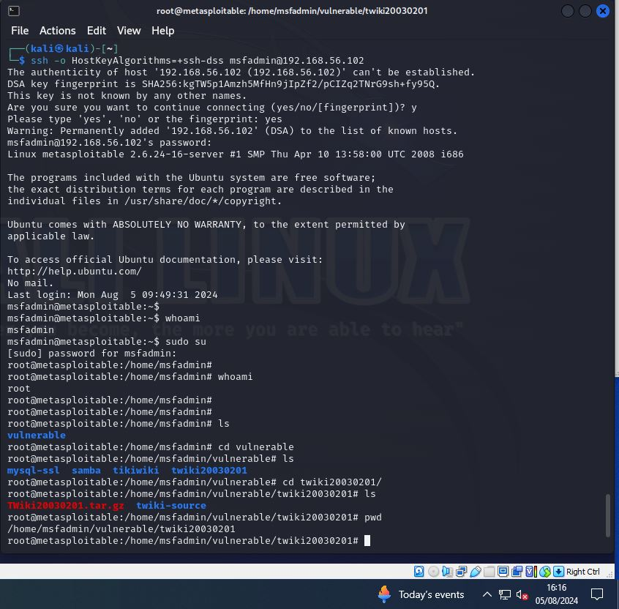
Figure 100 Kali Linux - SSH Login Command Output
Successfully have accessed the local file share on Metasploitable VM with root privileges as in Figure 101. Accessing local file shares with root privileges reveals data collection vulnerabilities.
Tactic: Collection
Technique: Data from Local System [T1005]

SCP with default credentials successfully downloaded files to Kali Linux VM, confirming access to Metasploitable VM’s file system in Figure 101. This helps pentesters evaluate data exfiltration risks, test security controls, and identify vulnerabilities in default configurations, enhancing overall security posture.
Tactic: Exfiltration
Technique: Exfiltration over C2 Channel [T1041]

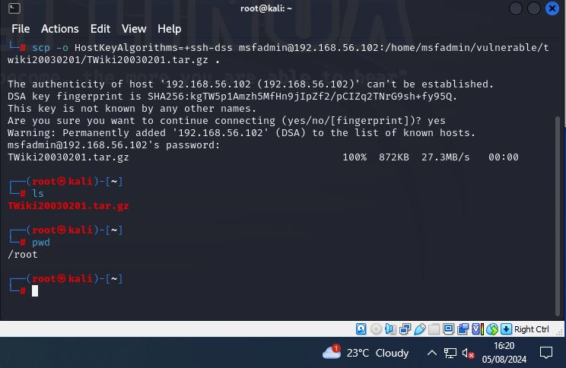
Figure 101 Kali Linux - SCP Access Successful

The credential access attack scenario concludes with successful exploitation using default credentials, privilege escalation to root, and data collection from the local file share, demonstrating critical security weaknesses.

Reporting
Reports detail vulnerabilities, their severity, successful exploits, and guide stakeholders in prioritizing remediation efforts. We are summarizing here, the below phases in VAPT methodology
- Result Analysis
- Reporting
- Cleanup
Result Analysis:
The result analysis phase in VAPT with MITRE ATT&CK framework helps pentesters identify critical vulnerabilities and refine testing strategies, providing companies with actionable insights to enhance security and mitigate risks effectively. The vulnerability implications from DoS, SMB, and SSH attack scenarios highlight critical security gaps:
DoS Attack: The SYN flood attack revealed system availability issues, with defensive responses showing a need for better DoS mitigation strategies.
SMB Attack: Exploitation of SMB services (ports 139, 445) allowed unauthorized file access and lateral movement, emphasizing the need for improved SMB security and patch management.
SSH Login Attack: Exploiting weak default credentials led to unauthorized SSH access, privilege escalation, and data extraction, underscoring the necessity for robust authentication and privilege management controls.
These findings stress the importance of enhancing security measures and proactive vulnerability management.
Reporting:
The reporting phase in VAPT helps pentesters document findings clearly and comprehensively, enabling companies to understand vulnerabilities, prioritize remediation, and improve overall security posture. Here are the outcomes of the attacks,
DOS Attack: The Windows 10 Home VM sends RST packets, terminating connections, indicating no DoS vulnerability exploitation.
SMB Attack: Successfully uploaded a file to the "share" folder on Windows 10 Home VM, confirming write access via SMB as shown in Figure 102.
SSH Login Attack: Successfully downloaded a file to Kali Linux VM, confirming access to the Metasploitable VM using SSH as shown in Figure 103.
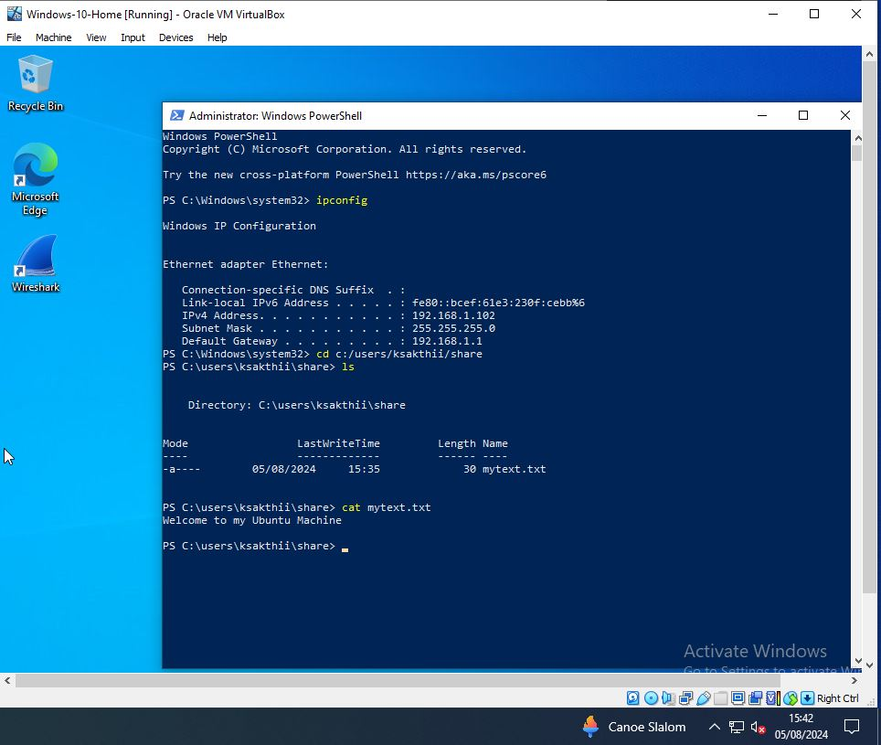
Figure 102 Windows 10 Home - SMB File Share Upload Output

Figure 103 Kali Linux - SCP File Download Output

Implement fixes, patches, and monitor continuously for long-term security. Here are the steps to be taken to remediate these attacks:
DOS Attack: No remediation needed; Windows handled attack.
SMB Attack Remediation:
- Restrict write permissions and secure SMB shares.
- Remove the unwanted files and directories.
- Enable firewalls at all times.
- Use strong passwords
- Apply security patches
- Implement Network Segmentation
SSH Login Attack Remediation:
- Enforce complex passwords.
- Use public/private key pairs.
- Block after failed attempts.
- Disable Root logins
- Apply patches and updates
- Track and Review access
- Disconnect unauthorized sessions as in Figure 105.

Cleanup:
The cleanup phase in VAPT removes any test-related changes, ensuring systems return to normal, preventing unintended disruptions, and maintaining security integrity.

SMB Attack:
The uploaded file on Windows 10 Home was deleted from the folder – “share” as shown in Figure 104.

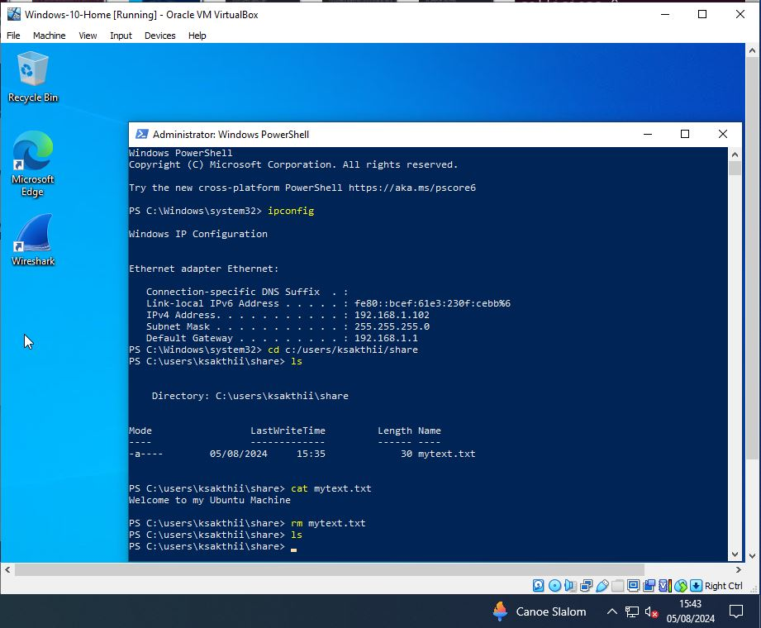
Figure 104 Windows 10 Home - SMB File Share Access Control

SSH Login Attack:
The SSH session was disconnected from the Metasploitable VM as in Figure 105.
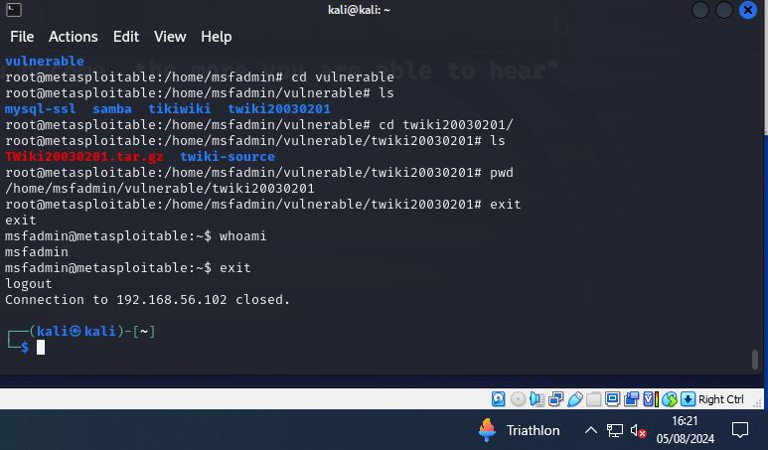
Figure 105 Kali Linux - SSH Session Logout

Summary
The inclusion of the MITRE ATT&CK framework in the VAPT methodology has significantly enhanced the scope of future penetration testing. By aligning the testing process with specific real-world attack vectors, such as DoS attacks, SMB attacks, and SSH brute-force attempts, this approach has uncovered crucial vulnerabilities that were previously overlooked.
The DoS attack scenario demonstrated the system's resilience, as it managed to terminate malicious connections using RST packets. This finding highlights the need for continuous refinement of network defenses and the importance of considering potential anomalies during scope evaluations.
The successful SMB attack, which allowed unauthorized file uploads to the Windows 10 Home VM, underscores the necessity of securing SMB shares and implementing stronger access controls. Future penetration tests should prioritize testing for SMB vulnerabilities and assess the effectiveness of network segmentation.
Lastly, the SSH login attack, though initially hindered by timeouts, ultimately succeeded using default credentials, pointing to weaknesses in credential management. Future tests should focus on improving password policies and connection stability, ensuring a more robust security posture.
By incorporating these findings, scope of future penetration tests are more comprehensively covered, leading to better-targeted remediation strategies and a stronger overall security posture.

Windows Domain Test Scenario
Figure 106 shows the network setup where penetration testing utilizes Kali Linux and rogue Windows VMs to target Windows 2019 and Windows 10 Pro VMs which are under the same domain. The VAPT methodology, with MITRE ATT&CK integration, ensures thorough testing of security vulnerabilities.

Windows 10 Home Rogue VM
IP Address:
192.168.56.104

Windows 10 Pro VM
IP Address: 192.168.56.107

Windows 2019 Server VM
Domain Controller
IP Address: 192.168.56.106

Attacker: Kali Linux VM
IP Address: 192.168.56.103

Figure 106 Windows Domain Test Setup

Vulnerability Assessment
Vulnerability assessment analyzes system weaknesses to preemptively address potential threats, focusing on information gathering to uncover and fortify vulnerabilities, enhancing overall security to businesses. Key phases from VAPT includes,
- Scope
- Reconnaissance
- Vulnerability Detection
- Information Analysis and Planning

Scope:
The scope phase in VAPT defines assessment boundaries and rules, helping pentesters focus efforts and ensuring stakeholder agreement on testing parameters. "Ifconfig" helps identify network interfaces and IP addresses, crucial for passive reconnaissance, as depicted in Figure 107.

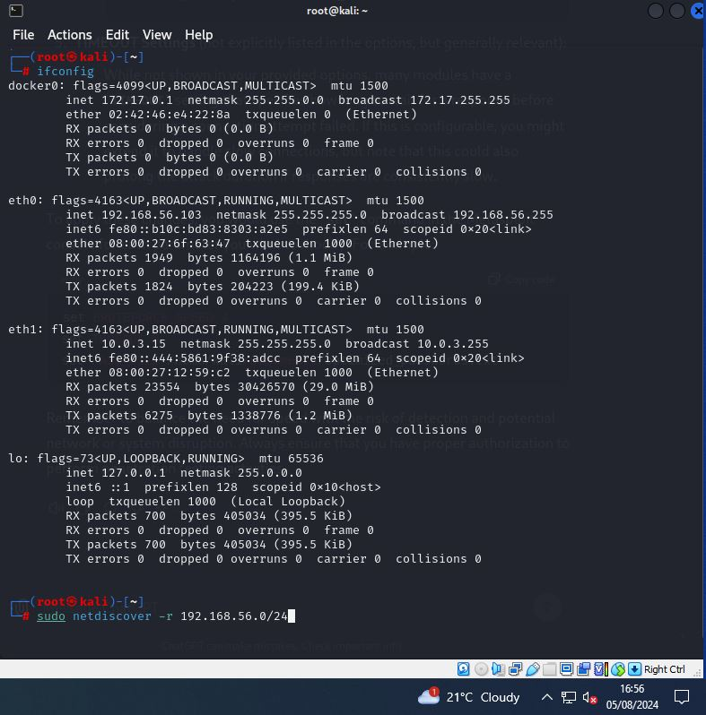
Figure 107 Kali Linux - Ifconfig Output

Reconnaissance:
Reconnaissance helps pentesters gather crucial data for targeted testing, while benefiting stakeholders by aligning on objectives and risk priorities. “Netdiscover” scans the network 192.168.56.0/24 and finds three hosts. “Nmblookup” identifies two hosts, Sakthi-PC and DC-Server, within the same group, UWTSD but domain name resolution fails as shown in Figure 108.

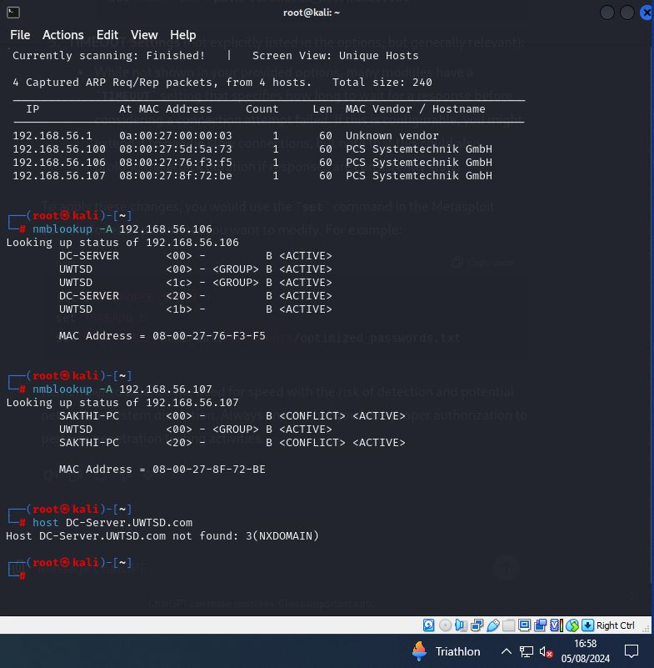
Figure 108 Kali Linux - Active Reconnaissance Tools

Vulnerability Detection:
Vulnerability detection helps pentesters identify weaknesses to address, benefiting stakeholders by revealing security gaps and prioritizing remediation efforts. Active reconnaissance and OpenVAS scans of subnet 192.168.56.0/25 found no major vulnerabilities as in Figure 109. OpenVAS’s detailed reports are essential for comprehensive assessment and issue analysis.

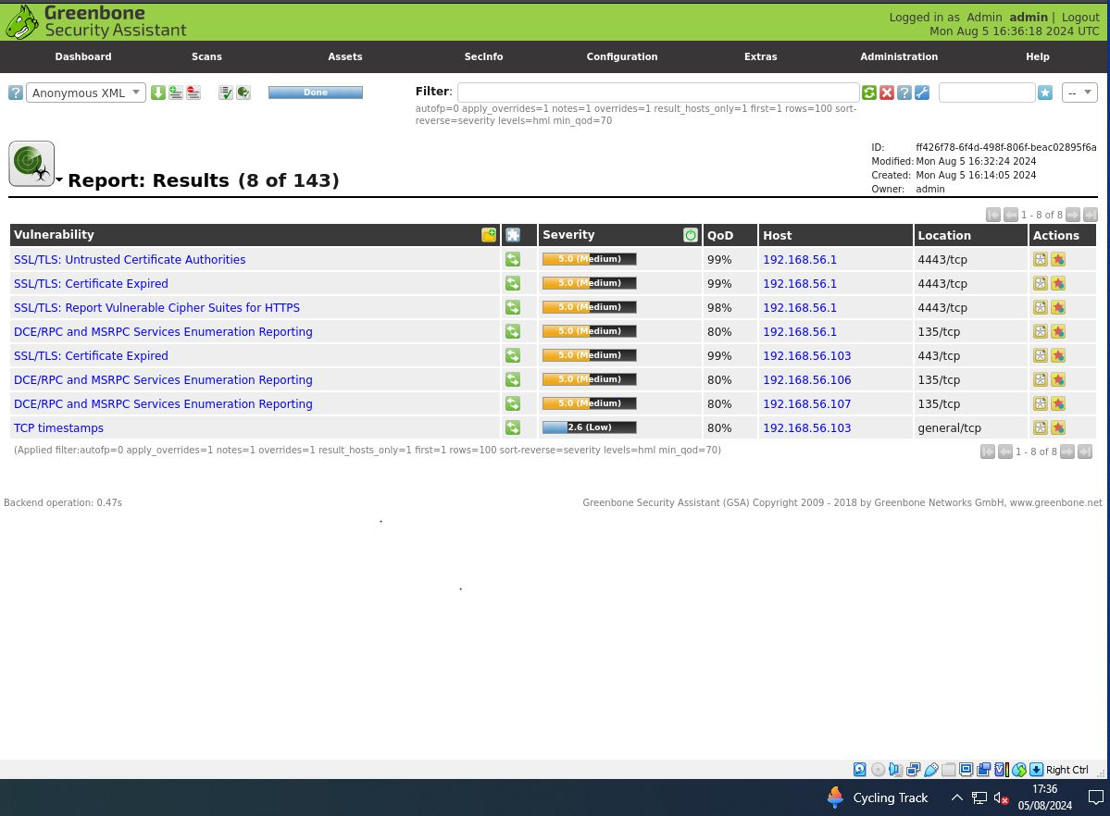
Figure 109 Kali Linux - OpenVas Scan Results

Information Analysis and Planning:
In the information analysis and planning phase, pentesters analyze network data and plan attacks, while stakeholders gain clarity on threat identification and remediation priorities. Tools like “Netdiscover” and “Nmblookup” reveal network hosts and domains, guiding targeted assessments.

Penetration Testing
Penetration testing uncovers vulnerabilities to strengthen the security posture. Incorporating the MITRE ATT&CK framework into VAPT's penetration testing enhances threat detection and precision by emulating adversary tactics, which aids penetration testers in identifying vulnerabilities and bolstering Windows Domain security.
Caldera, from MITRE ATT&CK, uses the Sandcat agent to launch ransomware attacks, with Sandcat being a password-protected executable file.

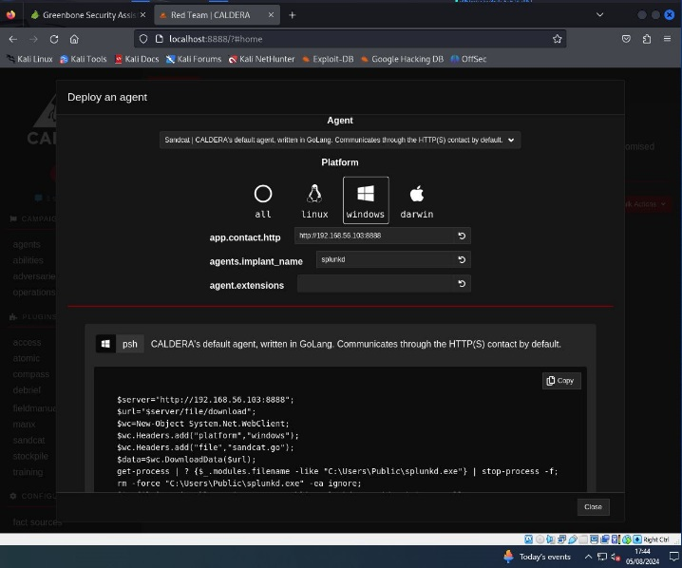
Figure 110 Kali Linux - Caldera Sandcat Agent

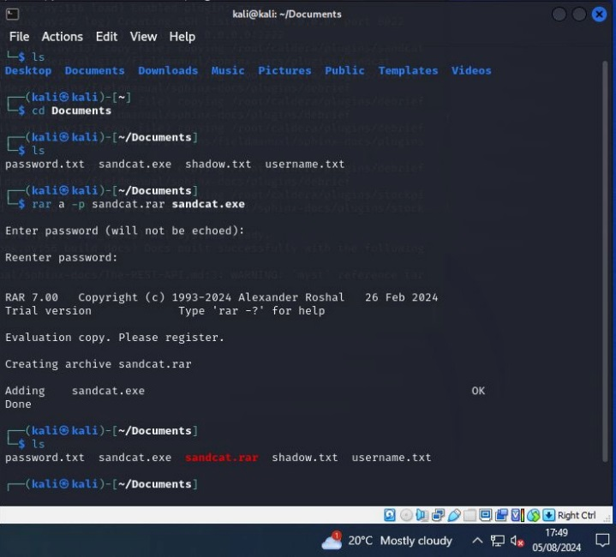
Figure 111 Kali Linux - Password-protected RAR File Creation

A phishing email with instructions successfully delivered and executed the Sandcat agent, leveraging social engineering as shown in Figure 112. Phishing enables initial access, allowing pentesters to test network defenses.
Tactic: Initial Access
Technique: Phishing - Spearphishing Attachment [T1566.001]


Figure 112 Windows 10 Pro - Spearphishing Email Access

Windows 10 Pro VM in Domain, verified via nslookup, allows file download, unzip, and execution with admin rights, achieving privilege escalation as illustrated in Figure 113. Privilege escalation tactics help pentesters gain elevated access for thorough testing.
Tactic: Privilege Escalation
Technique: Abuse Elevation Control Mechanism - Sudo and Sudo Caching [T1548.003]

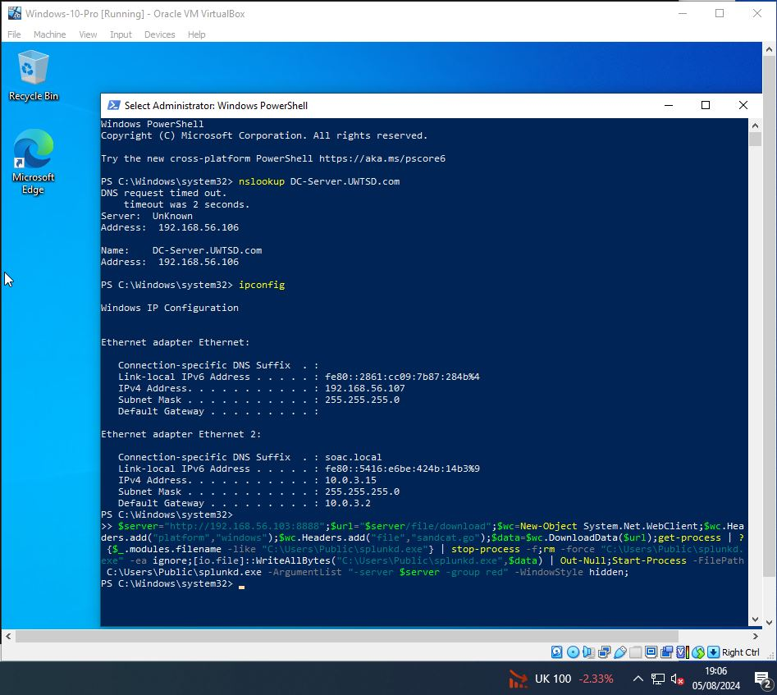
Figure 113 Windows 10 Pro – Caldera Sandcat Agent Execution

After executing the Sandcat agent with administrator rights, it establishes a connection back with Caldera on the Kali Linux VM as in Figure 114. Command and Control tactics enable pentesters to verify system communication.
Tactic: Command and Control
Technique: Application Layer Protocol - Web Protocols [T1071.001]
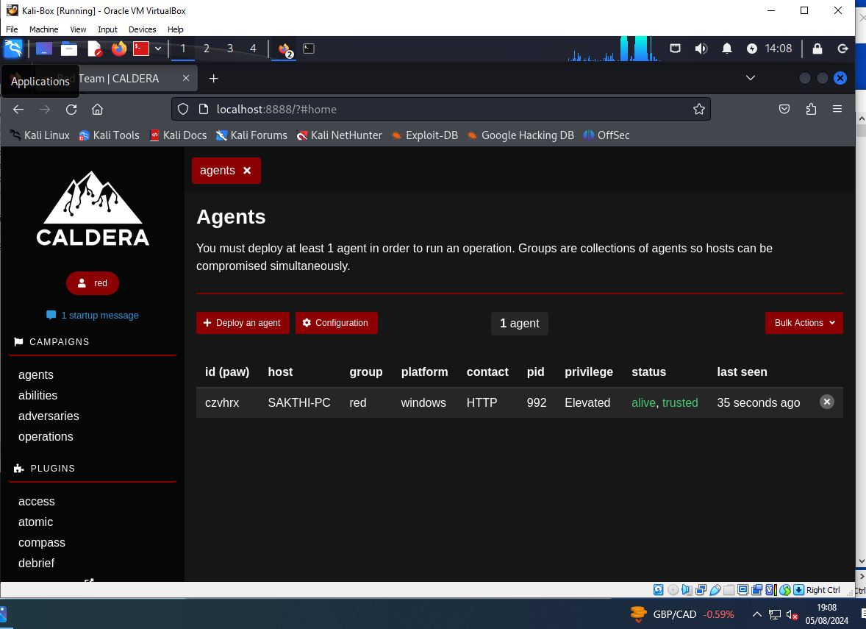
Figure 114 Kali Linux – Caldera Sandcat Agent Deployed
In Caldera, a "Windows Discovery" operation is set under the "Discovery" adversary group, running autonomously as in Figure 115. The jitter setting, adjusted to 10/30, controls the timing of operation requests to simulate more random, less predictable behavior.

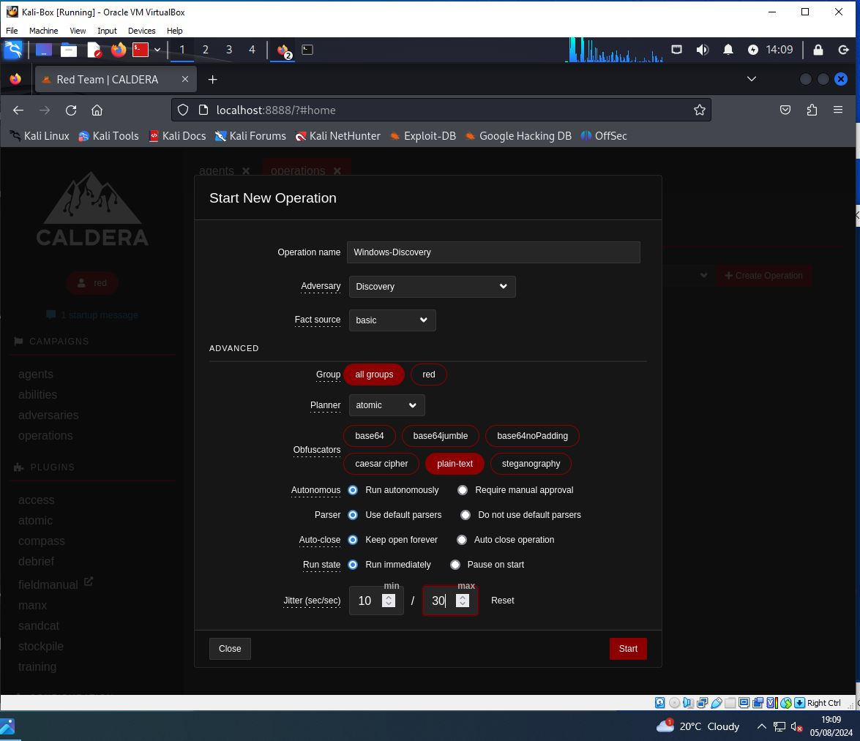
Figure 115 Kali Linux - Caldera Discovery Operation Creation

The Discovery Operation identifies active users, the domain controller IP, local users, running processes, and active firewalls on the Windows 10 Pro VM, which is part of the Windows domain as illustrated in the below figures. Discovery tactics help pentesters map networks and identify vulnerabilities.
Tactic: Discovery
Technique: Network Service Discovery [T1046]

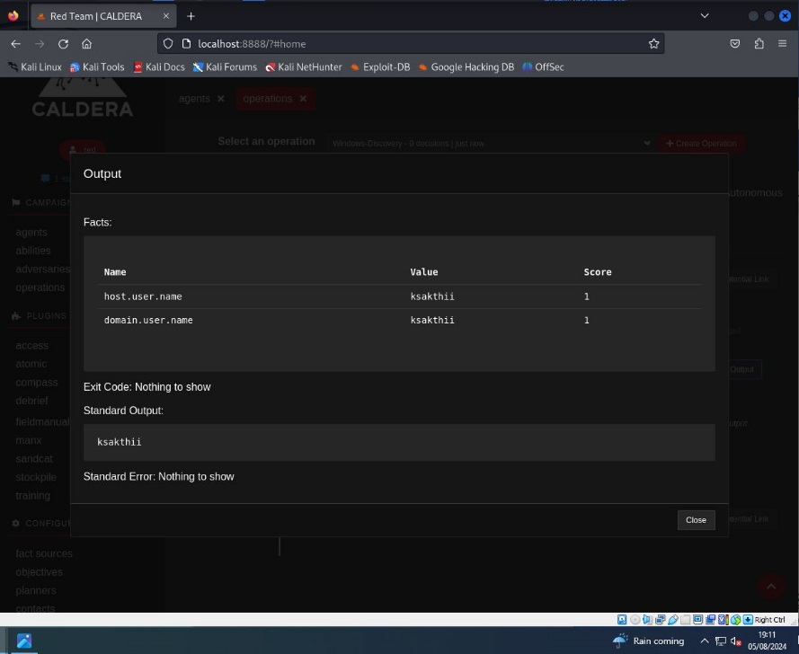
Figure 116 Kali Linux - Calera - Windows 10 Pro Username
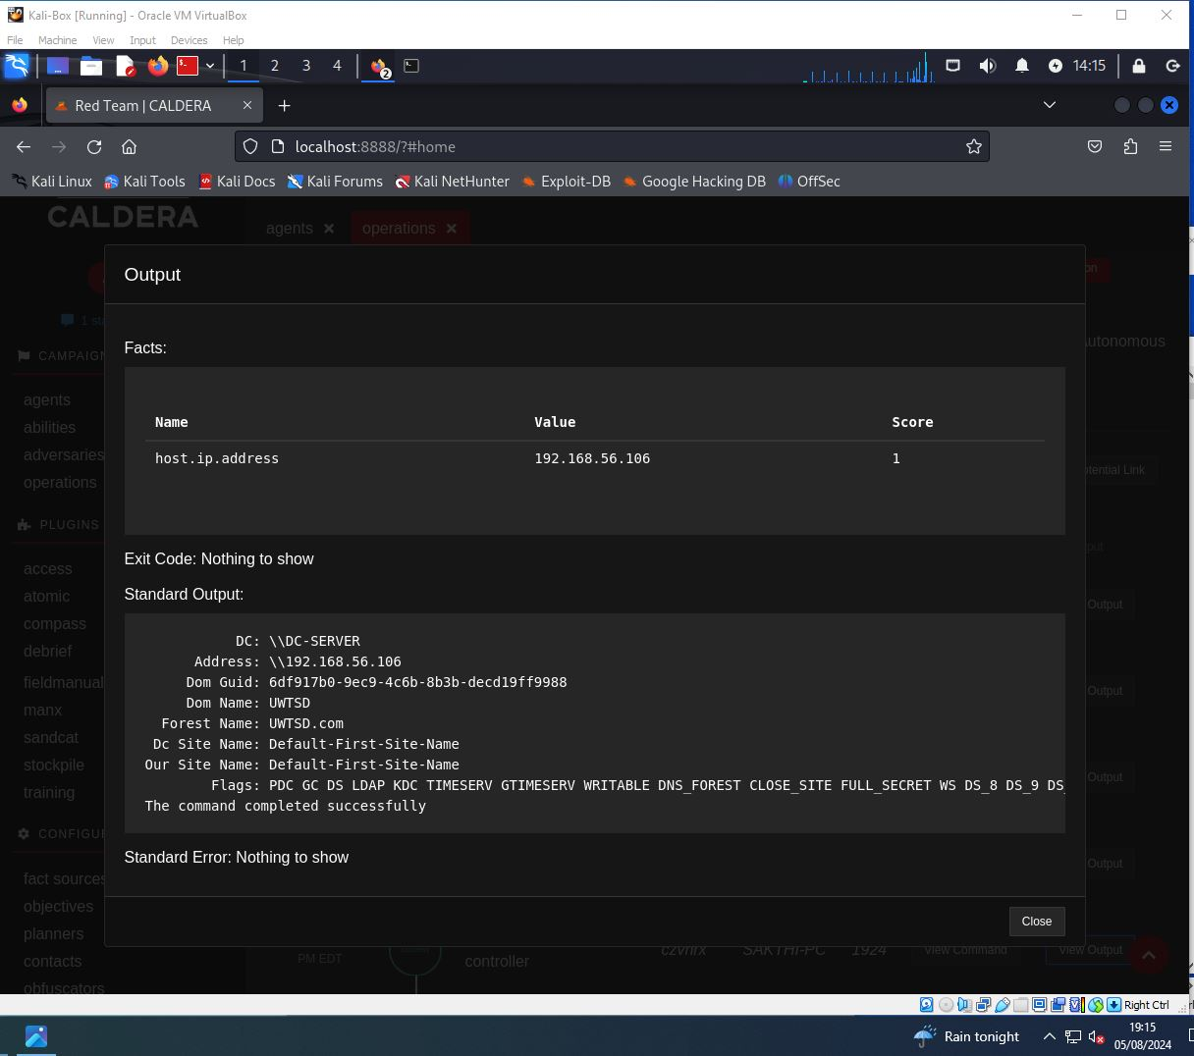
Figure 117 Kali Linux - Calera - Domain Controller Details

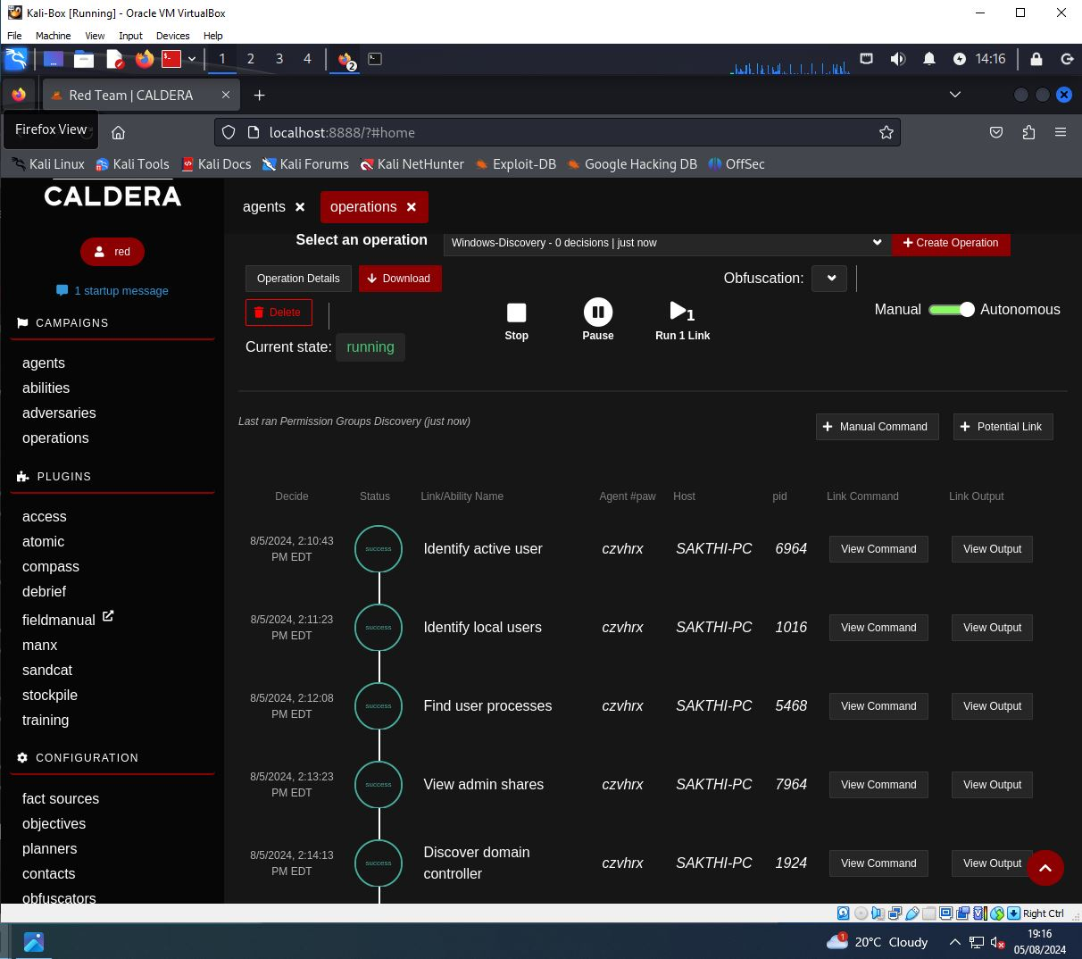
Figure 118 Kali Linux - Calera Discovery Operation Output

RDP session with the domain controller was successfully established using the found IP address and username as the password, demonstrating successful unauthorized access to the domain controller as in Figure 120.
Tactic: Lateral Movement
Technique: Remote Services – Remote Desktop Protocol [T1021.001]
This tactic aids pentesters by simulating unauthorized remote access, revealing vulnerabilities.

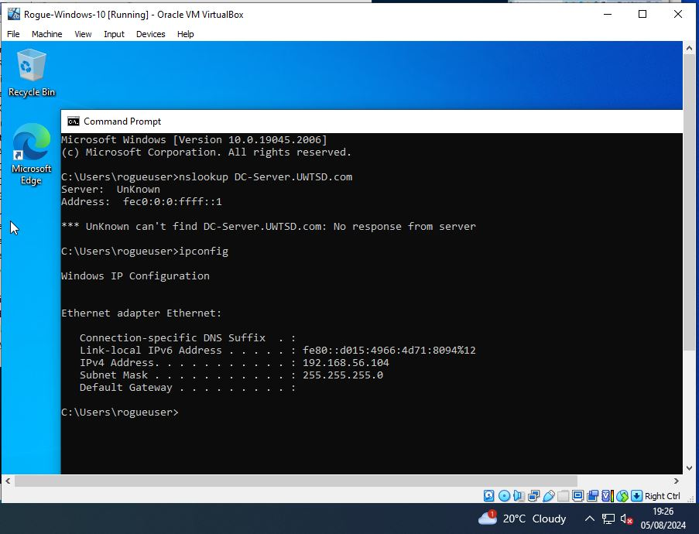
Figure 119 Rogue Windows 10 Home - Ifconfig Output

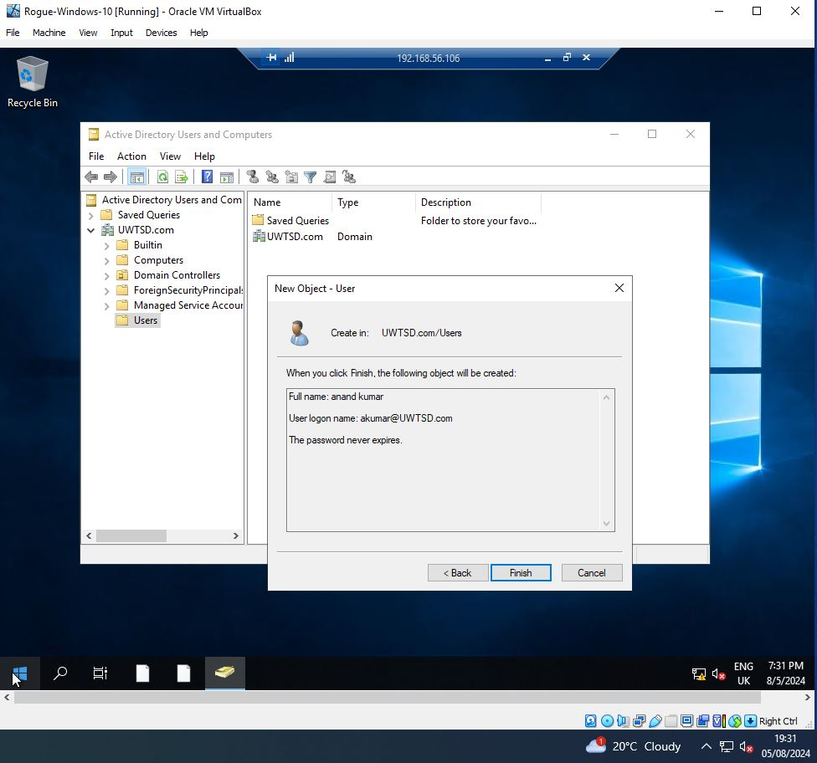
Figure 120 Rogue Windows 10 Home - RDP Session User Creation

A new user account was created on the domain controller during the RDP session, indicating successful unauthorized access in Figure 120. This tactic shows pentesters how attackers maintain access, revealing persistence vulnerabilities.
Tactic: Persistence
Technique: Create Account – Domain Account [T1136.002]

The account was modified to become a domain admin, granting elevated privileges and full control as shown in Figure 121. Reveals how attackers elevate permissions, helping pentesters identify privilege escalation vulnerabilities.
Tactic: Privilege Escalation
Technique: Account Manipulation [T1098]
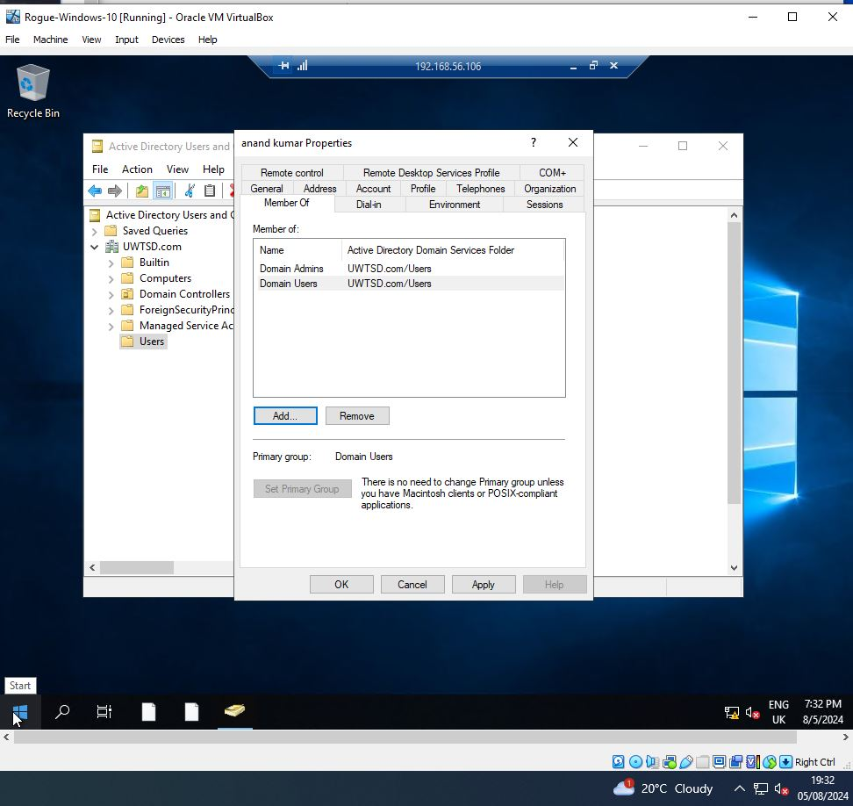
Figure 121 Rogue Windows 10 Home - RDP Session Domain Admin Privileges

Reporting
Reporting details vulnerabilities, their severity, and exploitation attempts, aiding stakeholders in understanding and addressing security gaps for improved posture. Here, we provide a summary of the phases in the VAPT methodology.
- Result Analysis
- Reporting
- Cleanup

Result Analysis:
Result analysis with MITRE ATT&CK helps pentesters identify specific attack vectors, improving threat assessment and providing stakeholders actionable security insights as,
Unauthorized access to the domain controller: Enables attackers to manipulate accounts, escalate privileges, and gain full control, compromising system integrity and security. This can lead to severe breaches, including data loss, unauthorized access, and system disruption.

Reporting:
Reporting analysis with MITRE ATT&CK provides detailed insights into attack methods, helping pentesters offer precise remediation and stakeholders understand threats.
Unauthorized access to the domain controller: Demonstrated critical vulnerabilities, highlighting the need for improved access controls and monitoring to prevent elevated privilege escalation and potential data breaches.
The newly created domain admin account “akumar” allows RDP access to the domain controller from rogue machines, validating the penetration test's effectiveness by demonstrating unauthorized privilege escalation as in Figure 122.
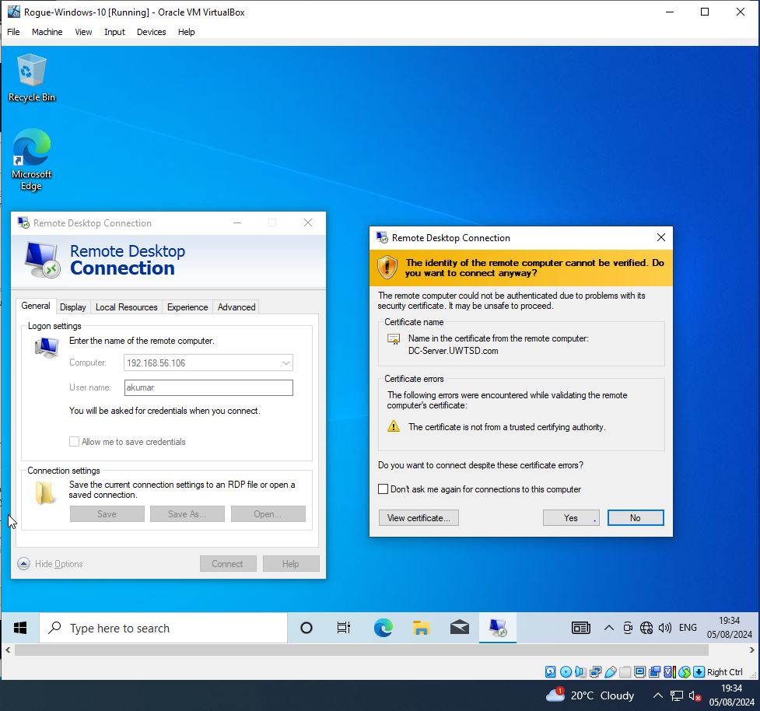
Figure 122 Rogue Windows 10 Home - RDP Session Using New User Account

Remediation steps involve applying fixes, patches, and configuration changes to address vulnerabilities. Continuous monitoring and patch management ensure ongoing defense and long-term security improvements against emerging threats.
Sandcat Agent Attack Remediation:
- Delete Compromised Accounts
- Disconnect Unauthorized Sessions
- Apply Security patches and Software updates
- Configure Firewalls
- Implement Multi-Factor Authentication (MFA)
- Conduct regular Security Training
- Perform regular Security audits

Cleanup:
The cleanup phase removes testing artifacts, ensuring system integrity, and prevents disruptions, helping pentesters and protecting stakeholders from residual risks.
The unauthorized user has been removed from the domain controller's user management system as shown in Figure 123.
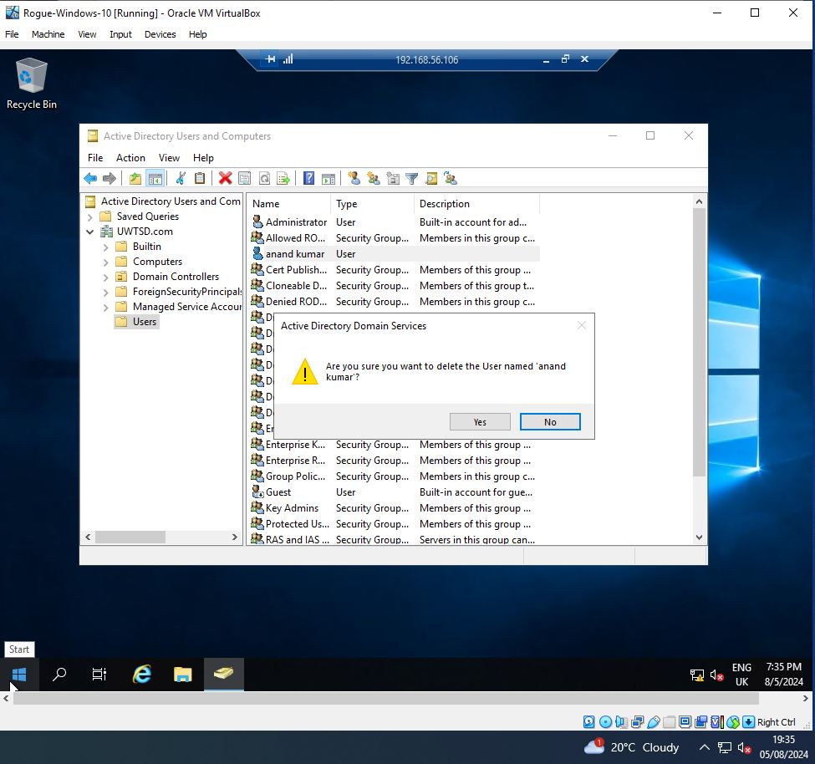
Figure 123 Rogue Windows 10 Home - Unauthorized User Account Deletion

The RDP session has been terminated from the domain controller as in Figure 124.
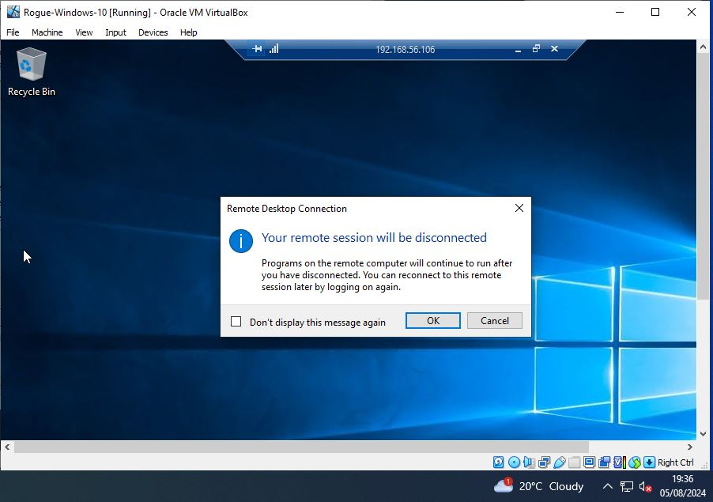
Figure 124 Rogue Windows 10 Home - RDP Session Disconnected

Summary
The experimental project revealed several critical findings and outcomes that can significantly enhance the scope reevaluation process for future penetration tests. By integrating the MITRE ATT&CK framework with the VAPT methodology, the project demonstrated an improved capability to identify gaps that traditional methods might overlook. Specifically, the failure of domain name resolution, as expected, emphasized the necessity of validating network configurations and considering potential anomalies within the network environment.
To strengthen future scope reevaluations, it’s vital to adopt a dynamic approach that allows for real-time adjustments based on reconnaissance findings. This includes refining network scanning techniques and expanding the scope to encompass previously overlooked targets and unexpected network behaviors. Continuous monitoring, iterative testing, and the incorporation of feedback loops will refine testing accuracy, and strengthening domain controller security with multi-factor authentication will better protect against unauthorized access. This approach ensures more comprehensive vulnerability identification and a stronger security posture.

Evaluation
Embedding MITRE ATT&CK into VAPT allows organizations to achieve broad coverage of attack vectors, align with industry-standard adversary techniques and current threat intelligence, and swiftly adapt to evolving attack trends. It improves communication with stakeholders by mapping findings to a recognized framework, making it easier to understand and prioritize risks. Streamlined testing efforts increase efficiency by focusing on the most relevant and impactful attack techniques, saving time and resources.
The literature review illustrates that Vulnerability Assessment and Penetration Testing (VAPT) effectively identifies and mitigates system vulnerabilities using tools like Metasploit and Nmap. VAPT strengthens cybersecurity. Penetration Testing Methodology emphasizes a structured approach with reconnaissance, vulnerability scanning, exploitation, and reporting phases improving security. The use of a Raspberry Pi with Kali Linux demonstrated cost-effective, versatile testing capabilities. Detailed reporting and post-test cleanup ensure comprehensive security insights and system restoration.
Reverse TCP shells: The study demonstrated Metasploit's effectiveness in exploiting Windows and Mac OS vulnerabilities to establish persistent, remote access to compromised systems, underscoring the importance of continuous VAPT and comprehensive reporting for robust security.
VSFTP backdoor exploits: Successfully exploited VSFTP vulnerabilities using Metasploit, achieving unauthorized access and demonstrating the effectiveness of continuous VAPT for identifying and exploiting security weaknesses.
Webmin backdoor: The study effectively used a Raspberry Pi with Kali Linux for penetration testing, revealing critical vulnerabilities, such as remote code execution. Exploitation via Metasploit demonstrated severe risks, emphasizing the platform's credibility in comprehensive security assessment
From the literature review, the VAPT methodology, through its structured phases and tools, provides comprehensive security assessments, identifies and mitigates vulnerabilities, and ensures robust reporting. This approach enhances stakeholders' confidence by improving security measures and demonstrating effective, cost-efficient testing. Table 1 shows that the VAPT methodology includes distinct stages—Scope, Reconnaissance, Vulnerability Detection, Information Gathering, Penetration Testing, Privilege Escalation, and Reporting.

VAPT Methodology

Attacks | Vulnerability Assessment |  |  |  | Penetration Testing |  | Reporting
Reverse Shell | Scope | Reconnaissance | Vulnerability Detection | Information Gathering | Penetration Testing | Privilege Escalation | Reporting
VSFTPD | Scope | Reconnaissance | Vulnerability Detection | Information Gathering | Penetration Testing | Privilege Escalation | Reporting

Table 1 VAPT Methodology

MITRE ATT&CK Integrated VAPT Methodology

Attacks | Vulnerability Assessment |  |  |  | Penetration Testing Stages |  |  |  |  |  |  |  |  |  |  | Reporting
DOS | Scope | Reconnaissance | Vulnerability  Detection | Information  Gathering | Impact |  |  |  |  |  | Defense Evasion |  |  |  |  | Reporting
Samba | Scope | Reconnaissance | Vulnerability  Detection | Information Gathering | Discovery |  | Privilege Escalation |  |  | Credential Access |  |  | Lateral Movement |  |  | Reporting
SSH Login | Scope | Reconnaissance | Vulnerability  Detection | Information  Gathering | Credential  Access |  |  | Initial  Access |  | Privilege  Escalation |  | Collection |  |  | Exfiltration | Reporting
Domain Controller Access | Scope | Reconnaissance | Vulnerability  Detection | Information  Gathering | Initial  Access | Privilege  Escalation |  |  | Command and  Control |  |  | Discovery |  | Lateral Movement |  | Reporting

Table 2 MITRE ATT&CK Integrated VAPT Methodology

The table 2 illustrates that integrating MITRE ATT&CK into VAPT methodology enriches penetration testing by mapping attacks to specific tactics and stages. This integration enhances the comprehensiveness of vulnerability assessments and reporting, providing detailed insights and improving the accuracy and effectiveness of threat detection and remediation thereby strengthening overall cybersecurity. The experimental study investigated DOS attack, Samba file share access, SSH login attempts, and unauthorized access to a Domain Controller, revealing critical insights into system vulnerabilities and their exploitability.
DOS Attack: The study demonstrated how a SYN flood attack could be mitigated by robust defense mechanisms within the target system but ongoing improvements are essential for maintaining resilience. The experiment revealed that while the system's defenses were effective, a real-world scenario could still lead to temporary disruptions. This differs from literature where the focus is often on detecting vulnerabilities rather than evaluating defense effectiveness.
Samba File Share Access: Unauthorized file uploads indicated weak access controls in Samba services, stressing the importance of strong permissions and security measures. This practical scenario differs from literature, which often highlights theoretical vulnerabilities rather than practical exploit outcomes
SSH Login Attempt: Exploiting default credentials revealed the critical need for robust password policies and disabling root logins. This practical finding diverges from literature that focuses on automated vulnerability detection without addressing specific exploits and its impacts from using default credentials.
Unauthorized Access to Domain Controller: This experiment exposed inadequate access controls and weak privilege management, highlighting the necessity for stringent authentication measures and regular monitoring to prevent unauthorized access, unlike literature that often generalizes vulnerabilities, this study provides specific recommendations for enhancing domain controller security.
Impact:
DOS attacks can cause service disruptions, Samba exploits can expose sensitive data, SSH exploits can lead to full system control and unauthorized access can compromise critical systems. Each scenario reveals different aspects of system weaknesses and highlights areas for improvement in security practices.

The cross-sectional study explored DoS attacks, SMB file share access, SSH login attempts, and unauthorized Domain Controller access. It demonstrated the necessity of the MITRE ATT&CK framework for addressing diverse threats. Aligning with the Attack Vector Model, the study defined scope, scanned for vulnerabilities, simulated attacks, and reported findings. This model visually maps potential attack pathways, strategies, and network gaps, offering a structured approach and aids in understanding vulnerabilities, planning defenses, and enhancing overall security by mapping potential threats and responses.

No Vulnerabilities detected
Scope

Reporting
Vulnerability Scanning

Attack Scenario
Network Gaps

Attack Strategy

Figure 125 Attack Vector Model

Scope: In the Attack Vector Model, scope defines the assessment’s objectives, boundaries, and rules of engagement, helping companies focus on critical assets and risks. Security professionals organize this by outlining what will be tested, setting engagement rules, and ensuring alignment with business priorities to maximize assessment effectiveness and relevance.
Vulnerability Scanning: Automated tools identify security weaknesses, offering companies insights to address gaps before exploitation. If no vulnerabilities are detected, the scope is reassessed for further testing. When found, security professionals use these findings to organize attack scenarios, simulating potential exploit paths and refining strategies for effective remediation, ensuring comprehensive security coverage and targeted mitigation efforts.
Attack Scenario: The model simulates real-world attack paths from detected vulnerabilities, enabling companies to understand potential threats and impacts. Security professionals analyze scan results to craft realistic attack scenarios, bridging the gap between identifying vulnerabilities and devising strategies, to map out how adversaries might exploit weaknesses, leading to more targeted and effective remediation efforts
Attack Strategy: Utilizing the MITRE ATT&CK framework, pentesters align their strategies with real-world adversary behaviors, exploiting identified vulnerabilities. This approach simulates sophisticated attacks, offering companies realistic insights into potential impacts, refining defenses, and enhancing remediation plans based on detailed, framework-driven analysis of tactics, techniques, and procedures.
Network Gaps: Analyzes security weaknesses revealed by attack strategies and scenarios, helping companies identify critical vulnerabilities and improve defenses. Pentesters use parameters like attack vectors, exploited techniques, and access levels to pinpoint these gaps. By understanding how attacks succeed, they can refine remediation efforts, address specific weaknesses, and enhance overall security posture in penetration testing activities, ensuring more robust protection against real-world threats.
Reporting: The reporting stage in penetration testing is vital for improving company’s security posture. It involves in reviewing vulnerability scans, attack scenarios, analyzing exploited attack vectors and network gaps, providing actionable insights for prioritizing risks and refining future test scopes. This stage aids compliance, enhances stakeholder confidence, and supports ongoing security improvements by ensuring targeted remediation, addressing evolving threats, and reducing breach risks and associated costs.

Scope: Reassessing and refining the scope based on reporting insights enhances the VAPT methodology by ensuring comprehensive coverage of new and emerging threats, improving vulnerability detection and response, which results in aligning with the latest threat landscape and network configurations. Integration with MITRE ATT&CK provides stakeholders with realistic threat scenarios, aligning remediation efforts with actual risks, improving security posture, and ensuring more targeted, effective protection.
The iterative model benefits pentesters by continuously revisiting or refining the scope to address previously missed, new and evolving threats to ensure all the critical areas are tested. This approach enhances security assessments by incorporating new findings, improving coverage, and adapting strategies for more accurate and comprehensive evaluations. It ensures continuous, dynamic adjustment and effective security measures are aligned with real-world attack scenarios so that penetration testing remains current, comprehensive and effective.

Efficiency Factors:
The integration of MITRE ATT&CK with the VAPT methodology through the Attack Vector Model introduces several qualitative and quantitative parameters that enhance the effectiveness and depth of security assessments,
Qualitative Parameters:
Comprehensive Coverage: Expanded with MITRE ATT&CK to include diverse tactics and techniques, improving overall threat coverage.
Realism of Scenarios: Improved by incorporating real-world attacker behavior, aligning more closely with actual threat landscapes.
Stakeholder Satisfaction: Enhanced through clearer, more relevant reporting and targeted remediation aligned with genuine risks.
Adaptability and Flexibility: Increased by continuously refining scope and tactics in response to new and evolving threats.
Compliance Alignment: More robust, ensuring alignment with industry standards and regulatory requirements.

Depth of Analysis: Delivers deeper insights into vulnerabilities and their exploitability, offering detailed remediation strategies.
Real-Time Feedback: The iterative approach provides real-time feedback, continuously refining testing strategies and improving the relevance and accuracy of security assessments.
Comprehensive Reporting: Detailed reporting on vulnerabilities, exploitation techniques, and recommended mitigations provided deeper insights into security postures.
Quantitative Parameters:
Vulnerabilities Detection: Increased with more thorough assessments using MITRE ATT&CK.
Response Time: Real-time adjustments improve overall efficiency, reducing time required to identify and exploit vulnerabilities.
Success Rate of Exploits: Higher success rates in exploiting vulnerabilities, validating findings through practical tests.
Time to Detect and Remediate: Potentially improved as threats are more accurately identified and prioritized.
Coverage Percentage: Expanded due to broader attack surface analysis.
False Positive/Negative Rates: Potentially reduced, as the model allows for more precise threat identification.
Impact Assessment: Enhanced with detailed understanding of threat impact, improving prioritization of remediation efforts.
The cross-sectional study explored various attack strategies, including DoS attacks, SMB file share access, SSH login attempts, and Domain Controller breaches, revealing diverse impact levels and exploitability. The study emphasized that while qualitative and quantitative data are valuable, they are insufficient alone to calculate and draw any definitive patterns, especially given the complexity and variety of attack scenarios tested. Each attack scenario highlighted that integrating MITRE ATT&CK into VAPT refines the methodology, providing a structured approach to effectively identify and mitigate real-world threats.
The Attack Vector Model enhances VAPT by structuring real-world attack simulations and integrating MITRE ATT&CK for detailed threat modeling. It ensures comprehensive scope definition, realistic vulnerability scanning, and precise exploit path modeling, aligning with adversary tactics, techniques, and procedures. This approach improves accuracy, coverage, and actionable insights, strengthening overall security posture and optimizing risk management.
Pentesters can leverage VAPT with the Attack Vector Model by understanding various attack vectors and integrating MITRE ATT&CK to simulate real-world scenarios. Key practices include defining a clear scope, conducting thorough scans, and modeling realistic exploit paths, which enhances vulnerability assessment accuracy and effectiveness. Continuous analysis and refinement based on findings will enhance accuracy and coverage thereby improving the effectiveness of vulnerability assessments.
This model also benefits researchers to simulate real-world attack paths and by integrating MITRE ATT&CK for detailed threat modeling. It enhances understanding of threat dynamics, improves precision in vulnerability assessments, and supports iterative refinement of testing strategies. This approach ensures accurate, actionable insights into exploitability and network gaps, advancing academic knowledge and practical security solutions.
Incorporating the MITRE ATT&CK framework allows VAPT to simulate real-world attack techniques and scenarios. This structured approach enables the methodology to identify and address potential gaps in network defenses that traditional methods might miss. The integration provides structured, dynamic testing strategies that adapt to evolving attack vectors and emerging threats by significantly improving efficiency and accuracy.

Conclusion
Integrating the MITRE ATT&CK framework into VAPT significantly improves penetration testing by aligning real-world attack tactics with specific stages and techniques. The experimental study confirms that this method broadens the scope of security assessments by reviewing diverse attack vectors. By providing a structured approach, it enhances the precision of threat detection and remediation. The integration ensures comprehensive testing that adheres to industry-standard adversary tactics, which improves stakeholder communication and delivers actionable insights. Furthermore, this approach, when combined with the Attack Vector Model, strengthens overall cybersecurity resilience and refines risk management strategies, leading to more effective and robust security measures.

Conclusion and Recommendations

Summary
Vulnerability Assessment and Penetration Testing (VAPT) focuses on discovering security weaknesses. There are challenges like limited scope and high costs, incorporating the MITRE ATT&CK framework can significantly improve the effectiveness of VAPT. This integration is set to improve threat detection, addresses testing gaps, and strengthens cybersecurity defenses against sophisticated threats, ensuring more comprehensive protection.
Expanding the scope to include MITRE ATT&CK tactics like exfiltration and lateral movement enhances VAPT effectiveness. This approach helps organizations better detect, respond to, and mitigate sophisticated attacks. Incorporating MITRE ATT&CK into VAPT also improves communication with stakeholders by mapping vulnerabilities to a recognized framework, making risk prioritization clearer. Additionally, it enables continuous improvement by adapting to evolving threats, ensuring comprehensive and up-to-date security assessments.
The research evaluates hypotheses by merging the MITRE ATT&CK framework with VAPT methodologies, employing a positivist and deductive approach. It generates empirical insights into cybersecurity weaknesses and attack scenarios. Utilizing tools such as Nmap, Metasploit, and Wireshark within Oracle Virtual Box, the framework assesses attack vectors and mitigation strategies, providing dependable and actionable insights to bolster security resilience.
Virtual machines are configured in Oracle Virtual Box, including Metasploitable 2, Kali Linux, Ubuntu 24 LTS, Windows 10 Home, and Windows Server 2019, for a detailed VAPT environment. Host-only adapter and internal network settings simulate an isolated network. Integrating Metasploit, Caldera, and MITRE ATT&CK enhances testing realism. This setup facilitates thorough vulnerability assessment, exploitation, and remediation, ensuring a robust cybersecurity evaluation. The approach emphasizes a methodical and iterative process in enhancing security posture.
The cross-sectional study investigated a range of attack strategies, such as DoS attacks, SMB file sharing access, SSH login attempts, and breaches of the Domain Controller. Through experimental study, integrating MITRE ATT&CK into VAPT refines penetration testing phase in VAPT by aligning real-world attack tactics, broadening assessment scope, and improving threat detection. This approach, combined with the Attack Vector Model, provides a structured approach, enhances accuracy, stakeholder communication, and overall cybersecurity resilience, optimizing risk management and security measures.

Conclusion
Integrating MITRE ATT&CK with VAPT enhances penetration testing by covering advanced tactics and broadening the assessment scope. Using tools like Nmap and Metasploit within Oracle Virtual Box, this approach improves precision of threat detection, remediation and addresses gaps, strengthening cybersecurity. The iterative nature of the Attack Vector Model refines the scope continuously, ensuring coverage of diverse and evolving attack vectors. This method provides actionable insights for pentesters, supports researchers in understanding threats, and improves stakeholder communication with structured findings. Overall, it optimizes risk management strategies and ensures comprehensive protection against emerging threats, enhancing overall cybersecurity resilience.

Recommendations for further Research
The integration of MITRE ATT&CK into VAPT has proven effective, but there are opportunities for improvement. Refining scope management by dynamically adjusting it based on real-time findings and incorporating automated tools for continuous monitoring could enhance assessment thoroughness. This approach would help ensure vulnerabilities are not missed, particularly in complex network environments.
Future research should emphasize tracking changes in cybersecurity threats and adaptive measures over time to enhance penetration testing. By monitoring how attacker behaviors and vulnerabilities evolve, these studies can reveal important trends. This ongoing analysis will offer valuable insights for strategic planning and defense enhancements, leading to a deeper understanding of the shifting cybersecurity landscape and improved security measures.
Enhancing VAPT adaptability should focus through AI and machine learning for proactive threat prediction. It should also explore integrating additional frameworks, cloud-based solutions for real-time analysis, and strategies to reduce VAPT's time and resource demands, making it more scalable and accessible.
These recommendations aim to build on the success of this project, ensuring that the integrating MITRE ATT&CK into VAPT methodology remains effective and relevant in an evolving cybersecurity landscape.

Reflection

Introduction
Reflecting on the five objectives, the enhanced VAPT methodology integrated with the MITRE ATT&CK framework has led to substantial improvements in vulnerability detection and mitigation. The process highlighted key learning points and identified areas for future optimization.

Objective 1: Review of VAPT Methodology
The VAPT methodology was reviewed to identify inefficiencies and gaps in traditional approaches. The analysis focused on the effectiveness of each phase, such as vulnerability detection and penetration testing, within the scope of modern cybersecurity challenges. This theoretical review highlighted areas where traditional VAPT methods fall short, particularly in dynamic threat environments, paving the way for the integration of the MITRE ATT&CK framework.
DoS Attack: Failed to detect SYN flood attacks due to limited testing scope and outdated methods.
SMB File Share Access: Overlooked unauthorized access due to weak file permissions and inadequate monitoring.
SSH Login Attempt: Missed vulnerabilities from default credentials, posing severe security risks.
Unauthorized Domain Controller Access: Ineffective detection of privilege escalation attempts, leaving gaps in security.

Objective 2: Re-design VAPT with MITRE ATT&CK Framework
The VAPT methodology was redesigned by incorporating the MITRE ATT&CK framework, which offers a more structured approach to identifying and mitigating threats. This integration enables a more comprehensive evaluation of potential vulnerabilities by aligning penetration testing with real-world attack techniques, ensuring a more robust security posture.
DoS Attack: Integrated MITRE ATT&CK improved SYN flood detection and response strategies.
SMB File Share Access: Enhanced detection of unauthorized file access through refined monitoring techniques.
SSH Login Attempt: Improved identification of risks related to default credentials using MITRE techniques.
Unauthorized Domain Controller Access: Strengthened privilege escalation detection with better integration of MITRE framework.

Objective 3: Analyze Real-World Attack Scenarios
Real-world attack scenarios were analyzed to refine the VAPT scope. This ensured the methodology could address evolving threats and provided a foundation for more effective future penetration testing.
DoS Attack: Focused on real-world SYN flood scenarios to enhance defense mechanisms.
SMB File Share Access: Analyzed impact of weak permissions leading to unauthorized file access.
SSH Login Attempt: Evaluated risks from default credentials in practical scenarios.
Unauthorized Domain Controller Access: Investigated how weak controls enable unauthorized access in real-world settings.

Objective 4: Investigate Attack Strategies and Techniques
This objective was achieved by studying various attack methods, providing a comprehensive understanding of how attackers compromise systems. This knowledge was used to enhance the VAPT methodology.
DoS Attack: Explored effective SYN flood attack strategies to refine detection and mitigation.
SMB File Share Access: Studied exploitation methods targeting weak Samba permissions.
SSH Login Attempt: Investigated attacker techniques exploiting default credentials.
Unauthorized Domain Controller Access: Examined strategies for unnoticed privilege escalation and access.

Objective 5: Evaluate Network Gaps and Scope Re-Evaluation
Network gaps were evaluated to refine the scope of VAPT, ensuring thorough security assessments that adapt to emerging threats.
DoS Attack: Expanded scope for better SYN flood detection and prevention.
SMB File Share Access: Tightened permissions and improved monitoring to prevent unauthorized access.
SSH Login Attempt: Strengthened password policies to mitigate risks from default credentials.
Unauthorized Domain Controller Access: Enhanced monitoring for better detection of unauthorized privilege escalation.

Aim: Improving Scope and the Risk Analysis process of VAPT Methodology
The research underscores the pivotal role of scope in Vulnerability Assessment and Penetration Testing (VAPT), where a limited scope risks missing critical vulnerabilities, leaving untested areas while an overly broad scope raises complexity, costs, and resource demands. To tackle these issues, the study optimized the VAPT methodology by incorporating the MITRE ATT&CK framework, thereby expanding the scope of penetration testing for more precise vulnerability detection and remediation. Enhanced techniques improved responses to diverse attack scenarios, including DoS attacks, SMB file share access violations, SSH login attempts, and unauthorized domain controller access.
By analyzing real-world attack scenarios and refining defense strategies, the investigations into attack methods provided deeper insights into security gaps. By re-evaluating the scope and tightening controls, the methodology became more adaptive and comprehensive. The optimization achieved the goal of a robust VAPT approach, increasing the accuracy of vulnerability identification, mitigation and providing a stronger security posture against evolving cyber threats, fulfilling the research goal of developing a robust and dynamic VAPT methodology.

Conclusion
The evaluation of the five objectives demonstrates that the MITRE ATT&CK integration into VAPT methodology effectively achieved the aim of a more robust cybersecurity strategy. However, reflecting on the process, there are areas for improvement, such as refining the scope and enhancing real-time adaptability. By incorporating these insights, future assessments can be even more precise and comprehensive, ensuring superior security outcomes and more efficient resource utilization. Continuous learning and adaptation will be key in maintaining an effective defense strategy.

References

[1] A. Fatima et al., “Impact and Research Challenges of Penetrating Testing and Vulnerability Assessment on Network Threat,” in 2023 International Conference on Business Analytics for Technology and Security (ICBATS), Dubai, United Arab Emirates: IEEE, Mar. 2023, pp. 1–8. doi: 10.1109/ICBATS57792.2023.10111168.
[2] Y. Khera, D. Kumar, Sujay, and N. Garg, “Analysis and Impact of Vulnerability Assessment and Penetration Testing,” in 2019 International Conference on Machine Learning, Big Data, Cloud and Parallel Computing (COMITCon), Faridabad, India: IEEE, Feb. 2019, pp. 525–530. doi: 10.1109/COMITCon.2019.8862224.
[3] K. Patel, “A Survey on Vulnerability Assessment & Penetration Testing for Secure Communication,” in 2019 3rd International Conference on Trends in Electronics and Informatics (ICOEI), Tirunelveli, India: IEEE, Apr. 2019, pp. 320–325. doi: 10.1109/ICOEI.2019.8862767.
[4] J. Softić and Z. Vejzović, “Impact of Vulnerability Assesment and Penetration Testing (VAPT) on Operating System Security,” in 2023 22nd International Symposium INFOTEH-JAHORINA (INFOTEH), East Sarajevo, Bosnia and Herzegovina: IEEE, Mar. 2023, pp. 1–6. doi: 10.1109/INFOTEH57020.2023.10094095.
[5] “MITRE ATT&CK®.” Accessed: May 09, 2024. [Online]. Available: https://attack.mitre.org/
[6] Ö. Aslan, S. S. Aktuğ, M. Ozkan-Okay, A. A. Yilmaz, and E. Akin, “A Comprehensive Review of Cyber Security Vulnerabilities, Threats, Attacks, and Solutions,” Electronics, vol. 12, no. 6, p. 1333, Mar. 2023, doi: 10.3390/electronics12061333.
[7] M. Humayun, M. Niazi, N. Jhanjhi, M. Alshayeb, and S. Mahmood, “Cyber Security Threats and Vulnerabilities: A Systematic Mapping Study,” Arab. J. Sci. Eng., vol. 45, no. 4, pp. 3171–3189, Apr. 2020, doi: 10.1007/s13369-019-04319-2.
[8] U. Ravindran and R. V. Potukuchi, “A Review on Web Application Vulnerability Assessment and Penetration Testing,” Rev. Comput. Eng. Stud., vol. 9, no. 1, pp. 1–22, Mar. 2022, doi: 10.18280/rces.090101.
[9] A. Raza and W. Ahmed, “Threat and Vulnerability management life cycle in operating systems. A systematic review,” vol. 9, no. 1, 2022.
[10] “Penetration Testing Process: A Preliminary Study,” presented at the Open International Journal of Informatics (OIJI),
[11] J. Li, “Vulnerabilities Mapping based on OWASP-SANS: A Survey for Static Application Security Testing (SAST),” Ann. Emerg. Technol. Comput., vol. 4, no. 3, pp. 1–8, Jul. 2020, doi: 10.33166/AETiC.2020.03.001.
[12] K. Amin and D. P. Sharma, “Red Team Analysis of Information Security Measures and Response,” vol. 07, no. 04, 2020.
[13] J. N. Goel and B. M. Mehtre, “Vulnerability Assessment & Penetration Testing as a Cyber Defence Technology,” Procedia Comput. Sci., vol. 57, pp. 710–715, 2015, doi: 10.1016/j.procs.2015.07.458.
[14] R. Pandey, V. Jyothindar, and U. K. Chopra, “Vulnerability Assessment and Penetration Testing: A portable solution Implementation,” in 2020 12th International Conference on Computational Intelligence and Communication Networks (CICN), Bhimtal, India: IEEE, Sep. 2020, pp. 398–402. doi: 10.1109/CICN49253.2020.9242640.
[15] A. Joshi, A. Raturi, and S. Kumar, “An Analysis of Vulnerability Scanners in Web Applications for VAPT,” in 2022 International Conference on Computational Intelligence and Sustainable Engineering Solutions (CISES), Greater Noida, India: IEEE, May 2022, pp. 278–283. doi: 10.1109/CISES54857.2022.9844365.
[16] “What Is Penetration Testing? Definition, Process & Methods.” Accessed: May 09, 2024. [Online]. Available: https://www.itgovernance.co.uk/penetration-testing
[17] A. Goutam and V. Tiwari, “Vulnerability Assessment and Penetration Testing to Enhance the Security of Web Application,” in 2019 4th International Conference on Information Systems and Computer Networks (ISCON), Mathura, India: IEEE, Nov. 2019, pp. 601–605. doi: 10.1109/ISCON47742.2019.9036175.
[18] W. Wardana, A. Almaarif, and A. Widjajarto, “Vulnerability Assessment and Penetration Testing On The Xyz Website Using Nist 800-115 Standard,” Syntax Lit. J. Ilm. Indones., vol. 7, no. 1, p. 520, Jan. 2022, doi: 10.36418/syntax-literate.v7i1.5800.
[19] P. Lachkov, L. Tawalbeh, and S. Bhatt, “Vulnerability Assessment for Applications Security through Penetration Simulation and Testing,” J. Web Eng., Dec. 2022, doi: 10.13052/jwe1540-9589.2178.
[20] P. Formosa, M. Wilson, and D. Richards, “A principlist framework for cybersecurity ethics,” Comput. Secur., vol. 109, p. 102382, Oct. 2021, doi: 10.1016/j.cose.2021.102382.
[21] A. Aibekova and V. Selvarajah, “Offensive Security: Study on Penetration Testing Attacks, Methods, and their Types,” in 2022 IEEE International Conference on Distributed Computing and Electrical Circuits and Electronics (ICDCECE), Ballari, India: IEEE, Apr. 2022, pp. 1–9. doi: 10.1109/ICDCECE53908.2022.9792772.
[22] V. Casola, A. De Benedictis, M. Rak, and U. Villano, “A novel Security-by-Design methodology: Modeling and assessing security by SLAs with a quantitative approach,” J. Syst. Softw., vol. 163, p. 110537, May 2020, doi: 10.1016/j.jss.2020.110537.
[23] A. Annarelli, F. Nonino, and G. Palombi, “Understanding the management of cyber resilient systems,” Comput. Ind. Eng., vol. 149, p. 106829, Nov. 2020, doi: 10.1016/j.cie.2020.106829.
[24] R. Gangupantulu et al., “Using Cyber Terrain in Reinforcement Learning for Penetration Testing,” in 2022 IEEE International Conference on Omni-layer Intelligent Systems (COINS), Barcelona, Spain: IEEE, Aug. 2022, pp. 1–8. doi: 10.1109/COINS54846.2022.9855011.
[25] Z. Hu, R. Beuran, and Y. Tan, “Automated Penetration Testing Using Deep Reinforcement Learning,” in 2020 IEEE European Symposium on Security and Privacy Workshops (EuroS&PW), Genoa, Italy: IEEE, Sep. 2020, pp. 2–10. doi: 10.1109/EuroSPW51379.2020.00010.
[26] Y. Tyagi, S. Bhardwaj, S. Shekhar, and A. P, “Efficient Vulnerability Assessment and Penetration Testing: A Framework for Automation,” in 2023 International Conference on Computational Intelligence and Sustainable Engineering Solutions (CISES), Greater Noida, India: IEEE, Apr. 2023, pp. 553–557. doi: 10.1109/CISES58720.2023.10183397.
[27] H. M. Adam, Widyawan, and G. D. Putra, “A Review of Penetration Testing Frameworks, Tools, and Application Areas,” in 2023 IEEE 7th International Conference on Information Technology, Information Systems and Electrical Engineering (ICITISEE), Purwokerto, Indonesia: IEEE, Nov. 2023, pp. 319–324. doi: 10.1109/ICITISEE58992.2023.10404397.
[28] S. Yulianto, E. Krisnanik, and M. S. Hartawan, “Strengthening IT Governance in the Crypto Marketplace: Leveraging Penetration Testing and Standards Alignment,” in 2023 International Conference on Informatics, Multimedia, Cyber and Informations System (ICIMCIS), Jakarta Selatan, Indonesia: IEEE, Nov. 2023, pp. 200–205. doi: 10.1109/ICIMCIS60089.2023.10349052.
[29] H. Manocha, A. Srivastava, C. Verma, R. Gupta, and B. Bansal, “Security Assessment Rating Framework for Enterprises using MITRE ATT&CK® Matrix”.
[30] W. Xiong, E. Legrand, O. Åberg, and R. Lagerström, “Cyber security threat modeling based on the MITRE Enterprise ATT&CK Matrix,” Softw. Syst. Model., vol. 21, no. 1, pp. 157–177, Feb. 2022, doi: 10.1007/s10270-021-00898-7.
[31] P. Rajesh, M. Alam, M. Tahernezhadi, A. Monika, and G. Chanakya, “Analysis Of Cyber Threat Detection And Emulation Using MITRE Attack Framework,” in 2022 International Conference on Intelligent Data Science Technologies and Applications (IDSTA), San Antonio, TX, USA: IEEE, Sep. 2022, pp. 4–12. doi: 10.1109/IDSTA55301.2022.9923170.
[32] M. N. K. Saunders, P. Lewis, and A. Thornhill, Research methods for business students, 5th ed. New York: Prentice Hall, 2009.
[33] “Gain a shell remotely : DistCC Remote Code Execution Vulnerability.” Accessed: Aug. 09, 2024. [Online]. Available: http://www.securityspace.com/smysecure/catid.html?id=1.3.6.1.4.1.25623.1.0.103553

APPENDIX

PROJECT MANAGEMENT

A Gantt chart visually represents the timeline of a project, showing start and end dates for various tasks on how to do project management. It helps in scheduling, tracking progress, and managing time by providing a clear, cross-sectional view of task dependencies and durations. Advantages include improved planning, resource allocation, and the ability to monitor task progress against deadlines.

Old Gantt chart:
The Project Proposal phase includes
Background Reading to build foundational knowledge and contextual understanding.
Proposal Development to create a detailed plan
Review of Literature to gather relevant research.
Each stage ensures a thorough preparation, aligning objectives with existing knowledge and guiding effective proposal formulation as in Table 1.

The next phase is designed as
Research Design and Methodology: Outlines research framework and techniques, ensuring a structured approach.
Implementation Phase: Executes the research plan, applying methods to gather data. Scope and Scanning: Identifies and assesses target areas for vulnerabilities.
Exploit and Access: Tests security measures by attempting to breach identified vulnerabilities.
Experimental Study: Conducts in-depth analysis to evaluate system defenses. Evaluation: Reviews effectiveness of testing and security measures.
Re-scoping: Adjusts testing parameters based on findings.
Analysis and Interpretation: Analyzes data and interprets results for actionable insights.
Final Report Writing: Compiles comprehensive findings and recommendations.
Report Submission: Finalizes and submits the report.

Old Gantt chart:

Task Name | Feb' 24 |  |  |  | Mar'24 |  |  |  | Apr' 24 |  |  |  |  | May ' 24 |  |  |  |  |  |  | Jun' 24 |  |  |  |  |  |  |  | Jul' 24 |  |  |  |  |  |  |  | Aug' 24 |  |  |  |  |  |  |  | Sep' 24
Task Name | 1 | 2 | 3 | 4 | 1 | 2 | 3 | 4 | 1 | 2 | 3 | 4 | 1 |  | 2 | 3 |  | 4 |  | 1 |  | 2 |  | 3 |  | 4 |  | 1 |  | 2 |  | 3 |  | 4 |  | 1 |  | 2 |  | 3 |  | 4 |  | 1 |  | 2
Background Reading
Proposal Development
Review of Literature
Research Design and Methodology
Implementation Phase
1. Scope and Scanning
2. Exploit and Access
Experimental Study
1. Evaluation
2. Re-scoping
Analysis and Interpretation
Final Report Writing
Report Submission

Table 3 Old Gantt chart
Current Gantt chart:

Task Name | Feb' 24 |  |  |  | Mar'24 |  |  |  | Apr' 24 |  |  |  |  | May ' 24 |  |  |  |  |  |  | Jun' 24 |  |  |  |  |  |  |  | Jul' 24 |  |  |  |  |  |  |  | Aug' 24
Task Name | 1 | 2 | 3 | 4 | 1 | 2 | 3 | 4 | 1 | 2 | 3 | 4 | 1 |  | 2 | 3 |  | 4 |  | 1 |  | 2 |  | 3 |  | 4 |  | 1 |  | 2 |  | 3 |  | 4 |  | 1 |  | 2 |  | 3 |  | 4
Background Reading
Proposal Development
Review of Literature
Experimental Setup
1. Scope and Scanning
2. Exploitation Analysis
Report - Literature Review/Research Process
Report - Research Design
Implementation Phase
Testing & Evaluation
Final Report Writing
Report Submission

Table 4 Current Gantt chart

Current Gantt chart

Table 2 depicts the Current Gantt chart, the Project Proposal phase remains consistent, maintaining background reading and proposal development, ensuring foundational knowledge and thorough preparation for subsequent research.

The next phase is executed as
Experimental Setup: Sets up and configures the testing environment.
Scope and Scanning: Assesses and evaluates vulnerabilities for completeness.
Exploitation Analysis: Analyzes and tests vulnerabilities to assess real-world impact.
Report - Literature Review and Research Process: Documents findings from literature and research processes.
Report - Research Design: Details research methodology and design.
Implementation Phase: Applies research findings to practical scenarios.
Testing and Evaluation: Assesses effectiveness of security measures and tests.
Final Report Writing: Compiles and organizes a detailed report of 15,000 words.
Report Submission: Finalizes and submits the comprehensive report.

The current Gantt chart enhances the project’s efficiency by restructuring phases for clarity and focus. It extends the report writing phase and incorporates dedicated times for literature review and research design, improving the thoroughness and quality of the 15,000-word report.

ETHICS FORM

APPLICATION FOR ETHICAL APPROVAL

In order for research to result in benefit and minimise risk of harm, it must be conducted ethically. A researcher may not be covered by the University’s insurance if ethical approval has not been obtained prior to commencement.

The University follows the OECD Frascati manual definition of research activity: “creative work undertaken on a systematic basis in order to increase the stock of knowledge, including knowledge of man, culture and society, and the use of this stock of knowledge to devise new applications”. As such this covers activities undertaken by members of staff, postgraduate research students, and both taught postgraduate and undergraduate students working on dissertations/projects.

The individual undertaking the research activity is known as the “principal researcher”.

Ethical approval is not required for routine audits, performance reviews, quality assurance studies, testing within normal educational requirements, and literary or artistic criticism.

Please read the notes for guidance before completing ALL sections of the form.

This form must be completed and approved prior to undertaking any research activity. Please see Checklist for details of process for different categories of application.

Delete the Guidance Notes at the end of the form BEFORE submitting your application

SECTION A: About You (Principal Researcher)
Full Name: |  | SAKTHI SANGEETHA KANDASSWAMY
Tick all boxes which apply: |  | Member of staff: | ☐ | Honorary research fellow: | ☐
Undergraduate Student | ☐ | Taught Postgraduate Student | ☒ | Postgraduate Research Student | ☐
,
Institute/Academic Discipline/Centre: | UWTSD CAMPUS, SWANSEA
Campus: | IQ BUILDING, KINGS ROAD, SWANSEA, SA1 8AL
E-mail address: | 2236179@STUDENT.UWTSD.AC.UK
Contact Telephone Number: | 0044-7435823626
For students:
Student Number: | 2236179
Programme of Study: | MSc Cybersecurity and Digital Forensics
Director of Studies/Supervisor: | Carlene E-A Campbell

SECTION B: Approval for Research Activity
Has the research activity received approval in principle?  (please check the Guidance Notes as to the appropriate approval process for different levels of research by different categories of individual) |  | YES | ☐ | NO | ☒
 |  |  |  | Date
If Yes, please indicate source of approval (and date where known): Approval in principle must be obtained from the relevant source prior to seeking ethical approval | Research Degrees Committee |  | ☐
 | Institute Research Committee |  | ☐
 | Other (write in) |  | ☐

SECTION C: Internal and External Ethical Guidance Materials
Please list the core ethical guidance documents that have been referred to during the completion of this form (including any discipline-specific codes of research ethics, and also any specific ethical guidance relating to the proposed methodology). Please tick to confirm that your research proposal adheres to these codes and guidelines.
UWTSD Research Ethics & Integrity Code of Practice | ☒
UWTSD Research Data Management Policy | ☐
 | ☐

SECTION D: External Collaborative Research Activity
Does the research activity involve collaborators outside of the University? |  | YES | ☐ | NO | ☒
If Yes, please provide the name of the external organisation and name and contact details for the main contact person and confirmation this person has consented to their personal data being shared.as part of this collaboration.
Institution
Contact person name
Contact person e-mail address

Has this individual consented to sharing their details on this form? |  | YES | ☐ | NO |  |  | ☒
Are you in receipt of a KESS scholarship? |  | YES | ☐ | NO |  |  | ☒
Is your research externally funded |  | YES | ☐ | NO |  |  | ☒
Are you specifically employed to undertake this research in either a paid or voluntary capacity? | Voluntary | YES | ☐ | NO |  | ☒
 | Employed | YES | ☐ | NO |  | ☒
Is the research being undertaken within an existing UWTSD Athrofa Professional Learning Partnership (APLP) | If YES then the permission question below does not need to be answered. | YES | ☐ | NO |  |  | ☒
Permission to undertake the research has been provided by the partner organisation | (If YES attach copy)  If NO the application cannot continue | YES | ☐ | NO |  |  | ☒

Where research activity is carried out in collaboration with an external organisation
Does this organisation have its own ethics approval system? | YES | ☐ | NO | ☒
If Yes, please attach a copy of any final approval (or interim approval) from the organisation

SECTION E: Details of Research Activity
Indicative title: | Analysing Risk in Vulnerability Assessment and Penetration Testing Methodology
Proposed start date: | 2 – FEB - 2024 | Proposed end date: | 28-AUG-2024
Introduction to the Research (maximum 300 words)
Ensure that you write for a Non-Specialist Audience when outlining your response to the three points below:
- Purpose of Research Activity
- Proposed Research Question
- Aims of Research Activity
- Objectives of Research Activity
Demonstrate, briefly, how Existing Research has informed the proposed activity and explain
- What the research activity will add to the body of knowledge
- How it addresses an area of importance.
Purpose of Research Activity
To enhance Vulnerability Assessment and Penetration Testing (VAPT) methodologies by integrating the MITRE ATT&CK framework, improving detection, response, and adaptability to sophisticate cyber threats.

(this box should expand as you type)
Research Question
How can the integration of the MITRE ATT&CK framework into VAPT methodologies improve scope and overall effectiveness of security assessments against complex cyber threats?

(this box should expand as you type)
Aims of Research Activity
The aim of this research is to develop and validate an optimized Vulnerability Assessment and Penetration Testing (VAPT) methodology by integrating the MITRE ATT&CK framework that enhances the scope and risk analysis process to improve the identification and mitigation of security vulnerabilities.

(this box should expand as you type)
Objectives of Research Activity
To enhance VAPT methodologies, this research aims to redesign the process using the MITRE ATT&CK framework, analyze real-world attack scenarios, investigate attacker strategies, and evaluate network gaps to improve the scope and effectiveness of future penetration testing for comprehensive security.

(this box should expand as you type)
Proposed methods (maximum 600 words)
Provide a brief summary of all the methods that may be used in the research activity, making it clear what specific techniques may be used. If methods other than those listed in this section are deemed appropriate later, additional ethical approval for those methods will be needed.
Redesign VAPT processes by integrating MITRE ATT&CK, using Metasploit and Nmap for simulating attacks, to improve detection, response, and security posture.
(this box should expand as you type)

Location of research activity
Identify all locations where research activity will take place.
IQ BUILDING, KINGS ROAD, SWANSEA, SA1 8AL
(this box should expand as you type)
Research activity outside of the UK
If research activity will take place overseas, you are responsible for ensuring that local ethical considerations are complied with and that the relevant permissions are sought. Specify any local guidelines (e.g. from local professional associations/learned societies/universities) that exist and whether these involve any ethical stipulations beyond those usual in the UK (provide details of any licenses or permissions required). Also specify whether there are any specific ethical issues raised by the local context in which the research activity is taking place, for example, particular cultural and/or legal sensitivities or vulnerabilities of participants.
NA

(this box should expand as you type)
Use of documentation not in the public domain: Are any documents NOT publicly available? | NO | ☒
 | YES | ☐
If Yes, please provide details here of how you will gain access to specific documentation that is not in the public domain and that this is in accordance with prevailing data protection law of the country in question and England and Wales.

(this box should expand as you type)

SECTION F: Scope of Research Activity
Will the research activity include: | YES | NO
Use of a questionnaire or similar research instrument? | ☐ | ☒
Use of interviews? | ☐ | ☒
Use of diaries? | ☐ | ☒
Participant observation with their knowledge? | ☐ | ☒
Participant observation without their knowledge? | ☐ | ☒
Use of video or audio recording? | ☐ | ☒
Access to personal or confidential information without the participants’ specific consent? | ☐ | ☒
Administration of any questions, test stimuli, presentation that may be experienced as physically, mentally or emotionally harmful / offensive? | ☐ | ☒
Performance of any acts which may cause embarrassment or affect self-esteem? | ☐ | ☒
Investigation of participants involved in illegal activities? | ☐ | ☒
Use of procedures that involve deception? | ☐ | ☒
Administration of any substance, agent or placebo? | ☐ | ☒
Working with live vertebrate animals? | ☐ | ☒
Other primary data collection methods, please explain in this box  For example, ‘focus groups’. Please indicate the type of data collection method(s) in this box and tick the accompany box. | ☐ | ☒
Details of any other primary data collection method:  (this box should expand as you type) | ☐ | ☒
If NO to every question, then the research activity is (ethically) low risk and may be exempt from some of the following sections (please refer to Guidance Notes).

If YES to any question, then no research activity should be undertaken until full ethical approval has been obtained.

SECTION G: Intended Participants
Who are the intended participants: | YES | NO
Students or staff at the University? | ☐ | ☒
Adults (over the age of 18 and competent to give consent)? | ☐ | ☒
Vulnerable adults? | ☐ | ☒
Children and Young People under the age of 18? (Consent from Parent, Carer or Guardian will be required) | ☐ | ☒
Prisoners? | ☐ | ☒
Young offenders? | ☐ | ☒
Those who could be considered to have a particularly dependent relationship with the investigator or a gatekeeper? | ☐ | ☒
People engaged in illegal activities? | ☐ | ☒
Others (please identify specifically any group who may be unable to give consent) please indicate here and tick the appropriate box. | ☐ | ☒
Other – please indicate here:  (this box should expand as you type) | ☐ | ☒

Participant numbers and source
Provide an estimate of the expected number of participants. How will you identify participants and how will they be recruited?
How many participants are expected? | NA  (this box should expand as you type)
Who will the participants be? | NA  (this box should expand as you type)
How will you identify the participants? | NA  (this box should expand as you type)

Information for participants: | YES | NO | N/A
Will you describe the main research procedures to participants in advance, so that they are informed about what to expect? | ☐ | ☐ | ☒
Will you tell participants that their participation is voluntary? | ☐ | ☐ | ☒
Will you obtain written consent for participation? | ☐ | ☐ | ☒
Will you explain to participants that refusal to participate in the research will not affect their treatment or education (if relevant)? | ☐ | ☐ | ☒
If the research is observational, will you ask participants for their consent to being observed? | ☐ | ☐ | ☒
Will you tell participants that they may withdraw from the research at any time and for any reason? | ☐ | ☐ | ☒
With questionnaires, will you give participants the option of omitting questions they do not want to answer? | ☐ | ☐ | ☒
Will you tell participants that their data will be treated with full confidentiality and that, if published, it will not be identifiable as theirs? | ☐ | ☐ | ☒
Will you debrief participants at the end of their participation, in a way appropriate to the type of research undertaken? | ☐ | ☐ | ☒
If NO to any of above questions, please give an explanation
(this box should expand as you type)

Information for participants: | YES | NO | N/A
Will participants be paid? | ☐ | ☐ | ☒
Is specialist electrical or other equipment to be used with participants? | ☐ | ☐ | ☒
Are there any financial or other interests to the investigator or University arising from this study? | ☐ | ☐ | ☒
Will the research activity involve deliberately misleading participants in any way, or the partial or full concealment of the specific study aims? | ☐ | ☐ | ☒
If YES to any question, please provide full details
(this box should expand as you type)

SECTION H: Anticipated Risks
Outline any anticipated risks that may adversely affect any of the participants, the researchers and/or the University, and the steps that will be taken to address them.

If you have completed a full risk assessment (for example as required by a laboratory, or external research collaborator) you may append that to this form.
Full risk assessment completed and appended? |  | Yes | ☐
 |  | No | ☒
Risks to participants
For example: emotional distress, financial disclosure, physical harm, transfer of personal data, sensitive organisational information
Risk to Participant:  NA  (this box should expand as you type) | How will you mitigate the Risk to Participant  NA  (this box should expand as you type)
If research activity may include sensitive, embarrassing or upsetting topics (e.g. sexual activity, drug use) or issues likely to disclose information requiring further action (e.g. criminal activity), give details of the procedures to deal with these issues, including any support/advice (e.g. helpline numbers) to be offered to participants. Note that where applicable, consent procedures should make it clear that if something potentially or actually illegal is discovered in the course of a project, it may need to be disclosed to the proper authorities
NA

(this box should expand as you type)
Risks to investigator
For example: personal safety, physical harm, emotional distress, risk of accusation of harm/impropriety, conflict of interest
Risk to Investigator:  Data Loss risk if there is any damage to the lab setup created in the University Lab machines  (this box should expand as you type) | How will you mitigate the Risk to Investigator:  Take backup of the lab setup  (this box should expand as you type)
University/institutional risks
For example: adverse publicity, financial loss, data protection
Risk to University:  Financial risk if there is damage to University lab machines  (this box should expand as you type) | How will you mitigate the Risk to University:  Don’t overload the lab machine to cause damage  (this box should expand as you type)

Disclosure and Barring Service
If the research activity involves children or vulnerable adults, a Disclosure and Barring Service (DBS) certificate must be obtained before any contact with such participants. | YES | NO | N/A
Does your research require you to hold a current DBS Certificate? | ☐ | ☐ | ☒

SECTION I: Feedback, Consent and Confidentiality
Feedback
What de-briefing and feedback will be provided to participants, how will this be done and when?
NA

(this box should expand as you type)
Informed consent
Describe the arrangements to inform potential participants, before providing consent, of what is involved in participating. Describe the arrangements for participants to provide full consent before data collection begins. If gaining consent in this way is inappropriate, explain how consent will be obtained and recorded in accordance with prevailing data protection legislation.
NA

(this box should expand as you type)
Confidentiality / Anonymity
Set out how anonymity of participants and confidentiality will be ensured in any outputs. If anonymity is not being offered, explain why this is the case.
NA

(this box should expand as you type)

SECTION J: Data Protection and Storage
In completing this section refer to the University’s Research Data Management Policy and the extensive resources on the University’s Research Data Management web pages (http://uwtsd.ac.uk/library/research-data-management/).
Does the research activity involve personal data (as defined by the General Data Protection Regulation 2016 “GDPR” and the Data Protection Act 2018 “DPA”)? | YES | NO
“Personal data” means any information relating to an identified or identifiable natural person (‘data subject’). An identifiable natural person is one who can be identified, directly or indirectly, in particular by reference to an identifier such as a name, an identification number, location data, an online identifier or to one or more factors specific to the physical, physiological, genetic, mental, economic, cultural or social identity of that natural person. | ☐ | NO
If YES, provide a description of the data and explain why this data needs to be collected:
(this box should expand as you type)
Does it involve special category data (as defined by the GDPR)? | YES | NO
“Special category data” means sensitive personal data consisting of information as to the data subjects’ –  (a) racial or ethnic origin,  (b) political opinions,  (c ) religious beliefs or other beliefs of a similar nature,  (d) membership of a trade union (within the meaning of the Trade Union and Labour Relations (Consolidation) Act 1992),  (e) physical or mental health or condition,  (f) sexual life,  (g) genetics,  (h) biometric data (as used for ID purposes), | ☐ | NO
If YES, provide a description of the special category data and explain why this data needs to be collected:
(this box should expand as you type)
Will the research activity involve storing personal data and/or special category data on one of the following: | YES | NO
Manual files (i.e. in paper form)? | ☐ | ☒
University computers? | ☐ | ☒
Private company computers? | ☐ | ☒
Home or other personal computers? | ☐ | ☒
Laptop computers/ CDs/ Portable disk-drives/ memory sticks? | ☐ | ☒
“Cloud” storage or websites? | ☐ | ☒
Other – specify: | ☐ | ☒
For all stored data, explain the measures in place to ensure the security of the data collected, data confidentiality, including details of password protection, encryption, anonymisation and pseudonymisation:
All data will be kept in password protected cloud storage on the University Office 365 system which
will not be shared. Audio/visual data will be transcribed to check accuracy of reporting. Any USB sticks used to store or transfer data will be password protected.
(this box should expand as you type)
All Data Storage
Will the research activity involve any of the following activities: | YES | NO
Electronic transfer of data in any form? | ☐ | ☒
Sharing of data with others at the University? | ☐ | ☒
Sharing of data with other organisations? | ☐ | ☒
Export of data outside the European Union or importing of data from outside the UK? | ☐ | ☒
Use of personal addresses, postcodes, faxes, emails or telephone numbers? | ☐ | ☒
Publication of data that might allow identification of individuals? | ☐ | ☒
Use of data management system? | ☐ | ☒
Data archiving? | ☐ | ☒
If YES to any question, please provide full details, explaining how this will be conducted in accordance with the GDPR and DPA (and/or any international equivalent):
(this box should expand as you type)
List all who will have access to the data generated by the research activity:
NA

(this box should expand as you type)
List who will have control of, and act as custodian(s) for, data generated by the research activity:
NA

(this box should expand as you type)
Give details of data storage arrangements, including security measures in place to protect the data, where data will be stored, how long for, and in what form. Will data be archived – if so how and if not why not.
All data will be encrypted and kept in password protected cloud storage on the University Office 365 system which will not be shared. Any USB sticks used to store or transfer data will be password protected, and will be reformatted at the end of the project in order to destroy the data. The data will be stored until the completion of the project and then deleted.

(this box should expand as you type)
Please indicate if your data will be stored in the UWTSD Research Data Repository (see https://researchdata.uwtsd.ac.uk/ ). If so please explain. (Most relevant to academic staff)
NA

(this box should expand as you type)
Confirm that you have read the UWTSD guidance on data management (see https://www.uwtsd.ac.uk/library/research-data-management/) | YES | ☒
 | NO | ☐
Confirm that you are aware that you need to keep all data until after your research has completed or the end of your funding | YES | ☒
 | NO | ☐

SECTION K: Declaration
The information which I have provided is correct and complete to the best of my knowledge. I have attempted to identify any risks and issues related to the research activity and acknowledge my obligations and the rights of the participants.

In submitting this application I hereby confirm that I undertake to ensure that the above named research activity will meet the University’s Research Ethics and Integrity Code of Practice which is published on the website: https://www.uwtsd.ac.uk/research/research-ethics/
Signature of applicant: | SAKTHI SANGEETHA KANDASWAMY | Date: 8/26/2024

For STUDENT Submissions:
Director of Studies/Supervisor: |  | Date:
Signature: |  | Date:

For STAFF Submissions:
Academic Director/ Assistant Dean: |  | Date:
Signature: |  | Date:

Checklist: Please complete the checklist below to ensure that you have completed the form according to the guidelines and attached any required documentation:
☒ | I have read the guidance notes supplied before completing the form.
☒ | I have completed ALL RELEVANT sections of the form in full.
☐ | I confirm that the research activity has received approval in principle
☐ | I have attached a copy of final/interim approval from external organisation (where appropriate)
☐ | I have attached a full risk assessment (and have NOT completed Section H of this form) (where appropriate) ONLY TICK IF YOU HAVE ATTACHED A FULL RISK ASSESSMENT
☒ | I understand that it is my responsibility to ensure that the above named research activity will meet the University’s Research Ethics and Integrity Code of Practice.
☒ | I understand that before commencing data collection all documents aimed at respondents (including information sheets, consent forms, questionnaires, interview schedules etc.) must be confirmed by the DoS/Supervisor, module tutor or Academic Director.
☒ | I have deleted the guidance notes before submitting the PG2 for consideration

RESEARCH STUDENTS AND STAFF ONLY
All communications relating to this application during its processing must be in writing and emailed to pgresearch@uwtsd.ac.uk , with the title ‘Ethical Approval’ followed by your name.
You will be informed of the outcome of your claim by email; therefore it is important that you check your University and personal email accounts regularly.

STUDENTS ON UNDERGRADUATE OR TAUGHT MASTERS PROGRAMMES should submit this form (and receive the outcome) via systems explained to you by the supervisor/module leader.

This form is available electronically from the Academic Office web pages: https://www.uwtsd.ac.uk/academic-office/appendices-and-forms/

Application Process

All staff research projects and all research students must submit the Ethical Approval Form to the University Research Ethics Committee via the Academic Office (pgresearch@uwtsd.ac.uk). Staff research directly in relation to personal study for taught undergraduate or Masters programmes should be submitted via the Institute procedures explained below.

Taught masters and taught undergraduate research Ethical Approval Forms are considered within Institutes. Institutes will provide details of the specific processes for this. Where the Ethical issues within any single ethical application are of particular concern the Institute will refer these to the University Research Ethics Committee. Any student activity that involves the collection of primary data needs to undergo Ethical approval, this includes assignment work as well as dissertations.

Notes for guidance in completion of this form

Section A: About You
Please complete all relevant sections

Section B: Approval for research activity
Research proposals must be approved in principle before applying for Ethical Approval. The proposal approval only becomes final when the ethical approval is received.

The process for proposal approval varies according the individual and programme of study:
- Research students, by application on form PG1 to the Research Degrees Committee
- Taught students by review of research proposal within Institutes (Institutes provide specific details of these processes)
- Staff, by agreement by the Academic Director/Assistant Dean

Section C: External Ethical Guidance materials
Many discipline areas are required to operate with the discipline specific codes of research ethics (for example health, psychology, education etc.), any such codes must be listed and you must tick to confirm that you have consulted with these.

Section D: External Collaborative Research Activity
Provide details of the external collaborative partners, where appropriate you might want to submit a copy of the external collaboration agreement with the Ethical Approval Form. If the partner requires the research to be subject to its own internal Ethical approval process then please provide details of that process and a copy of any final (or interim) approvals received from the organisation.

Section E: Details of Research Activity
Remember that the individuals reviewing this Ethical Approval Form may not have seen your research proposal, and also may not be experts in the specific area of your research. The information provided should therefore be jargon free and clearly stated.
Indicative Title: please use the same title as used on the research proposal.
Purpose: the Ethical approval process will want to ensure that the methods you propose are adequate and appropriate to address the research aims and objectives. Excessive additional data collection can be seen as unethical.
Proposed Methods: the Ethical approval process seeks to ensure that you understand the methods that are intended, and that the implementation of those methods will be appropriate and without unnecessary impact on respondents. This section must explain how the methods described will lead to the collection of necessary and sufficient data, but not excessive data. Please be specific.
Location: this needs to mention geographical location and also local situation (for example, within Local Authority Offices in Cardiff, using a private room but close to other individuals). If you are collecting data within an organisational setting then you need to explain the permissions that you have obtained to do this.
Research Activity outside of the UK: please complete this section in detail, and note any guidance you have received. Also describe your own familiarity (or not) with the location that you will be utilising.

Section F: Scope of Research Activity
Please tick ALL of the research activities that might be undertaken. If any additional types of activity are intended then please add an extra box and describe these.
If you have answered no to all questions in F then sections G and J do not need to be completed. Section H should be considered, and may be completed. Signatures are still required in section K.

Section G: Intended Participants
Please tick all categories that might apply.
Numbers & Source: if you are using a series of different methods or research activities please list numbers for each stage/phase. Be clear about how you will find respondents. Will you use intermediaries, and if so how? How will you ensure compliance with your sampling strategy?
Information for participants: all participants should be appropriately informed about the research, what is expected of them and what will happen to the information that they provide. The Ethical review process does not ask to see this documentation, but requires this to be reviewed and approved by the Director of Studies in the case of research students, the supervisor/module tutor in relation to students on taught programmes and the Academic Director/Assistant Dean in relation to staff research.

Section H: Anticipate Risks
All research carries some level of risk. The answers you provide to questions in this section will be reviewed to ensure that you have an appropriate understanding of the type of risks involved and how you can mitigate against these risks. If you have completed a full risk assessment, as required for example for laboratory work, field work, clinical tests, diving operations, or by a collaborative partner, you may append that to this form. In that case, please tick the box indicating this has been provided. You will not then be required to complete Section H.
Risk to participants Think very carefully about how your actions/questions/discussions might affect the people you are involving as participants. You might identify the risk as small but it would still be a risk. Many types of question have the potential to make respondents less content with their life / job; you need to recognise and try to ameliorate any such effects
If these are business owners, time with you may reduce profit.
In some locations physical risk is very real to both participants and yourself, please consider this.
Risk to you, the researcher Think about where you will meet people, if there are any dangers involved in the location. If you are meeting people as individuals think about using a public place. In general do not visit people in their own homes or remote locations. If you are talking to individuals about certain issues think about how their responses might affect you emotionally. What about the risk of collecting insufficient data?
Risk to the University When undertaking your research, you are acting as a member of the University (student or staff). Professionalism is important, so it is important to be well organised and well prepared. Punctuality, clarity etc. are all part of this. What will you do to ensure this? You must ensure you do not harm the good name of the University in any way and do nothing to undermine the reputation of the research it conducts and sponsors. Upholding high standards of conduct and integrity are vital in this regard. You must also conduct the research in such a way to minimise the potential for claims of negligence made against the University, its researchers and any collaborating individual or organisation. In this respect you should always comply with ethical, legal and professional frameworks, obligations and standards as required by statutory and regulatory authorities, as well as the university’s Research Integrity and Ethics Code of Practice. Research misconduct in this respect can take many forms, including:
- fabrication: making up results or other outputs (eg, artefacts) and presenting them as if they were real
- falsification: manipulating research processes or changing or omitting data without good cause
- plagiarism: using other people’s material without giving proper credit
- failure to meet ethical, legal and professional obligations: for example failure to declare competing interests; misrepresentation of involvement or authorship; misrepresentation of interests; breach of confidentiality; lack of informed consent; misuse of personal data; and abuse of research subjects or material
- improper dealing with allegations of misconduct: failing to address possible infringements such as attempts to cover up misconduct and reprisals against whistle-blowers

Adverse Outcomes. Think carefully about the possibilities, and cover here

Section I: Feedback, Consent and Confidentiality
Feedback to participants: outline your approach. Will interview transcripts be shared with respondents to check accuracy? Will summaries of questionnaire analysis be made available to respondents in some way? Will an overview report be provided? How and when?
Informed consent: Draft letter / e-mail / or heading (or footer) section of questionnaire must be approved by DoS/supervisor (if research student), supervisor/module tutor if taught student, or Academic Director / Assistant Dean if a member of staff.
Confidentiality/Anonymity. Explain clearly how you will ensure confidentiality and anonymity.

Section J: Data Protection and Storage
Before completing this section it is necessary to read the University’s Research Data Management information. The questions that follow are designed to ensure compliance with the Data Protection Act as well as established research protocols.

Many research activities will involve electronic transfer of data and use of data management systems in the summarisation and analysis of data. You will need to explain these in relation to compliance with the Data Protection Act.
Think carefully about who will have access to your data, this will include supervisors and examiners. Also that a thesis will be made available via the University library and the British Library system. If you are seeking an access bar for a period of time after completion then mention it here. If you will provide a copy of your findings, or intend to give a presentation, to a facilitating/ supporting/accessing organisation then explain that in this section. But also think about the general principle of data sharing, as explained in the Research Data Management information.
In terms of storage of data please ensure security, and also mitigate against loss of data.

Section K: Declaration
Ensure the appropriate countersignatures have been provided
Look carefully at the checklist and ensure that you comply with and tick all that are relevant to your research.

