LCBB5014
Data Handling and Business Intelligence
Data Analysis Report
Ihsan Ul Haq
Gigel Ruse 2130478
Table of Contents
Introduction 1
Data Cleaning and Preparation 2
Descriptive Statistics and Summary 3
Trend Analysis and Visualisation 8
Statistical Analysis using SPSS 11
Insights and Recommendations 14
References 15
Appendices 16
Appendix A- ANOVA Supporting 16

List of Figures
Figure 1: Data after Cleaning (Self-Prepared) 2
Figure 2: Descriptive Statistics of Excel (Self-Prepared) 3
Figure 3: Descriptive Statistics of SPSS (Self-Prepared) 3
Figure 4: Frequency Table of Weather (Self-Prepared) 4
Figure 5: Frequency Table of Road Traffic Density (Self-Prepared) 4
Figure 6: Frequency Table of Type of Order (Self-Prepared) 5
Figure 7: Frequency Table of Type of Vehicle (Self-Prepared) 5
Figure 8: Weather Distribution (Self-Prepared) 5
Figure 9: Road Traffic Distribution (Self-Prepared) 6
Figure 10: Vehicle Type Distribution (Self-Prepared) 6
Figure 11: Age Distribution (Self-Prepared) 7
Figure 12: Chart 1 (Self-Prepared) 8
Figure 13: Chart 2 (Self-Prepared) 9
Figure 14: Chart 3 (Self-Prepared) 9
Figure 15: Chart 4 (Self-Prepared) 10
Figure 16: ANOVA Table (Self-Prepared) 11
Figure 17: Correlation (Self-Prepared) 11
Figure 18: Regression Output (Self-Prepared) 12
Figure 19: Ad Hoc Test for ANOVA (Self-Prepared) 16

Introduction
This report uses a food delivery dataset to analyse the business performance and operational performance through data handling and business intelligence methods. The data set includes the variables of the features of personnel delivery, the specifics of the orders, the time of delivery, the weather, the traffic density on the roads, and the type of vehicle. This report aims to determine trends, patterns, and relationships which impact the effectiveness of delivery and customer satisfaction.
The first step of the analysis is data cleaning and pre-treatment in Microsoft Excel in order to be accurate and consistent in dealing with missing values and correcting the formatting procedures. Excel and SPSS are then used to create descriptive statistics to summarise the most important numerical and categorical variables. The trend analysis and visualisation methods are used to examine trends of delivery time and ratings in the various operating conditions. Moreover, statistical testing, hypothesis testing, correlation, and regression analysis using SPSS are performed to analyse the relationships among the selected variables. The results are expected to give practical suggestions and recommendations that can be helpful in enhancing the performance of deliveries and operational decision-making (Lind, Marchal and Wathen, 2017).

Data Cleaning and Preparation
The dataset has been purged in Microsoft Excel following a rule-based and structured model. The filter tool was used to identify missing values by checking entries of the variable as “NaN”. The deletion of rows was based on the absence of critical variables; in this case, they were Delivery_person_Age, Delivery_person Ratings, or any of the four coordinate variables (Restaurant latitude, Restaurant longitude, Delivery location latitude, and Delivery location longitude). Row data with a value of 0 was also deleted, since this is a geographic invalidity.
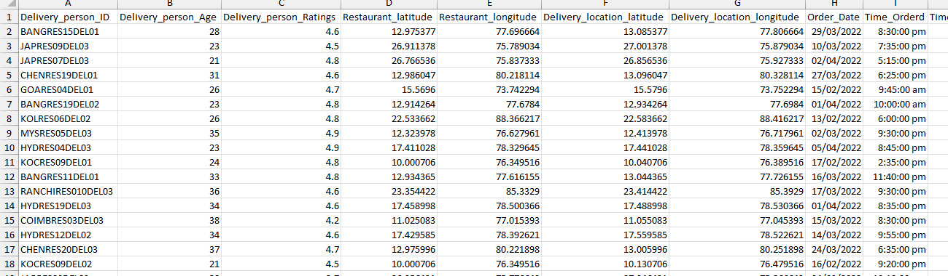
Figure 1: Data after Cleaning (Self-Prepared)
Imputation was used for non-critical variables. The Multiple_deliveries had missing values, which were substituted by 0 as there were no additional deliveries. The values of Festival NaN were changed to No, and the values of City NaN were changed to the most frequent city detected using a Pivot Table.
Time variables that were in decimal form (e.g. 0.75) were converted into standard time using the time formatting options in Excel. Duplicates were eliminated, and categorical text discrepancies were fixed. These measures helped to make the dataset complete, consistent and appropriate to be able to statistically analyse it correctly (Sharpe, Richard and Velleman, 2019).

Descriptive Statistics and Summary
Excel was used to create descriptive statistics along with SPSS in order to make a mainstream representation of the data. The SPSS output is used to confirm the results presented in Figure 3, although Figure 2 shows the Excel descriptive statistics. There are no missing values in the chosen variables in the dataset, and the number of valid elements is 10,051. The average age of delivery personnel is 29.50 years, the lowest is 20 years, and the highest is 39 years, which means that it has a young workforce, and the age of this workforce is concentrated within a small age group. Delivery_person_Ratings average is high, and it is 4.635 between 5.0 and 2.5. This indicates a tenderness towards high and steady customer satisfaction, and the deviation in the lowest and highest rates is not very high.
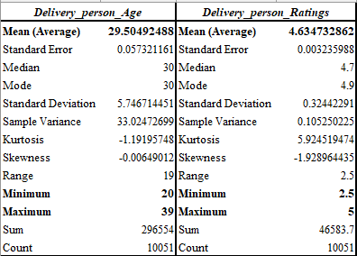
Figure 2: Descriptive Statistics of Excel (Self-Prepared)
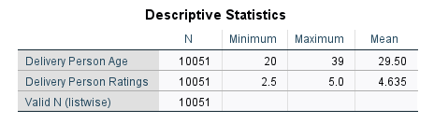
Figure 3: Descriptive Statistics of SPSS (Self-Prepared)
The SPSS frequency analysis was used to analyse the distribution of categorical variables (Azen and Walker, 2011). Weather conditions in Figure 4 are rather evenly distributed as demonstrated. Sunny and Windy each contribute 17.3 per cent of deliveries, with Cloudy (16.8) and Sandstorms (16.8) next. Stormy (16.1%) and Fog (15.8%) have slightly lower percentages; however, by and large, the dataset is characterised by an exposure to a variety of weather conditions, instead of the prevalence of one.
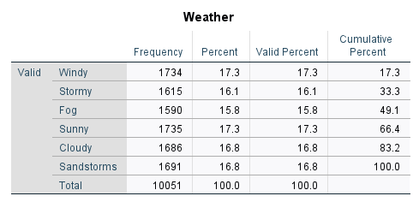
Figure 4: Frequency Table of Weather (Self-Prepared)
Figure 5 indicates that the density of road traffic is different. The most frequent are Low traffic (34.3%), Jam conditions (31.2%), and Medium traffic (24.5). The least prevalent are high traffic conditions of 9.9. This implies that there is less severe traffic events, despite the congestion.
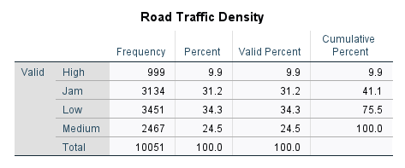
Figure 5: Frequency Table of Road Traffic Density (Self-Prepared)
The types of orders are nearly evenly distributed in Buffet (25.4%), Drinks (25.6%), Meal (24.5%), and Snack (24.6%), which shows that the customer demand is balanced. Figure 7 indicates that motorcycles are the leading in delivery operations (58.9%), then there are scooters (33.3%), and electric scooters (7.8%).
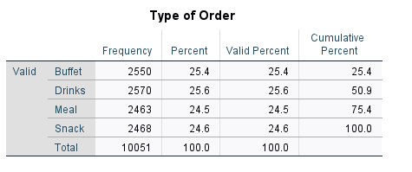
Figure 6: Frequency Table of Type of Order (Self-Prepared)
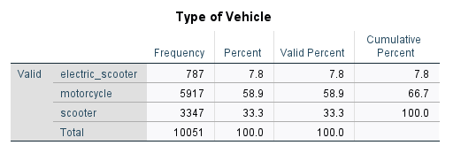
Figure 7: Frequency Table of Type of Vehicle (Self-Prepared)
The visual summaries in Figures 8 to 11 are represented as column charts and a histogram, which serve to support the accurate interpretation and further allow performing an easier comparison between the categories of operations.
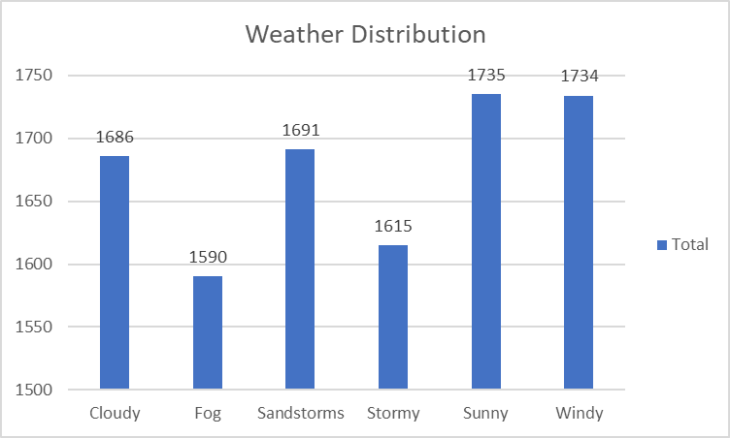
Figure 8: Weather Distribution (Self-Prepared)
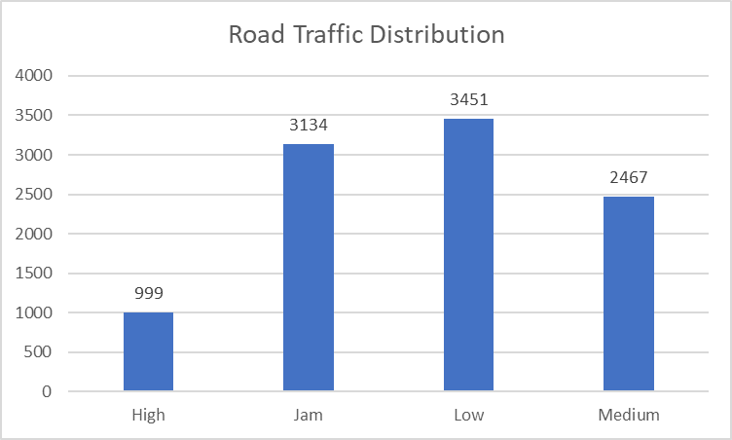
Figure 9: Road Traffic Distribution (Self-Prepared)
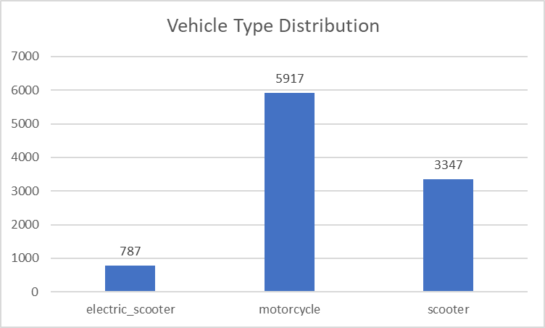
Figure 10: Vehicle Type Distribution (Self-Prepared)
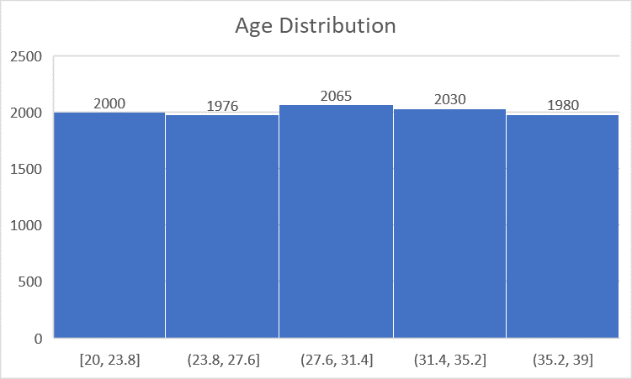
Figure 11: Age Distribution (Self-Prepared)

Trend Analysis and Visualisation
Trend analysis was used in Microsoft Excel to determine the trends in the performance of the delivery and the relationships between the conditions of operation and the service results (Sherstneva and Sherstneva, 2020). Bar charts and scatter plots were drawn in the form of the visualisations in order to demonstrate the patterns and dependencies in the dataset.
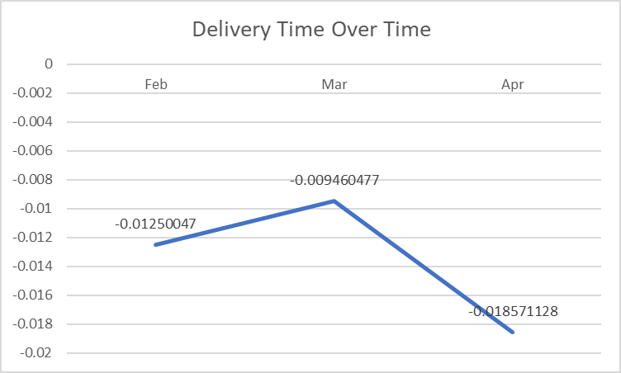
Figure 12: Chart 1 (Self-Prepared)
The average delivery time is shown in Figure 12, showing the trend of the average delivery time during February, March and April. The chart indicates that there was a slight improvement between the months of February and March, and then a significant decline was seen in April. This difference implies time fluctuations in operations, maybe due to the levels of demand, traffic conditions or variations in season that impact the efficiency of the delivery (Makinde, Ramatsetse and Munyai, 2020).
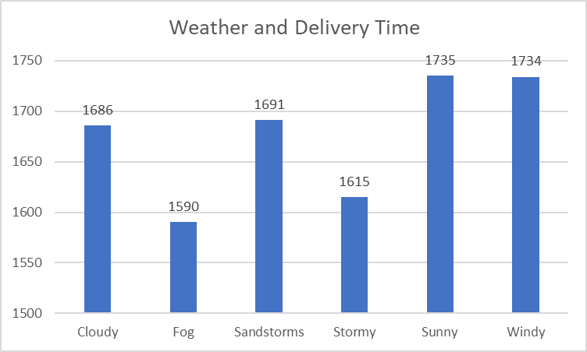
Figure 13: Chart 2 (Self-Prepared)
The correlation between weather and delivery activity is shown in Figure 13. This distribution is relatively equalised in terms of the volume of deliveries of all types of weather, with Sunny (1,735) and Windy (1,734) prevailing the most, and Sandstorms (1,691) and Cloudy (1,686) being the second in frequency. Fog (1,590) and Stormy (1,615) conditions seem to be slightly less common. Whereas the amount of delivery does not differ dramatically by weather types, the operational stress is probably greater in extreme weather conditions like Stormy and Sandstorms, and this could cause the difference in delivery time. It implies that as long as deliveries are made at any time of the day or night, there is a possibility that unfavourable weather can affect efficiency.
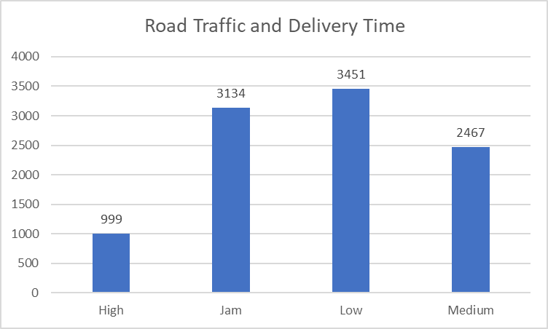
Figure 14: Chart 3 (Self-Prepared)
Road traffic density distribution is provided in Figure 14. The number of most deliveries (3,451) is in the category of Low traffic, followed by Jam (3,134) and Medium (2,467), and finally, High traffic makes up the least percentage (999). The fact that the frequency of deliveries under low and jam conditions is higher means that one of the operational challenges is traffic congestion. By extension, it can be deduced that deliveries at times of jam or heavy traffic would tend to have higher delivery times in terms of congestion delay.
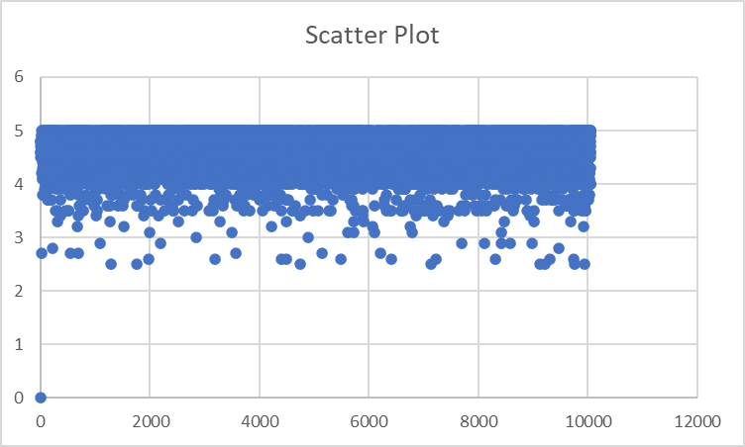
Figure 15: Chart 4 (Self-Prepared)
Scatter plots were used to address the issue of the relationship between delivery ratings and delivery patterns. The scatter plot (Figure 15) indicates high ratings that are concentrated between 4 and 5 throughout the dataset, which is evidence of high levels of service performance. The overall downward and upward trend is not observed in the observations, indicating that there is no definite trend in the ratings of deliveries irrespective of the order sequence. Moreover, there seems to be no noticeable linear correlation between delivery activity and ratings that are very strong, meaning that an element of operations, like traffic and weather, can possibly have a greater impact on time efficiency than the score on customer satisfaction (Luo et al., 2022).
Graphical analysis shows steady ratings of services and different conditions of operations. Traffic density seems to be a more significant operational constraint factor than weather variability. The findings indicate that further statistical testing is required in the analysis section below to determine the magnitude of these observed relationships.

Statistical Analysis using SPSS
In SPSS, statistical analysis was done to determine the relationships that exist between operational variables and the performance of the deliveries. Hypothesis testing, correlation analysis and regression modelling were conducted to find out whether the chosen factors play a significant role in Delivery Person Ratings (Lind, Marchal and Wathen, 2017).
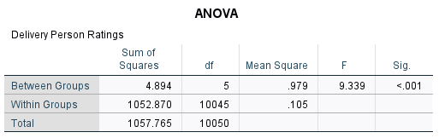
Figure 16: ANOVA Table (Self-Prepared)
In order to determine the difference in customer ratings in different weather conditions, a one- way ANOVA was performed. The findings demonstrated a statistically significant difference between the ratings within the categories of weather, F(5, 10045) = 9.339, p less than 0.001. It thus rejected the null hypothesis of no difference. The differences in means were small, although statistically significant. Cloudy (M = 4.663) and Fog (M = 4.659) were rated slightly higher, whereas Windy (M = 4.612) and Sandstorms (M = 4.612) were slightly lower in their rating. Post hoc tests of Tukey showed that there were some significant differences in pairs, but the difference in variation was small. This means that weather conditions do exert a statistically significant but practically insignificant influence on customer ratings.
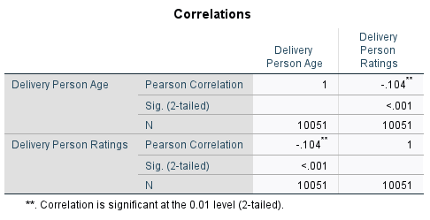
Figure 17: Correlation (Self-Prepared)
Correlation analysis has been carried out to investigate the relationship between Delivery_Person_Age and Delivery_Person_Ratings. The correlation by Pearson showed that there was a weak negative association, which was statistically significant (r = -0.104, p < 0.001). It means that at higher ages, an increase in the number of delivery personnel will reduce the ratings slightly. Nevertheless, the correlation is extremely low, and it implies that age is not a powerful predictor of service quality (Ejdys and Gulc, 2020). The small effect size is offset by the large sample size (N=10,051), which helps in achieving statistical significance.
Figure 18: Regression Output (Self-Prepared)
To determine whether the Delivery person's age, Road traffic density, Weather and Delivery time predict Delivery person Ratings, a multiple regression analysis was carried out. The regression model as a whole was also statistically noteworthy, F(4, 9863) = 40.674, p < 0.001. Nevertheless, the model only has a small percentage (1.6) of variance in ratings (R 2 = 0.016), which has a weak explanation quality. Delivery person age (B = -0.006, p < 0.001) and road traffic density (B = 0.021, p < 0.001) were found to be significant, but Weather (p = 0.052) and Delivery time (p = 0.221) were not.
Altogether, the statistically significant relationship between some of the variables exists, but the effect of the variables on the customer ratings in practice is weak, which means that other factors in service ratings could be considered.

Insights and Recommendations
The analysis has given some crucial understanding of the performance of delivery and operating conditions. The statistics of the workforce are descriptive, showing that the workforce is young, with high customer ratings being maintained, implying that the quality of service remains steady. Weather conditions were found to have statistically significant differences in ratings, but the practical effect was not significant because the difference in mean was low among categories. The density of traffic seemed to be a stronger operational variable, and congestion is one of the typical conditions of delivery. The correlation analysis indicated a weak negative relationship between the age of delivery personnel and ratings, but the regression analysis indicated that age and traffic density were statistically significant predictors of ratings. However, the total implementation ability of the regression model was weak, which implies that other unseen and unobservable factors are likely to determine customer satisfaction (Lind, Marchal and Wathen, 2017).
According to these findings, a number of recommendations can be given. The optimisation strategies of routes should consider traffic-sensitive navigation plans in order to reduce delay on congested routes or jams. Use of vehicle types can also be assigned strategically by ensuring that urban areas that experience heavy use of vehicles get motorcycles to improve efficiency (Thondoo et al., 2020). Also, specific training and performance control may facilitate the regular delivery of service regardless of the weather conditions.
The weaknesses of the research are the low explanatory power of the regression model and the lack of variables, such as the complexity of delivery distance or customer expectations. It is possible that in future the study may include more operational and behavioural variables to describe differences in the performance of delivery and customer ratings.

References
Azen, R. and Walker, C.M. (2011). Categorical data analysis for the behavioral and social sciences. New York, Ny: Routledge.
Ejdys, J. and Gulc, A. (2020). Trust in Courier Services and Its Antecedents as a Determinant of Perceived Service Quality and Future Intention to Use Courier Service. Sustainability, 12(21), p.9088. doi:https://doi.org/10.3390/su12219088.
Lind, D., Marchal, W. and Wathen, S. (2017). Statistical Techniques in Business and Economics. Mcgraw-Hill College.
Luo, S., He, S.Y., Grant-Muller, S. and Song, L. (2022). Influential factors in customer satisfaction of transit services: Using crowdsourced data to capture the heterogeneity across individuals, space and time. Transport Policy, 131. doi:https://doi.org/10.1016/j.tranpol.2022.12.011.
Makinde, O., Ramatsetse, B. and Munyai, T. (2020). A dynamic programming model for Reconfigurable Vibrating Screen machine operations planning in a fluctuating market environment. Procedia Manufacturing, 43, pp.247–254. doi:https://doi.org/10.1016/j.promfg.2020.02.149.
Sharpe, N.R., Richard, D. and Velleman, P.F. (2019). Business statistics. 4th ed. Boston, Ma: Pearson.
Sherstneva, A. and Sherstneva, O. (2020). Analysis of Statistical Information for Data Trend Forecasting. 2020 International Ural Conference on Electrical Power Engineering (UralCon), pp.153–158. doi:https://doi.org/10.1109/uralcon49858.2020.9216276.
Thondoo, M., Marquet, O., Márquez, S. and Nieuwenhuijsen, M.J. (2020). Small cities, big needs: Urban transport planning in cities of developing countries. Journal of Transport & Health, [online] 19, p.100944. doi:https://doi.org/10.1016/j.jth.2020.100944.
Hair, J.F., Black, W.C., Babin, B.J. and Anderson, R.E. (2019) Multivariate Data Analysis. 8th edn. London: SAGE Publications.
Pallant, J. (2020) SPSS Survival Manual: A Step by Step Guide to Data Analysis Using IBM SPSS. 7th edn. London: SAGE Publications.

Appendices

Appendix A- ANOVA Supporting

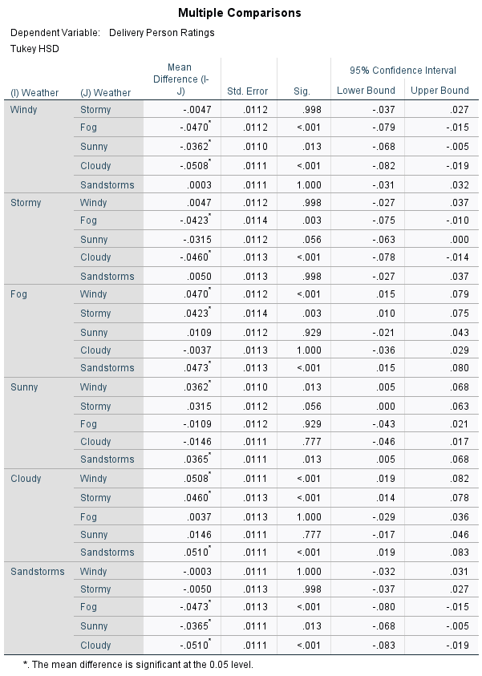
Figure 19: Ad Hoc Test for ANOVA (Self-Prepared)

