NAME: Anamaria Dragan
MODULE: NEW DIGITAL SKILLS- LCLM4002
DEADLINE: 4th October 2026
STUDENT ID: 2607515

DS1 My digital skills life

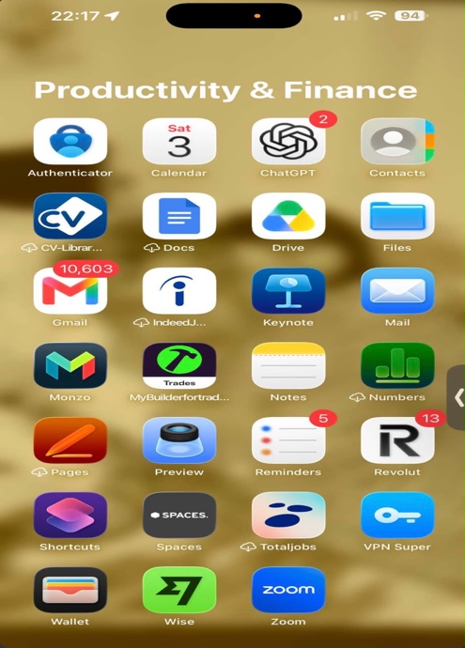 this picture represents all my digital apps that I use in my every day life to manage my finances, check , send and reply to emails and save my online documents.

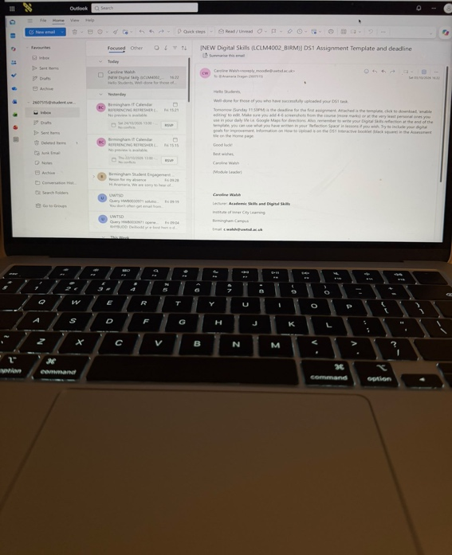 in this picture you can see me using school emails , where I often log in to check any updates or important informations.

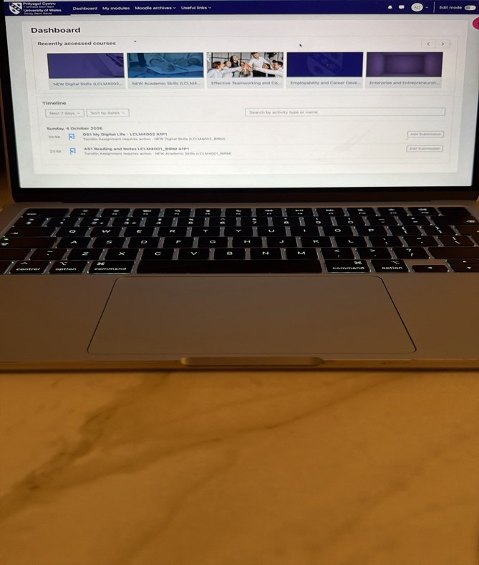 in this picture I show you that I can log in into my Moodle website , to check my modules , upload my assessments and be up to date with all the weekly academic work.

My Reflection

In my day-to-day life I use a lot of my digital skills using my phone apps. I usually use my online banking apps to manage my finances, files app to save all my online documents, authenticator app to give myself access to all the university personal account, chat gpt to find out anything I am unsure about and social media to interact with friends and family. Sometimes I am unsure about things and one of them is excel spreadsheet. I haven’t been very good at using excel in the past and I would like to gain a new digital skill by learning how to use excel. I hope that this module can teach me that and at the end of it to be able to confidently use this Microsoft app.

