Student ID – 2209098 Elena Galban

Table of Contents

Introduction 2
Task 1 – Written summary 3
Preparing for Higher Education 3
Task 2 – Mind map 5
Becoming a Digital Learner – Mind Map 5
Task 3 – Presentation 7
Task 4 – Reflection 8
Borton’s reflective tool 8
Conclusion 11
References 12

Introduction
Higher education has certainly seen growth in the UK, the number of students enrolling for higher education has increased and so does the universities and institutes. It is important to prepare for higher education, getting into Oxford university or Cambridge university is certainly difficult but it can take careers to new heights. This report describes the various aspects of preparing for higher education, and becoming a digital learner, it, the report also provides a mind map and reflection using Borton’s model.

Task 1 – Written summary

Preparing for Higher Education
Higher education in the UK generally means undergraduate or postgraduate studies that one pursues after school (nidirect.gov.uk, 2022). Higher education provided by universities not only increases the knowledge about certain subjects, but it focuses on a more sustainable development of the students (Hallinger and Chatpinyakoop, 2019). One of the key aspects of higher education is to promote diverse & future-oriented prospects and affect the decision-making process and behaviour of pursuers.
To stay productive and achieve career objectives it is important to study effectively and use the available resources to the fullest. Preparation is a must to produce the best result, a proper time and place for preparing must be decided, and the surrounding environment must be free from distractions. The first step is always to state the objectives and plan accordingly, it is important to prioritize the important and urgent tasks first. The Eisenhower Principle can certainly help in identifying the most important tasks (researchgate.net, 2022) that can help the students to prioritize, it can save time and effort for being more productive. Gathering the resources and using them to their full capacity is expected from students, but procrastination can come in the way of it. Doing a regular self-assessment can help to stay on the right track, procrastination and perfectionism can also be handled with appropriate actions and support. Sustaining in a fast-paced environment requires students to learn the necessary skills, and several digital skills and tools that can increase efficiency and productivity are essential to learning (Siebel, 2019). Various writing formats such as reports, or essays are needed to be learned with proper referencing and without copying. Assessments are a great way of learning, they can be written, oral or visual but they can certainly add value to the outcome in terms of knowledge and application.

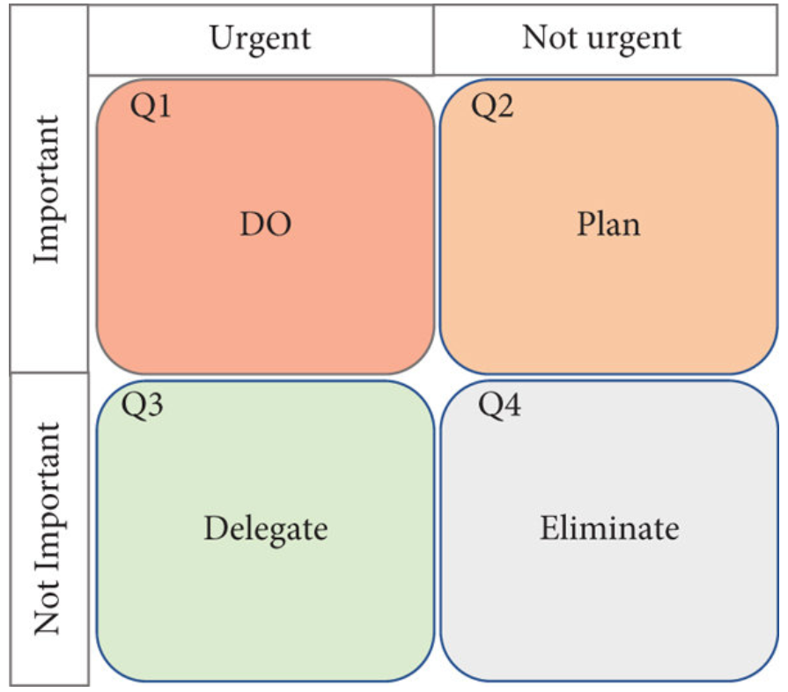
Fig: Eisenhower Matrix
(Source: researchgate.net, 2022)

Task 2 – Mind map
A mind Map is a tool in form of a diagram that provides a structure that helps in describing thoughts and to recall learnings or information (Almulla and Alamri, 2021).

Fig: Mind Map
Source: Created by Student

Becoming a Digital Learner – Mind Map
The concept of online learning is certainly becoming more and more popular (Ferri et al., 2020), and efficient use of appropriate resources can prove to be very beneficial for any student. Digital learning platforms and libraries are a good source of providing the required knowledge and can also clarify doubts or any setbacks. To continue learning efficiently, the resources provided by the university must be first understood and studied, along with proper guidance and clear objectives. The digital learning concept prepares students for the various challenges that need to be acknowledged such as copyrights and identifying fake news. Resources provided in the assessment offer sources such as the library that can be accessed anytime and help to dive deeper into the topic of discussion. It is important to always check the credibility of any information, a site with a lot of ads is always sceptical of providing honest information. Writing ability is always a focus in the assessments and it is an essential element that will be of use in the future, it needs a careful understanding of the frameworks and structure.
The assessments and the various sources of information such as the libraries have motivated me to seek knowledge and grow my understanding of certain concepts. Various topics of discussion such as written ability and critical thinking have gained my interest, the topics are simple yet interesting to understand. The library allows us to learn either the overview or go deeper and learn more about topics, it has proven very effective in keeping the interest alive. My critical thinking ability has also improved, and it has become easier to distinguish between dependable content and untrustworthy information. Overall, the experience has been beneficial and has made me more productive and efficient.

Task 3 – Presentation
Please follow this link to view my presentation:
The foundations of my identity are based on honesty, I pursue a responsible role that tests my capabilities and the skills I will acquire along the way. I continue to seek information regularly from various sources such as the internet, books, journals, etc to improve my current understanding and interests. I thrive in a competitive environment that allows me to test my experiences, I enjoy working with people and accomplishing tasks as a team. I know the importance of effective communication and it has helped me stay clear and specific while addressing issues or misunderstandings. It is important for one to fully understand self before acknowledging the surrounding environment, personal values and beliefs must be firm and based on which the identity is determined. Keeping this thought in mind I regularly like to take feedback from peers and teachers that help me improve and build a social bond with everyone around me. I like to stay curious and once I found anything interesting, I seek to learn everything about it, books and the internet have certainly helped me improve a lot of my attributes such as communication and confidence. Overall, I can say I am certainly a team player and working on any task as a team makes the task more interesting and easier to accomplish.

Task 4 – Reflection

Borton’s reflective tool
Borton’s reflective tool is an effective way to deliver a fair reflection, it analyses three key questions that are What, So What, and Now What and addresses the learnings expectations and outcome (Snyder, 2019).

Fig 01: Borton’s model of reflection
Source: Created by student

What? | So What? | Now What?
What happened?  What did I observe and do?  What was my reaction?  What did other people do who were involved in this? | So, what are the effects of what I learned?  So, what were my feelings at the time of the lesson?  So, what were my feelings, after the lesson?  So, what are the positive aspects of the experience? | Now, what are the implications of learning?  Now, what aspect should be focussed on?  Now, what help do I need to improve?
What?
The university has provided the facility of learning online which certainly has its merits and demerits (Gherheș et al., 2021), but in terms of providing necessary information through various sources, it has been effective. Units and topics were available to be accessed anytime and all the related information was easy to seek and understand. Not only the overview that was easy to interpret but additional information on most of the topics was available to take the knowledge and understanding of the topic further.

So What?
The lessons were clear and easy to learn, for me personally the topics became interesting and motivated me to search more about them over the internet. Various topics such as the importance of identifying credible sources and discarding fake news were useful in future perspectives also. The online learning experience felt difficult at first but as the process started the fear went off and I efficiently utilized the multiple resources.

Now What?
The learnings and topics were certainly useful and left an impression on me, I will certainly seek more on the libraries to further indulge my knowledge. Visually appealing content helped for better understanding the topic and introducing more of it in form of charts and graphs can be more beneficial. I need more focus on the topics that I don’t feel are interesting but are necessary to learn, with proper guidance and self-analysis I can identify more areas that need development.

Conclusion
Various aspects of online learning were emphasized, and the online platform didn’t fall behind in providing the required resources. To pursue higher studies, proper planning with clear objectives and plans is required, and optimal use of the technology and resources available can be of great help. Borton’s model was used to deliver the reflection and the mind map was also used to recall the key learnings and depicted the interconnectedness. The resources were sufficient in information and made the learning experience fulfilling and exciting.

References
Almulla, M.A. and Alamri, M.M., 2021. Using Conceptual Mapping for Learning to Affect Students’ Motivation and Academic Achievement. Sustainability, 13(7), p.4029.
Ferri, F., Grifoni, P. and Guzzo, T., 2020. Online learning and emergency remote teaching: Opportunities and challenges in emergency situations. Societies, 10(4), p.86.
Gherheș, V., Stoian, C.E., Fărcașiu, M.A. and Stanici, M., 2021. E-learning vs. face-to-face learning: Analyzing students’ preferences and behaviours. Sustainability, 13(8), p.4381.
Hallinger, P. and Chatpinyakoop, C., 2019. A bibliometric review of research on higher education for sustainable development, 1998–2018. Sustainability, 11(8), p.2401.
nidirect.gov.uk, 2022 nidirect.gov [Online] What higher education is Available at <https://www.nidirect.gov.uk/articles/what-higher-education#:~:text=Higher%20education%20is%20third%20level,includes%20undergraduate%20and%20postgraduate%20study.> [Accessed on 26 October 2022]
researchgate.net, 2022 research gate [Online] The Time Management Matrix (Eisenhower’s matrix) Available at <https://www.researchgate.net/figure/The-Time-Management-Matrix-Eisenhowers-matrix_fig1_358265747> [Accessed on 27 October 2022 ]
Siebel, T.M., 2019. Digital transformation: survive and thrive in an era of mass extinction. RosettaBooks.
Snyder, M.M., 2019. Designing socially-mediated reflection in online discussions. FDLA Journal, 4(1), p.3.

